Contents
The Incident Report Review Process 2
Incident Report Review Process Overview 2
MRC Report Review and Approval 2
DDS Report Review and Approval 3
Scenario: Compile and Submit the Incident Report Review (IRR)/ Area Office Management Review (AOMR) 4
Scenario: Compile and Submit the Secondary Incident Report Review (SIRR)/ Regional Office Management Review (ROMR) 7
Alternate Scenario: Mark an Incident as “Not Approved” 11

The Incident Report Review Process

Incident Report Review Process Overview
When an Incident Report has been submitted, it must be reviewed for completeness and accuracy by an Area Office user or Case Manager for quality assurance purposes. Upon review, the Area Office user or Case Manager will ultimately designate whether the report is approved or not approved. The HCSIS Incident Management module facilitates both levels of the incident report review to ensure that incidents receive the appropriate level and quality of review as necessary.

An Incident Report Review (IRR), also known as the Area Office Management Review (AOMR), is the level of review that is conducted for incidents that require a minor level of review. An Incident Report Review is “closed” in the system after it has been reviewed and approved. For incidents that only require a minor-level of review, approval by the Area Office user or Case Manager closes the incident. In this document, we will refer to this initial review as the “First Level Review.”

A Secondary Incident Report Review (SIRR), also known as the Regional Office Management Review (ROMR), is the second level of review that is conducted for incidents that require a major level of review. This level of review takes place after the incident is approved at the first level of review. This second level of review is conducted by the Regional Office user or Case Manager Supervisor. A Secondary Incident Report Review is “closed” in the system after it has been reviewed and approved. In this document, we will refer to this level of review as the “Second Level Review.”

The table below shows which reporting process will be followed for individuals on each state and waiver program.

DDS Reporting Process | MRC Reporting Process
DDS Intensive Supports Waiver | ABI Non Residential Habilitation Waiver
DDS Community Living Waiver | MFP Community Living Waiver
DDS Adult Supports Waiver
DDS State Programs
ABI Residential Habilitation Waiver
MFP Residential Support Waiver

MRC Report Review and Approval

MRC First Level of Review
Incidents requiring a minor level of review only undergo the first level of review, known as the Incident Report Review (IRR) at MRC. The incident can be approved or not approved during this review.

If Approved: If the incident is approved after the initial review, the incident is closed because it requires only a minor level of review.

If NOT Approved: The incident is sent back to the provider who will review and resubmit the report if the incident is not approved. The provider will have seven calendar days to resubmit the final incident report.
Incident requiring a minor-level review is finalized

Case Manager conducts the IRR
Incident Report is closed
Approved
Not Approved

MRC Second Level of Review
Incidents requiring a major level of review undergo both a first and second level of review. If the first level is not approved, the report is sent back to the provider. If the first level is approved, the report undergoes the Secondary Incident Report Review (SIRR) and the process repeats itself.
Incident requiring a major-level review is finalized
Incident Report is closed
Not Approved

Case Manager Supervisor conducts the SIRR

Case Manager conducts the IRR
Approved
Approved
Not Approved

DDS Report Review and Approval

DDS First Level of Review
Incidents requiring a minor level of review undergo only the first level of review, known as the Area Office Management Review (AOMR) at DDS. The review can be approved or not approved during this review.
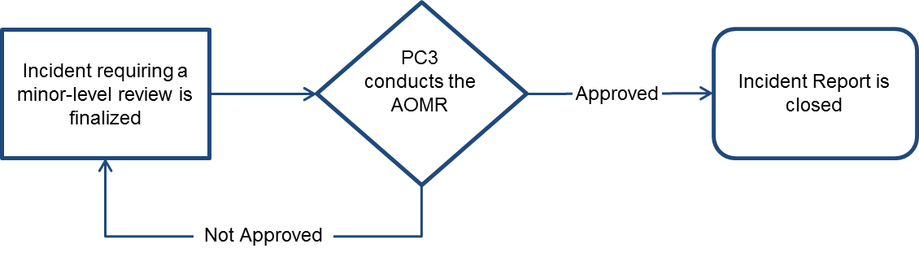

If Approved: Since this incident requires only a minor level of review, once the initial review is approved the incident is closed.

If NOT Approved: If the incident report is not approved, it is sent back to the provider to be reviewed and resubmitted. The provider will have seven calendar days to resubmit the incident report.

DDS Second Level of Review
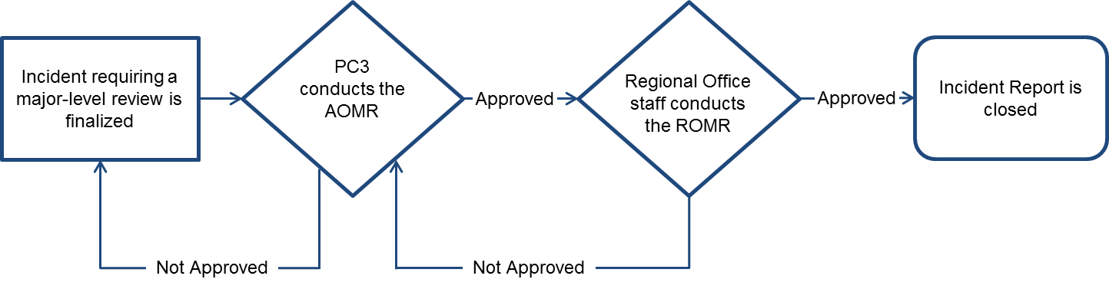
Incidents requiring a major level of review undergo both a first and second level of review. If the first level is not approved, the report is sent back to the provider. If the first level is approved, the report undergoes the Regional Office Management Review (ROMR) and the process repeats itself.

Scenario: Compile and Submit the Incident Report Review (IRR)/ Area Office Management Review (AOMR)
An Incident Report Review (at MRC) or Area Office Management Review (at DDS) begins once an incident report has been submitted, and can last up to 7 calendar days.

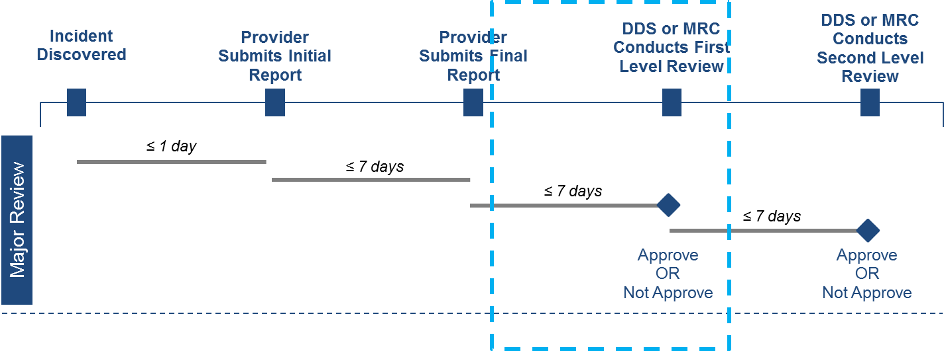
Roles and Responsibilities
- The following users can compile and submit the IRR/ AOMR
  - MRC Case Manager
  - MRC Case Manager Supervisor
  - MRC Central Office Oversight
  - DDS Service Coordinator Supervisor
  - DDS Service Coordinator
  - DDS Area Office

First Steps:
- An Incident Report has been submitted for review
- The user logs into HCSIS
- The user navigates to the Quality Management Module
- The user navigates to the Incident Management sub-module

Scenario Steps
- Navigate to the Event Data Entry page

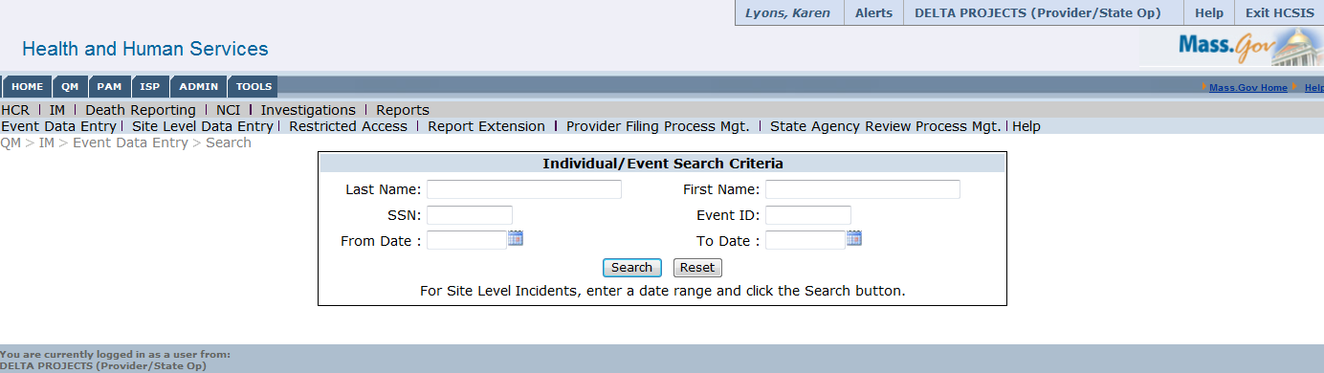

- Search for an Individual

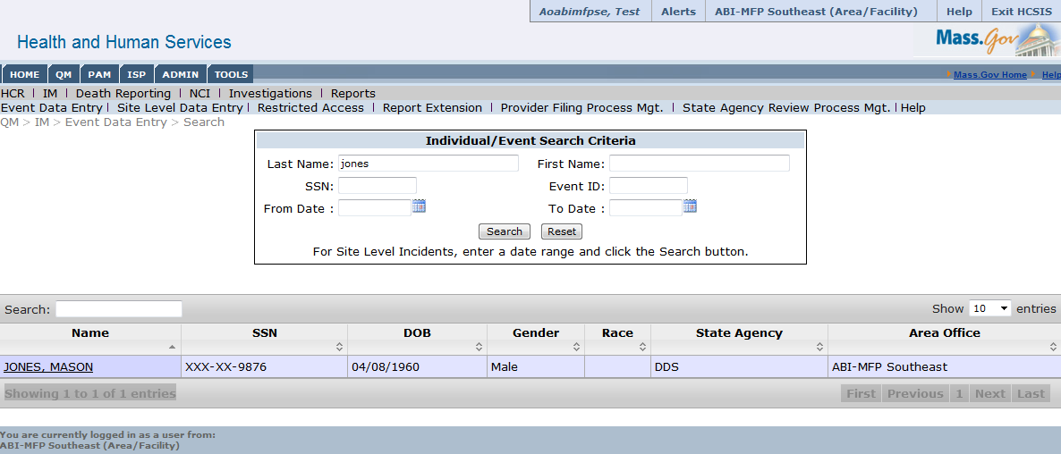
- Select the individual’s name to be redirected to the individual’s event history

- Select the ID corresponding to the event requiring an IRR/AOMR

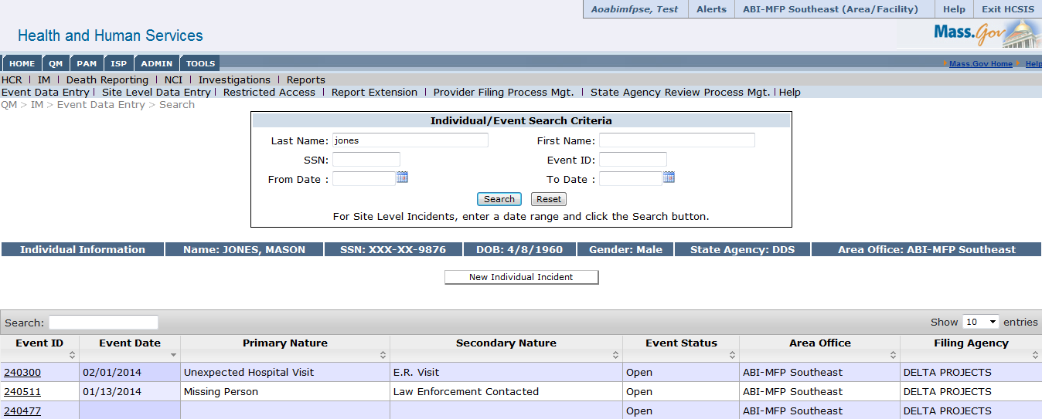

- Select “Create” on the event switchboard under Area Office Management Review/ Incident Report Review

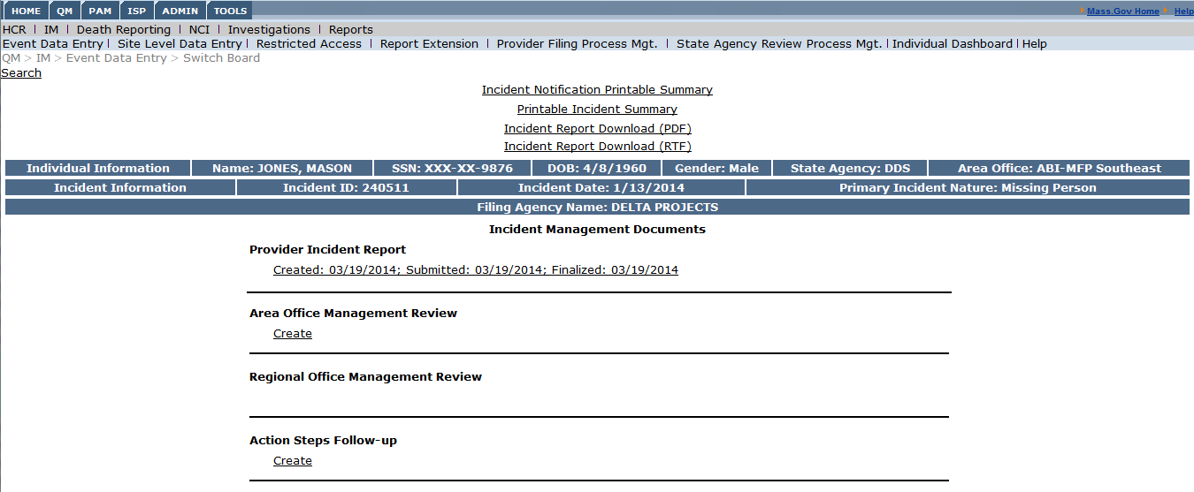
Created: 01/14/2014; Initial Report Submitted: 01/14/2014; Finalized: 01/21/2014

- Complete Required Fields

The IRR/ AOMR form consists of only one screen. The user will need to fill out required fields in addition to indicating the status of review which may be; approved, not approved, or approved with modification to category.

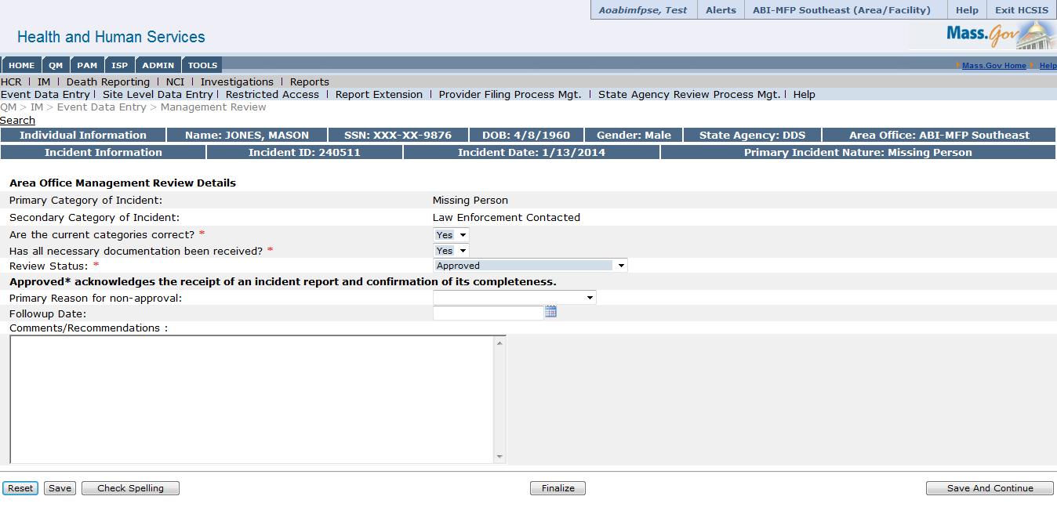

- Finalize the IRR/ AOMR

Scenario: Compile and Submit the Secondary Incident Report Review (SIRR)/ Regional Office Management Review (ROMR)
A Secondary Incident Report Review (MRC) or Regional Office Management Review (DDS) begins once the first level of review is approved, and can last up to 7 days. The regional office actor or case manager supervisor will receive an alert that an incident requiring a major level of review has been approved.

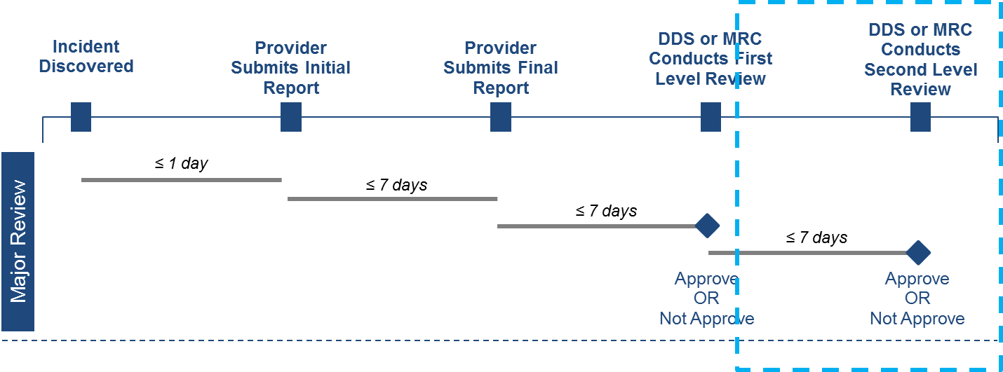
Roles and Responsibilities
- The following users can compile and submit the SIRR/ ROMR
  - MRC Case Manager Supervisor
  - MRC Central Office Oversight
  - DDS Regional Office User

First Steps:
- The user logs into HCSIS
- The user navigates to the Quality Management Module
- The user navigates to the Incident Management sub-module

Scenario Steps
- Navigate to the Event Data Entry Screen

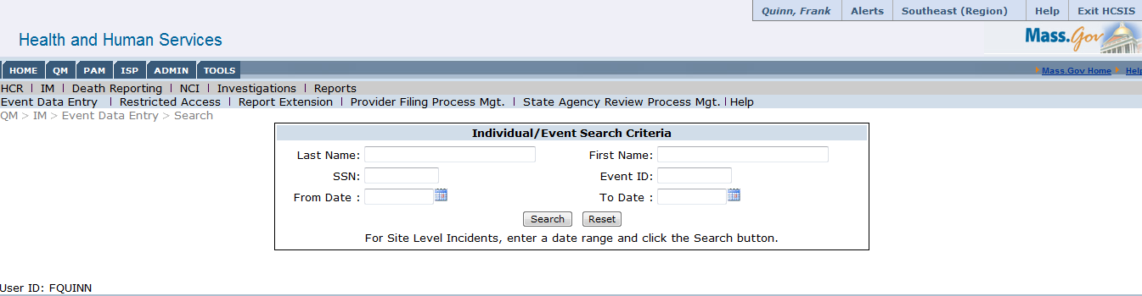

- Search for an Individual

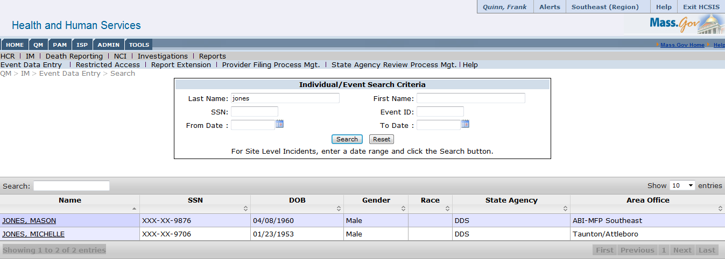

- Click the Individual’s name to be redirected to the individual’s event history

- Select the ID corresponding to the event requiring an SIRR/ROMR

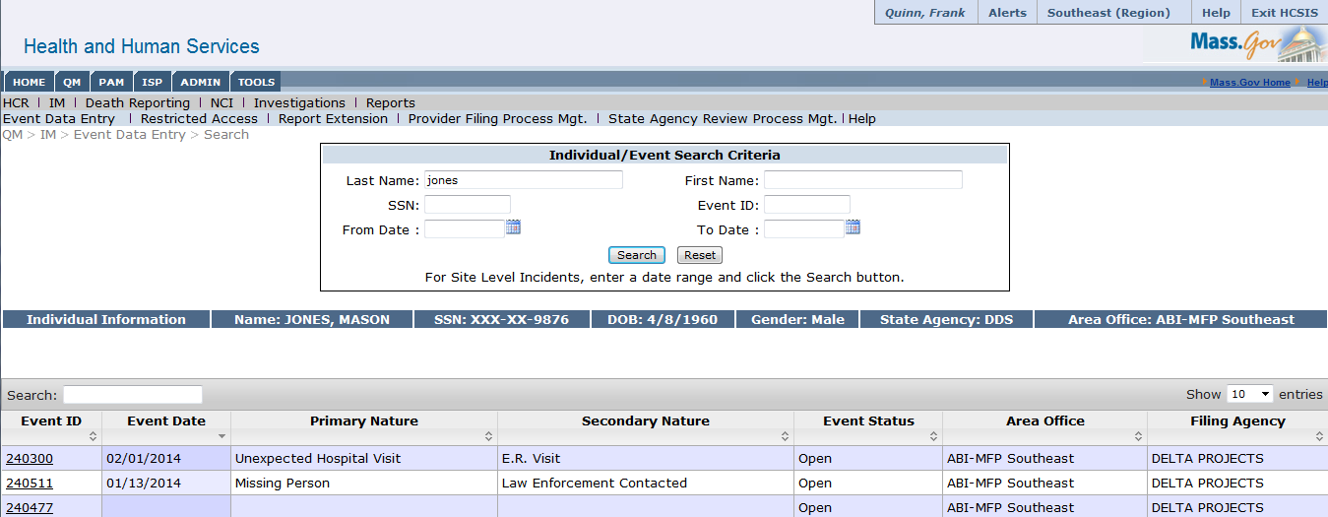

- Select “Create” on the event switchboard under Regional Office Management Review/ Secondary Incident Report Review
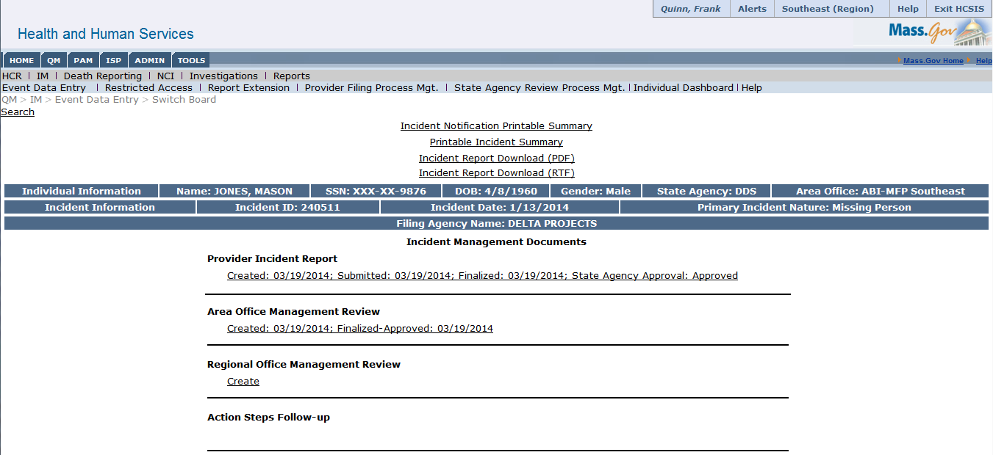

Created: 01/14/2014; Submitted: 01/14/2014; Finalized: 01/14/2014; State Agency Approval: Approved

Created: 01/14/2014; Finalized-Approved: 01/21/2014

- Complete Required Fields

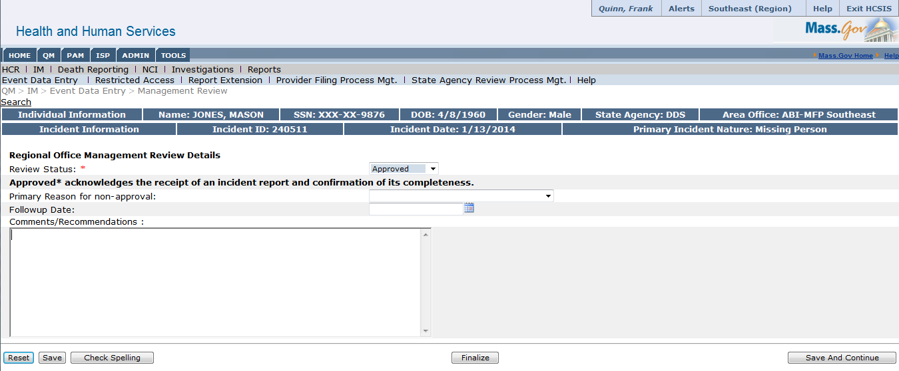

- Finalize the SIRR/ ROMR

Alternate Scenario: Mark an Incident as “Not Approved”
Instead of an incident being approved as shown in the scenarios above, there are situations in which an incident report will be marked as “Not Approved.” This may occur at either the first or second level of review. This scenario will illustrate an incident marked as “Not Approved” during the second level of review and follow the review process through the incident re-finalization.
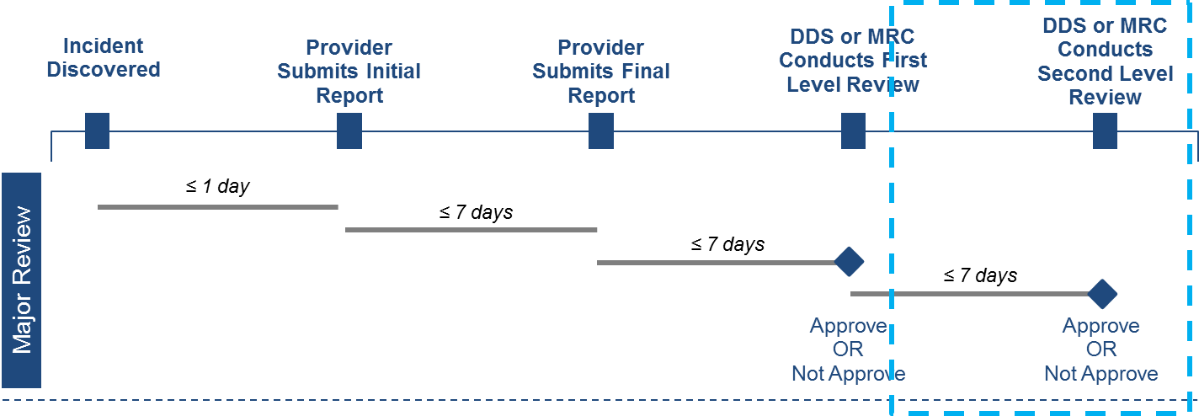
Roles and Responsibilities
- MRC Case Manager Supervisor: Can create and finalize the Second-level review
- MRC Central Office Oversight: Can create and finalize the Second-level review
- DDS ABI/MFP Regional User: Can create and finalize the second-level review

First Steps:
- The user logs into HCSIS
- The user views the alerts page
- The user navigates to the Incident Management sub-module

Scenario Steps
- Second-level reviewer views alert
  - The user who is responsible for the second level of review will receive an alert that the Area Office staff or Case Manager has approved a major incident

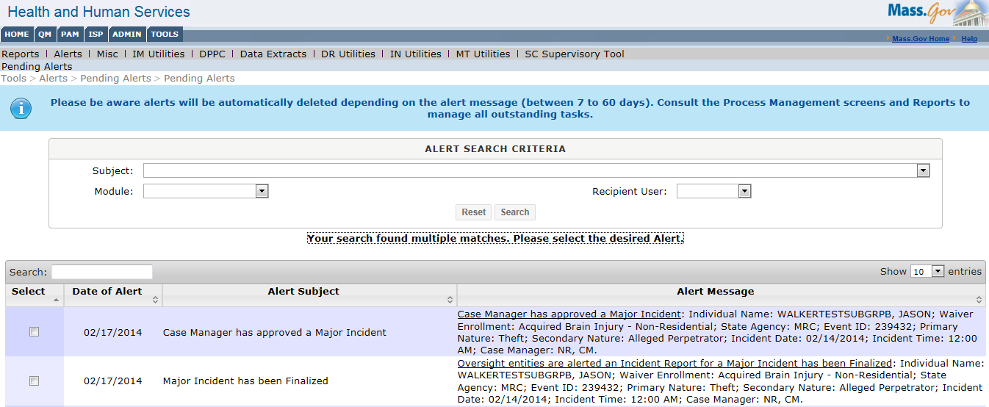

  - Clicking on the alert hyperlink brings the second-level reviewer to the Incident Report Switchboard

- Second-level reviewer completes the second-level review
  - The reviewer selects “create” to begin second-level review

  - The reviewer completes the review process, selecting “Not Approved” from the Review Status dropdown
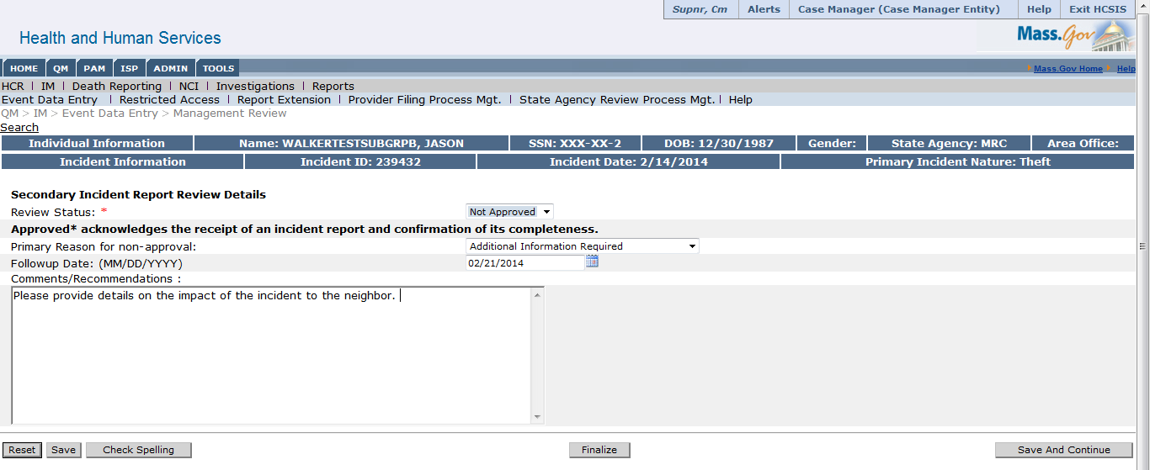

  - The Incident Switchboard reflects that second level review status is “Not Approved”

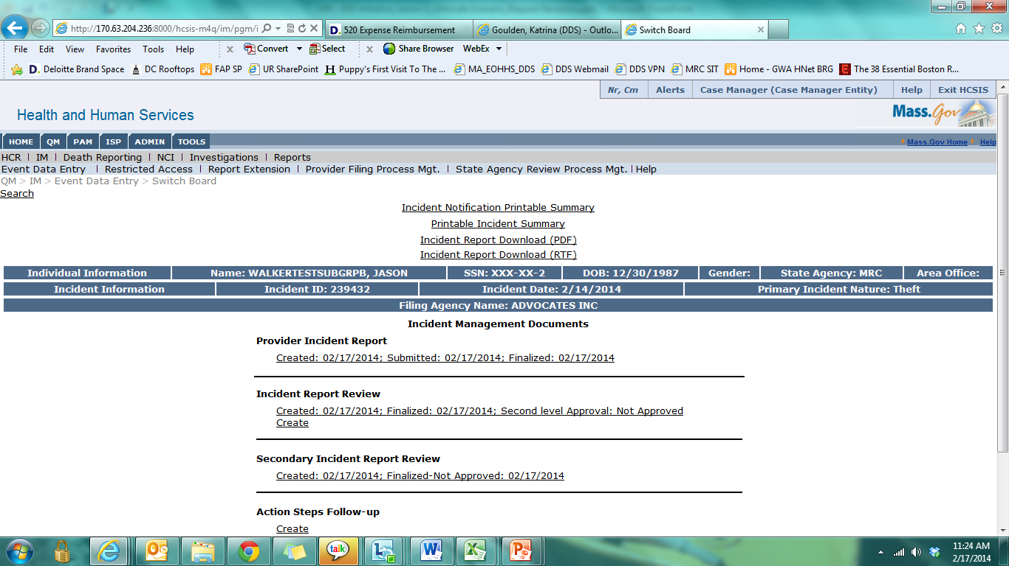

- First level reviewer receives an alert
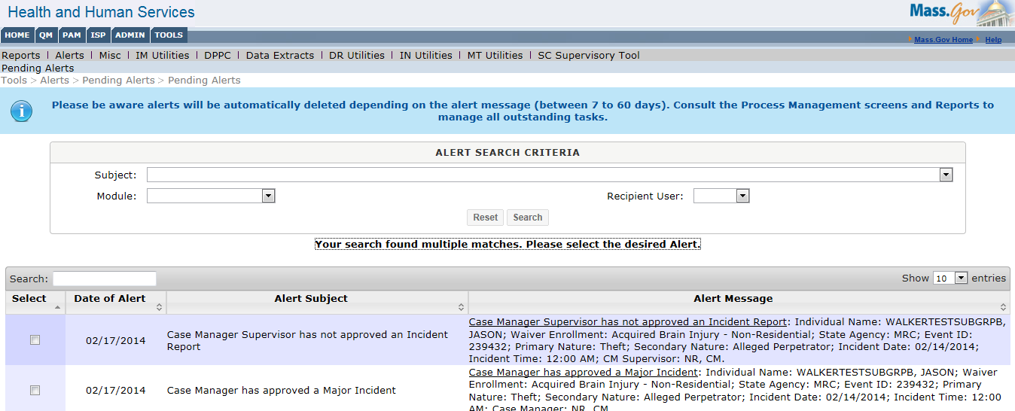
  - The reviewer receives an alert that the incident was not approved

  - Select the alert hyperlink to bring the first level reviewer to the Incident Switchboard

- First level reviewer creates a new AOMR/IRR
  - Selects “Create” to complete a new review

  - Completes the review and selects “Not Approved” from the Review Status dropdown, adding information as to why the report was not approved
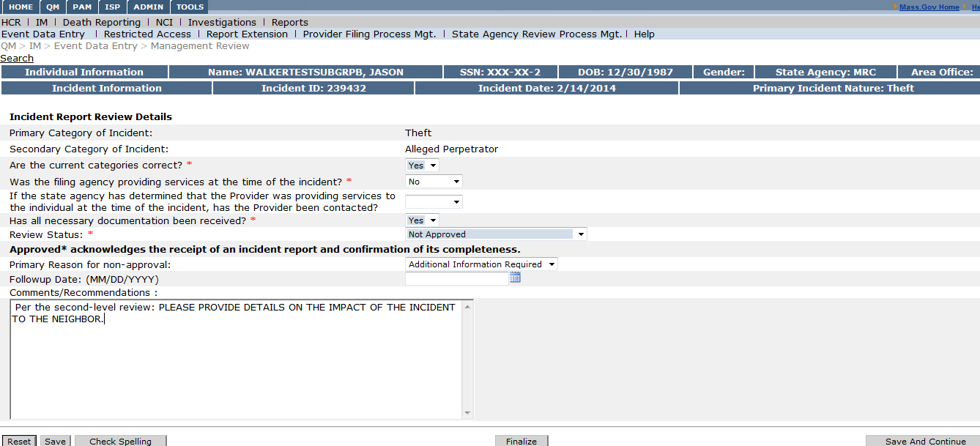
  - The event switchboard will automatically update to reflect the changes
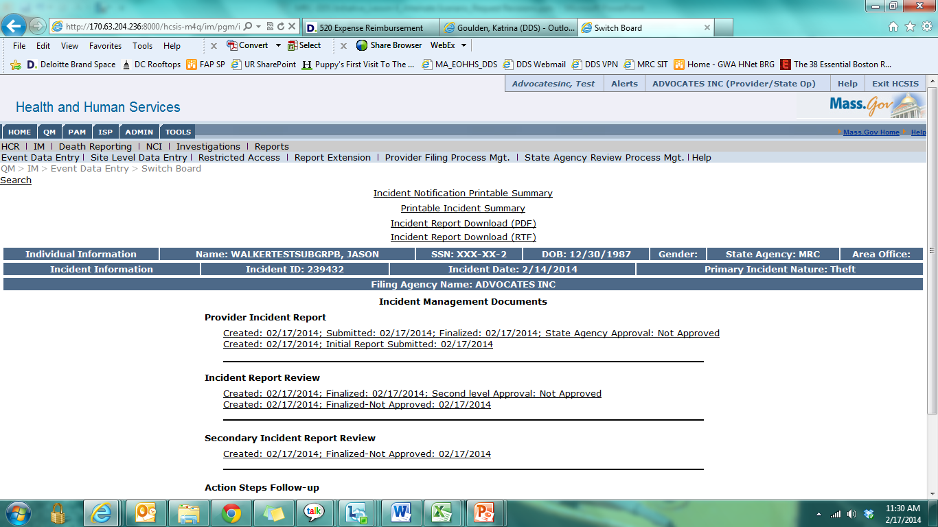

- Provider receives an alert
  - After the first level reviewer finalizes an incident review with the status of “Not Approved”, the Provider who submitted the incident report will receive an alert.

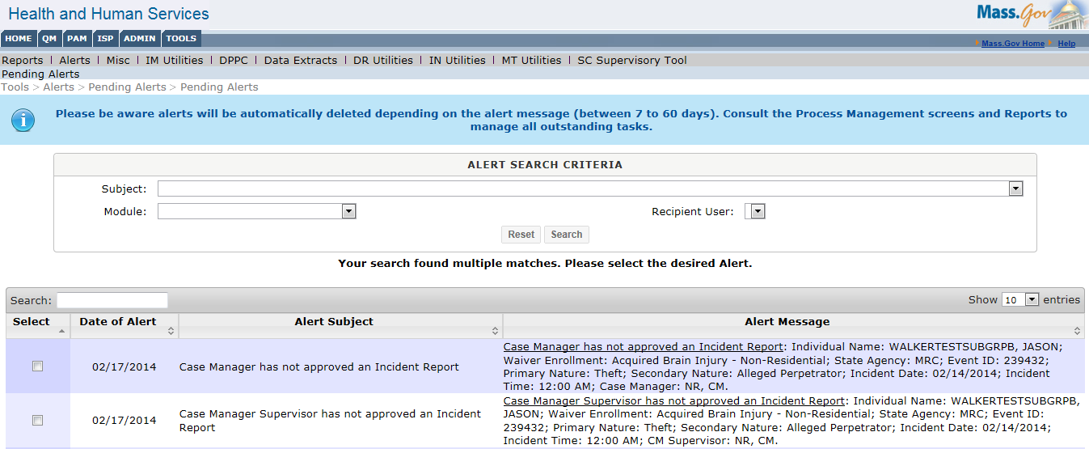

  - Provider views event switchboard and will see that the incident was marked as “Not Approved” A new link below Provider Incident Report shows the report has not yet been finalized. This link can be selected to finalize the incident report.

- Provider re-finalizes the incident report, making adjustments based on comments provided by the reviewers

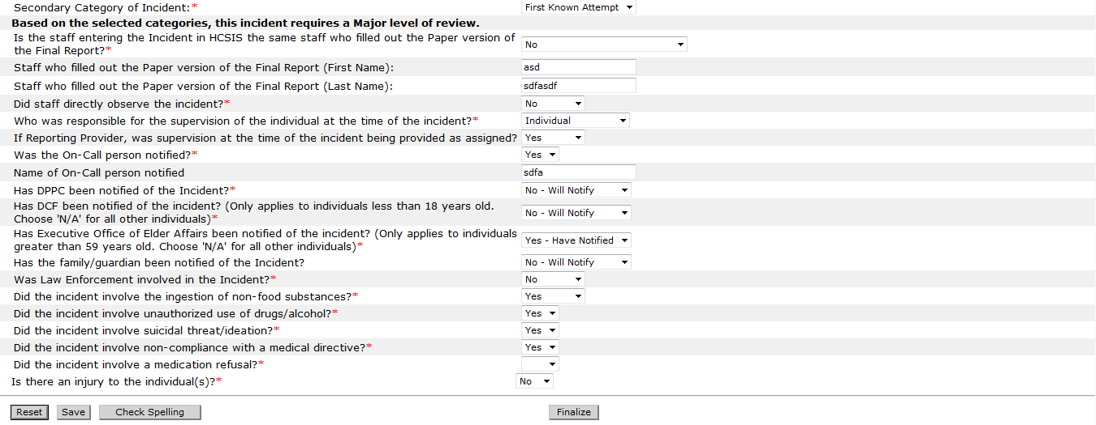

Next Steps: Review process begins again from the first level of review
