Additional Functionality
This section will cover additional functionalities available to end users within the Incident Management Module. In particular, this section will cover Creating Action Steps Follow Up, managing workload with Process Management screens, and using the Help features.

Scenario: Creating Action Steps Follow Up

Scenario Description:
- An incident has been finalized
- Action steps for the incident have been created
- The user would like to create an Action Steps Follow Up plan

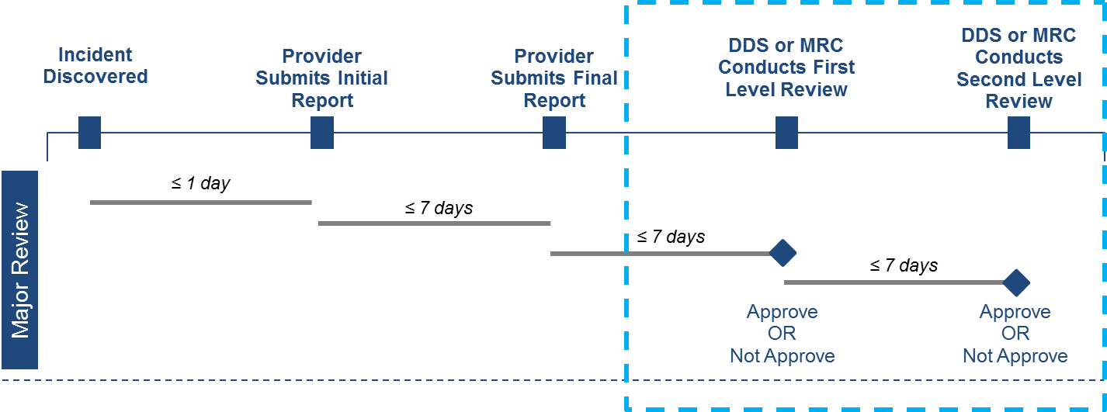

Roles and Responsibilities:
- MRC Case Manager: Create Action Steps Follow Up for individuals in their caseload
- MRC Case Manager Supervisor: Create Action Steps Follow Up for individuals in their caseload
- MRC Central Office Oversight: Create Action Steps Follow Up for individuals in their caseload
- DDS ABI/MFP Service Coordinator: Create Action Steps Follow Up for individuals in their caseload
First Steps:
- The user logs into HCSIS
- The user selects the Quality Management Module
- The user selects the Incident Management sub-module

Scenario Steps:
- Select Event Data Entry

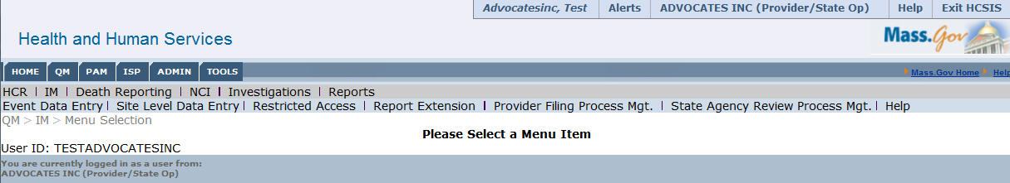

- Search for an individual

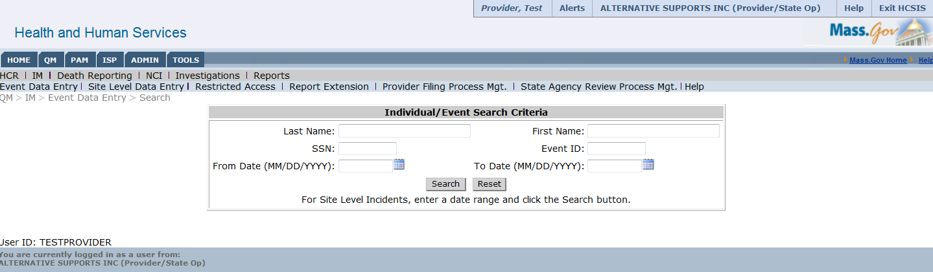

- Select an individual in order to view their individual event history
  - Select the individual

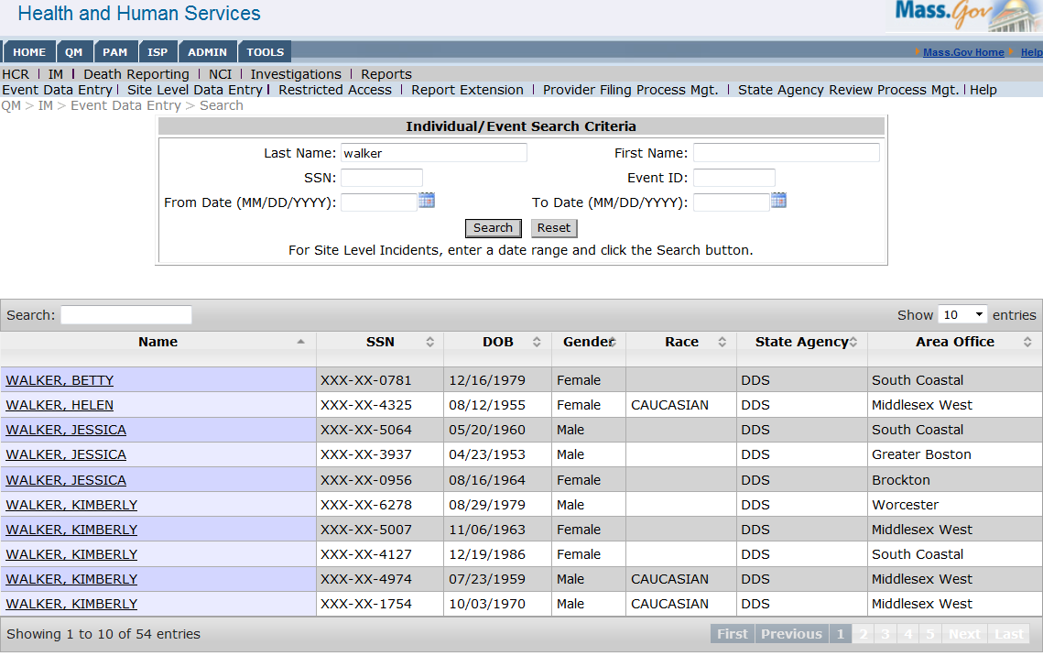

  - View the Individual’s Event History
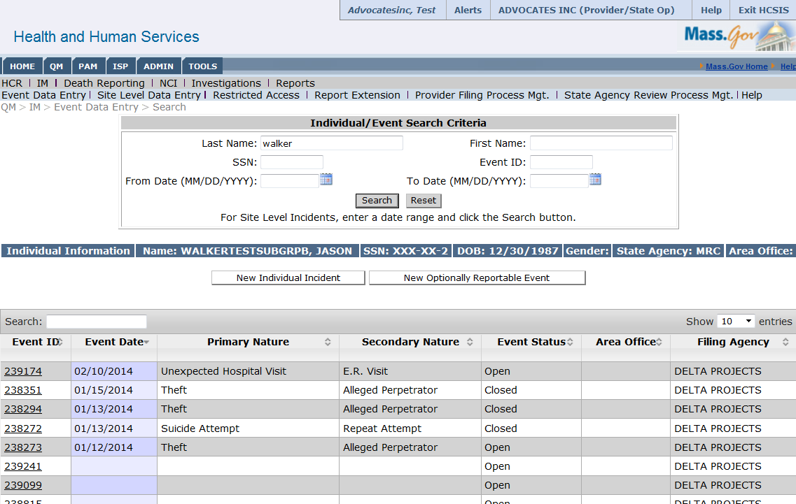

- View Incident Switchboard

After selecting the individual event from the Individual’s Event History, the incident switchboard will be displayed. At this point, the event has been submitted, finalized, and approved. To move to the next step, select “Create” under Action Steps Follow Up.

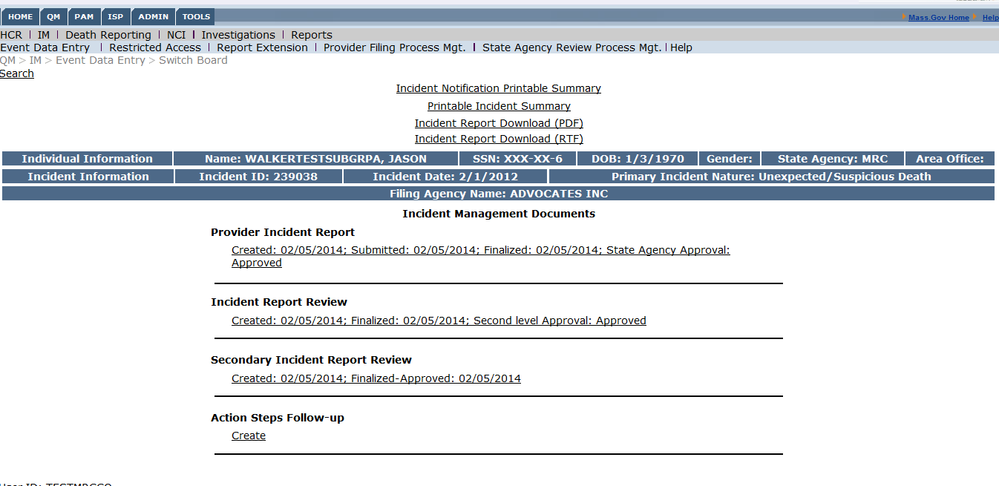

- Create Action Steps Follow Up

Input any action steps, responsible parties, target or actual completion date of action step, and add any additional comments.

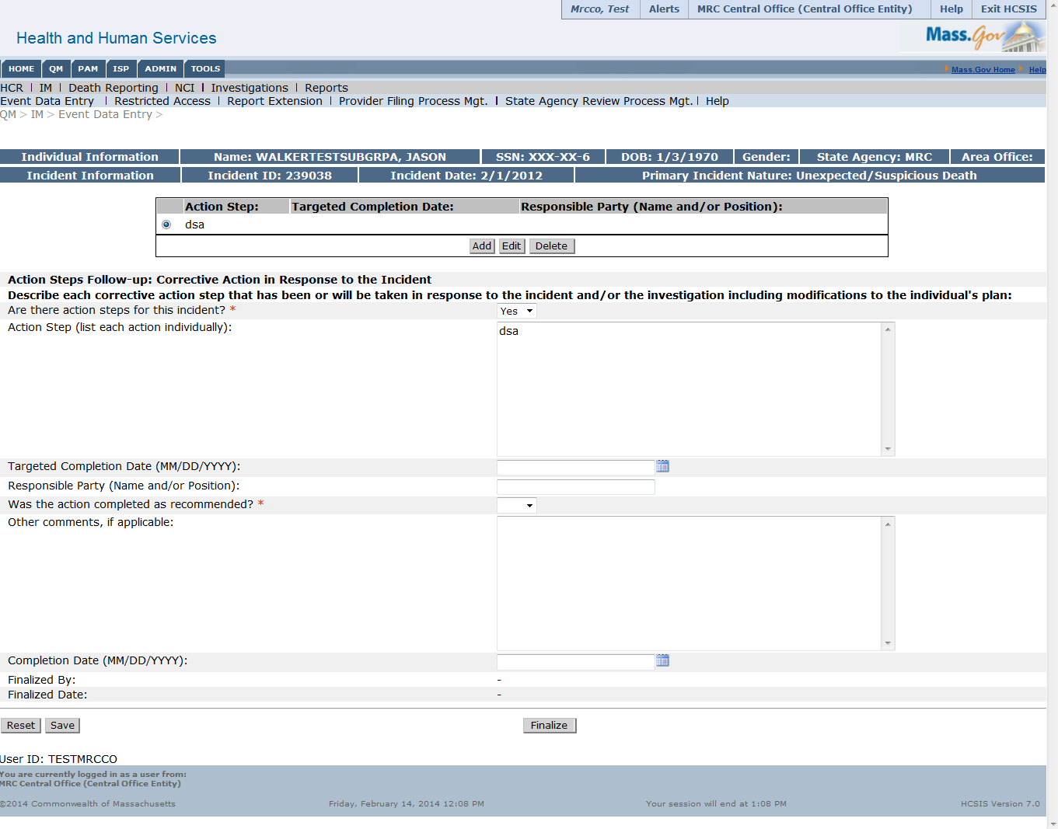

Input any actions steps, the responsible party, when the action step was completed by or is targeted to be completed by and any additional comments.
- Finalize Action Steps Follow Up by selecting “Finalize” at the bottom of the screen

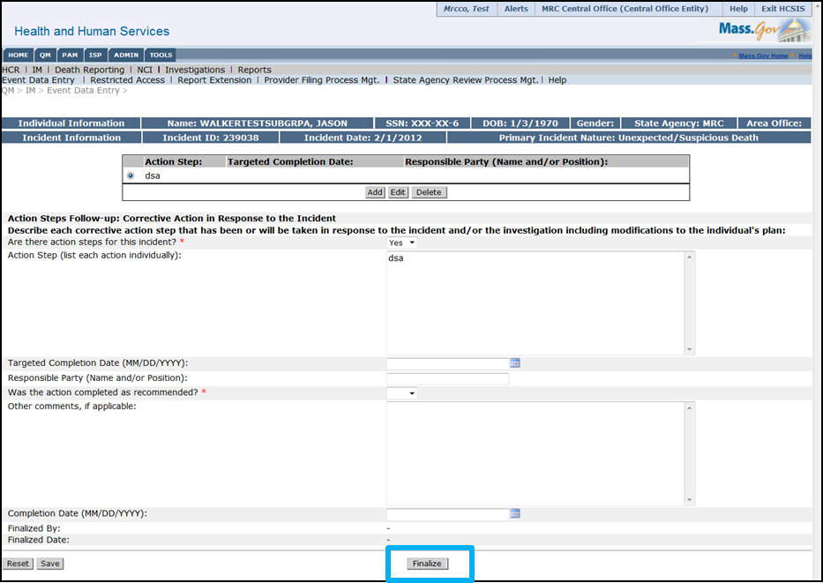

Next Steps
After finalizing the Action Steps, you will be brought back to the Event Switchboard. Action Steps Follow Up should be listed as “Created” and “Finalized”
From here you will be able to:
- Review other documents related to the incident
- Print or download the Incident Reports and Summary

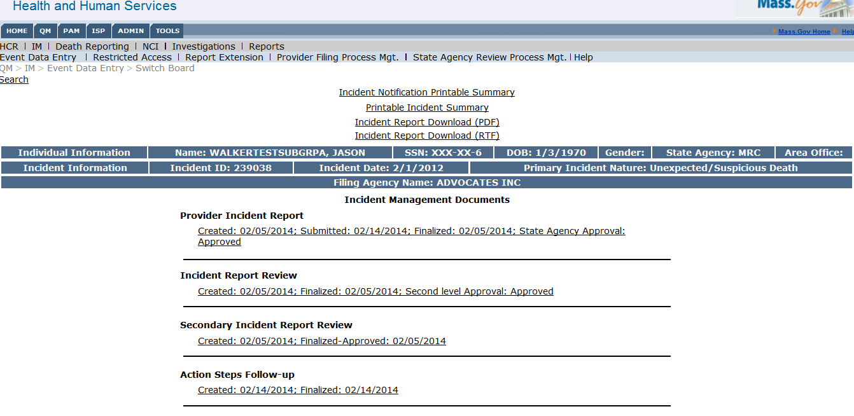

Alerts in HCSIS
Alerts are a great workload management tool for Incident Management and HCSIS. Alerts are messages that are stored within the system providing the user with pertinent updates. Please keep in mind that alerts can only be accessed via the system and therefore will not be sent to users via email.

Scenario: Viewing Alerts in HCSIS

Roles and Responsibilities
- The following users can view and manage alerts:
  - Providers (all roles)
  - Case Managers
  - Case Manager Supervisors
  - MRC Central Office
  - Service Coordinators
  - Service Coordinator Supervisors
  - DDS Central Office
- Users with the oversight roles will not receive Incident Management alerts

First Steps
- The user logs into HCSIS via the Virtual Gateway

Scenario Steps

- Navigate to the alerts screen
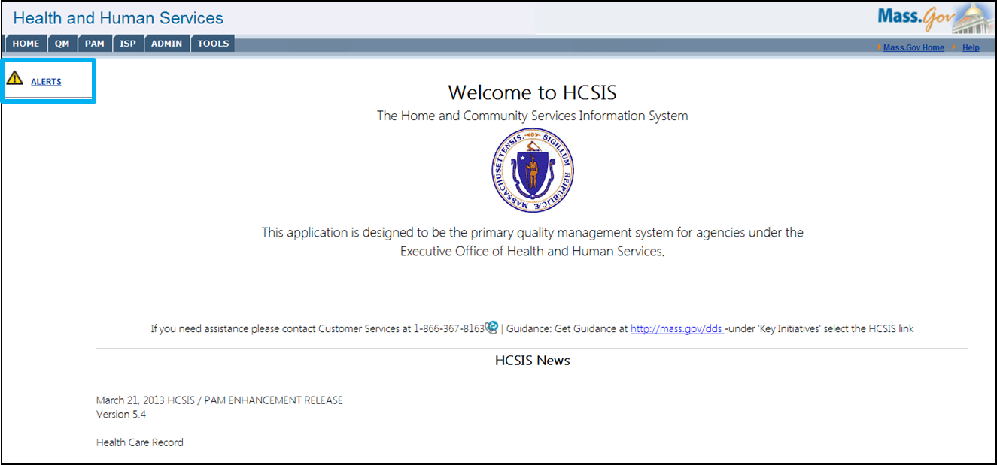

- View alerts

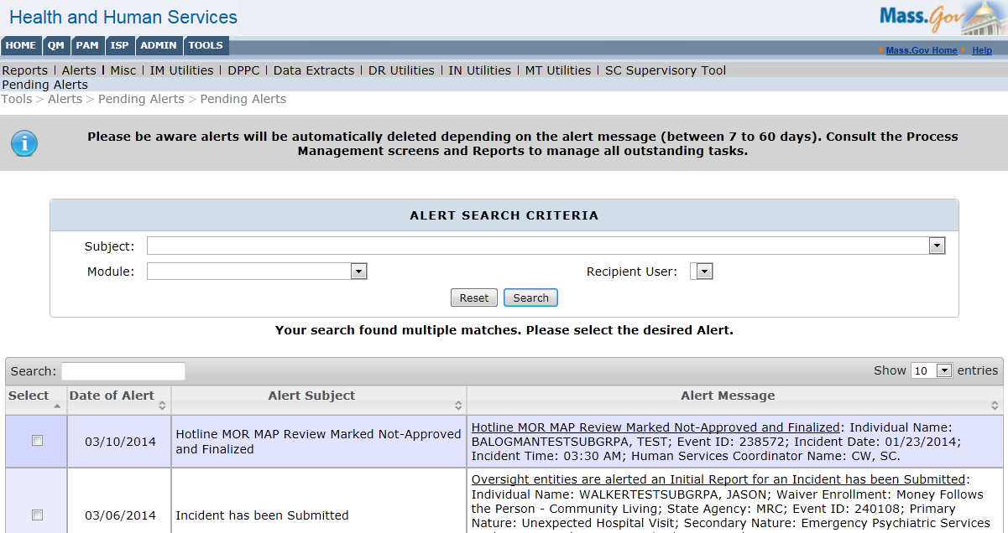

All alerts generated by all modules will be shown on the initial alerts page. Alerts can be addressed by clicking on the hyperlink within the alert message. Note that alerts have different lifespans depending on the module or action that has generated the alert. For Incident Management, alerts related to the submission and finalization of an incident have a lifespan of 21 days, whereas all other alerts have a lifespan of 7 days. Alerts can also be manually deleted using the check box next to the alert date as alerts are not automatically deleted once the action has been completed.

- Sort alerts

Alerts can be searched:
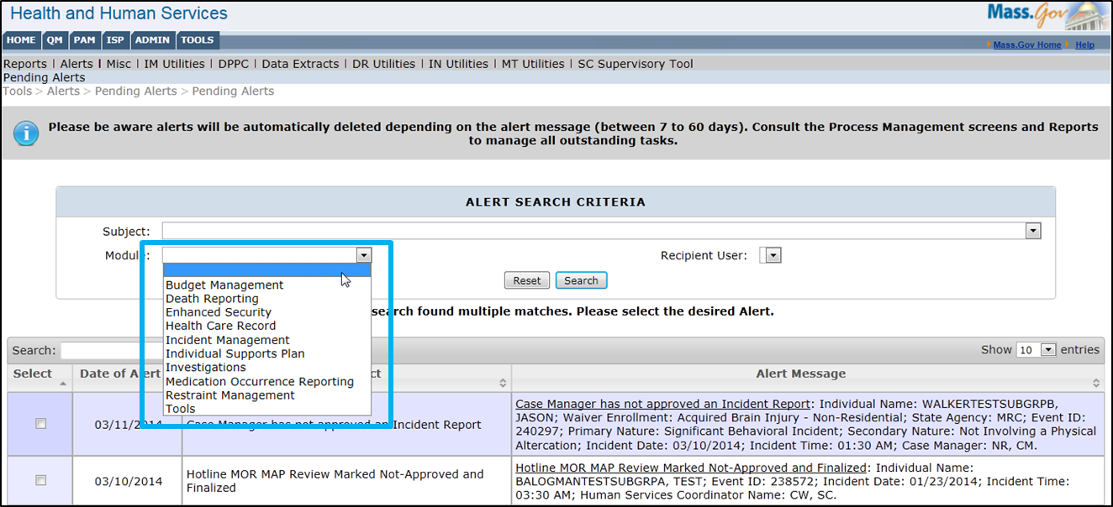

Alerts can be filtered by subject:

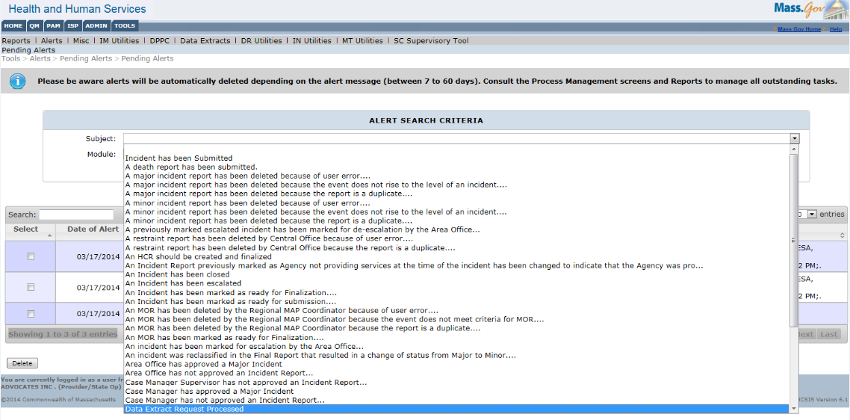

Alerts can be filtered by module:

Alerts can be manually deleted:

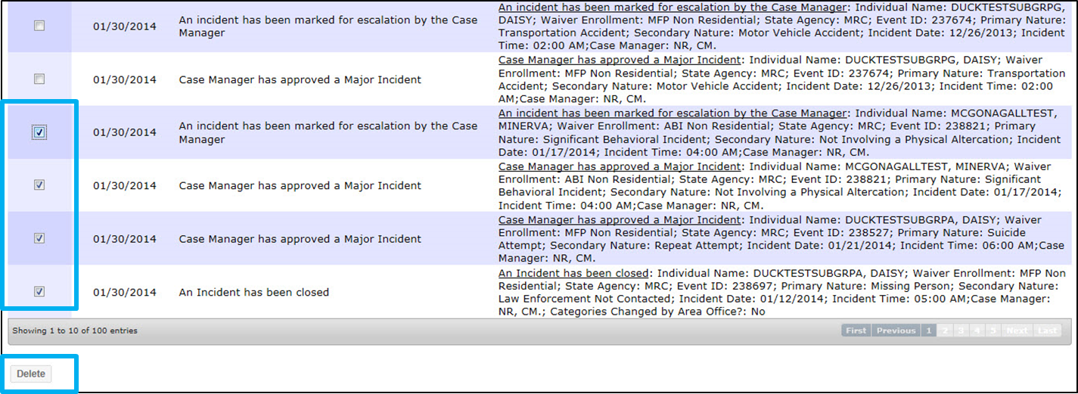
Searching, filtering and deleting alerts allow the user to focus on the alerts that are most relevant to his or her caseload at the time.

Process Management Screens
There are two process management tools available for DDS staff, MRC staff and provider agencies. They are as follows:
- Provider Filing Process Management: Displays the status and action required for incidents relative to the status of the incident from the perspective of the user who filed the incident report.

- State Agency Review Process Management: Displays the status and action required for incidents relative to the State Agency (DDS or MRC) Review Process.

These tools can be used for workload management as they present high-level information for all events in one area of the system. When using the process management screens to manage caseload, keep in mind:
- The tools are refreshed overnight and do NOT contain the data entered throughout the current business day
- Once an event has been closed, it will be removed from the process management screens
- Consider printing the screen(s) upon logging into HCSIS to view, prioritize and address items within the caseload

Scenario: Managing Workload with Provider Filing Process Management

Scenario Description:
- Providers and Staff would like to manage their incidents via the Provider Filing Process Management Screen
- This may occur at any point in time when the user has access to the Incident Management module.

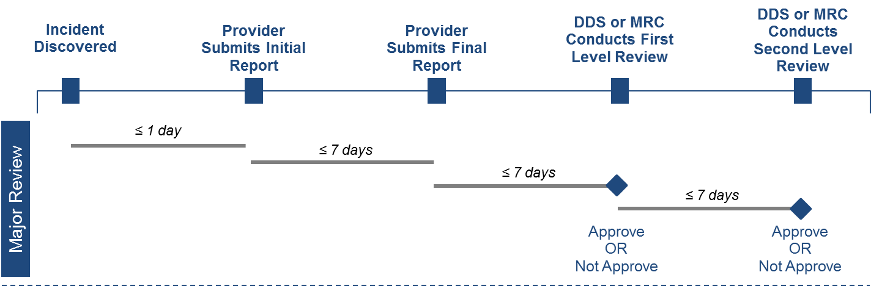

Roles and Responsibilities:

The following actors have access to this function:
- All-Individuals Oversight User
- DDS Central Office User
- MRC Central Office User
- Regional Office User
- Case Manager Supervisor
- Area Office User
- Service Coordinator Supervisor
- Service Coordinator
- Case Manager
- Provider

First Steps:
- The user logs into HCSIS

Scenario Steps:
- Log into HCSIS and select the QM module

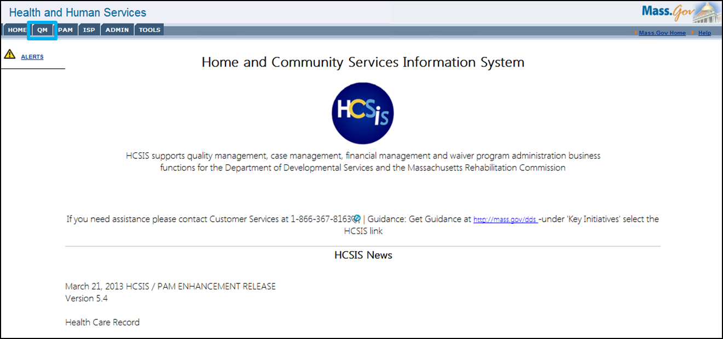
- Select the IM module
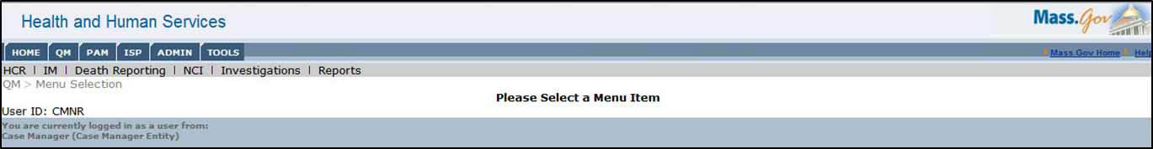

- Select Provider Filing Process Management
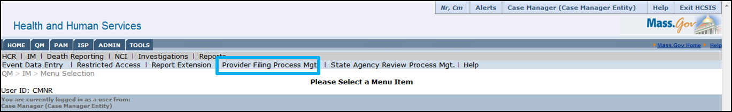

- Search for events by entering the “to” and “from” dates. Click “Search”
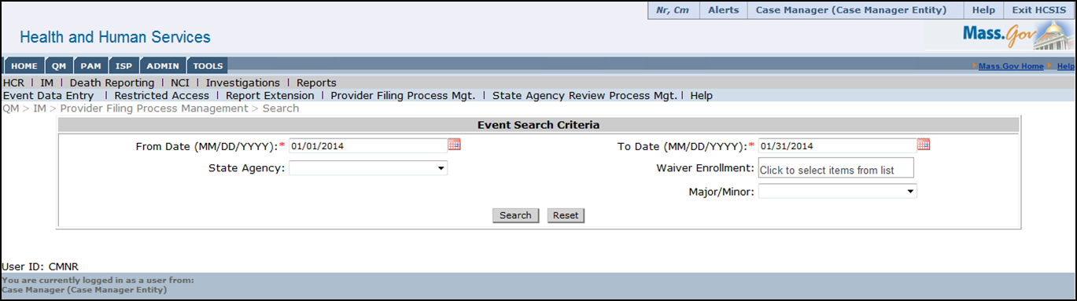

- View search results
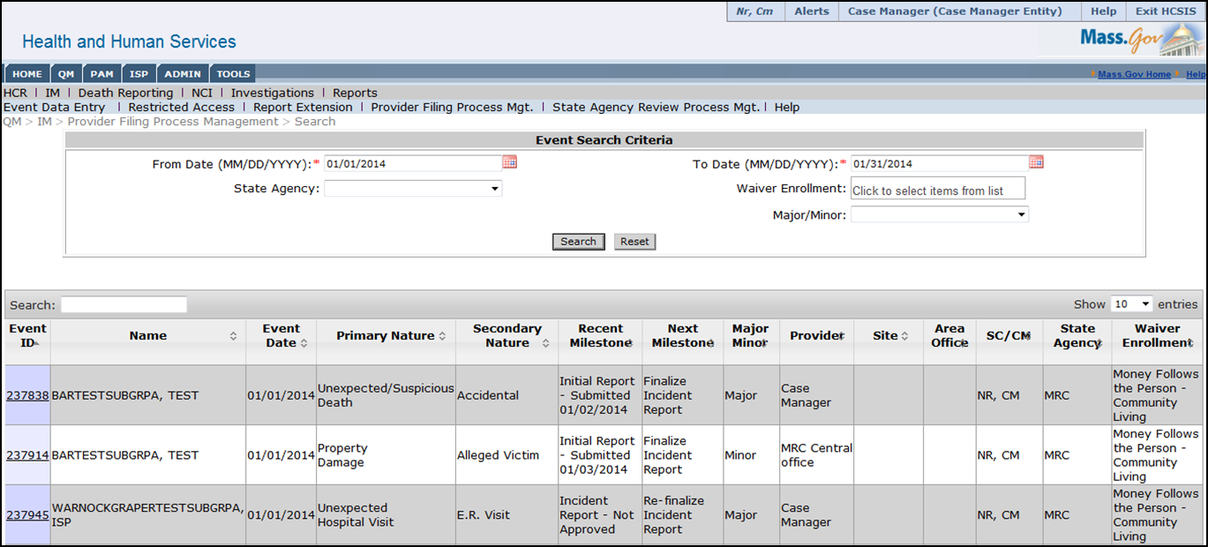
The provider filing process management screen displays the current status for all incidents that the user has access to. There are several key columns that can help the user easily identify next steps for an incident that enable caseload management. Specifically, the “Recent Milestone” and “Next Milestone” display the recent actions and next steps associated with the incident. Similar to all other search results screens in the Incident Management module, the results can be sorted by any of the columns and there is an additional search feature that allows the user to search within the existing search results. The screenshot above is from a Case Manager, who can see incidents for all individuals within their caseload.

Scenario: Managing Workload with State Agency Review Process Management
Scenario Description:
- Providers and staff would like to manage their incidents via the State Agency Review Process Management Screen
- This may occur at any point in time when the user has access to the Incident Management module

Roles and Responsibilities:

The following actors have access to this function:
- All-Individuals Oversight User
- DDS Central Office User
- MRC Central Office User
- Regional Office User
- Case Manager Supervisor
- Area Office User
- Service Coordinator Supervisor
- Service Coordinator
- Case Manager
- Provider

First Steps:
- The user logs into HCSIS

Scenario Steps:
- Log into HCSIS and select the QM module

- Select the IM module
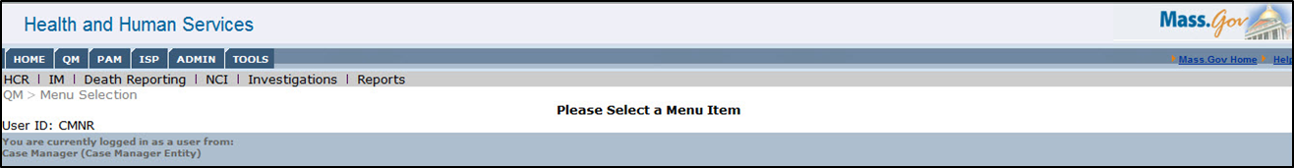
- Select State Agency Review Process Management
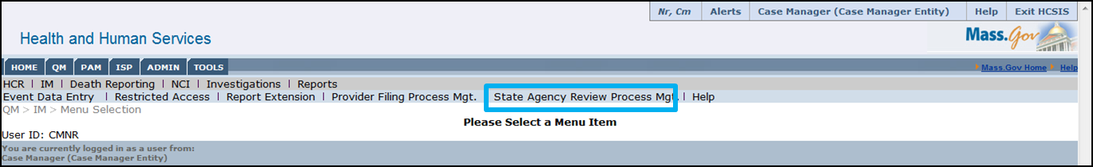

- Search for events by entering the “to” and “from” dates. Click “Search”
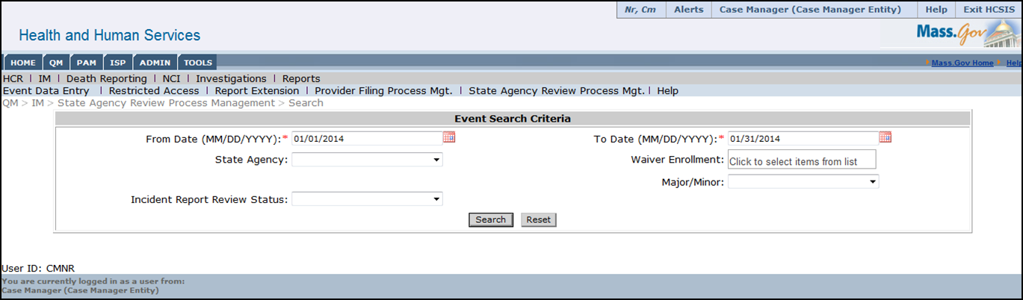
- View search results
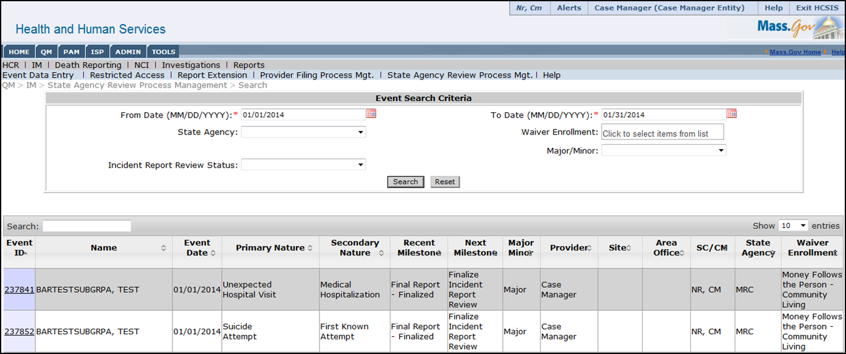
The state agency review process management screen displays the current status for all incidents that the user has access to. There are several key columns that can help the user easily identify next steps for an incident that enable caseload management. Specifically, the “Recent Milestone” and “Next Milestone” display the recent actions and next steps associated with the incident. Similar to all other search results screens in the Incident Management module, the results can be sorted by any of the columns and there is an additional search feature that allows the user to search within the existing search results. The screenshot above is from a Case Manager, who can see incidents for all individuals within their caseload.

HCSIS Reports
Reports are an additional way to view and monitor events that are recorded in HCSIS. These reports will capture trends in events for an individual, site or agency and can be a useful analysis tool. There are various reports for Incident Management, but the reports displayed in the system will vary based on the user’s role.

Scenario: Viewing Reports in HCSIS

Roles and Responsibilities
- The following users have access to Reports:
  - Providers (all roles)
  - Case Managers
  - Case Manager Supervisors
  - MRC Central Office
  - Service Coordinators
  - Service Coordinator Supervisors
  - DDS Regional Office
  - DDS Central Office

First Steps
- The user logs into HCSIS via the Virtual Gateway
- Select the QM tab

Scenario Steps
- Navigate to the Reports screen

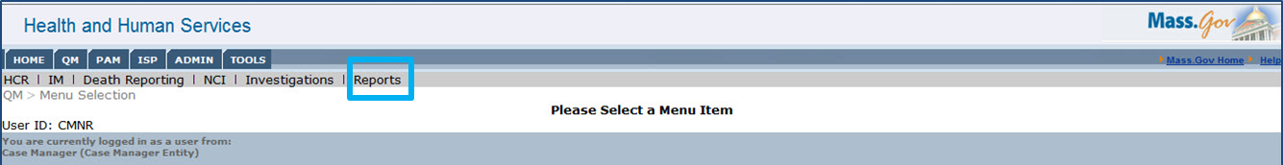

- Expand list of reports

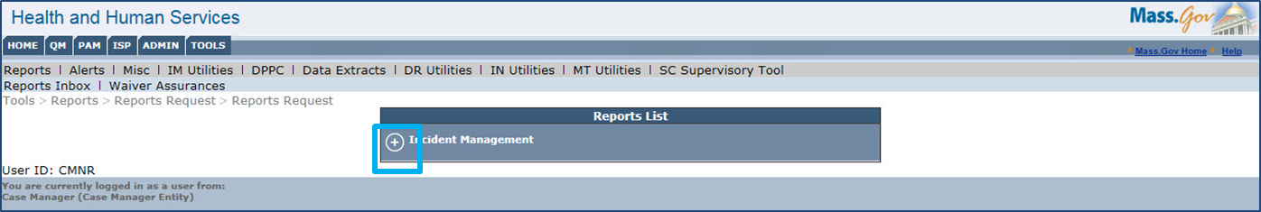
Click the “+” accordion control to access the full list of reports that can be requested.

- Select a report to view

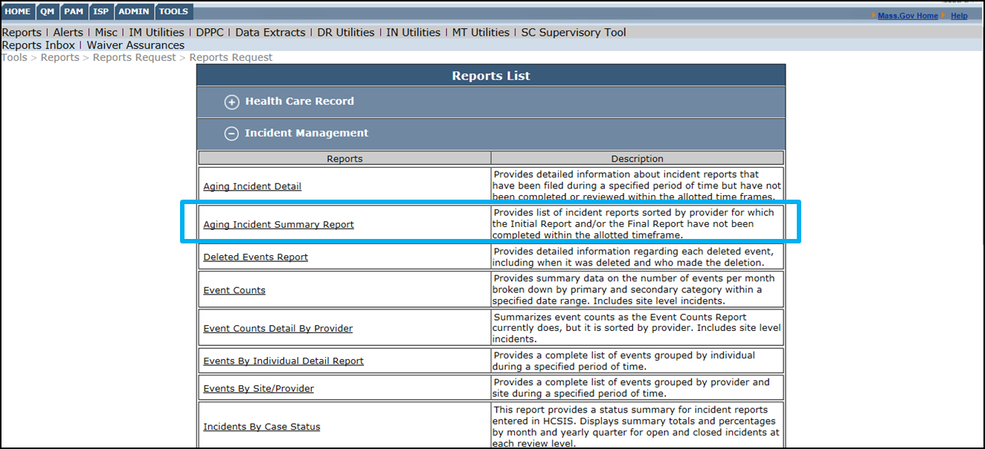
- Complete report request fields

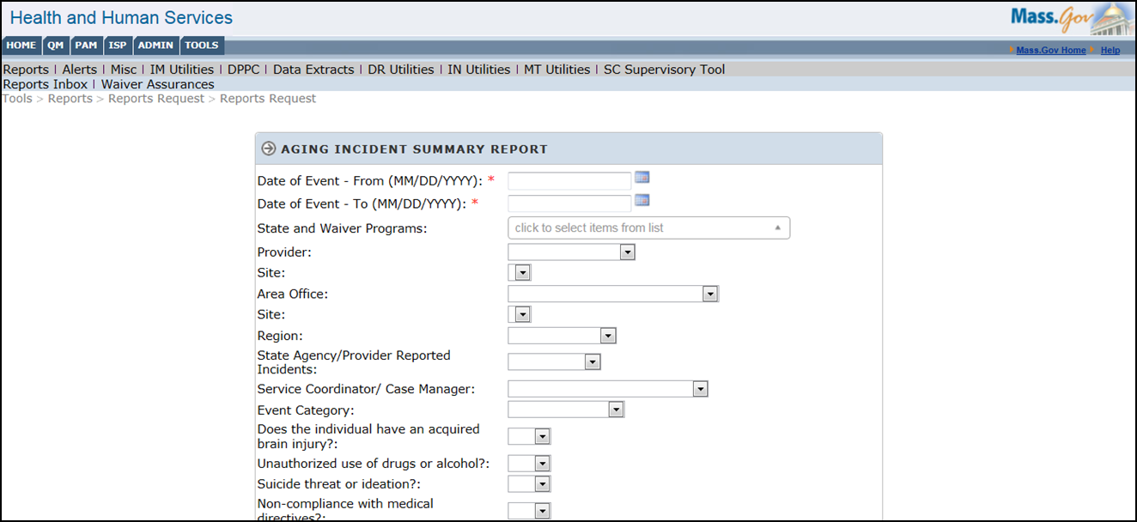
- Print or save the report

Choose one of three formats to export the report to before clicking “View Report.”

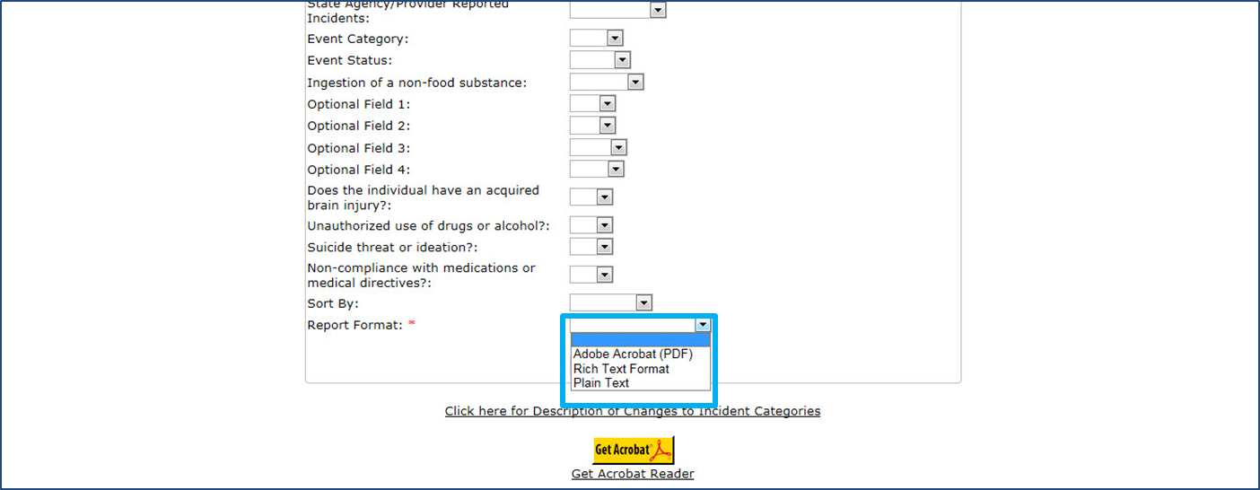

The report will open in a separate window in the format selected.

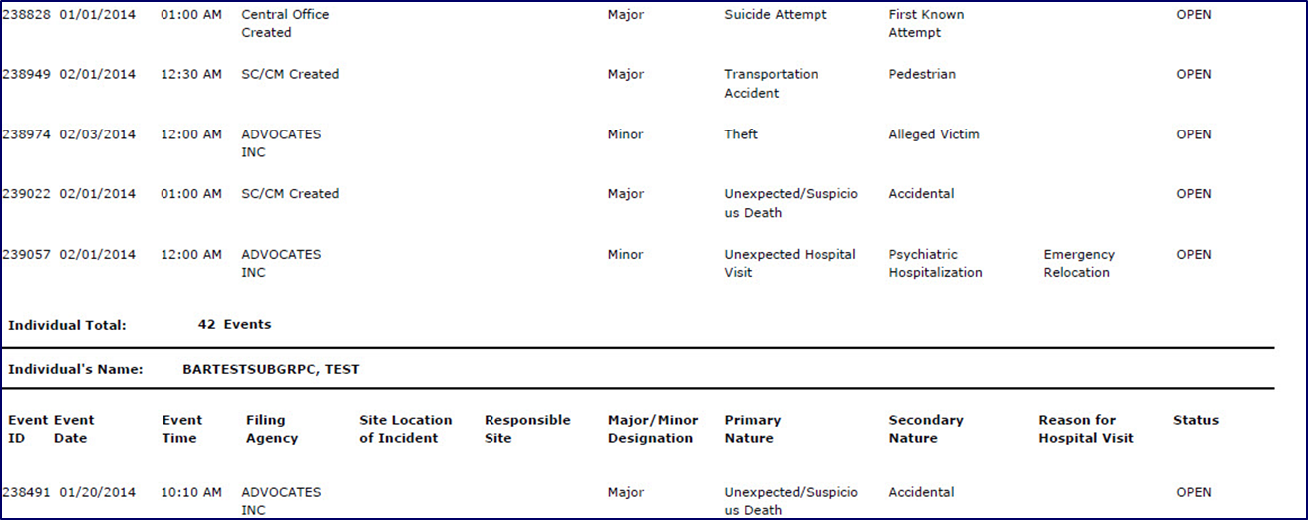
The above screenshot is an example of a report that has been exported to a PDF.

Incident Management Help Features
There are several resources, including reference documents, forms, and quick guides, posted within the Incident Management module. These documents are helpful tools that enable users to complete and review incident reports within HCSIS. Help features are available to all Incident Management module users at any point in time. For users who are familiar with the Incident Management module, the IM Reference page consolidates the reference documents that were previously distributed throughout the module in one central location.
The IM Reference page is a single location in which all forms, reference and help documents relative to Incident Management are consolidated for easy viewing. The page is accessible to all users with access to the Incident Management sub-module. This chart shows all of the documents that are on the help page and how they are categorized.
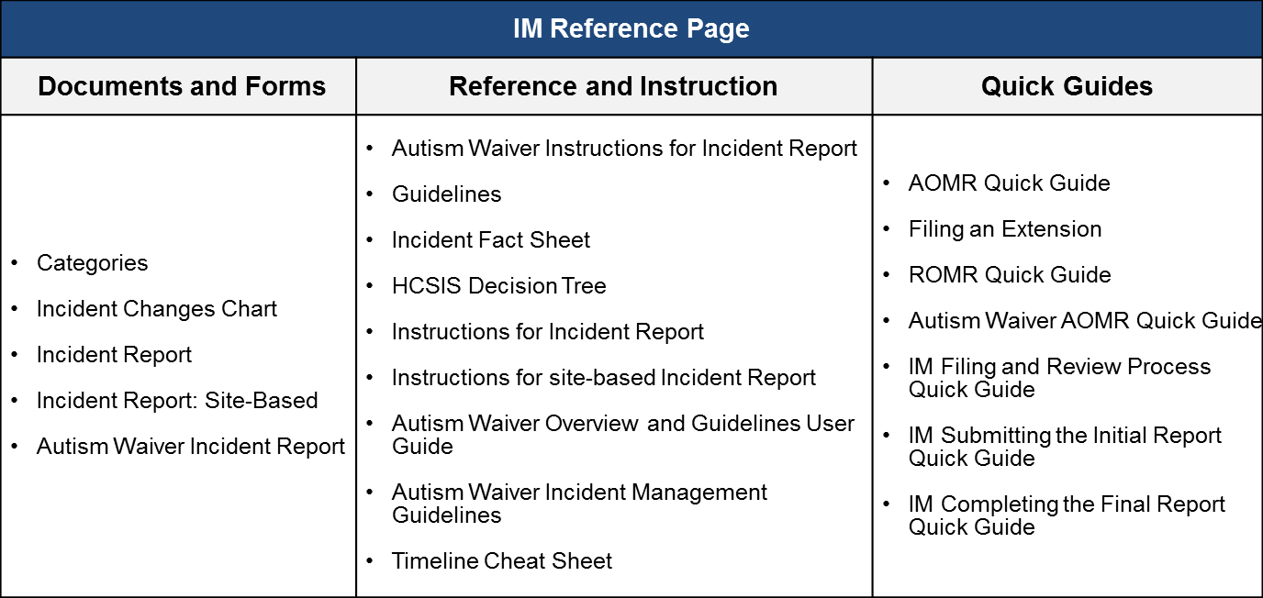

Scenario: Viewing the Help Features
Description:
- This scenario will cover the process of navigating to the help feature
- This is relevant to all users in the Incident Management Module and will be available at all points in the Incident Management process
Roles and Responsibilities:

The following actors have access to this function:
- All-Individuals Oversight User
- DDS Central Office User
- MRC Central Office User
- Regional Office User
- Case Manager Supervisor
- Area Office User
- Service Coordinator Supervisor
- Service Coordinator
- Case Manager
- Provider

First Steps:
- The user logs into HCSIS

Scenario Steps:
- Log into HCSIS and select the QM module

- Select the IM module

- Once the Incident Management module is open, you will notice a navigation bar on the top right of the page. Select “Help”. Below “Help” a link will appear that says “IM Reference”. Select this link to navigate to the reference page
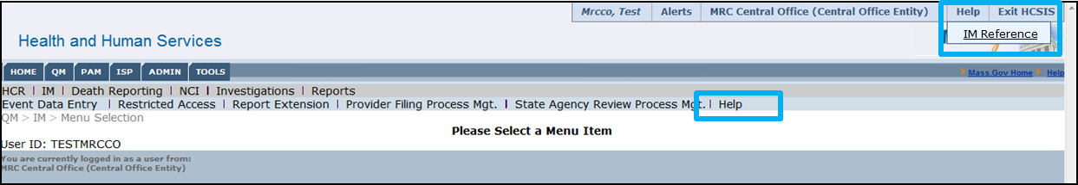

- Access the documents on the Help page
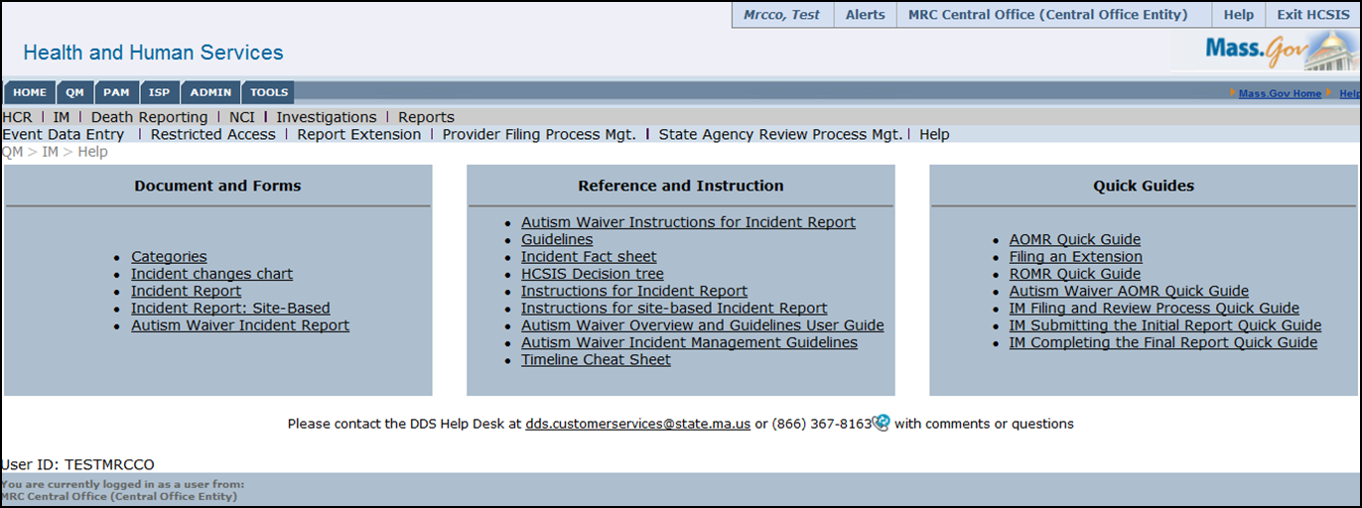
The documents available to you on the Help page within the Incident Management module can also be found at the DDS HCSIS website: http://www.mass.gov/eohhs/consumer/disability-services/services-by-type/intellectual-disability/provider-support/home-and-community-services-info/.

Next Steps
The Incident Management module will be accessible starting April 14, 2014. This will impact incidents submitted after that date. Further information on the Incident Management module can be found on the Department of Developmental Services under “Home and Community Services Information System (HCSIS)”.
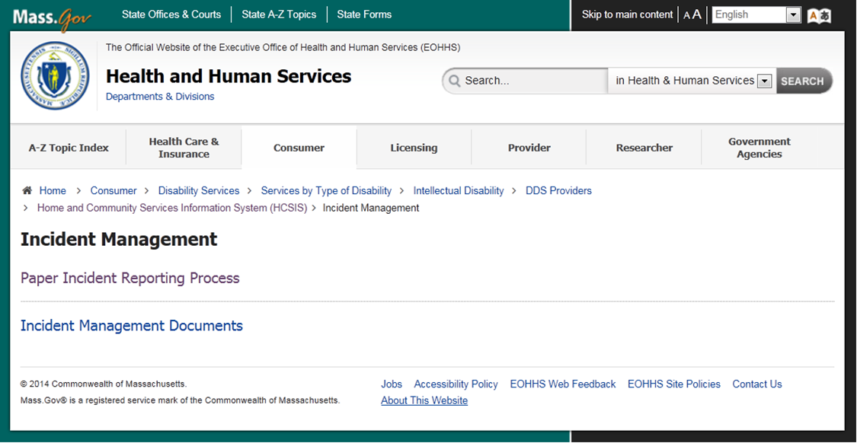
Incidents submitted prior to go-live will be completed with the current paper based process. The incident report can be accessed via the DDS website: http://www.mass.gov/eohhs/docs/dmr/hcsis/hcsis-incident-report.pdf. The information is categorized into the same sections as those on the online report.
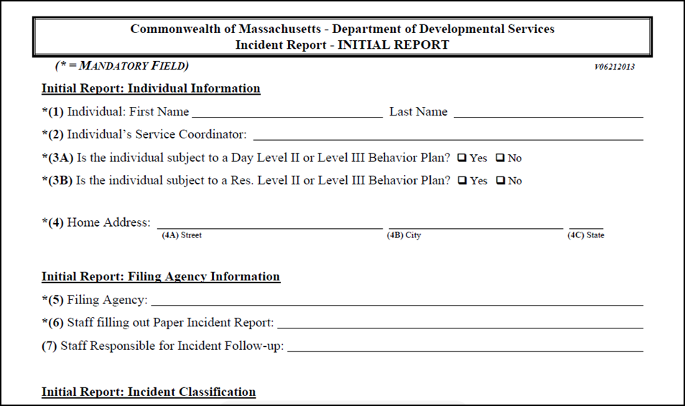
For questions, please contact the DDS Help Desk.
  - By phone: 1-866-367-8163
  - By email: dds.customerservices@state.ma.us
  - Hours of operation: 7AM – 7PM M-F

