INDOOR AIR QUALITY ASSESSMENT

Hanson Public Library

132 Maquan Street

Hanson, Massachusetts

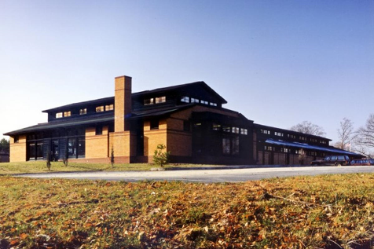

Prepared by:

Massachusetts Department of Public Health

Bureau of Environmental Health

Indoor Air Quality Program

January 2022

BACKGROUND
Building: | Hanson Public Library (HPL)
Address: | 132 Maquan Street, Hanson, MA
Requested by: | Karen Stolfer, Library Director, HPL
Reason for Request: | General indoor air quality (IAQ) concerns
Date of Assessment: | November 12, 2021
Massachusetts Department of Public Health/Bureau of Environmental Health (MDPH/BEH) Staff Conducting Assessment: | Michael Feeney, Director, IAQ Program
Building Description: | The HPL is part of a one-story wooden complex built in the early 1990’s. The HPL is connected to the Hanson Senior Center by a common hallway. The HPL consists of a main stack area, circulation desk, a historical room, several offices, storage space and an octagonal-shaped children’s library. The complex has a combination of different roof designs including flat rubber-membrane lined roofs, peaked asphalt/fiberglass shingle covered roofs and an octagonal-shaped roof above the children’s library. Beneath the first floor is a concrete-lined unfinished basement that is used for storage.
Windows: | Openable slots exist beneath windows to allow limited airflow.

INTRODUCTION
The IAQ Program conducted an assessment of the HPL on November 12, 2021, to assess reports of water damage and whether building components were moistened during the summer of 2021 by condensation, particularly in below-grade space that is used as offices. Results of this visit are listed in Tables 1 and 2. The HPL was previously assessed by the IAQ Program on January 29, 2010; a copy of that report is included as Appendix A.

METHODS
Please refer to the IAQ Manual for methods, sampling procedures, and interpretation of results (MDPH, 2015). BEH/IAQ staff also performed a visual inspection of building materials for water damage and/or microbial growth. Temperature of building components were measured using a laser thermometer to ascertain if materials could become moistened by condensation (Table 2).

RESULTS AND DISCUSSION
The following is a summary of indoor air testing results (Tables 1 and 2).
- Carbon dioxide levels were below the MDPH guideline of 800 parts per million (ppm) in all areas assessed. Please note discussion regarding furnace exhaust vent.
- Temperature was within the recommended range of 70°F to 78°F.
- Relative humidity was within the recommended range of 40 to 60% in all areas assessed.
- Carbon monoxide levels were non-detectable (ND) in all indoor areas assessed.

Ventilation
It can be seen from Table 1 that carbon dioxide levels were below 800 parts per million (ppm) in all areas surveyed, indicating adequate air exchange in the building at the time of the assessment. The heating, ventilation, and air conditioning (HVAC) system consists of air-handling units (AHU) located in mechanical rooms. Conditioned air is distributed to ceiling or wall-mounted air diffusers (Picture 1) and ducted back to AHUs via return vents.
The HVAC system is controlled by digital thermostats. Airflow is controlled using a fan switch that has two settings, on and auto. When the fan is set to on, the system provides a continuous source of air circulation and filtration. The automatic setting on the thermostat activates the HVAC system at a preset temperature. Once the preset temperature is reached, the HVAC system is deactivated. Therefore, no mechanical ventilation is provided until the thermostat re-activates the system. This was the case for the thermostat that controls the office area for the HPL. The MDPH recommends that digital thermostats be set to the fan “on” setting to provide continuous air circulation during occupied periods.
Fresh air diffusers appear to be coated with particulate matter (Picture 1). This condition may occur when either HVAC fitters are not installed properly or unfiltered air is introduced into the duct. One AHU had an inspection door open (Picture 2), which can allow unfiltered air to enter the ductwork.
Of note was the condition around the AHU room exterior door, which was covered with plant debris. In this condition, rainwater can be held against the door, which can then penetrate into the HVAC system as it operates. Each AHU room access door should be rendered airtight as feasible to prevent unconditioned air (and humidity) from entering.
Air circulation is facilitated by downdraft ceiling fans. The introduction of fresh outside air is supplemented through openable windows. As previously mentioned, windows do not fully open but have a slotted design which opens at the bottom to introduce air.
To maximize air exchange, the MDPH recommends that both supply and exhaust ventilation operate continuously during periods of occupancy. In order to have proper ventilation with a mechanical supply and exhaust system, the systems must be balanced to provide an adequate amount of fresh air to the interior of a room while removing stale air from the room. It is recommended that HVAC systems be re-balanced every five years to ensure adequate air systems function (SMACNA, 1994). The date of the last balancing of these systems was not available at the time of the assessment.
It is also important to note that despite ongoing maintenance and replacement of parts/components, many of the HVAC units are likely at or near at the end of their service life. Efficient function of equipment of this age (~ 20 years old) is difficult to maintain, since compatible replacement parts are often unavailable. According to the American Society of Heating, Refrigeration, and Air-Conditioning Engineering (ASHRAE), the service life of this type of unit is 15-20 years, assuming routine maintenance of the equipment (ASHRAE, 1991).

Microbial/Moisture Concerns
Water-damaged ceiling tiles were noted in a number of locations throughout the HPL (Table 1), which are reportedly attributed to ice dams that occur on the roof during winter months. Water-damaged gypsum wallboard (GW) was noted in a room adjacent to the children’s room, which is likely due to a roof leak during the extreme downpours that occurred during the summer of 2021.
Water-damaged carpeting was noted around the exterior door in the office space (Picture 3). Water penetrating beneath the exterior door is the likely source of water damage, which was previously noted in the September 2011 assessment (Appendix A).

Assessing Building Materials That May Be Prone to Condensation.
The HPL has many carpeted areas, which if exposed to moisture can support mold growth. IAQ staff did not observe water stains or musty odors on the main floor of the HPL. It is important to note that Massachusetts experienced extended periods of relative humidity during the summer of 2021. July of 2-21 was the wettest ever recorded in Massachusetts, and the three-month period from June through August, known as the meteorological summer, was the fourth wettest on record, according to the National Oceanic and Atmospheric Administration’s (NOAA) Centers for Environmental Information. The three-month period also was the third warmest ever in the state and was tied for the warmest on record across the United States (HG, 2021, NOAA, 2021).

Based on the type of floor construction (cement on soil), the HPL was assessed to determine if floors were subject to developing condensation during extended (> 24 hours) hot, humid weather. The key to managing condensation in hot, humid weather indoors is understanding dew point. When warm, moist air passes over a cooler surface, condensation can form. Condensation is the collection of moisture on a surface at or below the dew point. The dew point is the temperature that air must reach for saturation to occur. If a building material/component has a temperature below the dew point, condensation will accumulate on that material.

A method to locate areas in a building prone to condensation is to measure air and building material temperatures using a laser thermometer (Table 2). If a wide temperature range exists between measurements (>5°F), the building materials at the colder end of the range may be prone to becoming moistened with condensation if exposed to hot, humid weather (70% relative humidity) for extended periods of time. According to the test results in Table 2, some areas in offices near an exterior door as well as in below-grade space may develop condensation during extreme hot, humid weather.

Relative humidity measured in the building was well below 70% in all locations during this assessment (Table 1). According to American Society of Heating, Refrigerating and Air-Conditioning Engineers (ASHRAE), if relative humidity exceeds 70%, mold growth may occur due to wetting of building materials (ASHRAE, 1989). Porous materials such as gypsum wallboard, cardboard and other materials may become prone to developing mold colonization.
BEH/IAQ staff examined the building envelope to identify possible water sources to the interior of the building, including breaches in the building envelope or other conditions that could provide a source of moisture that can adversely affect IAQ. A number of conditions related to moisture were identified:
- Plants, trees, and leaves were observed in direct contact with and growing in close proximity to the foundation and building exterior, including AHU exterior doors. Plants in close proximity to the building envelope can cause water damage to brickwork and mortar. In addition, plants shading exterior walls can slow drying of exterior walls, which is important to prevent damage to brick and mortar as well as wood rot. Water can eventually penetrate the building due to subsequent freezing and thawing damage of brick/mortar during winter months.
- The exterior brick windowsills are covered in places with moss (Picture 4), which can be indicative of chronic water exposure. Moss tends to form on brickwork that retains moisture by lack of drainage, component design and/or is not dried by solar/thermal heat. Many of the wall surfaces of the HPL do not see extended exposure to sunlight due to the topography and trees along the south side of the building.
- With the exception of the exterior wall that forms the children’s library, the roof does not have a gutter/downspout system to capture rainwater. Rainwater flows off the roof edge to impact on stone at the base of exterior walls (Picture 5), as demonstrated by extensive furrows. As rainwater impacts the ground with force, soil becomes compressed, which creates furrows, allowing water to puddle at the base and splash against exterior walls. The repeated wetting and lack of drying, likely provides the condition that results in moss growth on windowsills, which can accelerate weathering/damage to brick and mortar.
- The exterior wall panels of the children’s library appear to have worn paint exposing the underlying building exterior. Exposing this material to moisture can accelerate decomposition.
- Damaged/deteriorating weather-stripping beneath exterior doors was observed. It is also important to note that there is no lip to the doorframe to prevent water penetration. Directly inside the door is wall-to-wall carpeting that can get wet during heavy rain.
- Gutters were found to be leaking (Picture 6).
These conditions can undermine the integrity of the building envelope and provide a means for water entry by capillary action into the building through exterior walls, foundation concrete and masonry (Lstiburek & Brennan, 2001). In addition, these breaches in exterior areas can provide a means for drafts and pest entry into the building.
The US Environmental Protection Agency (US EPA) and the American Conference of Governmental Industrial Hygienists (ACGIH) recommend that porous materials be dried with fans and heating within 24 to 48 hours of becoming wet (US EPA, 2008; ACGIH, 1989). If not dried within this time frame, mold growth may occur. Once mold has colonized porous materials, they are difficult to clean and should be removed/discarded.

Other IAQ Evaluations
Other conditions that can affect IAQ were observed during the assessment. The majority of the library, including office areas, has wall-to-wall carpeting that is reported to be original to the building. The Institute of Inspection, Cleaning and Restoration Certification (IICRC), recommends that carpeting be cleaned annually (or semi-annually in soiled high traffic areas) (IICRC, 2005). Since the average lifespan of a carpet is approximately eleven years (Bishop, 2002), consideration should be given to installing new flooring.

CONCLUSIONS AND RECOMMENDATIONS
The HPL has a number of issues related to moisture in the building, in addition to HVAC system issues noted in the previous IAQ assessment (Appendix A). The capacity of mechanical ventilation equipment to provide adequate heated air may be limited due to the age and design of the existing HVAC system. Since the previous visit, the HPL has experienced significant water exposure. With future periods of extreme relative humidity and rain expected in New England, management of buildings in such weather can be challenging, even with an HVAC system that has air chilling capacity. The following documents can provide guidance that can be used to reduce the impact of hot, humid weather in all buildings.
- Mold growth Prevention during Hot, Humid Weather https://www.mass.gov/service-details/preventing-mold-growth-in-massachusetts-schools-during-hot-humid-weather
- Methods for Increasing Comfort in Non-air-conditioned Schools https://www.mass.gov/doc/methods-for-increasing-comfort-in-non-air-conditioned-schools/download

To remedy building problems, two sets of recommendations are made: short-term measures that may be implemented as soon as practicable and long-term measures that will require planning and resources to address overall IAQ concerns.

Short-term Recommendations

HVAC System
- Implement any outstanding recommendations made in the IAQ assessment of September 2011.
- Close all HVAC system access doors in AHU rooms.
- Remove all debris from AHU exterior access doors.
- Render all AHU exterior access doors as watertight and airtight as feasible by installing new door sweeps and weather-stripping.
- Consider adopting a balancing schedule of every 5 years for all mechanical ventilation systems, as recommended by ventilation industrial standards (SMACNA, 1994).
- Change filters for air-handling equipment (e.g., AHUs) as per the manufacturer’s instructions or more frequently if needed.

Water Damage
- Repair leaking gutters.
- Repair roof leak that caused water-damaged GW, if not already completed. Replace water-damaged GW in a manner consistent with the US EPA document, Mold Remediation in Schools and Commercial Buildings (US EPA 2008).
- Replace water-damaged carpeting in office in a manner consistent with the US EPA document, Mold Remediation in Schools and Commercial Buildings (US EPA, 2008).
- Continue to monitor areas of the building for roof leaks, make repairs and change ceiling tiles as necessary.
- Routinely remove all leaves/debris in direct contact with exterior walls.
- Remove trees from the building perimeter to enhance solar drying of exterior walls. If trees are to exist on the HPL property, plant trees at a distance of their projected growth height.
- Ensure exterior plants/shrubbery are located at least five feet away from the building.
- Repaint or replace delaminating exterior wall panels outside of children’s library.
- Clean air diffusers, exhaust and return vents periodically of accumulated dust/debris.
- Refer to resource manual and other related indoor air quality documents located on the MDPH’s website for further building-wide evaluations and advice on maintaining public buildings. These documents are available at: https://mass.gov/dph/iaq.

Long-Term Recommendations
- Consideration should be made to replace the roof to prevent chronic roof leaks and further water damage.
- Consideration should be given to installing a gutter/downspout system of sufficient drainage capacity to prevent downpours from excessively wetting exterior walls.
- Consider a long-term plan to replace all carpeting in the building as funds become available.
- Have an HVAC engineer evaluate the AHUs, ductwork and thermostat controls.
- Work with town officials to develop a preventative maintenance program for all HVAC equipment town-wide.

REFERENCES
ACGIH. 1989. Guidelines for the Assessment of Bioaerosols in the Indoor Environment. American Conference of Governmental Industrial Hygienists, Cincinnati, OH.
ASHRAE. 1989. Ventilation for Acceptable Indoor Air Quality. American Society of Heating, Refrigeration and Air Conditioning Engineers. ANSI/ASHRAE 62-1989
ASHRAE. 1991. ASHRAE Applications Handbook, Chapter 33 “Owning and Operating Costs”. American Society of Heating, Refrigeration and Air Conditioning Engineers, Atlanta, GA.
Bishop. 2002. Bishop, J. & Institute of Inspection, Cleaning and Restoration Certification. A Life Cycle Cost Analysis for Floor Coverings in School Facilities.
HG. 2021. Mold keeps South Hadley High School shuttered. Hampshire Gazette. https://www.gazettenet.com/South-Hadley-High-School-still-closed-amid-mold-remediation-42413519
IICRC. 2005. Carpet Cleaning FAQ 4 Institute of Inspection, Cleaning and Restoration Certification. Institute of Inspection Cleaning and Restoration, Vancouver, WA.
Lstiburek, J. & Brennan, T. 2001. Read This Before You Design, Build or Renovate. Building Science Corporation, Westford, MA. U.S. Department of Housing and Urban Development, Region I, Boston, MA.
MDPH. 2015. Massachusetts Department of Public Health. Indoor Air Quality Manual: Chapters I-III. Available at: https://www.mass.gov/lists/indoor-air-quality-manual-and-appendices#indoor-air-quality-manual-
NOAA. 2021. Summer 2021 neck and neck with Dust Bowl summer for hottest on record. National Oceanic and Atmospheric Administration, 1401 Constitution Avenue NW, Room 5128, Washington, DC 20230 https://www.noaa.gov/news/summer-2021-neck-and-neck-with-dust-bowl-summer-for-hottest-on-record
SMACNA. 1994. HVAC Systems Commissioning Manual. 1st ed. Sheet Metal and Air Conditioning Contractors’ National Association, Inc., Chantilly, VA.
US EPA. 2008. “Mold Remediation in Schools and Commercial Buildings”. Office of Air and Radiation, Indoor Environments Division, Washington, DC. EPA 402-K-01-001. September 2008. Available at: http://www.epa.gov/mold/mold-remediation-schools-and-commercial-buildings-guide.
Picture 1
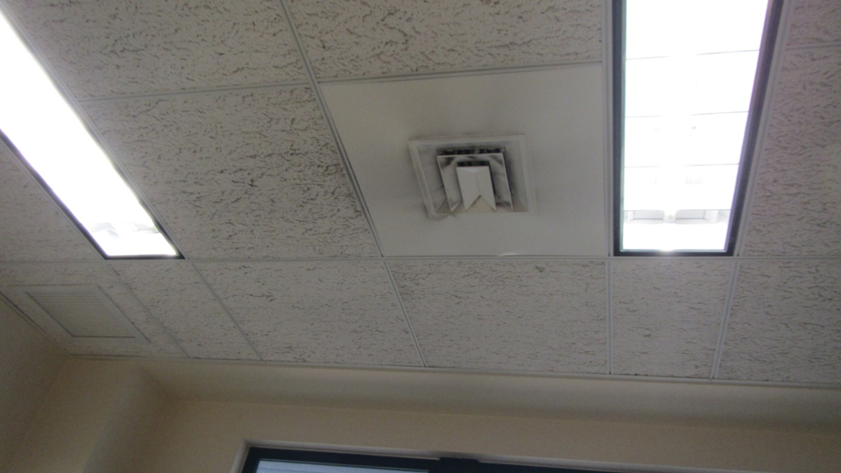
Fresh air diffusers appear to be coated with particulate matter
Picture 2
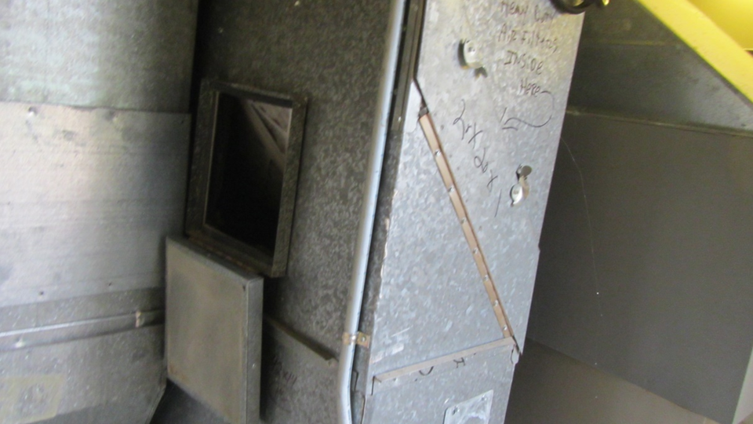
Duct inspection door open in AHU room
Picture 3
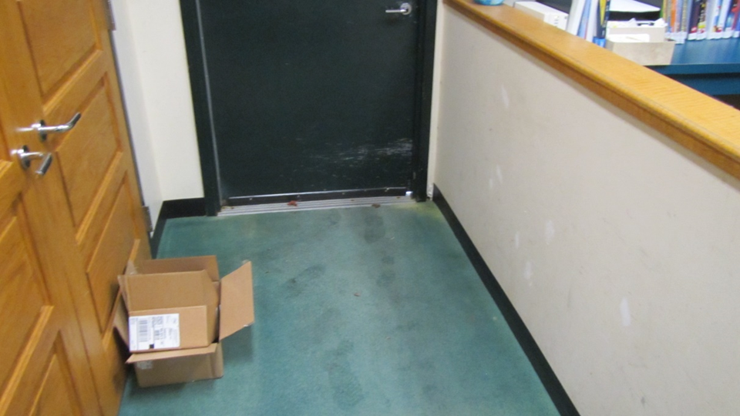
Water-damaged carpet at exterior door in office
Picture 4
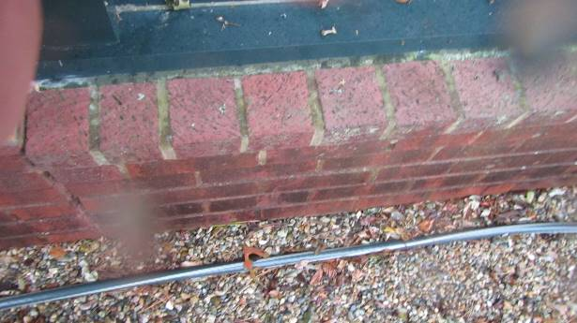
Exterior windowsills are covered in places with moss
Picture 5
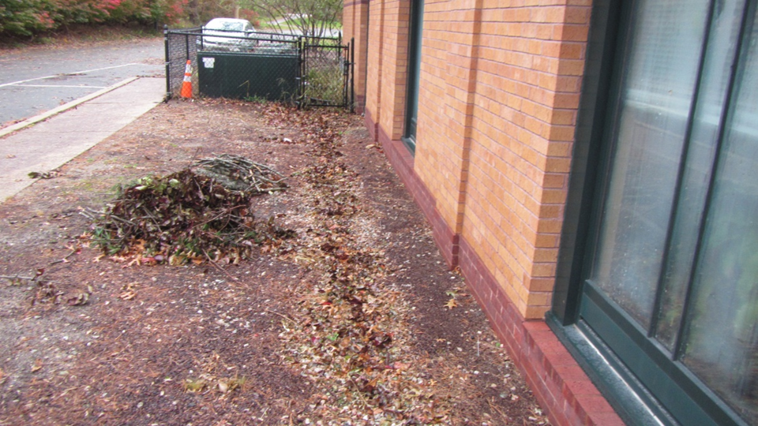
Furrow in ground from direct rainwater runoff from roof
Picture 6
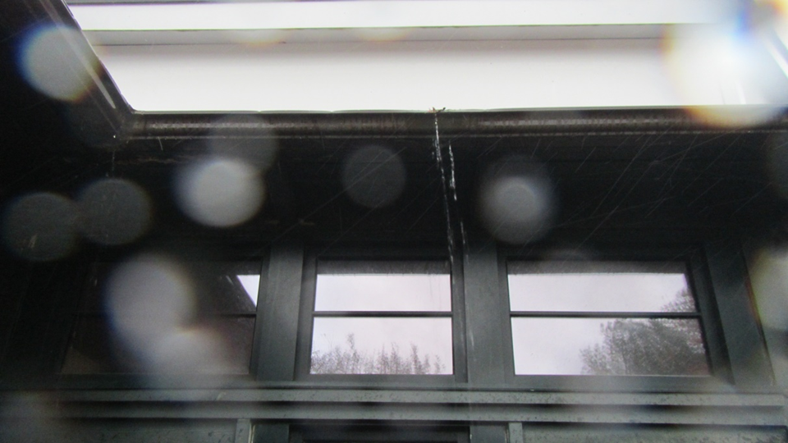
Leak from gutter, likely from a seam
Location | Carbon  Dioxide  (ppm) | Carbon Monoxide  (ppm) | Temp  (°F) | Relative  Humidity  (%) | Occupants  in Room | Windows  Openable | Ventilation |  | Remarks
 |  |  |  |  |  |  | Supply | Exhaust
Background | 393 | ND | 64 | 64 |  |  |  |  | Rain
Main desk | 421 | ND | 70 | 54 | 2 | Y | Y | Y
Children’s room | 462 | ND | 71 | 53 | 0 | Y | Y | Y
Youth non-fiction | 440 | ND | 71 | 50 | 0 | Y | Y | Y
Youth non-fiction A-W | 433 | ND | 71 | 50 | 0 | Y | Y | Y
Study room | 485 | ND | 72 | 47 | 0 | Y | Y | Y | 4 WD CTs
Homework room | 495 | ND | 71 | 50 | 0 | Y | Y | Y
Computer | 488 | ND | 71 | 48 | 0 | Y | Y | Y
Non-fiction | 461 | ND | 72 | 46 | 0 | Y | Y | Y
Mystery | 426 | ND | 72 | 45 | 0 | Y | Y | Y
Paperback M-Z | 431 | ND | 72 | 47 | 0 | Y | Y | Y
Fiction Iss-Ker | 438 | ND | 72 | 45 | 0 | Y | Y | Y | 4 WD CTs
Fiction Br | 431 | ND | 72 | 46 | 0 | Y | Y | Y | 2 WD CTs
Main office | 435 | ND | 72 | 50 | 2 | Y | Y | Y | 1 WD CT
Kitchen | 430 | ND | 72 | 53 | 0 | Y | Y | Y | 2 WD CTs
Head librarian office | 448 | ND | 72 | 52 | 1 | Y | Y | Y
Basement |  |  |  |  |  |  |  |  | Musty odor  Materials stored on floor

Location | Air Temp  (°F) | Relative Humidity  (%) | Dew Point  (°F) | Floor Temp  (°F) | Temp at Floor/ Exterior Wall Junction  (°F) | Air to Floor Temp  Difference  (°F) | Comments
Background | 64 | 64 | 51
Main desk | 70 | 54 | 52 | 73 | 68 | 3
Children’s room | 71 | 53 | 54 | 74 | 72 | 3
Youth non-fiction | 71 | 50 | 52 | 74 | 71 | 3
Youth non-fiction A-W | 71 | 50 | 52 | 74 | 71 | 3
Study room | 72 | 47 | 50 | 74 | 70 | 2
Homework room | 71 | 50 | 52 | 74 | 72 | 3
Computer | 71 | 48 | 51 | 74 | 71 | 3
Non-fiction | 72 | 46 | 49 | 74 | 71 | 2
Mystery | 72 | 45 | 50 | 71 | 69 | 1
Paperback M-Z | 72 | 47 | 50 | 65 | 67 | 7
Fiction Iss-Ker | 72 | 45 | 50 | 70 | 70 | 2
Location | Air Temp  (°F) | Relative Humidity  (%) | Dew Point  (°F) | Floor Temp  (°F) | Temp at Floor/ Exterior Wall Junction  (°F) | Air to Floor Temp  Difference  (°F) | Comments
Fiction Br | 72 | 46 | 50 | 70 | 68 | 2
Main office | 72 | 50 | 53 | 70 | 66 | 2
Kitchen | 72 | 53 | 56 | 69 | 68 | 3
Head librarian office | 72 | 52 | 54 | 70 |  | 2

INDOOR AIR QUALITY ASSESSMENT

Hanson Senior Center and Library

132 Maquan Street

Hanson, Massachusetts

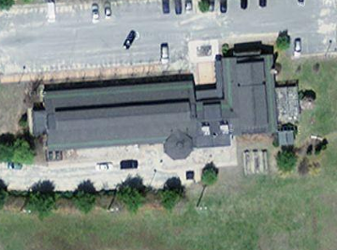

Prepared by:

Massachusetts Department of Public Health

Bureau of Environmental Health

Indoor Air Quality Program

April 2010

Background/Introduction
At the request of Mr. Richard Edgehille, Hanson Board of Health, the Massachusetts Department of Public Health (MDPH), Bureau of Environmental Health (BEH) provided assistance and consultation regarding indoor air quality concerns at the Hanson Senior Center (HSC), located at 132 Maquan Street, Hanson, Massachusetts. The HSC is part of a building complex that includes Hanson Public Library (HPL). The request was prompted by concerns of respiratory irritation and possible mold growth due to chronic water infiltration. On January 29, 2010, Cory Holmes, an Environmental Analyst/Inspector for BEH’s Indoor Air Quality (IAQ) Program made a visit to the HSC/HPL to conduct an indoor air quality assessment.
A preliminary report detailing conditions observed in the HPL regarding recommendations for remediation of water damaged gypsum wallboard and repair of rooftop exhaust pipes was previously issued by MDPH (MDPH, 2010). This report focuses on general IAQ conditions throughout both the HSC and HPL.
The HSC and HPL are part of a one-story wooden complex built in the early 1990’s. The HSC is connected to the Hanson Public Library (HPL) by a common hallway. The HSC has a large dining/recreation room, a kitchen, office space, living/reading room and storage areas. The HPL consists of a main stack area, circulation desk, a historical room, several offices, storage space and an octagonal-shaped children’s library. The complex has a combination of different roof designs consisting of flat rubber-membrane lined roofs, peaked asphalt/fiberglass shingle covered roofs and an octagonal-shaped roof above the children’s library. Windows throughout the complex are not fully openable; they contain a slotted opening to allow limited airflow. There is also a concrete-lined unfinished basement that is used for storage.

Method
Air tests for carbon dioxide, temperature, relative humidity and carbon monoxide were conducted with the TSI, Q-Trak, IAQ Monitor, Model 7565. BEH staff also performed a visual inspection of building materials for water damage and/or microbial growth. Moisture content of porous building materials was measured with a Delmhorst, BD-2000 Model, Moisture Detector equipped with a Delmhorst Standard Probe.

Results
The HSC/HPL complex has an employee population of approximately 30 and can be visited by up to several hundred individuals daily. Tests were taken during normal operations and results appear in Table 1.

Discussion

Ventilation
It can be seen from Table 1 that carbon dioxide levels were below 800 parts per million (ppm) in 8 of 10 areas surveyed, indicating adequate air exchange in most areas of the building at the time of the assessment. The heating, ventilation and air conditioning (HVAC) system consists of air-handling units (AHU) located in mechanical rooms or on the roof (Pictures 1 and 2). Conditioned air is distributed to ceiling or wall-mounted air diffusers (Pictures 3 and 4) and ducted back to AHUs via return vents (Picture 4). BEH staff examined the return vent in the HSC office suite and no draw of air could be detected.
The HVAC system is controlled by digital thermostats (Picture 5). Airflow is controlled using a fan switch that has two settings, on and auto. When the fan is set to on, the system provides a continuous source of air circulation and filtration. The automatic setting on the thermostat activates the HVAC system at a preset temperature. Once the preset temperature is reached, the HVAC system is deactivated. Therefore, no mechanical ventilation is provided until the thermostat re-activates the system. This was the case for the thermostat that controls the office area for the HSC. The MDPH recommends that digital thermostats be set to the fan “on” setting to provide continuous air circulation during occupied periods.
Air circulation is facilitated by the use of downdraft ceiling fans. The introduction of fresh outside air is supplemented by the use of openable windows. As previously mentioned, windows do not fully open but have a slotted design which opens at the bottom to introduce air (Picture 6).
To maximize air exchange, the MDPH recommends that both supply and exhaust ventilation operate continuously during periods of occupancy. In order to have proper ventilation with a mechanical supply and exhaust system, the systems must be balanced to provide an adequate amount of fresh air to the interior of a room while removing stale air from the room. It is recommended that HVAC systems be re-balanced every five years to ensure adequate air systems function (SMACNA, 1994). The date of the last balancing of these systems was not available at the time of the assessment.
The Massachusetts Building Code requires a minimum ventilation rate of 15 cubic feet per minute (cfm) per occupant of fresh outside air or have openable windows in each room (SBBRS, 1997; BOCA, 1993). The ventilation must be on at all times that the room is occupied. Providing adequate fresh air ventilation with open windows and maintaining the temperature in the comfort range during the cold weather season is impractical. Mechanical ventilation is usually required to provide adequate fresh air ventilation.
Carbon dioxide is not a problem in and of itself. It is used as an indicator of the adequacy of the fresh air ventilation. As carbon dioxide levels rise, it indicates that the ventilating system is malfunctioning or the design occupancy of the room is being exceeded. When this happens, a buildup of common indoor air pollutants can occur, leading to discomfort or health complaints. The Occupational Safety and Health Administration (OSHA) standard for carbon dioxide is 5,000 parts per million parts of air (ppm). Workers may be exposed to this level for 40 hours/week, based on a time-weighted average (OSHA, 1997).
The MDPH uses a guideline of 800 ppm for publicly occupied buildings. A guideline of 600 ppm or less is preferred in schools due to the fact that the majority of occupants are young and considered to be a more sensitive population in the evaluation of environmental health status. Inadequate ventilation and/or elevated temperatures are major causes of complaints such as respiratory, eye, nose and throat irritation, lethargy and headaches. For more information concerning carbon dioxide, consult Appendix A.
Temperature measurements ranged from 68° F to 70° F, which were slightly below or at the lower end of the MDPH recommended range (Table 1). The MDPH recommends that indoor air temperatures be maintained in a range of 70° F to 78° F in order to provide for the comfort of building occupants. In many cases concerning indoor air quality, fluctuations of temperature in occupied spaces are typically experienced, even in a building with an adequate fresh air supply.
The relative humidity measured in the building ranged from 10 to 18 percent, which was below the MDPH recommended comfort range (Table 1). The MDPH recommends a comfort range of 40 to 60 percent for indoor air relative humidity. Relative humidity levels in the building would be expected to drop during the winter months due to heating. The sensation of dryness and irritation is common in a low relative humidity environment. Low relative humidity is a very common problem during the heating season in the northeast part of the United States.

Microbial/Moisture Concerns
In order for building materials to support mold growth, a source of water exposure is necessary. As previously mentioned, the complex has had chronic issues with water penetration through the building envelope, mainly in the form of roof leaks and water penetration around the foundation. Roof repairs and drainage improvements have reportedly been conducted in recent years, which have improved conditions; however several areas remain sources of water penetration.
Active roof leaks through the octagonal roof of the children’s library were evident by water damaged walls, efflorescence, peeling paint and delaminating bookshelves (Pictures 7 and 8). Efflorescence is a characteristic sign of water damage to brick and mortar, but it is not mold growth. As moisture penetrates and works its way through mortar, brick or plaster, water-soluble compounds dissolve, creating a solution. As the solution moves to the surface of the material, the water evaporates, leaving behind white, powdery mineral deposits. The intricate roofing design of the entire complex, particularly the over the children's library, creates multiple surfaces, peaks, valleys, troughs, and flashing points, which all provide potential entryways for water penetration (Pictures 9 and 10).
Water damaged ceiling tiles were seen in a number of areas other than the children's library, particularly in the community room (Picture 11). Occasional leaks were reported by HSC staff from the lower roof of the dining room. Active leaks were also observed in the storage closet off the community room. This area had previously been remediated by Service Master, a flooding restoration firm. Water-damaged ceiling tiles indicate leaks from either the roof or plumbing system and can provide a source for mold growth. Water damaged ceiling tiles should be replaced after a water leak is discovered and repaired.
The roofs are reported to be original (~ 19 years old), which puts them toward the end of their useful lifespan (~ 20 years). Although the roof has been patched/repaired in several areas to help prevent further leaking, damaged shingles were noted. As mentioned, the HSC is connected to the Hanson Public Library (HPL) by a common hallway found in several areas and/or appeared to be severely degraded, as evidenced by the accumulation of asphalt granules in the gutter system (Picture 12).
BEH staff examined the outside perimeter of the building to identify breaches in the building envelope and/or other conditions that could provide a source of water penetration. A number of exterior sources for moisture infiltration were identified:
- Plants and trees were observed growing in close proximity to the foundation and building exterior. Plants in close proximity to the building envelope can cause water damage to brickwork and mortar. Water can eventually penetrate the brick subsequently freezing and thawing during the winter. This freezing/thawing action can weaken bricks and mortar, resulting in damage.
- The exterior wall panels of the children’s library were also damaged/delaminating. Exposing this material to moisture which can accelerate decomposition (Picture 13).
- Damaged/deteriorating weather-stripping beneath exterior doors was observed (Picture 14). It is also important to note that there is no lip to the doorframe to prevent water penetration; directly inside the door is wall to wall carpeting that can get wet during heavy rain.
- Gutters contained ice and were clogged with debris (Picture 12);
- Also observed were missing/damaged elbow extensions on downspouts, which cause water to empty against the foundation.
These conditions can undermine the integrity of the building envelope and provide a means for water entry by capillary action into the building through exterior walls, foundation concrete and masonry (Lstiburek & Brennan, 2001). In addition, these breaches in exterior areas can provide a means for drafts and pest entry into the building.
The US Environmental Protection Agency (US EPA) and the American Conference of Governmental Industrial Hygienists (ACGIH) recommend that porous materials be dried with fans and heating within 24 to 48 hours of becoming wet (US EPA, 2001; ACGIH, 1989). If not dried within this time frame, mold growth may occur. Once mold has colonized porous materials, they are difficult to clean and should be removed/discarded.

Other IAQ Evaluations
Indoor air quality can be negatively influenced by the presence of respiratory irritants, such as products of combustion. The process of combustion produces a number of pollutants. Common combustion emissions include carbon monoxide, carbon dioxide, water vapor and smoke (fine airborne particle material). Of these materials, exposure to carbon monoxide can produce immediate, acute health effects upon exposure. To determine whether combustion products were present in the building environment, BEH staff measured carbon monoxide levels within the building.
Carbon monoxide is a by-product of incomplete combustion of organic matter (e.g., gasoline, wood and tobacco). Exposure to carbon monoxide can produce immediate and acute health effects. Several air quality standards have been established to address carbon monoxide and prevent symptoms from exposure to these substances. The MDPH established a corrective action level concerning carbon monoxide in ice skating rinks that use fossil-fueled ice resurfacing equipment. If an operator of an indoor ice rink measures a carbon monoxide level over 30 ppm, taken 20 minutes after resurfacing within a rink, that operator must take actions to reduce carbon monoxide levels (MDPH, 1997).
The American Society of Heating Refrigeration and Air-Conditioning Engineers (ASHRAE) has adopted the National Ambient Air Quality Standards (NAAQS) as one set of criteria for assessing indoor air quality and monitoring of fresh air introduced by HVAC systems (ASHRAE, 1989). The NAAQS are standards established by the US EPA to protect the public health from six criteria pollutants, including carbon monoxide and particulate matter (US EPA, 2006). As recommended by ASHRAE, pollutant levels of fresh air introduced to a building should not exceed the NAAQS levels (ASHRAE, 1989). The NAAQS were adopted by reference in the Building Officials & Code Administrators (BOCA) National Mechanical Code of 1993 (BOCA, 1993), which is now an HVAC standard included in the Massachusetts State Building Code (SBBRS, 1997). According to the NAAQS, carbon monoxide levels in outdoor air should not exceed 9 ppm in an eight-hour average (US EPA, 2006).
Carbon monoxide should not be present in a typical, indoor environment. If it is present, indoor carbon monoxide levels should be less than or equal to outdoor levels. On the day of assessment, outdoor carbon monoxide concentrations were non-detect (ND) (Table 1). No measurable levels of carbon monoxide levels were detected inside the building at the time of the assessment.

Other Conditions
Other conditions that can affect indoor air quality were observed during the assessment. A number of supply diffusers and return vents were observed to have accumulated dust/debris (Picture 3). If return vents are not functioning, backdrafting can occur, which can re-aerosolize dust particles. Dust and allergens can be irritating to the eyes, nose and throat.
Office areas for the HSC and majority of the library contain wall to wall carpeting that is reported to be original to the building (approximately 19 years old). HSC staff could not confirm if a carpet cleaning/maintenance program was in place. The Institute of Inspection, Cleaning and Restoration Certification (IICRC), recommends that carpeting be cleaned annually (or semi-annually in soiled high traffic areas) (IICRC, 2005). Since the average lifespan of a carpet is approximately eleven years, consideration should be given to planning for the installation of new flooring (Bishop, 2002).

Conclusions/Recommendations
The conditions related to indoor air quality at the HSC/HPL complex raise a number of issues. Some of these conditions can be remedied by actions of building occupants. Other remediation efforts will require alteration to the building structure and equipment. For these reasons, a two-phase approach is recommended. The first consists of short-term measures to improve air quality and the second consists of long-term measures that will require planning and resources to adequately address the overall indoor air quality concerns.

Short-term Recommendations
- Continue to operate all ventilation systems (e.g., AHUs) throughout the building continuously during occupied periods.
- Examine return vent in HSC office suite for proper function. Make repairs as necessary to restore function.
- Consider adopting a balancing schedule of every 5 years for all mechanical ventilation systems, as recommended by ventilation industrial standards (SMACNA, 1994).
- Change filters for air-handling equipment (e.g., AHUs) as per the manufacturer’s instructions or more frequently if needed.
- For buildings in New England, periods of low relative humidity during the winter are often unavoidable. Therefore, scrupulous cleaning practices should be adopted to minimize common indoor air contaminants whose irritant effects can be enhanced when the relative humidity is low. To control for dusts, a high efficiency particulate arrestance (HEPA) filter equipped vacuum cleaner in conjunction with wet wiping of all surfaces is recommended. Avoid the use of feather dusters. Drinking water during the day can help ease some symptoms associated with a dry environment (throat and sinus irritations).
- Continue to monitor areas of the building for roof leaks, make repairs and change ceiling tiles as necessary. Disinfect areas of water leaks with an appropriate antimicrobial.
- Make repairs to gutter and downspout system in order to direct rainwater as far as practicable from the base of the building.
- Clean gutters periodically of accumulated debris to ensure proper drainage.
- Replace weather stripping beneath exterior doors.
- Trim back trees and ensure exterior plants/shrubbery are located at least five feet away from the building.
- Repaint or replace delaminating exterior wall panels outside of children’s library.
- Once leaks are repaired in the children’s library, scrape off efflorescence, clean and refinish walls.
- Repair/replace faulty/leaking roof flashing.
- Clean air diffusers and return vents periodically of accumulated dust.
- Clean carpeting annually or semi-annually in soiled high traffic areas as per the recommendations of the Institute of Inspection, Cleaning and Restoration Certification (IICRC). Copies of the IICRC fact sheet can be downloaded at: http://www.cleancareseminars.com/carpet_cleaning_faq4.htm (IICRC, 2005)
- Refer to resource manual and other related indoor air quality documents located on the MDPH’s website for further building-wide evaluations and advice on maintaining public buildings. These documents are available at: http://mass.gov/dph/indoor_air.

Long-Term Recommendations
- Continue to make repairs of roof leaks as necessary. Consideration should be made to replace the roof to prevent chronic roof leaks and further water damage.
- Consider a long-term plan to replace all carpeting in the building as funds become available. Consider replacing carpeting with a non-porous surface such as vinyl tile.
- Work with town officials to develop a preventative maintenance program for all HVAC equipment town-wide.

References
ACGIH. 1989. Guidelines for the Assessment of Bioaerosols in the Indoor Environment. American Conference of Governmental Industrial Hygienists, Cincinnati, OH.
ASHRAE. 1989. Ventilation for Acceptable Indoor Air Quality. American Society of Heating, Refrigeration and Air Conditioning Engineers. ANSI/ASHRAE 62-1989.
Bishop, J. & Institute of Inspection, Cleaning and Restoration Certification. 2002. A Life Cycle Cost Analysis for Floor Coverings in School Facilities.
BOCA. 1993. The BOCA National Mechanical Code/1993. 8th ed. Building Officials and Code Administrators International, Inc., Country Club Hill, IL.
IICRC. 2005. Carpet Cleaning FAQ 4 Institute of Inspection, Cleaning and Restoration Certification. Institute of Inspection Cleaning and Restoration, Vancouver, WA.
Lstiburek, J. & Brennan, T. 2001. Read This Before You Design, Build or Renovate. Building Science Corporation, Westford, MA. U.S. Department of Housing and Urban Development, Region I, Boston, MA.
MDPH. 1997. Requirements to Maintain Air Quality in Indoor Skating Rinks (State Sanitary Code, Chapter XI). 105 CMR 675.000. Massachusetts Department of Public Health, Boston, MA.
MDPH. 2010. Letter to Town Administrator, Renè J. Read, Regarding Water Damage and Condition of Exhaust Pipes at the Hanson Public Library. Dated February, 9, 2010. Massachusetts Department of Public Health, Boston, MA.
OSHA. 1997. Limits for Air Contaminants. Occupational Safety and Health Administration. Code of Federal Regulations. 29 C.F.R 1910.1000 Table Z-1-A.
SBBRS. 1997. Mechanical Ventilation. State Board of Building Regulations and Standards. Code of Massachusetts Regulations. 780 CMR 1209.0
SMACNA. 1994. HVAC Systems Commissioning Manual. 1st ed. Sheet Metal and Air Conditioning Contractors’ National Association, Inc., Chantilly, VA.
US EPA. 2001. “Mold Remediation in Schools and Commercial Buildings”. Office of Air and Radiation, Indoor Environments Division, Washington, DC. EPA 402-K-01-001. March 2001. Available at: http://www.epa.gov/iaq/molds/mold_remediation.html
US EPA. 2006. National Ambient Air Quality Standards (NAAQS). US Environmental Protection Agency, Office of Air Quality Planning and Standards, Washington, DC. Available at: http://www.epa.gov/air/criteria.html
Picture 1

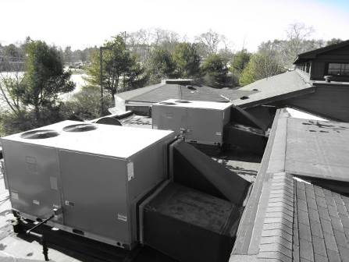

Rooftop Air Handling Units

Picture 2

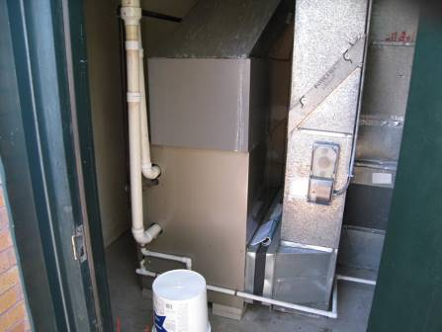

Air Handling Unit in Mechanical Room

Picture 3
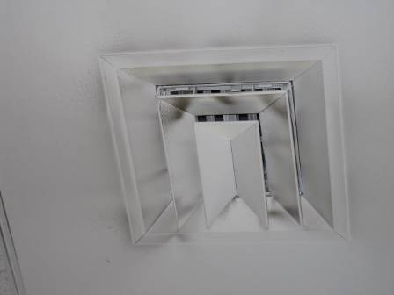

Ceiling-Mounted Supply Vent, Note Dust/Debris Accumulation

Picture 4

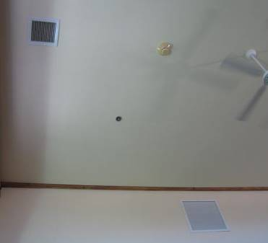

Wall-Mounted Supply Vent (Bottom) and Ceiling Mounted Return Vent

Picture 5

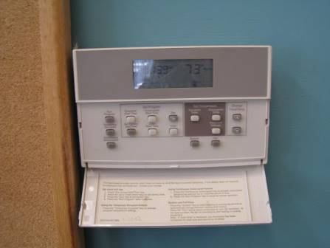

Digital Wall-Mounted Thermostat

Picture 6

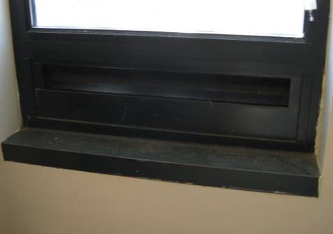

Slotted Window Opening

Picture 7

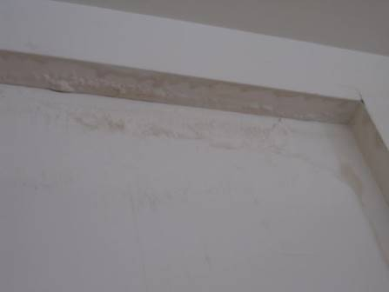

Efflorescence on Children’s Library Octagonal Walls

Picture 8

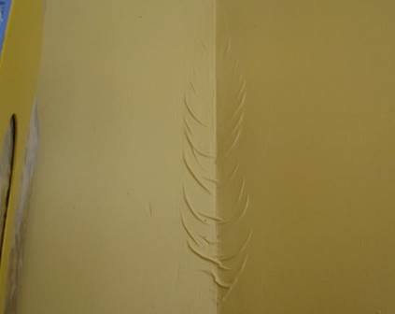

Peeling Paint on Children’s Library Octagonal Walls

Picture 9

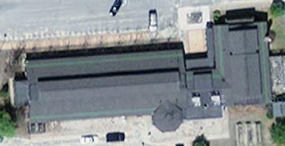

Multiple Roof Surfaces of the HSC/HPL Complex

Picture 10

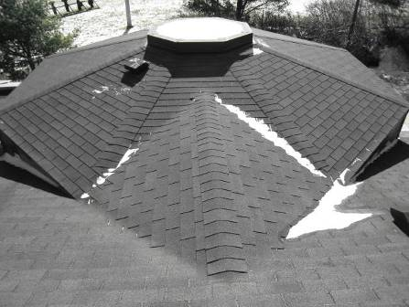

Octagonal Roof of the Children’s Library

Picture 11

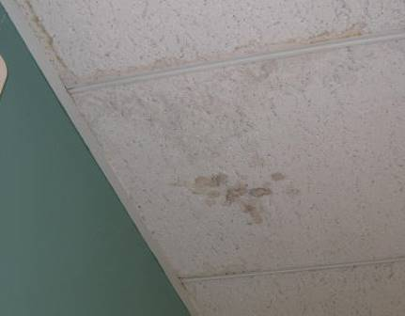

Water Damaged Ceiling Tiles

Picture 12

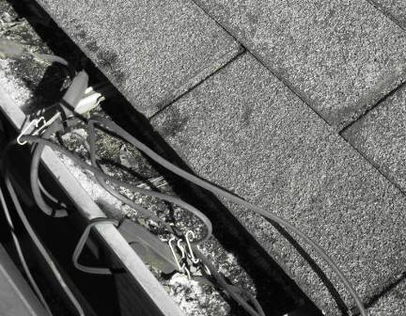

Asphalt Shingle Granules Accumulated in Gutter System

Picture 13

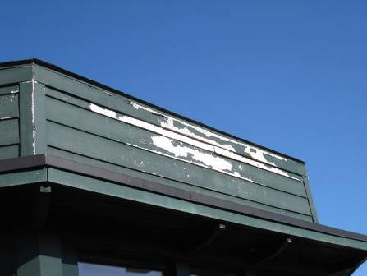

Delaminating Exterior Paint Exposing Exterior Wall Panels

Picture 14

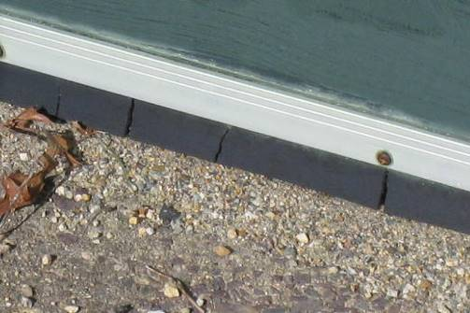

Deteriorating Weather Stripping on Exterior Door

 |  | Temp  (°F) | Relative  Humidity  (%) | Carbon  Dioxide  (*ppm) | Carbon  Monoxide  (*ppm) | Occupants  in Room | Windows  Openable | Ventilation |  | Remarks
 | Location/ Room |  |  |  |  |  |  | Supply | Exhaust
Background (outdoors) |  | < 32 | 23 | 350 | ND |  |  |  |  | Bitterly cold, clear skies, winds WSW 15-21 MPH, gusts up to 50
Senior Center
Kitchen |  | 68 | 18 | 868 | ND | 0 | N | Y | N | Gas stove, not vented to outside, spaces under exterior door
Dining Room |  | 69 | 12 | 606 | ND | 24 | Y | Y | Y | Ceiling fans, occasional leaks reported along the South wall/lower roof
Living Room |  | 69 | 11 | 534 | ND | 1 | Y | Y | Y
Office |  | 69 | 11 | 622 | ND | 1 | Y | Y | Y | Return vent no draw, carpet 20+ years old
Director’s Office |  | 70 | 10 | 509 | ND | 1 | Y | Y | N
Community Room |  | 70 | 16 | 871 | ND | 10 | Y | Y | Y | WD CTs-Dry, WD GW-Dry
Storage Area |  |  |  |  |  |  |  |  |  | Active leaks, Standing water, WD materials (GW, CTs) removed by Service Master

Library
Child’s Room | 70 | 15 | 596 | ND | 2 | Y | Y | Y | Broken window, WD GW, peeling paint, leaking octagonal roof/flashing, delaminating bookcase, All materials dry
Circulation Desk | 70 | 15 | 673 | ND | 2 | Y | Y | Y | Water penetration reported during wind driven rain
Main Library Area | 69 | 15 | 459 | ND | 15-20 | Y | Y | Y | WD GW-wet in Mystery Section, recommend removal, plumbing/heating system leak
Historical Room | 70 | 16 | 389 | ND | 0 | Y | Y | Y | WD GW, peeling paint
Basement |  |  |  |  |  |  |  |  | WD/Mold colonized GW removed

The service life is the median time during which a particular system or component of …[an HVAC]… system remains in its original service application and then is replaced. Replacement may occur for any reason, including, but not limited to, failure, general obsolescence, reduced reliability, excessive maintenance cost, and changed system requirements due to such influences as building characteristics or energy prices (ASHRAE, 1991).

