# Background/Introduction

**INDOOR AIR QUALITY ASSESSMENT**

**ODOR INVESTIGATION**

**Hanson Town Hall**

**542 Liberty Street**

**Hanson, Massachusetts**

[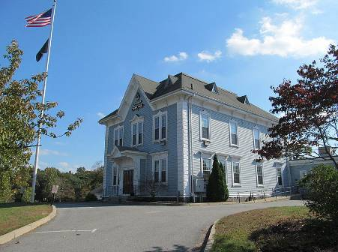](http://upload.wikimedia.org/wikipedia/commons/c/c0/Town_Hall,_September_2012,_Hanson_MA.jpg)

Prepared by:

Massachusetts Department of Public Health

Bureau of Environmental Health

Indoor Air Quality Program

November 2014

In response to a request by Ronald San Angelo, Town Administrator for the town of Hanson, the Massachusetts Department of Public Health (MDPH), Bureau of Environmental Health (BEH) provided assistance and consultation regarding indoor air quality (IAQ) at the Hanson Town Hall (HTH), 542 Liberty Street, Hanson, Massachusetts. On October 24, 2014, Cory Holmes, Environmental Analyst/Regional Inspector in BEH’s IAQ Program visited the HTH to conduct an assessment. The request was prompted by concerns of odors in first floor and basement areas. It was reported that odors had been on-going for the last several weeks and coincided with masonry work along the perimeter of the building.

# Methods

BEH/IAQ staff performed visual inspection of the building/materials and examined the building for the presence of odors and/or other environmental concerns. Air tests for airborne particle matter with a diameter less than 2.5 micrometers were taken with the TSI, DUSTTRAK™ Aerosol Monitor Model 8520. Screening for total volatile organic compounds (TVOCs) was conducted using a RAE Systems, MiniRAE Lite Model, Photoionization Detector. Air testing for carbon monoxide was conducted with the TSI, Q-Trak, IAQ Monitor, Model 7565. These tests were conducted to rule out any association of the odors with incomplete combustion products and/or chemical exposures.

# Results and Discussion

It was reported that odors, described as earth/decaying debris, have been on-going over the past several weeks. On the day of the assessment, slight odors were detected in the west end portions of the building (Table 1). It is important to note that the door to the basement is located in the west end hallway (Picture 1). Odors grew increasingly stronger upon entering the basement. BEH/IAQ staff noted substantial drafts around open utility holes in the common wall to the crawlspace (Pictures 2 through 4). BEH/IAQ staff removed the access panel to the crawlspace (Pictures 4 and 5) and immediately detected a strong pungent earth/decaying odor. Mr. San Angelo reported that a pest control company representative had recently entered the confined crawlspace but could not identify the source of the odor.

Drafts from the crawlspace were particulary strong the day of the assessment due to masonry work being done along the front/main entrance to the building, which removed the concrete stairs to create large breaches in the cobblestone foundation (Picture 6). The assessment occurred on a day of high winds (Picture 7), which pressurized the crawlspace forcing odors into the basement. The basement became pressurized from both the crawlspace drafts and a wall-mounted heater/blower (Picture 8), which then forced odors up the stairwell, which then passed through spaces in the basement stairwell door (Pictures 9 and 10) and into the western end of the HTH.

**Air Testing Results**

Testing results for carbon monoxide (CO), total volatile organic compounds (TVOCs), and particulate matter (PM2.5) were all either non-detect (ND) or at/below background levels (Table 1).

# Conclusions/Recommendations

Based upon tests conducted for VOCs, CO and PM2.5 the source of odors does not appear to be related to chemicals or products of combustion. Therefore odors are most likely earth/decaying debris in the crawl space which should dissipate over time. At the time of the assessment, the following recommendations were made:

1. Depressurize the basement/crawlspace relative to the first floor by using exhaust fans in basement windows to draw air away from the stairwell/occupied areas.
2. Temporarily seal basement access door with plastic and duct tape.
3. Seal around open/abandoned utility holes in basement ceiling/walls to prevent unwanted paths of drafts/odor migration.

**Picture 1**

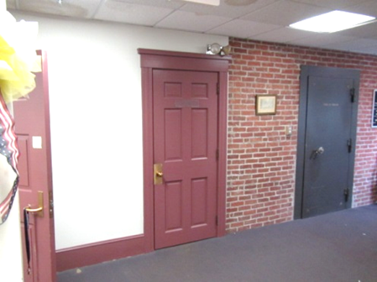

**Access door to the basement in the west end of the building**

**Picture 2**

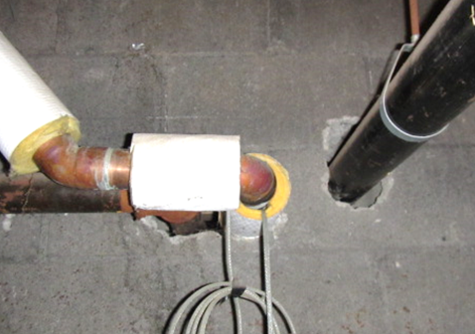

**Spaces around utilities in common wall with crawlspace where strong drafts/odors were penetrating**

**Picture 3**

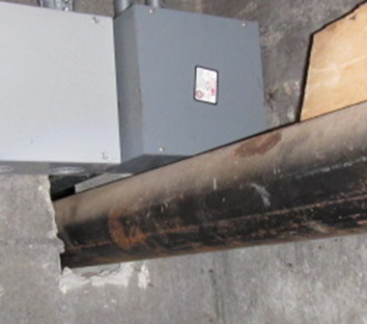

**Spaces around utility pipe in common wall with crawlspace where strong drafts/odors were penetrating**

**Picture 4**

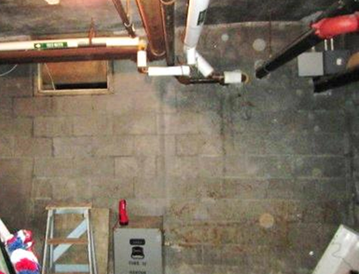

**Access hatch (arrow) and spaces around utility pipes in common wall with crawlspace where strong drafts/odors were penetrating**

**Picture 5**

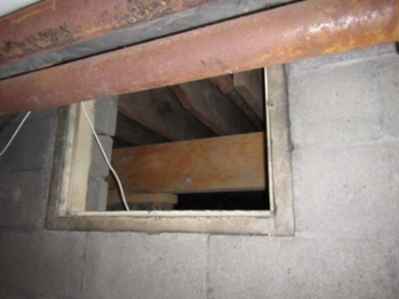

**Crawlspace access hatch**

**Picture 6**

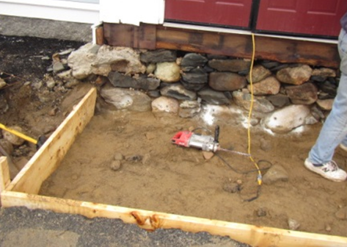

**Masonry work exposing large breaches in cobblestone foundation**

**Picture 7**

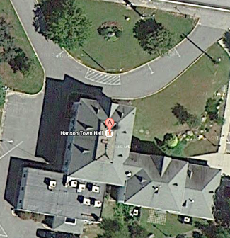

**Aerial view of Hanson Town Hall showing wind direction (arrow) and location of exposed cobblestone foundation in preceding picture**

**Picture 8**

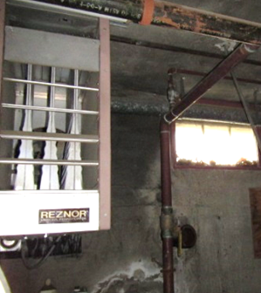

**Ceiling-mounted blower in basement**

**Picture 9**

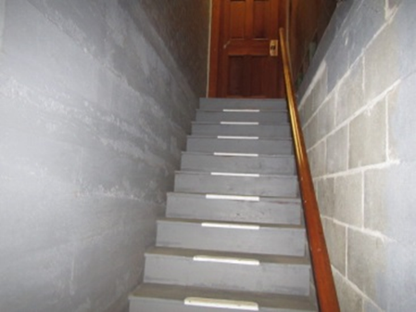

**Basement stairwell leading up to the west end of the building**

**Picture 10**

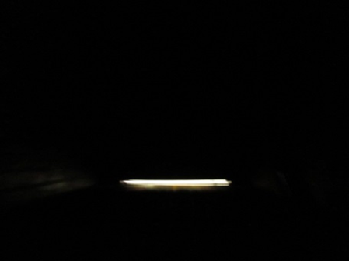

**Light indicating space beneath the basement stairwell door to the west end of building**

| **Location** | **Carbon Monoxide**  **(ppm)** | **TVOCs**  **(ppm)** | **PM2.5**  **(µg/m3)** | **Windows**  **Openable** | **Ventilation** | | | **Remarks** |
| --- | --- | --- | --- | --- | --- | --- | --- | --- |
| **Intake** | **Exhaust** | |
| Background (outdoors) | ND | ND | 10-12 |  |  | |  | Mostly cloudy, NNE winds 18 to 28 mph, gusts up to 39 mph |
| Selectmen Copier Room | ND | ND | 2 | Y | Y | | Y |  |
| Selectmen Reception | ND | ND | 3 | Y | Y | | Y |  |
| Town Administrator | ND | ND | 2 | Y | Y | | Y |  |
| Main Hallway East | ND | ND | 2 | N |  | |  |  |
| Main Hallway Center | ND | ND | 3 | N |  | |  |  |
| Main Hallway West | ND | ND | 3 | N |  | |  | Slight odor, space underneath basement door |
| Treasurer/Collector | ND | ND | 3 | Y | Y | | Y | Slight odor |
| Treasurer/Collector (Back Office Area) | ND | ND | 3 | Y | Y | | Y | Slight odor |
| Basement Stairwell | ND | ND | 3 |  |  | |  | More pronounced odor |
| Basement Workshop | ND | ND | 3 | N | N | | N | More pronounced odor, abandoned utility pipes, ceiling-mounted heat/blower |
| Basement Former Boiler Room | ND | ND | 7 | N | N | | N | Strong odors, from open utility holes/access panel to crawlspace, strong drafts present from crawlspace |