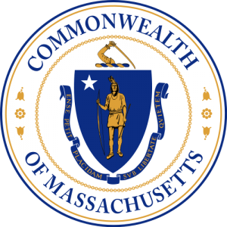
Chairman
Chad Hunter
South Shore

Vice Chairman/Clerk
Rosemary Lesch
North Shore

Members
William McHugh
North Shore

Robert Gillan
South Shore

Gregg Fraser
Cape & Islands

Charles Blair
Cape & Islands

Joseph Cheevers
Boston

James Concannon
State Police

Robert Akin
Environmental Police

Daniel Zivkovich
EOPSS

Robert Canepa CWO
US Coast Guard

Commonwealth of Massachusetts
Harbormaster Training Council

OPEN MEETING NOTICE

Under the provisions of M.G.L. c. 30A, the Harbormaster Training Council
will conduct an Open Meeting, to wit:

DATE: April 12, 2018

DAY: Thursday

PLACE: Salem Police
95 Margin St
Salem, MA

TIME: 10:00 a.m. – 12:00 p.m. (noon)

AGENDA

- Call to Order
- Review and approve minutes of March 15, 2018
- Waiver/Exemption Applications
- Review of 501CMR 16.00 Harbormaster Training Council
- Instructor Qualifications continued discussion
- Initial Training Requirement discussion – Intermittent Reserve Academy
- New Business -Member Comments
- Public Comments
- Next meeting
- Adjournment

Chad Hunter - Chairman

