INDOOR AIR QUALITY ASSESSMENT

Hardwick Municipal Office Building
307 Main Street
Gilbertville, Massachusetts

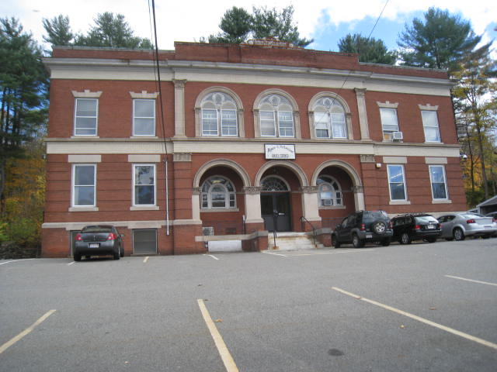

Prepared by:
Massachusetts Department of Public Health
Bureau of Environmental Health
Indoor Air Quality Program
April 2014

Background/Introduction
At the request of Sherry Patch, Hardwick Town Manager, the Massachusetts Department of Public Health (MDPH), Bureau of Environmental Health (BEH) provided assistance and consultation regarding indoor air quality (IAQ) at the Hardwick Municipal Office Building (HMOB), located at 307 Main Street, Gilbertville, Massachusetts. Concerns about general IAQ conditions prompted the assessment. On October 18, 2013, a visit was made to this building by Michael Feeney, Director of BEH’s IAQ Program and Kathleen Gilmore, Environmental Analyst/Regional Inspector within BEH’s IAQ Program.
The HMOB is a two-story, brown brick building originally constructed in 1910 as a high school. The basement previously housed the ventilation/air mixing room, boiler room, kitchen and cafeteria. The area has since been remodeled and the ventilation/air mixing room was converted into the offices for the Hardwick Police Department (HPD). The remainder of the basement is used for storage. The uppermost (second) floor contains a gymnasium with stage which is currently used for storage. The remaining locations in the building are occupied by various Hardwick government offices. Windows are openable throughout the building.

Methods
Air tests for carbon monoxide, carbon dioxide, temperature and relative humidity were conducted with the TSI, Q-Trak, IAQ Monitor, Model 8554. Air tests for airborne particle matter with a diameter less than 2.5 micrometers were taken with the TSI, DUSTTRAK™ Aerosol Monitor Model 8520. BEH/IAQ staff also performed visual inspection of building materials for water damage and/or microbial growth.

Results
The HMOB is staffed by approximately 6 employees, and can be visited up to 20 individuals on a daily basis. Tests were taken under normal operating conditions, and results appear in Table 1.

Discussion

Ventilation
It can be seen from Table 1 that carbon dioxide levels were below 800 parts per million (ppm) in all areas, indicating adequate air exchange at the time of assessment. It is important to note that although air exchange appeared adequate, the HMOB is not equipped with a functioning ventilation system. The HMOB’s original natural/gravity feed ventilation system has been abandoned, thus the sole source of ventilation in the building is openable windows. In addition, a number of areas were empty/sparsely populated at the time of the assessment, which can greatly reduce carbon dioxide levels. Carbon dioxide levels would be expected to increase with higher occupancy and windows closed.
Ventilation was originally provided by grated, louvered, wall vents (Pictures 1 and 2). The wall vents are connected by a ventilation shaft to vault-like “air-mixing” rooms in the basement. The draw of air into these vents is controlled by a draw chain pulley system. The chains of the pulley system were designed to set the flue in the ventilation shaft at a desired angle to adjust fresh air intake. Air movement in such a system is provided by the stack effect. Heating elements located in the base of the ventilation shaft warm the air, which rises up the ventilation shaft. As heated air rises, negative pressure is created, drawing cold air from the enclosed air-mixing rooms in the basement into the heating elements/ventilation shaft. This system was designed to draw outside air into the air-mixing rooms through windows. The percentage of fresh air is controlled by sash windows in the air mixing rooms. As reported above, this original system has been abandoned and the mixing rooms used for other purposes.
Currently ventilation is solely dependent on the use of openable windows. Rooms were originally configured to use cross-ventilation to provide comfort for building occupants. The building is equipped with windows on opposing exterior walls as well as transoms over hallway doors. This design allows for airflow to enter an open window, pass through a room, through the open transom to the hallway and subsequently pass through the open transom and window on the opposite side of the room on the leeward side (opposite the windward side) (Figure 1). This system fails if the windows or transoms are closed (Figure 2). Window-mounted air conditioners (ACs) provide cooling as needed.
Minimum design ventilation rates are mandated by the Massachusetts State Building Code (MSBC). Until 2011, the minimum ventilation rate in Massachusetts was higher for both occupied office spaces and general classrooms, with similar requirements for other occupied spaces (BOCA, 1993). The current version of the MSBC, promulgated in 2011 by the State Board of Building Regulations and Standards (SBBRS), adopted the 2009 International Mechanical Code (IMC) to set minimum ventilation rates. Please note that the MSBC is a minimum standard that is not health-based. At lower rates of cubic feet per minute (cfm) per occupant of fresh air, carbon dioxide levels would be expected to rise significantly. A ventilation rate of 20 cfm per occupant of fresh air provides optimal air exchange resulting in carbon dioxide levels at or below 800 ppm in the indoor environment in each area measured. MDPH recommends that carbon dioxide levels be maintained at 800 ppm or below. This is because most environmental and occupational health scientists involved with research on IAQ and health effects have documented significant increases in indoor air quality complaints and/or health effects when carbon dioxide levels rise above the MDPH guidelines of 800 ppm for schools, office buildings and other occupied spaces (Sundell et al., 2011). The ventilation must be on at all times that the room is occupied. Providing adequate fresh air ventilation with open windows and maintaining the temperature in the comfort range during the cold weather season is impractical. Mechanical ventilation is usually required to provide adequate fresh air ventilation.
Carbon dioxide is not a problem in and of itself. It is used as an indicator of the adequacy of the fresh air ventilation. As carbon dioxide levels rise, it indicates that the ventilating system is malfunctioning or the design occupancy of the room is being exceeded. When this happens, a buildup of common indoor air pollutants can occur, leading to discomfort or health complaints. The Occupational Safety and Health Administration (OSHA) standard for carbon dioxide is 5,000 parts per million parts of air (ppm). Workers may be exposed to this level for 40 hours/week, based on a time-weighted average (OSHA, 1997).
The MDPH uses a guideline of 800 ppm for publicly occupied buildings. A guideline of 600 ppm or less is preferred in schools due to the fact that the majority of occupants are young and considered to be a more sensitive population in the evaluation of environmental health status. Inadequate ventilation and/or elevated temperatures are major causes of complaints such as respiratory, eye, nose and throat irritation, lethargy and headaches. For more information concerning carbon dioxide, please see Appendix A.
Temperature measurements ranged from 74° F to 79° F, which were within or close to the upper end of the MDPH recommended range (Table 1). The MDPH recommends that indoor air temperatures be maintained in a range of 70° F to 78° F in order to provide for the comfort of building occupants. In many cases concerning indoor air quality, fluctuations of temperature in occupied spaces are typically experienced, even in a building with an adequate fresh air supply. In addition, it is difficult to control temperature and maintain comfort without a functioning ventilation system.
The relative humidity measured in the building ranged from 41 to 54 percent, which was within the MDPH recommended comfort range in all areas (Table 1). The MDPH recommends a comfort range of 40 to 60 percent for indoor air relative humidity. However, it is important to note that the indoor relative humidity was higher than outdoors in a range of + 1 to 12 percent. These measurements may be related to a lack of exhaust ventilation in the building which allows occupant-generated moisture to build up. Relative humidity levels in the building would be expected to drop during the winter months due to heating. The sensation of dryness and irritation is common in a low relative humidity environment. Low relative humidity is a very common problem during the heating season in the northeast part of the United States.

Microbial/Moisture Concerns
Water-damaged wall plaster, peeling paint, ceiling tiles and other moisture indicators were observed in a number of areas throughout the building (Table 1). In the uppermost level/former gymnasium, the observed damage to plaster is likely associated with steam leakage from a radiator valve (Picture 3). While plaster is not likely to grow mold, repeated moistening can lead to its deterioration. Water damage to ceiling tiles and plaster in other areas is likely due to periodic water leaks from plumbing or the roof.
The US Environmental Protection Agency (US EPA) and the American Conference of Governmental Industrial Hygienists (ACGIH) recommend that porous materials be dried with fans and heating within 24 to 48 hours of becoming wet (US EPA, 2001; ACGIH, 1989). If not dried within this time frame, mold growth may occur. Once mold has colonized porous materials, they are difficult to clean and should be removed/discarded.

Other IAQ Evaluations
Indoor air quality can be negatively influenced by the presence of respiratory irritants, such as products of combustion. The process of combustion produces a number of pollutants. Common combustion emissions include carbon monoxide, carbon dioxide, water vapor and smoke (fine airborne particle material). Of these materials, exposure to carbon monoxide and particulate matter with a diameter of 2.5 micrometers (μm) or less (PM2.5) can produce immediate, acute health effects upon exposure. To determine whether combustion products were present in the indoor environment, BEH/IAQ staff obtained measurements for carbon monoxide and PM2.5.

Carbon Monoxide
Carbon monoxide is a by-product of incomplete combustion of organic matter (e.g., gasoline, wood and tobacco). Exposure to carbon monoxide can produce immediate and acute health affects. Several air quality standards have been established to address carbon monoxide and prevent symptoms from exposure to these substances. The MDPH established a corrective action level concerning carbon monoxide in ice skating rinks that use fossil-fueled ice resurfacing equipment. If an operator of an indoor ice rink measures a carbon monoxide level over 30 ppm, taken 20 minutes after resurfacing within a rink, that operator must take actions to reduce carbon monoxide levels (MDPH, 1997).
The American Society of Heating Refrigeration and Air-Conditioning Engineers (ASHRAE) has adopted the National Ambient Air Quality Standards (NAAQS) as one set of criteria for assessing indoor air quality and monitoring of fresh air introduced by HVAC systems (ASHRAE, 1989). The NAAQS are standards established by the US EPA to protect the public health from six criteria pollutants, including carbon monoxide and particulate matter (US EPA, 2006). As recommended by ASHRAE, pollutant levels of fresh air introduced to a building should not exceed the NAAQS levels (ASHRAE, 1989). The NAAQS were adopted by reference in the Building Officials & Code Administrators (BOCA) National Mechanical Code of 1993 (BOCA, 1993), which is now an HVAC standard included in the Massachusetts State Building Code (SBBRS, 2011). According to the NAAQS, carbon monoxide levels in outdoor air should not exceed 9 ppm in an eight-hour average (US EPA, 2006).
Carbon monoxide should not be present in a typical, indoor environment. If it is present, indoor carbon monoxide levels should be less than or equal to outdoor levels. On the day of assessment, outdoor carbon monoxide concentrations were non-detect (ND). No measurable levels of carbon monoxide were detected inside the building during the assessment (Table 1).

Particulate Matter (PM2.5)
The US EPA has established NAAQS limits for exposure to particulate matter. Particulate matter includes airborne solids that can be irritating to the eyes, nose, and throat. The NAAQS originally established exposure limits to PM with a diameter of 10 μm or less (PM10). In 1997, US EPA established a more protective standard for fine airborne particulate matter with a diameter of 2.5 μm or less (PM2.5). This more stringent PM2.5 standard requires outdoor air particle levels be maintained below 35 μg/m³ over a 24-hour average (US EPA, 2006). Although both the ASHRAE standard and BOCA Code adopted the PM10 standard for evaluating air quality, MDPH uses the more protective PM2.5 standard for evaluating airborne PM concentrations in the indoor environment.
Indoor PM2.5 levels ranged from ND to 4 μg/m³ (Table 1), which were below the NAAQS PM2.5 level of 35 μg/m³. Frequently, indoor air levels of particulates (including PM2.5) can be at higher levels than those measured outdoors. A number of mechanical devices and/or activities that occur indoors can generate particulate matter during normal operations. Sources of indoor airborne particulates may include but are not limited to particles generated during the operation of fan belts in the HVAC system, cooking in the cafeteria stoves and microwave ovens; use of photocopiers, fax machines and computer printing devices; operation of an ordinary vacuum cleaner and heavy foot traffic indoors.
Although no measurable levels of carbon monoxide or elevated PM2.5 were detected, the potential for combustion products to migrate into occupied areas from the boiler room was observed via flexible ducts connecting the lowest level of the HMOB to the boiler/furnace room.

Other Conditions
Other conditions that can affect indoor air quality were observed during the assessment. There appear to be several pathways for pollutants from the boiler/furnace room to enter the area occupied by the HPD, as well as the main hallway of the first floor.
- An access door to the furnace area opens into HPD offices. Air and pollutants may pass through spaces in and around the door frame.
- An abandoned pipe in the furnace room opens into the former cafeteria (Pictures 4 and 5).
- A door to the furnace room was left open at the base of the stairs on the opposite side of the building from the HPD. A ceiling mounted radiator (Picture 6) that provides heat for the hallway exists outside the open basement door, which can allow furnace room odors to enter the main hallway though a floor heating vent (Picture 7).
As previously mentioned, window ACs are installed in a few areas. These units are normally equipped with filters, which should be cleaned or changed as per manufacturer’s instructions to avoid the build-up and re-aerosolization of dirt, dust and particulate matter.
A vent exists in the ceiling of the gymnasium, which is open to the outdoors. The open vent allows heat to escape the building and likely allows for hot, humid air to enter the building during warm weather.

Conclusions/Recommendations
Based on observations at the time of assessment, a two-phase approach is required for remediation. The first consists of short-term measures to improve air quality and the second consists of long-term measures that will require planning and resources to adequately address overall concerns.

Short-term Recommendations
- Repair the radiator valve in the former gymnasium. Repair plaster as needed.
- Install weather-stripping underneath boiler room/hallway doors to prevent the migration of odors and particulates.
- Seal the pipe in Pictures 4 and 5.
- Keep the door to the stairwell with the ceiling-mounted radiator (shown in Picture 6) closed.
- Close the vent in the gymnasium to reduce heat loss and prevent hot, humid air from entering the building.
- For buildings in New England, periods of low relative humidity during the winter are often unavoidable. Therefore, scrupulous cleaning practices should be adopted to minimize common indoor air contaminants whose irritant effects can be enhanced when the relative humidity is low. To control for dusts, a high efficiency particulate arrestance (HEPA) filter equipped vacuum cleaner in conjunction with wet wiping of all surfaces is recommended. Avoid the use of feather dusters. Drinking water during the day can help ease some symptoms associated with a dry environment (throat and sinus irritations).
- Clean/change filters for window ACs as per the manufacturer’s instructions or more frequently if needed.
- Refer to resource manuals and other related indoor air quality documents for further building-wide evaluations and advice on maintaining public buildings. These materials are located on the MDPH’s website: http://mass.gov/dph/iaq.

Long-term Recommendations
- Consider installing a unit ventilator (univent) in the HPD office to provide a fresh air supply for this area. Provide adequate exhaust ventilation for this area as well.

References
ACGIH. 1989. Guidelines for the Assessment of Bioaerosols in the Indoor Environment. American Conference of Governmental Industrial Hygienists, Cincinnati, OH.
ASHRAE. 1989. Ventilation for Acceptable Indoor Air Quality. American Society of Heating, Refrigeration and Air Conditioning Engineers. ANSI/ASHRAE 62-1989
BOCA. 1993. The BOCA National Mechanical Code/1993. 8th ed. Building Officials and Code Administrators International, Inc., Country Club Hill, IL.
MDPH. 1997. Requirements to Maintain Air Quality in Indoor Skating Rinks (State Sanitary Code, Chapter XI). 105 CMR 675.000. Massachusetts Department of Public Health, Boston, MA.
OSHA. 1997. Limits for Air Contaminants. Occupational Safety and Health Administration. Code of Federal Regulations. 29 C.F.R 1910.1000 Table Z-1-A.
SBBRS. 2011. Mechanical Ventilation. State Board of Building Regulations and Standards. Code of Massachusetts Regulations, 8th edition. 780 CMR 1209.0
Sundell. 2011. Sundell, J., H. Levin, W. W. Nazaroff, W. S. Cain, W. J. Fisk, D. T. Grimsrud, F. Gyntelberg, Y. Li, A. K. Persily, A. C. Pickering, J. M. Samet, J. D. Spengler, S. T. Taylor, and C. J. Weschler. Ventilation rates and health: multidisciplinary review of the scientific literature. Indoor Air, Volume 21: pp 191–204.
US EPA. 2001. “Mold Remediation in Schools and Commercial Buildings”. Office of Air and Radiation, Indoor Environments Division, Washington, DC. EPA 402-K-01-001. March 2001. Available at: http://www.epa.gov/mold/mold_remediation.html.
US EPA. 2006. National Ambient Air Quality Standards (NAAQS). US Environmental Protection Agency, Office of Air Quality Planning and Standards, Washington, DC. http://www.epa.gov/air/criteria.html.
Picture 1
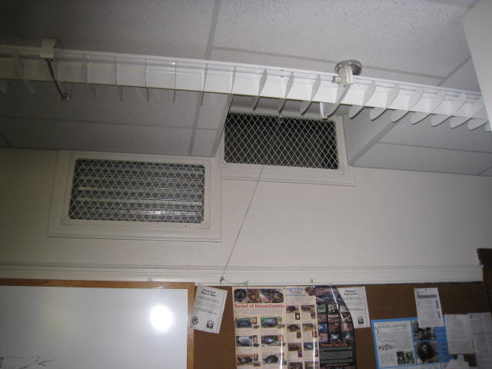
Former fresh air supply
Picture 2
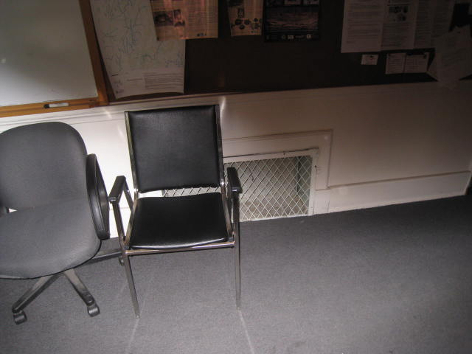
Former exhaust

Picture 3
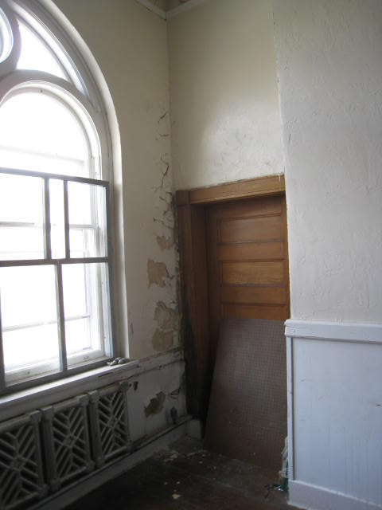
Leaking radiator valve, note damage to plaster
Picture 4
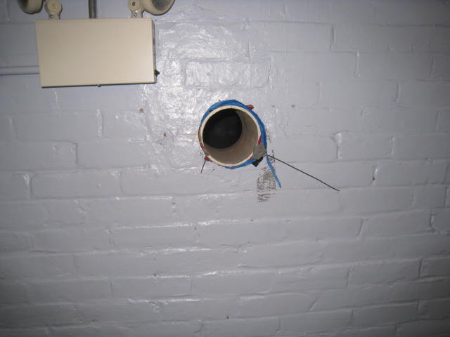
Hole in wall on occupied side of former cafeteria

Picture 5
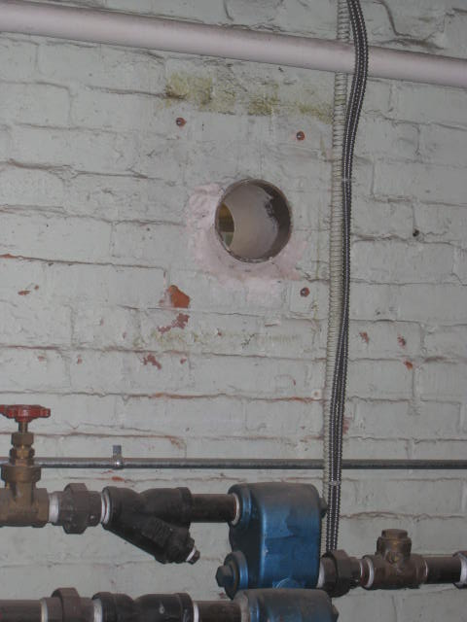
Hole in wall on furnace room side of wall from Picture 4
Picture 6
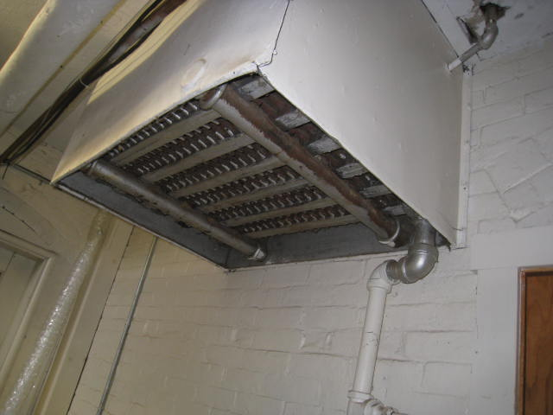
Radiator on ceiling outside furnace room door

Picture 7
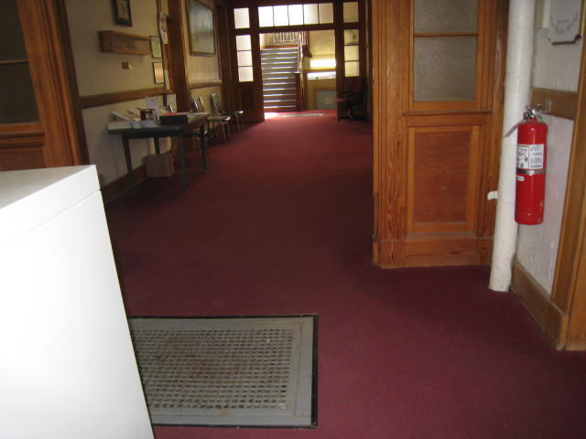
Floor heating vent above radiator in Picture 6
Location | Carbon  Dioxide  (ppm) | Carbon Monoxide  (ppm) |  | Temp  (°F) | Relative  Humidity  (%) | PM2.5  (µg/m³) |  | Occupants  in Room | Windows  Openable |  | Ventilation |  |  | Remarks
 |  |  |  |  |  |  |  |  |  |  | Intake | Exhaust
Background | 359 | ND |  | 69 | 42 |  |  |  |  |  |  |  |  | Idling police cars
Board of Selectmen | 497 | ND |  | 76 | 45 | 0 |  | 0 | Y |  | Y |  | Y | TS, WD CTs, WAC, DO, Bowed CTs
Town Administrator | 519 | ND |  | 76 | 47 | 2 |  | 1 | Y |  | Y |  | Y | TS, WAC, DO
Board of Health | 432 | ND |  | 75 | 46 | 1 |  | 0 | Y |  | Y |  | Y | WD CTs, DEM, TS, DO
Photocopy Room | 519 | ND |  | 75 | 47 | 1 |  | 0 | N |  | N |  | N | PC
Town Clerk | 462 | ND |  | 75 | 48 | 0 |  | 0 | N |  | Y |  | Y
Mail Room | 470 | ND |  | 75 | 50 | 1 |  | 0 | Y |  | N |  | N | TS
Breakroom | 488 | ND |  | 76 | 49 | 1 |  | 0 | N |  | N |  | N | TS
Board of Assessors | 597 | ND |  | 77 | 47 | 0 |  | 2 | Y |  | Y |  | Y | WAC, DO, Bowed CTs
Town Collection | 485 | ND |  | 79 | 41 | 1 |  | 0 | Y |  | N |  | N | Bowed CTs
Treasurer’s office e | 555 | ND |  | 78 | 43 | 1 |  | 1 | Y |  | Y |  | Y | TS
Accounts | 476 | ND |  | 79 | 44 | 1 |  | 0 | Y |  | Y |  | Y | WAC, Bowed CTs
Gym | 464 | ND |  | 76 | 44 | 1 |  | 0 | Y |  | Y |  | Y | Water-damaged wall plaster from radiator steam
Second Floor, NW | 463 | ND |  | 74 | 49 | 4 |  | 0 | Y |  | Y |  | Y | 3 WD CT
Second Floor, NE | 464 | ND |  | 74 | 50 | 1 |  | 0 | Y |  | Y |  | Y | 4 MT, 3 WD CT
Police Conference | 438 | ND |  | 75 | 54 | 1 |  | 0 | N |  | N |  | N | Dehumidifier
Corporal’s office | 421 | ND |  | 77 | 43 | 1 |  | 0 | Y |  | N |  | N
Main Police Office | 441 | ND |  | 77 | 44 | 1 |  | 1 | N |  | N |  | N | 1 MT, WAC

