INDOOR AIR QUALITY ASSESSMENT

Haverhill Citizen’s Center
10 Welcome Street
Haverhill, MA

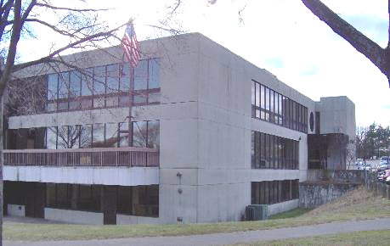

Prepared by:
Massachusetts Department of Public Health
Center for Environmental Health
Emergency Response/Indoor Air Quality Program
April 2007

Background/Introduction
At the request of James R. Peterson, Business Agent for the Truck Drivers & Helpers Local No.170, the Massachusetts Department of Public Health (MDPH), Center for Environmental Health (CEH) provided assistance and consultation regarding indoor air quality concerns at the Haverhill Citizen’s Center (HCC), 10 Welcome Street, Haverhill, Massachusetts. The request was prompted by concerns regarding indoor air quality. On December 19, 2006, a visit to conduct an indoor air quality assessment was made to the HCC by Mike Feeney, Director of the ER/IAQ Program.
The HCC is a two story building with a finished ground floor. This early 1977 building is constructed on a slab on a sloped grade of land. The building contains a multi-story main function room on the first floor. Various administrative offices and other multi-function rooms exist in the building. Interior walls are made of gypsum wallboard (GW). Windows are not openable.

Methods
Moisture content of porous building materials (i.e., gypsum wallboard, ceiling tiles and carpeting), were measured with Delmhorst, BD-2000 Model, Moisture Detector with a Delmhorst Standard Probe. Air tests for carbon dioxide, temperature and relative humidity were taken with the TSI, Q-Trak, IAQ Monitor. Air tests for carbon dioxide, temperature and relative humidity were taken with the TSI, Q-Trak, IAQ Monitor, Model 8551.

Results
The HCC houses approximately 10 employees and can be visited by several hundred people a day. Tests were taken during normal operations. Test results for general IAQ parameters (i.e., temperature, relative humidity and carbon dioxide) appear in Table 1.

Discussion
Ventilation
It can be seen from Table 1 that carbon dioxide levels in the HCC were below 800 parts per million (ppm) in all areas surveyed during the assessment. All rooms had carbon dioxide level below 800 ppm with windows closed, indicating an adequate supply of fresh air from the ventilation system. Fresh air is provided by rooftop-mounted air handling units (AHUs) (Picture 1). These AHUs are connected to ducts that supply fresh air to rooms through ceiling mounted air diffusers. By design, air diffusers are equipped with fixed louvers, which create airflow by directing the air supply along the ceiling to flow down the walls.
Local airflow to each air diffuser is controlled by a variable air volume (VAV) box. Each VAV box has a set of thermostat-controlled dampers that open or close depending on the temperature demand for a serviced area. Once the thermostat detects that the temperature has reached a predetermined level, the VAV box dampers close until heating or cooling is needed. VAV boxes also control the provision of fresh air to a serviced space. During times that the temperature of a space is adequate, the VAV box closes its damper and limits the amount of fresh air. In contrast, if the thermostat calls for the HVAC system to provide heat, the AHU fresh air intake damper would close to increase the temperature of the air in the ductwork and occupied spaces. Airflow would be noted from the ceiling air diffusers because the VAV box dampers are open, but fresh air supply would be limited by the closing of the rooftop fresh air intake damper.
While it has the advantage of energy conservation and lower operating costs, VAV box systems may cause problems related to insufficient outside/fresh air supply. For example, once the temperature requirement is met, airflow drops. Airflow can drop to zero in poorly performing HVAC systems (Plog, Niland and Quinlan, 1996). Please note that this condition may occur during times of outdoor temperature extremes (< 32º F or >90 º F). Air monitoring was conducted on a day with comfortable outdoor conditions (72º F). To ascertain whether zero airflow conditions exist, air monitoring during temperature extremes should be considered.
To maximize air exchange, the MDPH recommends that both supply and exhaust ventilation operate continuously during periods of occupancy. In order to have proper ventilation with a mechanical supply and exhaust system, the systems must be balanced to provide an adequate amount of fresh air to the interior of a room while removing stale air from the room. It is recommended that HVAC systems be re-balanced every five years to ensure adequate air systems function (SMACNA, 1994). At the time of this assessment, no information was available concerning the last date of balancing the HVAC system
The Massachusetts Building Code requires that each room have a minimum ventilation rate of 20 cubic feet per minute (cfm) per occupant of fresh outside air or openable windows (SBBRS, 1997; BOCA, 1993). The ventilation must be on at all times that the room is occupied. Providing adequate fresh air ventilation with open windows and maintaining the temperature in the comfort range during the cold weather season is impractical. Mechanical ventilation is usually required to provide adequate fresh air ventilation.
Carbon dioxide is not a problem in and of itself. It is used as an indicator of the adequacy of the fresh air ventilation. As carbon dioxide levels rise, it indicates that the ventilating system is malfunctioning or the design occupancy of the room is being exceeded. When this happens, a buildup of common indoor air pollutants can occur, leading to discomfort or health complaints. The Occupational Safety and Health Administration (OSHA) standard for carbon dioxide is 5,000 parts per million parts of air (ppm). Workers may be exposed to this level for 40 hours/week, based on a time-weighted average (OSHA, 1997).
The MDPH uses a guideline of 800 ppm for publicly occupied buildings. A guideline of 600 ppm or less is preferred in schools due to the fact that the majority of occupants are young and considered to be a more sensitive population in the evaluation of environmental health status. Inadequate ventilation and/or elevated temperatures are major causes of complaints such as respiratory, eye, nose and throat irritation, lethargy and headaches. For more information concerning carbon dioxide, please see Appendix A.
Temperature measurements were in a range of 68º F to 74º F, which were within or slightly below the MDPH recommended comfort range in some areas. The MDPH recommends that indoor air temperatures be maintained in a range of 70º F to 78º F in order to provide for the comfort of building occupants. In many cases concerning indoor air quality, fluctuations of temperature in occupied spaces are typically experienced, even in a building with an adequate fresh air supply.
The relative humidity in the building ranged from 21 to 30 percent, which was below the MDPH recommended comfort range in some areas. The MDPH recommends a comfort range of 40 to 60 percent for indoor air relative humidity. Relative humidity levels would be expected to drop during the winter months, due to heating. The sensation of dryness and irritation is common in a low relative humidity environment. Low relative humidity is a very common problem during the heating season in the northeast part of the United States.

Microbial/Moisture Concerns
The HCC has a history of chronic leaks stemming from the exterior wall, window system, skylight and roof. Water-damaged ceiling tiles, carpeting and walls were observed in areas throughout the second floor (Picture 2). Water-damaged ceiling tiles, carpet and GW can provide sources for mold growth and should be replaced after the water leak is repaired. The US Environmental Protection Agency (US EPA) and the American Conference of Governmental Industrial Hygienists (ACGIH) recommends that porous materials be dried with fans and heating within 24 to 48 hours of becoming wet (US EPA, 2001; ACGIH, 1989). If carpeting is not dried within this time frame, mold growth may occur. Since carpeting is porous surfaces; disinfection is likely to be ineffective. Removal of these materials is likely needed to prevent exposure of building occupants to mold and other associated pollutants.
The exterior wall system of the HCC consists of windows and stone paneling, which appear to consist of cemetious materials (Picture 3). It also appears that the wall panels have become deformed through moisture exposure (Pictures 4). Sealant compound between stone panels appears to be damaged or missing (Picture 6). In addition, it appears that cement panels along the south exterior wall were replaced with plywood painted to match the color of the stone panels (Picture 5). Seals between windows and the wall system, as well gaskets between glass and the window frame appear to be damaged/missing (Picture 7). Window systems in this condition are also likely sources of water intrusion to the building. Building staff have reported made repeated attempts to repair the exterior wall system.
Of note is the water damage sustained by the portion of the exterior wall corresponding to the pottery room. The exterior wall outside of this area consists of the aforementioned stone wall paneling system. It is likely that water is penetrating into the interior of the building and is accumulating behind the plastic wall coving, which does not allow moisture to evaporate.
CEH staff examined the exterior wall and could not locate weep holes. Weep holes are designed to provide for water drainage. Exterior wall systems should be designed to prevent moisture penetration into the building interior. An exterior wall system should consist of an exterior curtain wall (Figure 1). Behind the curtain wall is an air space that allows for water to drain downward and for the exterior cladding system to dry. Opposite the exterior wall and across the air space is a continuous, water-resistant material adhered to the back up wall that forms the drainage plane.
The purpose of the drainage plane is to prevent moisture that crosses the air space from penetrating into interior building systems. The drainage plane also directs moisture downwards toward the weep holes. The drainage plane can consist of a number of water-resistant materials, such as tarpaper or, in newer buildings, plastic wraps and should be continuous. Where breaks exist (e.g., window systems, door systems and univent fresh air intakes), additional materials (e.g. copper flashing) are typically installed as transitional surfaces to direct water to weep holes. If the drainage plane is discontinuous, missing flashing or lacking air space, rainwater may accumulate inside the wall cavity and lead to moisture penetration into the building.
In order to allow water to drain from the exterior brick wall system, a series of weep holes is customarily installed at or near the foundation slab/exterior wall system junction (Figure 1). Weep holes allow for accumulated water to drain from a wall system (Dalzell, 1955). Failure to install weep holes in brickwork will allow water to accumulate within the base of walls, resulting in seepage and possible moistening of interior building components (Figure 2). As mentioned, the exterior wall of the HCC lacks weep holes. As a result, water is likely accumulating against these wall panels, resulting water degrading the panels and therefore leading to panel failure.
Another potential source of water damage/mold growth is leaks from a large indoor planter (Picture 8). This planter, which is located along the south wall of the main activity room, corresponds to where the second floor extends beyond the first floor (Picture 5). The planter appears to drain through holes on the underside of the overhang (Picture 9). A planter of this size requires proper drainage to prevent water pooling and resultant mold growth. As noted previously, the cemetious exterior wall immediately adjacent to the planter had been replaced with painted plywood, indicating that the planter may not be properly draining. Of note are fresh air supply diffusers, which are located above the planter (Picture 10). Conditioned air appears to be directed onto the planter, which can result in aerosolization of debris, plant related matter and other materials. In addition, a piece of water-damaged plywood placed on the planters is used to support a speaker. The water-damaged plywood can serve as a source of mold growth.

Other IAQ Evaluations
A number of other conditions that can affect indoor air quality were noted during the assessment. A pottery kiln that is not ducted is located in the pottery room. Exhaust produced by the kiln is being drawn into the return vent and distributed to other areas serviced by the HVAC system. Confirming this condition is the heavy corrosion of the metal return vent grille. Kiln exhaust can contain corrosive, toxic and irritating materials, such as carbon monoxide, formaldehyde and sulfur dioxide. Kilns must have local exhaust ventilation to transport fumes to the outside of the building.
Also of note is the location of building’s rooftop exhaust vents relative to fresh air intake vents on the rooftop AHUs (Picture 11). As depicted, the exhaust vents are in close proximity and just below the AHU fresh air intakes. In this condition, air and pollutants expelled by the exhaust vent can be readily drawn into the AHU fresh air intake and redistributed into the building interior.

Conclusions/Recommendations
The conditions noted at the HCC raise a number of indoor air quality issues. Chronic water infiltration through the building envelope, as well as roof leaks have resulted in subsequent water damage to materials inside the building and failure of building exterior panels. Interior renovations (i.e., replacement of ceiling tiles and physical removal of mold-colonized GW) will serve to remove any actively growing mold colonies.
In view of the findings at the time of the assessment, the following recommendations are made:

- Ensure that the general mechanical ventilation system is deactivated and/or sealed (i.e., supply and return vents) in areas about to undergo remediation.
- Discard/replace water-damaged/mold colonized porous materials (e.g., ceiling tiles and other materials). This measure will remove actively growing mold colonies that may be present. This work should be conducted at a time when occupants are not present in the area. Contain the area where contaminated materials are removed to prevent the spread of dust and mold spores. Once work is completed, ensure that the area is thoroughly cleaned and disinfected with an appropriate antimicrobial. Renovation generated dust and particulates in carpeted areas should be vacuumed with a HEPA filtered vacuum cleaner.
- Conduct remediation activities in a manner consistent with recommendations in “Mold Remediation in Schools and Commercial Buildings” published by the US Environmental Protection Agency (US EPA, 2001). This document can be downloaded from the US EPA website at: http://www.epa.gov/iaq/molds/mold_remediation.html.
- Use local exhaust ventilation and isolation techniques to control remediation pollutants. Precautions should be taken to avoid the re-entrainment of these materials into the building.
- Disinfect non-porous surfaces (e.g., floors, walls, metal) with a one-in-ten bleach solution.
- Install adequate exhaust ventilation for the pottery kiln.
- Increase the height of exhaust vents to prevent odor entrainment.
- Consideration should be given to conducting a building envelope survey. Make any needed repairs to building envelope to prevent water infiltration and subsequent water damage.
- Contact an HVAC engineering firm for an assessment of ventilation systems building-wide (e.g., controls, air intake louvers, thermostats and ductwork/insulation).
- Replace missing/damaged ceiling tiles in order to maintain the integrity of the return plenum.
- Consider balancing mechanical ventilation systems every 5 years, as recommended by ventilation industrial standards (SMACNA, 1994).
- For buildings in New England, periods of low relative humidity during the winter are often unavoidable. Therefore, scrupulous cleaning practices should be adopted to minimize common indoor air contaminants whose irritant effects can be enhanced when the relative humidity is low. To control for dusts, a high efficiency particulate arrestance (HEPA) filter equipped vacuum cleaner in conjunction with wet wiping of all surfaces is recommended. Avoid the use of feather dusters. Drinking water during the day can help ease some symptoms associated with a dry environment (throat and sinus irritations).
- Consider removing the planter. If not feasible, ensure that the planter drains appropriately. Remove water damaged materials from the planter. Direct fresh air supply stream away from planter soil. .
- Refer to resource manual and other related indoor air quality documents for further building-wide evaluations and advice on maintaining public buildings; these materials are located on the MDPH’s website: http://mass.gov/dph/indoor_air.
.
References
ACGIH. 1989. Guidelines for the Assessment of Bioaerosols in the Indoor Environment. American Conference of Governmental Industrial Hygienists, Cincinnati, OH.

BOCA. 1993. The BOCA National Mechanical Code/1993. 8th ed. Building Officials and Code Administrators International, Inc., Country Club Hill, IL. Section M-308.1.1.

Dalzell, J.R. 1955. Simplified Masonry Planning and Building. McGraw-Hill Book Company, Inc. New York, NY.
OSHA. 1997. Limits for Air Contaminants. Occupational Safety and Health Administration. Code of Federal Regulations. 29 C.F.R 1910.1000 Table Z-1-A.

Plog, Barbara, Niland, Jill and Quinlan, Patricia, eds. 1996. Fundamentals of Industrial Hygiene. 4th ed. Illinois: National Safety Council.

SBBRS. 1997. Mechanical Ventilation. State Board of Building Regulations and Standards. Code of Massachusetts Regulations. 780 CMR 1209.0

SMACNA. 1994. HVAC Systems Commissioning Manual. 1st ed. Sheet Metal and Air Conditioning Contractors’ National Association, Inc., Chantilly, VA.

US EPA. 2001. Mold Remediation in Schools and Commercial Buildings. US Environmental Protection Agency, Office of Air and Radiation, Indoor Environments Division, Washington, DC. EPA 402-K-01-001. March 2001.

Picture 1

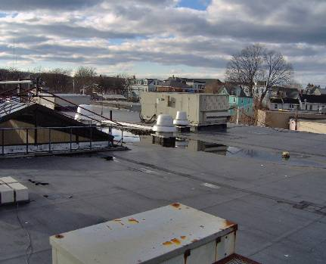

Rooftop AHUs

Picture 2

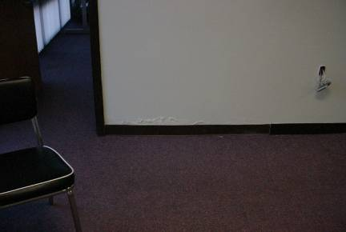

Water Damaged Wall

Picture 3

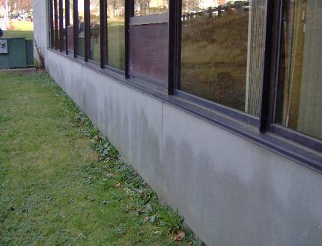

Stone Exterior Wall Panel

Picture 4

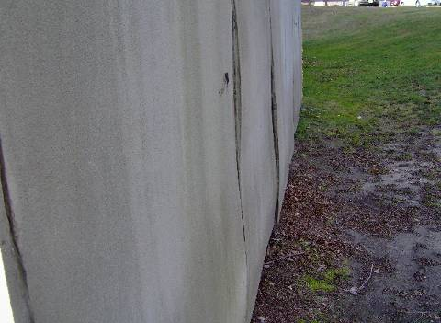

Deformed Stone Wall Panels

Picture 5

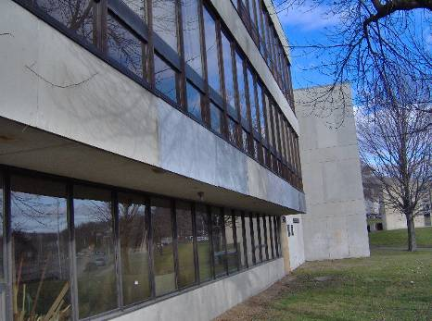

Cement Panels along the South Exterior Wall Appear To Be Replaced With Plywood Painted To Match the Color of the Stone Panels

Picture 6

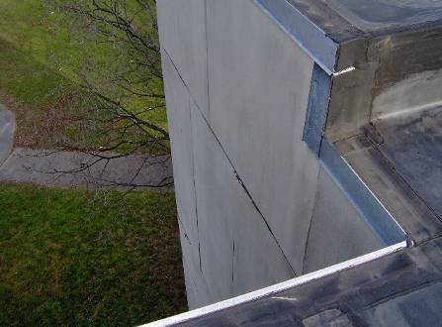

Example of Damaged Stone Panel Sealant
Picture 7

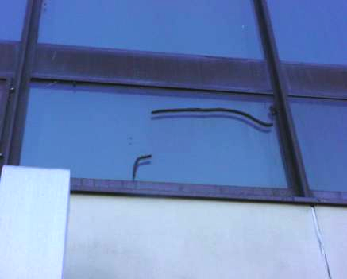

Damaged Window Frame Sealant
Picture 8

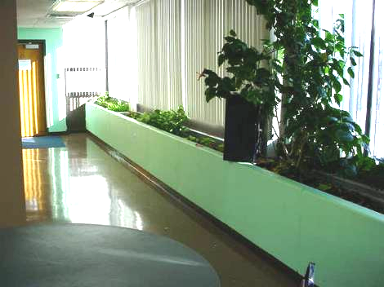

Indoor Planter

Picture 9

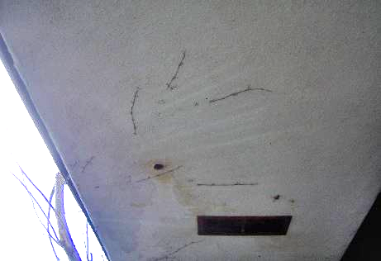

Example of a Presumed Drain for the Indoor Planter

Picture 10

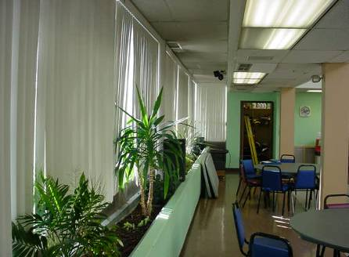

Fresh Air Supplies over Planter

Picture 11
Exhaust Fan Fresh Air Supply Intake
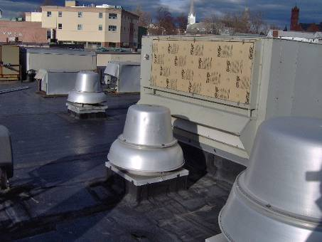

Exhaust Vent Located Next To Fresh Air Intake

Location | Carbon  Dioxide  (*ppm) | Temp  (°F) | Relative  Humidity  (%) | Occupants  in Room | Windows  Openable | Ventilation |  | Remarks
 |  |  |  |  |  | Supply | Exhaust | Remarks
Outside  (Background) | 351 | 40 | 38
40 | 555 | 69 | 26 | 3 | N | Y | Y | Door open
41 | 524 | 70 | 30 | 0 | Y | Y | Y | Do
42 | 547 | 70 | 23 | 2 | Y | Y | Y | Plants  Do
43 | 573 | 71 | 22 | 2 | Y | Y | Y
44 | 593 | 71 | 23 | 1 | Y | Y | Y | Plants  Do
45 | 501 | 69 | 21 | 0 | Y | Y | Y | 5 water damaged ceiling tiles  Water damaged carpet
Balcony | 653 | 73 | 25 | 0 | Y | Y | Y | 6 water damaged ceiling tiles
38 | 598 | 73 | 23 | 3 | Y | Y | Y | 6 water damaged ceiling tiles  Water damaged wall
37 | 627 | 74 | 23 | 1 | Y | Y | Y | 6 water damaged ceiling tiles  Water damaged wall  Water damaged carpet
39 | 553 | 73 | 21 | 0 | Y | Y | Y | 5 water damaged ceiling tiels
28 | 523 | 70 | 21 | 1 | Y | Y | Y | 2 water damaged ceiling tiles
29 | 577 | 70 | 21 | 0 | Y | Y | Y | 10 water damaged ceiling tiels  Large indoor planter  Door open
35 | 534 | 71 | 21 | 0 | Y | Y | Y
31 | 548 | 71 | 22 | 0 | Y | Y | Y
32 | 601 | 71 | 22 | 0 | Y | Y | Y | 4 water damaged ceiling tiles  Water damaged wall
22 | 538 | 68 | 22 | 0 | Y | Y | Y | 2 water damaged ceiling tiles
15 | 512 | 69 | 22 | 0 | Y | Y | Y | 1 water damaged ceiling tiles  Water damaged wall  Door open
16 | 524 | 69 | 22 | 0 | Y | Y | Y
17 | 476 | 68 | 22 | 0 | Y | Y | Y | 6 water damaged ceiling tiles  Water damaged wall  Kiln with no exhaust vent
21 wood shop | 626 | 74 | 26 | 0 | Y | Y | Y
Shuffleboard room | 524 | 72 | 21 | 8 | N | Y | Y

Figure 1

The Function of the Drainage Plane and Weep Holes to Drain Water from the Wall System, Prevent Moisture Penetration into the Interior

Drainage Plane

Driving Rain

Water
Movement

Exterior Curtain Wall

Weep Hole

Figure 2

Weep Hole Blocked with Wick and Water Accumulation in the Drainage Plane

Drainage Plane

Exterior Curtain Wall

Accumulate Water

Moisture Weep Hole Blocked with Wick

