**INDOOR AIR QUALITY ASSESSMENT**

**Haverhill City Hall, Room 310**

**4 Summer Street**

**Haverhill, MA**

Exterior view of Haverhill City Hall

Prepared by:

Massachusetts Department of Public Health

Bureau of Environmental Health

Indoor Air Quality Program

October 2016

# Background

|  |  |
| --- | --- |
| Building: | Haverhill City Hall, Room 310 |
| Address: | 4 Summer Street Haverhill, MA |
| Assessment Requested by: | Orlando Pacheco, Purchasing Agent/ Energy Manager |
| Reason for Request: | General Indoor Air Quality (IAQ) concerns |
| Date of Assessment: | September 26, 2016 |
| Massachusetts Department of Public Health/Bureau of Environmental Health (MDPH/BEH) Staff Conducting Assessment: | Jason Dustin, Environmental Analyst/Inspector, IAQ Program |
| Building Description: | Three-story, flat-roofed brick building |
| Building Population: | 1 Employee in this third floor office suite |
| Windows: | Openable |

# Methods

Please refer to the IAQ Manual for methods, sampling procedures, and interpretation of results (MDPH, 2015).

# IAQ Testing Results

The following is a summary of indoor air testing results (Table 1).

* ***Carbon dioxide levels*** were below 800 parts per million (ppm) in all areas assessed, indicating adequate fresh air in the space.
* ***Temperature*** was within the recommended range of 70°F to 78°F in all areas assessed.
* ***Relative humidity*** was within the recommended range of 40% to 60% in all areas assessed.
* ***Carbon monoxide*** levels were non-detectable in all indoor areas assessed.
* ***Fine particulate matter (PM2.5)*** concentrations measured were below the National Ambient Air Quality Standard (NAAQS) level of 35 μg/m3 in all areas assessed.
* ***Total Volatile Organic Compounds (TVOCs)*** were non-detect (ND) in all areas assessed.

## Ventilation

This assessment was limited to room #310, a third floor office suite within the building. This office suite did not have mechanical fresh air ventilation or an air handling unit (AHU). Fresh air is provided by open windows, window air conditioning units, and air infiltration.

The assessment results indicate that there was adequate fresh air for the occupancy in the office suite at the time of the visit.

## Microbial/Moisture Concerns

BEH staff did not observe any water-damaged building materials within this third floor office suite. The roof is directly above this level so any active water leaks should be readily detected.

There were a large number of file cabinets stored in this office area (Picture 1). Items originally stored in unconditioned areas such as basements should be examined for signs of water damage and odors prior to being brought into occupied areas. Any files/boxes found to be water-damaged should be scanned/copied and discarded since porous items not properly dried after becoming moistened can become colonized with mold. BEH staff did not observe any water-damaged files/boxes nor were any musty odors or microbial colonization detected at the time of the assessment.

Extended periods of high humidity during summer months may also moisten porous items such as stored files. The window air conditioning unit should be used to keep humidity levels within acceptable range (40-60%). Windows should not be opened during operation of the air conditioner to avoid condensation.

## Other IAQ Evaluations

Exposure to low levels of total volatile organic compounds (TVOCs) may produce eye, nose, throat, and/or respiratory irritation in some sensitive individuals. To determine if VOCs were present, BEH/IAQ staff measured TVOC levels within the office suite. TVOC levels were non-detect at the time of assessment. BEH/IAQ staff also examined rooms for products containing VOCs. BEH/IAQ staff noted hand sanitizers, fragrances, and dry erase materials in use within the office (Pictures 2 and 3). All of these products have the potential to be irritants to the eyes, nose, throat, and respiratory system of sensitive individuals.

The window of the office suite appeared to have a buildup of dust/debris in the window well (Picture 4). This debris should be cleaned regularly to avoid aerosolization of particulate matter which may have irritant effects to occupants.

This office area is carpeted. Carpets should be cleaned annually (or semi-annually in soiled/high traffic areas) in accordance with Institute of Inspection, Cleaning and Restoration Certification (IICRC) recommendations, (IICRC, 2012).

In addition, continued HEPA vacuuming and wet-wiping of flat surfaces should prevent dust from becoming a source of irritation.

Air conditioning units should be cleaned and maintained according to manufacturer recommendations. The filter in the unit in this office area was noted to be clean and in good repair (Picture 5).

# Conclusions/Recommendations

Based on observations at the time of assessment, the following is recommended:

1. Clean dust/debris from window wells regularly to avoid aerosolizing particulate matter.
2. Any files/boxes found to be water-damaged should be scanned/copied and discarded to avoid colonization with mold. Extra care should be given to avoid transferring water-damaged files from unconditioned areas (e.g., basement) to occupied areas.
3. Eliminate/reduce the use of hand sanitizers, fragrances, and dry erase materials in the office since all of these products have the potential to be irritants to the eyes, nose, throat, and respiratory system of sensitive individuals.
4. Continue to clean and maintain air conditioning unit according to manufacturer recommendations. Use air conditioning unit to keep humidity levels within acceptable levels during summer months and avoid opening windows while unit is in operation.
5. Carpets should be cleaned annually (or semi-annually in soiled/high traffic areas) in accordance with Institute of Inspection, Cleaning and Restoration Certification (IICRC) recommendations, (IICRC, 2012).
6. For buildings in New England, periods of low relative humidity during the winter are often unavoidable. Therefore, scrupulous cleaning practices should be adopted to minimize common indoor air contaminants whose irritant effects can be enhanced when the relative humidity is low. To control for dusts, a high efficiency particulate arrestance (HEPA) filter equipped vacuum cleaner in conjunction with wet wiping of all surfaces is recommended. Avoid the use of feather dusters. Drinking water during the day can help ease some symptoms associated with a dry environment (throat and sinus irritations).
7. Refer to resource manual and other related IAQ documents located on the MDPH’s website for further building-wide evaluations and advice on maintaining public buildings. These documents are available at: <http://mass.gov/dph/iaq>.

**Long Term Recommendations**

1. As long term capital improvement funding becomes available, consider hiring an HVAC design engineer to install mechanical ventilation (e.g., AHUs) which will more effectively control fresh air ventilation, exhaust, and temperature/humidity building wide.

# References

IICRC. 2012. Institute of Inspection, Cleaning and Restoration Certification. Carpet Cleaning: FAQ. Retrieved from <http://www.iicrc.org/consumers/care/carpet-cleaning>.

MDPH. 2015. Massachusetts Department of Public Health. Indoor Air Quality Manual: Chapters I-III. Available at: <http://www.mass.gov/eohhs/gov/departments/dph/programs/environmental-health/exposure-topics/iaq/iaq-manual/>.

**Picture 1**

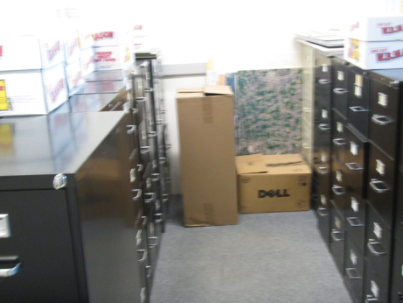

**File storage area**

**Picture 2**

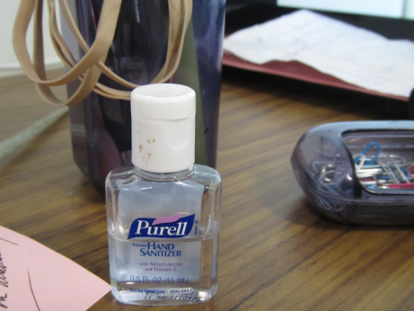

**Hand sanitizer with fragrance**

**Picture 3**

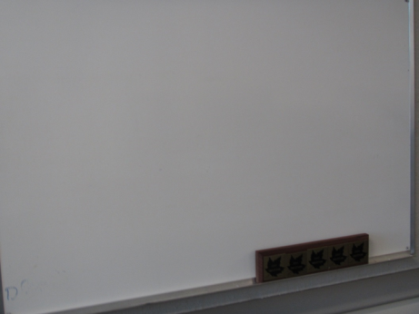

**Dry erase board and materials**

**Picture 4**

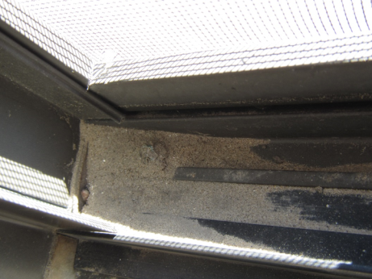

**Dust/debris accumulation in window well**

**Picture 5**

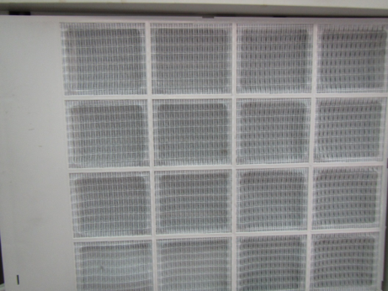

**Window AC unit filter**

| Location | Carbon  Dioxide  (ppm) | Carbon Monoxide  (ppm) | Temp  (°F) | Relative  Humidity  (%) | PM2.5  (µg/m3) | TVOCs  (ppm) | Occupants  in Room | Windows  Openable | Ventilation | | Remarks |
| --- | --- | --- | --- | --- | --- | --- | --- | --- | --- | --- | --- |
| Supply | Exhaust |
| Background | 359 | ND | 66 | 33 | 10 | ND | - | - | - | - | Sunny, cool |
| Office #310 | 615 | ND | 73 | 44 | 5 | ND | 1 | Y | N | N | AC, carpeted, HS, DEM, no WD or musty odors detected, large file storage, debris in window well |
| Hallway | 635 | ND | 72 | 46 | 7 | ND | 0 | Y | N | N |  |