WATER DAMAGE INVESTIGATION

Hayden-McFadden Elementary School
361 Cedar Grove Street
New Bedford, Massachusetts

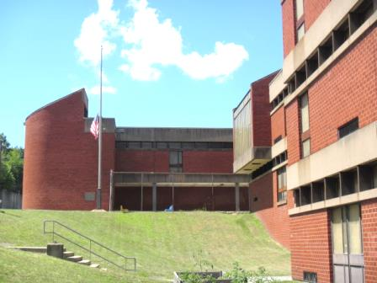

Prepared by:
Massachusetts Department of Public Health
Bureau of Environmental Health
Indoor Air Quality Program
August 2015

Background/Introduction
At the request of the New Bedford Health Department (NBHD), the Massachusetts Department of Public Health (MDPH), Bureau of Environmental Health (BEH) provided assistance and consultation at the Hayden-McFadden Elementary School (HMES), 361 Cedar Grove Street, New Bedford, Massachusetts. On July 23, 2015, staff from BEH’s Indoor Air Quality (IAQ) Program visited the HMES to conduct a walkthrough for issues related to water damage and/or mold growth. The assessment was coordinated through both the NBHD and the New Bedford Public School system (NBPS).
The HMES is a concrete and brick building that was constructed in the 1970s, and has a number of original installed components and materials still in place (e.g., carpeting, ventilation equipment, windows). It was reported by NBPS officials that capital repair projects were being developed to replace window systems, ceiling tile systems and carpets.

Methods
BEH/IAQ staff performed a visual inspection of building materials for water damage and/or microbial growth and other potential IAQ issues.

Observations and Discussion
In order for building materials to support mold growth, a source of water exposure is necessary. Identification and elimination of the source of water moistening building materials is necessary to control mold growth. In the case of the HMES, no specific water-related events had recently occurred (flooding, plumbing failures, etc.). However, it was evident by the number of water-stained/missing ceiling tiles throughout the building that it has had chronic issues with building/roof leaks over the years (Pictures 1 through 4). No musty odors and/or visible mold were observed on building components, with the possible exception of a ceiling tile in the art room, which had dark stains (Picture 1). It should be noted that the ceiling in this area is very high and not easily accessible. Water-damaged ceiling tiles can provide a source of mold and should be replaced after a water leak is discovered and repaired.
However, the majority of ceiling tiles at the HMES are of an interlocking type that cannot readily be removed/replaced (Pictures 1, 3 and 4). It was reported that in the case of some interlocking ceiling tiles that they are treated in-place with an antimicrobial sealant. In other cases, NBPS maintenance personnel remove damaged sections of interlocking tile and replace them with more easily maintained dropped ceiling tiles (Picture 5) in limited areas. As a result of chronic water damage in many areas, ceiling tiles are missing, which can allow dust/debris from above the ceiling tile system to enter occupied areas and be a source of eye and respiratory irritation.
Chronic building envelope leaks were also evident by the presence of efflorescence, water stains, and peeling paint on concrete indoors (Picture 4). Efflorescence is a characteristic sign of water damage but it is not mold growth. As moisture penetrates and works its way through mortar, brick or plaster, water-soluble compounds dissolve, creating a solution. As the solution moves to the surface of the material, the water evaporates, leaving behind white, powdery mineral deposits.
As stated previously, the NBPS are creating a capital repair plan to replace windows, which are original equipment and broken/damaged in many areas (Pictures 6 through 8). In addition, the majority of windows appeared opaque (Picture 8) and let limited natural light into rooms. Also noted on the exterior of the building was missing/damaged weather-stripping and corrosion of metal doors (Pictures 9 and 10). These conditions can allow for drafts, water penetration and pest entry into the building.
Visible mold growth was observed on cardboard that was installed above the ceiling tile system in the library (Picture 11), presumably as a means to catch water leaks. A main area of water penetration indoors is the greenhouse located directly above the library (Picture 12). The original glass for the greenhouse was broken/loose/damaged allowing rainwater to penetrate into the building (Pictures 13 through 15). In addition, hoses used to water plants were inside the greenhouse, which can provide a source of interior water damage, since the floor drains were clogged with growing vegetation (Picture 16). If not properly draining, water will accumulate and drain through utility holes, electrical conduits, and breaches in the floor, resulting in water-damaged ceiling tiles below, as shown in the library (Pictures 11 and 17).
Visible mold was also observed in several refrigerators in the faculty lunch/break areas (Pictures 18 through 21). All refrigerators should be cleaned regularly and if gaskets and other components cannot be adequately cleaned with an anti-microbial agent, they should be replaced.
The assessment occurred after teachers had left the building for summer break; several conditions in classrooms left behind by occupants can be conducive to water damage/mold growth over summer months, these include:
- Leaving materials, particularly non-porous/glossy items on walls/corkboards, etc. (Picture 22);
- Not removing/rolling up area carpets, pads and interlocking floor panels (Pictures 23 and 24);
- Placing furniture directly against walls (Pictures 25 and 26); and
- Storing porous items (cardboard boxes, paper, etc.) directly on floors (Picture 27).
These conditions can trap moisture behind them, which prevents airflow/drying during humid conditions (i.e., over 70% for extended periods of time) over summer months. In addition, it is recommended that area rugs be removed and cleaned over the summer.

Other Conditions
Other conditions that can affect IAQ were observed during the assessment. The HMES is not an air-conditioned building; therefore many classrooms had personal fans that were occluded with dust/debris from use. A few classrooms had portable air conditioners, which had filters occluded with dust/debris (Picture 28). Fans and filters should be cleaned periodically in order to prevent them from serving as a source of aerosolized particulates.
Carpeting in many areas was damaged, worn and/or stained (Picture 29), and in some areas original to the building (over 40 years old). The Institute of Inspection, Cleaning and Restoration Certification (IICRC) recommends that carpeting be cleaned annually (or semi-annually in soiled high traffic areas) (IICRC, 2012). NBPS officials reported that carpets are cleaned on an annual basis, usually during summer vacation. Since the average lifespan of a carpet in a school environment is approximately eleven years (Bishop, 2002), it is recommended to continue with plans for carpet removal as funds become available.
Finally, as a result of failing ceiling tiles from greenhouse leaks, several areas of exposed pipe insulation were observed above the ceiling in the library (Picture 30). Due to the age of the school, this may be asbestos-containing material (ACM). Intact asbestos-containing material (ACM) does not pose a health hazard. If damaged, ACM can be rendered friable and become aerosolized. Although the material appeared to be intact, it was recommended at the time of the assessment that the school’s asbestos management plan be consulted to determine the content of this material in order for prompt remediation (e.g., encapsulation) in a manner consistent with Massachusetts asbestos remediation laws (MDLI, 1993).

Conclusions/Recommendations
In view of the findings at the time of the visit, the following recommendations are made. Some of these conditions can be remedied by the actions of building occupants. Other remediation efforts will require alteration to the building structure and equipment. For these reasons, a two-phase approach is recommended. The first consists of short-term measures that can be initiated as soon as practicable and the second consists of long-term measures that will require planning and resources to adequately address overall concerns. In addition to the actions recommended below, we suggest consulting the following the MDPH guidance documents “Preventing Mold Growth in Massachusetts Schools during Hot, Humid Weather” attached as Appendix A and “Methods for Increasing Comfort in Non-Air-Conditioned Schools” attached as Appendix B.

Short-Term Recommendations
- Remove water-damaged cardboard in the library (Picture 11), ceiling tile in art room (Picture 1) and any other tiles/materials that appear to have mold growth (dark staining).
- Clean and disinfect mold-colonized refrigerator/freezer gaskets with a mild detergent or antimicrobial agent; if they cannot be adequately cleaned, replace.
- Evaluate strategies to stop water/moisture from penetrating the greenhouse (sealing/replacing broken/damaged glass, resealing around panes, etc.). Failure to address the sources of water penetration will result in repeated water damage of porous building materials and possible microbial growth.
- Unclog/remove debris from drains in greenhouse floor and ensure proper drainage, make repairs as needed.
- Replace missing/damaged weather-stripping on exterior doors.
- Clean/scrape loose paint and efflorescence in stairwell (Picture 4) and in other areas where found for refinishing.
- The following general measures should be taken in classrooms at the end of the school year (in any school building) to help prevent moisture “trapping”/condensation/mold growth over summer months:
- Removing posted materials, particularly non-porous/glossy items on walls/corkboards, etc.
- Removing/rolling up area carpets, pads and interlocking floor panels.
- Ensuring that furniture (file cabinets, bookcases, etc.) is not flush/directly against walls.
- Remove porous items (cardboard boxes, paper, etc.) so they are not stored directly on floors.
- Vacuum carpet with a high efficiency particulate arrestance (HEPA) filtered vacuum in combination with cleaning carpeting annually or semi-annually in soiled high traffic areas, as per the recommendations of the Institute of Inspection, Cleaning and Restoration Certification (IICRC, 2012).
- If carpets are cleaned over the summer, care should be taken to ensure proper drying due to excess relative humidity conditions (>70%) that can prevent drying and lead to microbial growth.
- Consult “Mold Remediation in Schools and Commercial Buildings” published by the US Environmental Protection Agency (US EPA, 2001) for more information on mold. This document can be downloaded from the US EPA website at: http://www.epa.gov/mold/mold_remediation.html.
- Clean/change filters and ensure proper drainage/cleaning/disinfection of portable ACs as per the manufacturers’ instructions or more frequently if needed.
- Determine if pipe insulation in library consists of ACM. Remediate any exposed/damaged ACM (e.g., encapsulate) in conformance with Massachusetts asbestos remediation and hazardous waste disposal laws and regulations.
- Contact a ceiling tile manufacture and/or consult with contractor to examine methods of either obtaining comparable replacement tiles or other method of sealing penetrations of the ceiling tile system.
- Refer to resource manuals and other related indoor air quality documents for further building-wide evaluations and advice on maintaining public buildings. These materials are located on the MDPH’s website: http://mass.gov/dph/iaq.

Long-Term Recommendations
The following long-term measures should be considered:
- Continue to plan capital repair projects as funds become available. Such capital repairs that should be considered include:
  - Window/exterior door replacement. Please note that due to the age of the building, sealant around doors/windows may contain regulated materials; address deteriorating sealant/caulking materials in accordance with federal/EPA regulations;
  - Ceiling tile replacement with dropped ceiling tile systems building-wide; and
  - Carpet removal/replacement with non-porous surfaces.
  - Repair of other building envelope issues allowing water penetration.

References
Bishop. 2002. Bishop, J. & Institute of Inspection, Cleaning and Restoration Certification. A Life Cycle Cost Analysis for Floor Coverings in School Facilities.
IICRC. 2012. Carpet Cleaning FAQ 4 Institute of Inspection, Cleaning and Restoration Certification. Institute of Inspection Cleaning and Restoration, Vancouver, WA.
MDLI. 1993. Regulation of the Removal, Containment or Encapsulation of Asbestos, Appendix 2. 453 CMR 6,92(I)(i).
US EPA. 2001. Mold Remediation in Schools and Commercial Buildings. US Environmental Protection Agency, Office of Air and Radiation, Indoor Environments Division, Washington, D.C. EPA 402-K-01-001. http://www.epa.gov/mold/mold_remediation.html
Picture 1
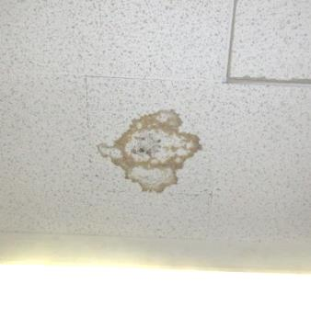
Water-damaged ceiling tile with possible mold growth (dark stains) in art room
Picture 2
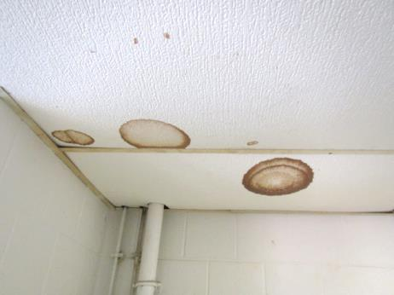
Water-damaged ceiling tiles
Picture 3
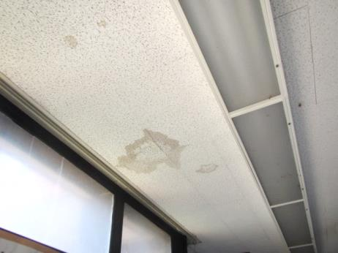
Water-damaged interlocking ceiling tiles
Picture 4
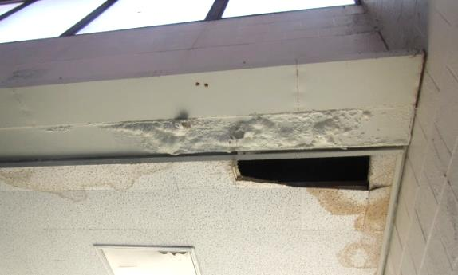
Water-damaged ceiling tiles and efflorescence (mineral deposits) in stairwell
Picture 5
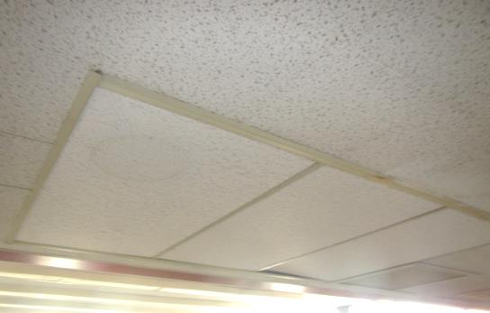
Section of dropped ceiling tiles replacing interlocking type
Picture 6
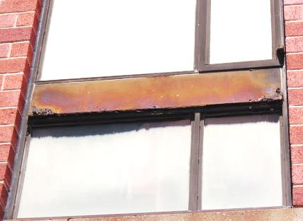
Corroded metal window frame
Picture 7
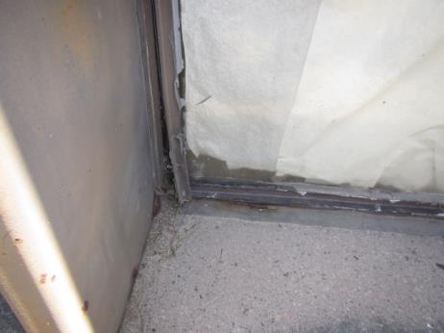
Damaged window frame
Picture 8
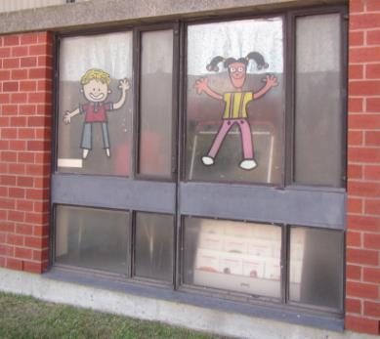
Typical window system, note opaque finish limiting natural light
Picture 9
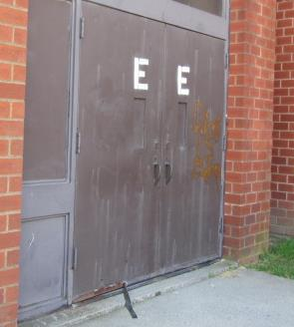
Corroded metal exterior door with missing/damaged weather-stripping
Picture 10
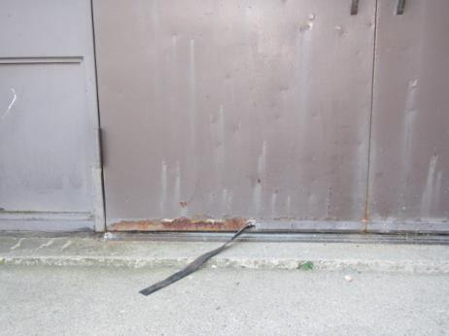
Close-up of corroded metal exterior door with missing/damaged weather-stripping
Picture 11
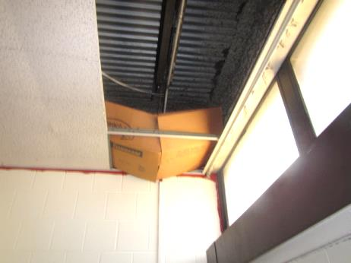
Water-damaged/mold-colonized cardboard in library
Picture 12
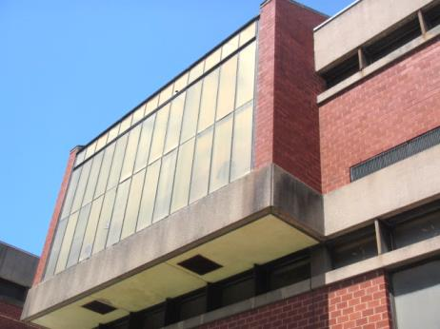
Greenhouse
Picture 13
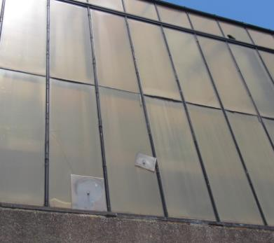
Damaged/loose/broken window panes of greenhouse
Picture 14
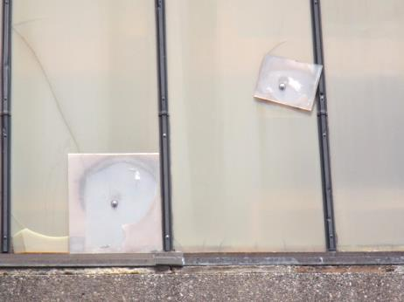
Damaged/loose/broken window panes of greenhouse
Picture 15
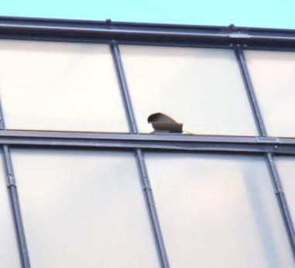
Damaged/broken window pane of greenhouse, note greenhouse is open to the elements
Picture 16
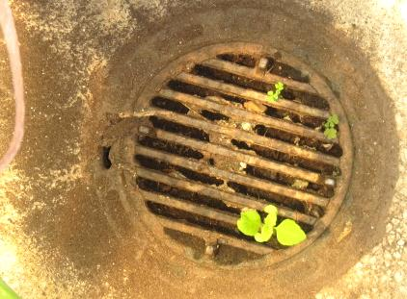
Debris clogging greenhouse floor drain, note plant growth
Picture 17
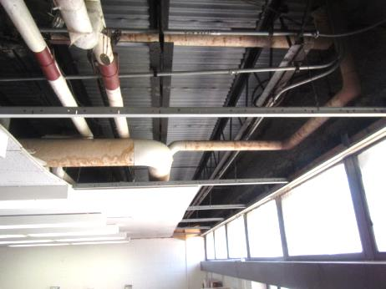
Missing ceiling tiles in the library directly below greenhouse
Picture 18
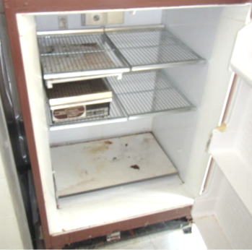
Mold-colonized refrigerator in faculty break area
Picture 19
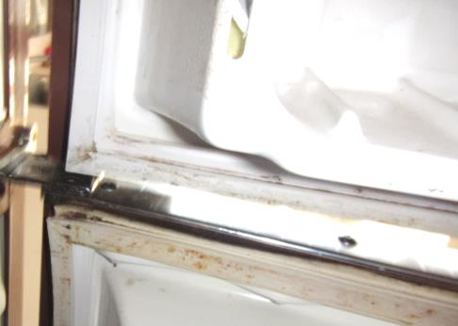
Mold-colonized refrigerator in faculty break area
Picture 20
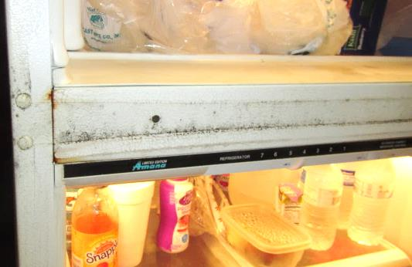
Mold-colonized refrigerator in faculty break area
Picture 21
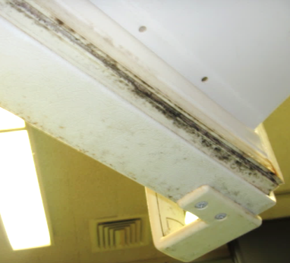
Mold-colonized refrigerator in faculty break area
Picture 22
Example of glossy/non-porous material on paper/wall in classroom
Picture 23
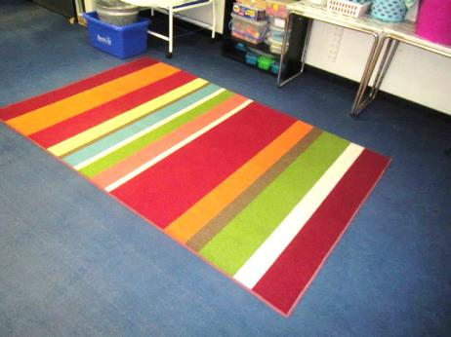
Area carpet on classroom carpet
Picture 24
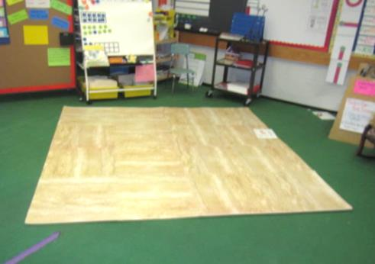
Non-porous floor mats on classroom carpet
Picture 25
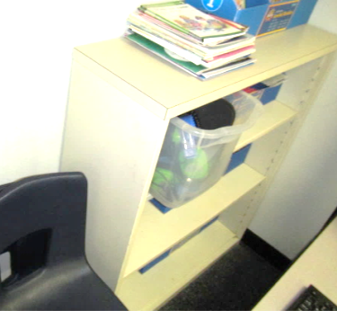
Example of furniture/bookcase directly against wall in classroom
Picture 26
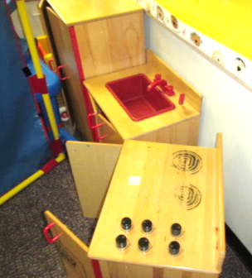
Example of furniture/classroom items directly against wall in classroom (play stove moved by MDPH staff)
Picture 27
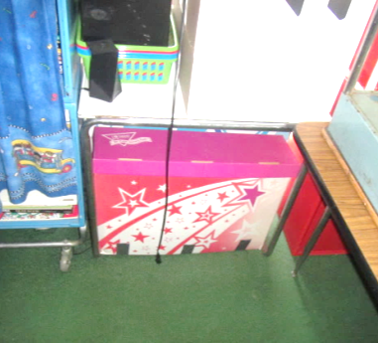
Cardboard box directly on floor
Picture 28
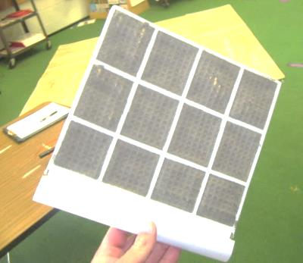
Portable AC filter occluded with dust/debris
Picture 29
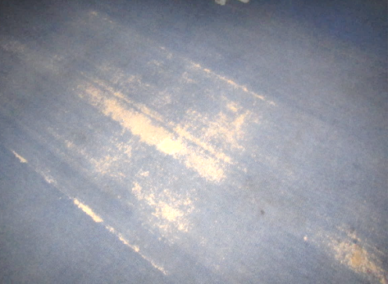
Severely worn/damaged carpeting
Picture 30
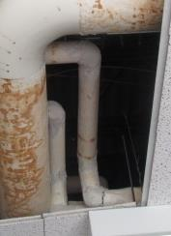
Exposed insulation material (arrows) on pipe elbows in library

