INDOOR AIR QUALITY ASSESSMENT
INCIDENT RESPONSE

Hayden-McFadden Elementary School
361 Cedar Grove Street
New Bedford, Massachusetts

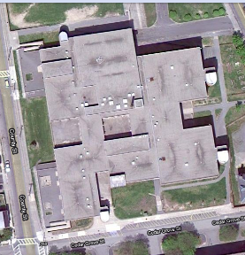

Prepared by:
Massachusetts Department of Public Health
Bureau of Environmental Health
Indoor Air Quality Program
May 2011

Background/Introduction
On Wednesday, March 3, 2011, the Massachusetts Department of Public Health (MDPH), Bureau of Environmental Health (BEH), Indoor Air Quality (IAQ) Program was contacted by Marianne De Souza, Director of the New Bedford Health Department (NBHD), regarding an evacuation at the Hayden-McFadden Elementary School (HMES) located at 361 Cedar Grove Street, New Bedford Massachusetts.
It was reported that around noon on March 3, 2011, a car had crashed into a utility pole near the school, resulting in a power surge. The power surge reportedly caused motors in several air-handling units (AHUs) at the school to “burn out.” Damage to the motors resulted in smoke and odors in the building. At the time of the call, Ms. De Souza reported that public safety officials had deemed the building safe for reoccupancy. BEH staff recommended removing/reducing residual odors through ventilation of the building overnight and increasing cleaning efforts such as wet wiping and wet moping.
On Thursday, March 4, 2011, Ms. De Souza reported that school had been cancelled due to lack of heat/ventilation as a result of damaged motors. Over the course of the day, five of the six AHU motors had been replaced (Pictures 1 and 2) and Ms. DeSouza requested that the MDPH IAQ Program visit the school to conduct IAQ testing that evening. Michael Feeney, Director of BEH’s Indoor Air Quality (IAQ) Program, visited the HMES to conduct indoor air quality testing. Mr. Feeney was accompanied by Cory Holmes and Sharon Lee, Environmental Analysts/Inspectors within BEH’s IAQ Program.

Methods
BEH staff conducted air sampling for carbon monoxide, particulate matter with a diameter of 2.5 micrometers (μm) or less (PM2.5) and total volatile organic compounds (TVOCs) to determine whether fire residue in the building was cleaned/aired out sufficiently. Tests for carbon monoxide were conducted with the TSI, Q-Trak, IAQ Monitor, Model 7565. Air tests for airborne particle matter with a diameter less than 2.5 micrometers were taken with the TSI, DUSTTRAK™ Aerosol Monitor Model 8520. Screening for volatile organic compounds was conducted using a Thermo Environmental Instruments Inc., Model 580 Series Photo Ionization Detector (PID).

Results
The school houses approximately 700 Pre-K through fifth grade students and approximately 60 staff. Tests were taken after school hours. Results appear in Table 1.

Discussion
To determine any residual impacts of the burned out motors and related smoke/odors in the building BEH staff took measurements for carbon monoxide, particulate matter and volatile organic compounds. Indoor air quality can be negatively influenced by the presence of respiratory irritants, such as products of combustion. The process of combustion produces a number of pollutants. Common combustion emissions include carbon monoxide, carbon dioxide, water vapor, and smoke (fine airborne particle material). Of these materials, exposure to carbon monoxide and PM2.5 can produce immediate, acute health effects upon exposure. To determine whether combustion products were present in the indoor environment, BEH staff obtained measurements for carbon monoxide and PM2.5.

Carbon Monoxide
Carbon monoxide is a by-product of incomplete combustion of organic matter (e.g., gasoline, wood and tobacco). Exposure to carbon monoxide can produce immediate and acute health effects. Several air quality standards have been established to address carbon monoxide and prevent symptoms from exposure to these substances. The MDPH established a corrective action level concerning carbon monoxide in ice skating rinks that use fossil-fueled ice resurfacing equipment. If an operator of an indoor ice rink measures a carbon monoxide level over 30 ppm, taken 20 minutes after resurfacing within a rink, that operator must take actions to reduce carbon monoxide levels (MDPH, 1997).
The American Society of Heating Refrigeration and Air-Conditioning Engineers (ASHRAE) has adopted the National Ambient Air Quality Standards (NAAQS) as one set of criteria for assessing indoor air quality and monitoring of fresh air introduced by HVAC systems (ASHRAE, 1989). The NAAQS are standards established by the US EPA to protect the public health from six criteria pollutants, including carbon monoxide and particulate matter (US EPA, 2006). As recommended by ASHRAE, pollutant levels of fresh air introduced to a building should not exceed the NAAQS levels (ASHRAE, 1989). The NAAQS were adopted by reference in the Building Officials & Code Administrators (BOCA) National Mechanical Code of 1993 (BOCA, 1993), which is now an HVAC standard included in the Massachusetts State Building Code (SBBRS, 1997). According to the NAAQS, carbon monoxide levels in outdoor air should not exceed 9 ppm in an eight-hour average (US EPA, 2006).
Carbon monoxide should not be present in a typical, indoor environment. If it is present, indoor carbon monoxide levels should be less than or equal to outdoor levels. On the day of the assessment, outdoor carbon monoxide concentrations were non-detect (ND) (Table 1). No measureable levels of carbon monoxide were detected inside the building during the assessment (Table 1).

Particulate Matter
The US EPA has established NAAQS limits for exposure to particulate matter. Particulate matter is airborne solids that can be irritating to the eyes, nose and throat. The NAAQS originally established exposure limits to particulate matter with a diameter of 10 μm or less (PM10). According to the NAAQS, PM10 levels should not exceed 150 micrograms per cubic meter (μg/m³) in a 24-hour average (US EPA, 2006). These standards were adopted by both ASHRAE and BOCA. Since the issuance of the ASHRAE standard and BOCA Code, US EPA established a more protective standard for fine airborne particles. This more stringent PM2.5 standard requires outdoor air particle levels be maintained below 35 μg/m³ over a 24-hour average (US EPA, 2006). Although both the ASHRAE standard and BOCA Code adopted the PM10 standard for evaluating air quality, MDPH uses the more protective PM2.5 standard for evaluating airborne particulate matter concentrations in the indoor environment.
Outdoor PM2.5 concentrations the day of the assessment were measured at 13μg/m³. PM2.5 levels measured inside the building ranged from 4 to 11 μg/m³ (Table 1). Both indoor and outdoor PM 2.5 levels were below the NAAQS PM2.5 level of 35 μg/m³. Frequently, indoor air levels of particulates (including PM2.5) can be at higher levels than those measured outdoors. A number of activities that occur indoors and/or mechanical devices can generate particulate during normal operations. Sources of indoor airborne particulates may include but are not limited to particles generated during the operation of fan belts in the HVAC system, use of stoves and/or microwave ovens in kitchen areas; use of photocopiers, fax machines and computer printing devices; operation of an ordinary vacuum cleaner and heavy foot traffic indoors.

Volatile Organic Compounds (VOCs)
Indoor air concentrations can be greatly impacted by the use of products containing volatile organic compounds (VOCs) within the building. VOCs are carbon-containing substances that have the ability to evaporate at room temperature. Frequently, exposure to low levels of total volatile organic compounds (TVOCs) may produce eye, nose, throat and/or respiratory irritation in some sensitive individuals. For example, chemicals evaporating from a paint can stored at room temperature would most likely contain VOCs. In the case of the HMES, the power surge burnt out wiring, which could provide a potential source of VOCs.
In an effort to determine whether VOCs were present in the building, air monitoring for TVOCs was conducted. Outdoor air samples were taken for comparison. On the day of the assessment, outdoor TVOC concentrations were non-detect (ND) (Table 1). No measureable levels of TVOCs were detected inside the building during the assessment (Table 1).

Other Conditions
A slight natural gas odor was noted in the 2nd floor hallway outside of the gymnasium/boiler room. MDPH staff recommended that the odor be monitored and if it didn’t dissipate by the morning prior to occupancy, school officials were advised to contact the New Bedford Fire Department and the City’s utility provider.

Conclusions/Recommendations
The air testing results indicated that carbon monoxide and TVOCs were non-detectable within all areas of the HMES surveyed. In addition, all PM2.5 levels measured were below the NAAQS PM2.5 level of 35 μg/m³. In view of the findings at the time of the visit, the following recommendations were made:
- Continue to make repairs any remaining damaged AHUs.
- Contact the New Bedford Fire Department and the City’s utility provider if natural gas odors persist.
- Consider adopting the US EPA (2000) document, “Tools for Schools”, as an instrument for maintaining a good indoor air quality environment in the building. This document is available at: http://www.epa.gov/iaq/schools/index.html.
- Refer to resource manual and other related indoor air quality documents located on the MDPH’s website for further building-wide evaluations and advice on maintaining public buildings. These documents are available at: http://mass.gov/dph/iaq.

References
ASHRAE. 1989. Ventilation for Acceptable Indoor Air Quality. American Society of Heating, Refrigeration and Air Conditioning Engineers. ANSI/ASHRAE 62-1989.
BOCA. 1993. The BOCA National Mechanical Code/1993. 8th ed. Building Officials and Code Administrators International, Inc., Country Club Hill, IL.
MDPH. 1997. Requirements to Maintain Air Quality in Indoor Skating Rinks (State Sanitary Code, Chapter XI). 105 CMR 675.000. Massachusetts Department of Public Health, Boston, MA.
SBBRS. 1997. Mechanical Ventilation. State Board of Building Regulations and Standards. Code of Massachusetts Regulations. 780 CMR 1209.0.
US EPA. 2006. National Ambient Air Quality Standards (NAAQS). US Environmental Protection Agency, Office of Air Quality Planning and Standards, Washington, DC. http://www.epa.gov/air/criteria.html
Picture 1

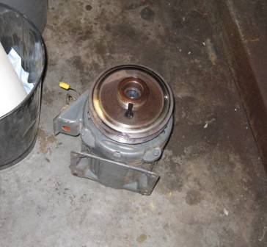

Burnt-Out AHU Motor on Floor of Boiler Room

Picture 2

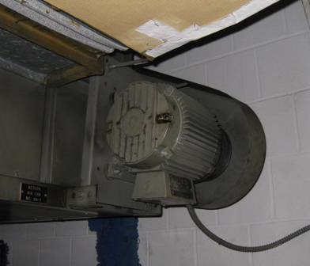

Motor Replaced on AHU in Boiler Room

