 | Massachusetts Department of Environmental Protection  Bureau of Air & Waste – Hazardous Waste  Hazardous Waste License Certification Statements
NOTE: COMPLETE ALL REQUIRED FORMS BEFORE SIGNING THIS STATEMENT | M.G.L. c. 62C § 49A(a) Certification Statement
Important: When filling out forms on the computer, use only the tab key to move your cursor - do not use the return key.  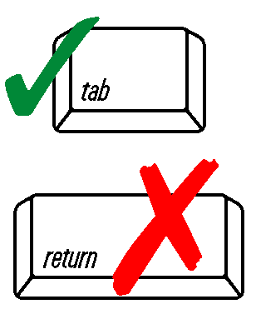 | The following certification is required by M.G.L. c. 62C; § 49A(a).  A person applying to any department, board, commission, division, authority, district or other agency of the commonwealth or a subdivision of the commonwealth, including a city, town or district, for a right or license to conduct a profession, trade or business or for the renewal of the right or license, shall certify upon application, under penalties of perjury, that he has complied with all laws of the commonwealth relating to taxes, reporting of employees and contractors, and withholding and remitting of child support.  I so affirm. | Print Name
 |  | Title
 |  | Date (MM/DD/YYYY)
Source of Signatory Authority:

If a Corporation:
President
Secretary
Treasurer
Vice President (if authorized by corporate vote)
Representative of the above
(if authorized by corporate vote and if responsible for overall operation of the facility)

If a Partnership:
General Partner

If a Sole Proprietorship:
Proprietor

 |  | Signature
NOTE: COMPLETE ALL REQUIRED FORMS BEFORE SIGNING THIS STATEMENT | 310 CMR 30.803 Certification Statement
 | The following statement, shall be separately signed by the person or persons listed in 310  CMR 30.807:  While this application is pending, and while any license issued pursuant to this application  remains in effect, I hereby authorize personnel or authorized agents of the Department, or authorized EPA representatives, to, without a warrant, to:  (a) enter the premises at all reasonable times for the purpose of investigating, sampling, or inspecting any records, condition, equipment, practice, or property relating to activities subject to M.G.L. c. 21C or RCRA;  (b) enter the premises at any time for the purpose of protecting public health, safety, or welfare, or to prevent damage to the environment;  (c) at all reasonable times have access to and copy all of records that are relevant to this application or any license issued pursuant to this application.  I so affirm. | Print Name
 |  | Title
 |  | Date (MM/DD/YYYY)
 |  | Signature

