Executive Office of Health and Human Services
Department of Public Health
Bureau of Health Care Safety & Quality

USER MANUAL

Health Care Facility Reporting System (HCFRS)
Version 1.0

H



Document Version 1.0
April 4, 2011

This document describes how to use the Health Care Facility Reporting System. It is meant to be a reference and resource for end users of the system.

Document Version History
Date | Version Number | Description
04/04/2011 | 1.0 | Initial version

Table of Contents
1 Introduction 5
1.1 Overview of the HCFRS 5
1.2 Additional Resources 5
2 Terminology 6
2.1 Acronyms 6
2.2 Definitions 6
3 Accessing the HCFRS 8
3.1 Logging In 8
3.2 Changing Password and Secret Questions 11
3.3 Timing Out 11
3.4 Logging Out 11
4 Data Submission and Security 13
4.1 Associations between Users 13
5 The HCFRS Home Page and Basic Navigation 14
5.1 The Navigation Toolbar 15
5.2 Shortcut Buttons 15
5.3 Workflows 16
5.3.1 Facility User Workflows 17
5.3.2 DPH User Workflows 17
5.4 Recently Viewed Cases 17
5.5 Resources 18
5.6 Support 18
6 Case Dashboard 19
7 View Question Package 20
8 Create a Case 21
9 Locked Case and Closing a Case 25
10 Edit a Case 26
11 Submit a Case 27
12 Edit and Submit a Returned Case 29
13 Enter 30-Day Report 30
14 Submit 30-Day Report 31
15 Search a Case 32
16 Print a Case 34
17 Reports 36
18 Approve a Case 38
19 Return a Case 40
20 Enter Incident Synopsis of a Case 41

Introduction

Overview of the HCFRS
The Massachusetts Department of Public Health (DPH), Bureau of Health Care Safety and Quality (BHCSQ) track and monitor Serious Reportable Events (SRE) and incidents which occur at licensed and certified health care facilities. The Health Care Facility Reporting System (HCFRS) is a secure and confidential, web-based system developed by experts at DPH. The HCFRS provides a single process for handling the intake and processing of reportable facility incidents and SRE’s for DPH.

In addition to the single business process, the system provides the following capabilities:

- Progress tracking starting from SRE identification to SRE closure.
- Creation of a single entry point for SRE’s.
- Consolidated reporting of all SRE activity, while maintaining confidentiality protections.
- Processing of BHCSQ facility incident reports.

Additional Resources
This document describes how to use the functionality of the HCFRS. It is meant to be a reference and resource for end users of the system. The other information regarding HCFRS which can be found at the HCFRS website includes:

- Training Videos. The HCFRS training videos demonstrate and explain the functionality of the HCFRS within easy to follow video presentations. Each video can be viewed at your own pace and includes a recorded voice explanation of how to best use the HCFRS.

- Virtual Gateway Login Aid. The HCFRS utilizes the Executive Office of Health and Human Services (EOHHS) Virtual Gateway Single Sign-On Portal. Instructions about how to use this portal are posted by EOHHS and detail how to login to the portal and change your password. Information about the Virtual Gateway is available on the Virtual Gateway Help Website at http://www.mass.gov/vg.

Terminology

Acronyms
The following lists some of the acronyms used within this document:
Acronym | Description
HCFRS | The Health Care Facility Reporting System.
ADA | Americans with Disabilities Act.
AIMS | Access and Identity Management Services.
BHCSQ | Bureau of Health Care Safety and Quality. BHCSQ is a part of DPH.
DPH | Department of Public Health.
FTP | File Transfer Protocol.
HCFRS | Health Care Facility Reporting System.
HIPAA | Health Insurance Portability and Accountability Act of 1996.
NQF | National Quality Forum.
PHI | Protected Health Information.
QPSD | Quality and Patient Safety Division. QPSD is a division of BORIM.
SRE | Serious Reportable Events. The Commonwealth of Massachusetts’s current definition of an SRE is based on the National Quality Forum's (NQF's) categorization of serious reportable events. NQF serious reportable events are adverse events that are of concern to both the public and healthcare professionals and providers; clearly identifiable and measurable, and thus feasible to include in a reporting system; and of a nature such that the risk of occurrence is significantly influenced by the policies and procedures of the healthcare facility.
VG | Virtual Gateway.

Definitions
The following defines some of the terms used within this document and the HCFRS:
- Activity Permission – The activity permission specifies which functions a user may perform within the system.
- Consumer – An individual, who is not associated with a facility that is submitting an Incident Report. This individual can be a patient, family member of a patient, etc. A person who is associated with a facility can also be a consumer if they are reporting on an event that is outside the facility’s perspective. A Consumer will contact DPH and have DPH submit the Intake Report. A Consumer will not have access to the system.
- Data Access Permission – The data access permission specifies the set of data to which an end user has access. If a user does not have permission to view or otherwise access certain data, it shall not be displayed in the user interface or any search results or other functions.
- Data Reviewer – An individual who reviews an Intake Report for content and completeness. BHCSQ will have Data Reviewers.
- End User – End users are accounts within the system that will be used to login. Each person using the system will be assigned to a single end user account and that account will be assigned to one or more roles within the system. End users will have a login id and password.
- Facility User – An individual at a facility that has been designated as the contact person for Intake Reports for their facility. This person will have the responsibility of submitting Intake Reports and handling any follow up questions that pertain to their facility.
- Incident – An event at a medical facility that a concerned party has reported to either the facility or to the BHCSQ.
- Intake Report – The record of the reported incident in the system. These will hold all of the information for a particular incident.
- Log – The log file stores error and activity messages for the purposes of troubleshooting by the system administrators. It also contains the results of audits designated by the Administrator. The log file is not available to end users of the system. Log file entries include a date and time stamp.
- Organization – Organizations are defined groups within the system that each have their own role and viewing authority.
- Party – The primary participant unit in the HCFRS. Users, Facilities, and Reporters are all tracked by party.
- Question Package – A Question Package is a grouping of questions that can be thought of as the electronic representation of a paper form.
- Report – Reports are the result of a query against the data within the system. The system supports Reports in the format of tables and charts. The system supports the generation of ad-hoc reports or parameterized reports based on pre-configured report templates.
- Reporter – Person who is reporting the Incident/SRE. If a person at the facility is submitting the Incident Report, then that person is automatically the reporter.
- Role – Each user will be assigned a role for security purposes. On login, the system will check the roles to which an end user belongs to determine the data that is displayed and what functions are available to that user. The role defines permissions for both data access and activities, determines which menu options are available to users, and therefore determines user privileges.
- User – A person who uses the system. Each user has a unique username and has a role.

Accessing the HCFRS
In order to access the HCFRS, health care providers need only a computer, internet access and a secure login and password. No extra software is necessary to install. The application supports Internet Explorer 6.0 and greater.
The following section describes how to login to and logout of the HCFRS. It also includes information regarding the system timeout should it be left idle for extended periods of time.

Logging In
The HCFRS is hosted on a secure portal, maintained by the Executive Office of Health and Human Services (EOHHS) called the Virtual Gateway (VG). Users will be provided a User Name and Password that permits access to the web-based system via the Virtual Gateway. For more information, please see the Virtual Gateway Help Website at http://www.mass.gov/vg. This portal provides single sign on and secure access to EOHHS applications such as the HCFRS. Therefore, the login process has two-steps. First, you will login into the Virtual Gateway using a username and password. Then, you will select the HCFRS from a list of applications and services available to you to log into the system.

- Go to the Virtual Gateway Login Page
Access the Virtual Gateway Home Page by typing the following into your Internet Browser window: https://gateway.hhs.state.ma.us. The Executive Office of Health and Human Services – Virtual Gateway splash page will appear.

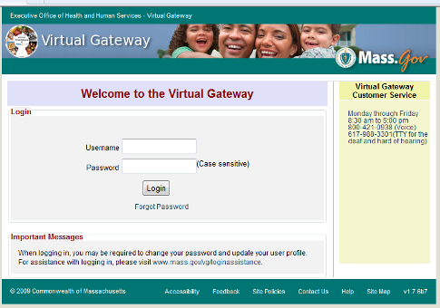

- Login to the Virtual Gateway
To login to the Virtual Gateway, the user must have a secure username and password. Enter the username and password and click the “Login” button. The user will be brought to a welcome page. This page will list all the applications to which you have access. If you do not see “Health Care Facility Reporting System” in the list, then please contact the Virtual Gateway Customer Service at 800-421-0938.
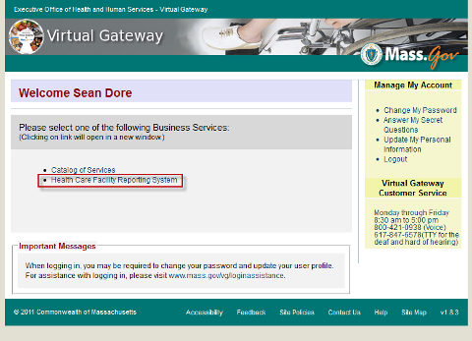

NOTE: Are you a New Virtual Gateway User?
If you are a new user to the Virtual Gateway, on your first login attempt, you will need to enter your temporary password. This password will be emailed to you as part of the Virtual Gateway account setup process. The Virtual Gateway will direct you to a page where you can update your password.

NOTE: Having Trouble Logging In to The Virtual Gateway?
If you do not have a username and password, or have trouble logging into the Virtual Gateway, please contact the Virtual Gateway Customer Service at 800-421-0938.

- Click on the link to “Health Care Facility Reporting System”
This will log the user into the HCFRS application. The HCFRS will then display the following page:

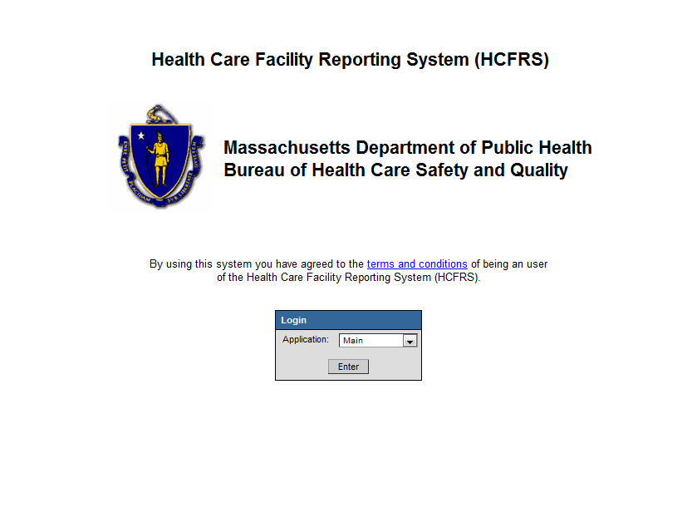

- Click “Enter” to access the Home Page for the HCFRS.

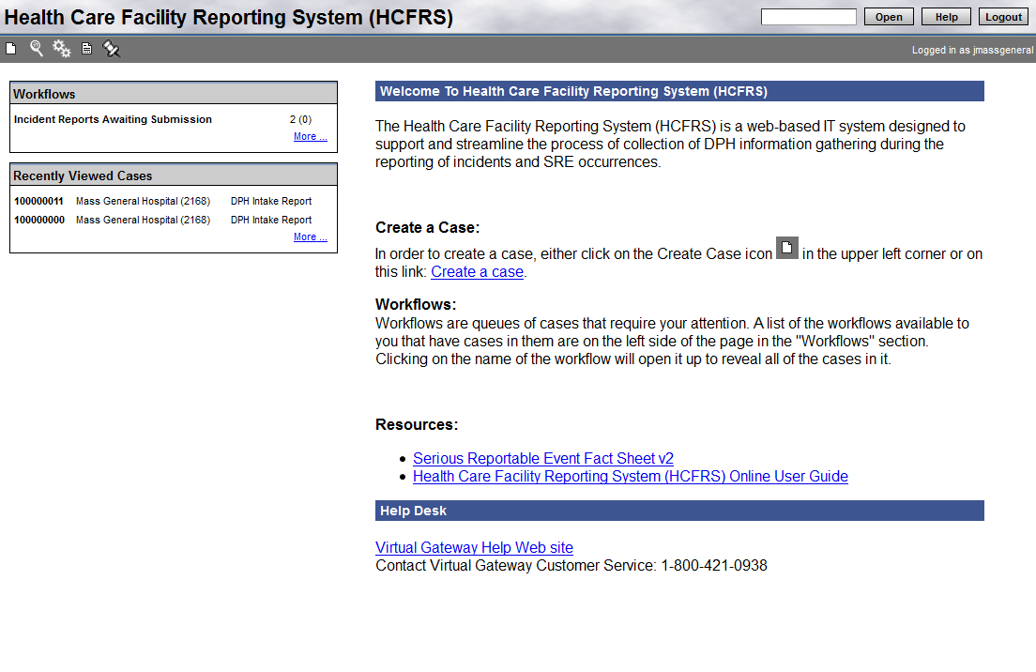

Changing Password and Secret Questions
Passwords will be provided upon initial use of the HCFRS by the VG. If a password must be retrieved or changed, please visit Virtual Gateway Help Website at http://www.mass.gov/vg

Timing Out
The Virtual Gateway enforces a system time-out after 2 hours when the system is idle, and after 8 hours regardless of use. When this occurs, the user will be prompted to log back into the Virtual Gateway.
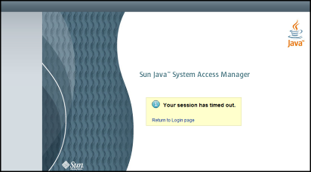

Logging Out
Logging out of the HCFRS is a two-step process: First you must logout of the HCFRS, then the Virtual Gateway single sign on portal.
- Logout of the HCFRS
To logout of the HCFRS, click the “Logout” button located on the upper right hand corner of the HCFRS Home Page.



This action logs the user out of the system and prompts the user to close the Internet Browser window within which the HCFRS was loaded. At this point the user is logged out of the HCFRS, but not the Virtual Gateway.
- Logout of the Virtual Gateway
To log out of the Virtual Gateway, click the “Logout” button on the right hand side of the Virtual Gateway Welcome Page.
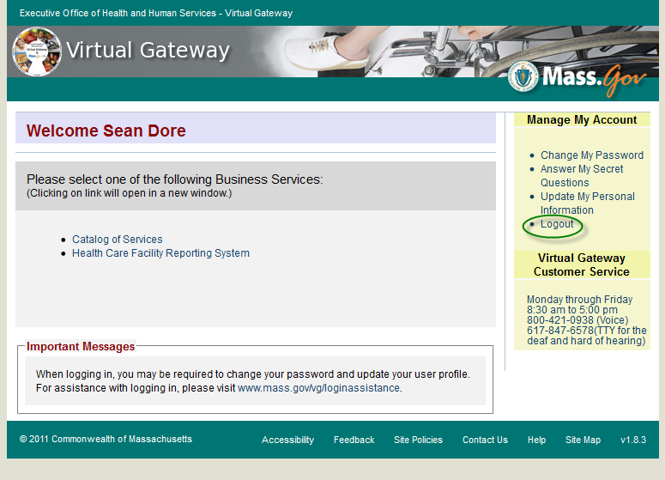
This will close the Virtual Gateway Welcome page and log you out of the Virtual Gateway.
NOTE: Must logout of both the Virtual Gateway and the HCFRS!
In order to log out of the HCFRS, you must log out of both the HCFRS and the Virtual gateway. If you only log out of the HCFRS and remain logged into the Virtual Gateway, users will then be able to re-launch the HCFRS without re-entering a username and password.
NOTE: Closing all internet browser windows automatically logs out of the system
Closing all the internet browser windows and tabs open on your computer will automatically log you out of the HCFRS and the Virtual Gateway. This is a security feature so that users who just close the internet browser do not remain logged in. However, if any other internet browser windows are open, even those that did not have the Virtual Gateway or the HCFRS in them, then the user will still be logged in. Thus, it is important to close all internet browsers or click the logout button after you are finished using the HCFRS

Data Submission and Security

Associations between Users
In an effort to enable easier reporting of Incidents and SRE occurrences at licensed hospitals, the DPH plans to make the HCFRS available to a wide range of end users who have reporting responsibilities. Reviewers at Bureau of Health Care Safety and Quality (BHCSQ) will track, monitor, and review SREs which occur at these licensed and certified health care facilities.
Authorized users at any given health care facility will have access to records in the HCFRS that have been created by that health care facility, but will not have access to records created by users at other health care facilities or BHCSQ.
Reviewers at the DPH and BHCSQ will track, monitor, and review Incidents and SRE occurrences once they are entered into the HCFRS and submitted by users at the health care facilities.
If an Incident or SRE occurrence is reported to DPH or BHCSQ by a source that is not a health care facility (e.g., a member of the public), a DPH or BHCSQ user will enter the Incident or SRE information into the HCFRS so that it can be tracked, monitored, and reviewed.

The HCFRS Home Page and Basic Navigation
After logging into the Virtual Gateway and the HCFRS, you will be directed to the HCFRS Home Page. The HCFRS Home Page provides information to end users and navigation buttons to access records within the system. Specifically, the Home Page is organized into the following sections, each of which is described below:
- Navigation Toolbar
- Shortcuts
- Workflows
- Recently Viewed Cases
- Resources
- Support
Navigation Toolbar

Shortcuts

Workflows
Recently Viewed Cases
Resources
Support

The Navigation Toolbar
Located at the upper left of the page, the Navigation Toolbar enables users to access the core functionality of the HCFRS. When the mouse pointer hovers over each icon on the Navigation Toolbar, a bubble-help note appears with the title of the icon’s function.
The following table shows the icons from the top left-hand side of the HCFRS Navigation Toolbar and briefly describes their functionality. The Navigation Toolbar offers quick access to some of the key functions within the application.
Create a Case – Clicking on this icon will allow users to create a new case in the system.

Search a Case – Clicking on this icon will allow users to search for an existing event.

Workflows – Clicking on this icon will allow users to view user Workflow queues. Workflow queues are designed to draw attention to events that may require some action by the user.

Reports – Clicking on this icon will allow users to generate reports such as a summary report, detailed report, and outstanding 30-day report.

Recent Cases – Clicking on this icon will allow users to see a list of recent events.

Shortcut Buttons
Located on the top right, the shortcuts allow quick access to open an existing case, view help material, and logout of the system.
Open Button. The Open button allows the user to quickly go to a case record when the user already knows the Case ID and Status. To use this button, the user will enter the HCFRS Case ID of the case they wish to retrieve. If a case has not yet been submitted to DPH, the HCFRS Case ID is a 10-digit ID consisting of letters and numbers. However, if a case has already been submitted to DPH, the HCFRS Case ID will have changed to a 7-digit ID consisting of letters and numbers in the following format: xxxx-xxx.
When users are uncertain of the status of a case, or do not know the Case ID, the HCFRS best practice is to search for the case using the Search a Case function by clicking on the magnifying glass icon in the Navigation Toolbar.
Help Button. The Help button will direct users to Help pages. Common issues are indexed within a Table of Contents to facilitate a search. Once a user has loaded a Case and the top shortcut buttons are no longer visible, there is a Help Button on the bottom of the page that will bring users to the Help sections specific to the part of the application they are accessing.
Logout Button. To logout of the system, click the Logout button. This action logs the user out of the system and takes the user back to the Virtual Gateway sign in page. At this point it is safe to close the browser window because the user has logged out of the HCFRS and will have to log back in to access data in the HCFRS.

Workflows
The Workflows box is located at the upper left of the Home Page. The HCFRS uses Workflows to identify events and tasks that require user attention. Based on predetermined and preprogrammed conditions, events automatically appear under Workflows based on what has happened or what has to happen next with an event. For example, if an event has been entered into the HCFRS by a Facility User, but has not yet been submitted to DPH, that event would appear in the “Incident Reports Awaiting Submission” Workflow.
Users should check the HCFRS Workflows daily to ensure that appropriate action is taken for pending events.
From the HCFRS Home Page, users can open a Workflow by highlighting and clicking the desired Workflow, or by clicking on the Workflows icon in the Navigation Toolbar at the top of the left-hand side of the Home Page.
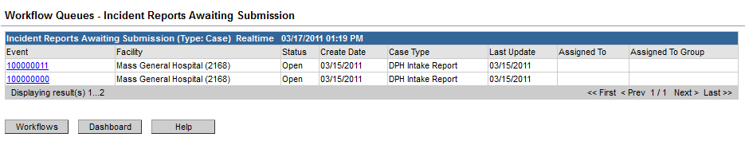
Once a Workflow has been opened, a user can open an existing Case listed within a Workflow by clicking on the Case ID number in the “Event” column.
Users can sort the cases in a Workflow by clicking on the column headings on the Workflow page. For example, if a user knows the date of an event, but does not know the case number, it may be helpful to sort by the date that the cases were created. Users can accomplish this by clicking on the “Create Date” column heading, which will cause an arrow to appear, indicating that the events in the Workflow are now being sorted by the “Create Date.”
To return to the HCFRS Home Page, click on the “Dashboard” button.
Users will see the following different types of Workflows depending on whether they are a Facility User or a DPH User:

Facility User Workflows
Depending on the type of event, there are two types of Workflows that could appear in the HCFRS for Facility Users.
Name | Description
Incident Reports Awaiting Submission | Intake Reports that have not been submitted by a facility user.
Awaiting 30 Day Report Submission | SREs that have not had their 30 day report submitted

DPH User Workflows
There are 8 types of Workflows that could appear in the HCFRS for DPH Users.
Name | Description
Incident Reports Awaiting Submission | Intake Reports that have not been submitted by a facility user.
Awaiting 30 Day Report Submission | SREs that have not had their 30 day report submitted
Incident Reports Awaiting 1st Approval | Intake Reports that have not been approved by the 1st DPH reviewer.
Incident Reports Awaiting 2nd Approval | Intake Reports that have not been approved by the 2nd DPH reviewer.
Incident Reports Awaiting Submission (by DPH Intake Group) | Intake Reports that have not been submitted and were created by the DPH Intake Group.
On-Sites Awaiting 2nd Approval | This is a subset of the “Incident Reports Awaiting 2nd Approval” Workflow. This Workflow will only contain cases classified as “On-Site Investigation” and those cases that are awaiting the 2nd DPH approval.
On-Sites Awaiting Processing to Legacy | On-Sites Awaiting Processing to the Legacy Incident System so it can be imported to the Complaints System.
Ongoing Off-Site Investigations | Intake Reports that are awaiting more information and are considered an ongoing Off-Site Investigation

Recently Viewed Cases
Recently Viewed Cases is located below the Workflows box at the left of the Home Page. This allows users to easily view and return to cases that were recently accessed or updated. To open a Recently Viewed Case, the user can highlight and click on the Case ID number. To view additional Recently Viewed Cases, highlight and click on the “More” link at the bottom right-hand corner of the Recently Viewed Cases box.

Resources
In the Resources section, users will find a list of key resources, such as the Serious Reportable Event (SRE) Fact Sheet and the HCFRS User Guide.

Support
In the Support section, users will find the contact information for the HCFRS Help Desk.

Case Dashboard
When opening a case, the Case Dashboard screen will be visible. The Case Dashboard offers high level information about the case. The following section describes each part of the Case Dashboard in detail.
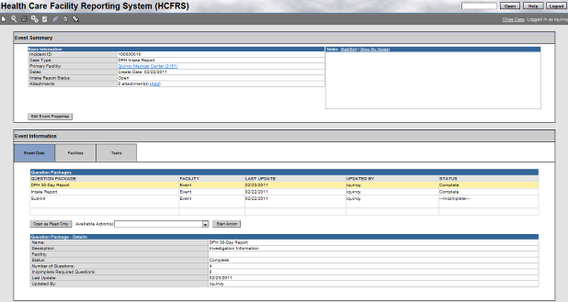
- The Event Summary section contains the Basic Information section. The Basic Information section will provide the following important summary information of the case being created:
  - Incident ID: this is an auto-generated number that uniquely identifies a case.
  - Case Type: this signifies the type of case and was previously selected on the Create Case screen. For Facility User purposes, this will always be set to “DPH Intake Report.”
  - Primary Facility: this is the facility to which this case corresponds.
  - Dates: this is the date that the case was created.
  - Intake Report Status: this is the status of the report within the HCFRS system. For Facility User purposes, this will always be set to “Open.”
  - Attachments: this will display the number of documents attached to this case. There is also an “Add” link that gives users the ability to attach documents to the case.

- The Event Information section is located in the middle of the screen. This section contains two tabs: Event Data and Facilities. Within the Event Data tab, there are two Question Package data tables. A Question Package is a grouping of questions that can be thought of as the electronic representation of a paper form. The Facility tab simply contains pre-populated information about the facility, such as name and address.

View Question Package
From the Case Dashboard, double-click on the name of a Question Package to open the Question Package in Read-Only mode. Read-Only mode allows a user to view the details even if the user does not have access to edit the information.
An alternative method to open a Question Package is to click on the name of the Question Package once to highlight it and then click on the “Open as Read Only” button.

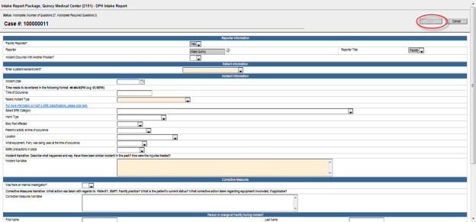

In Read-Only mode, the “Save” button at bottom of the page is disabled. Click on the “Cancel” button to return to the Event Summary and Event Information screen.

Create a Case
When an incident or SRE occurs at your facility that requires reporting to DPH, first gather information about the event and then start the data entry process. Once you have enough information regarding the incident, start entering the case into the system to be submitted for review by DPH. If the case falls under the SRE category, there is the additional requirement of entering and submitting the 30-day report (which will be covered in section 13). Create a case on the HCFRS system by following these steps:
- From the HCFRS Home Page, click on the “Create Case” icon in the Navigation Toolbar in the top left-hand side of the page. The “Create Case” icon is represented by the blank page icon. This will open the Create Case Screen.
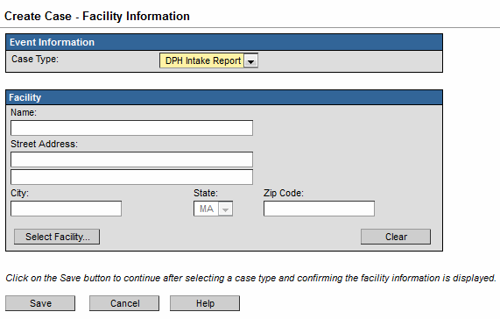
The Create Case screen is divided into two separate sections, Event Information and Facility.
- Event Information - The first section contains the Case Type drop down menu. This drop down menu allows the user to select from a list of available case types to submit. (The list of case types in the dropdown will depend on the user's permissions and role). Choose the appropriate case type by left-clicking the down arrow and picking from the list.
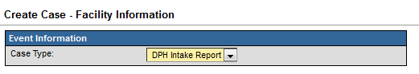
- Facility - Facility users will have the Facility information prefilled and will not be required to select a facility. DPH users will need to select a Facility from the system.

Steps to select a facility:

    - Click the “Select Facility” button at the lower left of the Add Case screen to open the facility search screen.
    - Enter in the search criteria for a facility. The search options are as follows:
- Facility ID
- Facility Name
- Facility Street Address
- Facility City
- Facility State
- Facility Zip Code
    - If the facility is located, select the facility's name from the list on the right side and click the Use Selected Party.

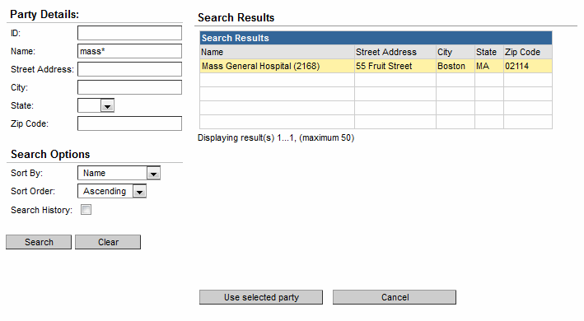
The more known data about the facility that can be entered, the better.

Once the data is entered automatically or by searching for an existing facility, click the Save button. This action automatically closes the Create Case window and brings the user to the Case Dashboard, where the newly-created event is now displayed.

- Enter Case Information - On the Event Data tab within the Case Dashboard, click on the Available Actions drop down menu. Select “Event – 1. Enter Intake Report” and then click the “Start Action” button. This will open the Intake Report.

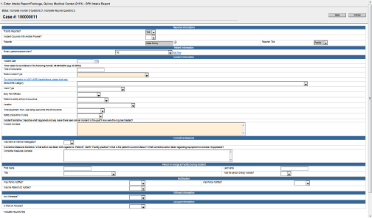
Listed below are some features of the Intake Report:
- Question Header - The top fixed pane in grey contains the name of the facility, the Case ID, and the “Save” and “Close” buttons. This information will always be displayed on the screen as you scroll through the form.
- Interactive Form - Depending on the answers entered for certain questions, the system may display or remove questions from the form. This will help streamline the data entry process in only displaying the questions that pertain to the given situation. The system will also customize the form based on the type of user (DPH or Facility User) and the type of facility to which the case pertains.
- Required Questions – The user can identify the required questions by the asterisk and the answer field highlighted in yellow. Required questions are those that need to be answered in order to complete the Intake Report. The user can still save the form and leave the case without answering the required questions, but will not be able to submit the report without answering them. This operates slightly differently from most web forms in that this system allows the user to navigate to another page without first completing the required questions. The status of the Intake Report will change from ‘Incomplete’ to ‘Complete’ when all of the required questions have been answered. The user will have to answer the required questions in these sections to complete the Intake Report.
- Prefilled Questions – In some situations, the system will prefill a question with an answer. In these cases, the answer field will be shaded grey and will be non-editable to the user.
- Repeatable Questions – Repeatable questions allow for multiple answers to the same question. This can be in the form of a single question or a block of questions. In these cases, an “Add New” link will appear next to the question. Clicking on this link will cause another instance of the question to appear, allowing the user to enter additional information if applicable.

After entering information for the case, the user has the option of either submitting the case to DPH now, or saving the case to be submitted at a later point in time. If the case is complete, it can be submitted to DPH. However, if the case is incomplete and/or the user is not ready to submit the case, then the case can be saved and closed to be completed later. Note that on the Event Data tab of the Event Information section you can verify whether or not the Intake Report is complete by looking at the extreme right column, “Status.” If the Intake Report status indicates that a case is incomplete, the user can reopen the report and complete the remaining question fields.

Locked Case and Closing a Case
Only one user at a time can have an "editable" copy of a case open. When one user has an event open, other users are not able to work on that same event. The HCFRS places a temporary lock on all active (open) events. When a user attempts to open an event that another user is already working on, the system displays an alert indicating that the event is locked. The user will still be able to open the event, however, access to the event will be in read-only mode. It is important to recognize that if a user is viewing an event in a read-only state, the question form will still seem to be editable. However, the “Save” button is deactivated, and thus they will be unable to save data. This feature is in place to prevent people from overwriting each other if there are multiple people entering in data for a particular case.
Because of the lock, it is important to Close a Case when finished working on it. When a user is working on a case, the system locks the case from editing by other users. Closing a case will release the lock from a case. Use the following steps to close a case:
- On the Case Dashboard, at the top left of the screen is the Navigation Toolbar. On the right hand side is a link called “Close Case.”

- Click on the Close Case link to tell the system that you are finished working on the case and want to release the lock on it. If you do not click the Close Case link before you leave the case, then the system will keep the lock on the case for 30 minutes.

- Once the case is closed, the Home Page screen is displayed. A case that has not been submitted can be found in the “Incident Reports Awaiting Submission” Workflow on the HCFRS Home Page.

Edit a Case
The Edit Case functionality allows a user to continue working on an incomplete Intake Report. The user can return to a previously saved case and edit it to complete the remaining question fields of the Intake Report. A user can only edit a case if it hasn’t been submitted to DPH. Use the following steps to edit an existing case:
            - Open the Case Dashboard for the case. Refer to the search section for instructions on searching for a case. Open the Intake Report by selecting “Enter Intake Report” from the available actions and clicking the “Start Action” button.

            - Once you are in the Enter Intake Report screen, you can edit any of the fields and complete any unanswered question fields. When you are finished editing, click the “Save” button at the top or bottom of the screen to save the changes. To leave the case, click the “Close Case” link in the upper right corner of the page.

Submit a Case
After creating the case and entering the required details in the Intake Report, the user can submit the case to DPH for review. Submitting a case will complete the Intake Report process. Follow these steps to submit a case for DPH review:
- If the case you wish to submit is not open already, open the case by either searching or utilizing a Workflow monitor.
- On the Case Dashboard, there is an option under the Available Actions drop down – “Event 2. Submit Intake Report.” Select this option and click on the “Start Action” button. This will open the Submit Intake Report question package page.
- The Submit Intake Report question package page screen contains the following three sections: Report Submissions, Follow-up Conversations and Incident Report Confirmations. If you are ready to submit the Intake Report, check the “Yes, I have completed all of the required fields and have confirmed the Intake Report status is complete” checkbox under Report Submissions.
- The Follow-up Conversations section allows the user to include a message regarding the submission that is viewable by DPH. Please note that information regarding the incident should be included in the Intake Report and not in the Follow-up Conversations section.
- Click on the “Save” button. This will submit the report. Please note that the fields under “Incident Report Submission Confirmations” section cannot be edited and are filled out by the system. These are used to track when the report is submitted.
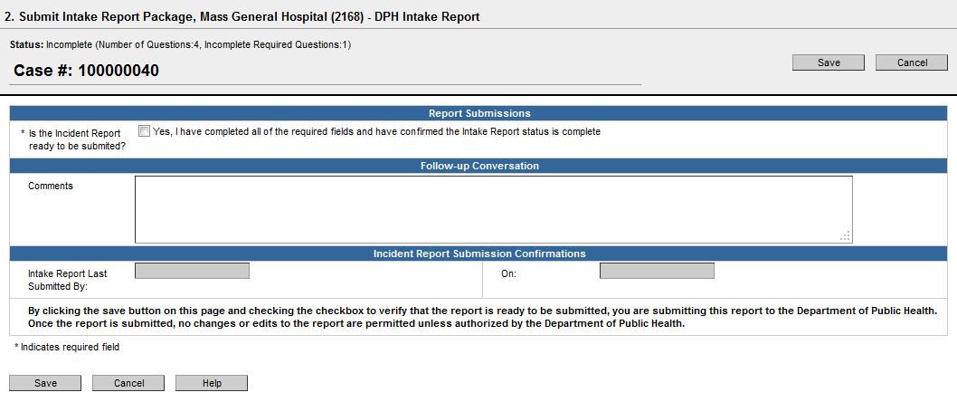
- After submitting the report, the Case Dashboard will be displayed. Under the Event Summary screen, notice that the case ID has changed. Every time a case is created, a 10-digit auto-generated ID is assigned to the case to uniquely identify it. When this case is submitted to DPH, a new ID is assigned to the case to attribute it to the facility from which it originated. This new ID is the ID that will be used to uniquely identify this case from this point forward.
The available actions for “Enter an Intake Report” and “Submit an Intake Report” will be no longer be available once a case has been submitted to DPH. The user can still open the Intake Report by selecting the Intake Report and clicking on “Open as Read-only” mode or double clicking the case it directly from the question package table. However, because the Intake Report has been submitted to DPH for review, the user will not be able to make any changes to it. The submitted case will no longer appear in the “Incident Reports Awaiting Submission” Workflow on the HCFRS Home Page.

Edit and Submit a Returned Case
During the DPH review process, DPH has the ability to send a case back to the facility user if more information is required. In such an instance, an email notification will be sent to the facility user stating, “Intake Report <incident ID> requires your attention.” Use the following steps to edit and resubmit a returned case:
- Click on the “Incident Report Awaiting Submission” Workflow Queue and find the case in question.
- Once on the Case Dashboard, open the “Submit” question package. In the “Follow-up Conversations” section, there should be some comments on why the case was returned to the facility user. This is how DPH will communicate what additional information is required to submit the case again.
- Enter in the required additional information and submit the case to DPH again following the same process as before.

Enter 30-Day Report
A 30-Day Report is required to be submitted by the facilities whenever a SRE incident is reported. To enter a 30-Day Report use the following steps:
- Open the intended SRE case from the “Awaiting 30 Day Report Submission” Workflow queue.
The “Awaiting 30 Day Report Submission” Workflow queue keeps track of the missing 30-Day Reports for SRE cases. A case gets added to this queue if it has been classified as a SRE case. The case will be removed from this queue when the 30-Day report for the case has been submitted to DPH.
- Select the “Enter the 30-Day Report” action and click on the “Start Action” button. The user will be brought to the 30-Day Report screen. The follow-up date field is auto-completed by the system based on the date of the incident and cannot be edited. This will serve as a reminder of when the 30-Day report is due.
- Complete the three question fields on this screen. For the “Check the boxes to confirm the following statements” question field, check the statements that are true for this case. Note that the “Preventability determination narrative” question field is required. For this section, write an explanation of action that is being taken to prevent the SRE from reoccurring. In the “Decision to seek payment” question field, select the option that applies to this case.
- Click the “Save” button at the bottom or the top of the screen. On the Case Dashboard, in the Event Data tab, the 30-Day Report status should have changed from Incomplete to Complete.
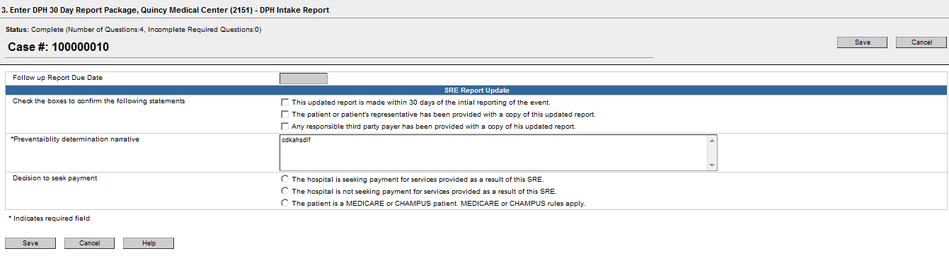

Submit 30-Day Report
If the 30-Day Report is not submitted in the allotted 30-day time frame, the HCFRS will remind in two ways. A follow-up email stating, “SRE Follow up report is due on <date>” will be sent to the facility user 10 days before the 30-Day Report is due. A second email will be sent to the facility user if the 30-Day report becomes overdue. These will be the only email reminders that will be sent regarding the 30-Day report. To submit a 30-Day Report:
- Open the Case Dashboard of the case. Select the “Submit 30-Day Report” from the Available Actions drop down menu and click on the “Start Action” button. The “Submit 30-Day Report Package” screen, which is similar to the Submit 30-Day Report screen, will be displayed.
- Submit 30-Day Report screen will have the following three sections: Report Submissions, Follow-up Conversations, and Incident Report Confirmations. To submit the 30-Day Report, check the “Yes, I have completed all of the required fields and have confirmed the 30 Day Report status is complete” checkbox under Report Submissions. The “Follow-up Conversations” section allows the user to include a message to DPH regarding the submission. Please note that information regarding the 30-Day Report should be included in the 30-Day Report, and not in the “Follow-up Conversations” section.
- Click the “Save” button to submit the report. Please note that the question fields under “30-Day Report Submission Confirmations” section cannot be edited and are auto-filled by the HCFRS. These fields are used to track when the report is submitted.
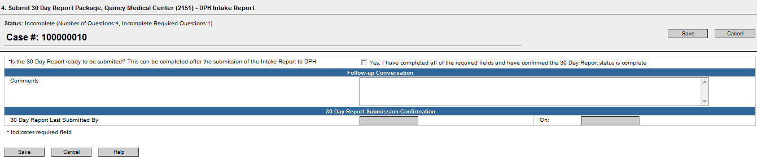
- A user can check whether the submission of the 30-Day Report was successful by viewing the “Available Action” drop down list. If the 30-Day Report has been successfully submitted, the list will not include the “Enter 30-Day Report” or “Submit 30-Day Report” options. On the HCFRS Home Page notice that the case has been removed from the “Awaiting 30 Day Report Submission” Workflow queue.

Search a Case
To locate an event that the user has not worked with recently, use the Search Case screen. Use the following steps to search for a case:
- To search for a case, click the “Search Case” button on the Navigation Toolbar to display the Search Case screen.
- Enter information about the case into the various fields under Search Criteria, and then click the “Search” button.
- The search results appear in a table to the right. If the system does not find a matching record, then a "No Matching Cases Found" message will appear below the table. If a matching record for the event is located, select the event from the table and click the “Use Selected Event” button.
- The following search criteria are available:
- Case ID: The unique ID of the event. Click this link to load the event.
- Name: Name of the Facility, as it appears on the Case Dashboard under, “Basic information and Primary facility.’
- Street address: Street Address of the facility, as it appears on the Case Dashboard under the Facilities tab.
- City: City where the facility is located, as it appears on the Case Dashboard under the Facilities tab.
- State: State where the facility is located. Note that the user cannot search for a case only by entering the state. For example, if just MA is selected from the list of the states, a “Minimum search criteria not specified” message will be displayed. Therefore, you will have to enter at least one additional search criteria along with the State.
- Zip Code: Zip code of the facility, as it appears on the Case Dashboard under the Facilities tab.
- At this time, it will not be useful for a user to search by Case Type because all Case Types are set to “DPH Intake Report.”
- Patient’s First Name and Last Name: The Patient’s first name and last name are the names of the patient involved in the incident.
- Incident Type: Incident Type is the event type as it appears on the Intake Report.
- Click “Search.” (Note: Clicking the “Clear” button will delete any search parameters that have been entered.)
- Search results will display in the table to the right of the screen, as shown.
- Upon locating the case in question, select the corresponding line and click “Use Selected Case” or simply double-click the record.
- This action automatically closes the search window and displays the selected record in the Case Dashboard.
NOTE: Case Access
A system user will be able to locate only the cases the user can access with respect to the permissions settings for that particular user. However, the DPH user can access all cases. The “Use Selected Case” button on the Search Case screen will only display events that the user is authorized to see, based on his or her group membership.
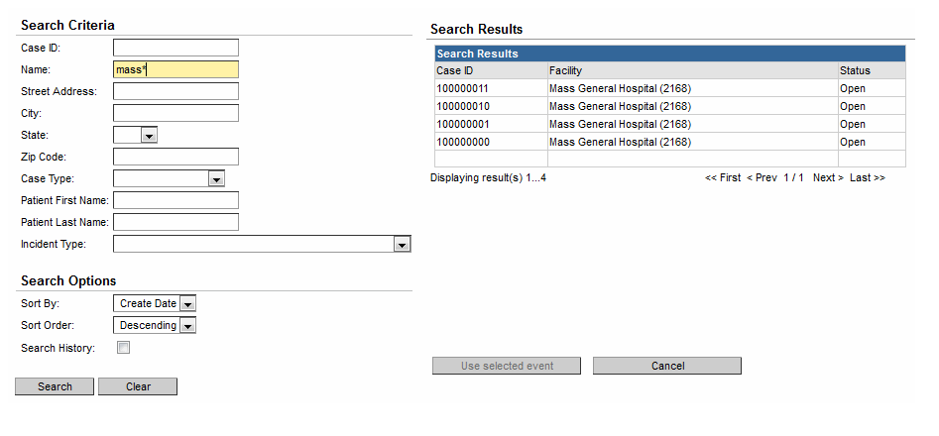
Using wildcards in searches - The search screens in the HCFRS support the use of wildcard characters. In the HCFRS, the wildcard character is an asterisk (*). The asterisk can represent one or more characters. You must enter at least two standard characters in a search field in order to use a wildcard. For example, entering mi* in the First Name field would return search results where the Patient’s first name is Michael, Mike, Minnie, Mickey, Millie, etc.
Sort By –The “Sort By” and “Sort Order” options provide two drop down menus for the user to choose how the search results are presented. The first drop down menu specifies which field to sort results by and the other drop down menu specifies the order in which the results will be presented, ascending (alphabetical or numeric) or descending (reverse alphabetical or numeric) order.

Print a Case
The system allows common letters, forms, and other documentation to be printed with prepopulated information about an event. To print a document, the user must first select a case to be referenced and then click the “Print Event” button.
- Open the case for which a document needs to be printed.
- Click the “Print Event” button.
- A screen will appear listing all the documents that are available for printing related to the specific event.
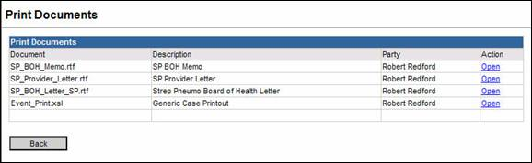
- Locate the desired document from the list displayed.
- Click the name of the document, or click the “Open” link in the Action column.
- A screen similar to the one below will prompt the user to Open or Save the document (These steps may vary slightly depending on the user’s version of the software).
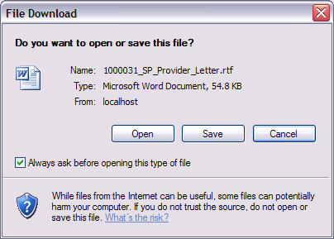
- Click “Open” to immediately open the document, or “Save” to save it before opening. (If the user clicks “Save,” a “Save As” screen will prompt the user to designate a location in which to save the document).
- The document opens in a new window populated with data from the case.
- To print a hard copy of a document, click the print option within the application. For example, in Microsoft Word, click “File/Print” to print the document.
- From the Print Documents screen, click the “Back” button to return to the Case Dashboard.
NOTE: If there is pre-populated data that is missing or incorrect in the print document, the user MUST go back into the system to make the updates. Otherwise the changes made to the document will not be retained. After making changes in the system, click on the print template again from the Print Documents screen and the information will be updated. Please note that if you are using Microsoft Word 2000, the document must first be saved locally and then opened from where it was saved. It is preferable to use the most recent version of Internet Explorer (or your browser of choice) if the user experiences problems with opening documents.

Reports
Reports in the HCFRS can be used to view and analyze data. The section explains how to run reports. Some reports can be displayed in two ways: In a non-editable format within the browser window or exported to an external application such as Excel. Exporting the data, allows for the data to be manipulated, formatted, and even graphed.
Viewing Reports
To run a report, follow the instructions below:
- From the HCFRS Home Page, click the “Reports” button.
- Click the “Category” drop down list and select the desired report category.
- Click the “Select Report” drop down list and select the desired report.
- If there is a description of what the report is used for and how it works, the description will be displayed.
- Enter the appropriate parameters for the report, including the Start Date and End Date of the data to be reported. Note that if the user needs to see data for the current day, the End Date should be set to the following day.
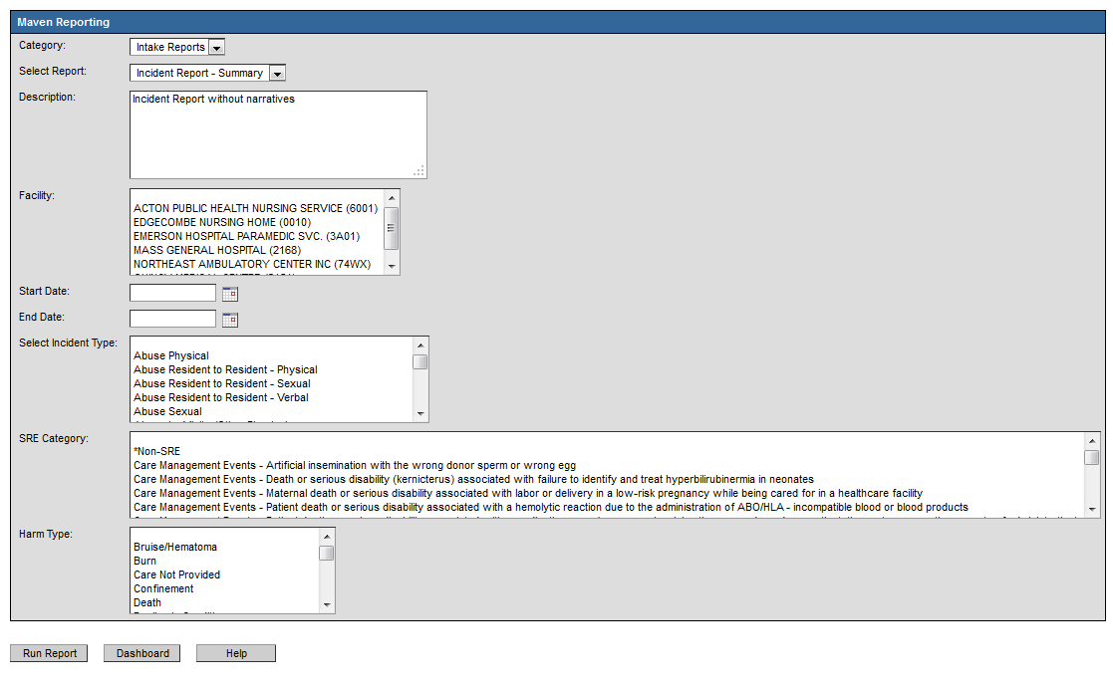

- To view the report in a browser window, click the “Run Report” button. This will display the results, but the user will be unable to change the formatting of the data.
Exporting Report Results
Depending on the type of report and the user’s level of access, the system may allow the report to be exported to Excel. Use the following steps to export the results.
- Follow the steps to select the report and set the parameters as needed. To view the report in Excel, click the Export Results button. The user will be prompted with a security warning from Microsoft.
- Click “Open” to immediately open the report, or click “Save” to save it before opening. (If the user clicks “Save,” a “Save As” dialog box will prompt the user to designate a file name for the report and a location in which to save the report.)
- The report opens and the data is able to be manipulated within the limits of Excel.

Approve a Case
Whenever a reportable incident occurs at a facility, it needs to be reported to DPH. Incidents are reported in the form of individual cases. The cases are created and submitted by the facility to DPH for further investigation. When DPH receives a case, it needs to confirm that all the required information is present in the case before pursuing further investigation. The review process is a two-person review.
1st Review
- On the HCFRS Home Page, click on the “Incident Reports Awaiting 1st Approval” Workflow queue. Select the intended case from the “Workflow Queues - Incident Reports Awaiting 1st Approval” screen by clicking on the case id. The user will be brought to the Case Dashboard.
- Review the information in the case by opening up the question packages in read-only mode.
- To approve a case, select the “Review Intake Report” from the Available Actions drop down menu, and click on “Start Action.”
- The Review Intake Report Package screen is displayed by the system. The Intake Review Package has the following sections: Revise Answers, DPH Synopsis, Disposition Status, Incident Report Approvals, Report Submissions, Follow-up Conversation and Data Exports.
- To approve the case, the reviewer should review the Revise Answer section, assign the Disposition Status to the case in the field “Incident Logged As,” and check the 1st Reviewer Approval checkbox.
- An optional step is if there are any comments or notes that you would like to leave for the 2nd reviewer, enter the comments into the “Reviewer Comments” field. Only users who have access to review and approve cases will have access to these comments.
- Click on the “Save” button at the bottom of the screen to save the approval. The Case Dashboard will be displayed. Click on the Close Case link to navigate out of the case.
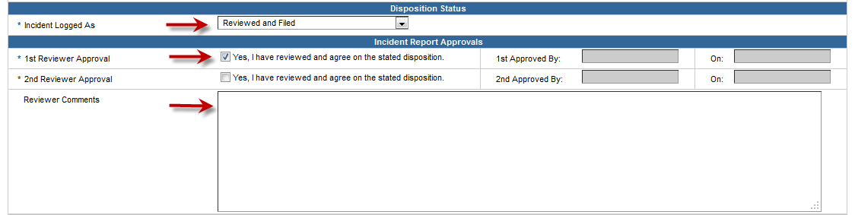
2nd Review
- On the HCFRS Home Page, click on the “Incident Reports Awaiting 2nd Approval” Workflow queue. On the Case Dashboard, notice that under the question packages section, the Reviewer Status shows: “Incomplete.”
- Review the information in the case by opening up the question packages in read-only mode.
- To approve the case, select “Review Intake Report” from the Available Actions drop down menu and click “Start Action.” The Review Intake Report Package screen is displayed by the system.
- The Review Intake Report Package screen displayed will be identical to the 1st Review Intake Report Package. However, the 2nd Review Intake Report Package will have the “Incident Logged In As” and the “1st Reviewer Approval” fields filled out. Review the question package, and if approved, check the 2nd Reviewer Approval checkbox.
- Click on the “Save” button at the bottom of the screen to Save the 2nd Review. On the Case Dashboard the status of “Reviewer” in the Question Package section will have changed from “Incomplete” to “Complete.”

Return a Case
A DPH Reviewer can return a case to the facility if more information regarding the incident is required.
- To return a case, login to the HCFRS Home Page and select the case from the “Incident Reports Awaiting 1st Approval” or “Incident Reports Awaiting 2nd Approval” Workflow queue.
- Select the intended case from the Workflow queue and navigate to the Case Dashboard. Select “Review Intake Report” from the “Available Actions” drop down menu, and click “Start Action.” The Review Intake Report Package screen is displayed by the system.
- To return the case to the facility for more information, uncheck the “Is the Incident Report ready to be submitted?” checkbox from Report Submission section. Click on the “Save” button at the bottom of the screen. This case will be available in the “Incident Reports Awaiting Submission” Workflow queue on the Case Dashboard of the facility it was sent from.
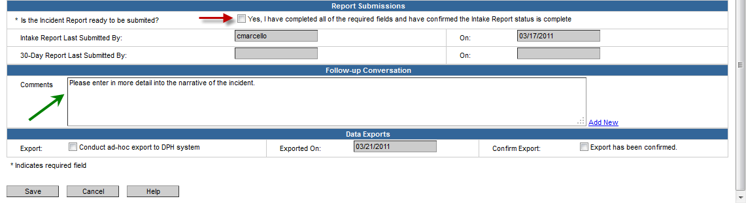

Enter Incident Synopsis of a Case
A DPH user can enter the Incident Synopsis for a case with up to 500 characters. The synopsis will be made available to the Legacy Complaints System. To enter the Incident Synopsis, use the following steps:
- Open a case to reach the Case Dashboard.
- Select “Enter Incident Synopsis” from the Available Actions drop down menu and click “Start Action.” The Enter Incident Synopsis Package screen is displayed by the system.
- Enter in the Incident Synopsis into the field. Note that the full narrative for the case is displayed as read-only.
- Click on the “Save” button at the bottom of the Enter Incident Synopsis screen to save the synopsis.
