Hepatitis remains a serious health threat that kills thousands of Americans annually and is a leading cause of liver cancer. The U.S. is facing rising rates of viral hepatitis, with tens of thousands of people newly infected with viral hepatitis every year.

In Massachusetts, overall cases of hepatitis C are rising. Although the number of new cases are declining, an estimated 250,000 people are now infected with hepatitis C. Not enough testing is done, especially in primary care settings, where opportunities to identify and treat cases are being missed. The Massachusetts Department of Public Health (DPH) estimates that only about 14% of Massachusetts residents have been tested for hepatitis C virus (HCV) infection at least once.

# of cases

While hepatitis A and hepatitis B are vaccine-preventable, hepatitis C is not. Hepatitis C can, however, be cured.

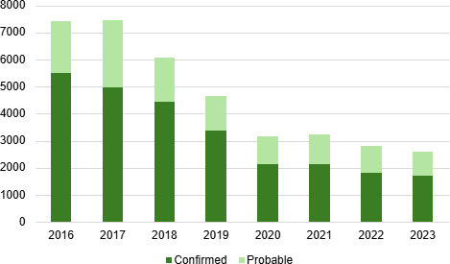

Figure 1. Confirmed and probable hepatitis C cases by year, MA, 2016-2023 . N=37,344. The number of newly reported confirmed and probable HCV cases has decreased substantially between 2016 and 2023, from a high of 7,450 cases in 2017, down 65% to 2,580 cases in 2023. While data should be interpreted with caution between 2020-2022 due to the impact on screening and clinical services from the COVID-19 pandemic, this decrease is also likely driven in part by the effect of increases in MA of prevention strategies such as harm reduction, with many cities and towns in MA now providing such services.



More than 95% of people with hepatitis C infection can be cured with 8-12 weeks of oral medication. Yet data show that in Massachusetts, only about 4 of 10 people with chronic hepatitis C infection receive treatment within one year after diagnosis.

# Treating hepatitis C: addressing myths

For most patients, hepatitis C treatment is not complicated and can begin without first waiting to see if someone spontaneously clears the virus on their own.

Treatment can be administered by primary care practitioners; it does not need to be prescribed by a specialist such as a hepatologist or gastroenterologist.

There are no clinical contraindications for treatment of patients who are using, or recently stopped using, drugs or alcohol.

Most patients tolerate treatment well. Clinicians should not assume that patients are unable or unwilling to adhere to treatment practices.

MassHealth and most insurers in Massachusetts do not restrict treatment based on sobriety. For most insurers in Massachusetts, there are no limits on the number of times a patient may be treated for hepatitis C. Patients are not restricted to a single course of treatment.



Most newly reported cases of hepatitis C infection are among people under age 30 who inject drugs.

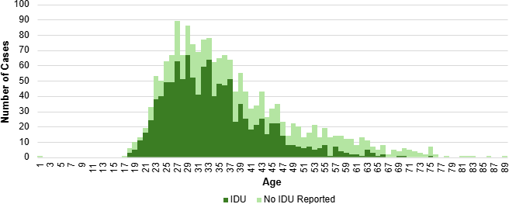

Figure 2. Number of acute hepatitis C cases reported by age and injection drug use risk,

MA, 2016-2023. N=1,781. 3 cases not included due to missing age, the “No IDU Reported” category includes cases with unknown IDU status. Acute cases of hepatitis C infection between 2016 and 2023 primarily occurred among adults under 40 years of age, and the predominant risk factor among acute cases is injection drug use.

# Testing for hepatitis C: latest guidance

Universal testing is urged for all groups as indicated below.

 All adults aged 18 years and older, at least once in their lifetime  All pregnant people during every pregnancy

Testing regardless of age or setting is recommended for anyone at risk:

 People who inject drugs and shared needles, syringes, or other injection equipment, even if once or many years ago

 People with HIV infection

Routine periodic testing is recommended for:

People with ongoing risk, especially people who inject drugs

People with medical conditions such as those receiving hemodialysis Any person who requests hepatitis C testing

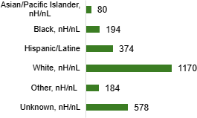 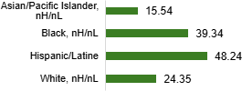

Figure 3. Number and rate per 100,000 of confirmed and probable hepatitis C cases by race and ethnicity, MA, 2023. N=2,580. The “Other” category includes combinations of two or more of the following race categories: "White," "Black," “American Indian or Alaska Native," "Asian/Pacific Islander "or "Other." American Indian or Alaska Natives are included in this category because data for this group alone cannot be displayed due to small case counts (1-4 cases) and small populations (<50,000).



Though the highest number of hepatitis C cases in Massachusetts in 2023 was observed among people identifying as White, non-Hispanic/non-Latine, the highest rates of infection were observed among individuals identifying as Hispanic/Latine and Black, non- Hispanic/non-Latine, which may be driven by inequitable access to prevention services such as harm reduction or medical treatment including curative therapies for hepatitis C infection.

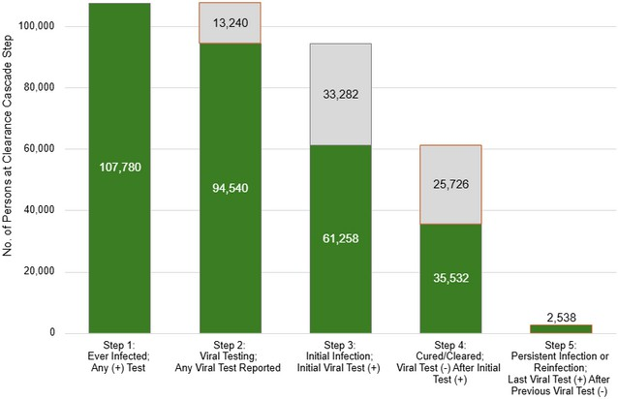Figure 4. Laboratory-based hepatitis C virus clearance cascade, MA, 2014-2023. The hepatitis C virus clearance cascade is a framework to measure population-level progress toward HCV clearance or cure.

A total of 107,780 individuals had at least one positive test for hepatitis C between 2014 and 2023. Of those, 94,540 (88%)

had a confirmatory test performed. Of those with confirmatory testing, 61,258 (65%) tested positive, and of those testing positive, 35,532 (58%) cleared infection. Persistent infection or reinfection was observed for 2,538 (4%) of all of those who cleared infection.

While Massachusetts outperformed the national estimate of 34%, 58% cleared/cured is short of the 80% goal by 2030 set by the US Viral Hepatitis National Strategic Plan and included in the Massachusetts HCV Elimination Plan. Developing a laboratory-based HCV clearance cascade illuminates gaps in confirmatory testing and treatment, as indicated by the sections of the figure highlighted in orange. At least 13,240 people need HCV confirmatory testing and at least 28,264 people need HCV treatment.



**Massachusetts Department of Public Health**

Bureau of Infectious Disease and Laboratory Sciences