INDOOR AIR QUALITY ASSESSMENT
ODOR INVESTIGATION

Health Care Quality Office
99 Chauncy St
Boston, Massachusetts

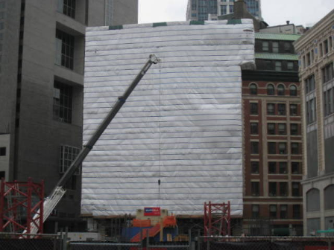

Prepared by:
Massachusetts Department of Public Health
Bureau of Environmental Health
Indoor Air Quality Program
April 2012

Background/Introduction
The Bureau of Environmental Health (BEH) responded to a request for assistance in evaluating indoor environmental concerns associated with façade renovations and a window replacements project at the Bureau of Health Care Safety and Quality (BHCSQ) offices located on the 2nd and 3rd floors of 99 Chauncy Street in Downtown Boston. Joyce Hilton of BHCSQ contacted the BEH’s Indoor Air Quality (IAQ) Program on May 3, 2012 to report staff concerns associated with odors and dusts from the renovations. A visit to the areas of concern was made by BEH IAQ staff On May 9, 2012 to evaluate building conditions and containment procedures for the renovation work.

Methods
Plans for the work in progress were discussed with BHCSQ prior to the visit. Given that no window replacement or related activities directly impacting the DPH-occupied spaces were being conducted at the time of the visit, no air quality measurements were conducted. Visual observations were made of the building’s exterior, the containment procedures in place inside and outside of the building for the façade renovation, as well as other conditions in the office spaces potentially impacted by the window replacement process.

Discussion
A number of factors were observed on the inside and outside of the building that may increase the potential for construction impacts into the occupied space.
- The location of the building, with a current vacant lot/construction site to the west, exposes the building to winds from the Boston Common area; this along with the presence of tall buildings along Avery Street may exacerbate impact of particulate matter associated with 99 Chauncy Street renovations.
- The current wrap covering outside the scaffolding is likely “trapping” the wind, pressurizing the space between the wrap and the wall of the building, forcing dust and odors into the building.
- Current containment inside the building consists of plastic material that is taped to the wall around the window frames, sometimes reinforced with staples (Picture 1). This material was noted to lack adherence with the tape peeling off in some offices, and deliberately breached with small holes (Picture 2) in most of the exterior offices examined. Containment only functions when it is continuous and intact; any holes can allow dust, debris and odors from construction activities to penetrate into occupied spaces. Where containment breaks, it needs to be repaired as soon as possible. The building and construction management contractors should be notified to repair the containment as soon as feasible. Containment is put in place for the protection of all occupants of the interim space and should not be deliberately breached.
- The configuration of the office spaces were evaluated in anticipation of planned interior window replacement. This work will involve creating holes in the building while the old windows are removed and the new ones are installed. The estimated time frame for this process according to the contractor is approximately two weeks. Ideally, work should take place while the affected areas are unoccupied.
- There were also concerns expressed regarding a raccoon infestation along the scaffolding of the building, for which Department of Fish and Game staff had been onsite but had not yet resolved. During the window replacement process, care must be taken to avoid potential entry of these and other pest animals into the building.

Recommendations
Based on the assessment performed by BEH/IAQ staff and discussion with BHCSQ staff on the project, the following recommendations are made:
- Window replacement would best be carried out either after business hours or on weekends.
- Given that the areas with cubicles 323 through 329 on the third floor as well as cubicles 229 through 234 and office 235 on the second floor cannot be readily contained using plastic sheet and tape without significant disruption of DPH operations, window replacement in these locations should not be done during business hours.
- It is further recommended that DPH personnel do not occupy an individual office during its window replacement. Ideally, alternative work space should be established for DPH staff during window replacement at their workstation. Efforts to coordinate the move of materials to the swing space should be undertaken before the work begins. One to two days of swing space should be allotted per office dependent on whether odors exist after the window is replaced.
- Current and future containment should be inspected by the construction contractor at least once per day for breaches and other problems. Staff should be strongly advised not to disturb containment. If staff observe plastic barriers with any breaches such as accidental rips or peeling tape during the work day, that staff should report this condition to a designated BHCSQ staff person for liaison with building management as soon as possible.
- Individual office doors should be sealed before the window removal begins using construction-grade plastic and tape both at the window opening itself and at the door, while window replacement work takes place. This will ensure that fugitive emissions/particulates do not enter other occupied areas of the space.
- Fresh air supplies and return vents in offices that are undergoing windows replacement must be sealed with plastic and tape during the work on that area to prevent the exhaust ducts from providing a migration path to occupied space. Any other breaches, such as incomplete interior walls or transoms must also be sealed.
- Construction-related cleaning, separate from regular building cleaning, must be conducted in each affected area once the work in that area is completed and before it is reoccupied. In order to facilitate post-construction cleaning, direct staff to clean work areas before work in individual areas. Extraneous files and other materials are more difficult to clean thoroughly.
- Consistent with Massachusetts General Laws, obtain from the building management the Material Safety Data Sheets (MSDSs) for any products, such as sealant or paint, to be used during the renovations so that these materials are available to building occupants if requested.
- Establish a system of notification between building occupants, program supervisory staff and the building and construction contractors so that scheduling information can be communicated promptly and so that building occupants can effectively report concerns and problems.
- Contact the BEH IAQ program to perform a follow-up assessment as warranted.
Figure 1

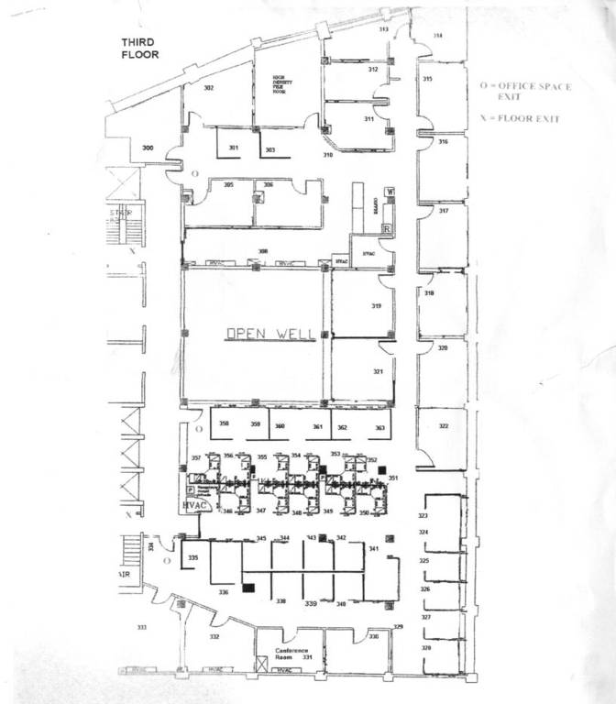

3rd Floor Plan of 99 Chauncy Street
(Box Indicates Location of Advised Week End Replacement)
Figure 2

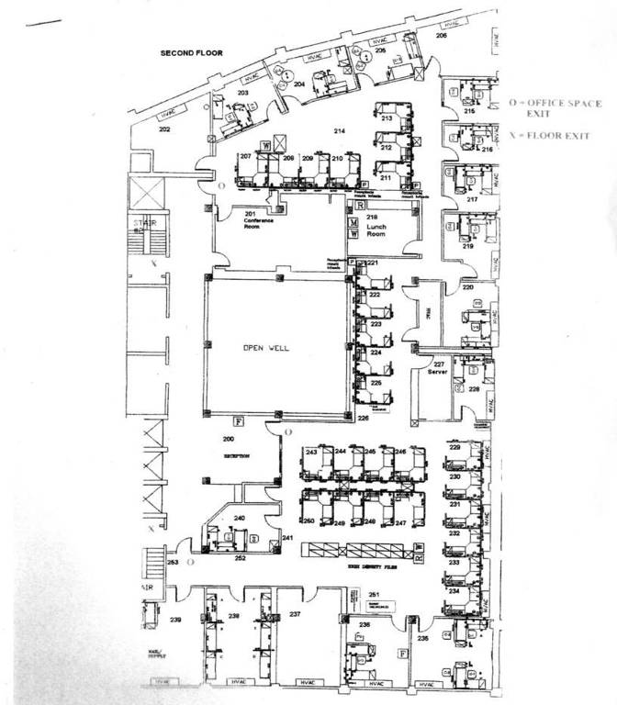

2nd Floor Plan of 99 Chauncy Street
(Box Indicates Location of Advised Week End Replacement)
Picture 1
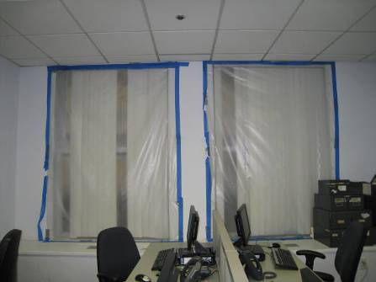
Typical containment during façade renovations
Picture 2
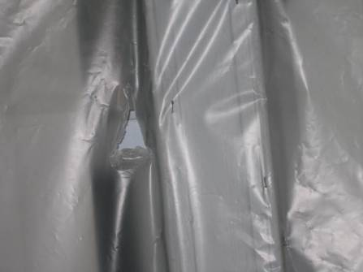
Hole in containment

