
The Commonwealth of Massachusetts
Executive Office of Health and Human Services Department of Public Health
250 Washington Street, Boston, MA 02108-4619
617-624-6000 | mass.gov/dph

Maura T. Healey
Governor
Kimberley Driscoll
Lieutenant Governor
Kiame Mahaniah, MD, MBA
Secretary
Robert Goldstein, MD, PhD
Commissioner

January 7, 2026

Timothy Carroll House Clerk
State House Room 145 Boston, MA 02133

Michael D. Hurley Senate Clerk
State House Room 335 Boston, MA 02133

Dear Mr. Clerk,

Pursuant to Sections 25L and 25N of Chapter 111 of the Massachusetts General Laws, please find enclosed a report from the Department of Public Health entitled the Massachusetts Health Care Workforce Center Annual Report, May 2024.


Sincerely,

Robert Goldstein, MD, PhD Commissioner
Department of Public Health

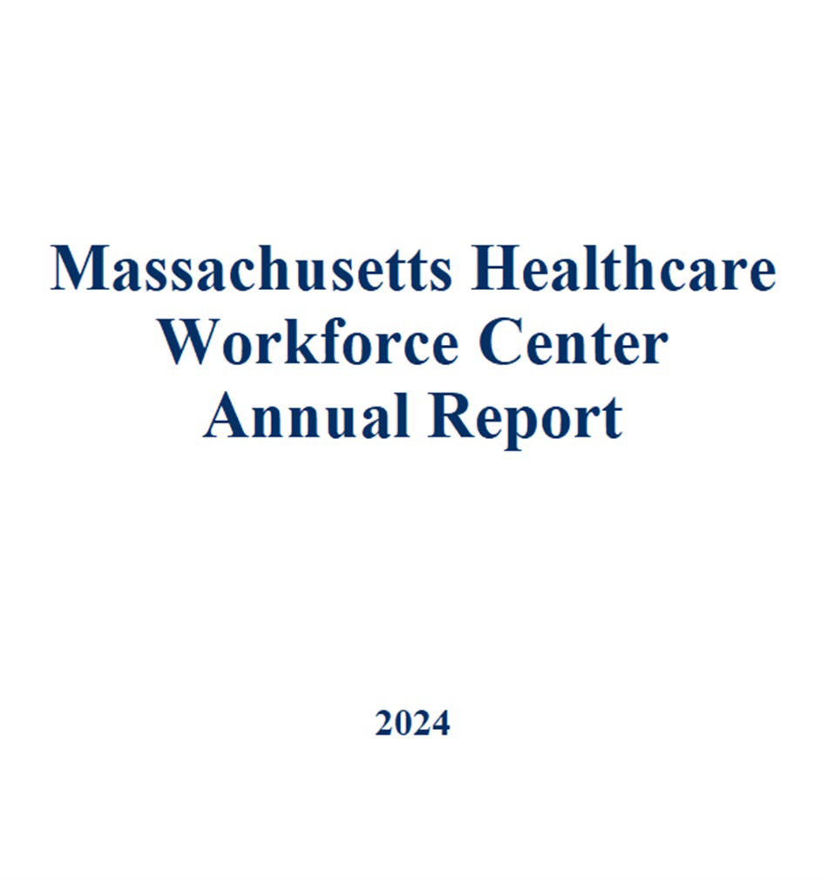
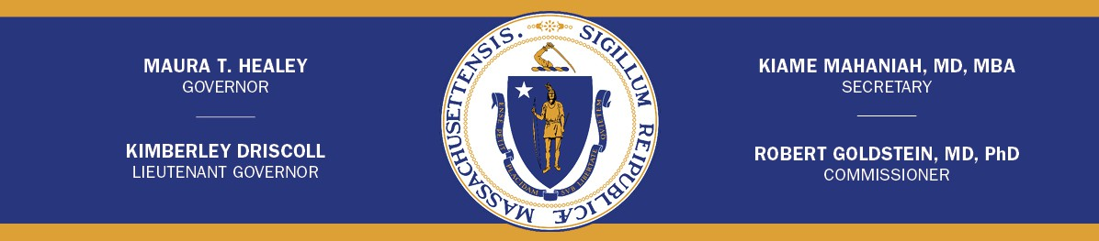

Legislative Mandate
Chapter 111 M.G.L, Section 25L
- There shall be in the department a health care workforce center to improve access to health and behavioral, substance use disorder and mental health care services. The center, in consultation with the health care workforce advisory council established by section 25M and the secretary of labor and workforce development, shall: (1) coordinate the department’s health care workforce activities with other state agencies and public and private entities involved in health care workforce training, recruitment and retention, including with the activities of the Health Care Workforce Transformation Fund; (2) monitor trends in access to primary care providers, and nurse practitioners and physician assistants practicing as primary care providers, behavioral, substance use disorder and mental health providers, and other physician and nursing providers, through activities including (i) reviewing existing data and collection of new data as needed to assess the capacity of the health care and behavioral, substance use disorder and mental health care workforce to serve patients, including patients with disabilities whose disabilities may include but are not limited to intellectual and developmental disabilities, including patient access and regional disparities in access to physicians, nurses, physician assistants, and behavioral, substance use disorder and mental health care professionals and to examine physician, nursing and physician assistant, behavioral, substance use disorder and mental health professionals’ satisfaction; (ii) reviewing existing laws, regulations, policies, contracting or reimbursement practices, and other factors that influence recruitment and retention of physicians, nurses, physician assistants, behavioral, substance use disorder and mental health professionals; (iii) projecting the ability of the workforce to meet the needs of patients over time; (iv) identifying strategies currently being employed to address workforce needs, shortages, recruitment and retention; (v) studying the capacity of public and private medical, nursing, physician assistant, behavioral, substance use disorder and mental health professional schools in the commonwealth to expand the supply of primary care physicians and nurse practitioners and physician assistants practicing as primary care providers and licensed behavioral, substance use disorder and mental health professionals; (3) establish criteria to identify underserved areas in the commonwealth for administering the loan repayment program established under section 25N and for determining statewide target areas for health care provider placement based on the level of access; and (4) address health care workforce shortages through the following activities, including: (i) coordinating state and federal loan repayment and incentive programs for health care providers; (ii) providing assistance and support to communities, physician groups, community health centers and community hospitals in developing cost-effective and comprehensive recruitment initiatives; (iii) maximizing all sources of public and private funds for recruitment initiatives; (iv) designing pilot programs and making regulatory and legislative proposals to address workforce needs, shortages, recruitment and retention; and (v) making short-term and long-term programmatic and policy recommendations to improve workforce performance, address identified workforce shortages and recruit and retain physicians, nurses, physician assistants and behavioral, substance use disorder and mental health professionals.
- The center shall maintain ongoing communication and coordination with the health disparities council, established by section 16O of chapter 6A.
- The center shall annually submit a report, not later than March 1, to the governor, the health disparities council, established by section 16O of chapter 6A; and the general court, by filing the same with the clerk of the house of representatives, the clerk of the senate, the joint committee on labor and workforce development, the joint committee on health care financing, and the joint committee on public health. The report shall include: (1) data on patient access and regional disparities in access to physicians, by specialty and sub-specialty, and nurses, physician assistants, behavioral, substance use disorder and mental health professionals; (2) data on factors influencing recruitment and retention of physicians, nurses, physician assistants, and

behavioral, substance use disorder and mental health professionals; (3) short and long-term projections of physician, nurse, physician assistant and behavioral, substance use disorder and mental health professionals supply and demand; (4) strategies being employed by the council or other entities to address workforce needs, shortages, recruitment and retention; (5) recommendations for designing, implementing and improving programs or policies to address workforce needs, shortages, recruitment and retention; and (6) proposals for statutory or regulatory changes to address workforce needs, shortages, recruitment and retention.
Chapter 111 M.G.L, Section 25N

- There shall be a health care workforce loan repayment program, administered by the health care workforce center established by section 25L. The program shall provide repayment assistance for graduate and medical school loans to participants who: (1) are graduates of medical, nursing, or physician assistant schools or accredited graduate schools; (2) specialize in family health or medicine, internal medicine, pediatrics, obstetrics/gynecology, psychiatry, behavioral health, mental health or substance use disorder treatment; (3) demonstrate competency in health information technology, at least equivalent to federal meaningful use standards as set forth in 45 C.F.R. Part 170, including use of electronic medical records, computerized physician order entry and e-prescribing; and (4) meet other eligibility criteria, including service requirements, established by the board.
Each recipient shall be required to enter into a contract with the commonwealth which shall obligate the recipient to perform a term of service of not less than 2 years in medically underserved areas as determined by the center.
- The center shall promulgate regulations for the administration and enforcement of this section which shall include penalties and repayment procedures if a participant fails to comply with the service contract.
The center shall, in consultation with the health care workforce advisory council and the public health council, establish criteria to identify medically underserved areas within the commonwealth. These criteria shall consist of quantifiable measures, which may include the availability of primary care medical services or behavioral, substance use disorder and mental health services within reasonable traveling distance, poverty levels and disparities in health care access or health outcomes.
- The center shall evaluate the program annually, including exit interviews of participants to determine their post-program service plans and to solicit program improvement recommendations.
- The center shall file an annual report, not later than July 1, with the governor, the clerks of the House of Representatives and the senate, the house and senate committees on ways and means, the joint committee on health care financing, the joint committee on mental health and substance abuse and the joint committee on public health. The report shall include annual data and historical trends of: (1) the number of applicants, the number accepted and the number of participants by race, gender, medical, nursing, physician assistant, behavioral health, substance use, and mental health specialty, graduate, physician assistant, medical or nursing school, residence prior to graduate, medical, nursing, or physician assistant school and where they plan to practice after program completion; (2) the service placement locations and length of service commitments by participants; (3) the number of participants who fail to fulfill the program requirements and the reason for the failures; (4) the number of former participants who continue to serve in underserved areas; and (5) program expenditures.

Executive Summary
This report provides information on the activities of the Department of Public Health’s (DPH) Health Care Workforce Center (HCWC) for calendar year 2023, the latest year for which data are available. The current health care workforce shortages experienced across the state underscore the importance of DPH’s work, paired with the work of the Executive Office of Health and Human Services MA Repay Program and the Executive Office of Education’s Financial Aid Expansion for Massachusetts Public College and University Students, to mitigate workforce shortages and increase access to health care professionals for underserved communities.

HCWC was established by Chapter 305 of the Acts of 2008 and expanded by Chapter 224 of the Acts of 2012. HCWC’s mission is to improve access to health care in the Commonwealth by supporting programs that assure an optimal supply and distribution of primary care and other health care professionals. The HCWC sits within the newly established Division of Community-Based Prevention and Care’s Workforce Innovations Center
The HCWC strives to fulfill its mandate and to further the goals of Chapter 224 by focusing its work in four areas:
  - Collection and analysis of data on the Commonwealth’s licensed health care workforce to support development of targeted strategies for addressing workforce gaps.
  - Administration of programs, including the Massachusetts Loan Repayment Program for Health Professionals (MLRP), the Conrad-30 / J-1 Visa Waiver Program (J-1 Visa Waiver Program), and the National Interest Waiver Program which encourages recruitment and retention of primary care providers and by supporting the selection of National Health Services Corps (NHSC) providers administered by the federal Health Resources & Services Administration (HRSA).
  - Supporting Shortage Designation applications in our role as the Massachusetts Primary Care Office for HRSA.
  - Coordinating with DPH health care workforce activities, including workforce development within the Commissioner’s Office, and other public and private primary care workforce development efforts. This work includes collaborating with other state agencies and programs, provider-based member organizations, state taskforces and committees, and schools of health professions and residency programs. The HCWC Advisory Council also provides guidance to the work and strategic direction of the HCWC.

To achieve program goals in 2023, the Health Care Workforce Center completed the following:
    - Leveraged federal and state health programs to provide loan repayment and visa incentives for 59 health professionals to practice in Massachusetts’ communities with provider shortages and underserved populations.
    - Approved 8 National Health Services Corp Program site applications to maintain the robust system of 245 National Health Service providers working at 92 sites across the state.
    - Updated data, supplementary materials, and scores for 14 Health Professional Shortage Designations for submission to HRSA.

Health Care Workforce Data Collection
The Health Professions Data Series was developed by the HCWC in 2009 following a state mandate to monitor the composition and distribution of health care providers in order to identify solutions to potential health care workforce shortages. A core dataset was developed to facilitate the monitoring of workforce trends and then incorporated into the licensure renewal process of seven health care provider disciplines including physicians, physician assistants, registered nurses, licensed practical nurses, dentists, dental hygienists, and pharmacists.

The core dataset contains data elements such as provider name, specialty, licensing, education and educational status, languages spoken, employment characteristics (e.g., location, practice type, provider role, planned work hours), and training needs related to providing care to patients with a disability. Data collection includes discipline-specific questions that are related to emerging practices and regulations. Data are collected biennially as a part of the state’s license renewal cycle.

In 2023, the Nursing Council on Workforce Sustainability reviewed the registered nurse licensure renewal survey and recommended updates and additions to the survey, including updated options for gender identity, race and ethnicity, and language, and new questions related to student debt load, hours worked per week, and contracted and travel nursing. The HCWC and the Bureau of Health Professions Licensure Board of Registration in Nursing approved these recommendations, and the updated survey was implemented for the 2024 registered nurse renewal cycle. The HCWC will be working with each licensure board that currently has a renewal survey over the next several renewal cycles to ensure the surveys are updated to capture new information that is relevant to each profession.

In 2023, the HCWC analyzed 2017-2022 Board of Registration in Nursing data; 2018, 2020, 2022 Board of Registration in Dentistry data; and 2022 Board of Registration in Medicine data. The 2018, 2020, and 2022 Board of Registration in Pharmacy data was also received in 2023 and will be analyzed in early 2024. While historically these data have been published as data briefs within a series, moving forward the HCWC will utilize data summary tables and dashboards to increase data usability and ensure the timely release of the data to inform policies and practices to meet the needs of the workforce and residents in real-time. These data summary tables and dashboards are being developed and will be published once finalized.
Data summary tables and dashboards will help inform program improvements for the Massachusetts Loan Repayment Program and support policy and program development and improvement for other programs within DPH, such as the Office of Oral Health, the Office of Health Equity, the State Office of Rural Health, the Bureau of Health Professions Licensure, and the Bureau of Substance Addiction Services.

Administration of Federal and State Programs
The HCWC plays a critical role in the recruitment and retention of primary care providers to care for underserved communities. For the past 16 years, HCWC has been implementing and promoting the following federal and state programs:
    - Massachusetts Loan Repayment Program for Health Professionals (MLRP)
    - J-1 Visa Waiver Program (J-1 Visa Waiver Program)
    - National Interest Waiver Program (NIW Program)
    - National Health Service Corps (NHSC)
    - Primary Care Office Shortage Designations
The HCWC is part of the Workforce Innovations Center within the Division of Community-Based Prevention and Care, which was established in 2022 to align community health programs and community health workforce initiatives. The Workforce Innovations Center also includes the Office of Community Health Workers, the Office of Oral Health, and community health center capacity building activities. Other programs within the Division include Cancer Initiatives and the Asthma Prevention and Control Program. The HCWC’s location in the Division ensures it is connected to important community health initiatives across the state and working collectively to address new and on-going health workforce needs.
Massachusetts Loan Repayment Program for Health Professionals The Massachusetts Loan Repayment Program for Health Professionals (MLRP) aims to increase Massachusetts residents’ access to primary care services in communities with significant shortages of health care providers and other identified barriers to care. The MLRP repays the educational loans of health professionals working in eligible healthcare organizations through grant funding from HRSA and state funds from the Bureau of Community Health and Prevention and the Bureau of Substance Addiction Services (BSAS) for Substance Use Disorder (SUD) Clinicians.

DPH has contracted with the Massachusetts League of Community Health Centers (MLCHC) to administer the application and award processes for the MLRP. The HCWC and MLCHC have a mutually agreed upon scope of work that includes conducting the MLRP application process, facilitating application review teams, and making the awards to recipients. The contract requires the MLCHC to adhere to MLRP policies, standard operating procedures, and federal program requirements.

MLRP is available to a variety of health professionals who provide health care services in outpatient primary care settings, outpatient behavioral health settings, and outpatient or residential substance use disorder (SUD) treatment settings. Eligibility is dependent upon the availability of federal and state resources and changes annually based on state needs. MLRP disciplines are listed below in Table 1.

Table 1: Eligible Health Professions for Massachusetts Loan Repayment Program
Advanced Practice Registered Nurses (APRN) | Marriage and Family Therapists (MFT)
Dentists (DDS & DMD) | Mental Health Counselors (MHC)
Doctor of Osteopathic and Allopathic Medicine (DO & MD) | Pharmacist (PharmD)
Health Service Psychologists (HSP) | Physician Assistant, (PA)
Licensed Independent Clinical Social Workers (LICSW) | Registered Dental Hygienists (RDH)
Licensed Professional Counselors (LPC) | Substance Use Disorder (SUD) Clinicians (LADC-I; LADC-II or CADC-I; CADC-II, and Bachelor Level SUD Services Professionals  interested in becoming Licensed)

Additional efforts have expanded loan repayment access for primary care and behavioral health clinicians. HCWC has collaborated with BSAS to expand MLRP to include SUD Clinicians. BSAS has provided funding for MLRP for the past several years for this purpose.

In 2023, the MLRP received 40 applications of which 33 applications were complete and eligible for review. The applications were scored by review teams using a standardized tool. With a total of $2,285,000, comprised of $735,000 in federal grant dollars,
$550,000 in state funds, and $1,000,000 in BSAS funding, the MLRP made 33 loan repayment awards to health professionals who committed to serve full-time for two years or part-time for four years in areas of the state with health professional shortages. Table 2 outlines the number of MLRP awards by profession:

Table 2: Number of MLRP Awards by Profession (2023)
Pharmacist | 10
Nurse Practitioner (NP) | 10
Medical Doctor (MD) | 2
Dentist | 2
Physician Assistant (PA) | 2
Licensed Independent Clinical Social Worker (LICSW) | 2
Dental Hygienist | 1
Licensed Mental Health Counselor (LMHC) | 1
Mental Health Counselor (MHC) | 1
Psychologist | 1
Grief Counselor | 1
Total | 33

Among those awarded, 8 (25%) were practicing in underserved areas in Boston and 25 (75%) outside of Boston; 30 (91%) practiced in urban areas and 3 (9%) in rural areas; 2
(6%) provided primary care services, 1 (3%) provided mental health services, and 3 (9%) provided dental health services; and 10 (30%) are pharmacists. The race and ethnicity of the 33 awarded applicants were: 0 (0%) American Indian, 0 (0%) biracial, 2
(6%) Black, 7 (21%) Asian, 4 (12%) Hispanic, 20 (61%) White.

Conrad 30/J-1 Visa Waiver Program
Another important resource for primary care capacity-building in underserved areas of Massachusetts is the Conrad 30/J-1 Physician Visa Waiver Program (J-1 Visa Waiver Program). State health departments can support up to 30 J-1 visa waivers for foreign physicians who plan to work in federally designated shortage areas and agree to provide safety-net services for medically underserved people for at least three years.

J-1 visas allow international medical school graduates to come to the United States under an educational exchange program, such as a residency or fellowship, for up to seven years. When their J-1 visa expires, they must return home for at least two years before applying for a permanent visa to come back to the United States. J-1 Visa Waivers eliminate the two-year home residency requirement and allow foreign-born physicians to remain and practice medicine in the United States if they agree to practice in a federally designated shortage or underserved area for at least three years. State government health agencies can sponsor up to thirty J-1 visa waiver requests annually through this program.

The HCWC prioritizes MLRP and J-1 visa waiver applications that support racial equity and the diverse needs of medically underserved communities. Furthermore, the HCWC supports DPH priorities to ensure a widespread geographic reach, addressing state residents’ behavioral health needs, including mental health and substance use disorder, and ensuring access to correctional health.

In 2023 the J1-Visa Waiver Program, DPH received 26 applications and supported all
26. A review of the applications was conducted by experienced review teams. Among the supported 26 applicants, there were 5 primary care physicians including psychiatrists and 21 non-primary care physicians including hospitalists, emergency room physicians, and specialists in professions where shortages exist. The program defines primary care as internal medicine, family practice, pediatrics, ob-gyn, geriatrics, and psychiatry.

Physicians Supported for J-1 Visa Waivers to Practice in Massachusetts (2023)
Primary Care Physicians/Psychiatrists | 5
Specialists | 21
Total Conrad-30/J-1 Visa Waiver Physicians | 26

National Interest Waiver Program
Through the National Interest Waiver Program (NIW), the U.S. Citizenship and Immigration Service (USCIS) allows individuals of exceptional ability and individuals who are members of professions holding advanced degrees to be granted a Green Card for permanent residence. This includes physicians who agree to work for a period of five years in an underserved area with a health professional shortage designation or in a Veterans Affairs facility. Physicians seeking a waiver must obtain a statement from a state department of health or a federal agency that has knowledge of the physician’s qualifications and is willing to attest that the physician’s work is in the public interest.
The HCWC provides letters to support these EB-2 petitions attesting that the physician applicants practice in an eligible site in a shortage area, such as a federally qualified community health center site. In 2023, the HCWC provided 20 NIW support letters.

National Health Service Corps
The National Health Service Corps (NHSC) awards scholarships and loan repayment to primary care providers in eligible disciplines at approved sites in communities where there are substantial provider shortages. While the HCWC does not administer or operate this program, it plays an important role in promoting the program to health care organizations and potential health provider applicants and assists Massachusetts healthcare organizations with becoming NHSC sites including reviewing and approving all eligible site applications. In 2023, the HCWC reviewed 9 applications and recommended 8 from Massachusetts health care organizations to participate in the federal NHSC program. Most of the applications were already-approved sites to be renewed, but some were new. Currently, the program has a total of 258 NHSC health providers in Massachusetts practicing at 92 sites across the state.

Current NHSC Program Participants in Massachusetts (2023)
NHSC Loan Repayment Program | 216
NHSC Scholars Program | 21
Student to Student Program | 21
Total NHSC Participants | 258

Health Professional Shortage Designation
The HCWC is responsible for managing federal Health Resources and Services Administration (HRSA) shortage designation databases, conducting the local and statewide assessments, and preparing and submitting applications for Massachusetts. Shortage designations are based on the evaluation of shortage/underservice criteria established by HRSA to qualify either geographic areas, population groups, or facilities as having a shortage of primary health care providers, dentists, and mental health professionals. The communities that qualify for Health Professional Shortage Area (HPSA) designation and Medically Underserved Area/Population (MUA/P) designation represent the most medically underserved populations in the state. The overall purpose is to identify areas of greatest need, so that limited resources can be prioritized and directed to the people in those areas.

Federal shortage designations provide access to federal grant funding, access to loan repayment incentives, and other program benefits for Massachusetts communities,

health care facilities, and providers. Some shortage designation benefits include clinician eligibility for MLRP, the J-1 Visa Waiver Program, National Health Service Corps (NHSC), and Medicare bonuses paid to physicians, and eligibility to bill Medicare for telehealth, among other benefits.

In 2023, Massachusetts had 151 designated HPSAs and 46 MUA/MUPs. Our HPSAs include: 6 geographic, 15 low-income population, 111 Federally Qualified Health Center (FQHC)/FQHC lookalikes, and 19 Correctional/ Facility HPSAs. Among the 3 HPSA health profession types, 47 are dental HPSAs, 49 are mental health, and 55 are primary care.

HRSA updates Massachusetts HPSA scores every two years as part of their National Service Data Update (NSDU). The next NSDU is scheduled for September 2024. In preparation for this process, existing healthcare provider data was reviewed and updated in HRSA’s Bureau of Health Workforce online Shortage Designation Management System (SDMS).

The HCWC worked with providers and organizations whose HPSA profile was expiring and scheduled to be withdrawn from SDMS. State and county houses of correction that served as state loan repayment and NHSC program sites were prioritized this year. The HCWC worked with prison leadership to generate and upload up-to-date providers lists to SDMS. For dental HPSAs that were rescheduled for withdrawal, the HCWC worked with the Office of Oral Health to ensure accurate dental provider information was uploaded to SDMS. In addition, new HPSA applications were explored for the City of Brockton and for Boston Healthcare for the Homeless Program. These applications are still in process while additional supporting documentation is gathered and explored.

In 2023, the HCWC submitted a total of 14 HPSA re-score applications for 4 Geographic HPSAs, 7 Low-Income Populations, and 3 Correctional Facilities HPSAs to HRSA. Two MUA/Ps were also reviewed. Licensure renewal data from the Board of Registration in Medicine and the Board of Registration in Dentistry as well as MassHealth claims data were used to verify physicians and dentists practice locations and to determine patient volume, particularly low income, Medicaid patient volume. The HCWC also gathered additional demographic, socioeconomic, and health trends data from each site to support applications.

Health Professional Shortage Designations Activity (2023)
Primary Care Shortage Designations | 4
Mental Health Shortage Designations | 2
Dental Health Shortage Designations | 5
Correctional Facility Designations | 3
Total NHSC Participants | 14

Conclusion
The Massachusetts HCWC expanded its loan repayment programs and developed additional trainings for health professionals that aim to address workforce shortages in primary care, racial equity, and workforce diversity, to improve the lives of the medically

underserved. Additional efforts to develop workforce scholarship and pipeline programs are essential to closing workforce gaps and meeting the needs of Massachusetts residents.

In 2023, the HCWC analyzed up to date relicensure data for our seven professions. By 2024, we will have updated data on the healthcare workforce labor supply so that DPH, our partners and other interested organizations can use these data to inform policies and programs aimed at addressing healthcare workforce shortages and improving access to care.

The Department of Public Health’s Health Care Workforce Center continues to support, maintain, and build a strong health care workforce that provides highly accessible quality care to all Massachusetts residents.

For more information about the DPH Health Care Workforce Center’s programs, please the webpage at : https://www.mass.gov/the-massachusetts-health-care-workforce-center-hcwc

