__________________________________________________________

Health Consultation
__________________________________________________________

Former Zonolite Facility

Wemelco Way

Easthampton, Hampshire County, Massachusetts

EPA Facility ID: MAD019335561

DECEMBER 15, 2006

Prepared by:

Environmental Toxicology Program
Center for Environmental Health
Massachusetts Department of Public Health
Under a cooperative agreement with the
Agency for Toxic Substances and Disease Registry
U.S. Department of Health and Human Services
Atlanta, Georgia
Foreword

ATSDR National Asbestos Exposure Review

Vermiculite was mined and processed in Libby, Montana, from the early 1920s until 1990. We now know that this vermiculite, which was shipped to many locations around the United States for processing, contained asbestos.

The National Asbestos Exposure Review (NAER) is a project of the Agency for Toxic Substances and Disease Registry (ATSDR). ATSDR is working with other federal, state, and local environmental and public health agencies to evaluate public health effects at sites that processed Libby vermiculite.

The evaluations focus on the processing sites and on human health effects that might be associated with possible past or current exposures. They do not consider commercial or consumer use of the products from these facilities.

The sites that processed Libby vermiculite will be evaluated by
- identifying ways people could have been exposed to asbestos in the past and ways that people could be exposed now, and
- determining whether the exposures represent a public health hazard.

ATSDR will use the information gained from the site-specific investigations to recommend further public health actions as needed. Site evaluations are progressing in two phases:

Phase 1: ATSDR has selected 28 sites that met either of the following criteria for the first phase of reviews:

- The U.S. Environmental Protection Agency (EPA) recommended further action at the site based upon contamination in place.

- The site was an exfoliation facility that processed more than 100,000 tons of vermiculite ore from a Libby mine. Exfoliation, a processing method in which ore is heated and “popped,” is expected to have released more asbestos than other processing methods.

The following document is one of the site-specific health consultations that ATSDR and its state health partners are developing for each of the 28 Phase 1 sites. A future report will summarize findings at the Phase 1 sites and include recommendations for evaluating the more than 200 remaining sites nationwide that received Libby vermiculite.

Phase 2: ATSDR will continue to evaluate former Libby vermiculite processing sites in accordance with the findings and recommendations contained in the summary report. ATSDR will also identify further actions as necessary to protect public health.

Table of Contents

Summary 1
Introduction 3
Background 4
Statement of the Issues 4
History of the Former Zonolite Site 4
Vermiculite Processing and Environmental Contamination 5
Initial Site Investigation and Site Activities 6
Health and Environmental Concerns Associated With Asbestos 7
Asbestos Health Effects and Toxicity 8
Summary of Field Investigations 16
Soil Sampling 16
Air Monitoring 20
MDPH Site Visits 23
Exposure Pathway Analysis 24
Past Exposure Pathways 25
Present Exposure Pathways 28
Future Exposure Pathways 30
Discussion 31
Exposure Assessment and Toxicological Evaluation 32
Exposure and Health Concerns Associated With the Former Zonolite Facility 32
Health Outcome Data 37
Child Health Section 38
Conclusions 39
Recommendations 41
Public Health Action Plan 42
Past Actions 42
Ongoing Actions 42
Certification 45
References 46
Tables 1–9 50
Figures 1–8 57
Appendices A–D 65
Appendix A 66
Appendix B 75
Appendix C 76
Appendix D 77

List of Tables

Table 1 Asbestos in soil samples at the former Zonolite site analyzed by polarized light microscopy (PLM) and transmission electron microscopy (TEM)

Table 2 Asbestos in surface soil samples (0 through 3 inches) at and near the former Zonolite site collected between May 2000 and April 2001 and analyzed by polarized light microscopy (PLM)

Table 3 Asbestos in near-surface soil samples (3 inches through 2 feet) at and near the former Zonolite site collected between May 2000 and April 2001 and analyzed by polarized light microscopy (PLM)

Table 4 Asbestos in subsurface soil samples (2 through 10 feet) at and near the former Zonolite site collected between May 2000 and April 2001 and analyzed by polarized light microscopy (PLM)

Table 5 Background/ambient air samples collected on-site during soil sampling at the Easthampton former Zonolite site and analyzed by phase contrast microscopy (PCM) (NIOSH Method 7400)

Table 6 Background/ambient air samples collected off-site during soil sampling near the Easthampton former Zonolite site and analyzed by phase contrast microscopy (PCM) (NIOSH Method 7400)

Table 7 Ambient air samples collected during soil sampling at the Easthampton former Zonolite site and analyzed by transmission electron microscopy (TEM)

Table 8 Ambient air samples collected during soil sampling near the Easthampton former Zonolite site and analyzed by transmission electron microscopy (TEM)

Table 9 Personal air samples collected at the Easthampton former Zonolite site and analyzed by phase contrast microscopy (NIOSH Method 7400)

List of Figures
Figure 1 Site map of the former Zonolite facility, Easthampton, Massachusetts

Figure 2 Site plan with sample locations, former Zonolite facility, Wemelco Way, Easthampton, Massachusetts

Figure 3 Initial surface soil sampling in May 2000, former Zonolite facility, Wemelco Way, Easthampton, Massachusetts

Figure 4 Detection in off-site rail bed west of the facility, former Zonolite facility, Wemelco Way, Easthampton, Massachusetts

Figure 5 Asbestos surface soil detections from grid sampling, former Zonolite facility, Wemelco Way, Easthampton, Massachusetts

Figure 6 Asbestos subsurface soil detections, former Zonolite facility, Wemelco Way, Easthampton, Massachusetts

Figure 7 Easthampton personal air samples (1974 to 1984), former Zonolite facility, Wemelco Way, Easthampton, Massachusetts

Figure 8 Easthampton personal air samples (1985 to 1991), former Zonolite facility, Wemelco Way, Easthampton, Massachusetts

List of Appendices

Appendix A Site Visit Photographs

Appendix B Wind Rose Data, 1998–2002, Westfield-Barnes Municipal Airport, Westfield, Massachusetts

Appendix C ATSDR Pathway Table

Appendix D ATSDR Hazard Category Definitions

Summary

The former Zonolite facility in Easthampton, Massachusetts, was an exfoliation plant operated by W.R. Grace & Company (WRG). The facility received asbestos-contaminated vermiculite from Libby, Montana, from 1963 to 1984, for the production of Zonolite attic insulation and Monokote fireproofing material. The facility continued production using vermiculite from other sources until 1992. The site, including a former rail line that abuts and passes through the southeastern property boundary, is located in a mixed residential and commercial area. It is one of 28 Phase 1 sites being evaluated by the federal Agency for Toxic Substances and Disease Registry (ATSDR) National Asbestos Exposure Review.

ATSDR analyzed environmental data and limited historical information for the site to assess past, present, and future opportunities for exposure for workers and the surrounding community. From this analysis, ATSDR determined that a completed exposure pathway of inhalation exposure to asbestos existed in the past for workers. It also existed for people who were in contact with workers at home, and potentially for individuals who may have had access to the site and areas of the rail bed that pass through and extend out from the site. Under past conditions the site posed a public health hazard. Currently, the potential pathway is still a concern with regard to certain areas of the rail bed.

Surface soil results analyzed by polarized light microscopy (PLM) indicate that detections of up to 9.8% asbestos were found in the on-site disposal area, which is currently covered and surrounded by thick vegetation. The site is accessible, primarily via an inactive rail bed that passes through and extends outward from the site. The on- and off-property portions of this rail bed contain asbestos ranging from nondetectable amounts up to 3.3% in surface soil. Of the sampling results available to date, the highest rail bed concentrations are located just off the property to the west-southwest. Evidence that the rail bed is currently used includes worn foot paths, empty beverage cans, and all-terrain vehicle (ATV) tracks. A path from the rail bed leads to a residential area nearby. Plans for construction of a bike path, part of a rails-to-trails project, have been proposed for the rail bed. Exposure concerns must be addressed before construction can begin. More than 50% of the surface soil samples collected along the rail bed had trace detections of asbestos. Furthermore, recreational activities tend to disturb surface soil and create dust. They also may increase a person’s rate of breathing, which may potentially increase the intake of asbestos-contaminated soil or dust.

Under current site conditions, according to ATSDR criteria, ATSDR would classify the site as an “indeterminate public health hazard.” Asbestos was detected in soil at levels at or above (≥) 1% and trace detection less than (<) 1% along the off-property and on-property portions of the rail bed. Evidence of ATV recreational use (e.g., possible ATV tracks and ramps) along the rail bed suggests that exposure to asbestos in air could potentially occur at the site. However, no air data are available for this area while recreational activities were occurring.

Further action is recommended to improve security or reduce opportunities for exposure, particularly along the rail bed west of Wemelco Way where recreational activities appear to be occurring. Additional soil and air sampling are recommended, also. Given that asbestos levels were found in air during soil boring work on the property, the Massachusetts Department of Public Health (MDPH) recommends that air sampling be conducted as a precaution during future remediation and development to assess opportunities for exposure. A review of asbestos-related cancer incidence and mortality information by MDPH is in progress and will be released as a separate report.

Introduction

The former Zonolite facility is located at the end of Wemelco Way in Easthampton, Massachusetts (Figures 1 and 2), in a mixed residential and commercial area. The site is bordered by
- Wemelco Way on the west,
- D.O.S Concrete Construction Co. (DOS) to the north,
- a former rail line that runs northeast-southwest through Easthampton to the south, and
- a hayfield to the east.

Approximately 1,393 people live within ½ mile of the site (W&C 2001a). The nearest residences are located within a 10th of a mile from the property boundary. A preschool operates within a ¼ mile northwest of the site.

The site occupies approximately 2.5 acres. It includes a warehouse (the location of the former Zonolite facility), a large paved parking lot on the northwest side of the building, and a former rail line that extends beyond the property boundary. East of the facility, an underground natural gas line runs south to north, and east of the gas line is a hayfield (see Figures 1 and 2 for site plan). Thick vegetation covers much of the site, but the rail bed and possibly the disposal area are accessible. Parts of the rail bed area are exposed, but thick plant growth covers the disposal area. There are no fences or locked gates on the property.

Plans to construct a bike path along the rail bed have been proposed. Exposure concerns with regard to asbestos will need to be addressed before construction.

Background

Statement of the Issues
The former Zonolite site in Easthampton is one of 28 Phase 1 sites being evaluated by the Agency for Toxic Substances and Disease Registry (ATSDR) as part of the National Asbestos Exposure Review. It was the site of an exfoliation facility that received shipments of concentrated vermiculite from Libby, Montana, beginning in 1963. Vermiculite ore from the Libby mines was contaminated with a specific form of asbestos, referred to as Libby asbestos. W.R. Grace & Company (WRG) shipping invoices, although not available from 1963 through 1966, indicate that from February 1966 to September 1984, approximately 183,255 tons of vermiculite from Libby were processed at the plant in Easthampton (EPA, unpublished, undated).

History of the Former Zonolite Site

Available records, from ATSDR and the Massachusetts Department of Environmental Protection (MA DEP) Western Regional Office (WERO) indicate that the exfoliation facility was operated by Grace Construction Products, a unit of WRG, and leased from Oldon Realty Trust /Oldon Limited Partnership (Oldon) from 1963 to 1992 (Leggette, Brashears & Graham 1996). Exfoliated vermiculite is commonly used as a conditioner for potting soil. It is also used as a bulking agent or additive in paint and plaster and for applications such as fireproofing and insulation. According to MA DEP, the Easthampton facility processed Libby vermiculite ore until 1984 and manufactured Zonolite attic insulation and Monokote, a spray-on fire protection for structural steel (MA DEP 2000a).
From 1984 to 1992, the plant continued production with vermiculite from locations other than Libby, Montana (Brian O’Connell, WR Grace, personal communication, February 2, 2003).

Vermiculite Processing and Environmental Contamination

Remedium Group Inc. (a subsidiary of WRG) hired Woodard & Curran Inc. (W&C) to conduct environmental investigations at the Easthampton facility. W&C noted that vermiculite concentrate was transported to the site by railway, processed and bagged within the facility, then loaded into trucks for shipping. Detectable amounts of asbestiform (asbestos-like) minerals were apparently present in the vermiculite concentrate. Spillage and disposal of some vermiculite occurred on the northeastern side of the site (W&C 2001a).

Waste materials from the plant included stoner or waste rock, vermiculite fines and screening, and baghouse dust (MA DEP 2000a). Records indicate that material was disposed of at the Oliver Street municipal landfill in Easthampton (operated 1963–1992) and at the Loudville Road town dump, which operated until 1969. However, sampling results indicate that the on-site field (approximately 200-by-300 feet in area) east of the facility (Figures 1 and 2) was also used for disposal of byproducts from the facility (W&C 2001a). In this report, this area is referred to as the disposal area. During the plant’s operation, MA DEP inspected the facility from time to time and responded to complaints from nearby residents about dust and odors from the plant (MA DEP 2000a).

Since 1997, J.P. Stevens Elastomerics (JPS) has leased the former Zonolite facility for storage of plastic goods (Personal communication, Tom Vinci, president, Stevens Roofing Systems, concerning pathway analysis and when JPS began leasing the facility. January 27, 2003). During site investigations, W&C noted that JPS employees infrequently visited the facility to load and unload products, and that the facility was often unoccupied (W&C 2001b). Available information indicates that the facility was unoccupied from 1992 to 1997. In 2000, when media reports about possible asbestos contamination appeared, Tom Vinci, the vice president of JPS, contacted Oldon for more information. The leasing company reported that before they left, WRG removed all the manufacturing equipment and had the plant washed down (WRG 1992). In 1992, WRG also collected five indoor air samples after the equipment was removed and the plant was washed down (WRG 1992). In 2000, Vinci hired Con-Test Analytical Laboratories of East Longmeadow, Massachusetts, to conduct sampling of the walls, floors, and insulation. Seven bulk samples of these surface materials were collected at several locations throughout the facility (JPS 2000). No indoor air samples have been collected since 1992.

Initial Site Investigation and Site Activities

In May 2000, MA DEP and the U.S. Environmental Protection Agency (EPA) conducted limited soil sampling at the former Zonolite facility and along the rail bed (Figure 3). Asbestiform minerals, ranging from 5% to 10% actinolite/tremolite, were detected by transmission electron microscopy (TEM) in soil samples from the disposal area (Table 1). In August 2000, MA DEP issued a Notice of Responsibility/Notice of Response Actions to WRG (W&C 2001a) and in June 2001, it classified the property as a Tier II site. MA DEP established June 30, 2001, as an interim deadline for reporting summary activities and analytical results accomplished to date and to begin discussion of remedial options for this site (W&C 2001a).

Two public information meetings were held by EPA and MA DEP. One on July 11, 2000, provided a brief site history. One on December 12, 2000, presented results of the soil investigations conducted in May 2000 and plans for future site assessment activities. In preparation for the July meeting, the Massachusetts Department of Public Health (MDPH) prepared a memo summarizing cancer incidence data from the Massachusetts Cancer Registry (MCR). It reported the incidence of mesothelioma reported among Easthampton residents from 1982 to 1995 (the latest year for which complete cancer incidence data for the state were available at that time). The review revealed a total of one mesothelioma case among Easthampton residents during that period. MDPH also noted that staff would be reviewing asbestos-related cancer incidence and mortality data for Easthampton to better address community concerns (MDPH 2000). At the December 2000 meeting, MA DEP noted that clean-up work, if necessary, would be coordinated with plans for a sewer line and construction of the bike path (MA DEP 2000b).

MDPH staff participated in three site visits. The first, on September 18, 2002, included representatives from ATSDR, WRG, the Easthampton Health Department, and MA DEP/WERO. The other site visits were conducted November 6, 2002, and September 23, 2003, with MA DEP/WERO. The three site visits focused especially on the on- and off-site portions of the rail bed that was used to transport Zonolite ore to and from the facility (where the proposed bike path would be constructed) and the disposal area (see photographs in Appendix A).

Health and Environmental Concerns Associated With Asbestos

The following sections provide an overview of several concepts relevant to the evaluation of asbestos exposure, including health effects, analytical techniques, and the current regulations concerning asbestos in the environment. ATSDR’s upcoming summary report for the national review of vermiculite sites will include a more detailed discussion of these topics.

Asbestos Overview

Asbestos is a general name applied to a group of silicate minerals consisting of thin, separable fibers arranged in parallel. Asbestos minerals fall into two classes, serpentine and amphibole. Serpentine asbestos has relatively long and flexible crystalline fibers. This class includes chrysotile, the predominant type of asbestos used commercially. Amphibole asbestos minerals are brittle and have a rod- or needle-like shape. Amphibole minerals regulated as asbestos by the U.S. Department of Labor’s Occupational Safety and Health Administration (OSHA) include five classes: fibrous tremolite, actinolite, anthophyllite, crocidolite, and amosite. Other amphibole minerals, including winchite, richterite, and others, can exhibit fibrous asbestiform properties (ATSDR 2001).

Asbestos fibers do not have any detectable odor or taste. They do not dissolve in water or evaporate, and they are resistant to heat, fire, and chemical and biological degradation.

The vermiculite mined from Zonolite Mountain is contaminated with amphibole asbestiform fibers, including winchite, richterite, and tremolite, as defined by Leake et al. (1997; Meeker et al. 2003). Collectively, the asbestiform minerals contaminating the vermiculite are referred to as Libby asbestos. The raw vermiculite ore was estimated to contain up to 26% Libby asbestos (MRI 1982). For most of the mine’s operation, Libby asbestos was considered a byproduct of little value and was not used commercially. The mined vermiculite ore was processed to remove unwanted materials. It was then sorted into various grades or sizes of vermiculite that were then shipped to sites across the nation for expansion (exfoliation) or use as a raw material in manufactured products. Samples of the various grades of unexpanded vermiculite shipped from the Libby mine contained 0.3% through 7% fibrous tremolite-actinolite (by mass) (MRI 1982).

Asbestos Health Effects and Toxicity
Breathing any type of asbestos increases the risk of the following health effects:
- Malignant mesothelioma – Cancer of the membrane (pleura) that surrounds the lung and other internal organs. This cancer can spread to tissues surrounding the lungs or other organs. Virtually all mesothelioma cases are attributable to asbestos exposure (ATSDR 2001).
- Lung cancer – Cancer of the lung tissue, also known as bronchogenic carcinoma. The exact mechanism relating asbestos exposure with lung cancer is not completely understood. The combination of tobacco smoking and asbestos exposure greatly increases the risk of developing lung cancer (ATSDR 2001).
- Noncancer effects – these include asbestosis, where asbestos fibers lodged in the lung cause scarring and reduce lung function; pleural plaques, localized or diffuse areas of thickening of the pleura (lining of the lung); pleural thickening, extensive thickening of the pleura which may restrict breathing; pleural calcification, calcium deposition on pleural areas thickened from chronic inflammation and scarring; and pleural effusions, fluid buildup in the pleural space between the lungs and the chest cavity (ATSDR 2001).

More evidence is needed to conclude whether inhaling asbestos increases the risk of cancers at sites other than the lungs, pleura, and abdominal cavity (ATSDR 2001).

Ingestion of asbestos causes little or no risk of noncancer effects (ATSDR 2001). However, short-term oral exposure might cause precursor lesions of colon cancer, and long-term oral exposure might lead to an increased risk of gastrointestinal tumors (ATSDR 2001).

ATSDR considers the inhalation route of exposure to be the most significant in the current evaluation of sites that received Libby vermiculite. Steps to prevent exposure from inhaling the fibers should also protect people against most exposures from swallowing or skin contact. Scientists generally agree that asbestos toxicity is dependent on fiber length and mineralogy. Fiber length may affect the body’s ability to clear the fiber. Mineralogy may affect the ability of the fiber to stay in a person’s body (biopersistence) and surface chemistry.

ATSDR, responding to concerns about asbestos fiber toxicity from the World Trade Center disaster, held an expert panel meeting in October 2002 to review fiber size and its role in fiber toxicity (ATSDR 2003a). The panel concluded that fiber length plays an important role in toxicity. Fibers shorter than 5 micrometers (μm) were thought to be unlikely to play a role in mesothelioma or lung cancer promotion. However, this cannot be ruled out. Fibers less than 5 μm in length may play a role in asbestosis when exposure duration is long and fiber concentrations are high (ATSDR 2003a).

These concepts suggest that amphibole asbestos is more toxic than chrysotile asbestos, mainly due to differences in physical characteristics. Chrysotile is broken down and cleared from the lung with relative ease. Amphibole is not removed as easily and builds up to high levels in lung tissue (Churg 1993). Some researchers believe the resulting increased duration of exposure to amphibole asbestos significantly increases the risk of mesothelioma and, to a lesser extent, asbestosis and lung cancer (Churg 1993). However, OSHA continues to regulate chrysotile and amphibole asbestos as one substance, as both types increase the risk of disease (OSHA 1994). EPA’s Integrated Risk Information System (IRIS) assessment of asbestos also treats mineralogy and fiber length as equally potent (EPA 2005a).

Exposure to asbestos does not necessarily mean an individual will get sick. The frequency, duration, and intensity of the exposure, along with personal risk factors (such as smoking, history of lung disease, and genetic susceptibility) determine the actual risk for an individual. The mineralogy and size of the asbestos fibers involved in the exposure are also important in determining the likelihood and the nature of potential health effects. Because of existing data gaps and limitations in scientific knowledge related to the types of asbestos at these sites, the risk of current or future health effects for exposed populations is difficult to put into numbers.

Scientists suspect that some types of asbestos fibers may be more likely to cause cancer than other asbestos fibers. The effects may also differ for different sites within the body. More definite answers require more information on fiber exposure by mineral type. Other data indicate that differences in fiber size distribution and other process differences can contribute at least as much to variations in risk as does the fiber type itself (EPA 2005a).

Counting fibers using regulatory definitions (see Current Standards and Guidelines section) does not adequately describe the risk of health effects. Fiber size, shape, and composition contribute collectively to risks in ways that are still being made known. For example, shorter fibers seem more likely to lodge in the deep lung, but longer fibers might be more likely to increase the risk of mesothelioma (ATSDR 2001, Berman and Crump 1999). Some of the unregulated amphibole minerals, such as winchite present in Libby asbestos, can exhibit asbestiform characteristics and contribute to risk. Fiber diameters greater than 2-5 μm are considered to be above the upper limit of respirability and do not contribute significantly to risk (ATSDR 2001, Berman and Crump 2003).

Current Standards, Regulations, and Recommendations for Asbestos

Asbestos includes the six regulated asbestiform minerals (i.e., chrysotile, fibrous tremolite, actinolite, anthophyllite, crocidolite, and amosite). In industrial applications, asbestos containing materials are commonly defined as any material with more than 1% bulk concentration of asbestos (EPA 1989). This is not a health-based level, but instead represents the practical detection limit of the 1970s when OSHA regulations were created. Recent studies show that disturbing soils containing less than 1% amphibole asbestos can suspend fibers in air at levels of potential health concern (EPA 2001a). Friable asbestos (asbestos which is crumbly and can be broken down to suspendable fibers) is listed as a hazardous air pollutant on EPA’s Toxic Release Inventory (EPA 2005b). Under Section 313 of the Emergency Planning and Community Right-to-Know Act, companies that release materials containing friable asbestos at concentrations that equal or exceed the 0.1% reporting limit must report the release (EPA 2001b).

OSHA has set a permissible exposure limit (PEL) of 0.1 fibers per cubic centimeter (f/cc) for asbestos fibers greater than 5 μm in length and with an aspect ratio (length-to-width) greater than 3:1, as determined by phase contrast microscopy (PCM) (OSHA 1994). This value represents a time-weighted average (TWA) exposure level for an 8-hour work shift, in a 40-hour workweek over a working lifetime. In addition, OSHA has defined an excursion limit in which no worker should be exposed to more than 1 f/cc of asbestos fibers, as averaged over a sampling period of 30 minutes (OSHA 1994). Historically, the OSHA PEL has steadily decreased from an initial standard of 12 f/cc established in 1971. The PEL levels before 1983 were determined through worker health observations. Levels set since then are based on quantitative risk assessment. ATSDR has used the current OSHA PEL of 0.1 f/cc as a reference point for evaluating asbestos inhalation exposure for past workers. ATSDR does not, however, support using the PEL for evaluating community member exposure, as the PEL is based on an unacceptable risk level for this population (ATSDR 2001).

In response to the World Trade Center disaster in 2001 and an immediate concern about asbestos levels in residences in the area, the U.S. Department of Health and Human Services, EPA, and the Department of Labor formed the Environmental Assessment Working Group. This work group included representatives from ATSDR, EPA, the Centers for Disease Control and Prevention’s (CDC) National Center for Environmental Health, the National Institute of Occupational Safety and Health (NIOSH), the New York City Department of Health and Mental Hygiene, the New York State Department of Health, OSHA, and other state, local, and private entities. The work group set a reoccupancy level of 0.01 f/cc, as analyzed by PCM, after cleanup. It required continued monitoring to ensure no long-term exposure to levels of 0.01 f/cc or more. It also recommended continuous evaluation regarding trends, further identification of sources, and actions as practical to reduce asbestos levels. The 0.01 f/cc was considered to reflect of the upper range of background asbestos concentrations normally found in New York City (ATSDR 2003b).

In Massachusetts, larger asbestos removal actions at educational facilities (e.g., schools) are subject to the federal Asbestos Hazardous Emergency Response Act (AHERA) re-occupancy criteria of 70 [fibrous] structures per millimeter squared as analyzed by TEM (453 CMR 6.00; 40 CFR Part 763.90[i]). This is not a health-based standard, but is a level that is considered to be indistinguishable from background levels.
In 2002, another multiagency task force headed by EPA was formed to evaluate indoor environments for the presence of contaminants that might pose long-term health risks to local (Lower Manhattan) residents. The task force, which included staff from ATSDR, developed a health-based benchmark for indoor air of 0.0009 f/cc, as analyzed by PCM. This benchmark, developed to be protective under long-term exposure, is based on risk-based criteria that include conservative exposure assumptions and the current EPA cancer slope factor. The 0.0009 f/cc benchmark for indoor air is primarily applicable to airborne chrysotile fibers and may underestimate risks for amphiboles (EPA 2003).

NIOSH set a recommended exposure limit (REL) of 0.1 f/cc by PCM for asbestos fibers greater than 5 μm in length. This REL is a TWA for up to a 10-hour workday in a 40-hour workweek (NIOSH 2002). The American Conference of Government Industrial Hygienists (ACGIH) has also adopted a TWA of 0.1 f/cc as its threshold limit value
(ACGIH 2000). These standards, however, are not applicable to residential buildings or schools because it is not necessarily protective of public health in such settings with non-worker populations (e.g., children) or longer exposure periods.

EPA has set a maximum contaminant level (MCL) for asbestos fibers in drinking water as 7 million fibers longer than 10 μm in length per liter to prevent an increased risk of developing benign intestinal polyps (EPA 2002). In Massachusetts, this drinking water standard value is referred to as the Massachusetts maximum contaminant level (MA DEP 2001). Currently, ATSDR, EPA, and MA DEP do not have guidance for asbestos in soil.

Asbestos is a known human carcinogen. Historically, EPA has calculated an inhalation unit risk for cancer (cancer slope factor) of 0.23 (f/cc)⁻¹ of asbestos (EPA 1986). This value estimates additive risk of lung cancer and mesothelioma using a relative risk model for lung cancer and an absolute risk model for mesothelioma. This quantitative risk model has significant limitations:
- The unit risks were based on measurements with PCM and therefore cannot be applied directly to measurements made with other analytical techniques.
- Unit risk should not be used if the air concentration exceeds 0.04 f/cc, because above this concentration the slope factor might differ from that stated (EPA 1986).
Perhaps the most significant limitation is that the model does not consider mineralogy, fiber size distribution, or other physical aspects of asbestos toxicity. EPA is updating its asbestos quantitative risk methodology, given the limitations of the current assessment and knowledge gained since it was implemented in 1986.

Methods for Measuring Asbestos

Various analytical methods are used to evaluate asbestos content in air, soil, and other bulk materials. Each method varies in its ability to measure fiber characteristics such as length, width, and mineral type.

For air samples, fiber quantification is traditionally done through PCM (NIOSH Method 7400) by counting fibers greater than 5 μm and with an aspect ratio (length-to-width) greater than 3:1. This is the standard method by which regulatory limits were developed (ATSDR 2001). Disadvantages of this method include the inability to detect fibers smaller than 0.25 μm in diameter and 5 μm in length or shorter, and the inability to distinguish between asbestos and nonasbestos fibers (ATSDR 2001).

Asbestos content in soil and bulk material samples is commonly determined using PLM, a method that uses polarized light to compare refractive indices of minerals. This method can distinguish between asbestos and nonasbestos fibers and between different types of asbestos. The PLM method can detect fibers with lengths greater than approximately 1
μm, widths greater than approximately 0.25 μm, and aspect ratios greater than 3:1. Detection limits for PLM methods are typically 0.25% to 1% asbestos by volume (ATSDR 2003c).

Scanning electron microscopy (SEM) and, more commonly, TEM are more sensitive methods and can detect smaller fibers than light microscopic techniques. TEM is a powerful tool to identify fibers too small to be resolved by light microscopy and should be used along with this method when necessary (OSHA 1996). TEM allows the use of electron diffraction and energy-dispersive x-ray methods, which give information on crystal structure and elemental composition, respectively. This information can be used to determine the elemental composition of the visualized fibers. SEM does not allow measurement of electron diffraction patterns. One disadvantage of electron microscopic methods is that it is difficult to determine asbestos concentrations in soils and other bulk materials (ATSDR 2001).

For risk assessment purposes, TEM measurements are sometimes multiplied by conversion factors to give PCM-equivalent fiber concentrations. The correlation between PCM fiber counts and TEM mass measurements is very poor. A conversion between TEM mass and PCM fiber count of 30 micrograms per cubic meter (μg/m³)/(f/cc) was adopted as a conversion factor. This value is highly uncertain, however, because it represents an average of conversions ranging from 5 to 150 (μg/m³)/(f/cc) (Personal Communication with Jim Christiansen, US Environmental Protection Agency, November 2002). The correlation between PCM fiber counts and TEM fiber counts is also very uncertain. No generally applicable conversion factor exists for these two measurements (Personal Communication with Jim Christiansen, US Environmental Protection Agency, November 2002). Generally, a combination of PCM and TEM is used to describe the fiber population in a particular sample.

Summary of Field Investigations

Soil Sampling

In May of 2000, MA DEP and EPA collected 12 samples: 8 surface (0 through 3 inches) and 4 near-surface samples (3 inches through 1.5 feet). Five surface samples, and four near-surface samples were collected from the disposal area identified by previous employees of WRG (W&C 2001a), two surface samples were collected from the on-property portion of the rail bed, and one surface sample was collected from the portion of the rail bed west of the property (Figure 3). Duplicate samples (A and B) were collected in case additional material was needed for analysis. However, just sample A of each pair of samples was analyzed (MA DEP 2000c). This initial sampling involved analysis of all 12 samples by EMSL Analytical of Westmont, New Jersey, using the TEM/Chatfield method. (The Eric Chatfield method is not an EPA-approved method for soil sampling and is pending ASTM International committee approval.) Seven of those samples were also analyzed by PLM with dispersion staining by EPA New England’s laboratory. Unlike all other analyses addressed in this report, for this initial sampling:
- all 12 samples were analyzed by TEM, which can distinguish specific types of amphibole minerals (e.g., fibrous tremolite, actinolite and anthophyllite) and is able to identify asbestos fibers less than 0.25 µm in diameter; and
- dispersion staining of the samples analyzed by PLM applies color to distinguish chrysotile (serpentine) fibers and amphibole fibers: amosite, crocidolite, tremolite, and actinolite.
Results of the PLM with dispersion staining indicated that the type of asbestos on the site is predominantly actinolite and tremolite, ranging from no visible asbestos to 9.8%. All—except one detection of asbestos—were from the disposal area. The one exception was from the rail bed just west of the site and asbestos was detected at 2.2% (sample 1A, Table 1).

Following initial sampling conducted in May 2000, EPA, MA DEP, and W&C collected an additional 147 surface soil samples from October 2000 through April 2001 (0 through 3 inches), which were then analyzed by PLM (10% of samples were also confirmed by TEM). The samples were collected generally every 50 feet on a grid approximately 1,000 by 400 feet, across the former Zonolite facility property, the rail bed, and surrounding properties (i.e., north, east and west of the site and along the rail bed, Figures 4 and 5). A geoprobe was used to collect 29 additional near-surface (3 inches through 2 feet) and 72 subsurface (2 feet through 10 feet) samples from the former Zonolite facility property itself, the on-property portion of the rail bed, and the off-property portion of the rail bed west of Wemelco Way (Figures 4 and 6). These samples were analyzed by PLM (10% of samples were also confirmed by TEM).

PLM soil data were tabulated for surface (0 through 3 inches), near surface (3 inches through 2 feet), and subsurface (2 through 10 feet) samples (see Tables 2, 3, and 4, respectively) and will be discussed in terms of six areas:
- the former Zonolite property (i.e., “the property”);
- the rail bed on the property;
- the rail bed east of the property;
- the rail bed west of the property;
- the hayfield, located adjacent to the property; and
- other nearby properties.

The property itself (with its boundaries) is noted in Figure 4. It includes the disposal area and a parking lot north of the facility, which abuts DOS, the concrete facility. The “site” refers to the property and areas affected by its activities (e.g., along the rail bed where ore was loaded and unloaded). The hayfield is located adjacent to the property, approximately 300 feet east of the facility building and about 15 feet from the nearest residents. Soil data for the other nearby properties were collected south of the rail bed, west of Wemelco Way, and north of the property on the DOS property. On Figure 5, surface soil asbestos detections from the October 2000 and April 2001 sampling rounds are noted as follows: not detected, trace detections <1%, and detections ≥1%.

Unless otherwise noted, 10% of soil samples were also analyzed by TEM. Table 1 tabulates all soil samples analyzed by both TEM and PLM, and solely by TEM. Generally, for samples analyzed by both PLM and TEM, results were within the same range, with two exceptions:
- subsurface soil sample B-119, with a detection of 4.4% by PLM and 15% by TEM,
- near-surface sample 8A, with a detection of 9.8% by PLM and a trace detection <1% by TEM.
Both samples were collected from the on-site disposal area. Differences between PLM and TEM results are due in part to the fact that the TEM method has higher magnification and greater sensitivity. That allows TEM to detect smaller fibers (i.e., below 0.25 µm), unless there are physical interferences that interfere with the analysis (SciLab Boston in W&C 2001a).

Surface Soil /Sediment

Results for the 152 total surface soil samples collected and analyzed by PLM (10% of samples were also confirmed by TEM) between May 2000 and April 2001 are listed in Table 2. The samples were collected in the following quantities and locations:
- 35 from the property,
- 14 from the rail bed on-property,
- 8 from the rail bed east of the property,
- 10 from the rail be west of the property,
- 30 from the hayfield, and
- 55 from other nearby properties (27 south of the rail bed, 13 west of Wemelco Way, and 15 north near the adjacent concrete facility).
Trace detections (<1%) were found at sample locations at the west, north, and south sides of the property (Table 2). Asbestos detections >1% in surface soil, ranging from 1.0% to
8.1%, were found in the east disposal area, in one sample near the northern property boundary at 2.9%, and in two samples from the rail bed west of the property at 2.2% and 3.3%.

In addition, three surface soil samples were collected and analyzed solely by TEM in May 2000 (two on the property not including the rail bed, and one from the on-property portion of the rail bed). One of the samples from the property not including the rail bed had trace detections of asbestos <1% and one had no visible asbestos. The sample from the on-property portion of the rail bed had a trace detection (<1%) of asbestos.

Five additional surface soil samples were collected approximately 15 feet from residences along the eastern border of the hayfield and analyzed by PLM. One sample was also confirmed by TEM. No visible asbestos was identified in these five samples.

MA DEP also collected three sediment samples (0 through 3 inches) from a stream that flows under the railroad track at the eastern corner of the property (Figure 4). These samples were analyzed solely by PLM. One sample had trace detections (<1%) of asbestos.

Near Surface Soil

The 31 near-surface soil samples (3 inches through 2 feet) collected and analyzed by PLM (10% of samples were also confirmed by TEM) included
- 25 samples on the property, but not on the rail bed;
- 4 near-surface samples from the on-property portion of the rail bed; and
- 2 near-surface samples from the portion of the rail bed west of the property (Table 3).

On the property outside of the rail bed, 16 of 25 near-surface samples had trace detections (<1%) of asbestos and 4 samples, all in the disposal area, had asbestos >1% ranging from 1.1 % to 9.8%. One of the four samples collected from the rail bed on-property had trace detections and the other three samples had no visible asbestos. For the two samples collected from the rail bed to the west of the property, the near-surface soil sample results indicated no visible asbestos.

In addition, two near-surface samples were collected and analyzed solely by TEM in May 2000. Both were collected on the property, and one sample had no visible asbestos and the other sample had trace detections (<1%) of asbestos.

Subsurface Soil

W&C and MA DEP collected 72 subsurface soil samples (2 through 10 feet) from soil borings in the disposal area (70 samples) and along the on-property portion of the rail bed (2 through 4 feet; two samples) (Table 4). These samples were analyzed by PLM (10% of samples were also confirmed by TEM). Nearly half of the samples (35 of 72) had trace detections (<1%) and four samples had asbestos >1%, ranging from 1.9% to 4.4%. All detections were in the disposal area, primarily in the shallow intervals (2 through 4 feet) of the borings. However, the maximum concentration of 4.4% (by PLM) was from a sample (B-119) taken at a depth of 5–6 feet depth. This sample also had a TEM detection of 15% asbestos (Table 1). In May of 2000, before the initial sampling, former employees of WRG identified the disposal area where presumably asbestos materials were buried over several years (W&C 2001a).

Air Monitoring

During soil investigations from September 2000 through April 2001, ambient air and personal air samples were collected and analyzed using PCM according to NIOSH 7400 method. Also, approximately 10% of the ambient air samples were analyzed by TEM. The personal air samples were obtained within the breathing zone of the individuals who were collecting soil samples and were analyzed by PCM to determine compliance with OSHA’s 8-hour time weighted average, PEL, and 30-minute short-term exposure limit (STEL) for asbestos exposure. Although federal standards are based on PCM, PCM analysis is not able to distinguish between asbestos and nonasbestos fibers.

In September and October 2000, while soil samples (both surface and borings) were being collected, ATC Associates, Inc. collected 24 ambient air samples (12 on the property, not including the rail bed, and 12 in the hayfield).They also collected 17 personal air samples for the workers collecting soil samples from both on the property not including the rail bed and in the hayfield.

In another sampling round in December 2000 to April 2001, while soil borings were being collected, W&C contracted with FLI Environmental Inc. (Dedham, Massachusetts) to collect ambient air and personal air samples. Twenty-nine ambient air/background samples were analyzed by PCM and five were analyzed by TEM according to on EPA’s AHERA standards by SciLab Boston Inc., of Weymouth, Massachusetts. For ambient air samples analyzed by PCM, 16 ambient air samples were collected on-property while soil samples and borings were actively being collected, mainly in the disposal area. In addition, five ambient air samples were collected along the rail bed to the west of the property, four were collected west of Wemelco Way, and four were collected from the DOS concrete facility north of the property. Ten personal air samples for the workers conducting soil borings on the property and along the rail bed to the west of the property were analyzed by PCM.

The fiber concentrations detected in ambient air during active soil sample collection ranged from <0.001 to 0.007 f/cc by PCM and from <0.0044 to <0.0051 f/cc for the 10% of samples analyzed by TEM. Asbestos detections in ambient air occurred on-property near the disposal area and off-property. The highest ambient air sample detections (i.e., 0.007 f/cc and 0.004 f/cc by PCM) occurred in the hayfield east of the property while soil sampling activity was occurring throughout the site.
It is not entirely clear why the detections in the air monitors from the hayfield in samples collected on October 5, 2000, were slightly higher than for other areas. As noted earlier, there were no detectable concentrations of asbestos in soil from the hayfield. The prevailing winds during the course of the day on October 5, 2000, were very light (i.e., nearly no wind) out of the northeast (i.e., blowing from the hayfield toward the disposal area) (NWS 2005). Also, the same workers who set up air sample collectors in the hayfield were setting up their equipment throughout the site while other workers were collecting soil samples. Hence, possible explanations for the detections found in the ambient air samples from the hayfield might be a temporary shift in the wind direction or perhaps cross-contamination from dust that might have been carried on the air sample collector’s clothing from another area of the site. It is noteworthy that detectable levels of asbestos in air outside of the property boundaries were found during these soil sampling activities.
Personal air samples, analyzed for OSHA’s 8-hour PEL, ranged from 0.006 f/cc to 0.018 f/cc by PCM and did not exceed the 0.1 f/cc per 8-hour standard. Personal air samples tested for OSHA’s 30-minute STEL ranged from 0.045 f/cc to 0.114 f/cc by PCM and did not exceed 1.0 f/cc. The highest air sample levels occurred for workers who were collecting soil borings from areas on the property, particularly near the disposal area.

According to wind direction data collected 8 miles south-southwest of the site from 1998 to 2002, the prevailing winds tend to blow from the northwest toward the southeast (Westfield-Barnes Municipal Airport 2002), away from populated residential areas (Appendix B).

MDPH Site Visits

Site visits were conducted September 18, 2002; November 6, 2002; and September 23, 2003. They particularly focused on the rail bed that was used to transport vermiculite ore to and from the facility (where the proposed bike path would be constructed) and the disposal area (see photographs in Appendix A). Evidence of recreational activity (i.e., ATV tracks) along the rail bed was noted in all three site visits.

The rail bed, with rail ties, runs east and west continuously along the southern border of the site. Some of the rail ties have become buried. Paths run on and along sections of the rail bed on-property and both east and west of the site. These include paths with vegetation between parallel tracks, indicating that the rail bed may currently be used for ATV riding, walking, or biking (Appendix A, Photograph 1). The paths along the rail bed run through areas west of the sites that contain asbestos. Other signs of ATV use in the area were evident (e.g., other parallel tracks leading to an open field from the rail bed). One path from the rail bed leads to a residential area (Appendix A, Photographs 2 and 3). The nearest residences are within a 10th of a mile east of the property, beyond the hayfield. No asbestos was detected in soil samples from the hayfield near these residences.

During two site visits, pieces of vermiculite and asbestos in surface soil along the rail bed were noted by MA DEP, both east and west of the facility. These observations and the patterns of asbestos detections from previous environmental sampling, suggest that vermiculite fell along the tracks primarily where cars were loaded and unloaded at and near the facility (Appendix A, Photograph 4).

The disposal area is on private property, but it is not fenced, leaving it somewhat accessible. The area is located several yards from the rail bed/bike path. It is surrounded by vegetation and is mostly covered with high grasses, with some briars and a few trees, primarily towards the far southeastern portion of the site (Appendix A, Photograph 5). On a mound and inside a rusted conveyor belt in the disposal area, MA DEP noted visible chunks of asbestos and vermiculite (Appendix A, Photographs 6–9).
The property itself is readily accessible; there are no fences or locked gates. Warning signs are posted throughout the property to deter trespassing and hunting, but they make no reference to possible contact with asbestos in soil (Appendix A, Photograph 10). Evidence of other recreational activity (i.e., paths and dirt ramps) was observed at various locations along the rail bed. Beverage cans and bottles were seen on both eastern and western parts of the rail bed (Appendix A, Photographs 11–15).

A strip of land on an incline between the parking lot and the concrete company property is covered with high grasses and debris, including pieces of concrete (Appendix A, Photograph 16). Old cans of paint and mineral spirits were seen in a heavily vegetated area in the northeast corner of the parking lot near the concrete company, also.

Exposure Pathway Analysis

An exposure pathway is how a person comes in contact with chemicals from a source of contamination. Every exposure pathway consists of the following five elements:
- a source of contamination;
- a media, such as air or soil, through which the contaminant is transported;
- a point of exposure where people can contact the contaminant;
- a route of exposure by which the contaminant enters or contacts the body; and
- a receptor population.
A pathway is considered complete if all five elements are present and connected. A pathway is considered potentially complete if the pathway elements are (or were) likely present, but insufficient information is available to eliminate or exclude the pathway. A pathway may also be considered potentially complete if it is currently missing one or more of the pathway elements, but the element(s) could easily be present at some point in time. An incomplete pathway is missing one or more of the pathway elements and it is likely that the elements were never present and not likely to be present at a later point in
time. An eliminated pathway was a potential or completed pathway in the past, but has had one or more of the pathway elements removed to prevent present and future exposures.

After reviewing information from Libby, Montana, and from facilities that processed vermiculite ore from Libby, ATSDR developed a list of possible exposure pathways for vermiculite processing facilities. All pathways have a common source—vermiculite from Libby contaminated with Libby asbestos—and a common route of exposure—inhalation. Although asbestos ingestion and skin exposure pathways could exist, health risks from these pathways are minor compared to those resulting from inhalation exposure to asbestos and will not be evaluated. Examples of the exposure pathways generally considered for each site are listed in the table in Appendix C. Not every pathway identified will be a significant source of exposure for a particular site. The pathways considered specifically for Easthampton are discussed below.

Past Exposure Pathways

Occupational (In-plant) Exposure Pathways

From 1964 to 1984, a completed exposure pathway existed for former workers of the Zonolite facility. Workers may have inhaled Libby asbestos fibers in dust during plant operations and while transporting materials on- and off-site. WRG records obtained by ATSDR indicate that former workers were exposed to significant levels of Libby asbestos in air at the Easthampton facility. Two hundred and forty-seven personal air monitoring sample results are available for the years 1974–1991. Results were reported as TWAs, and ranged from <0.001 to 9.29 f/cc by PCM (see table below).

Summary of historical occupational air monitoring data (1974 to 1991)
 | 1974 to 1984 | 1985 to 1991
Number of Samples | 130 | 117*
Detects (f/cc) | 128 (0.003 to 9.29) | 56 (0.001 to 0.05)
Non-detects (f/cc) | 2 (<0.003 to <0.27) | 51 (<0.001 to <0.009)
* Ten samples were too dusty to read (n = 3) or contained no visible asbestos (n = 7)

Of the personal air monitoring samples collected from 1974 to 1984, about 94% (122/130) were above the current OSHA limit of 0.1 f/cc (Figure 7). Of the 117 personal samples collected from 1985 to 1991, when the facility no longer received Libby vermiculite, none of the samples exceeded the 0.1 fiber/cc limit (Figure 8) (ATSDR 2003d).

The OSHA PELs for occupational exposures to asbestos have been lowered over time. When the asbestos PEL was first introduced in May 1971, it was set at 12 f/cc. It was later amended to 5 f/cc (December 1971), 2 f/cc (July 1976), 0.2 f/cc (June 1986), and finally to the current PEL of 0.1 f/cc (August 1994). Exceedances most frequently occurred for samples collected from areas associated with the bagging of vermiculite products, before the facility stopped receiving Libby vermiculite in 1984 (ATSDR 2003d). After 1984, no personal air samples exceeded current OSHA standards.

Despite the lack of exceedances for personal air monitoring samples after 1984, workers in the facility may have continued to be exposed to residual contamination if the residuals were disturbed and resuspended. However, the opportunities for exposure would be expected to be lower than opportunities for exposure before 1984.

Household Exposure Pathways
Past opportunities for a completed exposure pathway most likely existed before 1984 for household contacts of former workers of the plant. Available industrial hygiene information does not indicate that measures were taken to reduce exposure to workers’ household contacts (e.g., showering and changing clothes before going home). Therefore, workers are likely to have transported Libby asbestos contaminated dust to their homes on their clothing, skin, and hair. Household contacts of workers with jobs in which they were exposed to high levels of dust are likely to have had the highest levels of exposure.

On-Property Exposure Pathways
As noted previously, this consult does not include consideration for opportunities of exposure through skin contact with soil or by swallowing because these pathways are considered minor exposure pathways. However, soil particles can become airborne (e.g., during excavation) and thus pose inhalation concerns. Potential opportunities for exposure to airborne Libby asbestos may have existed in the past for construction workers during the installation of gas lines running south to north, across the property (Figure 3). MA DEP noted that the gas lines were installed in the mid-1980s, before the discovery of asbestos contaminated soil (MDPH 2002). The gas lines traverse the on-site field east of the facility, where trace detections and up to 1% asbestos were noted in surface and subsurface soils samples collected in 2000 and 2001. Thus, in the past, construction workers may have had short-term potential opportunities for exposure to Libby asbestos in dust from surface and subsurface soil during excavation.

The site is not fenced and MDPH found no evidence of any security measures taken to limit access to the site. This is a particular concern regarding the disposal area where asbestos was detected in surface soil at up to 8.1% and near-surface soil at up to 9.8% by PLM. The on-property portion of the rail bed, where asbestos was detected at trace levels <1%, also is not fenced. The disposal area soil, although currently thickly covered with vegetation, may have been accessible in the past to trespassers.

Off-Property Exposure Pathways
In the past, when the rail bed was active, it was probably less likely to have been used for recreational activities. However, the potential for some recreational use or intermittent contact by the public was possible.

No ambient air data were available before 2000, particularly from 1963 to 1984, the time the plant processed vermiculite from Libby. However, several reports indicate that MA DEP responded to complaints from residents about dust and odors (MA DEP 2000a). Thus, in recognition of historical complaints about dust and odors, under past conditions a potential pathway via ambient air may have existed off-site for individuals (e.g., residents). Such potential exposures, if they existed, would have likely been reduced or eliminated after production using Libby vermiculite ceased in 1984.

Present Exposure Pathways

Occupational Exposure Pathways
In August of 1992—after the Zonolite plant closed, the equipment was removed, and the plant was washed down—five clearance indoor ambient air samples were taken from inside the facility and analyzed by PCM. The sample results were detectable (i.e., ranged from 0.0006 to 0.008 f/cc by PCM) but did not exceed the current OSHA limit of 0.1 f/cc for daily occupational exposure (WRG 1992). The plant was vacant from 1992 to 1997. From the fall of 1997 to the present, JPS/Stevens Urethane has leased the facility; they began occupying it in the winter of 1997. Currently, employees are reported to be at the facility infrequently to load and unload products. According to JPS, PLM bulk asbestos analyses conducted in 2000 of the floors, walls, and insulation showed no evidence of asbestos (JPS 2000). However, no air monitoring was conducted during normal working conditions, therefore, a current potential air exposure pathway, while unlikely, cannot be completely eliminated for JPS/Stevens Urethane workers.

On-Property Exposure Pathways
Potential opportunities for exposure to asbestos in soil are possible, but not likely for individuals on-site (e.g. trespassers). The highest detections of asbestos in surface soil (8.1% by PLM), near-surface soil (9.8% by PLM), and subsurface soil (4.4% by PLM) were noted in the disposal area, which is now heavily vegetated. The disposal area is located about 50 to 100 feet east of the rail bed/bike path, through thick vegetation (e.g., some briars) and about 50 to 100 feet through a grassy field from the northern parking lot. Because the disposal area is surrounded and covered by thick vegetation and briars, it is not likely that individuals trespassing on the site today would have opportunities for exposure to Libby asbestos from this area. Construction or remediation workers are more likely to be in contact with Libby asbestos contaminated soil, particularly in the disposal area. Those workers may have opportunities for exposure during excavation of surface and subsurface soil if precautionary measures are not taken. However, under MA DEP 21e regulations, workers are more likely to be aware of asbestos contamination and, thus, take precautionary measures during construction or remediation activities.

Opportunities for exposure seem unlikely for trespassers on the strip of land near the northern parking lot that borders the concrete facility where asbestos in soil was detected at 2.2% (by PLM). This strip of land is on an incline that is covered with high grasses and large pieces of concrete debris. Because of the thick vegetation, it is not likely that trespassing in this area would result in exposures. However, there is a potential for this to happen if the amount of vegetation cover becomes less.

Disturbing soils on the rail bed could possibly lead to the release of asbestos in air. Of the 14 surface soil samples analyzed by PLM on the on-property portion of the rail bed, 10 had trace detection of asbestos at <1%, the rest had no visible asbestos. (Two of these samples were confirmed by TEM, also.)

The area where trace detection samples were collected had evidence of possible ATV or dirt bike use, and evidence of walkers or joggers along the rail bed. During site visits, evidence for ATV tracks was noted along and parallel to the rail bed, with vegetation between the tracks, indicating that the rail bed on-property may currently be used for recreation. Because an ATV (or dirt bike) could possibly disturb soil enough to resuspend asbestos fibers, inhalation exposure may occur while these activities are in progress, and so there could be a completed pathway for ATV riders and dirt bikers along the on-property portion of the rail bed. Also, beverage bottles and some cans were noted near a path leading from the rail bed to a residential area. Although walking or even jogging are activities that are not likely to disturb soil, if people are nearby while ATVs or dirt bikes are being used, this is a potential exposure pathway for them.

No personal or ambient air sample data from the time that the soil sampling was done in 2000 and 2001 are available for areas where soil samples were collected along the on-property portion of the rail bed. Regardless of air sample results, some studies have indicated that areas of existing asbestos contamination (even trace levels) in soil may be an intermittent source of asbestos in air during the time that the soil is being disturbed
(EPA 2001a). Thus, individuals using the rail bed and adjacent paths for recreation potentially could be exposed to Libby asbestos in air from these activities on the property.

Off-Property Exposure Pathways
Opportunities for exposure exist for people using the rail bed (e.g., ATV riders, joggers, bikers) west of the site where two detections in surface soil samples exceeded 1%. The two samples were collected along the off-property portion of the rail bed west of Wemelco Way (sample 1A and sample B+00 in Figure 4) and had respective asbestos detections of 2.2% and 3.3% by PLM. There is evidence (e.g., ATV tracks, beverage bottles) of recreational use along the rail bed west of the site. Consequently, a completed exposure pathway likely exists intermittently for would-be ATV riders along the rail bed since an ATV could disturb soil. This would likely be true for dirt bike riders as well. Also, five samples collected on the off-property portion of the rail bed west of Wemelco Way had trace detections of asbestos <1%. These data indicate that this area of the rail bed west of Wemelco Way does appear to be contaminated with asbestos and may potentially present opportunities for exposure to recreational users.

For other surrounding off-property areas, including the rail bed east of the property, the hayfield, the area west of Wemelco Way, and the area south of the rail bed (where possible ATV tracks were also spotted), most surface soil sample results (i.e., 90% of the results) indicated no visible asbestos. Ambient air asbestos detections were also found off site during soil sampling work. This indicates that there will remain a potential for off-site exposure via the air pathway if soil that is contaminated with asbestos is disturbed (e.g., during construction).

Future Exposure Pathways

In the future, unless current site conditions change, opportunities for exposure as discussed above will remain the same. If proposed plans to construct the bike path move forward, enhanced use of the site for recreation may invite additional opportunities for exposure for some of the most susceptible populations (e.g., children). That might occur through trespassing onto the property near the disposal area if no physical barrier (a fence) is established between the bike path and the property, and through contact with soil adjacent to the rail bed. Construction of a paved bike path could decrease or eliminate opportunities for exposure in the future by preventing contact with asbestos contaminated soil. Potential opportunities for airborne exposure will be a concern during the construction phase of the bike path. Careful planning (e.g., environmental monitoring, dust control practices) can help to reduce or eliminate these concerns. Recreational opportunities for exposure may remain a concern if asbestos-contaminated soils are present beside the bike path after it is completed. This concern can be addressed through careful planning, as noted.

Workers may experience opportunities for exposure during future construction or other types of site work that may bring them into contact with asbestos contaminated soils present on the property, especially in the disposal area. This might be avoided through informational sources, such as deed restrictions, that would maintain awareness on the part of current and future owners of the property that asbestos contamination is present. Such awareness would make it more likely that future opportunities for exposure during site work (e.g., landscaping) would be reduced or eliminated through use of precautionary measures (e.g., wetting soil, use of respiratory protection).

Discussion
The vermiculite processed at this site from 1963 to 1984 came from the mine in Libby, Montana, known to contain asbestos. Studies conducted in the Libby community associate adverse health effects with asbestos exposure (ATSDR 2002; Peipins et al. 2003). The findings at Libby provided the impetus for investigating this site and other sites across the nation that received asbestos-contaminated vermiculite from the Libby mine. It is important to recognize, however, that the asbestos exposures documented in the Libby community are in many ways unique and are not collectively expected to be present at other sites that processed or handled Libby vermiculite. The site investigation at the former Zonolite facility in Easthampton is part of a national effort to identify and evaluate potential asbestos exposures that may be expected at these other sites.

Exposure Assessment and Toxicological Evaluation

Evaluating the health effects of exposure to Libby asbestos requires extensive knowledge of both exposure pathways and toxicity data. The toxicological information currently available is limited. Therefore, the exact level of health concern for different fiber sizes and types of asbestos remains controversial. Site-specific exposure pathway information is also limited or unavailable. For now, information is limited concerning:

- Past concentrations of Libby asbestos in air in and around the plant, which, along with significant uncertainties and conflicts in the methods used to analyze asbestos, makes it difficult to estimate the levels of Libby asbestos people may have been exposed to;

- How often people came in contact with the Libby asbestos from the plant, because the greatest exposure opportunities occurred over 20 years ago; and

- How some vermiculite materials, such as waste rock, were handled or disposed, which makes it difficult to identify and assess both past and present potential exposures.

Given these difficulties, the public health implications of past operations at this site are evaluated qualitatively. Current health implications are likewise evaluated qualitatively.

Exposure and Health Concerns Associated With the Former Zonolite Facility

MDPH personnel from the Center for Environmental Health, Environmental Toxicology Program (CEH/ETP) summarized the available environmental data and exposure pathways for the former Zonolite site in this health consultation. To evaluate possible public health implications, estimates of opportunities for exposure to compounds must be combined with what is known about the toxicity of the chemicals. EPA and OSHA have defined soil with levels of asbestos >1% as asbestos containing material. However, this definition is not health-based (EPA 2001a). Soil with trace levels of asbestos <1% can still release fibers into the air at levels of potential health concern (EPA 2001a). Levels of asbestos detected during environmental sampling represent a snapshot in time, also, and may not be representative of levels of contaminants at other locations or times. Investigations conducted in recent years indicate some on-site surface, near-surface, and subsurface detections of >1% asbestos and trace detections <1%.

Two off-property soil samples on the rail bed west of Wemelco Way also had detectable amounts of asbestos >1% (i.e., 2.2 % and 3.3%), and some trace detections of asbestos <1%. In addition, personal air measurements for workers during the time that Libby vermiculite was used at the plant (i.e., 1963 to 1984) indicate levels exceeding current OSHA standards (e.g., the PEL of 0.1 f/cc by PCM). Hence, it is likely that a completed exposure pathway existed in the past for former workers at the plant and household contacts of workers during the time that Libby vermiculite was used. A completed pathway also may have existed for trespassers in the past, if opportunities for exposure to soil or dust in the disposal area existed (e.g., individuals may have had contact with the disposal area when soil was exposed without vegetative cover). Remedial or construction workers may have had opportunities for exposure before Libby asbestos contaminated soil was detected in 2000. They could still be exposed if adequate safety measures are not taken during current or future remediation or construction projects.

Former workers at the Zonolite facility had the greatest opportunities for exposures, during the 20 years in which the plant was operational and using Libby vermiculite. A plant profile completed in 1986 notes that the average number of employees at Easthampton was approximately 20 and that 6 employees lived in Easthampton (WRG 1986). During this time, families of workers, particularly those with high levels of exposures, may have been exposed to Libby asbestos fibers brought home on the clothing, shoes, or hair of workers. Such exposures are likely to have significantly
decreased after 1984, when Libby vermiculite was no longer used at the facility. Thus, historical exposure for former workers and their families is likely to have posed health concerns for these individuals.

Opportunities for exposures to construction workers, such as those who installed gas lines, may have occurred in recent years before 2000. These may have resulted in short duration exposure opportunities to trace detections of asbestos <1 % and detections of >1% asbestos in surface and subsurface soil samples. However, this was a short-term project and results from the personal air samples collected from workers during the 2000–2001 soil sampling events did not exceed current occupational health standards. Consequently, it is unlikely that this project work would have resulted in exposures of health concern.

Opportunities for exposures to construction or remedial workers after 2000 to the present are not likely to have been at levels of health concern. It is likely that precautions were taken by workers because of recent awareness of asbestos contamination at the site. This would have reduced or eliminated exposure opportunities. Because the site is mostly covered by plants, workers, trespassers, or others walking on the property would be unlikely to contact or disturb bare soil containing asbestos and thus would not be expected to experience opportunities for exposure to asbestos. The risk could increase if site conditions were to change and more soil was exposed.

To protect workers at this site in the future against opportunities for exposure, a mechanism should be put in place to alert them to the presence of asbestos in the soil future. Otherwise, opportunities for exposure may occur to construction, landscaping, remedial, and other workers who do not take precautionary measures, such as wearing respiratory protection. Given the results of personal air samples for workers during the 2000–2001 sampling events, it appears unlikely that short duration activities would result in exposures of health concern. However, it would always be prudent to avoid such risks if possible. Asbestos is a known human carcinogen, and there are still significant uncertainties with regard to the health effects of asbestos, as noted in earlier sections of this health consultation. MA DEP is able to place an activities use limitation on the site under their 21e program, if the property is planned to be used in the future and has not been remediated (Personal Communication, Anna Symington, Massachusetts Department of Environmental Protection, March 31, 2006).

Under current site conditions (i.e., without remediation), opportunities for exposure could increase if activities that disturb soil (e.g., excavation and possibly some recreational activities) occur on or around the site in areas where asbestos has been detected, and especially where soil is bare. This is a particular concern with respect to the planned construction of the rails-to-trails project. Without any barrier to prevent people from crossing the site, additional opportunities for exposure are possible. However, walking and other site activities that are not likely to disturb soil to the same degree as installation of soil borings, dirt biking, etc., would pose less risk for exposure under current site conditions. The area of highest soil concentrations, the disposal area, is covered with thick vegetation and inaccessible, and there was no evidence of trespassing on and around the disposal area. At times of the year when vegetation is sparse, there are specific locations, such as the mound and near the rusted conveyor belt in the disposal area, where Libby asbestos contamination is visible and somewhat accessible. It is not likely that trespassers (e.g., deer hunters) access this specific area. Inhalation exposures to those persons would be very short and unlikely to cause unusual health concerns.

Opportunities for exposure to trespassers (including ATV riders, dirt bike riders, and joggers) and visitors may also exist in other areas on and near the site. The strip of land between the northern parking lot and the concrete company contained one soil sample with a detection of 2.9% asbestos. However, since this area is covered with dense, high grasses, opportunities for exposure to asbestos in this area appear unlikely.
Of primary concern is the off-property rail bed west of Wemelco Way. Available data indicate levels of asbestos >1% (e.g., two samples at 2.2% and 3.3% asbestos) and trace detections <1% at that location. The on-property portion of the rail bed also contained trace detections of asbestos <1%. The rail bed is sparsely vegetated and has areas of exposed soil. Evidence of recreational activity, including paths for joggers, walkers, dirt bike riders, and ATV ramps and tracks, were noted along the rail bed. Although, walking and jogging are not likely to stir dust, riding a dirt bike or an ATV on the rail bed may potentially kick up fugitive dusts that may contain asbestos and could present public health concerns, particularly if these activities are frequent.

During sampling activities, asbestos was detected in ambient air in the hayfield east of the property at up to 0.007 f/cc. Although below current occupational standards (e.g., OSHA PEL of 0.1 f/cc), these levels were above the health-based World Trade Center guideline of 0.0009 f/cc by PCM and may present potential opportunities for inhalation exposure to individuals in the hayfield.

However, even though asbestos levels in air were above the health-based World Trade Center guideline of 0.0009 f/cc by PCM (during a period of active soil disturbance in the areas of the site with the highest soil concentrations [i.e., the disposal area]), this guideline is based on long-term, continuous residential exposure (i.e., 24 hours per day, 7 days per week, for 35 year). Thus opportunities for exposure to asbestos in air for individuals off-property are not likely to be at levels that could pose health concerns, particularly if soils are not disturbed. It is also important to note that The air measurements were done via PCM, and since this method cannot distinguish between asbestos fibers and nonasbestos fibers, it is unclear whether, or to what extent, asbestos fibers were present in the air samples.

Also of concern at the Easthampton site are plans for future development of a rails-to-trails project. Activities that disturb soil, such as excavation during construction (e.g., excavation along the rail bed and the removal of rail ties) could potentially be a public health concern. That would occur if the detections of asbestos >1% and trace detections of asbestos <1% on the rail bed are representative of concentrations in soil below the rail bed, and if the rail bed is disturbed without adequate measures to prevent inhalation of fugitive dust.

Health Outcome Data

In 2001, EPA identified five facilities in Massachusetts, including the former Zonolite facility in Easthampton, that may have received contaminated vermiculite ore from the Libby, Montana, mine. Under a separate cooperative agreement with ATSDR, MDPH’s Center for Environmental Health, Community Assessment Program is conducting a health statistics review in these five Massachusetts communities, including Easthampton. The review will try to determine whether elevated rates of asbestos-related diseases have occurred that could potentially be associated with asbestos exposures from the facilities. It will assess the incidence of asbestos-related cancers during the period 1986 to 1995, including mesothelioma, cancers of the lung and respiratory tract, and cancers of the digestive organs. The review also includes mortality data for asbestos-related cancers and other diseases, such as asbestosis, during the period 1979 to 1998.

Child Health Section

ATSDR recognizes that infants and children might be more vulnerable to exposures than adults in communities faced with environmental contamination. Because children depend completely on adults for risk identification and management decisions, ATSDR is committed to evaluating their special interests at this site.

The effects of asbestos on children and adults are thought to be similar. However, children could be especially vulnerable to asbestos exposures due to the following factors:

- Children are more likely to disturb fiber-laden soils or dust while playing.
- Children are closer to the ground and are thus more likely to breathe contaminated soils or dust.
- Children could be more at risk than people exposed later in life because of the long latency period between exposure and onset of asbestos-related respiratory disease.

The greatest opportunities for historical exposures were for children of former workers while the plant was operating using Libby vermiculite. It is not likely that children would have had access to the disposal area while the plant was operating. Nor is it likely that children access the disposal area, which is located in a fairly remote, heavily vegetated area of the site. Currently, there may be opportunities of exposures for children on and off the property along the widely accessible rail bed. This may occur where evidence for recreational activity has been observed and asbestos has been detected. It might also occur in locations where trace amounts of asbestos were detected. Consequently, the site may present a public health concern for children. However, this is less likely if such exposures (i.e., along the rail bed) are infrequent.

Conclusions

Evaluation of available environmental data for the Easthampton former Zonolite site revealed the following:

- A completed pathway existed in the past for workers and household contacts of workers while the plant operated using Libby asbestos (until 1984). A completed pathway may have existed in the past for trespassers in contact with Libby asbestos in soil and dust in the disposal area before it was overgrown by vegetation.

- According to JPS, the current occupiers of the former Zonolite facility building, PLM bulk asbestos analysis conducted in 2000 of the floors, walls, and insulation showed no evidence of asbestos (JPS 2000). While no actual air monitoring was conducted during normal working conditions, a current potential air exposure pathway is unlikely for JPS workers, but cannot be ruled out.

- Some areas on-site have Libby asbestos-contaminated soil. The highest levels and most widespread occurrence of Libby asbestos contamination were detected in the on-property disposal area. Asbestos up to 8.1% by PLM was detected in surface soil in this area and up to 9.8% was detected by PLM in near surface soil. The disposal area is surrounded and covered by thick vegetation, including some briars. Hence, opportunities for exposure in this area under current site conditions seem unlikely. Should this area be disturbed, further opportunities for exposure are possible to anyone who does not take appropriate protective measures.

- Ambient air testing and personal air monitoring were conducted on- and off-site in 2000 and 2001 during soil sampling activities conducted as part of site investigations. Up to 0.007 f/cc of asbestos was detected in ambient air and up to 0.114 f/cc (30-minute) was detected in personal air samples. These indicate that opportunities for exposure to asbestos fibers in air may exist during remediation and construction activities.

- Of particular concern are areas off the property, along the rail bed west of Wemelco Way, where detections of asbestos >1% and trace detections <1% were noted. The area also showed signs of current recreational use, such as ATV tracks and ramps adjacent to and running south along the rail bed. ATV use (or other recreational activities that disturb the soil) could potentially resuspend fibers, leading to inhalation exposure opportunities, and hence be a health concern. The rail bed (both off-property and on-property) and paths next to the rail bed may present opportunities for exposure now and in the future as they continue to be used for recreation.

ATSDR requires that one of five conclusion categories be used to summarize findings of health consultations and health assessments:
  - Urgent Public Health Hazard
  - Public Health Hazard
  - Indeterminate Public Health Hazard
  - No Apparent Public Health Hazard
  - No Public Health Hazard (see Appendix D)
A category is selected from site-specific conditions, such as the degree of public health hazard. The selection is based on the presence and duration of human exposure, contaminant concentration, nature of toxic effects associated with site-related contaminants, presence of physical hazards, and community health concerns.

Based on ATSDR criteria, ATSDR would classify the Easthampton former Zonolite site under past site conditions as a "Public Health Hazard" due to long-term opportunities for exposure to asbestos detected at levels that exceeded current guidelines in air for former workers inside the plant, and likely in breathing zone air outside the plant for workers involved in on-site soil disposal activities (e.g., in the disposal area) while Libby vermiculite was used at the facility (i.e., 1963 to 1984).

Under current site conditions, the site is considered an “Indeterminate Public Health Hazard.” Evidence of ATV recreational use suggests that opportunities for exposure exist where asbestos was detected in soil at levels >1% and at trace detections of <1% along the off-property and on-property portions of the rail bed. Based on ATSDR criteria, the site could pose a “Public Health Hazard” in the future if soils are disturbed (e.g., during excavation of soil or removal of rail ties) without adequate measures taken to prevent exposures. Should future development of the rail bed result in a paved bike path, the paved path should eliminate exposure opportunities to asbestos in soil in the future.

Recommendations

- Further action should be taken by property owners and other entities, as appropriate, to restrict access to the site, to improve security, and to reduce or eliminate opportunities for exposure. This is needed where detections of asbestos equal or exceed 1% and where trace detections were less than 1%, both on and off site. A particular concern is the off-site portion of the rail bed west of Wemelco Way where recreational activity is occurring.

- Asbestos air monitoring by current property owners should be conducted during normal working conditions to confirm that no indoor air exposure pathway exists for JPS/Stevens Urethane workers, the current occupants of the former Zonolite facility.

- Additional soil samples (for PLM and confirmatory TEM analysis) along the rail bed should be collected by environmental regulatory agencies or other entities to further assess the extent of contamination. These are particularly needed south of and parallel to the rail bed where ATV paths were observed, and where pieces of vermiculite were observed east and west of the property, especially before the development of the rails-to-trails project.

- Personal air samples should be collected along the rail bed/bike path during future remediation and development (e.g., the proposed rails-to-trails project) by the parties involved in any development plans in order to assess opportunities for exposure. Dust suppression measures should also be taken during future development by the parties involved to reduce any opportunities for exposure.

- An informational mechanism should be identified by Current property owners or environmental regulatory agencies to assure that awareness will be maintained on the part of current and future owners of the property that asbestos contamination is present and that precautionary measures need to be taken during site work (e.g., landscaping). With regard to the future of the property itself (e.g., the disposal area), if it is planned to be used and remediation has not already occurred, an activities use limitation under the MA DEP 21e program would be recommended.

Public Health Action Plan

Past Actions

- A public information meeting was held by EPA and MA DEP on July 11, 2000, to provide a brief site history. In preparation for this meeting, MDPH wrote a memo for distribution at the meeting, summarizing cancer incidence data from the Massachusetts Cancer Registry (MCR). The memo presented the incidence of mesothelioma reported among Easthampton residents from 1982 to 1995 (the latest year for which complete cancer incidence data for the state were available).

Ongoing Actions

- MDPH will continue, upon request, to review environmental data generated for the site, and provide public health interpretation and advice.

- MDPH will continue to provide technical assistance to foster education and outreach activities to raise awareness of the public regarding potential exposure to asbestos and other environmental health-related concerns associated with this site.

- MDPH’s Community Assessment Program Review is analyzing asbestos-related cancer incidence and mortality and health outcome data is currently being conducted by MDPH’s Community Assessment Program in relation to environmental data for the Easthampton site and will be issued as a separate report.

- MDPH will continue to collaborate with local, state, and federal agencies, including the National Asbestos Exposure Review, to address this public health issue.

- Upon request, MDPH will work with the town of Easthampton to review plans and recommend appropriate environmental tests and/or precautions as warranted for the bike path that is proposed for this site.

- MDPH will write a letter to MA DEP and enclose a recommendation that if the property itself (e.g., the disposal area) is planned to be used in the future and remediation has not already occurred, an activities use limitation be placed on the property under the MA DEP 21e program.

- MDPH will work with ATSDR to evaluate possible education and outreach activities for former workers and their families to educate them about past exposures and potential health concerns.
Preparer of Health Consultation

This document was prepared by the Environmental Toxicology Program, Center for Environmental Health, Massachusetts Department of Public Health. If you have any questions about this document, please contact Suzanne K. Condon, Associate Commissioner, CEH/MDPH, 7th Floor, 250 Washington Street, Boston, Massachusetts 02108.

Certification

The health consultation for the former Zonolite facility, Wemelco Way, Easthampton, Massachusetts, was prepared by the Massachusetts Department of Health under a cooperative agreement with the federal Agency for Toxic Substances and Disease Registry (ATSDR). It is in accordance with approved methodology and procedures existing at the time the health consultation was initiated. Editorial review was completed by the Cooperative Agreement partner.

____________________________________
Technical Project Officer, Cooperative Agreement Team, Division of Health Assessment and Consultation

The Division of Health Assessment and Consultation, ATSDR, has reviewed this health consultation and concurs with its findings.

______________________________________
Cooperative Agreement Team Leader, DHAC, ATSDR

References

40 CFR Part 763 Asbestos, Sect. 763.90 Response Actions (i) Completion of Response Actions (2003). Available at: http://www.access.gpo.gov/nara/cfr/waisidx_03/40cfr763_03.html.

453 Code of Massachusetts Regulations, Department of Labor and Industries, 6.00: The Removal, Containment or Encapsulation of Asbestos.

[ACGIH] American Conference of Government Industrial Hygienists. 2000. Threshold limit values for chemical substances and physical agents and biological exposure indices. Cincinnati, OH.

[ATSDR] Agency for Toxic Substances and Disease Registry. 2001. Toxicological profile for asbestos (update). Atlanta: US Department of Health and Human Services.

ATSDR. 2002. Health consultation on mortality in Libby, Montana. Atlanta: US Department of Health and Human Services.

ATSDR. 2003a. Report on the Expert Panel on Health Effects of Asbestos and Synthetic Vitreous Fibers: The influence of fiber length. Atlanta: US Department of Health and Human Services.

ATSDR. 2003b. World Trade Center Response Activities. Close-Out Report. September 11, 2001–April 30, 2003. Atlanta: US Department of Health and Human Services; May 16, 2003.

ATSDR. 2003c. Health consultation: former Western Minerals Denver Plant; Denver, Denver County, Colorado; September 9, 2003. Atlanta: US Department of Health and Human Services.

ATSDR. 2003d. Memo from Amanda Gonzalez to Rebecca Robateau, MDPH. Re: Documents of historical, occupational data for the Easthampton Facility from Robert Marriam, Remedium Group. April 9, 2003.

Berman DW, Crump K. 1999. Methodology for conducting risk assessments at asbestos superfund sites. Part 2: Technical background document (interim version). Prepared for the US Environmental Protection Agency Region 9, San Francisco; February 15, 1999.

Churg A. 1993. Asbestos-related disease in the workplace and the environment: controversial issues. In: Churg A, Katzenstein AA. The lung: current concepts (Monographs in pathology, no. 36). Philadelphia: Lippincott, Williams, and Wilkins. p. 54–77.

EPA Undated.Documentation of shipping invoices from various dates provided by WR Grace 104(e) as requested by EPA.

[EPA] US Environmental Protection Agency. 1986. Airborne asbestos health assessment update. EPA/600/8-84/003F.

EPA. 1989. Guidelines for conducting the AHERA TEM clearance test to determine completion of an asbestos abatement project. Washington, DC: US Environmental Protection Agency, Office of Toxic Substances, NTIS No. PB90-171778.

EPA. 2000. Letter from Gilberto Irizarry, on-scene coordinator, to Stephen S. Ball, MA DEP/WERO. Re: Lab results from New England Regional Lab (NERL) and START-EMSL Analytical. June 12, 2000.

EPA. 2001a. Memorandum from Christopher P. Weis, senior toxicologist, Libby asbestos site to Paul Peronard, on-scene coordinator, Libby asbestos site. Re: Amphibole mineral fibers in source materials in residential and commercial areas of Libby pose an imminent and substantial endangerment to public health. December 20, 2001.

EPA. 2001b. The Emergency Planning and Community Right-to-Know Act. Section 313 Release and Other Waste Management Reporting Requirements. EPA 260/K-01-001. Office of Environmental Information.

EPA. 2002. National primary drinking water regulations. Accessed July 16, 2002, at: http://www.epa.gov/safewater/mcl.html.

EPA. 2003. World Trade Center indoor environment assessment: selecting contaminants of potential concern and setting health-based benchmarks. New York: Environmental Protection Agency Region 2.

EPA. 2005a. Integrated Risk Information System (for asbestos). Accessed May 24, 2005, at: http://www.epa.gov/iris/subst/0371.htm.

EPA. 2005b. Toxic Air Pollutants Web site. Accessed May 27, 2005, at: http://www.epa.gov/air/toxicair/newtoxics.html.

[FLI] FLI Environmental Inc. 2001. Memo from Paul Matuszko, senior project manager, FLI Environmental Inc. to Chris Miller, Woodard & Curran. Re: Background air monitoring at the former Zonolite facility, Easthampton, MA (Project No. 2K-693), January 19, 2001.

[JPS] JP Stevens Elastomerics. 2000. Memorandum from Tom Vinci, vice president, manufacturing, JPS Elastomerics to Holyoke and Hampshire plant employees. Re: Cleanup of Hampshire plant storage facility. March 9, 2000.

Leggette, Brashears & Graham, Inc. 1996. Oldon Limited Partnership former Grace Construction Products, Easthampton, MA. Environmental site assessment-sale. Prepared for Oldon Limited Partnership by Leggette, Brashears & Graham, Inc. Nashua, New Hampshire.

[MA DEP] Massachusetts Department of Environmental Protection. 2000a. Letter from Alan Weinburg to Dennis LaCourse, Easthampton Board of Health. Re: Libby ore, disposal, residents’ complaints of dust and odors and future inspection and sampling. March 3, 2000.

MA DEP. 2000b Notes on file. Re: Public information meeting. July 11, 2000.

MA DEP. 2000c. Letter from Stephen Ball to Alan Weinburg. Re: Sampling in Easthampton at the former Zonolite plant. May 11, 2000.

MA DEP. 2001. Standards and Guidelines for Chemicals in Massachusetts Drinking Waters (Spring 2001). Accessed January 23, 2003, at: http://www.state.ma.us/dep/brp/dws/standard.htm.

Meeker GP, Bern AM, Brownfield IK, Lowers HA, Sutley SJ, Hoefen TM, et al. 2003. The composition and morphology of amphiboles from the Rainy Creek complex, near Libby, Montana. American Mineralogist 88:1955–69.

Leake BE, Woolley AR, Arps DES, Birch WD, Gilbert MC, Grice JD, et al. 1997. Nomenclature of the amphiboles: report of the subcommittee on amphiboles of the International Mineralogical Association, Commission on New Minerals and Mineral Names. American Mineralogist 1997; 82:1019–37.

[MDPH] Massachusetts Department of Public Health. 2000. Memorandum from Martha Steele to Charlie Kaniecki, Western Regional Office, MDPH. Re: Easthampton and cancer incidence. July 11, 2000.

MDPH 2002. Memo from Rebecca Robateau to Elaine Krueger. Re: Site visit to former vermiculite exfoliation facility in Easthampton. November 6, 2002.

[MRI] Midwest Research Institute. 1982. Collection, analysis, and characterization of vermiculite samples for fiber content and asbestos contamination. Report prepared for the US Environmental Protection Agency Office of Pesticides and Toxic Substances. Kansas City. September 1982.

[NIOSH] National Institute of Occupational Safety and Health. 2002. Online NIOSH pocket guide to chemical hazards. Accessed July 16, 2002 at: http://www.cdc.gov/niosh/npg/npgd0000.html.

[NWS] National Weather Service. 2005. Taunton, MA—daily climate data for Westfield (BAF) for October 2000.Accessed on July 14, 2005 at: http://www.erh.noaa.gov/box/dailystns.shtml.

[OSHA] Occupational Safety and Health Administration. 1994. Preamble to final rules for asbestos (amended 1994). III. Summary and explanation of revised standards. Accessed on July 16, 2002 at: http://www.osha.gov/pls/oshaweb/owadisp.show_document?p_table%20=PREAMBLES&p_id=777.

OSHA. 1996. Asbestos standards 29 CFR 1910.1001, Appendix B, Detailed procedures for asbestos sampling and analysis—non-mandatory. 51 FR 22733, June 20, 1986, as amended in 61 FR 43454, August 23, 1996. Accessed November 13, 2003 at: http://www.osha.gov/pls/oshaweb/owadisp.show_document?p_table=STANDARDS&p_id=10005.

Peipins LA, Lewin M, Campolucci S, Lybarger JA, Miller A, Middleton D, et al. 2003. Radiographic abnormalities and exposure to asbestos-contaminated vermiculite in the community of Libby, Montana, USA. Environ Health Perspect 111(14)1753–9.

Westfield-Barnes Municipal Airport. 2002. Re: Wind rose data collected 1998 to 2002, 8 miles south-southwest of former Zonolite site in Easthampton.

[W&C] Woodard & Curran Environmental Services. 2001a. Phase I initial site investigation report, W.R. Grace & Co.–Conn. Wemelco Way, Easthampton, MA. Woodard & Curran Inc. Environmental Services. Dedham, Massachusetts. June, 2001.

W&C. 2001b. Field investigation work plan: former Zonolite facility, Wemelco Way, Easthampton, MA. Woodard & Curran Environmental Services. Dedham, Massachusetts. December, 2001.

[WRG] WR Grace & Company. 1986. Memo from JW Wolter to JE Daniel (Enoree) and WJ McCaig, (Libby), expanding polystyrene plant managers. Re: Plant environmental profile. May 1, 1986.

WRG. 1992. Clearance sampling results from WR Grace requested August 20, 1992.

Tables 1–9

Table 1. Asbestos in soil samples at the former Zonolite site analyzed by polarized light microscopy (PLM) and transmission electron microscopy (TEM).
Source of Data | Date Collected | Type of Soil Sample | Sample ID  and Depth | Asbestos  % PLM | Asbestos % TEM | Location
EPA/  DEP | 5/2000 | Surface | 1A, 0–3 inches | 2.2 | NVA | Off-property railroad bed west
 |  |  | 2A, 0–3 inches | <1 | <1 | On-property railroad bed
 |  |  | 3A, 0–3 inches | <1 | NVA | On-property
 |  |  | 4A, 0.5–1.5 feet | NC | <1 | On-property
 |  |  | 5A, 0–3 inches | NC | <1 | On-property railroad bed
 |  |  | 6A, 0.5–1.5 feet | NC | NVA | On-property
 |  |  | 7A, 0–3 inches | 8.1 | 5 to 10 | On-property
 |  |  | 8A, 3–6 inches | 9.8 | <1 | On-property
 |  |  | 9A, 0–3 inches | NC | <1 | On-property
 |  |  | 10A, 3–8 inches | 6.4 | <1 | On-property
 |  |  | 11A, 0–3 inches | 1.0 | <1 | On-property
 |  |  | 12A, 0–3 inches | NC | NVA | On-property
DEP | 10/2000 | Surface | SS-03 | NVA | NVA | Off-property beyond hayfield; near residence
DEP/  W&C | 10/2000-  12/2000 | Surface/  Grid | AA-20  B (-05)  B-30  B-80  C-80  D-60  F-20  G-45  G-65  G-80  H-80 | NVA  <1  NVA  <1  NVA  6.5  <1  <1  NVA  NVA  NVA | NVA  <1  <1  <1  NVA  6.0  <1  <1  NVA  NVA  NVA | Off-site south of railroad bed  Off-property rail roadbed west  On-property railroad bed  On-property railroad bed  On-property  On-property  Off-property west of Wemelco Way  Off-property concrete facility  Off- property concrete facility  Off- property hayfield  Off- property hayfield
DEP | 10/2000 | Subsurface  2 to 10 feet | B-02, 6–8 feet  B-06, 2–4 feet  B-11, 2–4 feet | <1  <1  <1 | <1  <1  <1 | On-property  On-property  On-property
W&C | 1/2001 | Subsurface  1 to 8 feet | B-101, 1–2 feet  B-107, 3–5 feet  B-108, 1–2 feet  B-109, 1–2 feet | NVA  NVA  <1  <1 | NVA  NVA  <1  <1 | On-property  On-property  On-property  On-property
W&C | 4/2001 | Subsurface  2 to 10 feet | B-116, 6–7 feet  B-117, 1–2 feet  B-119, 5–6 feet | <1  <1  4.4 | <1  <1  15 | On-property  On-property  On-property

EPA US Environmental Protection Agency
DEP Massachusetts Department of Environmental Protection
NC not collected
NVA no visible asbestos
PLM polarized light microscopy
TEM transmission electron microscopy
W&C Woodward & Curran
< less than
Table 2. Asbestos in surface soil (0 through 3 inches) samples at and near the former Zonolite site collected between May 2000 and April 2001 and analyzed by polarized light microscopy (PLM).
Area Sampled | Total  Samples | No Visible Asbestos | Trace  (<1%) | Detects >1%  (Maximum)
Former Zonolite  property | 35 | 6 | 15 | 14 (8.1%)
On-property railroad bed | 14 | 4 | 10 | 0
Off-property railroad  bed – east | 8 | 6 | 2 | 0
Off-property railroad bed – west | 10 | 3 | 5 | 2 (3.3%)
Hayfield | 30 | 30 | 0 | 0
Other off-site* properties | 55 | 46 | 9 | 0

* Other off-site properties includes 55 samples from the following locations: 27 south of the rail bed, 13 west of Wemelco Way and 15 north of the Former Zonolite Property near DOS Concrete Construction Co.
< less than; > greater than or equal to

Table 3. Asbestos in near surface soil (3 inches through 2 feet) samples at and near the former Zonolite site collected between May 2000 and April 2001 and analyzed by polarized light microscopy (PLM).
Area Sampled | Total  Samples | No Visible Asbestos | Trace  (<1%) | Detects >1%  (Maximum)
Former Zonolite property | 25 | 5 | 16 | 4 (9.8%)
On-property railroad bed | 4 | 3 | 1 | 0
Off-property railroad bed –west | 2 | 2 | 0 | 0
< less than; > greater than or equal to

Table 4. Asbestos in subsurface soil (2 through 10 feet) samples at and near the former Zonolite site collected between May 2000 and April 2001 and analyzed by polarized light microscopy (PLM).
Area Sampled | Total  Samples | No Visible Asbestos | Trace  (<1%) | Detects >1%  (Maximum)
Former Zonolite property | 70 | 31 | 35 | 4 (4.4%)
On-property railroad bed | 2 | 2 | 0 | 0
< less than; ≥ greater than or equal to

Table 5. Background ambient air samples collected on-site during soil sampling at the Easthampton Former Zonolite site and analyzed by phase contrast microscopy (PCM) (NIOSH Method 7400).

Date Sampled | Sample Identification | Location | Fibers/cubic centimeter
9/21/00 | ATC-3515-01 | On-property | <0.002
9/21/00 | ATC-3515-02 | On-property | 0.002
9/21/00 | ATC-3515-05 | On-property | <0.003
9/21/00 | ATC-3515-06 | On-property | <0.003
10/3/00 | ATC-291-05 | On-property | 0.002
10/3/00 | ATC-291-06 | On-property | 0.002
10/3/00 | ATC-291-09 | On-property | 0.002
10/3/00 | ATC-291-10 | On-property | <0.001
10/4/00 | ATC-291-03 | On-property | 0.001
10/4/00 | ATC-291-04 | On-property | 0.001
10/5/00 | ATC-291-03 | On-property | 0.007
10/5/00 | ATC-291-04 | On-property | 0.002
12/21/00 | FLI-693-03 | On-property | <0.003
12/21/00 | FLI-693-04 | On-property | <0.003
12/21/00 | FLI-693-07 | On-property | <0.003
12/21/00 | FLI-693-08 | On-property | <0.003
12/21/00 | FLI-693-10 | On-property | <0.003
12/21/00 | FLI-693-11 | On-property | <0.003
12/22/00 | FLI-693-05 | On-property | <0.003
1/10/01 | FLI-693-01 | On-property | 0.002
1/10/01 | FLI-693-05 | On-property | 0.003
1/10/01 | FLI-693-06 | On-property | 0.003
4/26/01 | FLI-291-01 | On-property | <0.002
4/26/01 | FLI-291-03 | On-property | <0.002
4/26/01 | FLI-291-05 | On-property | <0.003
4/26/01 | FLI-291-06 | On-property | <0.003
4/26/01 | FLI-291-07 | On-property | <0.002
4/26/01 | FLI-291-08 | On-property | <0.002
< less than

Table 6. Background ambient air samples collected off-property during soil sampling near the Easthampton former Zonolite site and analyzed by phase contrast microscopy (PCM) (NIOSH Method 7400).

Date Sampled | Sample Identification | Location | Fibers/ cubic centimeter
12/22/00 | FLI-693-02 | Off-property west of Wemelco Way | <0.003
12/22/00 | FLI-693-06 | Off-property west of Wemelco Way | <0.003
1/10/01 | FLI-693-04 | Off-property west of Wemelco Way | 0.003
1/10/01 | FLI-693-08 | Off-property west of Wemelco Way | 0.003
12/21/00 | FLI-693-01 W&C | Off-property railroad bed west | <0.003
12/21/00 | FLI-693-02 | Off-property railroad bed west | <0.003
12/21/00 | FLI-693-05 | Off-property railroad bed west | <0.003
12/21/00 | FLI-693-09 | Off-property railroad bed west | <0.004
1/10/01 | FLI-693-03 | Off-property railroad bed west | 0.003
9/21/00 | ATC-3515-03 | Off-property hayfield | <0.002
9/21/00 | ATC-3515-04 | Off-property hayfield | 0.002
9/21/00 | ATC-3515-07 | Off-property hayfield | <0.003
9/21/00 | ATC-3515-08 | Off-property hayfield | <0.003
10/3/00 | ATC-291-03 | Off-property hayfield | 0.004
10/3/00 | ATC-291-04 | Off-property hayfield | <0.001
10/3/00 | ATC-291-07 | Off-property hayfield | <0.001
10/3/00 | ATC-291-08 | Off-property hayfield | 0.002
10/4/00 | ATC-291-05 | Off-property hayfield | 0.002
10/4/00 | ATC-291-06 | Off-property hayfield | 0.002
10/5/00 | ATC-291-05 | Off-property hayfield | 0.004
10/5/00 | ATC-291-06 | Off-property hayfield | 0.007
12/22/00 | FLI-693-03 | Off-property concrete facility | <0.003
12/22/00 | FLI-693-04 | Off-property concrete facility | <0.003
12/22/00 | FLI-693-07 | Off-property concrete facility | <0.003
12/22/00 | FLI-693-08 | Off-property concrete facility | <0.003
< less than

Table 7. Ambient air samples collected during soil sampling at the Easthampton former Zonolite site and analyzed by transmission electron microscopy (TEM).

Date Sampled | Sample ID | Location | Fibers/cubic centimeter (f/cc)
12/22/00 | FLI/SciL-693-01 | On-property | <0.0044
1/10/01 | SciL-01/Fl693-02 | On-property | <0.0047
5/01/01 | SciL-291-01 | On-property | <0.0046
< less than

Table 8. Ambient Air samples collected during soil sampling near the Easthampton former Zonolite site and analyzed by transmission electron microscopy (TEM).

Date Sampled | Sample ID | Location | Fibers/cubic centimeter (f/cc)
12/21/00 | FLI/SciL-693-06 | Off-property railroad bed west | <0.0045
1/10/01 | SciL-02/Fl693-07 | Off-property railroad bed west | <0.0051
< less than

Table 9. Personal air samples collected at Easthampton former Zonolite site and analyzed by phase contrast microscopy (NIOSH Method 7400)

Worker | Date Sampled | Sample ID | Location of Worker While Personal Air Samples Were Collected | Fibers/cubic centimeter (f/cc)
Worker 1 | 9/21/00 | ATC-113515-P02 | On-property | <0.01
 | 9/21/00 | ATC-113515-P07 | On-property | <0.04
 | 9/21/00 | ATC-11351-P09 | On-property | <0.04
 | 9/21/00 | ATC-351-P10 | On-property | <0.02
 | 9/21/00 |  | On-property | 0.008
 | 10/3/01 | ATC-291-03 | On-property and off-property hayfield | 0.01
 | 10/3/01 | ATC-291-04 | On-property and off-property hayfield | <0.01
 | 10/3/01 |  | On-property and off-property hayfield | 0.006
 | 10/4/01 | ATC-291-05 | On-property and off-property hayfield | 0.007
 | 10/4/01 | ATC-291-06 | On-property and off-property hayfield | 0.01
 | 10/4/01 |  | On-property and off-property hayfield | 0.01
 | 10/5/01 | ATC-291-07 | On-property and off-property hayfield | 0.01
 | 10/5/01 |  | On-property and off-property hayfield | 0.006
Worker 2 | 9/21/00 | ATC-113515-P05 | On-property | 0.04
 | 9/21/00 | ATC-113515-P06 | On-property | <0.04
 | 9/21/00 | ATC-113515-P08 | On-property | <0.04
 | 9/21/00 |  | On-property | 0.014
Worker 3 | 12/21/00 | FLI-693-01P | On-property and off-property railroad bed west | <0.045
 | 12/21/00 | FLI-693-02P | On-property and off-property railroad bed west | <0.016
 | 12/21/00 | FLI-693-03P | On-property and off-property railroad bed west | <0.018
Worker 4 | 1/10/01 | FLI-693-01P | On-property | <0.007
Worker 5 | 1/10/01 | FLI-693-01P | On-property | <0.007
 | 1/10/01 | FLI-693-31P | On-property | <0.086
 | 4/26/01 | FLI-291-P01/ W&C | On-property | 0.008
 | 4/26/01 | FLI-291-P04/ W&C | On-property | 0.114
Worker 6 | 4/26/01 | FLI-291-P02/ Zebra Env. | On-property | 0.017
 | 4/26/01 | FLI-291-P03/ Zebra Env. | On-property | 0.114
< less than

Regulatory Standards: Clean air after abatement (EPA/MA) 0.01 f/cc
OSHA 8-hour time-weighted average, 0.1 f/cc
permissible exposure limit (PEL)
OSHA 30-min short-term exposure limit (STEL) 1.0 f/cc
World Trade Center health-based guideline 0.0009 f/cc
for long-term residential exposure

Figures 1–8

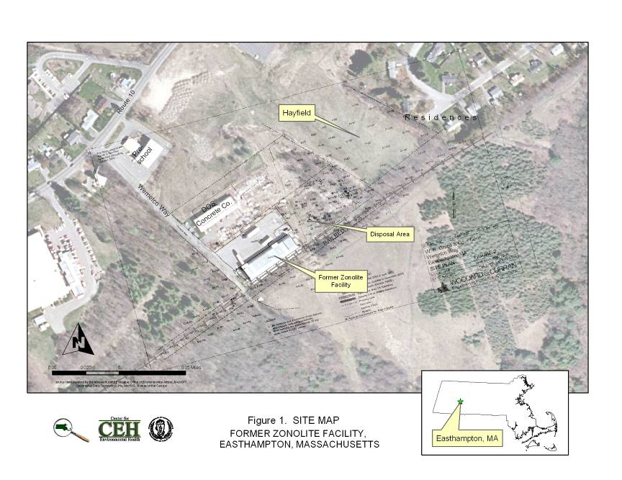
Figure 2. Site plan with sample locations, former Zonolite facility, Wemelco Way, Easthampton, Massachusetts
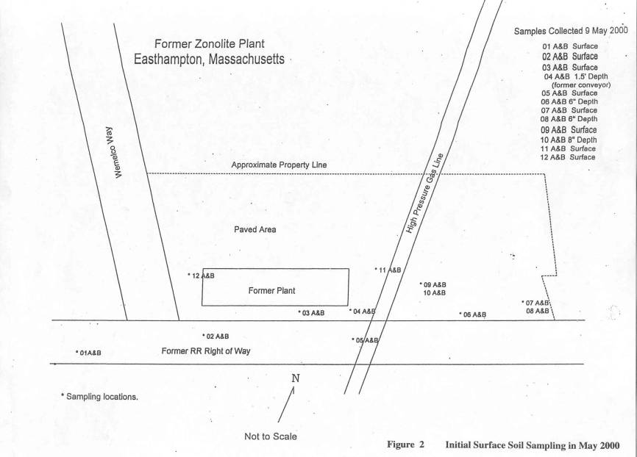
Figure 3. Initial surface soil sampling in May 2000, former Zonolite facility, Wemelco Way, Easthampton, Massachusetts.
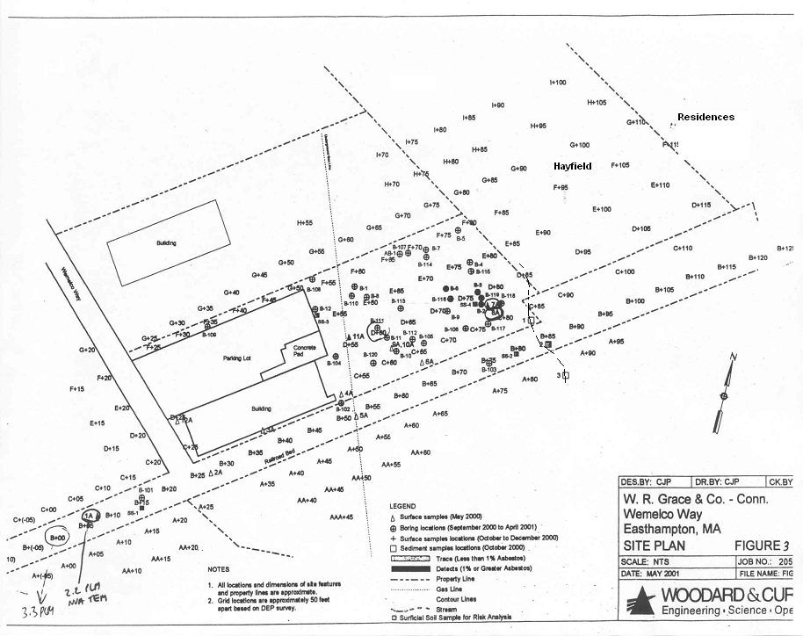
Figure 4. Detection in off-site rail bed west of the facility, former Zonolite facility, Wemelco Way, Easthampton, Massachusetts
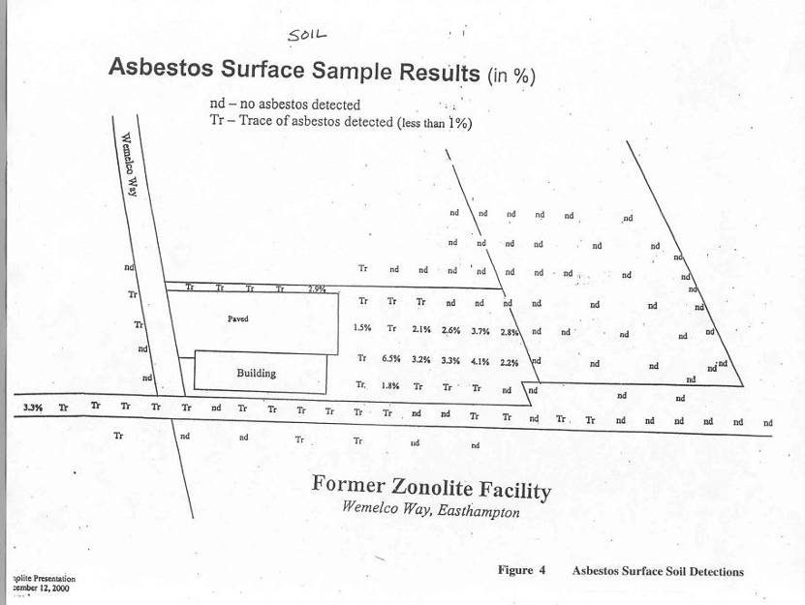
Figure 5. Asbestos surface soil detections from grid sampling, former Zonolite facility, Wemelco Way, Easthampton, Massachusetts
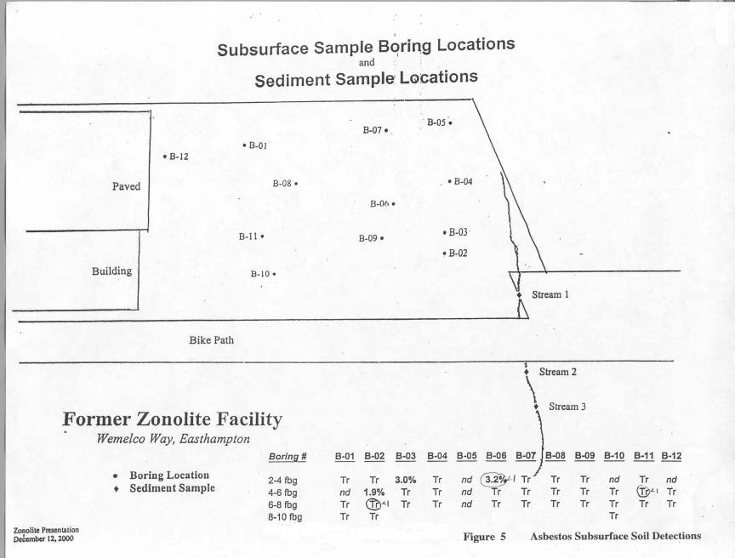
Figure 6. Asbestos subsurface soil detections, former Zonolite facility, Wemelco Way, Easthampton, Massachusetts

Appendices A–D

Appendix A
Site Visit Photographs

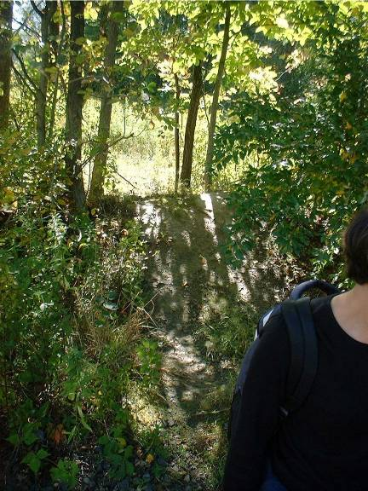
1. ATV ramp

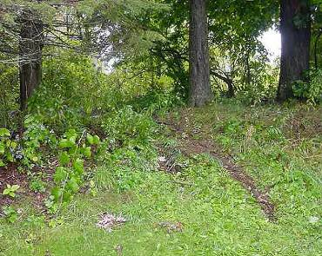
- Path on east side, behind the residential area (beyond the hayfield)

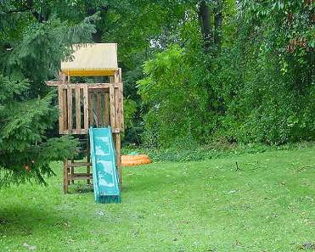
3. Play area behind path off the rail bed, east
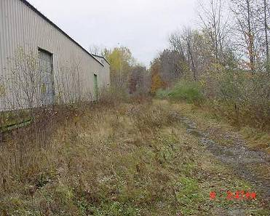
4. From the SW corner, facing NE, a rail bed (right) and near the facility’s docking area

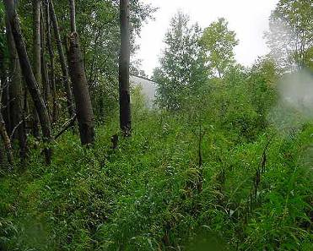
5. Disposal area and view of the facility from the east
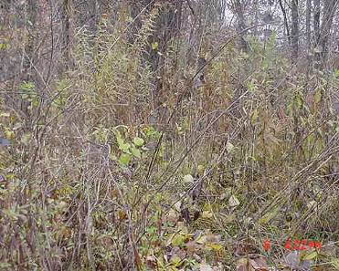
6. The mound in the disposal area where byproduct was discarded

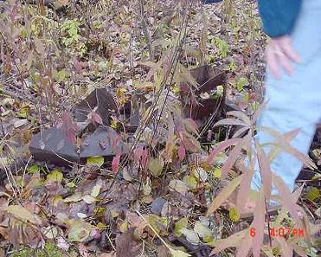
7. Rusted machinery used to transport vermiculite
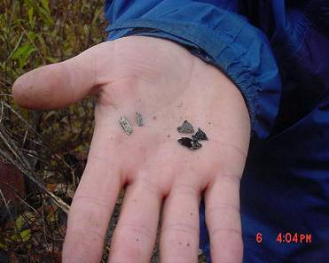
8. Rod-like fibrous asbestos (left) and very shiny, plate-like vermiculite from mound

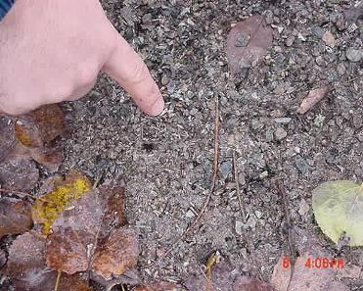
9. Pile with vermiculite and asbestos in the disposal area
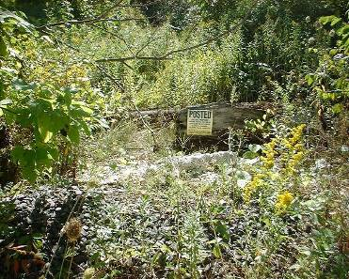
10. Warning sign (re: hunting, fishing and trespassing) on adjacent private property-south

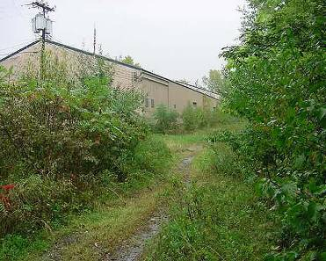
11. The former Zonolite facility, view west, facing east from path along rail bed
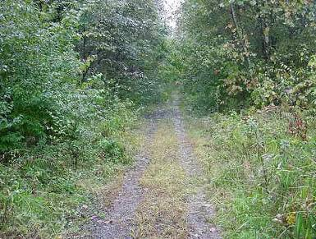
12. West part of the rail bed/right of way

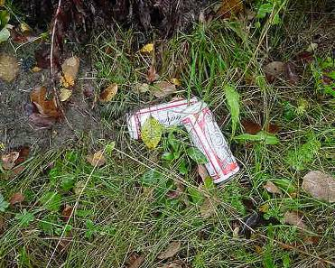
13. Beverage cans noted along the west side, near the rail bed
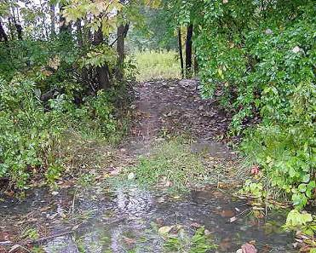
14. A dirt ramp, east along the rail bed

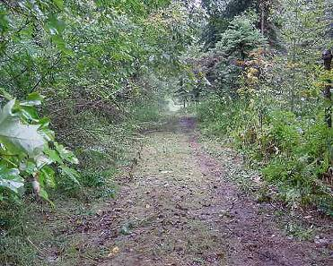
15. An ATV path, running parallel to and along the south side of the rail bed, east

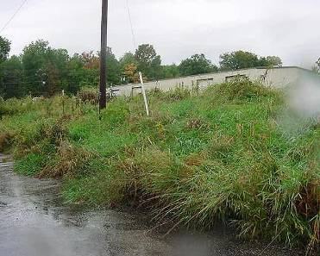
16. Vegetation in the area between the northern parking lot and the concrete company

Appendix B
Wind Rose Data, 1998–2002, Westfield-Barnes Municipal Airport
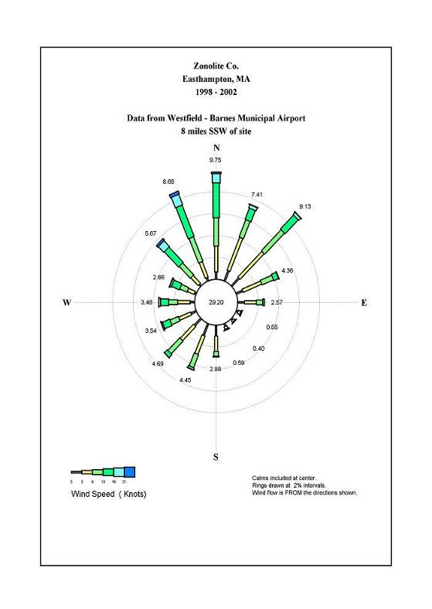

Appendix C
ATSDR Pathway Table

Pathway Name | Environmental Media and Transport Mechanisms | Point of Exposure | Route of Exposure | Exposure Population | Time
Occupational | Suspension of Libby asbestos fibers or contaminated dust into air during materials transport and handling operations or during processing operations | On site | Inhalation | Former workers | Past
Occupational | Suspension of Libby asbestos fibers into air from residual contamination inside former processing buildings | Inside former processing buildings | Inhalation | Current workers | Present, future
Household Contact | Suspension of Libby asbestos fibers into air from dirty clothing of workers after work | Workers’ homes | Inhalation | Former and/or current workers’ families and other household contacts | Past, present, future
Waste Piles | Suspension of Libby asbestos fibers into air by playing in or otherwise disturbing piles of vermiculite or waste rock | On site, at waste piles | Inhalation | Community members, particularly children | Past, present, future
On-Site Soil | Suspension of Libby asbestos fibers into air from disturbing contaminated material remaining in on-site soil (residual soil contamination, buried waste) | At areas of remaining contamination at the site or around the site | Inhalation | Current on-site workers, contractors, community members | Past, present, future
Ambient Air | Stack emissions and fugitive dust from plant operations into neighborhood air | Neighborhood around site | Inhalation | Community members, nearby workers | Past
Residential: Outdoor | Suspension of Libby asbestos fibers into air by disturbing contaminated vermiculite brought off the site for personal use (gardening, paving driveways, traction, fill) | Residential yards or driveways | Inhalation | Community members | Past, present, future
Residential: Indoor | Suspension of household dust containing Libby asbestos from plant emissions or waste rock brought home for personal use | Residences | Inhalation | Community members | Past, present, future
Consumer Products | Suspension of Libby asbestos fibers into air from using or disturbing insulation or other consumer products containing Libby vermiculite. | At homes where Libby asbestos-contaminated products were/are present | Inhalation | Community members, contractors, and repairmen | Past, present, future

Appendix D
ATSDR Hazard Category Definitions

Public health hazard categories are statements about whether people could be harmed by conditions present at the site in the past, present, or future. One or more hazard categories might be appropriate for each site. The five public health hazard categories are no public health hazard, no apparent public health hazard, indeterminate public health hazard, public health hazard, and urgent public health hazard.

No public health hazard
A category used in ATSDR’s public health assessment documents for sites where people have never and will never come into contact with harmful amounts of site-related substances.

No apparent public health hazard
A category used in ATSDR’s public health assessments for sites where human exposure to contaminated media might be occurring, might have occurred in the past, or might occur in the future, but where the exposure is not expected to cause any harmful health effects.

Indeterminate public health hazard
The category used in ATSDR’s public health assessment documents when a professional judgment about the level of health hazard cannot be made because information critical to such a decision is lacking.

Public health hazard
A category used in ATSDR’s public health assessments for sites that pose a public health hazard because of long-term exposures (more than 1 year) to sufficiently high levels of hazardous substances or radionuclides that could result in harmful health effects.

Urgent public health hazard
A category used in ATSDR’s public health assessments for sites where short-term exposures (less than 1 year) to hazardous substances or conditions could result in harmful health effects that require rapid intervention.

The term “vermiculite ore” refers to the combination of vermiculite, Libby asbestos, and rock as it was mined in Libby, Montanta. The term “vermiculite concentrate” or simply “vermiculite” is used to describe the graded vermiculite that was shipped from Libby to the various processing/handling sites.
Documentation was provided by W.R. Grace in response to an EPA CERCLA 104(e) request for information.
Once exfoliated by rapid heating, the resultant puffed vermiculite is light, stable, and resistant to heat.
JPS is the parent company of a roofing company and Steven’s Urethane (JPS 2003a).
Tier II is a designation given to certain hazardous waste sites, following criteria in Massachusetts General Law, Chapter 21E and the Massachusetts Contingency Plan (310 CMR 40.0480). Tier II sites are a lesser priority than Tier I sites in Massachusetts.
Completion of response actions for asbestos removal is also confirmed via TEM when the average concentration of asbestos in five samples collected from within the affected area is not statistically significantly different from five samples collected in the same manner outside the affected area (453 CMR 6.00; 40 CFR Part 763.90[i]).
The cancer slope factor estimates the probability of developing cancer from exposure to a substance over a lifetime. Assumptions of continuous exposure to a constant level of airborne fibers were combined with the IRIS slope factor for chrysolite fibers (0.23), using the PCM definition of a fiber (greater than 5 µm in length and an aspect ratio of 3:1 or greater) to establish a benchmark equivalent to a 1 in 10,000 excess 70 year lifetime cancer risk. It was then adjusted for a 35-year residence dwelling time (EPA 2003), as follows: 0.23 [conc.] = 1/10,000 * 35/70, where [conc.] = 0.0009 f/cc.
Environmental Monitoring Systems Laboratory (EMSL) in New Jersey is the headquarters of EPA’s regional laboratories and specializes in the analysis of asbestos by electron microscopy (EPA 2000).
EPA’s Laboratory was in Lexington, Massachusetts, and is now in Chelmsford, Massachusetts.
According to SciLab Boston reporting notes from sample reports in W&C 2001a.
These five surface soil samples are not shown on Figure 3, but they were located approximately between D-115 and I-100 in Figure 3 (Personal communication, Edward Weagle, site manager, Massachusetts Department of Environmental Protection, November 9, 2003), and they are visible in Figure 4.
NIOSH 7400 method uses the “A” rules for counting and does not distinguish between asbestos and non- asbestos fibers.
EPA AHERA standards for asbestos are in the Toxic Substances Control Act. This TEM method uses 0.45-micron pore filters and is used to distinguish asbestos and nonasbestos fibers (FLI 2001)
SciLab Boston Inc. participates in the National Voluntary Laboratory Accreditation Program and conducted TEM analysis for samples collected by FLI Environmental, Inc.
The highest air samples were found from workers collecting samples from the disposal area of the property where asbestos concentrations in soil were highest. These personal air sampling results were still in compliance with current occupational health standards. These standards would, however, not apply to the general population.
State officials have seen deer nearby during the site visits, and there are signs to deter hunting on the property.

