Appendix A: MassHealth RELD, Sex &
SOGI Data Standards *

- In this appendix, RELD is used as the abbreviation for race, ethnicity, language & disability status. SOGI is used as the abbreviation for sexual orientation and gender identity.

November 2021

Purpose of this appendix
The purpose of this appendix is to solicit stakeholder input on potential updates to the internal data standards that MassHealth uses for member-level data regarding race, ethnicity, language, disability status (RELD), sex, sexual orientation and gender identity (SOGI).

- The potential updates detailed within this appendix would primarily impact the application for MassHealth and health plans through the Massachusetts Health Connector, and the data systems used by MassHealth. [1]

  - The potential updates detailed within this appendix are not final. Several factors are expected to result in modifications to the information in this appendix, including forthcoming federal guidance on data standards, federal reporting requirements, and input from stakeholders through a public Request for Information (RFI) process.

  - Implementing changes to data standards and data systems can take months to years, depending on the scope of the changes.

  - MassHealth's internal data standards are separate from the standards that organizations, such as ACOs, may follow when reporting data to MassHealth.

  - MassHealth collects RELD and sex information for several purposes, including eligibility determination, monitoring of population health, policy development, health equity initiatives, and federal reporting.

Footnotes:
- MassHealth is the Medicaid and Children’s Health Insurance Program (CHIP) for the state of Massachusetts. The Massachusetts Health Connector is the state-based health insurance exchange for the state of Massachusetts.

Ethnicity
Purpose: This slide describes a possible structure for how MassHealth might collect the data element of ethnicity.
Background: The paper application for MassHealth and Health Connector health plans asks applicants for their race and ethnicity in a single question (i.e., “what is your race or ethnicity?”). ^{[1]} The on-line application asks applicants race and ethnicity in separate questions.
Potential Standard:
Option 1: The 2011 HHS Implementation Guidance, with minor modifications noted.
Option 2 and 3: CDC Race and Ethnicity Code Set Version 1.0 (March 2000) with a subset of the 43 ethnicities and 900+ races displayed to applicants

Questions and Valid Values | Notes
Option 1: Are you of Hispanic, Latino/a, or Spanish origin? (select one) [2], [3]  - No, not of Hispanic, Latino/a, or Spanish origin  - Yes, Mexican, Mexican American, Chicano/a  - Yes, Puerto Rican  - Yes, Cuban  - Yes, Another Hispanic, Latino/a or Spanish origin  - Decline to answer [3] | The first 5 values are recommended by the 2011 HHS Implementation Guidance.  They roll-up to the 1997 OMB standard for race & ethnicity that defines two  values (i.e., “Hispanic or Latino” and “Not Hispanic or Latino”).
Option 2: What is your ethnicity? (select all that apply). | Valid values existing in MassHealth’s data systems could include all of the 43 ethnicities and 900+ races that are part of the CDC Race and Ethnicity Code Set V1.0, with a subset of these 900+ values being displayed for applicants to choose from.
Option 3: What is your race or ethnicity? (select all that apply). | In Option 3, a combined question for race and ethnicity is used.  Valid values could include all ethnicities and races from the CDC Race and Ethnicity Code Set V1.0, with a subset of these values being displayed for applicants to choose from.  Although 1997 OMB guidelines mentions that a combined question is not the preferred approach, U.S. Census Bureau research found evidence that a combined question with checkboxes resulted in increased use of OMB standard categories, and decreased nonresponse. See slide 18 for an example of how option 3 might appear.

Notes:

- Ethnicity and race currently are not a required fields on the paper and on-line application for MassHealth and Health Connector plans. Applicants are not required to select an ethnicity or race for an application to be considered complete.

- OMB recommends that ethnicity be asked before race when two separate questions are used for race and ethnicity.

Other standards and value sets:
  - The 1997 OMB standard for race & ethnicity: Federal Register, Federal Register Notice, ONC
  - MA DPH (2009) race, ethnicity & language data standards, and a 2020 version of these standards which has been developed for internal Massachusetts Executive Office of Health & Human Services (EOHHS) use.
  - USCDI V2 - ethnicity (July 2021)
  - CDC Race and Ethnicity Code Set Version 1.0 (2000), which includes 40+ ethnicities and 900+ races: Description. List of races & ethnicities. PHIN VADS ethnicities
  - FHIR v4.01 standards for: race, ethnicity

- Federal reporting: The draft valid values are the same values by which Medicaid programs report ethnicity to CMS, with the exception of the value "Decline to answer”.

Alternative phrasing for asking ethnicity may include the following:
  - “Are you of Hispanic, Latino, or Spanish origin?” with only “Yes”, “No”, “Decline to Answer” and “Unknown” as valid values.
  - “Are you of Hispanic, Latinx, or Spanish origin?”
  - “Are you of Hispanic or Latino origin?”.
As per the 1997 OMB standard, the inclusion of “Spanish” is optional. In other words, either “Hispanic or Latino” or “Hispanic, Latino or Spanish” are recommended.

Footnotes:
  - In Massachusetts, the paper application for MassHealth and Health Connector plans is the Massachusetts Application for Health and Dental Coverage and Help Paying Costs [ACA-3].
  - The value of "Unknown" could exist as a valid value in the data, but it would not be displayed as an option for individuals to select. See HL7® Version 3 Null Flavor for types of unknown values.
  - *The values of “Decline to answer” and “Unknown” are not described in the 1997 OMB minimum standard for race & ethnicity

Race
Purpose: This slide describes a possible structure for how MassHealth might collect the data element of race.

Background: The paper application for MassHealth and Health Connector health plans asks applicants for their race and ethnicity in a single question
(i.e., “what is your race or ethnicity?” on slide 13). The on-line application asks applicants race and ethnicity in separate questions (shown on slide 16).

Potential Standard: Option 1: 1997 OMB minimum standard for race & ethnicity (which has 5 race categories), with minor modifications described with an *. Option 2 & 3: 2011 HHS Implementation Guidance (which has 14 race categories that roll up to the 5 minimum categories in the OMB standard

Questions and Valid Values | Notes
Option 1: What is your race? (select all that apply) [1]  □ American Indian or Alaska Native  - Asian  - Black or African American  - Native Hawaiian or Other Pacific Islander  - White  - Other (please specify ) [2]  - Decline to answer [2] | In this option, valid values existing in MassHealth’s data systems could include all of the 43 ethnicities and 900+ races that are part of the CDC Race and Ethnicity Code Set V1.0. For example, an applicant could write-in Portuguese, Haitian, or Chinese in the option for “Other (please specify ).”
Option 2: What is your race? (select all that apply) [1]  □ American Indian or Alaska Native  - Black or African American  - White  - Asian Indian  - Chinese  - Filipino  - Japanese  - Korean  - Vietnamese  - Other Asian  - Native Hawaiian or Other Pacific Islander  - Guamanian or Chamorro  - Samoan  - Other Pacific Islander  - Other (please specify ) [2]  - Decline to answer [2] | These are part of the OMB standard  These roll-up to the Asian  category of the OMB standard  These roll-up to the Native Hawaiian or Other Pacific Islander category of the OMB standard.
Option 3: What is your race or ethnicity? (select all that apply). | See slide 18 for an example of how option 3 might appear use of OMB standard categories, and decreased nonresponse. See slide 18 for an example of how option 3 might appear.

Notes:

- As recommended by 1997 OMB guidelines, “multi-racial” is not a category. Instead, individuals can select all race categories that apply.
- An alternative to displaying “American Indian or Alaska Native” is to provide an additional option to write-in a tribal nation, using the following option: “American Indian or Alaska Native (specific tribal nation: )”. U.S. Census Bureau research found that a write-in option increased detailed reporting for this group, when compared to three checkboxes (for American Indian, Alaska Native, and Central/South American Indian) and a write-in option.

Other standards and value sets considered:
  - MA DPH (2009) race, ethnicity & language data standards, and a 2020 version of these standards which has been developed for internal Massachusetts EOHHS use.
  - USCDI V2 – race (July 2021)
  - 2011 HHS Implementation Guidance which describes 14 different races, that roll-up to the 5 races that are specified in the1997 OMB race and ethnicity standard.
  - CDC Race and Ethnicity Code Set Version 1.0 (March 2000), which includes ~900 races: Description. List of ethnicities. PHIN VADS
- Federal reporting: The proposed valid values are the same values by which Medicaid programs report race to CMS (with the exception of “Decline to answer” and “Other (please specify)”.

Footnotes:
- The value of "Unknown" could exist as a valid value in the data, but it would not be displayed as an option for individuals to select. See HL7® Version 3 Null Flavor for types of unknown values.
5
- “Other (please specify)” and “Decline to answer” are values that are not specified in the 1997 OMB minimum standard for race & ethnicity.

Language
Purpose: This slide describes a possible structure for how MassHealth might collect the data element of language.

Questions and Valid Values | Notes
- Spoken language: What language do you prefer when speaking about health? (select one if 5 years old or older) [2], [3]  □ American Sign Language  □ Arabic  □ Cantonese (Chinese)  □ English  □ French  □ German  □ Haitian Creole  □ Hindi  □ Mandarin (Chinese)  □ Portuguese  □ Spanish  □ Vietnamese  □ Other (specify)  □ Decline to answer | NA
- Written language: In what language do you prefer health-related written materials? (select one) [2], [3]  □ American Sign Language  □ Arabic  □ Cantonese (Chinese)  □ English  □ French  □ German  □ Haitian Creole  □ Hindi  □ Mandarin (Chinese)  □ Portuguese  □ Spanish  □ Vietnamese  □ Other (specify)  □ Decline to answer[2] | The information regarding “preferred written language” may be used to help MassHealth and the Health Connector communicate with applicants and members. Written notices currently are produced in English and Spanish.  While providing language preferences is optional, it is strongly encouraged. If a member/applicant declines to provide this information, then the “decline to answer” option should be selected. If no selection is made, then the member/applicant’s preferred language will be recorded as “unknown”.
- English proficiency: How well do you speak English? (select one if 5 years old or older) [3]  - Very well  - Well  - Not well  - Not at all  - Decline to answer | This is the single question recommended by the 2011 HHS Implementation Guidance

Additional notes regarding language are on the next slide

Footnotes:
- Source: ONC’s webpage on Representing Patient Preferred Language.Valid values for language are listed alphabetically, except Other and Decline to answer are listed last. Which languages to display can be determined using different methodologies, for example displaying the top 10 or 20 most common languages spoken in MA according the American Community Survey. The exact number of languages that are displayed to applicants may depend on space available on the paper & electronic applications. There are different methods for determining the order in which languages are displayed, including: (a) alphabetically; (b) in order of decreasing frequency in the state; (c) by groups, whereby dialects of Chinese are grouped together, and dialects of Portuguese are grouped together.
- The value of "Unknown" could exist as a valid value in the data, but it would not be displayed as an option for individuals to select. See HL7® Version 3 Null Flavor for types of unknown values.

Notes:
  - Applicants have the option of not selecting any of the options regarding language displayed on an application. Not providing any information about language results in that individual receiving notices in English language.

Other standards and value sets:
    - The USCDI V2 (July 2021) includes “preferred language” but not English proficiency, written language or spoken language. The USCDI V2 does not have a standard yet for preferred language.
    - FHIR v4.01 standards for: race, ethnicity, disability status, written language, languages, language ability mode

Alternative questions and phrasing to consider:
  - Remove American Sign Language as one of the valid values displayed under the question, “What language do you prefer when speaking about health?”
  - Instead of using the phrase, “What language do you prefer to speak in about health?” use one of the alternatives:
    - “What language do you prefer to communicate in about health?“
    - "What is your preferred spoken language“
    - “What is your preferred language”
    - “Do you speak a language other than English at home? If “yes”, then what is this language?”
This option is recommended by the 2011 HHS Implementation Guidance for organizations that want additional information above English proficiency.

- Federal reporting: Medicaid programs are required to report primary language to CMS using the set of ISO 639-2 language codes. ISO 639 is a set of international standards that provides short codes for over 400 languages.

- The question regarding English proficiency (i.e., question #3 on the previous slide) is the recommended standard as per the 2011 HHS Implementation Guidance. It is based on the language question in the American Community Survey (ACS), and in the 2000 and 2010 Census.

Disability status
Purpose: This slide describes a possible structure for how MassHealth might collect information related to disability status.

Background: There is not yet a widely adopted national standard for disability status or disability. [1]
Potential Standard: To be determined

Questions and Valid Values | Notes
The two questions below are currently used in the paper and electronic applications:  - Do you have an injury, illness, or disability (including a disabling mental condition) that has lasted or is expected to last for at least 12 months? If legally blind, answer Yes. [2]  - Yes ^{[4]}  - No  - Do you need reasonable accommodation because of a disability or an injury?  If Yes, complete the rest of this application, including Supplement C: Accommodation. [2], [3]  - Yes  - No | NA

Notes:
- Other standards and value sets considered:
  - 2011 HHS Implementation Guidance on Data Collection Standards for Race, Ethnicity, Sex, Primary Language and Disability Status: For population surveys, HHS recommends the following six standardized questions regarding disability status. These questions are used by population surveys from HHS (e.g., BRFSS, MEPS), U.S. Census Bureau (e.g., ACS), etc.
- Are you deaf or do you have serious difficulty hearing?
- Are you blind or do you have serious difficulty seeing, even when wearing glasses?
- Because of a physical, mental, or emotional condition, do you have serious difficulty concentrating, remembering, or making decisions?
- Do you have serious difficulty walking or climbing stairs?
- Do you have difficulty dressing or bathing?
- Because of a physical, mental, or emotional condition, do you have difficulty doing errands alone such as visiting a doctor's office or shopping?
While these six questions are currently used in population-based health surveys, information collected by the current MassHealth application regarding disabilities and reasonable accommodations are used for individual-level eligibility determination and need for services.
  - USCDI V2 (July 2021) does not include a definition or standard for disability status
- Federal reporting: Medicaid programs are required to report “disability type” to CMS using valid values corresponding to the 6 disability-related questions listed above from 2011 HHS Guidance.

Footnotes:
- Source: ONC’s webpage on Representing Functional Status and/or Disability Status
- The value of "Unknown" could exist as a valid value in the data, but it would not be displayed as an option for individuals to select. See HL7® Version 3 Null Flavor for types of unknown values.
- Supplement C is shown on slide 20.
- If an applicant answers “yes” to this question regarding injury, illness or disability lasting at least 12 months, and that applicant is not verified as being disabled according to an electronic data
matching process with the federal Social Security Administration or the Massachusetts Rehabilitation Commission, then the applicant is asked to complete an Adult Disability Supplement (slide 21).

Sex
Purpose: This slide describes one possible data structure for the data element of sex.

Background: The paper and online applications for MassHealth and Health Connector health plans ask applicants for sex, with “Male” or “Female”
being the only options

Potential Standard: USCDI V2 standard regarding “Sex (Assigned at Birth)” (July 2021) with minor modifications described with an *.

Questions and Valid Values | Notes
What sex were you assigned at birth? (note: this is a required field) [1]  - Male  - Female  - Other (specify ) | *The value of “other” is not included in the USCDI V2 standard for sex assigned at birth.

Notes:

Other standards and value sets considered:
  - HL7 Version 3 Value Set (for “Administrative Gender”) . The HL7 V3 value set included the value of “Undifferentiated” which is proposed to not be included as a valid value.
  - FHIR v4.01 standards for: administrative gender, gender identity
  - ONC web page regarding Representing Patient Sex (At Birth)
  - MA DPH draft SOGI data guidelines, which have been developed for internal EOHHS use.
- Different standards exist for sex assigned at birth, administrative gender, gender for clinical purposes, and biologic sex.

Federal reporting:
  - Medicaid programs are required to report sex to CMS using the valid values of “Male”, “Female” and “Unknown”
  - CMS technical specifications describe that the sex data element corresponds to an individual's biologic sex.

Alternative questions or phrasing for this data element may include the following:
  - “What is your sex?” or “What is your biologic sex?” or …
  - “What is your biological sex or your self-identified sex?” (This phrasing is referenced in the definition for sex in the T-MSIS Data Dictionary v2.4.0, from December 2020).

Additional or alternative valid values to consider:
  - "Undetermined“ (this potential value his could be considered since it is a valid value for birth certificates in Massachusetts)
  - “Intersex”

Background information regarding birth certificates in Massachusetts:
  - The state-wide electronic birth registration system has the following valid values for sex: Male, Female, Undetermined.
  - "Undetermined" is used only in cases of intersex or extreme prematurity where the sex was not able to be determined.
  - A birth record can be amended based on gender affirming surgery, with choices being Male or Female.

Footnotes:
[1] The value of "Unknown" could exist as a valid value in the data, but it would not be displayed as an option for individuals to select. See HL7® Version 3 Null Flavor for types of unknown values.

Sexual orientation & Gender identity (SOGI)
Purpose: This slide describes a possible structure for how MassHealth might collect the data elements of sexual orientation and gender identity.

Background: The paper and online applications for MassHealth and Health Connector health plans do not ask applicants their sexual orientation or gender identity
Potential Standard: USCDI V2 standards related to Gender Identity and Sexual Orientation with minor modifications described with an *.

Questions and Valid Values | Notes
What is your sexual orientation? (select one) [1]  Answer this question if age 18 or above. [3]  - Asexual  - Bisexual  - Gay or lesbian  - Straight or heterosexual  - Queer  - Do not know  - Other, specify  - Decline to answer | *The following values are from the USCDI V2: Lesbian, gay or homosexual  *Something else, please describe  *Choose not to disclose
What is your gender? (select one) [1], [2]  Answer this question if age 18 or above. [3]  - Male  - Female  - Nonbinary, genderqueer, or not exclusively male or female  - Other, specify  - Decline to answer | *Genderqueer, neither exclusively male nor female  *Additional gender category or other, please specify  *Choose not to disclose
Are you transgender? (select one) [1], [4]  Answer this question if age 18 or above. [3]  - Yes  - No  - Do not know  - Decline to answer | *Female-to-Male / Transgender Male / Trans Man  *Male-to-female / Transgender Female / Trans Woman

Footnotes:
- The value of "Unknown" could exist as a valid value in the data, but it would not be displayed as an option for individuals to select. See HL7® Version 3 Null Flavor for types of unknown values.
- Alternative phrasing of this question to consider: “What is your gender identity?”
- Alternative to consider: an age other than 18 could be used. MA General Laws Chapter 231, section 85P recognizes 18 as the age when state residents are legally considered an adult.
- Alternative to consider: Instead of having “Are you transgender?” as a separate question, include “Transgender Male” and “Transgender Female” as options (alongside Male, Female and
Non-binary) within a single question regarding, “What is your gender identity?

SOGI (continued)

Notes:

- Other standards and value sets considered:
  - MA DPH draft SOGI data guidelines, which have been developed for internal EOHHS use.
  - UCSF Guidelines (June 2016)
  - ONC web pages regarding Gender Identity and Sexual Orientation

- Additional background information:
  - Massachusetts:
    - "Gender X" is an option on state driver licenses.
    - Massachusetts state laws regarding gender identity or expression

  - Federal:
    - The U.S. State Department plans to add a “gender marker for non-binary, intersex, and gender non-conforming persons’” when applying for a passport. (June 2021 release)

Supplemental information

Race and Ethnicity: Current State

The question below regarding race or ethnicity is on page 6 of the paper application:

5. Optional: What is your race or ethnicity? ___________________________ Please see page 17.
MassHealth is committed to providing equitable care for all members regardless of race, ethnicity, or language spoken. Please complete this question to help us meet your language needs. Know that your response is voluntary. Confidential, and will not impact your eligibility or to be used for any discriminatory purpose.

The race or ethnicity options listed below appear on page 17 of the paper application:

Race or Ethnicity (Optional) Choose the options that best describe you. Write in all that apply.
Please specify in Question 5 on page 2, 6, 10, and 14

- American Indian or Alaska Native
(Complete Step 3 and Supplement B)
See X)
- Black or African-American
- White or Caucasian
- Hispanic, Latino, or Spanish Origin
- Cuban
- Mexican, Mexican-American, or Chicano
- Puerto Rican
- OtherHispanic/Latino/Spanish
Origin - Please specify in Question 5
Asian
Asian Indian
  - Chinese
  - Japanese
  - Korean
  - Vietnamese
  - Other Asian -
Please specify in Question 5

Pacific Islander
Filipino
Guamanian or Chamorro
Native Hawaiian
Samoan
Other Pacific Islander -
Please specify in Questio

For any race or ethnicity not listed here, please specify in Question 5

Notes:
[1] The paper application (which is formally titled the Massachusetts Application for Health and Dental Coverage and Help Paying Costs [ACA-3]) is available here.

Race and Ethnicity: Current state (continued)
Paper application:
Step 3 (below) is on page 18 of the paper application.

Step 3 American Indian or Alaska Native (AI/AN) Household Member(s)

- Are you or is anyone in your household an American Indian or Alaska Native?
  - Yes
  - No

If No, skip to Step 4
If Yes, complete the rest of this application, including Supplement B: American Indian or Alaska Native Household Member

Name(s) of person(s)______________________________________________

American Indians and Alaska Natives who enroll in health coverage can also get services from the Indian Health Service, tribal health programs, or Urban Indian Health Programs. If you or any household members are American Indians or Alaska Natives, you may not have to pay premiums of copayments, and may get special monthly enrollment periods.
Paper application: Supplement B is page 23 of the paper application.

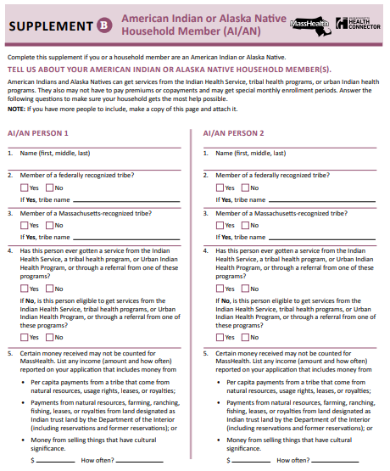
15

Electronic application
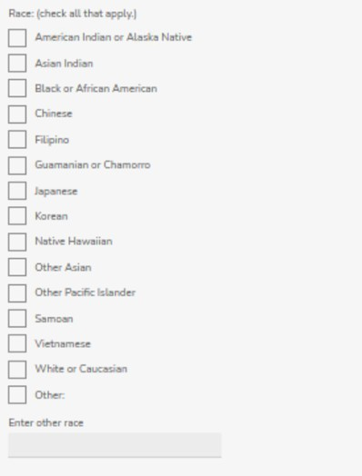

Part 1: Ethnicity
The section on ethnicity only appears if a person selects “Yes” to the question,
“Is [name of the applicant] of Hispanic, Latino, or Spanish origin?”
Part 2: Ethnicity

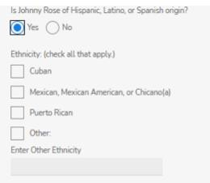
Is Abraham Lincoln of Hispanic, Latino, or Spanish origin?

Footnotes:
[1] The online application is available here (on mass.gov) and here (on the Massachusetts Health Connector website).

Ethnicity: displaying a detailed list
Purpose: This slide describes one option for collecting ethnicity, where a detailed list of ethnicities is displayed to an applicant. In this option, the list of ethnicities is very different than the minimum OMB standard where the only two ethnicities are Hispanic/Latino, or not Hispanic/Latino

What is your ethnicity? (select all that apply) [1]
- African (specify country )
- African American
- Albanian
- American
- Armenian
- Brazilian
- Cambodian/Khmer
- Canadian
- Cape Verdean
- Caribbean Islander (specify )
- Chinese
- Colombian
- Cuban
- Dominican
- English
- Filipino
- French
- German
- Greek
- Guatemalan

- Haitian
- Honduran
- Indian /Asian Indian (from/family from India)*
- Irish
- Italian
- Japanese
- Korean
- Laotian
- Mexican, Mexican American, Chicano
- Middle Eastern (specify )
- Native American
- Polish
- Portuguese
- Puerto Rican
- Russian
- Salvadoran
- Scottish
- Swedish
- Ukrainian
- Vietnamese
  - Other (specify )
  - Decline to answer

Footnotes:
- The value of "Unknown" could exist as a valid value in the data, but it would not be displayed as an option for individuals to select. See HL7® Version 3 Null Flavor for types of unknown values.

Notes:
- In the option for collecting ethnicity which is provided on this slide, the list of ethnicities that are displayed could be determined by different methods including using recommendations from MA DPH and/or the most prevalent ethnicities in Massachusetts according to data from the American Community Survey.
- The options displayed on this slide are adapted from the MA DPH (2009) race, ethnicity & language data standards,

Race and Ethnicity Single-Question Format
Purpose: This slide provides an example of asking race and ethnicity in a single-question format, instead of as two separate questions.

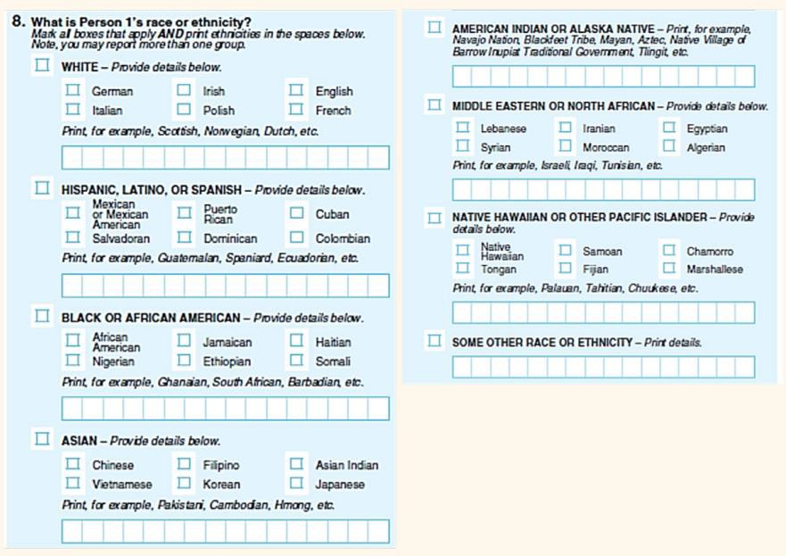

Possible modifications to the example on this slide could include the following:
  - Remove the instructions to “print
ethnicities in the spaces below” so that the instructions say, “Mark all boxes that apply.”
  - Remove the first 6 write-in fields leaving only the last write-

Notes:
- The above example is described in two sources:

Examples of how an applicant may respond to this single-question format:
- A person who views themselves as Asian-American:
This person might select “Asian”.
Or they might write “Asian American” in the field for “Some other race or
ethnicity”.
- A person who has one parent that identifies themselves as African American, and one parent that identifies as White with European ancestors:
This person may select “White” and
“Irish” and “Black or African American”.
Or they might write “biracial” in the field for “Some other race or ethnicity”.

- 2015 National Content Test: Race and Ethnicity Analysis Report. U.S. Census Bureau. 2017 (page 88). This report found that “the optimal question format is combined question with detailed checkboxes” (page xii).
- Collection of REL Data in Medicaid Applications: A 50-state Review of the Current Landscape. State Health Access Data Assistance Center. May 2021 (page 4). This report describes that 6 out of 50 state Medicaid programs use a combine race/ethnicity question, while 46 use separate questions for race and ethnicity.

Language: Current state

Paper application:

Electronic application:

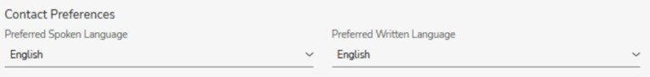

The drop-down menus for Preferred Spoken Language and Preferred Written Language include the following 23 options:

  - English
  - Arabic
  - Cambodian / Khmer
  - Cape Verdean Creole
  - Chinese – Cantonese
  - Chinese – Mandarin
  - French
  - Greek
  - Gujarati
- Haitian Creole
- Hindi
- Italian
- Korean
- Laotian
- Nepalese
- Polish
- Portuguese – Brazilian
- Portuguese – European
  - Russian
  - Somali
  - Spanish
  - Vietnamese
  - Other

Disability: Current state
Paper application:

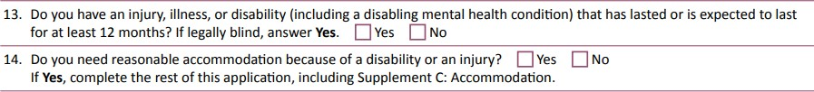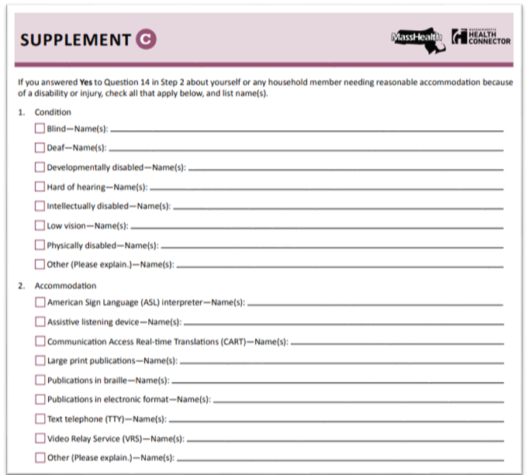

20

Disability: Current state (continued)

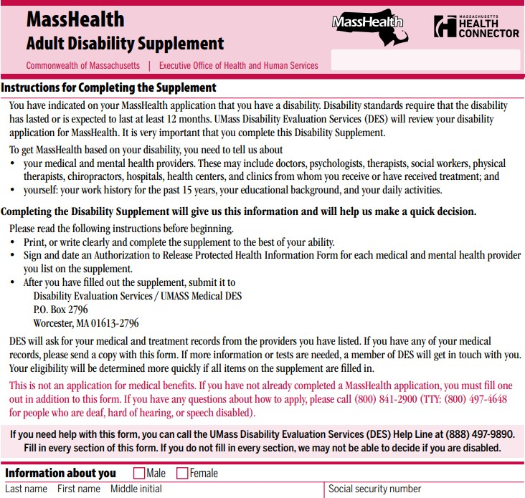

Notes:
- If an applicant answers “yes” to the question on the previous slide regarding injury, illness or disability lasting at least 12 months, and that applicant is not verified as being disabled according to an electronic data matching process with the federal Social Security Administration or the Massachusetts Rehabilitation Commission, then the applicant is asked to complete the Adult Disability Supplement.
- The Adult Disability Supplement (16 pages) is available on the webpage for MassHealth Member Forms.

Sex: Current state

Paper application:

Electronic application:
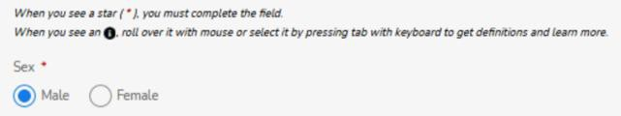

Resources
Massachusetts:
- Medicaid paper application: i.e., Massachusetts Application for Health and Dental Coverage and Help Paying Costs [ACA-3]
- Medicaid online application: available here (on mass.gov) and here (on the Massachusetts Health Connector website
- MA DPH (2009) race, ethnicity & language data standards, and a 2020 version of these standards which has been developed for internal Massachusetts Executive Office of Health & Human Services (EOHHS) use.

National:
- 1977 Office of Management and Budget (OMB) race and ethnicity standards
- 1997 Office of Management and Budget (OMB) race and ethnicity standard
- 2011 HHS Implementation Guidance on Data Collection Standards for Race, Ethnicity, Sex, Primary Language, and Disability Status
- T-MSIS Data Dictionary
- FHIR v4.01 standards for: race, ethnicity, disability status, written language, languages, language ability mode, administrative gender, gender identity
- United States Core Data for Interoperability (USCDI):
  - USCDI V2 (released July 2021)
- CDC Race and Ethnicity Code Set Version 1.0 (March 2000)
  - Overview from CDC (6 pages)
  - Table 1 and 2 (i.e., the list of races and ethnicities) (38 pages); CDC Code set as detailed in CDC’s PHIN VADS
- ONC standards for the following data elements:
  - Race and Ethnicity
  - Preferred Language
  - Functional Status and/or Disability
  - Sex (At Birth)
  - Sexual Orientation
  - Gender Identity
- HL7 V3 Null Flavor (i.e., different types of “Unknown” values):
  - As specified by CDC’s Public Health Information Network Vocabulary Access and Distribution System (PHIN VADS)
  - As specified by HL7 V3
- Collection of REL Data in Medicaid Applications: A 50-state Review of the Current Landscape. State Health Access Data Assistance Center (2021)

