APPENDICES

Appendix A: Glossary of Terms 2
Appendix B: Health Data 5
Appendix C: MassDEP Release and Clean Up Reporting for Focus Area 45
Appendix D. MassDEP Documentation of Air Monitoring Canisters and Station 51
Appendix E. Figures of MassDEP 2018 Air Monitoring Results 56
Appendix F. Real Estate Sales Price History 2015-2017 for Municipalities and Focus Area 76
Appendix G. Community Engagement 79

Appendix A: Glossary of Terms
HIA Glossary

Assessment
In relation to HIA, assessment provides a profile of existing health conditions of people and groups affected by a proposed change and estimates the potential health effects if the change were to occur.
Best available evidence
Conclusive evidence of the links between, for example, socio-environmental factors and health or the effectiveness of interventions, is not always available. In such cases, the best available evidence, that which is judged to be most reliable and compelling, can be used but with caution.

Community participation
Involving the community in an activity such as the planning of projects or carrying out a HIA. There are a number of models of community participation, some of which are outlined in the Gothenburg consensus paper on HIA (WHO, 1999). Levels of participation vary (Arnstein, 1969).

Determinants of health
Determinants of health are factors which influence health status and determine health differentials or health inequalities. They include biological factors (e.g. age, gender and ethnicity), behavior and lifestyles (e.g. smoking, alcohol consumption, diet and physical activity), physical and social environment (e.g. housing quality, workplace stressors, and air pollution), and access to health care (Lalonde, 1974; Labonete, 1993).

Disadvantaged / vulnerable / marginalized groups
These terms are applied to groups of people who, due to factors usually considered outside their control, do not have the same opportunities as other, more fortunate groups in society. Examples might include unemployed people, households without access to a personal vehicle, and those who may be more susceptible to disease due to their age.

Evidence base
The evidence base refers to a body of information, drawn from routine statistical analyses, published studies, and "grey" literature, that tells us something about what is already known about factors affecting health. For example, in the field of housing and health, there are a number of studies that demonstrate the links between damp and cold housing and respiratory disease and, increasingly, the links between high quality housing and quality of life (Thomson et al., 2001).

Health impact
A health impact can be positive or negative. A positive health impact is an effect which contributes to good health or to improving health. For example, having a sense of control over one’s life and having choices is known to have a beneficial effect on mental health and well-being, making people feel “healthier” (Wilkinson, 1996). A negative health impact has the opposite effect, causing or contributing to ill health. For example, working in unhygienic or unsafe conditions or spending a lot of time in an area with poor air quality is likely to have an adverse effect on physical health status.

Health impact assessment
Health impact assessment (HIA) is often defined as "A systematic process that uses an array of data sources and analytic methods and considers input from stakeholders to determine the potential effects of a proposed policy, plan, program or project on the health of a population and the distribution of those effects within the population. HIA provides recommendations on monitoring and managing those effects." (National Research Council of the National Academies, 2011).

Indicator
A health indicator is a characteristic of an individual, population, or environment which is subject to measurement (directly or indirectly) and can be used to describe one or more aspects of the health of an individual or population (quality, quantity and time).

Outcomes
The effect the process has had on the people targeted by it. These might include, for example, changes in their self-perceived health status or changes in the distribution of health determinants, or factors which are known to affect their health, well-being and quality of life.

Population (Affected population)
Groups of individuals defined by locality, biological criteria (e.g. age, gender, health condition, or common exposure), or social criteria (e.g. socio-economic status or cultural affiliation). How a population is defined in an HIA will depend on the proposed project/policy being considered, health issues of most concern, the extent and classification of existing evidence on those health issues, and what information is of most value to the policy-making process.

Project
A project is usually a discrete piece of work addressing a single population group or health determinant, usually with a pre-set time limit. Usually (but not always), the term refers to "bricks and mortar" projects involving construction of a discrete structure or group of structures, such as a power plant, highway, or housing development.

Recommendations
Practical solutions and strategies to manage identified adverse health impacts and maximize benefits to health that can be implemented within the political, economic, or technical limitations of the proposed change.

Reporting
In reference to the HIA, preparing the HIA report and sharing the findings with decision makers, affected communities, and other stakeholders.

Qualitative and quantitative
HIA tries to balance qualitative and quantitative evidence. It involves an evaluation of the quantitative, "scientific" evidence when it exists but also recognizes the importance of more qualitative information. This may include the opinions, experience and expectations of those people most directly affected by public policies. HIA tries to balance the various types of evidence (Barnes and Scott-Samuel, 1999). Generally speaking, quantitative evidence is based on what can be counted or measured objectively whilst qualitative evidence cannot be measured in the usual ways and may be more subjective. People’s perceptions, opinions and views are considered examples of qualitative information.

Scoping
Creating objectives for the HIA, in consultation with stakeholders, and outlining the process to identify potential health risks and benefits.

Screening
In relation to HIA, screening usually refers to an initial step being taken in order to determine whether a policy, program or project should be subject to a HIA. It is a step to understand whether the HIA is likely to add value and influence decision-making.

HIA Glossary References
- Arnstein, Sherry R. 1969. A Ladder of Citizen Participation. JAIP. 35(4):216-224.
- Barnes R, Scott-Samuel A. 1999. The Acheson report: beyond parenthood and apple pie. Journal of Epidemiology and Community Health. 53(6):322-3
- Labonete E, Paris J. 1993. Life events in borderline personality disorder. Canadian Journal of Psychiatry, 38(10):638.
- Lalonde M. 1974. A New Perspective on the Health of Canadians. Ottawa, Ontario, Canada: Minister of Supply and Services.
- National Research Council of the National Academies. 2011. Elements of a Health Impact Assessment. Improving Health in the United States: The Role of Health Impact Assessment.
- Thomson A., et al. 2001. Changing Patterns of Management Development. Oxford, UK, Mass., USA: Blackwell Publisher.
- Wilkinson, Richard G. 1996. Unhealthy Societies: The Affliction of Inequality. London: Routledge.
- World Health Organization. 2018. Health Impact Assessment: Glossary of terms used.. Available at: http://www.who.int/hia/about/glos/en/ .
- World Health Organization. 1999. Health Impact Assessment: main concepts and suggested approach. Gothenburg consensus paper. WHO Regional Office for Europe. Available at: http://www.euro.who.int/document/PAE/Gothenburgpaper.pdf.

Appendix B: Health Data

Pediatric Asthma Prevalence per 100 Students for Males and Females Combined
for School Years 2009-2010 to 2016-2017 by Community
Braintree
School Year | Student Case Count | Student Enrollment Count | Prevalence | 95% Confidence Interval | Statistical Significance | Stability
2009-2010 | 498 | 4,143 | 12.0 | 11.0 - 13.1 | Not statistically significantly different
2010-2011 | 477 | 4,200 | 11.4 | 10.3 - 12.4 | Not statistically significantly different
2011-2012 | 499 | 4,204 | 11.9 | 10.8 - 12.9 | Not statistically significantly different
2012-2013 | 466 | 4,250 | 11.0 | 10.0 - 12.0 | Statistically significantly lower
2013-2014 | 492 | 4,294 | 11.5 | 10.4 - 12.5 | Not statistically significantly different
2014-2015 | 463 | 4,250 | 10.9 | 9.9 - 11.9 | Statistically significantly lower
2015-2016 | 521 | 4,291 | 12.1 | 11.1 - 13.2 | Not statistically significantly different
2016-2017 | 528 | 4,277 | 12.3 | 11.3 - 13.4 | Not statistically significantly different
Braintree - Annual Average | 493 | 4,239 | 11.6 | 11.3 - 12.0 | Statistically significantly lower
Hingham
School Year | Student Case Count | Student Enrollment Count | Prevalence | 95% Confidence Interval | Statistical Significance | Stability
2009-2010 | 276 | 2,873 | 9.6 | 8.5 - 10.7 | Statistically significantly lower
2010-2011 | 307 | 3,231 | 9.5 | 8.4 - 10.6 | Statistically significantly lower
2011-2012 | 316 | 3,277 | 9.6 | 8.6 - 10.7 | Statistically significantly lower
2012-2013 | 316 | 3,287 | 9.6 | 8.6 - 10.7 | Statistically significantly lower
2013-2014 | 325 | 3,120 | 10.4 | 9.3 - 11.5 | Statistically significantly lower
2014-2015 | 244 | 3,303 | 7.4 | 6.5 - 8.3 | Statistically significantly lower
2015-2016 | 337 | 3,337 | 10.1 | 9.0 - 11.2 | Statistically significantly lower
2016-2017 | 313 | 3,385 | 9.2 | 8.2 - 10.3 | Statistically significantly lower
Hingham - Annual Average | 304 | 3,227 | 9.4 | 9.1 - 9.8 | Statistically significantly lower
Quincy
School Year | Student Case Count | Student Enrollment Count | Prevalence | 95% Confidence Interval | Statistical Significance | Stability
2009-2010 | 735 | 6,740 | 10.9 | 10.1 - 11.7 | Not statistically significantly different
2010-2011 | 726 | 6,890 | 10.5 | 9.8 - 11.3 | Statistically significantly lower
2011-2012 | 814 | 6,977 | 11.7 | 10.9 - 12.5 | Not statistically significantly different
2012-2013 | 748 | 7,040 | 10.6 | 9.9 - 11.4 | Statistically significantly lower
2013-2014 | 745 | 7,167 | 10.4 | 9.6 - 11.1 | Statistically significantly lower
2014-2015 | 804 | 7,112 | 11.3 | 10.5 - 12.1 | Statistically significantly lower
2015-2016 | 730 | 6,988 | 10.4 | 9.7 - 11.2 | Statistically significantly lower
2016-2017 | 584 | 7,069 | 8.3 | 7.6 - 8.9 | Statistically significantly lower

Quincy - Annual Average | 736 | 6,998 | 10.5 | 10.2 - 10.8 | Statistically significantly lower

Weymouth
School Year | Student Case Count | Student Enrollment Count | Prevalence (%) | 95% Confidence Interval | Statistical Significance | Stability
2009-2010 | 643 | 5,333 | 12.1 | 11.1 - 13.0 | Not statistically significantly different
2010-2011 | 704 | 5,383 | 13.1 | 12.1 - 14.0 | Statistically significantly higher
2011-2012 | 752 | 5,372 | 14.0 | 13.0 - 15.0 | Statistically significantly higher
2012-2013 | 703 | 5,328 | 13.2 | 12.2 - 14.2 | Statistically significantly higher
2013-2014 | 650 | 5,317 | 12.2 | 11.3 - 13.2 | Not statistically significantly different
2014-2015 | 641 | 5,224 | 12.3 | 11.3 - 13.2 | Not statistically significantly different
2015-2016 | 586 | 5,098 | 11.5 | 10.6 - 12.4 | Not statistically significantly different
2016-2017 | 561 | 4,933 | 11.4 | 10.4 - 12.3 | Not statistically significantly different
Weymouth - Annual Average | 655 | 5,249 | 12.5 | 12.1 - 12.8 | Statistically significantly higher
Statewide
School Year | Student Case Count | Student Enrollment Count | Prevalence | 95% Confidence Interval
2009-2010 | 80,440 | 696,904 | 11.5 | 11.4 - 11.6
2010-2011 | 80,948 | 693,338 | 11.7 | 11.6 - 11.8
2011-2012 | 82,548 | 691,614 | 11.9 | 11.8 - 12.0
2012-2013 | 83,568 | 691,060 | 12.1 | 12.0 - 12.2
2013-2014 | 85,364 | 689,300 | 12.4 | 12.3 - 12.5
2014-2015 | 83,854 | 685,649 | 12.2 | 12.1 - 12.3
2015-2016 | 84,230 | 681,295 | 12.4 | 12.3 - 12.5
2016-2017 | 82,279 | 679,336 | 12.1 | 12.0 - 12.2
Statewide - Annual Average | 82,904 | 688,562 | 12.0 | 12.0 - 12.1
· U or Unstable indicates that a rate is unstable, because it has a relative standard error > 30%, and should be interpreted with caution.
· NS indicates number/prevalence not shown due to small numbers. These data are suppressed for confidentiality reasons.
· NA indicates insufficient school enrollment data available to calculate prevalence. NA for both student case count and student enrollment may indicate the school location is no longer in use, or prevalence could not be calculated due to a data collection issue
· School list is based on the current data provided by the Massachusetts Department of Education http://www.doe.mass.edu/
· Asthma prevalence is only for children enrolled in grades Kindergarten through 8th grade.
· Community prevalence is based on the residential address of the student.
· When comparing prevalence across geographic areas, a variety of non-environmental factors can impact asthma prevalence.
· Statistical significance indicates that prevalence is different from the state prevalence and the difference is unlikely due to chance.
· 95% confidence intervals represent the precision of the estimates shown. When zero cases are observed in a population, the upper 95% confidence limit is calculated using a method known as the “rule of three.” This method calls for substituting a three for the number of cases when calculating the upper 95% confidence interval in order to produce a more accurate upper bound when the observed case count is zero.
· Data source: Bureau of Environmental Health Massachusetts Department of Public Health.
· Numbers and prevalence may differ slightly from those contained in other publications. These differences may be due to file updates, differences in calculating prevalence and updates in population estimates

Quincy - Public - Clifford H Marshall Elementary
School Year | Student Case Count | Student Enrollment Count | Prevalence | 95% Confidence Interval | Statistical Significance |  | Stability
2009-2010 | 35 | 535 | 6.5 | 4.3 - 8.7 | Statistically significantly lower
2010-2011 | 28 | 530 | 5.3 | 3.3 - 7.3 | Statistically significantly lower
2011-2012 | 61 | 563 | 10.8 | 8.1 - 13.5 | Not statistically significantly different
2012-2013 | 63 | 559 | 11.3 | 8.5 - 14.1 | Not statistically significantly different
2013-2014 | 67 | 577 | 11.6 | 8.8 - 14.4 | Not statistically significantly different
2014-2015 | 86 | 575 | 15 | 11.8 - 18.2 | Not statistically significantly different
2015-2016 | 86 | 577 | 14.9 | 11.8 - 18.0 | Not statistically significantly different
2016-2017 | 93 | 575 | 16.2 | 12.9 - 19.5 | Statistically significantly higher
School Annual Average | 65 | 561 | 11.6 | 10.6 - 12.6 | Not statistically significantly different
Quincy - Private - Mutanafisun Academy
School Year | Student Case Count | Student Enrollment Count | Prevalence | 95% Confidence Interval | Statistical Significance |  | Stability
2009-2010 | 0 | NA | NC | NC | NC
2010-2011 | 0 | NA | NC | NC | NC
2011-2012 | 0 | NA | NC | NC | NC
2012-2013 | 0 | 33 | 0 | 0 - 19.4 | Not statistically significantly different |  | Unstable
2013-2014 | 0 | 33 | 0 | 0 - 19.4 | Not statistically significantly different |  | Unstable
2014-2015 | NS | 37 | NS | NS | NS
2015-2016 | 0 | 27 | 0 | 0 - 23.7 | Not statistically significantly different |  | Unstable
2016-2017 | NS | 50 | NS | NS | NS
School Annual Average | 0 | 22 | 1.1 | 0.0 - 2.7 | Statistically significantly lower
Quincy - Public - Snug Harbor Community School
School Year | Student Case Count | Student Enrollment Count | Prevalence | 95% Confidence Interval | Statistical Significance |  | Stability
2009-2010 | 30 | 252 | 11.9 | 7.6 - 16.2 | Not statistically significantly different
2010-2011 | 31 | 285 | 10.9 | 7.1 - 14.7 | Not statistically significantly different
2011-2012 | 30 | 288 | 10.4 | 6.7 - 14.1 | Not statistically significantly different
2012-2013 | 25 | 291 | 8.6 | 5.2 - 12.0 | Statistically significantly lower
2013-2014 | 26 | 311 | 8.4 | 5.2 - 11.6 | Statistically significantly lower
2014-2015 | 40 | 300 | 13.3 | 9.2 - 17.4 | Not statistically significantly different
2015-2016 | 46 | 302 | 15.2 | 10.8 - 19.6 | Not statistically significantly different
2016-2017 | 43 | 303 | 14.2 | 10.0 - 18.4 | Not statistically significantly different
School Annual Average | 34 | 292 | 11.6 | 10.2 - 13.0 | Not statistically significantly different
Weymouth - Private - St Jerome Elementary
School Year | Student Case Count | Student Enrollment Count | Prevalence | 95% Confidence Interval | Statistical Significance |  | Stability
2009-2010 | 17 | 184 | 9.2 | 4.8 - 13.6 | Not statistically significantly different
2010-2011 | 15 | 188 | 8 | 4.0 - 12.0 | Not statistically significantly different
2011-2012 | 15 | 174 | 8.6 | 4.2 - 13.0 | Not statistically significantly different
2012-2013 | 15 | 179 | 8.4 | 4.1 - 12.7 | Not statistically significantly different
2013-2014 | 12 | 159 | 7.5 | 3.3 - 11.7 | Statistically significantly lower
2014-2015 | 13 | 157 | 8.3 | 3.8 - 12.8 | Not statistically significantly different
2015-2016 | 9 | 149 | 6 | 2.1 - 9.9 | Statistically significantly lower |  | Unstable
2016-2017 | 11 | 145 | 7.6 | 3.1 - 12.1 | Not statistically significantly different |  | Unstable
School Annual Average | 13 | 167 | 8 | 6.5 - 9.5 | Statistically significantly lower
Weymouth - Public - Wessagusset
School Year | Student Case Count | Student Enrollment Count | Prevalence | 95% Confidence Interval |  | Statistical Significance | Stability
2009-2010 | 33 | 405 | 8.1 | 5.3 - 10.9 |  | Statistically significantly lower
2010-2011 | 46 | 387 | 11.9 | 8.5 - 15.3 |  | Not statistically significantly different
2011-2012 | 40 | 375 | 10.7 | 7.4 - 14.0 |  | Not statistically significantly different
2012-2013 | 77 | 361 | 21.3 | 16.5 - 26.1 |  | Statistically significantly higher
2013-2014 | 50 | 353 | 14.2 | 10.3 - 18.1 |  | Not statistically significantly different
2014-2015 | 38 | 348 | 10.9 | 7.4 - 14.4 |  | Not statistically significantly different
2015-2016 | 21 | 330 | 6.4 | 3.7 - 9.1 |  | Statistically significantly lower
2016-2017 | 21 | 294 | 7.1 | 4.1 - 10.1 |  | Statistically significantly lower
School Annual Average | 41 | 357 | 11.4 | 10.2 - 12.7 |  | Not statistically significantly different
Statewide
School Year | Student Case Count | Student Enrollment Count | Prevalence | 95% Confidence Interval
2009-2010 | 80,440 | 696,904 | 11.5 | 11.4 - 11.6
2010-2011 | 80,948 | 693,338 | 11.7 | 11.6 - 11.8
2011-2012 | 82,548 | 691,614 | 11.9 | 11.8 - 12.0
2012-2013 | 83,568 | 691,060 | 12.1 | 12.0 - 12.2
2013-2014 | 85,364 | 689,300 | 12.4 | 12.3 - 12.5
2014-2015 | 83,854 | 685,649 | 12.2 | 12.1 - 12.3
2015-2016 | 84,230 | 681,295 | 12.4 | 12.3 - 12.5
2016-2017 | 82,279 | 679,336 | 12.1 | 12.0 - 12.2
Statewide - Annual Average | 82,904 | 688,562 | 12.0 | 12.0 - 12.1
· U or Unstable indicates that a rate is unstable, because it has a relative standard error > 30%, and should be interpreted with caution.
· NS indicates number/prevalence not shown due to small numbers. These data are suppressed for confidentiality reasons.
· NA indicates insufficient school enrollment data available to calculate prevalence. NA for both student case count and student enrollment may indicate the school location is no longer in use, or prevalence could not be calculated due to a data collection issue
· School list is based on the current data provided by the Massachusetts Department of Education http://www.doe.mass.edu/
· Asthma prevalence is only for children enrolled in grades Kindergarten through 8th grade.
· School prevalence is based on the school attended by the student.
· When comparing prevalence across geographic areas, a variety of non-environmental factors can impact asthma prevalence.
· Statistical significance indicates that prevalence is different from the state prevalence and the difference is unlikely due to chance.
· 95% confidence intervals represent the precision of the estimates shown. When zero cases are observed in a population, the upper 95% confidence limit is calculated using a method known as the “rule of three.” This method calls for substituting a three for the number of cases when calculating the upper 95% confidence interval in order to produce a more accurate upper bound when the observed case count is zero.
· Data source: Bureau of Environmental Health Massachusetts Department of Public Health.
· Numbers and prevalence may differ slightly from those contained in other publications. These differences may be due to file updates, differences in calculating prevalence and updates in population estimates

Braintree
Year | Case Count | Crude Rate | Age Adjusted Rate | Confidence Intervals | Statistical Difference | Stability
2000 | 44 | 13.0 | 12.1 | 8.5 - 15.7 | Not statistically significantly different | Stable
2001 | 36 | 10.6 | 10.6 | 7.1 - 14.1 | Not statistically significantly different | Stable
2002 | 39 | 11.4 | 10.8 | 7.4 - 14.2 | Not statistically significantly different | Stable
2003 | 43 | 12.5 | 12.7 | 8.9 - 16.5 | Not statistically significantly different | Stable
2004 | 49 | 14.2 | 13.4 | 9.6 - 17.1 | Not statistically significantly different | Stable
2005 | 32 | 9.2 | 8.3 | 5.4 - 11.2 | Statistically significantly lower | Stable
2006 | 45 | 12.9 | 11.7 | 8.3 - 15.2 | Not statistically significantly different | Stable
2007 | 53 | 15.1 | 14.3 | 10.4 - 18.1 | Not statistically significantly different | Stable
2008 | 46 | 13.0 | 12.5 | 8.9 - 16.1 | Not statistically significantly different | Stable
2009 | 59 | 16.6 | 15.2 | 11.3 - 19.0 | Not statistically significantly different | Stable
2010 | 52 | 14.6 | 14.2 | 10.3 - 18.0 | Not statistically significantly different | Stable
2011 | 70 | 19.3 | 19.0 | 14.6 - 23.5 | Not statistically significantly different | Stable
2012 | 37 | 10.1 | 9.4 | 6.4 - 12.5 | Statistically significantly lower | Stable
2013 | 42 | 11.3 | 11.2 | 7.8 - 14.6 | Not statistically significantly different | Stable
2014 | 42 | 11.1 | 11.4 | 8.0 - 14.9 | Not statistically significantly different | Stable
2015 | 31 | 8.1 | 7.8 | 5.1 - 10.5 | Statistically significantly lower
Braintree - Annual Average | 45 | 12.7 | 12.2 | 11.3 - 13.1 | Statistically significantly lower | Stable
Hingham
Year | Case Count | Crude Rate | Age Adjusted Rate | Confidence Intervals | Statistical Difference | Stability
2000 | NS | NS | NS | NS | NS | NS
2001 | 21 | 10.4 | 9.2 | 5.3 - 13.1 | Not statistically significantly different | Stable
2002 | 14 | 6.9 | 6.6 | 3.1 - 10.0 | Statistically significantly lower | Stable
2003 | 11 | 5.4 | 4.5 | 1.2 - 7.1 | Statistically significantly lower | Unstable
2004 | 14 | 6.7 | 6.3 | 3.0 - 9.6 | Statistically significantly lower | Stable
2005 | 24 | 11.4 | 9.5 | 5.7 - 13.3 | Statistically significantly lower | Stable
2006 | 11 | 5.2 | 4.9 | 2.0 - 7.7 | Statistically significantly lower | Unstable
2007 | 19 | 8.9 | 7.7 | 4.3 - 11.2 | Statistically significantly lower | Stable
2008 | 22 | 10.1 | 8.6 | 5.0 - 12.2 | Statistically significantly lower | Stable
2009 | 16 | 7.3 | 6.1 | 3.1 - 9.1 | Statistically significantly lower | Stable
2010 | 27 | 12.2 | 9.1 | 5.7 - 12.6 | Statistically significantly lower | Stable
2011 | 22 | 9.8 | 9.4 | 5.5 - 13.4 | Statistically significantly lower | Stable
2012 | 13 | 5.8 | 4.9 | 2.2 - 7.6 | Statistically significantly lower | Stable
2013 | 18 | 7.9 | 6.0 | 3.2 - 8.7 | Statistically significantly lower | Stable
2014 | NS | NS | NS | NS | NS | NS
2015 | 19 | 8.2 | 6.0 | 3.3 - 8.7 | Statistically significantly lower
Hingham - Annual Average | 17 | 7.7 | 6.6 | 5.8 - 7.4 | Statistically significantly lower | Stable
Quincy
Year | Case Count | Crude Rate | Age Adjusted Rate | Confidence Intervals | Statistical Difference | Stability
2000 | 111 | 12.6 | 12.5 | 10.2 - 14.8 | Not statistically significantly different | Stable
2001 | 117 | 13.2 | 13.4 | 10.9 - 15.8 | Not statistically significantly different | Stable
2002 | 104 | 11.7 | 12.1 | 9.8 - 14.5 | Not statistically significantly different | Stable
2003 | 136 | 15.2 | 15.7 | 13.0 - 18.3 | Not statistically significantly different | Stable
2004 | 108 | 12.0 | 12.1 | 9.8 - 14.3 | Not statistically significantly different | Stable
2005 | 131 | 14.5 | 14.5 | 12.0 - 17.0 | Not statistically significantly different | Stable
2006 | 141 | 15.6 | 16.0 | 13.3 - 18.6 | Not statistically significantly different | Stable
2007 | 105 | 11.5 | 11.4 | 9.2 - 13.5 | Statistically significantly lower | Stable
2008 | 121 | 13.2 | 13.1 | 10.7 - 15.4 | Statistically significantly lower | Stable
2009 | 123 | 13.4 | 13.9 | 11.4 - 16.3 | Not statistically significantly different | Stable
2010 | 114 | 12.4 | 12.4 | 10.1 - 14.7 | Statistically significantly lower | Stable
2011 | 119 | 12.7 | 12.3 | 10.1 - 14.5 | Statistically significantly lower | Stable
2012 | 89 | 9.4 | 9.7 | 7.7 - 11.8 | Statistically significantly lower | Stable
2013 | 82 | 8.6 | 8.5 | 6.7 - 10.3 | Statistically significantly lower | Stable
2014 | 104 | 10.7 | 10.4 | 8.4 - 12.4 | Not statistically significantly different | Stable
2015 | 78 | 8.0 | 8.5 | 6.6 - 10.4 | Statistically significantly lower
Quincy - Annual Average | 111 | 12.1 | 12.3 | 11.7 - 12.8 | Statistically significantly lower | Stable
Weymouth
Year | Case Count | Crude Rate | Age Adjusted Rate | Confidence Intervals | Statistical Difference | Stability
2000 | 72 | 13.3 | 13.1 | 10.0 - 16.1 | Not statistically significantly different | Stable
2001 | 67 | 12.4 | 12.0 | 9.2 - 14.9 | Not statistically significantly different | Stable
2002 | 70 | 13.0 | 13.1 | 10.0 - 16.1 | Not statistically significantly different | Stable
2003 | 77 | 14.3 | 14.0 | 10.9 - 17.1 | Not statistically significantly different | Stable
2004 | 71 | 13.2 | 12.7 | 9.7 - 15.6 | Not statistically significantly different | Stable
2005 | 86 | 16.0 | 15.6 | 12.3 - 18.9 | Not statistically significantly different | Stable
2006 | 75 | 13.9 | 13.9 | 10.8 - 17.0 | Not statistically significantly different | Stable
2007 | 70 | 13.0 | 13.1 | 10.1 - 16.2 | Not statistically significantly different | Stable
2008 | 110 | 20.5 | 21.1 | 17.2 - 25.1 | Statistically significantly higher | Stable
2009 | 100 | 18.6 | 18.2 | 14.7 - 21.8 | Not statistically significantly different | Stable
2010 | 101 | 18.8 | 19.6 | 15.8 - 23.4 | Not statistically significantly different | Stable
2011 | 89 | 16.4 | 17.3 | 13.7 - 20.9 | Not statistically significantly different | Stable
2012 | 89 | 16.3 | 16.5 | 13.1 - 19.9 | Not statistically significantly different | Stable
2013 | 73 | 13.3 | 13.0 | 10.0 - 16.0 | Not statistically significantly different | Stable
2014 | 92 | 16.7 | 16.0 | 12.7 - 19.3 | Statistically significantly higher | Stable
2015 | 81 | 14.6 | 13.6 | 10.6 - 16.6 | Not statistically significantly different
Weymouth - Annual Average | 83 | 15.3 | 15.2 | 14.4 - 16.0 | Statistically significantly higher | Stable
State Wide
Year | Case Count | Crude Rate | Age Adjusted Rate | Confidence Intervals
2000 | 8,039 | 12.7 | 12.6 | 12.3 - 12.9
2001 | 8,287 | 13.0 | 13.1 | 12.8 - 13.4
2002 | 8,084 | 12.7 | 12.8 | 12.5 - 13.1
2003 | 9,945 | 15.5 | 15.7 | 15.4 - 16.0
2004 | 8,855 | 13.8 | 13.8 | 13.5 - 14.1
2005 | 9,062 | 14.1 | 14.1 | 13.8 - 14.4
2006 | 9,491 | 14.7 | 14.7 | 14.4 - 15.0
2007 | 9,385 | 14.5 | 14.5 | 14.2 - 14.8
2008 | 10,311 | 15.8 | 15.9 | 15.6 - 16.2
2009 | 10,577 | 16.2 | 16.0 | 15.7 - 16.3
2010 | 10,133 | 15.5 | 15.5 | 15.2 - 15.8
2011 | 9,928 | 15.0 | 15.0 | 14.7 - 15.3
2012 | 8,852 | 13.3 | 13.4 | 13.1 - 13.7
2013 | 7,957 | 11.8 | 11.9 | 11.6 - 12.2
2014 | 8,172 | 12.0 | 11.9 | 11.6 - 12.2
2015 | 7,347 | 10.8 | 10.7 | 10.5 - 11.0
Statewide - Annual Average | 9,027 | 13.8 | 13.9 | 13.8 - 13.9
· U or Unstable indicates that a rate is unstable, because it has a relative standard error > 30%, and should be interpreted with caution.
· 95% confidence intervals are calculated using the age adjusted rate when it is displayed in the report.
· NS = Not shown. Statistics are suppressed to protect confidentiality when the number of cases is ≤10.
· 95% confidence intervals represent the precision of the estimates shown. When zero cases are observed in a population, the upper 95% confidence limit is calculated using a method known as the “rule of three.” This method calls for substituting a three for the number of cases when calculating the upper 95% confidence interval in order to produce a more accurate upper bound when the observed case count is zero.
· Numbers and rates may differ slightly from those contained in other publications. These differences may be due to file updates, differences in calculating rates and updates in population estimates.
· Difference in counts and rates in years prior to 2015 compared to 2015 could be a result of the change from ICD-9CM to ICD-10CM (coding of medical terminology and disease classification) that took place on October 1, 2015.
· Data source: Center for Health Information and Analysis (CHIA)
· Population estimates for 2000 and 2010 are from the U.S. Decennial Census. Inter-censal year estimates for 2001 through 2009 were created by linear interpolation of U.S. Decennial Census data. Post-censal year estimates for 2011 to present were created by the UMass Donahue Institute.

Zip Code 02191
Year | Case Count | Crude Rate | Age Adjusted Rate | Confidence Intervals | Statistical Difference | Stability
2010 | 18 | 21.3 | 21.6 | 11.6 - 31.6 | Not statistically significantly different | Stable
2011 | 13 | 14.9 | 22.5 | 10.3 - 34.7 | Not statistically significantly different | Stable
2012 | NS | NS | NS | NS | NS | Stable
2013 | NS | NS | NS | NS | NS | Stable
2014 | 11 | 13.2 | 13.8 | 5.6 - 22.0 | Not statistically significantly different | Stable
2015 | NS | NS | NS | NS | NS
Zip Code - 02191 Annual Average | 11 | 12.4 | 13.8 | 5.6 - 22.0 | Not statistically significantly different | Stable
State Wide
Year | Case Count | Crude Rate | Age Adjusted Rate | Confidence Intervals
2010 | 10,133 | 15.5 | 15.5 | 15.2 - 15.8
2011 | 9,928 | 15.0 | 15.0 | 14.7 - 15.3
2012 | 8,852 | 13.3 | 13.4 | 13.1 - 13.7
2013 | 7,957 | 11.8 | 11.9 | 11.6 - 12.2
2014 | 8,172 | 12.0 | 11.9 | 11.6 - 12.2
2015 | 7,347 | 10.8 | 10.7 | 10.5 - 11.0
Statewide - Annual Average | 8,732 | 13.1 | 13.1 | 12.8 - 13.4
· U or Unstable indicates that a rate is unstable, because it has a relative standard error > 30%, and should be interpreted with caution.
· 95% confidence intervals are calculated using the age adjusted rate when it is displayed in the report.
· NS = Not shown. Statistics are suppressed to protect confidentiality when the number of cases is ≤10.
· 95% confidence intervals represent the precision of the estimates shown. When zero cases are observed in a population, the upper 95% confidence limit is calculated using a method known as the “rule of three.” This method calls for substituting a three for the number of cases when calculating the upper 95% confidence interval in order to produce a more accurate upper bound when the observed case count is zero.
· Numbers and rates may differ slightly from those contained in other publications. These differences may be due to file updates, differences in calculating rates and updates in population estimates.
· Difference in counts and rates in years prior to 2015 compared to 2015 could be a result of the change from ICD-9CM to ICD-10CM (coding of medical terminology and disease classification) that took place on October 1, 2015.
· Data source: Center for Health Information and Analysis (CHIA)
· Population estimates for 2000 and 2010 are from the U.S. Decennial Census. Post-censal year estimates for 2011 to 2015 were created by the UMass Donahue Institute and used for statewide rates. Post-censal year estimates for 2011 to 2015 from the American Community Survey by the U.S. Census Bureau were used for zip code rates.

Braintree
Year | Case Count | Crude Rate | Age Adjusted Rate | Confidence Intervals | Statistical Difference | Stability
2002 | 139 | 40.6 | 42.6 | 35.5 - 49.7 | Statistically significantly lower | Stable
2003 | 165 | 48.0 | 52.3 | 44.3 - 60.3 | Statistically significantly lower | Stable
2004 | 176 | 50.9 | 54.3 | 46.3 - 62.4 | Statistically significantly lower | Stable
2005 | 173 | 49.7 | 53.1 | 45.2 - 61.0 | Statistically significantly lower | Stable
2006 | 153 | 43.7 | 47.3 | 39.8 - 54.8 | Statistically significantly lower | Stable
2007 | 132 | 37.5 | 39.3 | 32.6 - 46.0 | Statistically significantly lower | Stable
2008 | 127 | 35.9 | 38.4 | 31.7 - 45.0 | Statistically significantly lower | Stable
2009 | 181 | 50.9 | 53.8 | 45.9 - 61.6 | Statistically significantly lower | Stable
2010 | 134 | 37.5 | 39.2 | 32.6 - 45.9 | Statistically significantly lower | Stable
2011 | 185 | 51.0 | 53.0 | 45.4 - 60.7 | Statistically significantly lower | Stable
2012 | 162 | 44.0 | 47.0 | 39.7 - 54.2 | Statistically significantly lower | Stable
2013 | 169 | 45.3 | 49.6 | 42.1 - 57.0 | Statistically significantly lower | Stable
2014 | 201 | 53.3 | 58.3 | 50.3 - 66.4 | Statistically significantly lower | Stable
2015 | 162 | 42.5 | 46.0 | 38.9 - 53.1 | Statistically significantly lower
Braintree - Annual Average | 161 | 45.1 | 48.2 | 46.2 - 50.1 | Statistically significantly lower | Stable
Hingham
Year | Case Count | Crude Rate | Age Adjusted Rate | Confidence Intervals | Statistical Difference | Stability
2002 | 49 | 24.1 | 24.2 | 17.4 - 30.9 | Statistically significantly lower | Stable
2003 | 55 | 26.7 | 30.3 | 22.3 - 38.3 | Statistically significantly lower | Stable
2004 | 66 | 31.7 | 31.9 | 24.2 - 39.6 | Statistically significantly lower | Stable
2005 | 71 | 33.8 | 33.8 | 25.9 - 41.7 | Statistically significantly lower | Stable
2006 | 35 | 16.5 | 18.7 | 12.5 - 24.9 | Statistically significantly lower | Stable
2007 | 60 | 27.9 | 31.1 | 23.2 - 39.0 | Statistically significantly lower | Stable
2008 | 50 | 23.0 | 23.4 | 16.9 - 29.9 | Statistically significantly lower | Stable
2009 | 51 | 23.3 | 26.5 | 19.2 - 33.8 | Statistically significantly lower | Stable
2010 | 55 | 24.8 | 26.0 | 19.1 - 32.9 | Statistically significantly lower | Stable
2011 | 49 | 21.9 | 23.1 | 16.6 - 29.5 | Statistically significantly lower | Stable
2012 | 46 | 20.4 | 22.3 | 15.9 - 28.8 | Statistically significantly lower | Stable
2013 | 51 | 22.4 | 22.9 | 16.6 - 29.2 | Statistically significantly lower | Stable
2014 | 41 | 17.9 | 18.7 | 13.00- 24.5 | Statistically significantly lower | Stable
2015 | 54 | 23.3 | 21.7 | 15.9 - 27.5 | Statistically significantly lower
Hingham - Annual Average | 52 | 24.0 | 25.3 | 23.5 - 27.2 | Statistically significantly lower | Stable
Quincy
Year | Case Count | Crude Rate | Age Adjusted Rate | Confidence Intervals | Statistical Difference | Stability
2002 | 492 | 55.4 | 58.3 | 53.2 - 63.5 | Statistically significantly lower | Stable
2003 | 533 | 59.7 | 64.6 | 59.1 - 70.1 | Statistically significantly lower | Stable
2004 | 529 | 59.0 | 63.6 | 58.2 - 69.0 | Statistically significantly lower | Stable
2005 | 522 | 57.9 | 61.9 | 56.6 - 67.2 | Statistically significantly lower | Stable
2006 | 567 | 62.6 | 66.4 | 61.0 - 71.9 | Statistically significantly lower | Stable
2007 | 500 | 54.9 | 57.5 | 52.5 - 62.5 | Statistically significantly lower | Stable
2008 | 504 | 55.1 | 57.8 | 52.7 - 62.8 | Statistically significantly lower | Stable
2009 | 503 | 54.8 | 58.6 | 53.5 - 63.7 | Statistically significantly lower | Stable
2010 | 472 | 51.2 | 54.3 | 49.4 - 59.2 | Statistically significantly lower | Stable
2011 | 478 | 51.1 | 53.9 | 49.1 - 58.7 | Statistically significantly lower | Stable
2012 | 484 | 51.1 | 55.1 | 50.2 - 60.0 | Statistically significantly lower | Stable
2013 | 458 | 47.8 | 50.9 | 46.3 - 55.6 | Statistically significantly lower | Stable
2014 | 498 | 51.4 | 55.8 | 50.9 - 60.7 | Statistically significantly lower | Stable
2015 | 451 | 46.2 | 47.9 | 43.5 - 52.3 | Statistically significantly lower
Quincy - Annual Average | 499 | 54.0 | 57.6 | 56.3 - 59.0 | Statistically significantly lower | Stable
Weymouth
Year | Case Count | Crude Rate | Age Adjusted Rate | Confidence Intervals | Statistical Difference | Stability
2002 | 260 | 48.2 | 50.4 | 44.2 - 56.5 | Statistically significantly lower | Stable
2003 | 249 | 46.2 | 47.7 | 41.8 - 53.7 | Statistically significantly lower | Stable
2004 | 299 | 55.5 | 58.1 | 51.5 - 64.7 | Statistically significantly lower | Stable
2005 | 350 | 65.0 | 68.8 | 61.6 - 76.0 | Not statistically significantly different | Stable
2006 | 275 | 51.1 | 54.7 | 48.2 - 61.1 | Statistically significantly lower | Stable
2007 | 265 | 49.2 | 53.5 | 47.0 - 59.9 | Statistically significantly lower | Stable
2008 | 342 | 63.6 | 68.5 | 61.3 - 75.8 | Statistically significantly lower | Stable
2009 | 344 | 64.0 | 68.2 | 61.0 - 75.4 | Statistically significantly lower | Stable
2010 | 341 | 63.4 | 69.4 | 62.0 - 76.7 | Not statistically significantly different | Stable
2011 | 324 | 59.7 | 65.7 | 58.6 - 72.9 | Not statistically significantly different | Stable
2012 | 348 | 63.7 | 68.9 | 61.6 - 76.1 | Not statistically significantly different | Stable
2013 | 354 | 64.3 | 70.1 | 62.8 - 77.4 | Not statistically significantly different | Stable
2014 | 406 | 73.5 | 80.1 | 72.3 - 87.9 | Statistically significantly higher | Stable
2015 | 324 | 58.5 | 62.8 | 56.0 - 69.7 | Not statistically significantly different
Weymouth - Annual Average | 320 | 59.0 | 63.3 | 61.5 - 65.2 | Statistically significantly lower | Stable
State Wide
Year | Case Count | Crude Rate | Age Adjusted Rate | Confidence Intervals
2002 | 47,478 | 74.3 | 75.7 | 75.0 - 76.4
2003 | 51,063 | 79.7 | 81.6 | 80.9 - 82.3
2004 | 45,147 | 70.2 | 72.0 | 71.3 - 72.7
2005 | 46,020 | 71.4 | 73.3 | 72.6 - 74.0
2006 | 47,119 | 72.8 | 75.2 | 74.5 - 75.9
2007 | 45,486 | 70.1 | 72.8 | 72.1 - 73.5
2008 | 49,066 | 75.4 | 78.4 | 77.7 - 79.1
2009 | 47,869 | 73.3 | 76.3 | 75.6 - 77.0
2010 | 43,884 | 67.0 | 70.1 | 69.4 - 70.8
2011 | 45,152 | 68.2 | 71.6 | 70.9 - 72.3
2012 | 46,284 | 69.3 | 73.0 | 72.3 - 73.7
2013 | 43,897 | 65.2 | 68.7 | 68.1 - 69.3
2014 | 45,371 | 66.8 | 70.8 | 70.1 - 71.5
2015 | 42,887 | 62.8 | 66.5 | 65.9 - 57.2
Statewide - Annual Average | 46,195 | 70.4 | 73.3 | 73.1 - 73.4
· U or Unstable indicates that a rate is unstable, because it has a relative standard error > 30%, and should be interpreted with caution.
· 95% confidence intervals are calculated using the age adjusted rate when it is displayed in the report.
· NS = Not shown. Statistics are suppressed to protect confidentiality when the number of cases is ≤10.
· 95% confidence intervals represent the precision of the estimates shown. When zero cases are observed in a population, the upper 95% confidence limit is calculated using a method known as the “rule of three.” This method calls for substituting a three for the number of cases when calculating the upper 95% confidence interval in order to produce a more accurate upper bound when the observed case count is zero.
· Numbers and rates may differ slightly from those contained in other publications. These differences may be due to file updates, differences in calculating rates and updates in population estimates.
· Difference in counts and rates in years prior to 2015 compared to 2015 could be a result of the change from ICD-9CM to ICD-10CM (coding of medical terminology and disease classification) that took place on October 1, 2015.
· Data source: Center for Health Information and Analysis (CHIA)
· Population estimates for 2000 and 2010 are from the U.S. Decennial Census. Inter-censal year estimates for 2001 through 2009 were created by linear interpolation of U.S. Decennial Census data. Post-censal year estimates for 2011 to present were created by the UMass Donahue Institute.

Zip Code 02191
Year | Case Count | Crude Rate | Age Adjusted Rate | Confidence Intervals | Statistical Difference | Stability
2010 | 49 | 57.9 | 68.3 | 49.2 - 87.4 | Not statistically significantly different | Stable
2011 | 48 | 55.3 | 68.3 | 60.1 - 107.5 | Not statistically significantly different | Stable
2012 | 41 | 46.9 | 59.9 | 42.4 - 79.8 | Not statistically significantly different | Stable
2013 | 42 | 50.2 | 62.6 | 46.3 - 86.5 | Not statistically significantly different | Stable
2014 | 32 | 38.2 | 43.5 | 30.5 - 62.7 | Statistically significantly lower | Stable
2015 | 27 | 32.3 | 36.0 | 24.8 - 46.0 | Statistically significantly lower
Zip Code - 02191 Annual Average | 40 | 46.8 | 56.4 | 38.9 - 73.9 | Not statistically significantly different | Stable
State Wide
Year | Case Count | Crude Rate | Age Adjusted Rate | Confidence Intervals
2010 | 43,884 | 67.0 | 70.1 | 69.4 - 70.8
2011 | 45,152 | 68.2 | 71.6 | 70.9 - 72.3
2012 | 46,284 | 69.3 | 73.0 | 72.3 - 73.7
2013 | 43,897 | 65.2 | 68.7 | 68.1 - 69.3
2014 | 45,371 | 66.8 | 70.8 | 70.1 - 71.5
2015 | 42,887 | 62.8 | 66.5 | 65.9 - 67.2
Statewide - Annual Average | 44,579 | 66.5 | 70.1 | 69.4 - 70.8
· U or Unstable indicates that a rate is unstable, because it has a relative standard error > 30%, and should be interpreted with caution.
· 95% confidence intervals are calculated using the age adjusted rate when it is displayed in the report.
· NS = Not shown. Statistics are suppressed to protect confidentiality when the number of cases is ≤10.
· 95% confidence intervals represent the precision of the estimates shown. When zero cases are observed in a population, the upper 95% confidence limit is calculated using a method known as the “rule of three.” This method calls for substituting a three for the number of cases when calculating the upper 95% confidence interval in order to produce a more accurate upper bound when the observed case count is zero.
· Numbers and rates may differ slightly from those contained in other publications. These differences may be due to file updates, differences in calculating rates and updates in population estimates.
· Difference in counts and rates in years prior to 2015 compared to 2015 could be a result of the change from ICD-9CM to ICD-10CM (coding of medical terminology and disease classification) that took place on October 1, 2015.
· Data source: Center for Health Information and Analysis (CHIA)
· Population estimates for 2000 and 2010 are from the U.S. Decennial Census. Post-censal year estimates for 2011 to 2015 were created by the UMass Donahue Institute and used for statewide rates. Post-censal year estimates for 2011 to 2015 from the American Community Survey by the U.S. Census Bureau were used for zip code rates.

Braintree
Year | Case Count | Crude Rate | Age Adjusted Rate | Confidence Intervals | Statistical Difference | Stability
2000 | 98 | 40.8 | 32.8 | 26.3 - 39.3 | Not statistically significantly different | Stable
2001 | 112 | 46.4 | 37.2 | 30.3 - 44.1 | Not statistically significantly different | Stable
2002 | 96 | 39.5 | 32.3 | 25.8 - 38.7 | Not statistically significantly different | Stable
2003 | 109 | 44.7 | 35.6 | 28.9 - 42.2 | Not statistically significantly different | Stable
2004 | 117 | 47.7 | 37.8 | 30.9 - 44.6 | Statistically significantly higher | Stable
2005 | 110 | 44.6 | 35.5 | 28.9 - 42.1 | Statistically significantly higher | Stable
2006 | 90 | 36.3 | 28.3 | 22.5 - 34.2 | Not statistically significantly different | Stable
2007 | 107 | 43.0 | 34.5 | 28.0 - 41.1 | Statistically significantly higher | Stable
2008 | 127 | 50.8 | 41.1 | 33.9 - 48.2 | Statistically significantly higher | Stable
2009 | 130 | 51.7 | 40.5 | 33.5 - 47.4 | Statistically significantly higher | Stable
2010 | 125 | 49.5 | 40.4 | 33.3 - 47.5 | Statistically significantly higher | Stable
2011 | 139 | 54.3 | 43.9 | 36.6 - 51.2 | Statistically significantly higher | Stable
2012 | 123 | 47.4 | 36.6 | 30.1 - 43.1 | Not statistically significantly different | Stable
2013 | 94 | 35.8 | 29.0 | 23.2 - 34.9 | Not statistically significantly different | Stable
2014 | 92 | 34.7 | 28.9 | 23.0 - 34.9 | Not statistically significantly different | Stable
2015 | 107 | 40.1 | 32.1 | 26.0 - 38.2 | Not statistically significantly different
Braintree - Annual Average | 111 | 44.2 | 35.4 | 33.8 - 37.1 | Statistically significantly higher | Stable
Hingham
Year | Case Count | Crude Rate | Age Adjusted Rate | Confidence Intervals | Statistical Difference | Stability
2000 | 31 | 22.9 | 20.5 | 13.3 - 27.7 | Statistically significantly lower | Stable
2001 | 44 | 32.2 | 28.3 | 19.9 - 36.6 | Not statistically significantly different | Stable
2002 | 36 | 26.0 | 22.4 | 15.1 - 29.7 | Not statistically significantly different | Stable
2003 | 32 | 22.8 | 19.1 | 12.5 - 25.7 | Statistically significantly lower | Stable
2004 | 28 | 19.7 | 14.4 | 9.0 - 19.7 | Statistically significantly lower | Stable
2005 | 41 | 28.6 | 20.6 | 14.3 - 26.9 | Statistically significantly lower | Stable
2006 | 29 | 20.0 | 15.8 | 10.0 - 21.5 | Statistically significantly lower | Stable
2007 | 22 | 15.0 | 10.1 | 5.9 - 14.3 | Statistically significantly lower | Stable
2008 | 53 | 35.7 | 19.6 | 14.3 - 24.8 | Statistically significantly lower | Stable
2009 | 47 | 31.3 | 20.0 | 14.3 - 25.7 | Statistically significantly lower | Stable
2010 | 44 | 28.9 | 18.5 | 13.1 - 24.0 | Statistically significantly lower | Stable
2011 | 49 | 31.9 | 19.4 | 13.9 - 24.8 | Statistically significantly lower | Stable
2012 | 38 | 24.5 | 15.4 | 10.5 - 20.2 | Statistically significantly lower | Stable
2013 | 41 | 26.1 | 15.2 | 10.5 - 19.8 | Statistically significantly lower | Stable
2014 | 33 | 20.8 | 12.5 | 8.2 - 16.7 | Statistically significantly lower | Stable
2015 | 49 | 30.5 | 19.4 | 14.0 - 24.8 | Statistically significantly lower
Hingham - Annual Average | 39 | 26.1 | 18.2 | 16.8 - 19.6 | Statistically significantly lower | Stable
Quincy
Year | Case Count | Crude Rate | Age Adjusted Rate | Confidence Intervals | Statistical Difference | Stability
2000 | 303 | 46.2 | 44.5 | 39.4 - 49.5 | Statistically significantly higher | Stable
2001 | 304 | 46.1 | 43.5 | 38.6 - 48.4 | Statistically significantly higher | Stable
2002 | 256 | 38.7 | 36.4 | 32.0 - 40.9 | Statistically significantly higher | Stable
2003 | 302 | 45.4 | 42.3 | 37.5 - 47.0 | Statistically significantly higher | Stable
2004 | 345 | 51.6 | 48.6 | 43.5 - 53.7 | Statistically significantly higher | Stable
2005 | 340 | 50.6 | 47.7 | 42.7 - 52.8 | Statistically significantly higher | Stable
2006 | 282 | 41.7 | 40.3 | 35.6 - 45.0 | Statistically significantly higher | Stable
2007 | 286 | 42.1 | 40.1 | 35.4 - 44.7 | Statistically significantly higher | Stable
2008 | 353 | 51.7 | 49.0 | 43.9 - 54.1 | Statistically significantly higher | Stable
2009 | 352 | 51.3 | 48.7 | 43.7 - 53.8 | Statistically significantly higher | Stable
2010 | 304 | 44.1 | 41.3 | 36.6 - 45.9 | Statistically significantly higher | Stable
2011 | 299 | 42.7 | 39.8 | 35.3 - 44.3 | Statistically significantly higher | Stable
2012 | 259 | 36.5 | 34.8 | 30.6 - 39.1 | Statistically significantly higher | Stable
2013 | 220 | 30.6 | 28.4 | 24.7 - 32.2 | Not statistically significantly different | Stable
2014 | 224 | 30.8 | 28.4 | 24.7 - 32.1 | Not statistically significantly different | Stable
2015 | 236 | 32.2 | 29.2 | 25.5 - 32.0 | Not statistically significantly different
Quincy - Annual Average | 292 | 42.5 | 40.2 | 39.0 - 41.3 | Statistically significantly higher | Stable
Weymouth
Year | Case Count | Crude Rate | Age Adjusted Rate | Confidence Intervals | Statistical Difference | Stability
2000 | 189 | 49.0 | 46.1 | 39.6 - 52.7 | Statistically significantly higher | Stable
2001 | 176 | 45.6 | 42.3 | 36.1 - 48.6 | Statistically significantly higher | Stable
2002 | 164 | 42.5 | 39.5 | 33.4 - 45.5 | Statistically significantly higher | Stable
2003 | 194 | 50.2 | 46.5 | 40.0 - 53.1 | Statistically significantly higher | Stable
2004 | 166 | 43.0 | 39.2 | 33.2 - 45.1 | Statistically significantly higher | Stable
2005 | 175 | 45.3 | 41.4 | 35.3 - 47.6 | Statistically significantly higher | Stable
2006 | 149 | 38.6 | 34.8 | 29.2 - 40.3 | Statistically significantly higher | Stable
2007 | 157 | 40.6 | 37.1 | 31.3 - 42.9 | Statistically significantly higher | Stable
2008 | 228 | 58.9 | 53.0 | 46.1 - 59.8 | Statistically significantly higher | Stable
2009 | 208 | 53.8 | 47.7 | 41.3 - 54.2 | Statistically significantly higher | Stable
2010 | 216 | 55.8 | 49.1 | 42.5 - 55.6 | Statistically significantly higher | Stable
2011 | 205 | 52.4 | 45.3 | 39.1 - 51.5 | Statistically significantly higher | Stable
2012 | 215 | 54.5 | 47.7 | 41.3 - 54.1 | Statistically significantly higher | Stable
2013 | 226 | 56.8 | 48.2 | 41.9 - 54.5 | Statistically significantly higher | Stable
2014 | 273 | 68.2 | 56.0 | 49.3 - 62.6 | Statistically significantly higher | Stable
2015 | 244 | 60.9 | 50.4 | 44.0 - 56.7 | Statistically significantly higher
Weymouth - Annual Average | 199 | 51.1 | 45.3 | 43.7 - 46.8 | Statistically significantly higher | Stable
State Wide
Year | Case Count | Crude Rate | Age Adjusted Rate | Confidence Intervals
2000 | 14,325 | 33.6 | 33.2 | 32.7 - 33.7
2001 | 13,320 | 31.1 | 30.4 | 29.9 - 30.9
2002 | 13,140 | 30.5 | 29.5 | 29.0 - 30.0
2003 | 12,983 | 30.0 | 28.8 | 28.3 - 29.3
2004 | 12,259 | 28.2 | 26.8 | 26.3 - 27.3
2005 | 12,749 | 29.2 | 27.7 | 27.2 - 28.2
2006 | 12,615 | 28.8 | 27.0 | 26.5 - 27.5
2007 | 12,588 | 28.6 | 26.9 | 26.4 - 27.4
2008 | 15,338 | 34.7 | 32.3 | 31.8 - 32.8
2009 | 15,821 | 35.7 | 32.9 | 32.4 - 33.4
2010 | 15,846 | 35.6 | 32.8 | 32.3 - 33.3
2011 | 16,757 | 37.1 | 33.7 | 33.2 - 34.2
2012 | 15,218 | 33.3 | 29.8 | 29.3 - 30.3
2013 | 14,074 | 30.4 | 26.9 | 26.5 - 27.3
2014 | 13,271 | 28.4 | 25.0 | 24.6 - 25.4
2015 | 14,319 | 30.3 | 26.3 | 25.9 - 26.7
Statewide - Annual Average | 14,039 | 31.6 | 29.4 | 29.3 - 29.5
· COPD rates are only calculated among people 25 years of age and older.
· U or Unstable indicates that a rate is unstable, because it has a relative standard error > 30%, and should be interpreted with caution.
· 95% confidence intervals are calculated using the age adjusted rate when it is displayed in the report.
· NS = Not shown. Statistics are suppressed to protect confidentiality when the number of cases is ≤10.
· 95% confidence intervals represent the precision of the estimates shown. When zero cases are observed in a population, the upper 95% confidence limit is calculated using a method known as the “rule of three.” This method calls for substituting a three for the number of cases when calculating the upper 95% confidence interval in order to produce a more accurate upper bound when the observed case count is zero.
· Numbers and rates may differ slightly from those contained in other publications. These differences may be due to file updates, differences in calculating rates and updates in population estimates.
· Difference in counts and rates in years prior to 2015 compared to 2015 could be a result of the change from ICD-9CM to ICD-10CM (coding of medical terminology and disease classification) that took place on October 1, 2015.
· Data source: Center for Health Information and Analysis (CHIA)
· Population estimates for 2000 and 2010 are from the U.S. Decennial Census. Inter-censal year estimates for 2001 through 2009 were created by linear interpolation of U.S. Decennial Census data. Post-censal year estimates for 2011 to present were created by the UMass Donahue Institute.

Zip Code 02191
Year | Case Count | Crude Rate | Age Adjusted Rate | Confidence Intervals | Statistical Difference | Stability
2010 | 29 | 45.9 | 24.5 | 15.6 - 33.4 | Not statistically significantly different | Stable
2011 | 26 | 40.8 | 21.6 | 13.3 - 29.9 | Statistically significantly lower | Stable
2012 | 24 | 37.3 | 21.6 | 13.0 - 30.2 | Not statistically significantly different | Stable
2013 | 43 | 68.7 | 36.7 | 25.7 - 47.7 | Not statistically significantly different | Stable
2014 | 45 | 73.3 | 38.2 | 27.0 - 49.4 | Statistically significantly higher | Stable
2015 | 35 | 56.6 | 29.5 | 19.7 - 39.3 | Not statistically significantly different
Zip Code - 02191 Annual Average | 34 | 53.8 | 28.7 | 19.1 - 38.3 | Not statistically significantly different | Stable
State Wide
Year | Case Count | Crude Rate | Age Adjusted Rate | Confidence Intervals
2010 | 15,846 | 35.6 | 32.8 | 32.3 - 33.3
2011 | 16,757 | 37.1 | 33.7 | 33.2 - 34.2
2012 | 15,218 | 33.3 | 29.8 | 29.3 - 30.3
2013 | 14,074 | 30.4 | 26.9 | 26.5 - 27.3
2014 | 13,271 | 28.4 | 25.0 | 24.6 - 25.4
2015 | 14,319 | 30.3 | 26.3 | 25.9 - 26.7
Statewide - Annual Average | 14,914 | 32.5 | 29.1 | 28.6 - 29.6
· COPD rates are only calculated among people 25 years of age and older.
· U or Unstable indicates that a rate is unstable, because it has a relative standard error > 30%, and should be interpreted with caution.
· 95% confidence intervals are calculated using the age adjusted rate when it is displayed in the report.
· NS = Not shown. Statistics are suppressed to protect confidentiality when the number of cases is ≤10.
· 95% confidence intervals represent the precision of the estimates shown. When zero cases are observed in a population, the upper 95% confidence limit is calculated using a method known as the “rule of three.” This method calls for substituting a three for the number of cases when calculating the upper 95% confidence interval in order to produce a more accurate upper bound when the observed case count is zero.
· Numbers and rates may differ slightly from those contained in other publications. These differences may be due to file updates, differences in calculating rates and updates in population estimates.
· Difference in counts and rates in years prior to 2015 compared to 2015 could be a result of the change from ICD-9CM to ICD-10CM (coding of medical terminology and disease classification) that took place on October 1, 2015.
· Data source: Center for Health Information and Analysis (CHIA)
· Population estimates for 2000 and 2010 are from the U.S. Decennial Census. Post-censal year estimates for 2011 to 2015 were created by the UMass Donahue Institute and used for statewide rates. Post-censal year estimates for 2011 to 2015 from the American Community Survey by the U.S. Census Bureau were used for zip code rates.

Braintree
Year | Case Count | Crude Rate | Age Adjusted Rate | Confidence Intervals | Statistical Difference | Stability
2000 | 112 | 56.9 | 48.2 | 39.3 - 57.1 | Not statistically significantly different | Stable
2001 | 145 | 73.1 | 61.3 | 51.3 - 71.3 | Not statistically significantly different | Stable
2002 | 107 | 53.6 | 46.4 | 37.6 - 55.2 | Not statistically significantly different | Stable
2003 | 132 | 65.6 | 54.7 | 45.3 - 64.0 | Not statistically significantly different | Stable
2004 | 114 | 56.3 | 47.2 | 38.5 - 55.9 | Not statistically significantly different | Stable
2005 | 103 | 50.5 | 42.0 | 33.9 - 50.0 | Not statistically significantly different | Stable
2006 | 133 | 64.8 | 55.3 | 45.9 - 64.7 | Statistically significantly higher | Stable
2007 | 102 | 49.4 | 41.1 | 33.1 - 49.1 | Not statistically significantly different | Stable
2008 | 120 | 57.7 | 47.6 | 39.1 - 56.2 | Statistically significantly higher | Stable
2009 | 93 | 44.4 | 36.1 | 28.8 - 43.5 | Not statistically significantly different | Stable
2010 | 88 | 41.8 | 34.9 | 27.6 - 42.1 | Not statistically significantly different | Stable
2011 | 88 | 41.2 | 35.8 | 28.3 - 43.2 | Not statistically significantly different | Stable
2012 | 86 | 39.8 | 32.8 | 25.9 - 39.8 | Not statistically significantly different | Stable
2013 | 76 | 34.8 | 28.5 | 22.1 - 34.9 | Not statistically significantly different | Stable
2014 | 53 | 24.0 | 20.5 | 15.0 - 26.1 | Not statistically significantly different | Stable
2015 | 60 | 26.9 | 23.9 | 17.9 - 30.0 | Not statistically significantly different
Braintree - Annual Average | 101 | 48.3 | 41.0 | 39.0 - 43.0 | Statistically significantly higher | Stable
Hingham
Year | Case Count | Crude Rate | Age Adjusted Rate | Confidence Intervals | Statistical Difference | Stability
2000 | 62 | 52.9 | 52.2 | 39.2 - 65.2 | Not statistically significantly different | Stable
2001 | 43 | 36.0 | 34.3 | 24.0 - 44.5 | Statistically significantly lower | Stable
2002 | 46 | 37.8 | 33.9 | 24.1 - 43.7 | Statistically significantly lower | Stable
2003 | 61 | 49.3 | 44.8 | 33.6 - 56.1 | Not statistically significantly different | Stable
2004 | 48 | 38.1 | 34.6 | 24.8 - 44.4 | Statistically significantly lower | Stable
2005 | 49 | 38.3 | 32.1 | 23.1 - 41.1 | Not statistically significantly different | Stable
2006 | 49 | 37.6 | 30.1 | 21.6 - 38.5 | Statistically significantly lower | Stable
2007 | 51 | 38.5 | 30.7 | 22.2 - 39.1 | Not statistically significantly different | Stable
2008 | 46 | 34.2 | 28.2 | 20.1 - 36.4 | Not statistically significantly different | Stable
2009 | 52 | 38.0 | 28.6 | 20.9 - 36.4 | Not statistically significantly different | Stable
2010 | 41 | 29.5 | 22.5 | 15.6 - 29.4 | Statistically significantly lower | Stable
2011 | 43 | 30.6 | 23.7 | 16.6 - 30.8 | Not statistically significantly different | Stable
2012 | 36 | 25.4 | 15.4 | 10.4 - 20.4 | Statistically significantly lower | Stable
2013 | 42 | 29.4 | 19.3 | 13.5 - 25.2 | Statistically significantly lower | Stable
2014 | 46 | 31.9 | 19.6 | 14.0 - 25.3 | Not statistically significantly different | Stable
2015 | 26 | 17.8 | 12.0 | 7.4 - 16.6 | Statistically significantly lower
Hingham -Annual Average | 46 | 34.9 | 28.9 | 26.8 - 31.0 | Statistically significantly lower | Stable
Quincy
Year | Case Count | Crude Rate | Age Adjusted Rate | Confidence Intervals | Statistical Difference | Stability
2000 | 302 | 62.7 | 54.1 | 48.0 - 60.2 | Not statistically significantly different | Stable
2001 | 307 | 63.3 | 54.4 | 48.3 - 60.5 | Not statistically significantly different | Stable
2002 | 290 | 59.3 | 51.4 | 45.5 - 57.3 | Not statistically significantly different | Stable
2003 | 306 | 62.1 | 54.3 | 48.2 - 60.4 | Not statistically significantly different | Stable
2004 | 280 | 56.4 | 48.9 | 43.1 - 54.6 | Not statistically significantly different | Stable
2005 | 261 | 52.2 | 44.8 | 39.3 - 50.2 | Not statistically significantly different | Stable
2006 | 283 | 56.2 | 49.9 | 44.0 - 55.7 | Statistically significantly higher | Stable
2007 | 256 | 50.5 | 43.7 | 38.4 - 49.1 | Statistically significantly higher | Stable
2008 | 281 | 55.0 | 47.2 | 41.7 - 52.8 | Statistically significantly higher | Stable
2009 | 236 | 45.9 | 40.8 | 35.6 - 46.0 | Statistically significantly higher | Stable
2010 | 235 | 45.3 | 40.5 | 35.3 - 45.7 | Statistically significantly higher | Stable
2011 | 197 | 37.5 | 33.3 | 28.7 - 38.0 | Not statistically significantly different | Stable
2012 | 190 | 35.6 | 30.4 | 26.1 - 34.7 | Not statistically significantly different | Stable
2013 | 167 | 30.9 | 27.9 | 23.7 - 32.1 | Not statistically significantly different | Stable
2014 | 148 | 27.1 | 23.5 | 19.7 - 27.3 | Not statistically significantly different | Stable
2015 | 144 | 26.0 | 22.7 | 19.0 - 26.4 | Not statistically significantly different
Quincy -Annual Average | 243 | 47.4 | 41.7 | 40.4 - 43.0 | Statistically significantly higher | Stable
Weymouth
Year | Case Count | Crude Rate | Age Adjusted Rate | Confidence Intervals | Statistical Difference | Stability
2000 | 160 | 52.8 | 50.1 | 42.3 - 57.8 | Not statistically significantly different | Stable
2001 | 175 | 57.4 | 54.9 | 46.8 - 63.0 | Not statistically significantly different | Stable
2002 | 183 | 59.8 | 56.1 | 48.0 - 64.2 | Not statistically significantly different | Stable
2003 | 226 | 73.5 | 69.6 | 60.5 - 78.7 | Statistically significantly higher | Stable
2004 | 185 | 59.9 | 56.0 | 48.0 - 64.1 | Statistically significantly higher | Stable
2005 | 170 | 54.7 | 50.5 | 42.9 - 58.1 | Statistically significantly higher | Stable
2006 | 163 | 52.3 | 49.1 | 41.6 - 56.6 | Statistically significantly higher | Stable
2007 | 150 | 47.9 | 44.7 | 37.6 - 51.9 | Not statistically significantly different | Stable
2008 | 159 | 50.5 | 45.7 | 38.6 - 52.9 | Statistically significantly higher | Stable
2009 | 138 | 43.6 | 40.5 | 33.8 - 47.3 | Not statistically significantly different | Stable
2010 | 111 | 34.9 | 32.0 | 26.0 - 37.9 | Not statistically significantly different | Stable
2011 | 121 | 37.8 | 34.4 | 28.3 - 40.5 | Not statistically significantly different | Stable
2012 | 133 | 41.2 | 37.4 | 31.0 - 43.7 | Statistically significantly higher | Stable
2013 | 117 | 36.0 | 32.2 | 26.3 - 38.0 | Not statistically significantly different | Stable
2014 | 97 | 29.6 | 26.0 | 20.8 - 31.2 | Not statistically significantly different | Stable
2015 | 118 | 35.9 | 31.0 | 25.4 - 36.6 | Not statistically significantly different
Weymouth -Annual Average | 150 | 47.7 | 44.4 | 42.6 - 46.2 | Statistically significantly higher | Stable
State Wide
Year | Case Count | Crude Rate | Age Adjusted Rate | Confidence Intervals
2000 | 17,513 | 52.4 | 50.8 | 50.0 - 51.6
2001 | 17,817 | 52.9 | 50.9 | 50.2 - 51.6
2002 | 18,022 | 53.1 | 50.7 | 50.0 - 51.4
2003 | 18,269 | 53.4 | 50.8 | 50.1 - 51.5
2004 | 16,392 | 47.5 | 45.2 | 44.5 - 45.9
2005 | 15,346 | 44.2 | 41.5 | 40.8 - 42.2
2006 | 14,688 | 42 | 39.7 | 39.1 - 40.3
2007 | 14,116 | 40 | 37.4 | 36.8 - 38.0
2008 | 13,647 | 38.4 | 35.9 | 35.3 - 36.5
2009 | 13,128 | 36.7 | 34 | 33.4 - 34.6
2010 | 12,900 | 35.8 | 32.9 | 32.3 - 33.5
2011 | 12,214 | 33.6 | 30.7 | 30.2 - 31.2
2012 | 12,181 | 33.2 | 30.2 | 29.7 - 30.7
2013 | 11,090 | 29.9 | 26.8 | 26.3 - 27.3
2014 | 10,442 | 27.9 | 24.7 | 24.2 - 25.2
2015 | 11,511 | 30.5 | 26.8 | 26.3 - 27.3
Statewide -Annual Average | 14,330 | 40.4 | 38.0 | 37.9 - 38.2
· U or Unstable indicates that a rate is unstable, because it has a relative standard error > 30%, and should be interpreted with caution.
· 95% confidence intervals are calculated using the age adjusted rate when it is displayed in the report.
· NS = Not shown. Statistics are suppressed to protect confidentiality when the number of cases is ≤10.
· 95% confidence intervals represent the precision of the estimates shown. When zero cases are observed in a population, the upper 95% confidence limit is calculated using a method known as the “rule of three.” This method calls for substituting a three for the number of cases when calculating the upper 95% confidence interval in order to produce a more accurate upper bound when the observed case count is zero.
· Numbers and rates may differ slightly from those contained in other publications. These differences may be due to file updates, differences in calculating rates and updates in population estimates.
· Difference in counts and rates in years prior to 2015 compared to 2015 could be a result of the change from ICD-9CM to ICD-10CM (coding of medical terminology and disease classification) that took place on October 1, 2015.
· Data source: Center for Health Information and Analysis (CHIA)
· Population estimates for 2000 and 2010 are from the U.S. Decennial Census. Inter-censal year estimates for 2001 through 2009 were created by linear interpolation of U.S. Decennial Census data. Post-censal year estimates for 2011 to present were created by the UMass Donahue Institute.

Zip Code 02191
Year | Case Count | Crude Rate | Age Adjusted Rate | Confidence Intervals | Statistical Difference | Stability
2010 | NS | NS | NS | NS | NS | Stable
2011 | 19 | 33.6 | 16.6 | 9.2 - 24.3 | Statistically significantly lower | Stable
2012 | 14 | 24.7 | 10.4 | 5.3 - 17.2 | Statistically significantly lower | Stable
2013 | 24 | 43.7 | 18.9 | 12 - 28.1 | Not statistically significantly different | Stable
2014 | 16 | 30.1 | 12.3 | 12 - 28.1 | Not statistically significantly different | Stable
2015 | 20 | 38.9 | 18.0 | 9.4 - 24.2 | Statistically significantly lower
Zip Code - 02191 Annual Average | NS | NS | NS | NS | NS | Stable
State Wide
Year | Case Count | Crude Rate | Age Adjusted Rate | Confidence Intervals
2010 | 12,900 | 35.8 | 32.9 | 32.3 - 33.5
2011 | 12,214 | 33.6 | 30.7 | 30.2 - 31.2
2012 | 12,181 | 33.2 | 30.2 | 29.7 - 30.7
2013 | 11,090 | 29.9 | 26.8 | 26.3 - 27.3
2014 | 10,442 | 27.9 | 24.7 | 24.2 - 25.2
2015 | 11,511 | 30.5 | 26.8 | 26.3 - 27.3
Statewide -Annual Average | 11,723 | 31.8 | 28.7 | 28.2 - 29.2
· U or Unstable indicates that a rate is unstable, because it has a relative standard error > 30%, and should be interpreted with caution.
· 95% confidence intervals are calculated using the age adjusted rate when it is displayed in the report.
· NS = Not shown. Statistics are suppressed to protect confidentiality when the number of cases is ≤10.
· 95% confidence intervals represent the precision of the estimates shown. When zero cases are observed in a population, the upper 95% confidence limit is calculated using a method known as the “rule of three.” This method calls for substituting a three for the number of cases when calculating the upper 95% confidence interval in order to produce a more accurate upper bound when the observed case count is zero.
· Numbers and rates may differ slightly from those contained in other publications. These differences may be due to file updates, differences in calculating rates and updates in population estimates.
· Difference in counts and rates in years prior to 2015 compared to 2015 could be a result of the change from ICD-9CM to ICD-10CM (coding of medical terminology and disease classification) that took place on October 1, 2015.
· Data source: Center for Health Information and Analysis (CHIA)
· Population estimates for 2000 and 2010 are from the U.S. Decennial Census. Post-censal year estimates for 2011 to 2015 were created by the UMass Donahue Institute and used for statewide rates. Post-censal year estimates for 2011 to 2015 from the American Community Survey by the U.S. Census Bureau were used for zip code rates.

Braintree
Year | Case Count | Total Live Singleton Term Births | Percent | Confidence Intervals | Statistical Difference | Stability
2000 | 7 | 365 | 1.9 | 0.5 - 3.3 | Not statistically significantly different | Unstable
2001 | 8 | 360 | 2.2 | 0.7 - 3.7 | Not statistically significantly different | Unstable
2002 | 8 | 380 | 2.1 | 0.7 - 3.6 | Not statistically significantly different | Unstable
2003 | 6 | 370 | 1.6 | 0.3 - 2.9 | Not statistically significantly different | Unstable
2004 | NS | 337 | NS | NS | NS | Unstable
2005 | NS | 334 | NS | NS | NS | Unstable
2006 | 9 | 369 | 2.4 | 0.9 - 4.0 | Not statistically significantly different | Unstable
2007 | 9 | 372 | 2.4 | 0.9 - 4.0 | Not statistically significantly different | Unstable
2008 | 8 | 345 | 2.3 | 0.7 - 3.9 | Not statistically significantly different | Unstable
2009 | 5 | 373 | 1.3 | 0.2 - 2.5 | Not statistically significantly different | Unstable
2010 | NS | 326 | NS | NS | NS | Unstable
2011 | 5 | 356 | 1.4 | 0.2 - 2.6 | Not statistically significantly different | Unstable
2012 | 10 | 357 | 2.8 | 1.1 - 4.5 | Not statistically significantly different | Unstable
2013 | 7 | 362 | 1.9 | 0.5 - 3.4 | Not statistically significantly different | Unstable
2014 | 6 | 339 | 1.8 | 0.4 - 3.2 | Not statistically significantly different | Unstable
2015 | 9 | 373 | 2.4 | 0.9 - 4.0 | Not statistically significantly different | Unstable
Braintree- Annual Average | 6.5 | 357.4 | 1.8 | 1.5 - 2.2 | Not statistically significantly different
Hingham
Year | Case Count | Total Live Singleton Term Births | Percent | Confidence Intervals | Statistical Difference | Stability
2000 | NS | 259 | NS | NS | NS | Unstable
2001 | 0 | 221 | 0.0 | 0 - 2.9 | Not statistically significantly different | Unstable
2002 | 6 | 247 | 2.4 | 0.5 - 4.4 | Not statistically significantly different | Unstable
2003 | NS | 238 | NS | NS | NS | Unstable
2004 | NS | 226 | NS | NS | NS | Unstable
2005 | NS | 226 | NS | NS | NS | Unstable
2006 | NS | 213 | NS | NS | NS | Unstable
2007 | NS | 198 | NS | NS | NS | Unstable
2008 | 0 | 207 | 0.0 | 0 - 3.0 | Not statistically significantly different | Unstable
2009 | 0 | 208 | 0.0 | 0 - 3.0 | Not statistically significantly different | Unstable
2010 | 0 | 177 | 0.0 | 0 - 3.6 | Not statistically significantly different | Unstable
2011 | NS | 212 | NS | NS | NS | Unstable
2012 | NS | 184 | NS | NS | NS | Unstable
2013 | 0 | 214 | 0.0 | 0 - 3.0 | Not statistically significantly different | Unstable
2014 | NS | 175 | NS | NS | NS | Unstable
2015 | NS | 206 | NS | NS | NS | Unstable
Hingham- Annual Average | 1.9 | 213.2 | 0.9 | 0.6 - 1.2 | Statistically significantly lower | Unstable
Quincy
Year | Case Count | Total Live Singleton Term Births | Percent | Confidence Intervals | Statistical Difference | Stability
2000 | 21 | 1,016 | 2.1 | 1.2 - 2.9 | Not statistically significantly different
2001 | 17 | 1,027 | 1.7 | 0.9 - 2.4 | Not statistically significantly different
2002 | 19 | 1,053 | 1.8 | 1.0 - 2.6 | Not statistically significantly different
2003 | 24 | 1,077 | 2.2 | 1.4 - 3.1 | Not statistically significantly different
2004 | 18 | 1,044 | 1.7 | 0.9 - 2.5 | Not statistically significantly different
2005 | 22 | 1,016 | 2.2 | 1.3 - 3.1 | Not statistically significantly different
2006 | 19 | 1,033 | 1.8 | 1.0 - 2.7 | Not statistically significantly different
2007 | 18 | 1,078 | 1.7 | 0.9 - 2.4 | Not statistically significantly different
2008 | 35 | 1,179 | 3.0 | 2.0 - 3.9 | Not statistically significantly different
2009 | 20 | 1,135 | 1.8 | 1.0 - 2.5 | Not statistically significantly different
2010 | 20 | 1,098 | 1.8 | 1.0 - 2.6 | Not statistically significantly different
2011 | 25 | 1,128 | 2.2 | 1.4 - 3.0 | Not statistically significantly different
2012 | 21 | 1,119 | 1.9 | 1.0 - 2.7 | Not statistically significantly different
2013 | 20 | 1,128 | 1.8 | 1.0 - 2.5 | Not statistically significantly different
2014 | 28 | 1,075 | 2.6 | 1.7 - 3.6 | Not statistically significantly different
2015 | 30 | 1,100 | 2.7 | 1.8 - 3.7 | Not statistically significantly different
Qunicy- Annual Average | 22.3 | 1,082 | 2.1 | 1.9 - 2.3 | Not statistically significantly different
Weymouth
Year | Case Count | Total Live Singleton Term Births | Percent | Confidence Intervals | Statistical Difference | Stability
2000 | 16 | 667 | 2.4 | 1.2 - 3.6 | Not statistically significantly different
2001 | 9 | 619 | 1.5 | 0.5 - 2.4 | Not statistically significantly different | Unstable
2002 | 19 | 620 | 3.1 | 1.7 - 4.4 | Not statistically significantly different
2003 | 14 | 652 | 2.1 | 1.0 - 3.3 | Not statistically significantly different
2004 | 7 | 625 | 1.1 | 0.3 - 2.0 | Not statistically significantly different | Unstable
2005 | 7 | 618 | 1.1 | 0.3 - 2.0 | Not statistically significantly different | Unstable
2006 | 12 | 570 | 2.1 | 0.9 - 3.3 | Not statistically significantly different
2007 | 9 | 643 | 1.4 | 0.5 - 2.3 | Not statistically significantly different | Unstable
2008 | 8 | 586 | 1.4 | 0.4 - 2.3 | Not statistically significantly different | Unstable
2009 | 7 | 563 | 1.2 | 0.3 - 2.2 | Not statistically significantly different | Unstable
2010 | 11 | 571 | 1.9 | 0.8 - 3.0 | Not statistically significantly different | Unstable
2011 | 14 | 596 | 2.3 | 1.1 - 3.6 | Not statistically significantly different
2012 | 14 | 561 | 2.5 | 1.2 - 3.8 | Not statistically significantly different
2013 | 9 | 554 | 1.6 | 0.6 - 2.7 | Not statistically significantly different | Unstable
2014 | 13 | 591 | 2.2 | 1.0 - 3.4 | Not statistically significantly different
2015 | 12 | 580 | 2.1 | 0.9 - 3.2 | Not statistically significantly different
Weymouth- Annual Average | 11.3 | 601 | 1.9 | 1.6 - 2.2 | Not statistically significantly different | Unstable
Statewide
Year | Case Count | Total Live Singleton Term Births | Percent | Confidence Intervals
2000 | 1,399 | 71,377 | 2.0 | 1.9 - 2.1
2001 | 1,502 | 72,311 | 2.1 | 2.0 - 2.2
2002 | 1,491 | 71,662 | 2.1 | 2.0 - 2.2
2003 | 1,403 | 70,930 | 2.0 | 1.9 - 2.1
2004 | 1,383 | 69,382 | 2.0 | 1.9 - 2.1
2005 | 1,430 | 67,988 | 2.1 | 2.0 - 2.2
2006 | 1,556 | 68,987 | 2.3 | 2.1 - 2.4
2007 | 1,561 | 69,362 | 2.3 | 2.1 - 2.4
2008 | 1,466 | 68,224 | 2.1 | 2.0 - 2.3
2009 | 1,398 | 66,443 | 2.1 | 2.0 - 2.2
2010 | 1,459 | 65,024 | 2.2 | 2.1 - 2.4
2011 | 1,407 | 63,370 | 2.2 | 2.1 - 2.3
2012 | 1,407 | 63,604 | 2.2 | 2.1 - 2.3
2013 | 1,344 | 63,691 | 2.1 | 2.0 - 2.2
2014 | 1,364 | 64,128 | 2.1 | 2.0 - 2.2
2015 | 1,392 | 64,090 | 2.2 | 2.0 - 2.3
Statewide - Annual Average | 1,435 | 67,536 | 2.1 | 2.0 - 2.2
· Low birthweight means a singleton, term birth <2500 grams.
· Full term means a clinical estimate of gestational age >=37 weeks.
· U or Unstable indicates that a rate is unstable, because it has a relative standard error > 30%, and should be interpreted with caution.
· NS = Not shown. Statistics are suppressed to protect confidentiality when the number of cases is between 1 and 4 and the numerator is <1200
· 95% confidence intervals represent the precision of the estimates shown. When zero cases are observed in a population, the upper 95% confidence limit is calculated using a method known as the “rule of three.” This method calls for substituting a three for the number of cases when calculating the upper 95% confidence interval in order to produce a more accurate upper bound when the observed case count is zero.
· Numbers and rates may differ slightly from those contained in other publications. These differences may be due to file updates, differences in calculating rates and updates in population estimates.
· Data source: Massachusetts Registry of Vital Records and Statistics

CT 4178.02 (includes Environmental Justice Areas)
Year | Case Count | Total Live Singleton Term Births | Percent | Confidence Intervals | Statistical Difference | Stability
2000 | NS | 33 | NS | NS | NS | Unstable
2001 | NS | 40 | NS | NS | NS | Unstable
2002 | 0 | 28 | 0.0 | 0 - 22.2 | Not statistically significantly different | Unstable
2003 | NS | 35 | NS | NS | NS | Unstable
2004 | 0 | 37 | 0.0 | 0 - 16.9 | Not statistically significantly different | Unstable
2005 | 0 | 29 | 0.0 | 0 - 21.4 | Not statistically significantly different | Unstable
2006 | 0 | 24 | 0.0 | 0 - 25.7 | Not statistically significantly different | Unstable
2007 | NS | 30 | NS | NS | NS | Unstable
2008 | NS | 44 | NS | NS | NS | Unstable
2009 | NS | 41 | NS | NS | NS | Unstable
2010 | 0 | 22 | 0.0 | 0 - 28.0 | Not statistically significantly different | Unstable
2011 | NS | 39 | NS | NS | NS | Unstable
2012 | 0 | 25 | 0.0 | 0- 24.7 | Not statistically significantly different | Unstable
2013 | 0 | 34 | 0.0 | 0 - 18.4 | Not statistically significantly different | Unstable
2014 | 0 | 23 | 0.0 | 0 - 26.8 | Not statistically significantly different | Unstable
2015 | NS | 39 | NS | NS | NS | Unstable
CT 4178.02- Annual Average | 0.8 | 32.7 | 2.5 | 0 - 7.8 | Not statistically significantly different | Unstable
CT 4179.01 (includes Environmental Justice Areas)
Year | Case Count | Total Live Singleton Term Births | Percent | Confidence Intervals | Statistical Difference | Stability
2000 | NS | 69 | NS | NS | NS | Unstable
2001 | NS | 77 | NS | NS | NS | Unstable
2002 | NS | 85 | NS | NS | NS | Unstable
2003 | 5 | 76 | 6.6 | 1 - 12.2 | Not statistically significantly different | Unstable
2004 | NS | 79 | NS | NS | NS | Unstable
2005 | NS | 73 | NS | NS | NS | Unstable
2006 | 0 | 68 | 0.0 | 0 - 9.3 | Not statistically significantly different | Unstable
2007 | NS | 79 | NS | NS | NS | Unstable
2008 | NS | 81 | NS | NS | NS | Unstable
2009 | NS | 77 | NS | NS | NS | Unstable
2010 | NS | 75 | NS | NS | NS | Unstable
2011 | NS | 73 | NS | NS | NS | Unstable
2012 | NS | 64 | NS | NS | NS | Unstable
2013 | 6 | 81 | 7.4 | 1.7 - 13.1 | Not statistically significantly different | Unstable
2014 | NS | 64 | NS | NS | NS | Unstable
2015 | NS | 74 | NS | NS | NS | Unstable
CT 4179.01- Annual Average | 2.0 | 74.7 | 2.7 | 0 - 6.3 | Not statistically significantly different | Unstable
CT 4194
Year | Case Count | Total Live Singleton Term Births | Percent | Confidence Intervals | Statistical Difference | Stability
2000 | 0 | 38 | 0.0 | 0 - 16.5 | Not statistically significantly different | Unstable
2001 | NS | 44 | NS | NS | NS | Unstable
2002 | 0 | 41 | 0.0 | 0 - 15.3 | Not statistically significantly different | Unstable
2003 | NS | 38 | NS | NS | NS | Unstable
2004 | NS | 36 | NS | NS | NS | Unstable
2005 | 0 | 40 | 0.0 | 0 - 15.7 | Not statistically significantly different | Unstable
2006 | 0 | 32 | 0.0 | 0 - 19.5 | Not statistically significantly different | Unstable
2007 | NS | 50 | NS | NS | NS | Unstable
2008 | 0 | 30 | 0.0 | 0 - 20.7 | Not statistically significantly different | Unstable
2009 | NS | 36 | NS | NS | NS | Unstable
2010 | NS | 24 | NS | NS | NS | Unstable
2011 | 0 | 30 | 0.0 | 0 - 20.7 | Not statistically significantly different | Unstable
2012 | NS | 27 | NS | NS | NS | Unstable
2013 | 0 | 28 | 0.0 | 0 - 22.2 | Not statistically significantly different | Unstable
2014 | 0 | 25 | 0.0 | 0 - 24.7 | Not statistically significantly different | Unstable
2015 | NS | 35 | NS | NS | NS | Unstable
CT 4194- Annual Average | 0.6 | 34.6 | 1.8 | 0 - 6.2 | Not statistically significantly different | Unstable
CT 4227
Year | Case Count | Total Live Singleton Term Births | Percent | Confidence Intervals | Statistical Difference | Stability
2000 | 0 | 42 | 0.0 | 0 - 15.0 | Not statistically significantly different | Unstable
2001 | NS | 32 | NS | NS | NS | Unstable
2002 | NS | 49 | NS | NS | NS | Unstable
2003 | 0 | 47 | 0.0 | 0 - 13.4 | Not statistically significantly different | Unstable
2004 | NS | 51 | NS | NS | NS | Unstable
2005 | 0 | 49 | 0.0 | 0 - 12.8 | Not statistically significantly different | Unstable
2006 | NS | 36 | NS | NS | NS | Unstable
2007 | NS | 47 | NS | NS | NS | Unstable
2008 | NS | 40 | NS | NS | NS | Unstable
2009 | 0 | 40 | 0.0 | 0 - 15.7 | Not statistically significantly different | Unstable
2010 | 0 | 32 | 0.0 | 0 - 19.5 | Not statistically significantly different | Unstable
2011 | NS | 48 | NS | NS | NS | Unstable
2012 | 0 | 40 | 0.0 | 0- 15.7 | Not statistically significantly different | Unstable
2013 | 0 | 35 | 0.0 | 0- 17.9 | Not statistically significantly different | Unstable
2014 | NS | 43 | NS | NS | NS | Unstable
2015 | 5 | 39 | 12.8 | 2.3 - 23.3 | Not statistically significantly different | Unstable
CT 4227- Annual Average | 0.9 | 41.9 | 2.2 | 0 - 6.7 | Not statistically significantly different | Unstable
CT 4228
Year | Case Count | Total Live Singleton Term Births | Percent | Confidence Intervals | Statistical Difference | Stability
2000 | 0 | 48 | 0.0 | 0 - 13.1 | Not statistically significantly different | Unstable
2001 | 0 | 44 | 0.0 | 0 - 14.3 | Not statistically significantly different | Unstable
2002 | NS | 39 | NS | NS | NS | Unstable
2003 | NS | 42 | NS | NS | NS | Unstable
2004 | 0 | 38 | 0.0 | 0 - 16.5 | Not statistically significantly different | Unstable
2005 | 0 | 35 | 0.0 | 0 - 17.9 | Not statistically significantly different | Unstable
2006 | 0 | 33 | 0.0 | 0 - 18.9 | Not statistically significantly different | Unstable
2007 | NS | 26 | NS | NS | NS | Unstable
2008 | NS | 39 | NS | NS | NS | Unstable
2009 | 0 | 35 | 0.0 | 0 - 17.9 | Not statistically significantly different | Unstable
2010 | NS | 27 | NS | NS | NS | Unstable
2011 | NS | 38 | NS | NS | NS | Unstable
2012 | NS | 33 | NS | NS | NS | Unstable
2013 | NS | 29 | NS | NS | NS | Unstable
2014 | 0 | 27 | 0.0 | 0 - 23.0 | Not statistically significantly different | Unstable
2015 | 0 | 30 | 0.0 | 0 - 20.7 | Not statistically significantly different | Unstable
CT 4228- Annual Average | 0.8 | 35.2 | 2.1 | 0 - 6.9 | Not statistically significantly different | Unstable
Statewide
Year | Case Count | Total Live Singleton Term Births | Percent | Confidence Intervals
2000 | 1399 | 71377 | 2.0 | 1.9 - 2.1
2001 | 1502 | 72311 | 2.1 | 2.0 - 2.2
2002 | 1491 | 71662 | 2.1 | 2.0 - 2.2
2003 | 1403 | 70930 | 2.0 | 1.9 - 2.1
2004 | 1383 | 69382 | 2.0 | 1.9 - 2.1
2005 | 1430 | 67988 | 2.1 | 2.0 - 2.2
2006 | 1556 | 68987 | 2.3 | 2.1 - 2.4
2007 | 1561 | 69362 | 2.3 | 2.1 - 2.4
2008 | 1466 | 68224 | 2.1 | 2.0 - 2.3
2009 | 1398 | 66443 | 2.1 | 2.0 - 2.2
2010 | 1,459 | 65,024 | 2.2 | 2.1 - 2.4
2011 | 1,407 | 63,370 | 2.2 | 2.1 - 2.3
2012 | 1,407 | 63,604 | 2.2 | 2.1 - 2.3
2013 | 1,344 | 63,691 | 2.1 | 2.0 - 2.2
2014 | 1,364 | 64,128 | 2.1 | 2.0 - 2.2
2015 | 1,392 | 64,090 | 2.2 | 2.0 - 2.3
Statewide - Annual Average | 1,435 | 67,536 | 2.1 | 2.0 - 2.2
· Low birthweight means a singleton, term birth <2500 grams.
· Full term means a clinical estimate of gestational age >=37 weeks.
· U or Unstable indicates that a rate is unstable, because it has a relative standard error > 30%, and should be interpreted with caution.
· NS = Not shown. Statistics are suppressed to protect confidentiality when the number of cases is between 1 and 4 and the numerator is <1200
· 95% confidence intervals represent the precision of the estimates shown. When zero cases are observed in a population, the upper 95% confidence limit is calculated using a method known as the “rule of three.” This method calls for substituting a three for the number of cases when calculating the upper 95% confidence interval in order to produce a more accurate upper bound when the observed case count is zero.
· Numbers and rates may differ slightly from those contained in other publications. These differences may be due to file updates, differences in calculating rates and updates in population estimates.
· Data source: Massachusetts Registry of Vital Records and Statistics

 | Braintree |  | Hingham |  | Quincy |  | Weymouth
 | Males | Females | Males | Females | Males | Females | Males | Females
Bladder, Urinary | No Difference | No Difference | Lower | No Difference | No Difference | No Difference | No Difference | No Difference
Brain and Other Nervous System | No Difference | No Difference | No Difference | No Difference | No Difference | No Difference | No Difference | No Difference
Breast | No Difference | No Difference | No Difference | No Difference | No Difference | No Difference | No Difference | No Difference
Cervix Uteri | N/A | No Difference | N/A | No Difference | N/A | No Difference | N/A | No Difference
Colon/Rectum | No Difference | No Difference | No Difference | No Difference | Higher | No Difference | No Difference | No Difference
Esophagus | No Difference | No Difference | No Difference | No Difference | No Difference | No Difference | No Difference | No Difference
Hodgkin Lymphoma | No Difference | No Difference | No Difference | No Difference | No Difference | No Difference | No Difference | No Difference
Kidney & Renal Pelvis | No Difference | No Difference | No Difference | No Difference | No Difference | No Difference | No Difference | No Difference
Larynx | No Difference | No Difference | No Difference | No Difference | No Difference | No Difference | No Difference | No Difference
Leukemia | No Difference | No Difference | No Difference | No Difference | No Difference | No Difference | No Difference | No Difference
Liver & Intrahepatic Bile Duct | No Difference | No Difference | No Difference | No Difference | Higher | No Difference | No Difference | No Difference
Lung & Bronchus | No Difference | Higher | Lower | No Difference | No Difference | Higher | No Difference | Higher
Melanoma of Skin | No Difference | Higher | Higher | Higher | No Difference | No Difference | No Difference | No Difference
Multiple Myeloma | No Difference | No Difference | No Difference | No Difference | No Difference | No Difference | No Difference | No Difference
Non-Hodgkin Lymphoma | No Difference | No Difference | No Difference | Higher | No Difference | No Difference | No Difference | No Difference
Oral Cavity & Pharynx | No Difference | No Difference | No Difference | No Difference | Higher | No Difference | No Difference | No Difference
Ovary | N/A | No Difference | N/A | No Difference | N/A | No Difference | N/A | No Difference
Pancreas | No Difference | No Difference | No Difference | No Difference | No Difference | No Difference | No Difference | No Difference
Prostate | No Difference | N/A | No Difference | N/A | Lower | N/A | Lower | N/A
Stomach | No Difference | No Difference | No Difference | No Difference | No Difference | No Difference | No Difference | No Difference
Testis | No Difference | No Difference | No Difference | No Difference | No Difference | No Difference | No Difference | No Difference
Thyroid | No Difference | No Difference | No Difference | No Difference | No Difference | No Difference | No Difference | No Difference
Uteri Corpus and Uterus | N/A | No Difference | N/A | No Difference | N/A | No Difference | N/A | No Difference
All Sites/Types | Higher | Higher | Lower | No Difference | No Difference | No Difference | No Difference | No Difference

 | Braintree |  | Hingham |  | Quincy |  | Weymouth
 | Males | Females | Males | Females | Males | Females | Males | Females
Bladder, Urinary | No Difference | No Difference | No Difference | No Difference | No Difference | No Difference | No Difference | Higher
Brain and Other Nervous System | No Difference | No Difference | No Difference | No Difference | No Difference | No Difference | No Difference | No Difference
Breast | No Difference | No Difference | No Difference | No Difference | No Difference | No Difference | No Difference | No Difference
Cervix Uteri | N/A | No Difference | N/A | No Difference | N/A | Higher | N/A | No Difference
Colon/Rectum | No Difference | Higher | No Difference | No Difference | Higher | No Difference | No Difference | No Difference
Esophagus | No Difference | No Difference | No Difference | Higher | No Difference | No Difference | No Difference | No Difference
Hodgkin Lymphoma | No Difference | No Difference | No Difference | No Difference | No Difference | No Difference | No Difference | No Difference
Kidney & Renal Pelvis | No Difference | No Difference | No Difference | No Difference | No Difference | No Difference | No Difference | No Difference
Larynx | No Difference | No Difference | No Difference | No Difference | No Difference | No Difference | Higher | No Difference
Leukemia | Lower | No Difference | No Difference | No Difference | Lower | No Difference | No Difference | No Difference
Liver & Intrahepatic Bile Duct | No Difference | No Difference | No Difference | No Difference | Higher | No Difference | No Difference | No Difference
Lung & Bronchus | No Difference | No Difference | Lower | No Difference | Higher | Higher | Higher | No Difference
Melanoma of Skin | No Difference | No Difference | Higher | Higher | No Difference | No Difference | No Difference | Higher
Multiple Myeloma | No Difference | No Difference | No Difference | No Difference | No Difference | No Difference | No Difference | No Difference
Non-Hodgkin Lymphoma | No Difference | No Difference | No Difference | No Difference | No Difference | No Difference | No Difference | No Difference
Oral Cavity & Pharynx | No Difference | No Difference | No Difference | No Difference | Higher | No Difference | No Difference | No Difference
Ovary | N/A | No Difference | N/A | No Difference | N/A | No Difference | N/A | No Difference
Pancreas | No Difference | No Difference | No Difference | No Difference | No Difference | No Difference | No Difference | No Difference
Prostate | No Difference | N/A | No Difference | N/A | No Difference | N/A | No Difference | N/A
Stomach | No Difference | No Difference | No Difference | No Difference | No Difference | No Difference | No Difference | No Difference
Testis | No Difference | No Difference | No Difference | No Difference | No Difference | No Difference | No Difference | No Difference
Thyroid | No Difference | No Difference | No Difference | No Difference | No Difference | No Difference | No Difference | No Difference
Uteri Corpus and Uterus | N/A | No Difference | N/A | No Difference | N/A | No Difference | N/A | No Difference
All Sites/Types | No Difference | No Difference | No Difference | No Difference | Higher | Higher | No Difference | No Difference
Provisional Data: The 2011-2015 Massachusetts cancer incidence data for cities and towns are provisional and subject to revision until they have been thoroughly reviewed for final approval.

Appendix C: MassDEP Release and Clean Up Reporting for Focus Area

RTN | City/Town | Release Address | Site Name Location Aid | Reporting Category | Notification Date | Compliance Status | Date | Phase | RAO Class | Chemical Type
4-3010013 | BRAINTREE | 385 QUINCY AVE | NEAR GUARD SHACK | TWO HR | 10/03/1993 | RAO | 11/26/1993 |  | A1 | Hazardous Material
4-3011233 | BRAINTREE | 385 QUINCY AVE | TANK A8 IN TANK FARM | TWO HR | 07/07/1994 | RAO | 09/06/1994 |  | A1 | Oil
4-3010584 | BRAINTREE | 385 QUINCY AVE | CITGO TERMINAL | TWO HR | 02/14/1994 | RAO | 11/07/1994 |  | A1 | Oil
4-3012574 | BRAINTREE | 385 QUINCY AVE | CLEAN HARBORS OF BRAINTREE INC | TWO HR | 06/14/1995 | RAO | 08/01/1995 |  | A1 | Hazardous Material
4-3012656 | BRAINTREE | 385 QUINCY AVE | CLEAN HARBORS OF BRAINTREE INC | TWO HR | 07/06/1995 | RAO | 09/05/1995 |  | A1 | Hazardous Material
4-3013024 | BRAINTREE | 385 QUINCY AVE | TANK FARM | TWO HR | 10/10/1995 | RAO | 12/08/1995 |  | A1 | Hazardous Material
4-3012630 | BRAINTREE | HILL AVE | ON SIDE OF ROAD | TWO HR | 06/27/1995 | RAO | 03/11/1996
4-3013372 | BRAINTREE | 385 QUINCY AVE | NO LOCATION AID | TWO HR | 01/26/1996 | RAO | 03/21/1996 |  | A1 | Hazardous Material
4-3013502 | BRAINTREE | 385 QUINCY AVE | CLEAN HARBORS OF BRAINTREE | TWO HR | 02/29/1996 | RAO | 04/22/1996 |  | A1 | Hazardous Material
4-3013443 | BRAINTREE | 385 QUINCY AVE | NO LOCATION AID | TWO HR | 02/12/1996 | ADEQUATE REG | 06/11/1996 |  |  | Oil
4-3013677 | BRAINTREE | 385 QUINCY AVE | CLEAN HARBORS OF BRAINTREE INC | TWO HR | 04/18/1996 | RAO | 06/20/1996 |  | A1 | Oil and Hazardous Material
4-3013855 | BRAINTREE | 385 QUINCY AVE | CLEAN HARBORS | TWO HR | 06/05/1996 | RAO | 07/29/1996 |  | A1 | Oil
4-3000529 | BRAINTREE | 385 QUINCY AVE | CLEAN HARBORS INC | NONE | 01/15/1987 | ADEQUATE REG | 02/12/1997
4-3015193 | BRAINTREE | 175 WEST HOWARD ST | MOOSE POST | 72 HR | 06/11/1997 | DPS | 01/12/1998 |  |  | Oil
4-3016771 | BRAINTREE | 385 QUINCY AVE | CLEAN HARBORS | TWO HR | 05/07/1998 | RAO | 06/16/1998 |  | A1 | Hazardous Material
4-3016998 | BRAINTREE | 385 QUINCY AVE | BLDG 6 | TWO HR | 07/02/1998 | ADEQUATE REG | 06/11/1999 |  |  | Hazardous Material
4-3019525 | BRAINTREE | 1 HILL AVE | CLEAN HARBORS OF BRAINTREE INC | TWO HR | 05/08/2000 | RAO | 07/14/2000 |  | A2 | Oil
4-3019811 | BRAINTREE | 1 HILL AVE | CLEAN HARBORS OF BRAINTREE INC | TWO HR | 08/08/2000 | RAO | 10/11/2000 |  | A2
4-3019171 | BRAINTREE | 385 QUINCY AVE | CITGO PETROLEUM TERMINAL | TWO HR | 01/15/2000 | RTN CLOSED | 12/18/2000 |  |  | Oil
4-3019109 | BRAINTREE | 100 POTTER DR | BRAINTREE ELECTRIC LIGHT | 72 HR | 12/21/1999 | RTN CLOSED | 12/20/2000 |  |  | Oil
4-3019846 | BRAINTREE | 385 QUINCY AVE | NO LOCATION AID | TWO HR | 08/16/2000 | RTN CLOSED | 02/14/2001 |  |  | Oil
4-3019750 | BRAINTREE | 1 HILL AVE | NO LOCATION AID | TWO HR | 07/21/2000 | ADEQUATE REG | 04/12/2001 |  |  | Oil
4-3020619 | BRAINTREE | 1 HILL AVE | NO LOCATION AID | TWO HR | 04/23/2001 | RAO | 06/22/2001 |  | A1 | Oil
4-3020975 | BRAINTREE | 1 HILL AVE | NO LOCATION AID | TWO HR | 10/05/2001 | RAO | 10/05/2001 |  | A1 | Oil
4-3021436 | BRAINTREE | 1 HILL AVE | CLEAN HARBORS SOUTH OF TANK FARM | TWO HR | 01/29/2002 | RAO | 03/29/2002 |  | A1 | Oil and Hazardous Material
4-3021753 | BRAINTREE | 1 HILL AVE | WEST OF TANK FARM | TWO HR | 05/12/2002 | RAO | 07/18/2002 |  | A1 | Hazardous Material
4-3022150 | BRAINTREE | 1 HILL AVE | NO LOCATION AID | TWO HR | 09/27/2002 | RAO | 11/14/2002 |  | A1 | Oil and Hazardous Material
4-3021612 | BRAINTREE | 100 POTTER DR | BRAINTREE ELECTRIC LIGHT | TWO HR | 03/26/2002 | RTN CLOSED | 12/11/2002 |  |  | Oil
4-3022335 | BRAINTREE | HILL AVE | REAR OF 503 QUINCY AVE | TWO HR | 11/15/2002 | RAO | 01/21/2003 |  | A2
4-3023939 | BRAINTREE | 385 QUINCY AVE | ON SHORE BY DOCK | TWO HR | 06/08/2004 | RTN CLOSED | 06/07/2005 |  |  | Oil
4-3025137 | BRAINTREE | 385 QUINCY AVE | CITGO PETROLEUM BULK STORAGE TERMINAL | TWO HR | 08/14/2005 | RAO | 12/05/2005 |  | A1 | Oil
4-0021812 | BRAINTREE | 385 QUINCY AVE | CITGO STORAGE TERMINAL | TWO HR | 03/03/2009 | RAO | 05/05/2009 |  | A1 | Oil
4-0025889 | BRAINTREE | 385 QUINCY AVE. | CITGO PETROLEUM TERMINAL | TWO HR | 11/30/2015 | PSNC | 01/26/2016 |  | PN
4-0026018 | BRAINTREE | 385 QUINCY AVENUE | CITGO BRAINTREE | TWO HR | 03/02/2016 | PSNC | 04/25/2016 |  | PN
4-3022364 | BRAINTREE | 441R QUINCY AVE | RESIDENCE | TWO HR | 12/03/2002 | RAO | 07/22/2008 | PHASE II | B1 | Oil
4-3002059 | BRAINTREE | 100 POTTER DR | BRAINTREE ELEC POTTER STA | NONE | 04/05/1989 | RTN CLOSED | 08/07/2002 | PHASE III
4-3025628 | BRAINTREE | 35 LANCASTER RD | NO LOCATION AID | 120 DY | 02/01/2006 | RAO | 03/06/2009 | PHASE III | B1 | Oil and Hazardous Material
4-3000260 | BRAINTREE | 385 QUINCY AVE | CITGO BRAINTREE TERMINAL | NONE | 01/15/1987 | REMOPS | 11/17/2008 | PHASE V
3-0010363 | QUINCY | 450 QUINCY AVE | INTERSECTION WITH HOWARD ST | TWO HR | 12/28/1993 | RAO | 02/02/1994 |  | A1 | Oil
3-0015782 | QUINCY | 780 WASHINGTON ST | TWIN RIVERS | TWO HR | 12/04/1997 | RAO | 01/30/1998 |  | A1 | Oil
3-0015304 | QUINCY | 780 WASHINGTON ST | TWIN RIVERS | TWO HR | 07/16/1997 | RTN CLOSED | 07/31/1998 |  |  | Oil
3-0010266 | QUINCY | 97 EAST HOWARD ST | FMR GENERAL DYNAMICS SHIPYARD | TWO HR | 11/23/1993 | RTN CLOSED | 04/19/1999 |  |  | Oil
3-0019527 | QUINCY | 115 EAST HOWARD ST | QUINCY SHIPYARD BLDG 57 BRAINTREE | TWO HR | 05/08/2000 | RAO | 09/22/2000 |  | A1 | Oil and Hazardous Material
3-0021469 | QUINCY | 740 WASHINGTON ST | TRT TERMINAL | TWO HR | 02/07/2002 | RAO | 06/14/2002 |  | A1 | Hazardous Material
3-0022334 | QUINCY | EAST HOWARD ST | QUINCY SHIPYARD | TWO HR | 11/21/2002 | RAO | 01/29/2003 |  | A2 | Oil
3-0023109 | QUINCY | 740 WASHINGTON ST | VEGETABLE OIL SPILL TRT TERMINAL | TWO HR | 08/20/2003 | RAO | 10/20/2003 |  | A1 | Oil
3-0024539 | QUINCY | 780 WASHINGTON ST | COCONUT FATTY ACID RELEASE | TWO HR | 01/06/2005 | RAO | 03/07/2005 |  | A1
3-0024839 | QUINCY | 780 WASHINGTON ST | ANIMAL FAT RELEASE | TWO HR | 05/09/2005 | RAO | 07/05/2005 |  | A1
3-0025087 | QUINCY | 780 WASHINGTON ST | COCONUT FATTY ACID RELEASE | TWO HR | 07/31/2005 | RAO | 10/06/2005 |  | A2
3-0025135 | QUINCY | 780 WASHINGTON ST | VEGETABLE OIL/ANIMAL FAT RELEASE | TWO HR | 08/14/2005 | RAO | 10/20/2005 |  | A1
3-0025274 | QUINCY | 740 WASHINGTON ST | LOADING RACKS | TWO HR | 09/28/2005 | RAO | 12/05/2005 |  | A1 | Hazardous Material
3-0025920 | QUINCY | 458 QUINCY AVE | NO LOCATION AID | 120 DY | 05/22/2006 | URAM | 05/31/2006 |  |  | Oil
3-0026010 | QUINCY | 451 QUINCY AVE | GASOLINE STATION | TWO HR | 06/21/2006 | RAO | 08/28/2006 |  | A1 | Oil
3-0025565 | QUINCY | 115 EAST HOWARD ST | FORMER QUINCY SHIPYARD | TWO HR | 01/11/2006 | DPS | 10/27/2006 |  |  | Oil
3-0026184 | QUINCY | 780 WASHINGTON ST | TWIN RIVERS TECHNOLOGIES | TWO HR | 08/30/2006 | RAO | 10/30/2006 |  | A1
3-0027214 | QUINCY | 780 WASHINGTON ST | TWIN RIVERS TECHNOLOGIES | 120 DY | 10/24/2007 | RAO | 11/01/2007 |  | B1 | Hazardous Material
3-0027213 | QUINCY | 780 WASHINGTON ST | TWIN RIVERS TECHNOLOGIES | 120 DY | 10/24/2007 | RAO | 11/01/2007 |  | B1 | Hazardous Material
3-0022272 | QUINCY | 115 EAST HOWARD ST | FORMER FORE RIVER SHIPYARD | 120 DY | 11/01/2002 | RAO | 02/05/2008 |  | A2 | Hazardous Material
3-0027228 | QUINCY | 780 WASHINGTON ST | TWIN RIVERS TECHNOLOGIES | 120 DY | 11/01/2007 | RAO | 03/07/2008 |  | B2 | Hazardous Material
3-0027451 | QUINCY | 740 WASHINGTON ST | SPRAGUE OIL | TWO HR | 01/18/2008 | RAO | 03/12/2008 |  | A1 | Oil
3-0027642 | QUINCY | 64 BROADWAY | NO LOCATION AID | TWO HR | 04/22/2008 | RAO | 09/25/2008 |  | A1 | Oil
3-0027955 | QUINCY | 450 QUINCY AVE | TOWN FAIR TIRE | 120 DY | 09/05/2008 | RAO | 11/28/2008 |  | A2 | Hazardous Material
3-0028360 | QUINCY | 780 WASHINGTON ST | TWIN RIVERS TECHNOLOGIES WEST TANK FARM | TWO HR | 03/08/2009 | RAO | 04/10/2009 |  | A2
3-0028668 | QUINCY | 740 WASHINGTON ST | INDUSTRIAL PROPERTY | TWO HR | 08/12/2009 | RAO | 09/24/2009 |  | A1 | Oil
3-0028828 | QUINCY | 97 EAST HOWARD ST | QUINCY SHIPYARD | TWO HR | 10/24/2009 | RAO | 02/26/2010 |  | A1 | Oil
3-0029025 | QUINCY | 740 WASHINGTON ST | TERMINAL RACK | TWO HR | 01/21/2010 | RAO | 03/12/2010 |  | A1 | Oil
3-0029623 | QUINCY | 703 WASHINGTON STREET | HARBOR EXPRESS COMMUTER BOAT DOCK | TWO HR | 11/04/2010 | RAO | 11/30/2010 |  | A1 | Oil
3-0029686 | QUINCY | 780 WASHINGTON STREET | NO LOCATION AID | 120 DY | 12/06/2010 | URAM | 05/29/2012 |  |  | Hazardous Material
3-0031493 | QUINCY | 150 E HOWARD STREET | RDA DOCK | TWO HR | 05/01/2013 | RAO | 06/19/2013 |  | A1 | Oil
3-0031766 | QUINCY | EAST HOWARD STREET | BARGE ADELAIDE @ FORE RIVER SHIPYARD | TWO HR | 09/22/2013 | RAO | 01/14/2014 |  | A1
3-0032718 | QUINCY | 780 WASHINGTON STREET | NO LOCATION AID | TWO HR | 02/06/2015 | PSNC | 06/05/2015 |  | PN | Oil
3-0033360 | QUINCY | 740 WASHINGTON STREET | NO LOCATION AID | TWO HR | 01/13/2016 | PSNC | 02/29/2016 |  | PN | Oil
3-0033719 | QUINCY | 479 WASHINGTON STREET | COMMERCIAL PROPERTY | 72 HR | 07/22/2016 | PSNC | 09/21/2016 |  | PN | Oil and Hazardous Material
3-0033944 | QUINCY | 479 WASHINGTON STREET | FORMER PRIME HYUNDAI | 120 DY | 11/30/2016 | PSNC | 05/02/2017 |  | PN | Hazardous Material
3-0035093 | QUINCY | 780 WASHINGTON STREET | TWIN RIVERS TECHNOLOGIES MANUFACTURING | TWO HR | 07/27/2018 | UNCLASSIFIED | 07/27/2018 |  |  | Oil
3-0012920 | QUINCY | 780 WASHINGTON ST | WEYMOUTH FORE RIVER | TWO HR | 09/13/1995 | RTN CLOSED | 07/31/1998 | PHASE II |  | Oil
3-0019092 | QUINCY | 450 QUINCY AVE | NO LOCATION AID | 120 DY | 12/20/1999 | RAO | 04/12/2004 | PHASE II | B1 | Oil and Hazardous Material
3-0029469 | QUINCY | 140 DOANE STREET | QUINCY FIRE DEPARTMENT BUILDING | TWO HR | 08/26/2010 | RAO | 08/27/2012 | PHASE II | A2 | Oil
3-0032600 | QUINCY | 18 SWAN ROAD | RESIDENCE | TWO HR | 11/09/2014 | PSNC | 07/25/2016 | PHASE II | PN | Oil
3-0024568 | QUINCY | EAST HOWARD ST | DRYDOCKS 11 AND 12 | 120 DY | 01/17/2005 | RAO | 06/23/2009 | PHASE III | B2 | Hazardous Material
3-0019676 | QUINCY | 451 QUINCY AVE | NO LOCATION AID | 120 DY | 10/16/2000 | RAO | 09/15/2008 | PHASE IV | A3 | Oil
3-0000536 | QUINCY | 97 EAST HOWARD ST | GENERAL DYNAMICS FMR | NONE | 01/15/1987 | RAO | 04/30/2004 | PHASE V | C1
3-0003804 | QUINCY | 780 WASHINGTON ST | PROCTER & GAMBLE MFG CO | NONE | 05/19/1992 | REMOPS | 07/31/2006 | PHASE V |  | Oil
4-3003941 | WEYMOUTH | 69 NORTON ST | YACHT CLUB FACILITY | NONE | 04/15/1992 | WCSPRM | 05/05/1994 |  |  | Oil
4-3010923 | WEYMOUTH | 252 BRIDGE ST | NO LOCATION AID | 120 DY | 04/22/1994 | RAO | 05/13/1994 |  | A3 | Oil
4-3011475 | WEYMOUTH | 230 BRIDGE ST | AUTO PALACE | TWO HR | 08/06/1994 | RAO | 10/05/1994 |  |  | Oil
4-3012715 | WEYMOUTH | 296-300 BRIDGE ST | ROUTE 3A | 120 DY | 07/21/1995 | RAO | 08/16/1996 |  | A3 | Oil
4-3003609 | WEYMOUTH | 5 BRIDGE ST | CH SPRAGUE & SON CO | NONE | 01/24/1989 | RAO | 07/17/1997 |  | A2 | Oil
4-3015472 | WEYMOUTH | BRIDGE ST | MA ELEC | TWO HR | 08/26/1997 | RAO | 10/24/1997 |  | A1 | Oil
4-3016744 | WEYMOUTH | BRIDGE ST | NO LOCATION AID | 120 DY | 05/01/1998 | URAM | 05/01/1998 |  |  | Oil
4-3016796 | WEYMOUTH | BRIDGE ST | BECO | 72 HR | 05/14/1998 | RTN CLOSED | 12/02/1998 |  |  | Oil
4-3015814 | WEYMOUTH | BRIDGE ST | FMR ELECTRIC GENERATING FACILITY | 120 DY | 12/04/1997 | RAO | 12/18/1998 |  | A2 | Oil
4-3018816 | WEYMOUTH | 1 BRIDGE ST | FMR GENERATING FACILITY | TWO HR | 09/30/1999 | RTN CLOSED | 12/08/1999 |  |  | Hazardous Material
4-3019358 | WEYMOUTH | 1 BRIDGE ST | FMR GENERATING FACILITY | TWO HR | 03/13/2000 | RTN CLOSED | 05/12/2000 |  |  | Oil
4-3020775 | WEYMOUTH | 1 BRIDGE ST | FRM EDGAR STATION | TWO HR | 06/12/2001 | RAO | 08/10/2001 |  | A1
4-3021150 | WEYMOUTH | 10 BRIDGE ST | NO LOCATION AID | 120 DY | 10/11/2001 | URAM | 10/18/2001 |  |  | Oil
4-3019012 | WEYMOUTH | 1 BRIDGE ST | NO LOCATION AID | TWO HR | 11/29/1999 | RAO | 10/22/2001 |  | A2 | Oil and Hazardous Material
4-3021295 | WEYMOUTH | 7 RIVERBANK RD | EAST OF MORELL ST | TWO HR | 12/01/2001 | RAO | 05/31/2002 |  | A2 | Oil
4-3021901 | WEYMOUTH | EVANS ST | POLE NO 10 | TWO HR | 06/28/2002 | RAO | 08/26/2002 |  | A1 | Oil
4-3022694 | WEYMOUTH | 1 BRIDGE ST | 42-14-24N 70-57-53W | TWO HR | 03/22/2003 | RAO | 09/02/2003 |  | A2 | Oil
4-0026243 | WEYMOUTH | 6 AND 50 BRIDGE STREET | CALPINE FORE RIVER | 72 HR | 07/29/2016 | RTN CLOSED | 07/28/2017
4-3010636 | WEYMOUTH | 22 FAIRLAWN RD | PROGRESS ST | TWO HR | 03/01/1994 | RAO | 08/16/1995 | PHASE II | A1 | Oil
4-3015813 | WEYMOUTH | BRIDGE ST | FMR ELECTRIC GENRTR STATION #2 TRANSFER | 120 DY | 12/04/1997 | RAO | 09/29/2000 | PHASE II | A2 | Oil
4-3018690 | WEYMOUTH | 1 BRIDGE ST | SITHE FMR GENERATING FACILITY | TWO HR | 08/27/1999 | RAO | 12/03/2001 | PHASE II | A3 | Oil and Hazardous Material
4-0026230 | WEYMOUTH | 6 & 50 BRIDGE STREET | 6 & 50 BRIDGE STREET | 120 DY | 07/29/2016 | TIER 2 | 07/28/2017 | PHASE II
4-3004395 | WEYMOUTH | 291 BRIDGE ST | 3A AUTO SERVICES | NONE | 05/05/1992 | RAO | 12/12/2002 | PHASE III | A2 | Oil
4-3004720 | WEYMOUTH | 5 BRIDGE ST | EDGAR STATION PIPELINE | NONE | 10/01/1993 | RAO | 05/26/2000 | PHASE IV | A2

Appendix D. MassDEP Documentation of Air Monitoring Canisters and Station
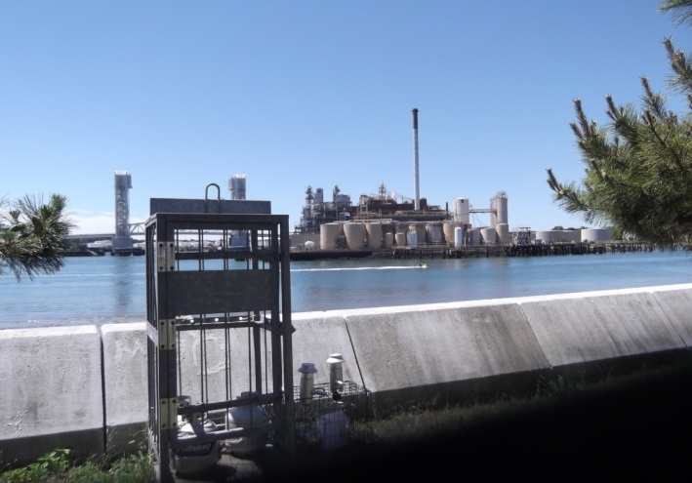 | 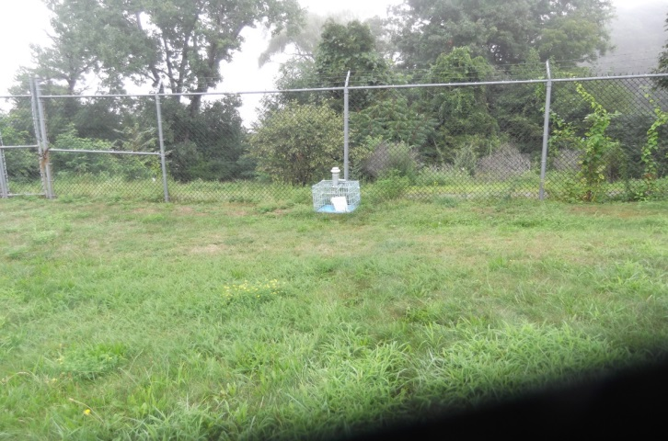
Quincy – Clement O’Brien Tower | Braintree – Braintree Electric and Light Department
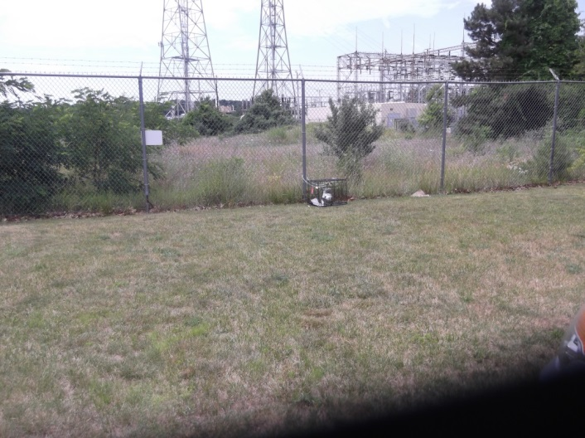 | 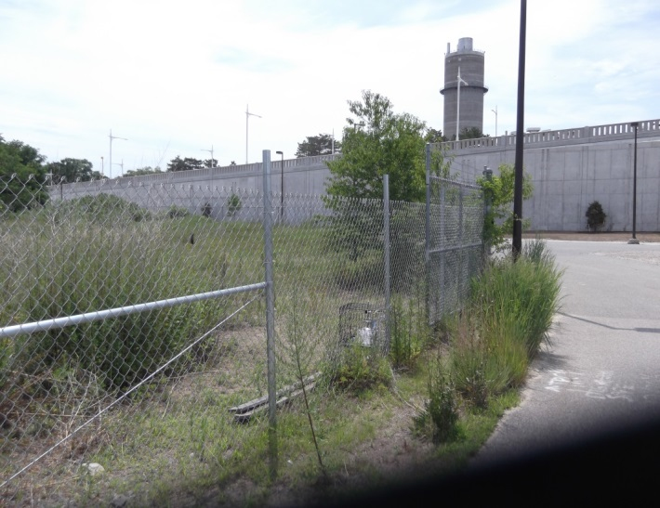
Weymouth 1 – Fore River Energy Center | Weymouth 2 – Enbridge Site
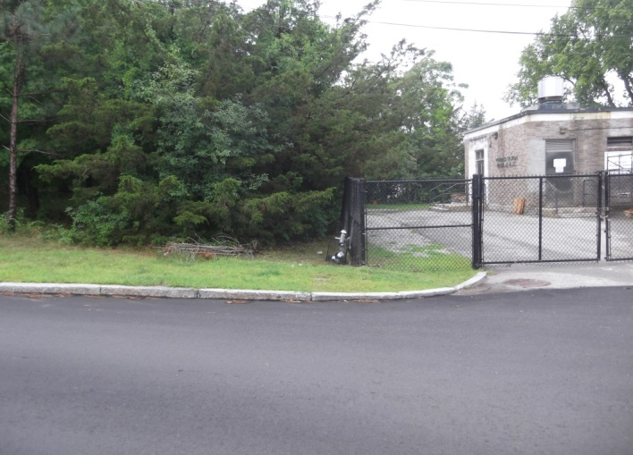 | 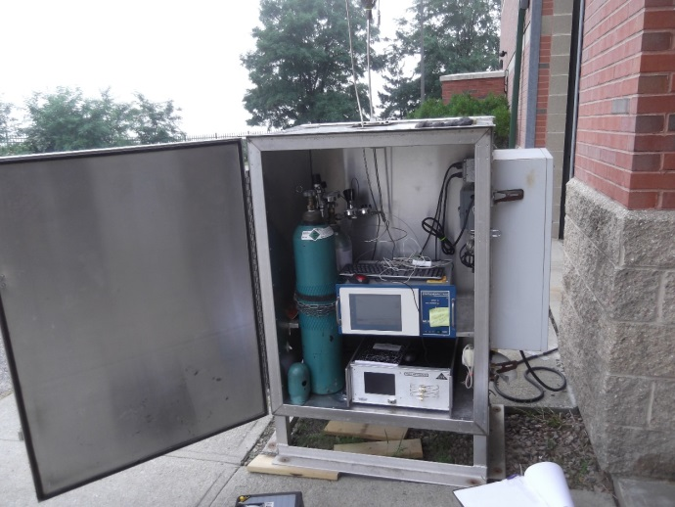
Hingham – MWRA Pumping Station/Stodder’s Neck | Mini-station at Weymouth MWRA Pump Station

Wind Roses (Wind Direction / Wind Speed) From Von Hillern Street, Boston Monitoring Station
(hour 11 – hour 10)
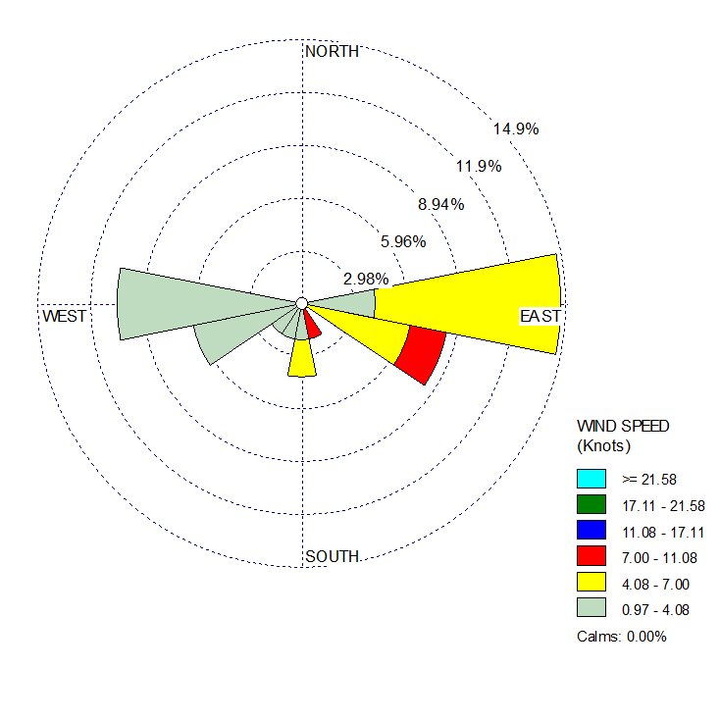
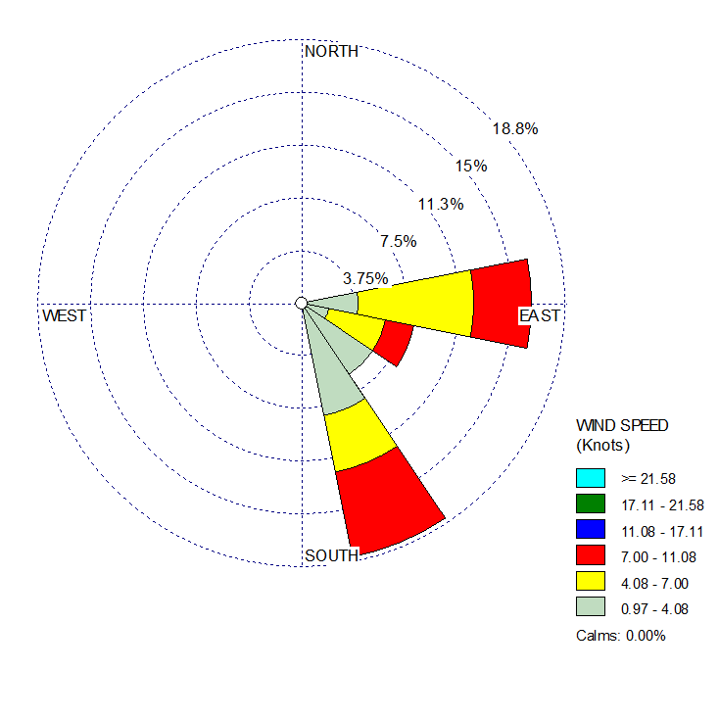
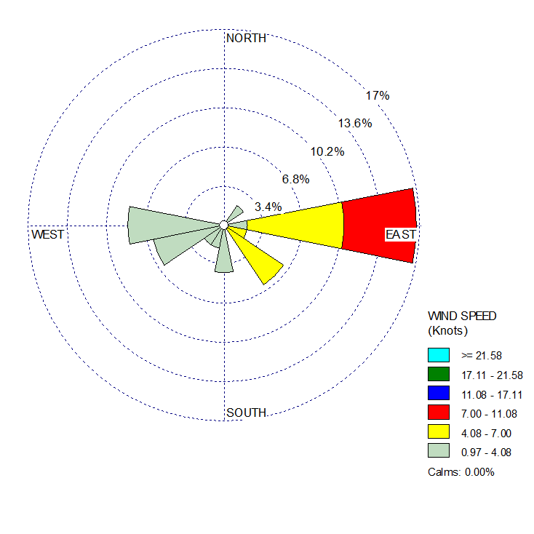
July 7, 2018 – July 8, 2018
July 13, 2018 – July 14, 2018

July 19, 2018 – July 20, 2018

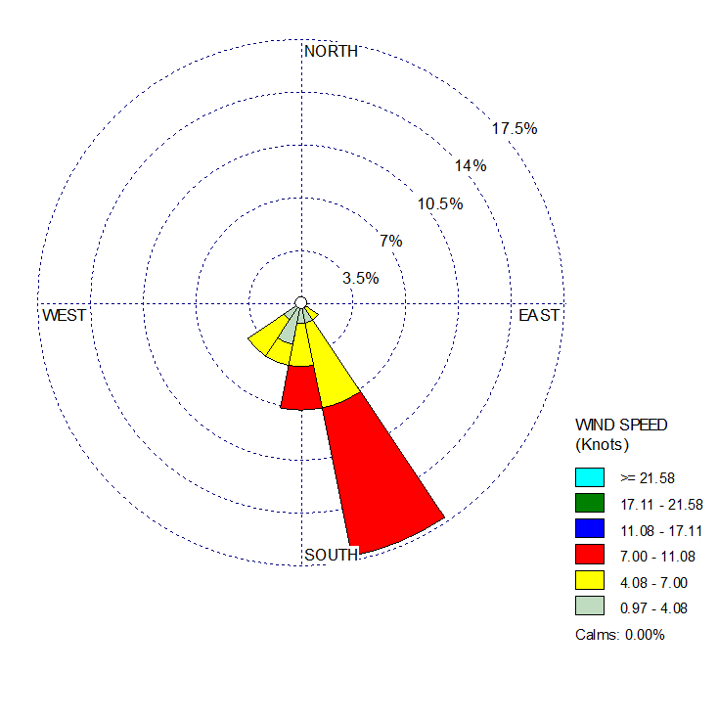
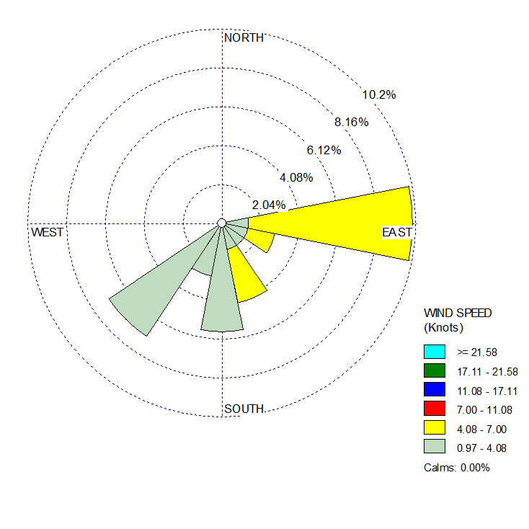
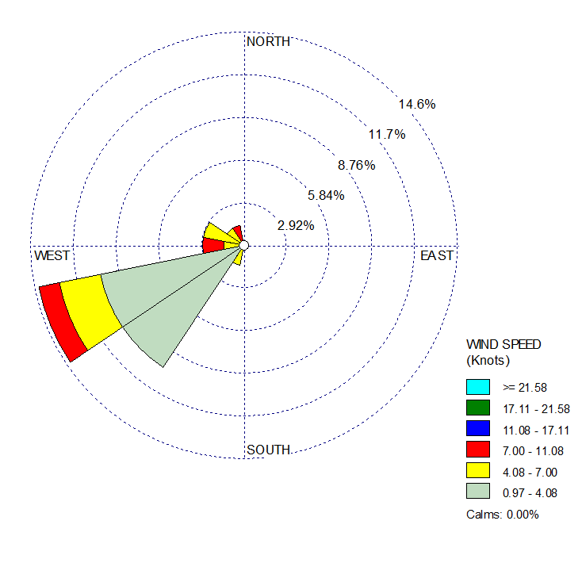
July 25, 2018 – July 26, 2018
July 31, 2018 – August 1, 2018

August 6, 2018 – August 7, 2018

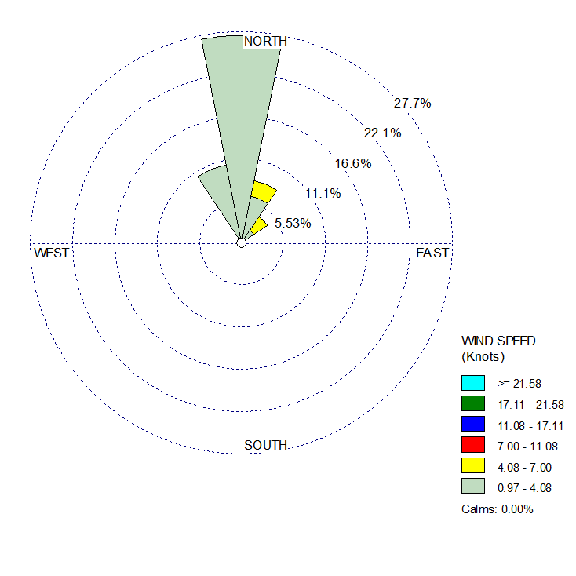
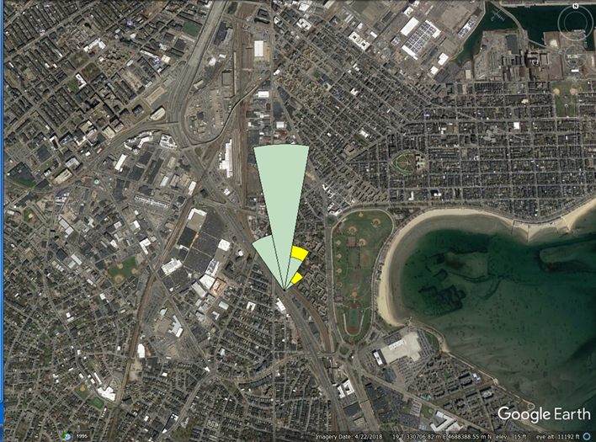
August 12, 2018 – August 13, 2018
Location of Von Hillern monitor station shown below with wind rose for August 12 - 13 superimposed.

Wind Direction / Wind Speed / Maximum Temperature
From Von Hillern Street, Boston Monitoring Station (hour 11 – hour 10)

July 7 - 8, 2018  Wind Direction / Wind Speed (hours)  E = 9 > 5 mph = 11  SE = 3 < 5 mph = 13  S = 3  SW = 5  W = 4  Max Temp July 7: 73 F  Max Temp July 8: 81 F | July 13 – 14, 2018  Wind Direction / Wind Speed (hours)  E = 9 > 5 mph = 15  SE = 15 < 5 mph = 9  Max Temp July 13: 77 F  Max Temp July 14: 75 F
July 19 – 20, 2018  Wind Direction / Wind Speed (hours)  NE = 1 > 5 mph = 12  E = 8 < 5 mph = 12  SE = 4  S = 2  SW = 5  W = 4  Max Temp July 19: 75 F  Max Temp July 20: 89 F | July 25 – 26, 2018  Wind Direction / Wind Speed (hours)  SE = 14 > 10 mph = 3  S = 4 5 – 10 mph = 17  SW = 6 < 5 mph = 4  Max Temp July 25: 84 F  Max Temp July 26: 84 F
July 31 – August 1, 2018  Wind Direction / Wind Speed (hours)  E = 7 > 5 mph = 9  SE = 6 < 5 mph = 15  S = 4  SW = 7  Max Temp July 31: 82 F  Max Temp August 1: 82 F | August 6 – 7, 2018  Wind Direction / Wind Speed (hours)  SW = 18 > 5 mph = 11  W = 1 < 5 mph = 13  NW = 5  Max Temp August 6: 95 F  Max Temp August 7: 95 F
August 12 – 13, 2018

Wind Direction / Wind Speed (hours)
NW = 4 > 5 mph = 3
N = 14 < 5 mph = 21
NE = 6

Max Temp August 12: 73 F
Max Temp August 13: 73 F

Appendix E. Figures of MassDEP 2018 Air Monitoring Results
Benzene Concentrations from Canister Samples relative to TEL
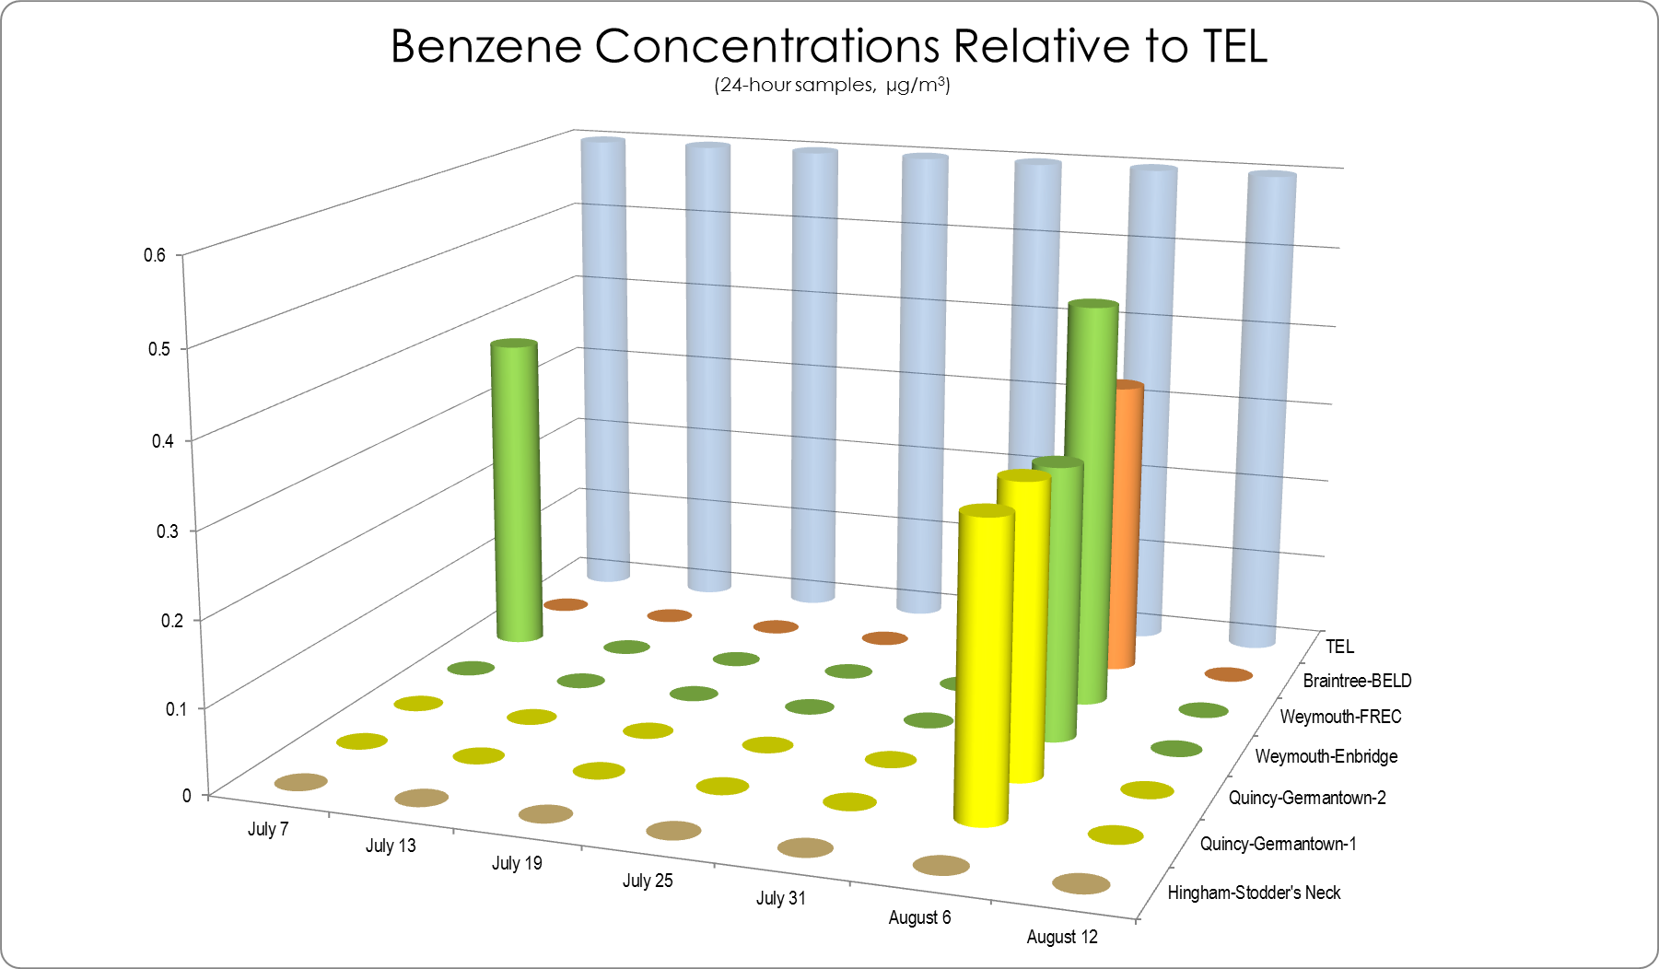
TEL = Threshold Effects Exposure Limit (24-Hour Average)
µg/m3 = micrograms per cubic meter
0 = Not detected at the reporting limit
Ethyl Benzene Concentrations from Canister Samples relative to TEL
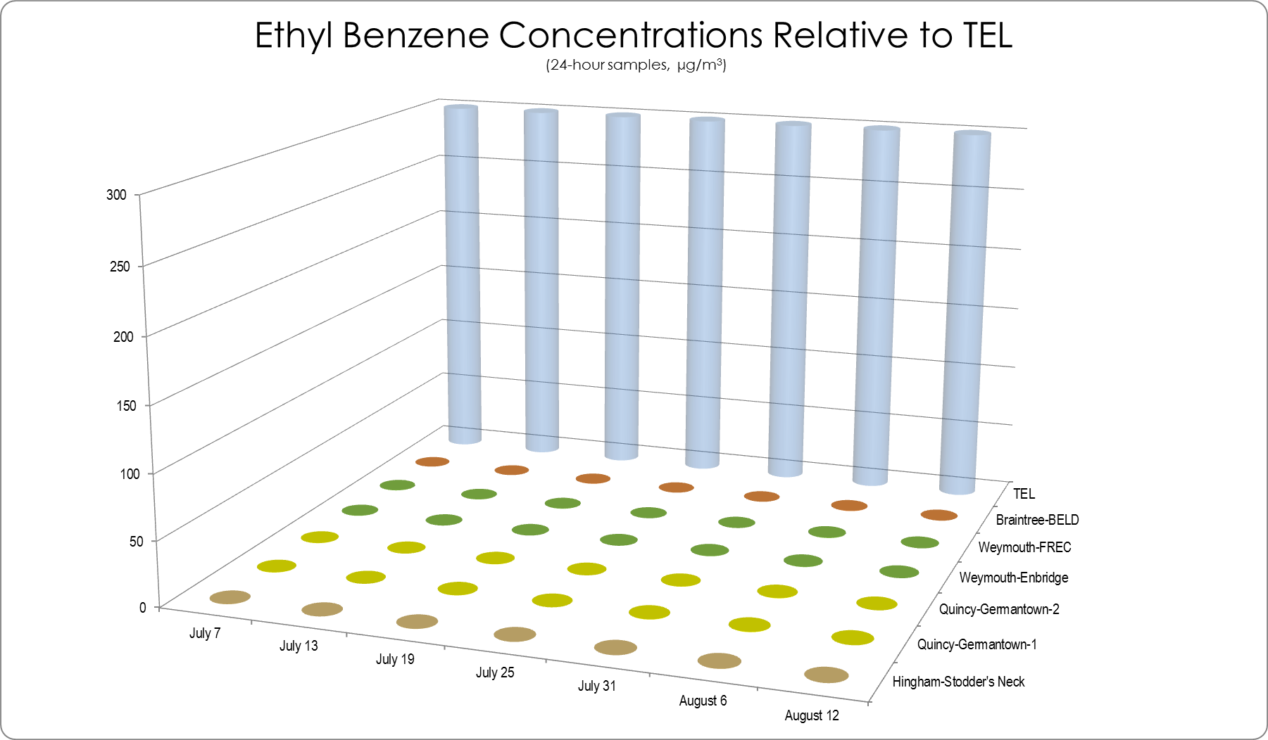
TEL = Threshold Effects Exposure Limit (24-Hour Average)
µg/m3 = micrograms per cubic meter
0 = Not detected at the reporting limit

Toluene Concentrations from Canister Samples relative to TEL
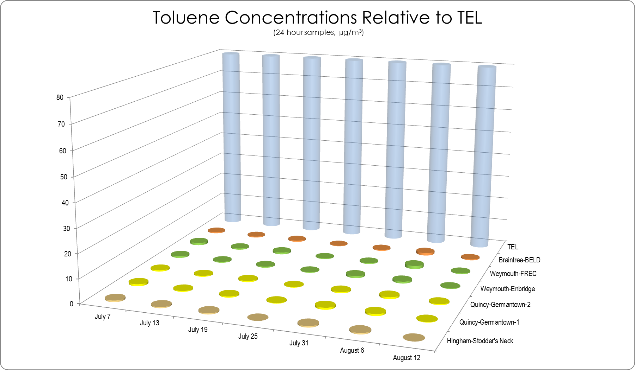
TEL = Threshold Effects Exposure Limit (24-Hour Average)
µg/m3 = micrograms per cubic meter
0 = Not detected at the reporting limit

Xylene Concentrations from Canister Samples relative to TEL
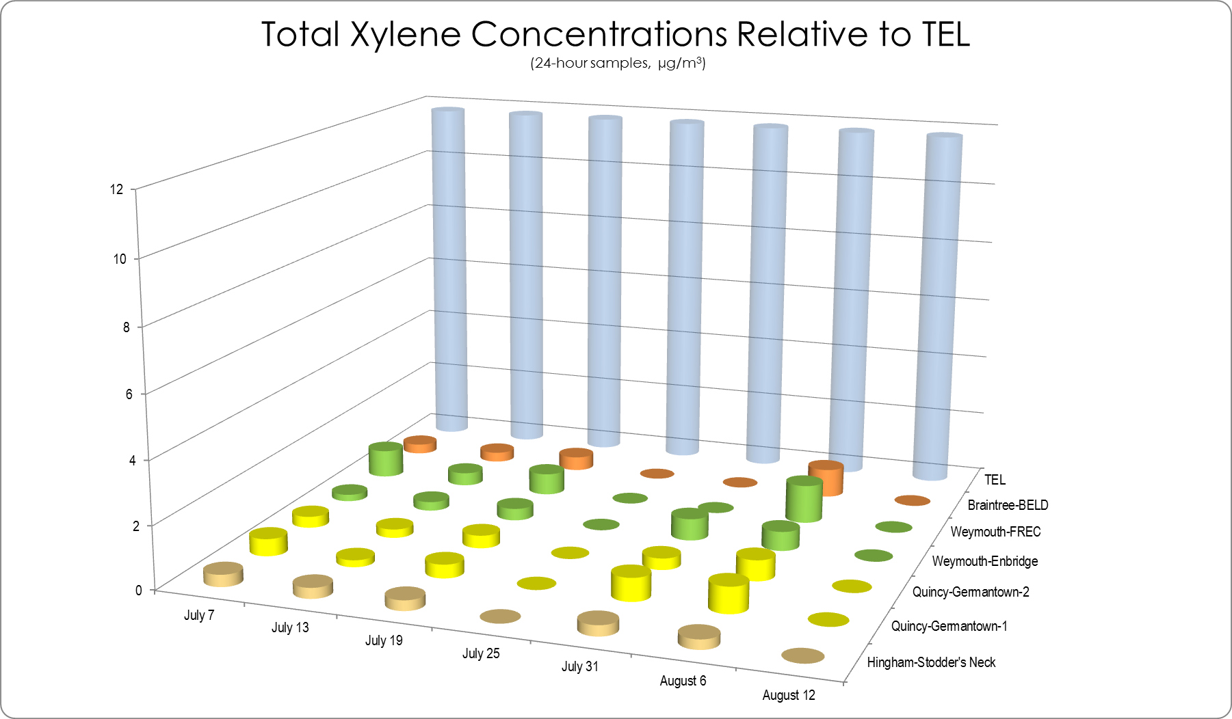
TEL = Threshold Effects Exposure Limit (24-Hour Average)
µg/m3 = micrograms per cubic meter
0 = Not detected at the reporting limit

Dichloroethane Concentrations from Canister Samples relative to TEL
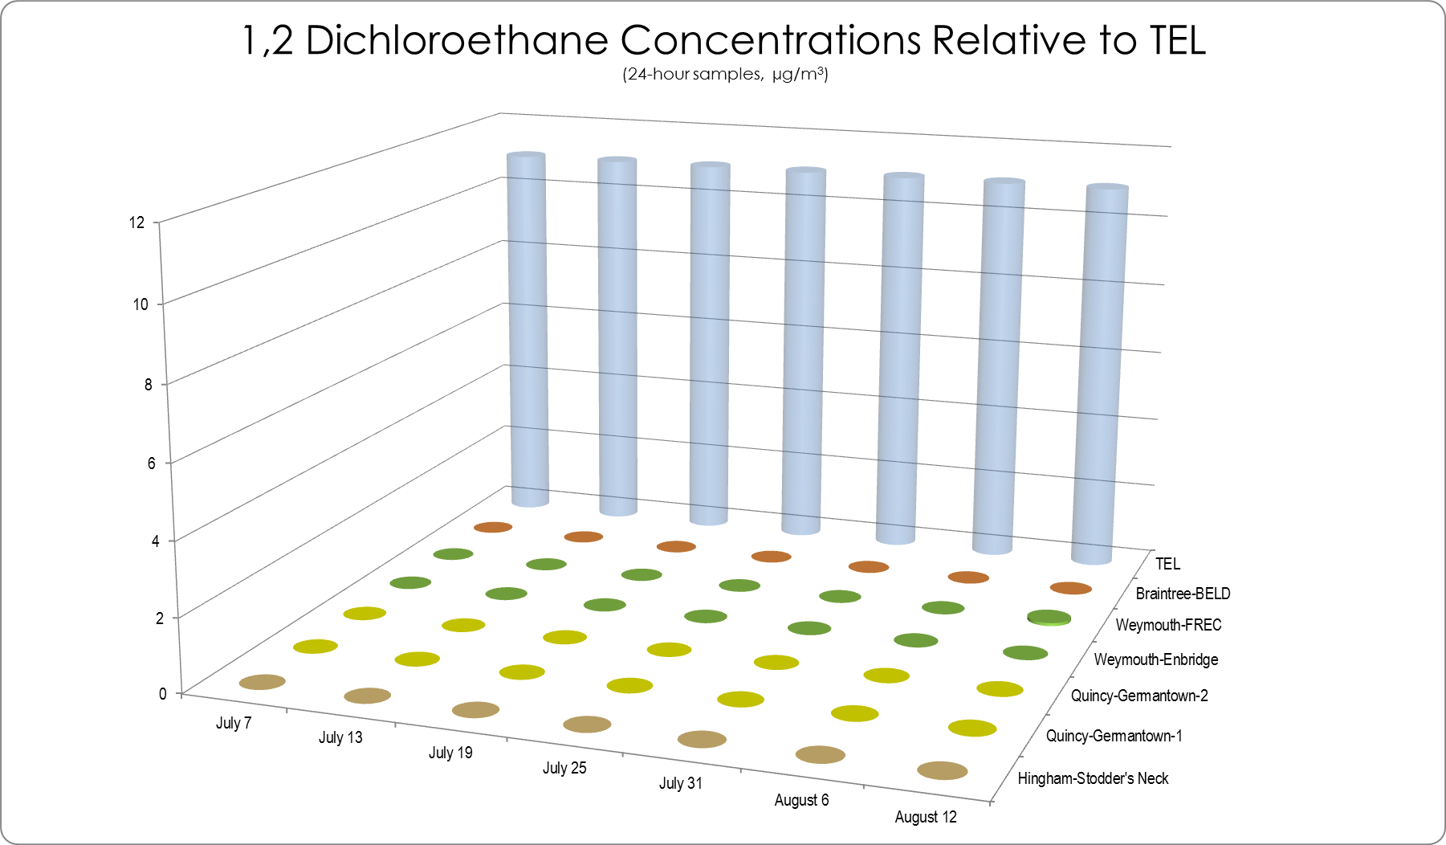
TEL = Threshold Effects Exposure Limit (24-Hour Average)
µg/m3 = micrograms per cubic meter
0 = Not detected at the reporting limit

Trichloroethane Concentrations from Canister Samples relative to TEL
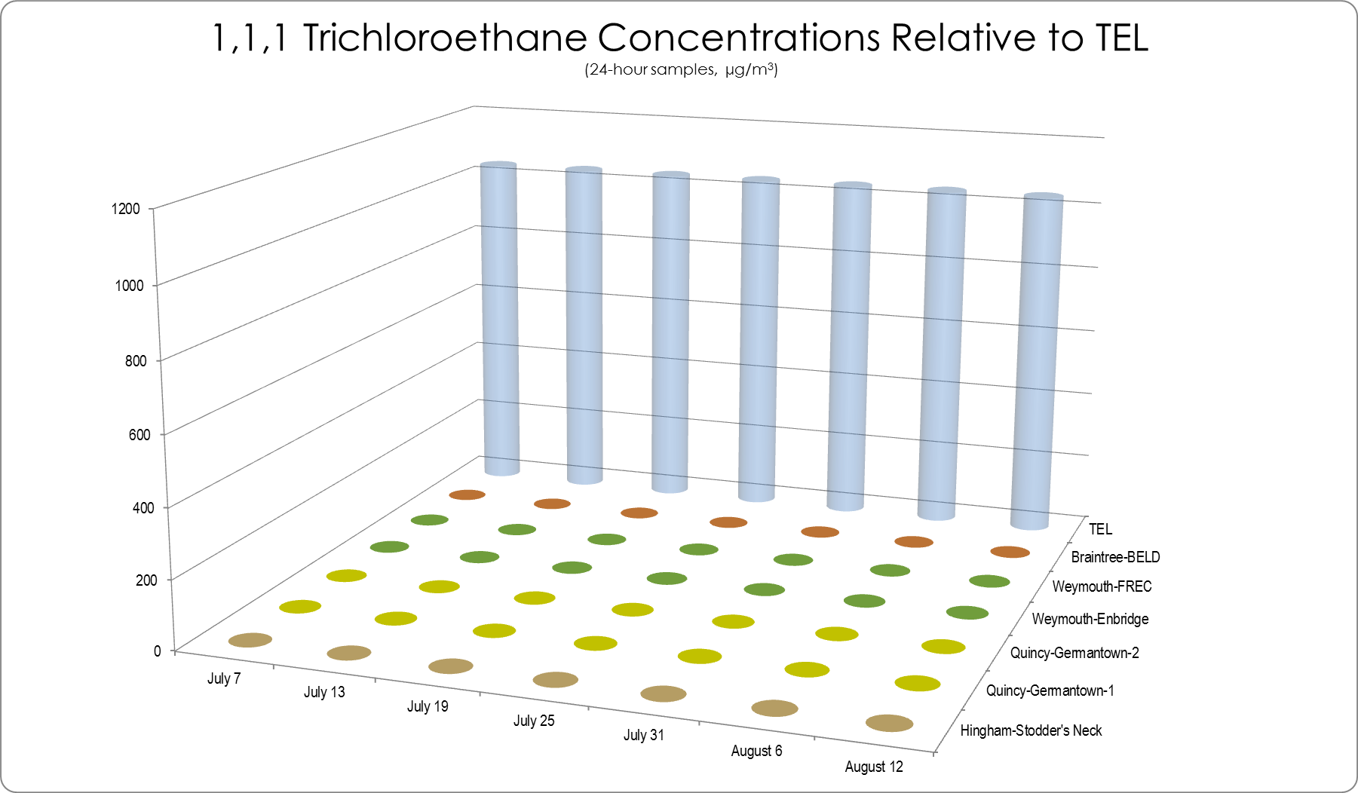
TEL = Threshold Effects Exposure Limit (24-Hour Average)
µg/m3 = micrograms per cubic meter
0 = Not detected at the reporting limit

Acetone Concentrations from Canister Samples relative to TEL
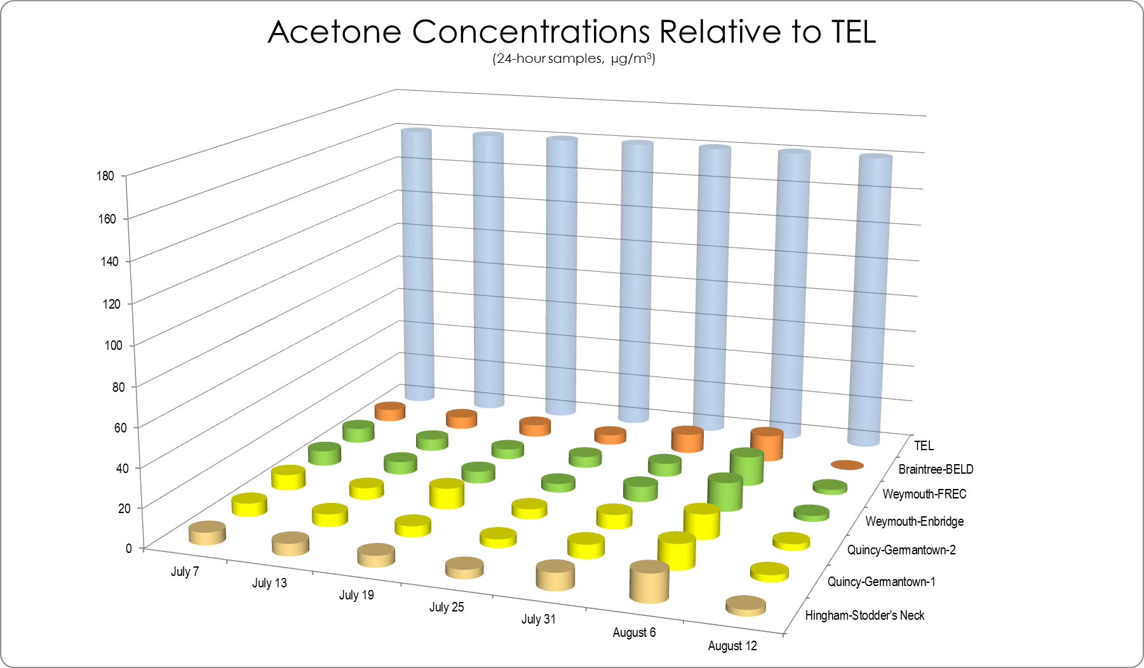
TEL = Threshold Effects Exposure Limit (24-Hour Average)
µg/m3 = micrograms per cubic meter
0 = Not detected at the reporting limit

Bromoform Concentrations from Canister Samples relative to TEL
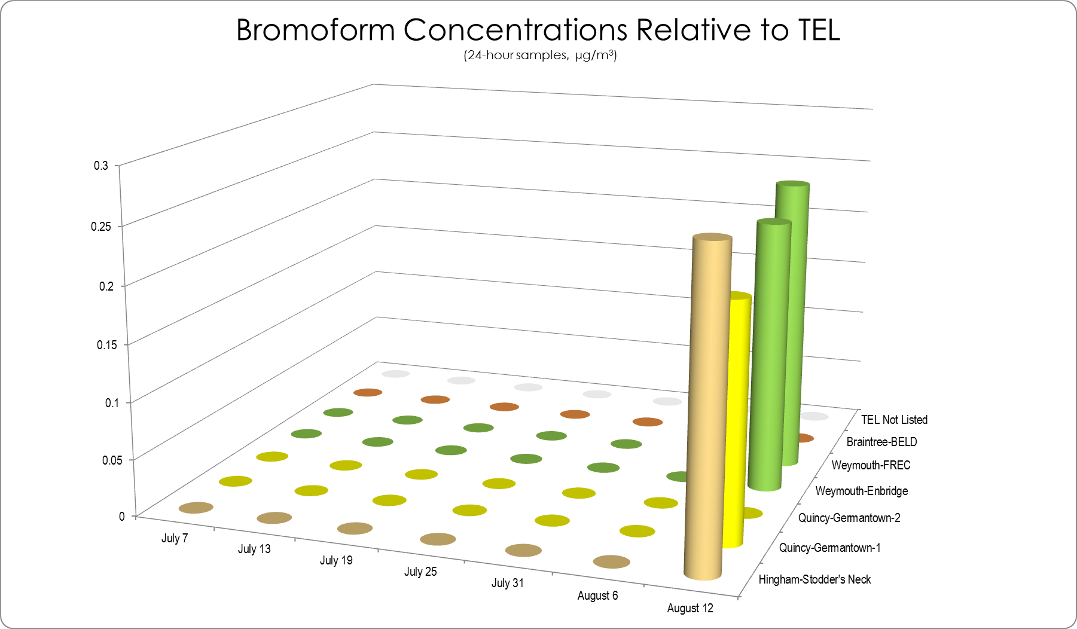
TEL = Threshold Effects Exposure Limit (24-Hour Average)
µg/m3 = micrograms per cubic meter
0 = Not detected at the reporting limit

Carbon Tetrachloride Concentrations from Canister Samples relative to TEL
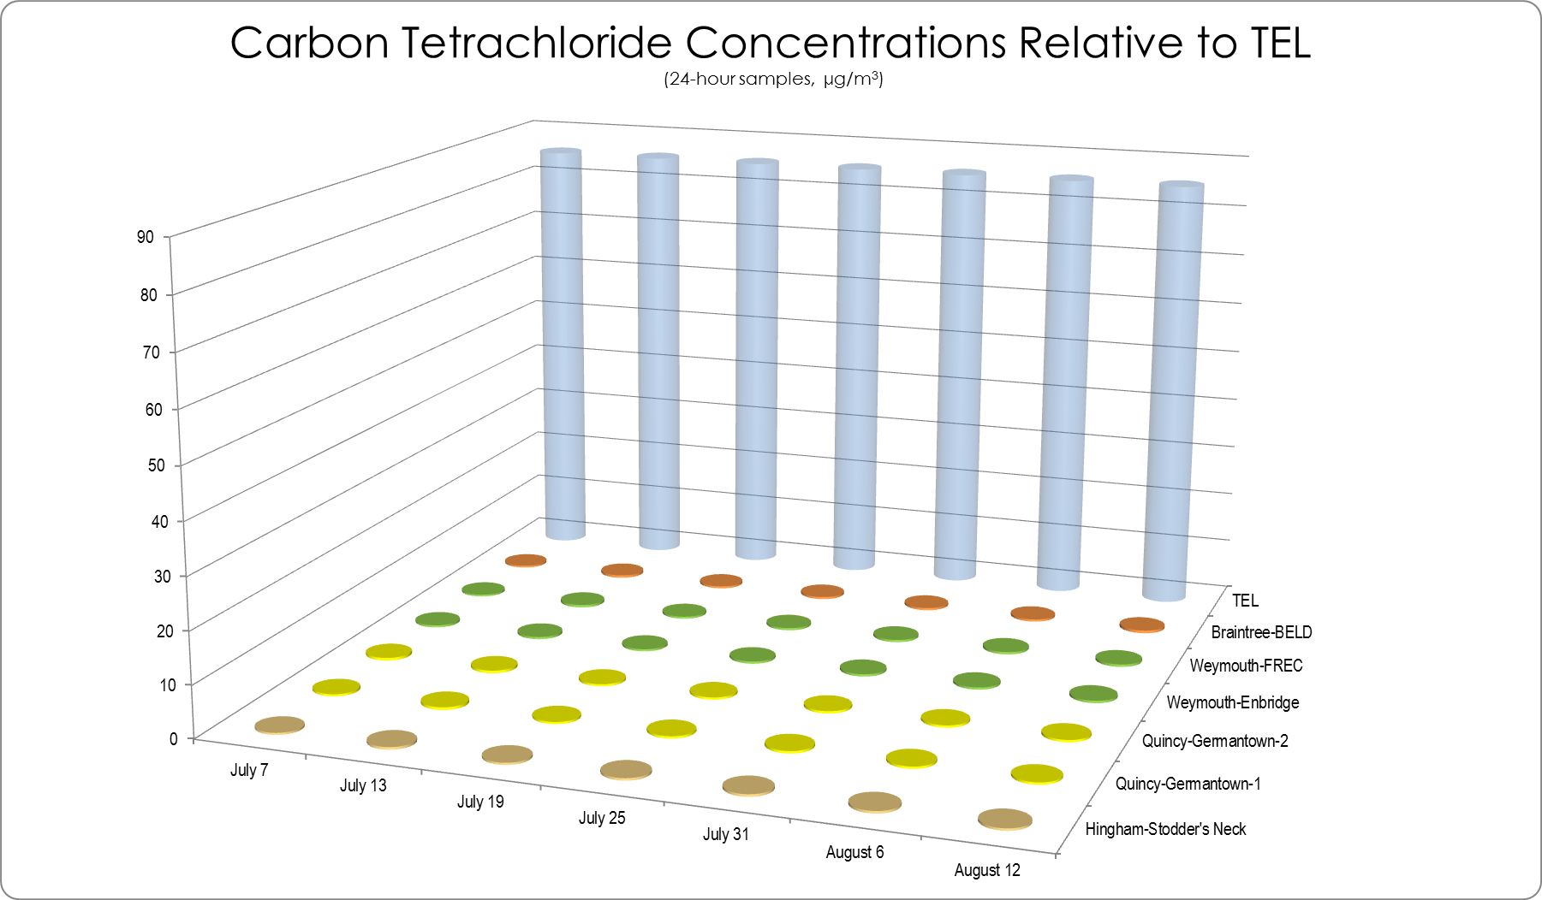
TEL = Threshold Effects Exposure Limit (24-Hour Average)
µg/m3 = micrograms per cubic meter
0 = Not detected at the reporting limit

Chloroform Concentrations from Canister Samples relative to TEL
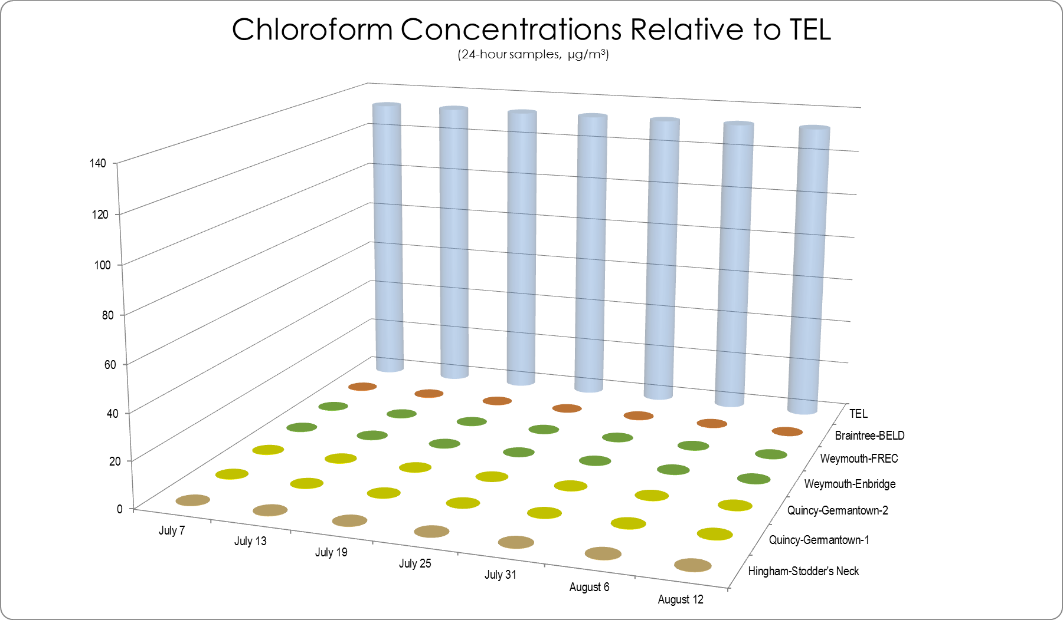
TEL = Threshold Effects Exposure Limit (24-Hour Average)
µg/m3 = micrograms per cubic meter
0 = Not detected at the reporting limit

Methylene Concentrations from Canister Samples relative to TEL
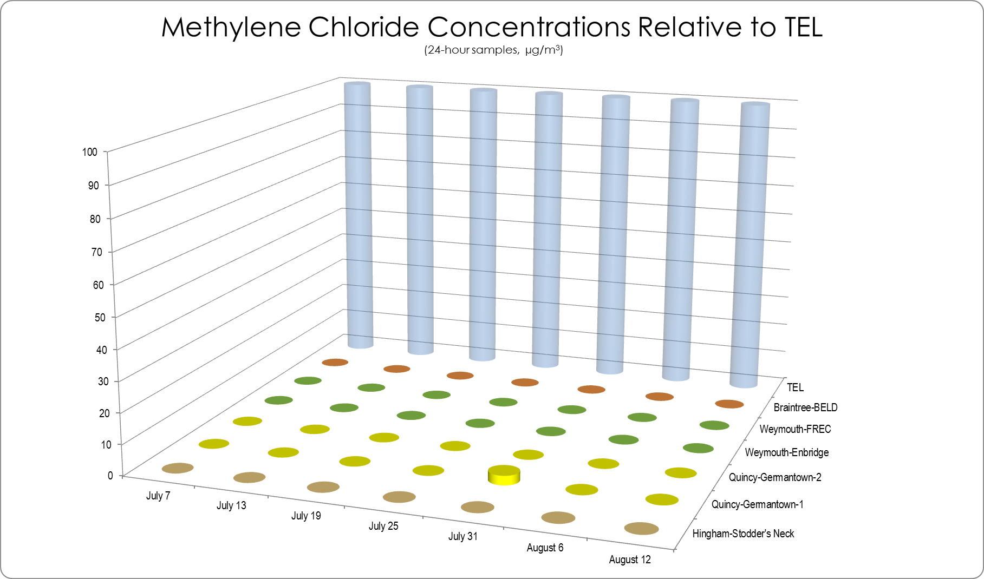
TEL = Threshold Effects Exposure Limit (24-Hour Average)
µg/m3 = micrograms per cubic meter
0 = Not detected at the reporting limit

Naphthalene Concentrations from Canister Samples relative to TEL
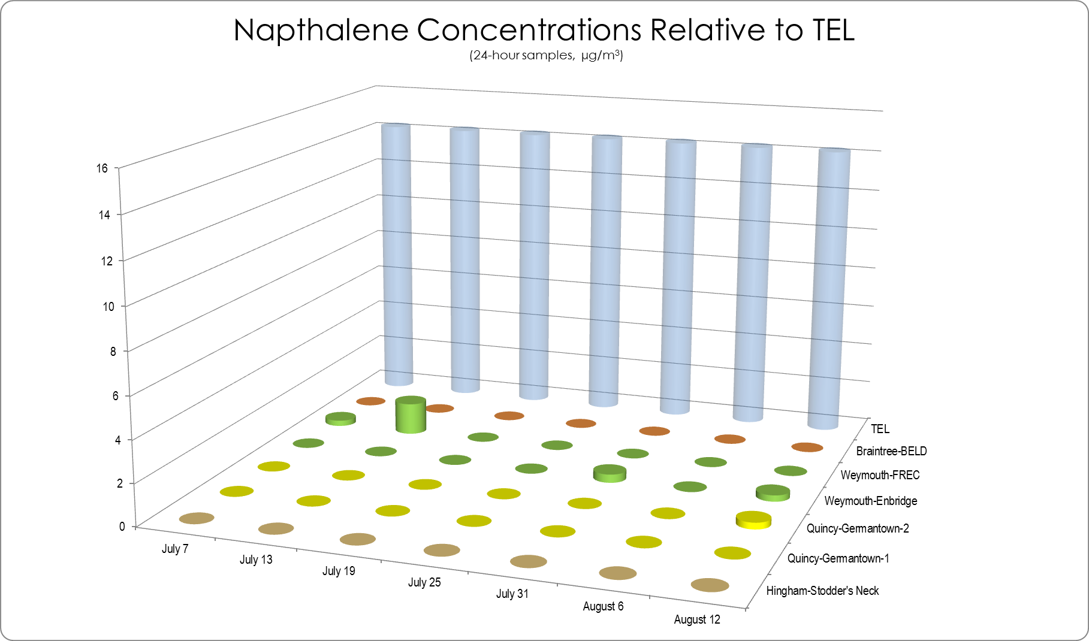
TEL = Threshold Effects Exposure Limit (24-Hour Average)
µg/m3 = micrograms per cubic meter
0 = Not detected at the reporting limit

Styrene Concentrations from Canister Samples relative to TEL
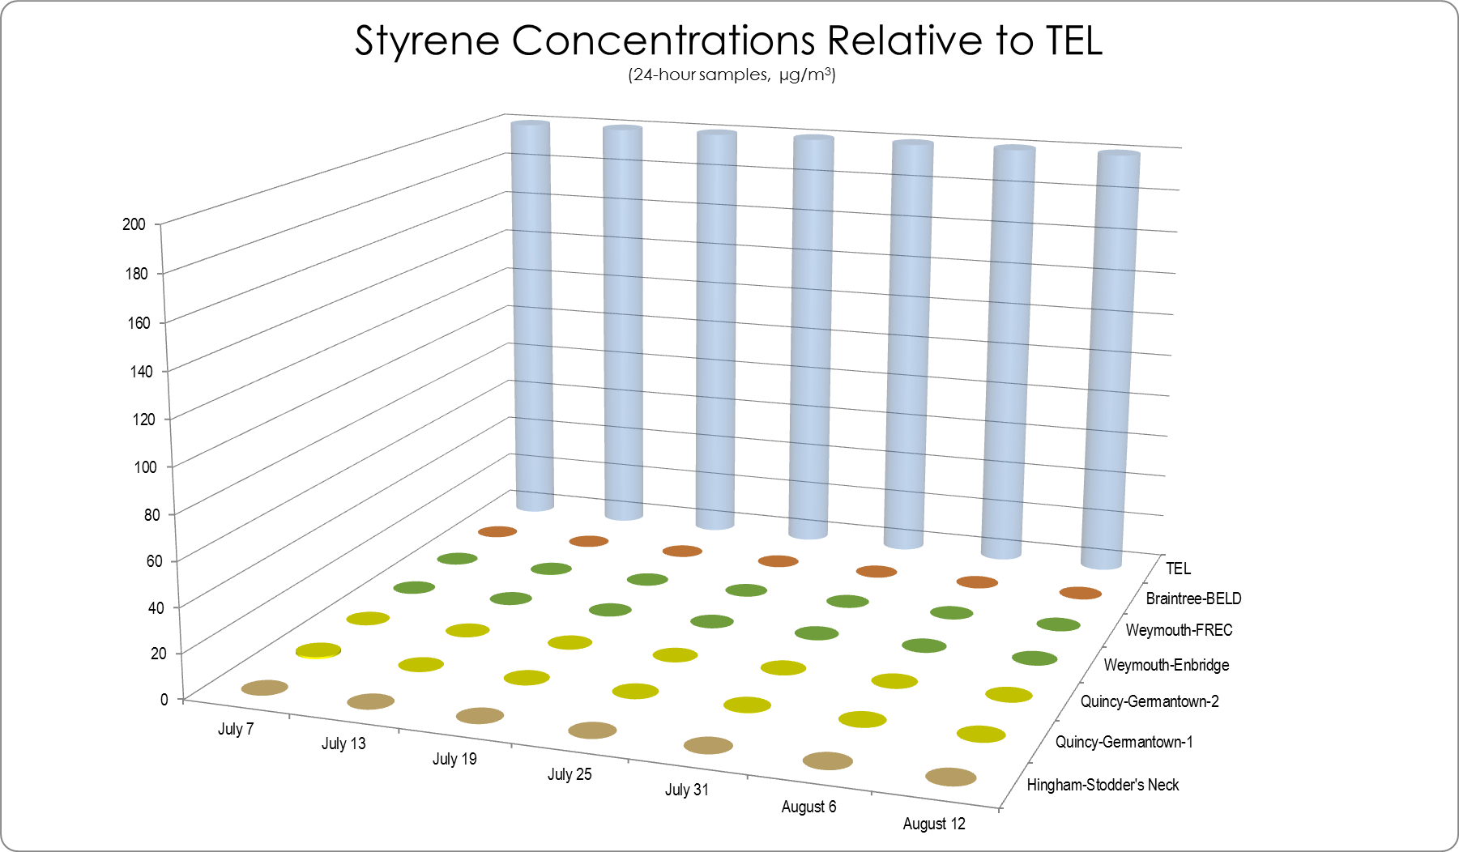
TEL = Threshold Effects Exposure Limit (24-Hour Average)
µg/m3 = micrograms per cubic meter
0 = Not detected at the reporting limit

Tetrachloroethane Concentrations from Canister Samples relative to TEL
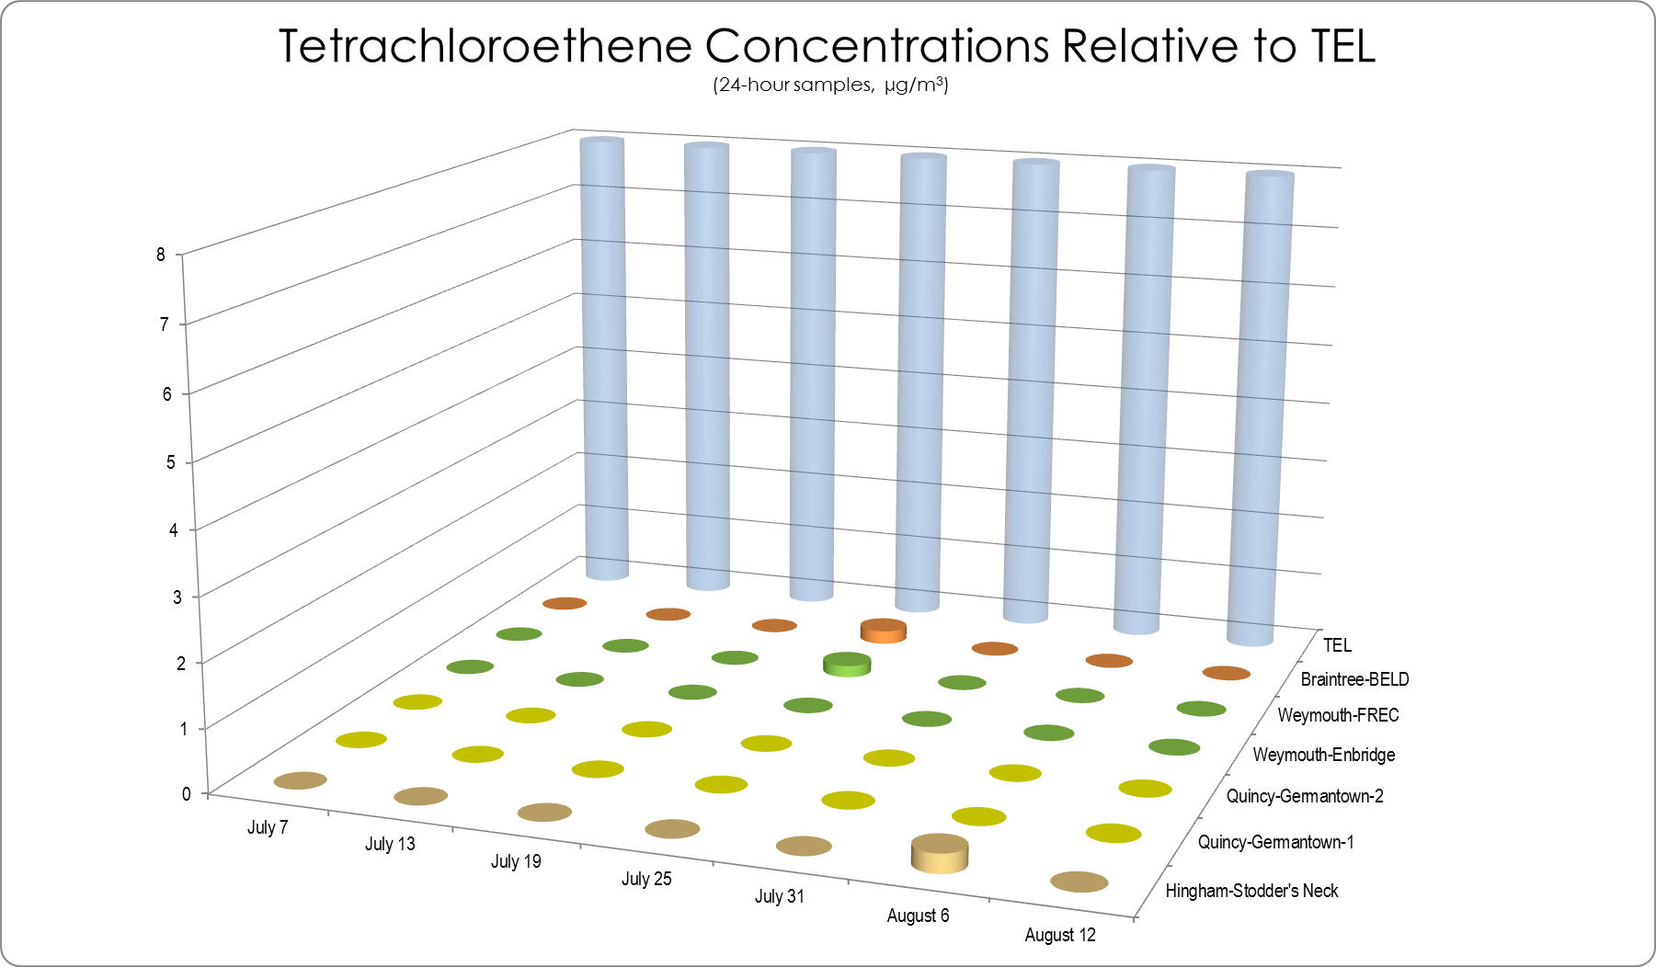
TEL = Threshold Effects Exposure Limit (24-Hour Average)
µg/m3 = micrograms per cubic meter
0 = Not detected at the reporting limit

Benzene Concentrations from Air Monitoring at MWRA Pump Station
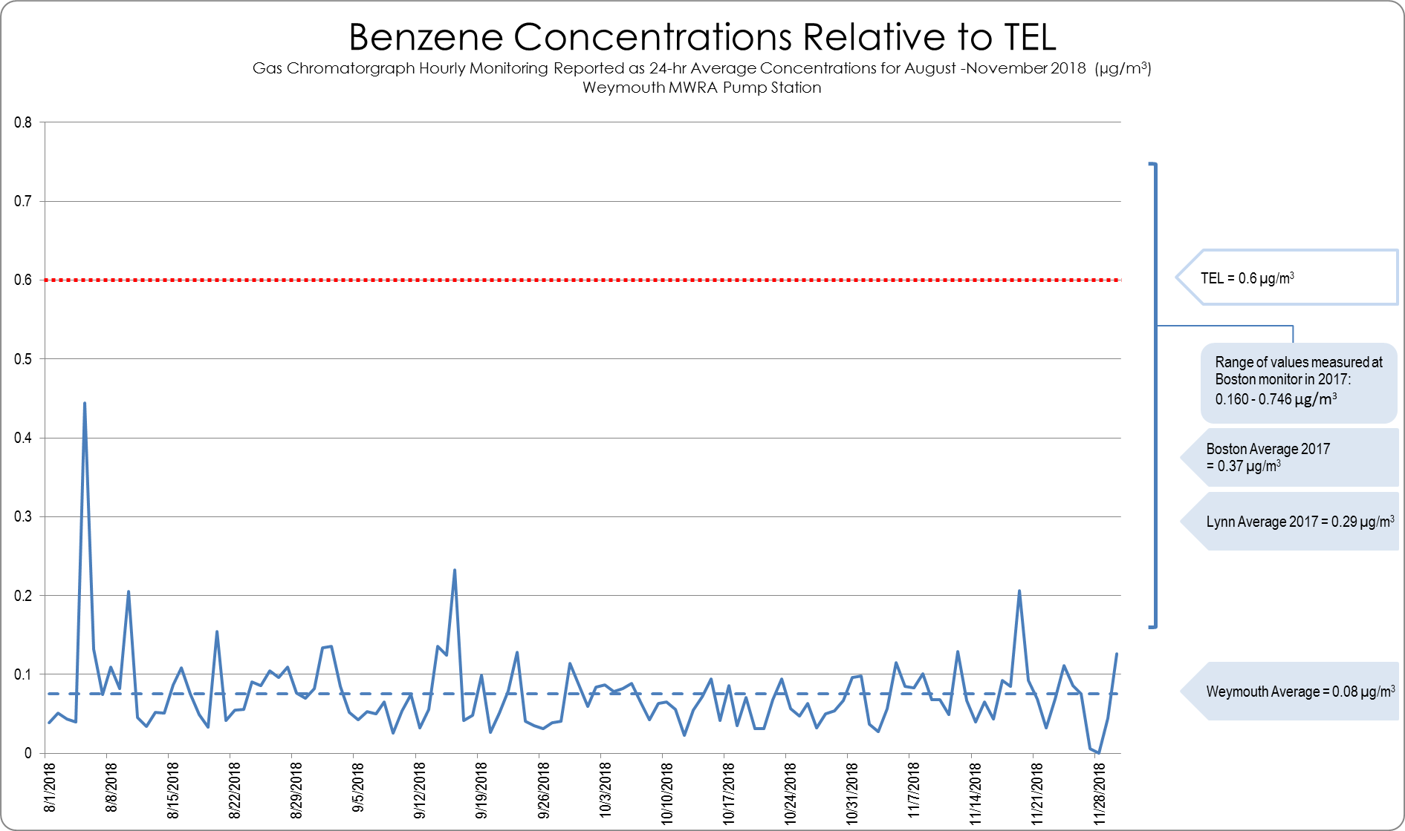
TEL = Threshold Effects Exposure Limit (24-Hour Average)
µg/m3 = micrograms per cubic meter
Toluene Concentrations from Air Monitoring at MWRA Pump Station
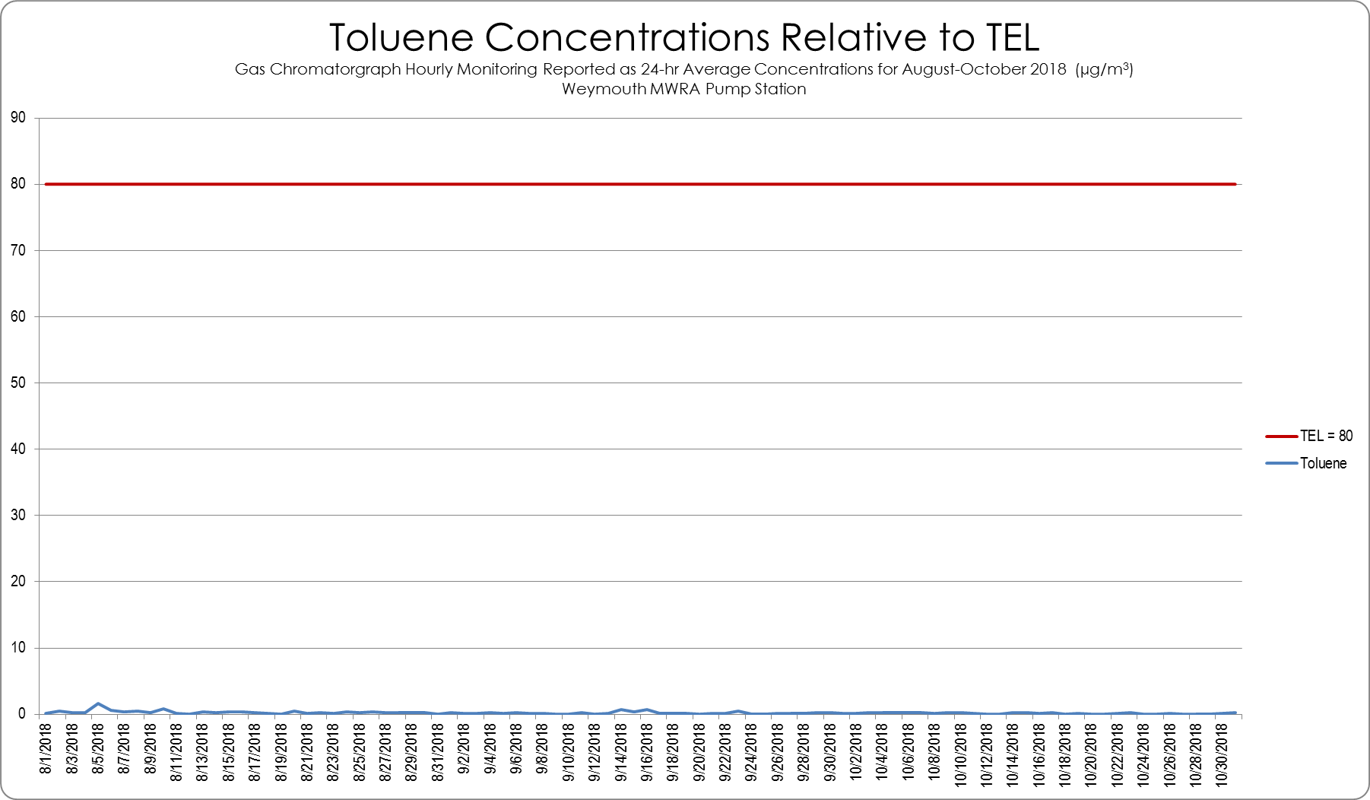
TEL = Threshold Effects Exposure Limit (24-Hour Average)
µg/m³ = micrograms per cubic meter

Ethylbenzene Concentrations from Air Monitoring at MWRA Pump Station
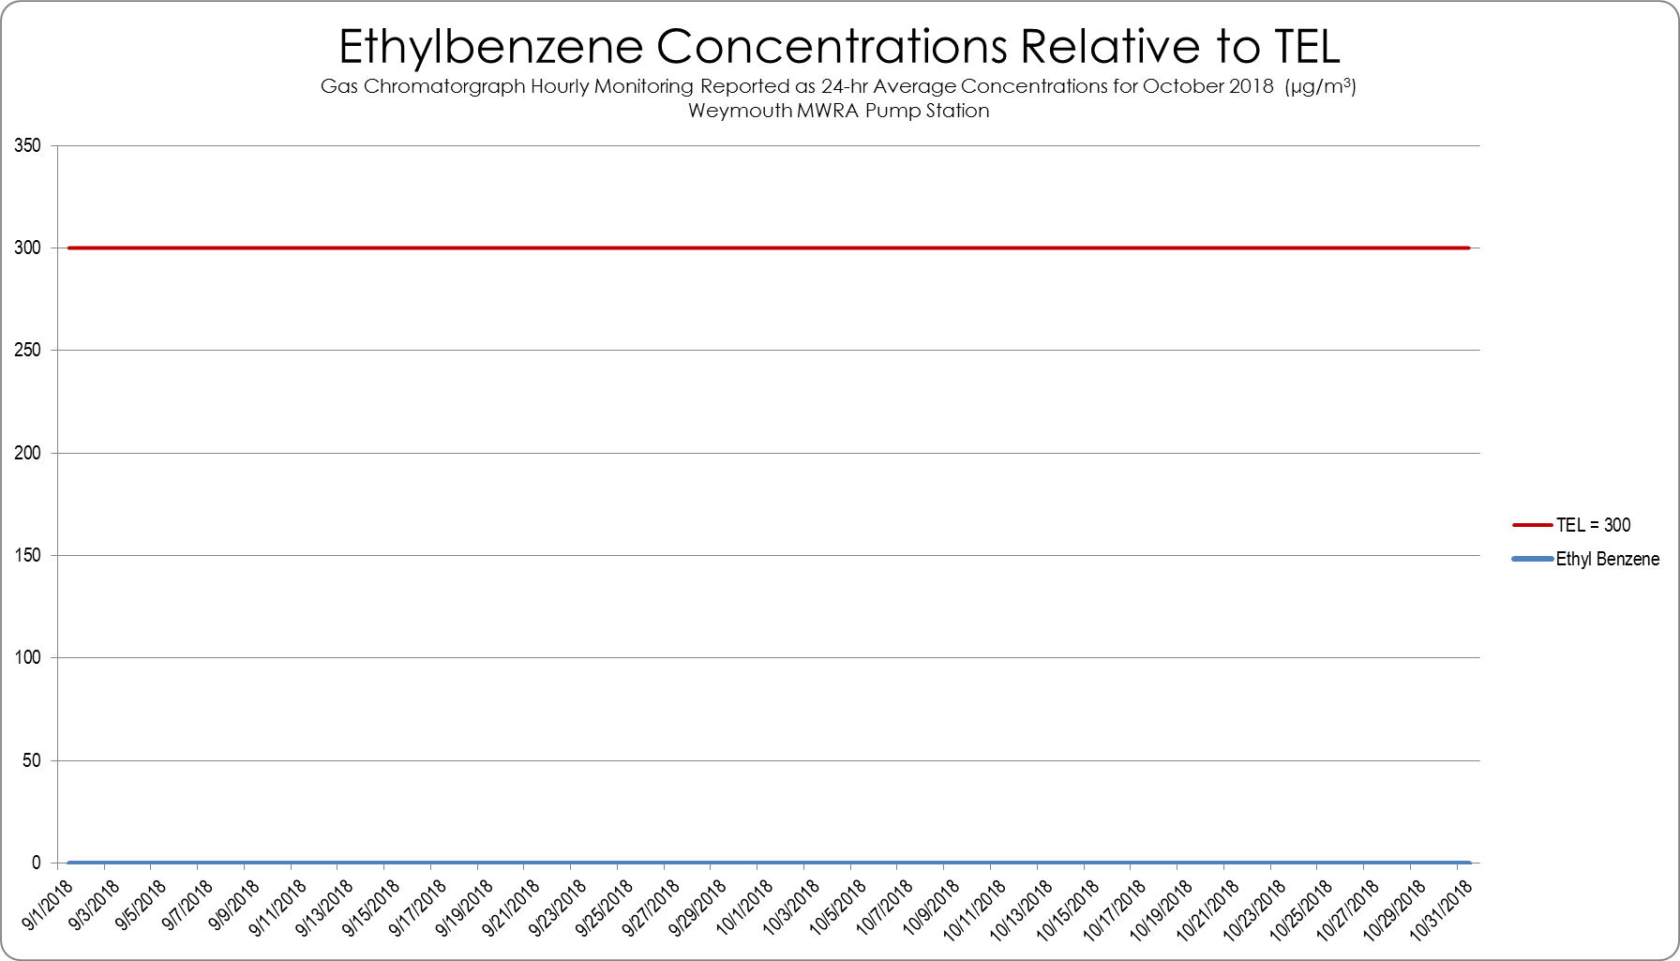
TEL = Threshold Effects Exposure Limit (24-Hour Average)
µg/m³ = micrograms per cubic meter
Total Xylene Concentrations from Air Monitoring at MWRA Pump Station
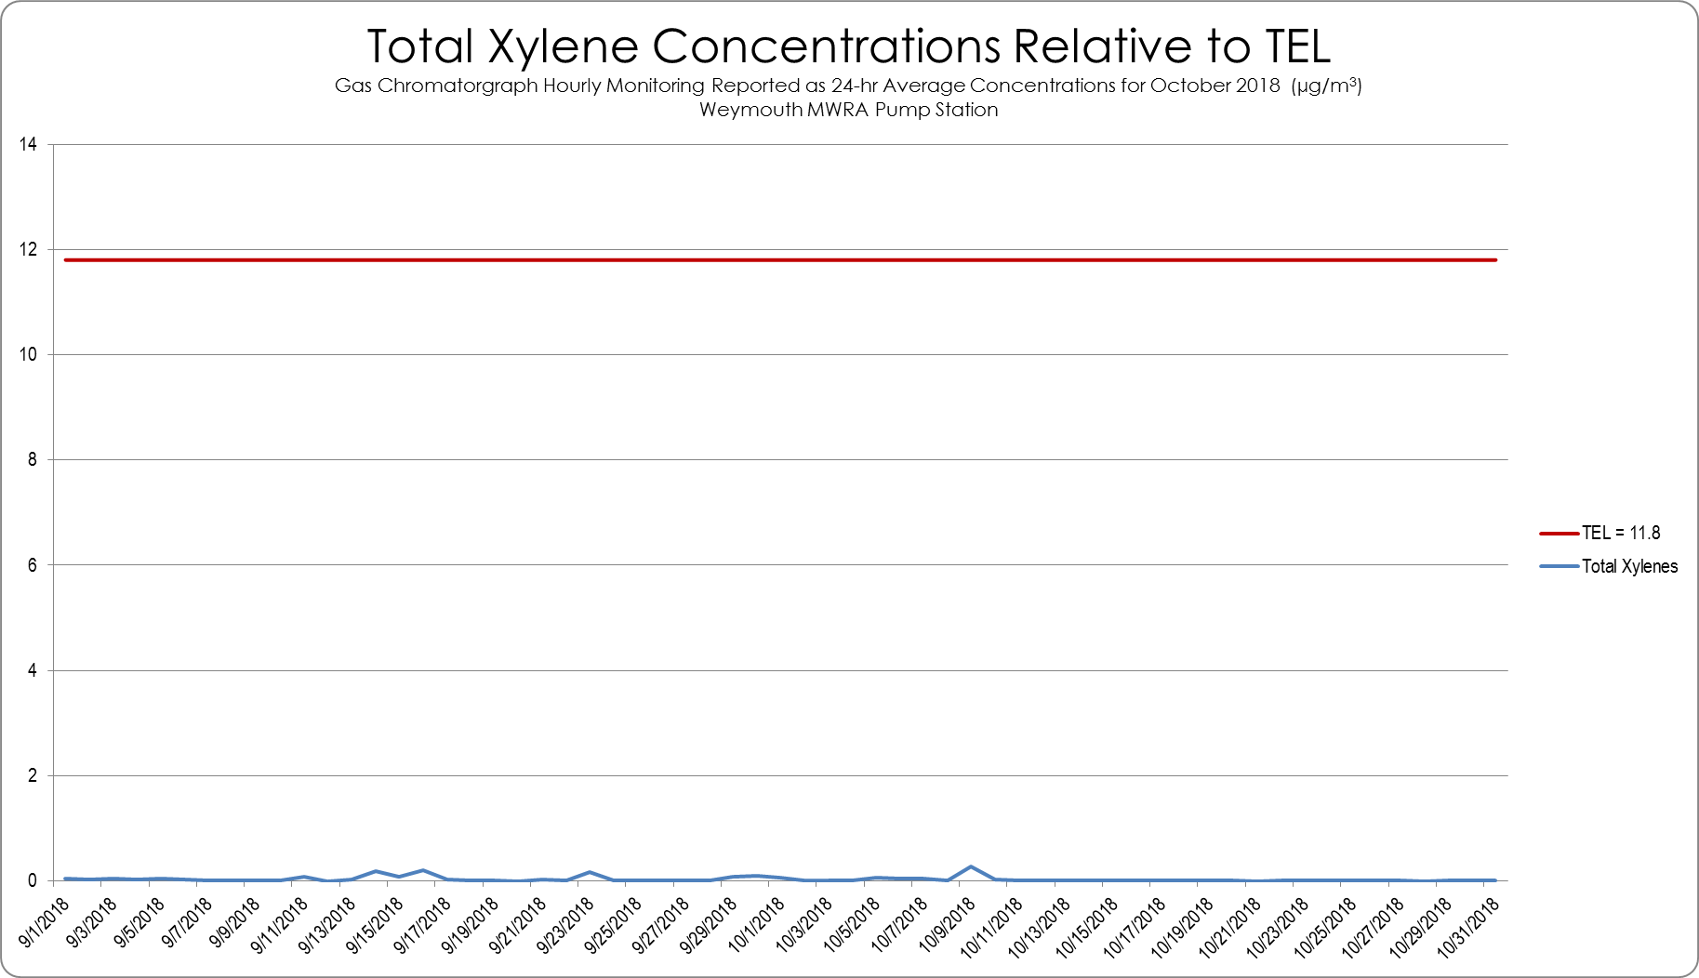
TEL = Threshold Effects Exposure Limit (24-Hour Average)
µg/m³ = micrograms per cubic meter

Formaldehyde 24-hr Concentrations from Air Monitoring at MWRA Pump Station
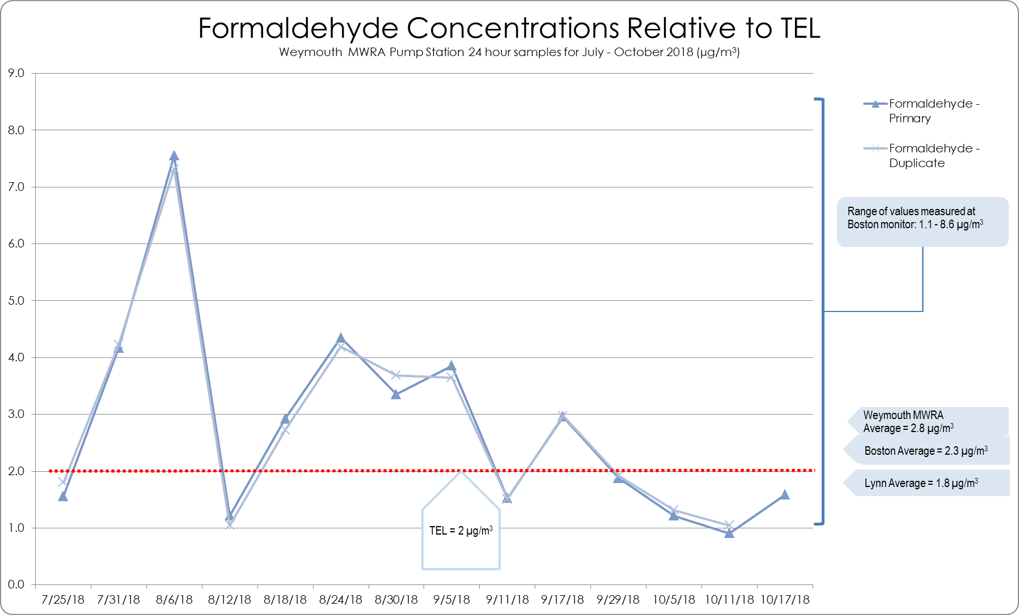
TEL = Threshold Effects Exposure Limit (24-Hour Average)
µg/m³ = micrograms per cubic meter

Acetaldehyde 24-hr Concentrations from Air Monitoring at MWRA Pump Station
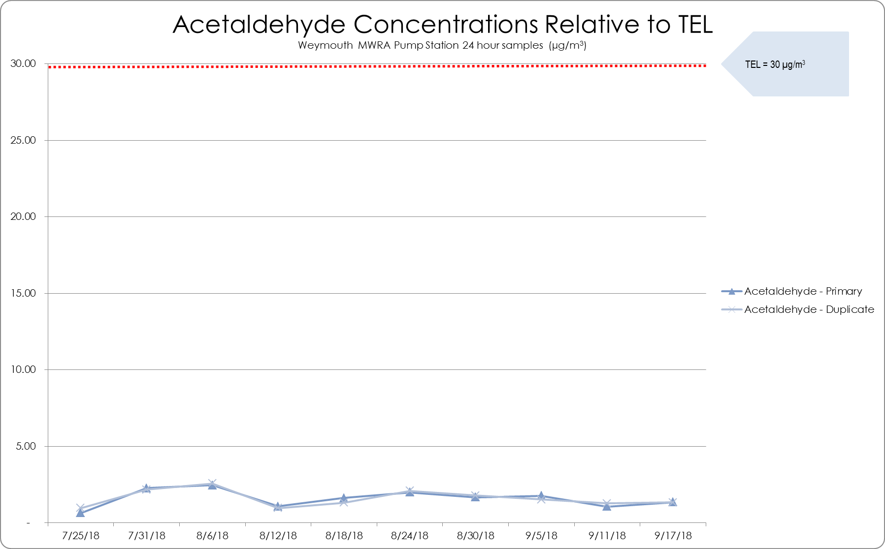
TEL = Threshold Effects Exposure Limit (24-Hour Average)
µg/m³ = micrograms per cubic meter

Appendix F. Real Estate Sales Price History 2015-2017 for Municipalities and Focus Area

Municipality | Sale Year | Residential Type | Average Price | Median Price
Braintree | 2015 | 2 Family Residence | $ 469,495.00 | $ 452,000.00
Braintree | 2016 | 2 Family Residence | $ 487,869.00 | $ 490,500.00
Braintree | 2017 | 2 Family Residence | $ 511,667.00 | $ 490,000.00
Braintree | 2015 | 3 Family Residence | $ 612,900.00 | $ 612,900.00
Braintree | 2016 | 3 Family Residence | $ 543,333.00 | $ 500,000.00
Braintree | 2017 | 3 Family Residence | $ 295,000.00 | $ 295,000.00
Braintree | 2015 | Condominium | $ 328,164.00 | $ 310,000.00
Braintree | 2016 | Condominium | $ 312,908.00 | $ 295,000.00
Braintree | 2017 | Condominium | $ 368,318.00 | $ 328,450.00
Braintree | 2015 | Single Family Residence | $ 409,636.00 | $ 385,000.00
Braintree | 2016 | Single Family Residence | $ 457,799.00 | $ 424,167.00
Braintree | 2017 | Single Family Residence | $ 481,868.00 | $ 455,000.00
Hingham | 2015 | 2 Family Residence | $ 761,537.00 | $ 485,000.00
Hingham | 2016 | 2 Family Residence | $ 542,500.00 | $ 529,500.00
Hingham | 2017 | 2 Family Residence | $ 635,000.00 | $ 635,000.00
Hingham | 2017 | 3 Family Residence | $ 517,500.00 | $ 517,500.00
Hingham | 2015 | Condominium | $ 643,657.00 | $ 643,400.00
Hingham | 2016 | Condominium | $ 546,955.00 | $ 340,000.00
Hingham | 2017 | Condominium | $ 676,102.00 | $ 439,950.00
Hingham | 2015 | Single Family Residence | $ 812,419.00 | $ 718,500.00
Hingham | 2016 | Single Family Residence | $ 838,658.00 | $ 732,000.00
Hingham | 2017 | Single Family Residence | $ 948,407.00 | $ 775,000.00
Quincy | 2015 | 2 Family Residence | $ 489,353.00 | $ 481,750.00
Quincy | 2016 | 2 Family Residence | $ 529,755.00 | $ 540,000.00
Quincy | 2017 | 2 Family Residence | $ 573,938.00 | $ 565,000.00
Quincy | 2015 | 3 Family Residence | $ 617,850.00 | $ 630,000.00
Quincy | 2016 | 3 Family Residence | $ 619,536.00 | $ 626,000.00
Quincy | 2017 | 3 Family Residence | $ 666,424.00 | $ 630,000.00
Quincy | 2015 | Condominium | $ 1,650,550.00 | $ 306,000.00
Quincy | 2016 | Condominium | $ 326,183.00 | $ 298,000.00
Quincy | 2017 | Condominium | $ 335,296.00 | $ 300,000.00
Quincy | 2015 | Single Family Residence | $ 386,607.00 | $ 382,000.00
Quincy | 2016 | Single Family Residence | $ 418,554.00 | $ 406,000.00
Quincy | 2017 | Single Family Residence | $ 447,470.00 | $ 435,800.00
Weymouth | 2015 | 2 Family Residence | $ 369,321.00 | $ 356,500.00
Weymouth | 2016 | 2 Family Residence | $ 407,164.00 | $ 402,000.00
Weymouth | 2017 | 2 Family Residence | $ 675,471.00 | $ 463,500.00
Weymouth | 2015 | 3 Family Residence | $ 412,000.00 | $ 402,000.00
Weymouth | 2016 | 3 Family Residence | $ 393,425.00 | $ 385,000.00
Weymouth | 2017 | 3 Family Residence | $ 490,067.00 | $ 495,000.00
Weymouth | 2015 | Condominium | $ 216,685.00 | $ 200,000.00
Weymouth | 2016 | Condominium | $ 215,659.00 | $ 204,950.00
Weymouth | 2017 | Condominium | $ 238,900.00 | $ 220,000.00
Weymouth | 2015 | Single Family Residence | $ 329,415.00 | $ 325,000.00
Weymouth | 2016 | Single Family Residence | $ 347,863.00 | $ 344,475.00
Weymouth | 2017 | Single Family Residence | $ 387,387.00 | $ 377,000.00

Appendix G. Community Engagement
A listing of meeting held and materials and information shared during the engagement process can be found on the project website: www.foreriverhia.com.
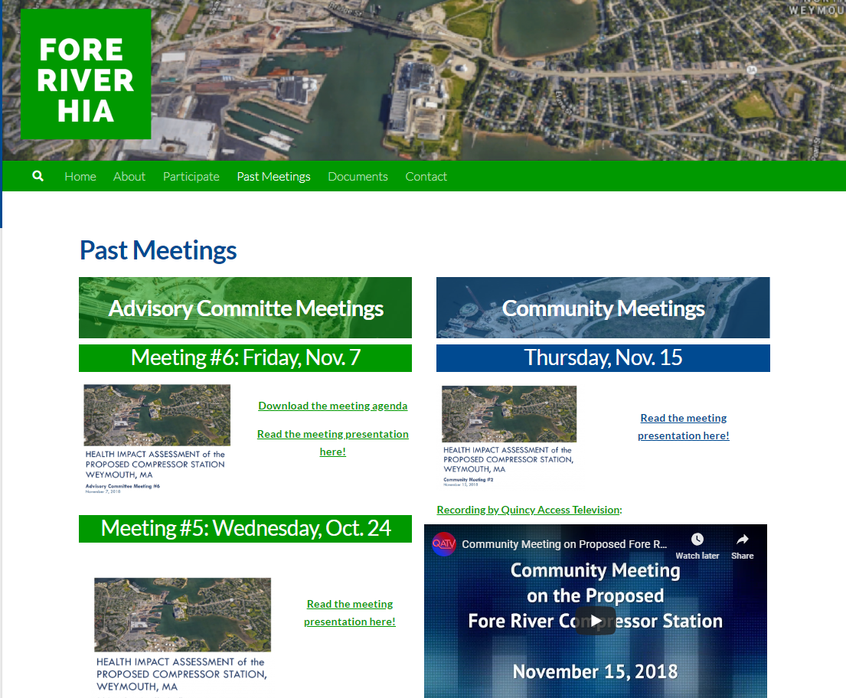

Modified from the UCLA Health Impact Assessment Clearinghouse: http://www.ph.ucla.edu/hs/health-impact/

