Health Impact Assessment of a Proposed Natural Gas Compressor Station in Weymouth, MA
Executive Summary
Research continues to demonstrate that social, economic, and environmental conditions can have substantial and lifelong influence on people’s health. Consequently, there is reason to explore how decisions occurring outside of the public health and healthcare sectors can have both positive and negative effects on the health of our communities.
What is a Health Impact Assessment?
A Health Impact Assessment (HIA) is a process that uses available data, health expertise, and public input to identify the possible health effects of a proposed project, program or policy. An HIA’s purpose is not to determine if a project should or should not be approved, but to ensure, to the best extent possible, that potential positive impacts are promoted and negative impacts are mitigated.

In 2017, the Massachusetts Department of Public Health (MDPH) and the Massachusetts Department of Environmental Protection (MassDEP) were charged with preparing a Health Impact Assessment (HIA) of a natural gas transmission compressor station proposed in the Town of Weymouth, Massachusetts. The station is proposed as part of a private-sector energy infrastructure investment plan and is subject to federal and state approvals, including an air quality permit.
The HIA was conducted as a systematic approach to determine: 1) the current health status of the local community, 2) current background air quality near the proposed project site, 3) the potential health effects of the proposed compressor station on residents of surrounding neighborhoods and municipalities and, 4) possible actions to protect and promote community health in the area. MDPH contracted with the Metropolitan Area Planning Council (MAPC) to assist with the facilitation of the HIA, the community engagement process, and the HIA report. MDPH provided project management and reviewed and analyzed health surveillance data to assess existing conditions. MassDEP conducted air monitoring and assessed potential impacts to air quality to inform the HIA.
Background
In 2015, Algonquin Gas Transmission, LLC (a subsidiary of Enbridge, Inc.) proposed the construction and operation of a new natural gas transmission compressor station at 50 Bridge Street in Weymouth, MA. The proposed compressor station is subject to a number of regulatory reviews and permits. To ensure compliance with state air quality regulations, MassDEP requires an air quality plan approval prior to initiating construction of the project since it would constitute a new emissions source.
Following the announcement of the proposed natural gas compressor station, residents, community groups, and local and state legislators from the Towns of Weymouth, Braintree, and Hingham and the City of Quincy expressed concern about potential impacts the station could have on the surrounding neighborhoods and municipalities, especially given concerns about existing air quality and the number of industrial air pollution sources already present in the Fore River Basin area. In recognition of these concerns, Governor Baker issued a directive for several state agencies to conduct additional reviews of possible impacts on public safety and coastal resiliency as well as to conduct an HIA to document background air levels at the site and current health status of the community and to consider future air quality impacts on public health.
Community Engagement
Community engagement was essential to inform and guide the HIA. The assessment of the proposed compressor station included engagement with a project Advisory Committee (seven meetings), two Community Meetings, interviews with multiple key informants, and a project website, www.foreriverhia.com. Each engagement opportunity was used to facilitate two-way communications - to request input and guidance, and to share materials and outputs – with officials, residents and stakeholders throughout the HIA process.
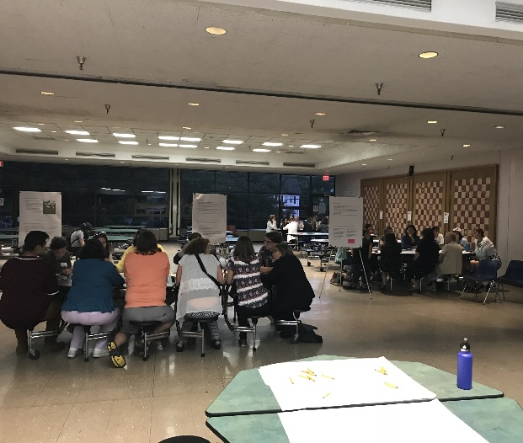
Scope
The HIA team facilitated a series of meetings with residents, stakeholders, and an Advisory Committee to help shape the scope of the HIA. Through the scoping phase, participants raised concerns that the proposed station could contribute to changes in: air quality, noise, coastal flooding, public safety, natural resources, climate change, land uses and transportation. Attendees asserted that these changes could affect short- and long-term health conditions in the area, including rates of cancers, chronic diseases and mental health, and have a more significant impact on specific populations such as older adults, children, and residents of Environmental Justice (EJ) neighborhoods. A focus area was defined to include the area within 1.25 miles of the proposed compressor station that maintains proximity but also includes several nearby existing facilities and neighborhoods. Two EJ areas are located within the focus area: the Germantown and Quincy Point neighborhoods of Quincy.
The scoping process resulted in the prioritization of Air Quality, Noise, and Land Use and Natural Resources as pathways to assess potential health impacts in the HIA. The following pathway diagrams show possible pathways through which the project could potentially impact health. The HIA scope did not include assessing public safety or coastal resiliency because these areas were being addressed separately by other agencies in accordance with the Governor’s directive.

Overview of Baseline Health Conditions
Readily available baseline data for several health outcomes that could potentially be impacted by the proposed compressor station were reviewed to characterize the current health status of the local community. The residents of neighborhoods surrounding the station and of the four involved municipalities share many of the health characteristics of other residents of Massachusetts, and in some cases, report better outcomes than the state overall. However, there are differences where residents of the municipalities and nearby neighborhoods experience health risks and outcomes that are worse than the statewide rates.
- Residents of Braintree, Quincy, and Weymouth experienced more hospitalizations for the respiratory condition of chronic obstructive pulmonary disease (COPD) when compared to the state average. Weymouth also had higher rates of pediatric asthma (grades K through 8th) and asthma hospitalizations (all ages) than the state average.
- Residents of Braintree, Quincy, and Weymouth experienced higher rates of cardiovascular conditions (heart attack hospitalizations) when compared to the state average.
- Each of the municipalities was found to have elevated levels of certain types of cancer. Cancer types that were consistently elevated over a 10-year period include melanoma in Hingham; lung cancers in Weymouth; and cancers of the colon/rectum, liver, lung and oral cavity/pharynx in Quincy. Whereas melanoma is associated with sun exposure, the other cancers share tobacco use as a common risk factor.
- Of those residents in the four municipalities diagnosed with one of the eight tobacco-associated cancer types that were elevated over at least one of the two time periods, about 80% were current or former smokers. In addition, Quincy and Weymouth are estimated to have a greater percentage of residents with health conditions such as diabetes or behaviors like smoking or lack of regular physical activity that can increase their risk for chronic diseases or certain cancers.
Impact Assessment Summary
Air Quality
The proposed station will produce air emissions that include criteria pollutants (e.g., particulate matter, nitrogen dioxide) and air toxics (e.g., benzene, formaldehyde), and emissions from the station will occur during both the construction and operational phases of the station. There is an extensive body of literature linking air pollution to mortality and hospitalizations due to respiratory, cardiovascular, and neurological diseases.
Figure 1. Pathway for Potential Air Quality-related Health Impacts
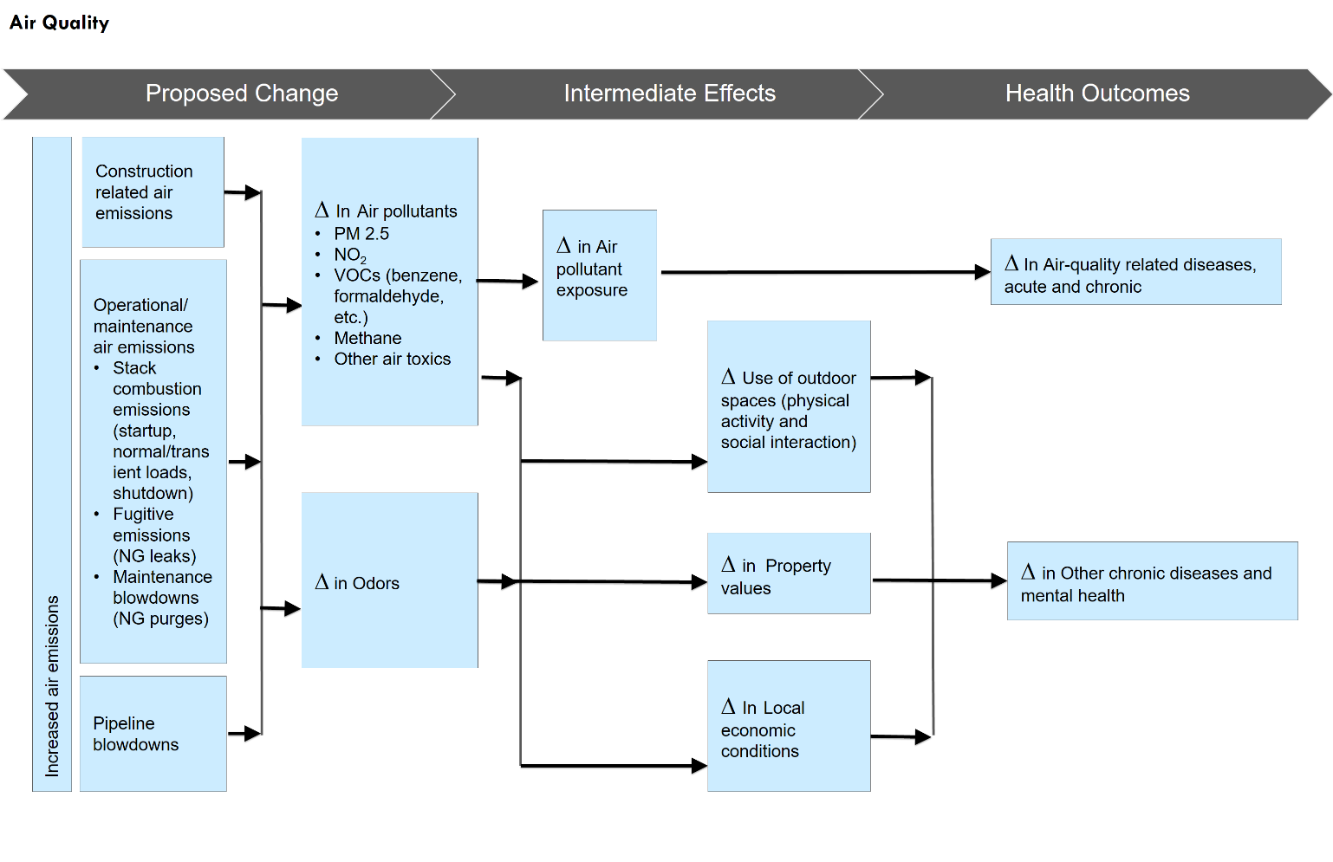
The assessment of air quality impacts relied on available information about air pollutant emissions projected from the station, background air quality monitoring by MassDEP, and use of available literature and input from stakeholders in public health, environmental health, and the growing field of work related to natural gas infrastructure. The HIA predicts that estimated air emissions from the proposed station are not likely to cause health effects through direct exposure because estimated air emissions do not exceed daily or annual health-protective regulatory standards or guidelines.
Community Perspectives: Public Safety and Climate Change
The HIA was preceded by multiple years of activities in opposition to the proposed compressor station and its siting in Weymouth along the Fore River. This prior engagement resulted in the formation of community groups and actions taken by these organizations as well as public officials and statewide groups to challenge the proposal. For example, residents conducted their own air monitoring and analysis, the town of Weymouth conducted independent noise monitoring, and residents connected with other groups in the state that are investigating the effects of natural gas infrastructure, including compressor stations.
Many of these same residents and stakeholders provided their feedback through the HIA process, sharing the effects they feel the proposed station would have on residents, neighborhoods and the environment in the surrounding areas. While many of these issues are addressed in the HIA, participants identified other issues that were not addressed given the scope of the project and other work occurring related to the proposed station. Among these, two raised frequently were public safety and climate change.
Public safety issues were raised from the start of the HIA, including the risk of explosion, impacts to nearby sewer and power infrastructure, and effects on evacuation routing and emergency vehicle access on Route 3A/Bridge Street. Participants emphasized that the public safety risks were felt to be significant and even more so in the proposed location given the density of the population in the area and the number of energy and maritime related uses in the Fore River Basin. Concerns related to public safety issues were shared with the Executive Office of Public Safety, which is working to ensure that such concerns are being evaluated and addressed.
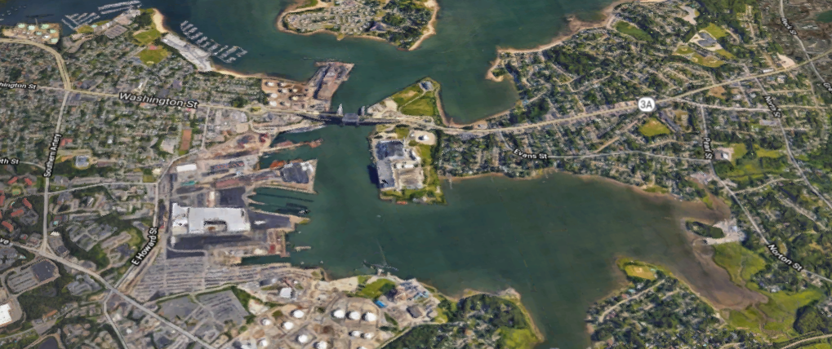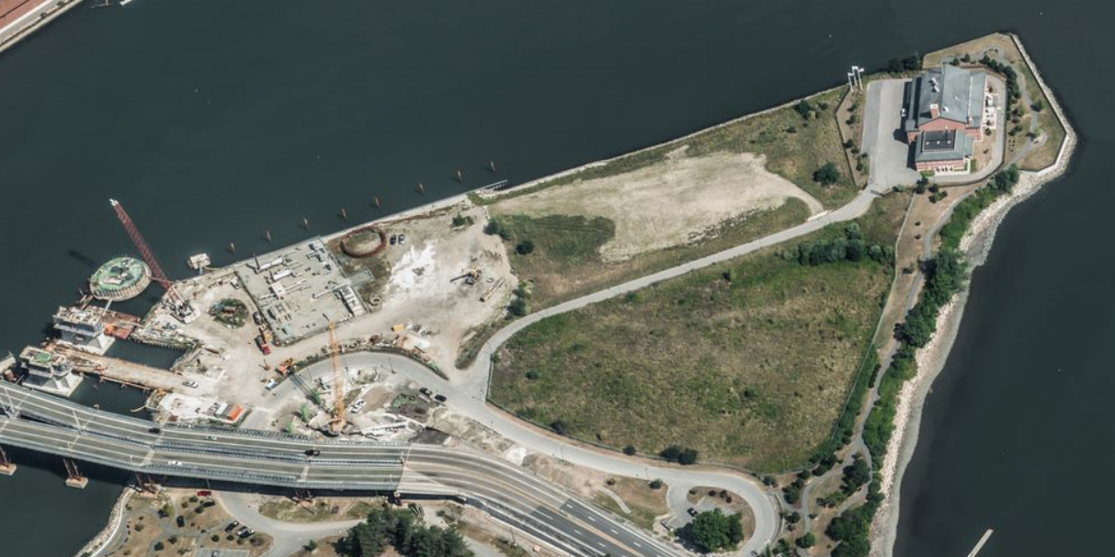
Process participants repeatedly emphasized the connection between the proposed compressor station and climate change. They called out recent examples of flooding in the area and how flooding has been experienced more often than in the past. Many saw an increasing risk for the site of the proposed station, which is surrounded by the Fore River on three sides, given the projected effects of climate change on precipitation patterns and rising sea levels. Coastal Zone Management was tasked by the Governor to review potential flood risks.
Participants also called out links between use of carbon-based fuels (including natural gas and its key elements, such as methane), greenhouse gas emissions and human health and how the proposed station represented a continued reliance on an energy source that will contribute to climate change.

Noise
Sound levels can impact public health. Research links exposure to higher volumes of sound, both as loud individual events and continuous sources, to changes in health. Sound that is higher than recommended levels can affect behavior through annoyance, disturbance of sleep patterns, and inflammation of bodily systems. Studies have also linked exposure to sound above health protective thresholds to increased risks for developing cardiovascular disease and diabetes as well as injury due to decreased attention and fatigue. Populations who may be more sensitive to increased daytime and nighttime sound levels include children and older adults, people with existing cardiovascular health conditions, and those who are sensitive to lower frequencies of sound.
Figure 2. Pathway for Potential Noise-related Health Impacts
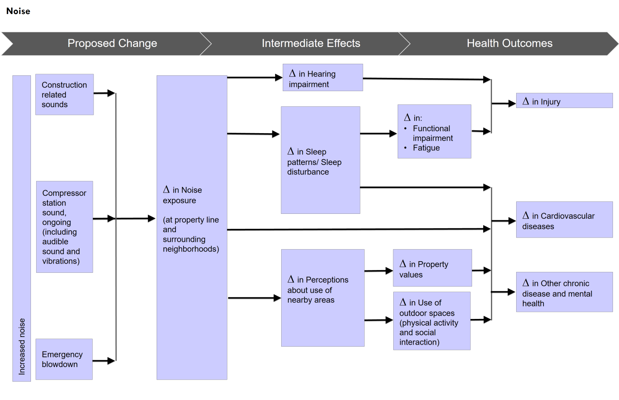
Existing, or ambient, sound levels in the surrounding areas would change as a result of the proposed compressor station. Sounds will be produced through the construction phase of the site, which is expected to last approximately nine months, and the operation of the compressor station would become a new source of continuous sound. Assessment of noise impacts from the proposed station relied on available studies and analysis about existing ambient sound levels, projections of sound emissions from the station, and review of available literature and input from stakeholders in the fields of public health, environmental health, and unconventional natural gas infrastructure. The HIA predicts that estimated sound levels during the construction of the proposed station may have negative effects on health, especially for those who use the conservation land adjacent to the property and those who are more sensitive to sound. The HIA also predicts that estimated sound from the operations of the proposed station are not likely to cause health effects through direct exposure since available data indicates the levels will be below recommended thresholds.
Land Use/Natural Resources
The proposed natural gas compressor station would be a new industrial use in the Fore River Basin. The new use would involve the redevelopment of a former industrial brownfield site, work that includes site assessment, implementation of protective measures and site closure. The site is along a working waterfront in a Designated Port Area (an area designated by the Commonwealth of Massachusetts for water-dependent industrial uses) and adjacent to community and natural resources. Research suggests that a majority of a population’s health is determined by social, environmental and behavioral factors that shape the context in which people live. Characteristics of the built and natural environments such as availability of places to walk and green spaces have been linked to behaviors that are health promoting (e.g., physical activity) and to conditions that are health protective (e.g., remediation and removal of hazardous materials). These characteristics also can affect natural resources (e.g., animals, fish, or vegetative species).
Figure 3. Pathway for Potential Land Use and Natural Resource-related Health Impacts
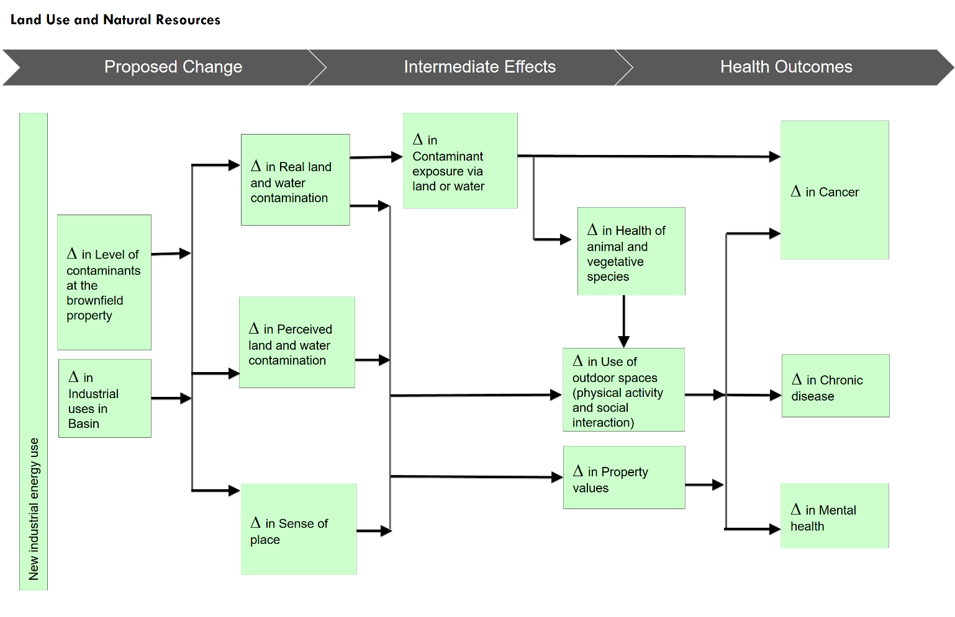
Assessment of impacts from changes to land use and natural resources was based on available studies and analysis about existing land uses, parks and conservation space, and wildlife; information about the construction activities and building and site design of the proposed station; review of available literature; and, input from stakeholders in the fields of public health, environmental health, land use planning and water resources. The HIA predicts that changes to land use and natural resources are not likely to cause health effects through direct exposure.
The proponent has taken responsibility for completing response actions at the site in compliance with Massachusetts Hazardous Waste Site Cleanup regulations. These regulations require full assessment of the site and action to ensure that a condition of No Significant Risk of Harm is achieved for all current and foreseeable uses of the site. This condition is expected to be maintained through an Activity and Use Limitation (AUL) as part of the site’s Permanent Solution. An AUL prevents activities and uses at the property that are inconsistent with site conditions. The AUL will also require a Release Abatement Measure if excavation encounters contaminated soil, a measure that will further protect future site workers’ health and the environment. The site’s Permanent Solution must also ensure protection of natural resources (e.g., fish species in the Fore River). In addition to the expected closure of the contaminated site, vegetative improvements are proposed through new plantings along the fence line.
Construction of the proposed station is stated to employ 75 workers on average and 110 workers during peak construction activities. The proponent assumes that 5% - 27% of personnel will come from the local workforce, which could be up to 30 people during peak construction periods. During operation, two full-time workers would be employed at the proposed compressor station, complemented by one full-time engine analyst, who would work on a regional basis for the proponent.
Summary Impact Characterization Table for Direct Exposures
Estimated air emissions and sound do not exceed health-protective regulatory standards and guidelines with the exception of estimated sound levels during construction. Additionally, the proposed redevelopment of the site has led to Waste Site Cleanup response actions that have resulted in site assessment, prescriptive measures for protecting future workers from exposure to subsurface contamination and an Activity and Use Limitation placed on the property to prevent uses inconsistent with site conditions.
 | Type of Exposure | Geographical Extent of Exposure | Direction of Health Effects | Likelihood of  Health Effects | Relative Magnitude  of Health Effect | Vulnerable Populations
Air Quality | Direct Exposures | Local (within focus area) | Neutral | Unlikely | Very Low | No
Noise | Direct Exposures | Local (within focus area) | Negative (during construction)/  Neutral (during operation) | Possible (during construction)/  Unlikely (during operation) | Low (during construction)/  Very Low (during operation) | Yes
Land Use and Natural Resources | Direct Exposures | Local (within focus area) | Neutral | Unlikely | Very Low | No

Impact Characterization Table for Other Mechanisms
The estimated new air emissions, sound levels and land use and natural resource changes could have potential health effects through other mechanisms including increased stress among residents in surrounding areas and changes in perception about use of outdoor spaces and real estate property values. These perceptions could potentially contribute to residents’ feelings of uncertainty and lack of control, which have been associated with negative mental health effects. Perceptions of environmental factors have associations with health outcomes as studies have found those living in environments perceived as unhealthy can experience higher levels of stress and mental health issues.
 | Type of Exposure | Geographical Extent of Exposure | Direction of Health Effects | Likelihood of Health Effects | Relative Magnitude of Health Effect | Vulnerable Populations
Other Mechanisms | Indirect/ Perceived | Community-wide (focus and surrounding areas) | Negative | Uncertain | Uncertain | Yes

Community Perspectives: Advisory Committee and Effects from the Proposed Station
An Advisory Committee comprised of Fore River area residents and local officials provided feedback and guidance in the development of the HIA. It should be noted that multiple members of the project Advisory Committee expressed their belief that the construction of the compressor station would very likely result in negative health effects. The Committee’s concern regarding potential impacts were based, in part, on questions about the projected emissions data provided by the proponent, the potential for natural gas accidents and malfunctions to occur, the extent of air quality monitoring that was conducted, and uncertainty regarding whether existing air standards and guidelines are sufficiently health-protective.
The Advisory Committee expressed concerns about direct health impacts from noise, based, in part, on information available from other public sources (e.g., audio recordings of natural gas infrastructure posted on the internet) and their sense of the current background sound levels, which they reported were lower than measured by the proponent.
Committee members also maintained that changes to land use and natural resources due to construction of the proposed compressor station are very likely to result in negative health effects, based, in part, on expected impacts to recreational and social use of the King’s Cove Park and uncertainty of whether existing site contamination would remain confined or could affect the Fore River.
Potential Actions:
The HIA suggests that direct exposure to changes associated with the proposed station is not likely to cause health effects with the exception of estimated sound levels during construction. As noted, however, there are other mechanisms through which the proposed change could have health effects on surrounding communities. A set of Potential Actions has been developed through the HIA to address these concerns and potential impacts as well as other environmental and health issues noted throughout the process.

Potential Actions Related to Proposed Compressor Station
- Enhanced Construction Management to provide more resident awareness of changes occurring and to relieve pressure on the municipal public health staff. Potentially identify a point person at Enbridge who would be responsible for addressing air and noise issues and other community concerns that may arise.
- Enhanced Blowdown Alert System that warns municipal staff and interested residents in advance of planned blowdowns and immediately when an emergency blowdown occurs, and documents the length of time, volume, and noise level of the blowdowns.
- Use of Enhanced Leak Detection to address concerns and potential impacts of fugitive emissions that could increase air pollution levels in and around the Fore River Basin.
- Additional Site Plantings and Maintenance Plan and Improved Fence Design to increase green space and site aesthetics, particularly given proximity to King’s Cove recreation area.

Potential Actions Related to Environmental and Health Conditions
- Installation of an Air Quality Monitor to monitor pollutants of concern in the Fore River Basin.
- Promotion of secondhand smoking laws and outreach to support smoke-free workplaces and housing programs to reduce tobacco-associated cancers and COPD through collaboration of local boards of health, tobacco-free community partnerships and the MDPH Bureau of Community Health and Prevention’s Tobacco Cessation and Prevention Program.
- Dissemination of radon testing information to the public, testing of radon at schools and public buildings to reduce lung cancer risk, and assessment of indoor air quality at schools to reduce pediatric asthma through increased support for Local Health Departments and direct assistance from the MDPH Bureau of Environmental Health’s Indoor Air Quality Program and Radon Unit.
- Promotion of health risk reduction behaviors to reduce chronic diseases and improve respiratory health, notably among children in Weymouth through local wellness initiatives and increased support for Local Health Departments, Community Health Centers, and the MDPH Bureau of Community Health and Prevention’s Mass in Motion Program.
Community Perspectives: Recommendations
Advisory committee members, as well as other community members, were asked for recommendation ideas based on the assessment. While a common starting position for most was a recommendation to abandon the project, many did provide ideas for recommendations, which were used to develop the potential actions in the report. A number of other community recommendations are highlighted below:
- Install a public deep sea fishing pier and expand the walking path around the entire waterway on the site.
- Set financial penalties for Enbridge that must be paid when air emission exceedances occur or when there are leaks above set thresholds. A portion of penalties should be directed back to the municipalities.
- Conduct more frequent stack emission testing for stationary air emission sources in the Fore River Basin.
- Adopt local regulations that set more conservative (health-protective) thresholds for noise and air emissions.
- Develop an Enhanced Monitoring and Reporting Emissions Program whereby the proponent details a protocol for monitoring air emissions and noise levels, reporting exceedances and documenting actions taken to address them.
- Create a decommissioning plan that details how the station would be retired from operations and the owner’s responsibility to address equipment or materials that might constitute an environmental hazard.
- Conduct independent site monitoring through a 3rd party contractor on a regular basis to document regular compliance of the station.

Conclusion
The HIA of the proposed natural gas transmission compressor station in Weymouth predicted no substantial changes in health from direct exposures from the station itself with the exception of estimated sound levels during construction. However, the assessment predicts that negative changes may be possible through other mechanisms, such as an increased perception of risk in the surrounding areas related to perceived pollution levels and less comfort with using nearby outdoor space.

Additional information, including the final HIA report, can be found on the project website, www.foreriverhia.com
Information on the coastal resilience review submitted to the Office of Coastal Zone Management can be found on the project website (www.foreriverhia.com) and information regarding the public safety work can be requested from the Executive Office of Public Safety and Security (eopssinfo@state.ma.us).
Certain populations may be more vulnerable to environmental exposures and other changes that directly or indirectly affect social determinants of health. These include people who have chronic diseases or disabilities that make them more susceptible to stressors and exposures; people who may be in certain stages of life, such as children, older adults, and women who are pregnant; and those who may work or occupy spaces that increase the amount of time they are around harmful situations, such as outdoor workers or workers in high-risk industries.
Impact Characterization Definitions: Type of Health Effects: Direct: the change occurs through physical exposures/ Other: the change occurs through other mechanisms (e.g., perception, awareness) Geographic Extent of Health Effects: Local: Effects felt within the focus area/Community-wide: Effects felt in focus and surrounding areas Direction of Health Effects: Neutral: No Meaningful Change Predicted/Positive: Change that is predicted to positively impact associated health conditions/Negative: Change that is predicted to negatively impact associated health conditions Likelihood of Health Effects: Uncertain: It is unclear if impacts will occur as a result of the proposal/ Unlikely: It is unlikely that impacts will occur as a result of the proposal/ Possible: It is possible that impacts will occur as a result of the proposal / Likely = it is likely that impacts will occur as a result of the proposal Relative Magnitude of Health Effects: Very Low: No cases expected/ Low: Individual cases/ Medium: Local, small limited impact to households/ High: Entire communities affected Vulnerable Populations: Yes: Disproportionately affects vulnerable populations/ No: Affects populations evenly

