Health Impact Assessment of a Proposed Natural Gas Compressor Station in Weymouth, MA
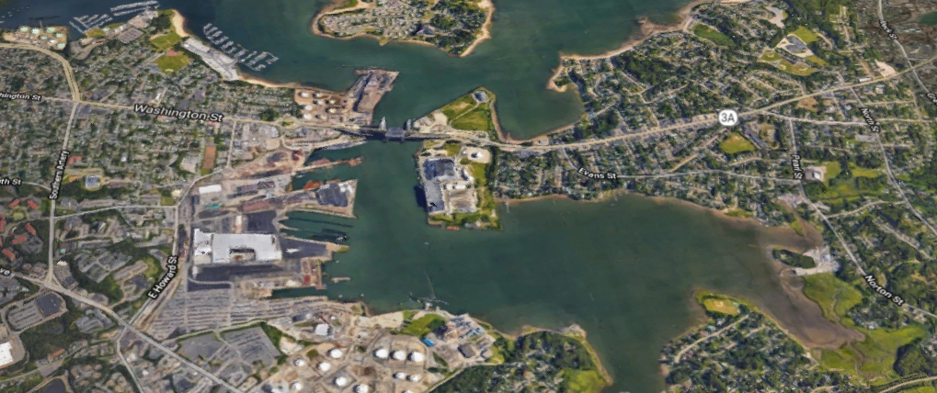




Acknowledgements
We would like to express our appreciation to the residents and other participants who joined the community meetings and provided their feedback to the HIA Team over the phone, via email and via the project website.
We would also like to extend deep appreciation to the members of the HIA Advisory Committee not only for contributing their time but also sharing their knowledge and perspectives. These were:
Alice Arena, member of East Braintree Civic Association
James Arsenault, Director, Department of Public Works, Town of Braintree
Dr. Turner Bledsoe, Hingham resident and member of Compressor Station Task Force
Matthew Brennan, Assistant Director, Department of Health, Town of Weymouth
Ross Edwards, Secretary, Quincy Climate Action Network
Dr. Elizabeth Eldridge, Hingham Board of Health
Mary Farrington, Hingham resident and member of Compressor Station Task Force
Rebecca Haugh, City Councilor, Town of Weymouth
Lori Hayden, Quincy resident
Michael Lang, member of East Braintree Civic Association
Jennifer Mathien, Hingham resident and member of Compressor Station Task Force
Marybeth McGrath, Director, Health and Inspectional Services, Town of Braintree
Frank Singleton, Conservation Commission, Town of Weymouth
Fay Strigler, member of Quincy Climate Action Network
Jonathan Tose, Retired Deputy Fire Chief, Town of Weymouth

Lastly, we would like to thank other municipal staff in Quincy, Braintree, and Weymouth for their assistance in providing meeting spaces for the Advisory Committee Meetings and Community Meetings. Staff provided invaluable assistance with the scheduling and setup of spaces that were part of the Community Engagement activities of the HIA.

Contents
Annotated Acronym Definitions 5
Guide to the Document 7
Part 1: Introduction to the Health Impact Assessment 8
Preface 8
Context of HIA 8
Regarding Environmental Exposures and Human Health 8
Regarding Climate Change and Human Health 9
Regarding Public Safety 10
Regarding Natural Gas Infrastructure 12
Background 14
Proposal to Construct a Natural Gas Compressor Station in Weymouth, MA 14
Overview of Regulatory Structure Related to the Proposed Plan 14
Community Concerns 15
Governor’s Directive 16
Part 2: HIA Process 18
Screening 18
Scoping 18
Process for Developing the HIA Scope 18
Preliminary Background Discussion and Document Scan 20
Scoping Outputs 20
Pathways 21
Impact Assessment Approach 22
Assessment 23
Recommendations 25
Reporting 25
Part 3: Impact Assessment 26
Health and Our Environment 26
Baseline Profile: Focus Area and Municipalities 27
Demographic Overview 28
Land Use and Environmental Context 36
Health Behaviors and Conditions 43
Limitations 46
Populations Potentially Facing Increased Risks 59
Impact Assessment 61
Assessment of Air Quality Impacts on Health in Focus Area 63
Summary of Findings from Air Quality Impact Assessment 63
Health Impact Pathway for Air Quality 63
Air Quality and Health 65
Current Air Quality Conditions 72
Estimated Air Pollutant Contributions from the Proposed Compressor Station 94
Characterization of the Air Quality Impacts on Health 108
Assumptions and Limitations 109
Assessment of Noise Impacts on Health in Focus Area 110
Summary of Findings from Noise Impact Assessment 110
Health Impact Pathway for Noise 110
Noise and Health 112
Current Sound/Noise Conditions 117
Estimated Noise from the Proposed Compressor Station 123
Characterization of the Noise Impacts on Health 129
Assumptions and Limitations 130
Assessment of Land Use and Natural Resources Impacts on Health in Focus Area 131
Summary of Findings from Land Use and Natural Resources Impact Assessment 131
Land Use and Natural Resources Pathway Diagram 131
Land Use and Natural Resources and Health 132
Current Land Use and Natural Resources Conditions 138
Estimated Effects on Land Use and Natural Resources from the Proposed Compressor Station 143
Characterization of the Impact of Changes to Land Use and Natural Resources on Health 147
Assumptions and Limitations 148
Summary Impact Tables 149
Direct Exposure 149
Other Mechanisms 149
Part 4: Potential Actions and Community Recommendations 152
Summary of Findings 152
Context for Potential Actions 152
Potential Actions Related to Proposed Compressor Station 153
Potential Actions: Environmental and Health Conditions 154
Conclusion 156

Annotated Acronym Definitions

ACS: American Community Survey
AEROMOD: U.S. EPA Regulatory Model
AALs: allowable ambient limits
AML: acute myeloid leukemia
AMS: American Meteorological Society
AUL: Activity and Use Limitation
BELD: Braintree Electric Light Department
BMI: body mass index
BRFSS: Behavioral Risk Factor Surveillance System
CCW: coal combustion waste
CDC: Centers for Disease Control and Prevention
CHIA: Center for Health Information and Analysis
CI: confidence interval
CO: carbon monoxide
COPD: chronic obstructive pulmonary disease
CSO: combined sewer overflows
CT: census tract
CZM: Coastal Zone Management
DPA: Designated Port Area
ED: emergency department
EFSB: Energy Facilities Siting Board
EJ: environmental justice
EOEEA: Executive Office of Energy and Environmental Affairs
EPA: United States Environmental Protection Agency
EPHT: Massachusetts Environmental Public Health Tracking
ESD: emergency shut-down
FERC: Federal Energy Regulatory Commission
FWS: U.S. Fish and Wildlife Service
HAPs: hazardous air pollutants
HIA: Health Impact Assessment
IAQ: Indoor Air Quality
IBD: intrahepatic bile duct
LFN: low frequency noise
M&R: metering and regulating
MAPC: Metropolitan Area Planning Council
MassDEP: Massachusetts Department of Environmental Protection
MassDOT: Massachusetts Department of Transportation
MCR: Massachusetts Cancer Registry
MDPH: Massachusetts Department of Public Health
MWRA: Massachusetts Water Resources Authority
NAAQS: National Ambient Air Quality Standards
NAC: noise abatement criteria
NHL: non-Hodgkin lymphoma
NO₂: nitrogen dioxide
NOx: nitrogen oxide
PHMSA: Pipeline and Hazardous Materials Safety Administration
PM: particulate matter
PM10: particulate matter of 10 microns or less
PM2.5: particulate matter of 2.5 microns or less
ppb: parts per billion
ppm: parts per million
PWL: power level
REC: recognized environmental conditions
SIL: Significant Impact Level
SIR: standardized incidence ratio
SO₂: sulfur dioxide
TELs: threshold effects exposure limits
TICs: tentatively identified compounds
TMDL: total maximum daily load
UFP: ultrafine particulates
UGD: unconventional gas development
VOCs: volatile organic compounds
WHO: World Health Organization
μg/m³: micrograms per cubic meter

Guide to the Document
This Health Impact Assessment (HIA) documents the process and output of an assessment of a proposed natural gas compressor station in Weymouth, MA. The HIA was conducted as result of a state directive and was part of a number of activities focused on assessing the potential health effects that could result from the construction and operation of a compressor station at 50 Bridge Street (Route 3A) in Weymouth.
The HIA report is divided into four Parts. Part 1 provides the background and context for this HIA. It describes the focus and purpose of the HIA, provides an overview of the proposed compressor station and state and community actions that occurred to initiate the HIA. Part 2 provides an overview of the general HIA process, with a focus on scoping, and how the process was conducted for this particular HIA.
Part 3 is the impact assessment. It offers a summary of selected baseline demographic and health characteristics of the populations living in nearby surrounding neighborhoods (2 kilometer radius around the proposed station referred to as the focus area) and municipalities (Weymouth, Quincy, Braintree, Hingham). It includes the assessment of three pathways through which the proposed compressor station could potentially directly affect community health through changes in exposures or how the proposed station could potentially affect health through other mechanisms. Finally, Part 4 recommends potential actions based on the HIA findings and aims to promote positive health outcomes while mitigating potential negative impacts. Potential actions are provided that directly relate to the proposed compressor station, and potential actions are also provided related to existing health and environmental factors identified through the assessment process.
The HIA process and report was facilitated by the Metropolitan Area Planning Council (MAPC) in partnership with the Massachusetts Department of Public Health (MDPH) and the Massachusetts Department of Environmental Protection (MassDEP). The HIA is the first conducted on natural gas infrastructure in Massachusetts.

Part 1: Introduction to the Health Impact Assessment

Preface
Human health does not exist in an individual vacuum - research continues to reveal that people’s health and wellness are affected by community conditions. The social, economic, and environmental factors that one experiences have significant influence on a variety of health conditions and behaviors that can increase or decrease health risks across one’s lifetime.
Understanding the connection and interactions between health factors is important: it provides impetus for exploring how public policies and decisions will affect such factors and potentially impact a community’s well-being. Health Impact Assessment (HIA is a method to systematically assess the potential positive and negative health consequences of proposed policies, plans, and projects outside of the public health sector (an overview of an HIA process is provided in Part 2). Rather than evaluating or remediating past actions, HIAs seek to identify unanticipated health effects in advance of decision-making and allow stakeholders and policymakers to integrate health protection and promotion into their decisions. HIA has a particular emphasis on health equity, or how a policy or project may impact existing health inequities, in addition to a focus on population health.
An HIA differs from other impact and risk assessment processes such as an Environmental Assessment or a Human Health Risk Assessment. These other forms of assessment typically evaluate only changes in health risks from exposure to chemicals (e.g., hazardous air pollutants) or tend to focus on effects to natural resources like vegetation, water, and soil. By comparison, an HIA is conducted to identify potential health effects – using a combination of science and community and stakeholder input - and determine what, if any, negative impacts may need to be mitigated or positive impacts could be promoted. While different, these various forms of assessment can be complimentary in providing science, health data, and other information valuable to understanding and protecting public health.
While the goal of an HIA is to anticipate and provide recommendations that advance public health, it cannot be expected to prevent or promote all possible health impacts of a given decision. HIA is an approach that encourages a greater incorporation of public health and community perspectives into decision-making processes.

Context of HIA

Regarding Environmental Exposures and Human Health
Everyone is affected by the environment in which they live. Environmental conditions, including the quality of the built environment, air, water, land, and food around us, influence us through our direct interactions (e.g., sound levels on auditory and cardiovascular systems) and through other mechanisms related to individual perceptions and social factors (e.g., collective efficacy, social capital).
When poor environmental quality is present and humans are exposed to it - for example, due to pollution - both individual and community health can be affected. Conversely, positive environmental conditions, such as clean air and water, can improve individual and community health. This HIA attempts to be inclusive by reviewing health effects across multiple environmental factors, but the scope does not include an exhaustive review of all individual environmental exposures on human health, as a Human Health Risk Assessment might undertake.

Regarding Climate Change and Human Health
This HIA is focused on potential changes to community health that could occur due to the construction and operation of a proposed compressor station. The scope is focused on potential health impacts on the nearby neighborhoods and four surrounding municipalities that could occur due to the proposed station.
While the scope is focused on impact within a local geography, the HIA is cognizant of established links between the use of carbon-based fuels (including natural gas and its key elements, such as methane), greenhouse gas emissions and human health. According to the National Institute of Environmental Health Sciences, “changes in the greenhouse gas concentrations and other drivers alter the global climate and bring about myriad human health consequences. Environmental consequences of climate change, such as extreme heat waves, rising sea-levels, changes in precipitation resulting in flooding and droughts, intense hurricanes, and degraded air quality, directly and indirectly affect the physical, social, and psychological health of humans. Climate change can be a driver of disease migration, as well as exacerbate health effects resulting from the release of toxic air pollutants in vulnerable populations such as children, the elderly, and those with asthma or cardiovascular disease.”
In addition, the HIA acknowledges that research has demonstrated that methane, while short lived and present in relatively low concentrations in the atmosphere, has greater climate forcing potential (i.e., absorbs greater levels of radiation than other greenhouse gases).
Community Perspectives: Climate Change Impacts on Health
The intersection of climate change and possible health impacts was raised in Community and Advisory Committee meetings. Participants emphasized the connection between continued reliance on fuels that involve greenhouse gas emissions like CO₂ and its potential consequences for the deterioration of public health. Below is a pathway diagram developed by an Advisory Committee member and shared to highlight linkages from the proposed station to climate driven changes and health outcomes.
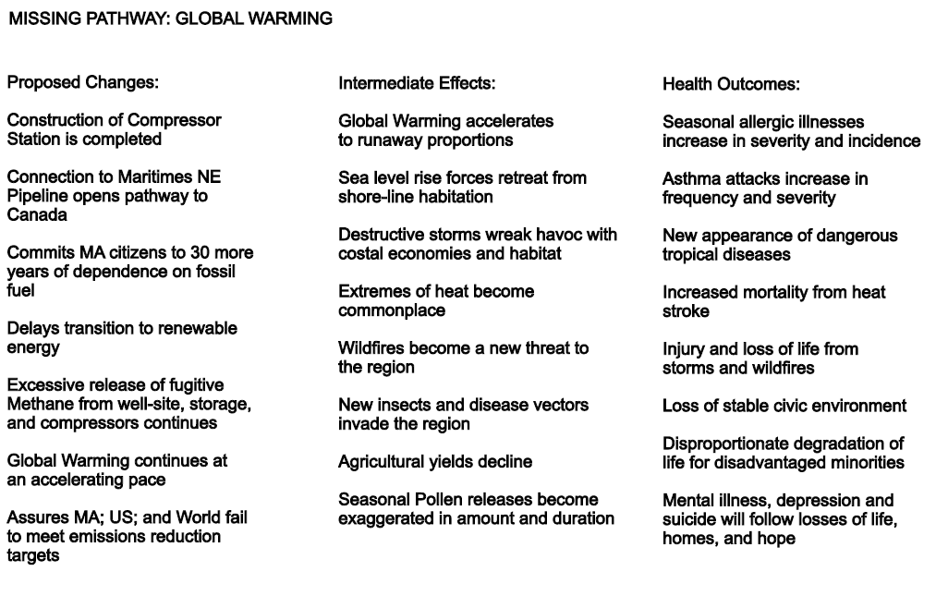
Source: T. Bledsoe, HIA Advisory Committee member

Regarding Public Safety
Throughout the HIA process, community members raised concerns about the public safety implications of the proposed natural gas compressor station. Broad concerns included the effects of potential natural gas infrastructure emergencies on residents, nearby traffic, and emergency vehicle access. A concern that was identified by many stakeholders was the potential for human, weather-driven or mechanical incidents to cause an explosion at the compressor station that would impact surrounding neighborhoods and destroy other key infrastructure in the Fore River basin, including the new Fore River Bridge and the Massachusetts Water Resources Authority (MWRA) sewage pump station. This concern was also raised by local Emergency Management staff, particularly after excessive pressure buildup in natural gas lines in the Merrimack Valley resulted in explosions and fires in local residences during this HIA process.
While public Safety concerns will be referenced in this HIA report, they are not a formal component of the HIA. To address these public safety concerns related to the proposed compressor station in Weymouth, the Massachusetts Executive Office of Public Safety and Security and the Executive Office of Energy and Environmental Affairs (EOEEA) are working to ensure these concerns are considered and addressed by the Pipeline and Hazardous Materials Safety Administration (PHMSA) in a process separate from the HIA.
Public Safety: Conceptual Pathway for Public Safety-related Health Impacts
Public safety issues were raised by participants from the start of the HIA, including the risk of explosion, impacts to nearby sewer, bridge and power infrastructure, and effects on evacuation routing and emergency vehicle access on Route 3A/Bridge Street. Participants emphasized that the public safety risks were felt to be significant and even more so in the proposed location given the density of the population in the area and the number of energy and maritime related uses in the Fore River Basin. The following pathway diagram was developed based on the discussions and input from the community.
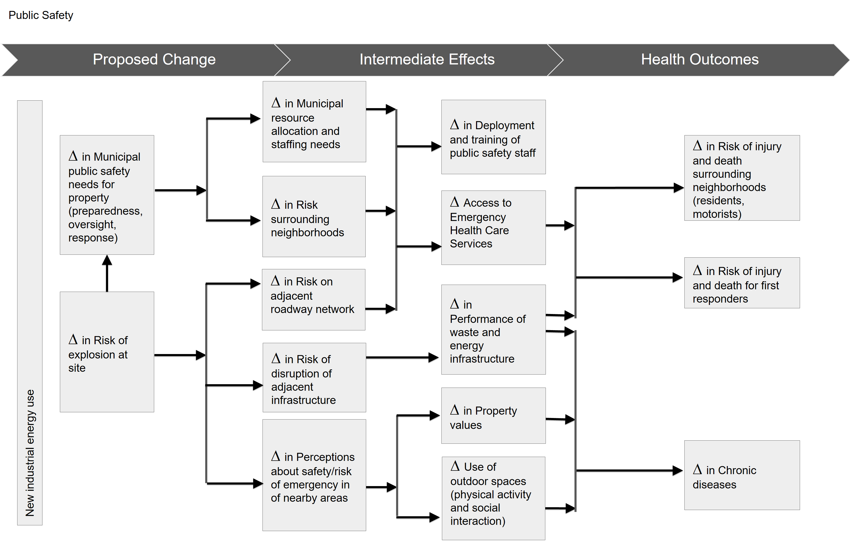

Regarding Natural Gas Infrastructure
Natural gas as an energy source has grown in use across the United States with national consumption increasing by nearly 20% over the past 10 years. Natural gas surpassed coal as the United States’ main energy source in 2016. Multiple factors have contributed to the increase in use. Compared to fuel oil and coal, natural gas releases less carbon dioxide, sulfur, mercury, particulates, and nitrogen oxides (precursors to smog). New methods of natural gas extraction, including hydraulic fracturing (“fracking”), have resulted in increased domestic gas production. Shale gas production began on a large scale in 2000 and now represents approximately 62% of U.S. dry natural gas production. Over the past decade, natural gas production in the United States has increased by over 50%, while prices have fallen by roughly half. Increases in supply generally drive lower natural gas prices, while weather is one of many factors affecting natural gas consumption.
The growth in use of natural gas has been accompanied by an expansion in the infrastructure used to extract, transport, distribute and deliver natural gas. The United States became a net exporter of natural gas for the first time in 2017 as more infrastructure was developed to transport natural gas.
The HIA acknowledges that the proposed transmission compressor station is part of a larger natural gas infrastructure expansion project that seeks to distribute fuel farther north into New England, with the potential for international export. If a future carbon policy were implemented, the U.S. Department of Energy projects even greater interstate natural gas pipeline and infrastructure needs. The HIA does not address the expansion project as its scope is focused on potential localized health effects from the proposed compressor station in Weymouth.

A Snapshot of the History of the Fore River Basin
The Fore River Basin is formed by the confluence of the Fore River, Back River, and Hingham and Quincy Bays. The Fore River stretches for five miles from the mouth of the Monatiquot River in Braintree to Hingham Bay. The Basin is part of the Massachusetts Bay watershed. The nearby Wessagussett neighborhood, home to the second oldest colony in Massachusetts, was formed in 1622 – just two years after the Plymouth colony. The basin’s protection from the ocean meant it was an ideal location for ships, shipbuilding and mills. Fishing was prevalent, and as manufacturing and business grew, railroads brought more residents and visitors to the area. The Fore River Basin has historically been home to numerous industrial activities, including the Fore River Shipyard owned by General Dynamics (1883 – 1986). The current Braintree Electric Light Department site on the Fore River in Braintree was an electricity generation station as early as 1892. The Basin peninsula was filled in between 1910-1920, during the development of Edgar power generation station (part of Braintree Electric Light Department). Industrial activities continued to expand near the site of the Shipyard, including additional electricity generating stations - Boston Edison began its Weymouth operations in the Basin in 1925. Procter and Gamble later established a soap plant in Quincy (now occupied by Twin Rivers Technologies). Working class neighborhoods supported by these industries sprang up in Quincy Point, Germantown, and North Weymouth.
The Fore River has a history of its own – the Army Corps of Engineers completed a three-mile-long channel from Hingham Bay to the Fore River Bridge in 1927. In 1960, the Corps completed additional work on the river to create channels connecting Hingham and Quincy Bays and Nantasket Road through the Boston Harbor to the Fore River Bridge. The first bridge over the Fore River was built between Quincy and Weymouth in 1812. In 2012, renovations began on a nearly $250 million new bridge, which was completed in 2018.
Source(s):
Town of Weymouth. About Weymouth: First Hundred Years, Written by Theodore G. “Ted” Clarke.
Enbridge. Final Public Involvement Plan: Algonquin Gas Transmission, LLC - Atlantic Bridge Project, Weymouth Compressor Station
Funding Universe. Boston Edison Company History / International Directory of Company Histories. 1996.
Town of Braintree. Braintree Electric Light Department: Brownfield Revitalization and Community Engagement. 2010.

Background

Proposal to Construct a Natural Gas Compressor Station in Weymouth, MA
In 2015, Algonquin Gas Transmission, LLC (a subsidiary of Enbridge, Inc.) proposed the construction and operation of a new natural gas transmission compressor station at 50 Bridge Street in Weymouth, Massachusetts. The location of the proposed station is the site of an operating natural gas metering and regulating (M&R) station for the Algonquin Gas Transmission pipeline which transports natural gas from New Jersey through Connecticut and Rhode Island to Massachusetts. The station is proposed to be equipped with one Solar Taurus 60 7,700 horsepower (hp) natural gas-fired turbine-driven compressor unit.
Figure 1. Location of Proposed Compressor Station
Source: MAPC, Bing Maps
The proposed transmission compressor station is planned to support capacity upgrades and expansion of Algonquin’s natural gas transmission pipeline system for additional transportation and deliveries on the Maritimes and Northeast Pipeline, LLC system that connects Northeastern United States and Canada (Nova Scotia). Collectively, this overall upgrade and expansion project on the Algonquin transmission system is referred to as the Atlantic Bridge Project.

Overview of Regulatory Structure Related to the Proposed Plan
The proposed transmission compressor station is subject to a number of regulatory reviews and permits that must be approved for the proposed station to be constructed and operated. Required approvals and other oversight include:
- At the Federal level: the Federal Energy Regulatory Commission (FERC) and the Pipeline and Hazardous Materials Safety Administration, which is part of the United States Department of Transportation
- At the State level: MassDEP and the MA Office of Coastal Zone Management (CZM)
- At the Local level: The Town of Weymouth Conservation Commission
Review and permits are necessary for a number of features, one of which is air emissions that would be emitted by the proposed compressor station. MassDEP requires an air quality plan approval prior to initiating construction of a project that will be a new air pollutant emissions source (or is a modification of an existing source). The air quality plan approval addresses air emissions as well as sound that will be produced by a source.
The proposed station includes a number of equipment components that would be emissions sources, including:
- Natural gas-fired systems:
  - turbine-driven compressor unit
  - emergency generator
  - compressor fuel gas heater
  - catalytic space heaters
- Remote reservoir parts washer
- Separator vessels and storage tanks
The plan approval also accounts for fugitive emissions from the compressor (e.g., from piping, fittings, connections) during routine operations and venting of gas (i.e., blowdowns) during maintenance. The compressor station can also involve emergency blowdowns that would produce air emissions.
Algonquin Gas Transmission, LLC has applied for a non-major comprehensive air plan approval (Non-Major CPA) for the emission sources from the proposed compressor station. Algonquin also proposed that the new compressor station be considered in combination with the existing M&R station facility to evaluate emissions impacts.

Community Concerns
Following the announcement of the proposed natural gas transmission compressor station, residents, community groups, and state and local officials from the Towns of Weymouth, Braintree, and Hingham and the City of Quincy, as well as Congressional elected officials, expressed concern regarding the development and potential impacts on people living in the surrounding neighborhoods and towns. The response and concerns have been expressed over a period of time, beginning from the initial proposal through to the present. Over that period, residents, local and elected officials, and other stakeholders have raised concerns that include, but are not limited to:
- Siting of the station in a densely populated area
- Safety issues that could be related to the station (e.g., risk of explosions)
- Existing burden of industrial sources already in the Fore River basin
- Existing levels of air pollutants present in the basin
- Existing disease burden among residents
- Continued use of fossil fuels and its energy policy implications (e.g., climate change)
- Contribution of more noise and odors to the surrounding neighborhoods
- Threats to property values
A number of existing community organizations, including the East Braintree Civic Association and the North Weymouth Civic Association, as well as newly formed organizations, such as the Fore River Residents Against the Compressor Station and the Hingham Compressor Station Task Force, organized and joined in opposition to the station. These organizations and others, including concerned citizens and state senators and representatives, petitioned the state to conduct additional reviews of the proposed station and consider opportunities for additional public comments on the proposal.
An initial response to these petitions was the provision of a 30-day comment period on the Algonquin application for a non-major comprehensive air plan approval. MassDEP received over 1,200 comments and is currently preparing responses.
Requests continued for a review of the potential health impacts of the proposed compressor station and in early 2017, a number of local and state elected officials, in coordination with residents and community organizations, submitted additional requests for the review. In response, Governor Charlie Baker issued a directive for review of potential impacts on health, public safety and coastal resiliency.

Governor’s Directive
The July 2017 directive charged the Massachusetts Department of Public Health (MDPH) and the Massachusetts Department of Environmental Protection (MassDEP) to jointly prepare a health impact assessment of the proposed compressor station. The assessment was to document background air levels at the site and current health status of the community and consider of future air quality impacts on public health.
In addition to the HIA, the Governor included two more directives in the letter. These were for:
- The Secretary of Public Safety and the Secretary of Energy and Environmental Affairs to facilitate an opportunity for the public to bring their concerns directly to the federal Department of Transportation’s Pipeline and Hazardous Materials Safety Administration.
- The Massachusetts Office of Coastal Zone Management to review the project's safety and reliability under coastal storm conditions, taking into account rising sea levels. Specifically, CZM was directed to request additional information from the project proponent regarding what the specific flooding and inundation risks are related to the proposed station and its location and what potential effects of future sea level rise may be, given the design life of the facility. CZM was also asked to review how the public safety concerns communicated to PHMSA will be affected by flood risks.

Part 2: HIA Process
A Health Impact Assessment is a process that uses available data, health expertise, and public input to identify the possible health effects of a proposed change. HIAs are used to assess proposals, such as new development projects or legislative policies, and to recommend actions that minimize health risks and maximize health benefits. The process moves through a series of steps which are described below in the context of the proposed natural gas transmission compressor station in Weymouth.

Screening
The screening phase of the HIA process determines whether or not the proposed plan, policy, or in this case, project, has the potential to impact health and, subsequently whether or not conducting an HIA will add value to the decision-making process. The proposed compressor station moved through the screening phase as a result of public requests for an HIA and the directive issued by Governor Baker in 2017.

Scoping
The scoping phase is the second phase of the HIA process. The purpose of scoping is to develop a work plan for conducting the HIA, define the health issues and populations of interest, and describe the potential pathways through which the proposed change could impact health. In March 2018, MDPH contracted with the Metropolitan Area Planning Council to facilitate the HIA for the proposed natural gas transmission compressor station in Weymouth. Jointly, the MDPH, MassDEP, and MAPC formed the HIA project team and initiated the scoping phase.

Process for Developing the HIA Scope
Community input is essential to inform and guide the HIA. For the HIA of the proposed compressor station, there was already substantial input offered through a variety of channels about the proposal. The HIA thus sought to provide a venue to bring in those who were already stakeholders in the proposal process in addition to residents and others in the communities potentially impacted by the proposal.

HIA Advisory Committee Meetings and Community Meeting
The HIA team formed an advisory committee for the project to represent the four impacted municipalities - Weymouth, Quincy, Braintree, and Hingham. The team asked the chief officials of the municipalities to recommend members to serve on the HIA Advisory Committee. The request sought recommendations in the following categories:
- Local Health Departments: One representative from each of the local Health Department or Board of Health
- Municipalities At Large: Up to four each from Weymouth, Quincy and Braintree (abutting communities) and up to two from Hingham
In addition to representatives from the municipalities, the HIA Team asked for a recommendation of a representative from the following community organizations:
- East Braintree Civic Association
- North Weymouth Civic Association
- Fore River Watershed Association
- Quincy Climate Action Network
The advisors who formed the HIA Advisory Committee participated in two meetings as part of the scoping process. The purpose of the initial meeting on June 14, 2018, was to:
- Build familiarity among advisory committee members and the HIA project team
- Review the proposed change (i.e., construction of a natural gas transmission compressor station) and learn about the HIA process
- Initiate discussions and development of the HIA scope by identifying positive or negative changes, including health-related changes, that they anticipated could occur if the proposed compressor station were constructed
The meeting included a presentation that provided an overview of the HIA process and available information about the proposed compressor station, related review and permit processes, and a proposal for air quality monitoring that would build on previously-conducted, citizen-based air monitoring.
A Community Meeting was held on June 20, 2018 to share information about the HIA process and request input from residents and other stakeholders. Participants were provided with information and materials that had been shared with the Advisory Committee members and engaged in small group discussions around existing conditions in areas surrounding the proposed compressor station, health issues or risks of most concern related to the proposed station, and recommendations for data sources and indicators for use in the assessment.
At the second meeting of the advisory committee, which was held on June 26, 2018, the advisors were asked to help finalize the scoping process. The group was provided with a recap of the HIA process, with a particular focus on the scoping step of HIA, and a summary of issues raised at the Community meeting. The advisors were then engaged in a discussion around what elements to prioritize for the HIA scope.
In addition to providing guidance on elements to prioritize, the HIA team asked advisory committee members to help identify additional information for the scope, including potential data sources, science and literature, assessment methods, and at-risk populations.
Figure 2. June 2018 HIA Community Meeting
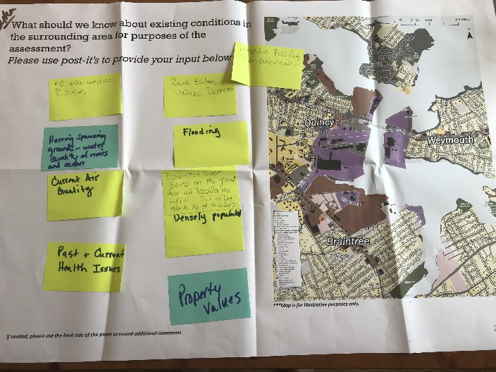
Source: MAPC

Preliminary Background Discussion and Document Scan
To prepare for the HIA scope and community engagement, the HIA Team began to collect, become familiar with, and discuss information and data relevant to the proposal. The work included:
- HIA Team meetings
- Design of the community engagement events
- Review of the Governor’s directive
- A preliminary scan of related HIAs
- Preliminary research on natural gas infrastructure
- Collection of demographic data for the municipalities
- Identification of potential sources of health data
- Preliminary mapping of the area surrounding the proposed compressor station
- Review of communications and outreach to state-elected officials for the area surrounding the proposed compressor station

Scoping Outputs
The HIA Team reviewed and synthesized information and input collected through the scoping phase of the HIA. Below is a synthesis of the main themes that emerged from the scoping phase as potential impact pathways for the HIA scope and assessment.
Figure 3. Community and Advisory Committee Identified Concerns related to the Proposed Natural Gas Transmission Compressor Station (Scoping Step)
Change | Reason Provided
Noise | The station’s construction, continuous operations and maintenance, and unplanned events (e.g., emergency equipment venting) would contribute more sound and vibrations to the area, which is unique given that the location is surrounded by water on three sides.
Air Quality | The station’s construction, continuous operations and maintenance, and unplanned events (e.g., emergency equipment venting) would contribute more emissions and odors, including hazardous air pollutants, to the surrounding areas. The emissions would add to an area perceived to have higher emission levels that may already be impacting the health of residents.
Coastal Flooding | The site of the proposed station is surrounded by water on three sides which raises concerns of flooding, a condition that surrounding neighborhoods have experienced recently. The flooding risk may be exacerbated by potential sea level rise due to climate change.
Public Safety | The proposed station could experience an event such as an explosion that would adversely affect the health and safety of residents as well as first responders. The station would also place a greater emergency preparedness burden on municipal public safety staff.
Natural Resources, terrestrial and aquatic | The Fore River basin has seen a re-emergence of fish species, including some that spawn up the river, as uses have changed and remediation of environmental hazards has occurred in the basin. The proposed station may contribute air and water pollution to an area that has seen improvements and these contributions would put local natural resources at risk, as well as those who rely or benefit from these resources (e.g., fishermen).
Land Use and Outdoor Spaces | There is a perception that the area is becoming more livable due to a decreasing presence of industrial uses in the basin. The proposed compressor station will alter this perception and consequently may negatively affect property values, outdoor activity, and mental health in the areas adjacent to and surrounding the site.
Transportation | Route 3A is a major commuter route for the South Shore and an evacuation route for the towns to the south and east of the Fore River Bridge, which sits adjacent to the site of the proposed station. Disruption from the site – such as an emergency event – could block the route and cause local and regional transportation issues.

Pathways
After of a review of the identified concerns, the HIA Team selected three pathways to form the scope. The selection was based on public input and guidance offered by the HIA Advisory Committee. The pathways are:
- Air Quality
- Noise
- Land Use and Natural Resources
The pathways build on the main themes identified through the scoping process. Although not all of the concerns raised have a specific pathway, many of them show up in the three prioritized pathways either in whole or in part. The Impact Assessment section of the report provides details about each pathway and what associated potential changes and impacts would be reviewed as part of the assessment of change were the compressor station to be constructed and put into operation as proposed. Additionally, a focus area was defined to include the area within 2 kilometers (1.25 miles) of the proposed compressor station that maintains proximity but also includes several nearby existing facilities and neighborhoods.

Impact Assessment Approach
A set of primary existing conditions and impact questions were developed to guide the HIA Team in assessing how construction and operation of the proposed transmission compressor station could potentially impact health outcomes. Supplemental research and data collection was conducted as needed to assist with identifying available information and interpretation of the findings.

Existing Conditions Questions
- What is the demographic profile (e.g., population, age, income, population density) for: those living within close proximity of the proposed site (2 kilometer/1.25 mile radius around site) and those living within the towns of Quincy, Weymouth, Braintree, and Hingham?
- What is the baseline health profile (e.g., chronic diseases, cancer rates, etc.) for: those living in close proximity to the proposed site and those living within the towns of Quincy, Weymouth, Braintree, and Hingham?
- What are the current environmental conditions (e.g., brownfields, areas of critical environmental concern) of the property of the proposed compressor station and nearby area as well as adjacent and nearby natural resources?
- What are the current land uses (e.g., residential, industrial, educational) for the area that includes and surrounds the site of the proposed compressor station?
- What are the current pollution levels (e.g., ambient air quality) in the area surrounding the site of the proposed compressor station? How do these compare to other geographies (e.g., regional, state) and to recommended levels?
- What are the contributors to the current air pollution levels? What types and amounts of air pollutants do these nearby sources emit?
- What, if any, associations are documented between air pollutants currently in the area and health outcomes and behaviors?
- What are the current background sound levels for the area that includes and surrounds the site of the proposed compressor station? What are the contributors to the current sound levels?
- What, if any, associations are documented between noise and changes in health conditions or behaviors?
- What, if any, contamination is currently on the property and in the waters adjacent to the proposed compressor station?
- What, if any, associations are documented between identified land and water contaminants on or near the site of the proposed station and health outcomes or behaviors?

Impact Assessment Questions
- What are the types of and amounts of air emissions that the proposed natural gas transmission compressor station will release? Do measurements of emission quantities and types of emissions include the various emission sources expected from the station (e.g., fugitive emissions, planned blowdown, emergency blowdown)?
- What, if any, associations are documented between emissions expected from the proposed station and changes in health outcomes or behaviors?
- How, if at all, could changes in pollutant concentrations in the area affect the health of the surrounding community? Who, if any, might have a greater risk or opportunity for a change in health? What, if any, changes could occur in the near term and which, if any, could occur over time?
- What is the expected level of sound that the proposed station will produce? What differences, if any, are there among the sound profile between regular operations and unplanned events (e.g., planned blowdown as compared to an emergency blowdown)?
- How, if at all, could changes in sound levels in the area affect the health of the surrounding community? Who, if any, might have a greater risk or opportunity for a change in health? What, if any, changes could occur in the near term and which, if any, could occur over time?
- How, if at all, would the proposed station affect (e.g., reduce, introduce, maintain) identified existing land and water contaminants?
- How, if at all, could changes in land and water contamination levels in the area affect the health of the surrounding community? Who, if any, might have a greater risk or opportunity for a change in health?
- What strategies can mitigate or eliminate potential negative impacts from air, noise, or land use changes related to the proposed station? What strategies can promote potential positive impacts from air, noise, or land use changes related to the proposed compressor station? What is the strength of evidence for the identified strategies?

Assessment
Assessment provides a profile of the baseline, or “existing,” relevant conditions among the populations impacted and evaluates the potential health impacts that the proposed station could have on the baseline conditions.

Literature Review
The literature review was conducted to document what is known about connections between health outcomes, environmental and demographic factors, and details of natural gas infrastructure (with a specific focus on transmission compressor stations). The review began with collection and review of available peer-reviewed and empirical literature related to the proposed research questions. A snowball information approach was used for identifying and collecting additional information resources. The approach focused on key terms from the initial literature search and the materials referenced by the reviewed documents. White and grey literature was referenced when peer-reviewed and empirical literature was not available.
The literature review also included materials submitted by the HIA Advisory Committee and by the community members and stakeholders who engaged in the HIA process.

Key Informant Interviews
During the assessment phase interviews were held with key informants. Identification of key informants was based on their specialized knowledge (e.g., environmental health, natural gas infrastructure, impact assessments) and unique perspectives related to the proposed change (e.g., geographic area of impact). A similar set of questions were used with each key informant. Questions focused on the background of the informant and whether they had any involvement with processes related to the proposed compressor station, their perspective and reasoning about potential impacts from the station, and ideas for potential actions to take in response were the station to be permitted.

Data and Indicators
Data sources for the HIA included:
- Demographics: Age, ethnicity, income and poverty status, educational attainment, environmental justice populations, and geographic mobility based on the most recent American Community Survey (ACS) and US Census data
- Health: Data from the MDPH including the state-wide hospitalization discharge dataset, the Massachusetts Cancer Registry, the Registry of Vital Records and Statistics, the Behavioral Risk Factor Surveillance System (BRFSS) dataset, and the Massachusetts Environmental Public Health Tracking (EPHT) program.
- Environmental Conditions and Land Use: Data from state (e.g., Massachusetts Office of Geographic Information Systems) and local sources (e.g., town data) including land use, natural resource, coastal and marine features, infrastructure, and regulated area.
- Air Emissions: Primary and secondary data sources, including the MassDEP statewide air quality monitoring data as well as the air quality monitoring that occurred in concert with the HIA.

Community Engagement
Meetings were held with the Advisory Committee in August, September, October, and November of 2018 as part of the Assessment phase of the HIA. The initial meetings focused on sharing information and providing background data on demographics, health, and air quality. Subsequent meetings involved impact assessment discussions for each pathway where the HIA Team and the Advisors reviewed information on existing conditions, evidence on connections between projected changes and health outcomes, and characterization of potential health impacts. Information about existing conditions and changes associated with the proposed station, which are part of the Impact Assessment (Part 3), was also presented at a Community Meeting on November 15, 2018 for review and feedback with residents and other stakeholders.

Recommendations
The recommendation phase builds off the impact assessment to provide actions that can be taken to address identified health impacts in the context of the proposed change. Potential actions were developed beginning at the November 7, 2018 HIA Advisory Committee meeting and continued through the final committee meeting on November 28, 2018. The HIA Team and advisory committee discussed the potential action items based on a set of criteria, including relationship to identified impacts, feasibility, and use of evidence. The set of ideas was used by the HIA Team to develop the potential actions that are included in the HIA report.

Reporting
Reporting communicates the findings and recommended actions developed during the HIA process to decision makers and stakeholders. The HIA report considers the nature and magnitude of the health impacts and their distribution in the population. It summarizes the key health impact issues, and is followed by potential actions to improve heath determinants and outcomes. Reporting for the HIA of the proposed transmission compressor station consists of the full report and an Executive Summary.

Part 3: Impact Assessment
The Assessment step of an HIA seeks to capture how a proposed change may directly or indirectly impact population health. The assessment step is guided by elements laid out in the scoping step of the HIA, including causal pathways, health-related indicators and data sources, geographic context, and vulnerable populations.
The Assessment step in an HIA includes two main elements:
- Understanding existing conditions, which involves characterizing
  - Current demographic indicators (e.g., income, race/ethnicity, age, and language)
  - Related health conditions and behaviors (e.g., hospitalizations, behavioral risk factors, etc.)
  - Populations that may experience disproportionate impacts from the proposed change
- Assessing potential health impacts, which involves estimating how
  - Effects related to the proposed change may affect health determinants and outcomes based on available evidence and assessment tools
  - Existing conditions could be impacted by the proposed change according to evidence linking health determinants, behaviors and outcomes
  - Current and potential future vulnerable populations could be specifically affected by the proposed change
The result of the assessment is a set of predictions that informs the recommendations which will go to decision-makers and stakeholders.

Health and Our Environment
Health is about much more than treating illness. Protecting community health starts in our homes, schools, workplaces, neighborhoods, and communities. A health determinant framework addresses the distribution of good and poor health in a population, and considers the upstream determinants of health. It examines who is ill and who is well, and the larger social and economic contexts associated with health. It recognizes that factors such as employment status, income, poverty, housing, race and racism, social connections and networks, and the neighborhood environment critically affect population health.
Figure 4. Social Determinants of Health Framework
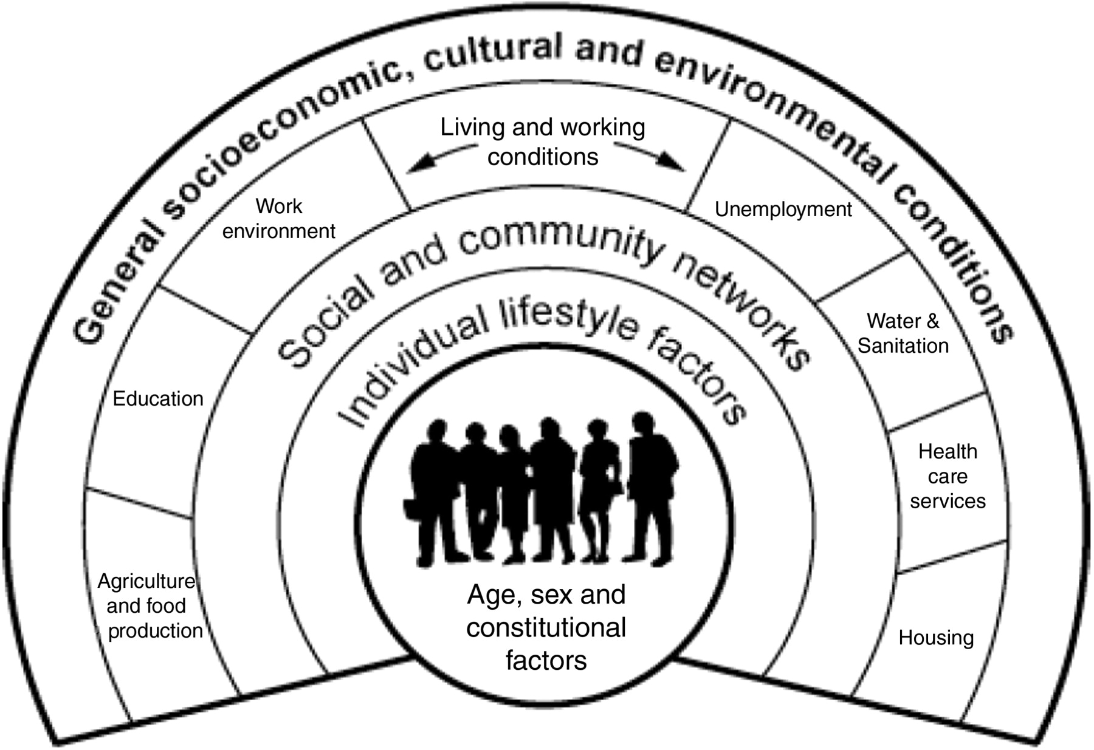
Source: World Health Organization

Baseline Profile: Focus Area and Municipalities
In this section, a baseline profile is presented for a focus area around the proposed station and for the four municipalities. The profile provides an understanding of current health conditions and factors that may be affected by the proposed change.
We have organized the profile to feature data at three geographic scales as data was available (Figure 5):
- Focus Area: A two kilometer (approximately one and a quarter mile) focus area to reflect community concerns about proximity and describe characteristics of those who live closest to the proposed station
- Municipalities: Municipal profiles for the city and towns engaged in the HIA, which is inclusive of the two kilometer focus area, to reflect populations in the surrounding areas
- State: Statewide data (inclusive of the focus areas and the municipalities) to offer a comparison for characteristics of residents who live in the focus area and surrounding municipalities
Figure 5. Focus Area and Municipalities Map
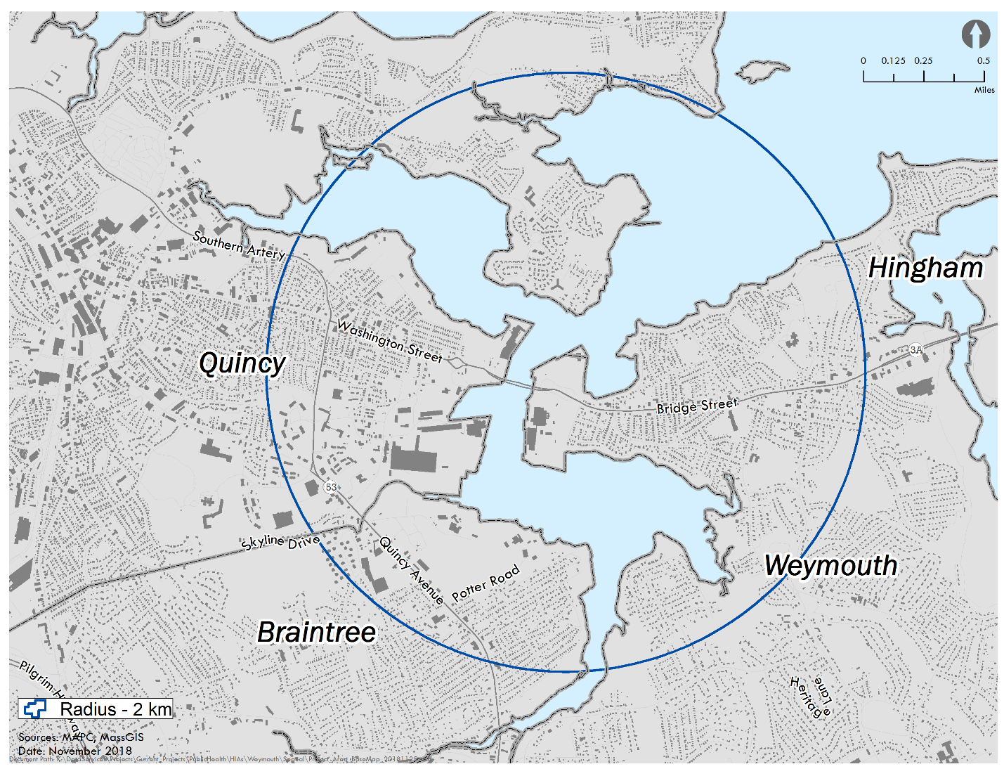
Source: MAPC

Demographic Overview
The four municipalities have a total population of over 205,000 people with Quincy at the largest (92,000 residents) and Hingham at the smallest (23,000 residents). The focus area, which includes portions of Braintree, Quincy and Weymouth, is estimated to have a population of 20,000 people.
Figure 6. Population by Age
 | Focus Area | Hingham | Quincy | Weymouth | Braintree | MA
Total Population | 20,058 | 22,157 | 92,271 | 53,743 | 35,744 | 6,547,629
Under 5 | 1,147 | 1,408 | 4,978 | 3,160 | 2,081 | 367,087
5 to 9 | 1,071 | 1,848 | 4,056 | 3,000 | 2,338 | 385,687
10 to 14 | 1,007 | 1,783 | 3,811 | 3,077 | 2,373 | 405,613
15 to 17 | 628 | 993 | 2,458 | 1,889 | 1,377 | 260,536
Under 18 | 3,853 | 6,032 | 15,303 | 11,126 | 8,169 | 1,418,923
18 to 24 | 1,499 | 934 | 8,020 | 3,913 | 2,330 | 677,888
25 to 34 | 2,652 | 1,306 | 17,117 | 6,932 | 4,180 | 845,141
35 to 64 | 8,498 | 9,541 | 37,925 | 23,603 | 14,992 | 2,702,953
65 and over | 3,556 | 4,344 | 13,906 | 8,169 | 6,073 | 902,724
Source: US Census 2010
The focus area has a percent population of children less than 5 years of age (5.7%) that is similar to the state’s (5.6%) and surrounding municipalities (range 5.4-6.4%). Hingham has the highest percentage of residents under the age of 18 (27%); Quincy has the highest number of residents under the age of 18 (more than 15,000). All of the municipalities and the focus area have higher percentages of residents over the age of 65 as compared to the state (15% or more of their population). As with younger residents, the highest percentage of older adults is located in Hingham (20%) and the highest number reside in Quincy (approximately 14,000).
The focus area (23%) and Quincy (34%) have higher percentages of people of color as compared to the municipalities and Quincy has a higher percentage than the state (24%).

Figure 7. Race
 | Focus Area | Hingham | Quincy | Weymouth | Braintree | MA
White | 15,398 | 21,135 | 60,448 | 47,364 | 30,471 | 4,984,800
Black | 796 | 109 | 3,998 | 1,527 | 911 | 391,693
American Indian | 36 | 31 | 137 | 87 | 46 | 10,778
Asian | 2,672 | 343 | 22,124 | 1,716 | 2,687 | 347,495
Pacific Islander | 6 | 8 | 21 | 10 | 10 | 1,467
Other | 176 | 36 | 768 | 764 | 245 | 61,547
Two or More Races | 355 | 254 | 1,686 | 863 | 484 | 122,195
Latinx | 619 | 241 | 3,089 | 1,412 | 890 | 627,654
Source: US Census 2010
In particular, the focus area (13%) and Quincy (24%) have a higher percentage of people of Asian descent than the state (5%) or any of the other municipalities (range 2-8%). Hingham has the highest percentage of white residents (95%) with Weymouth and Braintree following (88% and 85%, respectively).

English comprises the highest percentage of spoken languages across all geographies. There are fewer Spanish speaking populations in the focus area and municipalities (up to 2%) as compared to the state (9%). The focus area (14%) and Quincy (25%) have more people speaking Asian languages (e.g., Mandarin Chinese, Japanese, Korean) than the other three municipalities (approximately 2%-7%) and the state (4%).

Figure 8. Language Spoken at Home
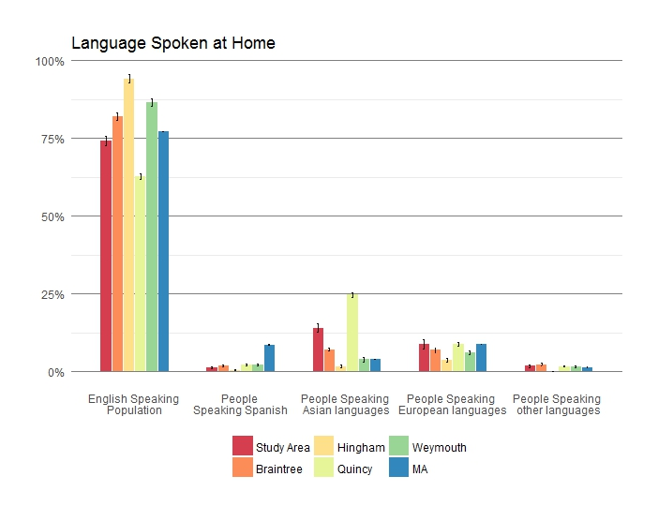
Source: American Community Survey 2012-2016
A higher percentage of people with less than a high school or an associate degree live in the focus area and Quincy (more than 10%) as compared to other municipalities and the state (10% or less). There is also a lower proportion of those with a bachelor’s degree in the focus area (less than 20%) than in either the municipalities on average or the state (22% or more).

Figure 9. Educational Attainment
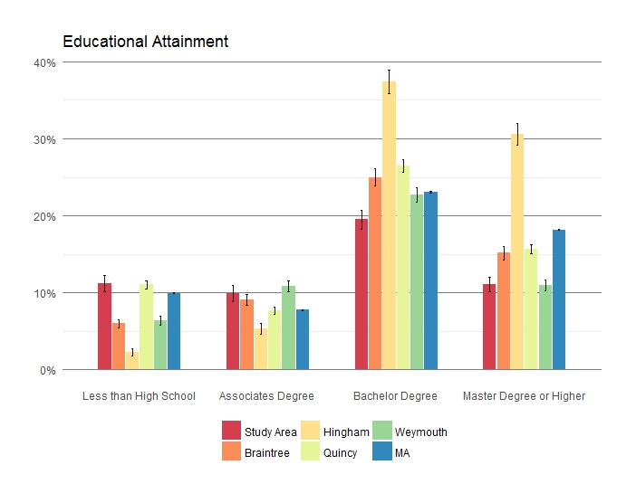
Source: American Community Survey 2012-2016
Economically, the focus area is estimated to have a higher percentage of people earning less than $15,000 annually (14%) as compared to the surrounding municipalities and the state (range 7 – 12%). By contrast, Hingham residents are estimated to have the highest percentage of household incomes above $150,000 (nearly 20%). Additionally, the focus area has a higher percentage of people living in poverty (12%) as compared to the state (11%) and the municipalities (range 5 – 10 %), but the percentage is not statistically different from Quincy or the state.

Figure 10. Household Income
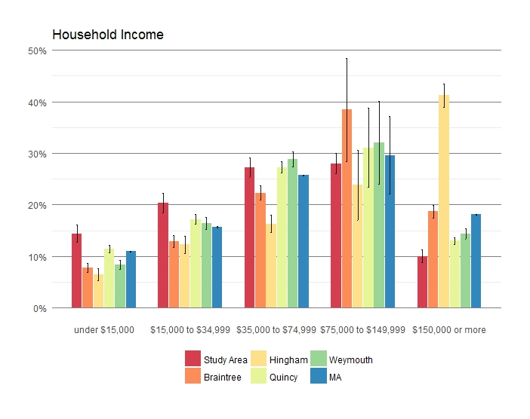
Source: American Community Survey 2012-2016

Figure 11. Population in Poverty
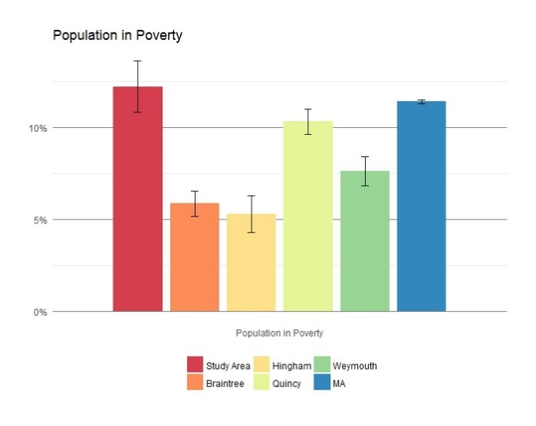
Source: American Community Survey 2012-2016
In the focus area, as with is the surrounding municipalities, approximately one third of homeowners have lived in their home for nearly 30 years or more. This percentage is higher than the state average, where it is closer to one in four homeowners who have lived in their homes for that period of time. For homeowners who have lived in the focus area and the surrounding municipalities for less time, the highest percentage is represented by those who moved in between 2000 and 2009 (range of approximately 25-35%), which is similar to the state average over the 10 year period (33%).
Figure 12. Year of Householder Move
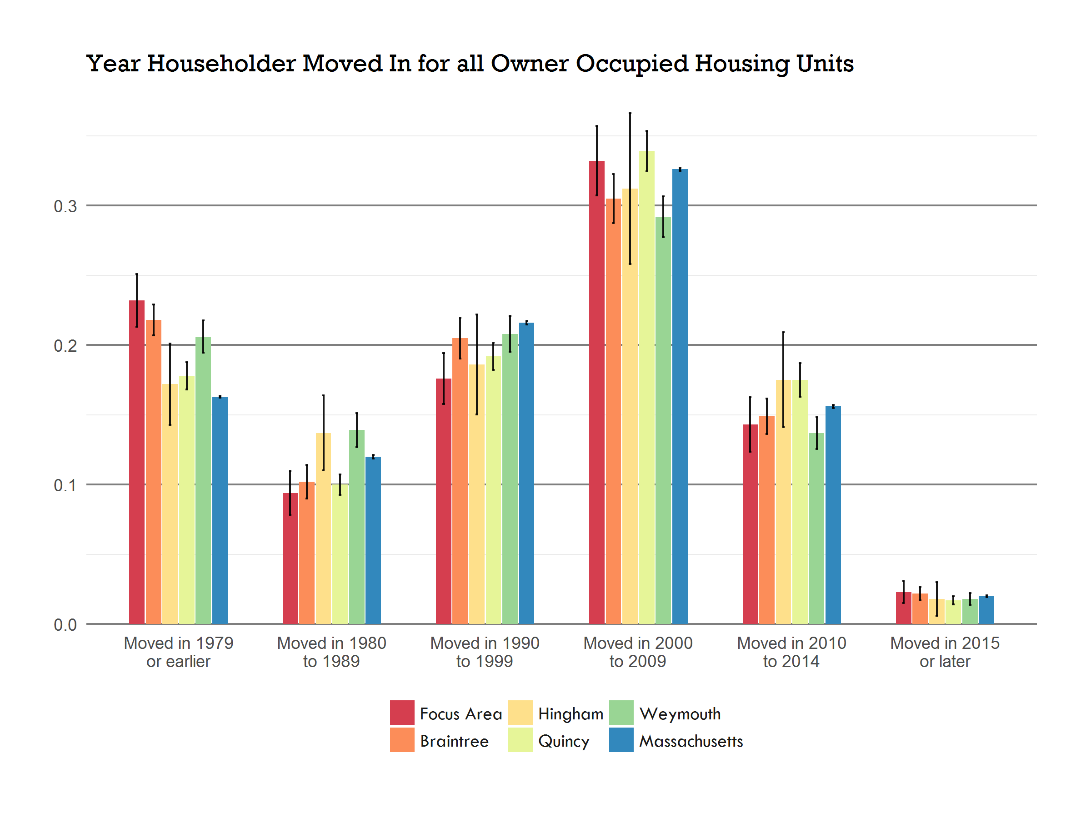
Source: American Community Survey 2012-2016
Data for the past 10 years also indicates that most residents (80% or more) in the focus area and the four municipalities have remained in the same home, which is similar to percentages in the state overall.

Location | ACS Years | % of Population that Lived in the Same House 1 Year | Upper Limit (MOE) | Lower Limit (MOE)
Focus Area | 2007-11 | 88.3 | 94.0 | 82.6
Focus Area | 2012-16 | 89.8 | 93.3 | 86.3
Braintree | 2007-11 | 89.9 | 91.5 | 88.2
Braintree | 2012-16 | 90.3 | 91.9 | 88.8
Hingham | 2007-11 | 93.8 | 95.2 | 92.3
Hingham | 2012-16 | 92.3 | 94.2 | 90.3
Quincy | 2007-11 | 81.9 | 83.4 | 80.5
Quincy | 2012-16 | 85.3 | 86.6 | 84.0
Weymouth | 2007-11 | 90.8 | 92.2 | 89.4
Weymouth | 2012-16 | 88.8 | 90.3 | 87.3
Massachusetts | 2007-11 | 86.5 | 86.7 | 86.3
Massachusetts | 2012-16 | 87.1 | 87.2 | 86.9
Source: American Community Survey 2012-2016

Environmental Justice
The focus area includes Environmental Justice populations. Environmental justice is based on the principle that all people have a right to be protected from environmental pollution and to live in and enjoy a clean and healthful environment. These communities are defined as U.S. Census block groups that meet one or more of the following criteria: 1) the median annual household income is at or below 65% of the statewide median income for Massachusetts, 2) 25% of the residents are minority or 25% of residents are foreign born, or 3) 25% of residents are lacking English language proficiency.
Figure 13. Environmental Justice Neighborhoods
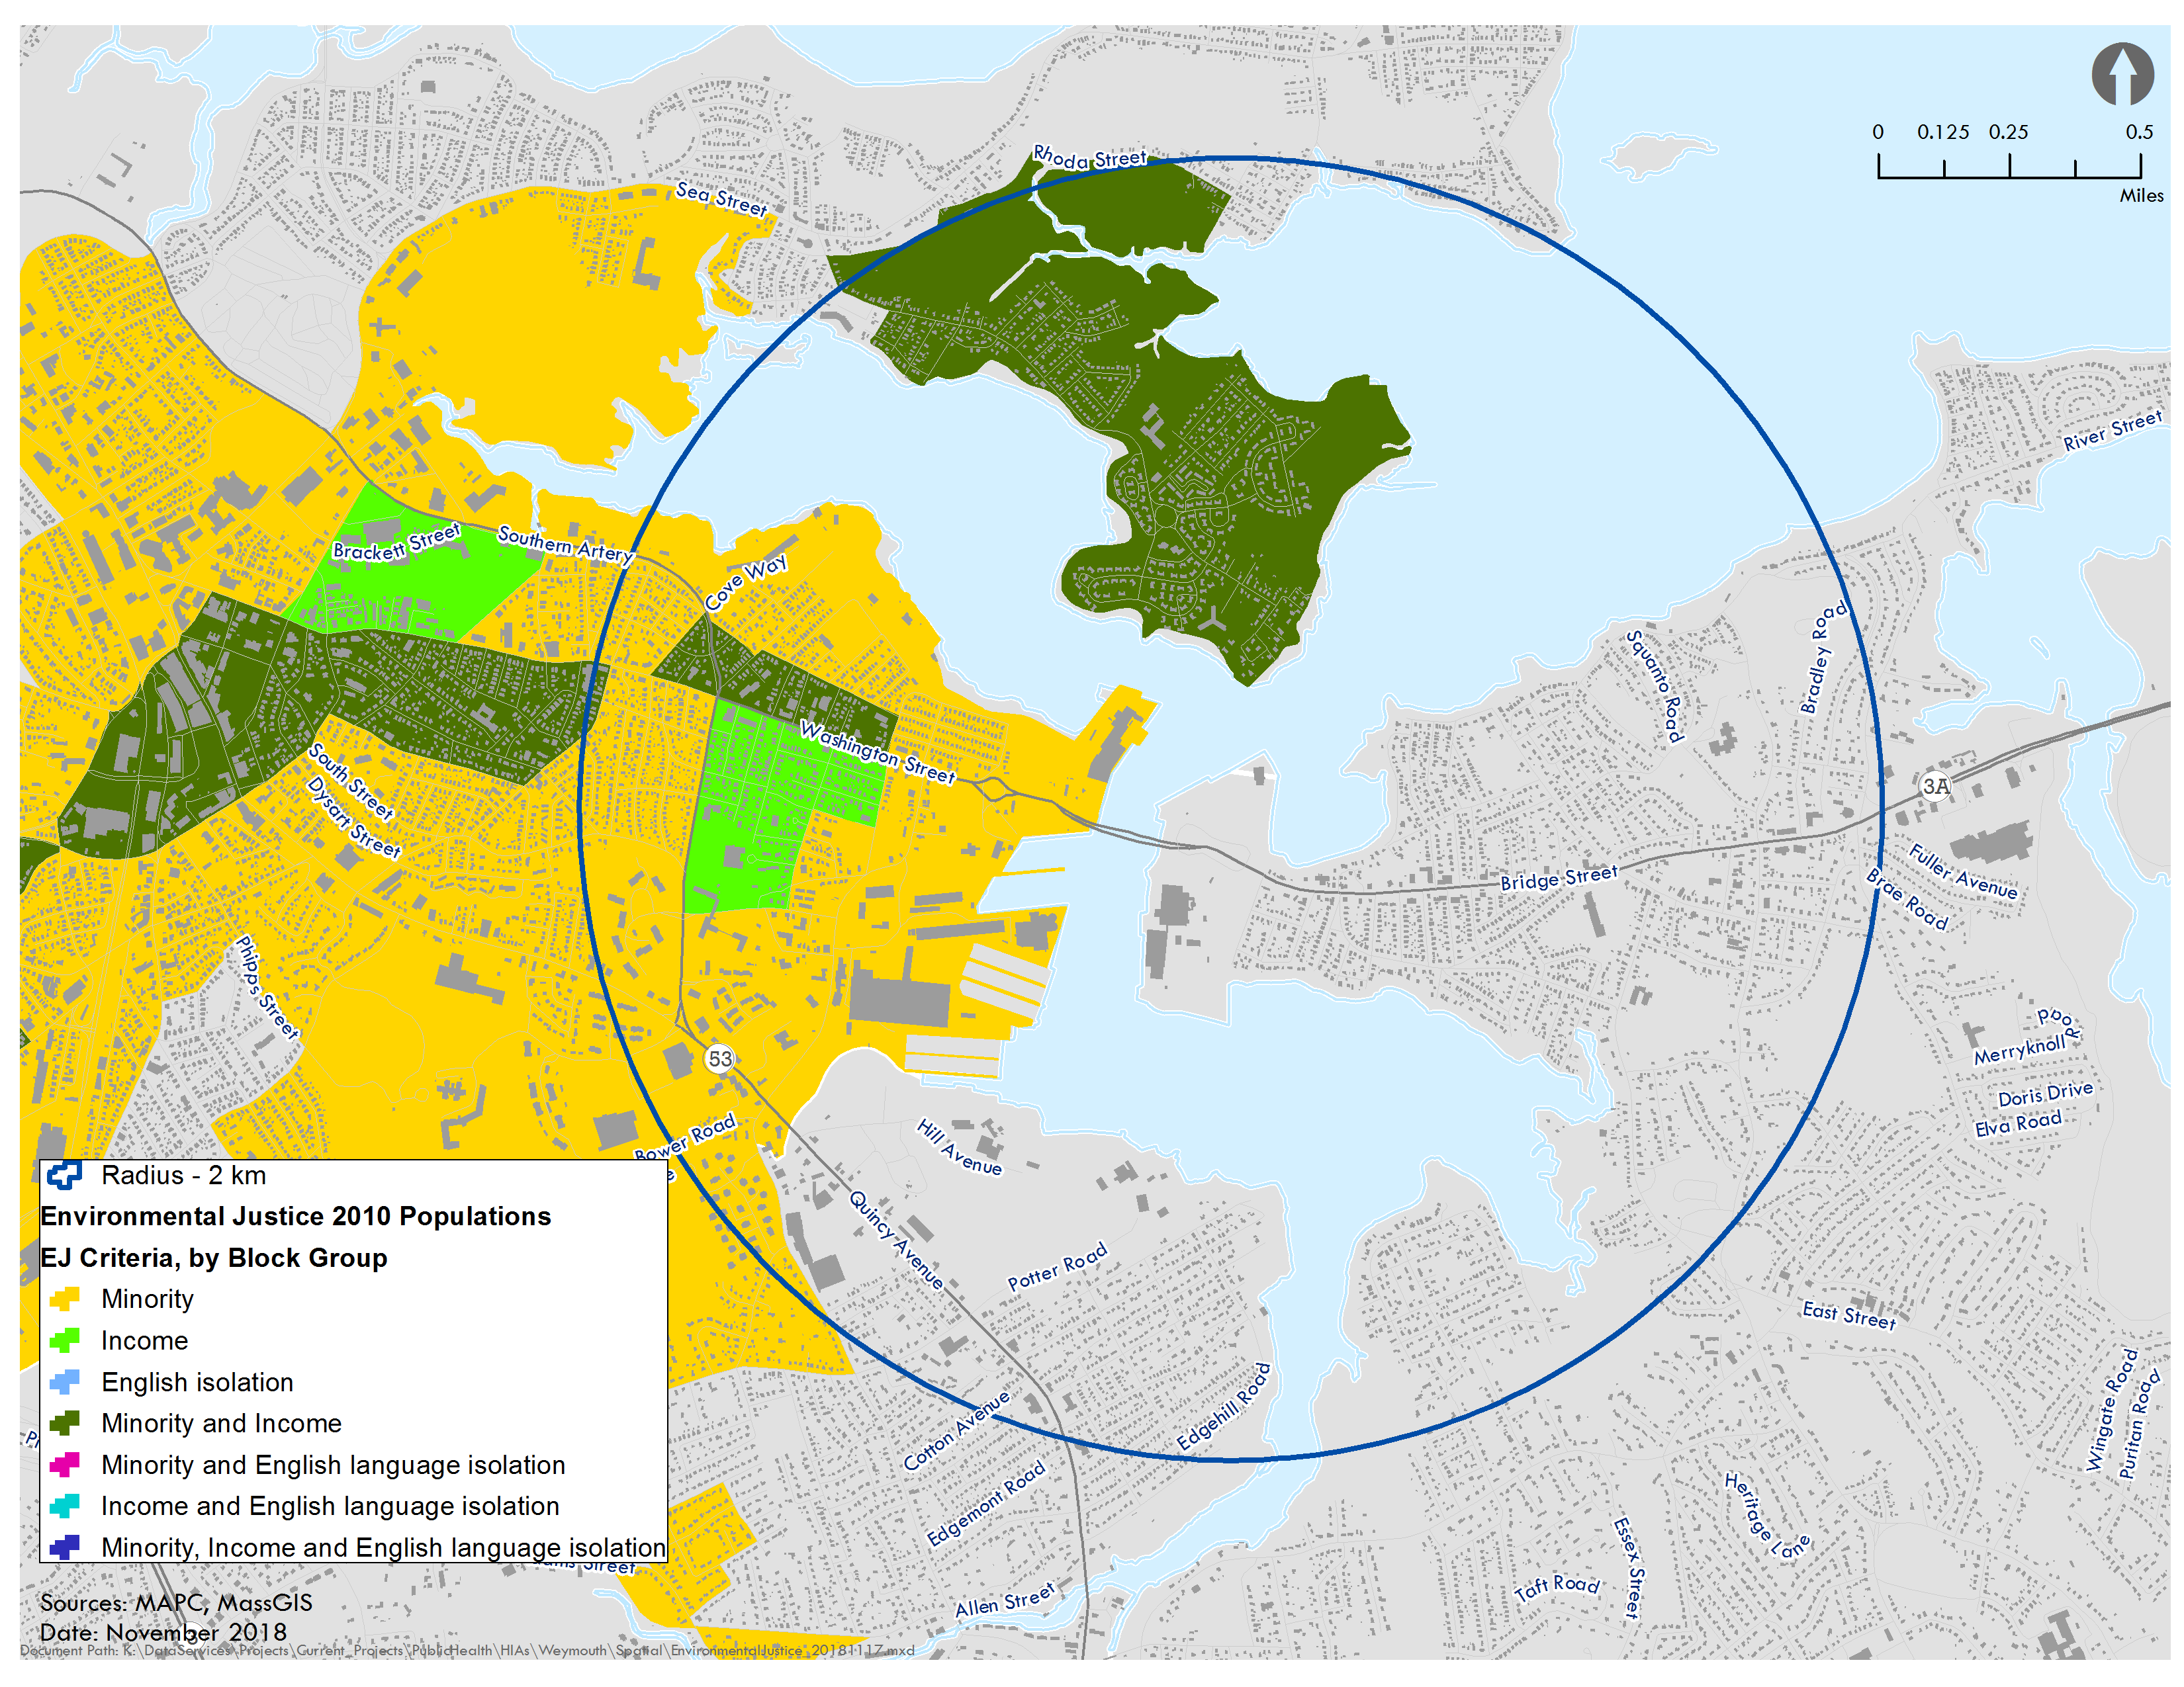
Source: MassGIS, MAPC
Two Environmental Justice criteria are met for populations in the focus area: minority population and low income. These populations are found in the Quincy Point and Germantown neighborhoods on the Quincy side of the Fore River. In particular, the census block groups (which typically include between 600 and 3,000 people) are located in Germantown and north of Washington Street in the Quincy Point neighborhood.
Community Perspectives
Residents and stakeholders provided their feedback about neighborhoods and environment in the areas surrounding the proposed compressor station site. In particular, residents called out potential vulnerable populations in the surrounding areas, including children and students, older adults, pregnant women, people with disabilities and limited mobility, those living with chronic diseases and residents of Environmental Justice neighborhoods. The community shared that the area is densely populated and urban in nature, and noted that most other compressor stations appear to operate in either less densely developed or rural areas. Residents highlighted the existing industrial nature of the Fore River area with uses like the Citgo Petroleum Terminal, Clean Harbors and Twin Rivers Technology and a history of contamination from past and current uses. Others in the process raised issues related to the water resources and animal species that live in the Fore River basin such as herring that spawn up river.
While not addressed in the HIA, residents identified many issues related to public safety, including the risk of explosion, impacts to nearby sewer, bridge and power infrastructure, and effects on evacuation routing and emergency vehicle access on Route 3A/Bridge Street. Participants also called out recent examples of flooding in the area and that flooding is experienced more often than in the past. It was felt that the risk of flooding at the proposed station would be increasing given the effects of climate change on precipitation patterns and rising sea levels.

Land Use and Environmental Context
Land use and environmental conditions describe conditions related to the development of land such as homes and offices and the presence of natural resources. This section provides a brief overview of existing conditions as they relate to land development and environmental resources adjacent to and surrounding the proposed station. More information about these conditions is also included in the Land Use and Natural Resources impact assessment section of the document.

Land Use Overview
In and around the focus area, the prominent land uses are commercial, industrial, and residential. Closest to the proposed site, the surrounding land uses are industrial, characterized by power production (Calpine Fore River Energy Center, Braintree Electric Light Department), chemical processing (Twin Rivers Technology), wastewater service and recycling (MWRA intermediate pump station, New England Fertilizer Company), waste management services (Clean Harbors), and storage of chemicals and energy materials (Citgo Terminal, Sprague Terminal).
Figure 14. Land Use
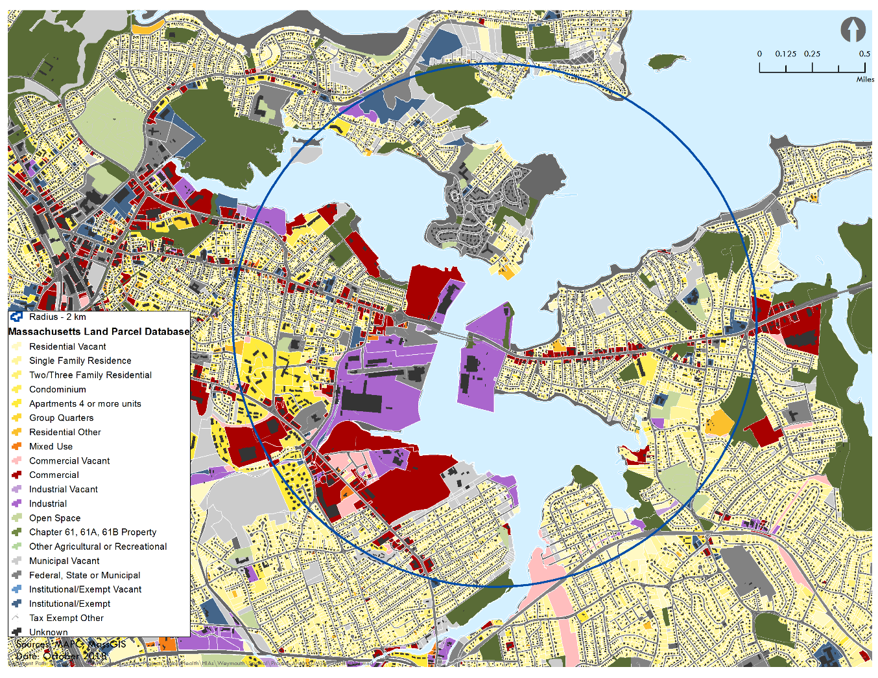
Source: MassGIS, MAPC
Commercial uses consist of a mix of primarily retail establishments along Route 3A. Residential uses are located behind the commercial uses on Route 3A and off of local roads in the area. On the Weymouth side, residences are single- or two-family homes while on the Quincy side, there is a greater mix of multi-family residences. Across the river from the proposed site, two public housing developments are located in the Germantown neighborhood: Snug Harbor (family housing, 400 units) and Crowley Court (housing for older adults and people with disabilities, 45 units).
Six schools (four public and two private) are present in the 2 KM focus area for the proposed station.
- Clifford Marshall Elementary School in Quincy
- Snug Harbor Elementary School in Quincy
- Wessagusset Elementary School in Weymouth
- St. Jerome Elementary School in Weymouth
- Johnson Early Childhood Center
- Noble Academy (formerly Mutanafisun Academy)
The schools are estimated to have a combined student population of approximately 1,700 and include public and private Pre-K and elementary schools (up to 8th grade).
Figure 15. Schools
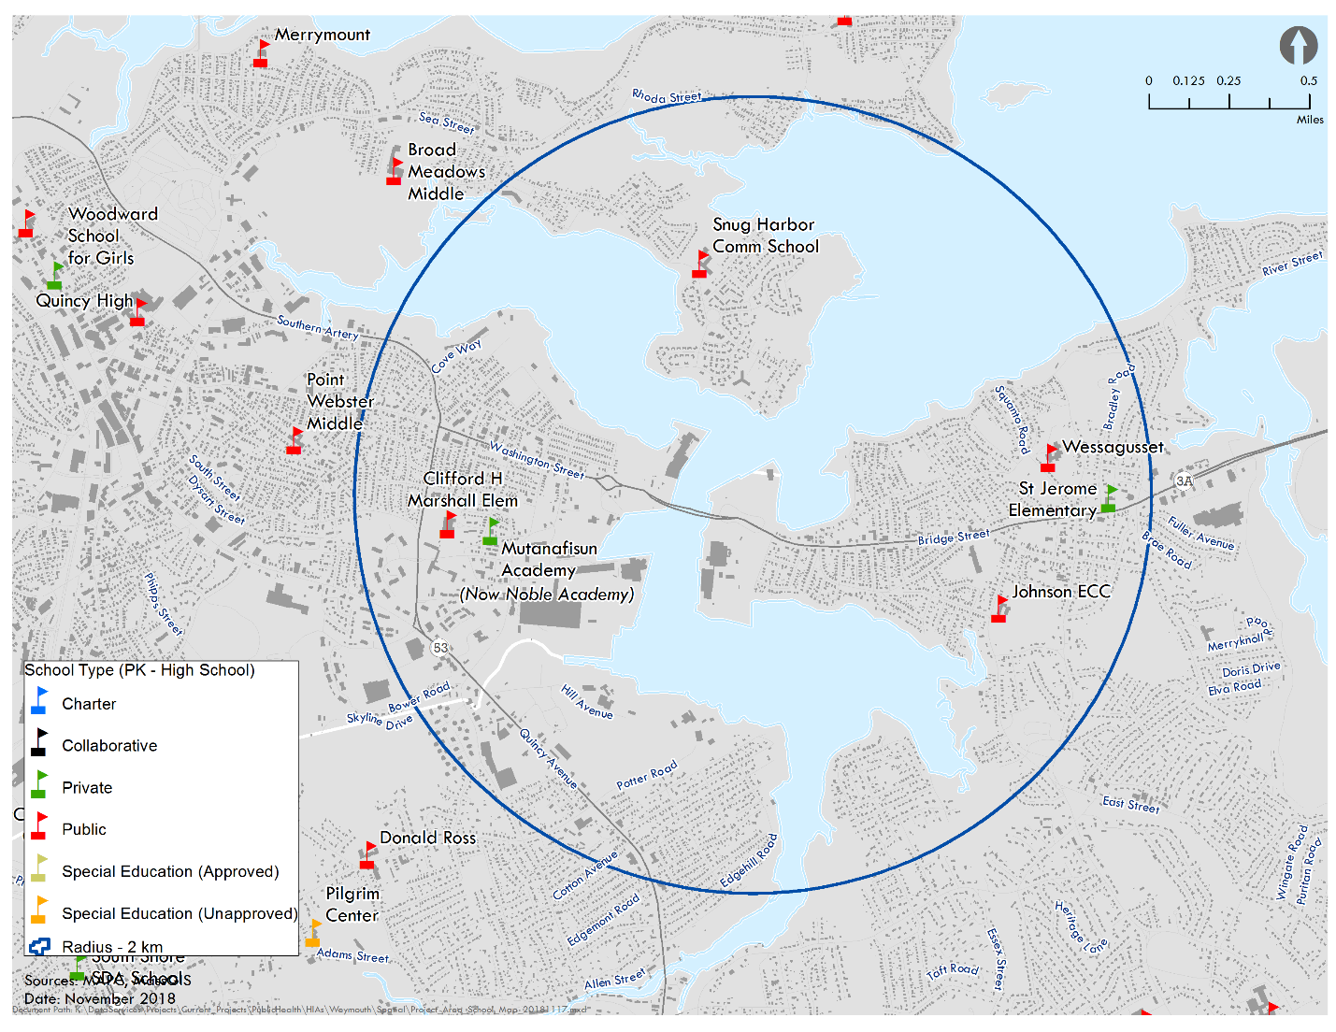
Source: MassGIS, MAPC
While these schools are more proximate to the proposed station, there are numerous schools that fall within a slightly larger radius (2.5 miles), including additional public elementary, middle and high schools in Weymouth, Quincy and Braintree. This description identifies schools from available geographic data so it should be noted that there may be additional private pre-K, nursery, daycare and other private educational facilities for youth located in the focus area and in the surrounding areas.

Environmental Contamination
The Executive Office of Energy and Environmental Affairs maintains an inventory of properties where there has been a reportable release of contaminants as well as properties where assessment and cleanup activities have occurred (Appendix C). The inventory identifies that a number of properties in the 2 KM focus area (including parts of Weymouth, Quincy, and Braintree) have had reportable releases and clean ups, including on the site of the proposed compressor station, over the past 25 years. The majority of locations were former or current industrial properties located along or near the Fore River.
Data from the release inventory indicate that most were related to the release or discovery of oil. Nine of the identified release sites have proceeded to Phase II assessment (comprehensive site assessment), six have entered phases where remedial actions were selected and implemented (Phase III and IV assessments), and two have proceeded to adopt long-term treatment processes and monitoring processes to track cleanup of the site. As of fall 2018, a temporary or permanent solution is noted in nearly each case for the identified releases.

Designated Port Area
The Weymouth Fore River is a designated Port Area (DPA). The state designation promotes and protects water-dependent industrial uses in Massachusetts. The designated areas possess particular physical and operational features essential for industrial uses that are water-dependent or that require marine transportation (e.g., commercial fishing, shipping), or that need large volumes of water for withdrawal or discharge. In general, a DPA seeks to protect areas where there are water-dependent industrial uses from conversion to non-industrial or non-water dependent types of development that could be built and operated in locations away from the coast.

Figure 16. DPA Map
Source: Massachusetts Office of Coastal Zone Management
The Weymouth Fore River DPA includes over 650 acres of land and water area, covering portions of land in Quincy and Weymouth. The proposed site of the compressor station is located in the Fore River DPA.

Recreation and Conservation Land
The area surrounding the proposed station is built out. As noted in the land use description, residential, commercial, and industrial uses exist on developable land adjacent to and surrounding the proposed compressor station. There are some small portions of land that are undeveloped. In Weymouth, this includes the King’s Cove and Lovell’s Grove open spaces. Both areas share a property line with the site of the proposed station and provide parking, walking paths, green space and views of the Fore River and basin.
Figure 17. Open Space and Conservation Areas
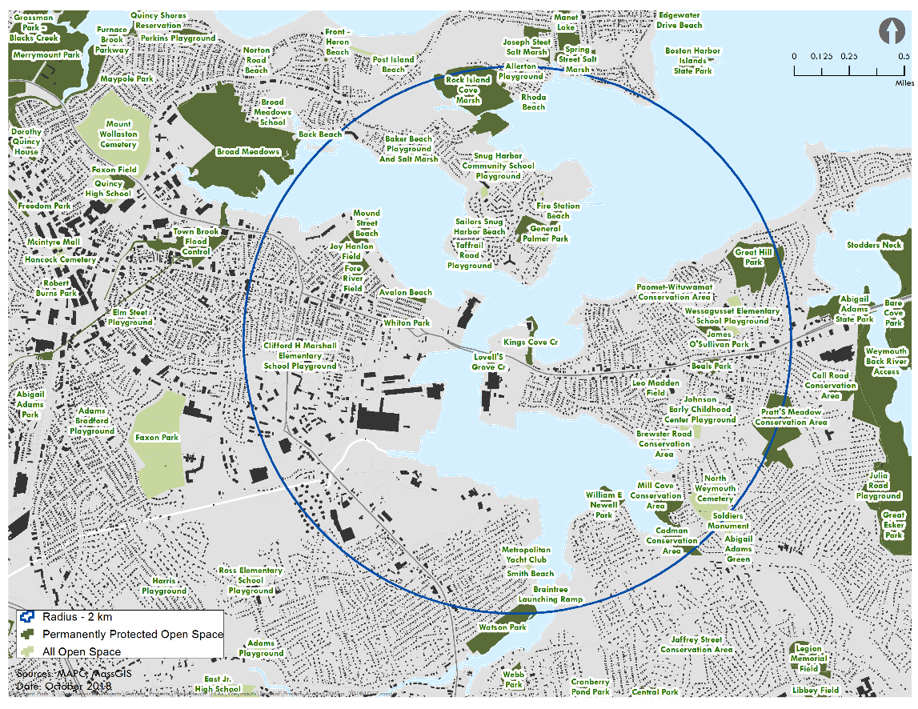
Source: MassGIS, MAPC
Other open spaces that are proximate and inside the focus area include Wessagusset Wetland and Woodland conservation area, O’Sullivan and Beals Parks, Great Hill Park, and Pratts Meadow. Just outside the focus area in Weymouth is the Weymouth Back River, which is bordered by the Great Esker Park in Weymouth and the Bare Cove Park on the Hingham side of the river.
In Quincy, multiple small parks fall within the focus area, such as Mound Street Beach and Victory Park, as do recreation spaces associated with schools such as the Clifford Marshall school playground. In addition, the Broad Meadow Marsh is located just outside the focus area. The area is a home to a salt marsh and contains Passanageset Park.
Braintree has open space areas in the focus area as well. Along the Fore River, there is the Cadman Conservation Area and Newell Playground. The conservation area provides protection for water resources associated with the river and the playground has recreational fields and play spaces.
In addition to the parks and conservation areas, there are numerous recreational boating sites in and around the focus area. Residents of the area have or use boats on the Fore River and other nearby waterbodies. Marinas in the area include:
- Town River Yacht Club in Quincy
- Bay Pointe Marina in Quincy
- Wessagusset Yacht Club in Weymouth
- Tern Harbor Marina in north Weymouth
- Metropolitan Yacht Club in Braintree
- Braintree Yacht Club in Braintree
Potential for Flooding and Sea Level Rise
The Governor’s directive that initiated the process for the HIA also directed the Massachusetts Office of Coastal Zone Management to review the proposed compressor station’s safety and reliability under coastal storm conditions, taking into account rising sea levels. To conduct this review, CZM requested additional information and analysis from the project proponent to identify the specific flooding and inundation risks for the site and the station. The proponent was requested to provide this information accounting for potential effects of future sea level rise and the design life of the facility.
The response from the proponent providing the additional information and analysis can be found on the project website: http://foreriverhia.com/documents/.

Water resources
The Fore River begins at the confluence of the Monatiquot River and Smelt Brook in Braintree and runs north and easterly for approximately three to four miles, emptying into Hingham Bay. Part of the Weymouth and Weir watershed, the river covers approximately 50 square miles (including Braintree, Quincy, and Weymouth) and is host to shellfish beds and anadromous smelt and herring runs.
The river has a history of dealing with pollutants. Past industrial uses along the river corridor have impacted the river through pollutants like heavy metals. Municipal combined sewer overflows (CSO) have resulted in bacterial pollution to the rivers waters. While municipal projects over the last decade have addressed CSO-related pollutant contributions, the EPA designates the Fore River as a category 5, meaning it is an impaired or threatened waterway and requires a total maximum daily load (TMDL),. MassDEP lists the river on the state’s Impaired Waters 303(d) List, noting impairments are pathogens from fecal contamination and non-naturally occurring chemical groups (e.g., polychlorinated biphenyls in fish tissue).
Figure 18. Fore River Map and Associated Water Bodies
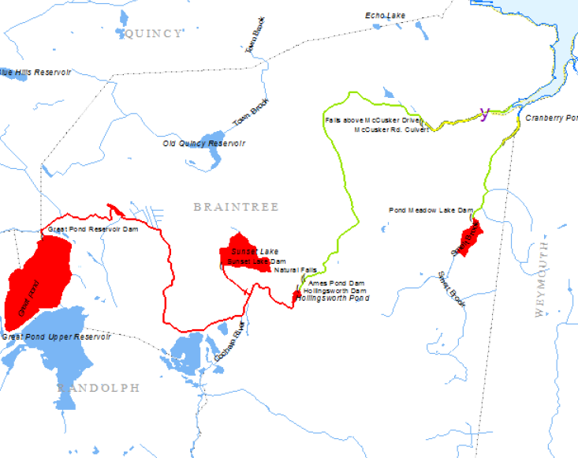
Source: River Herring Spawning and Nursery Habitat Assessment: Fore River Watershed 2008-2010
Discussions and studies have occurred to restore portions of the Fore River so that herring can spawn farther up the river. The work would include addressing existing impediments and dams along the river so that the herring could spawn up into the Great Pond reservoir. The restoration would help expand habitat for the river herring themselves and as part of an ecosystem in which they provide food for other terrestrial and aquatic wildlife and potentially, if deemed safe, for human recreational, commercial and subsistence uses.

Health Behaviors and Conditions
A baseline health profile was developed to identify health conditions that are relevant to residents and stakeholders and to be used in the assessment. The profile provides a characterization of existing conditions that serves as a basis to understand how the proposed compressor station may impact health in the short- and long-term. The profile provides information, when available, about the residents living closest to the proposed station (two kilometer focus area) and the four municipalities (Weymouth, Quincy, Braintree, and Hingham). Information is also provided for the state to provide a basis for comparison and information about the health status on average across the Commonwealth.

Behavioral Risk Factor Surveillance System
The state BRFSS is an annual telephone survey that collects data on health conditions, risk factors, and behaviors. Based on the survey, the state can develop small area estimates that characterize the data for municipalities. While the estimates are derived from the state BRFSS, the estimates may be based on relatively few respondents or have standard errors that are larger than average. Although this is not ideal from a data perspective, it provides the best estimate for conditions at a municipal level.

Municipal Estimates
BRFSS data is presented below for the four municipalities as it is the smallest geography available. The data includes percentages, as available, and ranking of each municipality according to quintiles. For the ranking, a number "1" means the municipality has one of the lowest percentages of people reporting the identified health condition, risk factor, or protective factor while a "5" means the community has one of the highest percentages of people with that health condition, risk factor, or protective factor. For example, a “1” ranking for smoking would indicate a municipality is among cities and towns with the lowest percentages of residents who report smoking while a “1” ranking for exercise would indicate a municipality is among cities and towns with the lowest percentages of residents who report engaging in physical activity.
Adult smoking
Smoking is a direct contributor to multiple health conditions including certain cancers, heart disease, lung diseases, and chronic obstructive pulmonary disease (COPD) and increases a person’s risk for other diseases and problems of the immune system. In Massachusetts, it is estimated that less than 14% of people smoke on average. Among the municipalities, it is estimated that Quincy and Weymouth residents are among the cities and towns with the highest number of smokers in the state.
Figure 19. Adult Smoking
Town Name | % | LCL | UCL | Quintile
Braintree | 12.5 | 8.5 | 17.9 | 2
Hingham | 13.4 | 8.7 | 19.9 | 3
Quincy | 18.2 | 15.7 | 21.0 | 5
Weymouth | 20.2 | 15.2 | 26.3 | 5
Source: MA BRFSSS 2012-2014
Adults lacking regular physical activity
Physical activity bestows many health benefits including reducing risk for chronic diseases and certain cancers. In the latest reporting from the state’s BRFSS, it is estimated that 80% of adult residents engaged in some exercise over the last month outside of their work. Among the municipalities, it is estimated that Quincy and Weymouth are among municipalities reporting the lowest percentages in the state, while Braintree is among the middle and Hingham among the highest.
Figure 20. Adult Lack of Physical Activity
 | Quintile
Braintree | 3
Hingham | 5
Quincy | 1
Weymouth | 1
Source: MA BRFSSS 2012-2014
Adult obesity and overweight
Unhealthy weight can lead to heart disease, stroke, diabetes (type 2) and certain types of cancer. While Massachusetts has one of the lowest rates of adult obesity (body mass index – BMI – over 30) in the nation (26%), the rate has been rising (previously 15% in 2000). It is estimated that Braintree and Hingham are among the municipalities with a lower percentage of obesity while Quincy is estimated to be among the middle and Weymouth among the municipalities who report higher percentages of residents who are obese.
Figure 21. Adult Obesity
Town Name | % | LCL | UCL | Quintile
Braintree | 19.0 | 14.5 | 24.6 | 1
Hingham | 20.6 | 15.3 | 27.2 | 2
Quincy | 21.3 | 18.9 | 24.0 | 3
Weymouth | 23.1 | 18.3 | 28.8 | 4
Source: MA BRFSSS 2012-2014
For percentage of residents that are overweight (BMI of 25 to < 30), Hingham is estimated to have among the lowest, Braintree among the middle, and Quincy and Weymouth among the highest in the state.
Figure 22. Adult Overweight
Town Name | % | LCL | UCL | Quintile
Braintree | 58.0 | 51.4 | 64.4 | 3
Hingham | 54.5 | 46.8 | 61.9 | 2
Quincy | 59.9 | 56.8 | 63.0 | 4
Weymouth | 60.7 | 54.5 | 66.7 | 4
Source: MA BRFSSS 2012-2014
Adult diabetes
Diabetes is a condition that results from the body not being able to utilize and absorb sugars as it normally would. As a result, people with diabetes have high levels of sugar in their bloodstream, which over time can lead to health issues such as heart disease, kidney disease, and vision impairments. Some people are born with diabetes, but increasingly, more people have developed diabetes (Type 2) because of diet, lack of physical activity and unhealthy weight. Type 2 diabetes is often preceded by a diagnosis of prediabetes which indicates blood sugar levels are high but not yet at a level for a diabetes diagnosis.
Quincy, Braintree, and Weymouth are estimated to be among municipalities with the highest percentages of residents with diabetes in the state (8% or more), while Hingham is among the lowest. Conversely, Hingham is among the municipalities with the highest percentages of prediabetes while the other three municipalities are among those with the lowest.
Figure 23. Adult Diabetes
Town Name | % | LCL | UCL | Quintile
Braintree | 9.6 | 6.8 | 13.2 | 5
Hingham | 5.8 | 3.7 | 9.0 | 1
Quincy | 8.8 | 7.4 | 10.4 | 5
Weymouth | 8.0 | 5.7 | 11.0 | 4
Source: MA BRFSSS 2012-2014
Figure 24. Adult Prediabetes
Town Name | % | LCL | UCL | Quintile
Braintree | 6.1 | 4.6 | 8.0 | 1
Hingham | 6.9 | 5.2 | 8.9 | 4
Quincy | 6.2 | 5.0 | 7.8 | 2
Weymouth | 6.0 | 4.6 | 7.8 | 1
Source: MA BRFSSS 2012-2014
Adult heart disease
Heart disease is the leading cause of death in the nation. In addition, many who experience cardiovascular-related disease can experience lower quality of life and take on significant additional costs to manage or treat their conditions. Braintree, Hingham, and Weymouth are estimated to be among the municipalities with the highest percentages of heart disease.
Figure 25. Adult Cardiovascular Disease
Town Name | % | LCL | UCL | Quintile
Braintree | 5.8 | 4.3 | 7.8 | 4
Hingham | 6.5 | 4.8 | 8.8 | 5
Quincy | 5.5 | 4.6 | 6.6 | 3
Weymouth | 6.2 | 4.7 | 8.1 | 4
Source: MA BRFSSS 2011, 2012, 2014
Adult Mental Health
Braintree and Hingham residents are estimated to be in municipalities reporting the least amount of poor mental health while Quincy and Weymouth are estimated to be among municipalities experiencing it the most.
Figure 26. Adult Poor Mental Health
Town Name | % | LCL | UCL | Quintile
Braintree | 8.9 | 6.3 | 12.4 | 1
Hingham | 8.5 | 5.9 | 12.2 | 1
Quincy | 11.0 | 9.2 | 13.2 | 4
Weymouth | 14.0 | 10.5 | 18.3 | 5
Source: MA BRFSSS 2012-2014

Limitations
BRFSS data was not available for a number of health conditions or behaviors at the municipal scale. These were: Adult Short Sleep Duration, Adults eating 5 fruits or vegetables per day, Adult asthma, and Adult COPD. While there is not another available source for the first two health behaviors, the latter two conditions (asthma and COPD) have data available through others sources and is presented among the Massachusetts Environmental Public Health Tracking data.

Data from the State-Wide Hospitalization Discharge, Cancer and Reproductive Health Datasets
The Massachusetts Environmental Public Health Tracking (MA EPHT) website provides public access to environmental and health data and the opportunity to look at possible links between environmental exposure and chronic diseases statewide and locally. Readily available baseline data for several health outcomes identified in the pathway diagrams is provided to characterize existing conditions at the community level for Braintree, Hingham, Quincy, and Weymouth. For health outcomes with data available at a smaller geographic level such as census tract (CT) or zip code, a more focused evaluation was conducted when more than 40% of the population resided within the focus area (resulted in one zip code: (02191). The following sections provide a summary of the findings with more detailed data provided in Appendix B. To protect privacy, no information is shown that could potentially identify an individual.
Figure 27. Census Tract Map
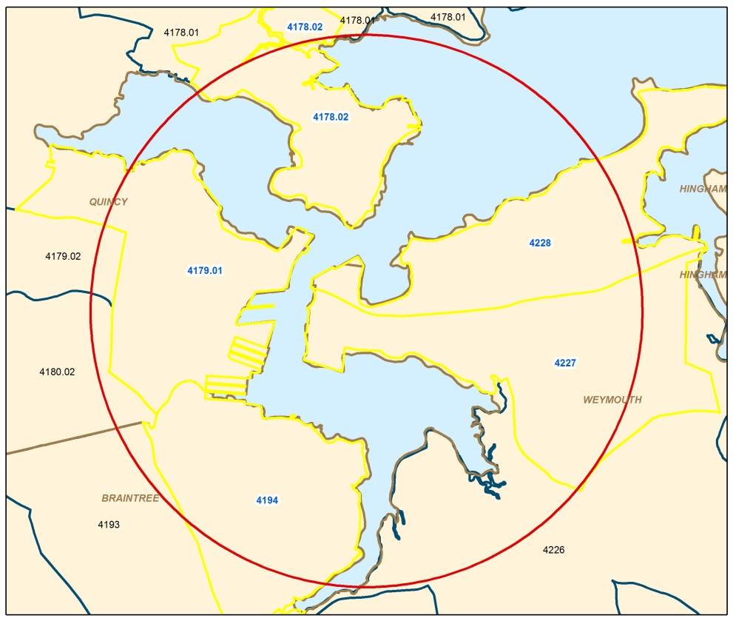
Source: MassGIS, MDPH
Figure 28. Zip Code Map
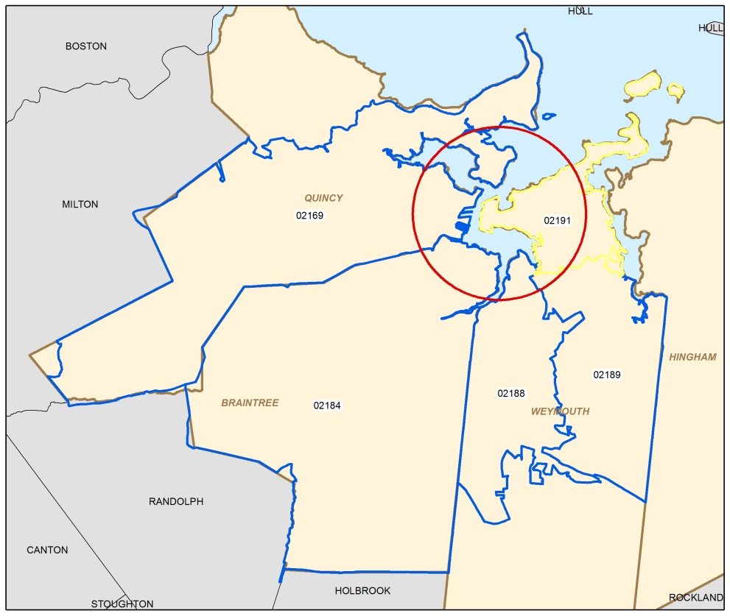
Source: MassGIS, MDPH
Risk Factors
A risk factor is something that increases a person’s risk of getting a disease. Some risk factors can be avoided while others cannot. Risk factors include: hereditary conditions, lifestyle factors, medical conditions and treatments, infections, and environmental exposures.
Source(s): MPDH Bureau of Environmental Health

Respiratory conditions
The MDPH Bureau of Environmental Health tracks the occurrence of asthma among students in Kindergarten through 8th grade statewide through school health records from public and private schools. Pediatric asthma prevalence is available by community of residence and by school.
The Massachusetts Center for Health Information and Analysis (CHIA) collects data on hospitalization visits from all acute care hospitals and satellite emergency facilities in the state. Information on inpatient hospital visits and emergency department (ED) visits is provided for asthma and COPD at the community and zip code level. It should be noted that some patients enter the hospital through an ED, but are later admitted to the hospital as inpatients. These patients are included in both the ED visit and hospital admission rates.
Pediatric Asthma Prevalence
Pediatric asthma prevalence in schools is defined as the percentage of enrolled students (Kindergarten through 8th grade) reported by school nurses to have asthma during a school year. Prevalence by community is based on the residential address of the student.
The annual average prevalence of pediatric asthma over the last 8 school years (2009-2010 through 2016-2017) in Weymouth (12.5%) was statistically significantly higher than that of the state (12.0%). In the other three communities, the annual average prevalence was statistically significantly lower than that of the state.
Of the 5 schools located within the focus area that have students enrolled in grades Kindergarten through 8th grade, the annual average prevalence of pediatric asthma over the entire time period was either not statistically different or statistically lower than that of the state. Although the Johnson Early Childcare Center is located within the focus area, the MDPH Bureau of Environmental Health does not have asthma prevalence data for early education centers.
Figure 29. School Map
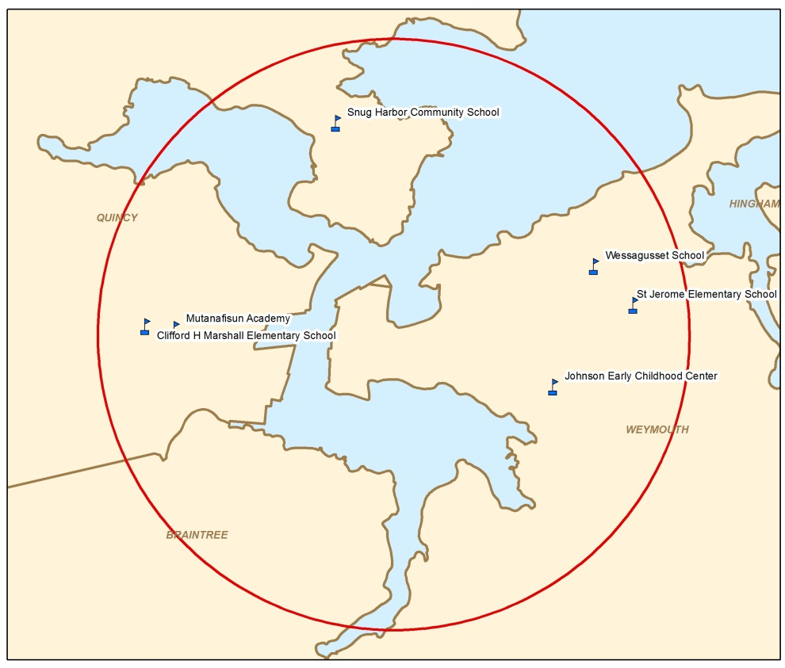
Source: MassGIS, MDPH
Figure 30. Pediatric Asthma
Statistical Significance of Prevalence Rates of Pediatric Asthma
Compared to Statewide (2009/2010-2016/2017)
By Community
Braintree | Lower
Hingham | Lower
Quincy | Lower
Weymouth | Higher
By School (within Focus Area)
Clifford H. Marshall Elementary School (Quincy) | No Difference
Noble Academy (Quincy) | Lower
Snug Harbor Community School (Quincy) | No Difference
St. Jerome Elementary School (Weymouth) | Lower
Wessagusset Primary School (Weymouth) | No Difference
Data source: MDPH Bureau of Environmental Health
Asthma and Chronic Obstructive Pulmonary Disease
Asthma is an illness that affects the respiratory tract and airways that carry oxygen into and out of the lungs. During an asthma attack, these airways constrict, resulting in wheezing and difficulty breathing. Asthma can affect people of all ages. However, it often starts in childhood and is more common in children than adults. While the causes of asthma are unknown, episodes of asthma (asthma attacks) can be triggered by certain environmental pollutants such as air pollution (particulate matter, ozone, emissions from vehicles and other combustion sources), mold, pets/pet dander, and fine particles like smoke and dust.
COPD refers to a group of chronic diseases, including emphysema and chronic bronchitis, which affect the flow of air in the lungs and make breathing difficult. Over time, exposure to irritants that damage your lungs and airways can cause COPD. The main cause of COPD is smoking, but nonsmokers can also get COPD. Long-term exposure to air pollution, secondhand smoke, dust, fumes and chemicals (which are often work-related) can cause or exacerbate COPD.
Source(s): Massachusetts Environmental Public Health Tracking

Asthma hospital admissions (all ages)
Asthma hospital admissions represent the number of asthma hospitalizations serious enough to require a hospital stay longer than 24 hours.
The annual average age-adjusted rate of asthma hospital admissions during 2000-2015 in Weymouth (15.2 per 100,000) was statistically significantly higher than that of the state (13.9 per 100,000). In the other three communities, the annual average age-adjusted rate of asthma hospital admissions was statistically lower than that of the state.
At the zip code level, the annual average age-adjusted rate of asthma hospital admissions during 2010-2015 in Zip Code 02191 was not statistically significantly different from that of the state.
Age-Adjusted Rates
In general, disease is associated with age. To control for differences in ages among populations, we calculate age-adjusted rates. For example, prostate cancer is more common among older men. A county containing 10,000 men over the age of 50 would naturally have more prostate cancer diagnoses than a county containing only 2,000 men over 50. In order to accurately compare prostate cancer in these two counties, we must adjust for their different age structures.
To determine if a community's rate is significantly different from the state rate or if the difference may be due solely to chance, a 95% confidence interval (CI) is calculated for each rate. A 95% CI assesses the magnitude and stability of a measure. Specifically, a 95% CI is the range of estimated values that has a 95% probability of including the true rate for the population.
A method for determining if one rate estimate is statistically significantly different from another is by comparing the CIs. If the 95% CI for the rate of one community or population does not overlap the CI of another, then it can be concluded that the two populations are statistically significantly different from each other. If the 95% CIs do overlap, then the rates of the two populations are likely not statistically significantly different from one another. "Statistically significantly different" means that the difference observed between the two rates will occur by chance less than 5 percent of the time.
Source(s): Massachusetts Environmental Public Health Tracking

Asthma emergency department visits (all ages)
Asthma ED visits give the best estimate of the total number of asthma-related hospital visits, excluding the small number of asthma hospitalizations that begin as inpatient admissions.
The annual average age-adjusted rate of asthma ED visits during 2002-2015 in each of the four communities was statistically lower than that of the state.
At the zip code level, the annual average age-adjusted rate of asthma ED visits during 2010-2015 in Zip Code 02191 was not statistically significantly different from that of the state.
COPD hospital admissions (among people age 25 and older)
The rates provided here for COPD hospital admissions are only calculated among people 25 years of age and older because this age group is most affected by the disease.
The annual average age-adjusted rate of COPD hospital admissions during 2000-2015 was statistically significantly higher in three of the communities compared to that of the state. The average annual age-adjusted rates were 35.4 per 100,000 in Braintree, 40.2 per 100,000 in Quincy, and 45.3 per 100,000 in Weymouth compared to 29.4 per 100,000 statewide. In Hingham, the annual average age-adjusted rate of COPD hospital admissions was statistically significantly lower than that of the state.
At the zip code level, the annual average age-adjusted rate of COPD hospital admissions during 2010-2015 in Zip Code 02191 was not statistically significantly different from that of the state.
COPD emergency department visits (among people age 25 and older)
The rates provided here for COPD ED visits are only calculated among people 25 years of age and older because this age group is most affected by the disease.
The annual average age-adjusted rates of COPD ED visits during 2002-2015 in Quincy (74.9 per 100,000) and in Weymouth (92.8 per 100,000) were statistically significantly higher than that of the state (66.7 per 100,000). In the other two communities, the annual average age-adjusted rate of COPD hospital admissions was statistically lower than that of the state.
At the zip code level, the annual average age-adjusted rate of COPD ED visits during 2010-2015 in Zip Code 02191 was not statistically significantly different from that of the state.
Figure 31. Respiratory Conditions
Statistical Significance of Age-Adjusted Rates of
Respiratory Conditions Compared to Statewide
 | Braintree | Hingham | Quincy | Weymouth | Zip Code 02191
Asthma Hospital Admissions  2000-2015 | Lower | Lower | Lower | Higher | No Difference
Asthma Emergency Department Visits  2002-2015 | Lower | Lower | Lower | Lower | No Difference
COPD Hospital Admissions  2000-2015 | Higher | Lower | Higher | Higher | No Difference
COPD Emergency Department Visits  2002-2015 | Lower | Lower | Higher | Higher | No Difference
Data source: Center for Health Information and Analysis

Cardiovascular conditions
The Massachusetts CHIA collects data on hospitalization visits from all acute care hospitals and satellite emergency facilities in the state. Information on inpatient hospital admissions is provided for acute myocardial infarction, or heart attack, at the community and zip code level. Because nearly all heart attack hospitalizations result in an inpatient admission, data will not be presented for heart attack ED visits separately.
Air Pollution and Cardiovascular Disease
In Massachusetts, heart disease, stroke, and other diseases of the heart and blood vessels are responsible for approximately 35% of all deaths in the state. While commonly known risk factors for heart attack include obesity, smoking, and high cholesterol, a number of public health studies have found an increased risk of heart attack from exposure to certain air pollutants, such as particulate matter. The elderly, patients with pre-existing heart disease, those who are survivors of heart attack, or those with COPD are particularly vulnerable.
Source(s): Massachusetts Environmental Public Health Tracking

Heart attack hospital admissions (among people age 35 and older)
The annual average age-adjusted rate of heart attack hospital admissions during 2000-2015 was statistically significantly higher in three of the communities compared to that of the state. The average annual age-adjusted rates were 41.0 per 100,000 in Braintree, 41.7 per 100,000 in Quincy, and 44.4 per 100,000 in Weymouth compared to 38.0 per 100,000 statewide. In Hingham, the annual average age-adjusted rate of heart attack hospital admissions was statistically significantly lower than that of the state.
At the zip code level, the annual average age-adjusted rate of heart attack hospital admissions during 2010-2015 in Zip Code 02191 was not shown due to complementary suppression rules in order to maintain patient privacy. However, the rates for individual years were either statistically significantly lower or not statistically different from that of the state.
Figure 32. Cardiovascular Conditions
Statistical Significance of Rates of Cardiovascular Conditions Compared to Statewide
Heart Attack Hospital Admissions
2000-2015
Braintree | Higher
Hingham | Lower
Quincy | Higher
Weymouth | Higher
Zip Code 02191 | NS (Not Shown)
Data source: Center for Health Information and Analysis

Cancer
The Massachusetts Cancer Registry (MCR) is a population-based surveillance system that has been monitoring cancer incidence in the state since 1982. By law, all new diagnoses of cancer among Massachusetts residents are required to be reported to the MCR by the hospital or facility where a diagnosis is made. Once the MCR receives the data, the MCR does an extensive review of the data for quality control, part of which involves removing any duplicate records from “second opinions.” For this reason, 2013 is the most recent year for which data were available at the initiation of this evaluation. Provisional data for 2014 and 2015 have been included and are subject to revision until they have been thoroughly reviewed for final approval.
Cancer is not one disease, but a group of diseases. Research has shown that there are more than 100 different types of cancer, each with different causative (or risk) factors. For this reason, each type of cancer is evaluated separately. The MCR publishes incidence rates for 23 cancer types in its city and town supplement report using standardized incidence ratios (SIRs). An SIR is the ratio of the observed number of cancer diagnoses in an area to the expected number of diagnoses multiplied by 100. Age-specific statewide incidence rates are applied to the population distribution of the particular geographic area of interest to calculate the number of expected cancer diagnoses.
Cancer Development
Many cancers occur because of changes to cells that happen by random chance. These are called sporadic or spontaneous mutations and are not due to any particular exposure to a cancer-causing agent (i.e., carcinogen). Other times, exposure may be an initiating or contributing factor to the development of cancer in an individual. The latency period is the time interval between an initiating event (such as a random cellular mutation or exposure to a carcinogen) and the appearance of symptoms of the disease or its diagnosis. Cancer, in general, has a long latency period but it may vary depending on the type, magnitude, and timing of the exposure. Cancers that are solid tumors are believed to have a long latency period, estimated to be no shorter than 10 years and possibly as long as 50 years or more. For hematopoietic or blood-related cancers, such as leukemia, experts think that the general latency period may be shorter, most commonly on the order of 5 to 10 years. Due to the long latency period for most types of cancer, it is difficult to identify exposures that may have contributed to an individual’s cancer development. It is likely that multiple risk factors influence the development of most cancers. In addition, an individual’s risk of developing cancer may change over time and may depend on a complex interaction between their genetic makeup and exposure to a cancer-causing agent.
Source(s):
Bang KM. Epidemiology of Occupational Cancer. Occupational Medicine. 1996.
Frumkin H. Carcinogens. In: Levy BS and Wegman DH, editors. Occupational Health- Recognizing and Preventing Work-Related Disease. 3rd ed. 1995.
Hall EJ. Radiobiology for the radiologist. 6th ed. 2006.
National Research Council (NRC). Health risks from exposure to low levels of ionizing radiation. BEIR VII Phase 2. 2005.
United Nations Scientific Committee on the Effects of Atomic Radiation (UNSCEAR. Sources and Effects of Ionizing Radiation. Volume I. 2000.

Community Level
During the two 5-year time periods of 2006-2010 and 2011-2015, the majority of cancer types occurred about as expected in each of the four communities. Statistically significant elevations occurred in 10 different cancer types in at least one community during at least one of the two 5-year time periods. Cancer types that were consistently statistically significantly elevated during both 5-year time periods consisted of melanoma in Hingham, lung and bronchus cancer in Weymouth, and the following four cancer types in Quincy: cancers of the colon/rectum, liver and intrahepatic bile duct (IBD), lung and bronchus, and oral cavity and pharynx.
Statistical Significance
It is important to note that statistical significance alone does not necessarily imply public health significance. Determination of statistical significance is one tool used to interpret cancer patterns. Findings that may warrant further public health investigation include a large number of diagnoses of one type of cancer diagnosed in a relatively short time period rather than several different types diagnosed over a long period of time, rare types of cancer rather than common types, and/or a large number of diagnoses among individuals in age groups not usually affected by that cancer.
For more information on cancer in Massachusetts, visit https://www.mass.gov/info-details/cancer-in-massachusetts.
Source(s): MDPH Bureau of Environmental Health
For each of the statistically significant elevations, the ages at the time of diagnosis, histology (cell type), and spatial distribution of address at the time of diagnosis were reviewed. Overall, the ages at the time of diagnosis and histology (cell type) followed what would be expected for each particular cancer type based on state and national trends. The spatial distribution of diagnoses for each cancer type generally followed the population density pattern with the community.
Occupational exposures are possible risk factors for six of the cancer types that were statistically significantly elevated: bladder, esophagus, liver and IBD, lung and bronchus, melanoma, and non-Hodgkin lymphoma (NHL). Of those individuals diagnosed with one of these six cancer types and for whom a specific occupation was reported at the time of diagnosis (n=1,066), approximately 10% had a possible occupational exposure that may have been a contributing factor.
Tobacco use is an established risk factor for 8 of the cancer types that were statistically significantly elevated: cancers of the bladder, cervix, colon/rectum, esophagus, larynx, liver and IBD, lung and bronchus, and oral cavity and pharynx. Of those individuals diagnosed with one of these 8 cancer types and for whom a tobacco use history was reported at the time of diagnosis (n=1,576), 80% were current or former smokers. For comparison, 83% of Massachusetts residents diagnosed with one of these 8 cancer types during 2006-2015 (and for whom a tobacco use history was reported at the time of diagnosis) were current or former smokers.
For more information on risk factors for several cancer types, visit https://matracking.ehs.state.ma.us/Health-Data/Cancer/Risk_Factor_Summaries.html.
Figure 33. Cancer (Bold indicates cancer types that are consistently statistically significantly elevated during both time periods.)
Statistically Significantly Elevated Cancer Types
Community | 2006-2010 | 2011-2015*
Braintree | Lung & Bronchus (females)  Melanoma (females)  All sites (males & females) | Colon/Rectum (females)
Hingham | Melanoma (males & females)  NHL (females) | Esophagus (females)  Melanoma (males & females)
Quincy | Colon/Rectum (males)  Liver & IBD (males)  Lung & Bronchus (females)  Oral Cavity & Pharynx (males) | Cervical (females)  Colon/Rectum (males)  Liver & IBD (males)  Lung & Bronchus (males & females)  Oral Cavity & Pharynx (males)  All sites (males & females)
Weymouth | Lung & Bronchus (females) | Bladder (females)  Larynx (males)  Lung & Bronchus (males)  Melanoma (females)
Source: Massachusetts Cancer Registry

Census Tract Level
The incidence of three cancer types most associated with projected air emissions (particularly benzene and formaldehyde) was evaluated for each of the five CTs in the focus area during 2006-2010 and 2011-2015: acute myeloid leukemia (AML), lung and bronchus cancer, and nasal/nasopharynx cancer.,
The number of diagnoses of AML and nasal/nasopharynx cancer was less than five in each CT during both time periods. Due to instability of incidence rates based on a small numbers of diagnoses, statistical significance is not assessed when fewer than five diagnoses were observed. A closer review of the ages at the time of diagnosis and spatial distribution of address at the time of diagnosis for both of these cancer types showed no unusual patterns. It should be noted that tobacco use is an established risk factor for AML. Of those individuals residing in these 5 CTs who were diagnosed with AML during 2006-2015 and for whom tobacco use was reported at the time of diagnosis (n=9), 78% were current or former smokers.
Lung and bronchus cancer was statistically significantly elevated among males in CT 4178.02 (which includes the Germantown neighborhood of Quincy) during both 5-year time periods and among males in CT 4179.01 (which includes the Quincy Point neighborhood of Quincy) during 2011-2015. Of those who had a specific occupation reported at the time of diagnosis (n=33), approximately 1/3rd had a possible occupational exposure. Of those who had a tobacco use history reported at the time of diagnosis (n=44), 80% were current or former smokers. These two CTs are Environmental Justice areas.

Reproductive outcomes
Birth and reproductive health outcome data are collected by the MDPH Registry of Vital Records and Statistics. Medical data, such as birth weight and gestational age, are based on information supplied by hospitals and birthing facilities.
Low birth weight occurs when the growth of the fetus is abnormally slow. Growth retardation is measured by the number and percentage of term, singleton infants with low birth weights. Low birth weight is when an infant is born with a weight less than 2,500 grams, or 5.5 pounds at birth. Birth weight of an infant is directly related to its gestational age; therefore, this measure is restricted to singleton, term births.
Low Birth Weight
Many studies have looked at how genes, hormonal changes, maternal stress, racism, occupational and environmental factors, and infections may contribute to low birth weight. Fairly strong evidence has been found for an association between low birth weight and air pollutants such as carbon monoxide and environmental tobacco smoke. Mixed findings exist for the association between low birth weight and other ambient air pollutants, such as particulate matter and ozone.
Source(s): National Center for Environmental Health, Environmental Health Tracking Branch
Low birth weight
In Hingham, the annual average percent of low birth weight births during 2000-2015 was statistically significantly lower than that of the state. For each of the other three communities, the annual average percent of low birth weight births during 2000-2015 was not statistically significantly different from that of the state.
For each of the five census tracts within the focus area, the annual average percent of low birth weight births during 2010-2015 was not statistically significantly different from that of the state.

Figure 34. Low Birth Weight
Statistical Significance of Rates of Low Birth Weight
Compared to Statewide
By Community (2000-2015)
Braintree | No Difference
Hingham | Lower
Quincy | No Difference
Weymouth | No Difference
By Census Tract (within Focus Area) (2010-2015)
CT 4178.02 | No Difference
CT 4179.01 | No Difference
CT 4194 | No Difference
CT 4227 | No Difference
CT 4228 | No Difference
Source: Massachusetts Registry of Vital Records and Statistics

Populations Potentially Facing Increased Risks
Certain populations may be more vulnerable to environmental exposures and other changes that directly or indirectly affect social determinants of health. These include people who have chronic diseases or disabilities that make them more susceptible to stressors and exposures; people who may be in certain stages of life, such as children, older adults, and people who are pregnant; and those who may work or occupy spaces that increase the amount of time they are around harmful elements, such as outdoor workers or workers in high-risk industries.
Through our existing conditions review and input from community members, the following are populations that may face greater risks in the context of the proposed compressor station. A summary of that information is included below for the focus area (2 KM radius). Note that some of the identified populations may overlap (e.g., students and population under the 18, older adults and people with disabilities).
Population | Focus Area Count/Estimate | Source | Notes
Pregnant women | N/a | --- | Data is not available to provide a count or estimate of this population in the focus area or the municipalities.
Students | 1,700 | DESE; SchoolDigger | In the 2017 school year, there were 25,565 students enrolled in a Public School in Braintree, Hingham, Quincy, and Weymouth.
Population Under Age 5 | 1,100 | US Census 2010 | In 2010, there were a total of 11,627 residents under the age of 5.
Population Under Age 18 | 3,800 | US Census 2010 | In 2010, there were a total of 40,630 residents under the age of 18.
Older Adults (65 and over) | 3,500 | US Census 2010 | In 2010, there were a total of 40,630 residents over the age of 65. Additionally, it is estimated that 31% of households in the focus area are households with Seniors (65 yrs+) (Source: ACS 2012-1016).
People with disabilities | 3,200 | ACS 2012-1016 | This is approximately 16% of the population in the focus area and a higher proportion than the rates in the surrounding municipalities.
Environmental Justice (EJ) Populations | 9,200 | 2010 US Census | The EJ population accounts for approximately 46% of the focus area.
Non-English Speaking Population | 600 | ACS 2012-1016 | 4% of the population in the focus area does not speak English well; 3% does not speak English at all.
Geographic mobility | 2,000 moved in the last year | ACS 2012-1016 | 90% of the population in the focus area lived in the same house 1 year ago.

Community Perspectives
Many of the populations potentially facing increased risks described above were identified through engagement with our Advisory Committee and those at the Community Meetings. Participants shared that there were specific groups of people, like children, older adults, and pregnant women, who were of concern to them given that they may be more susceptible to potential impacts of the proposed compressor station.
In addition to the groups above, participants identified other groups. Participants felt that commuters along Route 3A, which has an estimated traffic volume of 35,000 vehicles per day, were potentially at greater risk through daily trips passing by the proposed station site. Similarly, participants identified the role of generational impacts. They called out those who have lived in the area for long periods of time and who may be at greater risk given a long history with what has been an industrial area. Lastly, participants called out first responders as another population that they felt faced more risks. They felt that first responders were facing a new set of challenges that have not typically been part of their preparedness activities and that this prompted a need for increased capacity and training for a potential emergency, such as an explosion, that could occur at the site.
While there are limitations to defining these populations more specifically (e.g., origin and destination of commuters), it is important to note these populations and where possible, identify sources to monitor possible effects on these groups.
It should be noted that identification of these populations by participants was from the perspective that related to the three HIA pathways as well as concerns about potential effects from any potential public safety emergency.

Impact Assessment
The impact assessment explores how potential changes due to the proposed compressor station could affect the health of residents and others from the areas surrounding the site. After reviewing the evidence from the literature on potential connections between Air Quality, Noise, and Land Use and Natural Resources and health, the evidence from the literature and community input is applied in the context of the proposed change. Baseline data, as available, is used to estimate how the proposed compressor station would alter existing conditions and how these changes in turn may affect health.
We have divided the assessment into three sections for each of the pathways.
Pathway Diagrams
Pathway diagrams were developed for each of the three prioritized themes: Air Quality, Noise and Land Use and Natural Resources. The purpose of the pathway diagram is to illustrate how changes associated with the compressor station may potentially affect health determinants and health conditions. The pathways are not meant to be comprehensive but are intended to reflect possible connections that are based on available evidence and community input of perceived impacts of the proposed compressor station on people’s lives and their health.

The diagrams are read from left to right, moving from changes that are anticipated to occur as a result of the station to the immediate and longer term impacts that could potentially affect health.

Since the pathways depict possible impacts of the proposed station, the associated changes with intermediate effects and health outcomes are represented as deltas (Δ).

Impact Characterization Definitions
Impact characterization tables are provided at the end of Part 3. The tables provide a summary of assessed impacts and potential health effects based on available science, existing conditions, and proposed changes. The characterizations are qualitative and represent an informed judgment of impacts and the health effects. The following definitions are used with the impact characterizations:
Type of Health Effects
Direct: the change occurs through physical exposures
Other: the change occurs through other mechanisms (e.g., perception, awareness)
Geographic Extent of Health Effects
Local: Effects felt within the focus area
Community-wide: Effects felt in focus and surrounding areas
Direction of Health Effects
Neutral: No meaningful change predicted
Positive: Change that is predicted to positively impact associated health conditions
Negative: Change that is predicted to negatively impact associated health conditions
Likelihood of Health Effects
Uncertain: It is unclear if impacts will occur as a result of the proposal
Unlikely: It is unlikely that impacts will occur as a result of the proposal
Possible: It is possible that impacts will occur as a result of the proposal
Likely: It is likely that impacts will occur as a result of the proposal
Relative Magnitude of Health Effects
Very Low: No cases expected
Low: Individual cases
Medium: Local, small limited impact to households
High: Entire communities affected
Vulnerable Populations
Yes: Disproportionately affects vulnerable populations
No: Affects populations evenly
As with the impact pathway sections, the impact characterization tables involve acknowledgement of assumptions and limitations.

Assessment of Air Quality Impacts on Health in Focus Area

Summary of Findings from Air Quality Impact Assessment
- The proposed station will produce air emissions that include criteria pollutants and air toxics.
- Activities that are estimated to produce the emissions include construction and operation of the proposed station.
- There is an extensive body of literature linking air pollution to short- and long-term effects on health.
- Mechanisms through which air pollution affect health include direct exposure and other mechanisms, such as the role of perceived impacts that increase stress.
- Estimated air emissions from the proposed station are not likely to cause health effects through direct exposure because estimated air emissions do not exceed daily or annual health-protective regulatory standards or guidelines.
- The estimated new emissions are expected to have potential health effects through other mechanisms including increased stress among residents in surrounding areas and changes in perception about use of outdoor spaces and real estate property values.

Health Impact Pathway for Air Quality
The Air Quality pathway diagram focuses on the air emissions that are expected to be produced by the proposed transmission compressor station. The pathway identifies three main ways in which the emissions would occur: emissions produced through construction of the station, emissions that are released through operation and maintenance of the station (including planned case vent blowdowns), and emissions that are released during emergency shut-down, which could include an unplanned station blowdown event. The pathway shows potential linkages between additional air emissions from the proposed station and potential health impacts from exposure to these emissions on those living in and using the surrounding areas. The pathway hypothesizes that the change in exposure could directly affect health conditions or indirectly by other mechanisms such as altering conditions that encourage physical activity and use of outdoor space and influencing social determinants of health such as income and economic opportunity.

Figure 35. Pathway for Potential Air Quality-related Health Impacts
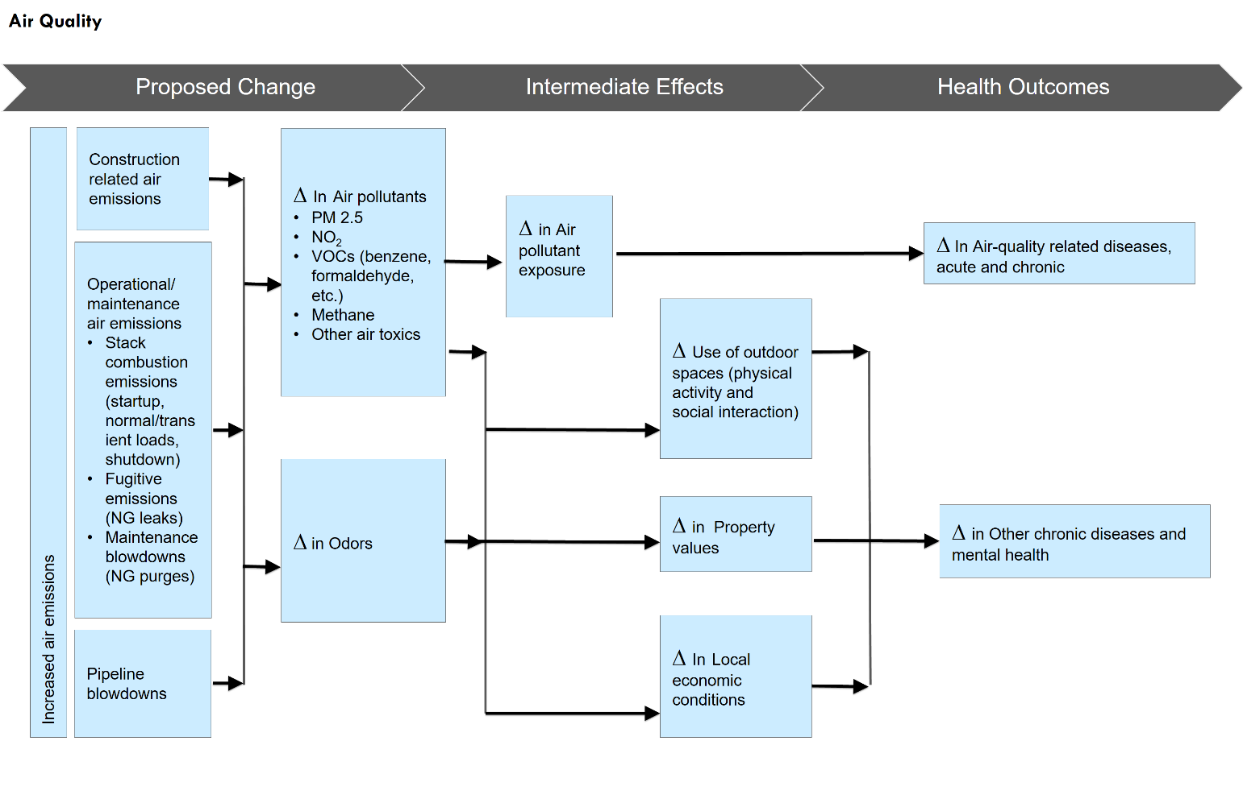

Methods
A literature review was conducted to identify relevant studies. The review drew upon available research and publications from relevant regulatory agencies (e.g., Environmental Protection Agency) and a snowball method collection and review of published studies from the public health and environmental fields on the relationship between air pollutants, health risk, and health conditions. The review collected reports and papers published about natural gas infrastructure and its documented relationships to health effects. Also included in the review were reports and materials shared by the HIA Advisory Committee.
The estimated emission of air pollutants and the impact on the existing air quality conditions in the Fore River area are based on Algonquin’s latest air dispersion modeling report (updated May 2018). The model they used (American Meteorological Society (AMS) and U.S. EPA Regulatory Model (AERMOD) v18081) is a steady‐state air dispersion model created by experts from AMS and EPA, and is the EPA‐preferred model to use for regulatory purposes for short-range dispersion (up to 50 km) from stationary industrial sources.
For the HIA, a qualitative assessment was conducted of how the contribution of emissions from the proposed station would change exposure levels in the surrounding areas. Exposure levels for air toxics were compared to MassDEP’s Allowable Ambient Limits (AALs) and Threshold Effects Exposure Limits (TELs), which are ambient air health guidelines, and for criteria pollutants were compared to EPA’s National Ambient Air Quality Standards (NAAQS). The assessment also included a review and prediction of how perceived changes in air quality could impact health in the surrounding areas. The estimated effects of perceived changes relied heavily on existing literature.

Air Quality and Health
There is an extensive body of literature linking air pollution to mortality and hospitalizations due to asthma exacerbation, chronic lung disease, heart attacks, ischemic heart disease, and other major cardiovascular disease. In the context of regulation of air pollutants in the US, there are two categories of air pollutants that are of primary relevance: criteria air pollutants and air toxics. An overview of the state of science related to the potential health effects associated with these air pollutants is summarized below.

Criteria Air Pollutants
The Environmental Protection Agency (EPA) identifies 6 criteria air pollutants that have important human health impacts: Ozone, carbon monoxide (CO), particulate matter (PM), nitrogen dioxide (NO₂), sulfur dioxide (SO₂), and lead. The Clean Air Act requires the EPA to establish public health and welfare-based exposure standards for these six criteria air pollutants and States to develop plans to achieve these standards.

Particulate Matter
Particulate matter air pollution – PM₁₀ and PM_{2.5} – comes mainly from automobiles and power plants, and has been linked to higher rates of mortality and coronary disease. Health effects include asthma exacerbation and difficult or painful breathing, especially in children and the elderly. Cardiovascular disease events account for most of the excess mortality attributed to PM exposure. Additionally, epidemiologic evidence has accumulated for a relationship between acute PM and nonfatal cardiovascular events, including: hospital admissions, myocardial infarction, and cardiac arrhythmias.
PM_{2.5} and Health Effects: Emerging Research
The standard used to establish health protective levels of PM_{2.5} is the National Ambient Air Quality Standards (NAAQS). Over time the standards for PM_{2.5} have changed based on research providing evidence of health effects associated with lower exposure concentrations. For example, the annual average standard for PM_{2.5} in 1997 was set at 15.0 µg/m³ for primary and secondary levels; in 2012, revisions set an annual primary level of 12.0 µg/m³, which was found to be protective of public health, particularly for people who may be more at risk like older adults and children, and a secondary level of 15.0 µg/m³.
Research into the effects of PM_{2.5} has continued and a small but growing set of evidence suggests that exposure levels below the NAAQS primary standard are associated with adverse health effects. An example of this research is a recent study of associations between PM_{2.5} levels and Medicare populations where evidence was found of increase risk of mortality for older adults and a risk that was more pronounced for people of color and people with lower incomes.
Source(s):
Di Q., et al. Air Pollution and Mortality in the Medicare Population. New England Journal of Medicine, 2017.
Wellenius, G. et al. Ambient Air Pollution and the Risk of Acute Ischemic Stroke. Archives of Internal Medicine, 2012.
Shi L., et al. Low-Concentration PM2.5 and Mortality: Estimating Acute and Chronic Effects in a Population-Based Study. Environmental Health Perspectives, 2015.
Vodonos, A. et al. The concentration-response between long-term PM2.5 exposure and mortality; A meta-regression approach. Environmental Research, 2018.

Ozone
Ground level ozone, the chief ingredient in “smog,” is not emitted directly into the air, but is created by chemical reactions between nitrogen oxides (NOx) and volatile organic compounds (VOCs) in the presence of sunlight. Breathing ozone can irritate the respiratory system, reduce lung function, heighten sensitivity to allergens, and may contribute to premature death in people with heart and lung disease. In general, as concentrations of ground-level ozone increase, more people experience health symptoms, the effects become more serious, and hospital admissions for respiratory problems increase. When ground-level ozone reaches unhealthy levels, children and people with asthma or other respiratory diseases are at highest risk.

Sulfur Dioxide
SO₂ is a colorless, but pungent, gas and used as the representative pollutant for the larger family of sulfur oxides. Power plants and other sources that burn fossil fuels are the primary sources of SO_{2.} It also occurs naturally through processes such as volcanic eruptions. There is strong evidence indicating that short-term SO₂ exposure causes respiratory diseases. Particularly among people with asthma, short-term SO₂ exposure, even at very low concentrations (0.2-0.3 ppm) can cause asthma exacerbation, manifested by decreased lung function and respiratory symptoms. Recent multi-city studies suggested that short-term SO₂ exposures, especially in combination with NO₂ exposure, may be associated with the total mortality of a population. Long-term exposure is associated with the development of asthma, especially allergic asthma, in children; additional evidence suggests that long-term SO₂ exposure may cause other respiratory diseases.

Carbon Monoxide
CO is invisible and has no odor, but it can be dangerous to health and potentially fatal in high concentrations. Motor vehicle exhaust contributes roughly 60 percent of all carbon monoxide emissions nationwide, and up to 95 percent in cities. Air concentrations of CO can be particularly high in areas with heavy traffic congestion. There is evidence that relevant short-term exposures to CO likely causes cardiovascular morbidity (such as early course of myocardial infarction) and mortality, particularly in individuals with coronary artery disease. Evidence also suggests that severe hypoxia caused by short- and long-term exposures to CO may cause central nervous system damage, including impaired coordination, tracking, driving ability, vigilance and cognitive performance. Maternal exposure to CO is associated with an increased risk of cardiac birth defects, and evidence suggests that long-term exposures to CO may cause adverse developmental effects and birth outcomes.

Nitrogen Dioxide
NO₂ is one of a group of highly reactive gases containing nitrogen and oxygen in varying amounts (known collectively as NOx). Many of these gases are colorless and odorless. But one, NO₂, often is seen along with particle pollution as a reddish-brown layer in the air over urban areas. Primary sources of NOx emissions include motor vehicles, electric utilities and other industrial, commercial and residential sources that burn fuels. Short-term exposure to NO₂ at concentrations as low as 3-50 ppb on average is associated with increased ED visits and hospital admissions for respiratory causes, especially asthma. There is sufficient evidence that short-term exposure to NO₂ at a concentrations level of 100-300 ppb increases airway hyper-responsiveness particularly in children and asthmatics and at a concentration level of 1,000-2,000 ppb increases susceptibility to infections and airway inflammation. Long-term exposure to NO₂ is associated with diminished lung function growth among children.

Air Toxics
Toxic air pollutants are pollutants that may be present in ambient air and are associated with increased risk of cancer or other serious health conditions after exposure to elevated concentrations for many years. Sometimes referred to as hazardous air pollutants (HAPs), these pollutants are regulated separately from the criteria air pollutants. Air toxics can have effects (e.g., difficulty breathing, headaches) associated with high short-term exposure (e.g., minutes to hours) and with long-term exposures (many years) that may lead to cancer, birth defects, disorders of the respiratory and nervous systems and other serious health conditions. The amount of exposure, i.e. the concentration of the pollutant and length of time of the exposure, is associated with the potential for adverse health effects.
Threshold Exposure Limits and Allowable Ambient Limits
The MassDEP Office of Research and Standards develops health- and science-based air guidelines - known as AALs and TELs - to evaluate potential human health risks from exposures to chemicals in air.
The TELs are based on non-cancer health effects. The TEL is a concentration intended to protect the general population, including sensitive populations such as children, from adverse health effects over a lifetime of continuous exposure. TELs are decreased by a factor of 5 (i.e., reduced to 20% of limit) to take into account the fact that people may be exposed to a chemical from other sources, including indoor air, food, soil and water. The AALs are based on known or suspected carcinogenic health effects and represent a concentration associated with a one in one million excess lifetime cancer risk over a lifetime of continuous exposure. Taken together, the TELs and AALs are intended to protect sensitive members of the population from harmful effects assuming exposure to the same average concentration 24 hours each day for 70 years.
MassDEP uses AALs and TELs primarily in its air pollution control permitting program. The agency also uses AALs and TELs to evaluate the potential for health effects from chemicals present in ambient and indoor air. Exposure above an AAL or TEL does not automatically mean an individual will develop cancer or experience non-cancer health effects. However, the risk or probability of developing adverse effects increases with intensity and frequency of exposure.
Source(s): MassDEP Ambient Air Toxics Guidelines
MassDEP health- and science-based air guidelines - known as Allowable Ambient Limits (AALs) and Threshold Effect Exposure Limits (TELs) – are used to evaluate potential human health risks from exposures to chemicals in air. Included below is an inventory of chemicals that are relevant to the proposed transmission compressor station, along with the air guideline levels.
Figure 36. TEL and AAL for Massachusetts
Chemical Name | TEL (µg/m³) | AAL (µg/m³)
Acetaldehyde | 30 | 0.4
Acrolein | 0.07 | 0.07
Benzene | 0.6 | 0.1
Butadiene (1,3-) | 1.2 | 0.003
Carbon Tetrachloride | 85.52 | 0.07
Chlorobenzene | 93.88 | 6.26
Chloroform | 132.76 | 0.04
Dichloromethane (Methylene Chloride) | 100 | 60
Ethylbenzene | 300 | 300
Formaldehyde | 2 | 0.08
Methanol | 7.13 | 7.13
Naphthalene | 14.25 | 14.25
Propylene Oxide | 6 | 0.3
Styrene | 200 | 2
Tetrachloroethane (1,1,2,2-) | 18.67 | 0.02
Toluene | 80 | 20
Trichloroethane (1,1,2-) | 14.84 | 0.06
Vinyl Chloride | 3.47 | 0.38
Source: MassDEP Ambient Air Toxics Guidelines

Relationship between Air Pollution and Environmental Stressors
There is emerging science regarding how interactions among environmental or psychosocial stressors and air pollution can affect people’s health. Research suggests that similar to direct exposure (e.g., breathing in air pollutant), environmental stressors at an individual or neighborhood level can lead to physiological changes (e.g., stress, sympathetic nervous system effects) that shape health outcomes. New studies have found that a combination of higher levels of air pollution and stressors together can produce worse outcomes than if one was to experience only one. These worse outcomes have included higher prevalence for stroke and diabetes, reduced cognitive functions, and higher levels of asthma exacerbations. In many of the studies, the stressors are characterized through measures of neighborhood disorder, which seek to portray a picture of a community’s physical and social environment in relation to feelings of control and ownership.

Natural Gas Infrastructure and Air Pollution
The increase in natural gas extraction, processing, transmission and distribution has led to the introduction of new supporting infrastructure across the US. In some places, the new infrastructure is located closer to populated areas than older infrastructure, which has increased the number of people who are in proximity to the processes that extract and transport natural gas. A set of research and reporting has emerged to document the potential impacts, including health effects, of the closer proximity between the infrastructure (sometimes referred to as unconventional gas development - UGD) and communities. This research primarily focuses on production scale compressor stations where many other pieces of UGD infrastructure are present (e.g., gas extraction wells, storage tanks, processing plants). Production compressor stations, which involve compressors of varying size (i.e., horsepower) and number depending on their function, serve the purpose of moving natural gas from the site of production via gathering lines to processing plants and then again to move the natural gas into pipelines for distribution. These production facilities are much larger than transmission compressor stations, including that proposed for Weymouth, which move natural gas along pipelines. The quality of gas at production compressor stations is also much lower as it is raw and unrefined and therefore can contain many more contaminants than the refined gas moving through a transmission station such as the one proposed for Weymouth. Therefore, the findings of these studies are not directly comparable to the proposed compressor station in Weymouth.
In 2015, the Southwest Pennsylvania Environmental Health Project, a nonprofit public health organization, developed a summary report on compressor stations and potential health impacts. The report provides information about emissions (e.g., construction and operations, fugitive emissions and blowdowns) from a limited number of compressor station locations in Pennsylvania and Texas (inclusive of compressor stations of various sizes and located near production sites as well as on gathering and transmission lines). The report asserts that standard reporting of air emissions from compressor stations, such as annual measures or amounts in tons per year, can obscure peak exposures that could occur at various times throughout the year during construction or specific events like blowdowns. The report documents possible health effects from emissions (e.g., benzene, formaldehyde, PM) associated with compressor stations as found from self-reported health surveys. It should be noted that while the summary report focuses on compressor stations, it does not differentiate between those that are transmission compressor stations (such as the proposed compressor station in Weymouth) and those which operate as part of nearby well pad and production sites nor does it differentiate between compressor stations of differing size. It should also be noted that MassDEP’s evaluation of the proposed station considers more than what would be provided in standard annual emissions reporting. This evaluation, which includes source-specific modeling of maximum potential emissions and site-specific meteorological data, is described in more detail below.
Self-Reported Health Data
Several factors should be considered when reviewing information solicited from a self-report health survey. First, it is important to recognize that, typically, people who are worried are willing to participate and those who aren’t worried or don’t want the work to go on (for whatever reason) will refuse to participate by not returning a paper survey. This results in a biased response.
Second, a comparison population is required to interpret the findings of a survey and assess whether the experience of the target audience is, in fact, unusual (i.e., different from an appropriate comparison population). There are several variables that affect disease rates, so one would need to account for differences in age, gender, and other variables that could account for the difference in experience between the target audience and the comparison population. By using disease registries (as opposed to a self-report survey), one can use the statewide experience as the comparison population; it is large and stable and, therefore, is a very good comparison population.
Third, individuals may not always be able to give accurate diagnostic information. With a disease registry, physicians or hospitals provide the report for a new diagnosis with detailed information. For example, because each type of cancer has its own set of risk factors, it is critical to know what the primary site of cancer is as well as, for some cancer types, the subtype or histology of the cancer. Many people would not have that level of detail, even about themselves.
The INGAA Foundation, an association for natural gas pipelines and companies, produced a white paper in 2016 that describes how regulatory processes are in place to protect those living in proximity to natural gas compressor stations. The paper offers an overview of existing regulatory and permitting processes (e.g., Clean Air Act, federal, state, and local authorities) for compressor stations and how the processes protect the health of those living near stations for a variety of factors, including air quality and greenhouse gases. It is a detailed accounting of procedures in place to permit compressor station and the basis by which these processes rely on established health-protective thresholds (e.g., NAAQS).
A more recent report, the fifth edition of the Compendium of Scientific, Medical, and Media Findings Demonstrating Risks and Harms of Fracking, provides an inventory of findings from peer-reviewed articles, investigative reports and public sector reports that focus on shale gas and oil extraction. Studies highlighted in the report about compressor stations, inclusive of stations near well pad and production sites and on gathering and transmission lines, offered the following findings:
- Compressor stations are likely sources of methane emissions and can periodically emit large amounts. Along the supply chain, compressor stations likely contribute to more than a third of overall methane emissions (as compared to 51% from production sites and 13% from processing plants).
- When looking at a range of production equipment, compressor stations were strongly associated with atmospheric concentrations of toxic chemicals that were higher than reported background concentrations.
- In New York State, the largest emissions, by volume, from compressor stations were nitrogen oxides, carbon monoxide, VOCs, formaldehyde, and particulate matter - pollutants with linkages to cancer, development disorders, and chronic diseases.
- Levels of PM_{2.5} around a compressor station were found at levels that can deleteriously affect human health if long-term exposure were to occur and that might pose more immediate harm to sensitive populations, including older adults and people with asthma.
- Around compressor stations in the states of Arkansas, Pennsylvania, and Wyoming, the levels of formaldehyde (a carcinogen) were higher than health protective levels. Their presence could be the byproduct of combustion or through fugitive methane emissions that can lead to the creation of formaldehyde in direct sunlight.

Current Air Quality Conditions
Current air quality conditions are characterized through the use of: historical ambient air monitoring data from MassDEP monitoring stations in the Boston Metro area and ambient air monitoring data collected by MassDEP in the Fore River Basin from July to November, 2018.

Air Monitoring Data
MassDEP operates a statewide network of 22 monitoring stations in 17 communities across the Commonwealth. The primary purpose of these monitoring stations is to determine compliance with NAAQS established by the EPA for criteria pollutants, which include ozone, particulate matter, nitrogen dioxide, sulfur dioxide, carbon monoxide, and lead. Based on air monitoring data collected by MassDEP, Massachusetts has been designated by EPA as meeting all of the current NAAQS, although Massachusetts does experience exceedances of the ozone NAAQS at some monitoring locations during the hot summer months when ozone is most prevalent. In addition to monitoring criteria pollutants, MassDEP monitors VOCs, some of which are designated as HAPs, at monitoring stations in Boston, Lynn, and Chicopee.
Figure 37 through Figure 40 show monitoring trends in the Boston Metro area for criteria pollutants that would be emitted by the proposed compressor station, which include fine PM_{2.5}, NO₂, SO₂, and CO. Existing air quality data for each of these pollutants are well below their respective NAAQS.

Figure 37. PM2.5 Annual Average Concentration 2008-2017 (µg/m3)
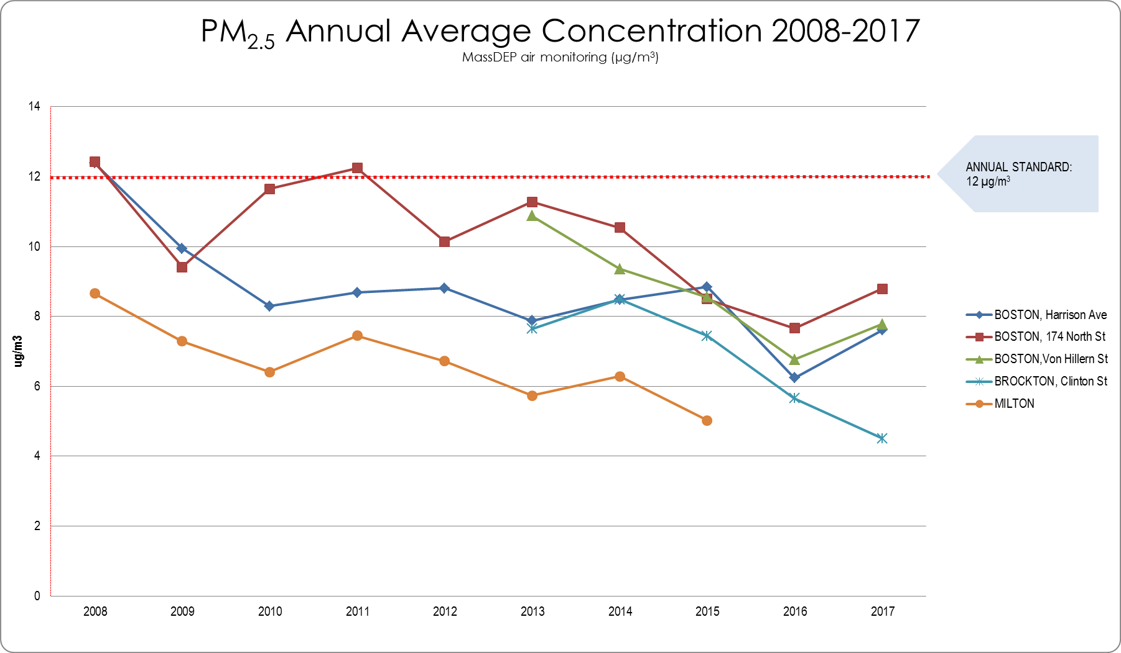
µg/m³ = micrograms per cubic meter

Figure 38. NO2 Annual Average of 1-hr 98th Percentile Concentration 2008-2017(ppb)
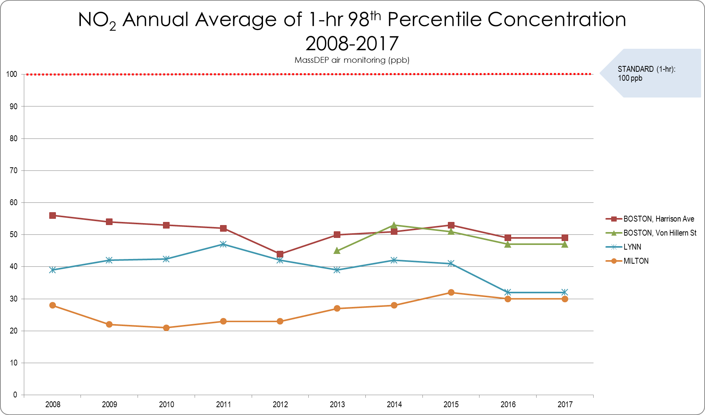
ppb = parts per billion

Figure 39. SO2 Annual Average of 1-hr 99th Percentile Concentration 2008-2017(ppb)
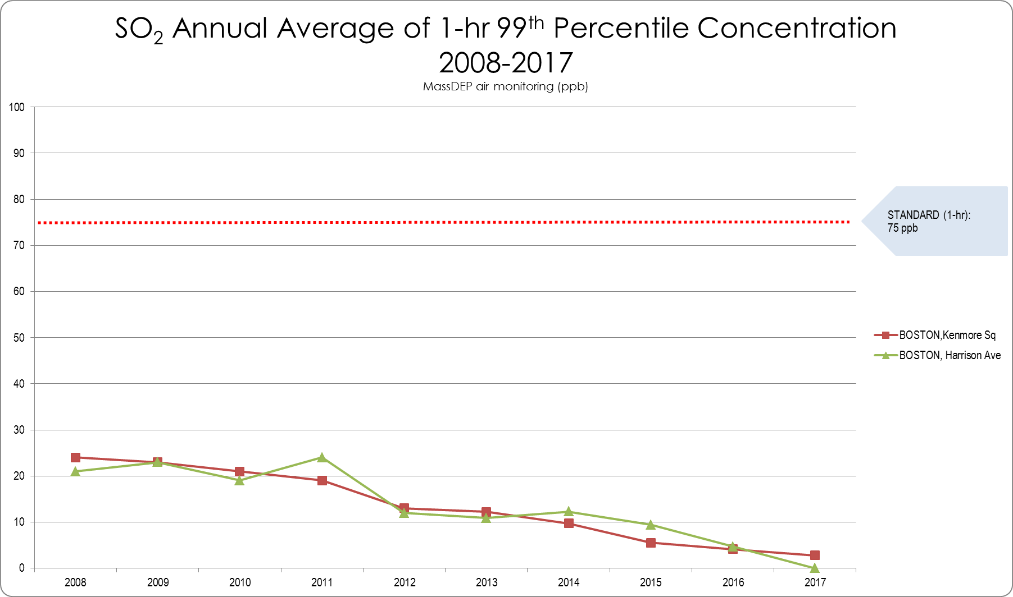
ppb = parts per billion

Figure 40. CO 2nd Max 8-hr Concentration 2008-2017(ppm)
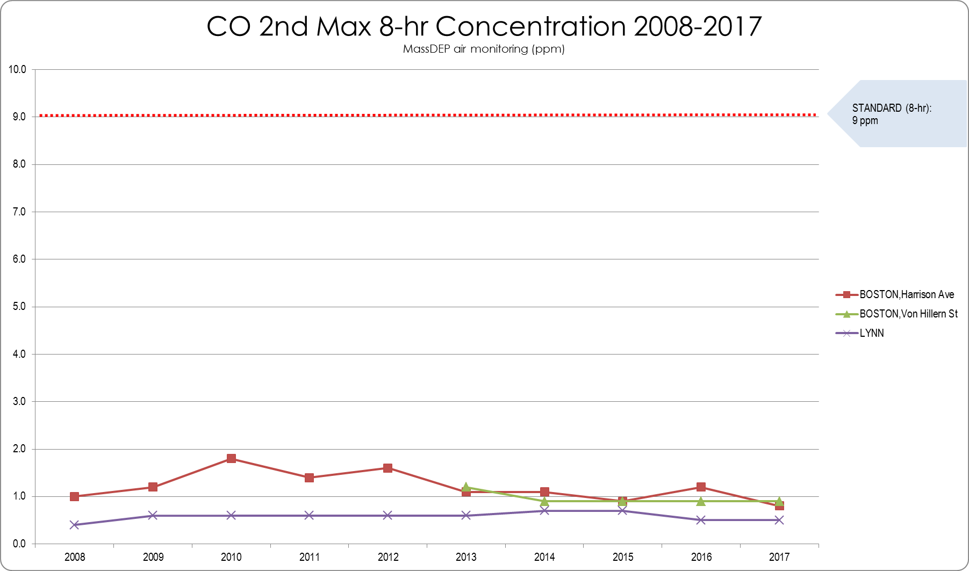
ppm = parts per million

Figure 41 through Figure 44 show VOCs monitoring trends in Boston and Lynn for benzene and formaldehyde, two pollutants that would be emitted from the proposed compressor station for which citizens have raised particular concerns. While annual average levels of these pollutants are relatively low (in most cases less than one part per billion), these levels are above MassDEP’s AALs, which are screening-level concentrations that are considered to be health-protective for a lifetime of continuous exposure (breathing these levels 24 hours per day for 70 years). MassDEP’s monitoring stations are located in urban and suburban areas and can be considered generally representative of air quality in the Boston Metro area, including the Fore River area. Note that the bracketed ranges called out on the right side of the same figures indicate the range of concentrations detected in the Fore River area during MassDEP’s July to November 2018 monitoring effort (detailed in the next section).

Figure 41. Benzene 24-hr Concentrations – Boston 2015-2017
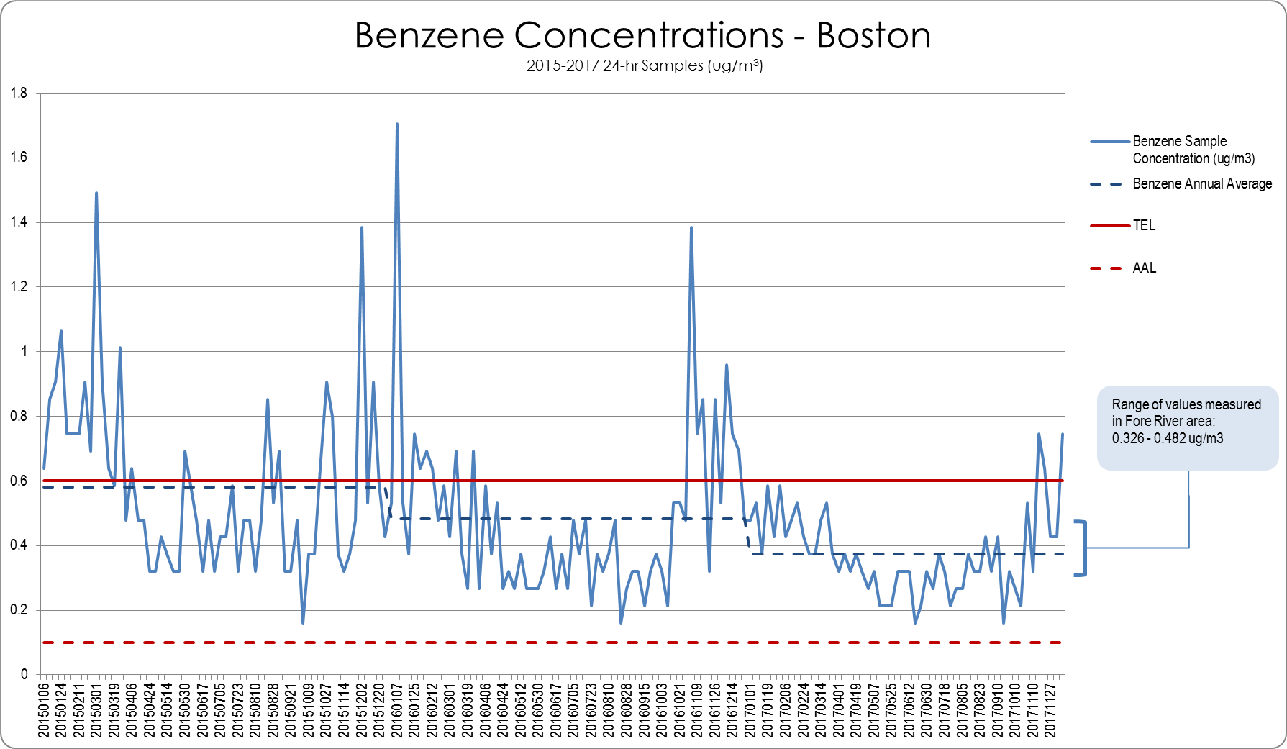
TEL = Threshold Effects Exposure Limit (24-Hour Average)
AAL = Allowable Ambient Limit (Annual Average)
µg/m3 = micrograms per cubic meter

Figure 42. Benzene 24-hr Concentrations – Lynn 2015-2017
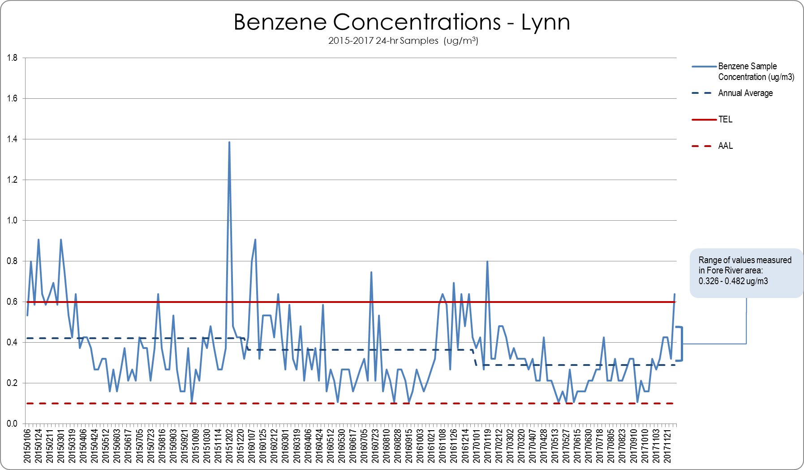
TEL = Threshold Effects Exposure Limit (24-Hour Average)
AAL = Allowable Ambient Limit (Annual Average)
µg/m3 = micrograms per cubic meter

Figure 43. Formaldehyde 24-hr Concentrations – Boston 2015-2017
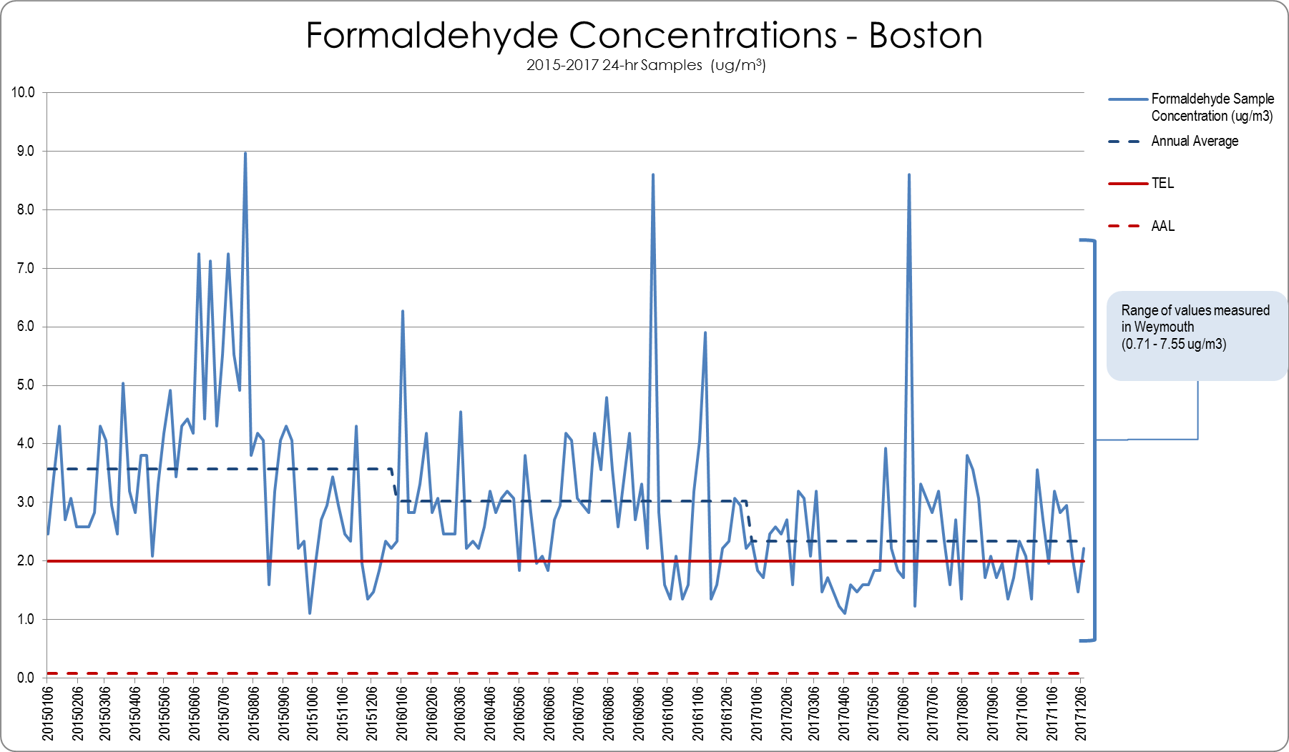
TEL = Threshold Effects Exposure Limit (24-Hour Average)
AAL = Allowable Ambient Limit (Annual Average)
µg/m3 = micrograms per cubic meter

Figure 44. Formaldehyde 24-hr Concentrations – Lynn 2015-2017
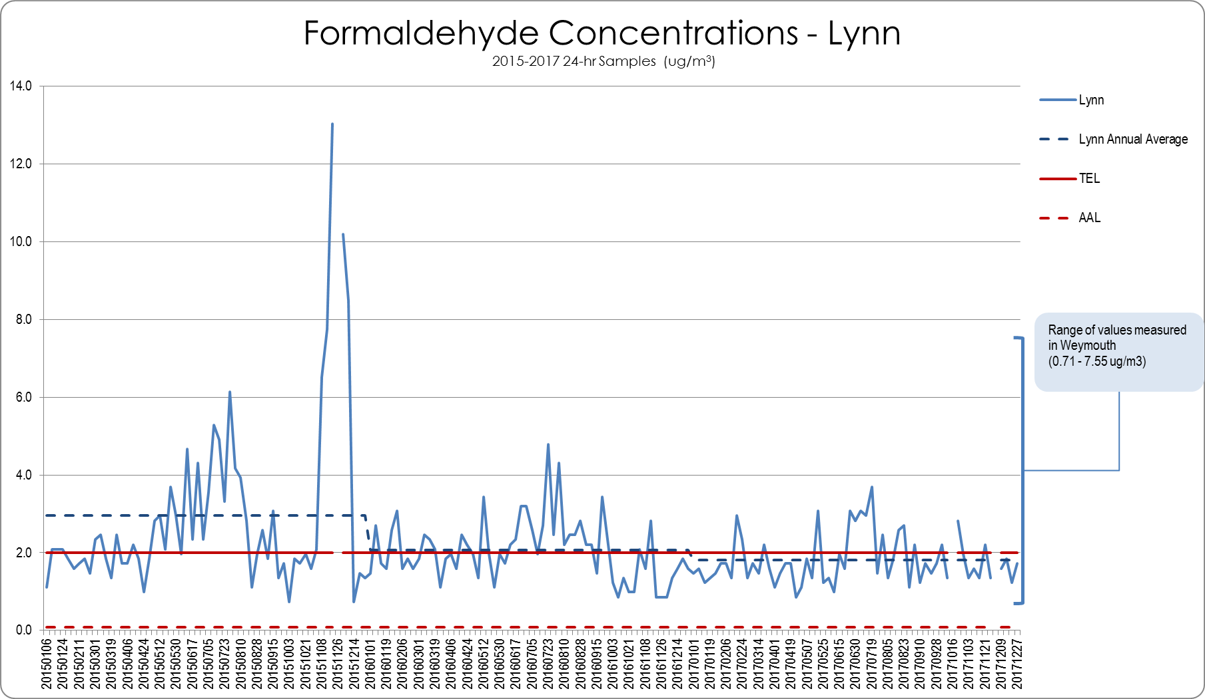
TEL = Threshold Effects Exposure Limit (24-Hour Average)
AAL = Allowable Ambient Limit (Annual Average)
µg/m3 = micrograms per cubic meter

Citizen-Led Air Monitoring
Residents and stakeholders, including medical professionals, who were concerned about the potential effects of the proposed compressor station, initiated a citizen air quality monitoring effort in 2017. This monitoring detected benzene and other VOCs at levels comparable to levels measured by MassDEP at its Boston monitoring station. This raised public concerns about existing pollution levels in the Fore River area. Summaries of the citizen data are available at https://www.nocompressor.com/.
Due to these concerns, and in accordance with Governor Baker’s July 2017 directive, MassDEP conducted focused VOC monitoring in the Fore River area as part of the HIA.

MassDEP Fore River Basin Air Monitoring
MassDEP conducted two phases of ambient air monitoring to better define existing levels of VOCs in the Fore River area. The first phase of monitoring was from July 7, 2018 through August 12, 2018. MassDEP placed air sampling canisters that collected 24-hour VOC samples at five locations on an every 6th day schedule for 7 weeks, which ensured that every day of the week was sampled. For each sample day, MassDEP staff set out the canisters around mid-day and collected the canisters the following day. Under a contract with MassDEP, Alpha Analytical Laboratories picked up the canisters from MassDEP and analyzed the samples. MassDEP also collected wind speed and wind direction data for each day from the Von Hillern Street, Boston monitoring station.
Four monitoring locations in Weymouth, Quincy and Braintree were selected based on their proximity to local residential areas and sources of emissions, and the ability to secure monitoring canisters for the duration of the study. A fifth location was selected in Hingham to represent an area background site (not in the immediate Fore River area). The locations are listed below:
- Quincy (Q1) – Clement O’Brien Tower (73 Bicknell Street). An elderly housing complex, located in Germantown, directly across the Fore River from the main Fore River industrial area and the Fore River (Route 3A) Bridge. The canister was placed on the South end of the property, adjacent to the seawall. A duplicate canister was placed at this location for quality assurance purposes (i.e., two side-by-side samples taken on each sample day).
- Braintree (B1) – Braintree Electric Light Department (10 Potter Road). The canister was placed in an open area at the eastern fence line of the property, adjacent to a public walking trail and a residential street (Glenrose Ave) and to the Southeast of the Citgo terminal and the Clean Harbors hazardous waste processing facility.
- Weymouth (W1) – The canister was placed on the southern fence line of the Fore River Energy Center (9 Bridge Street), adjacent to Bluff Road and Monatiquot Street.
- Hingham (H1) – The canister was placed at the Hingham MWRA Pump Station (463 Lincoln Street), adjacent to Stodder’s Neck State Park. This site served as a background site (not in the immediate Fore River area).
- Weymouth (W2) – Enbridge property, north of Route 3A (12 Bridge Street). The canister was placed at the site of the proposed gas compressor station, just off the driveway leading to the Weymouth MWRA Pump Station.
Figure 45 shows the locations of where the canisters were placed (locations of the 2017 citizen air sampling also are shown) and photographs of the canisters placed at these locations are available in Appendix D.
Figure 45. MassDEP Monitoring Locations
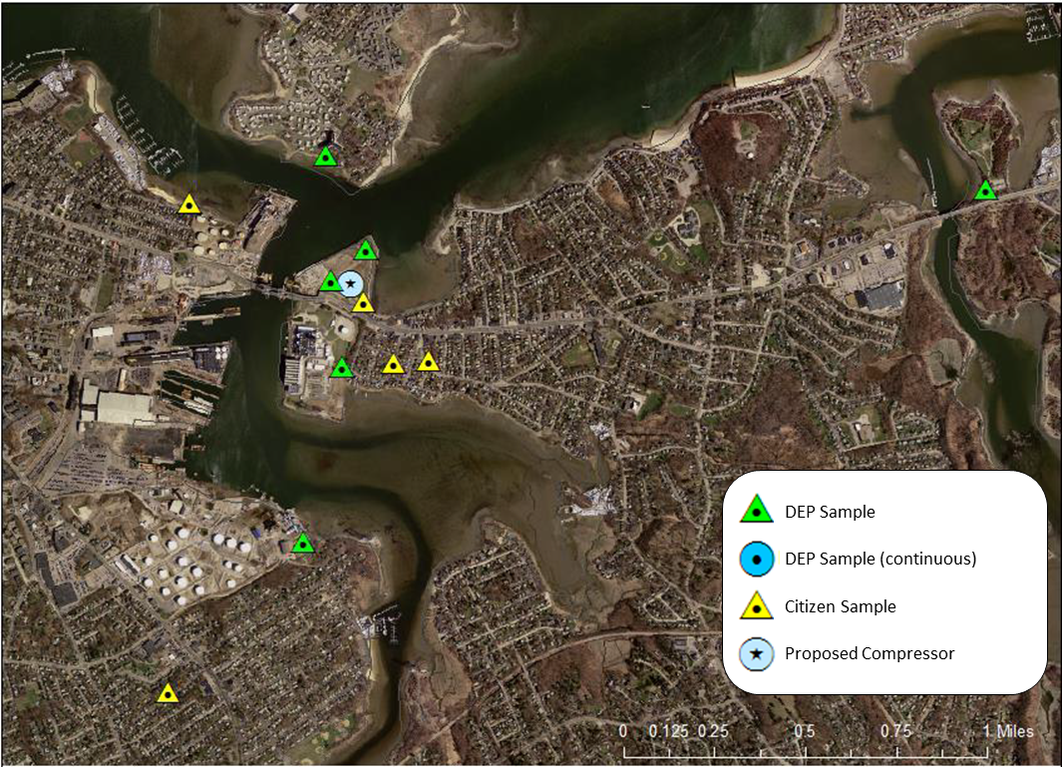
Source: MassDEP
The results of the canister VOC monitoring are summarized in Figure 47through Figure 52. All of the 24-hour sample results showed levels below MassDEP’s 24-hour TEL guidelines, in many cases by orders of magnitude. While not directly comparable, some of the 24-hour levels (e.g., benzene, carbon tetrachloride, chloroform) were above MassDEP’s annual AAL guidelines. These levels are consistent with levels for these pollutants measured by MassDEP at its Boston and Lynn monitoring stations.
MassDEP also asked Alpha Analytical Laboratory to report tentatively identified compounds (TICs) from each sample (Figure 46 lists the TICs reported). A TIC is a non-target compound that can be detected by an analytical testing method, but the identity and concentration of the compound cannot be confirmed by the specific analytical testing method being used. Some TICs can be artifacts of the laboratory testing process (i.e., not of sample origin). For example, organo-silicon compounds are found in components of analytical instrumentation and may be identified as TICs in the analytical results. No definitive conclusions can be drawn from the TICs reported data. Note that the only TIC that was reported above a TEL or AAL was methanol (methanol is not carcinogenic so the TEL and AAL are the same value). The methanol TEL of 7.13 µg/m³ was derived in 1990. In 2013, EPA published a new toxicity value for methanol indicating that it is much less toxic. An updated TEL based on that new information would be more than one hundred times higher than the 1990 TEL (approximately 4,000 µg/m³). The highest concentration of methanol was 60.1 µg/m³, which is lower than an updated TEL would be if based on the new EPA toxicity value.
Figure 46. TICs from VOC Canister Sampling
Timethyl, silanol  Hexamethyl-cyclotrisilane  Methanol  Ethanol  Hexanal  d – Limonene  Chlorotrifluoroethene  Acetaldehyde  Hexamethyl-disoloxane  Tetrahydrofuran | Decane  2-methyl, 1.3 butidiene  Propane  Butane  Pentane  Acetaphenone  Benzene, ethanamine  1,2 Pentadiene  Cyclopropane ethylidiene  Methyl Cyclopentane
Source: MassDEP
The second phase of monitoring was conducted from August 1 through November 30, in which MassDEP operated a semi-continuous monitor with gas chromatograph located at the Weymouth MWRA pump station to collect samples of benzene, toluene, ethyl benzene and xylenes in order to obtain a larger set of data and to observe changes over time. MassDEP also collected 24-hour formaldehyde and acetaldehyde samples every 6 days at the same location. Photographs of the instruments used are shown in Appendix D. Monitoring results are shown in Figure 47 through Figure 52 (as well as in Appendix E). The semi-continuous monitoring showed levels of benzene below 24-hour TELs but above annual AALs, similar to the canister sampling from the first phase of monitoring as well as MassDEP monitoring in Boston and Lynn. The formaldehyde monitoring showed some 24-hour samples above TELs and some below TELs, and showed levels above annual AALs. These levels are similar to formaldehyde levels MassDEP has measured in Boston.

Figure 47. Detected VOCs from Canister Samples (µg/m3)
 | Sample Date / Pollutant Detected | Hingham  Stodder's Neck | Quincy  Germantown-1 | Quincy  Germantown-2 | Weymouth  Enbridge | Weymouth  FREC | Braintree  BELD |  | TEL | AAL
July 7 to July 8, 2018
 | Acetone | 6.44 | 6.87 | 8.2 | 7.96 | 7.98 | 6.65 |  | 160.54 | 160.54
 | Chloroform | 0.127 | 0.156 | 0.156 | 0.151 | 0.166 | 0.166 |  | 132.76 | 0.04
 | Carbon Tetrachloride | 0.39 | 0.415 | 0.528 | 0.415 | 0.365 | 0.377 |  | 85.52 | 0.07
 | Benzene | ND | ND | ND | ND | 0.383 | ND |  | 0.6 | 0.1
 | Toluene | 0.648 | 0.84 | 0.539 | 0.731 | 1.04 | 0.467 |  | 80 | 20
 | Ethyl Benzene | 0.1 | 0.135 | 0.096 | 0.156 | 0.213 | ND |  | 300 | 300
 | Styrene | ND | 0.915 | ND | ND | ND | ND |  | 200 | 2
 | Total Xylene | 0.387 | 0.556 | 0.365 | 0.22 | 0.904 | 0.322 |  | 11.8 | 11.8
 | Naphthalene | ND | ND | ND | ND | 0.278 | ND |  | 14.25 | 14.25
July 13 to July 14, 2018
 | Acetone | 6.27 | 6.49 | 6.1 | 6.77 | 6.39 | 6.6 |  | 160.54 | 160.54
 | Chloroform | 0.176 | 0.166 | 0.151 | 0.151 | 0.181 | 0.234 |  | 132.76 | 0.04
 | Carbon Tetrachloride | 0.491 | 0.528 | 0.522 | 0.44 | 0.51 | 0.522 |  | 85.52 | 0.07
 | Benzene | ND | ND | ND | ND | ND | ND |  | 0.6 | 0.1
 | Toluene | 0.441 | 0.388 | 0.403 | 0.433 | 0.558 | 0.433 |  | 80 | 20
 | Ethyl Benzene | ND | ND | ND | ND | 0.104 | ND |  | 300 | 300
 | Styrene | ND | ND | ND | ND | 0.115 | ND |  | 200 | 2
 | Total Xylene | 0.343 | 0.222 | 0.278 | 0.291 | 0.425 | 0.322 |  | 11.8 | 11.8
 | Naphthalene | ND | ND | ND | ND | 1.55 | ND |  | 14.25 | 14.25
July 19 to July 20, 2018
 | Acetone | 5.87 | 5.68 | 10.9 | 6.32 | 5.51 | 6.6 |  | 160.54 | 160.54
 | Chloroform | 0.098 | 0.098 | 0.098 | 0.098 | 0.103 | 0.117 |  | 132.76 | 0.04
 | Carbon Tetrachloride | 0.409 | 0.403 | 0.415 | 0.415 | 0.415 | 0.428 |  | 85.52 | 0.07
 | Benzene | ND | ND | ND | ND | ND | ND |  | 0.6 | 0.1
 | Toluene | 0.467 | 0.482 | 0.49 | 0.494 | 0.825 | 0.546 |  | 80 | 20
 | Ethyl Benzene | 0.087 | 0.109 | 0.104 | ND | 0.174 | 0.113 |  | 300 | 300
 | Total Xylene | 0.33 | 0.438 | 0.412 | 0.386 | 0.699 | 0.456 |  | 11.8 | 11.8
July 25 to July 26, 2018
 | Acetone | 4.66 | 4.44 | 5.23 | 4.7 | 6.01 | 5.37 |  | 160.54 | 160.54
 | Chloroform | ND | ND | ND | ND | 0.098 | ND |  | 132.76 | 0.04
 | Carbon Tetrachloride | 0.459 | 0.44 | 0.447 | 0.447 | 0.447 | 0.459 |  | 85.52 | 0.07
 | Benzene | ND | ND | ND | ND | ND | ND |  | 0.6 | 0.1
 | Toluene | ND | 0.219 | 0.211 | 0.249 | 0.283 | 0.241 |  | 80 | 20
 | Ethyl Benzene | ND | ND | ND | ND | ND | ND |  | 300 | 300
 | Total Xylene | ND | ND | ND | ND | ND | ND |  | 11.8 | 11.8
 | Tetrachloroethene | ND | ND | ND | ND | 0.19 | 0.217 |  | 8 | 0.3
July 31 to August 1, 2018
 | Acetone | 8.93 | 7.25 | 7.51 | 8.03 | 7.03 | 10.3 |  | 160.54 | 160.54
 | Chloroform | 0.112 | 0.132 | 0.112 | 0.117 | 0.117 | 0.137 |  | 132.76 | 0.04
 | Carbon Tetrachloride | 0.472 | 0.459 | 0.453 | 0.459 | 0.459 | 0.453 |  | 85.52 | 0.07
 | Benzene | ND | ND | ND | ND | ND | ND |  | 0.6 | 0.1
 | Toluene | 0.558 | 0.814 | 0.52 | 0.848 | 0.384 | 0.433 |  | 80 | 20
 | Ethyl Benzene | ND | 0.169 | 0.096 | 0.156 | ND | ND |  | 300 | 300
 | Styrene | ND | 0.102 | ND | 0.128 | ND | ND |  | 200 | 2
 | Total Xylene | 0.339 | 0.743 | 0.369 | 0.703 | ND | ND |  | 11.8 | 11.8
 | Naphthalene | ND | ND | ND | 0.404 | ND | ND |  | 14.25 | 14.25
 | Methylene Chloride | ND | 3.06 | ND | ND | ND | ND |  | 100 | 60
August 6 to August 7, 2018
 | Acetone | 14.3 | 13.1 | 13 | 15.1 | 15.4 | 14.1 |  | 160.54 | 160.54
 | Chloroform | 0.142 | 0.132 | 0.132 | 0.127 | 0.137 | 0.142 |  | 132.76 | 0.04
 | Carbon Tetrachloride | 0.453 | 0.434 | 0.44 | 0.434 | 0.465 | 0.447 |  | 85.52 | 0.07
 | Benzene | ND | 0.342 | 0.345 | 0.326 | 0.482 | 0.355 |  | 0.6 | 0.1
 | Toluene | 0.539 | 0.791 | 0.795 | 0.78 | 1.33 | 1.1 |  | 80 | 20
 | Ethyl Benzene | 0.087 | 0.217 | 0.187 | 0.156 | 0.282 | 0.213 |  | 300 | 300
 | Total Xylene | 0.309 | 0.838 | 0.664 | 0.621 | 1.238 | 0.925 |  | 11.8 | 11.8
 | 111 Trichloroethane | ND | ND | ND | ND | ND | 0.109 |  | 1038.37 | 1038.37
 | Tetrachloroethene | 0.298 | ND | ND | ND | ND | ND |  | 8 | 0.3
August 12 to August 13, 2018
 | Acetone | 3.16 | 3.47 | 3.37 | 3.11 | 2.8 | ND |  | 160.54 | 160.54
 | Chloroform | 0.122 | 0.112 | 0.117 | 0.151 | 0.112 | ND |  | 132.76 | 0.04
 | Carbon Tetrachloride | 0.421 | 0.421 | 0.44 | 0.472 | 0.491 | 0.549 |  | 85.52 | 0.07
 | Benzene | ND | ND | ND | ND | ND | ND |  | 0.6 | 0.1
 | Toluene | ND | 0.188 | 0.388 | 0.226 | 0.328 | 0.396 |  | 80 | 20
 | Ethyl Benzene | ND | ND | ND | ND | ND | ND |  | 300 | 300
 | Total Xylene | ND | ND | ND | ND | ND | ND |  | 11.8 | 11.8
 | Naphthalene | ND | ND | 0.315 | 0.304 | ND | ND |  | 14.25 | 14.25
 | Bromoform | 0.269 | 0.207 | ND | 0.238 | 0.258 | ND |  | Not listed | Not listed
 | 1,2 Dichloroethane | ND | ND | ND | ND | 0.085 | ND |  | 11.01 | 0.04
TEL = Threshold Effects Exposure Limit (24-Hour Average)
AAL = Allowable Ambient Limit (Annual Average)
µg/m3 = micrograms per cubic meter
Concentrations are from 24-hour samples
Monitoring Sites
Stodder's Neck - MWRA Pump Station (Hingham)
Quincy-Germantown 1 - Clement O'Brien Tower (Quincy) - Primary
Quincy-Germantown 2 - Clement O'Brien Tower (Quincy) - Collocated
BELD - Braintree Electric (Braintree)
Enbridge - Enbridge Property (Weymouth)
FREC - Fore River Energy Center (Weymouth)

Figure 48. Benzene Concentrations from Canister Samples relative to TEL
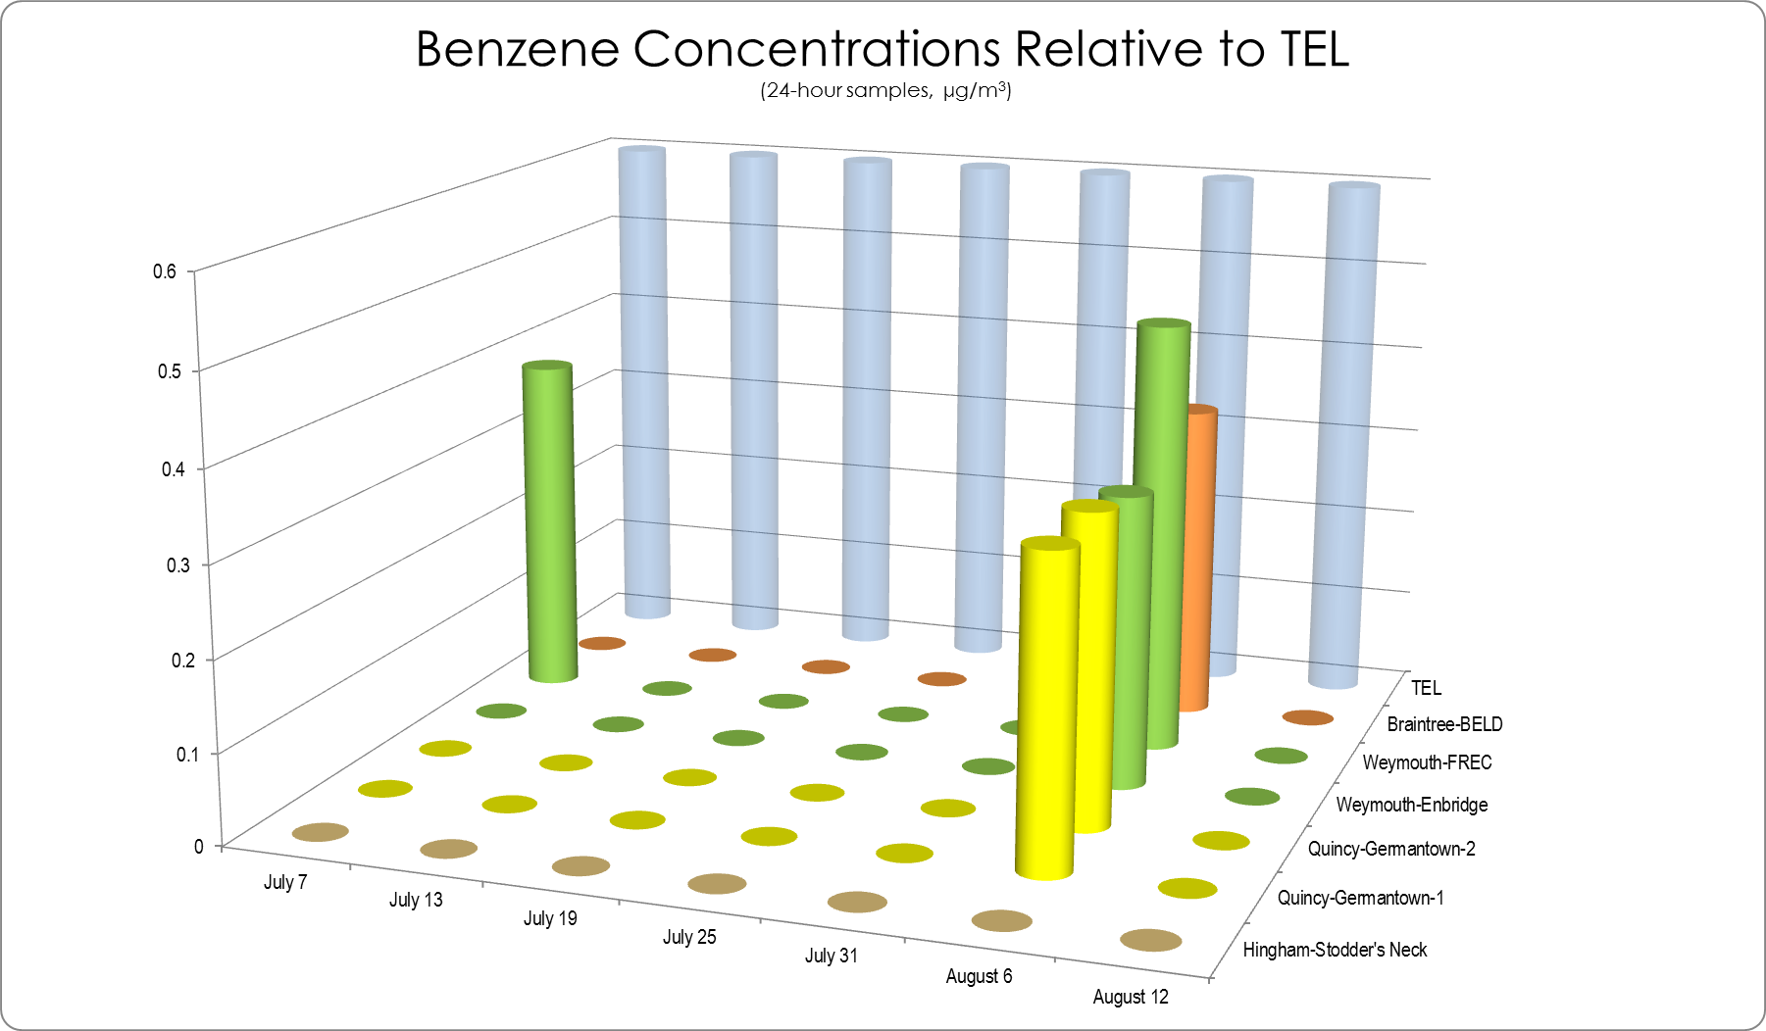
TEL = Threshold Effects Exposure Limit (24-Hour Average)
µg/m3 = micrograms per cubic meter
0 = Not detected at the reporting limit

Figure 49. Benzene Concentrations from Air Monitoring at MWRA Pump Station
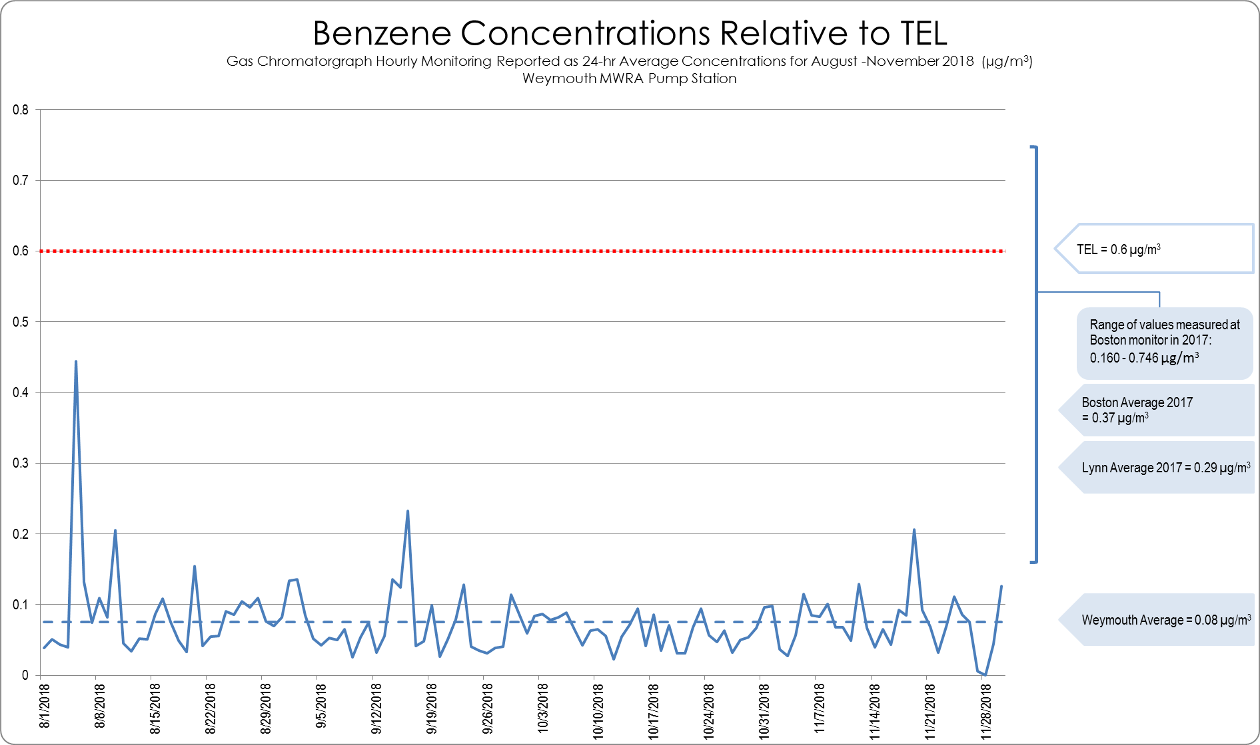
TEL = Threshold Effects Exposure Limit (24-Hour Average), µg/m3 = micrograms per cubic meter

Figure 50. Toluene Concentrations from Canister Samples relative to TEL
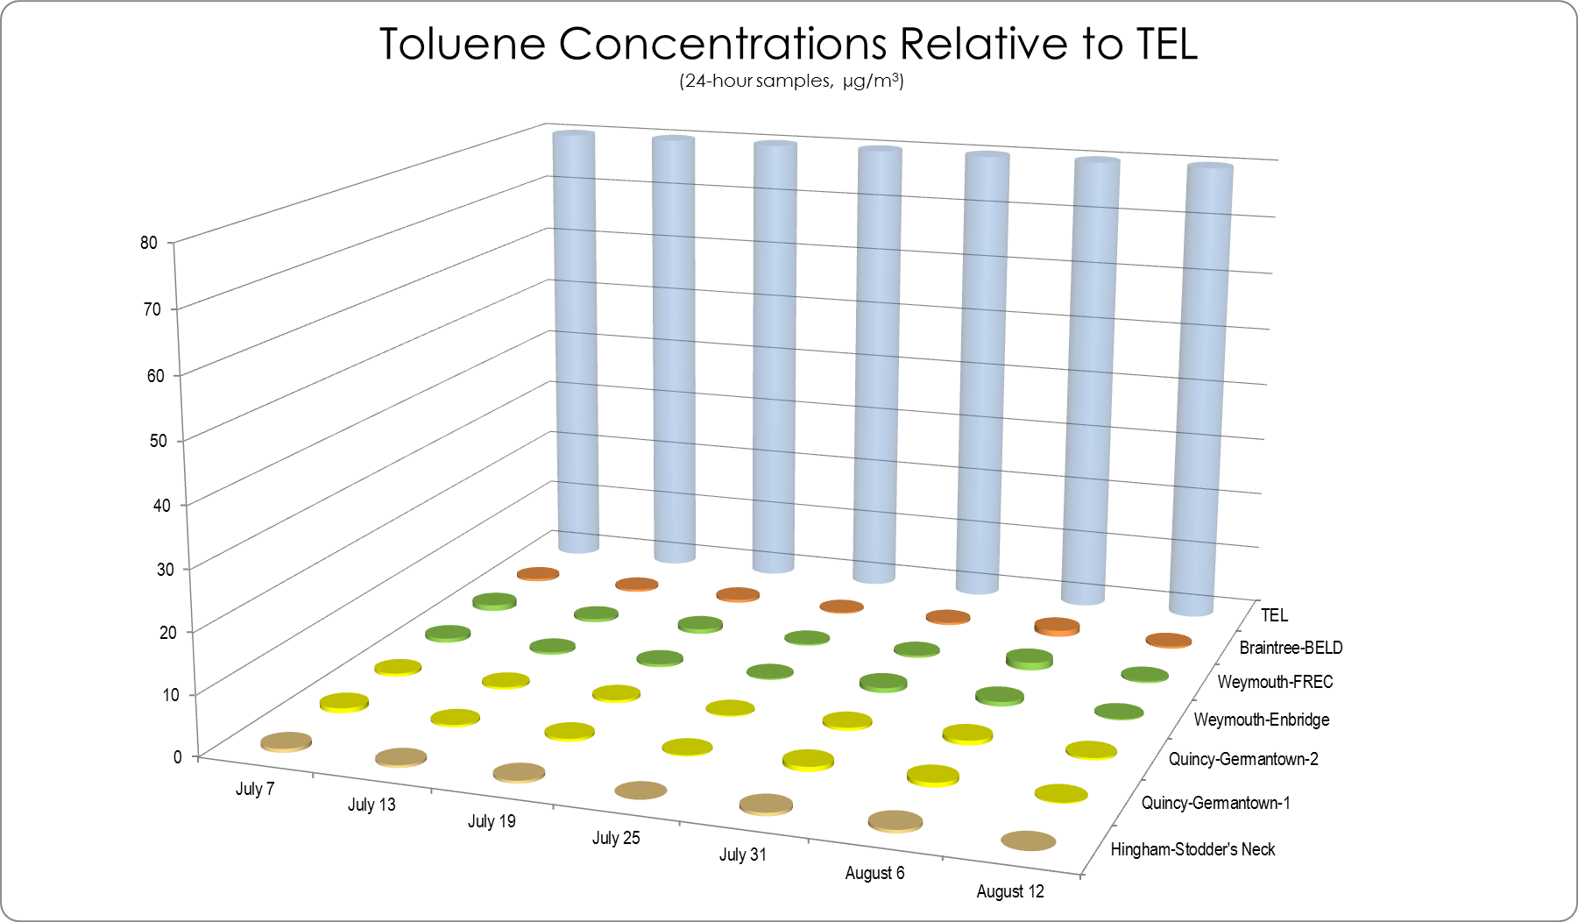
TEL = Threshold Effects Exposure Limit (24-Hour Average)
µg/m3 = micrograms per cubic meter
0 = Not detected at the reporting limit

Figure 51. Toluene Concentrations from Air Monitoring at MWRA Pump Station
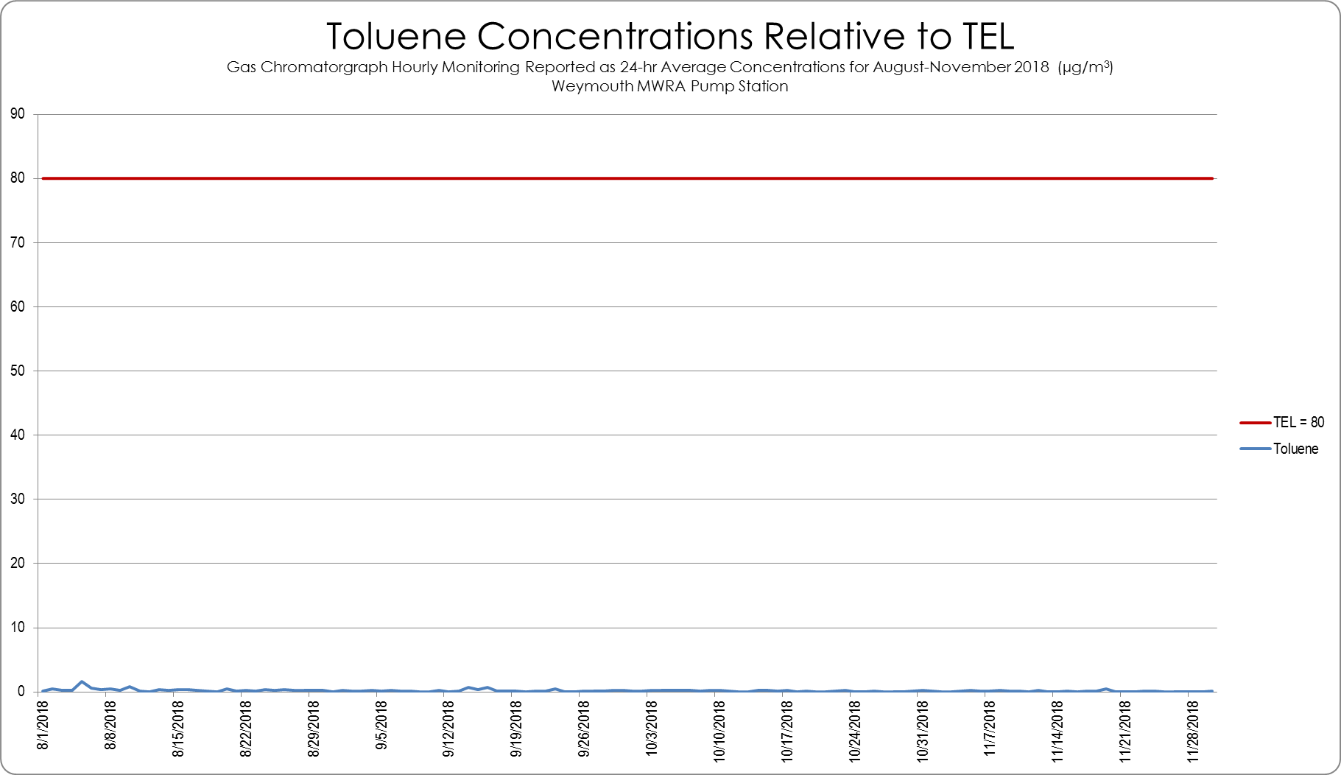
TEL = Threshold Effects Exposure Limit (24-Hour Average), µg/m3 = micrograms per cubic meter

Figure 52. Formaldehyde 24-hr Concentrations from Air Monitoring at MWRA Pump Station
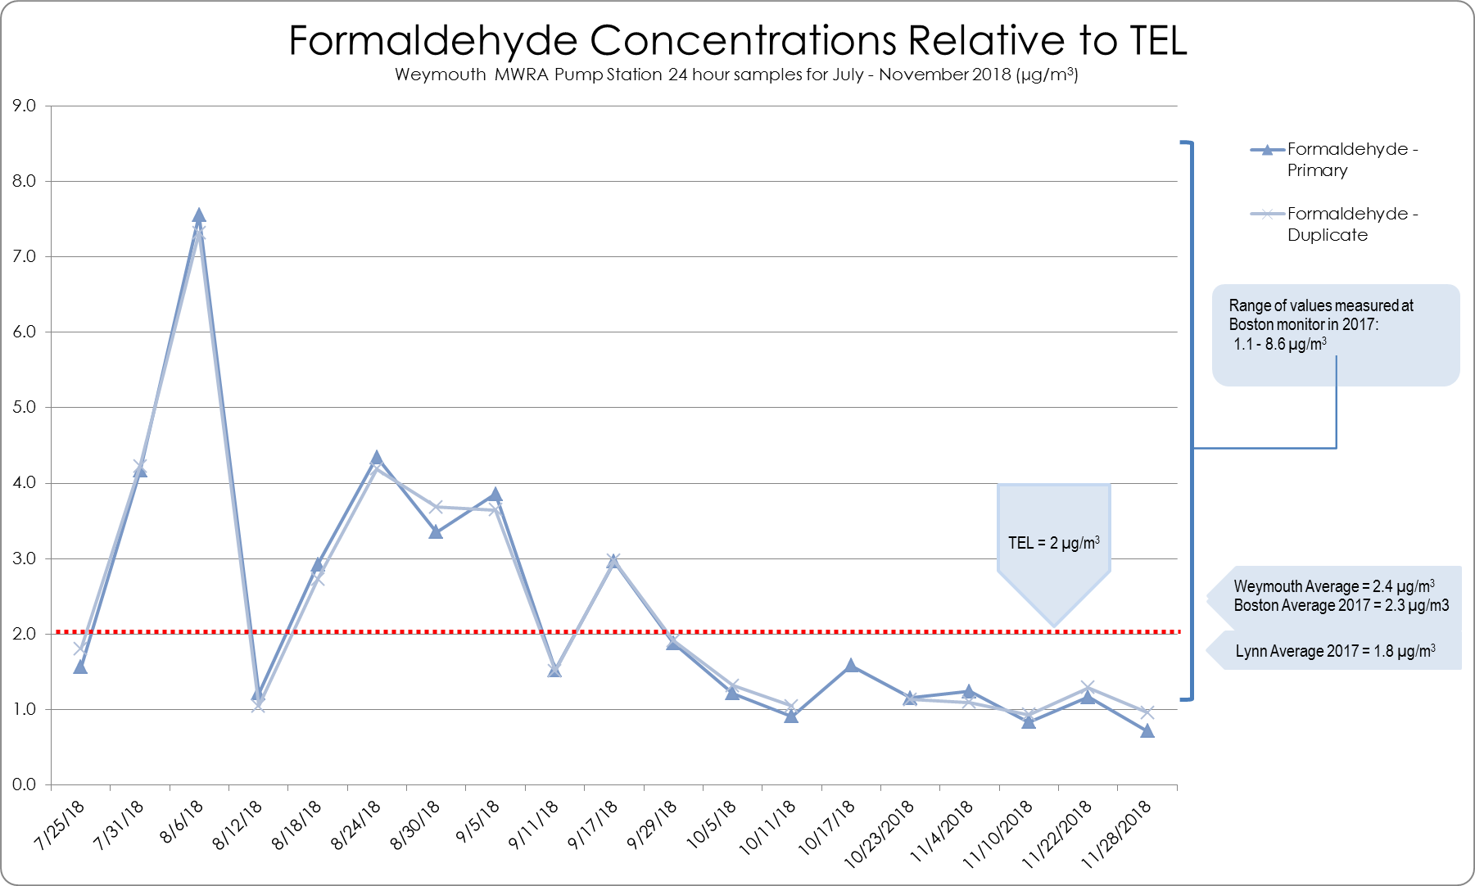
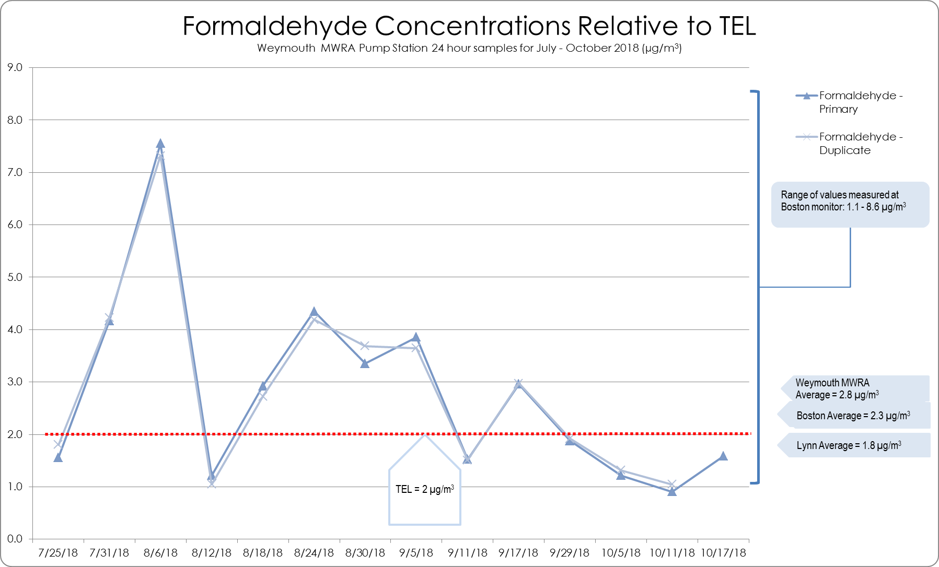

TEL = Threshold Effects Exposure Limit (24-Hour Average), µg/m³ = micrograms per cubic meter

Estimated Air Pollutant Contributions from the Proposed Compressor Station
To determine potential changes in air quality, MassDEP analyzed air dispersion modeling data submitted by Enbridge as part of the air permit application for the proposed compressor station. This included assessing projected emissions from the proposed compressor station and assessing cumulative modeling results that combined compressor station emissions with emissions from nearby sources. Modeled results from the compressor station were assessed with and without background levels to evaluate the potential contribution of the proposed compressor station to existing background air quality levels. In all cases, the monitoring or modeled levels for each pollutant were compared to their respective standard or health-based guideline value.

Air Dispersion Modeling
Air dispersion modeling is a tool that can be used to predict how a potential new emission source will affect air quality. EPA’s AERMOD air quality dispersion model is the standard model used to support regulatory air permitting. This model uses emission rates, source parameters, and meteorological inputs to predict concentrations of pollutants at downwind receptor grid locations. Generally, the modeling is used to perform a worst-case analysis, in that it uses the maximum potential emission rates for each pollutant from each emissions unit and combines that with the most recent 5 years of representative hourly meteorological data to calculate and locate the highest possible concentrations over a receptor grid surrounding a proposed new emissions source. These worst-case concentrations are then compared to, and must meet, applicable standards and guidelines.
As part of its air quality permit application, Enbridge was required to perform air dispersion modeling to estimate the impact of potential emissions from the proposed compressor station and to demonstrate compliance with NAAQS and MassDEP’s AAL and TEL air toxics guidelines. Enbridge updated its air dispersion modeling in May 2018.
In accordance with standard modeling protocol developed by EPA, MassDEP required Enbridge to perform cumulative modeling for those criteria pollutants that were determined to be above EPA-published significance levels; these were fine PM_{2.}), annual and 24-hour standards; NO₂, 1-hour and annual standards; and SO₂, 24-hour standard. The modeling included:
- Maximum emission rates from the existing Enbridge M&R facility and the proposed compressor station;
- Maximum normal emission rates from nearby large sources, including:
  - Fore River Energy Center, including recently permitted “black start” engines
  - Braintree Electric Light Department
  - Twin Rivers Technologies
  - New England Fertilizer Company (MWRA sludge processing);
- Addition of background air quality levels (based on MassDEP monitoring in Boston);
- Calculation of concentrations based on form of standard; e.g., PM_{2.5} annual average, PM_{2.5} 24-hour (98th percentile), 1-hour NO₂ (98th percentile);
- Comparison to the respective NAAQS, which are set to be protective of health, including sensitive receptors, with an adequate margin of safety.
The cumulative modeling shows that under various worst-case scenarios, potential emissions from the proposed compressor station combined with emissions from large nearby sources would not lead to any violations of the health-based NAAQS.
Because some public concerns were raised about the cumulative modeling result for 1-hour NO₂, which showed a maximum concentration of 176.04 µg/m³ relative to the NAAQS of 188 µg/m³, MassDEP conducted further analysis of the contribution of each facility to the modeled 1-hour NO₂ maximum concentrations (see Figure 53).
- The overall maximum concentration of 176.04 µg/m³ occurs at a receptor point near BELD. Of this 176.04 µg/m³ maximum concentration, 94.6 µg/m³ is from background, 80.8 µg/m³ is from BELD, and the remainder is from other facilities. The proposed compressor station contributes 0.004 µg/m³ at the maximum receptor point.
- MassDEP calculated a local maximum, which is the highest modeled concentration from the facilities at a receptor point near the project site. The local maximum is 153.5 µg/m³ and occurs between the site of the proposed compressor station and the existing M&R facility. The proposed compressor station contributes 0.029 µg/m³ at this receptor point.
- MassDEP also calculated a facility maximum, which is the modeled concentration at the receptor point at which the proposed compressor station contributes the highest concentration. The facility maximum is 119.2 µg/m³ and occurs at the east fence line of the proposed compressor station. The proposed compressor station contributes 17.4 µg/m³ at this receptor point.
In summary, the modeling shows that the highest concentration in the form of the standard that the proposed compressor station would contribute toward 1-hour NO₂ levels is 17.4 µg/m³.

Figure 53. Cumulative Modeling Results for 1-Hour NO2 (µg/m3)
 |  | Overall | Local | Facility
 |  | Maximum | Maximum | Maximum
NAAQS Concentration |  | 188 | 188 | 188
Reported Max Impact |  | 176.04 | 153.47 | 119.23
 | (Percent of NAAQS) | (93.6%) | (81.6%) | (63.4%)
Background Contribution |  | 94.63 | 94.63 | 94.63
Modeled Contributions
 | Proposed Algonquin | 0.004 | 0.029 | 17.400
 | Existing Algonquin | 0.010 | 58.813 | 0.700
 | Fore River Energy | 0.093 | 0.001 | 0.100
 | Braintree Electric | 80.823 | 0.000 | 0.300
 | Twin Rivers Technologies | 0.066 | 0.001 | 6.100
 | MWRA Sludge Processing | 0.410 | 0.000 | 0.000
Total Modeled NO2 |  | 81.41 | 58.84 | 24.60

Source: May 2018 Modeling Report
Notes: Yellow highlight is max contribution
High-1st high result for the proposed Project alone exceeds the SIL of 7.5 ug/m3, which triggers the cumulative modeling.
Overall max occurs in Braintree near BELD facility.
Local max occurs near fence line (west of proposed compressor station and east of M&R facility)
Facility max occurs near fence line (east of proposed compressor station)
Meteorology = Logan/Gray 2012-2016 (this is different meteorology than used in SIL and FERC modeling). A SIL is an ambient air concentration value published by EPA that is used as a compliance demonstration tool in air quality modeling below which a source is considered to have an insignificant impact on ambient air quality.
Each set of max results is associated with different meteorological hours (i.e., different weather on different days)

Note that the overall maximum concentration noted above occurs near BELD because BELD has relatively high permitted potential emissions even though its actual emissions are much lower than its permitted emissions. Figure 54 illustrates how the modeling (which assumes worst-case emissions) compares to actual emissions from the modeled facilities.

Figure 54. Modeled vs. Actual Emissions of Nearby Sources
Modeled emissions in equivalent tons per year (tpy) = max (grams per second) for 1 year
Actual emissions is average of emissions for 2013-2015

For VOCs, Algonquin used maximum emission rates from the existing M&R facility and the proposed compressor station to model concentrations for comparison with MassDEP’s TELs and AALs. All of the modeled concentrations were below the TELs and AALs. In air permitting, TELs and AALs represent screening-level guidelines that indicate the maximum ambient air concentration of a toxic pollutant that may be contributed by a single source or facility. Therefore, the modeling does not take into account background or other unrelated sources.
Figure 55 shows the modeling results for benzene, formaldehyde, and acrolein, which had modeled maximum concentrations closest to their respective TELs or AALs. These maximum concentrations occur at receptor points at the site of the proposed compressor station and concentrations decrease farther away from the site. MassDEP also calculated concentrations at the King’s Cove walking path and at the nearest residence on Bridge Street. Figure 56 through Figure 61 shows concentration isopleths for these three VOCs that illustrate decreasing concentrations away from the site as they asymptotically approach background levels. Since these concentrations do not include background concentrations, MassDEP used VOC data from its Boston monitoring station to represent background to illustrate what worst-case concentrations would be at the site of the proposed compressor station. Figure 62 through Figure 64 present the background data with the addition of the modeled maximum concentrations at the site. Note that these potential maximum cumulative values occur only within the site of the proposed compressor station and do not extend beyond the site boundaries.

Figure 55. Modeling Results for Benzene, Formaldehyde, Acrolein
Concentrations for Kings Cove path and the nearest residences estimated from isopleths; areas outside of an isopleth band are less than the indicated concentration
Nearest Residences are south and east of the proposed facility

Figure 56. Modeled Benzene 24-hr Concentrations
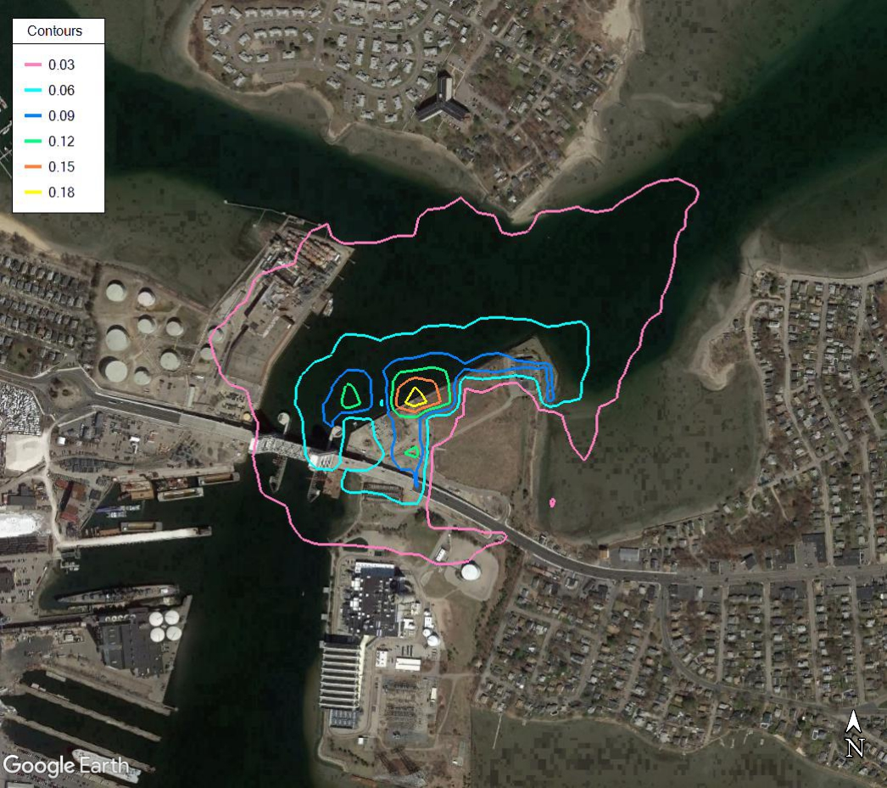
Contours in µg/m³
Max = 0.217 µg/m³
TEL = 0.60 µg/m³

TEL = Threshold Effects Exposure Limit (24-Hour Average)
µg/m3 = micrograms per cubic meter
5% of TEL
Figure 57. Modeled Benzene Annual Concentrations
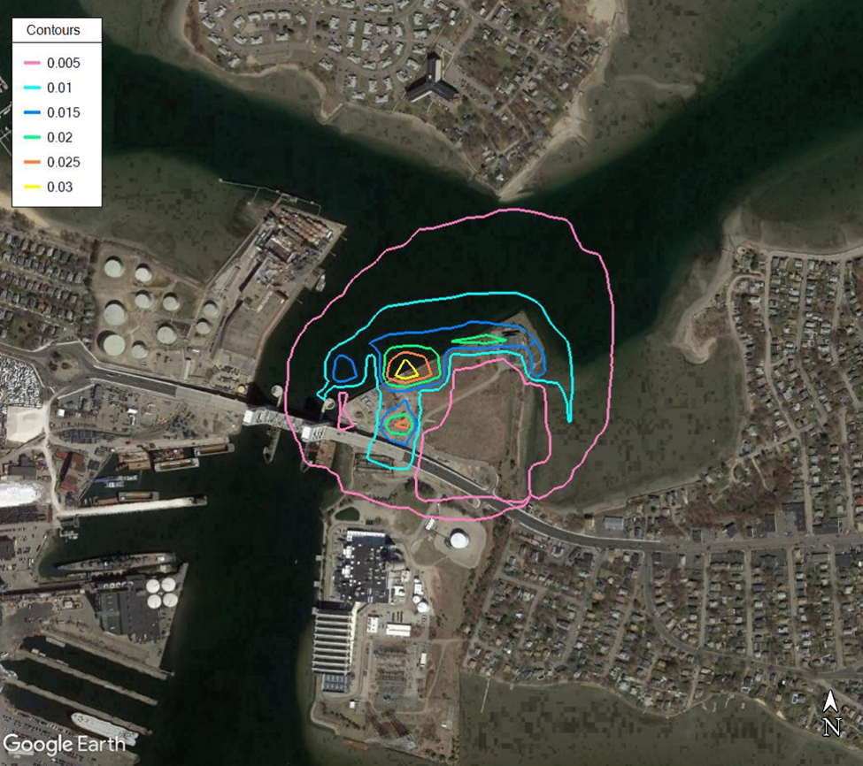
Contours in µg/m³
Max = 0.0426 µg/m³
AAL = 0.1 µg/m³

AAL = Allowable Ambient Limit (Annual Average)
µg/m3 = micrograms per cubic meter
5% of AAL
Figure 58. Modeled Formaldehyde 24-hr Concentrations
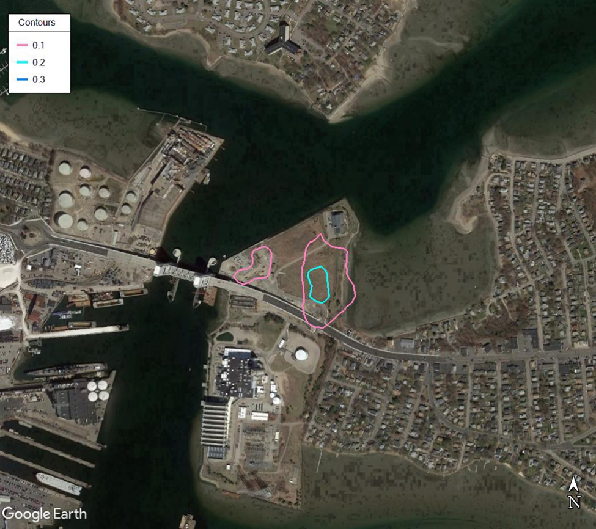
Contours in µg/m³
Max = 0.386 µg/m³
TEL = 2 µg/m³

TEL = Threshold Effects Exposure Limit (24-Hour Average)
µg/m3 = micrograms per cubic meter
5% of TEL
Figure 59. Modeled Formaldehyde Annual Concentrations
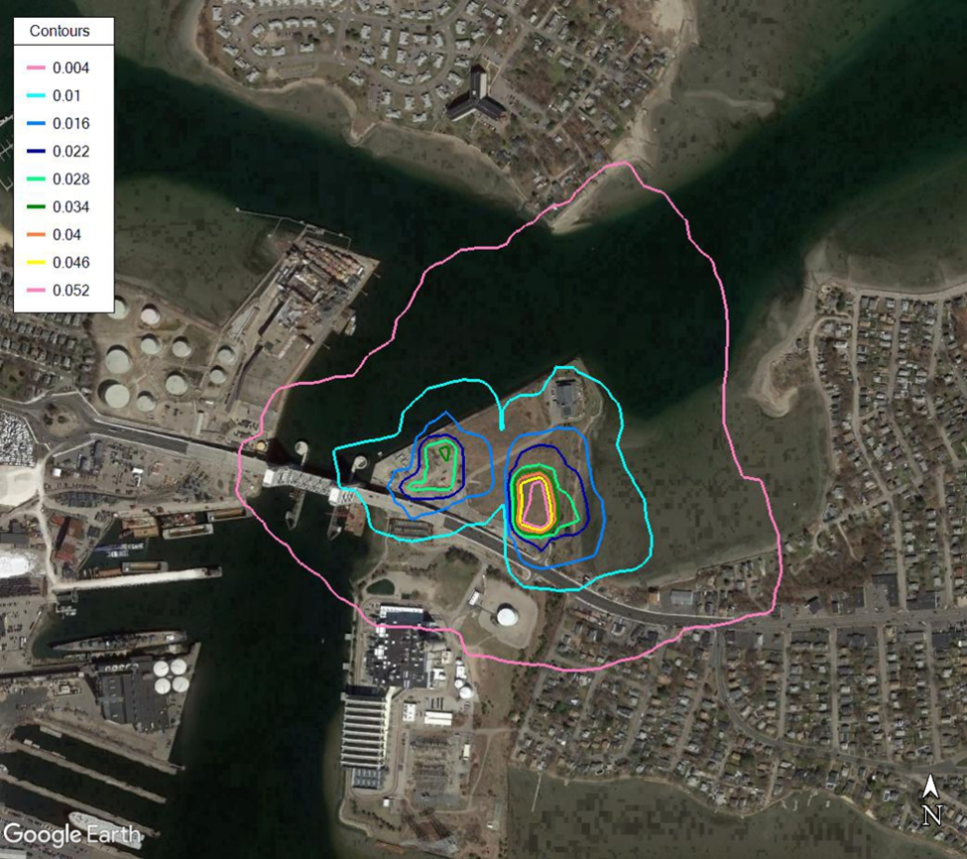
Contours in µg/m³
Max = 0.0554 µg/m3
AAL = 0.08 µg/m3

AAL = Allowable Ambient Limit (Annual Average)
µg/m3 = micrograms per cubic meter
5% of AAL
Figure 60. Modeled Acrolein 24-hr Concentrations
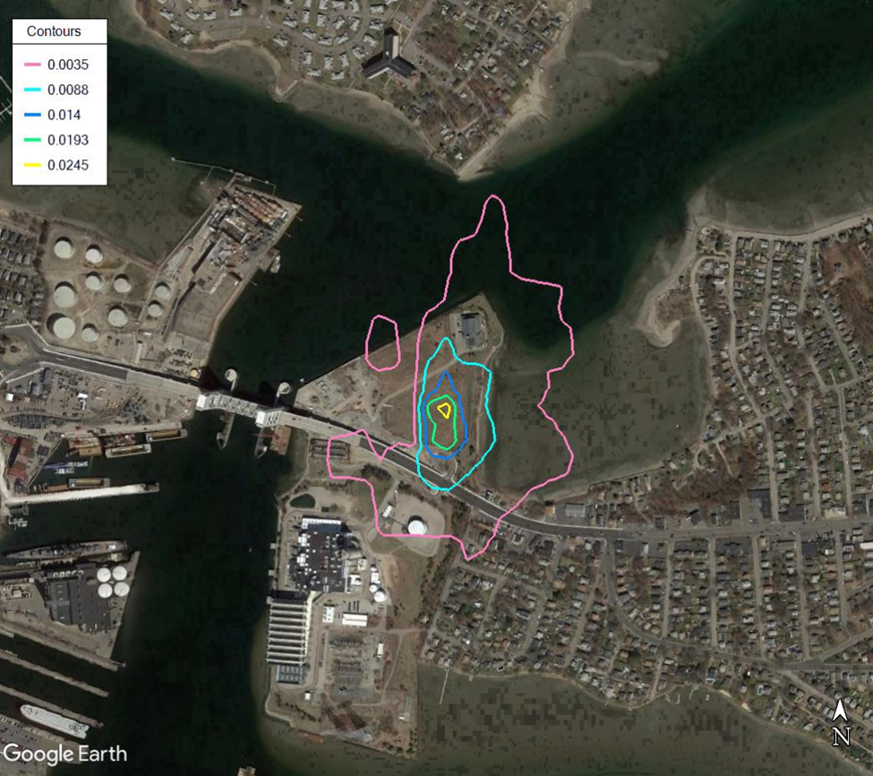
Contours in µg/m³
Max = 0.037 µg/m³
TEL = 0.07 µg/m³

TEL = Threshold Effects Exposure Limit (24-Hour Average)
µg/m3 = micrograms per cubic meter
5% of TEL
Figure 61. Modeled Acrolein Annual Concentrations
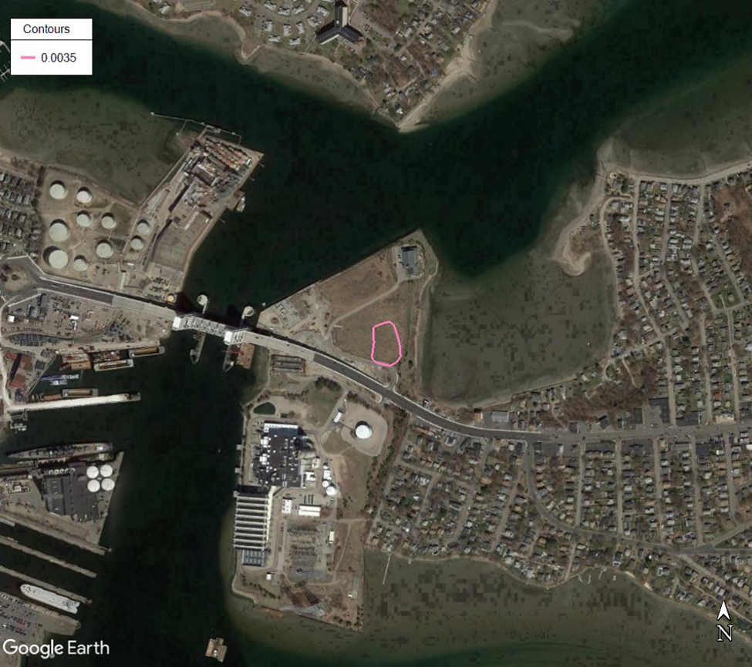
Contours in µg/m³
Max = 0.0049 µg/m³
AAL = 0.07 µg/m³

AAL = Allowable Ambient Limit (Annual Average)
µg/m3 = micrograms per cubic meter
5% of AAL
Figure 62. Benzene Background Plus Modeled Maximum Relative to AAL/TEL
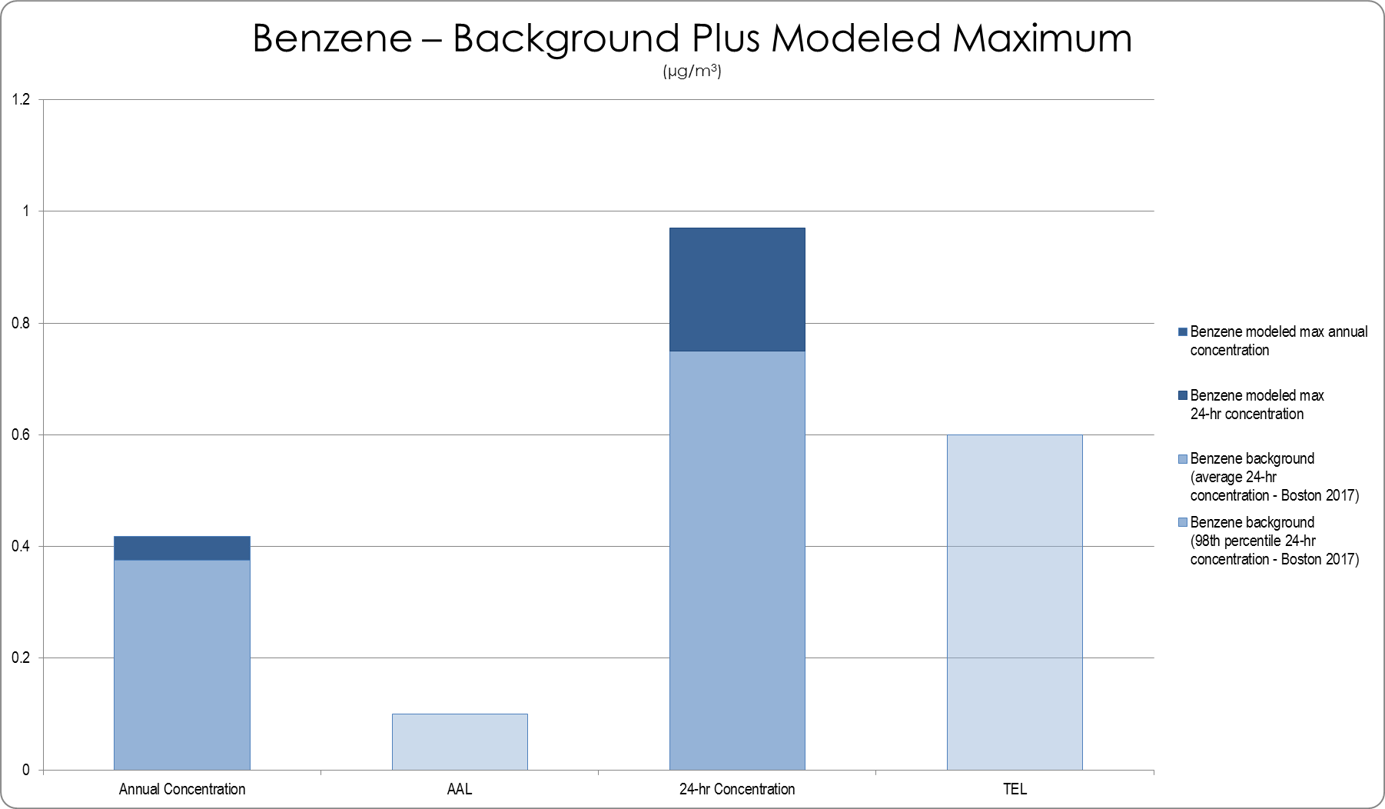
TEL = Threshold Effects Exposure Limit (24-Hour Average)
AAL = Allowable Ambient Limit (Annual Average)
µg/m³ = micrograms per cubic meter
Figure 63. Formaldehyde Background Plus Modeled Maximum Relative to AAL/TEL
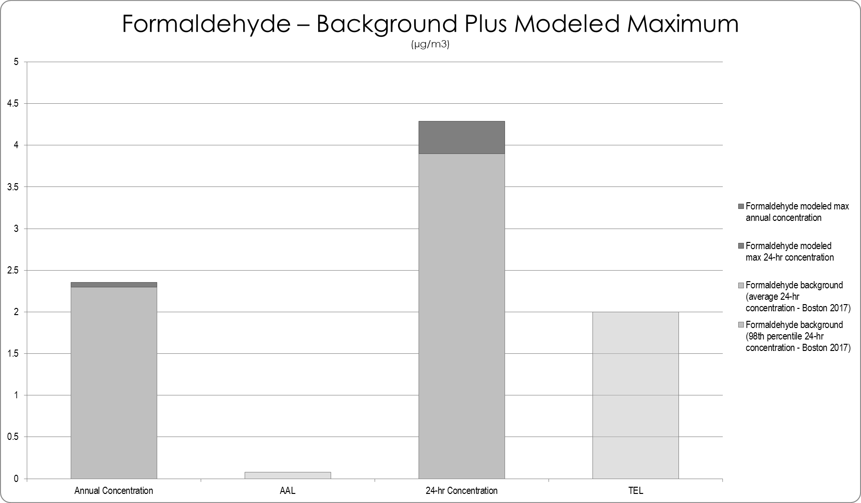
TEL = Threshold Effects Exposure Limit (24-Hour Average)
AAL = Allowable Ambient Limit (Annual Average)
µg/m³ = micrograms per cubic meter

Figure 64. Acrolein Background Plus Modeled Maximum Relative to AAL/TEL
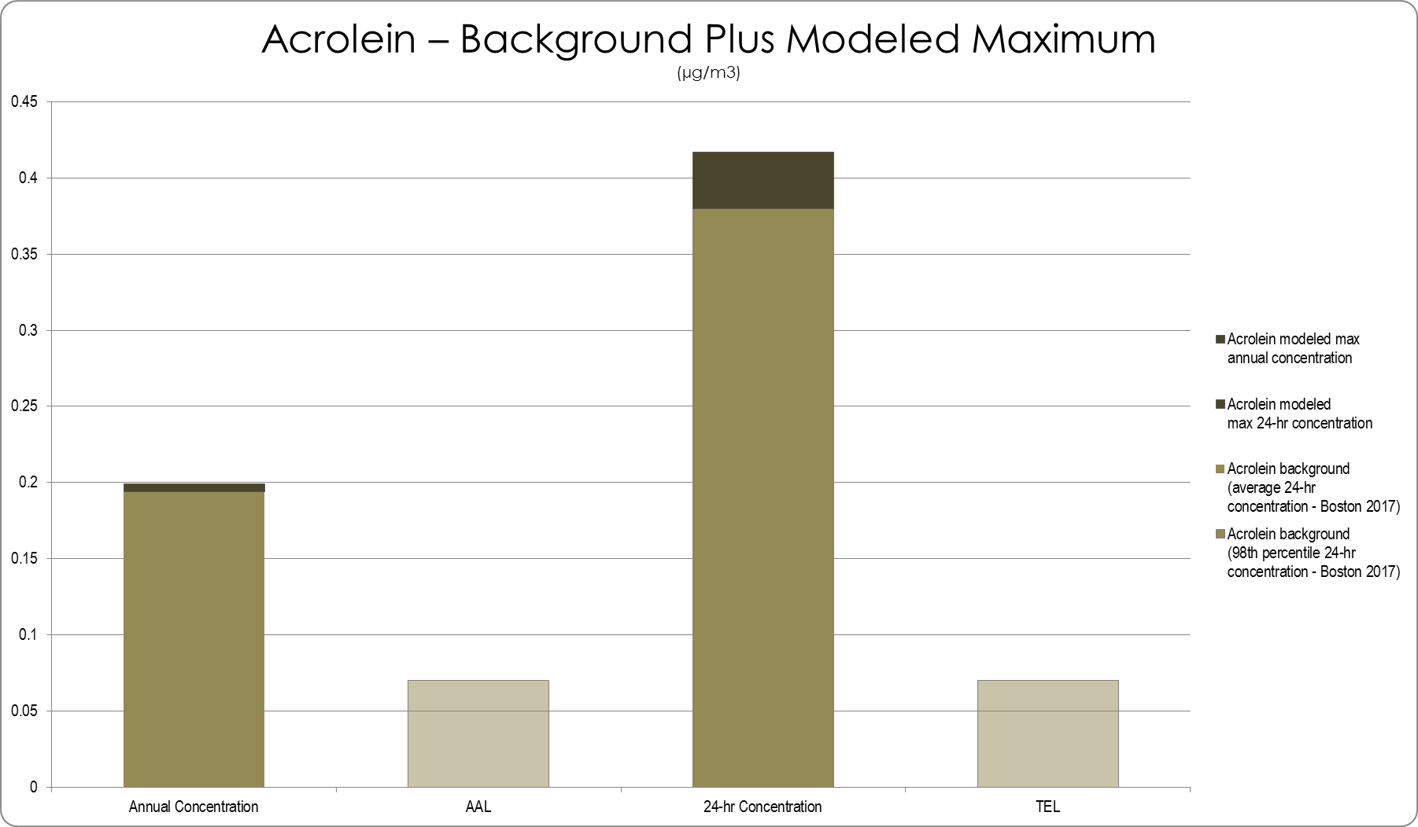
TEL = Threshold Effects Exposure Limit (24-Hour Average)
AAL = Allowable Ambient Limit (Annual Average)
µg/m³ = micrograms per cubic meter

Community identified effects and perspectives
Community participants and interested stakeholders placed a heavy emphasis on the potential air emissions that the proposed compressor station could generate. Most comments provided during the process focused on the chemicals that could be in the natural gas, the amount of emissions that would be produced (specifically air toxics like benzene and formaldehyde and criteria pollutants such as NO₂ andPM_{2.5}), and how the emissions would add to current air pollution levels in the Fore River basin that many felt were already too high. Comments also addressed how the proposed change was occurring adjacent to Environmental Justices neighborhoods that were located across the Fore River in Quincy.
Participants expressed concern for how elevated air pollution levels could exacerbate or lead to changes in the health of area residents. Participants were concerned for how those who already experienced poor health would be affected by the new emissions. Multiple participants who resided in the surrounding areas recounted personal stories of battles with respiratory and chronic health conditions as well as the loss of neighbors or relatives to cancer.
In addition to health concerns, community comments focused on how emissions from the station would contribute to climate change and how they had concern for impacts to the property values and the economic conditions of nearby neighborhoods. Residents also voiced concern for odors that could accompany the station, especially during blowdowns, regular or emergency.

Characterization of the Air Quality Impacts on Health
Exposure to air pollution at certain levels can have immediate and long-term effects on people’s health. Thresholds that have been established as health protective are used in regulatory processes in order to assess how new projects may impact health. When considering anticipated changes in air emission exposures due to criteria pollutants and air toxics associated with the proposed compressor station, the new emissions introduce the possibility of increased exposure to air pollutants and potential health impacts if such exposures exceed health standards or guidelines.
For direct exposure, the proposed station will generate new emissions through construction and operation of the station. The construction phase is estimated to produce emissions from site preparation and infrastructure building activities and from equipment such as bulldozers and heavy trucks. Emissions are expected to include dust and vehicle exhaust, both of which include particulate matter, and these would be present in varying levels over the estimated 9-month construction period. The proponent has established procedures to manage dust through their erosion and sediment control plan.
The operation of the station is estimated to emit criteria pollutants that will result in concentrations below NAAQS and air toxics that will not contribute concentrations above TELs and AALs. The highest concentrations of pollutants are modeled to occur within and very close to the station fenceline and so the highest direct exposures would be at the project site. Based on available information for direct exposure, there are neither positive nor negative health effects expected as estimated emission levels are less than health protective standards and guidelines.
The health impact from air emissions due to the proposed compressor station is summarized in the impact characterization table at the end of Part 3.

Assumptions and Limitations
The impact assessment is based on available information and as a result there are number of assumptions and limitations involved in the assessment. These are:
- The information was collected from the sources noted in the methods section, which include a mixture of team research of existing studies and science, information developed by the project proponent (Enbridge), and information submitted by the community participants and project advisors. The review was conducted in an expedited fashion so cannot be considered a systematic or comprehensive review although significant efforts were made to collect the most up to date information and science.
- The air monitoring used to establish existing conditions was conducted for less than a full year and therefore represents the timeframe monitored.
- An assessment of the cumulative or interactive effects of the air pollutants identified is not part of the impact assessment although a number of measures (e.g., TELs) and tools used (e.g., air modeling) do attempt to account for such interactions.

Assessment of Noise Impacts on Health in Focus Area
Introduction of a natural gas compressor station will produce additional sounds to nearby neighborhoods and surrounding municipalities. The construction phase will produce noise from the transportation of materials and equipment to and from the site, vehicles used by construction workers who commute to the site, and activities that occur for site clearing, construction of compressor units and associated structures, and testing of the station. The operational phase will create sound from the running of the compressor and supporting and emergency equipment. The operational phase will also include continuous day and night time running of the station as well as scheduled and unscheduled blowdowns of compressor station equipment.

Summary of Findings from Noise Impact Assessment
- The proposed station will produce sound through the construction phase and when in operation.
- Sound is defined as a measure of pressure in air from a source to the surroundings; noise is defined as unwanted or disturbing sound.
- Research links exposure to higher volumes of sound, both as loud individual events and continuous sources, to changes in behavior through annoyance, disturbance of sleep patterns and inflammation of bodily systems.
- Studies have linked exposure to sound above health protective thresholds to increased risks for developing cardiovascular disease and diabetes as well as injury due to decreased attention and fatigue.
- A version of sound, referred to as low frequency noise since it is in a range typically not audible to most people, has also been shown to adversely affect the health of the population capable of hearing or feeling the sound.
- Estimated sound levels during the construction of the proposed station may have negative effects on health, especially for those who use the conservation land adjacent to the property and those who are more sensitive to sound.
- Estimated sound from the operations of the proposed station are not likely to cause health effects through direct exposure since available data indicates the levels will be below recommended thresholds.
- Estimated sound levels may have potential health effects through other mechanisms including increased stress among residents in surrounding areas and changes in perception about use of outdoor spaces and real estate property values.
- There are populations who may be more sensitive to increased sound levels: children and older adults, people with existing cardiovascular health conditions, and those who are sensitive to lower frequencies of sound.

Health Impact Pathway for Noise
The Noise pathway diagram focuses on the unwanted sounds, or noise, that would be produced by construction and operation of the proposed station. The pathway identifies three main ways in which noise could be produced: during construction of the station, during ongoing operations of the station, and during emergency events. The pathway provides linkages for how sound from the proposed compressor station could contribute to additional unwanted sound to the area surrounding the station and be experienced by those living or traveling through the area. The pathway hypothesizes that the change in noise exposure could directly affect health conditions that are associated with elevated sound levels, such as sleep disturbance and cardiovascular disease, as well as through other mechanisms to affect health behaviors such as physical activity and influence social determinants of health.
Figure 65. Pathway for Potential Noise-related Health Impacts
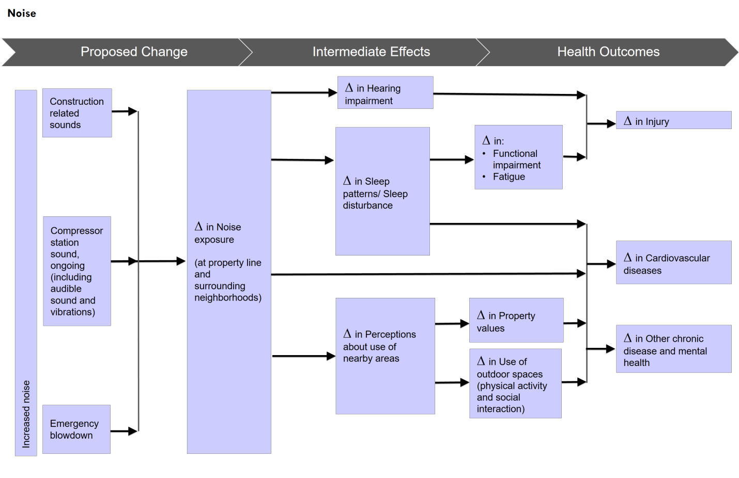

Methods
A literature scan was conducted to identify relevant studies. The scan drew upon available research and publications from regulatory agencies (e.g., EPA) and a snowball method collection and review of published studies from the public health and environmental fields on the relationship between noise, health risk, and health conditions. The review collected reports and papers published about natural gas infrastructure and its documented relationships to health effects. Also included in the review were reports and materials shared by the HIA Advisory Committee.
For existing and proposed conditions, available information was collected from Enbridge and the Federal Energy Regulatory Commission (e.g., Environmental Assessment Resource Reports, Sound Level Impact Assessment Report), the Town of Weymouth (e.g., Open Space and Recreation Plan), the Massachusetts Department of Transportation (MassDOT) , community organizations (e.g., studies of the Fore River), and other publicly available material. Also included in the review are materials that were shared by members of the HIA Advisory Committee and community participants.
Modeled levels of sound from the proposed compressor station were used to conduct a qualitative assessment of whether the contribution from the proposed station would change noise exposure levels in the surrounding areas. Exposure levels used for the assessment were the EPA recommended daytime and nighttime sound levels.

Noise and Health
Sound and noise are not the same thing. Sound is defined as a measure of pressure in air from a source to the surroundings; noise is defined as unwanted or disturbing sound. Sound becomes unwanted (i.e., noise or noise pollution) when it either interferes with normal activities such as conversations, disrupts sleep pattern or diminishes a person’s ability to enjoy their daily life. The unit of measurement for sound is the decibel and sound is typically weighted to reflect the actual loudness level as heard by average human ears. The most common weighting used is A-weighted noise level which makes sound with different frequency spectrums comparable and has been found to be a more reasonable approximation of human hearing.
Noise has an impact on our health; the World Health Organization (WHO) estimates at that least 1 million years of healthy life years are lost every year in western European countries because of environmental noise. Exposure to acute, high decibel sounds (85 dB(A)) or greater for long periods of time is associated with hearing loss. While in most cases, exposure to acute, high-decibel sounds occurs in occupational settings, chronic exposure in other setting can contribute to noise related hearing loss.
EPA recommends an average 24-hr exposure limit of 45 dB(A) indoors and 55 dB(A) outdoors to protect people from all adverse effects on health and welfare in residential areas. More recently the WHO has updated their Environmental Noise Guidelines for the European Region, which was based on systematic reviews of the most recent science on connections between noise and health. The new recommended levels, which are based on noise from transport, wind and leisure activities, establish average daily exposure levels and nighttime specific levels. With the exception of leisure noise (e.g., concerts), the guidelines set levels below the daytime limits of 54 dB(A) or lower (below the current EPA limit) and established lower nighttime limits: 45 dB(A) or less.
Measurement of Sound
The human ear responds to sound of different frequencies differently. Sound with the same amplitude but different frequencies will be perceived by the human ear as having different subjective loudness. In order to deal with differentiated sensitivity, a method called “A weighting” is used to adjust the sound level (by adding or subtracting certain decibels) at different frequencies within the range of human hearing (20 – 20,000 Hz). The A-weighted noise level makes sounds with different frequency spectrums comparable, and is a more reasonable approximation to reflect the actual noise loudness level as heard by average human ears. The unit for A-weighted sound level is dBA or dB(A).
The figure demonstrates the weighting characteristics of A-weighting in comparison to the C-weighting systems, which does not adjust for sound at lower frequencies. Note how the A-weighted sound level is lower than the actual sound pressure level when the frequency of the sound is lower than 1,000 Hz. This is because human ears are less sensitive to low-frequency sound and low-frequency noise does not sound as loud as regular noise with the same sound pressure level.
Additionally, sound measurement uses a logarithmic scale. Instead of increasing in equal increments, a logarithmic scale increases by a factor of 10. Thus, a large increase in noise corresponds with only a modest increase in decibels. For example, if cars on a highway generate 60 dB(A) of sound, doubling the number of vehicles on the roadway would correspond to an increase in sound levels not to 120 dB(A), but to 63 dB(A). Correspondingly, a 10 dB(A) reduction in sound levels corresponds with a substantial reduction in perceived noise.
Source(s):
EPA. Information on Levels of Environmental Noise Requisite to Protect Public Health and Welfare with an Adequate Margin of Safety. 1974.
Federal Interagency Committee on Noise. Federal Agency Review of Selected Airport Noise Analysis Issues. 1992.

People react differently to sound, based on emotional and physical factors such as the extent to which someone is accustomed to current sounds or has hearing sensitivity. Noise annoyance can lead to a number of negative emotions – anger, depression, anxiety and agitation – which can adversely affect both the individual and those around them. Annoyance from noise has been associated with mental health issues (depression and anxiety) and with increased risk of chronic stress.
Night-time noise exposure can also cause annoyance, which has been associated with sleep disturbance. Characterized by difficulty in falling asleep and frequent awakenings, sleep disturbance experienced over a long period of time can lead to less productivity at work, greater need for health care services, and increase risk of injury. In addition to resulting in less restful sleep, sleep disturbance due to noise has been associated with changes in the body’s inability to regulate blood pressure and other changes in the cardiovascular system.
Extended exposure to high noise levels can lead to inflammation or swelling. While inflammation in the case of an infection is beneficial, long-term inflammation can increase the risk of heart disease, such as coronary artery disease, hypertension, stroke, diabetes, and heart failure. Chronic or long-term exposure to noise levels above 60 dB(A) have been associated with high-blood pressure, hypertension, and ischemic heart disease.

Low Frequency Noise
Low frequency noise (LFN) is generally defined as noise with dominant sound energy in the frequency range from 20 Hz to 250 Hz. Since there are people who are more sensitive to LFN, the A-weighting method, which is traditionally used in noise studies, may underestimate the level of LFN and thus its health effects. C-weighting may be better for assessment of health effects.
A systematic review of seven observational studies between 2000 and 2015 found there may be some associations between exposure to LFN and self-reported annoyance, as well as various other symptoms (i.e., hypertension, sleep-related problems, concentration difficulties, headache), in the adult population living in the vicinity of a range of LFN sources. In particular, annoyance has been found to be significantly higher in populations exposed to steady-state LFN as compared to steady-state flat-frequency noise. Prevalence of annoyance has been found to increase with higher levels of LFN.
A possible reason for association of LFN with other symptoms is that energy content in the 20-160 Hz range has been shown to be related to sleep disturbance, concentration difficulties, irritability, anxiety, and tiredness. While the identified issues are not directly health issues, they may increase the risk of injury or changes in the cardiovascular system as noted above as conditions associated with sleep disturbances.

Populations More Sensitive to Noise
There are subsets of people that have been found to be more sensitive to sound and are affected at levels lower than those set as protective for a general population. This sensitivity may come from the ability to perceive sound at lower frequencies, which is approximately 12 dB more sensitive than the average person; this sub population is estimated to be 2.5% of a population.
Other populations may be more sensitive due to developmental, age, chronic physical or mental health conditions, or occupational requirements. Examples include children who are engaged in cognitive tasks in school environments; hearing-impaired individuals who can experience additional issues with speech perception; and people with psychiatric disorders that have a reduced capacity to cope in noisier environments.

Compressor Stations and Noise
Research is still emerging on the effects and perceptions of noise from compressor stations. Many studies have included compressor stations as part of larger natural gas infrastructure projects (e.g., hydraulic fracturing) where there are many additional pieces of equipment generating sound. One recent study that occurred in West Virginia monitored noise levels at eleven households who lived in the vicinity of two compressor stations (compressor size unknown). Through noise monitoring that was conducted at the study participant’s homes, it was found that the compressor stations did increase sound levels, both outdoor and indoor, for homes closer than 1000 feet to a station.
Another study that occurred in the vicinity of Mesa Verde National Park in Colorado used a model to identify potential impacts of noise from compressor station noise. The model projected that the 64 compressor stations located outside of the park could elevate sound levels above the ambient level by a minimum of 35 dB(A).
The Town of Burrillville, RI, commissioned an independent noise monitoring study of an existing compressor station located in the town in March 2018. The study followed a set of improvements to the station (exhaust systems of some of the units) and was meant to check the results of the station owner’s estimates that sound from the facility had been reduced. The study replicated two measurement locations (residences) used by the station’s owners and added four other nearby residences identified by the community. The study found that sound levels at the two nearby residences measured the same sound levels as reported by the compressor station’s owner (44 dB(A)) and that, overall, the audible sound emissions from the compressor station were reduced (by 13 dB(A)) as a result of station improvements and retirement of two older compressor units. The study also found that the operating compressor units had distinctive low frequency sound signatures. In particular, the study found that one unit emitted low frequency sounds (50-100 Hz) that were prominent relative to the ambient level when they were relatively low, such as at night.

Current Sound/Noise Conditions
Current contributors to existing ambient sounds level at the site of the proposed compressor station and surrounding areas include vehicular traffic on Route 3A (Bridge Street), nearby existing industrial facilities such as the MWRA Pumping Station and Calpine power plant, Twin Rivers plant and general sounds from the homes and commercial uses in the surrounding neighborhoods. For this area, a number of studies have been conducted in the past 10 years that provide a picture of current sound levels in the vicinity of the proposed station.
Starting with the oldest study, a noise assessment was conducted in 2010 to document ambient sound conditions and to estimate noise from construction activities and future bridge traffic related to the planned new Fore River Bridge (Route 3A). Since it was a transportation project, the assessment captured data according to a one-hour equivalent sound level – L_{eq}(h) – which is A-weighted and a different sound measure than may be used with land use and development projects.
The 2010 noise assessment found the following existing sound levels at five locations in proximity to the planned new bridge:
Figure 66. 2010 Fore River Bridge Noise Monitoring Results
ID | Receptor Description | Location | Existing Noise, Leq(h) | Land-Use Category
M1 | 53 St. Germaine Street | Quincy | 58 | B (Residential)
M2 | 75 Kings Cove Beach Road | Weymouth | 55 | B (Residential)
M3 | 101 Bridge Street (Route 3A) | Weymouth | 67 | B (Residential)
M4 | 21 Dee Road | Quincy | 55 | B (Residential)
M5 | 50 Monatiquot Street | Weymouth | 54 | B (Residential)
Source: Noise Technical Report for the Fore River Bridge Replacement Study, AECOM
Figure 67. 2010 Fore River Bridge Noise Monitoring Locations
Source: Noise Technical Report for the Fore River Bridge Replacement Study, AECOM
Existing baseline noise levels were measured during various periods of the day with the intent to document the worst-case noise hour. Two of the sites (M1 and M3) from the bridge noise assessment identified sound levels (58 dB(A) and 67 dB(A), respectively) that exceeded the EPA recommended outdoor sound level (55dB(A)).
The monitoring for the noise control plan of the Fore River Bridge in October 2012 included follow up measurements in similar locations as the 2010 study. These measurements, which occurred for a 24-hour period, prior to completion of bridge construction, found the following levels at three separate time periods:
Figure 68. 2012 Fore River Bridge Noise Monitoring Results
ID | Receptor Description | Average Daytime Noise, Leq(h) | Average Evening Noise, Leq(h) | Average Nighttime Noise, Leq(h)
M1 | 53 St. Germaine Street | 56 | 56 | 56
M2 | 79 Kings Cove Beach Road | 51 | 53 | 52
M3 | 101 Bridge Street (Route 3A) | 68 | 67 | 62
M4 | 17 Dee Road | 55 | 53 | 49
M5 | 50 Monatiquot Street | 54 | 53 | 52
Source: MassDOT December 2012 to April 2013 Noise Control Plan
Figure 69. 2010 Fore River Bridge Noise Monitoring Locations
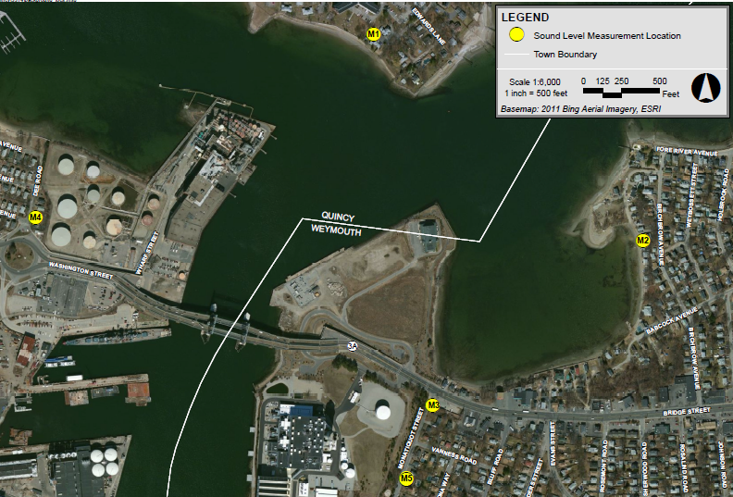
Source: MassDOT December 2012 to April 2013 Noise Control Plan
The monitoring study found Leq 1-hour measurements similar to the earlier study with M1 and M3 continuing to have levels (56 dB(A) and range of 62-68 dB(A), respectively) that exceeded the EPA recommended outdoor sound level (55dB(A)).
When the compressor station was initially proposed, the proponent provided a 24-hour noise assessment as part of their submission to FERC. The reported ambient sound levels were questioned and consequently, the Town of Weymouth conducted an independent study using a number of locations included in the initial acoustical analysis conducted by the proponent. The town’s measurement occurred over one week in April 2017 at four locations. One location was in King’s Cove (approximately 550 north of Bridge Street) and the others were intended to replicate three locations used in Enbridge’s initial monitoring at residences on Bridge Street, Bluff Road, and Fore River Avenue, although by contrast some of the measurements occurred in the rear yard of the properties (Enbridge’s study locations were along the front yards). A map of the town’s monitoring location follows.
Figure 70. Weymouth 2017 Noise Monitoring Locations
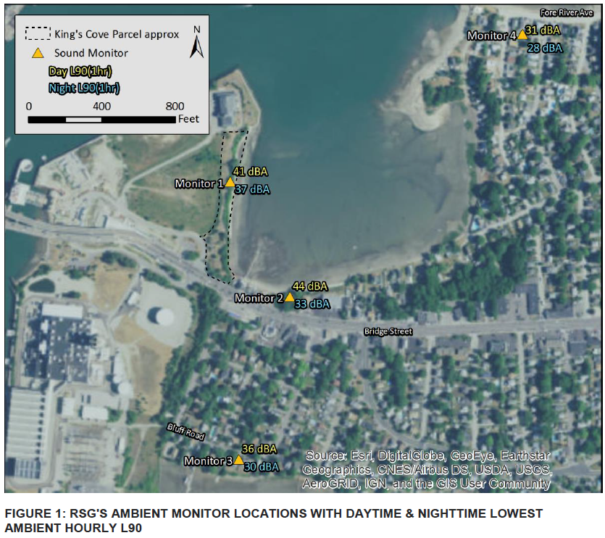
Source: RSG Review of Proposed Plan Approval for Algonquin Gas Transmission, LLC
The town’s measurement reported the daytime and nighttime ambient sound level for the locations using a L₉₀ 1-hour dB(A) level, which represents the sound level that is exceeded 90% of the time. As compared to the MassDOT studies for the Fore River Bridge (2010 and 2012), the town’s study identified the lowest levels of sound during daytime (7am to 10pm) and nighttime periods (10pm to 7am). The monitoring results indicate that lowest ambient sound levels are below 45 dB(A).
Figure 71. Weymouth 2017 Noise Monitoring Results
Location | Lowest Daytime Ambient Sound Level  (L90 1hr, dB(A)) | Lowest Nighttime Ambient Sound Level  (L90 1hr, dB(A))
Monitor 1 | 41 | 37
Monitor 2 | 44 | 33
Monitor 3 | 36 | 30
Monitor 4 | 31 | 28
Source: RSG Review of Proposed Plan Approval for Algonquin Gas Transmission, LLC
The proponent conducted another sound study for the proposed compressor station in September 2018. Collection of sound data occurred over a 14-day period, which included the temporary failure of two monitoring devices, and resulted in measurements that occurred for between 8 and 14 days across all devices. Six locations were measured, including King’s Cove Park adjacent to the proposed site, and multiple residential locations, ranging in approximate distances of 840 feet (residence on Bridge St in Weymouth) to 2,850 feet (park among residences on Washington Street) from the site. The locations are shown in the map below.
Figure 72. Enbridge 2018 Noise Monitoring Locations
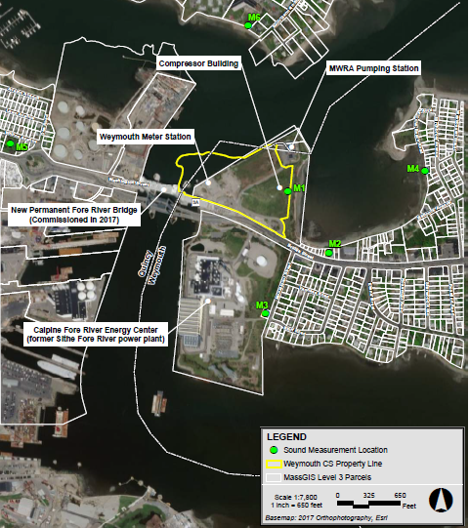
Source: Update to Non-Major Comprehensive Plan Approval Application, Algonquin Gas Transmission, LLC – Weymouth Compressor Station, October 2018
The assessment calculated the L₉₀ levels, which establish the lowest sound levels (i.e., the sound level that is lower than 90% of the measured sound level) for daytime and nighttime periods. Measurements at these locations identified the following sound levels:
Figure 73. Enbridge 2018 Noise Monitoring Results
Location ID | Description | Daytime L₉₀  dB(A) | Nighttime L₉₀  dB(A)
M1 | King’s Cove PL | 44 | 40
M2 | Bridge St. | 48 | 36
M3 | Monatiquot St. | 44 | 45
M4 | King’s Cove Beach Road | 40 | 37
M5 | Quincy Park | 45 | 34
M6 | O’Brien Towers | 42 | 41
Source: Update to Non-Major Comprehensive Plan Approval Application, Algonquin Gas Transmission, LLC – Weymouth Compressor Station, October 2018
Although not all locations were similar to the town’s 2017 study, the 2018 study also documented levels that were at or below 45 dB(A), with the exception of some daytime levels along Bridge Street (48 dB(A)).

Estimated Noise from the Proposed Compressor Station

Construction
Construction activities for the proposed station will include use of heavy equipment that will emit sound during the daytime (7am – 6pm). The equipment and estimated sound levels are estimated to produce the following sound levels.
Figure 74. Enbridge Proposed Construction Equipment Noise
Type of Equipment | Equipment  Power Rating or Capacity  (HP) | Estimated Number Required | Sound Level at 50 Ft. (dB(A)) | Resulting PWL of Single Piece of Equip.  (dB(A)) | Assumed Maximum  Number Operating at One Time | Estimated Maximum Sound Level of Equip.  (dB(A))
Diesel Generator | 250 to 400 | 1 to 2 | 65 - 70 | 102 | 1 | 102
Bulldozer | 250 to 700 | 1 to 2 | 75 - 80 | 110 | 1 | 110
Grader | 450 to 600 | 1 to 2 | 70 - 75 | 105 | 1 | 105
Backhoe | 130 to 210 | 1 to 2 | 65 - 72 | 104 | 1 | 104
Front End Loader | 150 to 250 | 1 to 2 | 65 - 70 | 102 | 1 | 102
Truck Loaded | 40 Ton | As needed | 70 - 75 | 105 | 1 | 105
Source: Non-Major Comprehensive Plan Approval Application, Algonquin Gas Transmission, LLC – Weymouth Compressor Station, September 2016
These estimates assume that multiple pieces of equipment are in use and that the loudest equipment is operating during the same time frame. For purposes of the HIA, the estimated maximum A-weighted power level (PWL) is assumed to represent this condition (i.e., values in final column). As a result, the initial estimated total under such a condition would be 113 dB(A).
The proponent, in their permit application, estimates that these values represent a sound level at 50 feet from the source and that attenuation of the sound (due to characteristics of sound propagation) over a distance of 650 feet will reduce the overall level by 54 decibels. It is stated that a berm is currently present between the site (where construction activities will occur) and the nearest residential property (approximately 600 feet or more away from the site), which will further reduce the sound emissions from construction by 3 dB(A). The resulting estimated a-weighted sound contribution from the construction activities is estimated to be 56 dB(A). Under this condition, the resulting daytime sound level at the closest residence on Bridge Street during construction is estimated to be 56.3 dB(A) using the town’s L₉₀ daytime ambient and 56.6 dB(A) using the proponent’s L₉₀ daytime ambient. In each case, it would represent an increase of 12 decibels over the L₉₀ background ambient sound levels. The estimated construction sound levels do not include sound that would be generated from the commuter vehicles coming to and from the site before and after work hours.

Operations
When in operation, multiple pieces of equipment for the compressor station would contribute new sounds to the surrounding areas. The identified sources of sound associated with the station are:
- Gas turbine exhaust system
- Gas turbine air intake filter system
- Outdoor lube oil cooler (serves the station compressor unit)
- Outdoor gas cooler (serves the station compressor unit)
- Aboveground gas piping and associated components (e.g., valves, suction filter separators)
The proponent has proposed the following modifications to the identified equipment in order to reduce sound:
- Gas turbine exhaust – 2-stage silencer
- Gas turbine air intake – 5-foot silencer and air intake filter
- Lube oil cooler – installation of quieter model and placement behind courtyard barrier wall (8.5-inch concrete)
- Gas cooler – placement behind courtyard barrier wall (8.5-inch concrete) (replaces gas cooler)
- Aboveground piping – acoustical pipe insulation and placement behind courtyard barrier wall (8.5-inch concrete)
- Gas turbine and compressor – 8.5-inch thick concrete block building, double-insulated roll-up doors and no windows

The referenced 8.5-inch concrete barrier wall is a proposed 19-foot wall that be will be constructed between the compressor building and auxiliary building so that a courtyard is formed around the above referenced pieces of equipment (e.g., gas cooler).
Figure 75. Enbridge Proposed Noise Mitigation Measures
Source: Update to Non-Major Comprehensive Plan Approval Application, Algonquin Gas Transmission, LLC – Weymouth Compressor Station, October 2018
The combination of the sound mitigation measures with the expected sound from the station operating at full load (e.g., assumption of lube oil cooler operating on a 100 degree Fahrenheit day) is projected to increase sound levels in the area and change the ambient daytime and nighttime sound levels by the values below.
Figure 76. Operation: Daytime level (7am – 10pm)
Description | Land Use | Background Noise Level | Modeled Project- Only Noise Level (Proposed) | Combined Project + Background Noise Level | Increase Above Background
Description | Land Use | dB(A) | dB(A) | dB(A) | dB(A)
- King’s Cove PL | Public | 44 | 47 | 49 | 5
- Bridge St. | Residence | 48 | 44 | 49 | 1
- Monatiquot St. | Residence | 44 | 40 | 46 | 2
- King’s Cove Beach Road | Residence | 40 | 31 | 41 | 1
- Quincy Park | Residence | 45 | 35 | 45 | 0
- O’Brien Towers | Residence | 42 | 36 | 43 | 1
Source: Update to Non-Major Comprehensive Plan Approval Application, Algonquin Gas Transmission, LLC – Weymouth Compressor Station, October 2018
Figure 77. Operation: Nighttime level (10pm – 7am)
Description | Land Use | Background Noise Level | Modeled Project- Only Noise Level (Proposed) | Combined Project + Background Noise Level | Increase Above Background
Description | Land Use | dB(A) | dB(A) | dB(A) | dB(A)
- King’s Cove PL | Public | 40 | 47 | 47 | 7
- Bridge St. | Residence | 36 | 44 | 44 | 8
- Monatiquot St. | Residence | 45 | 40 | 46 | 1
- King’s Cove Beach Road | Residence | 37 | 31 | 38 | 1
- Quincy Park | Residence | 34 | 35 | 37 | 3
- O’Brien Towers | Residence | 41 | 36 | 42 | 1
Source: Update to Non-Major Comprehensive Plan Approval Application, Algonquin Gas Transmission, LLC – Weymouth Compressor Station, October 2018
The resulting change in sound due to the proposed compressor station operations is projected to increase daytime ambient sound levels between 0-5 decibels, with the highest increase occurring at King’s Cove (+5 decibels). An increase in nighttime ambient sound levels is projected to be between 1-8 decibels, with the highest increase at the closest residence) on Bridge St (+8 decibels). The projected increases are reported to also include a 2 dB(A) uncertainty factor which was used to overestimate expected sounds generated by the equipment.
Figure 78. Enbridge Modelled Sound Levels for Station Operations
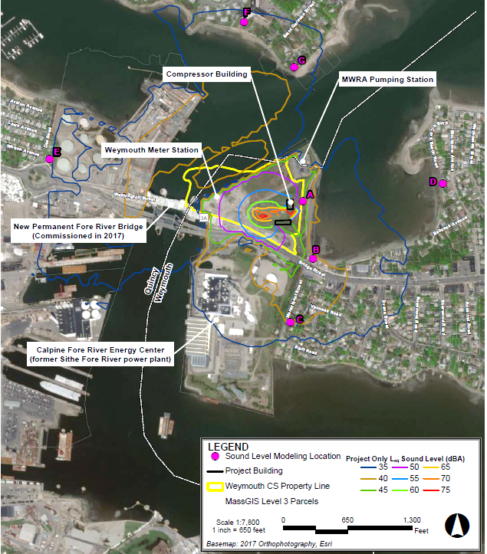
Source: Update to Non-Major Comprehensive Plan Approval Application, Algonquin Gas Transmission, LLC – Weymouth Compressor Station, October 2018

Daytime ambient sound levels are not projected to exceed 55 dB(A) at any location and one location (King’s Cove) is projected to exceed 45 dB(A) at nighttime, both being measures considered by EPA to be health protective. In no case is the projected increase during operation of the proposed compressor station, either daytime or nighttime, expected to exceed MassDEP’s noise policy (i.e., increase of 10 dB(A) over ambient).
Operations of the proposed station will include intermittent sources of sound as well. The proposed station would have a stand-by emergency generator that is expected to be run for one hour each month as part of regular maintenance and readiness testing. The proponent proposes that testing of the generator would occur only during daytime hours, defined as 7am and 5pm. Compliance testing for MassDEP indicates that testing could add 1-5 decibel increases, with King’s Cove and the Bridge Street and Monatiquot St residences experiencing an increase of 4 dB(A) and the King’s Cove Beach Road residence experiencing 5 dB(A) increase. In each case, the expected level is below the EPA recommended threshold (55 dB(A)).
The station will also conduct case vent blowdowns, which are planned blowdowns to facilitate equipment maintenance and are not emergency blowdowns. The proponent reports that the case vent blowdowns would occur less than 20 times annually, which if run at this frequency would be once every two to three weeks. Each case vent blowdown is proposed to last for less than three minutes. The proponent proposed to fit the case vent with an exhaust silencer that is designed to reduce the sound from the blowdown to 49 dB(A) at a distance of 300 feet. Additional assessment in response to a request from MassDEP indicates that when case vent blowdowns occur all but King’s Cove would experience a 2 decibel or less increase. King’s Cove is estimated to experience an increase of 9 decibels if the case vent blowdown was to occur during a time when background is at the quietest level measured by the proponent (48 dB(A)).
There is the likely possibility that emergency blowdowns will occur at the proposed compressor station. Emergency blowdowns are unplanned and occur when an emergency (e.g., leak) requires that a portion of the natural gas pipeline or compressor be evacuated in order to safely address the issue. An Emergency Shut-Down (ESD) vent would be used in these events and if an event were to occur, it is expected that it would last one to five minutes. The additional assessment estimated the ESD sound contribution and indicates that all but King’s Cove would have a 4 decibel or less increase over the L₉₀ background level. At King’s Cove the increase is estimated to be 17 dB(A) were an ESD vent blowdown to occur.

Community Perspectives: Noise Impacts
Participants – including residents and stakeholders – expressed concern for how noise coming from the proposed station would affect health, social, recreational and economic conditions in the surrounding areas. They identified that sound from the station could lead to the annoyance of nearby residents which could have impacts on people’s sleep and ability to conduct daily activities. Concerns were raised about how children would be affected by noise during the school day, such as reduced ability to concentrate or participate in learning environments, or get to sleep if they go to bed early. Some participants also identified a potential risk for reproductive issues based on studies that found associations between noise levels and fetal development. Other participants shared that since the proposed location would be along the water, the sound would be amplified or carry over longer distances affecting neighborhoods on the other side of the Fore River and King’s Cove waterway.
Participants shared that King’s Cove Park was a valued open space and that it was used for recreation, dog walking, and, sometimes, faith services. They felt the increased noise levels, during construction and operations, would directly impact those who use the space and would greatly limit future use of the park. This would represent a loss of activities that supported more physical activity and social interaction.
As with the air emissions, community comments also focused on how noise from the station could impact property values and the economic conditions of nearby neighborhoods. Participants expressed high levels of disbelief in the projected sound levels provided by the proponent. In particular, participants stated (and shared examples from online videos) that the blowdowns, regular or emergency, would be much louder and last longer than the proponent estimated in its application materials submitted to MassDEP.

Characterization of the Noise Impacts on Health
Sound that is unwanted is considered noise and sound levels that exceed certain thresholds (e.g., 55 dB(A) in outdoor environments) can affect people’s short- and long-term health and in extreme cases (e.g., prolonged exposure to sound above 85 dB(A)) can lead to hearing loss. When considering anticipated changes in noise exposures associated with the proposed compressor station within the focus area and surrounding municipalities, noise could be a driver in health changes. The station, as proposed, would increase sound during the construction phase of the project and during operations of the compressor station.
The construction phases is estimated to last approximately 9 months and will involve equipment during daytime hours (7am – 6pm) that is expected to produce higher sound levels than what is presently experienced in the area. Noise levels from construction are expected to increase daytime ambient sound levels by up to 12 decibels at the nearest residence and even higher at King’s Cove Park, which shares a property line with the site. Construction related noise could possibly limit health protective behaviors at King’s Cove Park and so may have adverse effects on health during the 9-month construction period.
Operations at the station will produce sound which will be the result of equipment that is running continuously (e.g., turbine) paired with equipment that will run intermittently (e.g., case vent blowdowns, emergency engine testing). While ambient daytime and sound levels would increase due to the proposed station, but the increased levels are not estimated to be at a level that would lead to hearing loss in the surrounding community. Furthermore, the increased outdoor sound levels from normal operations are not estimated to be at a level or exist for extended periods of time that would cause annoyance (i.e., not exceed 55 dB(A)).
There are vulnerable populations proximate to the site. In Quincy, there are residents who live in identified environmental justice neighborhoods; the Germantown and Quincy Point neighborhoods. Projected changes in sound levels are expected to be below health protective thresholds at these locations based on available data. There are six schools in the focus area but none are expected to be disrupted during school hours given projected changes in ambient sound levels and distance between the schools and the construction activities and operations associated with the proposed compressor station.
The health impact from noise due to the proposed compressor station is summarized in the impact characterization table at the end of Part 3.

Assumptions and Limitations
The impact assessment is based on available information and as a result there are number of assumptions and limitations involved in the assessment. These are:
- The information was collected from the sources noted in the methods section, which include a mixture of team research in existing studies and science, information developed by the project proponent (Enbridge), and information submitted by the community participants and project advisors. The review was conducted in an expedited fashion so cannot be considered a systematic or comprehensive review although significant efforts were made to collect the most up to date science.
- The sound measurements used to establish existing conditions and projected changes relied on secondary data and no independent sound monitoring and modeling was conducted as part of the HIA for construction or operations.
- The assessment does not include an estimated of impacts from the interactive effects of the air pollutants and sound levels.

Assessment of Land Use and Natural Resources Impacts on Health in Focus Area
A natural gas compressor station would represent a new industrial use in the Fore River Basin. Although there are a number of nearby existing industrial uses, the proposed compressor would be constructed on a vacant site that was formerly home to a coal-based electrical power plant. The new industrial use would involve the redevelopment of a former industrial brownfield site along a working waterfront and adjacent to community and natural environmental resources.

Summary of Findings from Land Use and Natural Resources Impact Assessment
- Research suggests that a majority of a population’s health is determined by social, environmental and behavioral factors that shape the context in which people live.
- Characteristics of the built and natural environments such as availability of places to walk and green spaces have been linked to behaviors that are health promoting (e.g., physical activity) and to conditions that are health protective (e.g., remediation and removal of hazardous materials).
- Perceptions of environmental factors has an association with health outcomes as studies have found those living in environments perceived as unhealthy experience higher levels of stress and mental health issues.
- Estimated changes to land uses and natural resources from the proposed station are not likely to cause health effects through direct exposure.
- The estimated change to land use and natural resources may have potential health effects through other mechanisms including changes in perception about desirability of using outdoor spaces and real estate property values as well as potentially contribute to residents’ feelings of uncertainty and lack of control, which has been associated with negative mental health effects.

Land Use and Natural Resources Pathway Diagram
The Land Use and Natural Resources pathway focuses on the effects that the proposed compressor station could have as a result of the redevelopment of the property and potential changes to the land (e.g., soil) and nearby waters (e.g., Fore River). The pathway identifies two main ways in which the change could affect the land use and natural resources: disturbance of existing ground contamination at the property that was the site of former industrial uses and the introduction of a new industrial use to the area. The pathway hypothesizes that the redevelopment of the site could change exposure levels via hazardous materials that are present in the ground and water. It also hypothesizes that the proposed compressor station could influence people to perceive new that hazardous materials are present in the land and water surrounding the station, and that the area is not changing in a way that is favorable to the surrounding community. The pathway hypothesizes that there could be health effects for people, animals, and plants via direct exposure to pollution and other changes in health resulting from changing behaviors and the economic desirability of the area.
Figure 79. Pathway for Potential Land Use and Natural Resource-related Health Impacts
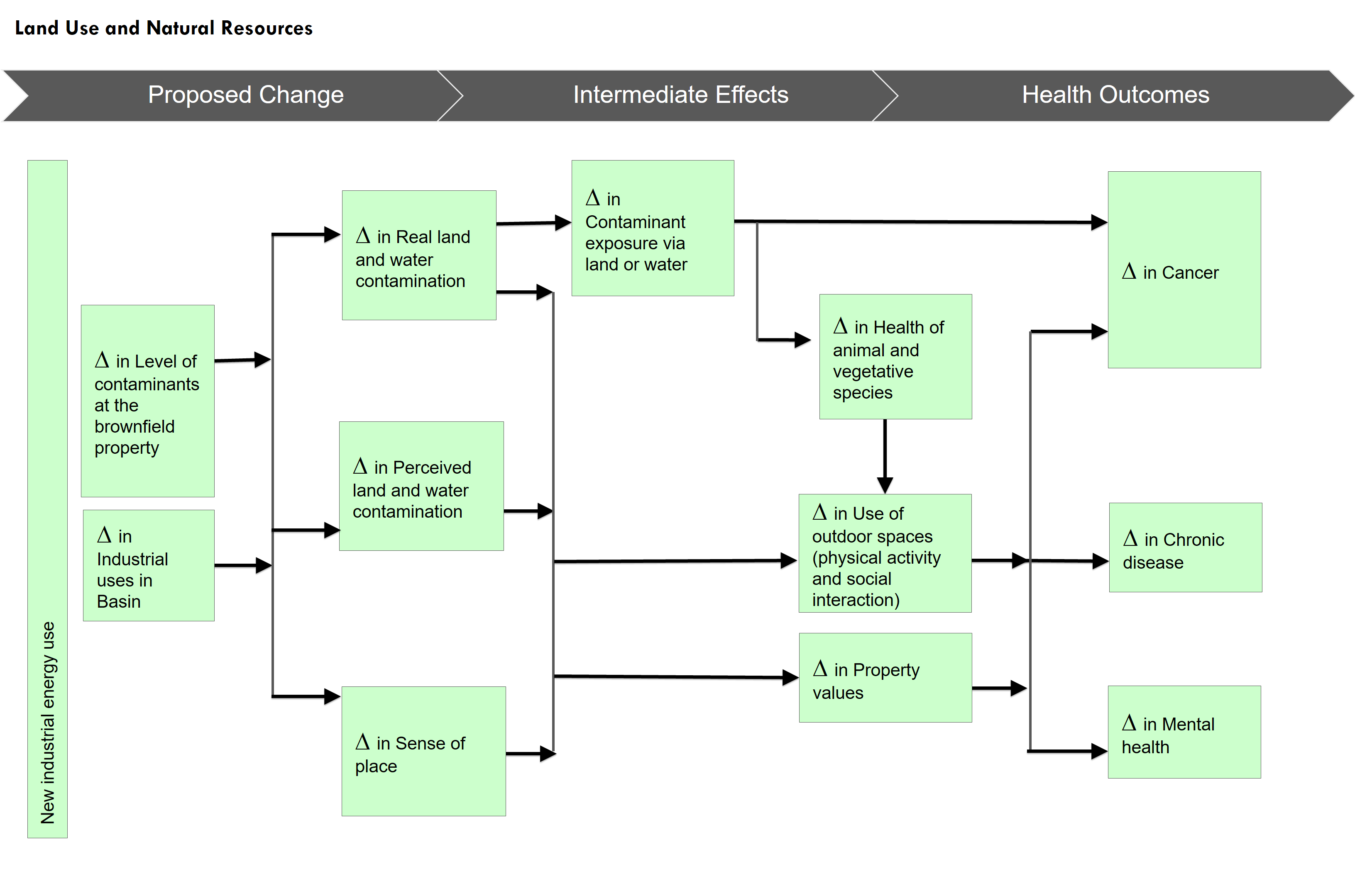

Methods
A literature review was conducted to identify relevant studies. The review drew upon available research and publications from relevant regulatory agencies (e.g., EPA) and a snowball method collection and review of published studies from the public health, urban planning, natural resource and environmental fields on the relationship between land use, natural resources, and health conditions. The review collected reports and papers published about natural gas infrastructure and its documented relationships to health. Also included in the review were documents that characterized existing and proposed conditions. These materials include available information from Enbridge and FERC (e.g., Environmental Assessment Resource Reports), the Town of Weymouth (e.g., Open Space and Recreation Plan), community organizations (e.g., studies of the Fore River), and other publicly available material. Also included in the review are materials that were shared by members of the HIA Advisory Committee and community participants.

Land Use and Natural Resources and Health
Research suggests that more than 60% of a population’s health is determined by social, environmental and behavioral factors that shape the context in which people live. Land use and its effect on built and natural environments contribute to these factors. Land use refers to the management, regulation, and protection of private and public lands and uses that include human development of homes, businesses, industry, and conservation of natural resources, species, and environments. Below is a summary of literature and research findings that have explored the links between land use, natural resources, and health.

Natural Environments
Abundant and accessible parks and open space are not just amenities. Evidence suggests that they are associated with beneficial health behaviors and are protective factors in community health. Access to parks, open space, and greenery may protect against poor mental health outcomes by encouraging more socializing and thus fostering greater social support, particularly among women. Access to green spaces, in particular, may also provide opportunities for physical activity or provide members of a community with sanctuary from stress.
Further research suggests that the presence of trees themselves, in addition to other vegetation, may also promote community health. Trees and other vegetation remove air pollutants and promote cleaner and more breathable air. By providing shade for streets and buildings, trees shade their surrounding environments thereby reducing the presence of heat islands and decreasing ultra violet exposure, which directly impacts skin cancer risk. Finally, trees more so than bushes or shrubs may also play an important role in promoting positive mental health outcomes and positive social behavior and have even been linked to reductions in crime.
Blue space refers to the visibility of and access to water resources such as naturally occurring water bodies as well as man-made water bodies. Research into the health effects of blue spaces is nascent with early evidence suggesting an association between exposure to outdoor blue spaces and health benefits. The associations found include positive effects on mental health and levels of physical activity, not unlike benefits associated with green spaces. Social interaction may also be an effect of blue space exposure with self-report responses indicating the spaces encouraged or were visited due to their role in enhanced bonding and connections. In general, within the existing body of work, there have been inconsistent associations of the direct effects of blue space on health conditions such as obesity and cardiovascular health.

Brownfields
A brownfield is defined by the Centers for Disease Control and Prevention (CDC) as “abandoned or underused portions of land occupied by vacant businesses or closed military structures, located in formerly industrial or urban areas.” Brownfields are typically abandoned or for sale or lease and have been used historically for commercial or industrial purposes. Health impacts due to brownﬁelds and contaminated sites include:
- Safety due to abandoned structures, open foundations, other infrastructure or equipment that may be compromised due to lack of maintenance, vandalism or deterioration, controlled substance contaminated sites (i.e., methamphetamine labs) and abandoned mine sites;
- Social and economic concerns due to blight, crime, reduced social capital, reductions in the local government tax base and private property values that may reduce social services; and,
- Environmental issues due to biological, physical and chemical site contamination, groundwater impacts, surface runoff or migration of contaminants as well as wastes dumped on site.
Exposure to environmental contamination can have numerous health effects depending on the specifics of the prior land use and the materials remaining on the site that might be harmful to human health. Cleaning up and reinvesting in brownfields and land reuse has the potential to improve and protect the environment, economy, and surrounding community’s health and well-being.
In addition, coal combustion waste (CCW) – material that remains after coal is burned to produce electricity – has been found to damage animals and their habitats. EPA has documented exposure to CCW with adverse conditions in terrestrial and aquatic animals that include: fish kills, amphibian deformities, snake metabolic effects, plant toxicity, fish deformities, inhibited fish reproductive capacity, and risks to mammals that uptake these flora and fauna.

Perception of Risk from Industrial Land Use
Direct exposure to environmental pollution and hazards can have effects on people’s health through mechanisms such as injury, poisoning, or interruption of natural biologic processes. The perception of environmental pollution may have indirect health effects, playing a role as a stressor and affecting mental health and other psychosocial mechanisms.
Risk perception, or what might be termed subjective exposure, refers to people’s judgment of negative impacts such as getting sick, hurt, or dying. Higher levels of risk perception can translate into episodic or chronic stress, with the former referring to a short-term event and the latter representing stress that persists for a person over long periods of time. Risk perception does vary among populations. Pregnant women and older adults have greater perceptions of risk from environmental hazards such as water or air pollution. Conversely, some research indicates that people of color and people with lower incomes may have reduced perceptions of risks of exposure due to experiences of higher levels of distress and fewer stress-reducing resources.
While stress can occur at an individual level, it can take the form of social or community stressors that contribute to chronic stress at a population level. Chronic stress of this sort has been linked to increased blood pressure and thickening of veins, which in turn can have the effect of the weakening the heart’s ability to function. Suppression of immunity responses has also been associated with chronic stress. The reduction in the immune response ability can manifest as slower recovery of wounds and increased susceptibility to viral infections.
An example of a contributor to chronic community stress is proximity to industrial properties and environmentally contaminated properties. At one level, the contribution appears to occur through the perceived risk of the environmental pollution. For example, an exploration of people living in proximity of the Three Mile Island nuclear reactor found indicators of higher stress levels (through measured cortisol levels) and reduced immune systems (levels of lymphocytes), suggesting the perceived hazard was having mental and physical health effects. Other studies have found similar associations between sites associated with environmental hazards and increased levels of stress. By contrast, there are indications that green and open spaces lead to self-reported positive perceptions of health.
At another level, the perceptions of the industrial activity and environmental threat appear to be associated with feelings of uncertainty, lack of control, and stigma. Residential proximity to industrial uses has been associated with perceptions of neighborhood disorder, which indicates a sense of breakdown of order and control in a community, and feelings of personal powerlessness, which is an indicator linked to experiences of stress and anxiety.

Construction Activities
There is limited research available on the effects construction activities can have on community health. One study of five communities by the Building Research Establishment did explore the impacts experienced by community members during construction projects. Residents reported risks to health from several sources:
- Noise from machinery and increased traffic
- Dust, particularly from demolition activity
- Dirt and mud from the site affecting streets
- Parking disruption by workpeople, site vehicles, and site visitors
- Increased traffic and congestion caused by deliveries, site traffic, and work vehicles
- Restriction of access to homes, shops and streets
- Safety risks from holes in pavements, difficult road crossings, and falling materials
The study also noted that communication and consultation were key activities to manage concern about potential risks and create more successful projects.

Property Value
Economic wealth (including earnings and other financial returns) is correlated with positive health behaviors and longer life expectancy. Though wealth can come from many sources (e.g., employment), housing-related real estate has played a major role in the growth and loss of wealth among US households, particularly in the last 50 years.
A measure of economic worth in housing real estate is property value. Property value in its simplest form is a financial valuation of real property (land and structures). From a financial market perspective, property value is represented by what buyers are willing to pay for the available home (e.g., single family home, condominium). For the public sector, property value of a home is captured by an assessment of the value of the building, associated structure, and land and serves as a basis for the levying of property taxes.
Increasing property values represent a positive change when owners of real estate can capture (e.g., home sale) or leverage (e.g., home equity loan) the additional financial value without incurring costs, such as higher taxes, that outstrip current income or other sources of wealth. Decreasing property values represent a negative change when they reduce present or expected wealth from real estate and leave owners owing more (i.e., mortgage debt) than an appraised or assessed value. Circumstances where property value decreases an owners financial resources – either through increasing costs of ownership or decreasing property values – can contribute to material hardship. A condition which means having to choose between such things as payments for a property and other basic needs such as food, utilities and health care, high levels of material hardship are associated with worse health outcomes overall and can have lifetime effects on children when they experience long periods of hardship.
One study suggests that in the absence of a highly-publicized event, location near a fuel pipeline is not viewed as a significant environmental risk. A study in Bellingham, Washington yielded no evidence that either of two pipelines had an effect on sales price of properties located nearby. After a June 1999 pipeline explosion, they found a significant, negative effect based on proximity to the pipeline. As distance from the pipeline increased, there was a rapid decay in the estimated price effect, and this effect diminished over time. Two separate studies found that compressor stations did not significantly impacted property values “when noise and visual impacts are sufficiently mitigated. Similarly a review of four compressor stations in 2016 found that “compressor stations appear to have no widespread, systematic impact on value or land use, particularly outside of 0.5 miles”.

Natural Gas Infrastructure and Ecological Changes
Knowledge of the physical effects of natural gas infrastructure and use on non-human species such as land-based animals and birds is limited. It is recognized that aquatic mammals and fish can be physically damaged by water-born sound and vibration waves caused by construction activities associated with industrial development, such as underwater blasting and pile driving.
From an ecological impacts perspective, natural gas infrastructure could have the potential to affect ecosystems. A U.S. Geological Survey study found that “the arrival of drilling and fracking activities coincided with an increase in salinity in a creek that drains public land in a semi-arid region of Wyoming.” This finding suggested that disturbance of naturally salt-rich soils by ongoing oil and gas activities, including pipeline, road, and well pad construction, was the culprit.
Similarly, natural gas infrastructure may have the potential to impact wildlife habitats. A 2017 Canadian study found that oil and gas infrastructure contributes to habit fragmentation and increases the abundance and parasitism of cowbirds on Savannah sparrow nests in the Northern Great Plains. Populations of North American grassland songs birds, including the Savannah sparrow, are declining, mostly due to habitat loss and degradation. These results suggest that “brood parasitism associated with oil and natural gas infrastructure may result in additional pressures that reduce the productivity of this declining grassland songbird.”
Another set of studies looked at the effects of compressor station noise on avian habitats. Their findings indicate that the presence of compressor station noise reduced the expected presence of certain bird species.

Current Land Use and Natural Resources Conditions

Land Use
The proposed compressor station would be on an approximately 16-acre site bounded by Route 3A (Bridge St.), the Fore River Energy Center, and the Fore River and King’s Cove (adjacent water bodies). The site is currently zoned by the Town of Weymouth as General Industrial (I-2), which is one of four industrial zoning classifications in the town.
The land for the proposed station is mostly vacant with shrubs and herbaceous vegetation on the site. An operating Enbridge natural gas pipeline M&) station, which measures flows and regulates pressure on the existing natural gas line, exists on the site. The M&R station is located on the western side of the property, along the Fore River and just below and to the north of the Fore River Bridge, approximately 300 feet to the east of the proposed compressor station. The M&R station is part of Enbridge’s existing I-10 pipeline system, which supplies natural gas for uses in the area, including the Fore River Energy Center (approximately 600 feet to the south).
Figure 80. Existing M&R Station in Weymouth
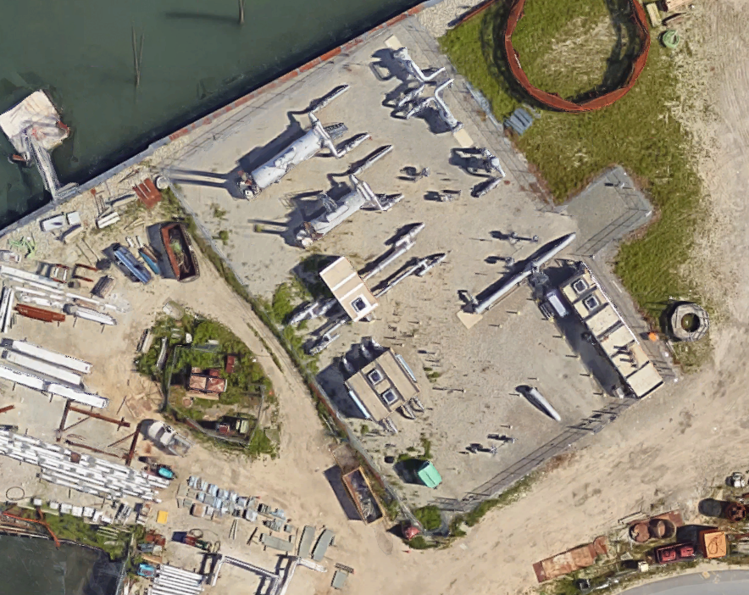
Source: Google Maps Satellite view of existing M&R station.
The proposed compressor station is in the state-designated coastal zone management area and the Commonwealth-designated Weymouth Fore River Designated Port Area. The proposed compressor station location would be situated between an existing sewage pumping facility (MWRA), which serves Braintree, Holbrook, Randolph, and parts of Weymouth, and an electric power plant (Calpine Fore River Energy Center).
The site was historically used as an oil terminal and coal storage facility, which included operations involving the transfer of petroleum products and storage of petroleum in on-site aboveground storage tanks. However, no petroleum storage tank closure records were found for this site.
The topography of the site indicates that grades were raised above natural, pre-existing conditions with a current elevation of the property varying between approximately 12 and 15 feet above sea level. Historical documents, including topographic maps, indicate the site was filled sometime between 1920 and 1936. A Phase 1 Environmental assessment was conducted at the site and revealed two Recognized Environmental Conditions (RECs) and one Historical REC. The two RECs include historic site use (coal, petroleum, and salt storage facility) and historic filling of the site (using coal ash for a fill material), which indicate the presence of hazardous substances and/or petroleum products at the property. As described in the Phase I Environmental Site Assessment, high contaminant concentrations were attributed to the presence of coal ash observed during excavations for borings and test pits. Soil and groundwater samples collected in 1992 indicate the property is underlain by varying amounts of anthropogenic materials (such as brick and wood debris, coal fragments, and coal ash) and contaminants such as arsenic (up to 228 milligrams per kilogram).
At the proposed compressor site, there have been three reported releases or cleanups with two occurring in 2017 as part of the site investigation for the proposed station. More information on reported releases and cleanups in the areas surrounding the station is available in Appendix C.

Energy Facilities Siting Board Agreement
In 1998, Sithe Energy purchased the former Edgar Power Station and proposed to construct a natural gas-fired electric generating facility. The proposal for the new electrical station required application to the Energy Facilities Siting Board (EFSB), which is responsible for reviewing and approving large energy facilities such as power plants, electric transmission lines, and natural gas pipelines within the Commonwealth.
The natural gas-fired electric generating facility was approved in 2000 and, as part of the decision, the EFSB included language that required Sithe to work with the Town of Weymouth, the Fore River Watershed Association and related state agencies to develop plans for additional public access on the northern portion of the land (site of proposed station). In the decision, there is reference to an agreement between Sithe Energy and the Town of Weymouth “to work cooperatively toward a mutually agreeable plan for the future development or use of the northern portion of the site.”
Since that time, the property has been re-purchased three more times with the most recent purchase of the northern portion of the site by Algonquin (now Enbridge).

Recreational and Conservation Lands
Adjacent to the site of the proposed compressor station are the Kings Cove and Lovell’s Grove recreational area. The Kings Cove area is an approximately 3-acre waterfront site with a paved path and benches. It consists of the access road to the MWRA building, a vegetative focus along the shoreline, and the shore of Town River Bay. The site is the subject of a conservation restriction granted to the Town of Weymouth Conservation Commission. The Kings Cove Park property is part of the 16.2-acre parcel purchased for the proposed compressor station but will is not within the construction workspace or on land used for operations of the station.
Lovell’s Grove encompasses approximately one acre with waterfront access, a small grassed area, and benches. It is located under and south of the Fore River Bridge, adjacent to the Fore River Energy Center, approximately 110 feet southwest of the proposed compressor station site. Lovell’s Grove is also subject to a conservation restriction granted to the Town of Weymouth Conservation Commission.
Additional recreational spaces and conservation land are located in the 2km focus area and these areas are described in the Natural Resources section under the Existing Conditions description for the area.

Water Resources
The proposed compressor station site sits along the Fore River. The river is a final portion of a larger watershed and network of water resources which drains nearly 50 square miles and contains freshwater and estuarine characteristics.
In addition to information from the Existing Conditions section, the Fore River is identified by the state’s BioMAP 2 as a Core Habitat (Aquatic Core) and Critical Natural Landscape (Coastal Adaptation Area). The Aquatic Core element indicates the river is identified as an intact river corridor within which important physical and ecological processes occur and serve as ecosystems for fish species and other aquatic Species of Conservation Concern. The entirety of the Fore River is covered by the Aquatic Core designation. However, BioMap2 does not identify species of conservation concern along the river.
The critical landscape designation identifies areas that may be vulnerable to sea level rise and where land may be needed for inward migration of salt marshes. The designated section of the Fore River corresponds to Cadman Conservation Area, a location with several marshes along the river.

Noted earlier (Existing Conditions section), the Fore River has been studied in order to identify changes that could extend herring runs farther up the river and its tributaries. A recent study has proposed removal of several obstructions in order to facilitate fish passage needs and allow the herring run to extend to Great Pond in Braintree.

Ecological Conditions
The shoreline surrounding the site of the proposed compressor station has not been identified as habitat used or suitable to protected species. This includes the piping plover, red knot, or roseate tern or other identified sensitive bird species. Since the issuance of the EA, the U.S. Fish and Wildlife Service (FWS) has issued a concurrence letter stating that the FWS has “no information to refute the no effect determination submitted for those species” (including the piping plover).
Additional information can be found in the Existing Conditions section.

Property Values
Residential property values, as measured by real estate sales, have been mostly increasing in the four municipalities. Since 2000, real estate value (as measure by single family home prices) has risen, fallen and then risen again. Most recently, during the period from 2015 to 2017, each municipality has recorded double digits percentage increases in average and median single family home prices (with the exception of Hingham which had an 8% increase in its median). For 2017, Hingham reported the highest median single family home price ($775,000); Braintree and Quincy had median single family home prices in the high $400,000’s; and Weymouth had a median single family home price of $377,000. In 2017, the median single family home price in Massachusetts was $395,000, according to the Warren Group.
Figure 81. Median Single Family Home Sale Prices 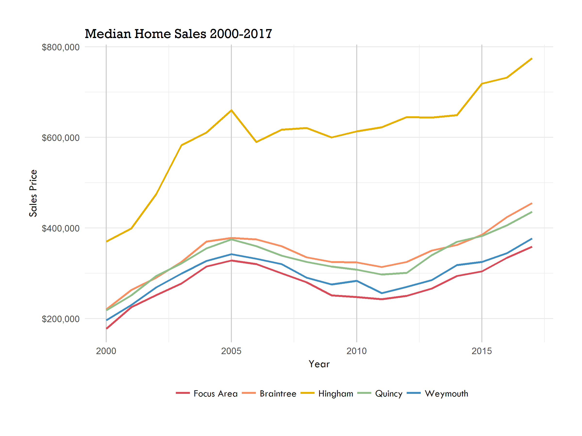
Source: Warren Group
In the focus area, a similar trend exists for increasing single family home prices. As of 2017, the median single family homes price was approximately $370,000, slightly below that of Weymouth. While median prices did increase since 2000, the focus area consistently had the lowest median prices among the different geographies.

Estimated Effects on Land Use and Natural Resources from the Proposed Compressor Station

Construction
The construction of the station, which includes work to tie into the existing M&R station, is proposed to temporarily occupy approximately 13 acres of the 16-acre property.
Construction of the proposed station is stated to employ 75 workers on average and 110 workers during peak construction activities. The proponent assumes that 5% - 27% of personnel will come from the local workforce, which could be up to 30 people during peak construction periods.
Travel to and from the site will include these personnel as well as vehicles transporting construction materials. Access and egress for the site is via driveways along the northbound and southbound lanes of Bridge Street on the southern side of the Fore River Bridge. It is stated that the hours of construction will be from 7am and 6pm with the assumptions that workers at the site will arrive prior to and after these hours.
Tractor trailers will travel to the site initially to deliver equipment (e.g., excavators, bulldozer) needed for site preparation. Concrete trucks are also expected to access the site as part of laying the foundation for the proposed station. It is estimated that the following additional tractor trailer trips will come to the site following site preparation:
- 30 tractor trailer trips for the delivery of construction materials
- 10 tractor trailer trips for the delivery of the station components: the turbine, compressor, intake and exhaust systems
- Regular tractor trailer deliveries of pre-fabricated piping and other material are expected over a four-month periods during construction. These deliveries are expected to occur at varying times and generally should not exceed three per day.
Construction information indicates that trucks accessing the site will be standard-sized tractor trailers with the exception of approximately four oversized, permitted loads, the delivery of which will be coordinated with local and state authorities as required. The Federal limit on the width of commercial motor vehicles is 102 inches (8.5 feet) and the minimum allowable length for a tractor trailer is 48 feet (cab and semitrailer).
Tractor trailer trips to the site are proposed to follow a designated travel route (Construction Vehicle Route Map).
Figure 82. Construction Vehicle Route Map 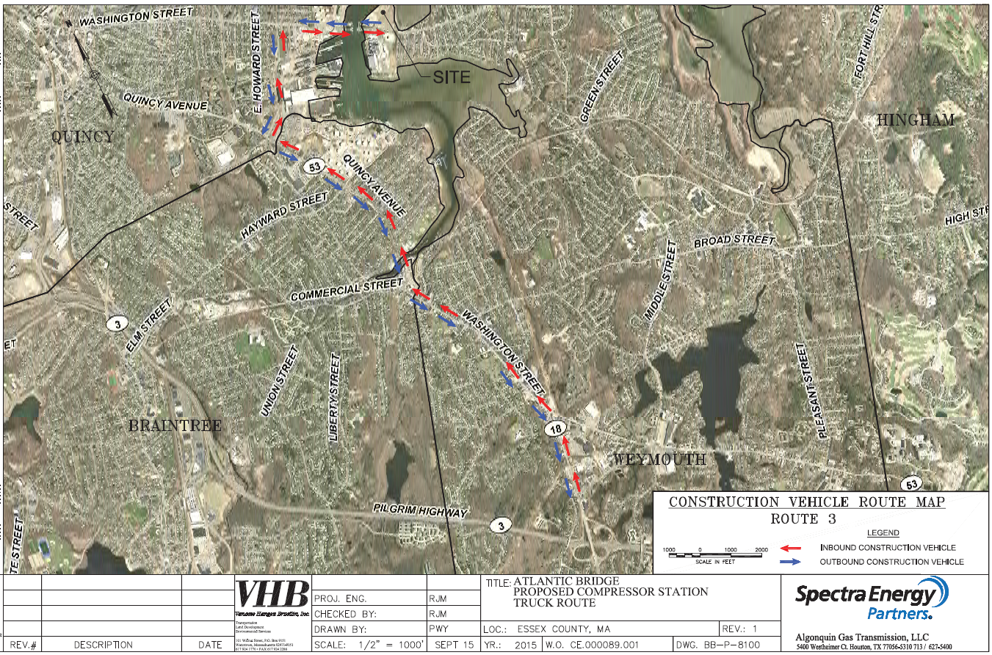
Source: Spectra (Enbridge). Atlantic Bridge Project Resource Report 5: Socioeconomics. 2015.
Construction on the site is expected to involve site disturbance and could produce dust and erosion. The proponent has developed an Erosion and Sediment Control Plan that is designed to control these expected byproducts. The plan provides guidelines for measures to control soil erosion and sediment as well as measures specific to conditions at the site of the proposed station.

The construction is proposed to occur in conformance with the existing activity and use limitation (AUL) for the site. The AUL prevents recreational and residential uses on the site should it be proposed for a reuse and requires the following: control of exposure to subsurface materials by covering historic fill; management of dust from the site; use and disposal of soils; and monitoring of indoor air in the proposed buildings. The AUL follows a regulatory closure of the site that determined the location of oil contamination and that the subsurface materials (e.g., light non-aqueous phase liquid) are not migrating on the site.
Algonquin plans to use drills and augers rather than pile driving to minimize sound and vibration contributions to the surrounding environment, particularly the aquatic environment.

Operations
The operation of the proposed compressor station would constitute a new industrial use in the area. The station facilities are proposed to occupy approximately 4 acres with the remainder of the property (approximately 12 acres) to stay undeveloped and serve as a buffer between the station and the coastline and adjacent waterways. Portions of the undeveloped land will include a required 100 foot wetland buffer setback. A chain link fence is shown to enclose the occupied portion of the property and 0.5 acre of fenced in the wetland buffer along the King’s Cove waterway.
A rendering of the proposed compressor station shows the addition of two new buildings, one which will house a compressor unit and another which will house offices, control rooms, and storage space. Both buildings are presented to be visually similar to the existing MWRA pumping station which is constructed of red brick with black, pitched roofs. The two new buildings are proposed at heights of 45 feet (compressor building at roof peak) and 25 feet (auxiliary building at roof peak) and noted by the proponent to be 30 feet lower than the MWRA pump station building.
The buildings will also sit approximately five feet higher than the existing grade of the site. This would result in the compressor station buildings and the courtyard area sitting at an elevation of approximately 19 feet above sea level. The finished floor elevation of the buildings would be 19.5 feet.
Once operational, it is expected that there will be two full-time operational workers including a mechanic and technician at the proposed compressor station. Their work will be complemented by one full-time engine analyst, who will work on a regional basis for the proponent.
Stormwater on the site is proposed to be treated by installation of several onsite catch basins that will lead to an infiltration basin on the northwestern side of the property. The discharge areas for the stormwater are proposed to be lined with stone to reduce the speed of water flows.
Replanting is proposed for the site. The new plantings include a mixture of trees and shrubs are primarily located along the eastern edge of along the station site boundary with King’s Cove. An existing berm of approximately 19 feet will remain along the eastern edge of the site, located between the proposed plantings and King’s Cove Park.
Figure 83. Proposed Landscaping Plan
Source: Atlantic Bridge (Enbridge). Weymouth Compressor Station: Planting Plan. 2016.
Parking for the proposed compressor station appears to include 10 spaces adjacent to the auxiliary building. There also appears to be three truck bays adjacent to the auxiliary building.
Community Perspectives: Land Use and Natural Resource Impacts
Residents and other participants raised concerns about the siting of the compressor station in the proposed location. Many felt the area was already heavily industrialized, including with energy and manufacturing facilities, and that another industrial use was not desired. For some the proposed compressor station felt like a step backward after many attempts, some successful, to clean up the environment and introduce green spaces in the area like King’s Cove Park.
Participants shared that the surrounding neighborhoods were densely populated and home to potentially vulnerable populations including children and students in nearby schools, older adults, and people with disabilities. They noted that this location was more urban in nature than where current compressor stations are located. Some wondered if this would be a unique siting location for such a station and whether it could set an unfavorable precedent for the siting of other stations.
Participants also noted the general lack of vegetation and green space in the area which affects wildlife habitats. Participants identified the work that has gone into improving water quality and efforts like those of the Fore River Watershed Association to help fish species thrive in the Fore River Basin. Shared by many was a concern for who would be responsible for decommissioning the proposed station should it been damaged by natural hazards or no longer be needed for transporting natural gas.

Characterization of the Impact of Changes to Land Use and Natural Resources on Health
Characteristics of the built and natural environments such as availability of places to walk and green spaces have been linked to behaviors that are health promoting (e.g., physical activity) and to conditions that are health protective (e.g., remediation and removal of hazardous materials). In addition, perceptions of environmental factors have associations with health outcomes as studies have found those living in environments perceived as unhealthy experience higher levels of stress and mental health issues.
The effects of the proposed compressor station on land use and natural resources involve a mixture of direct effects (e.g., new industrial use) and perceptions related to the proposed station as a new industrial land use in the Fore River basin.
The construction plan involves no disruption of subsurface contaminants, conformance with an existing AUL, and an erosion and sediment control plan that provide a protocol to prevent exposure and that offer response plans if an accident with the potential for exposure were to occur. With the exception of an accidental or emergency event, it is not estimated that construction activities will create a risk or affect the health of nearby residents through contamination. The AUL and cleanup activities on the property, which is a brownfield, should be beneficial to community health and limit the potential for future contamination of land and water resources.
Similarly, while construction noise could impact ecological health, the use of drilling (rather than driving piles) for construction minimizes the likelihood that terrestrial and aquatic species would be adversely affected. In addition, protected species have not been noted in the area by public or private sector reviews nor has habitat for such protected species been identified on the site. Consequently, impacts to sensitive species are not expected.
For the operating station, research by FERC and others suggest no impact is expected on property values. Over the period of 2015-2017, during which the station was proposed, there has not been a recorded drop in the value of single family home prices in either the surrounding municipalities or focus area, although the focus area has had lower average prices than the municipalities on the whole. A caveat, though, is that most studies have looked at property values in rural locations.
Given the temporary increase in employment (110 people, with 30 possible local hires, during peak construction) and expected annual Ad Valorem tax, increased economic activity and returns may have potential positive health effects for a limited population. While employment effects will be temporary, additional municipal taxes for the Town of Weymouth could provide resources over time to make changes that increase open space in the area and other changes that protect and promote community health.
The health impact from land use and natural resource changes due to the proposed compressor station is summarized in the impact characterization table at the end of Part 3.

Assumptions and Limitations
The impact assessment is based on available information and as a result there are number of assumptions and limitations involved in the assessment. These are:
- The information was collected from the sources noted in the methods section, which include a mixture of team research in existing studies and science, information developed by the project proponent (Enbridge), and information submitted by the community participants and project advisors. The review was conducted in an expedited fashion so cannot be considered a systematic or comprehensive review although significant efforts were made to collect the most up to date science.
- Data was not found on compressor stations that operate in similarly urban locations.
- At the time of report completion, there are number of pending decisions or finalization of permits related to proposed land use.
- Although there were a number of engagement opportunities, the Advisory Committee and community members believed more engagement with residents in Environmental Justice neighborhoods would have added more contextual information and feedback to inform the assessment.

Summary Impact Tables

Direct Exposure
Estimated air emissions and sound do not exceed health protective regulatory standards and guidelines with the exception of estimated sound levels during construction. Additionally, redevelopment of the proposed site has resulted in Waste Site Cleanup response actions that have resulted in site assessment, prescriptive measures for protecting future workers from exposure to subsurface contamination and an Activity and Use Limitation placed on the property to prevent uses inconsistent with site conditions.
Figure 84. Summary Impact Characterization Table for Direct Exposures
 | Type of Exposure | Geographical Extent of Exposure | Direction of Health Effects | Likelihood of Health Effects | Relative Magnitude of Health Effect | Vulnerable Populations
Air Quality | Direct Exposures | Local (within focus area) | Neutral | Unlikely | Very Low | No
Noise | Direct Exposures | Local (within focus area) | Negative (during construction)/  Neutral (during operation) | Possible (during construction)/  Unlikely (during operation) | Low (during construction)/  Very Low (during operation) | Yes
Land Use and Natural Resources | Direct Exposures | Local (within focus area) | Neutral | Unlikely | Very Low | No

Other Mechanisms
The estimated new air emissions, sound levels and land use and natural resource changes could have potential health effects through other mechanisms including increased stress among residents in surrounding areas and changes in perception about use of outdoor spaces and real estate property values. These perceptions could potentially contribute to residents’ feelings of uncertainty and lack of control, which have been associated with negative mental health effects. Perceptions of environmental factors have association with health outcomes as studies have found those living in environments perceived as unhealthy can experience higher levels of stress and mental health issues.
Figure 85. Impact Characterization Table for Other Mechanisms
 | Type of Exposure | Geographical Extent of Exposure | Direction of Health Effects | Likelihood of Health Effects | Relative Magnitude of Health Effect | Vulnerable Populations
Other Mechanisms | Indirect/ Perceived | Community-wide (focus and surrounding areas) | Negative | Uncertain | Uncertain | Yes

Air Quality
The estimated new emissions may have potential health effects through other mechanisms. These include the role of perception and sense of place. For perception, negative health impacts may occur through a perceived increase in and perceived effects of emissions coming from the proposed station. The perceptions are likely to be present in the focus area as well as the surrounding communities based on feedback from participants and stakeholders in the process.
Health impacts may occur through increased levels of stress and reduced comfort in use of outdoor spaces, particularly resulting in less physical activity occurring in recreation and conservation land close to the proposed station. Health impacts may occur due to changes in wealth due to how people value residential and commercial real estate near the station site; while research to date suggests drops in real estate value do not occur, none of the research has occurred in more urban settings such as in Weymouth where the compressor station is proposed.
There are vulnerable populations who could be more susceptible to other mechanisms of health impacts. Existing mothers and older adults have been found to be more sensitive to perceived changes, particularly changes that are felt to be environmental hazards to those who are developing or already have weakened health systems.

Noise
Health impacts could occur through perceived increases in and perceived effects of noise coming from the proposed station. If so, there may be people who report health issues due to the station and the potential for property owners to experience lower market values for their properties.
It is not likely that the entire community would be affected by or perceive changes in the sound level. Those who live in the focus area will experience higher ambient noise due to construction during daytime hours and due to operations during daytime and nighttime hours. Noise impacts, if any, will therefore be localized to areas in close proximity to the site (i.e., focus area).
There are vulnerable populations proximate to the site. In Quincy, there are residents who live in identified environmental justice neighborhoods, which include the Germantown and Quincy Point neighborhoods. Projected changes in sound levels are expected to be below health protective thresholds at these locations based on available data. There are six schools in the focus area but none are expected to be disrupted during school hours given projected changes in ambient sound levels and distance between the schools and the construction activities and operations associated with the proposed compressor station.

Land Use and Natural Resources
Construction activities are likely to impact the recreational experience of community members. According to the cited Building Research Establishment study, residents feared physical risks to health from pollution and dust, among other environmental factors, during construction. If users of King’s Cove Park and Lovell’s Grove are directly influenced by the construction activities or perceive effects due to their proximity to the construction site, this perception may reduce or prevent physical activity and social interactions in these spaces.
Equally, when in operation, the presence of the station may depress levels of physical activity in the two recreation areas. The proponent does plan to construct buildings that are architecturally and materially similar to the existing MWRA building; however, the new use will be apparent with connections to the M&R station and fencing of the property. Proposed landscaping, if maintained over time, does have the potential to buffer the proposed use and increase exposure to green space.
There are vulnerable populations who could be more susceptible to other mechanisms of health impacts from changes in the land use and natural resources. These include people of color and people with lower incomes who can already experience health inequities and along with others, may experience a reduced feeling of ownership or control of the area given the opposition to the proposed station.

Note
The impact tables reflect the assessment based on available information regarding the proposed compressor station as proposed through November 2018. Should changes be proposed such as an expansion of the station (e.g., additional compressors), the assessment would not reflect the new proposal and would have to be revised and updated with new information. If this were to occur, there is potential for the assessed impacts to change.

Part 4: Potential Actions and Community Recommendations

Summary of Findings
The HIA estimates that were a natural compressor station to be constructed as proposed, there could be a potential mix of neutral and negative impacts on public health, primarily through mechanisms other than direct exposure, in areas immediately around the station and in the four surrounding municipalities. The assessment looked specifically at three pathways to make estimates: air quality, noise, and land use and natural resources.
The estimates are based on a review of current evidence and science, demographic, land use and health data, input from stakeholders and available information about estimated changes to be produced by the proposed station. The estimates rely on literature and research from the fields of health, land use and natural resources, and unconventional natural gas development; uses existing conditions data on health behaviors and risk factors, hospitalizations, and social determinants of health; and has been informed by input and advice from experts from the health care fields, environmental and community health sectors, HIA practitioners, stakeholders, and representatives from the impacted communities, in particular the project Advisory Committee.
The HIA characterizes impacts using quantitative data as much as possible to assist in predicting potential health impacts. In some cases, primary or independently collected data was available (e.g., MassDEP air monitoring) and in other instances the HIA used data that was the result of materials developed by the project proponent, such as expected air and noise emissions from the station. If more time and resources were available for the HIA there is the potential that independent analyses could have been conducted to produce this data. However, as with many HIAs and with other project review processes, secondary data produced by a proponent was used and most, if not all, of the data cited was reviewed and checked by regulatory agencies prior to acceptance.
To note, the assessment focused on the proposed compressor station as an individual project, not on its role or functions in larger pipeline expansion projects or in the context of the development of natural gas infrastructure across New England or the US.

Context for Potential Actions
Potential actions recommended through an HIA are intended to promote positive health impacts associated with a proposed change and to identify possible mitigating actions that will address assessed negative health impacts.
Through HIA, a goal is that recommended actions should:
- Flow from the results of the assessment.
- Be based on public health principles of harm avoidance.
- Be evidence-based.
- Both mitigate harms and enhance health benefits.
- Be specific and actionable.
- Be useable by those who must implement them.
These were used a guiding considerations in developing and proposed the set of potential actions that follow.

Potential Actions Related to Proposed Compressor Station
The primary focus of the potential actions relates to a pending MassDEP air quality plan decision. The MassDEP, in accordance with its air pollution control regulations, must determine if the proposed facility will meet all applicable regulatory requirements. If a proposal meets all requirements, then MassDEP must permit the facility. MassDEP may include permit conditions on its approval.
The potential actions below are proposed as conditions were a permit to be granted for the proposed compressor station.
Figure 86. Air Permit Actions
Potential Action | Rationale and Impact
Enhanced Construction Management | Construction of the compressor is predicted to potentially introduce new air emissions and to produce sound levels above recommended EPA guidelines for outdoor noise. These emissions, particularly noise, are very likely to affect or influence users of the King’s Cove Park. The proponent should have an assigned and available point person during the construction phase to respond to noise and air emission issues. In addition, a complaint telephone line that residents can call should be made available and a log kept of calls made and issue identified. The result would be more resident awareness of changes occurring on the site which would relieve pressure on the municipal public health staff since nuisance issues could be sent directly to the proponent.
Enhanced Blowdown Alert System | A health, as well as safety, concern is the blowdowns that would occur at the station. These include the planned maintenance blowdowns as well as the emergency blowdowns. The proponent should be required to develop and disseminate a plan for communicating when blowdowns are expected to occur. The plan should include alerts via email and text to municipal staff and interested residents. Alerts should provide at least 72 hour notice of the planned blowdowns and occur immediately when an emergency blowdown takes place. In addition, the proponent should have to issue a report that documents the length of time, contents, and noise level registered for the blowdowns. The enhanced system could assist in addressing local concerns about air and noise pollution and would provide a reliable mechanism for checking for regular compliance of the station.
Use of Enhanced Leak Detection | Require infrared detection to supplement the required leak detection and repair program. The enhanced detection would address concerns about potential impacts from fugitive emissions related to the compressor station. Fugitive emissions were a concern related to perceptions of increasing air pollution levels in and around the Fore River Basin.
Additional Site Plantings and Maintenance Plan and Improved Fence Design | The Town of Weymouth has favored a change that would expand green space, water access and the overall outdoor appearance of the site of the proposed station. The new use would introduce planting but these would be primarily located on the eastern side of the site. In order to introduce more greenery the proponent should be required to introduce more vegetation around the site, primarily the southern and western edges of the property. A maintenance plan, with dedicated annual funding, should be developed for the plantings so that existing vegetation is supported and so that there is replacement of vegetation that does die off. The current proposed chain link fencing should also be replaced with wrought iron or more architecturally attractive security fencing.

While not addressed in the HIA, public safety is an issue of concern for residents and municipal officials, particularly those involved with public safety and emergency response. These safety concerns do have potential health consequences: injury, disruption of daily activities, and health care services, among others. For more information on the safety-related process, please contact the Massachusetts Executive Office of Public Safety and Security.

Potential Actions: Environmental and Health Conditions
The secondary focus of potential actions relates to environmental and health conditions that were identified through the HIA.
The proposed station is subject to federal and state regulations that are intended to protect public health; however, the regulations can be limited in scope or not take a holistic view of public health. The limitations do not have to constrain other potential actions that may be possible in a broader public health context, related to industrial development in the Fore River Basin.
These potential actions are offered more broadly to address existing environmental and health conditions identified through the HIA process:
Figure 87. Actions to Address Environmental and Health Conditions
Potential Actions | Rationale and Impact
Installation of an Air Quality Monitor | There are no existing air quality monitors in the Fore River Basin and the nearest current monitor is located in Boston. Installation of an air quality monitor in Weymouth would monitor pollutants of concern to provide information about changes in air quality that could affect risks to the residents in the Fore River Basin.
Promotion of secondhand smoking laws and outreach to support smoke-free workplaces and housing programs to reduce tobacco-associated cancers and COPD | Given the connection with COPD and many of the elevated cancers to use of tobacco, enhanced collaboration between local boards of health, tobacco-free community partnerships and the MDPH Bureau of Community Health and Prevention’s Tobacco Cessation and Prevention Program could help reduce risk factors in the municipalities, particularly Quincy and Weymouth.
Dissemination of radon testing information to the public, testing of radon at schools and public buildings to reduce lung cancer risk, and assessment of indoor air quality at schools to reduce pediatric asthma | Radon is the second leading cause of lung cancer and the leading cause among non-smokers. Increased support for Local Health Departments in Braintree, Quincy, and Weymouth to encourage radon testing in homes and make residents aware that they can seek advice on testing their home for radon through MDPH Bureau of Environmental Health’s Indoor Air Quality Program and Radon Unit would help reduce the incidence of lung cancer. Direct assistance from MDPH/BEH’s IAQ Program for testing indoor air and radon at schools and public buildings would reduce lung cancer risk and mitigate conditions that may exacerbate asthma.
Promotion of health risk reduction behaviors to reduce chronic diseases and improve respiratory health, notably among children in Weymouth | A proportion of the population assessed through the HIA appears to experience respiratory health issues more than others in the state. There is an opportunity to leverage local wellness initiatives and provide additional resources to community health centers to support individuals and families, particularly those with children in Weymouth, to manage and prevent respiratory health issues. Increased support for the MDPH Bureau of Community Health and Prevention’s Mass in Motion Program would assist in promoting conditions conducive to health promoting behaviors.

Community Perspectives: Recommendations
Advisory committee members, as well as other community members, were asked for recommendation ideas based on the assessment. While a starting common position for most was a recommendation to abandon the project, many did provide ideas for recommendations, which were used to develop the potential actions in the report. A number of other community recommendations are highlighted below:
- Install a public deep sea fishing pier and expand the walking path around the entire waterway on the site.
- Set financial penalties for Enbridge that must be paid when air emission exceedances occur or when there are leaks above set thresholds. A portion of penalties should be directed back to the municipalities.
- Conduct more frequent stack emission testing for stationary air emission sources in the Fore River Basin.
- Adopt local regulations that set more conservative (health protective) thresholds for noise and air emissions.
- Develop an Enhanced Monitoring and Reporting Emissions Program whereby the proponent details a protocol for monitoring air emissions and noise levels, reporting exceedances and documenting actions taken to address them.
- Create a decommissioning plan that details how the station would be retired from operations and the owner’s responsibility to address equipment or materials that might constitute an environmental hazard.
- Conduct independent site monitoring through a 3rd party contractor on a regular basis to document regular compliance of the station.

Conclusion
The HIA of the proposed natural gas transmission compressor station in Weymouth predicted no substantial changes in health from direct exposures from the station itself with the exception of estimated sound levels during construction. However, the assessment predicts that negative changes may be possible through other mechanisms, such as an increased perception of risk in the surrounding areas related to perceived pollution levels and less comfort with using nearby outdoor space.

U.S. Global Change Research Program. Impacts, Risks, and Adaptation in the United States: Fourth National Climate Assessment, Volume I - Chapter 14, Human Health. November, 2018.
National Institute of Environmental Health Sciences. Health Impacts: Climate and Human Health. 2018.
EPA. Greenhouse Gas Emissions – Overview of Greenhouse Gases: Methane Emissions. 2018
US Energy Information Administration. Natural Gas: US Natural Gas Consumption. 2018.
US Energy Information Administration. Natural Gas Explained: Factors Affecting Natural Gas Prices. 2017.
US Energy Information Administration. Natural Gas Explained: Where Our Natural Gas Comes From. 2017.
US Energy Information Administration. Frequently Asked Questions: How much shale gas is produced in the United States. 2018.
US Energy Information Administration. Data: Natural Gas Prices, October 2018. 2018.
US Energy Information Administration. Natural Gas Explained: Factors Affecting Natural Gas Prices. 2017.
International Energy Agency. Key Natural Gas Trends 2017. 2018.
US Department of Energy. Natural Gas Infrastructure Implications of Increased Demand from the Electric Power Sector. 2015.
The pipeline runs from Mahwah, New Jersey to Beverly, Massachusetts.
Enbridge. Update to Non-Major Comprehensive Plan Approval Permit Application: Algonquin Gas Transmission, LLC – Weymouth Compressor Station. May 2018.
Information on the coastal resilience review submitted to the Office of Coastal Zone Management can be found on the project website (www.foreriverhia.com) and information regarding the public safety work can be requested from the Executive Office of Public Safety and Security (eopssinfo@state.ma.us).
Materials from the HIA Advisory Committee Meetings and the two Community Meetings are available on the project website: www.foreriverhia.com.
The community organizations were asked for Advisory Committee recommendations in response to a request from state-elected officials representing the four communities.
The Public Safety pathway also was identified as a priority by the Advisory Committee but is being dealt with separately under the Governor’s directive.
Pathway diagrams and explanations are provided in Part 3: Impact Assessment.
Grey literature consists of sources produced outside the traditional academic or commercial publishers and is not peer reviewed. Examples include reports, theses, conference proceedings, working papers, and government documents.
Latinx is a gender-neutral term and is comparable to use of Latino and Latina (Non-white Hispanic).
An overview of the current built and natural environment is provided here as context for the area where the proposed compressor station would be cited. Much of the information included in this section is also relevant to and referenced in the Land Use and Natural Resources impact assessment and pathway.
Based on Massachusetts Department of Elementary and Secondary Education enrollment data for public schools and SchoolDigger data for private schools.
Executive Office of Energy and Environmental Affairs. Waste Site & Reportable Releases: https://eeaonline.eea.state.ma.us/portal#!/search/wastesite
Boston Harbor Watersheds Water Quality and Hydrologic Investigations. June 2003.
https://www3.epa.gov/region1/npdes/stormwater/ma/305b303dMaps/Boston_MA.pdf
TMDL refers to the identification of a maximum amount of a pollutant that a body of water can receive while still meeting water quality standards. It is designated with the purpose of restoring an impaired water body.
http://www.mass.gov/eea/docs/dep/water/resources/07v5/16ilwplist.pdf
Massachusetts Division of Marine Fisheries. River Herring Spawning and Nursery Habitat Assessment: Fore River Watershed 2008-2010. February 2015.
These data are statistical estimates calculated by MDPH based on the Behavioral Risk Factor Surveillance System Survey.
In order to provide data for more Massachusetts communities, town level estimates are included that may be based on relatively few respondents or have standard errors that are larger than average. When a cell is has a red accent, the confidence interval for this community is wider than the normal limits set by MDPH. Therefore, the estimate for this town should be interpreted with caution.
Centers for Disease Control and Prevention, National Center for Health Statistics Mortality in the United States, 2016. https://www.cdc.gov/nchs/products/databriefs/db293.htm
MA EPHT website: www.mass.gov/dph/matracking
Based on research by the Massachusetts Cancer Registry (MCR, 2013), which included an evaluation of the reliability of the tobacco use history information reported to the MCR, it appears that the category of “never smoker” is less reliable than other reporting categories (such as current or former smoker). Many individuals are reported as never having smoked when, based on medical record reviews, they are individuals who are not current smokers but whose past tobacco use is unknown. These individuals should more accurately be reported as having an unknown tobacco use history rather than being categorized as never having used tobacco products. This misclassification is expected to result in an overestimate of those categorized as “never smokers” and an underestimate of those categorized as “former smokers.” Massachusetts Cancer Registry. 2013. "CDC/CER Innovative Uses of Cancer Registries for Public Health Applications: Primary Payer at Diagnosis Data Quality Evaluation for Invasive Colorectal and Breast Cancer Cases in the Massachusetts Cancer Registry (MCR) from 2005 to 2009." MCR Fall Educational Workshop. December 5, 2013.
Agency for Toxic Substances and Disease Registry (ATSDR). 2007. ToxFAQs for Benzene. Atlanta, GA: U.S. Department of Health and Human Services, Public Health Service. https://www.atsdr.cdc.gov/toxfaqs/tf.asp?id=38&tid=14
Agency for Toxic Substances and Disease Registry (ATSDR). 1999. ToxFAQs for Formaldehyde. Atlanta, GA: U.S. Department of Health and Human Services, Public Health Service. https://www.atsdr.cdc.gov/toxfaqs/tf.asp?id=219&tid=39
Periodic planned station equipment blowdowns occur for maintenance or safety purposes. Source: https://www.epa.gov/sites/production/files/2016-06/documents/redesignblowdownsystems.pdf
Enviroware AERMOD: https://www.enviroware.com/aermod/
EPA. Hazardous Air Pollutants: Health Effects Notebook for Hazardous Air Pollutants. 2018; Roman, H., et al. Expert Judgment Assessment of the Mortality Impact of Changes in Ambient Fine Particulate Matter in the U.S. Environmental Science & Technology, 2008; Health Effects Institute. Revised Analyses of Time-Series Studies of Air Pollution and Health. 2003;
Criteria pollutants are also considered regional pollutants that travel long distances. As such, sources located in other states can impact air quality Massachusetts.
A third category of particulate matter is Ultrafine Particulates (UFP), which are smaller than PM_{2.5} and have an evidence base of associated health effects. For reference, Ultrafine Particle Metrics and Research Considerations: Review of the 2015 UFP Workshop.
Dockery, D., et al. An Association Between Air Pollution and Mortality in Six U.S. Cities. New England Journal of Medicine, 1993; Pope, C. A. Particulate Air Pollution as a Predictor of Mortality in a Prospective Study of U.S. Adults. American Journal of Respiratory and Critical Care Medicine, 1995.
Goldberg, M., et al. The Association Between Daily Mortality and Ambient Air Particle Pollution in Montreal, Quebec: 1. Nonaccidental Mortality. Environmental Research, 2001.
Zanobetti, A. and J. Schwartz. The Effect of Particulate Air Pollution on Emergency Admissions for Myocardial Infarction: A Multicity Case-Crossover Analysis. Environmental Health Perspectives, 2005.
Peters, A. et al. Increased Particulate Air Pollution and the Triggering of Myocardial Infarction. Circulation, 2001.
MassDEP. Ground-Level Ozone. 2012.
Ibid
EPA. Sulfur Dioxide (SO₂) Pollution: What are the harmful effects of SO_{2.} 2018.
World Health Organization. Air quality guidelines for Europe, 2nd Edition: Sulfur dioxide. 2000.
Wang L., et al. Associations between short-term exposure to ambient sulfur dioxide and increased cause-specific mortality in 272 Chinese cities. Environment International, 2018.
EPA. Sulfur Dioxide (SO₂) Pollution: What are the harmful effects of SO_{2.} 2018.
EPA. Integrated Science Assessment for Carbon Monoxide. 2010.
Ibid.
Ibid.
EPA. Integrated Science Assessment for Oxides of Nitrogen — Health Criteria. 2008.
Ibid.
Subset of TELs and AALs included in air toxics modeling for the proposed compressor station.
Nazmi, Aet al. Cross-sectional and longitudinal associations of neighborhood characteristics with inflammatory markers: Findings from the multi-ethnic study of atherosclerosis. Health Place, 2010.
Hazlehurst, M. et al. Individual and Neighborhood Stressors, Air Pollution and Cardiovascular Disease. International Journal of Environmental Research and Public Health, 2018; Ailshire, J. et al. Neighborhood Psychosocial Stressors, Air Pollution, and Cognitive Function among Older U.S. Adults. Social Science & Medicine, 2017; Shmool, J. et al. Social stressors and air pollution across New York City communities: a spatial approach for assessing correlations among multiple exposures. Environmental Health, 2014.
The Weymouth station is proposed to include one 7,700 hp natural gas-fired turbine-driven compressor unit.
EPA. Natural Gas STAR Program: Overview of the Oil and Natural Gas Industry. 2018.
Environmental Health Project. Summary on Compressor Stations and Health Impacts. 2015.
The INGAA Foundation, Inc. How The Regulatory Process Protects Those Living Near Natural Gas Transmission Compressor Stations. 2016.
Concerned Health Professionals of New York and Physicians for Social Responsibility. Compendium of Scientific, Medical, and Media Findings Demonstrating Risks and Harms of Fracking. 2018.
Payne, B. F. et al. Characterization of methane plumes downwind of natural gas compressor stations in Pennsylvania and New York. Science of the Total Environment, 2017.
Zavala-Araiza, D., et al. Reconciling divergent estimates of oil and gas methane emissions. Proceedings of the National Academies of Science, 2015.
Rich, A., et al. An exploratory study of air emissions associated with shale gas development and production in the Barnett Shale. Journal of the Air & Waste Management Association, 2014.
Russo, P. N., & Carpenter, D. O. Health effects associated with stack chemical emissions from NYS natural gas compressor stations, 2008-2014. 2017.
Agency for Toxic Substances and Disease Registry. Health Consultation: Brooklyn Township PM2.5, Brooklyn Township, Susquehanna County, Pennsylvania. 2016.
Macey, G. P., et al. Air concentrations of volatile compounds near oil and gas production: a community-based exploratory study. Environmental Health, 2014.
Based on a 3-year rolling average.
The most recent statewide monitoring results and trends are summarized in MassDEP’s 2017 Air Quality Reports available at https://www.mass.gov/lists/massdep-air-monitoring-plans-reports-studies.
Sampling and analysis was performed in accordance with EPA Method TO-15 “Compendium of Methods for the Determination of Toxic Organic Compounds in Ambient Air”
The alpha-numeric designations for each location are used in the laboratory reports submitted by Alpha Analytical that are available at www.foreriverhia.com.
Available at https://www.mass.gov/service-details/algonquin-natural-gas-compressor-station-weymouth
Based on monitoring data from MassDEP’s Boston Von Hillern Street near-road NO₂ monitoring station.
Noise is defined as generally defined as unwanted sound; EPA has a recommended an outdoor level of 55 decibels and indoor level of 45 decibels as thresholds that prevent annoyance and interference with daily activities. Source: EPA. Information on Levels of Environmental Noise Requisite to Protect Public Health and Welfare with an Adequate Margin of Safety (PDF). 1974.
EPA. Clean Air Act Overiew: Clean Air Act Title IV - Noise Pollution. 2018.
EPA. Information on Levels of Environmental Noise Requisite to Protect Public Health and Welfare with an Adequate Margin of Safety. 1974.
WHO. Burden of disease from environmental noise Quantification of healthy life years lost in Europe. 2011.
National Institute for Occupational Safety and Health (NIOSH). Noise and Hearing Loss Prevention. 2018.
EPA. Information on Levels of Environmental Noise Requisite to Protect Public Health and Welfare with an Adequate Margin of Safety. 1974.
MassDOT. Type I and Type II Noise Abatement Policy and Procedures. 2011
WHO. Guidelines for Community Noise. 1999.
Beutel, M. et al. Noise Annoyance Is Associated with Depression and Anxiety in the General Population- The Contribution of Aircraft Noise. PLoS One, 2016.
Institute of Medicine (US) Committee on Sleep Medicine and Research. Sleep Disorders and Sleep Deprivation: An Unmet Public Health Problem, 2006.
WHO. Guidelines for Community Noise. 1999.
Münzel, T. et al. The Adverse Effects of Environmental Noise Exposure on Oxidative Stress and Cardiovascular Risk. Antioxidants & Redox Signaling, 2018.
Babish W. Transportation noise and cardiovascular risk: updated review and synthesis of epidemiological studies indicate that the evidence has increased. Noise & Health, 2006
Baliatsas, C. et al. Health effects from low-frequency noise and infrasound in the general population: Is it time to listen? A systematic review of observational studies. Science of the Total Environment, 2016.
Leventhall, HG.Low frequency noise and annoyance. Noise & Health, 2004.
Baliatsas, C. et al. Health effects from low-frequency noise and infrasound in the general population: Is it time to listen? A systematic review of observational studies. Science of the Total Environment, 2016.
Waye, K. Effects of Low Frequency Noise and Vibrations: Environmental and Occupational Perspectives. Noise and Health, 2011.
Ibid.
Leventhall, HG.Low frequency noise and annoyance. Noise & Health, 2004.
WHO. Guidelines for Community Noise. 1999.
Boyle et al. A pilot study to assess residential noise exposure near natural gas compressor stations. PLOS ONE, April 2017.
Barber, J. et al. Anthropogenic noise exposure in protected natural areas: estimating the scale of ecological consequences. Landscape Ecology, 2011.
Hessler Associates, Inc. Survey of Community Sound Levels Enbridge Burrillville Gas Compressor Station.2018.
The Massachusetts Department of Transportation follows noise abatement criteria (NAC) set by the Federal Highway Administration. The NAC provides sounds levels that when exceeded can be mitigated by introduction of measures such as noise barriers. Land Use Category B refers to land uses that are primarily residential in nature and has a L_{eq}(h) of 67 dB(A).
Town of Weymouth/RSG Review of Proposed Plan Approval for Algonquin Gas Transmission, LLC, April 2017.
Update to Non-Major Comprehensive Plan Approval Application, Algonquin Gas Transmission, LLC – Weymouth Compressor Station, October 2018.
Hemispherical sound propagation: when a source is located on a flat continuous plane/surface (e.g., ground), sound radiates hemispherically from the source.
Enbridge. Update to Non-Major Comprehensive Plan Approval Application, Transmittal No. X266786 - Application No. SE-15-027: Algonquin Gas Transmission, LLC – Weymouth Compressor Station. 2018
Ibid.
Ibid
Ibid
Epsilon Associates, Inc. Weymouth Compressor Station – Infrequent Sound Sources And Site Elevation memorandum. November 2018.
Ibid.
Ibid.
County Health Rankings and Roadmaps. What and Why We Rank: County Health Rankings Model. 2018.
Sallis, J. et al. Co-benefits of designing communities for active living: an exploration of literature. International Journal of Behavioral Nutrition and Physical, 2015.
Stigsdotter, U. et al. Health Promoting Outdoor Environments--associations Between Green Space, and Health, Health-related Quality of Life and Stress Based on a Danish National Representative Survey. Scandinavian Journal of Public Health, 2010.
Jim, C Y, and W. Chen. Assessing the Ecosystem Service of Air Pollutant Removal by Urban Trees in Guangzhou (China). Journal of Environmental Management, 2008.
Stanton, W. et al. Primary Prevention of Skin Cancer: a Review of Sun Protection in Australia and Internationally. Health Promotion International, 2004
Kuo, F. and W. Sullivan. Environment and Crime in the Inner City Does Vegetation Reduce Crime?” Environment and Behavior, 2001.
Mireia Gascon, et al. Outdoor blue spaces, human health and well-being: A systematic review of quantitative studies. International Journal of Hygiene and Environmental Health, November 2017 ; Sebastian Völker and Thomas Kistemann. The impact of blue space on human health and well-being – Salutogenetic health effects of inland surface waters: A review. International Journal of Hygiene and Environmental Health, November 2011.
Bell, Siânde, et al. The importance of nature in mediating social and psychological benefits associated with visits to freshwater blue space. Landscape and Urban Planning, November 2017; Sebastian Völker and Thomas Kistemann. Developing the urban blue: Comparative health responses to blue and green urban open spaces in Germany. Health & Place, September 2015.
Mireia Gascon, et al. Outdoor blue spaces, human health and well-being: A systematic review of quantitative studies. International Journal of Hygiene and Environmental Health, November 2017
National Center for Environmental Health. Healthy Places Terminology. 2013.
US EPA. EPA. Brownfields: Public Health and Health Monitoring. 2006.
Agency for Toxic Substances and Disease Registry. Leading Change for Healthy Communities and Successful Land Reuse. 2010.
Congressional Research Service. Regulating Coal Combustion Waste Disposal: Issues for Congress. 2010.
Hye-Jin Paek and Thomas Hove. Risk Perceptions and Risk Characteristics. Oxford Research Encyclopedias: Communication, 2017.
Ashley Shepherd, et al. Risk Perceptions of Environmental Hazards and Human Reproduction: A Community-Based Survey. International Scholarly Research Network, September 2011.
Kondo, Michelle, et al. Place-based stressors associated with industry and air pollution. Health &Place, March 2014.
Schneiderman, Neil, Gail Ironson, and Scott D. Siegel. Stress and Health: Psychological, Behavioral, and Biological Determinants. Annual Review of Clinical Psychology, October 2008.
Ibid.
McKinnon W, et al. Chronic stress, leukocyte subpopulations, and humoral response to latent viruses. Health Psychology, 1989.
Peek, MK. Environmental hazards and stress: evidence from the Texas City Stress and Health Study. Journal of Epidemiological Community Health, October 2009.
Vaz Eric, Michael Cusimano, and Tony Hernandez. Land use perception of self-reported health: Exploratory analysis of anthropogenic land use phenotypes. Land Use Policy, July 2015.
Hallman WK and AH Wandersman. Attribution of responsibility and individual and collective coping with environmental threats. Journal of Societal Issues, 1992.
Downey, Liam and Marieke Van Willigen. Environmental Stressors: The Mental Health Impacts of Living Near Industrial Activity. Journal of Health and Social Behavior, September 2005.
http://projects.bre.co.uk/productive_workplace/pdf/ImpactsOfConstruction.pdf
US Centers for Disease Control and Prevention. Health, United States, 2011: With Special Feature on Socioeconomic Status and Health. 2012.
Herbert, C. et al. Is Homeownership Still an Effective Means of Building Wealth for Low-income and Minority Households? (Was it Ever?). Joint Center for Housing Studies Harvard University, 2013.
Hansen, J. et al. Environmental Hazards and Residential Property Values: Evidence From a Major Pipeline Event. Land Economics, 2006.
Ibid.
US FERC Docket Nos. CP16-9-001 CP16-9-008. Order on Rehearing, 2017; Fruits, E. The Impact of the Presence of a Natural Gas Pipeline on Residential Property Values. Social Science Research Network Journal, 2008.
Foster, S. A Study of Natural Gas Compressor Stations and Residential Property Values. 2016.
Federal Highway Administration. Noise: Construction Noise Handbook. 2006.
Concerned Health Professionals of New York and Physicians for Social Responsibility. Compendium of Scientific, Medical, and Media Findings Demonstrating Risks and Harms of Fracking. 2018.
Concerned Health Professionals of New York and Physicians for Social Responsibility. Compendium of Scientific, Medical, and Media Findings Demonstrating Risks and Harms of Fracking. 2018.
Bernath-Plaisted, J. et al. Conventional oil and natural gas infrastructure increases brown-headed cowbird relative abundance and parasitism in mixed-grass prairie. Royal Society Open Science, 2017.
Francis et al. Landscape patterns of avian habitat use and nest success are affected by chronic gas well compressor noise. Landscape Ecology, 2011; Barber et al. Anthropogenic noise exposure in protected natural areas: estimating the scale of ecological consequences. Landscape Ecology, 2011.
See Existing Conditions section of Part III for additional Land Use and Natural Resource information surrounding the proposed compressor location.
Town of Weymouth Zoning Ordinance, https://www.ecode360.com/30091162
Spectra (Enbridge). Atlantic Bridge Project Resource Report 8: Land Use, Recreation, and Aesthetics.2015.
Algonguin Gas Transmission, LLC. (Enbridge). Atlantic Bridge Project: Environmental Assessment. 2016.
Energy Facilities Siting Board. Final Decision, EFSB 98-7. 2000.
Ibid.
Spectra (Enbridge). Atlantic Bridge Project Resource Report 8: Land Use, Recreation, and Aesthetics.2015.
Spectra (Enbridge). Atlantic Bridge Project Resource Report 8: Land Use, Recreation, and Aesthetics.2015.
Massachusetts Department of Fish & Game. BioMap2: Conserving the Biodiversity of Massachusetts in a Changing World. 2010.
Massachusetts Division of Marine Fisheries. River Herring Spawning and Nursery Habitat Assessment: Fore River Watershed 2008-2010. 2015.
US FERC Docket Nos. CP16-9-001 CP16-9-008. Order on Rehearing, 2017.
See Appendix F for full table with single, 2-, and 3-family and condominium sales data
Algonguin Gas Transmission, LLC. (Enbridge). Atlantic Bridge Project: Environmental Assessment. 2016.
Ibid
Ibid
Spectra (Enbridge). Atlantic Bridge Project Resource Report 5: Socioeconomics. 2015.
U.S. Department of Transportation, Federal Highway Administration. Federal Size Regulations for Commercial Motor Vehicles. February, 2017.
Spectra (Enbridge). Atlantic Bridge Project Resource Report 5: Socioeconomics. 2015.
Spectra (Enbridge). Atlantic Bridge Project Resource Report 1. 2015.
Resource Report 8 – Land Use, Recreation, and 8-28 Atlantic Bridge Project
Atlantic Bridge (Enbridge). Weymouth Compressor Station: Planting Plan. 2016.
Atlantic Bridge (Enbridge). Weymouth Compressor Station: Planting Plan. 2016.
For definitions see Impact Characterization Definitions at beginning of Part 3.
Based on recommendation success factors adapted from adapted from the book Health Impact Assessment in the United States (2014).

