Program: | AQEIP / MQEIP / MBHV-QEIP
Performance Year: | 2
Deliverable: | Health Quality and Equity Strategic Plan
Submission Portal: | OnBase
Submission Due Date: | December 31, 2024
File Naming Convention: | EntityAbbreviation_HQEStrategicPlan_YYYYMMDD
Suggested Page Limit: | 10 pages

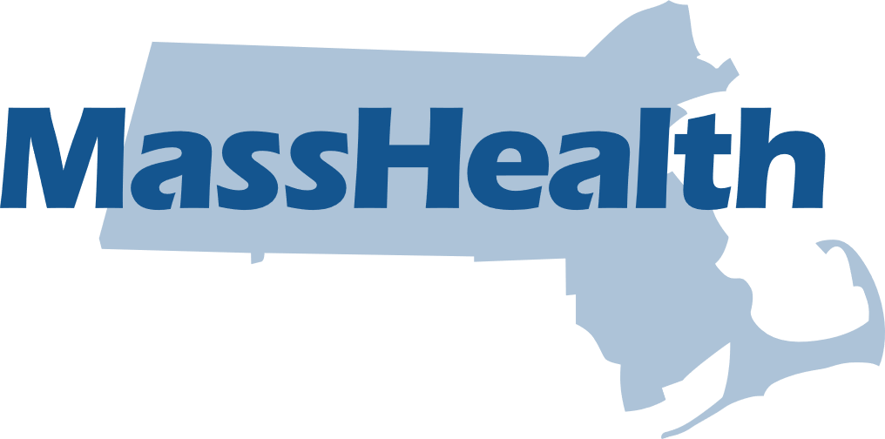

MassHealth ACO, MCO, and MBHV Quality and Equity Incentive Program (AQEIP, MQEIP, and MBHV-QEIP)

Introduction
The QEIP requires, among other things, that individual ACOs/MCOs/MBHV complete and submit to MassHealth this Health Quality and Equity Strategic Plan (hereinafter, the “Strategic Plan”), which connects to important components of the QEIP. This Strategic Plan serves as an opportunity for individual ACOs/MCOs/MBHV to create and update a plan that guides their implementation and continuous quality improvement of health quality and equity activities over the next four years. To ensure an equitable and community-driven plan, ACOs/MCOs/MBHV should collaborate with their Health Quality and Equity Committee to develop their Strategic Plan.
MassHealth encourages individual ACOs/MCOs/MBHV to consider doing the following activities as part of the planning process: key planning sessions and meetings with the Health Quality and Equity Committee, the Patient and Family Advisory Committee (PFAC), other methods of soliciting patient input, and providers representing the population served by the organization such as other community hospitals, other community-based providers, Community Partners, members, and members’ families.
The Performance Year (PY) 2 Reconciliation Payment is contingent upon completion and submission of the Strategic Plan.

Instructions
Each organization will submit a Health Quality & Equity Strategic Plan deliverable annually. While some overlap amongst entities in an ACO/MCO health system is expected and acceptable, each individual organization must respond to the Strategic Plan prompts included in this Strategic Plan Update template (the “Template”) at the individual ACO/MCO, unless otherwise indicated. Individual ACOs/MCOs/MBHV may cite relevant information from existing strategic plans or other relevant sources that directly pertains to prompts in this Template. Additionally, information submitted can be broader than activities within the QEIP; however, the information should explicitly consider the MassHealth population.
There are 6 sections that will need to be completed, as well as two appendices. Your response to each individual question must not exceed 500 words. See below for breakdown of sections.

- Section 1: Strategic Plan Process
- Section 2: Needs Assessment
- Section 3: Health Equity Strategic Goals
- Section 4: Commitment to Equity
- Section 5: Committees
- Section 6: External Community Engagement

Appendix A: HRSN Referral Annual Plans (and HRSN Services Plans)
Appendix B: HRSN Screening

This Strategic Plan Update is to be completed, in accordance with this Template, by each individual ACO/MCO/MBHV and submitted to MassHealth by December 31, 2024. All completed Strategic Plans must be submitted via OnBase.

Contact Information
Point of Contact Name: | Add text
Organization Name: | Add text
Point of Contact Email Address: | Add text

Section 1: Strategic Plan Process
Please remember that your response to each individual question must not exceed 500 words.
- Please provide a link to your published Executive Summary from your PY1 Strategic Plan on your website.

Link:
- Please describe the process used for implementing, reviewing, and improving the PY1 Health Quality & Equity Strategic Plan and related strategic planning efforts that have contributed to this plan over the past year. Please make sure to specify the involvement of the Health Quality and Equity Committee.

Section 2: Needs Assessment
Please remember that your response to each individual question must not exceed 500 words.
- Please describe how you continue to assess the health equity needs of your MassHealth members and include the date and year you carried out a Population and Community Needs Assessment (PCNA) or any other needs assessments. The answer must include the date and year of an upcoming PCNA or any other needs assessment. Note: this answer must be unique to the individual ACO/MCO named on this Strategic Plan.

- Over the past year, what have you learned about the MassHealth population you serve and the communities in which they live?
To illustrate this:
- Please provide clear, concise, and readable MassHealth data that summarize and stratify your organization’s population served by RELD SOGI. We DO NOT want member level data or data that could inadvertently identify someone.
- Where possible, stratify your organization’s population served by town or zip code level population data.
- Please ensure that you explain how the data supports your response.
- Please also include a brief description of the significant health needs of your MassHealth patients, inclusive of physical, social and behavioral health needs.
- In the past year, in what ways have you designed and implemented new services or adapted existing services to address the inequities you’ve identified through the data summarized above in Question 3? Your response may reference PIP related activities and services, but you do not need to replicate content that is captured in PIP deliverables.
- Did your individual ACO/MCO/MBHV identify any environmental health/climate concerns during the PCNA? If so, please provide a description of how your organization defines “environmental health” and describe the identified concerns.
- How has your individual ACO/MCO/MBHV considered environmental health/climate concerns as a factor in differences in health and health care quality outcomes? If you have not considered environmental health factors yet, what are current barriers you are facing in beginning to think about the impact of the environment on health outcomes?

Section 3: Health Equity Strategic Goals
Please remember that your response to each individual question must not exceed 500 words.
- Have any of your goals been modified from PY1, if so, please specify how the goal changed and provide the rationale? If there are no changes, you must indicate “No changes have been made.”
- What are your top 3 high-level health equity strategic goals for PY3 (calendar year 2025)? These goals may relate to your PIPs if applicable and can go beyond the QEIP requirements. Should they relate to your PIPs, you do not need to replicate content that is captured in the PIP deliverables. Discussing at a high-level what the goals are suffices. Please specify whether any of these goals are informed by your most recent PCNA. Please specify whether any of these goals are informed by your most recent PCNA.
- For each high-level strategic goal, please complete the table below with the anticipated milestones in the PY3 to make progress towards the goal.

High-Level Goals | Milestones
- Goal #1
- Goal #2
- Goal #3

- For each high-level strategic goal, please complete the table below with anticipated barriers for each goal and potential solutions to overcome that barrier.

High-Level Goals | Barriers | Potential Solutions
- Goal #1
- Goal #2
- Goal #3

Section 4: Commitment to Equity
Please remember that your response to each individual question must not exceed 500 words.
- Has your definition of health equity changed since PY1? If no, you must write “no changes.” If so, what is the new definition? What are the key changes?
- Has your individual ACO/MCO/MBHV public statement of commitment to equity changed since your last submission? If it has changed, you must include it below. If there are no changes, you must indicate “No changes have been made.”
  - If your individual ACO/MCO/MBHV did not have a public statement of commitment to equity in PY1, please provide it here.
- Please select below which teams are contributing to health equity at your organization.
☐ Executive Senior Leadership
☐ Clinical Teams
☐ Performance Improvement
☐ Quality
☐ Population Health
☐ Care/Case Management
☐ Patients
☐ PFAC
☐ HQEC
☐ Community Based Organizations
☐ BH and LTSS Community Partners
☐ Other (please describe)
- At your individual ACO/MCO/MBHV, how has your organizational structure related to implementing QEIP changed since the start of the program? Please describe any staffing challenges that have impacted your organizational structure.

- Please describe how health equity has been or will be integrated into internal organizational policies and procedures individual ACO/MCO/MBHV. Internal policies and procedures may include business operations, human resources, professional development, and organizational management.

- Please describe how health equity has been or will be integrated in external policies and procedures individual ACO/MCO/MBHV. External policies and procedures may include marketing strategies, enrollment and disenrollment, member and provider outreach, utilization management, and the Flexible Services program.

Section 5: Committees
Please remember that your response to each individual question must not exceed 500 words.
Patient and Family Advisory Committee (PFAC)

- How many participants currently serve on the PFAC?
- How many of the participants are MassHealth members?
- How many of the participants are guardians, caregivers, or family members of MassHealth members?

- Please describe your approach to recruitment.

- What recruitment strategies have been most successful?

  - What recruitment strategies have not worked as well?

- How did you select members for participation?

- Do you offer any supports or incentives to participants? If yes, select all that apply:

☐ Transportation to/from meetings
☐ Free parking
☐ Meals/snacks
☐ Childcare (including onsite, vouchers, or other reimbursement)
☐ Gift cards
☐ Stipends
☐ Laptops or other technology for virtual participation (please describe)
☐ Other (please describe)

- What accommodations do you provide for participants?
- Are interpreter services offered to participants whose first language is not English? If yes, please describe.

- How are agendas determined for meetings?

- How have you adapted the implementation of your strategy based on PFAC feedback? Please provide specific examples.

- Please identify and describe any best practices for engaging MassHealth members on the committee.

- What has been the most challenging aspect of setting up and managing this committee? Please describe.
Health Quality & Equity Committee (HQEC)
- Do you have a combined HQEC across health system or is it separate? If combined, please complete this section once for your system and make sure to reference which entity submitted the completed section.

- How many participants currently serve on the HQEC?
- How many of the participants are MassHealth members?
- How many of the participants are front-line staff members?
- Please list any other types of HQEC participants such as advocates, providers, and other stakeholders.

- Please describe your approach to recruitment.

- What recruitment strategies have been most successful?

  - What recruitment strategies have not worked as well?
  - How did you select members for participation?

- Do you offer any supports or incentives to participants? If yes, select all that apply:

☐ Transportation to/from meetings
☐ Free parking
☐ Meals/snacks
☐ Childcare (including onsite, vouchers, or other reimbursement)
☐ Gift cards
☐ Stipends
☐ Laptops or other technology for virtual participation (please describe)
☐ Other (please describe)

- What accommodations do you provide for participants?

- Are interpreter services offered to participants whose first language is not English? If yes, please describe.

- How are agendas determined for meetings?

- How has the HQEC informed the health equity implementation and strategy at your organization? Please provide specific examples.

- What has been the most challenging aspect of setting up and managing this committee? Please describe.

Section 6: External Community Engagement
Please remember that your response to each individual question must not exceed 500 words.
- How are you engaging with community-based organizations and neighboring areas separate from the PCNA, PFAC and HQEC? Please list any relevant organizations you are working with.
- How have you adapted the implementation of your health equity strategy based on MassHealth member and community feedback? Your answer must include specific examples. Please identify whether the change in strategy was also suggested by participants on the PFAC and HQEC.

Appendix A: HRSN Referral Annual Plans & HRSN Services Plans
(Note: not required for MCOs or MBHV. MCOs and MBHV may skip this appendix)
One of MassHealth’s key goals in this demonstration period is to advance health equity by focusing on initiatives that address the Health-Related Social Needs (HRSN) of members. ACOs will annually submit to MassHealth a detailed “HRSN Referral” plan for how they intend to refer beneficiaries to services to address unmet HRSNs, inclusive of connecting eligible members HRSN Services (including the Specialized Community Supports Program (CSP) programs, Flexible Services Program), other benefits/entitlements that address unmet HRSNs, and other relevant supports. The HRSN Referral plans must also describe how ACOs will be able to report, upon MassHealth request, on HRSN referrals by their staff, contractors, or partners. In these HRSN Referral plans, ACOs must ensure that the HRSN services are provided to members in ways that are culturally appropriate and trauma-informed.
Additionally, MassHealth’s HRSN Services (including Specialized Community Supports Program and Flexible Services) aim to address the housing and nutrition needs of certain, eligible members. ACOs are expected to utilize the HRSN Services in order to improve members’ health and advance health equity. On an annual basis, starting with Rate year 2025, ACOs will be required to submit a post-year equity analysis based on access to these services in the new HRSN framework (details forthcoming).
- Please describe your ACO’s HRSN Referral Plan. The Plan should include:
- how beneficiaries will be referred to services to address unmet HRSNs;
- how you will utilize existing MassHealth benefits including Specialized CSP as well as other entitlement programs to address unmet HRSNs;
- how you will utilize the Flexible Services Program to address unmet HRSNs; and
- how you will ensure that HRSN services are provided to members in a way that is culturally appropriate and trauma-informed.
- At MassHealth’s request, how will you be able to report upon HRSN referrals conducted by your staff, contractors, and other partners, including whether services were delivered, and whether the unmet HRSNs were addressed?
- Describe how your ACO is utilizing the Flexible Services Program and Specialized CSP Services as a tool to advance health equity? Please include details about risk factors (i.e., experiencing homelessness, risk of homelessness, risk for nutritional deficiency or imbalance) being addressed by these programs.
- How will your ACO ensure equitable access to the HRSN Services regardless of race, ethnicity, language, disability, sex, sexual orientation, and gender identity and address potential disparities in access and outcomes?
- How will your ACO ensure equitable access for children to the Flexible Services Program and address potential disparities in access and outcomes?
- How will your ACO ensure services provided are culturally appropriate (e.g., food options are appropriate) and trauma informed?

Appendix B: HRSN Screening
(Note: not required for MCOs or MBHV. MCOs and MBHV may skip this appendix)
MassHealth and ACOs participating in the QEIP are incentivized to meaningfully improve rates of health-related social needs (HRSN) screening of its beneficiaries and establish the capacity to track and report on screenings and referrals.
The questions in this section assess your organization’s capacity and plans to systematically capture HRSN screening in performance year 3 (PY3 2025) of the QEIP.
- Will your organization have the capacity to track HRSN screenings using any of the following CPT administrative codes¹? Please answer “yes” or “no” for each item.

 | Yes | No
- CPT M1207
- CPT M1208
- CPT M1237
- HCPCS G0136

- Will your organization have the capacity to report HRSN screenings using any of the following CPT administrative codes? Please answer “yes” or “no” for each item.

 | Yes | No
- CPT M1207
- CPT M1208
- CPT M1237
- HCPCS G0136

- Will your organization have the capacity to track HRSN screenings using ICD-10 codes²?
  - Yes
  - No

- Will your organization have the capacity to report HRSN screenings using ICD-10 codes²?
  - Yes
  - No

- Please describe any challenges your organization is encountering related to your capacity to track and report administrative codes for HRSN screenings in PY3. And how you plan to address challenges related to your capacity to track and report administrative codes for HRSN screenings in PY3.

- Please describe any challenges your organization is encountering related to your capacity to track and report HRSN screenings using supplemental data in PY3. And how you plan to address challenges related to your capacity to track and report HRSN screenings using supplemental data in PY3.
1. CPT and HCPCS codes are the administrative data utilized to calculate rate 1 of the QEIP HRSN screening measure.
2. ICD-10 codes are the administrative data utilized to calculate rate 2 of the QEIP HRSN screening measure. A complete list of ICD-10 codes is provided in the QEIP HRSN screening measure specifications.

