Health Safety Net Eligibility Processes
FY2015

Introduction

The Executive Office of Health and Human Services (EOHHS) hereby submits this report to the Massachusetts Legislature in compliance with Section 65 of M.G.L. Chapter 118E as established by Section 131 of Chapter 224 of the Acts of 2012. Section 65 requires EOHHS to provide an annual report evaluating the processes used to determine eligibility for Health Safety Net (HSN) reimbursable health services. Specifically, Section 65 calls for:

- An analysis of the effectiveness of these processes in enforcing eligibility requirements for publicly-funded health programs and in enrolling uninsured residents into programs of health insurance offered by public and private sources;
- An assessment of the impact of these processes on the level of reimbursable health services by providers; and
- Recommendations for ongoing improvements that will enhance the performance of eligibility determination systems and reduce hospital administrative costs.

This report provides the required evaluation and illustrates that service utilization has declined since the implementation of Massachusetts health care reform in 2006. Through continued coordination and collaboration with MassHealth and the Health Connector (Connector), HSN will continue to realize improvements to the eligibility systems that support it.

Health Safety Net Eligibility Background

The HSN was created by Chapter 58 of the Acts of 2006 as the successor to the Uncompensated Care Pool (UCP). The HSN, like its predecessor, serves as a safety net for uninsured and underinsured Massachusetts residents by reimbursing acute care hospitals and community health centers (CHCs) for allowable services. Some of the HSN’s key eligibility policies include:
- Individuals may be eligible for the HSN if they are uninsured or underinsured and document family income between 0% and 400% of the federal poverty level (FPL).
  - Uninsured individuals with family income up to 200% of the FPL may be eligible for HSN Primary.
  - Individuals with incomes between 0% and 200% of the FPL who are enrolled in insurance programs with limited benefits (such as MassHealth Limited) may be eligible for HSN Secondary.
  - Uninsured and underinsured individuals with family income between 200.1% and 400% of the FPL may be eligible for HSN Primary Partial or Secondary Partial, which includes a deductible based on the patient’s income.
- HSN Secondary is available to enrolled ConnectorCare members for dental services not covered by their managed care plan, as long as the member is otherwise HSN eligible.
- The HSN may also pay for eligible services provided to members of other Qualified Health Plans (QHPs) offered by the Connector that are not covered by their primary insurance, as long as the member is otherwise HSN eligible.
- The HSN provides temporary eligibility to individuals determined eligible for ConnectorCare during enrollment “gap” periods, which include the 10 days prior to a patient’s application, and a period of time after submission of their application, in order to allow sufficient time to complete the enrollment process.
- The HSN may pay for emergency or urgent care bad debt at acute hospitals or Community Health Centers (CHCs) in cases where a provider is unable to collect payment from a patient after pursuing collection activity for a specified time period. Bad debt payments are only made for individuals who were uninsured and had no HSN eligibility at the time the services were provided.
- Individuals enrolled in MassHealth programs that provide comprehensive benefits, such as MassHealth Standard, are eligible only for certain dental services not covered by MassHealth.
- Some individuals may qualify for other types HSN eligibility under certain special circumstances. These patients make up a very small component of the HSN caseload.
  - The HSN has a Medical Hardship program, which reimburses allowable medical expenses for services provided to patients who have medical bills that exceed a specified proportion of their income. This is a retrospective eligibility type, for services delivered up to 12 months before the application date.
  - HSN Confidential is a program for minors seeking treatment for sexually transmitted diseases and/or family planning services, and for survivors of domestic violence who have a reasonable fear of domestic violence. Providers may only submit claims for confidential services when no other source of funding is available to pay for the services confidentially. This eligibility type must be renewed annually with the assistance of a provider.

Enforcement of Eligibility Requirements

Eligibility Determinations
Due to systems issues beginning in January 2014 and continuing into calendar year 2015 related to implementation of the Affordable Care Act (ACA), the Commonwealth was unable to accurately determine many applicants’ eligibility in many cases. These systems issues impacted eligibility determinations for MassHealth, Connector programs, and the Health Safety Net. In order to provide coverage at this time, the Commonwealth delayed annual redeterminations, temporarily extended certain coverage types such as the Commonwealth Care program, and enrolled many new applicants who did not have other coverage into temporary MassHealth coverage.

As a result of these systems issues, the Health Safety Net was unable to determine eligibility using its normal eligibility processes in many cases during this time. Many applicants who may have been determined eligible for the HSN were determined into one of the temporary coverage types. Applicants who may have been determined into ConnectorCare and received HSN gap eligibility for a period of time may have been placed into temporary coverage as well.

Over the course of calendar year 2015, MassHealth and the Connector worked to determine eligibility to place members into their appropriate, non-temporary coverage types. The Connector discontinued the Commonwealth Care program and MassHealth ended its Temporary coverage program in early 2015.

MassHealth is engaged in the process of completing the redetermination process for all existing members, including HSN members. New applicants, and MassHealth and ConnectorCare members who were redetermined, are now being successfully determined eligible for the Health Safety Net or are receiving HSN Secondary as applicable.

Current State of Eligibility System
There have been major improvements to the eligibility system, which are now able to accurately determine eligibility for the MassHealth, Connector programs, and the HSN in most cases. As outlined above, the HSN provides gap eligibility to patients in subsidized Connector programs until they enroll in a plan. After enrollment, the HSN continues to pay for dental services provided to these patients. To accomplish this, patients who are eligible for both programs receive both a Connector determination and an HSN determination after applying for coverage. Due to system constraints, the Commonwealth’s Eligibility Verification System (EVS) is unable to differentiate between individuals who have HSN only and those who have HSN Secondary to ConnectorCare or a Qualified Health Plan (QHP). Providers have been advised to check with patients and in third party systems to determine if a patient has other coverage before billing the HSN. The HSN continues to actively work with MassHealth and the Connector to develop and implement system updates that will allow Connector plan eligibility and enrollment information to be displayed in EVS.

The Commonwealth has made improvements to its eligibility determination system in preparation for the Connector’s 2016 Open Enrollment period. Though all current Connector members must be redetermined during Open Enrollment, in 2016 for the first time, renewal forms will be automatically prefilled for current members. Members whose income and other information has not changed will not need to take action to remain on their plan as long as they continue to pay their premiums. Members who do need to update their application will be able to do so themselves, rather than requiring the assistance of a customer service representative. In addition, new applicants will be able to seamlessly submit applications online, on paper, or by phone. Each of these improvements streamlines the application and reenrollment process, reducing churn and gaps in coverage. A similar streamlined process will be implemented by MassHealth in early 2016. As patients maintain uninterrupted insurance coverage, demand for HSN gap eligibility may decline.

Claims Processing
With the exception of bad debt claims, all HSN claims must be for services provided to patients with HSN eligibility. In Health Safety Net FY08, an HSN claims adjudication system was developed at the Health Safety Net Office that began matching all non-emergency bad debt HSN claims to an HSN-eligible patient prior to payment, leaving no paid claims unmatched. The Health Safety Net Office receives a regular feed of eligibility data from the Medicaid Management Information System (MMIS), MassHealth’s claims processing system. This data feed allows the claims adjudication system to immediately deny claims that cannot be matched to an HSN-eligible patient. The eligibility feed has also allowed the system to properly adjudicate bad debt claims, as claims for insured or HSN-eligible patients do not qualify for bad debt reimbursement.

The state fiscal year 2012 budget (Chapter 68 of the Acts of 2011) required the HSN to transition its claims processing to MMIS by July 2012. The first phase of this transition occurred on July 15, 2012 for all medical claims. The transition allowed HSN claims to pass through the full range of claims editing available in MMIS, including edits to capture duplicate claims, medically unnecessary services, medically unlikely services, and incorporating correct coding initiative edits. However, MMIS is currently unable to run full HSN eligibility edits or price HSN claims. Therefore, some eligibility editing continues to occur outside of MMIS using the same eligibility data used by the legacy medical claims adjudication system. Pricing also continues to occur outside of MMIS due to differences in HSN and MassHealth pricing methodologies. Discussions are underway regarding moving these functions into MMIS, although an implementation timeline has not been established.

HSN pharmacy claims are processed and priced using MassHealth’s Pharmacy Online Processing System (POPS). POPS is able to process HSN pharmacy claims because the HSN pays for prescription drugs using the same rates that MassHealth uses.

Starting in SFY17, MassHealth’s dental vendor is also expected to begin processing and pricing HSN dental claims. Currently, HSN dental claims are processed directly by the HSN. The HSN Office has been actively involved in the preparation and ongoing procurement of a vendor to ensure a smooth transition for dental claims processing. The system will both adjudicate and price dental claims for the HSN using MassHealth edits and pricing logic that will already exist in the system, reducing the need for manual processes and increasing overall claims processing efficiency.

Identifying Other Available Insurers
The HSN serves as a payer of last resort for eligible providers of services to patients who are unable to obtain affordable health coverage through other sources. As such, the HSN does not make payments to providers if another payment source is available. To ensure compliance with these principles, the HSN has implemented the following program integrity measures:
- The HSN uses a common application and eligibility system to ensure that eligibility policies are applied consistently between the HSN, MassHealth, and the Connector.
- The eligibility systems that HSN providers access communicate HSN eligibility and cost sharing policies within the systems constraints referenced above.
- The Health Safety Net Office contracts with a vendor to identify paid HSN claims for which an insurance payment or payment from a legal settlement is available, and to recover HSN funds prior to the insurance or settlement payment. During HSN Fiscal Year 2015 to date, the vendor recovered $829,122 on behalf of the HSN.
- The Health Safety Net Office also contracts with a vendor that reviews paid inpatient primary claims to determine whether another payer was available on the date of service, and to recommend the recovery of payment in cases where the provider did not appropriately bill the primary payer prior to billing the HSN. During HSN Fiscal Year 2015, over $100,000 has been recovered to date as a result of the review process.

Verification of Income and Eligibility
Income is verified by MassHealth during the eligibility determination process. If an applicant reports income, then income verification is required before an eligibility determination is made. Income verification may be in the form of a match to a federal data hub, or documentation such as recent pay stubs or a recent tax return. MassHealth also performs regular data matches with the Department of Revenue and other data sources on all eligible individuals with a Social Security Number in order to verify wage information.

As explained above, eligibility is also verified for each HSN claim before it is paid. HSN Primary and Secondary claims are run through eligibility logic during the adjudication process to ensure that the member is known to the MMIS system and has HSN eligibility on the date of service. For Bad Debt claims, the system ensures that no eligibility is present on the date of service before allowing the claim to pass.

The HSN also has a grievance process in place for patients who believe they received an inaccurate eligibility determination, or would like to dispute an action taken by the HSN or a provider. HSN staff promptly responds to patients, with most grievances resolved in a single business day. For more complicated cases, collaboration with other state offices and agencies may be required, but patients receive regular updates until a resolution is reached.

Encouraging Enrollment in Other Available Insurance Programs
Section 65 of MGL Chapter 118E requires the Health Safety Net Office to “develop programs and guidelines to encourage maximum enrollment of uninsured individuals who receive health services reimbursed by the fund into health care plans and programs of health insurance offered by public and private sources.” Since the implementation of this requirement in 2006, the Health Safety Net Office has undertaken varying initiatives to encourage patients to enroll in available, affordable insurance plans.

In October 2007, when the HSN replaced the Uncompensated Care Pool, approximately 48,000 Commonwealth Care-eligible individuals had not yet enrolled in Commonwealth Care. Between October and December of 2007, these individuals were informed that their HSN eligibility would end after a period of time sufficient to complete the Commonwealth Care enrollment process. All Commonwealth Care-eligible individuals were subsequently removed from the HSN between December 2007 and February 2008.

As a result of the Affordable Care Act, many patients who previously were eligible only for the HSN have become eligible for other programs. Under the ACA, a new coverage type called MassHealth CarePlus was created to cover certain patients with incomes up to 133% of the FPL who were not previously eligible for Medicaid. MassHealth Standard also became available to certain HSN patients between 19 and 20 years of age in this income range. On January 1, 2014, approximately 30,000 HSN patients were transitioned into MassHealth Standard and CarePlus coverage. The ACA also expanded subsidies to individuals from 300-400% of the FPL through advanced premium tax credits (APTCs). APTCs can be applied to the cost of Qualified Health Plans offered by the Connector to reduce the premium amounts paid by members who may have only been eligible for HSN in the past.

Impact of HSN Eligibility Policies on the Level of Total HSN Demand from Providers

The effects of HSN eligibility requirements and other changes related to health care reform are reflected in UCP/HSN payment and demand statistics. Demand from hospitals and CHCs reflects the impact of policies on overall utilization of HSN reimbursable services.

As seen in Figure 1, UCP/HSN demand declined by 40 percent between Uncompensated Care Pool Fiscal Year 2007 (UCP07), the last year of the UCP, and Health Safety Net Fiscal Year 2008 (HSN08), the first year of the HSN. HSN demand has gradually increased between HSN09 and HSN12. This increase may be due to economic factors and coverage changes in other programs, including coverage changes for certain dental and inpatient services in the MassHealth program. Demand in HSN13 decreased, though this was driven by claims processing adjustments, rather than by a decrease in actual demand for services. As health care costs rise across the Commonwealth, HSN demand has been relatively stable since 2012. An analysis of HSN demand data for FY15 is not yet complete as the HSN is still receiving and processing claims for this time period.

HSN Total Demand and Payment Trends (Figure 1)
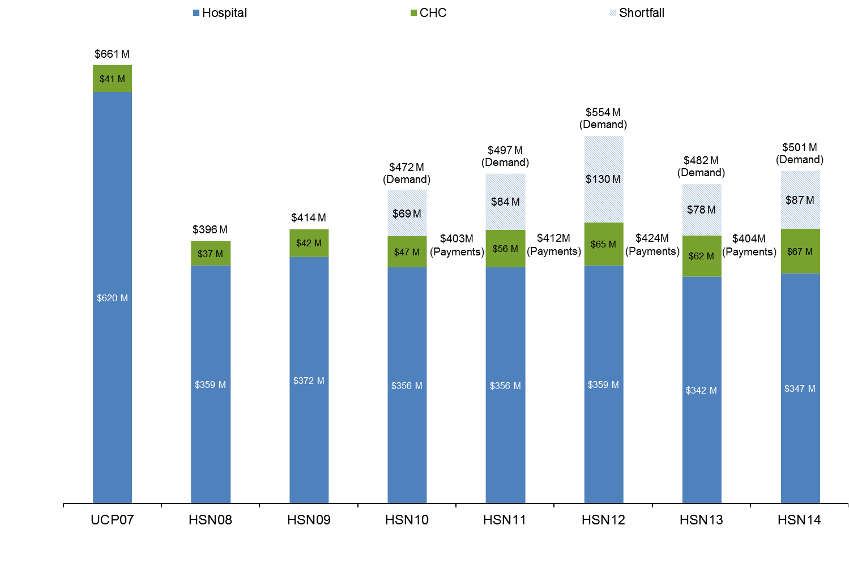

Recommendations for Ongoing Improvement
The Health Safety Net Office continues to work collaboratively with MassHealth and the Connector to implement the Affordable Care Act. The Health Safety Net Office will continue to collaborate with state agencies on enhancements to the new eligibility system and determination processes. The HSN plans to prioritize the following improvements for FY16:
- Complete redeterminations for all HSN-eligible patients.
- Continue to improve written notices to ensure clear communications about eligibility, including that HSN should only be used if no other coverage is available.
- Utilize ConnectorCare and other QHP enrollment data to improve communication around patient eligibility and to improve claims processing eligibility logic for members eligible for ConnectorCare.
- Simplify deductible calculations and resume assigning deductibles based on the new methodology.

The Health Safety Net Office will continue to collaborate with state agencies on additional systems and program integrity improvements.

