Massachusetts Department
Of
Public Health

Bureau of Environmental Health,
Community Assessment Program

Health Statistics Review of Asbestos-Related Diseases in Three Massachusetts Communities with Potential Human Exposure to Vermiculite Ore

July 2008

Table of Contents

I. Executive Summary 1
II. Introduction 8
III. Background 9
IV. Methods 10
A. Data Sources 11
1. Incidence Data 11
2. Mortality Data 13
B. Geographic Distribution 15
C. Statistical Analyses 17
1. Calculation of a Standardized Incidence Ratio (SIR) 17
2. Interpretation of a Standardized Incidence Ratio (SIR) 17
3. Calculation of a Standardized Mortality Ratio (SMR) 18
4. Interpretation of a Standardized Mortality Ratio (SMR) 19
5. Calculation of a Standardized Rate Ratio (SRR) 20
6. Calculation of the 95% Confidence Interval 21
D. Review of Risk Factor Information 22
V. Results 24
A. Billerica 24
1. Asbestos-Related Cancer Incidence in the Town of Billerica (Table 1) 25
2. Asbestos-Related Cancer Incidence in Billerica Census Tracts (Tables 1A and 1B) 26
3. Review of Cancer Incidence Risk Factor Information 27
4. Asbestos-Related Mortality in the Town of Billerica (Table 2) 29
5. Asbestos-Related Mortality in the Billerica Census Tracts (Table 2A-2C) 30
6. Review of Mortality Risk Factor Information 32
7. Geographic Distribution 34
8. Summary 35
B. Cambridge 36
1. Asbestos-Related Cancer Incidence in the City of Cambridge (Table 3) 37
2. Asbestos-Related Cancer Incidence in Cambridge Census Tracts (Table 3A – 3H) 38
3. Review of Cancer Incidence Risk Factor Information 39
4. Asbestos-Related Mortality in the City of Cambridge (Table 4) 41
5. Asbestos-Related Mortality in Cambridge Census Tracts (Tables 4A – 4O) 41
6. Review of Mortality Risk Factor Information 44
7. Geographic Distribution 46
8. Summary 47
C. Easthampton 49
1. Asbestos-Related Cancer Incidence in the Town of Easthampton (Table 5) 49
2. Asbestos-Related Cancer Incidence in Easthampton Census Tracts (Table 5A) 50
3. Review of Cancer Incidence Risk Factor Information 50
4. Asbestos-Related Mortality in the Town of Easthampton (Table 6) 51
5. Asbestos-Related Mortality in the Easthampton Census Tracts (Table 6A) 52
6. Review of Mortality Risk Factor Information 53
7. Geographic Distribution 53
8. Summary 54
VI. limitations 55
VII. Conclusions 57
VIII. recommendations 61
ReferenceS 62
TABLES 64
FIGURES 101
Appendix A 105
Appendix B 107
Appendix C 109
Appendix D 145
Appendix E 161

TABLES

Table 1. Asbestos-Related Cancer Incidence – Billerica
Table 1A. Asbestos-Related Cancer Incidence – Billerica Census Tracts 3161-3164
Table 1B. Asbestos-Related Cancer Incidence – Billerica Census Tracts 3165
Table 2. Asbestos-Related Cancer Mortality – Billerica
Table 2A. Asbestos-Related Cancer Mortality – Billerica Census Tracts 3161-3162
Table 2B. Asbestos-Related Cancer Mortality – Billerica Census Tracts 3163-3164
Table 2C. Asbestos-Related Cancer Mortality – Billerica Census Tracts 3165
Table 3. Asbestos-Related Cancer Incidence – Cambridge
Table 3A. Asbestos-Related Cancer Incidence – Cambridge Census Tracts 3521-3524
Table 3B. Asbestos-Related Cancer Incidence – Cambridge Census Tracts 3525-3528
Table 3C. Asbestos-Related Cancer Incidence – Cambridge Census Tracts 3529-3532
Table 3D. Asbestos-Related Cancer Incidence – Cambridge Census Tracts 3533-3536
Table 3E. Asbestos-Related Cancer Incidence – Cambridge Census Tracts 3537-3540
Table 3F. Asbestos-Related Cancer Incidence – Cambridge Census Tracts 3541-3544
Table 3G. Asbestos-Related Cancer Incidence – Cambridge Census Tracts 3545-3548
Table 3H. Asbestos-Related Cancer Incidence – Cambridge Census Tracts 3549-3550
Table 4. Asbestos-Related Cancer Mortality – Cambridge
Table 4A. Asbestos-Related Cancer Mortality – Cambridge Census Tracts 3521-3522
Table 4B. Asbestos-Related Cancer Mortality – Cambridge Census Tracts 3523-3524
Table 4C. Asbestos-Related Cancer Mortality – Cambridge Census Tracts 3525-3526
Table 4D. Asbestos-Related Cancer Mortality – Cambridge Census Tracts 3527-3528
Table 4E. Asbestos-Related Cancer Mortality – Cambridge Census Tracts 3529-3530
Table 4F. Asbestos-Related Cancer Mortality – Cambridge Census Tracts 3531-3532
Table 4G. Asbestos-Related Cancer Mortality – Cambridge Census Tracts 3533-3534
Table 4H. Asbestos-Related Cancer Mortality – Cambridge Census Tracts 3535-3536
Table 4I. Asbestos-Related Cancer Mortality – Cambridge Census Tracts 3537-3538
Table 4J. Asbestos-Related Cancer Mortality – Cambridge Census Tracts 3539-3540
Table 4K. Asbestos-Related Cancer Mortality – Cambridge Census Tracts 3541-3542
Table 4L. Asbestos-Related Cancer Mortality – Cambridge Census Tracts 3543-3544
Table 4M. Asbestos-Related Cancer Mortality – Cambridge Census Tracts 3545-3546
Table 4N. Asbestos-Related Cancer Mortality – Cambridge Census Tracts 3547-3548
Table 4O. Asbestos-Related Cancer Mortality – Cambridge Census Tracts 3549-3550
Table 5. Asbestos-Related Cancer Incidence – Easthampton
Table 5A. Asbestos-Related Cancer Incidence – Easthampton Census Tracts 8223-8224
Table 6. Asbestos-Related Cancer Mortality – Easthampton
Table 6A. Asbestos-Related Cancer Mortality – Easthampton Census Tracts 8223-8224

FIGURES

Figure 1. Billerica Census Tract Map
Figure 2. Cambridge Census Tract Map
Figure 3. Easthampton Census Tract Map

APPENDICES

Appendix A: Asbestos-Related Health Outcomes: Incidence Data
Appendix B: Asbestos-Related Health Outcomes: Mortality Data
Appendix C: Standardized Rate Ratios
Appendix D: Cancer Incidence and Mortality Data Review – Hingham
Appendix E: Cancer Incidence and Mortality Data Review - Westminster
- Executive Summary
Under a cooperative agreement with the federal Agency for Toxic Substances and Disease Registry (ATSDR), the Massachusetts Department of Public Health’s (MDPH) Bureau of Environmental Health (BEH) reviewed the incidence and mortality of asbestos-related diseases in five communities. ATSDR issued cooperative agreements to select state public health agencies to conduct health statistics reviews related to potential human exposure to contaminated vermiculite ore (an asbestos-containing mineral) at sites across the United States. These sites were identified by the U.S. Environmental Protection Agency (USEPA) as having possibly received vermiculite from a mine in Libby, Montana. Specifically, the purpose of these health statistics reviews was to determine whether elevated numbers of asbestos-related diseases and deaths occurred in select Massachusetts communities that may have received asbestos-contaminated vermiculite ore.

Libby, Montana, is the site of a vermiculite mine which began operation in the early 1920s and continued operations until 1990 when it closed. The vermiculite from the Libby mine is a naturally-occurring fibrous mineral contaminated with a particularly toxic form of asbestos called tremolite. For decades, contaminated ore from the Libby mine was shipped to processing facilities throughout the United States to be used in the manufacture of building construction materials, steel, plastics, fertilizers and chemicals. While in operation, the USEPA estimates that the Libby mine may have produced 80% of the world’s supply of vermiculite.

In 2000, ATSDR analyzed mortality statistics for Libby for the 20-year period from 1979 to 1998 to generate an understanding of mortality potentially associated with historical asbestos exposures in Libby. For the 20-year period reviewed, mortality in Libby resulting from asbestosis was approximately 40 to 60 times higher than expected. Mesothelioma mortality was also elevated. Both asbestosis and mesothelioma are strongly associated with exposure to asbestos. It was the findings from ATSDR’s report that prompted the federal agency to work cooperatively with select states to review health statistics on diseases and deaths potentially related to exposure to asbestos-contaminated vermiculite ore.

Initially, the USEPA identified five communities in Massachusetts with industries that possibly could have received vermiculite ore from Libby, Montana. These communities included: Billerica, Cambridge, Easthampton, Hingham, and Westminster. After an extensive records review, the USEPA concluded that there was no evidence of an industrial facility in Hingham or Westminster that accepted or processed vermiculite ore.

Populations living near vermiculite-processing facilities may have encountered higher-than-average levels of asbestos exposure. These exposures may have occurred among individuals living in the vicinity of these facilities or among individuals working at the facilities. The majority of releases would have occurred during the mining, milling, or exfoliation of vermiculite. Exfoliation, the major processing step at vermiculite-processing facilities, involves heating the vermiculite to eliminate water and puff the vermiculite; this process results in the release of asbestos from the vermiculite. The most significant route of human exposure to asbestos is the inhalation of asbestos fibers. Asbestos exposure is known to increase the risk of a number of diseases including asbestosis, mesothelioma, lung cancer, and other respiratory diseases.

Of the five communities identified initially by the USEPA as possibly having received vermiculite ore from the Libby, Montana mine, one community, Easthampton, was found upon further investigation to have an exfoliation facility within its boundaries. Two other communities, Billerica and Cambridge, had industrial facilities in their communities that either manufactured (the Zonolite Company in Billerica) or conducted research on (the W.R. Grace Company in Cambridge) asbestos-containing products.

With a few exceptions, the incidence of and mortality from asbestos-related sentinel cancers and causes of death occurred about as expected in the five communities of Billerica, Cambridge, Easthampton, Hingham, and Westminster. Cancer incidence data were reviewed for the 10-year period of 1986 through 1995 while mortality data were reviewed for the 20-year period of 1979 through 1998. A review of the geographic distribution of place of residence at diagnosis or death for the five communities did not reveal any unusual spatial patterns either on a townwide basis or in the vicinity of the industrial facilities of interest.

In Hingham and Westminster, where there is no evidence of the industrial use of vermiculite, with a few exceptions, the incidence of and mortality from asbestos-related cancers and diseases was about as expected. In Westminster, one additional case of cancer of the peritoneum, retroperitoneum, and pleura (two diagnoses observed versus one diagnosis expected) as well as one additional death from asbestosis (one death observed versus 0.1 deaths expected) occurred during the time period evaluated. In Hingham, townwide mortality was statistically significantly elevated for peritoneum cancers (including mesothelioma) with 11 deaths reported when approximately two deaths were expected. Seven of the 11 deaths were reportedly due to mesothelioma; the death certificates of two of the seven individuals indicated possible occupational exposure to asbestos. Shipbuilding in southeastern Massachusetts was one of the primary industries during the period around World War II. Asbestos was used in shipbuilding to insulate boilers, steam pipes, and hot water pipes.

In Easthampton, the location of the Zonolite exfoliation facility, the incidence of asbestos-related sentinel cancers was lower than expected based on national rates. Mortality rates for sentinel causes of death were about as expected in Easthampton. No deaths were reported from cancers of the peritoneum, retroperitoneum, and pleura (including mesothelioma) and one death from asbestosis was reported while less than one death would be expected in this population. Thus, the occurrence of asbestos-related cancers and diseases in Easthampton was about as expected.

In Billerica, where the Zonolite Company manufactured products using vermiculite over an eleven-year period, the incidence and/or mortality for some sentinel health outcomes were statistically significantly different than expected for the town as a whole. While the incidence of mesothelioma was as expected, the mortality rate for males was higher than expected in Billerica, with six deaths from cancers of the peritoneum, retroperitoneum, and pleura (five specifically from mesothelioma) reported whereas approximately 1.2 deaths were expected. Although smoking history was not available on the death certificates of these individuals, two of the six death certificates listed occupations where asbestos exposures were possible. In addition, both the incidence of and mortality from lung and bronchus cancers were statistically significantly elevated in Billerica townwide and in three of its five census tracts. A review of available risk factor information revealed that between 80 and 90 percent of the individuals diagnosed with lung and bronchus cancer were current or former smokers; this increased to between 96 and 100% for those individuals with a known smoking history. Also, between 10 and 12 percent of those diagnosed with lung and bronchus cancer or those who died of this cancer reported occupations where exposure to asbestos was possible. A review of the geographic distribution of place of residence at diagnosis or death for these sentinel health outcomes did not reveal any unusual patterns that could not be attributed to areas of higher population density. No unusual geographic patterns were noted in the vicinity of the former Zonolite facility.

In Cambridge, where the W.R. Grace facility conducted research and development on products that contained asbestos, the townwide incidence and/or mortality rates were about as expected for the following sentinel health outcomes: mesothelioma; cancers of the peritoneum, retroperitoneum, and pleura; lung and bronchus cancer; and deaths from asbestosis. In some instances the number of observed deaths exceeded the number expected but the differences were not statistically significant.

Although the incidence of lung and bronchus cancer citywide occurred significantly less often than expected, two census tracts had significantly more diagnoses of lung and bronchus cancer than expected and four census tracts had significantly more deaths from lung and bronchus cancer than expected. An examination of risk factor information for these census tracts revealed that smoking may have played a role in the development of these cancers, with between 77 and 89% of the cases being current or former smokers. Among those individuals with known smoking status in these two CTs, 100% of them were current or former smokers. Although smoking history is not available on death certificates, occupational information for 3 of the 4 census tracts with higher than expected mortality rates indicated that between 7 and 10% of the individuals could have been exposed to asbestos on their jobs.

In the census tract where the W.R. Grace facility was located, both the incidence and mortality for the sentinel health outcomes was about as expected. No diagnoses or deaths were reported in this CT (or its adjacent CT) for mesothelioma, asbestosis, or cancers of the peritoneum, retroperitoneum, or pleura. No statistically significant differences in the incidence or mortality rates for lung and bronchus cancer were found in either of these CTs.

In conclusion, through the Massachusetts Cancer Registry, the Bureau of Environmental Health will continue to monitor the incidence of asbestos-related diseases in Easthampton. Although the incidence and mortality rates of asbestos-related diseases in Easthampton were about as expected or lower than expected, based on statewide rates, due to the former presence of an exfoliation facility in Easthampton that processed vermiculite from 1963 until 1992 and the long latency period of asbestos-related diseases, MDPH will continue to monitor the incidence of asbestos-related cancers in Easthampton.

This report covered a broad range of health outcomes, such as the incidence of digestive organ cancers and mortality from chronic obstructive pulmonary disease. While the focus of the analysis was on those cancer types or causes of death strongly associated with asbestos exposure, MDPH has provided all of the data generated as part of its cooperative agreement with ATSDR in the hope that the data will be informative to local health departments and their communities.

- Introduction
Under a cooperative agreement with the federal Agency for Toxic Substances and Disease Registry (ATSDR), the Massachusetts Department of Public Health’s (MDPH) Bureau of Environmental Health (BEH) reviewed the incidence and mortality of asbestos-related diseases in five Massachusetts communities. ATSDR issued cooperative agreements to selected state public health agencies to conduct health statistics reviews related to potential human exposure to contaminated vermiculite ore (an asbestos-containing mineral) at sites across the United States. These sites were identified by the U.S. Environmental Protection Agency (USEPA) as having possibly received vermiculite from a mine in Libby, Montana. Specifically, the purpose of these health statistics reviews was to determine whether elevated numbers of asbestos-related diseases and deaths occurred in select Massachusetts communities that may have received asbestos-contaminated vermiculite ore.

Initially, the USEPA identified five communities in Massachusetts with industries that possibly could have received vermiculite ore from Libby, Montana. These communities included: Billerica, Cambridge, Easthampton, Hingham, and Westminster. After an extensive records review, the USEPA concluded that there was no evidence of an industrial facility in Hingham that accepted or processed vermiculite ore (W. Toland, USEPA, personal communication, 2005). The USEPA record review included Hingham business registration records and building permits dating back to the 1930s; Massachusetts Secretary of State, Corporate Registration Division records; and personal visits to the Hingham Fire and Police Departments as well as the Hingham Public Library and Senior Citizens Center. The USEPA also investigated whether a facility in Westminster, the Advance Coating Company, ever received vermiculite ore and concluded that there was no evidence of this facility ever receiving or processing vermiculite ore (D. McIntyre, USEPA, personal communication, 2005). Because this health statistics review began before it was concluded that vermiculite ore had not been shipped to either Hingham or Westminster, we had conducted health statistics reviews for both communities and have included them in Appendices D and E.
- Background
Libby, Montana, is the site of a vermiculite mine which began operation in the early 1920s and continued operations until 1990 when it closed. The Zonolite Company operated the mine from the 1920s until 1963, when the W.R. Grace Company bought the mine. The vermiculite from the Libby mine is a naturally-occurring fibrous mineral contaminated with a particularly toxic form of asbestos called tremolite. The vermiculite ore was estimated to contain between 0 and 25% tremolite asbestos by weight (ATSDR 2001). For decades, contaminated ore from the Libby mine was shipped to processing facilities throughout the United States to be used in the manufacture of building construction materials, steel, plastics, fertilizers and chemicals (ATSDR 2001). While in operation, the USEPA estimates that the Libby mine may have produced 80% of the world’s supply of vermiculite.

In 2000, ATSDR analyzed mortality statistics for Libby for the 20-year period from 1979 to 1998 (ATSDR 2000a). Its review of death certificate data was conducted to generate an understanding of mortality potentially associated with historical asbestos exposures in Libby. For the 20-year period reviewed, mortality in Libby resulting from asbestosis was approximately 40 to 60 times higher than expected. Mesothelioma mortality was also elevated. Both asbestosis and mesothelioma are strongly associated with exposure to asbestos. It was the findings from ATSDR’s report that prompted the federal agency to work cooperatively with select states to review health statistics on diseases and deaths potentially related to exposure to asbestos-contaminated vermiculite ore.

Populations living near vermiculite-processing facilities may have encountered higher-than-average levels of asbestos exposure. These exposures may have occurred among individuals living in the vicinity of these facilities or among individuals working at the facilities. The majority of releases would have occurred during the mining, milling, or exfoliation of vermiculite. Exfoliation, the major processing step at vermiculite-processing facilities, involves heating the vermiculite to eliminate water and puff the vermiculite; this process results in the release of asbestos from the vermiculite (ATSDR 2001). The most significant route of human exposure to asbestos is the inhalation of asbestos fibers. Asbestos exposure is known to increase the risk of a number of diseases including asbestosis, mesothelioma, lung cancer, and other respiratory diseases.
- Methods
The health statistics reviews of the five Massachusetts communities were conducted according to a standard protocol established by the ATSDR (ATSDR 2001). Three different statistics were calculated for each community: standardized incidence ratios (SIRs), standardized mortality ratios (SMRs), and standardized rate ratios (SRRs). These statistics will be defined later in the section entitled Statistical Analyses. In the body of this report, we present the SIRs and SMRs for three of the five communities. All SRRs are reported in Appendices C and D. ATSDR included the calculation of SRRs in its protocol to allow for comparisons amongst communities across the country. As stated in its protocol, comparisons between two communities are only valid if there are no differences in the age-sex distributions of the two community populations. Because each SRR is weighted by the population distribution of a particular reference population, comparisons between communities are valid; see Appendix C for an explanation of how an SRR is calculated. Most relevant for this report, however, are the SIRs and SMRs that allow comparison of a community’s experience to that of a larger, more stable population (in this case, the U.S. population). Although MDPH typically calculates SIRs and SMRs using the statewide cancer or mortality experience for comparison, it was necessary for this health statistics review to follow the methodology prescribed in the ATSDR protocol. Both approaches are valid; the key factor is to use a large, stable population for comparison.

Data Sources

Asbestos-related cancer incidence and mortality data were obtained from the MDPH Bureau of Health Statistics, Research, and Evaluation (BHSRE). The BHSRE contains both the Registry of Vital Records and Statistics and the Massachusetts Cancer Registry (MCR).

Incidence Data

Cancer incidence data (i.e., reports of new cancer diagnoses) for individuals diagnosed with an asbestos-related cancer type were obtained from the MCR for the towns of Billerica, Cambridge, Easthampton, Hingham, and Westminster. Asbestos-related cancer types were stipulated by the ATSDR in its protocol and include malignant neoplasms of the following sites: digestive organs; respiratory system and intrathoracic organs (hereinafter referred to as respiratory system cancers); lung and bronchus; peritoneum, retroperitoneum, and pleura (hereinafter referred to as peritoneum cancers); and mesothelioma. Coding for these cancer types follows the International Classification of Diseases for Oncology (ICD-O2) system (WHO 1990). (The incidence coding definitions specified in the protocol are shown in Appendix A.) Mesothelioma, cancer of the lining of the lung and other organs, is defined by morphology or cell type and not by the site of occurrence. Therefore, if a mesothelioma occurred in the peritoneum or pleura, for example, it will be counted in that cancer type as well as a mesothelioma. The observed cases in this evaluation consisted of individuals diagnosed with one of the above cancer types during the time period of January 1, 1986 through December 31, 1995, the period of study stipulated in the ATSDR protocol. Cases were selected for inclusion based on the residential address reported to the hospital or reporting medical facility at the time of diagnosis.

For this report, we focus primarily in the Results section on incidence data for those cancer types suggested as having a strong association with asbestos exposure. These sentinel cancer types include: lung and bronchus, peritoneum cancers, and mesothelioma. ATSDR, in its protocol, included other cancer types which it characterizes as having a weaker association with asbestos exposure; these include digestive organ cancers and respiratory system cancers other than those involving the lung and bronchus. The category of respiratory system cancers is broad and includes the following parts of the respiratory system: lung and bronchus; peritoneum, retroperitoneum, and pleura (including mesothelioma); larynx, trachea, thymus, heart and mediastinum, and other ill-defined sites within the respiratory system. Because the associations between asbestos and lung and bronchus cancer and mesothelioma are the strongest, and because other risk factors (such as tobacco) are more strongly associated with cancers in other parts of the respiratory system, we focus in this report on lung and bronchus cancer and peritoneum cancers.

The MCR data files may occasionally contain duplicate reports of cases. The data in this report have been controlled for duplicate cases by excluding them from the analyses. Duplicate cases are additional reports of the same primary site cancer case. The decision that a case was a duplicate report and should be excluded from the analyses was made by the MCR after consulting with the hospital or reporting facilities and obtaining additional information regarding the histology and/or pathology of the case. Individuals who were diagnosed with multiple primary site cancers were included as separate cases in the analyses in this report. A multiple primary cancer case is defined by the MCR as a new cancer in a different location in the body, or a new cancer of the same histology (cell type) as an earlier cancer, if diagnosed in the same primary site (original location in the body) more than two months after the initial diagnosis.

Mortality Data

Asbestos-related mortality was defined as any death in the five communities where the underlying cause was one of the following asbestos-related diseases specified by the ATSDR in its protocol:
- Malignant neoplasm of digestive organs
- Malignant neoplasm of respiratory system and intrathoracic organs (hereinafter referred to as respiratory system cancers)
- Malignant neoplasm of lung and bronchus
- Malignant neoplasm of peritoneum, retroperitoneum, and pleura (includes mesothelioma); hereinafter referred to as peritoneum cancers (including mesothelioma)
- Malignant neoplasm without specification of site (hereinafter referred to as site-unspecified neoplasms)
- Diseases of pulmonary circulation
- Chronic obstructive pulmonary disease (COPD)
- Pneumoconioses and other lung diseases due to external agents (hereinafter referred to as pneumoconioses)
- Asbestosis
- Other diseases of the respiratory system
Coding for these causes of death follows the International Classification of Diseases, Injuries, and Causes of Death (ICD-9) system, Ninth Revision (WHO 1978). Malignant neoplasms without specification of site were included in the death certificate search because ATSDR discovered, in its review of mortality data for Libby, Montana, that some mesothelioma deaths had been miscoded as unspecified malignant neoplasms. MDPH reviewed death certificates with the ICD-9 code for unspecified malignant neoplasms and, if the death certificate listed mesothelioma on it, then it was re-coded to the correct ICD-9 code for mesothelioma. Individuals who died of one of the above causes between January 1, 1979 and December 31, 1998 and whose death certificate showed a residence in one of the five communities were included in this analysis. The 20-year time period was specified in the ATSDR protocol.

As with the incidence data, the primary focus in this report is on those causes of death with a strong association with asbestos exposure. These sentinel causes of death include: lung and bronchus cancers, peritoneum cancers (including mesothelioma deaths), and asbestosis. ASTDR included other causes of death in its protocol because either they represent a weaker association with asbestos exposure or they are conditions that could be aggravated by asbestos exposure and lead to premature mortality (such as COPD).

Geographic Distribution

Residential address at the time of diagnosis or time of death for each individual reported with a sentinel cancer or cause of death was mapped using a computerized geographic information system (GIS) (ESRI 1998). This allowed for the assignment of census tract location for each case which permitted an evaluation of the spatial distribution of individual cases at a smaller geographic level (i.e. census tracts) than the community as a whole.

Because accurate age group and gender specific population data are required to calculate cancer incidence and mortality rates, the census tract (CT) is the smallest geographic area for which these rates can be accurately calculated. Specifically, a CT is a smaller statistical subdivision of a county as defined by the U.S. Bureau of the Census. Census tracts usually contain between 2,500 and 8,000 persons and are designed to be homogeneous with respect to population characteristics (USDOC 1990).

Because the incidence and mortality data, collectively, span the years 1979 through 1998, it was necessary to consider census tract designations that existed within the five communities in both the 1980 and 1990 census years. According to the 1980 U.S. Census (USDOC 1980), the town of Billerica compromised five census tracts, the city of Cambridge compromised thirty census tracts, the town of Easthampton compromised two census tracts, the town of Hingham compromised three census tracts, and the town of Westminster comprised one census tract. Between the 1980 and 1990 censuses, the Bureau of the Census further subdivided one census tract in Easthampton (CT 8224) and one census tract in Hingham (CT 5012). The split in these census tracts produced three census tracts in Easthampton (CT 8223, CT 8224.01, and CT 8224.02) and four census tracts in Hingham (CT 5012.01, CT 5012.02, CT 5011.01, CT 5011.02). In order to evaluate cancer incidence by census tract over time, population data for the split census tracts were combined for 1990 in Hingham and Easthampton to remain consistent with the 1980 population data and CT designations. Therefore, for the purpose of this evaluation, cancer and mortality rates were calculated according to the 1980 census tract designations for five census tracts in Billerica (CT 3161-CT 3165), thirty Cambridge census tracts (CT 3521–CT 3550), two in Easthampton (CT 8223 and CT 8224), three Hingham census tracts (CT 5011.01, CT 5011.02 and CT 5012), and one Westminster census tract (CT 7081).

The geographic distribution was determined using a qualitative evaluation of the point pattern of cases within the towns and their individual census tracts. In instances where the address information was incomplete (i.e., did not include specific streets or street numbers), efforts were made to research those cases using telephone books and town residential lists issued within two years of an individual’s diagnosis or death. This evaluation specifically focused on the geographic pattern of sentinel health outcomes in the neighborhoods surrounding the facilities that potentially received asbestos-contaminated vermiculite. For confidentiality reasons, maps of the location of individual cases are not provided in this report.

Statistical Analyses

Calculation of a Standardized Incidence Ratio (SIR)

To determine whether elevated numbers of asbestos-related cancer cases occurred in the five Massachusetts communities, cancer incidence data were tabulated by age group and gender to compare the observed number of cancer cases to the number that would be expected based on the U.S. cancer rate. Standardized incidence ratios (SIRs) were calculated for the time period 1986-1995 for each of the asbestos-related ICD-O2 codes for each city as a whole and for each census tract within each community.

To calculate SIRs, population data from the 1990 U.S. Census (USDOC 1992) were used to obtain the population of a community by age group and gender. The 1990 census population serves as an approximate mid-year point for the study time period of 1986-1995.

Interpretation of a Standardized Incidence Ratio (SIR)

An SIR is an estimate of the occurrence of cancer in a population relative to what might be expected if the population had the same cancer experience as a larger comparison population designated as “normal” or average. Using the U. S. population as a comparison provides a stable population base for the calculation of incidence rates.

Specifically, the SIR is the ratio of the observed number of cases in an area to the expected number, where the expected number is based on the U.S. cancer incidence rates provided by the Surveillance, Epidemiology, and End Results (SEER 2000). The population structure of each community is adjusted to the U.S. incidence rate to calculate the number of expected cancer cases. Comparisons of SIRs between communities or census tracts are not possible because each community has different population characteristics.

An SIR of exactly one indicates that the number of asbestos-related cancer cases observed in the community or census tract being evaluated is equal to the number of cases expected in the comparison or “normal” population. An SIR greater than one indicates that more cancer cases occurred than were expected, and an SIR less than one indicates that fewer cancer cases occurred than were expected. Accordingly, an SIR of 1.5 is interpreted as 50% more cancer cases than the expected number; an SIR of 0.9 indicates 10% fewer cancer cases than expected.

Calculation of a Standardized Mortality Ratio (SMR)

To determine whether elevated numbers of asbestos-related deaths occurred in the five communities or their census tracts, mortality data were tabulated in a similar way to the cancer incidence data, to compare the observed number of deaths to the number that would be expected based on nationwide death rates for asbestos-related causes of death. Standardized mortality ratios (SMRs) were calculated for the 20-year period 1979-1998 for each of the asbestos-related ICD-9 codes, for each community as a whole and their census tracts. Population data from the 1990 Census (USDOC 1992) were used to calculate the SMRs. The ATSDR determined that the 1990 Census data provide the most representative estimates of the size and age structure for the time period of interest (ATSDR 2001). In addition, the 1990 census population serves as an approximate mid-year point for the study period.

Interpretation of a Standardized Mortality Ratio (SMR)

An SMR is interpreted in a similar way to an SIR. An SMR is an estimate of the occurrence of mortality in a population relative to what might be expected if the population had the same mortality experience as a comparison population designated as “normal” or average. The SMR is the ratio of the observed number of deaths in an area to the expected number of deaths based on mortality rates in the U.S. population (ATSDR 2001). For this review, the expected numbers of deaths were provided by the National Center of Health Statistics (ATSDR 2001). As with SIRs, comparisons of SMRs between communities are not possible because each community has different population characteristics.

As with an SIR, an SMR of exactly one indicates that an area’s mortality experience is equal to that expected based on U.S. mortality rates. An SMR greater than one indicates that more deaths occurred than were expected, and an SMR less than one indicates that fewer deaths occurred than were expected.

Calculation of a Standardized Rate Ratio (SRR)

A third statistic called a standardized rate ratio (SRR) was also computed in this Health Statistics Review. An SRR is the ratio of the number of expected deaths (or cancer cases) in the reference population, based on the cancer or mortality rates in the community, to the number of observed deaths (or cancer cases) in the reference population. An SRR greater than one indicates that a community’s mortality (or incidence) is higher than that of the reference population while an SRR less than one indicates that a community’s mortality (or incidence) is lower than that of the reference population.

As stated earlier, comparisons of SIRs or SMRs between communities or census tracts are not possible because of differences in the age and gender distributions of the communities. Comparing the cancer or mortality experience of communities can be achieved, however, by using a common population distribution (a reference population) to calculate an SRR.

The SRRs calculated in this Health Statistics Review are reported in Appendix C. While one of the objectives of ATSDR’s national review was to compare the SRRs between the communities that received Libby vermiculite (i.e. a national ranking), the MDPH focus was on community-specific SIRs and SMRs for asbestos-related diseases, to determine if asbestos-related cancers or deaths occurred at rates greater than would be expected in a given community.

Calculation of the 95% Confidence Interval

To help interpret or measure the stability of a standardized rate such as an SIR or SMR, the statistical significance of each SIR (or SMR) was assessed by calculating a 95% confidence interval (95% CI) to determine if the observed number of cases or deaths is “significantly different” from the expected number or if the difference may be due solely to chance (Rothman and Boice 1982). Specifically, a 95% CI is the range of estimated SIR (or SMR) values that have a 95% probability of including the true SIR (or SMR) for the population. If the 95% CI range does not include the value one, then the study population is significantly different from the comparison or “normal population”. “Significantly different” means there is less than a 5% chance that the observed difference (either increase or decrease) is the result of random fluctuation in the number of observed cancer cases or deaths.

For example, if a confidence interval does not include one and the interval is above one (e.g., 1.5-1.8), there is a statistically significant increase in number of cancer cases or deaths. Similarly, if the confidence interval does not include one and the interval is below one (e.g., 0.4-0.8), the number of cases or deaths is statistically significantly lower than expected. If the confidence interval range includes one, the true SIR may be one. In this case, it cannot be determined with certainty that the difference between the observed and expected number of cases or deaths reflects a real increase or decrease or is the result of chance. It is important to note that statistical significance does not necessarily imply public health significance. Determination of statistical significance is just one tool used to interpret standardized rates.

In addition to the range of the estimates contained in the confidence interval, the width of the confidence interval also reflects the stability of the SIR (or SMR) estimate. For example, a narrow confidence interval (e.g., 1.2-1.4) allows a fair level of certainty that the calculated SIR is close to the true SIR for the population. A wide interval (e.g., 0.8-4.5) leaves considerable doubt about the true SIR, which could be much lower than or much higher than the calculated SIR. This would indicate an unstable statistic. Due to the instability of incidence and mortality rates based on small numbers of cases or deaths, statistical significance was not assessed when fewer than five cases or deaths were observed.

Review of Risk Factor Information

For our evaluation of asbestos-related cancer incidence, MDPH reviewed smoking history and occupation reported to the MCR at the time of cancer diagnosis. For our evaluation of asbestos-related mortality, occupation recorded at the time of death was reviewed; however, it was not possible to evaluate the contribution of smoking as smoking status is not recorded on death certificates. This risk factor information was assessed to determine whether these factors may have contributed to the observed rates of asbestos-related disease incidence or mortality in any of the five study communities.

Occupational exposures to certain chemicals have been associated with the development of certain cancers and health outcomes. Industrial workers often have more intense and prolonged exposures to chemicals than does the general population, particularly in the past when standards and regulations for workers’ protection were not established or enforced. Exposure to asbestos fibers is an important and well-documented risk factor for asbestosis, mesothelioma, and lung cancer (ATSDR 2001). Some evidence exists of associations, although weaker than for the above-mentioned outcomes, between asbestos exposure and digestive/gastrointestinal cancers as well as other respiratory diseases. Individuals who have been exposed to asbestos and smoke tobacco products have an increased risk of lung cancer 60 to 90 times greater than the general population (ACS 2001). Both smokers and nonsmokers exposed to asbestos also have a greater risk of developing a type of cancer that starts in the pleura (the layer of cells that line the outer surface of the lung). Insulation workers, asbestos factory workers, shipyard workers, asbestos miners and millers, and construction workers have all been identified as being at high risk of developing mesothelioma due to asbestos exposure. Family members of workers exposed to asbestos are also suspected to be at an increased risk of developing mesothelioma when they breathe in asbestos fibers from the clothing of exposed workers (ATSDR 2001).

Usual occupation and usual industry as reported at the time of diagnosis or death was reviewed to determine whether occupational exposures could have contributed to the incidence of asbestos-related cancers or deaths evaluated in this report. It should be noted, however, that the occupational information reported to the MCR and the Registry of Vital Records, when available, is limited to job titles and does not include information that could further define exposure potential for individual cases. In addition, occupational information is often incomplete in that a number of individuals will have a reported occupation as “unknown” or “retired.”

For this review, job title was placed into one of four categories: asbestos exposure reported at the time of diagnosis or at the date of death; possible asbestos exposure; other occupations; and, finally, housewives, at home-workers, and never-worked were placed in a fourth category. Job titles such as construction worker, fireman, mechanic, plumber, railroad worker, and shipyard worker were grouped into occupations with possible asbestos exposure because, historically, these occupations have had some risk of asbestos exposures. In addition, occupations such as electricians, electrical engineers, engineers, foremen, laborers, machinists, machine operators, steel and metal workers, and technicians which are thought to have less risk of asbestos exposure were grouped as other occupations. Other occupations also included retired, unknown, disabled or unemployed at the time of diagnosis or at death.

Information about personal risk factors such as family history and diet and other factors that may also influence the development of certain cancers is not collected by the MCR or the Registry of Vital Records, and therefore, it was not possible to evaluate these factors in this review.
- Results

Billerica

The former industrial facility in Billerica that was identified by the USEPA as having received vermiculite from the Libby, Montana mine was known as the Zonolite Company, which occupied a 3-acre parcel of land located in the Iron Horse Industrial Park at 900 High Street in North Billerica, in CT 3165 (Figure 1). The USEPA reported that available historical records indicate that, between 1953 and 1963, the Zonolite Company leased a facility in North Billerica from the Boston and Maine Railroad (B&M) to manufacture home insulation, concrete, and fill material using the mineral vermiculite (USEPA 2001). The W. R. Grace Company purchased the Zonolite plant in 1963 and closed it in 1964. The plant was believed to have processed vermiculite ore from the Libby mine.

Iron Horse Park is a federal Superfund site that occupies approximately 553 acres of land in North Billerica. Designated in 1984 as a Superfund site, it has undergone extensive evaluation and cleanup by the USEPA, work that is ongoing. Industrial activities by B&M as well as other companies that leased or bought parcels of land on the site from B&M, including the Johns-Manville Products Corporation (a manufacturer of asbestos-containing products), resulted in widespread contamination of the property, including asbestos contamination.

Asbestos-Related Cancer Incidence in the Town of Billerica (Table 1)

During 1986-1995, two of the three sentinel cancer types evaluated in Billerica on a townwide basis occurred as expected or slightly below the expected rates: peritoneum cancers (3 diagnoses observed vs. 4.4 diagnoses expected) and mesothelioma (3 diagnoses observed vs. 2.6 diagnoses expected). (Because the three mesotheliomas occurred in the pleura, they are the same individuals as the three cases of peritoneum cancers.) During this 10-year period, however, townwide incidence of cancers of the lung and bronchus occurred statistically significantly more often than expected based on national rates (231 diagnoses observed vs. 166.7 diagnoses expected; SIR = 1.4, 95% CI = 1.2 – 1.6). Lung and bronchus cancer was statistically significantly elevated among females (111 diagnoses observed vs. 65.6 diagnoses expected; SIR = 1.7, 95% CI = 1.4 – 2.0) and nearly achieved statistical significance among males (120 diagnoses observed vs. 100.3 expected; SIR = 1.2, 95% CI = 1.0 – 1.4). These data are presented in Table 1.

As seen in Table 1, the incidence of cancers of the digestive organs was slightly higher than expected, but the elevation was not statistically significant.

Asbestos-Related Cancer Incidence in Billerica Census Tracts (Tables 1A and 1B)

Incidence rates of sentinel cancer types were near expected rates in two of Billerica’s five census tracts: CT 3163 and CT 3165 (the location of the Zonolite Company). In CT 3165, no diagnoses of peritoneum cancers or mesothelioma were reported. In CT 3165, 44 diagnoses of lung and bronchus cancers were reported where 31.7 diagnoses were expected. The elevation nearly achieved statistical significance and was due to non-statistically significant elevations among males (24 diagnoses observed vs. 17.8 diagnoses expected) and females (20 diagnoses observed vs. 13.1 diagnoses expected). In CT 3163, the number of observed diagnoses of lung and bronchus cancer exceeded the expected number (34 observed vs. 26.0 expected); the difference was not statistically significant. One individual diagnosed with mesothelioma (of the pleura) resided in CT 3163. During 1986-1995, cancers of the lung and bronchus occurred more frequently than expected in all five CTs, an elevation that was statistically significant in CTs 3161 and 3164. Among males and females combined, 25 more cases occurred than expected in CT 3161 (78 observed vs. 52.7 expected; SIR = 1.5, 95% CI = 1.2 – 1.9). Among females in CT 3164, approximately seven more cases occurred than expected (15 observed vs. 8.0 expected; SIR = 1.9, 95% CI = 1.1 – 3.1). Two of the three mesothelioma cases in Billerica resided in CT 3162. These data are presented in Tables 1A and 1B.

The incidence of digestive organ cancers was about as expected in all five of Billerica’s CTs.

Review of Cancer Incidence Risk Factor Information

Tobacco History

A review of tobacco use among individuals in Billerica diagnosed with cancers of the lung and bronchus revealed that 88% (202 of 231) were current or former smokers, 10% (24 of 231) had unknown smoking status at the time of diagnosis, and 2% (5 of 231) reported being non-smokers. Thus, 98% of those individuals with a known smoking history and who were diagnosed with lung and bronchus cancer reported being current or former smokers. Within the two CTs with statistically significant elevations in lung and bronchus cancer, the percentage of individuals who were reported to be current or former smokers ranged from 80 to 90 percent; this increased to between 96 and 100% for those individuals with a known smoking history. Therefore, for lung and bronchus cancer, which was statistically significantly elevated in Billerica, it appears that smoking may have played some role in the development of these cancers.

Occupational History Review

A review of occupational information reported to the MCR for the 449 individuals in Billerica diagnosed with one of the asbestos-related cancers during 1986 – 1995 showed that three individuals reported occupational exposure to asbestos at the time of their diagnosis. In addition, 10% (44 of 449) reported an occupation that could possibly be associated with an increased risk of asbestos exposure.

During 1986-1995, the incidence of lung and bronchus cancer occurred statistically significantly more often than expected in Billerica, particularly among females. Ten percent (22 of 231) of those diagnosed with lung and bronchus cancer reported job titles associated with possible exposure to asbestos. In addition, two individuals reported asbestos exposure in their occupational history.

The incidence of lung and bronchus cancer also occurred statistically significantly more often than expected in CT 3161 and among females in CT 3164. One individual in CT 3161 reported a positive occupational asbestos exposure. In addition, five of the 78 individuals diagnosed with lung and bronchus cancer in this CT reported occupations with possible exposure to asbestos, the remaining 92% of cases reported either job titles not typically related to asbestos exposure or limited information regarding their occupational history. In CT 3164, none of the females reported occupations associated with possible asbestos exposure; 3 of the 15 females reported no or limited occupational information.

For lung and bronchus cancers in Billerica, it appears that between 8 and 10% of the individuals diagnosed during the 10-year period of 1986 through 1995 reported occupations, at the time of their diagnosis, associated with an increased risk of asbestos exposure. It should be noted, however, that specific job duty information that could further define exposure potential for these individuals was not available through the MCR.

Asbestos-Related Mortality in the Town of Billerica (Table 2)

Over the 20-year time period 1979-1998, townwide mortality occurred statistically significantly more often than expected based on national rates for the following sentinel causes of death: lung and bronchus cancers and peritoneum cancers including mesothelioma. The mortality rate for asbestosis was about as expected with one death reported where approximately 0.4 deaths were expected.

During this time period, a statistically significant increase (SMR = 1.2. 95% CI = 1.1 -1.4) in mortality from cancers of the lung and bronchus occurred (331 deaths observed vs. 271.4 deaths expected). The elevation occurred mainly among females (135 observed vs. 93.5 expected; SMR = 1.4, 95% CI = 1.2 – 1.7), although among males, the elevation nearly achieved statistical significance. During 1979-1998, deaths due to peritoneum cancers (including mesothelioma) occurred townwide more often than expected (7 observed vs. 2.1 expected; SMR = 3.4, 95% CI = 1.4 – 6.9). This elevation occurred mainly among males (6 observed vs. 1.2 expected; SMR = 5.0, 95% CI = 1.8 – 10.9). Five of the seven deaths were from mesothelioma. These data are presented in Table 2.

During 1979-1998, the mortality rates for six of the ten causes of death evaluated in Billerica on a townwide basis occurred approximately as expected: digestive organ cancers, unspecified neoplasms, diseases of pulmonary circulation, pneumoconioses, asbestosis, and other diseases of the respiratory system. Although in some instances the number of observed deaths exceeded the expected number, based on national rates, no statistically significant differences between the numbers of observed and expected deaths were found for these six causes of death. Mortality due to cancers of the respiratory system was significantly elevated townwide, however, the majority of these cancers were of the lung and bronchus (331 of 345 or 96%) and were discussed as sentinel outcomes. Deaths due to COPD occurred statistically significantly more often than expected in Billerica during this time period (185 observed vs. 150.2 expected; SMR = 1.2, 95% CI = 1.1 – 1.4).

Asbestos-Related Mortality in the Billerica Census Tracts (Table 2A-2C)

With a few exceptions, mortality rates for sentinel causes of death were near expected rates in three of the five CTs of Billerica: CT 3161, CT 3162, and CT 3163. In CT 3161, although the number of observed deaths was greater than expected for the three sentinel causes of death, the differences were not statistically significant for lung and bronchus cancer (104 observed vs. 86.0 expected); the numbers of observed deaths for the other sentinel causes of death were less than five and thus statistical significance was not evaluated. In CT 3161, two mesothelioma deaths and one asbestosis death were reported. In CT 3162, two mesothelioma deaths occurred while no asbestosis deaths were reported in this census tract; for lung and bronchus cancer, 71 deaths occurred where approximately 56.0 were expected, this difference was not statistically significant. In CT 3163, no deaths from either asbestosis or peritoneum cancers (including mesothelioma) occurred; the number of deaths from lung and bronchus cancers was slightly greater than expected (45 deaths observed vs. 41.9 deaths expected).

In CTs 3164 and 3165 (the location of the Zonolite Company), mortality due to lung and bronchus cancer was statistically significantly elevated for females. In CT 3165, 31 deaths were reported where approximately 19.1 were expected (SMR = 1.6, 95% CI = 1.1 – 2.3). One death from pleural cancer occurred in CT 3165 while no asbestosis deaths occurred. In CT 3164, 20 deaths from lung and bronchus cancers were reported where approximately 11.2 were expected (SMR = 1.8, 95% CI = 1.1 – 2.8). No asbestosis deaths occurred in CT 3164 while one death from mesothelioma occurred.

Mortality from most other causes of death was not significantly elevated in Billerica’s five CTs, with a few exceptions. CT 3161 experienced a statistically significantly elevated mortality rate in males for other diseases of the respiratory system (12 observed vs. 4.5 expected; SMR = 2.7, 95% CI = 1.4 – 4.7). In CT 3165, deaths from cancers of the digestive organs occurred in males more often than expected (28 observed vs. 16.6 expected; SMR = 1.7, 95% CI = 1.1 – 2.4). Deaths due to COPD occurred statistically significantly more frequently than expected in CTs 3162 and 3163. In CT 3162, 30 deaths were reported from COPD in males while approximately 17.7 were expected (SMR = 1.7, 95% CI = 1.2 – 2.4). In CT 3163, 17 deaths were reported in females from COPD while approximately 8.9 were expected (SMR = 1.9, 95% CI = 1.1 – 3.1).

Review of Mortality Risk Factor Information

Occupational History Review

A review of occupational information on the death certificates of the 843 individuals of Billerica who died of one of the asbestos-related diseases during the 20-year time period (1979 – 1998) revealed two individuals with occupational exposures to asbestos. In addition, 13% (106 of 843) of these individuals had information on their death certificates that indicated possible occupational exposure to asbestos.

A review of occupational information on the death certificates of individuals in Billerica who died due to cancers of the lung and bronchus, a sentinel cancer that was significantly elevated during 1979-1998, revealed that one individual reported a job title indicating asbestos exposure. Townwide, 12% (40 of 331) of those who died of lung and bronchus cancers had job titles on their death certificates with possible asbestos exposure. In CTs 3164 and 3165, where the mortality rates for cancers of the lung and bronchus were significantly elevated, occupational information on death certificates revealed that 6% (6 of 108) of individuals had job titles associated with possible exposure to asbestos.

Between 1979-1998, the townwide mortality rate for peritoneum cancers (including mesothelioma) was statistically significantly higher than expected in Billerica, mainly among males. A review of occupational information on the seven individuals with these types of cancers indicated that one reported a job title indicating asbestos exposure while another individual’s death certificate had a job title indicating possible asbestos exposure. The remaining five individuals had job titles not thought to be associated with occupational exposure to asbestos.

During 1979-1998, the mortality rate for cancers of the digestive system occurred statistically significantly more often than expected in CT 3165 among males. Twenty-five percent of the males (7 of 28) had occupations where exposure to asbestos might have been possible. The remaining 75% had other occupations not typically associated with asbestos exposure.

Mortality from COPD was statistically significantly elevated in Billerica as well as in two particular CTs (3162 and 3163). Townwide, 14% (25 of 185) of those who died of COPD had occupations that could have been associated with an increased risk of exposure to asbestos. In CTs 3162 and 3163, 16% (8 of 49) and 15% (5 of 33) of those who died of COPD had occupations involving possible exposure to asbestos, respectively.

For most of the statistically significantly elevated mortality rates in Billerica, it appears that between 6 and 29% of the individuals who died during the 20-year period of 1979 through 1998 had occupations reported on their death certificates that have been associated with an increased risk of asbestos exposure. It should be restated, however, that specific job duty information that could further define exposure potential for these individuals was not available through the death certificates.

Geographic Distribution

In addition to determining incidence and mortality rates for asbestos-related diseases, a qualitative evaluation of the point pattern of sentinel cancer diagnoses and deaths in Billerica was conducted. Place of residence at the time of diagnosis or death was mapped to assess any possible geographic concentration of individuals in relation to each other or in relation to the Zonolite facility.

In general, review of the geographic distribution of sentinel health outcomes for the years 1985-1996 did not reveal any apparent spatial patterns at the neighborhood (or census tract) level that could not be attributed to such factors as areas of higher population density. The three individuals diagnosed with mesothelioma (as well as cancer of the pleura) resided in the two CTs in the southern section of Billerica (CT 3162 and 3163). (The Zonolite facility was in CT 3165 in northern Billerica.) The cases were fairly evenly distributed across the two census tracts and did not reside in any one neighborhood. Similarly, no unusual pattern was noted in the distribution of place of residence for those individuals diagnosed with lung and bronchus cancer.

A review of the geographic distribution of residence at the time of death from sentinel causes of death did not reveal any unusual patterns. One death from asbestosis occurred in Billerica during the 20-year period evaluated. The residence at time of death was in CT 3161. Five deaths from mesothelioma and two deaths from peritoneum cancers occurred during this time period; mapping of the seven residences at death revealed that they were spread fairly evenly across Billerica. The geographic distribution of residence at death for those individuals who died of lung and bronchus cancer appeared to be consistent with the areas of higher population density throughout the town.

Summary

- For Billerica, the incidence and/or mortality rates for three of the sentinel health outcomes associated with exposure to asbestos were about as expected based on national rates. These included: the incidence of mesothelioma and cancers of the peritoneum, retroperitoneum, and pleura; and, deaths from asbestosis.
- During the 20-year period of 1979-1998, deaths in Billerica due to cancers of the peritoneum, retroperitoneum, and pleura (including mesothelioma) occurred more often than expected, particularly among men. Seven deaths were reported where approximately two were expected; this elevation was statistically significant. Five of the seven deaths were from mesothelioma and two deaths were from cancers of the pleura and peritoneum, respectively. The geographic distribution of the seven residences of the individuals who died from these causes was not unusual, with their places of residence covering four of the five census tracts. One individual resided in the CT where the Zonolite facility was located. It is possible that occupational exposure to asbestos could have contributed to two of the seven deaths.
- Incidence and mortality rates for cancer of the lung and bronchus were statistically significantly elevated townwide in Billerica as well as in CTs 3161 and 3164. In CT 3165, the mortality rate for lung and bronchus cancer in females was significantly elevated. A review of risk factor information (occupational and smoking history) for individuals diagnosed with lung and bronchus cancer revealed that both risk factors likely played some role in the incidence of this cancer in Billerica. While asbestos exposure and smoking are both independently associated with an increased risk of lung cancer, if an individual is exposed to both, their risk is increased by 60 to 90 fold. Townwide and within the two census tracts where lung cancer incidence was elevated, between 80 and 90% of the individuals diagnosed were reported to be current or former smokers and those percentages increased to between 96 and 100% among those with a known smoking history. Approximately 10% of the Billerica residents diagnosed with lung cancer between 1986 and 1995 and 12% of those who died of lung cancer between 1979 and 1998 were reported to work in occupations involving possible exposure to asbestos.
- In general, review of the geographic distribution of sentinel cancers and deaths did not reveal any apparent spatial patterns at the neighborhood (or census tract) level that could not be attributed to such factors as areas of higher population density.

Cambridge
The property in Cambridge that was identified by the USEPA as having possibly received vermiculite ore from the Libby, Montana, mine is at 62 Whittemore Avenue (CT 3550), where the W.R. Grace Company owned a facility. In response to an Environmental Working Group (EWG) Action report (EWG 2005) which indicated that the Cambridge facility received 112 shipments of vermiculite ore, totaling 10,279 tons, the MDEP communicated with the Licensed Site Professional (LSP) for the Cambridge W.R. Grace site and received the following information (J. Miano, MDEP, personal communication, January 2006):
- No evidence exists that the W.R. Grace facility at this location was an exfoliation facility.
- It is possible that the W.R. Grace facility received vermiculite ore from the Libby, Montana mine. However, because the facility was not equipped to process large amounts of vermiculite ore, it is likely that any amount received was relatively small in volume.
- Although there is no evidence of the disposal of vermiculite ore on the property, MDEP reports that asbestos has been found in surface and subsurface soil on the property. Although it is known that many buildings containing asbestos-containing materials were demolished on the property, it is not clear that this was the only source of asbestos in soil. It is known that W.R. Grace did bench-scale research and development at this facility on their products, many of which contained asbestos (such as brake pads, adhesives, caulking compounds, and fireproofing sprays).
- MDEP reported that the asbestos in soil was determined to pose No Significant Risk under the current use conditions of the property, and that there will be a deed notice containing an Activity Use Limitation (AUL) to control development and soil disturbance activities to mitigate potential exposures for future property use.

Asbestos-Related Cancer Incidence in the City of Cambridge (Table 3)

In the city of Cambridge, the three sentinel cancer types occurred citywide at rates either approximately equal to or less than expected during the period 1986-1995: peritoneum cancers (7 diagnoses observed vs. 13.5 diagnoses expected), mesothelioma (3 diagnoses observed vs. 8.3 expected), and lung and bronchus cancer (434 diagnoses observed vs. 507.7 diagnoses expected). (The three mesotheliomas occurred in the peritoneum, retroperitoneum or pleura and therefore are counted in that cancer type as well.) The incidence of lung and bronchus cancers citywide occurred statistically significantly less often than expected based on national rates.

As seen in Table 3, the incidence of cancers of the digestive organs was about as expected, with 588 diagnoses observed compared to approximately 585 expected.

Asbestos-Related Cancer Incidence in Cambridge Census Tracts (Table 3A – 3H)

Incidence rates of sentinel asbestos-related cancers were near expected rates in 28 of the 30 CTs in Cambridge. In some CTs the number of observed diagnoses was greater than the number expected for some cancer types, but the differences were not statistically significant. Four of the 28 CTs had statistically significantly lower rates of lung and bronchus cancers than would be expected: CT 3527, 3535, 3540, and 3542. Two CTs, 3529 and 3530, however, had statistically significantly more diagnoses of lung and bronchus cancers than expected. Among females in CT 3529, 13 diagnoses were observed while approximately 6 were expected (SIR = 2.1, 95% CI = 1.1 – 3.6). Among males in CT 3530, 28 diagnoses were observed while approximately 13 were expected (SIR = 2.2, 95% CI = 1.4 – 3.1).

In CT 3550, the location of the W.R. Grace Company, no diagnoses of peritoneum cancers or mesothelioma were reported. The incidence of lung and bronchus cancers was lower than expected in this CT (18 diagnoses observed vs. 26.2 diagnoses expected). In CT 3549, which borders the W.R. Grace facility, there were no peritoneum cancers or mesotheliomas reported; the incidence of lung and bronchus cancers was about as expected (28 diagnoses observed vs. 27.4 expected).

The incidence of digestive organ cancers was about as expected in all but two of Cambridge’s 30 CTs. Among males in CT 3546, approximately 10 more cases occurred than expected (24 observed vs. 14.4 expected; SIR = 1.7, 95% CI = 1.1 – 2.5). Similarly, among males in CT 3549, approximately 10 more cases occurred than expected (25 observed vs. 15.1 expected, SIR = 1.7, 95% CI = 1.1 – 2.5).

Review of Cancer Incidence Risk Factor Information

Tobacco History

A review of tobacco use among individuals in Cambridge diagnosed with cancers of the lung and bronchus revealed that 87% (379 of 434) were current or former smokers, 7% (29 of 434) had unknown smoking status at the time of diagnosis, and 6% (26 of 434) reported being non-smokers. Thus, 93% of individuals with a known smoking history and who were diagnosed with lung and bronchus cancer reported being current or former smokers. Among males in CT 3530 and females in CT 3529, where the rates of lung and bronchus cancer were statistically significantly elevated and approximately twice the rates expected, the percentages of current or former smokers were 89% (25 of 28) and 77% (10 of 13), respectively. Among those individuals with known smoking status in these two CTs, 100% of them were current or former smokers. Therefore, it appears that smoking was likely to have played some role in the development of lung and bronchus cancers in Cambridge.

Occupational History Review

A review of occupational information reported to the MCR for the 1,074 individuals in Cambridge diagnosed with one of the asbestos-related cancers during 1986-1995 revealed that nine individuals reported at the time of their diagnosis occupational exposure to asbestos. In addition, 3% (33 of 1074) reported an occupation that could possibly be associated with an increased risk of asbestos exposure. The remaining 96% of the individuals had job titles not thought to be associated with asbestos exposure.

During 1986-1995, lung and bronchus cancer occurred statistically significantly more often than expected in CT 3529 (among females) and CT 3530 (among males). Among females in CT 3529, the occupation of 23% (3 of 13) was reported as unknown or retired, 54% (7 of 13) were reported to work in occupations not associated with exposure to asbestos, and 23% (3 of 13) were either housewives or never worked. Among males in CT 3530, the occupation of 39% (11 of 28) was reported as unknown or retired, 14% (4 of 28) reported job titles associated with possible exposure to asbestos, and 47% (13 of 28) were reported to work in occupations not associated with exposure to asbestos.

During 1986-1995, the incidence of cancers of the digestive organs occurred statistically significantly more often than expected among males in CTs 3546 and 3549. In CT 3546, one individual reported an occupation with an increased risk of exposure to asbestos and, of the remaining 23 individuals with digestive organ cancer, 15 reported job titles not typically related to asbestos exposure while 8 were retired or their occupation was unknown. In CT 3549, three individuals reported occupations with possible exposure to asbestos and, of the remaining 22 individuals, 13 reported job titles not associated with asbestos exposure and 9 were either retired or their occupation was unknown.

Asbestos-Related Mortality in the City of Cambridge (Table 4)

Over the 20-year time period 1979-1998, townwide mortality occurred about as expected for lung and bronchus cancers (865 deaths observed vs. 840 deaths expected; SMR = 1.0, 95% CI = 1.0-1.1). For peritoneum cancers (including mesothelioma), 11 deaths were observed while approximately 7 were expected (SMR = 1.6, 95% CI = 0.8 – 2.9). The mortality rate for asbestosis was about as expected with one death observed while approximately 2 deaths were expected.

Mortality from cancer of the digestive organs occurred statistically significantly more often than expected in Cambridge (696 deaths observed vs. 552.4 expected; SMR = 1.3, 95% CI = 1.2 – 1.4). This was due to statistically significant increases in deaths reported among both males and females in the city. COPD mortality was statistically significantly lower than expected with 473 deaths observed versus approximately 568 deaths expected (SMR = 0.8, 95% CI = 0.8 – 0.9).

Asbestos-Related Mortality in Cambridge Census Tracts (Tables 4A – 4O)

Mortality rates for sentinel causes of death were near expected rates in 24 of Cambridge’s 30 census tracts. Some census tracts experienced more observed deaths than expected but the differences were not statistically significant. In 4 of the 24 census tracts (3536, 3540, 3541, and 3542), the mortality rate for lung and bronchus cancers was statistically significantly lower than expected. In two census tracts (3522 and 3528), the mortality rate for lung and bronchus cancers was of borderline statistical significance. In CT 3522, 45 deaths were observed while approximately 33 deaths were expected (SMR = 1.4, 95% CI = 1.0 – 1.8). Similarly, in CT 3528, 31 deaths were observed while approximately 21 were expected (SMR = 1.5, 95% CI = 1.0 – 2.1). In CT 3550, where the W.R. Grace facility was located, 50 deaths from lung and bronchus cancer were observed while approximately 45 deaths were expected; the elevation was not statistically significant.

Statistically significant elevations in lung and bronchus cancer mortality occurred in four census tracts: 3525, 3530, 3544, and 3548. In CT 3525, 35 deaths were observed while approximately 21 were expected (SMR = 1.6, 95% CI = 1.1 – 2.3); this elevation occurred mainly among males. In CT 3530, 62 deaths were observed while approximately 36 were expected (SMR = 1.7, 95% CI = 1.3 – 2.2); this elevation occurred mainly among males. In CT 3544, mortality from lung and bronchus cancer was significantly elevated in females only, with 14 deaths observed while approximately 7 were expected (SMR = 2.1, 95% CI = 1.2 – 3.6). In CT 3548, 30 deaths were observed while approximately 20 deaths were expected (SMR = 1.5, 95% CI = 1.0 – 2.2); this elevation occurred mainly among males.

In 22 of Cambridge’s 30 census tracts, no deaths from either asbestosis or peritoneum cancers (including mesothelioma) occurred during the 20-year period of 1979-1998. One asbestosis death occurred in CT 3547. Eleven deaths were reported townwide during this period from peritoneum cancers (including mesothelioma) while approximately 7 deaths were expected; this difference is not statistically significant (SMR = 1.6; 95% CI = 0.8 – 2.9). The 11 deaths occurred in 7 census tracts:

Census Tract | Observed | Expected | Cancer Subtype
3521 | 1 | 0.2 | retroperitoneum
3529 | 3 | 0.2 | 2 mesotheliomas and 1 retroperitoneum
3533 | 1 | 0.2 | retroperitoneum
3538 | 1 | 0.3 | retroperitoneum
3544 | 1 | 0.1 | mesothelioma
3546 | 2 | 0.4 | 2 mesotheliomas
3548 | 2 | 0.2 | 2 mesotheliomas

In CT 3550, the location of the W.R. Grace Company, no deaths were reported from asbestosis or peritoneum cancers (including mesothelioma) during the 20-year period. Lung and bronchus cancer deaths occurred more often than expected (50 observed vs. 44.6 expected) but the elevation was not statistically significant. Similarly, in CT 3549, which borders the W.R. Grace Company, no deaths were reported from asbestosis or peritoneum cancers (including mesothelioma) during the 20-year period. The number of lung and bronchus cancer deaths observed was greater than the number expected (54 observed vs. 44.9 expected) but the elevation was not statistically significant.

Mortality from most other causes of death was not significantly elevated in Cambridge’s 30 CTs, with some exceptions. Mortality from cancers of the digestive organs was statistically significantly elevated in 10 of 30 census tracts and was significantly lower than expected in two CTs: 3542 and 3550 (the CT where the W.R. Grace facility was located). Mortality from COPD was significantly lower than expected in 4 of the 30 CTs: 3541, 3542, 3543, and 3545. One CT, 3522, had a statistically significant elevation in COPD among females (18 observed vs. 10.1 expected; SMR = 1.8, 95% CI = 1.1 – 2.8). Similarly, one census tract (3521) had a statistically significant elevation in mortality from diseases of pulmonary circulation (6 observed vs. 2.1 expected; SMR = 2.9, 95% CI = 1.1 – 6.2).

Review of Mortality Risk Factor Information

a) Occupational History Review

A review of occupational information on the death certificates of the 2,523 individuals of Cambridge who died of one of the asbestos-related diseases during the 20-year time period revealed three individuals with occupational exposures to asbestos. In addition, 8% (194 of 2, 523) of these individuals had death certificates that indicated possible occupational exposure to asbestos based on their recorded usual occupation and industry. Of these individuals, the majority (51%) had construction work listed as their occupation at time of death. The remaining 49% had job titles such as firemen, mechanics, plumbers, and railroad and shipyard workers.

Although not statistically significant, more deaths from peritoneum cancers (including mesothelioma) occurred townwide than expected (11 observed vs. 6.7 expected). Of the 7 individuals who died of mesothelioma, two individuals worked in occupations where exposure to asbestos was possible. Of the 4 individuals who died of other peritoneum cancers, one individual worked in an occupation where asbestos exposure was possible.

Mortality from lung and bronchus cancer, a sentinel cancer, was statistically significantly elevated in four CTs: 3525, 3530, 3544, and 3548. Except for CT 3544, where no death certificates indicated job titles with possible asbestos exposures, between 7 and 10% of the individuals in the other three CTs who died of lung and bronchus cancer could have been exposed to asbestos, based on the occupation recorded on their death certificate.

Mortality from cancers of the digestive organs was statistically significantly elevated townwide and in 10 of Cambridge’s 30 CTs. Of the 696 individuals who died from cancers of digestive organs townwide, 6% (39 of 696) were reported to work in occupations where exposure to asbestos was possible. Except for CTs 3529 and 3544, where no death certificates indicated job titles with possible asbestos exposures, between 4 and 17% of the individuals in the other eight CTs who died of digestive organ cancer could have been exposed to asbestos.

Mortality from COPD and diseases of pulmonary circulation was also statistically significantly elevated in CT 3522. However, the death certificates did not identify any individuals who were likely to have been exposed to asbestos in their workplace. In CT 3521, where mortality from diseases of pulmonary circulation was elevated, one of six individuals who died from this cause could have been exposed to asbestos in the workplace.

For most of the statistically significantly elevated mortality rates in Cambridge, mainly in particular CTs, it appears that between 4 and 17% of the individuals who died during the 20-year period of 1979 through 1998 had occupations reported on their death certificates that have been associated with an increased risk of asbestos exposure. It should be noted, however, that specific job duty information that could further define exposure potential for these individuals was not available through the death certificates.

Geographic Distribution

In addition to determining incidence and mortality rates for asbestos-related diseases, a qualitative evaluation of the point pattern of sentinel cancer diagnoses and deaths in Cambridge was conducted. Place of residence at the time of diagnosis or death was mapped to assess any possible geographic concentration of individuals in relation to each other or the W.R. Grace facility.

In general, review of the geographic distribution of residence at time of death for those who died of lung and bronchus cancer did not reveal any spatial patterns at the neighborhood level that could not be attributed to high population density.

Seven individuals were diagnosed with cancers of the peritoneum, retroperitoneum, and pleura in Cambridge during the 1986 – 1995 time period. Three of these individuals had mesothelioma. The place of residence at time of diagnosis for these seven individuals spanned six census tracts (3521, 3527, 3534, 3542, 3546, and 3548), with none in the census tract where the W.R. Grace Company was located. The three individuals with mesothelioma resided in three CTs: 3527, 3546, and 3548.

A review of the geographic distribution of residence at time of death for the 11 individuals who died of cancers of the peritoneum, retroperitoneum, and pleura, seven of whom died of mesothelioma, showed that these 11 individuals resided in seven CTs (3521, 3529, 3533, 3538, 3544, 3546, and 3548). Of the seven individuals who died of mesothelioma, their places of residence at death were mapped to four CTs: 3529, 3544, 3546, and 3548. None of these deaths occurred in individuals residing in CT 3550, where the W.R. Grace facility was located.

Summary

- For the sentinel health outcomes associated with exposure to asbestos, the incidence and/or mortality rates in Cambridge were about as expected. These included: mesothelioma; cancers of the peritoneum, retroperitoneum, and pleura; lung and bronchus cancer; and deaths from asbestosis.
- The incidence of lung and bronchus cancer citywide occurred statistically significantly less often than expected based on national rates.
- In 28 of the 30 census tracts in Cambridge, incidence rates of sentinel cancers were near expected rates. Two census tracts, 3529 and 3530, however, had significantly more diagnoses of lung and bronchus cancer than expected. In both census tracts, smoking may have played a role in the development of these cancers, with between 77 and 89% of the cases being current or former smokers. These percentages increased to 100% for those individuals with a known smoking status. In addition, in CT 3530, 14% of the cases reported job titles associated with possible exposure to asbestos.
- In 26 of the 30 census tracts in Cambridge, mortality rates for sentinel causes of death were near expected rates. In 4 of the 30 CTs (3525, 3530, 3544, and 3548), however, statistically significantly more deaths occurred from lung and bronchus cancer than were expected. Between 7 and 10% of the individuals in the 3 CTs other than CT 3544 could have been exposed to asbestos, based on the occupation recorded on their death certificate. (Smoking history is not reported on death certificates.)
- In general, review of the geographic distribution of sentinel cancers and deaths did not reveal any apparent spatial patterns at the neighborhood level that could not be attributed to such factors as areas of higher population density. The place of residence (either at diagnosis or time of death) for those individuals with asbestosis, mesothelioma, or cancer of the peritoneum, retroperitoneum or pleura spanned eleven census tracts, with no apparent concentrations in any of the CTs.
- In CT 3550, the location of the W.R. Grace facility, the incidence and mortality for the sentinel health outcomes was about as expected. No diagnoses or deaths were reported in this CT (or the adjacent CT of 3549) for the following outcomes: mesothelioma, asbestosis, or cancers of the peritoneum, retroperitoneum, or pleura. In addition, no statistically significant differences in the incidence or mortality rates of lung and bronchus cancer were found in the two CTs.

Easthampton

The former Zonolite Facility in Easthampton was an exfoliation plant that was operated by W.R. Grace & Company. It received asbestos-contaminated vermiculite from Libby, Montana from 1963 to 1984 that was used to produce Zonolite attic insulation and Monokote fireproofing material. The facility continued production using vermiculite from sources other than the Libby mine until 1992. The site, which is located in a mixed residential/commercial area, is one of 28 Phase I sites being evaluated under ATSDR’s National Asbestos Exposure Review. The former facility is located in CT 8224.

Under a cooperative agreement with ATSDR, the MDPH /BEH conducted a public health consultation on the former Zonolite facility in Easthampton. MDPH/BEH analyzed environmental sampling data and historical information on the facility to assess past, present, and future opportunities for asbestos exposure of facility workers and the surrounding community.

Asbestos-Related Cancer Incidence in the Town of Easthampton (Table 5)

During 1986-1995, the three sentinel cancer types evaluated in Easthampton on a townwide basis occurred below expected rates: peritoneum cancers (no diagnoses observed vs. 2.7 diagnoses expected), mesothelioma (1 diagnosis observed vs. 1.7 diagnoses expected), and lung and bronchus cancer (91 diagnoses observed vs. 107.4 diagnoses expected). (See Table 5 for a summary of results).

As seen in Table 5, the townwide incidence of cancers of the digestive organs was about as expected or below expected rates.

Asbestos-Related Cancer Incidence in Easthampton Census Tracts (Table 5A)

The incidence of sentinel cancers in Easthampton’s two census tracts, CT 8223 and CT 8224, was about as expected or lower than expected during the 10 years examined. In CT 8224, one diagnosis of mesothelioma was observed and one diagnosis was expected.

Cancers of the digestive system occurred slightly more often than expected among males in both Easthampton census tracts; neither elevation was statistically significant. These results are presented in Table 5A.

Review of Cancer Incidence Risk Factor Information

Tobacco Use

A review of tobacco use among individuals diagnosed with lung and bronchus cancer indicated that 81% (74 of 91) were current or former smokers, 6% (5 of 91) were non-smokers, and 13% (12 of 91) had unknown smoking status at the time of diagnosis. Among those individuals with a known smoking history, 94% (74 of 79) were current or former smokers. Smoking history was unknown for the one individual in Easthampton diagnosed with mesothelioma during 1986-1995.

Occupational History Review

A review of occupational information reported to the MCR for the 209 individuals in Easthampton diagnosed with one of the asbestos-related cancers during 1986-1995 showed that one individual reported occupational exposure to asbestos at the time of their diagnosis. In addition, 8% (17 of 209) reported an occupation that could possibly be associated with an increased risk of asbestos exposure. It should be noted, however, that specific job duty information that could further define exposure potential for these individuals was not available through the MCR. The remaining 91% (191 of 209) of the individuals had job titles not associated with an increased risk of exposure to asbestos.

Asbestos-Related Mortality in the Town of Easthampton (Table 6)

Over the 20-year time period 1979-1998, townwide mortality for the sentinel causes of death was about as would be expected. No diagnoses of peritoneum cancers (including mesotheliomas) were reported and one case of asbestosis was reported while less than one case was expected. The incidence of lung and bronchus cancer was also about as expected (179 observed deaths vs. 176.4 deaths expected).

During 1979-1998, the mortality rates for the following additional causes of death were at or near expected rates: digestive organ cancers, site-unspecified neoplasms, diseases of pulmonary circulation, COPD, and pneumoconiosis. For other diseases of the respiratory system, however, the mortality rate for males was statistically significantly elevated townwide (25 observed vs. 10.5 expected; SMR = 2.4, 95% CI = 1.6 – 3.5). A review of the death certificates for these 25 males did not reveal any specific asbestos-related diseases such as mesothelioma or asbestosis. Causes of death or contributing conditions included pulmonary fibrosis, chronic lung disease, or various acute conditions (such as pneumonias). The conditions listed on the death certificates were non-specific, some of which are associated with multiple causes while the majority are thought to be idiopathic (of unknown cause).

Asbestos-Related Mortality in the Easthampton Census Tracts (Table 6A)

Mortality rates for sentinel causes of death were near expected rates in Easthampton’s two census tracts. No deaths due to peritoneum cancers were reported in either CT. In CT 8224 (the location of the former Zonolite facility), no deaths from asbestosis were reported; in CT 8223, one death from asbestosis was reported while less than one death was expected. The mortality rate for lung and bronchus cancer was about as expected in both CTs, with no statistically significant differences compared to national rates.

During 1979-1998, the mortality rate for digestive organ cancers in CT 8223 was elevated, mainly from a statistically significant elevation of digestive cancer deaths among males (42 observed vs. 25.1 expected; SMR = 1.7, 95% CI = 1.2 – 2.3). Deaths due to other diseases of the respiratory system also occurred statistically significantly more often than expected among males in CT 8223 (11 observed vs. 4.5 expected, SMR = 2.4, 95% CI = 1.2 – 4.4) and CT 8224 (14 observed vs. 5.9 expected; SMR = 2.4, 95% CI = 1.3 – 4.0).

Review of Mortality Risk Factor Information

Occupational History Review

A review of occupational information on the death certificates of the 501 individuals of Easthampton who died of one of the asbestos-related diseases during the 20-year time period of 1979-1998 revealed one individual with an occupational exposure to asbestos. In addition, 8% (40 of 501) of these individuals had death certificates that indicated possible occupational exposure to asbestos based on their recorded usual occupation and industry.

Mortality from other diseases of the respiratory system was statistically significantly elevated in Easthampton as well as in its two CTs. Townwide, 16% (5 of 31) of those who died from other diseases of the respiratory system had occupations that could have been associated with an increased risk of asbestos exposure. In CT 8223, where mortality from digestive organ cancers was statistically significantly elevated, 10% (6 of 60) who died from this cause had occupations involving possible exposure to asbestos. It should be noted, however, that specific job information that could further define exposure potential for these individuals was not available through the death certificates.

Geographic Distribution

In addition to determining incidence and mortality rates for asbestos-related diseases, a qualitative evaluation of the point pattern of sentinel cancer diagnoses and deaths in Easthampton was conducted. Place of residence at the time of diagnosis or death was mapped to assess any possible geographic concentration of individuals in relation to each other or in relation to the Zonolite facility.

In general, review of the geographic distribution of sentinel health outcomes did not reveal any apparent spatial patterns at the neighborhood level that could not be attributed to such factors as areas of higher population density. The residences at diagnosis or at death were evenly distributed across Easthampton and across both CTs, consistent with the population density distribution of the town.

Summary

- For Easthampton and its two census tracts, the incidence rates for the three sentinel cancer types were about as expected or lower than expected, based on national rates. These included: mesothelioma; cancers of the peritoneum, retroperitoneum, and pleura; and lung and bronchus cancer.
- Over the 20-year time period (1979-1998), with one exception, mortality rates for sentinel causes of death were near or below expected rates across Easthampton and within its two census tracts. In CT 8223, one death from asbestosis was reported while less than one death was expected. No deaths from cancers of the peritoneum, retroperitoneum, or pleura were reported in either census tract. The mortality rate for lung and bronchus cancer was about as expected in both CTs, with no statistically significant differences compared to national rates.
- The mortality rate for other diseases of the respiratory system was statistically significantly elevated in Easthampton males. A review of the death certificates for these males did not reveal any specific asbestos-related diseases such as mesothelioma or asbestosis; rather non-specific conditions, with multiple causes, such as chronic lung disease or pulmonary fibrosis were listed.

- limitations
The purpose of this health statistics review was to assess whether Massachusetts communities with facilities that received vermiculite from the Libby, Montana mine had higher than expected rates of asbestos-related cancers or deaths. This type of assessment has several limitations.

Mesothelioma is a key sentinel cancer for the surveillance of asbestos-related diseases because it is almost exclusively associated with asbestos exposure. However, its incidence and mortality can be expected to be underestimated in Massachusetts as well as across the country. The difficulty in diagnosing mesothelioma contributes to its under-diagnosis, which can, in turn, affect both incidence and mortality rates (Pinheiro et al. 2004). In addition, research has shown that the use of an electronic death certificate file, using ICD -9 coded cause of death data to identify individuals who died of mesothelioma, historically resulted in the underascertainment of mesothelioma cases. Before 1999, mortality data on mesothelioma were limited due to the lack of a specific ICD-9 code for mesothelioma. Mesothelioma deaths were often coded as a neoplasm of an unspecified site (ICD 199.1). To improve ascertainment for this analysis, death certificates were obtained and reviewed for every cause of death coded as ICD 199.1. In 1999, an ICD-10 code specifically for mesothelioma began to be used. Even with the implementation of the ICD-10 coding system, however, mesothelioma is expected to be under-diagnosed and miscoded, for perhaps 20% of the deaths from mesothelioma (Pinheiro et al. 2004). Because the rate of under-diagnosis of mesothelioma in Massachusetts would be expected to be comparable to the country as a whole, the comparisons made in this report between mesothelioma incidence and mortality in the five Massachusetts communities versus that of the United States as a whole should still be valid.

Other limitations associated with the use of death certificate and cancer incidence data include possible confounding from occupational or environmental exposures to asbestos from sources other than the vermiculite sites; an inability to account for population migration; and, uncertainty associated with disease latency periods. For asbestos-related diseases and most types of cancer, the latency period or period of development can range from 10 to 30 years and, in some cases, may be more than 40 or 50 years.

This was an analysis of descriptive health outcome data to determine whether the pattern or occurrence of selected cancer types or causes of death were unusual. Information from descriptive analyses cannot determine the precise causal relationships or the synergistic roles that may have played a part in the development of individual cancers or diseases in these communities. The synergistic relationship between smoking and asbestos exposure is illustrated with an increased risk of lung cancer in smokers who are exposed to asbestos of 60 to 90 fold.

Some of the health outcomes in this report have very strong associations with asbestos exposure. For example, mesothelioma is almost exclusively associated with asbestos exposure. For lung and bronchus cancer, however, there are multiple risk factors, the strongest being cigarette smoking. Other important risk factors include secondhand smoke; occupational or environmental exposures to asbestos, arsenic, radon, and some organic chemicals such as benzene; air pollution; and radiation exposure (ACS 2005). Although smoking history was reported to the MCR for the majority of individuals, smoking history is not recorded on death certificates. In addition, detailed occupational information on specific job duties, that would allow an evaluation of the potential for asbestos exposure, was not available for this report.

- Conclusions

Of the five communities identified initially by the USEPA as possibly having received vermiculite ore from the Libby, Montana mine, one community, Easthampton, was found upon further investigation to have an exfoliation facility within its boundaries. Industrial activities at exfoliation facilities represent the greatest potential for the release of asbestos fibers into the workplace as well as the environment. Two other communities, Billerica and Cambridge, had industrial facilities in their communities that either manufactured (the Zonolite Company in Billerica) or conducted research on (the W.R. Grace Company in Cambridge) asbestos-containing products. After an extensive records review, the USEPA concluded that there was no evidence of an industrial facility in Hingham that accepted or processed vermiculite ore. The USEPA also concluded that there was no evidence that the Advance Coating Company in Westminster ever accepted or processed vermiculite ore.

With a few exceptions, the incidence of and mortality from asbestos-related sentinel cancers and causes of death occurred about as expected in the five communities of Billerica, Cambridge, Easthampton, Hingham, and Westminster. A review of the geographic distribution of place of residence at diagnosis or death for the five communities did not reveal any unusual spatial patterns either on a townwide basis or in the vicinity of the industrial facilities of interest.

In Hingham and Westminster, where there is no evidence of the industrial use of vermiculite, with a few exceptions, the incidence of and mortality from asbestos-related cancers and diseases was about as expected. In Westminster, one additional case of cancer of the peritoneum, retroperitoneum, and pleura (two diagnoses observed versus one diagnosis expected) as well as one additional death from asbestosis (one death observed versus 0.1 deaths expected) occurred during the time period evaluated. In Hingham, townwide mortality was statistically significantly elevated for peritoneum cancers (including mesothelioma) with 11 deaths reported when approximately two deaths were expected. Seven of the 11 deaths were reportedly due to mesothelioma; the death certificates of two of the seven individuals indicated possible occupational exposure to asbestos. Shipbuilding in southeastern Massachusetts was one of the primary industries during the period around World War II. Asbestos was used in shipbuilding to insulate boilers, steam pipes, and hot water pipes.

In Easthampton, the location of the Zonolite exfoliation facility, the incidence of asbestos-related sentinel cancers was lower than expected based on national rates. Mortality rates for sentinel causes of death were about as expected in Easthampton. No deaths were reported from cancers of the peritoneum, retroperitoneum, and pleura (including mesothelioma) and one death from asbestosis was reported while less than one death would be expected in this population. Thus, the occurrence of asbestos-related cancers and diseases in Easthampton was about as expected.

In Billerica, where the Zonolite Company manufactured products using vermiculite over an eleven-year period, the incidence and/or mortality for some sentinel health outcomes were statistically significantly different than expected for the town as a whole. While the incidence of mesothelioma was as expected, the mortality rate for males was higher than expected in Billerica, with six deaths from cancers of the peritoneum, retroperitoneum, and pleura (five specifically from mesothelioma) reported whereas approximately 1.2 deaths were expected. Although smoking history was not available on the death certificates of these individuals, two of the six death certificates listed occupations where asbestos exposures were possible. In addition, both the incidence of and mortality from lung and bronchus cancers were statistically significantly elevated in Billerica townwide and in three of its five census tracts. A review of available risk factor information revealed that between 80 and 90 percent of the individuals diagnosed with lung and bronchus cancer were current or former smokers; this increased to between 96 and 100% for those individuals with a known smoking history. Also, between 10 and 12 percent of those diagnosed with lung and bronchus cancer or those who died of this cancer reported occupations where exposure to asbestos was possible. A review of the geographic distribution of place of residence at diagnosis or death for these sentinel health outcomes did not reveal any unusual patterns that could not be attributed to areas of higher population density. No unusual geographic patterns were noted in the vicinity of the former Zonolite facility.

In Cambridge, where the W.R. Grace facility conducted research and development on products that contained asbestos, the townwide incidence and/or mortality rates were about as expected for the following sentinel health outcomes: mesothelioma; cancers of the peritoneum, retroperitoneum, and pleura; lung and bronchus cancer; and deaths from asbestosis. In some instances the number of observed deaths exceeded the number expected but the differences were not statistically significant.

Although the incidence of lung and bronchus cancer citywide occurred significantly less often than expected, two census tracts had significantly more diagnoses of lung and bronchus cancer than expected and four census tracts had significantly more deaths from lung and bronchus cancer than expected. An examination of risk factor information for these census tracts revealed that smoking may have played a role in the development of these cancers, with between 77 and 89% of the cases being current or former smokers. Among those individuals with known smoking status in these two CTs, 100% of them were current or former smokers. Although smoking history is not available on death certificates, occupational information for 3 of the 4 census tracts with higher than expected mortality rates indicated that between 7 and 10% of the individuals could have been exposed to asbestos on their jobs.

In the census tract where the W.R. Grace facility was located, both the incidence and mortality for the sentinel health outcomes was about as expected. No diagnoses or deaths were reported in this CT (or its adjacent CT) for mesothelioma, asbestosis, or cancers of the peritoneum, retroperitoneum, or pleura. No statistically significant differences in the incidence or mortality rates for lung and bronchus cancer were found in either of these CTs.

In general, review of the geographic distribution of sentinel cancers and deaths in Cambridge did not reveal any apparent spatial patterns at the neighborhood level that could not be attributed to such factors as areas of higher population density. The place of residence (either at diagnosis or time of death) for those individuals with either asbestosis, mesothelioma, or cancers of the peritoneum, retroperitoneum, or pleura spanned 11 census tracts with no apparent concentrations in any of the census tracts.

This report covered a broad range of health outcomes, such as the incidence of digestive organ cancers and mortality from chronic obstructive pulmonary disease. While the focus of the analysis was on those cancer types or causes of death strongly associated with asbestos exposure, MDPH has provided all of the data generated as part of its cooperative agreement with ATSDR in the hope that the data will be informative to local health departments and their communities.

- recommendations

Through the Massachusetts Cancer Registry, the Bureau of Environmental Health will continue to monitor the incidence of asbestos-related diseases in Easthampton. Although the incidence and mortality rates of asbestos-related diseases in Easthampton were about as expected or lower than expected, based on statewide rates, due to the former presence of an exfoliation facility in Easthampton that processed vermiculite from 1963 until 1992 and the long latency period of asbestos-related diseases, MDPH will continue to monitor the incidence of asbestos-related cancers in Easthampton.

ReferenceS

Agency for Toxic Substances and Disease Registry (ATSDR). 2000. Health consultation concerning tremolite. Atlanta: U.S. Department of Health and Human Services. April 2000.

ATSDR 2000a. Health Consultation, Mortality from Asbestosis in Libby, Montana, Libby Asbestos Site, Libby, Lincoln County, Montana. CERCLIS No. MT0009083840. December 12, 2000.

ATSDR. 2001. Health Statistics Review Protocol for U.S. Communities that Received Asbestos-Contaminated Vermiculite from Libby, Montana. Atlanta. U.S. Department of Health and Human Services. April 2001.

ATSDR. 2003. Asbestos: Health Effects of Exposure to Asbestos. http://www.atsdr.cdc.gov/asbestos/asbestos_effects.html. Atlanta: U.S. Department of Health and Human Services. October 2003.

American Cancer Society (ACS). 2005. Cancer Facts & Figures 2005. Atlanta: American Cancer Society, Inc.

ACS. 2003. Cancer Facts & Figures 2003. Atlanta: American Cancer Society, Inc.

ACS. 2001. Clinical Oncology. Lenhard R.E., Osteen, R.T., and Gansler T., editors. Atlanta, Georgia.

ACS. 2000. Lung Cancer. Available at: http://www3.cancer.org/cancerinfo/.

Environmental Systems Research Institute (ESRI). 1998. ArcView, version 3.2. 1998. Copyright ESRI, 1992-1999. Redlands, California.

Environmental Working Group (EWG). 2005. Available at: http://www.ewg.org/issues_content/asbestos/20050426/pdf/MA_factsheet.pdf.

Pinheiro GA et al. 2004. Malignant mesothelioma surveillance: a comparison of ICD10 mortality data with SEER incidence data in nine areas of the United States. Int J Occup Environ Health 10:3:251-255.

Rothman K and Boice J. 1982. Epidemiological Analysis with a Programmable Calculator. Boston: Epidemiology Resources, Inc. 1982.

Surveillance, Epidemiology and End Results (SEER). 2000. SEER Cancer Incidence Public-Use Database, 1973-1997. SEER *Stat 3.0. April 2000.

U.S. Department of Commerce (USDOC). 1992. 1990 Census of the Population. General Characteristics. Washington, D.C.

USDOC. 1990. Census of Population: General Population Characteristics, Massachusetts. U.S. Department of Commerce, Washington, DC: US Gov’t Printing Office.

USDOC. 1980. Census of Population: General Population Characteristics, Massachusetts. U.S. Department of Commerce, Washington, DC: US Gov’t Printing Office.

United States Environmental Protection Agency (USEPA). February 1985. Exposure assessment for asbestos-contaminated vermiculite. Washington, D.C.: U. S. Environmental Protection Agency. PA contract no. 68-01-6271 and 68-02-3968.

USEPA. 2001. Memorandum to the North Billerica Former Zonolite Site File from J. Cajigas, Roy F. Weston, Inc. TDD No. 00-11-0019, PCS No. 1547, Document Control No. R-1285. February 19, 2001.

WHO. 1978. International Classification of Diseases, Injuries and Causes of Death, Revision 9. World Health Organization. Geneva: Switzerland.

WHO. 1990. International Classification of Diseases for Oncology, Revision 2. World Health Organization. Geneva: Switzerland.

TABLES

FIGURES
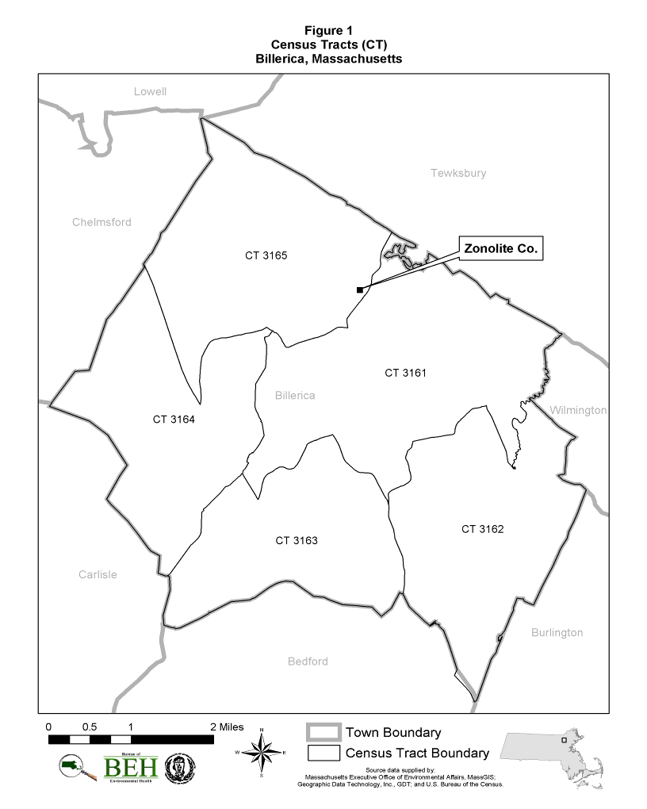
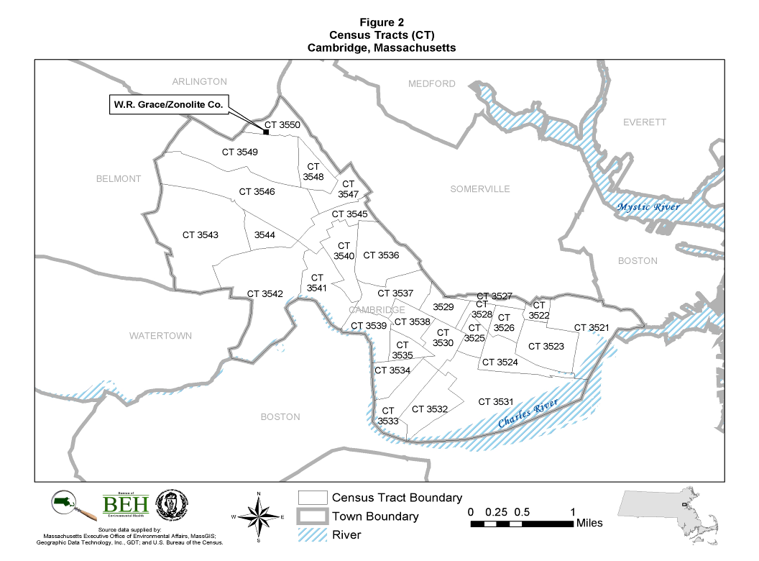
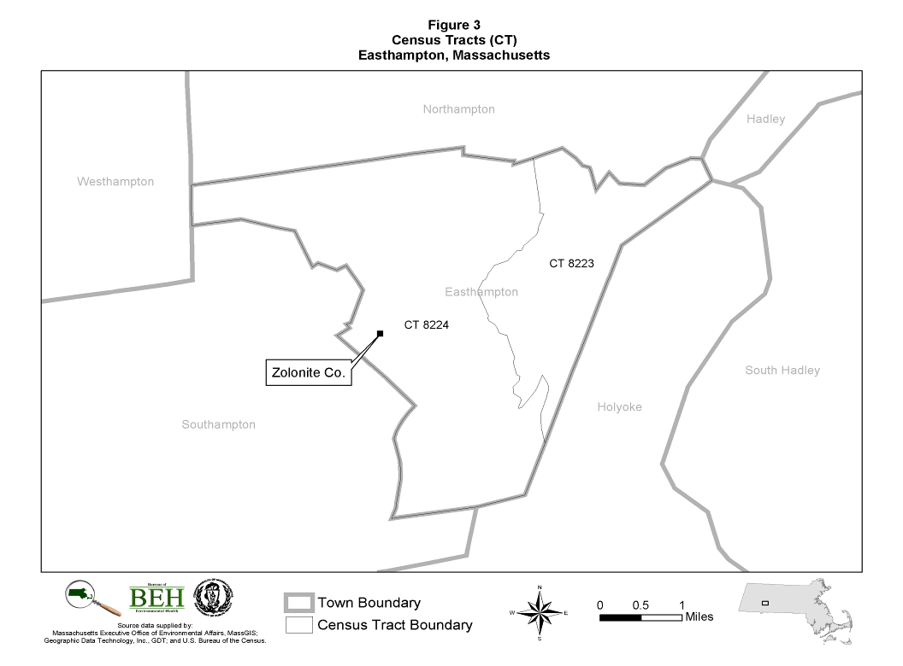

Appendix A

Asbestos-Related Health Outcomes: Incidence Data

Appendix B

Asbestos-Related Health Outcomes: Mortality Data

Appendix C

Standardized Rate Ratios
Appendix C

A third statistic called a standardized rate ratio (SRR) was also computed in this Health Statistics Review. As stated earlier, comparisons of SIRs or SMRs between communities or census tracts are not possible because of differences in the age and gender distributions of the communities. Comparing the cancer or mortality experience of communities can be achieved, however, by using a common population distribution (a reference population) to calculate an SRR.

An SRR is the ratio of the number of expected deaths (or cancer cases) in the reference population, based on the cancer or mortality rates in the community, to the number of observed deaths (or cancer cases) in the reference population. The expected number of deaths or cancer cases is the weighted sum of the community’s rates, where the weights used are the stratum-specific (i.e., age, gender) population distribution of the reference population (i.e., from the National Center for Health Statistics and SEER). Because each SRR is weighted by the population distribution of a particular reference population, SRRs may be validly compared across communities.

An SRR of exactly one indicates that a community’s mortality (or incidence) is equal to that of the reference population, based on the cancer or mortality rates of the community. An SRR greater than one indicates that a community’s mortality (or incidence) is higher than that of the reference population while an SRR less than one indicates that a community’s mortality (or incidence) is lower than that of the reference population.

Appendix D

Cancer Incidence and Mortality Data Review – Hingham
Appendix D
Cancer Incidence and Mortality Data Review
Hingham, Massachusetts

As noted in the main text, after an extensive records review, the USEPA concluded that there was no evidence of an industrial facility in Hingham that accepted or processed vermiculite ore (W. Toland, USEPA, personal communication, 2005). The USEPA record review included Hingham business registration records and building permits dating back to the 1930s; Massachusetts Secretary of State, Corporate Registration Division records; and personal visits to the Hingham Fire and Police Departments as well as the Hingham Public Library and Senior Citizens Center. Because this health statistics review began before it was confirmed that no asbestos facility existed in Hingham, we conducted a health statistics review for Hingham and have included the results here.

Cancer Incidence in the Town of Hingham (Table D.1)

Over the 10 year period of 1986 - 1995, the incidence of the five types of cancer evaluated occurred about as expected, with a few exceptions. Cancers of the lung/bronchus occurred statistically significantly less often than expected in the town of Hingham overall. In addition, the incidence of peritoneum, retroperitoneum and pleura cancers was slightly higher than expected (6 diagnoses observed vs. 3.5 diagnoses expected); the elevation, however, was not statistically significant. Townwide, three cases of mesothelioma were reported while approximately two cases were expected. More Hingham residents were diagnosed with digestive system cancers than was expected (160 diagnoses observed vs. 151.6 diagnoses expected) but the elevation was not statistically significant. (See Table D.1 for a summary of results).

Cancer Incidence in Hingham Census Tracts (Table D.2)

The town of Hingham is geographically subdivided into three census tracts (CTs 5011.01, 5011.02 and CT 5012). CTs 5011.01 and 5011.02 are located in the northern portion of the town with CT 5011.01 bordering the towns of Hull and Cohasset. CT 5011.02 borders the town of Weymouth. CT 5012 is the largest of the three census tracts and encompasses the southern half of the town of Hingham. The location and boundaries of Hingham’s census tracts are illustrated in Figure D.1.

Review of incidence rates for the CTs within Hingham showed that most of the cancer types investigated occurred at approximately equal to or less than expected rates. In CT 5012, which includes the southern half of Hingham, lung and bronchus cancer occurred statistically significantly less often than expected. In a few instances, the number of observed cancers was greater than the number expected but the elevations were not statistically significant. In CT 5011.02, four diagnoses of peritoneum cancers were observed while approximately one diagnosis was expected. Cancer incidence data for Hingham’s census tracts are summarized in Table D.2.

Cancer Incidence Risk Factor Information

Tobacco Use

A review of tobacco use among individuals diagnosed with lung and bronchus cancer in Hingham indicated that 80% were current or former smokers at the time of their diagnosis. The remaining 7% were non-smokers while smoking history was unknown for 13% of those with respiratory system cancers. Of those individuals with a known smoking status, 92% reported to be current or former smokers at the time of their diagnosis.

Of the six individuals diagnosed with cancers of the peritoneum, retroperitoneum and pleura, three were current or former smokers while three reportedly had never smoked at the time of their diagnosis. The three individuals diagnosed in Hingham with mesothelioma were current or former smokers at the time of their diagnosis.

Occupational History Review

Occupational history information for the six individuals diagnosed with cancers of the peritoneum, retroperitoneum and pleura indicated that one individual reported at the time of their diagnosis occupational exposure to asbestos. The other five individuals reported either job titles not typically related to asbestos exposure or limited information regarding their occupational history. One of the three individuals diagnosed with mesothelioma reported an occupation with an increased risk of asbestos exposure.

Review of occupational information for females diagnosed with cancers of the respiratory system in CT 5011.02, where more diagnoses were observed than expected, revealed that one woman reported at the time of her diagnosis a positive occupational exposure to asbestos while the remaining 27 women reported job titles not associated with an increased risk of asbestos exposure.

Mortality in the Town of Hingham (Table D.3)

Over the 20-year time period 1979-1998, townwide mortality was statistically significantly elevated, compared to national rates, for cancers of the peritoneum, retroperitoneum, and pleura (including mesothelioma) (11 deaths observed vs. 1.7 deaths expected). These types of cancer occurred more often than expected among both males and females in Hingham. Cause of death for seven of the 11 individuals was reported as mesothelioma. Deaths due to lung and bronchus cancer occurred statistically significantly less often than expected (186 deaths observed vs. 229.5 deaths expected). This was mainly due to a statistically significant decrease in reported deaths from lung and bronchus cancer among males (101 deaths observed vs. 149.7 deaths expected). During this 20-year time period, diseases of the pulmonary circulation also occurred statistically significantly less often then expected townwide (9 deaths observed vs. 20.6 deaths expected).

Mortality in Hingham Census Tracts (Tables D.4 and D.5)

For most causes of death, mortality rates in Hingham’s three CTs were about as expected, with a few exceptions. During the 20-year period, deaths due to cancers of the peritoneum, retroperitoneum and pleura (including mesothelioma) occurred statistically significantly more often then expected in CT 5011.02 (5 deaths observed vs. 0.6 deaths expected) and in CT 5012 (5 deaths observed vs. 0.8 deaths expected). In CT 5011.01, there was one death reported from cancers of the peritoneum, retroperitoneum and pleura and two deaths from asbestosis, while less than one death from each type was expected.

During 1979-1998, deaths due to COPD occurred statistically significant less often than expected among males in CT 5011.01(6 deaths observed vs. 16.0 deaths expected).

In CT 5011.02, deaths due to digestive organ cancers occurred statistically significantly more often than expected (63 deaths observed vs. 47.5 deaths expected).

During 1979-1998, deaths due to lung and bronchus cancer occurred statistically significantly less often than expected in CT 5012, due to a decrease among males in this census tract. Among males, there were 34 less deaths than expected (37 deaths observed vs. 70.8 deaths expected).

Mortality Risk Factor Information

Occupational History Review

A review of occupational information on the death certificates of the 565 individuals of Hingham who died of one of the causes of death evaluated revealed that 7% (40 of 565) had job titles with an increased risk of exposure to asbestos. The remaining 93% (525 of 565) had job titles not thought to be associated with occupational exposure to asbestos.

Between 1979-1998, the townwide mortality rate for peritoneum cancers (including mesothelioma) was statistically significantly elevated. This elevation occurred mainly in two CTs: 5011.02 and 5012. Of the 11 individuals diagnosed with peritoneum cancers in Hingham, seven of the 11 deaths were reportedly due to mesothelioma. The death certificates of two individuals, both of whom died of mesothelioma, indicated possible occupational exposure to asbestos. Shipbuilding in southeastern Massachusetts was one of the primary industries during the period around World War II. Asbestos was used in the shipbuilding process to insulate boilers, steam pipes, and hot water pipes.

Of the two individuals who died of asbestosis in Hingham, one death certificate did not indicate possible occupational exposure to asbestos while the second death certificate identified the individual as a laborer, and therefore work with asbestos cannot be ruled out.

Mortality from cancers of the digestive organs occurred statistically significantly more often than expected in CT 5011.02. Sixty-three deaths were reported due to digestive system cancers among males and females in this census tract while approximately 48 deaths were expected. Occupational history information reported on death certificates for these individuals indicated that the majority (76%; 48 of 63) had job titles not typically associated with exposure to asbestos. However, three males in this census tract reportedly had possible occupational exposures to asbestos. Death certificates for the remaining 19% of the individuals who died of digestive organ cancers in this census tract did not indicate a potential for occupational exposure to asbestos.

Hingham Geographic Distribution

In addition to determining incidence and mortality rates, a qualitative evaluation of the point pattern of selected diseases and causes of death was conducted. Place of residence at the time of diagnosis or death was mapped to assess any possible geographic concentration of disease.

Place of residence at diagnosis for the six individuals diagnosed with peritoneum cancers (two of whom were also diagnosed with mesothelioma) and the other Hingham resident diagnosed with mesothelioma were mapped. Four of these individuals lived in CT 5011.02, one lived in 5011.01, and one lived in 5012. None of the addresses appeared to be concentrated in any one area or neighborhood.

Between 1979-1998, the mortality rate for cancers of the peritoneum, retroperitoneum, pleura (including mesothelioma) was statistically significantly elevated in Hingham and two of its census tracts (CT 5011.02 and 5012). A review of the geographic distribution of residence at death for the 11 individuals who died of these causes revealed no apparent concentration of deaths in any particular neighborhood of Hingham.

Although the two individuals who died of asbestosis in Hingham both were residents of CT 5011.01 at the time of their death, they did not live in close proximity to one another.

Conclusions

- Over the 10-year period of 1986-1995, the incidence of the five types of cancer evaluated occurred about as expected in Hingham, with a few exceptions. The incidence of peritoneum cancers was slightly higher than expected (6 diagnoses observed vs. 3.5 diagnoses expected) but the elevation was not statistically significant. Cancer of the lung and bronchus occurred significantly less often than expected townwide.
- Review of incidence rates for the CTs within Hingham showed that most of the cancer types investigated occurred at approximately equal to or less than expected rates. In CT 5011.02, however, more diagnoses from peritoneum cancers occurred than were expected. It is possible that smoking and occupational exposure to asbestos may have played a role in the incidence of this type of cancer in Hingham.
- The pattern of mortality rates for the selected causes of death was very similar to the pattern of incidence rates in Hingham. Over the 20-year time period 1979-1998, townwide mortality was statistically significantly elevated for peritoneum cancers (including mesothelioma). Eleven deaths were reported (seven due to mesothelioma) while approximately two deaths were expected. Ten of the eleven deaths occurred in two of Hingham’s three CTs. The death certificates of two of the 11 individuals, both of whom died of mesothelioma, indicated a possible occupational exposure to asbestos. (No smoking history information is available through death certificates.) Shipbuilding in southeastern Massachusetts was one of the primary industries during the period around World War II. Asbestos was used in the shipbuilding process to insulate boilers, steam pipes, and hot water pipes.
- The mortality rate for lung and bronchus cancer was significantly lower than expected townwide, as was the incidence rate for this type of cancer.
- Review of the geographic distribution of the residences of those in Hingham who died of selected causes of death (lung and bronchus cancer, peritoneum cancers, and asbestosis) did not reveal any apparent spatial patterns at the neighborhood or census tract level that could not be attributed to such factors as higher population density.

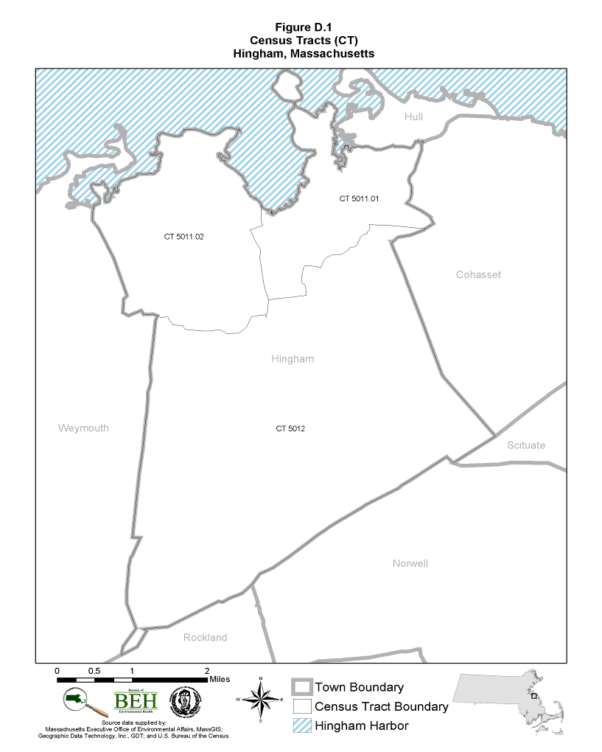

Appendix E

Cancer Incidence and Mortality Data Review - Westminster
Appendix E
Cancer Incidence and Mortality Data Review
Westminster, MA

As noted in the main text, the USEPA concluded that there was no evidence that the Advance Coating Company in eastern Westminster ever accepted or processed vermiculite ore (D. McIntyre, USEPA, personal communication, 2005) (see Figure E.1). Although on the USEPA original list of facilities that may have received vermiculite ore from the Libby, Montana, mine, the agency’s investigation found no evidence that this was true. Because this health statistics review began before it was concluded that vermiculite ore had not been shipped to the Westminster facility, we conducted a health statistics review for Westminster and have included the results here.

Asbestos-Related Cancer Incidence in the Town of Westminster (Table E.1)

During 1986-1995, the three sentinel cancer types occurred in Westminster at rates either approximately equal to or less than expected rates: peritoneum cancers (2 diagnoses observed vs. 1.0 expected), mesothelioma (one diagnosis observed vs. 0.6 diagnoses expected), and lung and bronchus cancer (27 diagnoses observed vs. 37.1 diagnoses expected). These data are presented in Table E.1.

As seen in Table E.1, the incidence of cancers of the digestive organs was greater than expected due to an increase among males; however, the elevation was not statistically significant (28 diagnoses observed versus 22.1 diagnoses expected).

Review of Cancer Incidence Risk Factor Information

Tobacco History

A review of tobacco use for the two individuals with cancers of the peritoneum, retroperitoneum and pleura revealed that one individual was a current smoker at the time of their diagnosis while the other individual had never smoked. Of the 27 individuals who were diagnosed with lung and bronchus cancer, 78% (21 of 27) were current or former smokers at the time of their diagnosis, 19% (5 of 27) had an unknown smoking status, and 3% (1 of 27) never smoked. Thus, 95% (21 of 22) of individuals with a known smoking history and who were diagnosed with lung and bronchus cancer reported being current or former smokers.

Occupational History Review

A review of occupational information reported to the MCR for the 77 individuals in Westminster diagnosed with one of the asbestos-related cancers during 1986-1995 showed that seven individuals had possible exposure to asbestos. The remaining 91% (70 of 77) reported either job titles not typically related to asbestos exposure or limited or no information regarding their occupational history.

Of the two individuals with peritoneum cancers, one reported being a housewife while the second person reported being retired at the time of their diagnoses.

Asbestos-Related Mortality in the Town of Westminster (Table E.2)

Over the 20-year time period 1979-1998, townwide mortality for the sentinel causes of death was about as or lower than would be expected. There was one reported death from asbestosis in Westminster while no deaths were expected. There was one reported death from cancer of the peritoneum, retroperitoneum and pleura (which was a mesothelioma) while approximately one death was expected. The mortality rate for lung and bronchus cancer was lower than expected in Westminster (48 observed vs. 60.5 expected).

The mortality rates for the following additional causes of death were at or near expected rates: digestive organ cancers, site-unspecified neoplasms, diseases of pulmonary circulation, COPD, pneumoconiosis, and other diseases of the respiratory system. In some instances the number of observed deaths exceeded the expected number, based on national rates, but no statistically significant differences between the number of observed and expected deaths were found.

Review of Mortality Risk Factor Information

Occupational History

A review of occupational information on the death certificates of the 141 individuals in Westminster who died of one of the asbestos-related diseases during the 20-year time period of 1979-1998 revealed eight individuals (6%) had job titles associated with possible exposure to asbestos. Eighty-one percent (114 of 141) of the individuals had job titles not associated with an increased risk of exposure to asbestos. The remaining 13% (19 of 141) were housewives or had never worked.

Geographic Distribution

In addition to determining incidence and mortality rates for asbestos-related diseases, a qualitative evaluation of the point pattern of sentinel cancer diagnoses and deaths in Westminster was conducted. Place of residence at the time of diagnosis or death was mapped to assess any possible geographic concentration of disease.

In general, review of the geographic distribution of sentinel health outcomes did not reveal any apparent spatial patterns at the neighborhood level that could not be attributed to such factors as areas of higher population density. The residences of the two peritoneum cancer cases were in different neighborhoods. The distribution of residences for those Westminster residents with lung and bronchus cancer was fairly spread out across the town, consistent with population density. The one individual who died of asbestosis was a fireman; it is possible that he faced an increased risk of asbestos exposure through his occupation.

Conclusions

- For Westminster, the three sentinel cancer types occurred at rates approximately equal to or less than expected rates: peritoneum cancers (2 diagnoses observed vs. 1.0 expected), mesothelioma (one diagnosis observed vs. 0.6 diagnoses expected), and lung and bronchus cancer (27 diagnoses observed vs. 37.1 diagnoses expected).
- Over the 20-year time period 1979-1998, townwide mortality for the sentinel causes of death was about as expected or less than expected.
- Review of the geographic distribution of sentinel health outcomes did not reveal any apparent spatial patterns at the neighborhood (or census tract) level that could not be attributed to such factors as areas of higher population density.

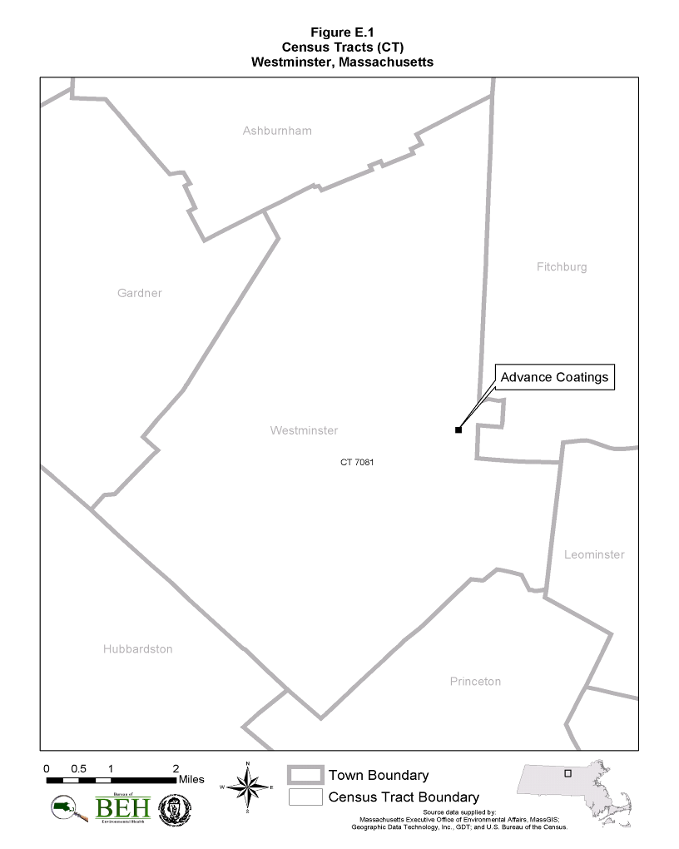

As stated earlier, the MDPH, in calculating SIRs, typically estimates an expected number of cases by applying the statewide cancer rate to the population of interest. However, because this Health Statistics Review is part of a national review, the federal ATSDR stipulated that all participating states use national cancer rates to estimate the expected number of cases in a community.
Typically, MDPH reports an SIR as the ratio of the observed number of cases to the expected number multiplied by 100. Therefore, an SIR of 100 would indicate that the number of cancer cases observed is equal to the number expected. However, to conform to the ATSDR protocol for this Health Statistics Review, an SIR is simply defined as the ratio of the observed to the expected. MDPH typically uses a multiplier of 100 for the ease of interpretation. Both methods of calculating an SIR produce comparable results.
These include: 3521, 3523, 3524, 3526, 3527, 3529, 3531 – 3543, 3545, 3546, 3547, 3549, and 3550.
These include: 3521, 3524, 3525, 3528, 3529, 3530, 3533, 3544, 3546, and 3549.

