Health Status of Hispanic Adults in Massachusetts by Spoken Language Preference

Massachusetts Behavioral Risk Factor Surveillance System
1999-2002



Division of Research and Epidemiology
Bureau of Health Information, Statistics, Research, and Evaluation

Massachusetts Department of Public Health

February 2008

Health Status of Hispanic Adults in Massachusetts by Spoken Language Preference

Massachusetts Behavioral Risk Factor Surveillance System
1999-2002

Division of Research and Epidemiology
Bureau of Health Information, Statistics, Research, and Evaluation

Massachusetts Department of Public Health

February 2008

Acknowledgments

This report was prepared by Isabel Cáceres and Malena Orejuela-Hood, Epidemiologists of the Division of Research and Epidemiology, Bureau of Health Information, Statistics, Research, and Evaluation.

Special thanks go to: Bruce Cohen, Director, Division of Research and Epidemiology, Bureau of Health Information, Statistics, Research, and Evaluation; Zi Zhang, Director, Health Survey Program (HSP), Bureau of Health Information, Statistics, Research, and Evaluation; and Brunilda Torres, Director, Office of Health Equity, for input in development and review stages.

We also like to thank Brian Bradbury*, Epidemiologist, HSP, for his contributions to the conception of this report; Susan Keyes, Senior Research Analyst; Vera Mouradian, Senior Analyst; Esther Kang*, Program Coordinator; Nahara Borja*, Epidemiologist; and Xuelei Pan, Research Analyst for their contributions of data and comments to this report.

In addition, we wish to thank all reviewers for their comprehensive review of this publication, in special to: Margarita Alegría, Ph.D., Director, Center for Multicultural Mental Health Research, Cambridge Health Alliance & Harvard Medical School; Iris García-Caban, Ph.D., Quality and Performance Improvement Coordinator, Massachusetts Executive Office of Health & Human Services, MassHealth Office of Acute & Ambulatory Care (OAAC); and M. Barton Laws, Ph.D., Senior Investigator in Social Science and Policy, Latin American Health Institute. Boston, Massachusetts.

To obtain additional copies of this report, contact:

Massachusetts Department of Public Health
Bureau of Health Information, Statistics, Research, and Evaluation
250 Washington Street, 6th floor
Boston, MA 02108

This publication can be downloaded from the following website:

http://www.mass.gov/Eeohhs2/docs/dph/behavioral_risk/hispanic_language.pdf

Table of Contents
Preface 7
Highlights 9
Background 11
Methods 12
Limitations of this Report 14
Summary Findings 15
Demographic Description of the BRFSS 1999-2002 Study Samples 19

Table 1. Sample Size of Respondents to the 1999-2002 Massachusetts BRFSS 20

Map of Massachusetts Regions 21

Table 2. Hispanic Population in Selected Cities and in Massachusetts, Census 2000 22
Prevalence of Selected Indicators of Poor Health 23

Table 3a. Prevalence of Selected Indicators of Poor Health

Hispanics vs. White non-Hispanics, and State Overall Population 25

Table 3b. Prevalence of Selected Indicators of Poor Health

Spanish- and English-speaking Hispanics vs. White non-Hispanics 26
Prevalence of Selected Healthy Practices, Behaviors, and Attitudes 27

Table 4a. Prevalence of Selected Healthy Practices, Behaviors, and Attitudes

Hispanics vs. White non-Hispanics, and State Overall Population 28

Table 4b. Prevalence of Selected Healthy Practices, Behaviors, and Attitudes

Spanish- and English-speaking Hispanics vs. White non-Hispanics 29
General Indicators of Overall Poor Health Status 30

Poor General Health 31
Table 5. Poor General Health Prevalence 32
Figure 1. Prevalence of Poor General Health§ 33
Figure 2. Community-specific Prevalence of Poor General Health 35

15+ Days Feeling Sad In The Past Month 36
Table 6. 15+ Days Feeling Sad In The Past Month Prevalence 37
Figure 3. Prevalence of 15+ Days Feeling Sad In The Past Month§ 38
Figure 4. Community-specific Prevalence of 15+ Days Feeling Sad In The Past Month 40

Poor Physical Health 41
Table 7. Poor Physical Health Prevalence 42
Figure 5. Prevalence of Poor Physical Health§ 43
Figure 6. Community-specific Prevalence of Poor Physical Health 45
References 46
Appendix 47

What is the BRFSS? 47

BRFSS Methodology 47

BRFSS Variables Used 48

Preliminary Results MA BRFSS 2003-2006 50

Preface

The idea for this report was conceived in 2001 by staff from the Health Survey Program (HSP) three years after the Spanish version of the Massachusetts Behavioral Risk Factor Surveillance System (BRFS) survey was introduced as an option to selected participants. HSP staff convened an advisory committee which shaped the contents of this report. The advisory committee included department staff and external experts, including representatives of the Latin American Health Institute, the Gaston Institute, Spanish American Union, Boston University, and Massachusetts General Hospital.

Changes in staff and superseding priorities within the department postponed the production of this report. In 2004, the report was revived and since then it has evolved into this final form based on BRFSS data aggregated for the years 1999-2002. Analysis of preliminary BRFSS 2003-2006 data indicates that between 1999-2002 and 2003-2006, the difference between Hispanics and White non-Hispanics outcomes have remained stable, with few exceptions. The proportion of Spanish-speaking Hispanics adults reporting no health insurance, and no visits to a doctor due to cost increased by 82% and 56% respectively (from 13.0%, 95%CI 9.7-16.3% in 1999-2002 to 23.6%, 95%CI 17.2-30.0% in 2003-2006 for no health insurance and from 11.0%, 95%CI 8.1-13.8% in 1999-2002 to 17.2%, 95%CI 13.9-20.6% in 2003-2006 for no visits to doctor due to cost), as well as the disparity between Hispanics and White–non Hispanics, widening the gap to access to health care among Spanish-speaking Hispanics. Please see the Appendix for definition of variables used and for summary results based on preliminary 2003-2006 data.

This report is intended to make a critical contribution as it is the first time the Massachusetts Department of Public Health has been able to provide health status information about the growing Hispanic population, specifically for English-speaking and Spanish-speaking Hispanics. Spanish-speaking Hispanics in Massachusetts may represent a distinct demographic target group. Although Spanish-speaking Hispanics come from many countries, our analyses indicate that, as a group, they tend to have lower levels of education and income, limited access to health care, limited use of preventive services, and poor health status. The findings of this report support the association between language of choice and health status of Hispanics in Massachusetts. Hopefully, this information will further policy development, identify subpopulations at risk, and more effectively target programs for those in need of services.

Highlights

- This is the first Massachusetts Department of Public Health report focusing not only on the health status of Hispanics but specifically on the health status of English-speaking and Spanish-speaking Hispanics. Although Spanish-speaking Hispanics come from many countries and represent many cultures, they may have important differences and require separately targeted services and public health messages.
- In general, Hispanics reported worse outcomes than White non-Hispanics in areas including health status, health care access, risk and chronic conditions, and preventive behaviors.
  - Thirteen percent of Spanish-speaking Hispanic adults and 12% of English-speaking Hispanic adults reported having no insurance compared with 6% among White non-Hispanics and were nearly twice as likely to report not being able to see a doctor due to cost (11.0% and 11.3% vs. 6.1%).
  - Hispanics reported worse physical health status than White non-Hispanics (14.5% vs. 8.2%)
  - Hispanics were more likely to report being overweight and obese and more likely to report being told they have diabetes.
  - Hispanics were less likely to report preventive health behaviors such as: visiting a dentist in the past year (62% and 71%, vs. 78%) and doing any exercise in the past month (49% and 66%, vs. 80).
  - Hispanic women were less likely to report having a clinical breast exam in the past 2 years as compared to White non-Hispanics women of the same age.
- Spanish-speaking and English-speaking Hispanic respondents differed in many characteristics.
  - Spanish-speaking Hispanics were more likely to be older than their English-speaking counterparts; have lower levels of education and income; and be less evenly distributed across the state (60% of Spanish-speaking Hispanics live in the Boston and Northeast regions of the state, as compared to 42% of English-speaking Hispanics live in these same regions).
  - Spanish-speaking Hispanics reported worse general health status than their English-speaking counterparts (2.5 times more likely to report poor or fair health) and much worse than their White non-Hispanics counterparts (4.3 times more likely to report poor or fair health).
  - Spanish-speaking Hispanics reported worse levels of (24% lower; 49.9% vs. 65.7%) physical exercise during the past month than their English-speaking counterparts and much worse levels (38% lower; 49.9% vs. 80.4%) than White non-Hispanics did.
  - Spanish-speaking Hispanics reported being less likely to have a personal doctor than both their English-speaking counterparts (15% lower) and White non-Hispanics (19% lower).
- In some areas Hispanics fared better than White non-Hispanics respondents. For example, Hispanics had healthier attitudes towards the negative effects of drinking, smoking, and environmental smoke, mainly driven by the attitudes of the Spanish-speaking Hispanics.
  - For example, Spanish-speaking Hispanic adults were less likely than White non-Hispanic adults to report current smoking (16% vs. 20%), binge drinking (11% vs. 19%), and more likely to report not allowing smoking at home (88% vs. 65%), and supporting a smoking ban in restaurants (86% vs. 59%).
  - Both, Spanish- and English-speaking Hispanic adults were less likely than White non-Hispanic adults to report heavy drinking (2% and 4%, vs. 8%).
- The findings of this report support the association between language and health status of Hispanics in Massachusetts. Hopefully, this information will enable the development of better policies, the identification of subpopulations at risk, and more effective targeting of programs for those in need of services.

Background

The Hispanic population in Massachusetts has grown substantially over the past decades, and continues to grow. The number of Hispanic residents in Massachusetts increased by 62%, between 1990 and 2002 (from 287,561 in 1990 to 465,881, in 2002). A 58% increase was also observed in the number of Hispanic residents speaking Spanish at home between the last two censuses (from 234,742 in 1990 to 370,011, in 2000, among residents 5 years of age and older) .
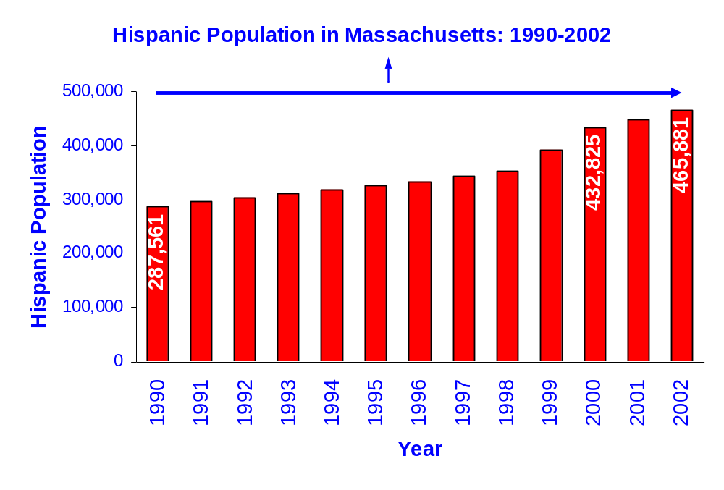
Hispanics in Massachusetts have lower average educational attainment and lower average incomes than White non-Hispanics. These socioeconomic risk factors for poor health outcomes are most pronounced among Spanish-speaking Hispanics. Three out of four Spanish-speaking Hispanics have incomes of less than $25,000, as compared with one out of three English-speaking Hispanics and one out of five White non-Hispanics (Table 1).

According to the BRFSS, the percentage of Hispanics who report their health as poor or fair has been consistently higher than the percentages of all other racial and ethnic groups. In 2002, the Massachusetts BRFSS report showed that Hispanic adults (37%) are more likely than White non-Hispanic (11%), Black non-Hispanic (14%) or Asian non-Hispanic (11%) adults to report Poor general health¹.

Recent research suggests that being proficient in English may be associated with health outcomes for Hispanics. Caraway L. Timmins’ report on Hispanics in the U.S. identified the lack of English fluency as a marker for poor health care and poor health status, independent of other risk factors such as poverty or low educational attainment².

There is also evidence suggesting that place of birth and spoken language preference among Hispanic mothers in Massachusetts is related to some perinatal outcomes³. Among Hispanic mothers who preferred Spanish as their spoken language, those born in the continental U.S. (i.e., the 50 states and the District of Columbia) were more likely to be less than 20 years of age at the time of delivery, and were also more likely to report having smoked cigarettes during their current pregnancy than those mothers who were foreign born.

It has been documented that the use of language by immigrant populations in the United States is highly correlated with other measures of acculturation⁴. Given this finding, we assumed preferred spoken language among Hispanics as a valid proxy measure of acculturation. This means that those who prefer Spanish as spoken language can be presumed to be less acculturated than those who prefer English as their spoken language.

Methods

This report, Health Status of Spanish-speaking Hispanic Adults in Massachusetts by Spoken Language Preference, uses BRFSS data aggregated from 1999 to 2002. Comparisons of responses from Hispanics, by language of preference, with those of White non-Hispanics are made for thirty-seven health indicators. First, Hispanics as a group are compared with White non-Hispanics. Then, Spanish- and English-speaking Hispanics are compared separately with White non-Hispanics. In addition, this report presents an analysis of the prevalence of three general indicators of health status by gender, age, education, and region of residence, for Spanish- and English-speaking Hispanics, and White non-Hispanics. For details of the BRFSS sampling methodology please see the Appendix.

Comparison Groups

The Spanish-speaking Hispanic group is made up of respondents who completed the Spanish version of the BRFSS survey (n=1,307). Those who identified themselves as Hispanic in the questionnaire and chose to respond to the English version made up the English-speaking Hispanic group (n=1,624), and those who identified themselves as White non-Hispanics and completed the English version of the BRFSS questionnaire made up the White non-Hispanic group (n=28,173). This latter group is used as the reference group. (The fact that Hispanics chose to respond the BRFSS survey in English does not mean that they do not speak Spanish, nor does it mean that Hispanics who chose to respond in Spanish do not speak English. Rather, it merely represents their language preference when responding verbally to the survey.)

Measures and Analyses Used in this Report

Prevalence of health indicators presented here are the percentage or weighted proportion of respondents in a particular category. The age-adjusted prevalence is a weighted average of the age-specific prevalence in which the weights are the proportions of persons in the corresponding age groups of the 2000 U.S. population. Age-adjustment has been applied to prevalence of all self reported health indicators presented in this report. This has been done in order to eliminate differences that may in fact be due to different age distributions when comparing different population groups (e.g., Hispanics vs. White non-Hispanics).

Ninety-five percent confidence intervals (95% CI) were used to compare prevalence between a group and the reference group: White non-Hispanics. Non-overlapping intervals signify statistically significant differences. A group is said to have a better or worse outcome than the reference group based on non-overlapping 95% CI of the indicator’s prevalence. For instance, for a desirable indicator (e.g., visit to the dentist in the past year) better means that the lower bound of the group’s 95% CI is greater than the reference group’s upper bound 95% CI. For an undesirable indicator (e.g., no health insurance), a worse outcome means that the lower bound of the group’s 95% CI is higher than the reference group’s upper bound 95% CI.

Analyses were performed using SAS 8.1. Graphs were produced using Microsoft Excel 2002, and maps with ArcMap 9.0. SUDAAN was used to age-adjust prevalence using the 2000 U.S. standard population. For questions with age restrictions other than 18 and older, such as colonoscopy (to adult ages 50 and older) or use of birth control (to women ages 18 to 45), among others, a corresponding standardized age distribution was used for age-adjustment.

Indicators of Self-reported Health Status Used in this Report

Three general measures of self-reported health status are used in this report: 1) Poor general health; 2) 15+ days feeling sad in the past month; and 3) poor physical health. In the survey, respondents were asked to describe their health as excellent, very good, good, fair, or poor. Adults who reported that their health was fair or poor are referred to as having Poor general health throughout this report. Respondents were also asked to report the number of days that they had felt sad, blue, or depressed during the past month. Adults who reported 15 or more days of feeling sad, blue, or depressed, during the past month, are referred to as having 15+ days feeling sad in the past month throughout this report (Please note that 15+ days feeling sad in the past month does not distinguish between those having feelings of grieving after an unfortunate event-which are normal, from those who are chronically sad and depressed). Finally, respondents were asked to report the number of days during the past month that their physical health, which includes physical illness and injury, had not been good. Adults who reported 15 or more days during the past month that they had felt their physical health was not good, are referred as to having Poor physical health throughout this report. (For a description of all indicators of health used in this report see Table A1 in the Appendix.)

Organization of this Report

The first section of this report includes the prevalence of health indicators associated with poor health outcomes such as overall assessment of poor health status, lack of health care access, risk behaviors, and chronic health conditions (Table 3a, Table 3b).

The second section includes the prevalence of health indicators associated with preventive behaviors, healthy practices and attitudes such as visits to dentists in the past year, regular exercise, eating five or more fruits and vegetables a day, cholesterol checks in the past five years, use of recommended screening tests, use of birth control among women, and HIV testing presented in Table 4a and Table 4b. Also, included in this group are two indicators related to healthy environmental practices such as support for rules against smoking in the home and bans on smoking in restaurants.

The third section includes the prevalence of the three general indicators of overall poor health status: Poor general health, 15+ days feeling sad in the past month, and Poor physical health for Spanish-speaking Hispanics, English-speaking Hispanics, and compared with those of White non-Hispanics by gender, age, education, and region of residence (Table 5, Table 6, and Table 7).

In addition to the comparisons mentioned above, we have made within-group comparisons of Poor general health, 15+ days feeling sad in the past month, and Poor physical health. We compared the outcomes for these indicators within Spanish-speaking Hispanics, English-speaking Hispanics, and White Non-Hispanics by stratifying (making subgroups) by age, per capita income, EOHHS Region of residence, and selected cities of residence. For example, the prevalence of Poor general health for each subgroup (e.g. 20-24 year olds) of Spanish-speaking Hispanics is compared with the prevalence of Poor general health for all Spanish-speaking Hispanics (overall). If the subgroup’s prevalence differs significantly from the group’s overall prevalence, we present this subgroup’s outcome in Figure 1a. Significantly disparate subgroup outcomes for English-speaking Hispanics are presented in Figure 1b, and significantly disparate subgroup outcomes for White non-Hispanics are presented in Figure 1c. Figures 3 identify statistically significantly different characteristics among Spanish-speaking Hispanics (a), English-speaking Hispanics (b), and White non-Hispanics (c), for 15+ days feeling sad in the past month. Figures 5 identify statistically significantly different characteristics within Spanish-speaking Hispanics (a), English-speaking Hispanics (b), and White non-Hispanics (c) for Poor physical health.

For cities with sufficient data for both Hispanics and White non-Hispanics, city-specific prevalence rates for these three indicators of overall poor health status are presented in Figures 2, 4, and 6.

Limitations of this Report

The analyses done for this report do not take into account cultural and linguistic differences between Spanish and English speakers that may affect the interpretation of questions and how responses are given. In spite of diligent attention to accurate translation, concepts do not map directly from one language to another. For example, terms such as “excellent,” “good,” “fair,” and “poor” may not correspond precisely to their nearest equivalents in Spanish. There also may be differences among Spanish-speaker from different countries who may have different cultural norms or proclivities, or different dialects of Spanish, thus possibly affecting respondents’ interpretation of the question asked, and mode of response.

While the prevalence of outcomes have been adjusted by age, other social determinants of health such as gender, income, and education may also have an impact on the results of group comparisons in this report. We tried to examine some of these factors in the analysis for the three general indicators of poor health status, but fully exploring the interaction of the effects of these factors on health status is beyond the scope of this report.

City-specific prevalence rates of the three general health status indicators were limited to comparisons between Hispanics (English- and Spanish-speaking combined) and White -non-Hispanics. Although the cities selected for this report have the largest Hispanic populations in the state, and health indicators were aggregated for 4-years of BRFSS data, city-specific prevalence for Hispanics by language of preference could not be provided for Holyoke and Lynn due to insufficient numbers. Similarly, prevalence for White non-Hispanics residents of Chelsea were not included due to insufficient numbers.

All data collected by the BRFSS are based on respondent self-report. By its nature, self-reported data may be subject to bias (or systematic error) for several reasons. An individual may have difficulty remembering events that occurred a long time ago or the frequency of certain behaviors. Some respondents may over report socially desirable behaviors, while underreporting behaviors they perceive to be less acceptable. Despite the declining response rate of the BRFSS and limitations of its random-digit-dial modality, a comparison of the Massachusetts 2000 BRFSS sample to the 2000 Census data shows that the MA BRFSS is a fairly accurate reflection of the Massachusetts population in most demographics and socioeconomic variables⁵. Finally, because the BRFSS surveys a randomly selected sample of Massachusetts adults, these results may differ from those derived from another random sample to some extent simply due to chance. This variation is reflected in the confidence intervals.

Summary Findings

In general, Hispanics reported worse outcomes than White non-Hispanics in important areas including health status, health care access, risk conditions, and chronic conditions (Table 3a). Also, Hispanics reported worse outcomes than White non-Hispanics regarding preventive behaviors (Table 4a). These latter results may also be an indication of lack of health care access and of physician’s recommendation for health care rather than personal behavior or personal preferences. The Latina Breast Cancer Control Study found that insurance status and age primarily determined whether Latinas were screened, mediated by access to physician services and whether physicians recommended screening⁶.

Hispanics were more likely to report support for smoking restrictions and to have better outcomes for smoking and drinking than White non-Hispanics. These positive attitudes among Hispanics toward drinking, smoking, and environmental smoking were mainly driven by the attitudes of the Spanish-speaking Hispanics. Spanish-speaking Hispanics were more likely to support these attitudes, while there were no differences between English-speaking Hispanics and White non-Hispanics toward these attitudes (Table 3b).

The Hispanic population is younger than the White non-Hispanic population. However, Hispanics in the Massachusetts BRFSS have consistently reported poorer health status than any other racial and ethnic groups. Between 1999 and 2002, according to the Massachusetts BRFSS, the percentage of Hispanics who reported their health as poor or fair was 33%, (95%CI: 30.4-35.4), which was three times higher than that of White non-Hispanics (11%, 95%CI: 10.3-11.3).

The health status of Hispanics compared with that of White non-Hispanics varied across ten cities with the largest Hispanic population in the state. Hispanics reported worse health status than White non-Hispanics in Springfield (more than 3 times worse), Worcester (3 times worse), Boston (3 times worse), Lawrence (2.6 times worse), New Bedford (2 times worse), and Fall River (1.4 times worse) (Table 5). Also, in Springfield, Hispanics reported worse 15+ days feeling sad in the past month (17% vs. 9%, Table 6) and worse physical health status (18% vs. 11%, Table 7) than White non-Hispanics.

Spanish-speaking Hispanics

Socio-demographic Characteristics- Spanish-speaking Hispanics (Table 1) were more likely to
- Be older than their English-speaking counterparts (31% of Spanish-speaking Hispanics are aged 45 years and older, compared with 21% of English-speaking Hispanics)
- Have lower levels of education and income than English-speaking Hispanics did
- Be less evenly distributed across the state than English–speaking Hispanics did (60% of Spanish-speaking Hispanics reside in the Boston and Northeast regions of the state).

Within Spanish-speaking Hispanics:
- Better general health status occurred for persons under 45 years of age and for those having 1 to 3 years of college education, compared with what the Spanish-speaking Hispanic group reported as a whole. While worse general health status in this group occurred for persons 45 years of age or older (Figure 1a).
- Better 15+ days feeling sad in the past month occurred for persons 18 to 24 years of age and for those with incomes between $25,000 and $35,000 (Figure 3a), as compared with the Spanish–Speaking group as a whole.
- Better physical health status occurred for persons under 35 years of age (Figure 5a) than the Spanish-speaking Hispanic group reported as a whole
English-speaking Hispanics

Socio-demographic Characteristics- English-speaking Hispanics (Table 1)
- Were more likely to be younger than both the Spanish-speaking Hispanic and White non-Hispanic populations. Fifty-eight percent of the English-speaking Hispanics were under 35 years of age, compared with 47% of Spanish-speaking Hispanics, and 29% of the White non-Hispanic population.
- Had similar proportion of adults with high school and some college education as White non-Hispanics.

Within English-speaking Hispanics:
- Worse general health status occurred for persons with less than high school education, with incomes less than $25,000, and for those living in Worcester and in the Central region of the state, compared with what the English-speaking Hispanic group reported as a whole. While better general health status, occurred for persons with incomes over $50,000, and under 35 years of age (Figure 1b).
- Better 15+ days feeling sad in the past month occurred for persons living in the North East and Metro West regions of the state (Figure 3b).
- Better physical health status occurred among persons living in the city of Lawrence (Figure 5b).

When separating Hispanics by their preference of spoken language and compared with White non-Hispanics we found the following:

Health Status

Poor General Health
- Both, Spanish- and English-speaking Hispanics reported worse general health status than White non-Hispanics. However, Spanish-speaking Hispanics reported worse (2.5 times) general health status than their English-speaking counterparts and much worse (4.3 times) than White non-Hispanics did.
- All Spanish-speaking Hispanic subgroups by gender, age groups, education, and region of residence, were more likely than their White non-Hispanic counterparts to report Poor general health, with the exception of those having college education or more.
- For the following subgroups, English-speaking Hispanics reported worse general health status than their White non-Hispanic counterparts:
  - Females
  - Being 45 to 54 years of age
  - Having college education or more
  - Living in the Western, Central, or Boston regions of the state

15+ Days Feeling Sad In The Past Month
- Spanish-speaking Hispanics reported worse 15+ days feeling sad in the past month than White non-Hispanics for persons 45 to 54 years of age (18% vs. 10%). For persons 18 to 24 years of age, Spanish-speaking Hispanics reported better 15+ days feeling sad in the past month than their White non-Hispanic counterparts (2% 15+ days feeling sad in the past month vs. 12%).
- Among residents in the Western region of the state, English-speaking Hispanics reported worse 15+ days feeling sad in the past month than their White non-Hispanic counterparts living in the same region (17% vs. 10%).

Poor Physical Health
- Both, Spanish- and English-speaking Hispanics reported worse physical health status than White non-Hispanics.
- The following subgroups of Spanish-speaking Hispanics reported worse physical health status than their White non-Hispanic counterparts:
  - Males (16% vs. 8%)
  - Females (15% vs. 9%)
  - Being 35 to 44 years of age (13% vs. 6%)
  - Being 45 to 54 years of age (21% vs. 9%)
  - Being 55 to 64 years of age (29% vs. 11%)
  - Being 1 to 3 years of college education (27% vs. 9%)
  - Living in the North East (18% vs. 8%) and Metro west ( 20% vs. 7%) regions

- English-speaking Hispanics reported worse physical health status than their White non-Hispanic counterparts for persons 35 to 44 years age (12% vs. 6%).

Health Care Access

- Both, Spanish- and English-speaking Hispanics reported less access to health insurance, compared with White non-Hispanics. Thirteen percent of Spanish-speaking Hispanic adults and 12% of English-speaking Hispanic adults reported having no insurance compared with 6% among White non-Hispanics.
- Both, Spanish- and English-speaking Hispanics were nearly twice as likely to report not being able to see a doctor due to costs than White non-Hispanics (11.0% and 11.3% vs. 6.1%).
- Spanish-speaking Hispanic adults were less likely than White non-Hispanic to report having a personal doctor (71% vs. 89%).

Risk and Chronic Conditions

- Spanish- and English-speaking Hispanics were more likely to report being overweight and obese than White non-Hispanics.
- Spanish- and English-speaking Hispanic adults were more likely to report being told they have diabetes than White non-Hispanics.
- Spanish-speaking Hispanic adults were 1.6 times more likely than White non-Hispanic to report having any disability (31.7% vs. 20.0%). And, among those who reported any disability, Spanish-speaking Hispanics were 2.6 times more likely to report need of help than White non-Hispanics did (12.5% vs. 4.9%).

Preventive Behaviors

Both, Spanish- and English-speaking Hispanics were less likely than White non-Hispanic to report
  - Visiting a dentist in the past year (62% and 71%, vs. 78%)
  - Doing any exercise in the past month (49% and 66%, vs. 80%)
  - Having regular physical activity (36% and 42%, vs. 53%)

Women’s Health Practices

- Both, Spanish- and English-speaking Hispanic women were less likely than White non-Hispanic women to report having a clinical breast exam in the past 2 years (77% and 81%, vs. 87%).
- Spanish-speaking Hispanic women were less likely than White non-Hispanic women to report current use of birth control (50% vs. 84%). (Please note that this does not take into account whether women are sexually active)

Smoking and Drinking

Hispanics reported better outcomes than White non-Hispanics in smoking and drinking behaviors as well as in support for smoking restrictions. These outcomes among Hispanics were driven by the Spanish-speaking Hispanics. English-speaking Hispanics had similar patterns as White non-Hispanics for these indicators.

- Spanish-speaking Hispanic adults were less likely than White non-Hispanic adults to report
  - Currently smoking (16% vs. 20%)
  - Heavy smoking (0.3% vs. 3%)
  - Binge drinking (11% vs. 19%)
- Both, Spanish- and English-speaking Hispanic adults were less likely than White non-Hispanic adults to report heavy drinking (2% and 4%, vs. 8%)
- Spanish-speaking Hispanic adults were more likely than White non-Hispanic adults to report
  - Not allowing smoking at home (88% vs. 65%)
  - Supporting a smoking ban in restaurants (86% vs. 59%)

Demographic Description of the BRFSS 1999-2002 Study Samples

The demographic characteristics of the study populations are presented in Table 1. White non-Hispanics account for 92% of the combined 3-groups weighted sample, while English-speaking Hispanics account for 5%, and Spanish-speaking Hispanics account for 3% of the weighted sample.

Age
The Hispanic population is younger than the White non-Hispanic population. The English-speaking Hispanic population is the youngest of the three groups, followed by the Spanish-speaking Hispanic and the White non-Hispanic groups. Fifty-eight percent (58%) of English-speaking Hispanics are ages 18-34; while 47% of Spanish-speaking Hispanics, and 29% of White non-Hispanics are ages 18-34.

Education and Income
Hispanics have lower average educational attainment and lower average incomes than White non-Hispanics. These socioeconomic risk factors are most prevalent among Spanish-speaking Hispanics who have higher rates of low educational attainment and lower average incomes than both White non-Hispanic and English-speaking Hispanic peers. Spanish-speaking Hispanics are ten times more likely to have less than a high school education compared with White non-Hispanics. English-speaking Hispanics are three times more likely than White non-Hispanics to have less than a high school education.

Income
Three out of four Spanish-speaking Hispanic adults have personal incomes of less than $25,000, as compared with one out three English-speaking Hispanics and one out of five White non-Hispanics. The larger proportion of Spanish-speaking Hispanic adults with less than high school education (62%) than both their English-speaking counterparts (15%) and White non-Hispanics adults (6%), may partially explain why Spanish-speaking respondents are poorer than the other two groups.

Region of Residence
Hispanics are more likely to reside in the Boston, North East, and Western EOHHS regions of the state. Together, these regions account for 73% of Spanish-speaking Hispanics and 58% of the English-speaking Hispanics. Sixty three percent of the White non-Hispanic population resides in the Metro West, South East and North East regions of the state.

Table 1. Sample Size of Respondents to the 1999-2002 Massachusetts BRFSS
for Spanish- and English-speaking Hispanics and White non-Hispanics
 | Spanish-speaking Hispanics |  | English-speaking Hispanics |  | White non-Hispanics
 | n | %* | n | %* | n | %*
Overall | 1,307 | 100% | 1,624 | 100% | 28,173 | 100%
Gender
Male | 439 | 46% | 570 | 45% | 11,538 | 47%
Female | 868 | 54% | 1,054 | 55% | 16,635 | 53%
Age Group
18-24 | 128 | 18% | 346 | 31% | 2,140 | 11%
25-34 | 364 | 29% | 534 | 27% | 5,574 | 18%
35-44 | 345 | 21% | 393 | 21% | 6,333 | 21%
45-54 | 240 | 17% | 184 | 11% | 5,223 | 18%
55-64 | 136 | 8% | 81 | 5% | 3,361 | 12%
65-74 | 71 | 5% | 50 | 3% | 2,775 | 11%
75+ | 21 | 1% | 28 | 2% | 2,374 | 9%
Education
<High School | 797 | 62% | 275 | 15% | 1,919 | 6%
High School | 334 | 24% | 527 | 31% | 7,495 | 27%
College 1-3 yrs | 110 | 9% | 431 | 28% | 6,898 | 25%
College 4+ yrs | 63 | 5% | 382 | 26% | 11,761 | 41%
Income
<$25,000 | 508 | 74% | 587 | 36% | 5,327 | 19%
$25,000-34,000 | 87 | 14% | 263 | 19% | 3,014 | 12%
$35,000-49,000 | 43 | 8% | 198 | 15% | 4,200 | 17%
$50,000-74,000 | 14 | 3% | 165 | 16% | 4,467 | 20%
$75,000 | 5 | 0% | 143 | 14% | 6,485 | 32%
Region
Western | 240 | 13% | 357 | 16% | 4,027 | 14%
Central | 124 | 9% | 206 | 12% | 3,973 | 14%
North East | 342 | 28% | 292 | 22% | 4,621 | 18%
Metro West | 53 | 10% | 146 | 17% | 4,932 | 24%
South East | 77 | 8% | 170 | 14% | 5,042 | 21%
Boston | 471 | 32% | 453 | 20% | 5,577 | 9%
*Based on weighted percentages.

Map of Massachusetts Regions

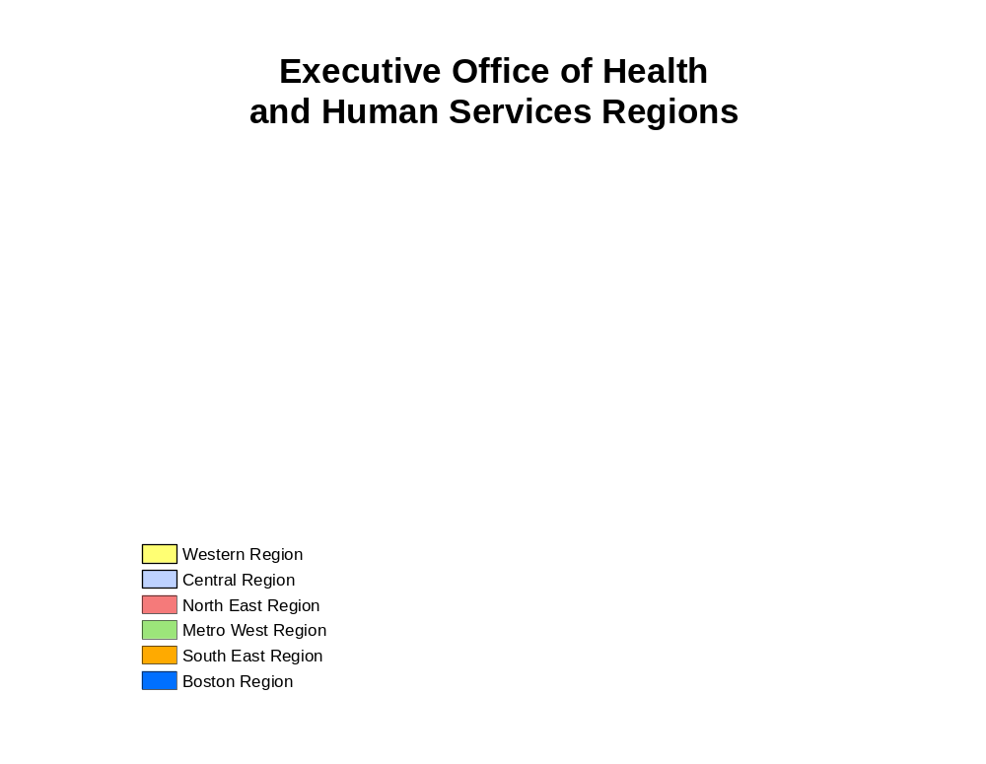
Map 1. Massachusetts Executive Office of Health and Human Services (EOHHS) Regions

Table 2. Hispanic Population in Selected Cities and in Massachusetts, Census 2000

City | Hispanic  Population | White non-Hispanic  Population | City  Population | %Hispanic  of City Pop | %Hispanic of State Hispanic Pop | %Spanish-speaking at Home, of City Pop
Boston | 85,089 | 306,878 | 589,141 | 14 | 20 | 14
Lawrence | 43,019 | 25,454 | 72,043 | 60 | 10 | 55
Springfield | 41,343 | 76,551 | 152,082 | 27 | 10 | 24
Worcester | 26,155 | 126,166 | 172,648 | 15 | 6 | 13
Chelsea | 16,984 | 14,246 | 35,080 | 48 | 4 | 44
Holyoke | 16,485 | 21,927 | 39,838 | 41 | 4 | 36
Lynn | 16,383 | 57,987 | 89,050 | 18 | 4 | 17
Lowell | 14,734 | 68,431 | 105,167 | 14 | 3 | 12
New Bedford | 9,576 | 79,066 | 93,768 | 10 | 2 | 8
Fall River | 3,040 | 84,515 | 91,938 | 3 | 1 | 2
Massachusetts | 428,729 | 5,326,585 | 6,349,097 | 7 | 100 | 6

Selected Cities

Table 2 shows the nine cities with the largest Hispanic population in the state, according to the Census 2000, and the city of Fall River which is routinely over-sampled in the BRFSS data collection. Approximately two thirds (64%) of the state’s Hispanic population resides in these 10 cities. Data for these Massachusetts cities are presented for the 3 general indicators of overall health status.

Prevalence of Selected Indicators of Poor Health

Twenty-one indicators of poor health are compared first between Hispanics and White non-Hispanic respondents (Table 3a) and second, between Hispanics and White non-Hispanics by preference of spoken language (Table 3b). These indicators cover topics such as poor overall general health status, lack of health care access and utilization, chronic conditions, and risk behaviors and conditions. Please see Appendix for definition of indicators used

Hispanic respondents compared with White non-Hispanic respondents
Hispanic adults reported worse outcomes than White non-Hispanics for twelve of twenty-one indicators of poor health (Table 3a). From largest to smallest difference between outcomes, these indicators are:
Poor general health 3.0 times higher (32.9% vs. 10.8%)
Ever told had a stroke 2.3 times higher ( 6.0% vs. 2.6%)
No health insurance 2.2 times higher (13.3% vs. 6.1%)
Did not see doctor due to cost 1.9 times higher (11.8% vs. 6.1%)
Ever told have diabetes 1.9 times higher ( 9.8% vs. 5.1%)
Disabled, need help with daily activities 1.9 times higher ( 9.2% vs. 4.9%)
Poor physical health 1.8 times higher (14.5% vs. 8.2%)
15+ days feeling sad in the past month 1.4 times higher (12.2% vs. 8.9%)
Obese (Body Mass Index >=30) 1.4 times higher (21.9% vs. 15.9%)
More than 5 teeth lost 1.2 times higher (21.1% vs. 17.5%)
Any disability 1.2 times higher (24.7% vs. 20.0%)
Overweight (Body Mass Index >=25) 1.2 times higher (64.6% vs. 52.1%)

In only four of these indicators did Hispanics reported better outcomes than White non-Hispanics
Current Smoker (17.7% vs. 20.3%)
Heavy Smoker ( 1.1% vs. 2.9%)
Binge Drinker (13.9% vs. 19.4%)
Heavy Drinker ( 2.8% vs. 7.6%)

Spanish-speaking Hispanic respondents compared with White non-Hispanic respondents
Spanish-speaking Hispanics reported worse outcomes than White non-Hispanics for nine of these measures of poor health (Table 3b). From largest to smallest difference between outcomes, these indicators are:
Poor general health 4.3 times higher (46.2% vs. 10.8%)
Disabled, need help with daily activities 2.6 times higher (12.5% vs. 4.9%)
Ever told have diabetes 2.3 times higher (11.6% vs. 5.1%)
No health insurance 2.1 times higher (13.0% vs. 6.1%)
Poor physical health 1.9 times higher (15.2% vs. 8.2%)
Did not see doctor due to cost 1.8 times higher (11.0% vs. 6.1%)
Any disability 1.9 times higher (31.7% vs. 20.0%)
Obese (Body Mass Index >=30) 1.4 times higher (22.0% vs. 15.9%)
Overweight (Body Mass Index >=25) 1.3 times higher (68.0% vs. 52.1%)

In four of twenty one indicators of poor health did Spanish-speaking Hispanics reported better outcomes than White non-Hispanics
Current Smoker (15.9% vs. 20.3%)
Heavy Smoker ( 0.3% vs. 2.9%)
Binge Drinker (11.2% vs. 19.4%)
Heavy Drinker ( 2.0% vs. 7.6%)
English-speaking Hispanic respondents compared with White non-Hispanic respondents
English-speaking Hispanics had worse outcomes than White non-Hispanics for seven of twenty-one measures of poor health (Table 3b). From largest to smallest difference between outcomes, these indicators are:
No health insurance 2.0 times higher (11.9% vs. 6.1%)
Did not see doctor due to cos t 1.9 times higher (11.3% vs. 6.1%)
Poor general health 1.7 times higher (18.7% vs. 10.8%)
Ever told have diabetes 1.6 times higher ( 8.3% vs. 5.1%)
Poor physical health 1.4 times higher (11.1% vs. 8.2%)
Obese (Body Mass Index >=30) 1.4 times higher (21.8% vs. 15.9%)
Overweight (Body Mass Index >=25) 1.2 times higher (63.6% vs. 52.1%)

In only one of twenty one indicators of poor health did English-speaking Hispanics reported better outcomes than White non-Hispanics
Heavy Drinker ( 3.6% vs. 7.6%)

The prevalence of Poor general health among Spanish-speaking Hispanics is nearly four times higher than that of White non-Hispanics (46% vs. 11%), while the prevalence for English-speaking Hispanics is nearly two times higher compared with that of White non-Hispanics (19% vs.11%) (Table 3b). [This is consistent with other state’s findings. For instance, the state of North Carolina has also reported significant differences in the prevalence of Poor general health between Spanish-speaking Hispanics and White non-Hispanics (38% vs. 18%)⁷.]

Both Spanish- and English-speaking Hispanics are more likely to be without health insurance compared with White non-Hispanics (13% and 12%, vs. 6%, respectively). This pattern is consistent with nationwide trends in which the number of uninsured Hispanics nearly doubled from 1990 to 2002. Hispanics remained consistently over-represented among the overall uninsured population in the U.S. (33% in 1990, and 32% in 2002)⁸.

Comment

It has been documented that the use of language by immigrant populations in the United States is highly correlated with other measures of acculturation⁴. Given this finding, we believe preferred spoken language among Hispanics is a valid proxy measure of acculturation in general. Our findings are consistent with this presumption in that, attitudes and behaviors of English-speaking (more acculturated) Hispanics are closer than those of the Spanish-speaking (less acculturated) Hispanics to those of the White non-Hispanic population.

The pattern of findings regarding smoking and drinking among Hispanics in Massachusetts is consistent with results of national studies as well. For example, one study indicates that the prevalence of smoking among Hispanics increases with increasing levels of acculturation⁹. Another study in 2003, that reviews the main research findings on alcohol consumption patterns, indicates that Hispanics’ norms and attitudes toward alcohol consumption are more conservative than those of White non-Hispanics. This study also indicates that the extent of acculturation to the US society, as reflected in language preference, also influences alcohol use among Hispanics¹⁰. Consistent with the acculturation hypothesis, we found that the risk of smoking and alcohol use among Hispanics in Massachusetts, although lower than that among White non-Hispanics, increases as Hispanics prefer English to Spanish: that is, with increasing acculturation.

Table 3a. Prevalence of Selected Indicators of Poor Health

Hispanics vs. White non-Hispanics, and State Overall Population
Massachusetts BRFSS 1999-2002
 | Hispanics |  | White non-Hispanics |  | State
Health Status | % | (95% CI) | % | (95% CI) | % | (95% CI)
Poor general health | 32.9 | (30.4-35.4) | 10.8 | (10.3-11.3) | 12.5 | (12.1-13.0)
15+ days feeling sad in the past month | 12.2* | (10.4-14.0) | 8.9 | (8.4-9.4) | 9.0 | (8.6-9.4)
Poor Physical Health | 14.5* | (12.4-16.6) | 8.2 | (7.8-8.6) | 8.7 | (8.3-9.0)
Health Care Access and Utilization | % | (95% CI) | % | (95% CI) | % | (95% CI)
No Health Insurance | 13.3* | (11.2-15.3) | 6.1 | (5.6-6.6) | 7.0 | (6.5-7.4)
Did not see doctor due to cost (1999, 2000) | 11.8* | (9.5-14.1) | 6.1 | (5.5-6.7) | 6.9 | (6.3-7.5)
No dental insurance (2000, 2001) | 37.4 | (32.5-42.3) | 36.1 | (34.8-37.5) | 36.4 | (35.1-37.6)
More than 5 teeth lost | 21.1* | (18.4-23.8) | 17.5 | (16.9-18.1) | 17.9 | (17.3-18.4)
Chronic Health Conditions | % | (95% CI) | % | (95% CI) | % | (95% CI)
Current Asthma (2000-2002) | 10.4 | (8.6-12.2) | 9.2 | (8.7-9.8) | 9.0 | (8.6-9.5)
Ever had Asthma (2000-2002) | 13.9 | (12.0-15.9) | 12.9 | (12.3-13.6) | 12.7 | (12.2-13.2)
Ever been told have diabetes | 9.8* | (7.9-11.7) | 5.1 | (4.7-5.4) | 5.5 | (5.2-5.8)
Ever been told have stroke (2000, 2001) | 6.0* | (3.2-8.8) | 2.6 | (2.2-3.0) | 2.9 | (2.5-3.3)
Any disability | 24.7* | (21.6-27.8) | 20.0 | (19.2-20.8) | 20.1 | (19.4-20.9)
Disability, needing help | 9.2* | (7.1-11.3) | 4.9 | (4.5-5.3) | 5.2 | (4.8-5.6)
Risk Behaviors/Conditions | % | (95% CI) | % | (95% CI) | % | (95% CI)
Current Smoker | 17.7 | (15.8-19.6) | 20.3 | (19.7-21.0) | 19.8 | (19.2-20.4)
Heavy Smoker | 1.1† | (0.6-1.6) | 2.9 | (2.7-3.2) | 2.6 | (2.4-2.8)
Binge drinker (5+ drinks at least once in the past month) (1999, 2001, 2002) | 13.9† | (11.1-16.6) | 19.4 | (18.4-20.4) | 18.8 | (17.9- 19.7)
Heavy Drinker (1999, 2001, 2002) | 2.8† | (1.9-3.8) | 7.6 | (7.1-8.2) | 6.9 | (6.5-7.3)
Overweight (BMI 25+) | 64.6* | (61.9-67.2) | 52.1 | (51.3-52.9) | 53.0 | (52.3-53.7)
Obese (BMI 30+) | 21.9* | (19.5-24.2) | 15.9 | (15.3-16.5) | 16.5 | (16.0-17.1)
Hypertension (1999, 2001) | 25.7 | (22.2-29.3) | 21.9 | (21.1-22.8) | 22.4 | (21.6-23.2)
High cholesterol (1999, 2001) | 27.1 | (23.1-31.2) | 27.7 | (26.7-28.8) | 27.5 | (26.5-28.4)
Note: Prevalence are age-adjusted to US 2000 standard population.

Table 3b. Prevalence of Selected Indicators of Poor Health

Spanish- and English-speaking Hispanics vs. White non-Hispanics
Massachusetts BRFSS 1999-2002
 | Spanish-speaking Hispanic |  | English-  speaking  Hispanic |  | White non-Hispanic
Health Status | % | (95% CI) | % | (95% CI) | % | (95% CI)
Poor general health | 46.2 | (42.6-49.8) | 18.7* | (15.5-21.8) | 10.8 | (10.3-11.3)
15+ days feeling sad in the past month | 10.9 | (8.5-13.4) | 11.5 | (9.0-14.0) | 8.9 | (8.4-9.4)
Poor Physical Health | 15.2* | (12.2-18.3) | 11.1* | (8.7-13.5) | 8.2 | (7.8-8.6)
Health Care Access and Utilization | % | (95% CI) | % | (95% CI) | % | (95% CI)
No Health Insurance | 13.0* | (9.7-16.3) | 11.9* | (9.1-14.7) | 6.1 | (5.6-6.6)
Did not see doctor due to cost (1999, 2000) | 11.0* | (8.1-13.8) | 11.3* | (8.2-14.5) | 6.1 | (5.5-6.7)
No dental insurance (2000, 2001) | 43.8 | (36.9-50.8) | 30.8 | (23.6-38.0) | 36.1 | (34.8-37.5)
More than 5 teeth lost | 18.9 | (15.3-22.6) | 19.0 | (14.9-23.1) | 17.5 | (16.9-18.1)
Chronic Health Conditions | % | (95% CI) | % | (95% CI) | % | (95% CI)
Current Asthma (2000-2002) | 10.0 | (7.4-12.5) | 11.3 | (8.3-14.3) | 9.2 | (8.7-9.8)
Ever had Asthma (2000-2002) | 13.3 | (10.5-16.1) | 15.3 | (12.2-18.5) | 12.9 | (12.3-13.6)
Ever been told have diabetes | 11.6* | (8.7-14.5) | 8.3* | (5.7-10.9) | 5.1 | (4.7-5.4)
Ever been told have stroke (2000, 2001) | 6.8 | (3.0-10.6) | 3.2 | (0.2-6.2) | 2.6 | (2.2-3.0)
Any disability | 31.7* | (27.1-36.3) | 19.1 | (15.3-22.9) | 20.0 | (19.2-20.8)
Disability, needing help | 12.5* | (8.7-16.3) | 6.2 | (4.2-8.2) | 4.9 | (4.5-5.3)
Risk Behaviors/Conditions | % | (95% CI) | % | (95% CI) | % | (95% CI)
Current Smoker | 15.9 | (13.1-18.6) | 19.9 | (17.0-22.7) | 20.3 | (19.7-21.0)
Heavy Smoker | 0.3† | (0.1-0.7) | 2.0 | (0.9-3.0) | 2.9 | (2.7-3.2)
Binge drinker (5+ drinks at least once in the past month) (1999, 2001, 2002) | 11.2† | (7.4-15.0) | 15.3 | (11.4-19.1) | 19.4 | (18.4 20.4)
Heavy Drinker (1999, 2001, 2002) | 2.0† | (0.5-3.6) | 3.6† | (2.2-5.0) | 7.6 | (7.1-8.2)
Overweight (BMI 25+) | 68.0* | (64.3-71.7) | 63.6* | (59.9-67.4) | 52.1 | (51.3-52.9)
Obese (BMI 30+) | 22.0* | (18.6-25.5) | 21.8* | (18.3-25.3) | 15.9 | (15.3-16.5)
Hypertension (1999, 2001) | 26.6 | (21.6-31.6) | 24.7 | (19.5-29.8) | 21.9 | (21.1-22.8)
High cholesterol (1999, 2001) | 23.7 | (18.4-29.1) | 29.6 | (23.6-35.6) | 27.7 | (26.7-28.8)
Note: Prevalence are age-adjusted to US 2000 standard population.

Prevalence of Selected Healthy Practices, Behaviors, and Attitudes

In this section, the prevalence of sixteen indicators relating to preventive behaviors and attitudes, women’s health practices and HIV testing are compared first between Hispanics and White non-Hispanics (Table 4a) and then between Hispanics and White non-Hispanics by spoken language preference (Table 4b). Hispanics reported worse outcomes for seven of the indicators. For four indicators, Hispanics reported better outcomes than White non-Hispanics.

Only fourteen indicators had sufficient data to stratify by preferred spoken language among Hispanics. Spanish-speaking Hispanics reported worse outcomes than White non-Hispanics in six of the indicators, and English-speaking Hispanics reported worse outcomes than White non-Hispanics in four (Table 4b).

Both Spanish- and English-speaking Hispanics reported worse outcomes than White non-Hispanics on: Any exercise during past month (50% and 66%, and 80%, respectively); Regular activity (36% and 42%, and 53%, respectively); Visit dentist in the past year (62% and 71%, and 78%, respectively); and Had a clinical breast exam in the past 2 years (62% and 71%, and 78%, respectively) (Table 4b).

The indicators that are reported as worse only for Spanish-speaking Hispanics compared with White non-Hispanics are: Has a personal doctor (71% and 89%, respectively); Current use of birth control (50% and 84%, respectively. Note that the latter difference does not take into account whether women are or not sexually active.); and Had cholesterol checked in past 5 years (68% and 80%, respectively) (Table 4b).

Hispanics are more likely to report support for smoking restrictions than White non-Hispanics (Smoking at home not allowed and Support smoking ban in restaurants). These positive attitudes among Hispanics toward environmental smoking are mainly driven by the attitudes of the Spanish-speaking Hispanics. Spanish-speaking Hispanics are more likely to support these attitudes, while there are no differences between English-speaking Hispanics and White non-Hispanics toward these attitudes (Table 4b).

Hispanics, both Spanish and English speakers, reported a higher prevalence of HIV testing than White non-Hispanics. The higher proportion of Hispanics testing for HIV should be interpreted with caution. One possible explanation may be that Hispanics are more likely to be at risk for HIV, and therefore more likely to have a motivation to be tested.

Table 4a. Prevalence of Selected Healthy Practices, Behaviors, and Attitudes

Hispanics vs. White non-Hispanics, and State Overall Population
Massachusetts BRFSS 1999-2002
 | Hispanics |  | White non-Hispanics |  | State
Preventive Behaviors/ Attitudes/Access | % | (95% CI) | % | (95% CI) | % | (95% CI)
Has a personal doctor (2001, 2002) | 76.6 | (73.3-79.9) | 88.6 | (87.8-89.3) | 87.0 | (86.3-87.7)
Dentist in the past year | 66.2* | (63.0-69.4) | 78.0 | (77.2-78.8) | 76.5 | (75.8-77.2)
Any exercise during past month (2000-2002) | 56.9* | (53.9-59.9) | 80.4 | (79.7-81.0) | 77.4 | (76.7-78.0)
Regular physical activity (2001, 2002) | 37.4* | (33.3-41.6) | 53.3 | (52.0-54.5) | 51.2 | (50.1-52.3)
Smoking at home not allowed | 78.2 | (75.9-80.4) | 64.6 | (63.8-65.4) | 66.1 | (65.4-66.7)
Support smoking ban in restaurants | 74.1† | (71.0-77.2) | 59.0 | (58.1-60.0) | 60.6 | (59.8-61.5)
5+ servings of fruits and vegetable a day (2000, 2002) | 27.8 | (24.2-31.5) | 29.9 | (28.9-30.9) | 29.7 | (28.8-30.6)
Cholesterol checked in past 5 yrs (1999, 2001) | 76.0 | (73.1-78.9) | 79.5 | (78.5-80.5) | 79.0 | (78.2-79.9)
Colonoscopy | 35.0* | (29.2-40.7) | 42.4 | (41.2-43.6) | 41.8 | (40.7-43.0)
Fecal occult blood test (FOBT) | 31.4 | (25.9-37.0) | 36.9 | (35.7-38.0) | 36.8 | (35.7-38.0)
Women’s Health | % | (95% CI) | % | (95% CI) | % | (95% CI)
Mammogram in past 2 years (1999, 2000, 2002) | 85.2 | (81.6-88.9) | 82.4 | (81.4-83.5) | 82.5 | (81.5-83.5)
Clinical breast exam in past 2 years (1999, 2000, 2002) | 80.5* | (77.8-83.3) | 86.5 | (85.7-87.4) | 84.8 | (84.0-85.6)
Pap smear in past 3 years | 85.9 | (82.8-89.1) | 89.1 | (88.3-89.8) | 88.3 | (87.6-89.0)
Currently use of birth control (2000, 2002) | 72.3* | (66.6-78.1) | 83.6 | (81.9-85.3) | 81.6 | (80.0-83.2)
HIV Testing | % | (95% CI) | % | (95% CI) | % | (95% CI)
Ever HIV tested | 56.1† | (53.4-58.8) | 45.2 | (44.3-46.1) | 46.5 | (45.7-47.3)
HIV tested in past 12 months | 21.1† | (19.0-23.3) | 12.9 | (12.3-13.6) | 14.2 | (13.6-14.8)
Note: Prevalence are age-adjusted to US 2000 standard population.

Table 4b. Prevalence of Selected Healthy Practices, Behaviors, and Attitudes

Spanish- and English-speaking Hispanics vs. White non-Hispanics
Massachusetts BRFSS 1999-2002
 | Spanish-speaking Hispanic |  | English-  speaking  Hispanic |  | White non-Hispanic
Preventive Behaviors/ Attitudes/Access | % | (95% CI) | % | (95% CI) | % | (95% CI)
Has a personal doctor (2001, 2002) | 71.4 | (66.5-76.2) | 84.1 | (80.4-87.8) | 88.6 | (87.8-89.3)
Dentist in the past year | 62.1* | (57.4-66.7) | 71.2* | (66.7-75.7) | 78.0 | (77.2-78.8)
Any exercise during past month (2000-2002) | 49.9* | (45.4-54.3) | 65.7* | (61.8-69.7) | 80.4 | (79.7-81.0)
Regular physical activity (2001, 2002) | 35.8* | (28.9-42.8) | 42.1* | (35.7-48.5) | 53.3 | (52.0-54.5)
Smoking at home not allowed | 88.3 | (85.9-90.7) | 68.8 | (65.0-72.6) | 64.6 | (63.8-65.4)
Support smoking ban in restaurants | 86.0† | (82.8-89.3) | 63.1 | (58.4-67.8) | 59.0 | (58.1-60.0)
5+ servings of fruits and vegetable a day (2000, 2002) | 24.9 | (20.1-29.7) | 29.5 | (24.1-34.8) | 29.9 | (28.9-30.9)
Cholesterol checked in past 5 yrs (1999, 2001) | 67.5* | (62.5-72.6) | 81.6 | (78.3-85.0) | 79.5 | (78.5-80.5)
Women's Health | % | (95% CI) | % | (95% CI) | % | (95% CI)
Mammogram in past 2 years (1999, 2000, 2002) | 85.4 | (80.9-89.9) | 84.4 | (77.6-91.2) | 82.4 | (81.4-83.5)
Clinical breast exam in past 2 years (1999, 2000, 2002) | 77.1* | (72.9-81.2) | 81.0* | (76.4-85.6) | 86.5 | (85.7-87.4)
Pap smear in past 3 years | 89.3 | (85.9-92.8) | 82.0 | (76.6-87.5) | 89.1 | (88.3-89.8)
Currently use of birth control (2000, 2002) | 50.4* | (38.3-62.4) | 82.4 | (76.8-87.9) | 83.6 | (81.9-85.3)
HIV Testing | % | (95% CI) | % | (95% CI) | % | (95% CI)
Ever HIV tested | 53.0† | (48.9-57.1) | 59.6† | (55.8-63.5) | 45.2 | (44.3-46.1)
HIV tested in past 12 months | 21.7† | (18.4-25.1) | 21.3† | (18.3-24.3) | 12.9 | (12.3-13.6)
Note: Prevalence are age-adjusted to US 2000 standard population.
Colonoscopy and Fecal occult blood test (FOBT) responses from Hispanics were insufficient to allow breaks by language.

General Indicators of Overall Poor Health Status

The data presented here are prevalence rates of self reported Poor general health, 15+ days feeling sad in the past month, and Poor physical health for Spanish- and English-speaking Hispanics compared with White non-Hispanics (Table 5). These three indicators of overall health are also presented for selected socio-demographic characteristics among Spanish- and English-speaking Hispanic, and White non-Hispanic groups, in comparison with the overall group’s prevalence (Figures 1, 3, and 5). Lastly, city-specific data are compared for Hispanics and White non-Hispanics (Figures 2, 4, and 6).

Poor General Health

Hispanics in general (Spanish and English speakers combined), reported worse general health status than White non-Hispanics (Table 3a). This is also true for both Spanish- and English-speaking Hispanics (Table 5).

Spanish-speaking Hispanic respondents vs. White non-Hispanic respondents
Spanish-speaking Hispanics reported worse poor general health than White non-Hispanics for all categories of gender, age, education, and region of residence (Table 5).

English-speaking Hispanic respondents vs. White non-Hispanic respondents
English-speaking Hispanics reported similar poor general health status as compared with White non-Hispanics, except for these subgroups: women, those aged 45 to 54 years, and those living in the Western, Central, or Boston regions of the state, for whom this outcome is worse compared with that for White non-Hispanics (Table 5).

Within Group Comparisons
Health status among Spanish-speaking Hispanic Subgroups
Spanish-speaking Hispanics ages 45 or older reported worse general health status than overall Spanish-speaking Hispanics do. Those who were younger than 45 and those with 1 to 3 years of college education reported better general health status within this group (Figure 1a).

Health status among English-speaking Hispanic Subgroups
Less than high school education, incomes less than $25,000, living in the Central region of the state, and living in the city of Worcester were characteristics associated with worse general health status among English-speaking Hispanics. Incomes over $50,000, and being younger than 35, were characteristics of individuals who reported better general health status in this group (Figure 1b).

Health status among White non-Hispanic Subgroups
Among White non-Hispanics, characteristics associated with worse general health status are: high school education or less education, incomes less than $25,000, ages 55 and older, living in the Boston region, and in the cities of Fall River, New Bedford Lynn, Lowell, and Lawrence (Figure 1c).

City of Residence - Hispanics vs. White non-Hispanics
In the cities of New Bedford, Lawrence, Springfield, Worcester, and Boston, Hispanics, overall, reported worse general health status than White non-Hispanics. In these cities, Hispanics are between two to three times more likely to report poor general health than White non-Hispanics (Figure 2).

Table 5. Poor General Health Prevalence
Spanish- and English-speaking Hispanics vs. White non-Hispanics
Massachusetts BRFSS 1999-2002
 | Spanish-speaking Hispanics |  | English-speaking Hispanics |  | White non-Hispanics
 | % | (95% CI) | % | (95% CI) | % | (95% CI)
Overall | 46.2 | (42.6-49.8) | 18.7* | (15.5-21.8) | 10.8 | (10.3-11.3)
Gender
Male | 47.6* | (42.1-53.0) | 16.4 | (11.8-21.0) | 11.3 | (10.5-12.0)
Female | 46.1* | (41.9-50.3) | 21.2* | (16.9-25.5) | 10.4 | (9.8-11.0)
Age Group
18-24 | 22.6* | (12.2-33.0) | 9.9 | (6.4-13.3) | 5.4 | (4.1-6.7)
25-34 | 28.3* | (21.8-34.8) | 7.9 | (5.0-10.7) | 4.2 | (3.3-5.1)
35-44 | 33.4* | (26.9-39.8) | 11.4 | (6.9-15.9) | 6.3 | (5.5-7.1)
45-54 | 59.5* | (51.2-67.9) | 27.8* | (19.3-36.3) | 10.0 | (9.0-11.1)
55-64 | 65.6* | (53.5-77.7) | 22.4 | (11.6-33.3) | 16.0 | (14.3-17.6)
65+ | 72.7* | (61.7-83.8) | 33.5 | (21.2-45.8) | 24.9 | (23.5-26.4)
Education
<High School | 50.5* | (45.9-55.1) | 32.4 | (25.0-39.9) | 28.4 | (25.0-31.8)
High School | 43.8* | (36.7-50.9) | 14.9 | (9.7-20.2) | 14.3 | (13.3-15.3)
College 1-3 yrs | 20.8* | (12.1-29.5) | 15.7 | (10.0-21.4) | 10.2 | (9.4-11.1)
College 4+ yrs | 48.1* | (35.0-61.3) | 15.4* | (9.1-21.6) | 6.0 | (5.4-6.6)
Region
Western | 51.5* | (43.8-59.1) | 26.0* | (18.6-33.5) | 10.9 | (9.7-12.0)
Central | 32.5* | (21.5-43.6) | 31.3* | (23.2-39.4) | 11.2 | (10.0-12.4)
North East | 47.6* | (41.6-53.6) | 14.7 | (8.5-21.0) | 11.6 | (10.5-12.8)
Metro West | 57.2* | (45.5-69.0) | 12.5 | (6.3-18.6) | 8.8 | (7.8-9.8)
South East | 32.8* | (20.6-45.1) | 15.5 | (9.4-21.7) | 11.5 | (10.5-12.5)
Boston | 44.6* | (37.9-51.2) | 26.2* | (18.4-34.0) | 12.7 | (11.3-14.1)
 | Hispanics
City
Boston | 34.8* |  | (29.6-39.9) |  | 12.5 | (11.1-13.8)
Chelsea | 41.6 |  | (24.3-59.0)
Fall River | 32.4 |  | (21.9-43.0) |  | 22.5 | (18.7-26.4)
Holyoke |  |  |  |  | 10.6 | (3.8-17.5)
Lawrence | 44.6* |  | (38.7-50.5) |  | 17.2 | (12.3-22.1)
Lowell | 27.5 |  | (18.1-36.9) |  | 17.8 | (14.4-21.2)
Lynn | 30.0 |  | (20.2-39.8) |  | 19.3 | (14.0-24.6)
New Bedford | 45.2* |  | (35.2-55.2) |  | 20.8 | (17.2-24.5)
Springfield | 40.2* |  | (34.8-45.6) |  | 11.8 | (9.7-13.9)
Worcester | 35.5* |  | (27.6-43.4) |  | 12.3 | (10.3-14.2)
Note: Prevalence are age-adjusted to US 2000 standard population, except for age groups which are age-specific.

Figure 1. Prevalence of Poor General Health§
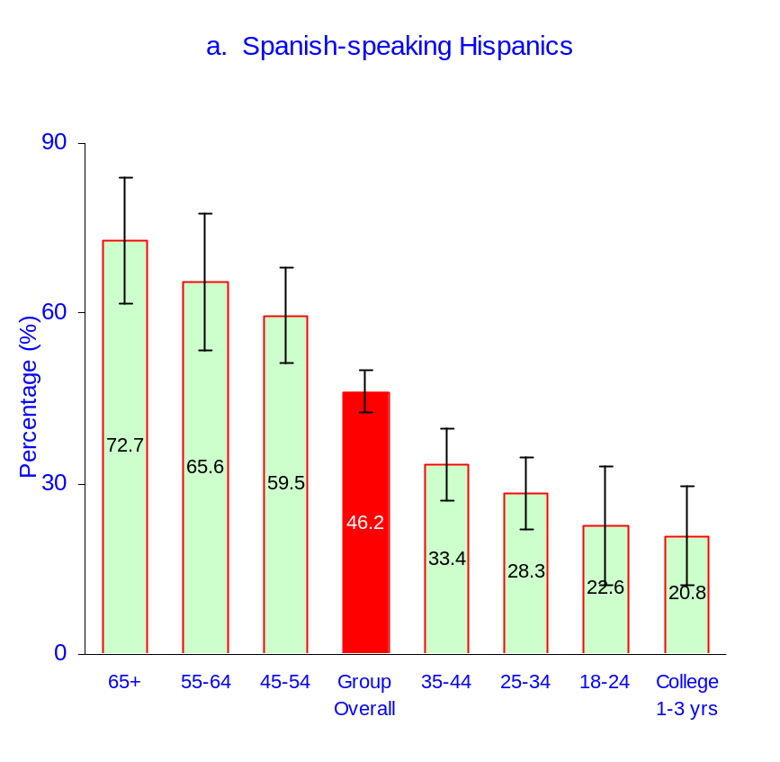

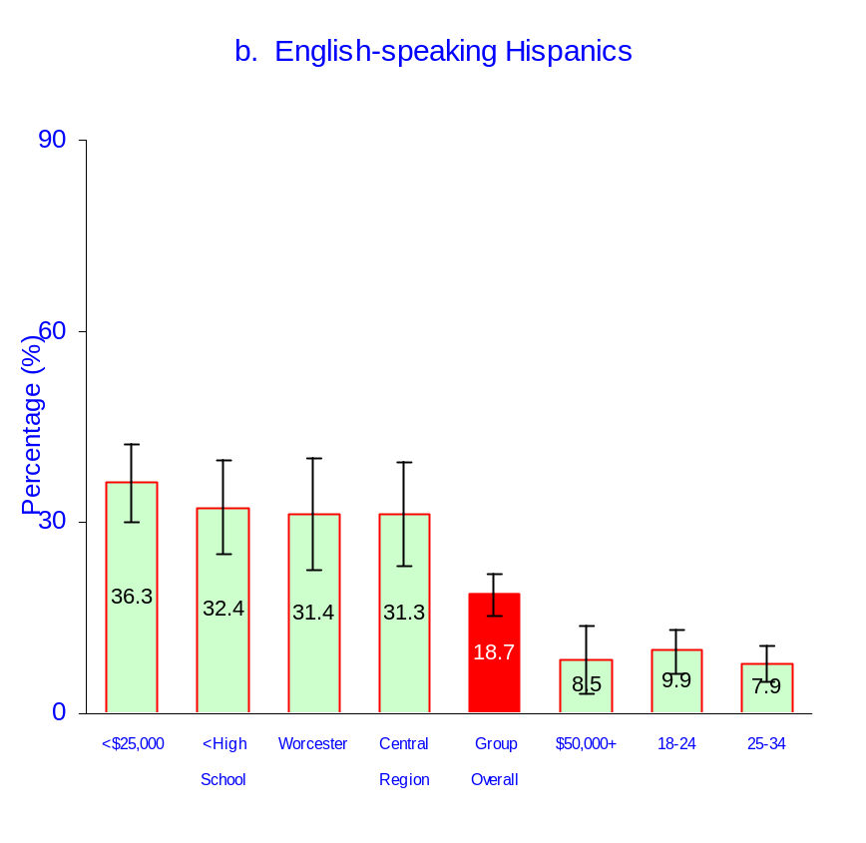

§ Only subgroups for which the indicator differs significantly from the group prevalence are shown

Figure 1. (continued) Prevalence of Poor General Health§
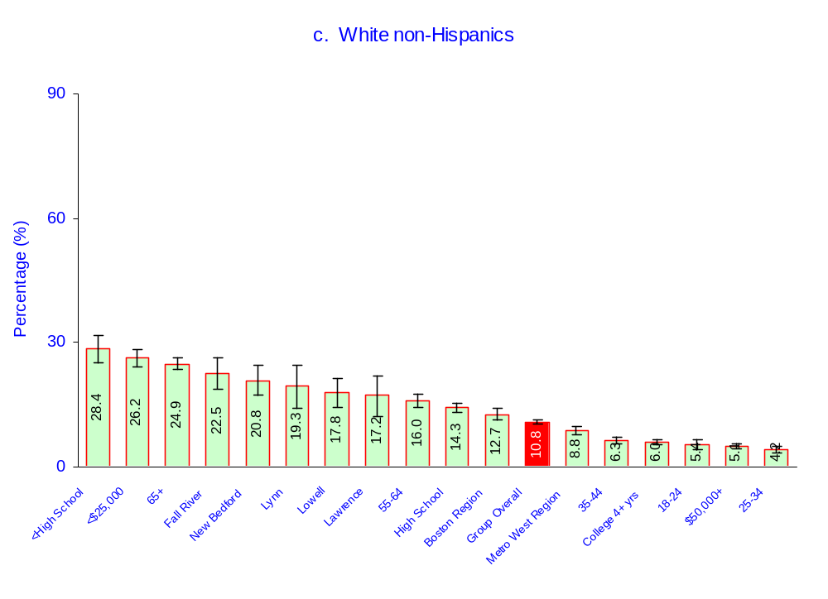

§ Only subgroups for which the indicator differs significantly from the group prevalence are shown
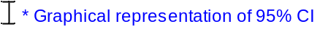

Figure 2. Community-specific Prevalence of Poor General Health

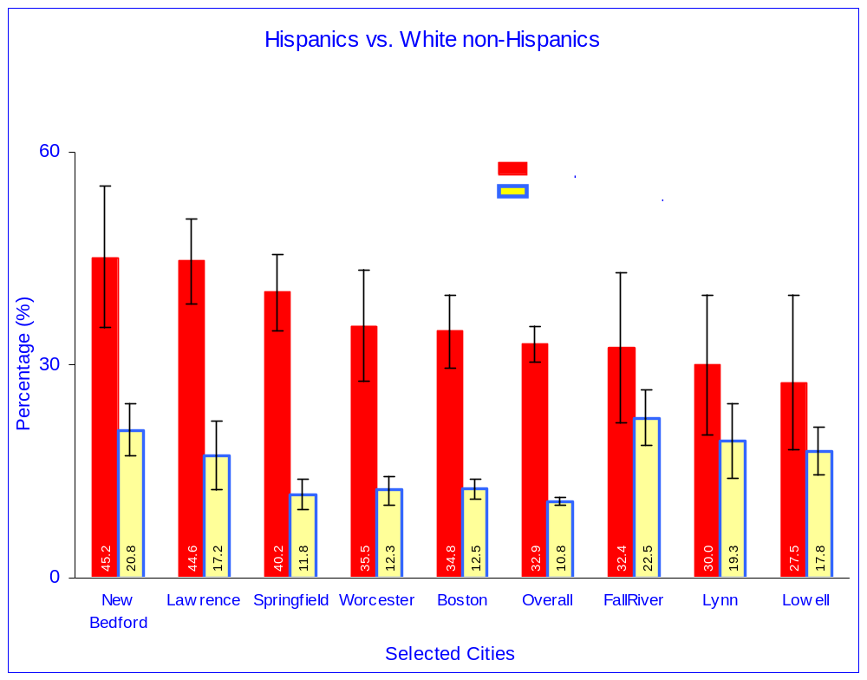

15+ Days Feeling Sad In The Past Month

Hispanics overall (Spanish and English speakers combined) were more likely to report recent feelings of sadness and depression than White non-Hispanics (Table 3a). However, when Hispanics are stratified by preference for spoken language, there is no statistically significant difference in reported 15+ days feeling sad in the past month between either Spanish-speaking or English-speaking Hispanic respondents and White non-Hispanic respondents (Table 6).

Spanish-speaking Hispanics vs. White non-Hispanics
Young Spanish-speaking adults (ages 18 to 24) reported better 15+ days feeling sad in the past month than White non-Hispanics of the same age range. Middle-aged Spanish-speaking adults (ages 45 to 54) reported worse 15+ days feeling sad in the past month than do White non-Hispanics in that age group (Table 6).

English-speaking Hispanics vs. White non-Hispanics
English-speaking Hispanics living in the Western Region of the state reported worse 15+ days feeling sad in the past month than White non-Hispanics (Table 6).

Within Group Comparisons
15+ days feeling sad in the past month among Spanish-speaking Hispanic Subgroups
Young Spanish-speaking Hispanic adults (ages 18 to 24) and those with incomes between $25,000 and $35,000 reported better 15+ days feeling sad in the past month than this group as whole (Figure 3a).

15+ days feeling sad in the past month among English-speaking Hispanic Subgroups
English-speaking Hispanics adults living in the North East and Metro West regions of the state reported better 15+ days feeling sad in the past month than the English-speaking Hispanic group as a whole (Figure 3b).

15+ days feeling sad in the past month among White non-Hispanic Subgroups
Living in the cities of Lynn, New Bedford, and Fall River, having an income less than $25,000, having a high school education or less, being young (ages 18 to 24), and being female were characteristics associated with worse 15+ days feeling sad in the past month than the group as a whole. Those with higher educational attainment (4 years of college or more), senior adults (ages 65 and older); those with incomes over $50,000, and men reported better 15+ days feeling sad in the past month than the group overall (Figure 3c).

City of Residence - Hispanics vs. White non-Hispanics
Although Hispanics overall have a greater prevalence of 15+ days feeling sad in the past month than do White non-Hispanics, among eight selected cities with sufficient data to report, only in Springfield Hispanics do have a greater prevalence of 15+ days feeling sad in the past month than White non-Hispanics. In this city, Hispanics were nearly twice more likely to report 15+ days feeling sad in the past month than White non-Hispanics (18.2% vs.10.6%) (Figure 4).

Table 6. 15+ Days Feeling Sad In The Past Month Prevalence
Spanish- and English-speaking Hispanics vs. White non-Hispanics
Massachusetts BRFSS 1999-2002
 | Spanish-speaking Hispanics |  | English-speaking Hispanics |  | White non-Hispanics
 | % | (95% CI) | % | (95% CI) | % | (95% CI)
Overall | 10.9 | (8.5-13.4) | 11.5 | (9.0-14.0) | 8.9 | (8.4-9.4)
Gender
Male | 12.3 | (7.2-17.3) | 8.5 | (5.1-11.9) | 7.5 | (6.8-8.1)
Female | 10.5 | (8.0-12.9) | 13.6 | (10.6-16.7) | 10.2 | (9.6-10.9)
Age Group
18-24 | 2.3† | (0.2-4.5) | 14.0 | (9.3-18.6) | 12.3 | (10.3-14.2)
25-34 | 7.5 | (4.0-11.0) | 8.7 | (6.0-11.5) | 8.6 | (7.4-9.7)
35-44 | 12.7 | (8.0-17.5) | 12.1 | (8.0-16.2) | 8.8 | (7.9-9.8)
45-54 | 17.7 | (10.9-24.5) | 14.4 | (8.1-20.7) | 9.8 | (8.7-10.8)
55-64 | 17.7 | (5.1-30.3) | 6.8 | (0.3-13.3) | 8.6 | (7.4-9.8)
65+ | 7.0 | (0.9-13.1) | 10.4 | (0.8-20.0) | 6.1 | (5.3-6.9)
Education
<High School | 11.9 | (8.7-15.1) | 15.3 | (9.7-20.8) | 17.1 | (14.2-20.0)
High School | 10.9 | (5.2-16.7) | 9.9 | (6.3-13.5) | 11.3 | (10.3-12.3)
College 1-3 yrs | 8.7 | (2.2-15.2) | 13.1 | (9.0-17.1) | 9.7 | (8.8-10.7)
College 4+ yrs | 5.8 | (0.9-10.6) | 8.6 | (3.3-13.9) | 6.1 | (5.4-6.7)
Region
Western | 17.7 | (10.7-24.7) | 17.1* | (11.7-22.6) | 9.9 | (8.7-11.2)
Central | 8.2 | (3.2-13.2) | 18.1 | (7.7-28.5) | 8.8 | (7.7-10.0)
North East | 10.1 | (6.0-14.2) | 5.5 | (2.5-8.5) | 9.0 | (7.9-10.1)
Metro West | 12.9 | (3.0-22.8) | 4.5 | (1.6-7.4) | 8.2 | (7.1-9.3)
South East | 7.1 | (1.7-12.5) | 14.8 | (7.8-21.9) | 9.7 | (8.6-10.7)
Boston | 10.4 | (5.1-15.7) | 10.3 | (5.8-14.8) | 8.5 | (7.4-9.7)
 | Hispanics
City
Boston | 12.4 |  | (8.0-16.8) |  | 9.1 | (7.9-10.4)
Chelsea | 3.2 |  | (0.9-10.4)
Fall River | 11.3 |  | (2.7-19.8) |  | 15.2 | (11.7-18.8)
Holyoke |  |  |  |  | 6.2 | (2.2-16.1)
Lawrence | 9.5 |  | (4.9-14.0) |  | 12.9 | (8.0-17.7)
Lowell | 11.1 |  | (5.3-16.9) |  | 11.5 | (8.4-14.7)
Lynn |  |  |  |  | 19.9 | (13.2-26.7)
New Bedford | 16.3 |  | (8.8-23.8) |  | 16.1 | (11.2-21.0)
Springfield | 18.2* |  | (13.9-22.5) |  | 10.6 | (8.4-12.7)
Worcester | 17.4 |  | (10.2-24.7) |  | 8.8 | (7.0-10.5)
Prevalence are age-adjusted to US 2000 standard population, except for age groups which are age-specific.

Figure 3. Prevalence of 15+ Days Feeling Sad In The Past Month§
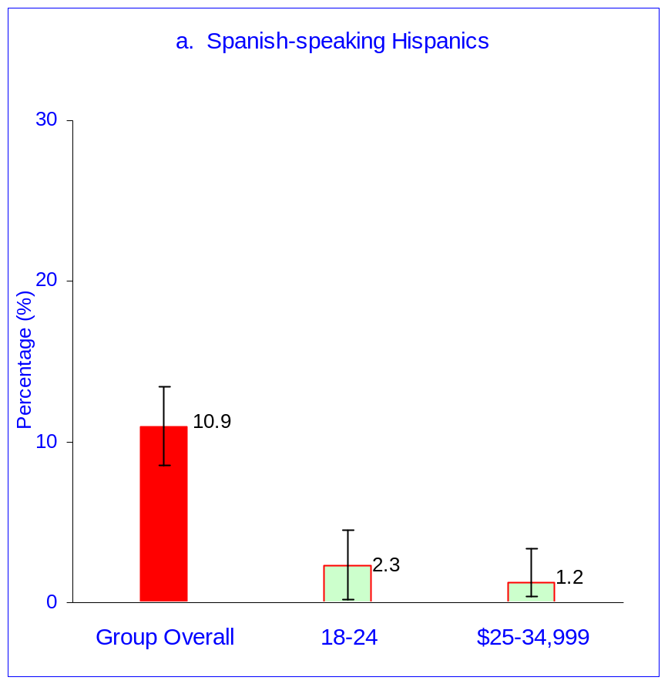

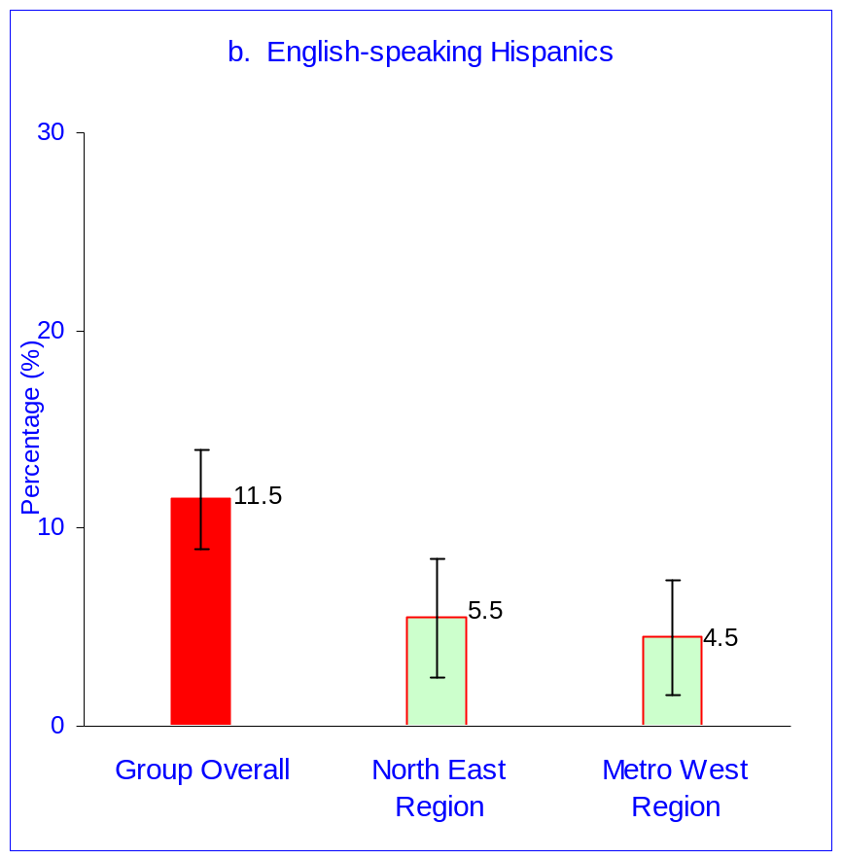

Figure 3. (continued) Prevalence of 15+ Days Feeling Sad In The Past Month§

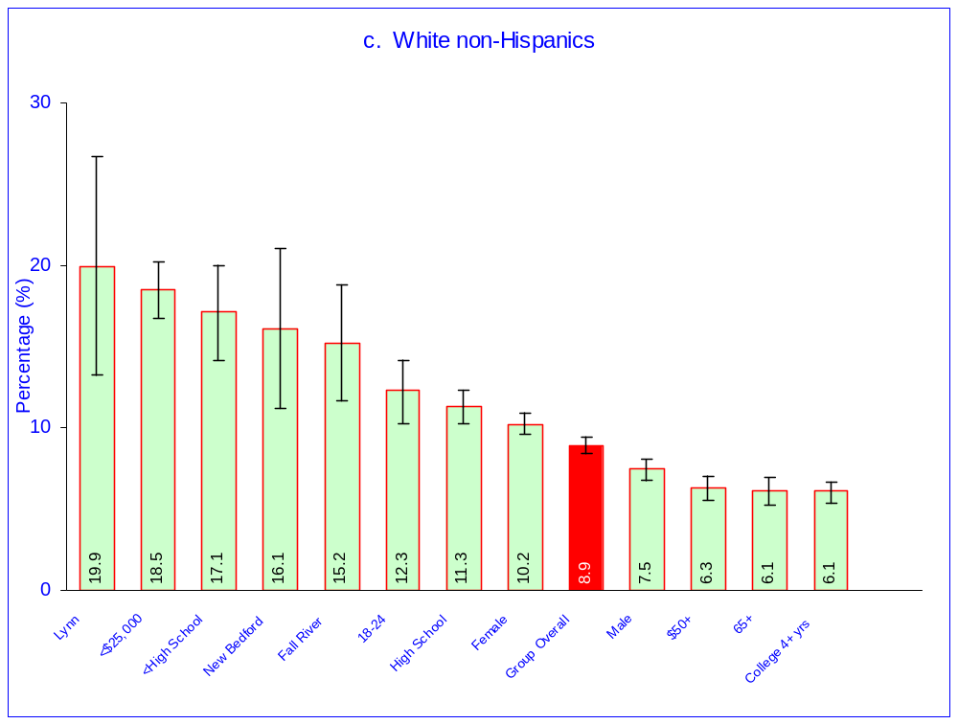

§ Only subgroups for which the indicator differs significantly from the group prevalence are shown

Figure 4. Community-specific Prevalence of 15+ Days Feeling Sad In The Past Month

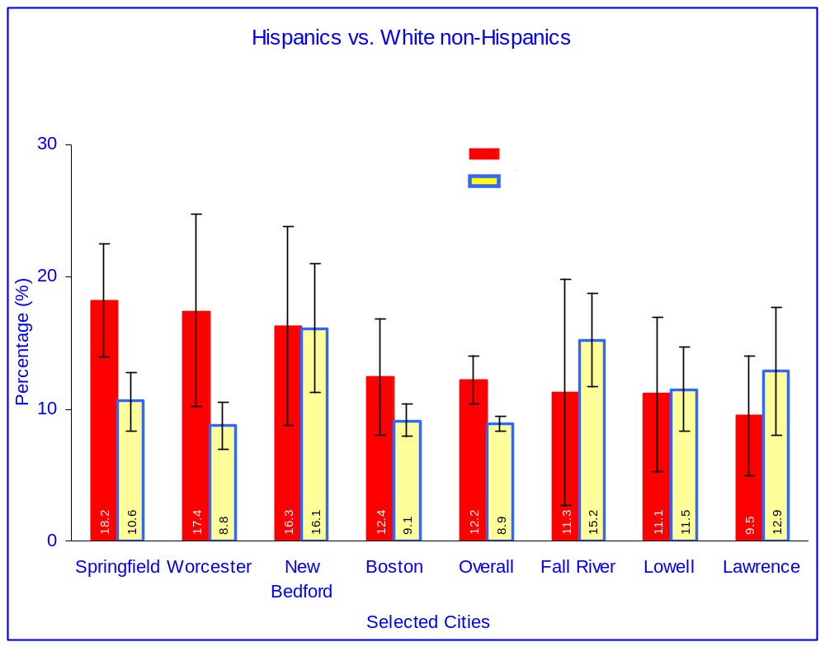

Poor Physical Health

Hispanics overall (Spanish and English speakers combined) reported worse physical health compared with White non-Hispanics (Table 3a). This is also true for both Spanish- and English-speaking Hispanics (Table 7).

Spanish-speaking Hispanics vs. White non-Hispanics
Spanish-speaking Hispanics reported worse physical health than White non-Hispanics among men, women, those who were ages 35 to 64, those with some college education (1-3 years), and among those living in the North East and Metro West regions of the state (Table 7).

English-speaking Hispanics vs. White non-Hispanics
English-speaking Hispanics reported similar physical health as White non-Hispanics for all specific categories of gender, age, education, and region of residence, except for adults at ages 35 to 44. For this age group (ages 35-44), English-speaking Hispanics reported worse physical health than White non-Hispanics (12.0% vs. 5.7%) (Table 7).

Within Group Comparisons
Physical health among Spanish-speaking Hispanic Subgroups
Spanish-speaking Hispanics having ages under 35 reported better physical health than the group as a whole (Figure 5a)

Physical health among English-speaking Hispanic Subgroups
Among English-speaking Hispanics, those living in the city of Lawrence reported better physical health than the group as a whole (Figure 5b).

Physical health among White non-Hispanic Subgroups
The characteristics among White non-Hispanics associated with worse physical health are: those with incomes less than $25,000, adults ages 55 and older, adults with high school education or less, and residents of the cities of New Bedford, Lowell, and Fall River. Characteristics associated with better physical health in this group are: young adults (ages 18 to 44); those with highest levels of educational attainment; and those with incomes over $50,000 (Figure 5c).

City of Residence - Hispanics vs. White non-Hispanics
Although Hispanics overall reported worse prevalence of poor physical health than do White non-Hispanics, among the selected cities, only in Springfield Hispanics do report worse poor physical health than White non-Hispanics. In this city, Hispanics were nearly twice as likely to report poor physical health as White non-Hispanics do (17.0% vs. 9.1%) (Figure 6).

Table 7. Poor Physical Health Prevalence
Spanish- and English-speaking Hispanics vs. White non-Hispanics
Massachusetts BRFSS 1999-2002
 | Spanish-speaking Hispanics |  | English-speaking Hispanics |  | White non-Hispanics
 | % | (95% CI) | % | (95% CI) | % | (95% CI)
Overall | 15.2 | (12.2-18.3) | 11.1* | (8.7-13.5) | 8.2 | (7.8-8.6)
Gender
Male | 16.2* | (10.1-22.4) | 9.8 | (6.5-13.1) | 7.7 | (7.1-8.3)
Female | 15.0* | (11.8-18.1) | 12.2 | (8.6-15.8) | 8.7 | (8.2-9.3)
Age Group
18-24 | 3.7 | (0.6-6.8) | 5.9 | (2.6-9.2)* | 3.4 | (2.4-4.4)*
25-34 | 5.0 | (2.2-7.8) | 6.0 | (3.5-8.5)* | 4.1 | (3.4-4.9)*
35-44 | 13.3* | (8.1-18.5) | 12.0* | (7.8-16.3)* | 5.7 | (5.0-6.5)*
45-54 | 21.1* | (13.5-28.7) | 13.4 | (7.6-19.1)* | 8.9 | (7.8-9.9)*
55-64 | 29.3* | (15.6-42.9) | 10.9 | (3.6-18.2)* | 11.1 | (9.8-12.4)*
65+ | 22.3 | (11.6-33.0) | 16.9 | (7.3-26.4)* | 16.9 | (15.6-18.2)*
Education
<High School | 14.5 | (10.9-18.2) | 18.9 | (12.5-25.3) | 16.7 | (13.9-19.4)
High School | 13.0 | (7.0-19.1) | 11.7 | (6.8-16.6) | 10.1 | (9.2-11.0)
College 1-3 yrs | 27.2* | (12.1-42.3) | 10.9 | (6.4-15.4) | 8.9 | (8.0-9.8)
College 4+ yrs | 20.1 | (4.2-36.0) | 8.1 | (3.6-12.5) | 5.6 | (5.0-6.2)
Region
Western | 15.7 | (9.5-22.0) | 10.0 | (6.3-13.7) | 8.8 | (7.7-9.9)
Central | 16.3 | (6.0-26.6) | 18.3 | (6.9-29.7) | 8.9 | (7.8-10.0)
North East | 18.3* | (12.2-24.4) | 12.4 | (3.8-21.1) | 8.2 | (7.2-9.1)
Metro West | 19.8* | (8.4-31.2) | 8.9 | (2.5-15.3) | 7.2 | (6.3-8.1)
South East | 10.5 | (3.9-17.1) | 10.3 | (5.4-15.2) | 9.0 | (8.1-10.0)
Boston | 10.7 | (5.3-16.0) | 12.9 | (7.1-18.8) | 7.8 | (6.7-9.0)
 | Hispanics
City
Boston | 12.2 |  | (7.8-16.6) |  | 7.8 | (6.6-9.0)
Chelsea | 3.0 |  | (0.8-10.4)
Fall River | 19.4 |  | (9.1-29.8) |  | 12.6 | (9.4-15.9)
Holyoke |  |  |  |  | 11.2 | (4.9-17.6)
Lawrence | 10.8 |  | (5.9-15.7) |  | 11.4 | (6.8-16.1)
Lowell | 19.4 |  | (8.2-30.6) |  | 12.7 | (9.5-15.9)
Lynn |  |  |  |  | 12.5 | (7.7-17.2)
New Bedford | 25.3 |  | (16.4-34.1) |  | 15.2 | (11.8-18.7)
Springfield | 17.0* |  | (12.5-21.5) |  | 9.1 | (7.1-11.1)
Worcester | 12.9 |  | (6.6-19.3) |  | 8.0 | (6.3-9.7)
Prevalence are age-adjusted to US 2000 standard population, except for age groups which are age-specific.

Figure 5. Prevalence of Poor Physical Health§
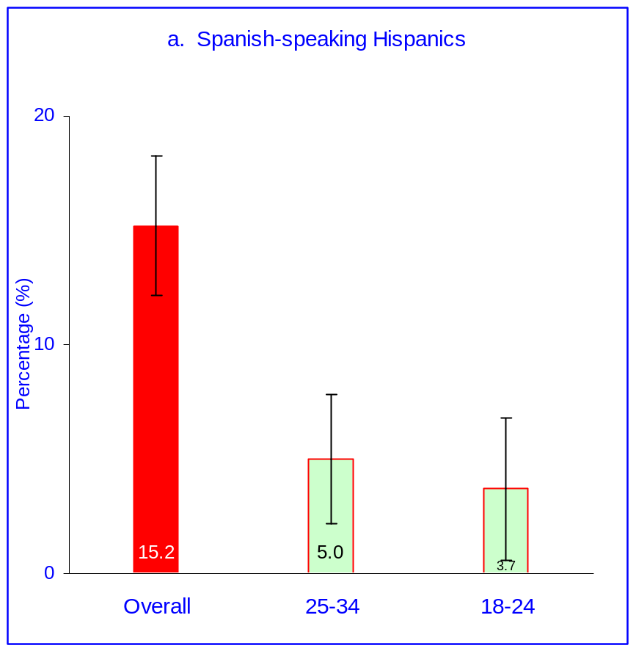

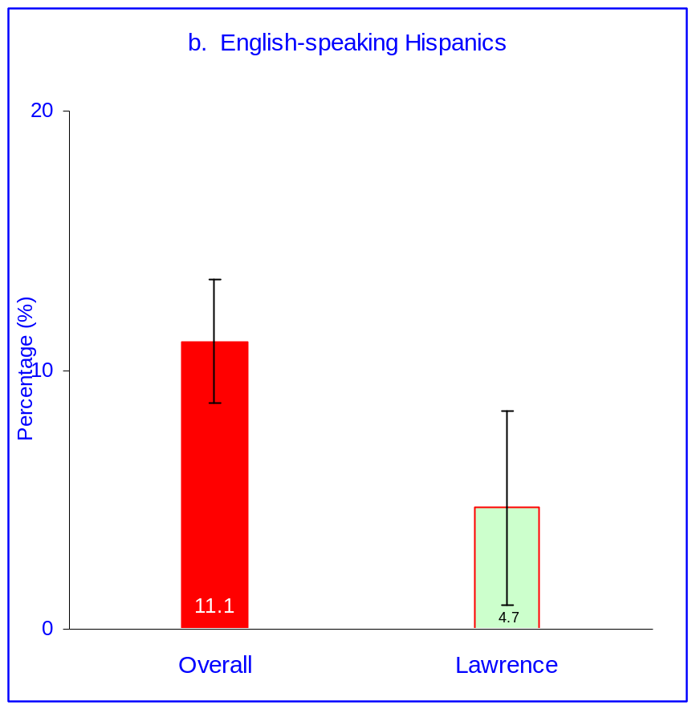

Figure 5. (continued) Prevalence of Poor Physical Health§
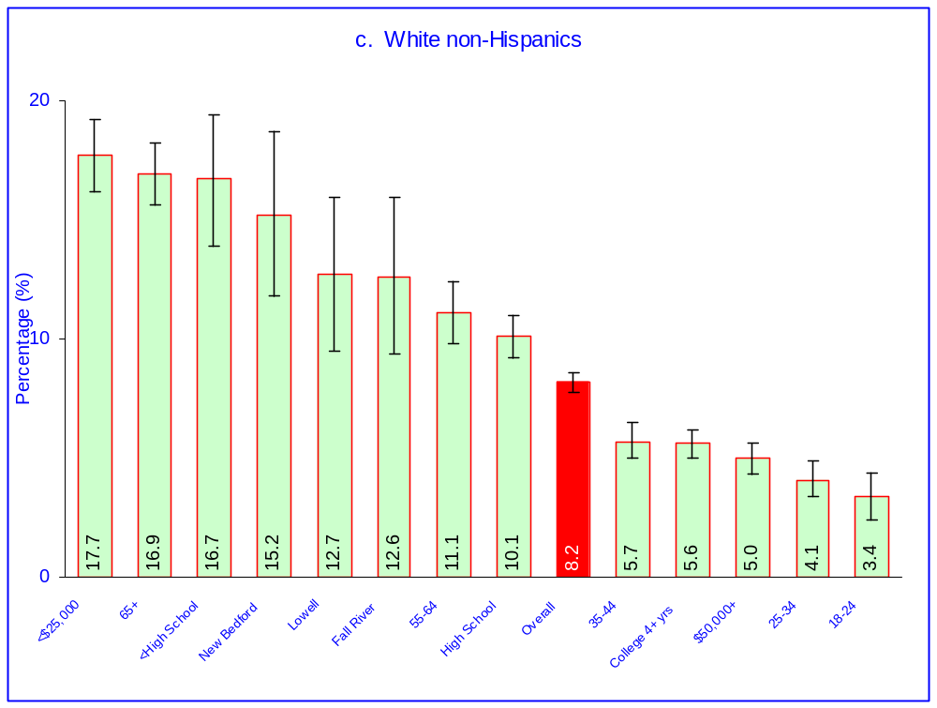

§ Only subgroups for which the indicator differs significantly from the group prevalence are shown

Figure 6. Community-specific Prevalence of Poor Physical Health
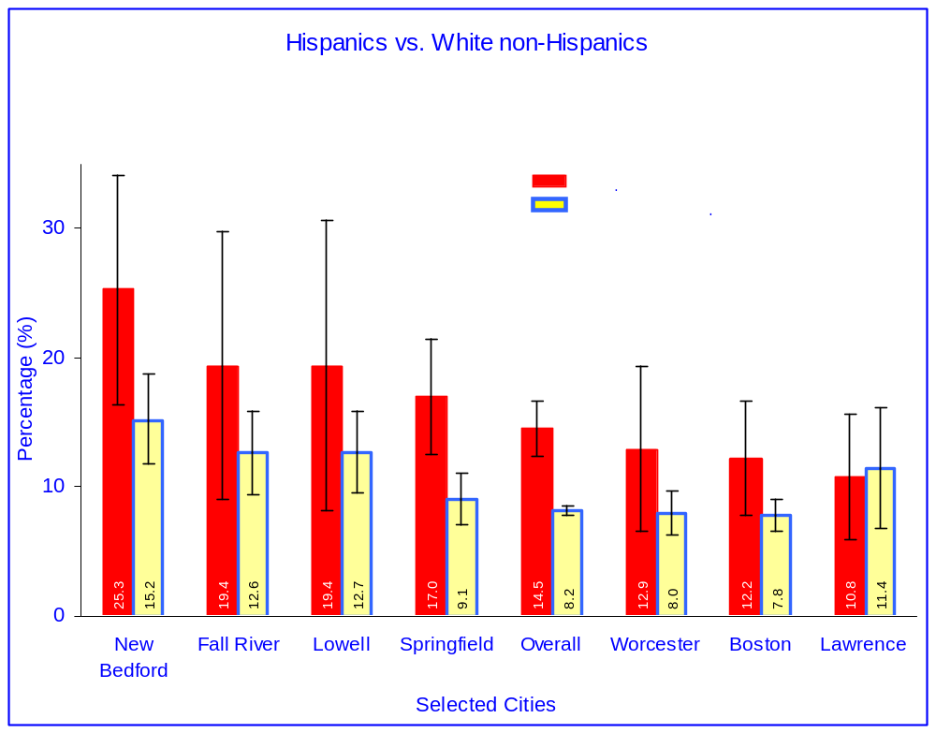

References

- A Profile of Health Among Massachusetts Adults, 2002. Health Survey Program, Center for Health Information, Statistics, Research, and Evaluation. Massachusetts Department of Public Health, April 2004.
- Timmins CL. The impact of language barriers on the health care of Latinos in the Unites States. Journal of Midwifery and Women’s Health 2002; 47(2):80-96.
- Hispanic Births in Massachusetts 1996-1999. Volume I: Statewide Data. Massachusetts Department of Public Health. November 2001; Chapter 7 (pages 79-85).
- Pérez-Stable, Eliseo J. et al. Cigarette Smoking Behavior Among US Latino Men and Women From Different Countries of Origin. American Journal of Public Health, Sep 2001; 91: 1424 - 1430.
- Zhang, Z; Cohen, B: How representative is the Massachusetts BRFSS sample: a comparison to the current census data. Presented at BRFSS Annual Conference, St. Louis, MO; February 2003.
- Laws, MB and Mayo, SJ. The Latina Breast Cancer Control Study. Journal of Community Health 1998. 23;
- Herrick, Harry; Gizlice, Ziya. Spanish-speaking Hispanics in North Carolina: Health Status, Access to Care, and Quality of Life. Special report by the State Center for Health Statistics. July 2004.
- Doty, Michelle M. Insurance, Access, and Quality of Care among Hispanic Populations. 2003 Chartpack. The Commonwealth Fund, October 2003.
- Singh, Gopal and Siahpush, Mohammad. Ethnic-Immigrant Differentials in Health Behaviors, Morbidity, and Cause-Specific Mortality in the United States: An Analysis of Two National Data Bases. Human Biology, February 2002, v. 74, no. 1, pp. 83–109.
- Galvan, Frank H. and Caetano, Raul. Alcohol Use and Related Problems Among Ethnic Minorities in the United States. National Institute of Alcohol Abuse and Alcoholism. December 2003.

Appendix

What is the BRFSS?

The Behavioral Risk Factor Surveillance System (BRFSS) is a continuous, random-digit-dial, telephone survey of adults age 18 and older, and is conducted in all states as a joint collaboration between the Centers for Disease Control and Prevention (CDC) and state Departments of Health. The survey has been in the field in Massachusetts since 1986. The BRFSS collects data on a variety of health characteristics, risk factors for chronic conditions, and preventive behaviors. The information obtained in this survey assists in identifying the need for health interventions, monitoring the effectiveness of existing intervention and prevention programs, developing health policy and legislation, and measuring progress toward attaining state and national health objectives.

Each year the BRFSS includes a core set of questions that were developed by the Centers for Disease Prevention and Control (CDC). For the years 1999-2002, these questions pertained to health status, health care access and utilization, oral health, tobacco use, alcohol use, weight control, hypertension and cholesterol awareness, skin cancer risk, colorectal cancer screening, diabetes, breast and cervical cancer screening, and HIV/AIDS. In addition to the core CDC questions, each year the Massachusetts BRFSS includes several additional topics. These topics do change from year to year, and they included disability/limitations, sexual assault and intimate partner violence, folic acid, osteoporosis, prostate cancer screening, gambling, elder health, children’s health, heart disease, teen pregnancy prevention, family planning, suicide, varicella/shingles and oral health.

BRFSS Methodology

The Massachusetts BRFSS is a random-digit-dial (RDD) telephone survey of non-institutionalized Massachusetts adults residing in households with telephones, and in 1999 was conducted by ORC Macro, Inc. The sampling of the survey population involved a list-assisted, stratified RDD sampling frame, which assures that Massachusetts households with telephone numbers assigned after publication of the current directories, as well as households with deliberately unlisted numbers, are included in the sample in appropriate proportions. This methodology is designed to more efficiently and validly reach all telephone equipped households, and to provide population estimates of health conditions and behaviors. Telephone numbers were randomly selected, and multiple attempts were made to reach each household. To be eligible to participate in the survey, a household had to be occupied by at least one adult aged 18 and older. Institutions, group quarters, and temporary residences lived-in for less than one month per year were ineligible. In 1999, additional interviews were conducted among adults residing in the following major cities in the Commonwealth: Boston, Worcester, Springfield, Lawrence, Lowell, Fall River, and New Bedford, in order to provide estimates of health at the local level.

Once a household was contacted, one adult was randomly selected to complete the interview. No proxy respondents or substitutions were allowed in the event that the selected adult was unwilling or unable to complete the interview for any reason such as language barriers, disability, or lack of availability. In addition to English, the survey has been conducted in Spanish and Portuguese since 1998. Each year, a proportion of the total number of residents that are called actually complete the survey. Each year, the data were weighted to reflect the probability of selection and differential participation by sex and age.

BRFSS Variables Used

Table A1. Variables Used in This Report,
Massachusetts BRFSS 1999-2002
Years of BRFSS Data Other Than 1999-2002 | Adult Ages Other Than 18+ | BRFSS Variable Description | Values/Responses Used
 |  | Health status | Fair or Poor
 |  | Physical health | >=15 days poor physical health
 |  | Mental health | >=15 days 15+ days feeling sad in the past month
 | 18-64 | Health insurance | No
2001, 2002 |  | Have personal health care provider | Yes
1999, 2000 |  | Could not see doctor in past 12 months due to cost | Yes
2000, 2001 |  | Dental insurance | No
 |  | Dental visit | Within the past year
 |  | Teeth loss | 6 or more
2000-2002 |  | Any exercise in past month other than regular job | Yes
2001, 2002 |  | Regular physical activity (meets recommendation) | Meets rec. for vigorous or moderate activity
2000, 2002 |  | Servings of fruit and vegetables per day | Five or More
1999, 2001 |  | Cholesterol checked | In Past 5 yrs
 |  | Smoking status | Current smokers (100+cig in lifetime and now smoke everyday or some days)
 |  | Heavy smoker | Smoke 21-76 cigarettes a day
 |  | Smoking rules at home | Smoking is Not Allowed
 |  | Smoking rules in restaurants | Smoking should not be allowed
1999, 2001, 2002 |  | Binge drinking (5+drinks at least once in past month) | Yes
1999, 2001, 2002 |  | Heavy drinking (>2drinks/day for men, >1drink/day for women) | Yes
 |  | Overweight (HP2010) | BMI>=25
 |  | Obese (HP2010) | BMI>=30
 |  | Ever been told by a dr. that had diabetes | Yes
2000-2002 |  | Ever been told by a health professional that had asthma | Yes
2000-2002 |  | Still have asthma | Yes
1999, 2001 |  | Ever been told by a health prof. that have high blood pressure | Yes
1999, 2001 |  | Ever been told by a health prof. that blood cholesterol is high | Yes
2000, 2001 | 40-99 | Ever been told by a health prof. that had a stroke | Yes
 |  | Have disability/No disability | Have disability
 |  | No disability-have disability-no help/have disability need help | Need help of others in routine activities
1999, 2000, 2002 | 40-49,50-59,60-69,70-79,80+ | Mammogram among women ages 40+ | In past two years
1999, 2000, 2002 |  | Clinical breast exam | In past two years
 |  | PAP smear test (excluding those with hysterectomy) | Test within past 3 yrs
2000, 2002 | 18-44 | Use birth control (not pregnant, not planning to be, no hysterectomy) | Yes
 | 18-64 | Ever tested for HIV | Yes
 | 18-64 | Tested for HIV in the past year | Tested during past 12 months
 | 50-99 | Blood stool home test | Tested in past 2 yrs
 | 50-99 | Sigmoidoscopy/colonoscopy exam | Examined in past 5 yrs

Preliminary Results MA BRFSS 2003-2006

Prevalence of Selected Indicators of Poor Health
For Spanish- and English-speaking Hispanics and White non-Hispanics
Massachusetts BRFSS 2003-2006
 | Spanish- speaking Hispanic |  | English-  speaking  Hispanic |  | White non-Hispanic
Health Status | % | (95% CI) | % | (95% CI) | % | (95% CI)
Poor General Health | 46.8 | 42.73-50.79 | 23.1 | 19.92-26.36 | 10.8 | 10.34-11.32
15+ days feeling sad in the past month | 14.1 | 11.09-17.07 | 11.9 | 9.78-14.00 | 8.9 | 8.42-9.40
Poor Physical Health | 15.2 | 12.41-17.89 | 11.7 | 9.21-14.14 | 8.2 | 7.78-8.61
Health Care Access and Utilization | % | (95% CI) | % | (95% CI) | % | (95% CI)
No Health Insurance | 23.6 | 17.17-30.00 | 13.2 | 8.24-18.07 | 5.6 | 4.65-6.52
Did not see doctor due to cost | 17.2 | 13.91-20.55 | 15.0 | 12.48-17.47 | 6.9 | 6.40-7.32
No dental insurance | NA |  | NA |  | NA
More than 5 teeth lost | 26.3 | 22.24-30.27 | 19.6 | 15.68-23.50 | 13.9 | 13.30-14.43
Chronic Health Conditions | % | (95% CI) | % | (95% CI) | % | (95% CI)
Current Asthma | 8.8 | 6.82-10.86 | 11.6 | 9.49-13.76 | 10.0 | 9.51-10.54
Ever had Asthma | 12.6 | 10.23-14.91 | 17.5 | 15.06-19.92 | 14.8 | 14.23-15.45
Ever been told have diabetes | 15.5 | 12.62-18.35 | 11.5 | 8.93-14.12 | 5.3 | 4.99-5.59
Ever been told have stroke | 2.4 | 1.17-3.52 | 2.8 | 1.24-4.41 | 1.8 | 1.59-2.01
Any disability | 30.0 | 24.67-35.40 | 25.2 | 19.77-30.70 | 20.7 | 19.79-21.61
Disability, needing help | 17.0 | 12.55-21.40 | 11.9 | 7.44-16.28 | 5.4 | 4.94-5.91
Risk Behaviors/Conditions | % | (95% CI) | % | (95% CI) | % | (95% CI)
Current Smoker | 13.9 | 10.94-16.85 | 20.0 | 17.16-22.88 | 19.0 | 18.35-19.72
Heavy Smoker | 0.0 | .004-.192 | 2.7 | 0.68-4.80 | 1.6 | 1.36-1.89
Binge drinker (5+ drinks at least once in the past month) | 10.3 | 7.70-12.97 | 13.5 | 11.12-15.94 | 19.4 | 18.66-20.10
Heavy Drinker | 1.6 | 0.34-2.84 | 4.9 | 3.19-6.63 | 7.5 | 6.89-8.05
Overweight (BMI 25+) | 71.2 | 66.98-75.39 | 64.3 | 60.59-67.92 | 53.7 | 52.84-54.53
Obese (BMI 30+) | 30.7 | 26.13-35.19 | 26.5 | 23.07-30.01 | 18.3 | 17.63-18.91
Hypertension | 30.3 | 24.66-35.85 | 25.1 | 20.34-29.86 | 23.1 | 22.26-23.94
High cholesterol | 39.9 | 31.21-48.59 | 33.9 | 27.85-39.97 | 30.8 | 29.74-31.88

Note: Prevalence are age-adjusted to US 2000 standard population.

Brian Bradbury, Nahara Borja, Xuelei Pan, and Esther Kang were staff members of the Health and Survey Program, Massachusetts Department of Public Health at the initiation of this report. Their contribution to the preparation of data for this report was very helpful.
The BRFSS is a continuous, random-digit-dial, telephone survey of adults age 18 and older. The survey has been in the field in Massachusetts since 1986 and collects data on a variety of health characteristics, risk factors for chronic conditions, and preventive behaviors. Please see the Appendix for a more detailed description of the BRFSS and the variables used for this report.
1990 Census file and 2002 Massachusetts Department of Public Health population estimates, MassCHIP v3.00 r319
1990 Census (adjusted to people 5 years-old and older), and 2000 Census Files, MassCHIP v3.00 r319
Indicators with worse prevalence than those for the reference group (percentages statistically significantly higher/lower than white non-Hispanic percentages)
Indicators with better prevalence than those for the reference group (percentages statistically significantly higher/lower than white non-Hispanic percentages)
Indicators with worse prevalence than those for the reference group (percentages statistically significantly higher than white non-Hispanic percentages)
Indicators with better prevalence than those for the reference group (percentages statistically significantly lower than white non-Hispanic percentages)
Indicators with worse prevalence than those for the reference group (percentages statistically significantly lower than white non-Hispanic percentages)
Indicators with better prevalence than those for the reference group (percentages statistically significantly higher than white non-Hispanic percentages)
indicators with worse prevalence than those for the reference group (percentages statistically significantly lower than white non-Hispanic percentages)
indicators with better prevalence than those for the reference group (percentages statistically significantly higher than white non-Hispanic percentages)
Indicators with worse prevalence than those for the reference group (percentages statistically significantly higher than white non-Hispanic percentages)
† Indicators with better prevalence than those for the reference group (percentages statistically significantly lower than white non-Hispanic percentages)
Indicators with worse prevalence than those for the reference group (percentages statistically significantly higher than white non-Hispanic percentages)
Indicators with worse prevalence than those for the reference group (percentages statistically significantly higher than white non-Hispanic percentages)

