Healthy Relationships, Sexuality and Disability
Resource Guide 2014 Edition
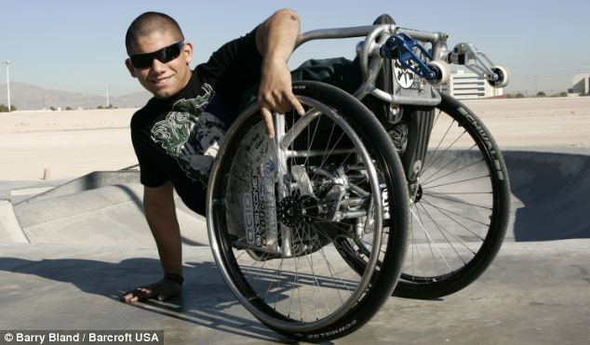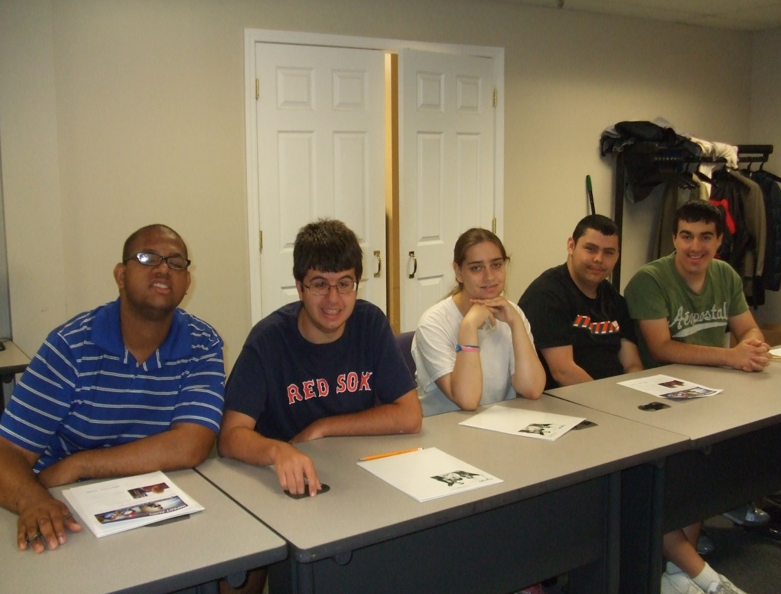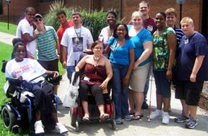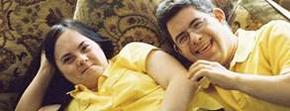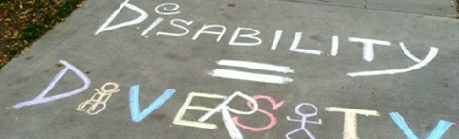

Prepared by a partnership between the Massachusetts Department of Public Health (MDPH) and the Massachusetts Department of Developmental Services (MDDS)

Supported by the MA Sexual Violence Prevention Plan made possible by Centers for Disease Control and Prevention (CDC) Cooperative Agreement 05037CONT07, CFDA 93.13: ‘Building Evaluation Capacity for
Rape Prevention and Education Funded Programs.’ Resource guide contents do not necessarily represent
the official views of the CDC.

Table of Contents

Topic: Page:

Introduction to the Resource Guide 3

Note to Parents, Providers, and Public Health Professionals 4

Talking Tips for Parents from Sexuality Educators in Massachusetts 5

Puberty and Human Development 6

Puberty and Human Development: Autism Spectrum Disorder (ASD) 8

General Sexuality Education 11

Social Skills and Relationship Development 22

Sexual Orientation and Identity 27

Sexual Health and Human Rights 30

Sexual Abuse Prevention 33

Appendix I 41

About this Resource Guide 53

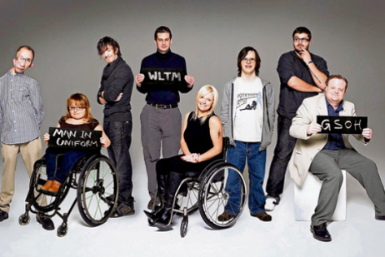
Introduction to the Resource Guide

Welcome to the Healthy Relationships, Sexuality and Disability Resource Guide! We are happy to share these helpful sexuality education resources with you. Young people living with disabilities (and their families and health care providers) helped create this guide. It lists their favorite sources of information about growing up healthy and safe.

Learning to access sex education and talk openly and honestly about sexual health is an important part of growing up. Young people who understand their own bodies, rights, and experiences may find it easier to communicate their needs and have them respected. All youth deserve information and support to get the knowledge, attitudes, behaviors and skills they need to stay healthy in relationships and protected from abuse.

If you have been looking for more information about how to grow up healthy and safe, this is the Guide for you! It includes books, CDs, websites, and other resources about:
- Changing bodies and feelings
- Getting and giving respect
- Dating and relationships
- Developing sexual identity and orientation
- Finding medical information and social support
- Protecting yourself from pregnancy, disease
and abuse

Developing sexual health and well-being

If you need more help, you can ask a trusted adult for help to find the information you need. Or you can contact the Division for Children & Youth with Special Health Needs Community Support Line at (800) 882-1435 (calling within MA), (617) 624-6060 or (617) 624-5992 (TTY) to speak to someone whose job is to help youth with disabilities and their families find information and resources. Many types of helpful community resources, public benefits, and state programs may be available
to you.

We hope you enjoy and continue to share these important resources and look forward to adding your
new favorites in the future.

- Developing sexual health and well-being

Note to Parents, Providers, and Public Health Professionals

The Healthy Relationships, Sexuality and Disability Resource Guide was created to benefit people with disabilities, a priority population identified in the 2009-2016 Massachusetts Sexual Violence Prevention Plan. Our state plan helps to promote health access and prevent abuse in populations who have historically experienced a higher risk of sexual violence, such as people with disabilities.¹ In 2009, state health and social service agencies jointly surveyed youth with intellectual and developmental disabilities (and the parents and providers who support them) to learn about their experiences and opinions accessing health education and resources. Together they helped identify many strengths and gaps in healthy sexuality education and abuse prevention education in Massachusetts.

Learning how to access accurate and appropriate health information and support is an important developmental task for all youth. Yet according to the 2009 needs and resources assessment survey, many youth with disabilities in Massachusetts lacked sufficient health education or support that addressed their unique needs. Parents and providers surveyed echoed youth requests for relevant sexuality education resources necessary to facilitate youth access to healthy, respectful, equitable relationships and lives free from abuse. Many of the resources in the Healthy Relationships, Sexuality and Disability Resource Guide were first suggested by the youth and adults who took part in the survey. Others were suggested by the staff of related state agencies and program partners.

Youth and adults with a wide range of intellectual, developmental and physical abilities and disabilities benefit from the multiple resource types (such as books, CD/DVDs, curricula, trainings, websites, helplines and support groups) listed in the Guide. International Standard Book Numbers (ISBN numbers) are listed for resources available in libraries or online bookstores. While many of the resources are free, costs do vary. Most resources are affordable for individuals and families, although a few may be more affordable to agencies or schools. We hope this Guide will help people living with disabilities and those who care about them find a wealth of resources designed to make sexuality education relevant and accessible to all.

¹Armour B, Wolf L, Mitra M, Brieding M. Differences in intimate partner violence among women with and without a disability, presentation at American Public Health Association, 10/27/2008

State agencies that helped with the survey:

Massachusetts Department of Public Health (MDPH); Massachusetts Department of
Developmental Services (MDDS), the Massachusetts Disabled Persons Protection Commission (DPPC)
Talking Tips for Parents from Sexuality Educators in Massachusetts

Sexuality Educators in Massachusetts shared these talking tips for parents of youth who have disabilities:

- Start early and talk often: remember, the more you do it, the easier it gets.
- Keep it simple; provide simple, direct explanations, using words they can understand. Long explanations can be unnecessary, or more confusing.
- Be “askable”: make it clear that they can ask you anything, as well as seek help to find the answer together.
- Use correct terms that prepare children to talk about their body and experiences: knowing the real names for their body parts makes it easier to communicate about them. Share the changes that will happen to their body and moods before puberty starts.
- Try multiple teaching techniques: present information through pictures, books, videos, or social learning models, including role play or asking “What would you do if…” This helps you reinforce your message and find out how they prefer to learn.
- Use “teachable moments”: You can start a conversation naturally while you’re watching television or people interacting, reading a book or listening to music together.
- Don’t feel like you have to have all the answers: it’s okay to say, “That’s a good question! I’m not sure about the answer but let’s find out together,” or “Let me think about that one,” if you need more time or information to confidently answer.
- Discuss your values and expectations, and consider theirs: Be willing to hear their entire question or story before responding. If you disagree, explain your concerns (safety, school rules, family expectations, laws, etc.) and come to a solution together.
- Model and teach helpful social skills, including self-esteem: Feeling good about yourself and worthy of being treated well helps prevent high risk behavior and abuse.
- See your son/daughter as a whole person capable of experiencing romantic love and affection: Remember that learning to navigate dating, relationships and healthy sexuality are normal developmental tasks best accomplished with your guidance and support.
- Encourage independent thinking and action, decision-making skills and boundary setting: give them support to make choices and decisions that are right for them. Show them how to set boundaries and respect the boundaries of others.
- Expose them to a variety of social situations and experiences: Create opportunities for your son/daughter to build a peer support system. Provide both appropriate supervision and opportunities for privacy.
- Teach them about consent and to powerfully say no (or, yes): When children are little, you can teach them “no, go, tell.” As they get older, reinforce the need to both clearly ask for, and give or refuse consent to dating, relationships and sexuality.
- Guide them to access ongoing sources of information and support: help them find medically-accurate, developmentally appropriate resources they can access independent of you, whether it is another trusted adult, health care provider or website.

Puberty and Human Development (Resources Listed Alphabetically by Title)

Puberty and Human Development | Contact Information & Availability | Resource Type & Overview | Intended Audience
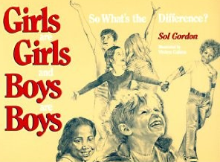 | Girls are Girls and Boys are Boys, So What’s the Difference?  Sol Gordon  Published by: Prometheus Books (1991)  ISBN: 0879756861 | This book explains the facts of human reproduction and the physical differences between boys and girls. It contains good illustrations of human development appropriate for all youth. | - Parents  - Children/youth
I Am a Beautiful Person: Sexuality  and Me | Produced by:  The PACER Center, a National Parent Advocacy Coalition for Educational Rights based in Minneapolis.  Available at: www.wifacets.org/videos/beautiful.html | This video provides discussion by parents and young people with disabilities about the important, but challenging topic of sexuality.  13 minutes. Closed-captioned. | - Children/youth with disabilities
Janet’s Got Her Period: Menstrual Care | Judi Gray, Jitka Jilich  Published by:  James Stanfield Co. 1990  Available at: www.stanfield.com/shop/other-sex-ed-programs-janet-got-her-period | This training program is geared to young women with cognitive impairment. It includes a video which is done in story form and features a girl with Down Syndrome and her family. There is an accompanying story/picture book of guidelines for “managing menstruation” and a set of pictographs. Actors have Australian accents. | - Health care professionals  - Educators and direct support professionals
Sexuality of Children and Adolescents With Developmental Disabilities | Pediatrics. Official Journal of the American  Academy of Pediatrics (2006)  Nancy A. Murphy, Ellen Roy Elias, for the Council on Children With Disabilities.  Available at:  http://pediatrics.aappublications.org/content/118/1/398.full.pdf | This report discusses issues of puberty, contraception, psychosexual development, sexual abuse, and sexuality education specific to children and youths with disabilities and their families. | - Health care professionals  - Parents of youth with disabilities  - Educators
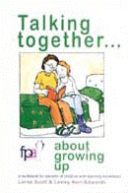 | Talking Together... About Growing Up: A Workbook for Parents of Children with Learning Disabilities  Lorna Scott, Lesley Kerr-Edwards, and Nic Watts  Published by: Family Planning Association (2010)  ISBN: 190550618X | This workbook offers support for parents and caregivers of children with learning disabilities who are approaching or are around the age of puberty. The easy-to-follow style and clear, picture based stories are suitable for young people who may not be able to read. Schools can adapt and use it as part of their sex and relationships education program and to develop their partnership with parents to support this work at home. | - Parents  - Children/youth with disabilities
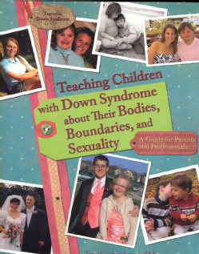 | Teaching Children with Down Syndrome about Their Bodies, Boundaries, and Sexuality: a Guide for Parents and Professionals  Terri Couwenhoven  Published by:  Woodbine House (2007)  ISBN: 189062733X | This training guide covers relevant issues and concerns for children of all ages, as well as later issues that affect teenagers and young adults. Relevant and helpful for any youth or young adult with developmental or intellectual disabilities (DD/ID). | - Parents of children with DD/ID  - Educators and direct support professionals  - Health care professionals
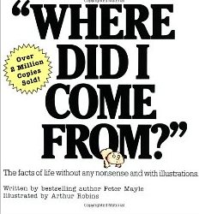 | “Where Did I Come From?”  Peter Mayle  Published by:  Lyle Stuart (2000)  ISBN: 0818402539 | This book covers the basic facts from love-making, orgasm, conception and growth inside the womb, through to the actual birth day. Names all the names and shows all the important parts of the body with colorful illustrations. This book is appropriate for younger audiences. | - Children/youth  - Parents

Puberty and Human Development: Autism Spectrum Disorders (ASD) (Resources Listed Alphabetically by Title)

Puberty and Human Development: ASD | Contact Information & Availability | Resource Type & Overview | Intended Audience
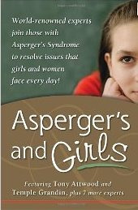 | Asperger’s and Girls  Tony Attwood  Published by:  Future Horizons (2006)  ISBN: 193256540X | This book on puberty and relationships was jointly written by girls and women with Asperger’s to empower individuals living with Asperger’s to successfully transition from girlhood to womanhood. | - Adolescent girls with Asperger’s  - Parents of adolescent girls with Asperger’s
 | Autism-Asperger’s & Sexuality: Puberty and Beyond  Jerry & Mary Newport  Published by:  Future Horizons (2002)  ISBN: 1885477880 | This book provides first-hand knowledge and practical advice to help guide young autistic adults/adults with Autism Spectrum Disorders (ASD) and their caregivers through the often difficult but important topic of puberty. | - Adolescents with ASD  - Parents of adolescents with ASD
Living with Autism: Puberty and Children on the Autism Spectrum | Autism Society  4340 East-West Hwy, Suite 350  Bethesda, Maryland 20814  (301) 657-0881 or 1 (800) 3-AUTISM  (1-800-328-8476)  Available at: http://www.autism-society.org/files/2014/04/LWA_Puberty.pdf | A parent’s guide to navigating and discussing puberty with an autistic daughter or son. You must register to use the website to access this resource. | - Parents of youth with ASD  - Educators and direct support professionals
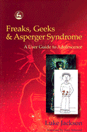 | Freaks, Geeks & Asperger Syndrome:  A User Guide to Adolescence  Luke Jackson  Published by:  Jessica Kingsley Pub (2002)  ISBN: 1843100983 | Drawing from his own experiences and gaining information from his teenage brother and sisters, Luke at 13 years old wrote this enlightening, honest and witty book in an attempt to address difficult topics such as bullying, friendships, when and how to tell others about ASD, school problems, dating, relationships and morality. | - Adolescents with ASD
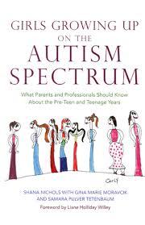 | Girls Growing Up on the Autism Spectrum: What Parents and Professionals Should Know About the Pre-Teen and Teenage Years  Shana Nichols, with Gina Marie Moravcik &  Samara Pulver Tetenbaum  Published by:  Jessica Kingsley Pub. (2008)  ISBN: 1843108550 | This book covers the many concerns commonly faced by girls with Autism Spectrum Disorders and their parents, from periods and puberty to worries over friendships and ‘fitting in.’ The authors give candid and realistic advice on a wide range of important teenage topics. | - Parents of girls with ASD  - Health care professionals
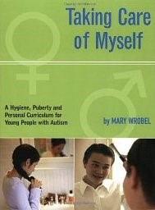 | Taking Care of Myself: A Hygiene, Puberty and Personal Curriculum for Young People with Autism  Mary Wrobel  Published by: Future Horizons (2003)  ISBN 1885477945 | This curriculum contains stories with information on health, hygiene, modesty, growth and development, menstruation, touching and personal safety and masturbation. | - Educators and direct support professionals

General Sexuality Education (Resources Listed Alphabetically by Title)

General Sexuality Education | Contact Information & Availability | Resource Type & Overview | Intended Audience
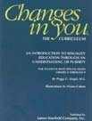  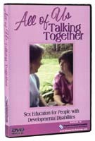 | All of Us Talking Together: Sex Education for People with Developmental Disabilities (1999)  Published by:  www.disabilitytraining.com  Available at: http://www.disabilitytraining.com/product-info.php?all_of_us_talking_together_dvd-pid552.html | This DVD contains a detailed sex education segment includes reproductive anatomy, pregnancy, contraception, and disease prevention. Social skills, desire for friendship, companionship, romance and relationships  are considered. | - Parents  - Children/youth with disabilities  - Educators and direct support professionals
 | Changes In You: An Introduction to Sexual Education Through an Understanding of Puberty  Published by:  James Stanfield Co.  Available for order from:  www.stanfield.com/products/family-life-relationships/other-family-ed-programs/ changes-in-you | This curriculum provides a gentle and sensitive approach that helps girls and boys feel confident and comfortable with the physical, social and emotional changes during teen years. It includes a trainer’s guide, laminated picture cards (11x17 inch), and student texts (5 each, boy/girl). | - Educators
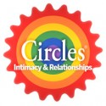 | CIRCLES®: Intimacy & Relationships Education  Contact:  Tonia Show or Trudy Grable  (408) 727-5775  trudy@php.com  Parents Helping Parents (PHP) San Jose, CA  Published by:  James Stanfield Co.  Available at:  http://www.stanfield.com/products/family-life-relationships/social-skills-circles-curriculum-intimacy-relationships | The CIRCLES curriculum is a 6 weeklong session that teaches social distance and levels of intimacy through the use of six color-coded concentric circles. It assists students to discriminate different degrees of intimacy and to adapt their behaviors accordingly. It also teaches students how relationships can be formed and maintained according to the social norms of our day. | - Youth and adults with DD/ID  - Sexuality educators  - Social service agencies that work with adults with DD/ID
Deciding on Birth Control: A guide for women with epilepsy | Ibis Reproductive Health  Available at:  www.ibisreproductivehealth.org/publications/ deciding-birth-control-guide-women-epilepsy  For more information, email: admin@ibisreproductivehealth.org  or call: (617) 349-0040 | This article is an in-depth guide about contraceptive decision-making for women with epilepsy. This guide answers common birth control questions and dispels myths about epilepsy and birth control usage. Included is also information identifying and describing each birth control method, the benefits, risks and concerns for women with epilepsy. In addition, the authors outline important questions to ask a physician, as well as a guide explaining how to have a conversation about contraception with  their doctor. | - Women with Epilepsy  - Health care professionals
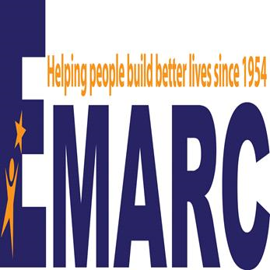 | EMARC: Relationship and Sexuality Groups and Trainings  Contact: Nicole Murphy and Paula Thompson  Relationship and Sexuality Groups  26 Princess Street, Wakefield, MA 01880  (781) 942-4888  nmurphy@theemarc.org or pthompson@theemarc.org  Available at:  http://theemarc.org | EMARC creates groups and trainings on sexuality, relationships and disability for diverse participants, from people living with disabilities to their parents and providers. Their interactive trainings include activities from curricula in this guide, as well as books and games. The conferences, trainings, ongoing relationship and sexuality support groups they provide may be privately funded or reimbursed by insurance. Contact Nicole and Paula for more information about your specific training or group needs. | - Health care professionals  - Educators and direct support professionals  - Parents  - Persons with disabilities  - Counselors and clinicians
F.L.A.S.H. Lesson Plans: Comprehensive Sexuality Education Curriculum | Contact:  Seattle and King County  516 Third Avenue  Seattle, WA 98104  (206) 296-0100 or (800) 325-6165  TTY Relay: 711  Available at:  www.kingcounty.gov/healthservices/ health/personal/famplan/educators/flash.aspx | The F.L.A.S.H. curriculum is a sexual education course for schools created by the Seattle, Washington, Office of Public Health. The curriculum can be downloaded at no charge from the website.  F.L.A.S.H. consists of lesson plans and transparencies for grades 4 through 12 as well as lesson plans and curriculum designed for special education students and young adults. | - Children/youth  - Parents  - Educators
 | Contact:  Ibis Reproductive Health  17 Dunster Street, Suite 201  Cambridge, MA 02138  Phone: (617) 349-0040  Email: admin@ibisreproductivehealth.org  Available at:  www.girlswithnerve.com | Young people with epilepsy helped create this website to connect other teens with epilepsy with the sexual and reproductive health information and support they need to be healthy. The website shares information on epilepsy 101, periods and menstrual problems, birth control, dating and parenting and pregnancy in the format and style the teens wanted. GirlsWithNerve.com includes many ways to connects and find support via Facebook, Twitter and guest blogging too. | - Young women with Epilepsy
Human Sexuality Education for Students with Special Needs | MarshMedia and the Puberty Education for Students with Special Needs programs (2007)  Liz Sweeney  Available at:  www.ejhs.org/volume10/MarshMedia%20White%20Paper.pdf | This publication and PowerPoint presentation discusses cultural and developmental considerations related to teaching youth with special needs about sexual health. | - Educators
Introduction to Sexuality Education for Individuals Who are Deaf-Blind and Significantly Developmentally Delayed | The National Information Clearinghouse on Children Who Are Deaf-Blind  Available at:  www.nationaldb.org/documents/products/sex-ed.pdf | This report discusses the importance of providing the deaf-blind population with information and skills on issues such as modesty, appropriate touch and personal boundaries, menstruation, masturbation, sexual health care, and  sexual abuse. | - Parents  - Health care professionals  - Adults who are deaf/blind or have significant DD  - Educators and direct support professionals
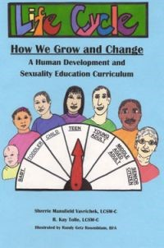 | Life Cycle - How We Grow and Change: A Human Development and Sexuality Education Curriculum  Sherrie M. Vavrichek and R. Kay Tolle  Published by:  Life Cycle Education Consultants, LLC. (2008)  Available for order from:  http://bluetowertraining.com/online-store | This curriculum is designed to teach youth and adults with developmental disabilities about psycho-social and sexual development throughout the human life cycle. Self-esteem, privacy awareness, respectful relationships, appropriate/inappropriate touch, abuse prevention, independence, physical  growth and change are some of the key concepts emphasized. Life Cycle includes an instructor's guide, pre and post test, quizzes, lesson plans, and over 100 student lessons and activities as well as a CD with full-color illustrations to enhance the teaching and learning process. | - Adolescents and adults with DD/ID  - Sexuality educators  - Direct support professionals
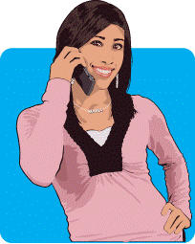 | Maria Talks! Statewide Sexual Health Helpline and Website  Produced by AIDS Action  Available at: www.mariatalks.com | This statewide helpline and website for teens and young adults provides youth-friendly low-literacy information about sexual health topics from anatomy to relationships and communication, sex, birth control, pregnancy options, HIV/STD prevention, sexual identity issues and more. It also provides information about and referrals to sexual health and youth development programs in MA. | - Youth  - Parents  - Educators and direct support professionals  - Health care professionals
Sex Education for Physically, Emotionally, and Mentally Challenged Youths | Advocates for Youth  Available at:  www.advocatesforyouth.org/publications/479? task=view | This resource guide provides an overview of common myths and facts about the sexuality of people living with disabilities, as well as guidelines for parents of physically or mentally challenged children and youths. Also includes a select, annotated bibliography of sex education materials and resources. PDF also available  for download. | - Parents  - Educators  - Health care professionals
Sexuality and Disabilities Bibliography | Available at:  www.siecus.org/index.cfm?fuseaction=page. viewpage&pageid=580&grandparentID=477& parentID=572 | This bibliography provides websites, curricula, and books for both educators and learners. | - Educators and direct support professionals
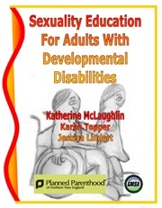 | Sexuality Education Curriculum for Adults with Developmental Disabilities  Planned Parenthood of Northern New England (2009) written in collaboration with Green Mountain Self Advocacy  Available for order from: www.plannedparenthood.org/planned-parenthood-northern-new-england/local-education-training/development-disabilites-sexuality | A three part curriculum that includes:  - Manual with tips on how to establish a sexuality education group and be an effective sex educator  - Curriculum with a peer education model and 20 lessons with scripts and handouts  - Pre/post test instructions for students. | - Adults with developmental disabilities/ intellectual disabilities  - Sexuality educators  - Direct support professionals
Sexuality Education for Youth with Disability or Chronic Illness: A Resource List | University of Michigan Health System  Available at: www.med.umich.edu/yourchild/topics/ disabsex.htm | Website with many types of resources for many different audiences. The site is regularly updated and resources are vetted by University of Michigan experts in child behavioral health. | - Persons with disabilities  - Support staff  - Family members  - Social service agencies that work people with disabilities  - Health care professionals  - Educators and direct support professionals
Sexuality in Mid- and Later Life Bibliography | Available at:  www.hawaii.edu/hivandaids/Sexuality%20in %20Middle%20and%20Later%20Life--Bibliography%20(2002).pdf | This bibliography includes curricula, websites, and books for educators and learners to understand and value sexual expression at  every age. | - Educators and direct support professionals
Sexuality Issues  for Youth with Disabilities  and Chronic Health Conditions | Florida University Gainesville  Institute for Child Health Policy  Ceci Shapland  (2000).  Available at: http://eric.ed.gov/?id=ed446401 | This guide is part of a series focusing on a comprehensive system of family-centered, culturally competent, community-based care for children with special health care needs who are approaching adulthood and may need assistance in making the transition from pediatric to adult health care and to post-secondary education and/or employment. The guide includes information for professionals about preventing teen pregnancy and planning programs that meet the needs of youth with disabilities. | - Health care professionals  - Direct support professionals
 | SIECUS Report: Sexuality Education for People with Disabilities  Published by:  Sexuality Information and Education Council of the United States, Inc Vol. 29, No.3 Feb./Mar. 2001  Available at:  http://one.center-school.org/search-document-detail.php?id=663 | This annotated bibliography on sexuality and disability includes information on books, videos, curricula, and organizations with information related to this subject. | - Educators and direct support professionals
 | Sproutflix  Available at: www.sproutflix.com | Sproutflix is a website that offers video streams, downloads, DVDs and playlists to be purchased and licensed for institutional use. Sproutflix works with youth with developmental and intellectual disabilities to create realistic and moving films that inspire, inform, and affect change. Search using the key words “independence,” “young adult,” “relationships,” “sexuality,” or by a particular type of disability. | - Persons with ID/DD  - Educators and direct support professionals  - Family members
Take 3 Steps to Women's Health! | Available at:  www.oakhillcrse.org/workbooks/content.asp? subnavid=118 | Take 3 Steps to Women’s Health! is a workbook for women with developmental disabilities that provides essential health information and takes the mystery out of routine breast and  pelvic screenings. | - Persons with disabilities  - Health care professionals
Teach-A-Bodies | An Effective Resource for Sex Education, Investigation, Therapy and Courtroom Testimony  Published by: June Harnest (1983)  Available at:  www.teach-a-bodies.com | This website offers anatomically correct plush dolls of varying ages, ethnicities and both sexes with an accompanying curriculum booklet. | - Health care professionals  - Educators and direct support professionals
Teaching Sexual Health Resource Lists | Society of Obstetricians and Gynecologists of Canada (SOGC) & Canadian Foundation for Women’s Health  Available at:  http://sexualityandu.ca/en | This society provides resource lists and guidelines for teachers providing sexual education to youth with intellectual disabilities and physical disabilities. | - Educators and direct support professionals
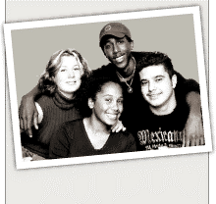 | Teaching Sexuality to Developmentally Disabled Youths: What Do I Say? How Do I Say It?  Lisa Maurer  Published by:  Resource Center for Adolescent Pregnancy Prevention  Available at:  http://recapp.etr.org/recapp/index.cfm?fuseaction=pages.educatorskillsdetail&pageid=96 | This publication contains specific suggestions, tips, and ideas for effectively teaching youth with developmental disabilities about sexuality topics. | - Educators and direct support professionals
Teen Pregnancy Prevention Education for Individuals with Intellectual Disabilities | Teen Pregnancy Prevention Education for Individuals with Intellectual Disabilities: A Supplemental Resource for Facilitators Using the Choosing the Best and Teen Outreach Program (TOP®) Curricula  Contact: Office for Children with Special Health Care Needs, Bureau of Women’s and Children’s Health within the Arizona Department of  Health Services  (602) 542-1860 or 1 (800) 232-1676  ocshcn@azdhs.gov  Available at:  www.azdhs.gov/phs/owch/sexcanwait/ documents/teen-pregnancy-prevention-education.pdf | This online supplemental sex education curriculum aids facilitators in adapting the Choosing the Best and Teen Outreach Program (TOP®) Teen Pregnancy Prevention Curricula for individuals with intellectual disabilities. The glossary, lesson planning and recommendations provided are relevant to other curricula. | - Health care professionals  - Direct support professionals
Ten Tips for Talking About Sexuality with Your Child who has Developmental Disabilities | Advocates for Youth  Available at:  www.advocatesforyouth.org/parents/172? task=view | This online article provides quick tips to help a child with developmental disabilities understand topics such as puberty, sex, love, self-esteem. | - Parents
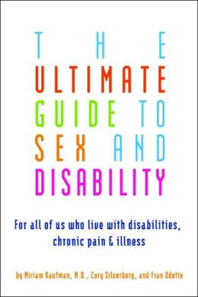 | The Ultimate Guide to Sex and Disability: for All of Us Who Live with Disabilities, Chronic Pain and Illness  Miriam Kaufman, Cory Silverberg and Fran Odette.  Published by:  Cleis Press (2007)  ISBN: 1573443042 | This book addresses a wide range of disabilities from chronic fatigue, back pain, and asthma to spinal cord injury, hearing and visual impairment, multiple sclerosis, and more. Provides readers with encouragement, support, and all the information they need to create a sex life that works for them. The authors, a medical doctor, a sex educator, and a disability activist, cover all aspects of sex and disability, including building a positive sexual self-image; positions to minimize stress and maximize pleasure; dealing with fatigue or pain during sex; finding partners and talking with partners about sex and disability; adapting sex toys;  and more. | - Adults with general physical disabilities
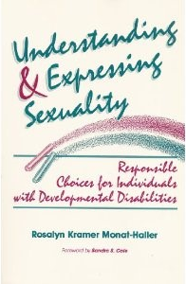 | Understanding & Expressing Sexuality: Responsible Choices for Individuals with Developmental Disabilities  Rosalyn Kramer Monat-Haller  Published by:  Paul H. Brookes (1992)  ISBN: 1557660735 | This book discusses topics and issues including: human anatomy and physiology, maturation and body changes, inappropriate sexual behavior, abuse, and offenders, birth control options, sexually transmitted diseases, aspects of psychosocial-sexual behavior and psychosocial development, and marriage and parenthood. | - Adults with DD/ID  - Educators and direct support professionals  - Disability advocates

Social Skills and Relationship Education (Resources Listed Alphabetically by Title)

Social Skills and Relationship Development | Contact Information & Availability | Resource Type & Overview | Intended Audience
 | Billy the Kid (2007)  Directed by: Jennifer Venditti  Rated: NR  ASIN: B001CCY434  Available at:  www.hulu.com/watch/135615 | This film follows Billy Price, a 15 year with Asperger’s Syndrome and a resident of Lisbon Falls, Maine. At 15, he has the same hopes and desires as other high-school students. For one thing, he wants a girlfriend and set his sights on 16-year-old Heather, a shy diner worker with a vision problem. | - Individuals with ASD  - Parents of individuals  - Educators
Down Syndrome Autism Connection (DSAC) | Contact:  Charlotte Gray at (978) 394-8416 or email: charlotte@downsyndromeautismconnection.org  Erin Knyff at (978) 902-3661 or email: Erin@downsyndromeautismconnection.org  Website:  www.ds-asd-connection.org | DSAC is a social and support group formed by moms Charlotte Gray and Erin Knyff. DSAC is a community of parents whose children have both Down syndrome and Autism Spectrum Disorder. Today, DSAC has 30 active families who meet once monthly by online chat to discuss the issues and challenges unique to the Down Syndrome-Autism community. Experts in the field often present on various topics relating to dual diagnosis. New members  are welcome! | - Families/parents of children with Down Syndrome or Autism
 | The Facts of Life…and More: Sexuality and Intimacy for People with Intellectual Disabilities  Leslie Walker  Published by:  Paul H Brookes (2007)  ISBN: 1557667144 | This book contains candid interviews and personal anecdotes that show how real-life couples with intellectual disabilities handle the joys and challenges of their relationships – courtship, sex, parenthood, disagreements, finances, and more. It includes examples of effective sexuality education techniques and vivid case studies illustrating key points. | - People with DD/ID  - Educators and direct support professionals  - Health care professionals
Mentor Match Program, Partners for Youth with Disability | Mentor Match Specialist, Partners for Youth with Disabilities  Steve Slowinski (ext.18, sslowinski@pyd.org) and  Kristin Humphrey (ext. 21, khumphrey@pyd.org)  95 Berkeley Street, Suite 109  Boston, MA 02116  Phone: (617) 556-4075  Website and application available at: www.pyd.org | Mentor Match is a mentoring program whose goal is to help young people with disabilities meet their full potential for personal development and independence by matching them with a caring adult mentor. | - Children/youth with disabilities (Ages 6-24)
 | Mozart and the Whale (2005)  Directed by: Petter Næss  Rated: PG-13  ASIN: B000J10KO6 | This film, starring Josh Hartnett and Radha Mitchell, is a heartwarming, romantic drama inspired by the true story of two people with Asperger’s Syndrome. | - Individuals over age 13 with ASD  - Parents of Individuals with ASD
Positive Choices  A Program on Healthy Relationships and Sexuality for Students with Intellectual and Developmental Disabilities | Positive Choices is an innovative curriculum designed to increase critical judgment about relationships and sexuality.  Available at:  http://oakhillcrse.org/provider-resources/content.asp?subnavid=91 | This comprehensive curriculum includes:  - 31 instructional units  - Teaching strategies that clearly present desired results, assessment evidence, and a learning plan that includes both content and process  - Over 220 scenarios for discussion, role-play and skill rehearsal  - A CD-ROM with anatomical illustrations  - Differentiated chapter tests  - Rubrics to assess skill development  - A fully illustrated student guide | - Educators working with secondary student and direct support professionals
 | Sexuality: Your Sons and Daughters with Intellectual Disabilities  Karin Melberg Schwier and Dave Hingsburger  Published by: Paul H. Brookes Pub. (2000)  ISBN: 1557664285  Available at:  www.amazon.com/exec/obidos/asin/ 1557664285/advocatesfory-20 | A reassuring book for parents that describes how to interact with children in a way that increases self-esteem, encourages appropriate behavior, empowers them to recognize and respond to abuse, and enables them to develop lifelong healthy relationships. | - Parents of children with DD/ID  - Educators and direct support professionals
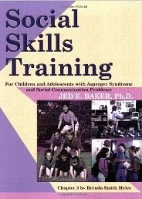 | Social Skills Training for Children and Adolescents with Asperger Syndrome and Social-Communications Problems  Jed Baker  Published by:  Autism Asperger Publishing Co. (2003) | This training guide highlights 70 of the skills that most commonly cause difficulty for individuals with autism spectrum disorders and social-communication problems. Each skill is presented with a reproducible skill handout, as well as activity sheets listing ways teachers and parents can demonstrate, practice and reinforce the skill in the classroom and at home. | - Parents of children and adolescents with ASD  - Educators and direct support professionals
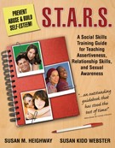 | S.T.A.R.S.: a Social Skills Training Guide for Teaching Assertiveness, Relationship Skills and Sexual Awareness  Susan Heighway  Published by:  Future Horizons (2007)  ISBN: 1932565256 | This training guide was designed to teach youths and adults with developmental disabilities about: understanding relationships, building social skills, and sexual awareness and assertiveness—with the goals of promoting positive sexuality and preventing sexual abuse. | - Parents  - Educators and direct support professionals
Ten Tips for Healthy Relationships: A workbook for adults | Available at :  http://oakhillcrse.org/workbooks/ content.asp?subnavid=115 | Ten Tips for Healthy Relationships is a workbook for adults with developmental disabilities that is designed to promote decision-making about safe relationships. | - Educators working with adults and direct support professionals
Whole Children | Contact: Kim Holden, Program Coordinator  (413) 585-8010 ext. 108  41 Russell Street, Box 15  Hadley, MA 01035  Available at: www.wholechildren.org | Whole Children offers programs and classes for children from toddler through teens with a range of abilities. Their teen program focuses on teaching skills such as self-advocacy, sexuality and social skills. They also provide a variety of social opportunities to help students develop and sustain friendships. | - Individuals with disabilities  - Parents of individuals with disabilities

Sexual Orientation and Identity (Resources Listed Alphabetically by Title)

Sexual Orientation and Identity | Contact Information & Availability | Resource Type & Overview | Intended Audience
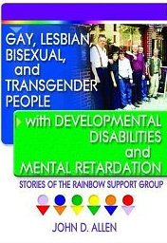 | Gay, Lesbian, Bisexual, and Transgender People with Developmental Disabilities and Mental Retardation: Stories of the Rainbow Support Group  John D. Allen  Published by: Harrington Park Press (2003)  ISBN: 1560233958 | This book describes the history behind the Rainbow Support Group and how it has been shattering myths and stereotypes surrounding people with developmental disabilities and mental retardation. Addresses the fears and concerns of its members and the positive aspects of group membership. | - People with DD/ID  - Educators and direct support professionals
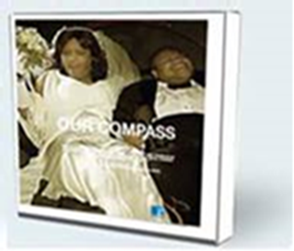 | Our Compass  Contact: Tess Vo  (416) 222-1320 ext. 171  compass@griffin-centre.org  Available at:  www.griffin-centre.org/ourcompass.php | This is a video documentary about the relationships that develop among eight young people with intellectual disabilities that attend a support group for lesbian gay, bisexual, transgender queer and questioning (LGTBQQ) youth. The Canadian youth talk about what it’s like to come out as both LBGTQQ and disabled, and share their life experiences with sexuality, gender identity, oppression and loneliness, love, dating, and families. A review is available at: www.griffin-centre.org/ourcompass.php. | - Educators and direct support professionals  - Parents  - Persons with ID/DD  - Counselors and clinicians
Rainbow Support Group of Massachusetts | Statewide Coordinators:  Pauline Bosma, Project Consultant  Rainbow Support Group of Massachusetts  500 Harrison Avenue  Boston, MA 02118  rainbows_58@yahoo.com  (866) 426-2253  Ed Bielecki, Coordinator  Massachusetts Advocates Standing Strong  500 Harrison Avenue  Boston, MA 02118  ed@mass-advocates.org  Pat Carney, Trainer  Department of Developmental Services, Central West Region  Office of Learning and Development  140 High Street  Springfield 01105  (413) 205-0820  patricia.carney@state.ma.us | Rainbow Support Groups are regional support groups for LGBTQ adults with developmental disabilities in MA. You can call the statewide coordinators listed in the contact information section of the numbers listed below for information and support, as well as to learn more about the current schedule and locations of the Rainbow Support Groups currently  held in:  Greater Boston:  (617) 876-4210, ext. 158 (hotline only)  Cambridge Family & Children’s Services  60 Gore Street  Cambridge, MA  Central Massachusetts:  (508) 755-2340  Seven Hills Foundation  81 Hope Avenue  Worcester, MA 01603  Western Massachusetts:  (413) 536-2410  Western MA Training Consortium  187 High Street Suite 2002  Holyoke, MA 01040 | - LGBTQ advocates and educators  - LGBTQ adults with disabilities
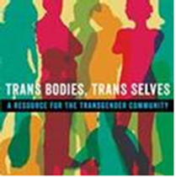 | Trans Bodies, Trans Selves: A Resource for the Transgender Community  Edited by: Laura Erickson-Schroth, MD, MA  Published by: Oxford University Press, 2014  ISBN: 0199325359 | Inspired by the classic sexuality resource guide “Our Bodies, Ourselves,” this comprehensive, reader-friendly resource guide was written by transgender and genderqueer authors. It has an inclusive perspective throughout, and contains a chapter about dis/abilities and deafness. Race, religion, employment, medical and surgical transition, mental health, relationships, sexuality, and parenthood are also discussed. It is a welcoming place for transgender and gender-questioning people, their partners and families, and others to find information on transgender life. | - Trans youth and adults with disabilities  - Trans youth and adults who are deaf  - Disability advocates and allies

Sexual Health and Human Rights (Resources Listed Alphabetically by Title)

Sexual Health and Human Rights | Contact Information & Availability | Resource Type & Overview | Intended Audience
A Training Manual for Direct Care Staff | Mark Steege and Shannon L. Peck  Contact:  5410 Fredericksburg Road,  Suite 111  San Antonio, Texas 78229  (877) 560-1739  orders@steegepublications.com  Published by:  The Steege Corporation | A curriculum designed to help direct care staff overcome their discomfort with the sexual behavior of individuals with intellectual disabilities. The manual is the outgrowth of workshops presented by the authors and is designed to be used for individual rather than group work so that each staff member can work through their own discomfort using the exercises in the manual. | - Health care professionals  - Direct support professionals
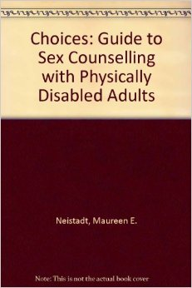 | Choices: A Guide to Sex Counseling with Physically Disabled Adults  Maureen E. Neistadt and Maureen Freda  Published by:  Krieger Pub. (1987)  ISBN: 0898749034 | This guide contains guidelines for sexuality counseling and examines issues of intimacy and communication, as well as the sexual response cycle. It discusses functional and sexual difficulties caused by disabilities and the impact of disability on social issues such as privacy, dating, marriage, and childbearing. Reading and resource lists are included. | - Health care professionals  - Counselors and clinicians
The GYN Exam Handbook & Exam Video | Maria Oliva Taylor  Published by:  James Stanfield Co. Inc. Santa Barbara, CA. 1991.  Available for order from:  www.stanfield.com/sex-ed-gyn-exam.html | This workbook and video was designed for females with special needs. Illustrates the essentials of gynecological/pelvic exam. Includes video and training manual for pelvic exam, Pap smear, and breast exam. | - Health care professionals
Impact: Feature Issue on Sexuality and People with Intellectual, Developmental, and Other Disabilities | Institute on Community Integration & Research and Training Center on Community Living  Volume 23: Number 2 Spring/Summer 2010  http://ici.umn.edu/products/impact/232  Contact:  University of Minnesota, 109 Pattee Hall, 150 Pillsbury Dr. SE, Minneapolis, MN 55455  (612) 624-4512  icipub@umn.edu | This publication is comprised of several articles written by people with disabilities and those who have supported them on their journey to learn about and experience sexuality, dating, intimacy, relationships, marriage and parenting. It was compiled to provide information and inspiration to further support the right and opportunity for people with disabilities to understand and express this essential dimension of human life, throughout the lifespan. Several additional resources, many written by self advocates, are included. | - Adolescents and adults with disabilities  - Parents of adolescents and adults with disabilities  - Educators and direct support professionals  - Disability advocates
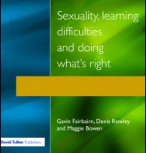 | Sexuality, Learning Disabilities, and Doing What’s Right  Gavin Fairbairn, Denis Rowley, and Maggie Bowen  Published by:  David Fulton Pub. (1995)  ISBN: 1853462926 | This book addresses sexuality and people with learning disabilities. It explores the rights that individuals have to be informed about sexuality issues, to form relationships, and to express themselves sexually. | - Parents  - Educators and direct support professionals  - Disability advocates
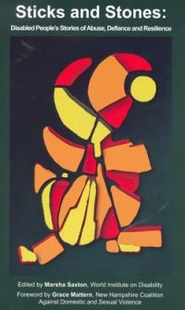 | Sticks and Stones: Disabled People's Stories of Abuse, Defiance and Resilience  Marsha Saxton  Published by:  World Institute on Disability (2009)  Available at:  http://bluetowertraining.com/online-store | This book contains a collection of over 50 stories about facing abuse and violence written by a diverse group of people with disabilities, family members, service providers, and other allies covering a wide range of mistreatment and recovery experiences. It helps educators and trainers build creative and meaningful activities around the stories. | - Health care professionals  - Educators and direct support professionals  - Disability advocates
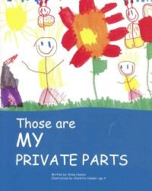 | Those are MY PRIVATE PARTS  Diane Hansen  Published by:  Empowerment productions (2004)  ISBN: 0976198800  Available at:  http://bluetowertraining.com/online-store | This book helps children open healthy communication about what is okay and what is not okay when it comes to touching private parts of the body. It uses child-friendly rhyming and colorful illustrations by a four-year-old to incorporate messages about sexual abuse prevention. Statistics and information on childhood sexual abuse are included for parents and educators. | - Children with disabilities  - Parents  - Educators and direct support professionals
Sexual Abuse Prevention (Resources Listed Alphabetically by Title)

Sexual Abuse Prevention | Contact Information & Availability | Resource Type & Overview | Intended Audience
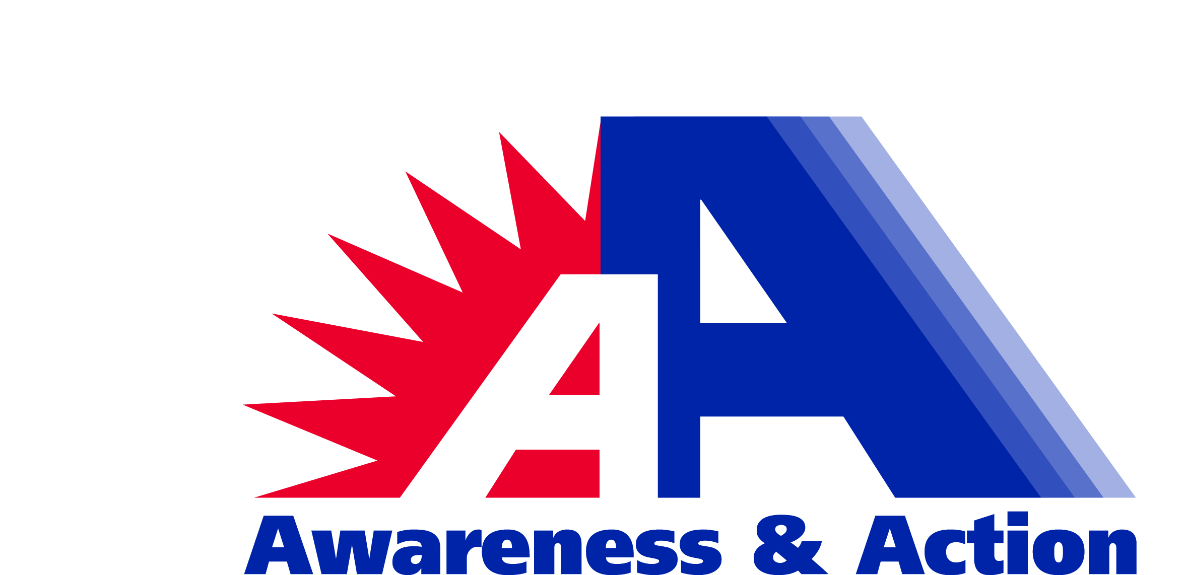 | Awareness & Action: Educating Persons with Disabilities on Recognizing, Reporting and Responding to Abuse Massachusetts Trainer Guide, Curriculum, Video and Participant Workbook  Contact:  Building Partnerships Initiative (BPI) c/o Disabled Persons Protection Commission (DPPC)  300 Granite Street, Suite 404  Braintree, MA 02184  (617) 727-6465  (888) 822-0350 TTY  www.mass.gov/dppc | The Awareness and Action: Educating Persons with Disabilities on Recognizing, Reporting and Responding to Abuse curriculum and supporting materials (PowerPoint slide presentation, video, participant workbook and trainer guide) were developed by persons with disabilities in partnership with the Building Partnerships for the Protection of Persons with Disabilities Initiative (BPI) to educate persons with disabilities and others about abuse committed against persons with disabilities.  The three-hour training, taught by persons with disabilities and others, and accompany video and participant workbook, introduces the abuse of persons with disabilities and closely examines how to recognize, report and respond to five different types of abuse (physical, sexual, neglect, verbal and financial) through five powerful vignettes, a slide presentation, group activities, skits and worksheets. At the end of the three-hour training, participants take home reporting and learning materials including a backpack, DVD of Abuse Stories, participant workbook, state and local resources and more. | - Persons with disabilities  - Support staff  - Family members  - Social service agencies that work people with disabilities  - Health care professionals  - Educators and direct support professionals
Communication is Protection! Brochure Series | Massachusetts Department of Public Health (MDPH)  Available at:  MDPH Division for  Children & Youth with Special Health Needs  250 Washington St. 4th floor  Boston, MA 02108  (800) 882-1435 (within MA)  or (617) 624-6060  (617) 624-5992 (TTY) | The Massachusetts Department of Public Health has developed this publication that includes two brochures for parents and caregivers that communicate the importance about talking about sex and sexuality with young people with disabilities. Includes referral to a statewide support line for children with special health care needs.  - Communication is Protection! Prevent Sexual Exploitation: Tri-fold brochure (double-sided). Offers communication tips to empower youths and prevent abuse.  - Communication is Protection! Sexuality & Youths with disabilities: Tri-fold brochure (double-sided). Offers communication tips to help teens build healthy relationships and promote socialization. | - Parents of youth with disabilities
Everyone’s Responsibility: Preventing Abuse Against People with Disabilities | AbleVision  www.triangleinc.org/index.php/ about_ablevision  Video available at:  http://youtu.be/Ps0Rt9TU3ao | Triangle's IMPACT: Ability program empowers people with disabilities and communities to prevent abuse. Ablevision is a show produced by people with disabilities. This Ablevision online video provides scenarios where both persons with disabilities and direct support professionals report sexual abuse. | - Adolescent to adult persons with disabilities  - Educators and direct support professionals
IMPACT: Ability | Contact:  Meagan Anderson, IMPACT: Ability Program Coordinator  (781) 321-3900  manderson@impactboston.org | Triangle's IMPACT: Ability program empowers people with disabilities and the organizations that serve them to prevent abuse. Triangle develops model policies and provides consultation on how to best provide self-defense training and respond to and report abuse including:  - Hands-on self-defense and assertive communication training to people with disabilities, including learning appropriate behavior in the workplace and other social settings.  - Training for Providers and Special Education teachers on how to respond to and prevent abuse.  - Consultation for developing Abuse Prevention Leadership Teams.  - Train-the-Trainer programs to teach staff and self-advocates how to deliver provider training sessions. | - Persons with disabilities  - Family members  - Social service agencies that work people with disabilities  - Educators and direct support professionals
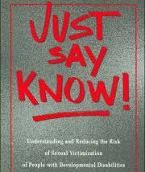 | Just Say Know! Understanding and Reducing the Risk of Sexual Victimization of People with Developmental Disabilities  Dave Hingsburger  Published by:  Diverse City Press (1995)  ISBN: 1896230008 | This book offers inspiration and practical guidance for families and clinicians on the subject of sexual abuse and the vulnerability of people with developmental disabilities. | - Parents  - Health care professionals  - Educators and direct support professionals
Kid & Teen Safe | Abuse Prevention Program for Youth with Disabilities  Published by: National Resource Center on Domestic Violence (2002)  Available at: www.vawnet.org/assoc_files_vawnet/nrc_ktsafe-full.pdf | A school-based program outline and curricula model, this comprehensive online booklet focuses on prevention and intervention of abuse of disabled students. Designed to aid in implementing school programs in abuse prevention. | - Educators
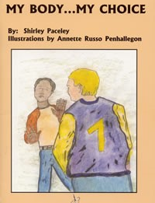 | My Body...My Choice  Shirley Paceley  Illustrated by Annette Russo Penhallegon (2001)  Available at: http://bluetowertraining.com/online-store | This fully illustrated mini-book is a guide that covers the basics of body safety, empowering people with disabilities across the nation to resist and report sexual abuse. | - Youth with disabilities  - Parents  - Educators
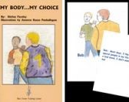 | My Body...My Choice Set  Shirley Paceley  Illustrated by Annette Russo Penhallegon (2001)  Available at:  http://bluetowertraining.com/online-store | This guide includes the fully illustrated mini-book written for youths and adults with developmental disabilities and 15 laminated cards which can be used in group settings to encourage discussions and role play about sexual abuse prevention. The colorful cards are leader friendly, featuring the words from the book on the back of each picture. | - Adults and youth with disabilities  - Parents  - Educators and direct support professionals
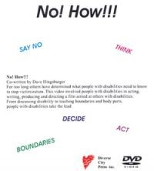 | No! How!!  Dave Hingsburger and Diverse City Press  Available at: www.diverse-city.com | This DVD includes all of the important elements of sexual abuse prevention as well as a problem-solving process for persons with developmental disabilities. The actors and actresses are people with developmental disabilities teaching others about sexual abuse—what it is and how to prevent it. | - Adults with disabilities  - Educators and direct support professionals
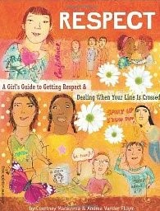 | Respect: A Girl's Guide to Getting Respect & Dealing When Your Line Is Crossed  Courtney Macavinta and Andrea Vander Pluym  Published by:  Free Spirit Publishing (2005)  ISBN: 1575421771 | This girl’s guide covers topics girls deal with daily, including body image, family, friends, the media, school, relationships, and rumors. Confronts tough issues like sexual harassment, date rape, sex, drugs, and alcohol. Thorough guide for parents and girls. | - Girls  - Parents  - Educators and direct service professionals
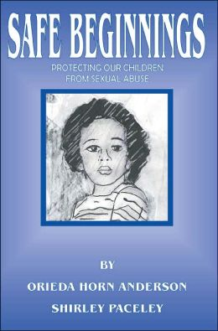 | Safe Beginnings: Protecting Our Children from Sexual Abuse  Orieda Horn Anderson and Shirley Paceley  Published by: Blue Tower Training Center (2003)  ISBN: 1931568200  Available at:  http://bluetowertraining.com/online-store | This guidebook contains:  - Strategies for teaching preschool children about self-respect, self-esteem, sexuality, and safety  - Skills for empowering children to resist and report sexual abuse  - How to create safe environments in nurseries, preschools, day care centers, and schools  - Tips for raising boys and girls  - What to do if abuse occurs  - Resources and ideas for social change | - Parents of pre-school children  - Educators and childcare workers
SafePlace: Disability Services Online | Available at:  http://safeplace.org/about/programs-and-services/disability-services-asap | This website offers educational presentations and training materials aimed at reducing the risk of sexual and domestic abuse of disabled people. Resources include tips on preventing, identifying and responding to abuse. | - Health care professionals  - Educators and direct support professionals
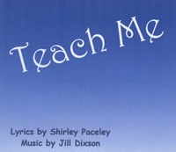 | Teach Me  Lyrics by Shirley Paceley, Music by Jill Dixson  Available at: http://bluetowertraining.com/online-store | A powerful song about sexual abuse of a person with developmental disabilities. Useful in counseling, employee development, prevention education, parent education, and community awareness. | - Parents  - Educators and direct support professionals  - Disability advocates  - Counselors and clinicians
Traumatic Brain Injury and Domestic Violence: Understanding the Intersections | Vawnet Special Collections on  Domestic Violence Prevention  Published: (2010)  Available at:  www.vawnet.org/special-collections/dvbraininjury.php | Special collection of best practices in domestic violence prevention and education for those with traumatic brain injuries. Includes screening tools and other resources. | - Educators and direct support professionals
Victimization of Persons with Traumatic Brain Injury or Other Disabilities | Centers for Disease Control & Prevention (CDC)  A Fact Sheet for Professionals  Available at: www.cdc.gov/traumaticbraininjury/pdf/ VictimizationTBI_Fact%20Sheet4Pros-a.pdf  A Fact Sheet for Friends and Families  Available at: www.cdc.gov/traumaticbraininjury/pdf/ VictimizationPerson_Fact%20Sheet4FrdsFal-a.pdf | This publication is a collection of fact sheets provide basic information about victimization and a summary of the research on the victimization of persons with traumatic brain injury. Each fact sheet provides resources for either professionals working with persons with traumatic brain injury or friends/family members. | - Health care professionals  - Family/friends
Violence in the Lives of the Deaf or Hard of Hearing | VAWnet Special Collections on Domestic Violence Prevention  Published: (2009)  Available at:  www.vawnet.org/special-collections/deaf.php | This report is a special collection of best practices in domestic violence prevention and education for the deaf and hard of hearing. Includes training tools and other resources. | - Educators and direct support professionals
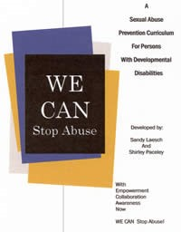 | WE CAN Stop Abuse: A Sexual Abuse Prevention Curriculum for Persons with Developmental Disabilities  Sandy Laesch and Shirley Paceley  Published by: Macon Resources, Inc (2004)  Available for order from: http://bluetowertraining.com/online-store | The WE CAN Stop Abuse curriculum has been proven effective for teaching abuse prevention skills to persons with developmental disabilities. The curriculum includes:  - Eight ready-to-use interactive sessions with several activities  - Introductory information for sexual assault center employees  - Goals and objectives for individual participants  - Evaluation instruments to measure individual skills  - Human sexuality resource list  - Overview of the WE CAN Stop Abuse Project in Illinois. | - Sexuality educators  - Direct support professionals  - Adults with DD/ID

Appendix I: Resources Listed Alphabetically by Type (A-F)

Here’s where you can find: Page:

A. Books and Guides 42

B. Reports and Publications 45

C. Workbooks and Curricula 47

D. Online Videos and DVDs 50

E. Websites 51

F. Programs and Classes 52

Appendix A. Books and Guides

Asperger’s and Girls, by Tony Attwood. Published by: Future Horizons (2006). ISBN: 193256540X.

Autism-Asperger’s & Sexuality: Puberty and Beyond, by Jerry & Mary Newport. Published by: Future Horizons (2002). ISBN: 1885477880.

Choices: A Guide to Sex Counseling with Physically Disabled Adults, by Maureen E. Neistadt and Maureen Freda. Published by: Krieger Pub (1987). ISBN: 0898749034.

Gay, Lesbian, Bisexual, and Transgender People with Developmental Disabilities and Mental Retardation: Stories of the Rainbow Support Group, by John D. Allen. Published by: Harrington Park Press (2003). ISBN: 1560233958.

Girls are Girls and Boys are Boys, So What’s the Difference? by Sol Gordon. Published by: Prometheus Books (1991). ISBN: 0879756861.

Girls Growing Up on the Autism Spectrum: What Parents and Professionals Should Know About the Pre-Teen and Teenage Years, by Shana Nichols, with Gina Marie Moravcik and Samara Pulver Tetenbaum. Published by: Jessica Kingsley Pub (2008). ISBN: 1843108550.

The Facts of Life…and More: Sexuality and Intimacy for People with Intellectual Disabilities, by Leslie Walker. Published by: Paul H Brookes (2007). ISBN: 1557667144.

Freaks, Geeks & Asperger Syndrome: A User Guide to Adolescence, by Luke Jackson. Published by: Jessica Kingsley Pub (2002).
ISBN: 1843100983.

Just Say Know! Understanding and Reducing the Risk of Sexual Victimization of People with Developmental Disabilities, by Dave Hingsburger. Published by: Diverse City Press (1995). ISBN: 1896230008.

Living with Autism: Puberty and Children on the Autism Spectrum, Autism Society: 4340 East-West Hwy, Suite 350, Bethesda, Maryland 20814. Contact: (301) 657-0881 or 1 (800) 3-AUTISM (1-800-328-8476).

My Body...My Choice, by Shirley Paceley and illustrated by Annette Russo. Published by Penhallegon (2001). Available at: http://bluetowertraining.com/online-store

Respect: A Girl's Guide to Getting Respect & Dealing When Your Line Is Crossed, by Courtney Macavinta and Andrea Vander Pluym. Published by: Free Spirit Publishing (2005). ISBN: 1575421771.

Safe Beginnings: Protecting Our Children from Sexual Abuse, by Orieda Horn Anderson and Shirley Paceley. Published by: Blue Tower Training Center (2003). ISBN: 1931568200. Available at: http://bluetowertraining.com/online-store

Sex Education for Physically, Emotionally, and Mentally Challenged Youths. Advocates for Youth. Available at: www.advocatesforyouth.org/publications/479?task=view

Sexuality Issues for Youth with Disabilities and Chronic Health Conditions, by Ceci Shapland. Florida University Gainesville, Institute for Child Health Policy (2000). Available at: http://eric.ed.gov/?id=ED446401

Sexuality, Learning Disabilities, and Doings What’s Right, by Gavin Fairbairn, Denis Rowley and Maggie Bowen. Published by: David Fulton Pub (1995). ISBN: 1853462926.

Sexuality: Your Sons and Daughters with Intellectual Disabilities, by Karin Melberg Schwier and Dave Hingsburger. Published by: Paul H. Brookes Pub (2000). ISBN: 1557664285. Available at: www.brookespublishing.com

Social Skills Training for Children and Adolescents with Asperger Syndrome and Social-Communications Problems, by Jed Baker. Published by: Autism Asperger Publishing Co. (2003).

Sticks and Stones: Disabled People's Stories of Abuse, Defiance and Resilience, by Marsha Saxton. Published by: World Institute on Disability (2009). Available at: http://bluetowertraining.com/online-store

Teaching Children with Down Syndrome about Their Bodies, Boundaries, and Sexuality: a Guide for Parents and Professionals, by Terri Couwenhoven. Published by: Woodbine House (2007). ISBN: 189062733X

Teach Me (song), lyrics by Shirley Paceley and music by Jill Dixson. Available at: http://bluetowertraining.com/online-store

Those are MY PRIVATE PARTS, by Diane Hansen. Published by: Empowerment Productions (2004). ISBN: 0976198800. Available at: http://bluetowertraining.com/online-store

Trans Bodies, Trans Selves: A Resource for the Transgender Community. Edited by: Laura Erickson-Schroth, MD, MA. Published by: Oxford University Press, (2014). ISBN: 0199325359.

The Ultimate Guide to Sex and Disability: for All of Us Who Live with Disabilities, Chronic Pain and Illness, by Miriam Kaufman, Cory Silverberg and Fran Odette. Published by: Cleis Press (2007). ISBN: 1573443042.

Understanding & Expressing Sexuality: Responsible Choices for Individuals with Developmental Disabilities, by Rosalyn Kramer and Monat-Haller. Published by: Paul H. Brookes (1992). ISBN: 1557660735.

WE CAN Stop Abuse: A Sexual Abuse Prevention Curriculum for Persons with Developmental Disabilities, by Sandy Laesch and Shirley Paceley. Published by: Macon Resources, Inc. (2004).

“Where Did I Come From?” by Peter Mayle. Published by: Lyle Stuart (2000). ISBN: 0818402539.

Appendix B. Reports and Publications

Communication is Protection! Brochure Series, Massachusetts Department of Public Health (MDPH). Available at: MDPH Division for Children & Youth with Special Health Needs, 250 Washington St. 4th floor Boston, MA 02108. Phone: (800) 882-1435 (within MA), or (617) 624-6060, (617) 624-5992 (TTY).

Deciding on Birth Control: A guide for women with epilepsy. Published by Ibis Reproductive Health. Available at: www.ibisreproductivehealth.org/publications/deciding-birth-control-guide-women-epilepsy

Human Sexuality Education for Students with Special Needs, by Liz Sweeney. Published by MarshMedia and the Puberty Education for Students with Special Needs programs (2007). Available at: http://www.ejhs.org/volume10/MarshMedia%20White%20Paper.pdf

Impact: Feature Issue on Sexuality and People with Intellectual, Developmental, and Other Disabilities by Institute on Community Integration & Research and Training Center on Community Living. Available at: http://ici.umn.edu/products/impact/232/

Introduction to Sexuality Education for Individuals Who Are Deaf-Blind and Significantly Developmentally Delayed, by The National Information Clearinghouse on Children Who Are Deaf-Blind. Available at: www.nationaldb.org/documents/products/sex-ed.pdf

Sex Education for Physically, Emotionally, and Mentally Challenged Youths Resource Guide, by Advocates for Youth. Available at: www.advocatesforyouth.org/publications/479?task=view

Sexuality and Disabilities Bibliography. Available at: www.siecus.org/index.cfm?fuseaction=page.viewpage&pageid=580&grandparentID=477&parentID=572

Sexuality in Mid- and Later Life Bibliography. Available at: www.hawaii.edu/hivandaids/Sexuality%20in%20Middle%20and%20Later%20Life--Bibliography%20(2002).pdf

Sexuality of Children and Adolescents with Developmental Disabilities, by Nancy A. Murphy and Ellen Roy Elias for the Council on Children With Disabilities, Official Journal of the American Academy of Pediatrics (2006). Available at: http://pediatrics.aappublications.org/content/118/1/398.full.pdf

SIECUS Report: Sexuality Education for People with Disabilities. Published by: Sexuality Information and Education Council of the United States, Inc. (Vol. 29, No.3 Feb./Mar. 2001). Available at: http://one.center-school.org/search-document-detail.php?ID=663

Teaching Sexuality to Developmentally Disabled Youths: What Do I Say? How Do I Say It? by Lisa Maurer, published by: Resource Center for Adolescent Pregnancy Prevention. Available at: http://recapp.etr.org/recapp/index.cfm?fuseaction=pages.educatorskillsdetail&pageid=96

Ten Tips for Talking About Sexuality with Your Child who has Developmental Disabilities, by Advocates for Youth. Available at: www.advocatesforyouth.org/parents/172?task=view

Traumatic Brain Injury and Domestic Violence: Understanding the Intersections, by VAWnet.org. Special Collections on Domestic Violence Prevention (2010). Available at: www.vawnet.org/special-collections/dvbrainInjury.php

Victimization of Persons with Traumatic Brain Injury or Other Disabilities, by Centers for Disease Control & Prevention (CDC).

A Fact Sheet for Professionals. Available at: www.cdc.gov/traumaticbraininjury/pdf/victimizationtbi_fact%20sheet4pros-a.pdf

A Fact Sheet for Friends and Families. Available at: www.cdc.gov/traumaticbraininjury/pdf/victimizationperson_
fact%20sheet4frdsfal-a.pdf

Violence in the Lives of the Deaf or Hard of Hearing, by Vawnet.org. Special Collections on Domestic Violence Prevention (2009). Available at: www.vawnet.org/special-collections/deaf.php

Appendix C. Workbooks and Curricula

Abuse Prevention Program for Youth with Disabilities. Published by: National Resource Center on Domestic Violence (2002). Available at: www.vawnet.org/assoc_files_vawnet/nrc_ktsafe-full.pdf

Awareness & Action: Educating Persons with Disabilities on Recognizing, Reporting and Responding to Abuse. Massachusetts Trainer Guide, Curriculum, Video and Participant Workbook Building Partnerships Initiative (BPI), Disabled Persons Protection Commission (DPPC). More information available at: www.mass.gov/dppc

Changes In You: An Introduction to Sexual Education Through an Understanding of Puberty. Published by: James Stanfield Co. Available at: www.stanfield.com/products/family-life-relationships/other-family-ed-programs/changes-in-you

CIRCLES®: Intimacy & Relationships Education, by Tonia Show and Trudy Grable. Available at: Phone: (408) 727-5775 or email: trudy@php.com

F.L.A.S.H. Lesson Plans: Comprehensive Sexuality Education Curriculum. Available at:
www.kingcounty.gov/healthservices/health/personal/famplan/educators/flash.aspx

The GYN Exam Handbook & Exam Video, by Maria Oliva Taylor. Published by: James Stanfield Co. Inc. Santa Barbara, CA. (1991). Available at: www.stanfield.com/sex-ed-gyn-exam.html

Janet’s Got Her Period: Menstrual Care, by Judi Gray and Jitka Jilich. Published by: James Stanfield Co. (1990). Available at: www.stanfield.com/shop/other-sex-ed-programs-janet-got-her-period

Life Cycle - How We Grow and Change: A Human Development and Sexuality Education Curriculum, by Sherrie M. Vavrichek and R. Kay Tolle. Published by: Life Cycle Education Consultants, LLC. (2008). Available at: http://bluetowertraining.com/online-store

Living with Autism: Puberty and Children on the Autism Spectrum, by Autism Society. Available at: www.autismsociety.org/files/ 2014/04/LWA_Puberty.pdf

Positive Choices: A Program on Healthy Relationships and Sexuality for Students with Intellectual and Developmental Disabilities. Available at: http://oakhillcrse.org/provider-resources/content.asp?subnavid=91

SafePlace: Disability Services Online. Available at: http://safeplace.org/about/programs-and-services/disability-services-asap

Sexuality Education Curriculum for Adults with Developmental Disabilities, by Planned Parenthood of Northern New England (2009), written in collaboration with Green Mountain Self Advocacy. Available at: www.plannedparenthood.org/planned-parenthood-northern-new-england/local-education-training/development-disabilites-sexuality

Social Skills Training for Children and Adolescents with Asperger Syndrome and Social-Communications Problems, by Jed Baker. Published by: Autism Asperger Publishing Co. (2003).

S.T.A.R.S.: a Social Skills Training Guide for Teaching Assertiveness, Relationship Skills and Sexual Awareness, by Susan Heighway. Published by: Future Horizons (2007) ISBN: 1932565256

Take 3 Steps to Women's Health! Available at: www.oakhillcrse.org/workbooks/content.asp?subnavid=118

Taking Care of Myself: A Hygiene, Puberty and Personal Curriculum for Young People with Autism, by Mary Wrobel. Published by: Future Horizons (2003). ISBN 1885477945.

Talking Together... About Growing Up: A Workbook for Parents of Children with Learning Disabilities, by Lorna Scott, Lesley Kerr-Edwards and Nic Watts. Published by: Family Planning Association (2010). ISBN: 190550618X.

Teach-A-Bodies An Effective Resource for Sex Education, Investigation, Therapy and Courtroom Testimony. Published by: June Harnest (1983). Available at: www.teach-a-bodies.com

Teaching Children with Down Syndrome about Their Bodies, Boundaries, and Sexuality: a Guide for Parents and Professionals, by Terri Couwenhoven. Published by: Woodbine House (2007). ISBN: 189062733X.

Teen Pregnancy Prevention Education for Individuals with Intellectual Disabilities: A Supplemental Resource for Facilitators Using the Choosing the Best and Teen Outreach Program (TOP®) Curricula. Published by: Office for Children with Special Health Care Needs, Bureau of Women’s and Children’s Health within the Arizona Department of Health Services. Available at: www.azdhs.gov/phs/owch/sexcanwait/documents/teen-pregnancy-prevention-education.pdf

Ten Tips for Healthy Relationships: A workbook for adults. Available at: http://oakhillcrse.org/workbooks/content.asp?subnavid=115
A Training Manual for Direct Care Staff, by Mark Steege and Shannon L. Peck. Published by: The Steege Corporation. Available at: phone: (877) 560-1739 or email: orders@steegepublications.com

Vawnet Special Collections on Domestic Violence Prevention Published: (2010). Available at: www.vawnet.org/specialcollections/ dvbraininjury.php

WE CAN Stop Abuse: A Sexual Abuse Prevention Curriculum for Persons with Developmental Disabilities, by Sandy Laesch and Shirley Paceley. Published by: Macon Resources, Inc. (2004). Available at: http://bluetowertraining.com/online-store

Appendix D. Online Videos and DVDs

All of Us Talking Together: Sex Education for People with Developmental Disabilities. (1999). Published by: www.disabilitytraining.com Available at: www.disabilitytraining.com/product-info.php?all_of_us_talking_together_dvd-pid552.html

Billy the Kid. Directed by: Jennifer Venditti. (2007). Rated: NR. ASIN: B001CCY434. Available at: www.hulu.com/watch/135615

Everyone’s Responsibility: Preventing Abuse Against People with Disabilities. Produced by: Ablevision. Available at: http://youtu.be/Ps0Rt9TU3ao

I Am a Beautiful Person: Sexuality and Me. Produced by: The PACER Center, a National Parent Advocacy Coalition for Educational Rights based in Minneapolis. Available at: www.wifacets.org/videos/beautiful.html

Mozart and the Whale. Directed by: Petter Næss. (2005). Rated: PG-13. ASIN: B000J10KO6

No! How!! by Dave Hingsburger and Diverse City Press. Available at: www.diverse-city.com

Our Compass. (2009). Available at: www.griffin-centre.org/ourcompass.php

Appendix E. Websites

Girls with Nerve, Ibis Reproductive Health. Website accessible at: www.girlswithnerve.com

Maria Talks! Statewide Sexual Health Helpline and Website. Produced by AIDS Action. Website accessible at: www.mariatalks.com

Online Mentoring Program Partners on Line (POL). To learn more, contact Meryl Libbey, Partners Online Program National Coordinator. Phone: (617) 556-4075 ext. 19 or email: mlibbey@pyd.org

SafePlace: Disability Services Online. Website accessible at: http://safeplace.org/about/programs-and-services/disability-services-asap

Sexuality Education for Youth with Disability or Chronic Illness: A Resource List, University of Michigan Health System. Available at: http://www.med.umich.edu/yourchild/topics/disabsex.htm

Sproutflix. Website accessible at: www.sproutflix.com

Teaching Sexual Health Resource Lists, Society of Obstetricians and Gynecologists of Canada (SOGC) & Canadian Foundation for Women’s Health. Website accessible at: http://sexualityandu.ca/en

Appendix F. Programs and Classes

Down Syndrome Autism Connection (DSAC). Information available at: www.ds-asd-connection.org

EMARC: Relationship and Sexuality Groups and Trainings. For more information, contact Nicole Murphy and Paula Thompson. Email: nmurphy@theemarc.org and pthompson@theemarc.org. Information available at http://theemarc.org

IMPACT: Ability. For more information, contact Meagan Anderson, IMPACT: Ability Program. Email: manderson@impactboston.org

Rainbow Support Group of Massachusetts. Statewide Coordinators: Pauline Bosma, Project Consultant rainbows_58@yahoo.com; Ed Bielecki, Coordinator ed@mass-advocates.org ; or Pat Carney, Trainer patricia.carney@state.ma.us

Whole Children, Inc. Information available at: www.wholechildren.org

About this Resource Guide

A key goal of the 2009-2016 Massachusetts Sexual Violence Prevention Plan is to improve our statewide capacity to promote healthy relationships, healthy sexuality, and abuse prevention among people with intellectual and developmental disabilities. Therefore in 2009, the Massachusetts Department of Public Health (MDPH) and Department of Developmental Services (MDDS) jointly surveyed youth living with disabilities (as well as the parents and providers who support them) about their experiences accessing related education in Massachusetts.

This needs and resources assessment was conducted by MDPH Bureau of Community Health and Prevention staff Marci Diamond, Jeanne Ward, and Pialee Roy, and MDDS Office of Quality Management staff including Janice O’Keefe. Substantial input was provided by Susan Love of the Disabled Persons Protection Commission, members of the DPH Division for Children & Youth with Special Health Needs Young Adult Advisory Council and other key program partners.

As a result, the Healthy Relationships, Sexuality and Disability Resource Guide was first developed in 2011 to address the identified strengths and gaps regarding abuse prevention and healthy sexuality education. Lenore Tsikitas, Health Access and Promotion Coordinator of the MDPH Family Planning Program

oversaw creation and production of the Guide with the input

and expertise of Patricia Carney, Training Coordinator of the MDDS Office of Learning and Development, and assistance of MDPH interns: Adeolu Odewale, Hannah Zangwill, Jayne Greenberg, Courtney Kaczmarsky and Siobhan Gruschow.

The Guide includes a wide range of resources with content descriptions and toll-free program support designed to help the reader decide which are most applicable to their own needs, situation, and organizational, familial, or personal values.
Please note:
- Some of the older resources may use outdated terms (such as ‘mental retardation’) that are no longer used to describe people with intellectual and developmental disabilities. These resources were only listed if they contained valuable information that was not available elsewhere.

- The presence of resources in this guide does not constitute an official endorsement of any particular state agency or organization named here

The Massachusetts Department of Public Health (MDPH) and Massachusetts Department of Developmental Services (MDDS) partnership was made possible by CDC Cooperative Agreement 05037CONT07, CFDA 93.13: Building Evaluation Capacity for Rape Prevention and Education Funded Programs. The contents of the Healthy Relationships, Sexuality and Disability Resource Guide are solely the responsibility of the authors and do not necessarily represent the official views of CDC.

Cover images are courtesy of IMPACT: Ability, the North Carolina Disabled Young People’s Collective, Barry Bland/Bancroft USA, National Collaborative on Workforce & Disability for Youth, Sheila Wray Gregoire, and others.

