INDOOR AIR QUALITY REASSESSMENT

Helen Mae Sauter Elementary School
130 Elm Street
Gardner, Massachusetts

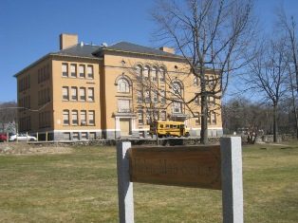

Prepared by:
Massachusetts Department of Public Health
Bureau of Environmental Health
Indoor Air Quality Program
September 2010

Background/Introduction
At the request of Mr. Robert O’Brien, Facilities Director for Gardner Public Schools (GPS), the Massachusetts Department of Public Health (MDPH), Bureau of Environmental Health (BEH) provided assistance and consultation in an on-going effort to monitor and improve indoor air quality conditions in each of the Gardner public schools. On April 1, 2010, Lisa Hébert, Environmental Analyst/Regional Inspector for BEH’s Indoor Air Quality (IAQ) Program conducted a reassessment at the Helen Mae Sauter Elementary School (HMSES), 130 Elm Street, Gardner, Massachusetts.

Actions on MDPH Recommendations
The building was previously visited by BEH staff in February 2006 in response to concerns regarding water damage and potential mold growth. A report was issued detailing conditions observed at the time with recommendations to improve indoor air quality (MDPH, 2006). Prior to this reassessment, BEH staff requested information as to the implementation of recommendations listed in the 2006 report. A summary of actions taken on previous recommendations is included as Appendix A.

Methods
Air tests for carbon monoxide, carbon dioxide, temperature and relative humidity were conducted with the TSI, Q-Trak, IAQ Monitor, Model 7565. Air tests for airborne particle matter with a diameter less than 2.5 micrometers were taken with the TSI, DUSTTRAK™ Aerosol Monitor Model 8520. BEH staff also performed visual inspection of building materials for water damage and/or microbial growth.

Results
The school houses approximately 248 children in grades one through three, with a staff of approximately 40. The school is visited daily by between 20 to 30 members of the general public. Tests were taken during normal operations and results appear in Table 1.

Discussion

Ventilation
It can be seen from Table 1 that carbon dioxide levels were above 800 parts per million (ppm) in fifteen of thirty-seven areas, indicating a lack of air exchange in a number of the areas surveyed. Please note that some areas with carbon dioxide levels below 800 ppm were sparsely occupied and/or had open windows, which can greatly reduce carbon dioxide. Carbon dioxide levels in these areas would be expected to rise with increased population and windows closed.
Fresh air in classrooms is supplied by a unit ventilator (univent) system (Figure 1). Univents draw air from outdoors through a fresh air intake located on the exterior walls of the building and return air through an air intake located at the base of each unit. Fresh and return air are mixed, filtered, heated and provided to classrooms through an air diffuser located in the top of the unit. Univents have control settings of off, low or high. Adjustable louvers control the ratio of outside to recirculated air. Obstructions to airflow, such as items stored on or in front of univents were seen in some areas (Picture 1/Table 1). In order for univents to provide fresh air as designed, units must be activated and remain free of obstructions.
Exhaust ventilation is provided by unit exhaust vents (Picture 2). This equipment contains two fans that draw air from the building, several of which were not operating during the assessment. Without functional exhaust ventilation, environmental pollutants can accumulate within the building and lead to air quality/comfort complaints.
To maximize air exchange, the MDPH recommends that both supply and exhaust ventilation operate continuously during periods of occupancy. In order to have proper ventilation with a mechanical supply and exhaust system, the systems must be balanced to provide an adequate amount of fresh air to the interior of a room while removing stale air from the room. It is recommended that HVAC systems be re-balanced every five years to ensure adequate air systems function (SMACNA, 1994).
The Massachusetts Building Code requires that each room have a minimum ventilation rate of 15 cubic feet per minute (cfm) per occupant of fresh outside air or openable windows (SBBRS, 1997; BOCA, 1993). The ventilation must be on at all times that the room is occupied. Providing adequate fresh air ventilation with open windows and maintaining the temperature in the comfort range during the cold weather season is impractical. Mechanical ventilation is usually required to provide adequate fresh air ventilation.
Carbon dioxide is not a problem in and of itself. It is used as an indicator of the adequacy of the fresh air ventilation. As carbon dioxide levels rise, it indicates that the ventilating system is malfunctioning or the design occupancy of the room is being exceeded. When this happens, a buildup of common indoor air pollutants can occur, leading to discomfort or health complaints. The Occupational Safety and Health Administration (OSHA) standard for carbon dioxide is 5,000 parts per million parts of air (ppm). Workers may be exposed to this level for 40 hours/week, based on a time-weighted average (OSHA, 1997).
The MDPH uses a guideline of 800 ppm for publicly occupied buildings. A guideline of 600 ppm or less is preferred in schools due to the fact that the majority of occupants are young and considered to be a more sensitive population in the evaluation of environmental health status. Inadequate ventilation and/or elevated temperatures are major causes of complaints such as respiratory, eye, nose and throat irritation, lethargy and headaches. For more information concerning carbon dioxide, consult Appendix B.
Indoor temperature measurements ranged from 69º F to 85º F, which were within the MDPH recommended comfort range in the majority of areas surveyed during the assessment (Table 1). The MDPH recommends that indoor air temperatures be maintained in a range of 70º F to 78º F in order to provide for the comfort of building occupants. In many cases concerning indoor air quality, fluctuations of temperature in occupied spaces are typically experienced, even in a building with an adequate fresh air supply.
The relative humidity measured in the building ranged from 26 to 50 percent, which was within or close to the MDPH recommended comfort range in the majority of areas surveyed during the assessment (Table 1). The MDPH recommends a comfort range of 40 to 60 percent for indoor air relative humidity. Relative humidity levels in the building would be expected to drop during the winter months due to heating. The sensation of dryness and irritation is common in a low relative humidity environment. Low relative humidity is a very common problem during the heating season in the northeast part of the United States.

Microbial/Moisture Concerns
BEH staff examined the exterior of the building to identify breaches in the building envelope and/or other conditions that could provide a source of water penetration. Several potential sources were identified:
- Evidence of current water leakage in the chair lift enclosure (Picture 3). Heavy accumulation of moss was observed on the interior and exterior of the enclosure (Picture 4). Moss was also observed on exterior window sealant and on windows. The presence of moss as shown in Picture 4 is indicative of chronic water exposure;
- The bottom of the chair lift enclosure was littered with organic debris, some of which was partially obstructing the drain at the base of the enclosure (Picture 5);
- Mortar around exterior brick was damaged/missing in some areas (Picture 6);
- Several areas of the building exhibited bulging brick (Picture 7);
- Sections of concrete apron were cracked and in disrepair (Picture 8);
- Pooling/splashing water was observed at the base of the building. The roof edge does not appear to have a gutter/downspout system. Rainwater pours off the roof, which then impacts on the tarmac and wall at the base of the building. Organic debris deposited in the crevices of windows is then moistened, providing a growth media for mosses and grass (Pictures 9 through 11);
- Delaminating plywood was observed adjacent to a window-mounted air conditioner (AC) (Picture 12);
- Cracks were observed on an exterior windowsill and wall adjacent to fresh air intakes (Picture 13);
The aforementioned conditions represent potential water penetration sources. Over time, these conditions can undermine the integrity of the building envelope and provide a means of entry into the building via capillary action through foundation concrete and masonry (Lstiburek & Brennan, 2001). In addition, these breaches may provide a means for pests/rodents to enter the building.
Water damage was evident in numerous areas throughout the interior of the building as well. The roof is in need of repair as evidenced by plastic sheeting installed in the attic to collect and direct rain water into a trash container (Picture 14). Several classrooms had water-damaged ceiling tiles indicating sources of water, such as penetration through the building envelope or leaks from the plumbing system (Pictures 15 and 16). Water-damaged ceiling tiles can provide a source of mold and should be replaced after a water leak is discovered and repaired. Some water-damaged ceiling tiles had been saturated and removed, while others had been painted over (Picture 17).
The US Environmental Protection Agency (US EPA) and the American Conference of Governmental Industrial Hygienists (ACGIH) recommend that porous materials be dried with fans and heating within 24 to 48 hours of becoming wet (US EPA, 2001; ACGIH, 1989). If not dried within this time frame, mold growth may occur. Once mold has colonized porous materials, they are difficult to clean and should be removed and discarded.
The basement exhibited numerous issues potentially related to penetration of moisture through the building envelope. A rotted windowsill was observed in the basement cafeteria (Picture 18). Peeling paint and efflorescence was observed on basement walls (Picture 19). Peeling paint was observed on the cafeteria floor, adjacent to the entrance ramp, presumably from water infiltration from the door leading to the chair lift enclosure (Picture 20). Evidence of chronic water penetration was also observed in the mechanical room. Finally, water-damaged window coverings were observed (Picture 21), indicating window leaks.
Plants were noted in several classrooms, one of which was resting on a paper towel (Picture 22), which is a porous material susceptible to mold growth. Plants can be a source of pollen and mold which can be respiratory irritants to some individuals. Plants should be properly maintained and equipped with drip pans and should be located away from ventilation components to prevent the aerosolization of dirt, pollen and mold.

Other IAQ Evaluations
Indoor air quality can be negatively influenced by the presence of respiratory irritants, such as products of combustion. The process of combustion produces a number of pollutants. Common combustion emissions include carbon monoxide, carbon dioxide, water vapor, and smoke (fine airborne particle material). Of these materials, exposure to carbon monoxide and particulate matter with a diameter of 2.5 micrometers (μm) or less (PM2.5) can produce immediate, acute health effects upon exposure. To determine whether combustion products were present in the indoor environment, BEH staff obtained measurements for carbon monoxide and PM2.5.

Carbon Monoxide
Carbon monoxide is a by-product of incomplete combustion of organic matter (e.g., gasoline, wood and tobacco). Exposure to carbon monoxide can produce immediate and acute health effects. Several air quality standards have been established to address carbon monoxide and prevent symptoms from exposure to these substances. The MDPH established a corrective action level concerning carbon monoxide in ice skating rinks that use fossil-fueled ice resurfacing equipment. If an operator of an indoor ice rink measures a carbon monoxide level over 30 ppm, taken 20 minutes after resurfacing within a rink, that operator must take actions to reduce carbon monoxide levels (MDPH, 1997).
The American Society of Heating Refrigeration and Air-Conditioning Engineers (ASHRAE) has adopted the National Ambient Air Quality Standards (NAAQS) as one set of criteria for assessing indoor air quality and monitoring of fresh air introduced by HVAC systems (ASHRAE, 1989). The NAAQS are standards established by the US EPA to protect the public health from six criteria pollutants, including carbon monoxide and particulate matter (US EPA, 2006). As recommended by ASHRAE, pollutant levels of fresh air introduced to a building should not exceed the NAAQS levels (ASHRAE, 1989). The NAAQS were adopted by reference in the Building Officials & Code Administrators (BOCA) National Mechanical Code of 1993 (BOCA, 1993), which is now an HVAC standard included in the Massachusetts State Building Code (SBBRS, 1997). According to the NAAQS, carbon monoxide levels in outdoor air should not exceed 9 ppm in an eight-hour average (US EPA, 2006).
Carbon monoxide should not be present in a typical, indoor environment. If it is present, indoor carbon monoxide levels should be less than or equal to outdoor levels. Outdoor carbon monoxide concentrations were non-detect (ND) the day of the assessment (Tables 1). No measureable levels of carbon monoxide were detected in the building during the assessment (Table 1).

Particulate Matter
The US EPA has established NAAQS limits for exposure to particulate matter. Particulate matter is airborne solids that can be irritating to the eyes, nose and throat. The NAAQS originally established exposure limits to particulate matter with a diameter of 10 μm or less (PM10). According to the NAAQS, PM10 levels should not exceed 150 micrograms per cubic meter (μg/m³) in a 24-hour average (US EPA, 2006). These standards were adopted by both ASHRAE and BOCA. Since the issuance of the ASHRAE standard and BOCA Code, US EPA established a more protective standard for fine airborne particles. This more stringent PM2.5 standard requires outdoor air particle levels be maintained below 35 μg/m³ over a 24-hour average (US EPA, 2006). Although both the ASHRAE standard and BOCA Code adopted the PM10 standard for evaluating air quality, MDPH uses the more protective PM2.5 standard for evaluating airborne particulate matter concentrations in the indoor environment.
Outdoor PM2.5 concentrations were measured at 2 μg/m³ (Table 1). PM2.5 levels measured indoors ranged from 3 to 12 μg/m³ (Table 1), which were below the NAAQS PM2.5 level of 35 μg/m³. Frequently, indoor air levels of particulates (including PM2.5) can be at higher levels than those measured outdoors. A number of mechanical devices and/or activities that occur indoors can generate particulate during normal operations. Sources of indoor airborne particulates may include but are not limited to particles generated during the operation of fan belts in the HVAC system, use of stoves and/or microwave ovens in kitchen areas; use of photocopiers, fax machines and computer printing devices; operation of an ordinary vacuum cleaner and heavy foot traffic indoors.

Volatile Organic Compounds
Indoor air concentrations can be greatly impacted by the use of products containing volatile organic compounds (VOCs). VOCs are carbon-containing substances that have the ability to evaporate at room temperature. Frequently, exposure to low levels of total VOCs (TVOCs) may produce eye, nose, throat and/or respiratory irritation in some sensitive individuals. For example, chemicals evaporating from a paint can stored at room temperature would most likely contain VOCs. In an effort to identify materials that can potentially increase indoor TVOC concentrations, MDPH staff examined areas for products containing these respiratory irritants. Several classrooms contained dry erase boards and dry erase board markers. Materials such as permanent markers, dry erase markers and dry erase board cleaners may contain VOCs, such as methyl isobutyl ketone, n-butyl acetate and butyl-cellusolve (Sanford, 1999), which can be irritating to the eyes, nose and throat.
Air fresheners and deodorizing materials were observed in several areas. Air deodorizers contain chemicals that can be irritating to the eyes, nose and throat of sensitive individuals. Many air fresheners contain 1,4-dichlorobenzene, a VOC which may cause reductions in lung function (NIH, 2006). Furthermore, deodorizing agents do not remove materials causing odors, but rather mask odors that may be present in the area.
A laminator and photocopier were observed in the teachers’ work room. Lamination machines melt plastic and give off odors and VOCs. Similarly, photocopiers also produce VOCs, waste heat and ozone, particularly if the equipment is older and in frequent use. Ozone is a respiratory irritant (Schmidt Etkin, 1992). No dedicated exhaust system exists to remove heat and odors produced by this equipment. Consideration should be given to placing a fan near an open window and operating the fan in a manner that removes excess heat and odors.

Other Conditions
Other conditions that can affect indoor air quality were observed during the assessment. Numerous penetrations in the infrastructure of the building were observed, namely, missing ceiling tiles and holes around open utility lines. This condition allows odors, vapors, dust and particulate matter to travel between rooms/floors within the building. Accumulated chalk dust was noted in many classrooms (Picture 23). Chalk dust is a fine particulate, which can be easily aerosolized and serve as an eye and respiratory irritant. Dust accumulation was also observed on the blades of several personal fans, and within the interior of some univents. These items should be routinely cleaned in order to prevent dust/debris from being aerosolized and redistributed throughout the room.
In several classrooms, items were observed on the floor, windowsills, tabletops, counters, bookcases and desks. The large number of items stored in classrooms provides a source for dusts to accumulate. These items (e.g., papers, folders, boxes) make it difficult for custodial staff to clean. Items should be relocated and/or be cleaned periodically to avoid excessive dust build up. In addition, these materials can accumulate on flat surfaces (e.g., desktops, shelving and carpets) and become aerosolized.
Upholstered furniture was observed in classrooms. Upholstered furniture is covered with fabric that comes in contact with human skin. This type of contact can leave oils, perspiration, hair and skin cells behind. Dust mites feed upon human skin cells and excrete waste products that contain allergens. In addition, if relative humidity levels increase above 60 percent, dust mites tend to proliferate (US EPA, 1992). In order to remove dust mites and other pollutants, frequent vacuuming of upholstered furniture is recommended (Berry, 1994). It is also recommended that upholstered furniture (if present in schools), be professionally cleaned on an annual basis. If an excessively dusty environment exists due to outdoor conditions or indoor activities (e.g., renovations), cleaning frequency should be increased (every six months) (IICRC, 2000).
The library contained wall-to-wall carpeting. Basement areas can become moist with condensation during hot, humid summer months. Relative humidity concentrations indoors above 70 percent can foster mold growth in susceptible materials (ASHRAE, 1989). Materials that can foster mold growth in a high humidity indoor environment include cardboard, paper, books, cloth and other materials in addition to carpeting.
Several window-mounted ACs and one air purifier were noted in the building. These items are normally equipped with filters, which should be cleaned or changed as per the manufacturer’s instructions to avoid the build-up and re-aerosolization of dirt, dust and particulate matter.
A steel beam was observed on the exterior of the building, which was likely installed as an attempt to stabilize the exterior structure at some point (Picture 24). It may be prudent to consider contracting with a structural engineer to examine the building to ensure its structural integrity.
Damaged or/or missing floor tiles were observed in some areas. These floor tiles may contain asbestos. In addition, a white insulating material in the boiler room was also observed to be in some disrepair and may contain asbestos (Picture 25). Intact asbestos-containing materials (ACM) do not pose a health hazard. If damaged, ACM can be rendered friable and become aerosolized. Friable asbestos is a chronic (long-term) health hazard, but will not produce acute (short-term) health effects (e.g., headaches) typically associated with buildings believed to have indoor air quality problems. Where asbestos-containing materials are found damaged, these materials should be removed or remediated in a manner consistent with Massachusetts asbestos remediation laws (MDLI, 1993).
It is probably worthwhile to note that all schools with ACMp resent are required to be in compliance with the Asbestos Hazard Emergency Response Act (AHERA). AHERA requires inspection of asbestos containing materials every three years. In addition, a semi-annual walkthrough is conducted to determine current conditions of ACM. AHERA requires public and private non-profit primary and secondary schools to inspect their buildings for asbestos-containing building materials and to develop, maintain and update an asbestos management plan to be kept at the school.

Conclusions/Recommendations
In view of the findings at the time of the reassessment, the following recommendations are made to further improve indoor air quality in the building:
- Continue to implement previous MDPH recommendations (MDPH, 2006).
- Improve air exchange in classrooms. An increase in the percentage of fresh air supply and/or increased exhaust capabilities is recommended. Contact an HVAC engineering firm to determine if univents/exhaust motors can be modified to increase the introduction of fresh air and/or removal of stale classroom air.
- Ensure exhaust vents are operational, make repairs as needed.
- Once repairs are made, operate all ventilation systems throughout the building (e.g., gym, cafeteria, classrooms) continuously during periods of occupancy.
- Remove all blockages in classrooms from univents and exhaust vents to ensure adequate airflow.
- Use openable windows in conjunction with mechanical ventilation to facilitate air exchange. Care should be taken to ensure windows are properly closed at night and weekends to avoid the freezing of pipes and potential flooding during winter months.
- Consider adopting a balancing schedule of every 5 years for all mechanical ventilation systems, as recommended by ventilation industrial standards (SMACNA, 1994).
- For buildings in New England, periods of low relative humidity during the winter are often unavoidable. Therefore, scrupulous cleaning practices should be adopted to minimize common indoor air contaminants whose irritant effects can be enhanced when the relative humidity is low. To control dusts, a high efficiency particulate arrestance (HEPA) filter equipped vacuum cleaner in conjunction with wet wiping of all surfaces is recommended. Avoid the use of feather dusters. Drinking water during the day can help ease some symptoms associated with a dry environment (throat and sinus irritations).
- Consider providing gutters/downspouts to collect water and deposit at least five feet away from the foundation of the building.
- Remove organic material (e.g., sand, grass, moss) from exterior windows and adjacent to the wall of building. Inspect/clean periodically.
- Eliminate water leakage into chair lift enclosure.
- Routinely remove organic debris from floor/walls of chair lift enclosure and ensure drain remains unobstructed. Inspect/clean periodically.
- Repair all cracked, missing mortar, with particular attention to the junction of the original building and the foundation of the chair lift enclosure.
- Repair/replace deteriorated concrete apron.
- Eliminate pooling water at base of building by re-grading depressed areas and by sloping perimeter landscaping to drain away from the building.
- Remove/replace delaminating plywood adjacent to AC.
- Repair/replace cracked exterior masonry windowsills.
- Replace rotted windowsill in cafeteria window.
- Repair any existing roof and plumbing leaks and remove and replace any remaining water-damaged ceiling tiles. Discontinue practice of painting water-damaged ceiling tiles. Examine the area above these tiles for mold growth. Disinfect areas of water leaks with an appropriate antimicrobial, as needed.
- Investigate and repair source(s) of water infiltration into basement.
- Ensure plants are equipped with drip pans and are not located on porous materials (e.g., paper towels). Examine drip pans periodically for mold growth and disinfect with an appropriate antimicrobial, as needed. Ensure plants are located away from fresh air supply sources.
- Routinely clean chalk/dry erase boards and trays.
- Refrain from using air fresheners or other air deodorizers.
- Consider installing local exhaust ventilation in areas using lamination machines and photocopiers or relocate to well-ventilated area. In the interim, consider opening a window and operating a fan in a manner that removes excess heat and odors when operating this equipment.
- Relocate or consider reducing the amount of materials stored in classrooms to allow for more thorough cleaning of classrooms. Clean items regularly with a wet cloth or sponge to prevent excessive dust build-up.
- Clean accumulated dust and debris periodically from univent interiors, exhaust vents and the blades of personal fans.
- Professionally clean upholstered furniture on an annual basis, if not feasible consider removing.
- Clean/change filters to ACs and air purifiers as per manufacturers’ instructions.
- Consideration should be given to discontinuing the use of carpeting in below grade areas. Prior to removing library carpeting, it should be determined whether or not the carpeting is glued to floor tiles containing asbestos containing materials (ACM).
- Ensure compliance with the Asbestos Hazard Emergency Response Act (AHERA).
- Remediate damaged ACMs (e.g., floor tiles, pipe insulation) throughout the building in conformance with Massachusetts asbestos remediation and hazardous waste disposal laws and regulations.
- Consider contacting a structural engineering firm in order to evaluate and ensure the building’s structural integrity.
- Consider adopting the US EPA (2000) document, “Tools for Schools”, as an instrument for maintaining a good indoor air quality environment in the building. This document is available at: http://www.epa.gov/iaq/schools/index.html.
- Refer to resource manual and other related indoor air quality documents located on the MDPH’s website for further building-wide evaluations and advice on maintaining public buildings. These documents are available at: http://mass.gov/dph/iaq.

References
ACGIH. 1989. Guidelines for the Assessment of Bioaerosols in the Indoor Environment. American Conference of Governmental Industrial Hygienists, Cincinnati, OH.
ASHRAE. 1989. Ventilation for Acceptable Indoor Air Quality. American Society of Heating, Refrigeration and Air Conditioning Engineers. ANSI/ASHRAE 62-1989.
Berry, M.A. 1994. Protecting the Built Environment: Cleaning for Health, Michael A. Berry, Chapel Hill, NC.
BOCA. 1993. The BOCA National Mechanical Code/1993. 8th ed. Building Officials and Code Administrators International, Inc., Country Club Hill, IL.
IICRC. 2000. IICRC S001 Reference Guideline for Professional On-Location Cleaning of Textile Floor Covering Materials Institute of Inspection, Cleaning and Restoration Certification. Institute of Inspection Cleaning and Restoration, Vancouver, WA.
Lstiburek, J. & Brennan, T. 2001. Read This Before You Design, Build or Renovate. Building Science Corporation, Westford, MA. U.S. Department of Housing and Urban Development, Region I, Boston, MA.
MDLI. 1993. Regulation of the Removal, Containment or Encapsulation of Asbestos, Appendix 2. 453 CMR 6,92(I)(i).
MDPH. 1997. Requirements to Maintain Air Quality in Indoor Skating Rinks (State Sanitary Code, Chapter XI). 105 CMR 675.000. Massachusetts Department of Public Health, Boston, MA.
MDPH. 2006. Indoor Air Quality Assessment, Helen Mae Sauter Elementary School, Gardner, MA. Massachusetts Department of Public Health, Boston, MA.
NIH. 2006. Chemical in Many Air Fresheners May Reduce Lung Function (#06-11). National Institutes of Health, Research Triangle Park, NC.
OSHA. 1997. Limits for Air Contaminants. Occupational Safety and Health Administration. Code of Federal Regulations. 29 C.F.R 1910.1000 Table Z-1-A.
Sanford. 1999. Material Safety Data Sheet (MSDS No: 198-17). Expo® Dry Erase Markers Bullet, Chisel, and Ultra Fine Tip. Sanford Corporation. Bellwood, IL.
SBBRS. 1997. Mechanical Ventilation. State Board of Building Regulations and Standards. Code of Massachusetts Regulations. 780 CMR 1209.0.
Schmidt Etkin, D. 1992. Office Furnishings/Equipment & IAQ Health Impacts, Prevention & Mitigation. Cutter Information Corporation, Indoor Air Quality Update, Arlington, MA.
SMACNA. 1994. HVAC Systems Commissioning Manual. 1st ed. Sheet Metal and Air Conditioning Contractors’ National Association, Inc., Chantilly, VA.
US EPA. 1992. Indoor Biological Pollutants. US Environmental Protection Agency, Environmental Criteria and Assessment Office, Office of Health and Environmental Assessment, research Triangle Park, NC. EPA 600/8-91/202 January 1992.
US EPA. 2000. Tools for Schools. Office of Air and Radiation, Office of Radiation and Indoor Air, Indoor Environments Division (6609J). EPA 402-K-95-001, Second Edition. http://www.epa.gov/iaq/schools/tools4s2.html.
US EPA. 2001. “Mold Remediation in Schools and Commercial Buildings”. Office of Air and Radiation, Indoor Environments Division, Washington, DC. EPA 402-K-01-001. March 2001. Available at: http://www.epa.gov/iaq/molds/mold_remediation.html.
US EPA. 2006. National Ambient Air Quality Standards (NAAQS). US Environmental Protection Agency, Office of Air Quality Planning and Standards, Washington, DC. http://www.epa.gov/air/criteria.html.
Picture 1

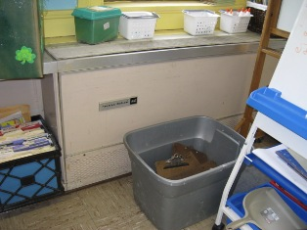

Obstructed Unit Ventilator

Picture 2

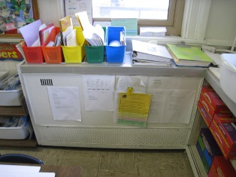

Unit Exhaust Vent

Picture 3

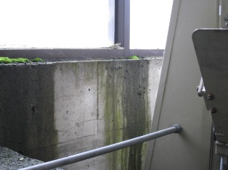

Water Infiltrating into Chair Lift Enclosure,
Note Moss Accumulation

Picture 4

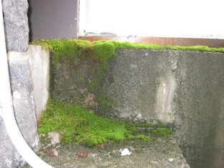

Moss Growth on Interior of Chair Lift Enclosure
Picture 5

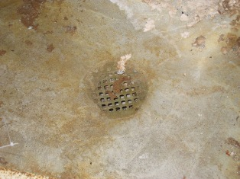

Organic Debris Partially Obstructing Drain in Chair Lift Enclosure

Picture 6

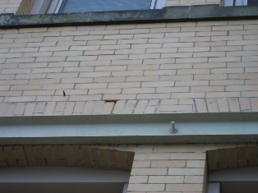

Missing Mortar

Picture 7

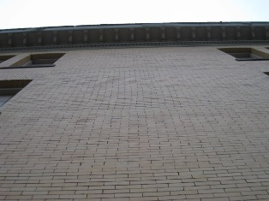

Bulging, Uneven Masonry Surface

Picture 8

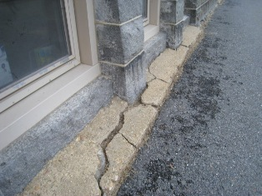

Numerous Cracks in Concrete Apron

Picture 9

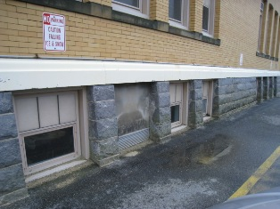

Pooling Water and Moistened Wall Due to Splashing

Picture 10

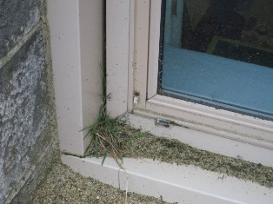

Plant Growth in Window on Moist Organic Material
Picture 11

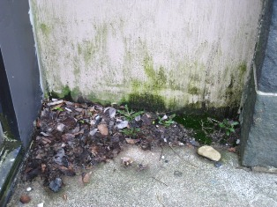

Plant and Moss Growth (Dark Staining on Wall) Adjacent to Moistened Organic Material

Picture 12

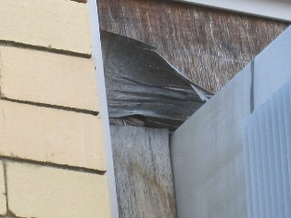

Delaminating Plywood above Window Mounted Air Conditioner

Picture 13

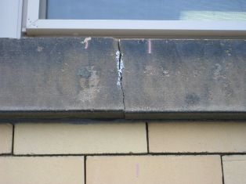

Cracked Exterior Window Sill

Picture 14

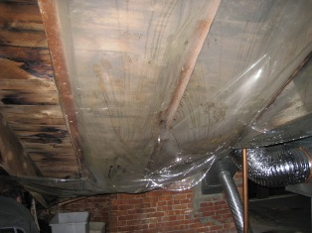

Plastic Sheeting Directing Water Infiltration to Plastic Trash Receptacle

Picture 15

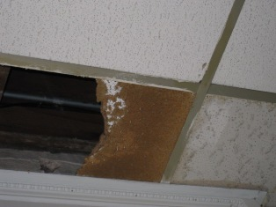

Previously Saturated Section of Broken Ceiling Tile

Picture 16

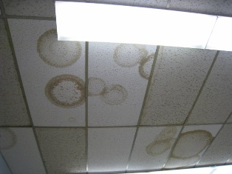

Numerous Previously Replaced Water-Damaged Ceiling Tiles

Picture 17

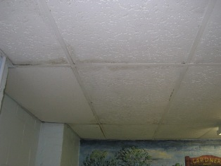

Water-Damaged Ceiling Tiles Appear to have been Repainted

Picture 18

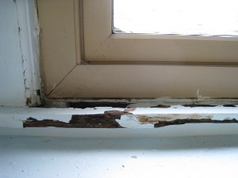

Water-Damaged/Rotted Sill

Picture 19

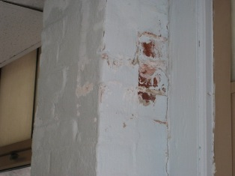

Peeling Paint and Efflorescence

Picture 20

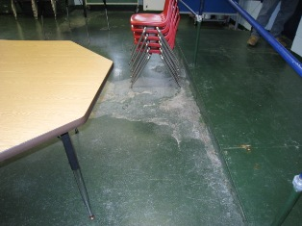

Peeling Paint on Basement Floor Adjacent to Ramp

Picture 21

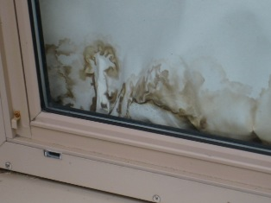

Water-Damaged Window Covering

Picture 22

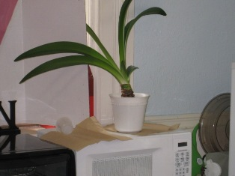

Plant Resting on Paper Towel

Picture 23

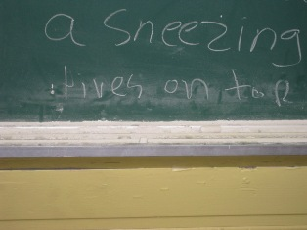

Heavy Accumulation of Chalk Dust in Tray

Picture 24

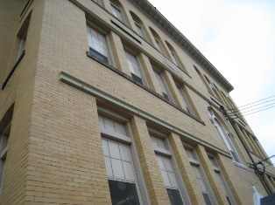

Steel Beam Installed on Exterior Masonry (Arrow)

Picture 25

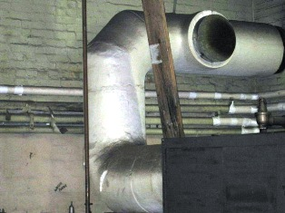

Cracked Insulating Material (Arrow)
Location | Carbon  Dioxide  (*ppm) | Temp  (°F) | Relative  Humidity  (%) | Carbon  Monoxide  (*ppm) | TVOCs  (*ppm) | Ultra-fine  Particulate | Occupants  in Room | Windows  Openable | Ventilation |  | Remarks
 |  |  |  |  |  |  |  |  | Supply | Exhaust | Remarks
Outside (Background) | 352 | 34 | 21 | N.D. | N.D. | 10
Kerr | 747 | 72 | 31 | N.D. | N.D. | 14 | 18 | Y | Y | Y | Clutter  Dry erase marker  Door open
Heglin | 892 | 72 | 33 | N.D. | N.D. | 18 | 23 | Y | Y | Y | Clutter  Dry erase marker  Door open
Breakroom | 929 | 73 | 35 | N.D. | N.D. | 21 | 4 | Y | N | N | Door open
Riley | 624 | 73 | 31 | N.D. | N.D. | 10 | 22 | Y | Y | Y | Dry erase markers  Window open  Door open exhaust vent off
Whitelin | 959 | 73 | 34 | N.D. | N.D. | 18 | 22 | Y | N | N | Window-mounted air conditioner  Clutter  Door open window open
Aubuchon | 821 | 72 | 31 | N.D. | N.D. | 27 | 21 | Y | Y | Y | Window-mounted air conditioner  Clutter  Univent blocked
205 | 578 | 72 | 30 | N.D. | N.D. | 8 | 1 | Y | Y | Y | Door open
Nurse’s office | 692 | 73 | 32 | N.D. | N.D. | 15 | 3 | Y | N | N | Door open
102 | 611 | 71 | 29 | N.D. | N.D. | 6 | 14 | Y | Y | Y | Univent off  Door open
Anderson | 813 | 73 | 33 | N.D. | N.D. | 6 | 18 | Y | Y | Y | Door open
Gallant | 662 | 73 | 30 | N.D. | N.D. | 7 | 12 | y | Y | Y | Door open
Office | 441 | 68 | 44 | N.D. | N.D. | 37 | 3 | Y | Y | N
Photocopier room | 488 | 72 | 40 | N.D. | N.D. | 40 | 0 | Y | N | N | Door open
Gym | 584 | 72 | 40 | N.D. | N.D. | 35 | 0 | Y | Y | Y | Door
301 | 641 | 71 | 38 | N.D. | N.D. | 34 | 21 | Y | Y | Y | Clutter  Dry erase marker  Door open
Johnson | 759 | 71 | 39 | N.D. | N.D. | 42 |  |  |  |  | 5 water damage ceiling tile  Clutter  Dry erase marker  Door open
Nott | 589 | 71 | 36 | N.D. | N.D. | 32 | 4 | Y | Y | Y | 1 water damage ceiling tile  Door open
Guidance | 357 | 70 | 28 | N.D. | N.D. | 1 | 1 | Y | Y | N | Dry erase marker  Door open
Speech | 393 | 72 | 29 | N.D. | N.D. | 4 | 1 | Y | N | Y | Exhaust vent off
Nott Anne | 450 | 71 | 31 | N.D. | N.D. | 4 | 22 | N | N | N | 6 water damage wall tiles
Computer room | 546 | 73 | 31 | N.D. | N.D. | 17 | 22 | Y | Y | Y | Exhaust vent off  25 computer room  Univent half covered by interior wall
Miller | 544 | 73 | 29 | N.D. | N.D. | 10 | 22 | Y | Y | Y | Clutter
Reading recovery | 793 | 72 | 34 | N.D. | N.D. | 15 | 1 | Y | Y | Y | Window-mounted air conditioner
105 | 1017 | 74 | 35 | N.D. | N.D. | 17 | 0 | Y | Y | Y | Univent off  1 water damaged ceiling tile  Dry erase markers
Hallway outside 105 | 850 | 74 | 32 | N.D. | N.D. | 20 | 6 | Y | N | N
Art room | 444 | 74 | 29 | N.D. | N.D. | 2 | 1 | Y | Y | N | Dehumidifier  Window-mounted air conditioner  Tennis balls on chairs
Library | 724 | 75 | 32 | N.D. | N.D. | 14 | 15 | Y | Y | Y | Dehumidifier  Window-mounted air conditioner  Water damaged wall tiles

Actions on Previous MDPH Recommendations
The following is a status report of actions taken on MDPH recommendations (in bold). The summary is based on reports from HMSES staff, GPS officials and observations of BEH staff.
Remove water damaged ceiling and acoustic wall tiles.
Action Taken: Numerous water-damaged ceiling tiles were observed during the assessment.
Examine the feasibility of installing a gutter/downspout system for the roof to prevent excess water exposure to the exterior wall. Ensure that the downspout drains water at a point that is at least 5 feet away from the exterior wall of the building.
Action Taken: Gutter and downspout systems have not been installed.
Take steps to prevent prolonged moisture contact with the foundation.
Action Taken: Not completed.
Operate all ventilation systems throughout the building (e.g., gym, auditorium, classrooms) continuously during periods of school occupancy independent of thermostat control to maximize air exchange. To increase airflow in classrooms, set univent controls to “high”.
Action Taken: Numerous exhaust vents were either off or non-functioning during the assessment.
Remove all blockages from univents to ensure adequate airflow.
Action Taken: Despite reported efforts, ventilation equipment remains blocked in a number of classrooms.
Use openable windows in conjunction with classroom univents and exhaust vents to increase air exchange. Care should be taken to ensure windows are properly closed at night and weekends to avoid the freezing of pipes and potential flooding.
Action Taken: Very few openable windows were open during the assessment.
Seal all holes in univent cabinets with an appropriate foil tape.
Action Taken: Partially completed.

Examine the feasibility of installing a mechanical exhaust vent for the automatic dishwasher in the kitchen.
Action Taken: Mechanical exhaust for the automatic dishwasher in the kitchen has been installed.
Relocate or consider reducing the amount of materials stored in classrooms to allow for more thorough cleaning. Clean items regularly with a wet cloth or sponge to prevent excessive dust build-up.
Action Taken: Action was completed, although this is an on-going process.

Consider discontinuing the use of tennis balls on walker legs to prevent latex dust generation.
Action Taken: Action Completed.

Efflorescence is a characteristic sign of water damage but it is not mold growth. As moisture penetrates and works its way through mortar, brick or plaster, water-soluble compounds dissolve, creating a solution. As the solution moves to the surface of the material, the water evaporates, leaving behind white, powdery mineral deposits.

