Help Keep Your EBT Card and 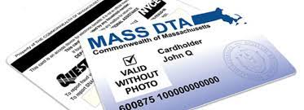DTA Benefits Safe!

Change your EBT card PIN before each time you get your benefits:

- Call the number on the back of your card: 800-997-2555.
- Choose your language.
- Enter the number on the front of your card.
- Press 2.
- Enter the last 4 digits of your Social Security Number (SSN). If you do not have an SSN, enter the last 4 digits of your 99 number assigned by DTA.
- Enter your Date of Birth (month/day/year – 2 digits for month, 2 digits for day, 4 digits for year). For example, 12 01 1989 for December 1, 1989.
- Enter your NEW 4-digit PIN; then enter it again. Choose a different PIN from any previous PINs.

This is the best way to try to protect your benefits if your card information has been stolen.

If you receive TAFDC or EAEDC cash assistance, ask about having your benefits deposited to your bank account. Call your case manager to set up direct deposit.

Learn more at Mass.gov/ProtectYourEBT

