

**Bureau of Infectious Disease and Laboratory Sciences**

**Hemovigilance Program Data Summary**

**January 1-December 31, 2017**

***Report updated on January 10, 2019\****

*Due to the identification of an error in a denominator calculation, we are issuing this updated 2017 report.

Corrections include:

* In Key Findings, (Pg. 4) the rate of adverse reactions in bed size group 1 was approximately 1.5 to 2 times higher than the statewide rate over the course of 2017, not 4.5-6 times higher as indicated in the original report.
* A footnote was added to the table: Transfusion Volume by Bed Size Group, Product Type, and Year, 2015 – 2017 (Pg. 8) clarifying that BSG was assigned based on the most recent facility annual survey submitted.
* In the graph:  Rates of Adverse Reactions per 10,000 Transfused Products by Bed Size Group Massachusetts, 2015 – 2017, (Pg. 15) the displayed rate line of adverse reactions for BSG 3 was an underestimate in the original report and is corrected in this updated report.

**Bureau of Infectious Disease and Laboratory Sciences**  
Massachusetts Department of Public Health  
305 South Street  
Jamaica Plain, MA 02130

**For questions about this report, contact:**

[Alexandra.dejesus@state.ma.us](mailto:Alexandra.dejesus@state.ma.us) or [Melissa.cumming@state.ma.us](mailto:Melissa.cumming@state.ma.us)

**Suggested citation:**

Massachusetts Department of Public Health, Bureau of Infectious Disease and Laboratory Sciences.*Hemovigilance Program Data Summary January – December 31, 2017.*

<http://www.mass.gov/eohhs/gov/departments/dph/programs/id/> . Published July 2018. Accessed [date].

**Acknowledgments**

This report was prepared by the following MDPH staff:

Alexandra De Jesus, MPH

Melissa Cumming, MS

Christina Brandeburg, MPH

Alfred DeMaria, Jr., MD

**Executive Summary**

**Technical Notes**

This report includes data generated by Massachusetts blood banks collected through the Hemovigilance Module of the National Healthcare Safety Network (NHSN) from January 1, 2017 through December 31, 2017. The purpose of this report is to provide information on transfusion activity in the state, as well as on transfusion-associated adverse events. Blood banks in Massachusetts can examine their own facility metrics and use this report for comparison and context.

For the first time, several of the metrics included in this report are displayed quarterly over a three-year time period (2015-2017), thus allowing for observation of trends over time. Presenting data in a quarterly format for transfusion volume, discarded products, and reaction rates provides more data to allow more stability of observed trend values.

The following are inclusion criteria for adverse reactions in this report:

Case criteria – reaction must either definitively or probably meet the NHSN case reporting criteria

Imputability – reaction must definitely, probably, or possibly meet NHSN imputability criteria

Reaction type – reaction must be one of twelve specified types, excluding “Other” and “Unknown”

Allergic reactions – *non-severe* allergic reactions are excluded from analysis

A technical advisory group (TAG) was established in June 2014 to provide guidance to the Massachusetts Department of Public Health (MDPH) in the statewide use of the Hemovigilance Module.

Current members of the TAG are:

**Chester Andrzejewski, Jr., PhD, MD, FCAP**

Medical Director

System Transfusion Medicine/Blood Banking and

Apheresis Medicine Services

Baystate Health/ Baystate Medical Center

**Christina Brandeburg, MPH**

Epidemiologist

Bureau of Infectious Disease

Massachusetts Department of Public Health

**Melissa Cumming, MS**

Epidemiologist

Hemovigilance Coordinator

Bureau of Infectious Disease

Massachusetts Department of Public Health

**Alexandra DeJesus, MPH**

Epidemiologist

Bureau of Infectious Disease

Massachusetts Department of Public Health

**Alfred DeMaria, Jr., MD**

Medical and Laboratory Consultant

Bureau of Infectious Disease

Massachusetts Department of Public Health

**Elzbieta Griffiths, MD**

Medical Director, Blood Bank,

Donor Center and Coagulation

Surgical Pathologist Mount Auburn Hospital

**Michele Herman, MT (ASCP)**

Compliance Officer - Transfusion Medicine

Beth Israel Deaconess Medical Center

**Kimberly Knox, RN, MHA, CIC**

Infection Prevention and Control Coordinator

Milford Regional Medical Center

**Eileen McHale, RN, BSN**

Healthcare Associated Infection Coordinator

Bureau of Health Care Safety and Quality

Massachusetts Department of Public Health

**Lynne O’Hearn, MT (ASCP)**

Transfusion Safety Officer

Baystate Medical Center

**Karen Quillen, MD**

Blood Bank Medical Director

Boston Medical Center

**Jorge Rios, MD**

Medical Director

American Red Cross Blood Services

Massachusetts Region

**Lynne Uhl, MD**

Vice Chair and Division Director for Laboratory and Transfusion Medicine

Beth Israel Deaconess Medical Center

**Pamela Waksmonski, MS, MT (ASCP), PMP, CRA**

Clinical Lab Program Manager

Bureau of Health Care Safety and Quality

Massachusetts Department of Public Health

**Data Summary**

This report includes data submitted by all 69 of Massachusetts licensed blood banks. Participation in the NHSN Hemovigilance Module is a regulatory requirement for all licensed blood banks and transfusion services in Massachusetts. Complete denominator and adverse reaction data were submitted by all 69 facilities for all months covered. Facilities are now stratified into three bed size groups, rather than total (annual) transfusion volume groups. Bed size groups are more stable over time and this stratification will prevent the comparison of the majority of facilities (those in the 100-299 bed size group) with those much smaller or larger.

NHSN Annual Facility Surveys, reporting facility characteristics, were provided by 64 of 69 licensed blood banks. Facilities that did not submit the annual facility survey for 2017 were not limited to any one bed size group. For those facilities that did not submit a 2017 annual facility survey, the most recent prior year submission was used. Survey data indicated that 78% of Massachusetts’ blood banks are located in non-profit acute care facilities. The number of beds in facilities ranged from 22 to 940, and the number of annual inpatient surgical procedures ranged from 0 to 20,464. Seventy-eight percent of blood banks reported that they are considered part of their facility’s core laboratory, while 58% of Massachusetts’ blood banks reported that they provided all of their own transfusion services, including all laboratory functions. Twenty-five percent of blood banks indicated that they have a dedicated position in quality assurance or patient safety for investigation of transfusion errors, and 20% indicated having such a dedicated position for investigation of transfusion-related adverse events. Eighty-seven percent of facilities were College of American Pathologists (CAP) accredited, 52% were accredited by AABB, and 57% indicated accreditation by the Joint Commission. All but one blood bank reported having a blood utilization review committee.

The volume of blood products transfused by Massachusetts’ blood banks varied widely. For whole blood- derived RBCs, the range was 0 to 31,231 units annually (mean: 3,076). For apheresis RBC units, the range was 0 to 4,360 units (mean: 386). For apheresis platelets, the range was 0 to 10,491 units (mean: 626), and for whole blood-derived plasma units the range was 0 to 6,694 (mean: 633). The number of whole blood units transfused statewide has decreased by 63% from 2015 to 2017. Only four facilities transfused any whole blood in 2017, and in all cases it was autologous. Nearly all blood banks, 66/69 (96%) attempted to issue only leukocyte-reduced or leuko-poor cellular components. 14/69 (20%) of blood banks collected blood at their facility and 3/69 (4%) performed point of issue bacterial testing on platelets prior to transfusion.

The number of RBC type and screen procedures performed by Massachusetts’ blood banks ranged from 128 to 85,735 (mean: 9,115) and RBC crossmatches ranged from 109 to 57,710 (mean: 5,680). The number of products transfused in 2016 averaged 30,848 products per month. In 2017, the number of products transfused decreased to an average of 29,997 products per month. The monthly average number of discarded products was 2,231, and there is evidence that product discards decreased over time.

Three transfusion-transmitted infections were reported in 2017 including one *Babesia microti* infection, one bacterial infection associated with platelets, and one bacterial infection associated with transfused RBCs. This was an overall decrease in the number of transfusion-transmitted infections reported compared to the prior two years, and a marked decrease in the number of reported *Babesia microti* infections. The 2017 rate of transfusion-transmitted infections in Massachusetts was 0.1 infections/10,000 products transfused.

From January 1, 2017 through December 31, 2017, there were 359,966 blood products issued and transfused by the 69 licensed blood banks in Massachusetts. During that time period, a total of 665 adverse reactions classified as possibly, probably, or definitely related to transfusion were reported, yielding an overall reaction rate of 18.5 reactions/10,000 products transfused.

Sixty (9%) of the reported reactions were considered serious or life-threatening, and four (0.6%) reactions were classified as fatal. Febrile non-hemolytic reactions were reported more frequently than other reaction types, making up 66% (438/665) of all adverse reactions reported.

**Key Findings**

* The rate of adverse reactions per 10,000 units transfused associated with platelets increased from an average of 15.9 per quarter in 2015 to 25.0 per quarter in 2017. The rate of adverse reactions associated with RBCs also increased from 2015 to 2017 from 15.4 to 20.6 per quarter. The rate of adverse reactions associated with plasma has remained stable over the three-year timeframe.
* The number of transfusion-associated infections decreased in 2017 when compared to 2015 and 2016. Possible reasons include increased screening of blood products for *Babesia*, as well as the 2017 implementation of an auto-designation feature in NHSN, which ensures strict application of case definition and imputability criteria for transfusion-transmitted infections.
* The number of febrile non-hemolytic transfusion reactions (FNHTRs) increased by 28% over the 2016 number (442 compared to 345). Possible reasons include increased awareness and familiarity with reporting guidelines.
* Nine (53%) facilities in bed size group 1 (< 100 beds) and nine (24%) facilities in bed size group 2 (100-299 beds) reported no adverse reactions, despite transfusing 5,867 and 18,378 total blood products, respectively.
* Among the facilities reporting zero adverse reactions in bed size groups 1 and 2, was the facility in each group that transfused the most products.
* The rate of adverse reactions in bed size group 1 was approximately 1.5 to 2 times higher than the statewide rate over the course of 2017. Among the smaller facilities reporting these higher rates are several with new oversight by larger transfusion service(s) that provide education about detection and reporting of adverse reactions. Thus, the higher rates may represent both a higher rate of adverse reactions, with possible reversal of historical underreporting accounting for some of the change.
* In 2017, 223 autologous whole blood products were transfused by just four facilities, and 175 autologous whole blood products were discarded by those facilities, leading to a discard ratio of 78.5 (number discarded per 100 products transfused).

The members of the Hemovigilance TAG appreciate the committed participation of the blood banks of Massachusetts in hemovigilance and hope that the availability of the metrics contained in this report will be useful for comparison, context, and quality improvement.

**Table of Contents**

**List of abbreviations 6**

**Volume of Blood Products Transfused 7**

**Transfusion Volume by Bed Size Group, Product Type, and Year, 2016-2017 8**

**Transfusion Volume by Emergency Preparedness Region 9**

**Volume of Blood Products Discarded 10**

**Number and Ratio of Discarded Products by Type and Facility 11**

**Number of Adverse Reactions by Type, Age Group, and Gender 12**

**Summary of Transfusion-transmitted Infections 13**

**Rates of Adverse Reactions per 10,000 Transfused Products** **by Product Type 14**

**Rates of Adverse Reactions per 10,000 Transfused Products by Bed Size Group…………...………15**

**Number of Adverse Reactions Reported by MA Facilities by Bed Size Group………………..………16**

**Rates of Adverse Reactions per 10,000 Total Units Transfused by Component Type………..….17-18**

**List of abbreviations**

* AABB – formerly American Association of Blood Banks
* AHTR – Acute hemolytic transfusion reaction
* ALLERG – Allergic reaction
* CAP – College of American Pathologists
* DHTR – Delayed hemolytic transfusion reaction
* DSTR – Delayed serologic transfusion reaction
* FNHTR – Febrile non-hemolytic transfusion reaction
* HTR – Hypotensive transfusion reaction
* PTP – Post-transfusion purpura
* TJC – The Joint Commission
* TACO – Transfusion-associated circulatory overload
* TAD – Transfusion-associated dyspnea
* TAGVHD – Transfusion-associated graft versus host disease
* TRALI – Transfusion-related acute lung injury
* TTI – Transfusion-transmitted infection

**Volume of Blood Products Transfused**

**Massachusetts, 2015-2017**

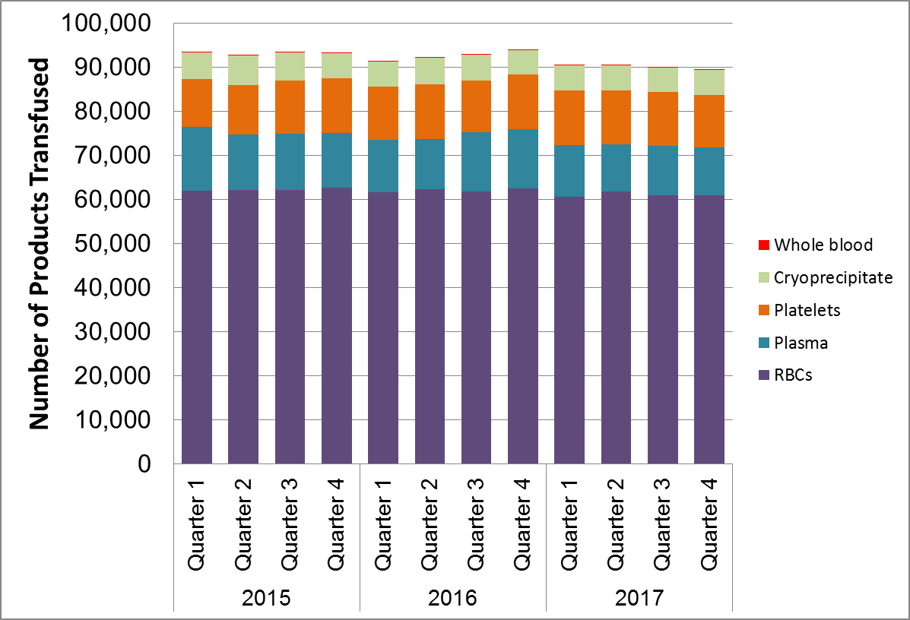

In 2015 and 2016, 70 facilities reported NHSN Hemovigilance data. In 2017, 69 facilities were reporting.

Whole blood refers to only autologous whole blood products.

**Transfusion Volume by Bed Size Group, Product Type, and Year, 2015-2017**



Whole blood refers to only autologous whole blood products.

Bed Size Group categorization was assigned based on the bed size reported in the facility’s most recent annual survey and was applied across all three years.

**Transfusion Volume by Emergency Preparedness (EP) Region**

**Massachusetts, 2017**

**(N=69 facilities reporting)**

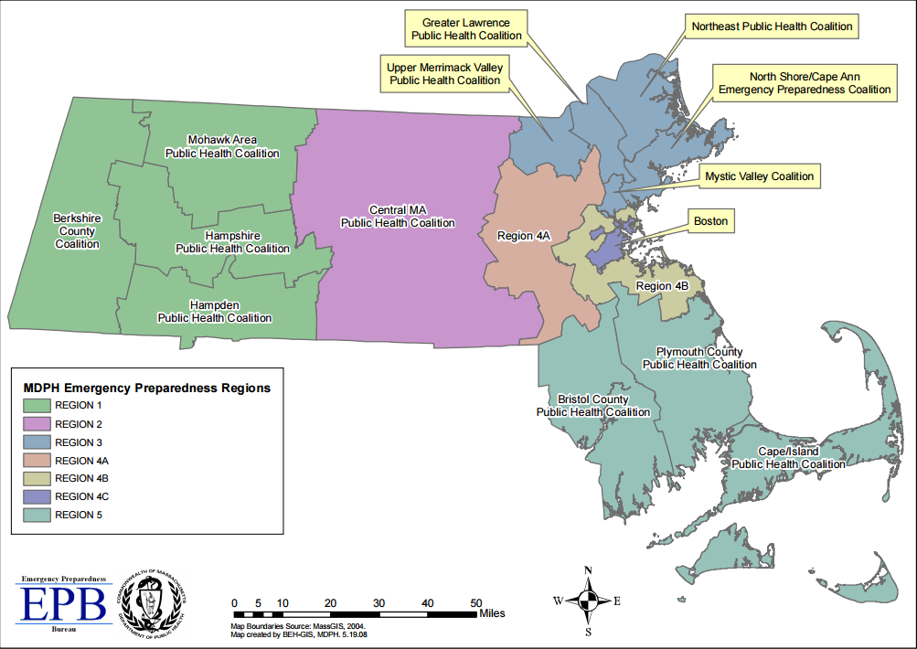



**Volume of Blood Products Discarded**

**Massachusetts, 2015-2017**

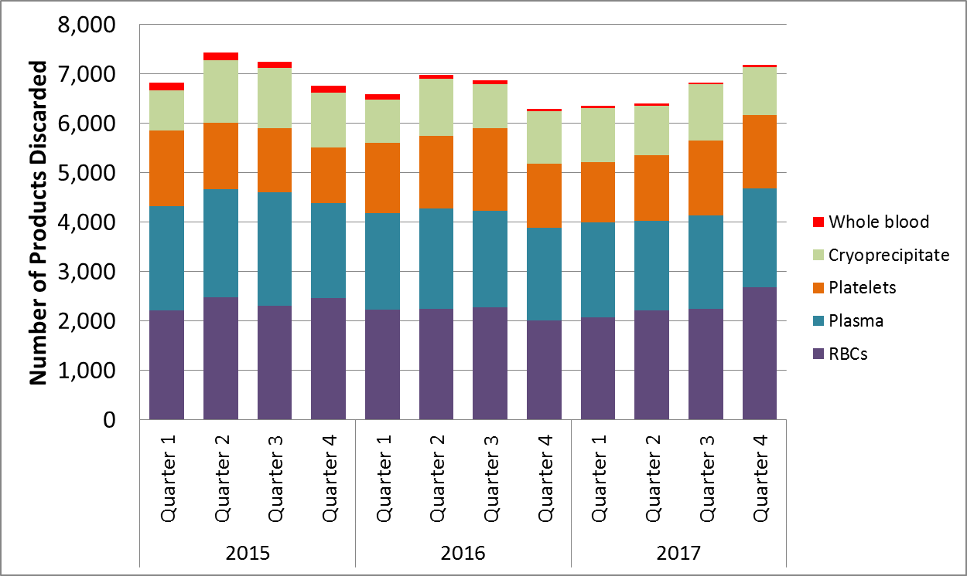

In 2015 and 2016, 70 facilities reported NHSN Hemovigilance data. In 2017, 69 facilities were reporting.

Whole blood refers to only autologous whole blood products.

**Number and Ratio of Discarded Products**

**by Type and Bed Size Group**

**Massachusetts, 2017**

**(N=69 facilities)**



*Note that the proper interpretation of Discard Ratio is: number discarded for every 100 products transfused.

Whole blood refers to only autologous whole blood products.

**Number of Adverse Reactions**

**by Type, Age Group, and Gender**

**Massachusetts, 2017**

**(N=69 facilities reporting)**



Non-severe allergic reactions were excluded from analysis.

No TAGHVD or PTP infections were reported in 2017.

**Summary of Transfusion-transmitted Infections**

**Massachusetts, 2017**

**(N=69 facilities reporting)**



*In 2017, the case definition and imputability determination were auto-designated in NHSN based on information entered about the event. Prior to 2017, a facility would apply the case definition and imputability criteria themselves to make these determinations. With the new auto-designation feature in NHSN, strict application of NHSN protocol criteria is ensured. A user has the option to “disagree” with the auto-designated determinations and indicate why if they choose. For the three reactions listed above in the gray boxes, the imputability chosen prior to auto-designation would have likely been “possible”, as indicated by the event information entered. For this reason, and to illustrate the impact of the auto-designation change on the reporting of transfusion-associated infections, they are included in this table, but excluded from rate calculations.

**Rates of Adverse Reactions per 10,000 Transfused Products by Product Type**

**Massachusetts, 2015-2017**

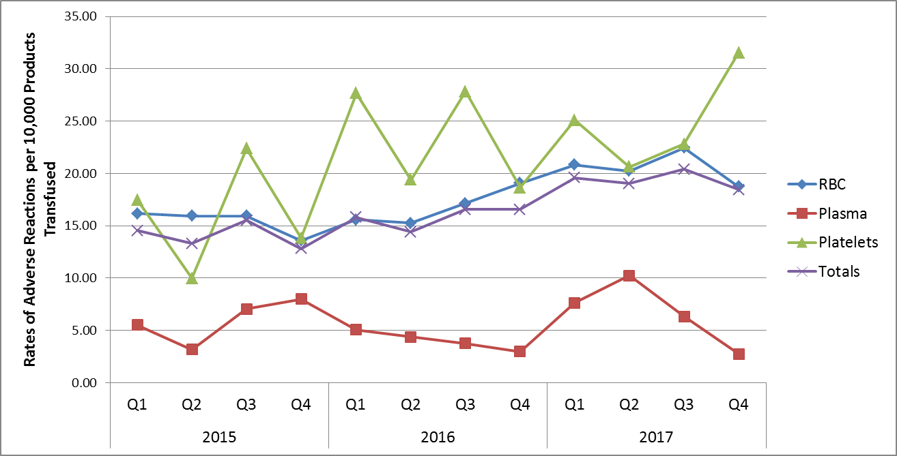

In 2015 and 2016, 70 facilities reported NHSN Hemovigilance data. In 2017, 69 facilities were reporting.

**Rates of Adverse Reactions per 10,000 Transfused Products by Bed Size Group**

**Massachusetts, 2015-2017**

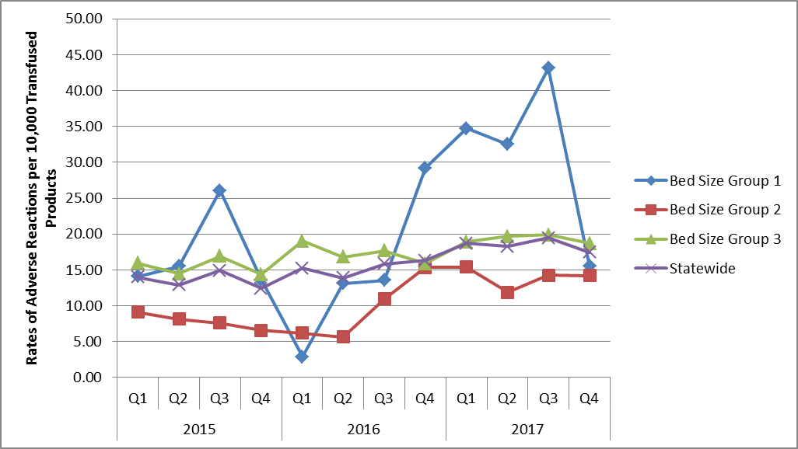

In 2015 and 2016, 70 facilities reported NHSN Hemovigilance data. In 2017, 69 facilities were reporting.

**Number of Adverse Reactions Reported by MA Facilities by Bed Size Group**

**2017**

***Facilities that reported adverse reactions***



***Facilities that did not report any adverse reactions***



Eight of seventeen facilities in bed size group 1 reported at least one adverse reaction, while nine facilities reported none. Those facilities that reported adverse reaction(s) had a mean transfusion volume of 989 products/month compared to 652 products/month for those reporting no reactions. Twenty-nine facilities in bed size group 2 reported at least one adverse reaction, while nine facilities reported none. Those facilities that reported adverse reaction(s) had a mean transfusion volume of 2,385 products/month compared to 2,042 products/month for those reporting no reactions. All facilities in bed size group 3 reported at least two adverse reactions.

**Rates of adverse reactions per 10,000 total units (full and aliquot) transfused, by component type**

**January 1, 2017- December 31, 2017**

**As reported to MDPH by 69 facilities**



**Rates of adverse reactions per 10,000 total units (full and aliquot) transfused, by component type**

**January 1, 2017- December 31, 2017**

**As reported to MDPH by 69 facilities**



Whole blood refers to only autologous whole blood products.

Nine adverse reactions listed “unknown” or “other” when indicating if specific implicated transfused blood product. These reactions are included in overall adverse reaction rate calculations but are excluded from component-specific rate calculations. One unit of granulocytes (reported as “other”) was implicated in the fatal TAD reaction. Five TACOs, one DSTR, and 2 FNHTRs had “unknown” blood products implicated.