

**Bureau of Infectious Disease and Laboratory Sciences**

**Hemovigilance Program Data Summary,**

**January 1-December 31, 2018**

**Suggested citation:**

Massachusetts Department of Public Health, Bureau of Infectious Disease and Laboratory Sciences.*Hemovigilance Program Data Summary January 1 – December 31, 2018.*

<https://www.mass.gov/service-details/reporting-requirements-for-blood-banks-and-hemovigilance-in-massachusetts>. Published September 2019. Accessed [date].

**Bureau of Infectious Disease and Laboratory Sciences**  
The Massachusetts Public Health State Laboratory  
305 South Street  
Jamaica Plain, MA 02130

**For questions about this report, contact:**

[Alexandra.dejesus@state.ma.us](mailto:Alexandra.dejesus@state.ma.us) or [Melissa.cumming@state.ma.us](mailto:Melissa.cumming@state.ma.us)

**Acknowledgments**

This report was prepared by the following MDPH staff:

Alexandra De Jesus, MPH

Melissa Cumming, MS

Christina Brandeburg, MPH

**Executive Summary**

**Introduction**

This report includes data submitted by Massachusetts blood banks to the Hemovigilance Module of the National Healthcare Safety Network (NHSN) from January 1, 2018 through December 31, 2018. The purpose of this report is to provide information on transfusion activity in the state, as well as on transfusion-associated adverse events. Blood banks in Massachusetts can examine their own facility metrics and use this report for comparison and context.

The members of the Massachusetts Hemovigilance TAG appreciate the committed participation of the Massachusetts blood banks and transfusion services in reporting hemovigilance data to NHSN, and hope that the availability of the metrics contained in this report will be useful to them for comparison, context, and quality improvement.

**Key Findings**

* There was an overall increase in transfused products for 2018. In particular, there was an increase in transfused products among facilities in bed size group (BSG) 3 (≥300 beds).
* Febrile non-hemolytic transfusion reactions (FNHTRs) continue to comprise the highest number of adverse reactions.
* No transfusion-related acute lung injuries (TRALIs) were reported.
* Platelets continue to be the blood product associated with the highest rate of adverse reactions. Additionally, there appears to be more variability over time in the adverse reaction rate associated with platelets than that associated with other blood product types.
* There was a 66% drop in whole blood transfusion among BSG 2 (100 to 299 beds) from 2017 to 2018. At least one facility ended their autologous whole blood transfusion program.

**Technical Notes**

The following are inclusion criteria for the adverse reactions included in this report:

* Case criteria – the reaction must either definitively or probably meet the NHSN case reporting criteria
* Imputability – the reaction must definitely, probably, or possibly meet NHSN imputability criteria
* Reaction type – the reaction must be one of twelve specified types in NHSN, excluding “Other” and “Unknown”
* Allergic reactions – *non-severe* allergic reactions are excluded from analysis and reporting is not required

Current reaction definitions and imputability criteria can be found at the following link: <https://www.cdc.gov/nhsn/PDFs/Biovigilance/BV-HV-protocol-current.pdf>.

**Data Summary**

This report includes data submitted by all 69 blood banks licensed in Massachusetts. Submission of data through the NHSN Hemovigilance Module is a regulatory requirement under 105 CMR 135.120 for all blood banks and transfusion services in Massachusetts. Complete denominator and adverse reaction data were submitted by all 69 facilities for all months covered. Facilities were stratified into three bed size groups for this report.

Responses to a NHSN annual facility survey, which describes facility characteristics, were provided by 60 blood banks. For those facilities that did not submit a 2018 annual facility survey, the most recent prior year submission was used. Bed size characteristics from the annual facility survey data can be found in Table 1. Eighty-eight percent of facilities were College of American Pathologists (CAP) accredited, 54% were accredited by AABB, and 49% indicated accreditation by the Joint Commission.

The volume of blood products transfused by Massachusetts blood banks varied widely. The number of whole blood units transfused statewide decreased by 77% from 2016 to 2018. Only four facilities transfused any whole blood in 2018, and in all cases it was autologous. The facility that transfused the largest amount of autologous whole blood ceased this practice in June 2018. Nearly all blood banks, 68 (99%) attempted to issue only leukocyte-reduced or leuko-poor cellular components. Fourteen (20%) blood banks collected blood at their facility, and eight (12%) performed point of issue bacterial testing on platelets prior to transfusion.

The number of red blood cell (RBC) type and screen procedures performed by Massachusetts blood banks ranged from 0 to 85,735 (mean: 9,451) and RBC crossmatches ranged from 0 to 57,710 (mean: 5,616). This year’s range included zero due to one facility ceasing operations in March and reporting no transfusion activity in January and February. The number of products transfused statewide in 2017 averaged 29,998 products per month. In 2018, the number of products transfused increased to an average of 31,187 products per month. The monthly average number of discarded products in 2018 was 2,101, representing a 6% decrease from 2016 to 2018.

Two transfusion-transmitted infections were reported in 2018, both of which were *Babesia microti* infections associated with transfused RBCs. This was a decrease in the total number of transfusion-transmitted infections reported compared to the prior two years, and a marked decrease in the number of reported *Babesia microti* infections. The 2018 rate of transfusion-transmitted infections in Massachusetts was 0.053 infections per 10,000 products transfused.

In 2018, there were 374,249 blood products transfused, with a total of 608 adverse reactions classified as possibly, probably, or definitely related to transfusion reported, yielding an overall reaction rate of 16.2 reactions per 10,000 products transfused. Thirty-eight (6%) of the reported reactions were considered serious or life-threatening, and two (0.3%) reactions were fatal. Febrile non-hemolytic reactions (FNHTRs) were reported more frequently than other reaction types, making up 81% (491/608) of all adverse reactions reported.

This year’s annual report includes adverse reaction data from 2017 and 2018 only. This is due to updates made to the hemovigilance module in 2017 which included the implementation of “auto-designation”. Auto-designation allows NHSN to automatically assign an adverse reaction’s case definition and imputability classification based on the clinical and laboratory data (i.e., signs, symptoms, and lab results) entered by the user. Prior to auto-designation, users would assign case definition and imputability classification themselves based on NHSN protocol rules. Because of this change in the module, it was determined that 2017 and 2018 data should not be directly compared to, or included in, trend analyses with earlier data, before auto-designation was implemented. For the 2017 Annual Report, 2015 and 2016 data were included for trend analyses by applying a “retro” designation to 2017 data, as if auto-designation had not yet been implemented. Moving forward, MDPH analysis will rely on the NHSN hemovigilance module auto-designation assignments for case definition and imputability. This means that 2017 adverse reaction data in last year’s annual report may differ from the 2017 adverse reaction data included in this year’s report.

The Technical Advisory Group (TAG) was established in June 2014 to provide guidance to the Massachusetts Department of Public Health (MDPH) in the analysis and use of statewide hemovigilance data.

Current members of the TAG are:

**Chester Andrzejewski, Jr., PhD, MD, FCAP**

Medical Director

System Transfusion Medicine/Blood Banking and

Apheresis Medicine Services

Baystate Health/ Baystate Medical Center

**Christina Brandeburg, MPH**

Epidemiologist

Bureau of Infectious Disease and Laboratory Sciences

Massachusetts Department of Public Health

**Melissa Cumming, MS**

Epidemiologist

Hemovigilance Coordinator

Bureau of Infectious Disease and Laboratory Sciences

Massachusetts Department of Public Health

**Alexandra De Jesus, MPH**

Epidemiologist

Bureau of Infectious Disease and Laboratory Sciences

Massachusetts Department of Public Health

**Alfred DeMaria, Jr., MD**

Medical and Laboratory Consultant

Bureau of Infectious Disease and Laboratory Sciences

Massachusetts Department of Public Health

**Elzbieta Griffiths, MD**

Medical Director, Blood Bank,

Donor Center and Coagulation

Surgical Pathologist Mount Auburn Hospital

**Michele Herman, MT (ASCP)**

Compliance Officer - Transfusion Medicine

Beth Israel Deaconess Medical Center

**Kimberly Knox, RN, MHA, CIC**

Infection Prevention and Control Coordinator

Milford Regional Medical Center

**Eileen McHale, RN, BSN**

Healthcare Associated Infection Coordinator

Bureau of Health Care Safety and Quality

Massachusetts Department of Public Health

**Lynne O’Hearn, MT (ASCP)**

Transfusion Safety Officer

Baystate Medical Center

**Jorge Rios, MD**

Medical Director

American Red Cross Blood Services

Massachusetts Region

**Lynne Uhl, MD**

Vice Chair and Division Director for Laboratory and Transfusion Medicine

Beth Israel Deaconess Medical Center

**Pamela Waksmonski, MS, MT (ASCP),**

**PMP, CRA**

Clinical Laboratory Program Manager

Bureau of Health Care Safety and Quality

Massachusetts Department of Public Health

**Table of Contents**

List of abbreviations 6

Table 1: Bed Size Characteristics from the 2018 Annual Facility Survey………………………………..7

Figure 1: Volume of Blood Products Transfused in Massachusetts, 2016-2018 8

Table 2: Transfusion Volume by Bed Size Group, Product Type, and Year, 2016-2018 9

Figure 2: Volume of Blood Products Discarded in Massachusetts, 2016-2018 10

Table 3: Number and Ratio of Discarded Products by Type and Bed Size Group, 2018………….....11

Table 4: Number of Adverse Reactions in Massachusetts, 2017-2018………………………………….12

Table 5: Number of Adverse Reactions by Type, Age Group, and Gender, 2018……………………..13

Table 6: Summary of Transfusion-transmitted Infections in Massachusetts, 2018 14

Figure 3: Rates of Adverse Reactions per 10,000 Transfused Products by Product Type………….15

Figure 4: Rates of Adverse Reactions per 10,000 Transfused Products by Bed Size Group……….16

Table 7: Rates of Adverse Reactions per 10,000 Total Units Transfused by Component Type..17-18

**List of Abbreviations**

* AABB – formerly American Association of Blood Banks
* AHTR – Acute hemolytic transfusion reaction
* ALLERG – Allergic reaction
* CAP – College of American Pathologists
* DHTR – Delayed hemolytic transfusion reaction
* DSTR – Delayed serologic transfusion reaction
* FNHTR – Febrile non-hemolytic transfusion reaction
* HTR – Hypotensive transfusion reaction
* PTP – Post-transfusion purpura
* TJC – The Joint Commission
* TACO – Transfusion-associated circulatory overload
* TAD – Transfusion-associated dyspnea
* TAGVHD – Transfusion-associated graft versus host disease
* TRALI – Transfusion-related acute lung injury
* TTI – Transfusion-transmitted infection

**Table 1: Bed Size Characteristics from the 2018 Annual Facility Survey**



For those facilities that did not submit a 2018 annual facility survey, the most recent prior year submission was used.

**Figure 1: Volume of Blood Products Transfused in Massachusetts, 2016-2018**

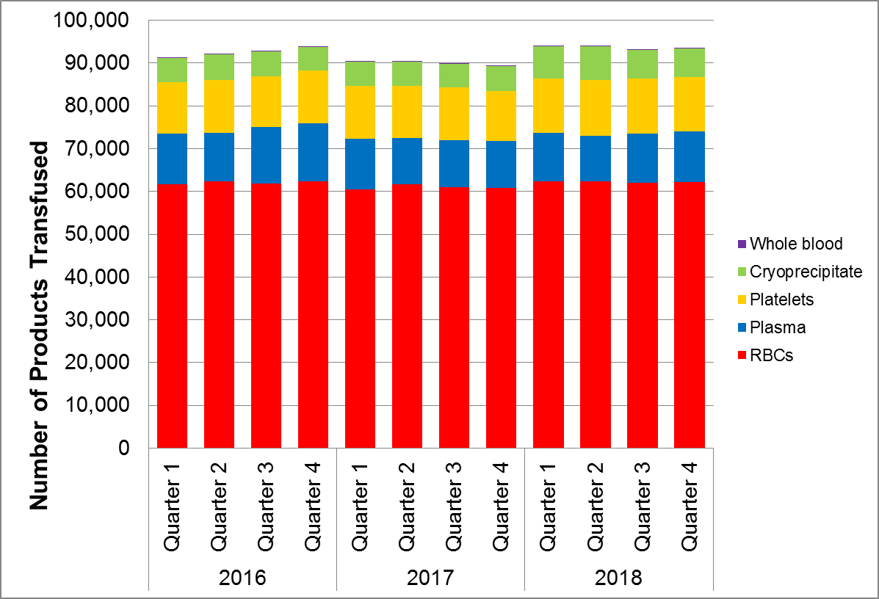

In 2016, 70 facilities reported NHSN Hemovigilance data. In 2017 and 2018, 69 facilities were reporting.

Whole blood refers to only autologous whole blood products.

**Table 2: Transfusion Volume by Bed Size Group, Product Type, and Year, 2016-2018**



* In 2016, 17 facilities were in Bed Size Group 1, 38 in Bed Size Group 2, and 15 in Bed Size Group 3.

** In 2017, 17 facilities were in Bed Size Group 1, 38 in Bed Size Group 2, and 14 in Bed Size Group 3.

*** In 2018, 17 facilities were in Bed Size Group 1, 37 in Bed Size Group 2, and 15 in Bed Size Group 3.

Whole blood refers to only autologous whole blood products.

Bed Size Group categorization was assigned based on the corresponding year’s annual facility survey.

**Figure 2: Volume of Blood Products Discarded in Massachusetts, 2016-2018**

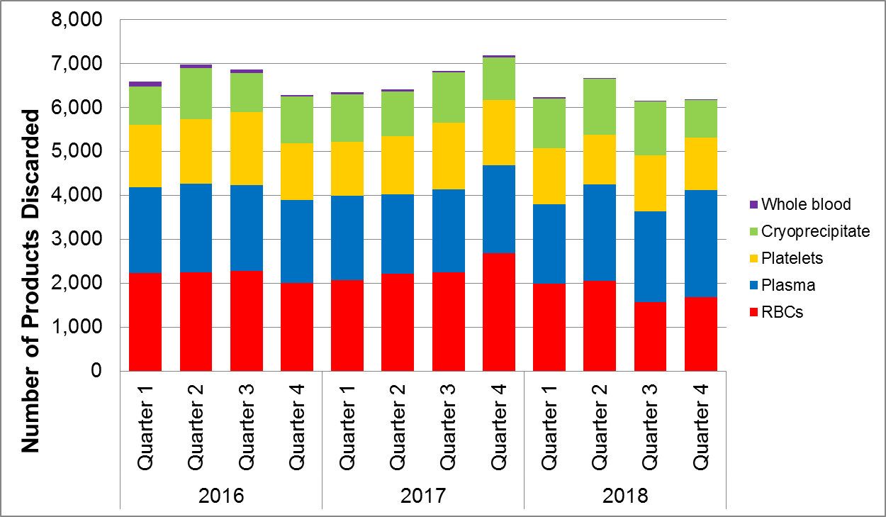

In 2016, 70 facilities reported NHSN Hemovigilance data. In 2017 and 2018, 69 facilities were reporting.

Whole blood refers to only autologous whole blood products.

**Table 3: Number and Ratio of Discarded Products**

**by Type and Bed Size Group Massachusetts, 2018 (N=69 facilities)**



* Discard ratio = the number of products discarded for every 100 products transfused.

Whole blood refers to only autologous whole blood products.

**Table 4: Number of Adverse Reactions in Massachusetts, 2017-2018**



**Table 5: Number of Adverse Reactions**

**by Type, Age Group, and Gender in Massachusetts, 2018**



Non-severe allergic reactions were excluded from analyses.

No TAGHVD or PTP infections were reported in 2018.

**Table 6: Summary of Transfusion-transmitted infections in Massachusetts, 2018**

|  |  |  |  |  |  |  |  |  |  |  |  |  |
| --- | --- | --- | --- | --- | --- | --- | --- | --- | --- | --- | --- | --- |
| Adverse Reaction Date | Number of Days from Transfusion to Reaction | Age at Adverse Reaction | Gender | Infection | Case Definition | Severity | Imputability | Associated Unit | Unit Tested | Unit Tested Positive | Donor Tested | Donor Tested Positive |
| 3/2018 | 30 | 74 | Female | *Babesia microti* | Definitive | Severe | Definite | Red Blood Cells | N | NA | Y | Y |
| 3/2018 | 29 | 72 | Male | *Babesia microti* | Definitive | Severe | Possible | Red Blood Cells | N | NA | Y | Y |

**Figure 3: Rates of Adverse Reactions per 10,000 Transfused Products**

**by Product Type in Massachusetts, 2017-2018**

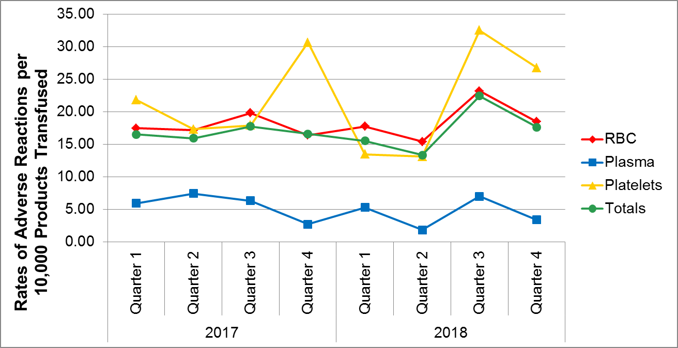

In 2017 and 2018, 69 facilities reported NHSN Hemovigilance data.

**Figure 4: Rates of Adverse Reactions per 10,000 Transfused Products**

**By Bed Size Group in Massachusetts, 2017-2018**

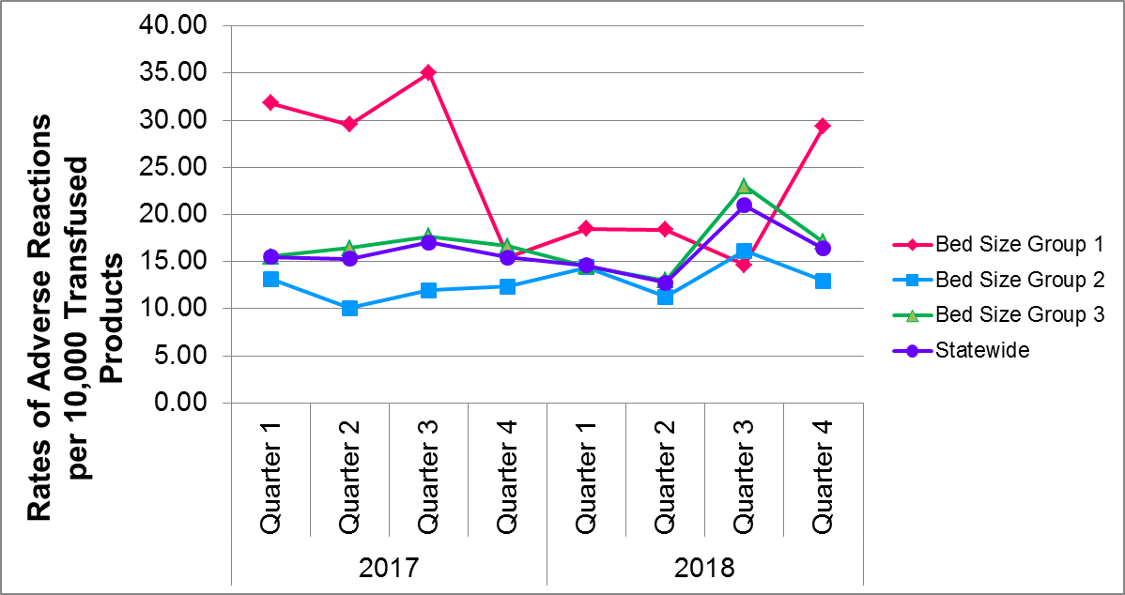

In 2017 and 2018, 69 facilities reported NHSN Hemovigilance data.

**Table 7: Rates of Adverse Reactions per 10,000 Total Units (Full and Aliquot)**

**Transfused by Component Type, 2018**



Whole blood refers to only autologous whole blood products.

Twelve adverse reactions were associated with an “unknown” transfused blood product. These reactions were included in the overall adverse reaction rate calculations, but were excluded from component-specific rate calculations. One allergic reaction, 8 FNHTRs, 2 TACOs, and 1 TAD reported an “unknown” blood product implicated.

**Table 7: Rates of Adverse Reactions per 10,000 Total Units (Full and Aliquot)**

**Transfused by Component Type, 2018**



Whole blood refers to only autologous whole blood products.

Twelve adverse reactions were associated with an “unknown” transfused blood product. These reactions were included in the overall adverse reaction rate calculations, but were excluded from component-specific rate calculations. One allergic reaction, 8 FNHTRs, 2 TACOs, and 1 TAD reported an “unknown” blood product implicated.