

**Bureau of Infectious Disease and Laboratory Sciences**

**Hemovigilance Program Data Summary**

**January 1-December 31, 2019**

**Suggested citation:**

Massachusetts Department of Public Health, Bureau of Infectious Disease and Laboratory Sciences.*Hemovigilance Program Data Summary January 1 – December 31, 2019.*

<https://www.mass.gov/service-details/reporting-requirements-for-blood-banks-and-hemovigilance-in-massachusetts>. Published July 2020. Accessed [date].

**Bureau of Infectious Disease and Laboratory Sciences**  
The Massachusetts Public Health State Laboratory  
305 South Street  
Jamaica Plain, MA 02130

**For questions about this report, contact:**

[Alexandra.dejesus@state.ma.us](mailto:Alexandra.dejesus@state.ma.us) or [Melissa.cumming@state.ma.us](mailto:Melissa.cumming@state.ma.us)

**Acknowledgments**

This report was prepared by the following MDPH staff:

Alexandra De Jesus, MPH, CIC

Melissa Cumming, MS, CIC

Christina Brandeburg, MPH, CIC

**Executive Summary**

**Introduction**

This report includes data submitted by Massachusetts blood banks to the Hemovigilance Module of the National Healthcare Safety Network (NHSN) from January 1, 2019 through December 31, 2019. The purpose of this report is to provide information on transfusion activity in the state, as well as on transfusion-associated adverse events. Blood banks in Massachusetts can examine their own facility metrics and use this report for comparison and context.

The members of the Massachusetts Hemovigilance Technical Advisory Group (TAG) appreciate the committed participation of Massachusetts blood banks and transfusion services in reporting hemovigilance data to NHSN for the past 4 years and hope that the availability of the metrics contained in this report will be useful to them for comparison, context, and quality improvement.

**Key Findings**

* There was an overall decrease in all transfused product types in 2019 except platelets, which saw a modest increase across all three bed size groups (BSG).
* There was an overall decrease in total products discarded in 2019, with plasma making up the largest proportion (36%) of all product discards.
* There was a nearly seven-fold increase in whole blood transfusions in 2019, driven primarily by a facility in BSG 3 (≥ 300 beds) that began a low-titer O whole blood emergency release program.
* Febrile non-hemolytic transfusion reactions (FNHTRs) continue to comprise the highest number of adverse reactions.
* The number of transfusion associated dyspnea (TAD) cases increased 2.3 times from 13 cases in 2018 (reported by 4 facilities) to 30 in 2019 (reported by 5 facilities).
* 93% of TAD cases in 2019 were reported by two facilities in BSG 3.
* 43% of TAD cases were reported in the month of April by four facilities; three in BSG 3 and one in BSG 2 (100-299 beds).
* Platelets continue to be the blood product associated with both the highest and most variable rate of adverse reactions over time, than those associated with other blood product types.

**Technical Notes**

The following are inclusion criteria for the adverse reactions included in this report:

* Case criteria – the reaction must either definitively or probably meet the NHSN case reporting criteria
* Imputability – the reaction must definitely, probably, or possibly meet NHSN imputability criteria
* Reaction type – the reaction must be one of twelve specified types in NHSN, excluding “Other” and “Unknown”
* Allergic reactions – *non-severe* allergic reactions are excluded from analysis and reporting is not required

Current reaction definitions and imputability criteria can be found at the following link: <https://www.cdc.gov/nhsn/PDFs/Biovigilance/BV-HV-protocol-current.pdf>.

**Data Summary**

This report includes data submitted by all 68 blood banks licensed in Massachusetts. Submission of data through the NHSN Hemovigilance Module is a regulatory requirement under 105 CMR 135.120 for all blood banks and transfusion services in Massachusetts. Complete denominator and adverse reaction data were submitted by all 68 facilities for all months covered. Facilities were stratified into three bed size groups for this report. One blood bank ceased operation in early 2019 and was excluded from this report, having transfused no blood products prior to closure.

Responses to a NHSN annual facility survey, which describe facility characteristics, were provided by 66 blood banks. For the two facilities that did not submit a 2019 annual facility survey, the 2018 annual facility survey was used. Bed size characteristics from the annual facility survey data can be found in Table 1. Eighty-eight percent of facilities were College of American Pathologists (CAP) accredited, 51% were accredited by AABB, and 53% indicated accreditation by the Joint Commission.

The volume of blood products transfused by Massachusetts blood banks varied widely. The number of whole blood units transfused statewide increased by 135% from 2017 to 2019. Only 4 facilities transfused whole blood in 2019, and one facility in BSG 3 began a low titer O whole blood emergency release program. Nearly all blood banks, 67 (99%) attempted to issue only leukocyte-reduced or leuko-poor cellular components. Twelve (18%) blood banks collected blood at their facility, and seven (10%) performed point of issue bacterial testing on platelets prior to transfusion.

The number of red blood cell (RBC) type and screen procedures performed by Massachusetts blood banks ranged from 178 to 90,351 (mean: 9,894) and RBC crossmatches ranged from 117 to 61,069 (mean: 5,705). The number of products transfused statewide, decreased from an average of 31,187 products per month in 2018 to an average of 30,361 products per month in 2019. The monthly average number of discarded products in 2019 was 2,016, representing a 4.5% decrease from 2018.

Three transfusion-transmitted infections were reported in 2019, one of which was a *Babesia microti* infection associated with transfused RBCs. The 2019 rate of transfusion-transmitted infections in Massachusetts was 0.082 infections per 10,000 products transfused.

In 2019, there were 364,333 blood products transfused and a total of 674 adverse reactions classified as possibly, probably, or definitely related to transfusion, yielding an overall reaction rate of 18.5 reactions per 10,000 products transfused. Sixty-one (9%) of the reported reactions were considered serious or life-threatening, and none of the reactions were fatal. Febrile non-hemolytic reactions (FNHTRs) were reported more frequently than other reaction types, making up 77% of all adverse reactions reported.

The Technical Advisory Group (TAG) was established in June 2014 to provide guidance to the Massachusetts Department of Public Health (MDPH) in the analysis and use of statewide hemovigilance data.

Current members of the TAG are:

**Chester Andrzejewski, Jr., PhD, MD, FCAP**

Medical Director

System Transfusion Medicine/Blood Banking and

Apheresis Medicine Services

Baystate Health/ Baystate Medical Center

**Christina Brandeburg, MPH, CIC**

Epidemiologist

Bureau of Infectious Disease and Laboratory Sciences

Massachusetts Department of Public Health

**Melissa Cumming, MS, CIC**

Epidemiologist

Hemovigilance Coordinator

Bureau of Infectious Disease and Laboratory Sciences

Massachusetts Department of Public Health

**Alexandra De Jesus, MPH, CIC**

Epidemiologist

Bureau of Infectious Disease and Laboratory Sciences

Massachusetts Department of Public Health

**Alfred DeMaria, Jr., MD**

Medical and Laboratory Consultant

Bureau of Infectious Disease and Laboratory Sciences

Massachusetts Department of Public Health

**Elzbieta Griffiths, MD**

Medical Director, Blood Bank,

Donor Center and Coagulation

Surgical Pathologist Mount Auburn Hospital

**Michele Herman, MT (ASCP)**

Compliance Officer - Transfusion Medicine

Beth Israel Deaconess Medical Center

**Kimberly Knox, RN, MHA, CIC**

Infection Prevention and Control Coordinator

Milford Regional Medical Center

**Eileen McHale, RN, BSN**

Healthcare Associated Infection Coordinator

Bureau of Health Care Safety and Quality

Massachusetts Department of Public Health

**Lynne O’Hearn, MT (ASCP)**

Transfusion Safety Officer

Baystate Medical Center

**Jorge Rios, MD**

Medical Director

American Red Cross Blood Services

Massachusetts Region

**Lynne Uhl, MD**

Vice Chair and Division Director for Laboratory and Transfusion Medicine

Beth Israel Deaconess Medical Center

**Jason Viau, BS, MT (ASCP)**

Senior Medical Technologist II, Blood Bank

Lahey Hospital & Medical Center

President

Massachusetts Association of Blood Banks

**Pamela Waksmonski, MS, MT (ASCP),**

**PMP, CRA**

Clinical Laboratory Program Manager

Bureau of Health Care Safety and Quality

Massachusetts Department of Public Health

**Table of Contents**

List of abbreviations 6

Table 1: Bed Size Characteristics from the 2019 Annual Facility Survey………………………………..7

Figure 1: Volume of Blood Products Transfused in Massachusetts, 2017-2019 8

Table 2: Transfusion Volume by Bed Size Group, Product Type, and Year, 2017-2019 9

Figure 2: Volume of Blood Products Discarded in Massachusetts, 2017-2019 10

Table 3: Number and Ratio of Discarded Products by Type and Bed Size Group, 2019………….....11

Table 4: Number of Adverse Reactions in Massachusetts, 2018-2019………………………………….12

Table 5: Number of Adverse Reactions by Type, Age Group, and Gender, 2019……………………..13

Table 6: Summary of Transfusion-transmitted Infections in Massachusetts, 2019 14

Figure 3: Rates of Adverse Reactions per 10,000 Transfused Products by Product Type………….15

Figure 4: Rates of Adverse Reactions per 10,000 Transfused Products by Bed Size Group……….16

Table 7: Rates of Adverse Reactions per 10,000 Total Units Transfused by Component Type..17-18

**List of Abbreviations**

* AABB – formerly American Association of Blood Banks
* AHTR – Acute hemolytic transfusion reaction
* ALLERG – Allergic reaction
* CAP – College of American Pathologists
* DHTR – Delayed hemolytic transfusion reaction
* DSTR – Delayed serologic transfusion reaction
* FNHTR – Febrile non-hemolytic transfusion reaction
* HTR – Hypotensive transfusion reaction
* PTP – Post-transfusion purpura
* TJC – The Joint Commission
* TACO – Transfusion-associated circulatory overload
* TAD – Transfusion-associated dyspnea
* TAGVHD – Transfusion-associated graft versus host disease
* TRALI – Transfusion-related acute lung injury
* TTI – Transfusion-transmitted infection

**Table 1: Bed Size Characteristics from the 2019 Annual Facility Survey**



For those facilities that did not submit a 2019 annual facility survey, the most recent prior year submission was used.

**Figure 1: Volume of Blood Products Transfused in Massachusetts, 2017-2019**

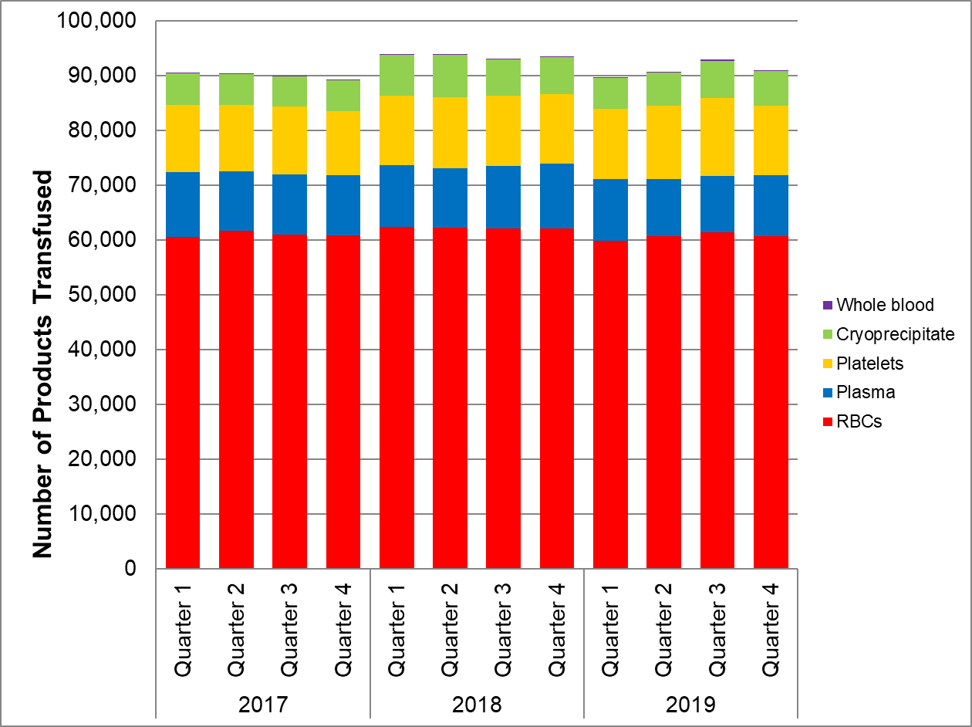

In 2017 & 2018, 69 facilities reported NHSN Hemovigilance data. In 2019, 68 facilities were reporting.

**Table 2: Transfusion Volume by Bed Size Group, Product Type, and Year, 2017-2019**



* In 2017, 17 facilities were in Bed Size Group 1, 38 in Bed Size Group 2, and 14 in Bed Size Group 3.

** In 2018, 17 facilities were in Bed Size Group 1, 37 in Bed Size Group 2, and 15 in Bed Size Group 3.

*** In 2019, 15 facilities were in Bed Size Group 1, 38 in Bed Size Group 2, and 15 in Bed Size Group 3.

Bed Size Group categorization was assigned based on the corresponding year’s annual facility survey.

**Figure 2: Volume of Blood Products Discarded in Massachusetts, 2017-2019**

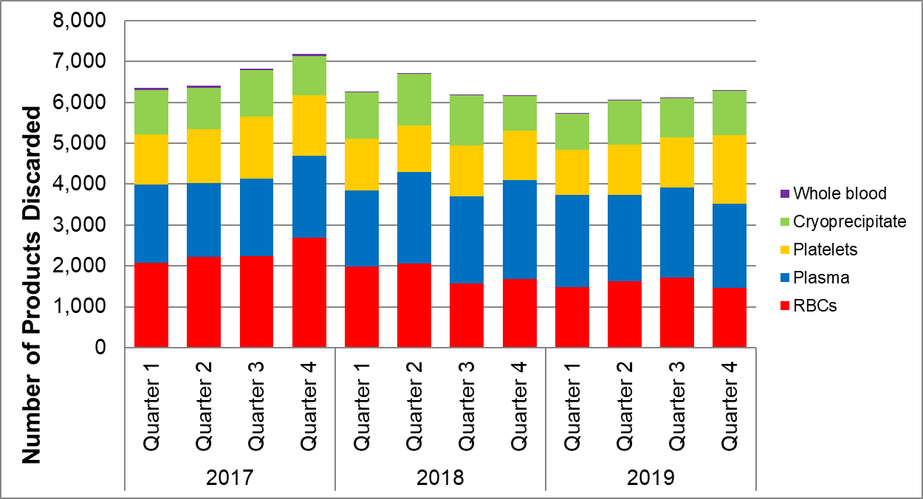

In 2017 & 2018, 69 facilities reported NHSN Hemovigilance data. In 2019, 68 facilities were reporting.

**Table 3: Number and Ratio of Discarded Products**

**by Type and Bed Size Group Massachusetts, 2019 (N=68 facilities)**



* Discard ratio = the number of products discarded for every 100 products transfused.

**Table 4: Number of Adverse Reactions in Massachusetts, 2018-2019**



**Table 5: Number of Adverse Reactions**

**by Type, Age Group, and Gender in Massachusetts, 2019**



Non-severe allergic reactions were excluded from analyses.

**Table 6: Summary of Transfusion-transmitted infections in Massachusetts, 2019**

|  |  |  |  |  |  |  |  |  |  |  |  |  |
| --- | --- | --- | --- | --- | --- | --- | --- | --- | --- | --- | --- | --- |
| Adverse Reaction Date | Number of Days from Tranfusion to Reaction | Age at Adverse Reaction | Gender | Infection | Case Definition | Severity | Imputability | Associated Unit | Unit Tested | Unit Tested Positive | Donor Tested | Donor Tested Positive |
| 4/2019 | 0 | 11 | Male | *Staphylococcus pasteuri* | Definitive | Severe | Possible | Platelets | N | NA | N | NA |
| 5/2019 | 0 | 60 | Female | *Staphylococcus hominis & Staphylococcus epidermidis* | Definitive | Non-Severe | Possible | Red Blood Cells | Y | Y | N | NA |
| 9/2019 | 39 | 69 | Male | *Babesia microti* | Definitive | Non-Severe | Possible | Red Blood Cells | N | NA | Y | Y |

**Figure 3: Rates of Adverse Reactions per 10,000 Transfused Products**

**by Product Type in Massachusetts, 2018-2019**

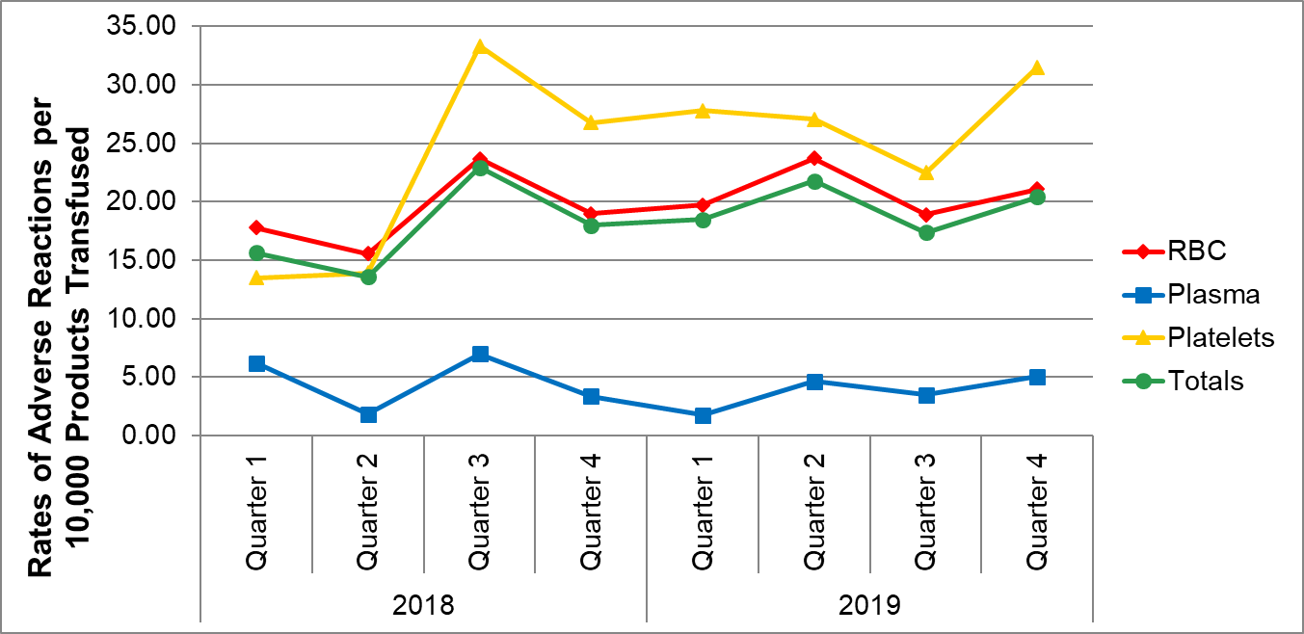

In 2017 & 2018, 69 facilities reported NHSN Hemovigilance data. In 2019, 68 facilities were reporting.

**Figure 4: Rates of Adverse Reactions per 10,000 Transfused Products**

**By Bed Size Group in Massachusetts, 2018-2019**

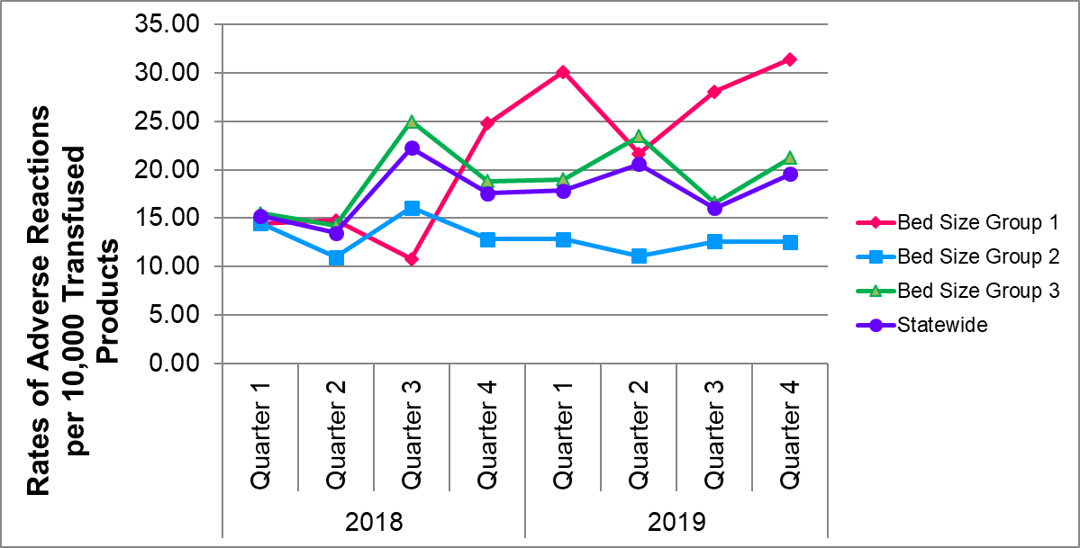

In 2017 & 2018, 69 facilities reported NHSN Hemovigilance data. In 2019, 68 facilities were reporting.

**Table 7: Rates of Adverse Reactions per 10,000 Total Units (Full and Aliquot)**

**Transfused by Component Type, 2019**



Ten adverse reactions were associated with an “unknown” transfused blood product. These reactions were included in the overall adverse reaction rate calculations, but were excluded from component-specific rate calculations. Five FNHTRs, 4 TACOs, and 1 TAD reported an “unknown” blood product implicated.

**Table 7: Rates of Adverse Reactions per 10,000 Total Units (Full and Aliquot)**

**Transfused by Component Type, 2019**



Ten adverse reactions were associated with an “unknown” transfused blood product. These reactions were included in the overall adverse reaction rate calculations, but were excluded from component-specific rate calculations. Five FNHTRs, 4 TACOs, and 1 TAD reported an “unknown” blood product implicated.