

**Bureau of Infectious Disease and Laboratory Sciences**

**Hemovigilance Program Data Summary**

**January 1-December 31, 2020**

**Suggested citation:**

Massachusetts Department of Public Health, Bureau of Infectious Disease and Laboratory Sciences.*Hemovigilance Program Data Summary January 1 – December 31, 2020.*

<https://www.mass.gov/service-details/reporting-requirements-for-blood-banks-and-hemovigilance-in-massachusetts>. Published October 2021. Accessed [date].

**Bureau of Infectious Disease and Laboratory Sciences**  
The Massachusetts State Public Health Laboratory  
305 South Street  
Jamaica Plain, MA 02130

**For questions about this report, contact:**

[Ashley.a.iannone@mass.gov](mailto:Ashley.a.iannone@mass.gov) or [Melissa.cumming@mass.gov](mailto:Melissa.cumming@mass.gov)

**Acknowledgments**

This report was prepared by the following MDPH staff:

Ashley Iannone, MPH

Christina Brandeburg, MPH, CIC

Jordan Schultz, MPH

Melissa Cumming, MS, CIC

**Executive Summary**

**Introduction**

This report includes data submitted by Massachusetts blood banks to the Hemovigilance Module of the Centers for Disease Control and Prevention’s National Healthcare Safety Network (NHSN) from January 1, 2020 through December 31, 2020. The purpose of this report is to provide information on transfusion activity in the state, as well as on transfusion-associated adverse events. Blood banks in Massachusetts can examine their own facility metrics and use this report for comparison and context.

The members of the Massachusetts Hemovigilance Technical Advisory Group (TAG) appreciate the committed participation of Massachusetts blood banks and transfusion services in reporting hemovigilance data to NHSN for the past 7 years and hope that the availability of the metrics contained in this report will be useful to them for comparison, context, and quality improvement.

**Key Findings**

* Total volume of transfused products decreased overall in 2020, likely due to changes in blood product utilization as a result of COVID-19 Pandemic response efforts.1

* There was an increase in total products discarded in Q1 and Q2 of 2020, with plasma making up the largest proportion (17.6%) of all product discards in 2020.
* There was a 55% increase in whole blood transfusions in 2020, driven primarily by a facility in bed size group (BSG) 3 (≥ 300 beds) that began a low-titer, type O positive whole blood emergency release program in 2019.
* Febrile non-hemolytic transfusion reactions (FNHTRs) continue to comprise the largest number of adverse reactions.
* The rate of all adverse reactions decreased from 18.5 per 10,000 products transfused in 2019, to 15.4 per 10,000 products transfused in 2020.
* 68% of transfusion-associated dyspnea (TAD) cases in 2020 were reported by two faciliies in BSG 3.
* Platelets continue to be the blood product associated with both the highest and most variable rate of adverse reactions over time, compared to other blood product types.

In an effort to capture data on a novel blood product introduced in 2020, Massachusetts facilities began reporting data in NHSN on COVID-19 Convalescent Plasma (CCP) use. There were 2,732 and 1,027 units of CCP transfused in 2020 and 2021, respectively. During this 2-year period there were 6 non-severe adverse reactions associated with CCP transfusion, 3 of these being FNHTRs.

**1** Kracalik, I, Mowla, S, Katz, L, Cumming, M, Sapiano, MRP, Basavaraju, SV. Impact of the early coronavirus disease 2019 pandemic on blood utilization in the United States: A time-series analysis of data reported to the National Healthcare Safety Network Hemovigilance Module. Transfusion. 2021; 61: S36– S43. https://doi.org/10.1111/trf.16451

**Technical Notes**

The following are inclusion criteria for the adverse reactions included in this report:

* Case criteria – the reaction must either definitively or probably meet the NHSN case reporting criteria
* Imputability – the reaction must definitely, probably, or possibly meet NHSN imputability criteria
* Reaction type – the reaction must be one of twelve specified types in NHSN, excluding “Other” and “Unknown”
* Allergic reactions – *non-severe* allergic reactions are excluded from analysis and reporting is not required

Current reaction definitions and imputability criteria can be found at the following link: <https://www.cdc.gov/nhsn/PDFs/Biovigilance/BV-HV-protocol-current.pdf>.

**Data Summary**

This report includes data submitted by all 67 blood banks licensed in Massachusetts. Submission of data through the NHSN Hemovigilance Module is a regulatory requirement under 105 CMR 135.120 for all blood banks and transfusion services in Massachusetts. Complete denominator and adverse reaction data were submitted by 66 facilities for all months covered. One facility closed in 2020 but reported data to NHSN through June. Facilities were stratified into three bed size groups for this report.

Responses to a NHSN annual facility survey, which describe facility characteristics, were provided by 50 blood banks. For the 17 facilities that did not submit a 2020 annual facility survey, the 2019 annual facility survey data were used. Bed size characteristics from the annual facility survey data can be found in Table 1. Eighty-seven percent of facilities were College of American Pathologists (CAP) accredited, 52% were accredited by AABB, and 46% indicated accreditation by the Joint Commission.

The volume of blood products transfused by Massachusetts blood banks varied widely. The number of whole blood units transfused statewide increased by 55% from 2019 to 2020. Only five facilities transfused whole blood in 2020, and one facility in BSG 3 was responsible for 78% of the whole blood units transfused in the state. All but one of the 67 blood banks attempted to issue only leukocyte-reduced or leuko-poor cellular components. Eleven (16%) blood banks collected blood at their facility and seven (10%) performed point of issue bacterial testing on platelets prior to transfusion. The number of blood banks collecting blood in 2020 decreased by just one facility, from the previous year.

The number of red blood cell (RBC) type and screen procedures performed by Massachusetts blood banks ranged from 218 to 80,022 (mean: 9,490) and RBC crossmatches ranged from 148 to 54,127 (mean: 5,423). The number of products transfused statewide decreased from an average of 30,361 products per month in 2019 to 29,047 products per month in 2020. The monthly average number of discarded products decreased by less than 1%, from 2,016 products discarded in 2019 to 2,003 products discarded in 2020.

Two transfusion-transmitted infections were reported in 2020, one of which was a *Babesia microti* infection associated with transfused RBCs. The 2020 rate of transfusion-transmitted infections in Massachusetts was 0.06 infections per 10,000 products transfused.

In 2020, there were 352,891 blood products transfused and a total of 545 adverse reactions classified as possibly, probably, or definitely related to transfusion, yielding an overall reaction rate of 15.4 reactions per 10,000 products transfused. Forty-five (8%) of the reported reactions were considered serious or life-threatening, and one of the reactions was fatal. Febrile non-hemolytic reactions (FNHTRs) were reported more frequently than other reaction types, making up 75% of all adverse reactions reported.

***New*** to this annual report is the inclusion of pathogen reduced denominator and adverse reaction data. In 2020, pathogen reduced products contributed 1% of total products transfused for the year. All pathogen reduced products transfused were psoralen-treated platelets. There were 10 adverse reactions associated with pathogen reduced products, with a rate of 28.11 per 10,000 pathogen reduced products transfused. Pathogen reduced products were transfused by just 20 facilities.

The Technical Advisory Group (TAG) was established in June 2014 to provide guidance to the Massachusetts Department of Public Health (MDPH) in the analysis and use of statewide hemovigilance data.

Current members of the TAG are:

**Chester Andrzejewski, Jr., PhD, MD, FCAP**

Medical Director

System Transfusion Medicine/Blood Banking and

Apheresis Medicine Services

Baystate Health/ Baystate Medical Center

**Christina Brandeburg, MPH, CIC**

Epidemiologist

Bureau of Infectious Disease and Laboratory Sciences

Massachusetts Department of Public Health

**Melissa Cumming, MS, CIC**

Epidemiologist

Hemovigilance Coordinator

Bureau of Infectious Disease and Laboratory Sciences

Massachusetts Department of Public Health

**Ashley Iannone, MPH**

Epidemiologist

Bureau of Infectious Disease and Laboratory Sciences

Massachusetts Department of Public Health

**Jordan Schultz, MPH**

Epidemiologist

Bureau of Infectious Disease and Laboratory Sciences

Massachusetts Department of Public Health

**Alfred DeMaria, Jr., MD**

Medical and Laboratory Consultant

Bureau of Infectious Disease and Laboratory Sciences

Massachusetts Department of Public Health

**Elzbieta Griffiths, MD**

Medical Director, Blood Bank,

Donor Center and Coagulation

Surgical Pathologist, Mount Auburn Hospital

**Michele Herman, MT (ASCP)**

Compliance Officer - Transfusion Medicine

Beth Israel Deaconess Medical Center

**Kimberly Knox, RN, MHA, CIC**

Infection Prevention and Control Coordinator

Milford Regional Medical Center

**Eileen McHale, RN, BSN**

Healthcare Associated Infection Coordinator

Bureau of Health Care Safety and Quality

Massachusetts Department of Public Health

**Lynne O’Hearn, MT (ASCP)**

Transfusion Safety Officer

Baystate Medical Center

**Jorge Rios, MD**

Medical Director

American Red Cross Blood Services

Massachusetts Region

**Lynne Uhl, MD**

Vice Chair and Division Director for Laboratory and Transfusion Medicine

Beth Israel Deaconess Medical Center

**Jason Viau, BS, MT (ASCP)**

Senior Medical Technologist II, Blood Bank

Lahey Hospital & Medical Center

President

Massachusetts Association of Blood Banks

**Pamela Waksmonski, MS, MT (ASCP),**

**PMP, CRA**

Clinical Laboratory Program Manager

Bureau of Health Care Safety and Quality

Massachusetts Department of Public Health

**Table of Contents**

List of abbreviations 6

Table 1: Bed Size Characteristics from the 2020 Annual Facility Survey………………………………..7

Figure 1: Volume of Blood Products Transfused in Massachusetts, 2018-2020 8

Table 2: Transfusion Volume by Bed Size Group, Product Type, and Year, 2018-2020 9

**Table 3: Volume of Pathogen Reduced Products Transfused in Massachusetts, 2018-2020..……..10**

Figure 2: Volume of Blood Products Discarded in Massachusetts, 2018-2020 11

Table 4: Number and Ratio of Discarded Products by Type and Bed Size Group, 2020………….....12

Table 5: Number of Adverse Reactions in Massachusetts, 2019-2020………………………………….13

**Table 6: Number of Adverse Reactions Associated with Pathogen Reduced Products in Massachusetts, 2019-2020…………………..……………………………………………..………..………….13**

Table 7: Number of Adverse Reactions by Type, Age Group, and Gender, 2020……………………..14

Table 8: Summary of Transfusion-transmitted Infections in Massachusetts, 2020 15

Figure 3: Rates of Adverse Reactions per 10,000 Transfused Products by Product Type………….16

Figure 4: Rates of Adverse Reactions per 10,000 Transfused Products by Bed Size Group……….17

Table 9: Rates of Adverse Reactions per 10,000 Total Units Transfused by Component Type……18

**Table 10: Rates of Adverse Reactions per 10,000 Total Units of Pathogen Reduced Products Transfused, 2018-2020…………………..……………………………………………..………..…..……….….19**

**Appendix A: COVID-19 Convalescent Plasma Supplemental…………………………………………….20**

**List of Abbreviations**

* AABB – Association for the Advancement of Blood and Biotherapies
* AHTR – Acute hemolytic transfusion reaction
* ALLERG – Allergic reaction
* CAP – College of American Pathologists
* DHTR – Delayed hemolytic transfusion reaction
* DSTR – Delayed serologic transfusion reaction
* FNHTR – Febrile non-hemolytic transfusion reaction
* HTR – Hypotensive transfusion reaction
* PTP – Post-transfusion purpura
* TJC – The Joint Commission
* TACO – Transfusion-associated circulatory overload
* TAD – Transfusion-associated dyspnea
* TAGVHD – Transfusion-associated graft versus host disease
* TRALI – Transfusion-related acute lung injury
* TTI – Transfusion-transmitted infection

**Table 1: Bed Size Characteristics from the 2020 Annual Facility Survey**

For those facilities that did not submit a 2020 annual facility survey, the most recent prior year submission was used.

**Figure 1: Volume of Blood Products Transfused in Massachusetts, 2018-2020**

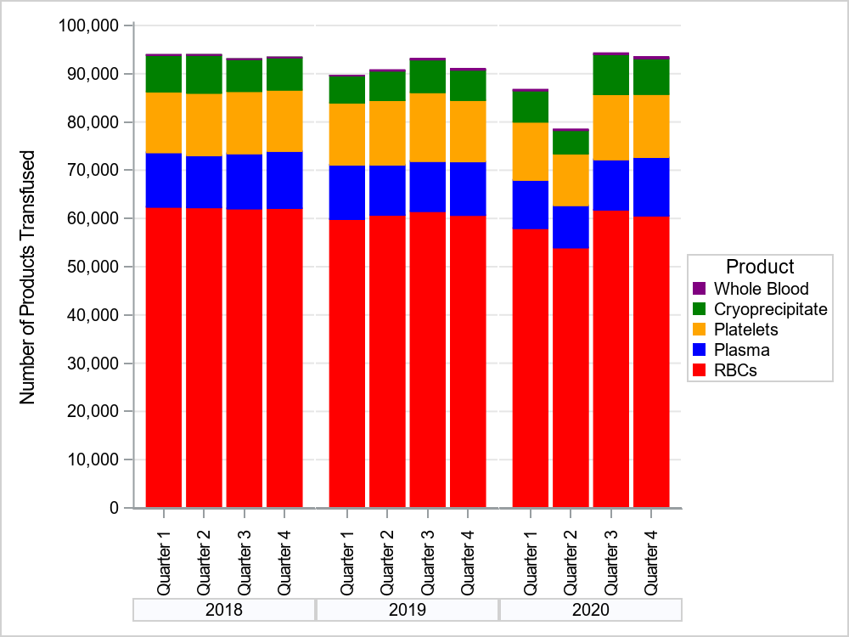

In 2018, 69 facilities reported NHSN Hemovigilance data. In 2019, 68 facilities reported. In 2020, 67 facilities reported.

**Table 2: Transfusion Volume by Bed Size Group, Product Type, and Year, 2018-2020**



* In 2018, 17 facilities were in Bed Size Group 1, 37 in Bed Size Group 2, and 15 in Bed Size Group 3.

**In 2019, 15 facilities were in Bed Size Group 1, 38 in Bed Size Group 2, and 15 in Bed Size Group 3.

***In 2020, 14 facilities were in Bed Size Group 1, 40 in Bed Size Group 2, and 13 in Bed Size Group 3.

Bed Size Group categorization was assigned based on the corresponding year’s annual facility survey.

**Table 3: Volume of Pathogen Reduced Products Transfused in Massachusetts, 2018-2020**



**Figure 2****: Volume of Blood Products Discarded in Massachusetts, 2018-2020**

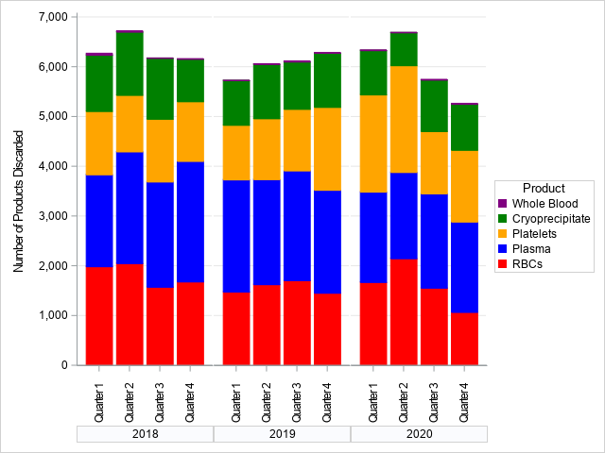

In 2018, 69 facilities reported NHSN Hemovigilance data. In 2019, 68 facilities reported, in 2020, 67 facilities reported.

**Table 4: Number and Ratio of Discarded Products**

**by Type and Bed Size Group Massachusetts, 2020 (N=67 facilities)**



* Discard ratio = the number of products discarded for every 100 products transfused.

**Table 5: Number of Adverse Reactions in Massachusetts, 2019-2020**



**Table 6: Number of Adverse Reactions Associated with Pathogen Reduced Products in Massachusetts, 2019-2020**



*All ARs were associated with apheresis derived, psoralen-treated platelets.

**Table 7: Number of Adverse Reactions**

 **by Type, Age Group, and Gender in Massachusetts, 2020**

Non-severe allergic reactions were excluded from analyses.

**Table 8: Summary of Transfusion-transmitted infections in Massachusetts, 2020**

**Figure 3: Rates of Adverse Reactions per 10,000 Transfused Products**

**by Product Type in Massachusetts, 2019-2020**

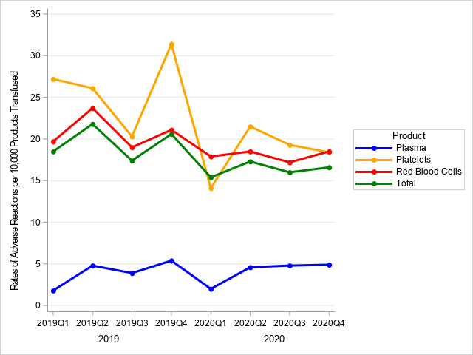

In 2018, 69 facilities reported NHSN Hemovigilance data. In 2019, 68 facilities reported. In 2020,

67 facilities reported.

**Figure 4: Rates of Adverse Reactions per 10,000 Transfused Products**

**By Bed Size Group in Massachusetts, 2019-2020**

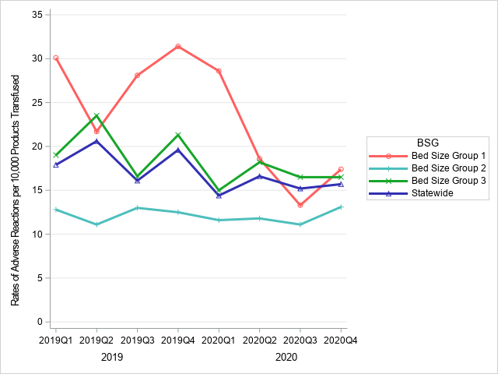

In 2018, 69 facilities reported NHSN Hemovigilance data. In 2019, 68 facilities reported. In 2020, 67

facilities reported.

**Table 9: Rates of Adverse Reactions per 10,000 Total Units (Full and Aliquot)**

**Transfused by Component Type, 2020**

Eleven adverse reactions were associated with an “unknown” transfused blood product. These reactions were included in the overall adverse reaction rate calculations, but were excluded from component-specific rate calculations. Two Allergic reactions, 6 FNHTRs, 2 TACOs, and 1 TAD reported an “unknown” blood product implicated.

**Table 10: Rates of Adverse Reactions per 10,000 Total Units of Pathogen Reduced Products Transfused, 2018-2020**

All adverse reactions were associated with apheresis derived; psoralen treated platelets. In 2018 and 2019, these were the only pathogen reduced products transfused, but in 2020, 149 units of whole blood derived, psoralen treated platelets were also transfused.

**APPENDIX A: COVID-19 Convalescent Plasma Supplemental**

In 2020, Massachusetts required blood banks to record the volume of COVID convalescent plasma (CCP) transfused at their facilities. The data presented in this supplemental appendix include CCP transfused from January of 2020 to June of 2021, when the transfusion of CCP dropped to zero use. In 2020, 2,732 units of CCP were transfused, and over 800 units were transfused in December of that year. So far in 2021, 1,027 units of CCP have been transfused.

Six adverse reactions have been associated with CCP transfusions, including 3 FNHTRs, 2 TADs, and 1 TACO. All ARs were non-severe.

**Figure A-1: Volume of CCP transfused from 2020-2021 compared to Confirmed COVID-19 Cases**

**Table A-1: Adverse Reactions Associated with transfusion of CCP from 2020-2021**

References

1. Kracalik, I, Mowla, S, Katz, L, Cumming, M, Sapiano, MRP, Basavaraju, SV. Impact of the early coronavirus disease 2019 pandemic on blood utilization in the United States: A time-series analysis of data reported to the National Healthcare Safety Network Hemovigilance Module. Transfusion. 2021; 61: S36– S43. https://doi.org/10.1111/trf.16451