

**Bureau of Infectious Disease and Laboratory Sciences**

**Hemovigilance Program Data Summary**

**January 1-December 31, 2021**

**Suggested citation:**

Massachusetts Department of Public Health, Bureau of Infectious Disease and Laboratory Sciences.*Hemovigilance Program Data Summary January 1– December 31, 2021.*

<https://www.mass.gov/service-details/reporting-requirements-for-blood-banks-and-hemovigilance-in-massachusetts>. Published May 2022. Accessed [date].

**Bureau of Infectious Disease and Laboratory Sciences**  
The Massachusetts State Public Health Laboratory  
305 South Street  
Jamaica Plain, MA 02130

**For questions about this report, contact:**

[Ashley.a.iannone@mass.gov](mailto:Ashley.a.iannone@mass.gov) or [Melissa.cumming@mass.gov](mailto:Melissa.cumming@mass.gov)

**Acknowledgments**

This report was prepared by the following MDPH staff:

Ashley Iannone, MPH

Christina Brandeburg, MPH, CIC

Jordan Schultz, MPH

Melissa Cumming, MS, CIC

**Executive Summary**

**Introduction**

This report includes new data submitted by Massachusetts blood banks to the Hemovigilance Module of the Centers for Disease Control and Prevention’s National Healthcare Safety Network (NHSN) from January 1 through December 31, 2021. The purpose of this report is to provide information on transfusion activity in the state, as well as on transfusion-associated adverse events. Blood banks in Massachusetts can examine their own facility metrics and use this report for comparison and context.

The members of the Massachusetts Hemovigilance Technical Advisory Group (TAG) appreciate the committed participation of Massachusetts blood banks and transfusion services in reporting hemovigilance data to NHSN for the past 8 years and hope that the availability of the metrics contained in this report will be useful to them for comparison, context, and quality improvement.

**Key Findings**

* Total volume of transfused products increased overall in 2021, while total products discarded decreased by 11% from 2020.
* Febrile non-hemolytic transfusion reactions (FNHTRs) continue to comprise the largest number of adverse reactions.

* There was a significant decrease in the number of severe allergic reactions reported from 21 in 2020 to four in 2021.
* The overall rate of adverse reactions increased from 15.4 per 10,000 products transfused in 2020, to 16.6 per 10,000 products transfused in 2021.
* Platelets continue to be the blood product associated with both the highest and most variable rate of adverse reactions over time.
* There was a 3.2-fold increase in the volume of pathogen reduced technology (PRT) products transfused in 2021 compared to 2020. Most of these products were apheresis derived, psoralen treated platelets.
* In 2021, there were 19 adverse reactions associated with PRT products for a rate of 16.80 per 10,000 PRT products transfused. Two (10.5%) of these reactions were severe or life-threatening. In comparison, there were 573 adverse reactions associated with non-PRT products for a rate of 16.55 per 10,000 non-PRT products transfused. 34 (6%) of these reactions were severe or life-threatening.
* Less than 30 units of COVID Convalescent plasma (CCP) were transfused since May 2021. CCP transfusion peaked in December of 2020 with 821 units transfused.

**Technical Notes**

The following are inclusion criteria for the adverse reactions included in this report:

* Case criteria – the reaction must either definitively or probably meet the NHSN case reporting criteria
* Imputability – the reaction must definitely, probably, or possibly meet NHSN imputability criteria
* Reaction type – the reaction must be one of twelve specified types in NHSN, excluding “Other” and “Unknown”
* Allergic reactions – *non-severe* allergic reactions are excluded from analysis and reporting is not required

Current reaction definitions and imputability criteria can be found at the following link: <https://www.cdc.gov/nhsn/PDFs/Biovigilance/BV-HV-protocol-current.pdf>.

**Data Summary**

This report includes data submitted by 65 blood banks licensed in Massachusetts. Submission of data through the NHSN Hemovigilance Module is a regulatory requirement under 105 CMR 135.120 for all blood banks and transfusion services in Massachusetts. Complete denominator and adverse reaction data were submitted by 65 facilities for all months covered. Two facilities closed in 2020 and did not report data to NHSN in 2021. Facilities were stratified into three bed size groups for this report defined as those with less than 100 beds, those with 100-299 beds, and those with greater than or equal to 300 beds.

Updated responses to the NHSN annual facility survey, which describe facility characteristics, were provided by 57 blood banks. For the 8 facilities that did not submit a 2021 annual facility survey, the most recently submitted annual facility survey data were used. Bed size characteristics from the annual facility survey data can be found in Table 1. Eighty-six percent of facilities were College of American Pathologists (CAP) accredited, 51% were accredited by AABB, and 42% indicated accreditation by the Joint Commission.

In 2021, there were more than 11,000 units of pathogen reduced products transfused across 60 different facilities, an increase from 3,558 units transfused across 17 facilities in 2020. In both 2020 and 2021, one facility in bed size group 3 transfused the majority of pathogen reduced products. All but one of the 65 blood banks attempted to issue only leukocyte-reduced or leuko-poor cellular components. Ten (15%) blood banks collected blood at their facility.

The number of red blood cell (RBC) type and screen procedures performed by Massachusetts blood banks ranged from 215 to 90,325 (mean: 10,329) and RBC crossmatches ranged from 146 to 218,836 (mean: 8,634). The number of products transfused statewide increased from an average of 29,047 products per month in 2020 to 29,797 in 2021. The monthly average number of discarded products decreased by 11%, from 2,003 products discarded in 2020 to 1,784 products discarded in 2021.

In 2021, only 4 severe allergic reactions were reported compared to 21 reported in 2020. There was no significant difference in which facilities reported these reactions in 2020 vs 2021, nor does it appear that this was a reporting or system error in NHSN. (Auto-designation of case definition, severity, and imputability in NHSN minimizes the potential for inter-facility differences in classification.)

In 2021, there were 357,564 blood products transfused and a total of 592 adverse reactions classified as possibly, probably, or definitely related to transfusion, yielding an overall reaction rate of 16.6 reactions per 10,000 products transfused. Thirty-six (6%) of the reported reactions were considered serious or life-threatening, and one of the reactions was fatal (TACO). Febrile non-hemolytic reactions (FNHTRs) were reported more frequently than other reaction types, making up 74% of all adverse reactions reported.

The Technical Advisory Group (TAG) was established in June 2014 to provide guidance to the Massachusetts Department of Public Health (MDPH) in the analysis and use of statewide hemovigilance data.

Current members of the TAG are:

**Chester Andrzejewski, Jr., PhD, MD, FCAP**

Medical Director

System Transfusion Medicine/Blood Banking and

Apheresis Medicine Services

Baystate Health/ Baystate Medical Center

**Christina Brandeburg, MPH, CIC**

Epidemiologist

Bureau of Infectious Disease and Laboratory Sciences

Massachusetts Department of Public Health

**Melissa Cumming, MS, CIC**

Epidemiologist

Hemovigilance Coordinator

Bureau of Infectious Disease and Laboratory Sciences

Massachusetts Department of Public Health

**Ashley Iannone, MPH**

Epidemiologist

Bureau of Infectious Disease and Laboratory Sciences

Massachusetts Department of Public Health

**Jordan Schultz, MPH**

Epidemiologist

Bureau of Infectious Disease and Laboratory Sciences

Massachusetts Department of Public Health

**Alfred DeMaria, Jr., MD**

Medical and Laboratory Consultant

Bureau of Infectious Disease and Laboratory Sciences

Massachusetts Department of Public Health

**Michele Herman, MT (ASCP)**

Compliance Officer - Transfusion Medicine

Beth Israel Deaconess Medical Center

**Kimberly Knox, RN, MHA, CIC**

Infection Prevention and Control Coordinator

Milford Regional Medical Center

**Eileen McHale, RN, BSN**

Healthcare Associated Infection Coordinator

Bureau of Health Care Safety and Quality

Massachusetts Department of Public Health

**Lynne O’Hearn, MT (ASCP)**

Transfusion Safety Officer

Baystate Medical Center

**Jorge Rios, MD**

Medical Director

American Red Cross Blood Services

Massachusetts Region

**Lynne Uhl, MD**

Vice Chair and Division Director for Laboratory and Transfusion Medicine

Beth Israel Deaconess Medical Center

**Jason Viau, BS, MT (ASCP)**

Senior Medical Technologist II, Blood Bank

Lahey Hospital & Medical Center

President

Massachusetts Association of Blood Banks

**Pamela Waksmonski, MS, MT (ASCP),**

**PMP, CRA**

Clinical Laboratory Program Manager

Bureau of Health Care Safety and Quality

Massachusetts Department of Public Health

Table of Contents

List of Abbreviations 7

Table 1: Bed Size Characteristics from the 2021 Annual Facility Survey* 8

Figure 1: Volume of Blood Products Transfused in Massachusetts, 2019-2021 9

Table 2: Transfusion Volume by Bed Size Group^, Product Type, and Year, 2019-2021 10

Table 3: Volume of Pathogen Reduced Products Transfused in Massachusetts, 2019-2021 11

Figure 2: Volume of Blood Products Discarded in Massachusetts, 2019-2021 12

Table 4: Number and Ratio of Discarded Products by Type and Bed Size Group Massachusetts, 2021 (N=65 facilities) 13

Table 5: Number of Adverse Reactions in Massachusetts, 2019-2021 14

Table 6: Number of Adverse Reactions Associated with Pathogen Reduced Products in Massachusetts, 2019-2021 14

Table 7: Number of Adverse Reactions by Type, Age Group, and Gender in Massachusetts, 2021 15

Figure 3: Rates of Adverse Reactions per 10,000 Transfused Products by Product Type in Massachusetts, 2019-2021 16

Figure 4: Rates of Adverse Reactions per 10,000 Transfused Products by Bed Size Group in Massachusetts, 2019-2021 17

Table 8: Rates of Adverse Reactions per 10,000 Total Units (Full and Aliquot) Transfused by Component Type, 2021 18

**List of Abbreviations**

* AABB – Association for the Advancement of Blood and Biotherapies
* AHTR – Acute hemolytic transfusion reaction
* ALLERG – Allergic reaction
* CAP – College of American Pathologists
* CCP- Covid Convalescent Plasma
* DHTR – Delayed hemolytic transfusion reaction
* DSTR – Delayed serologic transfusion reaction
* FNHTR – Febrile non-hemolytic transfusion reaction
* HTR – Hypotensive transfusion reaction
* PRT- Pathogen Reduction Technology
* PTP – Post-transfusion purpura
* TJC – The Joint Commission
* TACO – Transfusion-associated circulatory overload
* TAD – Transfusion-associated dyspnea
* TAGVHD – Transfusion-associated graft versus host disease
* TRALI – Transfusion-related acute lung injury
* TTI – Transfusion-transmitted infection

**Table 1: Bed Size Characteristics from the 2021 Annual Facility Survey\***

|  |  |  |  |  |
| --- | --- | --- | --- | --- |
|  | | **BSG 1  (1-99 Beds)** | **BSG 2** (100-299 Beds)** | **BSG 3  (≥ 300 Beds)** |
| Number of Hospitals | | 14 | 36 | 15 |
| Average Number of Beds Served by Transfusion Service (range) | | 59 (14-95) | 184 (100-290) | 500  (302-1,011) |
| Average Number of Inpatient Surgeries (range) | | 411  (0-1,050) | 1,802 (160-5,123) | 7,031 (1,736-18,222) |
| Average Number of Outpatient Surgeries (range) | | 1,548 (0-4,820) | 6,722 (641-70,874) | 10,952 (1,500-20,601) |
| Transfusion Service Serves Cancer Center (includes adult and pediatric) | | 8 (57%) | 24 (67%) | 12 (80%) |
| Medical School Affiliation | Major Teaching Hospital | 2 (14.3%) | 10 (28%) | 14 (93%) |
| Graduate Teaching Hospital | 0 | 7 (19%) | 1 (7%) |
| Undergraduate Teaching Hospital | 0 | 9 (25%) | 0 |
| Trauma Level | Level 1 | 0 | 0 | 9 (60%) |
| Level 2 | 0 | 1 (3%) | 2 (13%) |
| Level 3 | 1 (7%) | 8 (22%) | 1 (7%) |
| Level NA | 13 (93%) | 27 (75%) | 3 (20%) |
| Community Setting | Rural | 6 (43%) | 1 (3%) | 0 |
| Suburban | 8 (57%) | 23 (64%) | 4 (27%) |
| Urban | 0 | 12 (33%) | 11 (73%) |

*For those facilities that did not submit a 2021 annual facility survey (8), the most recent prior year submission was used.

** 2 facilities moved from BSG 2 to BSG 3 in 2021

**Figure 1: Volume of Blood Products Transfused in Massachusetts, 2019-2021**

In 2019, 68 facilities reported NHSN Hemovigilance data. In 2020, 67 facilities reported. In 2021, 65 facilities reported.

**Table 2: Transfusion Volume by Bed Size Group^, Product Type, and Year, 2019-2021**



*In 2019, 15 facilities were in Bed Size Group 1, 38 in Bed Size Group 2, and 15 in Bed Size Group 3.

**In 2020, 14 facilities were in Bed Size Group 1, 40 in Bed Size Group 2, and 13 in Bed Size Group 3.

***In 2021, 14 facilities were in Bed Size Group 1, 36 in Bed Size Group 2, and 15 in Bed Size Group 3.

^Bed Size Group categorization was assigned based on the corresponding year’s annual facility survey.

**Table 3: Volume of Pathogen Reduced Products Transfused in Massachusetts, 2019-2021**



**Figure 2****: Volume of Blood Products Discarded in Massachusetts, 2019-2021**

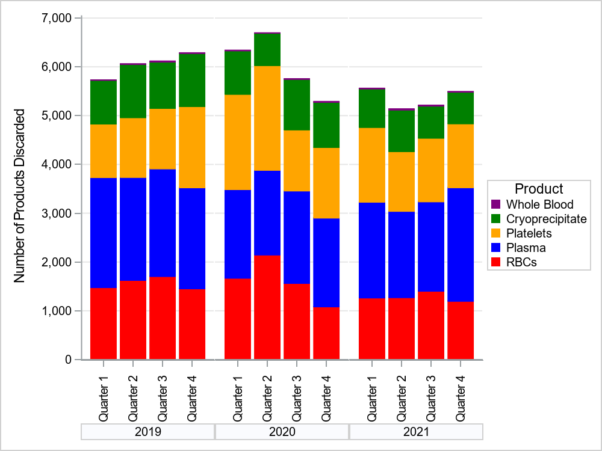

In 2019, 68 facilities reported NHSN Hemovigilance data. In 2020, 67 facilities reported. In 2021, 65 facilities reported.

**Table 4: Number and Ratio of Discarded Products  
by Type and Bed Size Group Massachusetts, 2021**



* Discard ratio = the number of products discarded for every 100 products transfused.

**Table 5: Number of Adverse Reactions in Massachusetts, 2019-2021**



**Table 6: Number of Adverse Reactions Associated with  
Pathogen Reduced Products in Massachusetts, 2019-2021**



*All ARs were associated with apheresis derived, psoralen-treated platelets.

**Table 7: Number of Adverse Reactions   
by Type, Age Group, and Gender in Massachusetts, 2021**

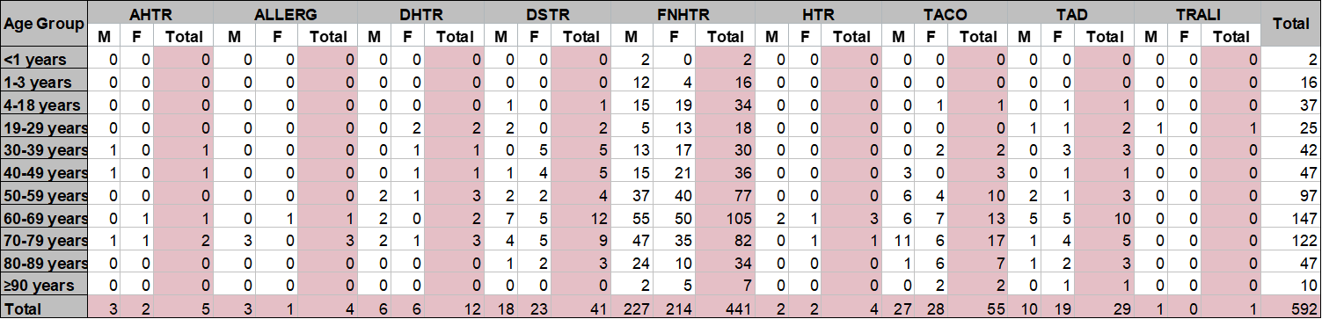

Non-severe allergic reactions were excluded from analyses.

**Figure 3: Rates of Adverse Reactions per 10,000 Transfused Products  
by Product Type in Massachusetts, 2019-2021**

In 2019, 68 facilities reported NHSN Hemovigilance data. In 2020, 67 facilities reported. In 2021, 65 facilities reported.

**Figure 4: Rates of Adverse Reactions per 10,000 Transfused Products  
by Bed Size Group in Massachusetts, 2019-2021**

In 2019, 68 facilities reported NHSN Hemovigilance data. In 2020, 67 facilities reported. In 2021, 65 facilities reported.

Rates in BSG 1 tend to be unstable over time as a result of lower transfusion volume and fewer ARs reported overall.

**Table 8: Rates of Adverse Reactions per 10,000 Total Units (Full and Aliquot)   
Transfused by Component Type, 2021**



34 adverse reactions were associated with an “unknown” transfused blood product. These reactions were included in the overall adverse reaction rate calculations, but were excluded from component-specific rate calculations. One AHTR, 1 ALLERG, 1 DSTR, 20 FNHTRs, 9 TACOs,1 TAD, and 1 TRALI reported an “unknown” blood product implicated