Bureau of Infectious Disease and Laboratory Sciences
Hemovigilance Program Data Summary
January 1-December 31, 2022

Suggested citation:

Massachusetts Department of Public Health, Bureau of Infectious Disease and Laboratory Sciences. Hemovigilance Program Data Summary January 1– December 31, 2022.
https://www.mass.gov/service-details/reporting-requirements-for-blood-banks-and-hemovigilance-in-massachusetts. Published August 2023. Accessed [date].

Bureau of Infectious Disease and Laboratory Sciences
The Massachusetts State Public Health Laboratory
305 South Street
Jamaica Plain, MA 02130

For questions about this report, contact:
Ashley.a.iannone@mass.gov or Melissa.cumming@mass.gov
Acknowledgments
This report was prepared by the following MDPH staff:
Ashley Iannone, MPH, CIC
Christina Brandeburg, MPH, CIC
Jordan Schultz, MPH
Melissa Cumming, MS, CIC
Amanda Slider, MPH, CIC

Executive Summary

Introduction

This report includes data submitted by Massachusetts blood banks to the Hemovigilance Module of the Centers for Disease Control and Prevention’s National Healthcare Safety Network (NHSN) from January 1 through December 31, 2022. The purpose of this report is to provide information on transfusion activity in the state, as well as transfusion-associated adverse events. Blood banks in Massachusetts can examine their own facility metrics and use this report for comparison and context.

The members of the Massachusetts Hemovigilance Technical Advisory Group (TAG) appreciate the committed participation of Massachusetts blood banks and transfusion services in reporting hemovigilance data to NHSN for the past 9 years and hope that the availability of the metrics contained in this report will be useful to them for comparison, context, and quality improvement.

Key Findings

- Total volume of transfused products decreased by 7% in 2022, with whole blood being the only component to show an increase in transfusions from 2021 to 2022.

- 6% of products in 2022 were discarded, an increase from 5.6% in 2021, with plasma being the most frequent product discarded both years.

- The number of severe allergic reactions increased to 17 in 2022 after only four were reported in 2021.

- Platelets continue to be the blood product associated with both the highest and most variable rate of adverse reactions over time.

- The overall rate of adverse reactions increased from 16.6 per 10,000 products transfused in 2021, to 18.5 per 10,000 products transfused in 2022.

- There was a 2-fold increase in the volume of pathogen reduction technology (PRT) products transfused in 2022 compared to 2021. Nearly half of all platelets transfused in 2022 were PRT platelets.

- In 2022, there were 50 adverse reactions associated with PRT platelets for a rate of 24.3 per 10,000 PRT products transfused. One (2%) of these reactions was life-threatening. In comparison, there were 75 adverse reactions associated with non-PRT platelets for a rate of 32.5 per 10,000, 19 (25%) of these reactions were severe or life-threatening.

Technical Notes

The following are inclusion criteria for the adverse reactions included in this report:

- Case criteria – the reaction must either definitively or probably meet the NHSN case reporting criteria
- Imputability – the reaction must definitely, probably, or possibly meet NHSN imputability criteria
- Reaction type – the reaction must be one of twelve specified types in NHSN, excluding “Other” and “Unknown”
- Allergic reactions – non-severe allergic reactions are excluded from analysis and reporting is not required

Current reaction definitions and imputability criteria can be found at the following link: https://www.cdc.gov/nhsn/PDFs/Biovigilance/BV-HV-protocol-current.pdf.
Data Summary
This report includes data submitted by 65 blood banks licensed in Massachusetts. Submission of data through the NHSN Hemovigilance Module is a regulatory requirement under 105 CMR 135.120 for all blood banks and transfusion services in Massachusetts. Complete denominator and adverse reaction data were submitted by 63 facilities for all months covered. Two facilities did not submit an entire years’ worth of denominator or adverse reaction data due to administrative issues that have now been addressed. Facilities were stratified into three bed size groups for this report defined as those with less than 100 beds, those with 100-299 beds, and those with greater than or equal to 300 beds.

Updated responses to the NHSN annual facility survey, which describes facility characteristics, were provided by 58 blood banks. For the 7 facilities that did not submit a 2022 annual facility survey, the most recently submitted annual facility survey data were used. Bed size characteristics from the annual facility survey data can be found in Table 1. Eighty-six percent of facilities were College of American Pathologists (CAP) accredited, 51% were accredited by the Association for the Advancement of Blood and Biotherapies (AABB), and 42% indicated accreditation by the Joint Commission.

In 2022, 61 different facilities transfused over 21,000 pathogen reduced products (PRT), a substantial increase from the 11,319 units transfused in 2021. Pathogen reduced platelets make up more than half of total platelets transfused in the state. All but one of the 65 blood banks attempted to issue only leukocyte-reduced or leuko-poor cellular components. Ten (15%) blood banks collected blood at their facility.

The number of red blood cell (RBC) type and screen procedures performed by Massachusetts’ blood banks ranged from 182 to 88,920 (mean: 10,430) and RBC crossmatches ranged from 114 to 49,660 (mean: 5,214). The number of products transfused statewide decreased from an average of 29,862 products per month in 2021 to 27,802 in 2022. The only blood component to see an increase in overall transfusion volume from 2021 to 2022 was whole blood. While, overall, fewer products were discarded in 2022 (20,978 vs 21,404 in 2021), the percentage of products discarded rose from 5.6% in 2021 to 6% in 2022.

One transfusion transmitted infection, Staphylococcus epidermidis, was reported in 2022. This severe infection was associated with a red blood cell unit which was tested and implicated. This is the first TTI reported since 2020.

In 2022, there were 333,629 blood products transfused and a total of 616 adverse reactions classified as possibly, probably, or definitely related to transfusion, yielding an overall reaction rate of 18.5 reactions per 10,000 products transfused. Sixty-five (11%) of the reported reactions were considered serious or life-threatening, and one of the reactions was fatal (TACO). This is the third year in a row that the number and proportion of TACO reactions has increased, making up 7% of all reactions in 2020, 9% in 2021, and 11% in 2022.

The Technical Advisory Group (TAG) was established in June 2014 to provide guidance to the Massachusetts Department of Public Health (MDPH) in the analysis and use of statewide hemovigilance data.

Current members of the TAG are:

Chester Andrzejewski, Jr., PhD, MD, FCAP
Medical Director
System Transfusion Medicine/Blood Banking and
Apheresis Medicine Services
Baystate Health/ Baystate Medical Center

Christina Brandeburg, MPH, CIC
Epidemiologist
Bureau of Infectious Disease and Laboratory Sciences
Massachusetts Department of Public Health

Melissa Cumming, MS, CIC
Epidemiologist
Hemovigilance Coordinator
Bureau of Infectious Disease and Laboratory Sciences
Massachusetts Department of Public Health

Ashley Iannone, MPH, CIC
Epidemiologist
Bureau of Infectious Disease and Laboratory Sciences
Massachusetts Department of Public Health

Jordan Schultz, MPH
Epidemiologist
Bureau of Infectious Disease and Laboratory Sciences
Massachusetts Department of Public Health

Amanda Slider, MPH, CIC
Epidemiologist
Bureau of Infectious Disease and Laboratory Sciences
Massachusetts Department of Public Health

Alfred DeMaria, Jr., MD
Medical and Laboratory Consultant
Bureau of Infectious Disease and Laboratory Sciences
Massachusetts Department of Public Health

Michele Herman, MT (ASCP)
Compliance Officer - Transfusion Medicine
Beth Israel Deaconess Medical Center

Kimberly Knox, RN, MHA, CIC
Infection Prevention and Control Coordinator
Milford Regional Medical Center

Eileen McHale, RN, BSN
Healthcare Associated Infection Coordinator
Bureau of Health Care Safety and Quality
Massachusetts Department of Public Health

Lynne O’Hearn, MT (ASCP)
Transfusion Safety Officer
Baystate Medical Center

Jorge Rios, MD
Medical Director
American Red Cross Blood Services
Massachusetts Region

Lynne Uhl, MD
Vice Chair and Division Director for Laboratory and Transfusion Medicine
Beth Israel Deaconess Medical Center

Pamela Waksmonski, MS, MT (ASCP),
PMP, CRA
Clinical Laboratory Program Manager
Bureau of Health Care Safety and Quality
Massachusetts Department of Public Health

Table of Contents
List of Abbreviations 7
Table 1: Bed Size Characteristics from the 2022 Annual Facility Survey 8
Figure 1: Volume of Blood Products Transfused in Massachusetts, 2020-2022 9
Table 2: Transfusion Volume by Bed Size Group, Product Type, and Year, 2020-2022 10
Table 3: Volume of Pathogen Reduced Products Transfused in Massachusetts, 2020-2022 11
Figure 2: Volume of Blood Products Discarded in Massachusetts, 2020-2022 12
Table 4: Number and Ratio of Discarded Products by Type and Bed Size Group Massachusetts, 2022 13
Table 5: Number of Adverse Reactions in Massachusetts, 2020-2022 14
Figure 3: Adverse Reaction Rates Associated with PRT vs. Non-PRT Platelets, 2020-2022 15
Table 6: Number of Adverse Reactions by Bed Size Group, 2020-2022 16
Table 7: Summary of Transfusion-transmitted infections in Massachusetts, 2022 17
Figure 4: Rates of Adverse Reactions per 10,000 Transfused Products by Product Type in Massachusetts, 2020-2022 18
Figure 5: Rates of Adverse Reactions per 10,000 Transfused Products by Bed Size Group in Massachusetts, 2020-2022 19
Table 8: Rates of Adverse Reactions per 10,000 Total Units (Full and Aliquot) Transfused by Component Type, 2022* 20

List of Abbreviations

- AABB – Association for the Advancement of Blood and Biotherapies
- AHTR – Acute hemolytic transfusion reaction
- ALLERG – Allergic reaction
- CAP – College of American Pathologists
- CCP- Covid Convalescent Plasma
- DHTR – Delayed hemolytic transfusion reaction
- DSTR – Delayed serologic transfusion reaction
- FNHTR – Febrile non-hemolytic transfusion reaction
- HTR – Hypotensive transfusion reaction
- PRT- Pathogen Reduction Technology
- PTP – Post-transfusion purpura
- TJC – The Joint Commission
- TACO – Transfusion-associated circulatory overload
- TAD – Transfusion-associated dyspnea
- TAGVHD – Transfusion-associated graft versus host disease
- TRALI – Transfusion-related acute lung injury
- TTI – Transfusion-transmitted infection

Table 1: Bed Size Characteristics from the 2022 Annual Facility Survey
 |  | BSG 1  (1-99 Beds) | BSG 2  (100-299 Beds) | BSG 3  (≥ 300 Beds)
Number of Hospitals |  | 14 | 36 | 15
Average Number of Beds Served by Transfusion Service (range) |  | 57  (14-95) | 185  (100-290) | 511  (302-1,021)
Average Number of Inpatient Surgeries (range) |  | 645  (0-3,594) | 1,642  (0-3,541) | 7,057  (1,736-19,891)
Average Number of Outpatient Surgeries (range) |  | 2,269  (0-9,582) | 4,860  (0-14,077) | 12,006  (1,500-23,456)
Transfusion Service Serves Cancer Center (includes adult and pediatric) |  | 8 (57%) | 25 (69%) | 12 (80%)
Medical School Affiliation | Major Teaching Hospital | 3 (21%) | 10 (28%) | 14 (93%)
 | Graduate Teaching Hospital | 1 (7%) | 6 (17%) | 1 (7%)
 | Undergraduate Teaching Hospital | 1 (7%) | 10 (28%) | 0
Trauma Level | Level 1 | 0 | 0 | 9 (60%)
 | Level 2 | 0 | 1;2.8 | 2 (13%)
 | Level 3 | 1 (7%) | 9;25 | 1 (7%)
 | Level NA | 13 (93%) | 26 (72%) | 3 (20%)
Community Setting | Rural | 6 (43%) | 1 (3%) | 0
 | Suburban | 7 (50%) | 24 (67%) | 4 (27%)
 | Urban | 1 (7%) | 11 (31%) | 11 (73%)

Figure 1: Volume of Blood Products Transfused in Massachusetts, 2020-2022
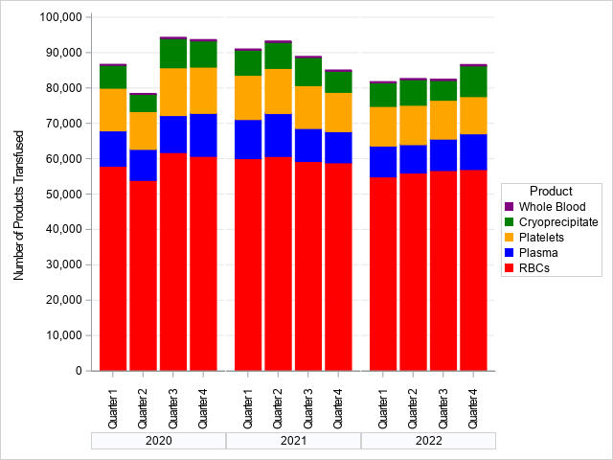
In 2020, 67 facilities reported NHSN Hemovigilance data. In 2021 and 2022, 65 facilities reported.

Table 2: Transfusion Volume by Bed Size Group, Product Type, and Year, 2020-2022
Bed Size Group | Product | 2020 Volume Transfused | 2021 Volume Transfused | 2022 Volume Transfused | Δ (2021-2022) | % Δ 2021-2022
BSG 1: 1-99 Beds | RBCs | 7,609 | 7,992 | 7,016 | -976 | -12.2
 | Plasma | 541 | 473 | 508 | 35 | 7.4
 | Platelets | 632 | 359 | 406 | 47 | 13.1
 | Cryoprecipitate | 22 | 21 | 26 | 5 | 23.8
 | Whole Blood | 0 | 0 | 0 | 0 | 0.0
BSG 2: 100-299 Beds | RBCs | 70,280 | 65,812 | 61,266 | -4,546 | -6.9
 | Plasma | 7,928 | 6,089 | 5,111 | -978 | -16.1
 | Platelets | 6,939 | 5,297 | 3,810 | -1,487 | -28.1
 | Cryoprecipitate | 1,672 | 1,087 | 1,316 | 229 | 21.1
 | Whole Blood | 1 | 1 | 0 | -1 | -100.0
BSG 3: ≥300 Beds | RBCs | 155,932 | 165,393 | 156,588 | -8,805 | -5.3
 | Plasma | 32,835 | 34,753 | 30,140 | -4,613 | -13.3
 | Platelets | 41,752 | 42,890 | 39,613 | -3,277 | -7.6
 | Cryoprecipitate | 25,310 | 27,253 | 26,826 | -427 | -1.6
 | Whole Blood | 809 | 926 | 1,003 | 77 | 8.3
All Facilities | RBCs | 233,821 | 239,197 | 224,870 | -14,327 | -6.0
 | Plasma | 41,304 | 41,315 | 35,759 | -5,556 | -13.4
 | Platelets | 49,323 | 48,546 | 43,829 | -4,717 | -9.7
 | Cryoprecipitate | 27,004 | 28,361 | 28,168 | -193 | -0.7
 | Whole Blood | 810 | 927 | 1,003 | 76 | 8.2

Table 3: Volume of Pathogen Reduced Products Transfused in Massachusetts, 2020-2022
Component Type | 2020 | 2021 | 2022
Total | 3,558 | 11,319 | 21,666
Platelets
Psoralen Treated
Apheresis Derived | 3,409 | 11,090 | 20,571
Whole Blood Derived | 149 | 66 | 677
Riboflavin Treated
Apheresis Derived | 0 | 9 | 25
Plasma
Psoralen Treated
Apheresis Derived | 0 | 154 | 378
Riboflavin Treated
Apheresis Derived | 0 | 0 | 15

Figure 2: Volume of Blood Products Discarded in Massachusetts, 2020-2022
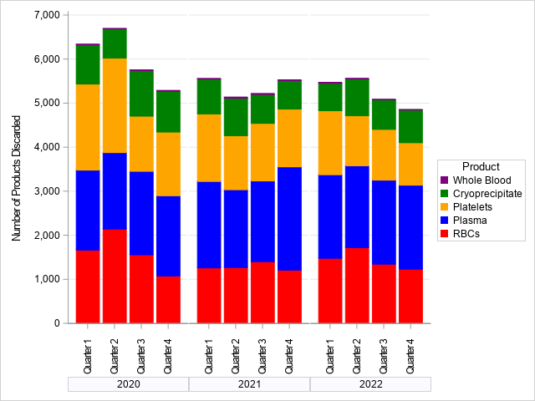
In 2020, 67 facilities reported NHSN Hemovigilance data. In 2021 and 2022 65 facilities reported.

2022 Bed Size Group | Product | Volume Transfused | Number of Products Discarded | Discard Ratio
BSG 1: 1-99 Beds  (N=14) | RBCs | 7,016 | 211 | 3.0
 | Plasma | 508 | 172 | 33.9
 | Platelets | 406 | 58 | 14.3
 | Cryoprecipitate | 26 | 3 | 11.5
 | Whole Blood | 0 | 0 | 0.0
BSG 2: 100-299 Beds  (N=36) | RBCs | 61,266 | 1,827 | 3.0
 | Plasma | 5,111 | 1,830 | 35.8
 | Platelets | 3,810 | 979 | 25.7
 | Cryoprecipitate | 1,316 | 125 | 9.5
 | Whole Blood | 0 | 0 | 0.0
BSG 3: ≥300 Beds  (N=15) | RBCs | 156,588 | 3,769 | 2.4
 | Plasma | 30,140 | 5,566 | 18.5
 | Platelets | 39,613 | 3,669 | 9.3
 | Cryoprecipitate | 26,826 | 2,741 | 10.2
 | Whole Blood | 1,003 | 28 | 2.8
All Facilities | RBCs | 224,870 | 5,807 | 2.6
 | Plasma | 35,759 | 7,568 | 21.2
 | Platelets | 43,829 | 4,706 | 10.7
 | Cryoprecipitate | 28,168 | 2,869 | 10.2
 | Whole Blood | 1,003 | 28 | 2.8

Table 4: Number and Ratio of Discarded Products
by Type and Bed Size Group Massachusetts, 2022

Table 5: Number of Adverse Reactions in Massachusetts, 2020-2022
Adverse Reaction Description | 2020 | 2021 | 2022
AHTR | 1 | 5 | 0
ALLERG | 21 | 4 | 17
DHTR | 9 | 12 | 5
DSTR | 31 | 41 | 37
FNHTR | 412 | 441 | 460
HTR | 5 | 4 | 2
INF | 2 | 0 | 1
TACO | 37 | 55 | 68
TAD | 28 | 29 | 25
TRALI | 1 | 1 | 1
Total | 547 | 592 | 616

Figure 3: Adverse Reaction Rates Associated with PRT vs. Non-PRT Platelets, 2020-2022
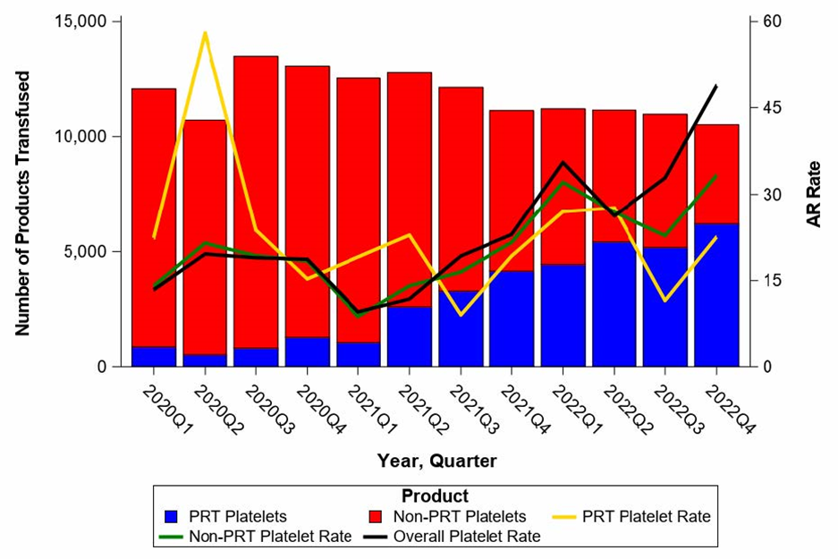

Table 6: Number of Adverse Reactions
by Bed Size Group, 2020-2022
Bed Size Group | Adverse Reaction | 2020 | 2021 | 2022
BSG 1: 1-99 Beds | AHTR | 0 | 0 | 0
 | ALLERG | 0 | 0 | 1
 | DHTR | 1 | 0 | 1
 | DSTR | 0 | 0 | 0
 | FNHTR | 10 | 13 | 10
 | HTR | 0 | 0 | 0
 | INF | 0 | 0 | 0
 | TACO | 1 | 4 | 4
 | TAD | 5 | 2 | 2
 | TRALI | 0 | 0 | 0
BSG 2: 100-299 Beds | AHTR | 0 | 0 | 0
 | ALLERG | 1 | 0 | 0
 | DHTR | 0 | 2 | 0
 | DSTR | 3 | 4 | 0
 | FNHTR | 91 | 81 | 62
 | HTR | 2 | 0 | 0
 | INF | 1 | 0 | 0
 | TACO | 3 | 1 | 5
 | TAD | 1 | 1 | 3
 | TRALI | 1 | 0 | 0
BSG 3: ≥300 Beds | AHTR | 1 | 5 | 0
 | ALLERG | 20 | 4 | 16
 | DHTR | 8 | 10 | 4
 | DSTR | 28 | 37 | 37
 | FNHTR | 308 | 347 | 388
 | HTR | 3 | 4 | 2
 | INF | 1 | 0 | 1
 | TACO | 33 | 50 | 59
 | TAD | 22 | 26 | 20
 | TRALI | 0 | 1 | 1

Table 7: Summary of Transfusion-transmitted infections in Massachusetts, 2022
Adverse  Reaction  Date | Number of Days from Transfusion and Reaction | Age at  Adverse  Reaction | Gender | Infection | Case  Definition | Severity | Imputability | Outcome | Associated  Unit | Unit  Tested | Unit  Tested  Positive | Donor  Tested
07/2022 | 0 | 61 | Male | Staphylococcus epidermidis | Definitely | Severe | Possibly | Not Determined | Red Blood  Cells | Yes | Yes | No

Figure 4: Rates of Adverse Reactions per 10,000 Transfused Products
by Product Type in Massachusetts, 2020-2022
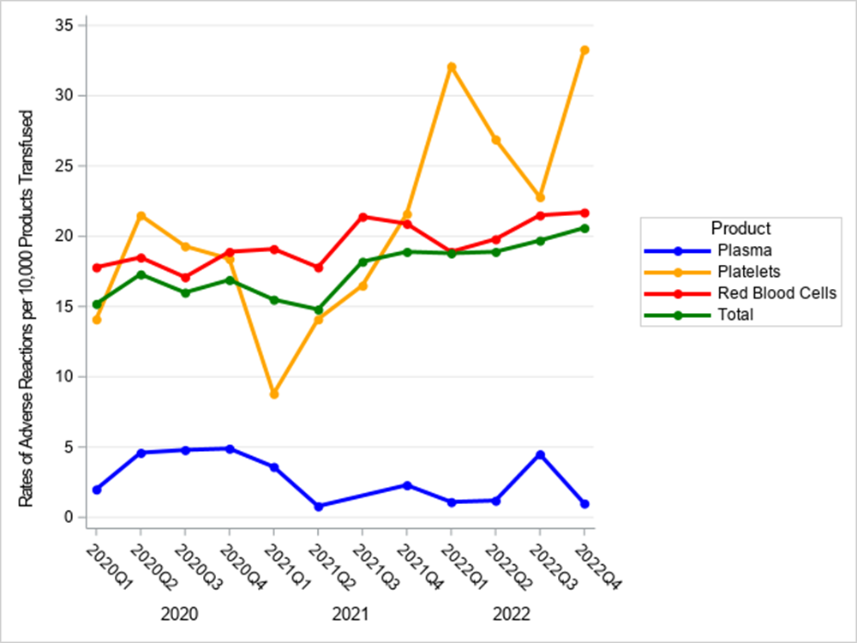
In 2020, 67 facilities reported NHSN Hemovigilance data. In 2021 and 2022 65 facilities reported.

Figure 5: Rates of Adverse Reactions per 10,000 Transfused Products
by Bed Size Group in Massachusetts, 2020-2022
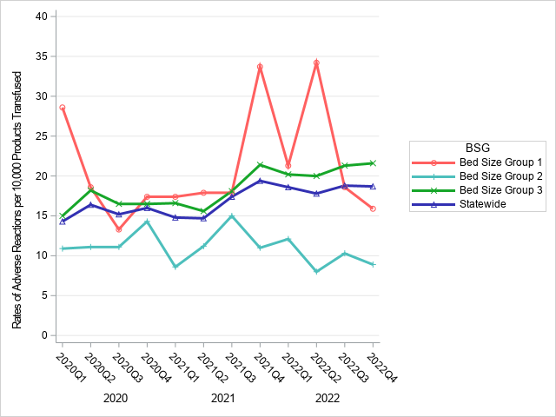
In 2020, 67 facilities reported NHSN Hemovigilance data. In 2021 and 2022 65 facilities reported.
Rates in BSG 1 tend to be unstable over time as a result of lower transfusion volume and fewer ARs reported overall.

Table 8: Rates of Adverse Reactions per 10,000 Total Units (Full and Aliquot)
Transfused by Component Type, 2022*
 | Transfused | All Reactions |  | ALLERGIC |  | DHTR |  | DSTR |  | FNHTR |  | HTR |  | TTI |  | TACO |  | TAD |  | TRALI
Component Type | N | N | Rate | N | Rate | N | Rate | N | Rate | N | Rate | N | Rate | N | Rate | N | Rate | N | Rate | N | Rate
All Components
All | 333,629 | 616 | 18.46 | 17 | 0.51 | 5 | 0.15 | 37 | 1.11 | 460 | 13.79 | 2 | 0.06 | 1 | 0.03 | 68 | 2.04 | 25 | 0.75 | 1 | 0.03
Severe Adverse Reactions |  | 50 | 1.5 | 8 | 0.24 | 1 | 0.03 | 0 | 0 | 14 | 0.42 | 0 | 0 | 1 | 0.03 | 23 | 0.69 | 2 | 0.06 | 1 | 0.03
Life Threatening Adverse Reactions |  | 14 | 0.42 | 8 | 0.24 | 0 | 0 | 0 | 0 | 0 | 0 | 0 | 0 | 0 | 0 | 5 | 0.15 | 1 | 0.03 | 0 | 0
Fata Adverse Reactions |  | 1 | 0.03 | 0 | 0 | 0 | 0 | 0 | 0 | 0 | 0 | 0 | 0 | 0 | 0 | 1 | 0.03 | 0 | 0 | 0 | 0
RBCS
All | 224,870 | 461⁺ | 20.5 | 2 | 0.09 | 5 | 0.22 | 35 | 1.56 | 332 | 14.76 | 2 | 0.09 | 1 | 0.04 | 60 | 2.67 | 23 | 1.02 | 1 | 0.04
Collection Method
Apheresis | 36,500 | 76 | 20.82 | 0 | 0 | 2 | 0.55 | 4 | 1.1 | 52 | 14.25 | 2 | 0.55 | 0 | 0 | 12 | 3.29 | 3 | 0.82 | 1 | 0.27
Whole blood-derived | 188,370 | 373 | 19.8 | 2 | 0.11 | 2 | 0.11 | 22 | 1.17 | 280 | 14.86 | 0 | 0 | 1 | 0.05 | 46 | 2.44 | 20 | 1.06 | 0 | 0
Irradiation
Irradiated | 107,572 | 244 | 22.68 | 1 | 0.09 | 4 | 0.37 | 8 | 0.74 | 201 | 18.69 | 1 | 0.09 | 1 | 0.09 | 19 | 1.77 | 9 | 0.84 | 0 | 0
Not Irradiated | 117,320 | 205 | 17.47 | 1 | 0.09 | 0 | 0 | 18 | 1.53 | 131 | 11.17 | 1 | 0.09 | 0 | 0 | 39 | 3.32 | 14 | 1.19 | 1 | 0.09
Leukoreduction
Leukoreduced | 214,206 | 421 | 19.65 | 2 | 0.09 | 4 | 0.19 | 25 | 1.17 | 307 | 14.33 | 2 | 0.09 | 1 | 0.05 | 57 | 2.66 | 22 | 1.03 | 1 | 0.05
Not Leukoreduced | 10,664 | 28 | 26.26 | 0 | 0 | 0 | 0 | 1 | 0.94 | 25 | 23.44 | 0 | 0 | 0 | 0 | 1 | 0.94 | 1 | 0.94 | 0 | 0
Platelets
All | 43,829 | 126^ | 28.75 | 11 | 2.51 | 0 | 0 | 0 | 0 | 112 | 25.55 | 0 | 0 | 0 | 0 | 2 | 0.46 | 1 | 0.23 | 0 | 0
Collection Method
Apheresis Derived | 43,671 | 125 | 28.62 | 11 | 2.52 | 0 | 0 | 0 | 0 | 112 | 25.65 | 0 | 0 | 0 | 0 | 1 | 0.23 | 1 | 0.23 | 0 | 0
Whole blood-derived | 158 | 0 | 0 | 0 | 0 | 0 | 0 | 0 | 0 | 0 | 0 | 0 | 0 | 0 | 0 | 0 | 0 | 0 | 0 | 0 | 0
Irradiation
Irradiated | 34,570 | 69 | 19.96 | 7 | 2.02 | 0 | 0 | 0 | 0 | 62 | 17.93 | 0 | 0 | 0 | 0 | 0 | 0 | 0 | 0 | 0 | 0
Not Irradiated | 9,259 | 56 | 60.48 | 4 | 4.32 | 0 | 0 | 0 | 0 | 50 | 54 | 0 | 0 | 0 | 0 | 1 | 1.08 | 1 | 1.08 | 0 | 0
Leukoreduction
Leukoreduced | 43,491 | 125 | 28.74 | 11 | 2.53 | 0 | 0 | 0 | 0 | 112 | 25.75 | 0 | 0 | 0 | 0 | 1 | 0.23 | 1 | 0.23 | 0 | 0
Not Leukoreduced | 338 | 0 | 0 | 0 | 0 | 0 | 0 | 0 | 0 | 0 | 0 | 0 | 0 | 0 | 0 | 0 | 0 | 0 | 0 | 0 | 0
Psoralen Treated
Apheresis Derived | 20,571 | 50 | 24.31 | 3 | 1.46 | 0 | 0 | 0 | 0 | 44 | 21.39 | 0 | 0 | 0 | 0 | 2 | 0.97 | 1 | 0.49 | 0 | 0
Whole blood-derived | 677 | 0 | 0 | 0 | 0 | 0 | 0 | 0 | 0 | 0 | 0 | 0 | 0 | 0 | 0 | 0 | 0 | 0 | 0 | 0 | 0
Riboflavin Treated
Apheresis Derived | 25 | 0 | 0 | 0 | 0 | 0 | 0 | 0 | 0 | 0 | 0 | 0 | 0 | 0 | 0 | 0 | 0 | 0 | 0 | 0 | 0
Plasma
All | 35,759 | 7 | 1.96 | 4 | 1.12 | 0 | 0 | 0 | 0 | 3 | 0.84 | 0 | 0 | 0 | 0 | 0 | 0 | 0 | 0 | 0 | 0
Collection Method
Apheresis | 8,481 | 1 | 1.18 | 0 | 0 | 0 | 0 | 0 | 0 | 1 | 1.18 | 0 | 0 | 0 | 0 | 0 | 0 | 0 | 0 | 0 | 0
Whole blood-derived | 27,278 | 6 | 2.2 | 4 | 1.47 | 0 | 0 | 0 | 0 | 2 | 0.73 | 0 | 0 | 0 | 0 | 0 | 0 | 0 | 0 | 0 | 0
Psoralen Treated
Apheresis Derived | 378 | 0 | 0 | 0 | 0 | 0 | 0 | 0 | 0 | 0 | 0 | 0 | 0 | 0 | 0 | 0 | 0 | 0 | 0 | 0 | 0
Cryoprecipitate
All | 28,168 | 0 | 0 | 0 | 0 | 0 | 0 | 0 | 0 | 0 | 0 | 0 | 0 | 0 | 0 | 0 | 0 | 0 | 0 | 0 | 0
Whole blood
All | 1,003 | 2 | 19.94 | 0 | 0 | 0 | 0 | 2 | 19.94 | 0 | 0 | 0 | 0 | 0 | 0 | 0 | 0 | 0 | 0 | 0 | 0
*18 adverse reactions were associated with an “unknown” transfused blood product. These reactions were included in the overall adverse reaction rate calculations, but were excluded from component-specific rate calculations. Eleven FNHTRs, 6 TACOs, and 1 TAD reported an “unknown” blood product implicated. 2 FNHTR reactions were associated with granulocytes.
+ 12 adverse reactions associated with red blood cells have an “unknown” product maniupulation- 1 DHTR, 9 DSTRs, 2 TACOs.
^ 1 adverse reaction associated with platelets had an “unknown” product maniupulation- 1 TACO

For those facilities that did not submit a 2022 annual facility survey (n=7), the most recent prior year submission was used.
One facility moved from BSG 2 to BSG 1 in 2022
One facility moved from BSG 1 to BSG 2 in 2022
Bed Size Group categorization was assigned based on the corresponding year’s annual facility survey.
In 2020, 14 facilities were in Bed Size Group 1, 40 in Bed Size Group 2, and 13 in Bed Size Group 3.
In 2021, 14 facilities were in Bed Size Group 1, 36 in Bed Size Group 2, and 15 in Bed Size Group 3.
In 2022, 14 facilities were in Bed Size Group 1, 36 in Bed Size Group 2, and 15 in Bed Size Group 3.
Discard ratio = the number of products discarded for every 100 products transfused.
In 2020, 14 facilities were in Bed Size Group 1, 40 in Bed Size Group 2, and 13 in Bed Size Group 3.
In 2021, 14 facilities were in Bed Size Group 1, 36 in Bed Size Group 2, and 15 in Bed Size Group 3.
In 2022, 14 facilities were in Bed Size Group 1, 36 in Bed Size Group 2, and 15 in Bed Size Group 3.
Unstable platelet rates are a result of decreasing platelet transfusion volume during this time with little change in the number of reactions associated with this product.

