

Bureau of Infectious Disease and Laboratory Sciences
Hemovigilance Program Data Summary
January 1-December 31, 2024

Suggested citation:

Massachusetts Department of Public Health, Bureau of Infectious Disease and Laboratory Sciences. Hemovigilance Program Data Summary January 1– December 31, 2024.
https://www.mass.gov/service-details/reporting-requirements-for-blood-banks-and-hemovigilance-in-massachusetts. Published September 2025. Accessed [date].

Bureau of Infectious Disease and Laboratory Sciences
Massachusetts Department of Public Health, Dr. Alfred DeMaria Jr. Campus
305 South Street
Jamaica Plain, MA 02130

For questions about this report, contact:
Melissa.cumming@mass.gov
Acknowledgments
This report was prepared by the following MDPH staff:
Ashley Iannone, MPH, CIC
Christina Brandeburg, MPH, CIC
Melissa Cumming, MS, CIC
Amanda Slider, MPH, CIC

Executive Summary

Introduction

This report includes data submitted by Massachusetts blood banks to the Hemovigilance Module of the Centers for Disease Control and Prevention’s National Healthcare Safety Network (NHSN) from January 1 through December 31, 2024. The purpose of this report is to provide information on transfusion activity in the state, as well as transfusion-associated adverse events. Blood banks in Massachusetts can examine their own facility metrics and use this report for comparison and context.

The members of the Massachusetts Hemovigilance Technical Advisory Group (TAG) appreciate the committed participation of Massachusetts blood banks and transfusion services in reporting hemovigilance data to NHSN for over 10 years and hope that the availability of the metrics contained in this report will be useful for comparison, context, and quality improvement.

Key Findings

- Total volume of transfused products increased by 5% in 2024, with cryoprecipitate increasing almost 30%, from 31,063 units transfused in 2023 to 40,247 in 2024. This cryoprecipitate increase was seen across all hospital bed size groups.

- 5.5% of products in 2024 were discarded with plasma being the most frequently discarded product with a rate of 20.9 discards per 100 plasma products transfused.

- The total number of reported adverse reactions decreased slightly between 2023 and 2024, including TACOs which saw the first decrease in four years, falling from 75 reactions in 2023 to 65 in 2024. Delayed serologic transfusion reactions (DSTR) decreased by 56% from 2023 to 2024.

- The overall rate of adverse reactions decreased for the third year in a row from 16.9 per 10,000 products transfused in 2023, to 15.8 per 10,000 products transfused in 2024.

- Platelets continue to be the blood product associated with both the highest and most variable rate of adverse reactions over time.

- The volume of pathogen reduction technology (PRT) products transfused saw a smaller increase from 2023 to 2024 than in recent years, increasing by just 4,000 units. Over 75% of platelets transfused in Massachusetts are treated with PRT.

- In 2024, there were 91 adverse reactions associated with PRT platelets for a rate of 25 per 10,000 PRT platelets transfused. Two of these reactions were classified as life-threatening (i.e., TACO). In comparison, there were 32 adverse reactions associated with conventional platelets for a rate of 27 per 10,000 non-PRT platelets transfused.

Technical Notes

The following are inclusion criteria for the adverse reactions included in this report:
- Case criteria – the reaction must either definitively or probably meet the NHSN case reporting criteria.
- Imputability – the reaction must definitely, probably, or possibly meet NHSN imputability criteria.
- Reaction type – the reaction must be one of twelve specified types in NHSN, excluding “Other” and “Unknown”.
- Allergic reactions – non-severe allergic reactions are excluded from analysis and reporting is not required.

Current reaction definitions and imputability criteria can be found at the following link: https://www.cdc.gov/nhsn/PDFs/Biovigilance/BV-HV-protocol-current.pdf.
Data Summary

This report includes data submitted by 66 licensed blood banks in Massachusetts. Submission of data through the NHSN Hemovigilance Module is a regulatory requirement under 105 CMR 135.120 for all blood banks and transfusion services licensed in Massachusetts. Complete denominator and adverse reaction data were submitted by 60 facilities for all months covered. Two facilities closed halfway through the year and did not submit a complete years’ worth of denominator and adverse reaction data. One new facility opened in 2024 and submitted data for half of the year.

Updated responses to the NHSN annual facility survey, which describes facility characteristics, were provided by 60 blood banks. Facilities were stratified into three bed size groups for this report defined as those with less than 100 beds, those with 100-299 beds, and those with 300 or more beds. For the 6 facilities that did not submit a 2024 annual facility survey, the most recently submitted annual facility survey data were used. Bed size characteristics from the annual facility survey data can be found in Table 1. Eighty-five percent of facilities were College of American Pathologists (CAP) accredited, 44% were accredited by AABB, and 41% indicated accreditation by the Joint Commission.

In 2024, 59 facilities transfused over 36,000 PRT products, a 13% increase from PRT products transfused in 2023. PRT platelets make up more than 75% of platelets transfused in Massachusetts. All 66 blood banks issued only leukocyte-reduced or leuko-poor cellular components. Twelve (18%) blood banks collected blood at their facility.

The number of red blood cell (RBC) type and screen procedures performed by Massachusetts’ blood banks ranged from 0 to 97,228 (mean: 10,582, median: 5,420) and RBC crossmatches ranged from 0 to 56,994 (mean: 5,520, median: 2,028). The number of products transfused statewide increased from an average of 29,042 products per month in 2023 to 30,523 in 2024. Plasma and platelets both saw a slight decrease in overall transfusion volume from 2023 to 2024. The percentage of blood products discarded decreased from 5.6% in 2023, to 5.5% in 2024, with plasma yielding the highest discard ratio of 20.9.

There were no transfusion transmitted infections reported in 2024. Both transfusion-associated circulatory overload (TACO) and DSTR reactions decreased by 13% and 56%, respectively. This is the first instance in five years that the number and proportion of TACO reactions has decreased, making up 11% of all reactions reported in 2024. Previously, TACO reactions accounted for 7% of all adverse reactions in 2020, 9% in 2021, 11% in 2022, and 13% in 2023.

In 2024, there were 366,278 blood products transfused, and a total of 579 adverse reactions classified as possibly, probably, or definitely related to transfusion, yielding an overall reaction rate of 15.8 reactions per 10,000 products transfused. Thirty-seven (6.4%) of the reported reactions were considered serious or life-threatening. There were no deaths associated with an adverse reaction reported in 2024.
The Hemovigilance Technical Advisory Group (TAG) was established in June 2014 to provide guidance to the Massachusetts Department of Public Health (MDPH) in the analysis and use of statewide hemovigilance data.

Current members of the TAG are:

Chester Andrzejewski, Jr., PhD, MD, FCAP
Medical Director
System Transfusion Medicine/Blood Banking and
Apheresis Medicine Services
Baystate Health/ Baystate Medical Center

Christina Brandeburg, MPH, CIC
Epidemiologist
Bureau of Infectious Disease and Laboratory Sciences
Massachusetts Department of Public Health

Melissa Cumming, MS, CIC
Epidemiologist
Hemovigilance Coordinator
Bureau of Infectious Disease and Laboratory Sciences
Massachusetts Department of Public Health

Ashley Iannone, MPH, CIC
Epidemiologist
Bureau of Infectious Disease and Laboratory Sciences
Massachusetts Department of Public Health

Amanda Slider, MPH, CIC
Epidemiologist
Bureau of Infectious Disease and Laboratory Sciences
Massachusetts Department of Public Health

Reggie Thomasson, MD
Boston Medical Center

Michele Herman, MT (ASCP)
Compliance Officer - Transfusion Medicine
Beth Israel Deaconess Medical Center

Eileen McHale, RN, BSN
Healthcare Associated Infection Coordinator
Bureau of Health Care Safety and Quality
Massachusetts Department of Public Health

Lynne O’Hearn, MT (ASCP)
Transfusion Safety Officer
Baystate Medical Center

Jorge Rios, MD
Medical Director
American Red Cross Blood Services
Massachusetts Region

Lynne Uhl, MD
Vice Chair and Division Director for Laboratory and Transfusion Medicine
Beth Israel Deaconess Medical Center

MaryEllen Casaubon MS, CQA
Clinical Laboratory Program Manager
Bureau of Health Care Safety and Quality
Massachusetts Department of Public Health

Deborah Gordon, MD, FACP
UMASS Memorial Health
Milford Regional Medical Center

Table of Contents
List of Abbreviations 7
Table 1: Bed Size Characteristics from the 2024 Annual Facility Survey 8
Figure 1: Volume of Blood Products Transfused in Massachusetts, 2022-2024 9
Table 2: Transfusion Volume by Bed Size Group, Product Type, and Year, 2022-2024 10
Table 3: Volume of Pathogen Reduced Products Transfused in Massachusetts, 2022-2024 11
Figure 2: Volume of Blood Products Discarded in Massachusetts, 2022-2024 12
Table 4: Number and Ratio of Discarded Products by Type and Bed Size Group Massachusetts, 2024 13
Table 5: Number of Adverse Reactions in Massachusetts, 2022-2024 14
Figure 3: Adverse Reaction Rates Associated with PRT vs. Non-PRT Platelets, 2022-2024 15
Table 6: Number of Adverse Reactions by Bed Size Group, 2022-2024 16
Figure 4: Rates of Adverse Reactions per 10,000 Transfused Products by Product Type in Massachusetts, 2022-2024 17
Figure 5: Rates of Adverse Reactions per 10,000 Transfused Products by Bed Size Group in Massachusetts, 2022-2024 18
Table 7: Rates of Adverse Reactions per 10,000 Total Units (Full and Aliquot) Transfused by Component Type, 2024 19-20

List of Abbreviations

- AABB – Association for the Advancement of Blood and Biotherapies
- AHTR – Acute hemolytic transfusion reaction
- ALLERG – Allergic reaction
- CAP – College of American Pathologists
- CCP- Covid Convalescent Plasma
- DHTR – Delayed hemolytic transfusion reaction
- DSTR – Delayed serologic transfusion reaction
- FNHTR – Febrile non-hemolytic transfusion reaction
- HTR – Hypotensive transfusion reaction
- PRT- Pathogen Reduction Technology
- PTP – Post-transfusion purpura
- TJC – The Joint Commission
- TACO – Transfusion-associated circulatory overload
- TAD – Transfusion-associated dyspnea
- TAGVHD – Transfusion-associated graft versus host disease
- TRALI – Transfusion-related acute lung injury
- TTI – Transfusion-transmitted infection

Table 1: Bed Size Characteristics from the 2024 Annual Facility Survey
 |  | BSG 1  (1-99 Beds) | BSG 2  (100-299 Beds) | BSG 3  (≥ 300 Beds)
Number of Hospitals |  | 16 | 35 | 15
Average Number of Beds Served by Transfusion Service (range) |  | 57  (14-97) | 189  (100-290) | 526  (302-1,045)
Average Number of Inpatient Surgeries (range) |  | 536  (0-2,136) | 1,609  (0-4,211) | 7,003  (1,736-20,582)
Average Number of Outpatient Surgeries (range) |  | 2,206  (0-7,049) | 5,073  (0-16,723) | 13,922  (2,878-28,058)
Transfusion Service Serves Cancer Center (includes adult and pediatric) |  | 9 (56%) | 22 (63%) | 14 (93%)
Medical School Affiliation | Major Teaching Hospital | 3 (19%) | 10 (29%) | 14 (93%)
Medical School Affiliation | Graduate Teaching Hospital | 4 (25%) | 8 (23%) | 1 (7%)
Medical School Affiliation | Undergraduate Teaching Hospital | 0 | 11 (31%) | 0
Trauma Level | Level 1 | 0 | 0 | 9 (60%)
Trauma Level | Level 2 | 0 | 1 (3%) | 2 (13%)
Trauma Level | Level 3 | 1 (6%) | 8 (23%) | 2 (13%)
Trauma Level | Level NA | 15 (94%) | 26 (74%) | 2 (13%)
Community Setting | Rural | 7 (44%) | 1 (3%) | 0
Community Setting | Suburban | 8 (50%) | 22 (63%) | 5 (33%)
Community Setting | Urban | 1 (6%) | 12 (34%) | 10 (67%)

Figure 1: Volume of Blood Products Transfused in Massachusetts, 2022-2024
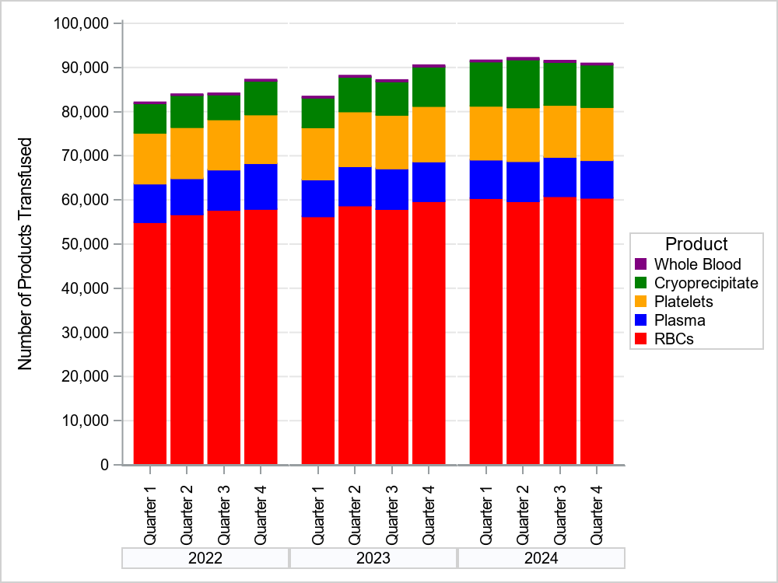

Table 2: Transfusion Volume by Bed Size Group, Product Type, and Year, 2022-2024
Bed Size Group | Product | 2022 Volume Transfused | 2023 Volume Transfused | 2024 Volume Transfused | Δ (2023-2024) | % Δ 2023-2024
BSG 1: 1-99 Beds | RBCs | 7,016 | 7,537 | 8,262 | 725 | 9.6
BSG 1: 1-99 Beds | Plasma | 508 | 480 | 480 | 0 | 0
BSG 1: 1-99 Beds | Platelets | 406 | 361 | 401 | 40 | 11.1
BSG 1: 1-99 Beds | Cryoprecipitate | 26 | 18 | 44 | 26 | 144.4
BSG 1: 1-99 Beds | Whole Blood | 0 | 0 | 36 | 36 | 3600.0
BSG 2: 100-299 Beds | RBCs | 61,266 | 57,667 | 57,260 | -407 | -0.7
BSG 2: 100-299 Beds | Plasma | 5,111 | 4,357 | 3,835 | -522 | -12
BSG 2: 100-299 Beds | Platelets | 3,810 | 2,417 | 1,971 | -446 | -18.5
BSG 2: 100-299 Beds | Cryoprecipitate | 1,316 | 1,457 | 1,791 | 334 | 22.9
BSG 2: 100-299 Beds | Whole Blood | 0 | 0 | 0 | 0 | 0.0
BSG 3: ≥300 Beds | RBCs | 159,155 | 167,498 | 175,970 | 8,472 | 5.1
BSG 3: ≥300 Beds | Plasma | 30,749 | 30,567 | 30,851 | 284 | 0.9
BSG 3: ≥300 Beds | Platelets | 41,321 | 46,163 | 45,780 | -383 | -0.8
BSG 3: ≥300 Beds | Cryoprecipitate | 25,794 | 29,588 | 38,412 | 8,824 | 29.8
BSG 3: ≥300 Beds | Whole Blood | 1,003 | 1,170 | 1,185 | 15 | 1.3
All Facilities | RBCs | 227,437 | 232,702 | 241,492 | 8,790 | 3.8
All Facilities | Plasma | 36,368 | 35,404 | 35,166 | -238 | -0.7
All Facilities | Platelets | 45,537 | 48,941 | 48,152 | -789 | -1.6
All Facilities | Cryoprecipitate | 27,136 | 31,063 | 40,247 | 9,184 | 29.6
All Facilities | Whole Blood | 1,003 | 1,170 | 1,221 | 51 | 4.4

Table 3: Volume of Pathogen Reduced Products Transfused in Massachusetts, 2022-2024
Component Type | 2022 | 2023 | 2024
Total | 21,666 | 32,249 | 36,334
Platelets
Psoralen Treated
Apheresis Derived | 20,573 | 31,009 | 35,378
Whole Blood Derived | 677 | 71 | 303
Riboflavin Treated
Apheresis Derived | 25 | 25 | 0
Plasma
Psoralen Treated
Apheresis Derived | 376 | 1,126 | 653
Whole Blood Derived | 15 | 18 | 0

Figure 2: Volume of Blood Products Discarded in Massachusetts, 2022-2024
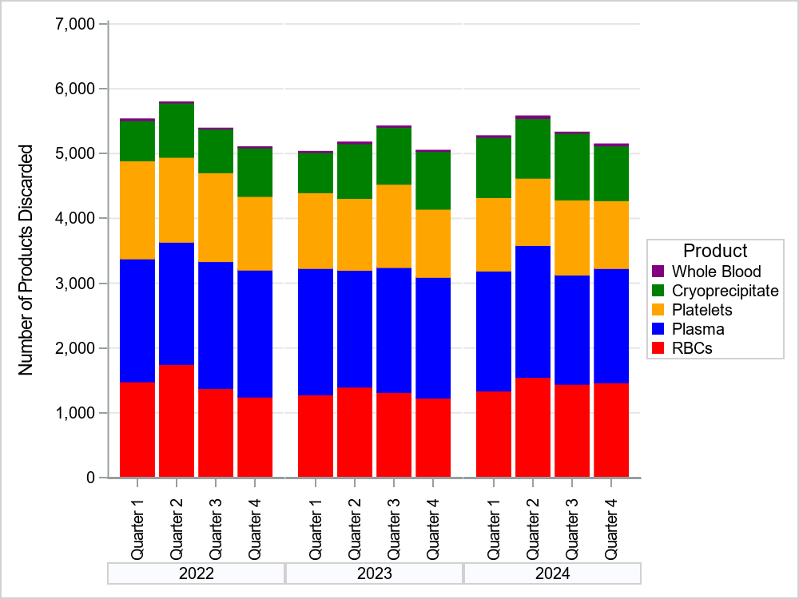

Table 4: Number and Ratio of Discarded Products
by Type and Bed Size Group Massachusetts, 2024
2024 Bed Size Group | Product | Volume Transfused | Number of Products Discarded | Discard Ratio
BSG 1: 1-99 Beds  (N=16) | RBCs | 8,262 | 166 | 2.0
BSG 1: 1-99 Beds  (N=16) | Plasma | 480 | 75 | 15.6
BSG 1: 1-99 Beds  (N=16) | Platelets | 401 | 36 | 9.0
BSG 1: 1-99 Beds  (N=16) | Cryoprecipitate | 44 | 1 | 2.3
BSG 1: 1-99 Beds  (N=16) | Whole Blood | 36 | 15 | 41.7
BSG 2: 100-299 Beds  (N=35) | RBCs | 57,260 | 1,490 | 2.6
BSG 2: 100-299 Beds  (N=35) | Plasma | 3,835 | 1,725 | 45.0
BSG 2: 100-299 Beds  (N=35) | Platelets | 1,971 | 434 | 22.0
BSG 2: 100-299 Beds  (N=35) | Cryoprecipitate | 1,791 | 234 | 13.1
BSG 2: 100-299 Beds  (N=35) | Whole Blood | 0 | 10 | 0.0
BSG 3: ≥300 Beds  (N=15) | RBCs | 175,970 | 4,157 | 2.4
BSG 3: ≥300 Beds  (N=15) | Plasma | 30,851 | 5,536 | 17.9
BSG 3: ≥300 Beds  (N=15) | Platelets | 45,780 | 3,907 | 8.5
BSG 3: ≥300 Beds  (N=15) | Cryoprecipitate | 38,412 | 3,492 | 9.1
BSG 3: ≥300 Beds  (N=15) | Whole Blood | 1,185 | 38 | 3.2
All Facilities | RBCs | 241,492 | 5,813 | 2.4
All Facilities | Plasma | 35,166 | 7,336 | 20.9
All Facilities | Platelets | 48,152 | 4,377 | 9.1
All Facilities | Cryoprecipitate | 40,247 | 3,727 | 9.3
All Facilities | Whole Blood | 1,221 | 63 | 5.2

Table 5: Number of Adverse Reactions in Massachusetts, 2022-2024
Adverse Reaction Description | 2022 | 2023 | 2024
AHTR | 0 | 2 | 1
ALLERG | 19 | 19 | 20
DHTR | 5 | 11 | 8
DSTR | 37 | 43 | 19
FNHTR | 462 | 403 | 431
HTR | 2 | 6 | 10
INF | 1 | 1 | 0
TACO | 68 | 75 | 65
TAD | 25 | 29 | 23
TRALI | 1 | 1 | 2
Total | 620 | 590 | 579

Figure 3: Adverse Reaction Rates Associated with PRT vs. Non-PRT Platelets, 2022-2024
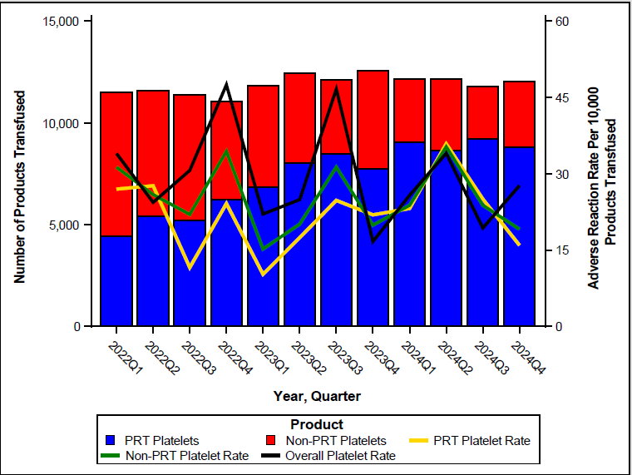

Table 6: Number of Adverse Reactions
by Bed Size Group, 2022-2024
Bed Size Group | Adverse Reaction | 2022 | 2023 | 2024
BSG 1: 1-99 Beds | AHTR | 0 | 0 | 0
BSG 1: 1-99 Beds | ALLERG | 1 | 2 | 0
BSG 1: 1-99 Beds | DHTR | 1 | 0 | 0
BSG 1: 1-99 Beds | DSTR | 0 | 0 | 0
BSG 1: 1-99 Beds | FNHTR | 10 | 11 | 7
BSG 1: 1-99 Beds | HTR | 0 | 0 | 0
BSG 1: 1-99 Beds | INF | 0 | 0 | 0
BSG 1: 1-99 Beds | TACO | 4 | 1 | 7
BSG 1: 1-99 Beds | TAD | 2 | 2 | 1
BSG 1: 1-99 Beds | TRALI | 0 | 0 | 0
BSG 2: 100-299 Beds | AHTR | 0 | 0 | 0
BSG 2: 100-299 Beds | ALLERG | 0 | 1 | 1
BSG 2: 100-299 Beds | DHTR | 0 | 1 | 1
BSG 2: 100-299 Beds | DSTR | 0 | 3 | 3
BSG 2: 100-299 Beds | FNHTR | 62 | 64 | 73
BSG 2: 100-299 Beds | HTR | 0 | 0 | 2
BSG 2: 100-299 Beds | INF | 0 | 0 | 0
BSG 2: 100-299 Beds | TACO | 5 | 2 | 3
BSG 2: 100-299 Beds | TAD | 3 | 2 | 1
BSG 2: 100-299 Beds | TRALI | 0 | 0 | 0
BSG 3: ≥300 Beds | AHTR | 0 | 2 | 1
BSG 3: ≥300 Beds | ALLERG | 18 | 16 | 19
BSG 3: ≥300 Beds | DHTR | 4 | 10 | 7
BSG 3: ≥300 Beds | DSTR | 37 | 40 | 16
BSG 3: ≥300 Beds | FNHTR | 390 | 328 | 351
BSG 3: ≥300 Beds | HTR | 2 | 6 | 8
BSG 3: ≥300 Beds | INF | 1 | 1 | 0
BSG 3: ≥300 Beds | TACO | 59 | 72 | 55
BSG 3: ≥300 Beds | TAD | 20 | 25 | 21
BSG 3: ≥300 Beds | TRALI | 1 | 1 | 2

Figure 4: Rates of Adverse Reactions per 10,000 Transfused Products
by Product Type in Massachusetts, 2022-2024
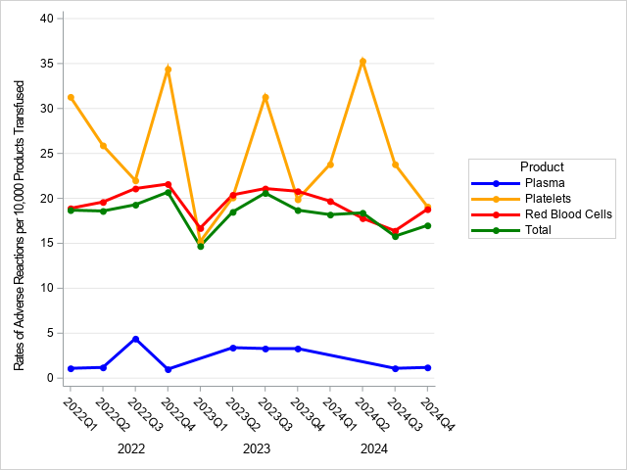

Figure 5: Rates of Adverse Reactions per 10,000 Transfused Products
by Bed Size Group in Massachusetts, 2022-2024
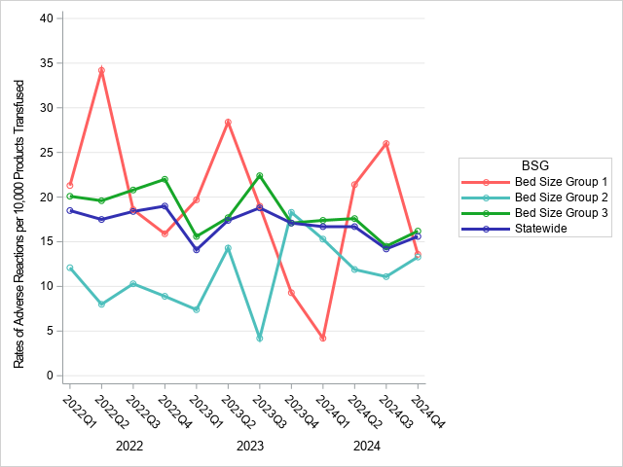

Table 7: Rates of Adverse Reactions per 10,000 Total Units (Full and Aliquot)
Transfused by Component Type, 2024
 | Transfused | All Reactions* |  | AHTR |  | ALLERGIC |  | DHTR |  | DSTR |  | FNHTR |  | HTR |  | TACO |  | TAD |  |  |  | TRALI
Component Type | N | N | Rate | N | Rate | N | Rate | N | Rate | N | Rate | N | Rate | N | Rate | N | Rate | N |  | Rate |  | N | Rate
All Components
All | 366,278 | 579 | 15.81 | 1 | 0.03 | 20 | 0.55 | 8 | 0.22 | 19 | 0.52 | 431 | 11.77 | 10 | 0.27 | 65 | 1.77 |  | 23 |  | 0.63 | 2 |  | 0.05
Severe Adverse Reactions |  | 31 | 0.85 | 0 | 0 | 11 | 0.3 | 1 | 0.03 | 0 | 0 | 11 | 0.3 | 1 | 0.03 | 6 | 0.16 |  | 1 |  | 0.03 | 0 |  | 0
Life Threatening Adverse Reactions |  | 6 | 0.16 | 0 | 0 | 2 | 0.05 | 0 | 0 | 0 | 0 | 0 | 0 | 1 | 0.03 | 3 | 0.08 |  | 0 |  | 0 | 0 |  | 0
RBCS
All⁺ | 241,492 | 439 | 18.18 | 1 | 0.04 | 10 | 0.41 | 8 | 0.33 | 19 | 0.79 | 320 | 13.25 | 9 | 0.37 | 52 | 2.15 |  | 18 |  | 0.75 | 2 |  | 0.08
Collection Method
Apheresis | 39,171 | 63 | 16.08 | 0 | 0 | 1 | 0.26 | 1 | 0.26 | 2 | 0.51 | 42 | 10.72 | 1 | 0.26 | 7 | 1.79 |  | 7 |  | 1.79 | 2 |  | 0.51
Whole blood-derived | 202,321 | 373 | 18.44 | 1 | 0.05 | 9 | 0.44 | 6 | 0.3 | 16 | 0.79 | 278 | 13.74 | 8 | 0.4 | 44 | 2.17 |  | 11 |  | 0.54 | 0 |  | 0
Irradiation
Irradiated | 121,641 | 221 | 18.17 | 1 | 0.08 | 3 | 0.25 | 5 | 0.41 | 2 | 0.16 | 182 | 14.96 | 5 | 0.41 | 16 | 1.32 |  | 5 |  | 0.41 | 2 |  | 0.16
Not Irradiated | 119,851 | 215 | 17.94 | 0 | 0 | 7 | 0.58 | 2 | 0.17 | 16 | 1.33 | 138 | 11.51 | 4 | 0.33 | 35 | 2.92 |  | 13 |  | 1.08 | 0 |  | 0
Leukoreduction
Leukoreduced | 234,275 | 425 | 18.14 | 1 | 0.04 | 10 | 0.43 | 7 | 0.3 | 18 | 0.77 | 309 | 13.19 | 9 | 0.38 | 51 | 2.18 |  | 18 |  | 0.77 | 2 |  | 0.09
Not Leukoreduced | 7,217 | 11 | 15.24 | 0 | 0 | 0 | 0 | 0 | 0 | 0 | 0 | 11 | 15.24 | 0 | 0 | 0 | 0 |  | 0 |  | 0 | 0 |  | 0
Platelets
All | 48,152 | 123 | 25.54 | 0 | 0 | 8 | 1.66 | 0 | 0 | 0 | 0 | 100 | 20.77 | 1 | 0.21 | 9 | 1.87 |  | 5 |  | 1.04 | 0 |  | 0
Collection Method
Apheresis Derived | 47,943 | 123 | 25.66 | 0 | 0 | 8 | 1.67 | 0 | 0 | 0 | 0 | 100 | 20.86 | 1 | 0.21 | 9 | 1.88 |  | 5 |  | 1.04 | 0 |  | 0
Whole blood-derived | 209 | 0 | 0 | 0 | 0 | 0 | 0 | 0 | 0 | 0 | 0 | 0 | 0 | 0 | 0 | 0 | 0 |  | 0 |  | 0 | 0 |  | 0
Irradiation
Irradiated | 23,621 | 33 | 13.97 | 0 | 0 | 3 | 1.27 | 0 | 0 | 0 | 0 | 27 | 11.43 | 0 | 0 | 1 | 0.42 |  | 2 |  | 0.85 | 0 |  | 0
Not Irradiated | 24,531 | 90 | 36.69 | 0 | 0 | 5 | 2.04 | 0 | 0 | 0 | 0 | 73 | 29.76 | 1 | 0.41 | 8 | 3.26 |  | 3 |  | 1.22 | 0 |  | 0
Leukoreduction
Leukoreduced | 47,866 | 123 | 25.7 | 0 | 0 | 8 | 1.67 | 0 | 0 | 0 | 0 | 100 | 20.89 | 1 | 0.21 | 9 | 1.88 |  | 5 |  | 1.04 | 0 |  | 0
Not Leukoreduced | 286 | 0 | 0 | 0 | 0 | 0 | 0 | 0 | 0 | 0 | 0 | 0 | 0 | 0 | 0 | 0 | 0 |  | 0 |  | 0 | 0 |  | 0
Psoralen Treated
Apheresis Derived | 35,378 | 91 | 25.72 | 0 | 0 | 5 | 1.41 | 0 | 0 | 0 | 0 | 74 | 20.92 | 1 | 0.28 | 9 | 2.54 |  | 2 |  | 0.57 | 0 |  | 0
Whole blood-derived | 303 | 0 | 0 | 0 | 0 | 0 | 0 | 0 | 0 | 0 | 0 | 0 | 0 | 0 | 0 | 0 | 0 |  | 0 |  | 0 | 0 |  | 0

* 14 adverse reactions were associated with an “unknown” transfused blood product. These reactions were included in the overall adverse reaction rate calculations, but were excluded from component-specific rate calculations. Two ALLERGs, 8 FNHTRs, and 4 TACOs reported an “unknown” blood product implicated.

+ 3 adverse reactions associated with red blood cells have an “unknown” product maniupulation- 1 DSTR, 1 DHTR, and 1 TACO.
Table 7: Rates of Adverse Reactions per 10,000 Total Units (Full and Aliquot)
Transfused by Component Type, 2024 (Continued)
 | Transfused | All Reactions* |  | AHTR |  | ALLERGIC |  | DHTR |  | DSTR |  | FNHTR |  |  | HTR |  |  | TACO |  | TAD |  | TRALI
Component Type | N | N | Rate | N | Rate | N | Rate | N | Rate | N | Rate | N | Rate |  | N |  | Rate | N | Rate | N | Rate | N | Rate
Plasma
All | 35,166 | 2 | 0.57 | 0 | 0 | 0 | 0 | 0 | 0 | 0 | 0 | 2 | 0.57 | 0 |  | 0 |  | 0 | 0 | 0 | 0 | 0 | 0
Collection Method
Apheresis Derived | 10,965 | 1 | 0.91 | 0 | 0 | 0 | 0 | 0 | 0 | 0 | 0 | 1 | 0.91 | 0 |  | 0 |  | 0 | 0 | 0 | 0 | 0 | 0
Whole blood-derived | 24,201 | 1 | 0.41 | 0 | 0 | 0 | 0 | 0 | 0 | 0 | 0 | 1 | 0.41 | 0 |  | 0 |  | 0 | 0 | 0 | 0 | 0 | 0
Psoralen Treated
Apheresis Derived | 653 | 0 | 0 | 0 | 0 | 0 | 0 | 0 | 0 | 0 | 0 | 0 | 0 | 0 |  | 0 |  | 0 | 0 | 0 | 0 | 0 | 0
Cryoprecipitate
All | 40,247 | 1 | 0.25 | 0 | 0 | 0 | 0 | 0 | 0 | 0 | 0 | 1 | 0.25 | 0 |  | 0 |  | 0 | 0 | 0 | 0 | 0 | 0
Whole blood
All | 1,221 | 0 | 0 | 0 | 0 | 0 | 0 | 0 | 0 | 0 | 0 | 0 | 0 | 0 |  | 0 |  | 0 | 0 | 0 | 0 | 0 | 0

* 14 adverse reactions were associated with an “unknown” transfused blood product. These reactions were included in the overall adverse reaction rate calculations, but were excluded from component-specific rate calculations. Two ALLERGs, 8 FNHTRs, and 4 TACOs reported an “unknown” blood product implicated.

+ 3 adverse reactions associated with red blood cells have an “unknown” product maniupulation- 1 DSTR, 1 DHTR, and 1 TACO.

For those facilities that did not submit a 2024 annual facility survey (n=6), the most recent prior year submission was used.
1 facility moved from BSG 2 to BSG 1 in 2024
Bed Size Group categorization was assigned based on the corresponding year’s annual facility survey.
In 2022, 14 facilities were in Bed Size Group 1, in 2023 there were 13, and 16 in 2024
In 2022, 36 facilities were in Bed Size Group 2, in 2023, there were 37, and in 2024 there were 35
In 2022, 2023, and 2024 there were 15 facilities in Bed Size Group 3
Discard ratio = the number of products discarded for every 100 products transfused.
In 2022, 14 facilities were in Bed Size Group 1, 36 in Bed Size Group 2, and 15 in Bed Size Group 3.
In 2023, 13 facilities were in Bed Size Group 1, 37 in Bed Size Group 2, and 15 in Bed Size Group 3.
In 2024, 16 facilities were in Bed Size Group 1, 35 in Bed Size Group 2, and 15 in Bed Size Group 3
Unstable platelet rates are a result of decreasing platelet transfusion volume during this time with little change in the number of reactions associated with this product.
Rates in BSG 1 tend to be unstable over time as a result of lower transfusion volume and fewer ARs reported overall.

