Bureau of Infectious Disease and Laboratory Sciences
Bureau of Health Care Safety and Quality

Hemovigilance Program Data Summary
January 1 – December 31, 2016

Bureau of Infectious Disease and Laboratory Sciences The Massachusetts State Public Health Laboratory
305 South Street
Jamaica Plain, MA 02130

Acknowledgments
This report was prepared by the following MDPH staff:

Anthony Osinski, MPH Melissa Cumming, MS Alfred DeMaria, MD

Executive Summary

Technical Notes

This report includes data collected through the Hemovigilance Module of the National Healthcare Safety Network (NHSN) by Massachusetts’ blood banks from January 1, 2016 through December 31, 2016. The purpose of this report is to provide baseline data on transfusion activity in the state, as well as information on transfusion-associated adverse events. Blood banks in Massachusetts can now examine their own facility metrics and use this report for comparison and context.

For the first time, several of the metrics included in this report are displayed quarterly over a two year time period (2015 and 2016), thus allowing for observation of trends over time. Presenting data in a quarterly format for transfusion volume, discarded products, and reaction rates effectively drives up the numerators and denominators leading to more observed stability in the trend plots.

A technical advisory group (TAG) was established in June 2014 to provide guidance to the Massachusetts Department of Public Health (MDPH) in the statewide use of the Hemovigilance Module.

Current members of the TAG are:

Chester Andrzejewski, Jr., PhD, MD, FCAP
Medical Director
System Transfusion Medicine/Blood Banking and
Apheresis Medicine Services
Baystate Health/ Baystate Medical Center
Melissa Cumming, MS Epidemiologist Hemovigilance Coordinator Bureau of Infectious Disease
Massachusetts Department of Public Health

Alfred DeMaria, Jr., MD
Medical Director, State Epidemiologist Bureau of Infectious Disease Massachusetts Department of Public Health
Deborah Gordon, MD Medical Director of Pathology Heywood Hospital

Elzbieta Griffiths, MD
Medical Director, Blood Bank, Donor Center and Coagulation
Surgical Pathologist Mount Auburn Hospital
Michele Herman MT(ASCP)
Compliance Officer - Transfusion Medicine Beth Israel Deaconess Medical Center

Kimberly Knox, RN, MHA, CIC
Infection Prevention and Control Coordinator Milford Regional Medical Center
Eileen McHale
Healthcare Associated Infection Coordinator Bureau of Health Care Safety and Quality Massachusetts Department of Public Health

Lynne O’Hearn
Quality Improvement Coordinator Baystate Medical Center
Anthony Osinski, MPH Epidemiologist Hemovigilance Coordinator Bureau of Infectious Disease
Massachusetts Department of Public Health

Karen Quillen, MD
Blood Bank Medical Director Boston Medical Center
Jorge Rios, MD Medical Director American Red Cross Blood Services Massachusetts Region

Lynne Uhl, MD
Chief, Division of Laboratory Medicine Beth Israel Deaconess Medical Center
Pamela Waksmonski MS, MT(ASCP), PMP, CRA
Clinical Lab Program Manager
Bureau of Health Care Safety and Quality Massachusetts Department of Public Health

Key Findings

This report includes blood transfusion data submitted by all 70 of Massachusetts’ licensed blood banks. Participation in the NHSN Hemovigilance Module is a regulatory requirement for all licensed blood banks and transfusion services in Massachusetts. Complete denominator and adverse reaction data was submitted by all 70 facilities for all months of interest.

In an effort to provide context to the blood transfusion data submitted to the NHSN Hemovigilance Module, MDPH requests that facilities complete an annual survey. Annual facility survey data was provided by 55 of 70 licensed blood banks. Facilities that did not submit an annual facility survey for 2016 were not concentrated in any particular transfusion volume group. Survey data indicated that 80% of Massachusetts’ blood banks are located in non-profit acute care facilities. The number of beds in facilities ranged from 25 to 940, and the number of annual inpatient surgical procedures ranged from 0 to 20,872. Eighty percent of blood banks report they are considered part of their facility’s core laboratory, while 58% of Massachusetts blood banks report that they provide all of their own transfusion services, including all laboratory functions. Twenty-four percent of blood banks indicated that they have a dedicated position in a quality or patient safety function for investigation of transfusion errors and 20% indicated having such a dedicated position for investigation of transfusion- related adverse events. 85% of facilities were College of American Pathologists (CAP) accredited, 53% were accredited by AABB, and 62% indicated accreditation by the Joint Commission. All blood banks had a blood utilization review committee.

The volume of blood products transfused by Massachusetts’ blood banks varied widely. For whole blood- derived RBCs, the range was 0 to 29,541 units annually (mean: 3,197). For apheresis RBC units, the range was 0 to 3,903 units (mean: 434). For apheresis platelets, the range was 0 to 10,137 units (mean: 694) and for whole blood-derived plasma units the range was 0 to 6,851 (mean: 702). Nearly all blood banks, 53/55 (93%) attempt to issue only leukocyte-reduced or leuko-poor cellular components. 13/55 (24%) of blood banks collect blood at their facility and 3/55 (5%) perform point of issue bacterial testing on platelets prior to transfusion.

The number of RBC type and screen procedures performed by Massachusetts blood banks ranged from 128 to 77,683 (mean: 9,740) and RBC crossmatch procedures ranged from 109 to 60,586 (mean: 6,306). The number of products transfused each month remained relatively stable from 2015 to 2016 and averaged 30,946 products per month. The monthly average number of discarded products was 2,285, and there is evidence that products discarded decreased over time.

Nine transfusion-transmitted infections were reported in 2016 including three Babesia microti infections, four infections caused by bacterially-contaminated platelets and two due to bacterially-contaminated RBCs. The transfusion-transmitted infections seen in 2016 differed from 2015 when all six reported infections were due to Babesia microti. The 2016 rate of transfusion-transmitted infections in Massachusetts was 0.24 infections/10,000 products transfused.

From January 1, 2016 through December 31, 2016 there were 369,629 blood products issued and transfused by the 70 licensed blood banks in Massachusetts. During that time period, a total of 563 adverse reactions classified as possibly, probably or definitely related to transfusion were reported, yielding an overall reaction rate of 15.23 reactions/10,000 products transfused.

Seventy-three (13%) of the reported reactions were considered serious or life-threatening and three (0.5%) reactions were fatal. Febrile, non-hemolytic reactions were reported more frequently than other reaction types making up 61% (345/563) of all adverse reactions reported.

The members of the Hemovigilance TAG appreciate the participation of all Massachusetts’ Hospital Blood Banks and hope that the availability of the metrics contained in this report will be useful for comparison, context and quality improvement.

Table of Contents

List of abbreviations 5
Annual Facility Survey (AFS) – Facility Characteristics 6
AFS – Transfusion Service Characteristics 7
AFS – Transfusion Service Computerization 10
AFS – Transfusion Service Specimen Handling and Testing 11
Volume of Blood Products Transfused 13
Transfusion Volume by Transfusion Volume Group, 14
Product Type, and Year, 2015-2016
Transfusion Volume by Emergency Preparedness Region 15
Volume of Blood Products Discarded 16
Number and Ratio of Discarded Products by Type and Facility 17
Transfusion Volume Group
Number of Adverse Reactions by Type, Age Group, and 18
Gender
Summary of Transfusion-transmitted Infections 19
Rates of Adverse Reactions per 10,000 Transfused Products 20
by Product Type
Rates of Adverse Reactions per 10,000 Transfused Products 21
By Facility Transfusion Volume Group
Rates of Adverse Reactions per 10,000 Total Units (Full and 22
Aliquot) Transfused by Component Type

List of abbreviations

- AABB – formerly American Association of Blood Banks
- AHTR – Acute hemolytic transfusion reaction
- ALLERG – Allergic reaction
- CAP – College of American Pathologists
- DHTR – Delayed hemolytic transfusion reaction
- DSTR – Delayed serologic transfusion reaction
- FNHTR – Febrile non-hemolytic transfusion reaction
- HTR – Hypotensive transfusion reaction
- PTP – Post-transfusion purpura
- TJC – The Joint Commission
- TACO – Transfusion-associated circulatory overload
- TAD – Transfusion-associated dyspnea
- TAGVHD – Transfusion-associated graft versus host disease
- TRALI – Transfusion-related acute lung injury
- TTI – Transfusion-transmitted infection

2016 Annual Facility Survey Data (N = 55 facilities reporting)
Facility Characteristics

1. Ownership | Not for profit, including church | 44 (80%)
 | For profit | 11 (20%)
 | Government | 0 (0%)
2. Is your hospital a | Yes | 28 (51%)
teaching hospital? | No | 27 (49%)
a. If yes, type: | Major | 16 (59%)
 | Graduate | 7 (26%)
 | Undergraduate | 4 (15%)
3. Community setting | Urban | 19 (34%)
 | Suburban | 30 (55%)
 | Rural | 6 (11%)
4. How is your hospital | The Joint Commission | 52 (95%)
accredited? | National Integrated Accreditation for | 3 (5%)
 | Healthcare Organizations

 | Min | Quartile 1 | Median | Mean | Quartile 3 | Max
5. Total beds served by the transfusion service | 25 | 100 | 152 | 233 | 280 | 940
6. Number of inpatient surgeries performed per year | 0 | 630 | 1,452 | 3,335 | 3,200 | 20,872
6. Number of outpatient surgeries performed per year | 0 | 2,082 | 3,828 | 5,268 | 7,552 | 21,025

7. At what trauma level | I | 8 (14%)
is your facility | II | 2 (4%)
certified? | III | 7 (13%)
 | IV | 1 (2%)
 | N/A | 37 (67%)

Transfusion Service Characteristics

8. Primary classification of facility areas served by the transfusion service (check all that apply): | General medical and surgical Obstetrics/gynecology Orthopedic  Cancer center Chronic disease  Children’s general medical and surgical  Children’s chronic disease Children’s cancer center Children’s orthopedic Other | 53 (96%)  36 (65%)  45 (82%)  39 (71%)  35 (64%)  12 (22%)  6 (11%)  6 (11%)  5 (9%)  4 (7%)
9. Does your healthcare facility | Yes | 32 (58%)
provide all of its own  transfusion services, including laboratory functions? | No, we contract with a blood center for some transfusion service functions | 18 (33%)
 | No, we contract with another | 5 (9%)
 | healthcare facility for some
 | transfusion service functions
10. Is the transfusion service part | Yes | 44 (80%)
of the facility’s core  laboratory? | No | 11 (20%)

11. How many dedicated transfusion service staff members are there?
 | Min | Quartile 1 | Median | Mean | Quartile 3 | Max
Physicians | 0 | 0.5 | 1.0 | 1.2 | 1.0 | 4.3
Medical technologists | 0 | 1.0 | 3.0 | 6.5 | 7.0 | 41.0
Medical laboratory technicians | 0 | 0 | 0 | 1.3 | 2.0 | 8.0

12. Does your hospital have a dedicated position or FTE in a quality or patient safety function for investigation of transfusion-related adverse reactions? | Yes No | 11 (20%)  44 (80%)
13. Does your hospital have a dedicated position or FTE in a quality or patient safety function for investigation of transfusion errors? | Yes No | 13 (24%)  42 (76%)
14. Is the transfusion service laboratory accredited by any of the following groups? (Select all that apply) | CAP AABB TJC | 47 (85%)  29 (53%)  34 (62%)

15. Does your facility have a committee that reviews blood utilization? | Yes No | 55 (100%)  0 (0%)

16. Total number of units/aliquots transfused annually:

 | Min | Quartile 1 | Median | Mean | Quartile 3 | Max
Whole blood derived RBC units | 0 | 535 | 1,297 | 3,197 | 2,554 | 29,541
Whole blood derived RBC aliquots | 0 | 0 | 0 | 85 | 2 | 2,615
Apheresis RBC units | 0 | 0 | 181 | 434 | 536 | 3,903
Apheresis RBC aliquots | 0 | 0 | 0 | 4 | 0 | 190
Whole blood derived platelet concentrates | 0 | 0 | 0 | 22 | 0 | 1,144
Average platelet pool size | 0 | 0 | 0 | 1 | 0 | 6
Apheresis platelet units | 0 | 35 | 111 | 694 | 430 | 10,137
Apheresis platelet aliquots | 0 | 0 | 0 | 74 | 0 | 3,772
Whole blood derived plasma units | 0 | 47 | 152 | 702 | 510 | 6,851
Whole blood derived plasma aliquots | 0 | 0 | 0 | 17 | 0 | 773
Apheresis plasma units | 0 | 0 | 0 | 30 | 7 | 653
Apheresis plasma aliquots | 0 | 0 | 0 | 1 | 0 | 25
Cryoprecipitate units | 0 | 0 | 4 | 372 | 70 | 4,739
Average cryoprecipitate pool size | 0 | 0 | 5 | 3 | 5 | 5
Granulocytes units | 0 | 0 | 0 | 0 | 0 | 5
Granulocytes aliquots | 0 | 0 | 0 | 0 | 0 | 0
Lymphocytes units | 0 | 0 | 0 | 0 | 0 | 0
Lymphocytes aliquots | 0 | 0 | 0 | 0 | 0 | 0

18. Are any of the following issued | Albumin | 6 (11%)
through the transfusion service? | Factors | 9 (16%)
(Check all that apply) | IV Immunoglobulin | 2 (4%)
 | IM Immunoglobulin | 1 (2%)
 | RhIg | 43 (78%)
 | None | 0 (0%)
19. Does your facility attempt to | Yes | 51 (93%)
transfuse only leukocyte-reduced | No | 4 (7%)
or leuko-poor cellular
components?
20. Are all units stored in the | Yes | 49 (89%)
transfusion service? | No | 6 (11%)
a. If no, locations of satellite | Ambulatory Care | 0 (0%)
storage: | Emergency Dept. | 3 (50%)
 | Operating room | 1 (17%)
 | Other | 2 (33%)
21. To what extent does the | Aliquot | 23 (42%)
transfusion service modify | Deglycerolizing | 6 (11%)
products? (Check all that apply) | Irradiation | 11 (20%)
 | Leukoreduction | 8 (15%)
 | Plasma reduction | 6 (11%)
 | Pooling | 10 (18%)
 | Washing | 8 (15%)
 | None of these | 29 (53%)
22. Do you collect blood for | Yes | 13 (24%)
transfusion at your facility? | No | 42 (76%)
a. If yes, check all that apply | Allogeneic | 12 (92%)
 | Autologous | 8 (62%)
 | Directed | 6 (46%)
23. Does your facility perform viral | Yes | 0 (0%)
testing on blood for transfusion? | No | 55 (100%)
24. Does your facility perform point | Yes | 3 (5%)
of issue bacterial testing on  platelets prior to transfusion? | No | 52 (95%)

Transfusion Service Computerization

25. Is the transfusion service computerized? | Yes No | 55 (100%)  0 (0%)
a. If yes, systems used: | Cerner Millenium | 3 (5%)
(Check all that apply) | HCLL | 10 (18%)
 | Hemocare | 1 (2%)
 | Meditech | 33 (60%)
 | Safetrace | 1 (2%)
 | Softbank | 3 (5%)
 | Other | 5 (9%)
26. Is the system ISBT-128 | Yes | 55 (100%)
compliant? | No | 0 (0%)
27. Does the transfusion service | Yes | 54 (98%)
system interface with the  patient registration system? | No | 1 (1%)
28. Are the transfusion service | Yes | 50 (91%)
adverse events entered into a  hospital-wide electronic | No | 5 (9%)
reporting system?
29. Does your facility use positive | Yes, hospital wide | 23 (42%)
patient ID technology for the  transfusion service? | Yes, certain areas Not used | 20 (36%)  12 (22%)
a. If yes, select purposes: | Specimen collection | 35 (64%)
(Check all that apply) | Product administration | 30 (55%)
b. If yes, select system(s) used: | Separate transfusion ID | 14 (25%)
(Check all that apply) | wristband system
 | Bedside ID band barcode | 30 (55%)
 | scanning
 | Other | 5 (9%)
30. Does your facility have | Yes | 53 (96%)
physician online order entry for  test requesting? | No | 2 (4%)
31. Does your facility have | Yes | 53 (96%)
physician online order entry for  product requesting? | No | 2 (4%)

Transfusion Service Specimen Handling and Testing

32. Are transfusion service | Always | 7 (13%)
specimens drawn by a | Sometimes | 45 (82%)
dedicated phlebotomy team? | Never | 3 (5%)

 | Min | Quartile 1 | Median | Mean | Quartile 3 | Max
a. If sometimes, what percentage of the time? | 5 | 50 | 80 | 71 | 90 | 99

33. What specimen labels are used | Handwritten | 22 (40%)
at your facility?  (Check all that apply) | Addressograph  Computer generated from lab test | 13 (24%)  45 (82%)
 | Computer generated by bedside
 | device | 24 (44%)
 | Other | 4 (7%)
34. Are phlebotomy staff members | Yes | 1 (2%)
allowed to correct patient  identification errors on pre- | No | 54 (98%)
transfusion specimen labels?
35. What items can be used to | Medical record | 51 (93%)
verify patient identification  during specimen collection and prior to product administration?  (Check all that apply) | Date of birth Gender  Patient first name Patient last name  Transfusion specimen ID system | 49 (89%)  5 (9%)  52 (94%)  54 (98%)  18 (33%)
 | Patient verbal confirmation of
 | name or date of birth | 42 (76%)
 | Other | 6 (11%)

36. How is routine type and screen done? Estimate frequency of each.

 | Min | Quartile 1 | Median | Mean | Quartile 3 | Max
Manual | 1 | 15 | 100 | 69 | 100 | 100
Automated | 40 | 80 | 90 | 85 | 95 | 100
Both | 1 | 9 | 50 | 56 | 100 | 100

37. Is the ABO group of a pre- transfusion specimen routinely confirmed? | Yes No | 54 (98%)  1 (2%)
a. If yes, check one: | All samples | 4 (8%)
 | If there is no laboratory record of | 45 (83%)
 | previous determination of patient’s
 | ABO group
 | If there is no laboratory record of | 5 (9%)
 | previous determination of patient’s
 | ABO group AND the patient is a
 | candidate for electronic crossmatching
b. If yes, is the confirmation | Yes | 33 (61%)
required on a separately | No | 21 (39%)
collected specimen
before a unit of Group A,
B or AB red blood cells is
issued for transfusion?

- How many RBC type and screen and crossmatch procedures were performed at your facility by any method?

 | Min | Quartile 1 | Median | Mean | Quartile 3 | Max
RBC type and screen | 128 | 1,464 | 3,858 | 9,740 | 8,629 | 77,683
RBC  crossmatch | 109 | 928 | 2,046 | 6,306 | 4,528 | 60,586

  - Estimate the percentage of crossmatch procedures done by each method:

 | Min | Quartile 1 | Median | Mean | Quartile 3 | Max
Electronically (N=26) | 0 | 70 | 80 | 76 | 90 | 95
Serologically (N=53) | 5 | 20 | 100 | 64 | 100 | 100
Don’t know (N=2) | N/A | N/A | N/A | N/A | N/A | N/A

Volume of Blood Products Transfused Massachusetts, 2015-2016 (N=70 facilities reporting)

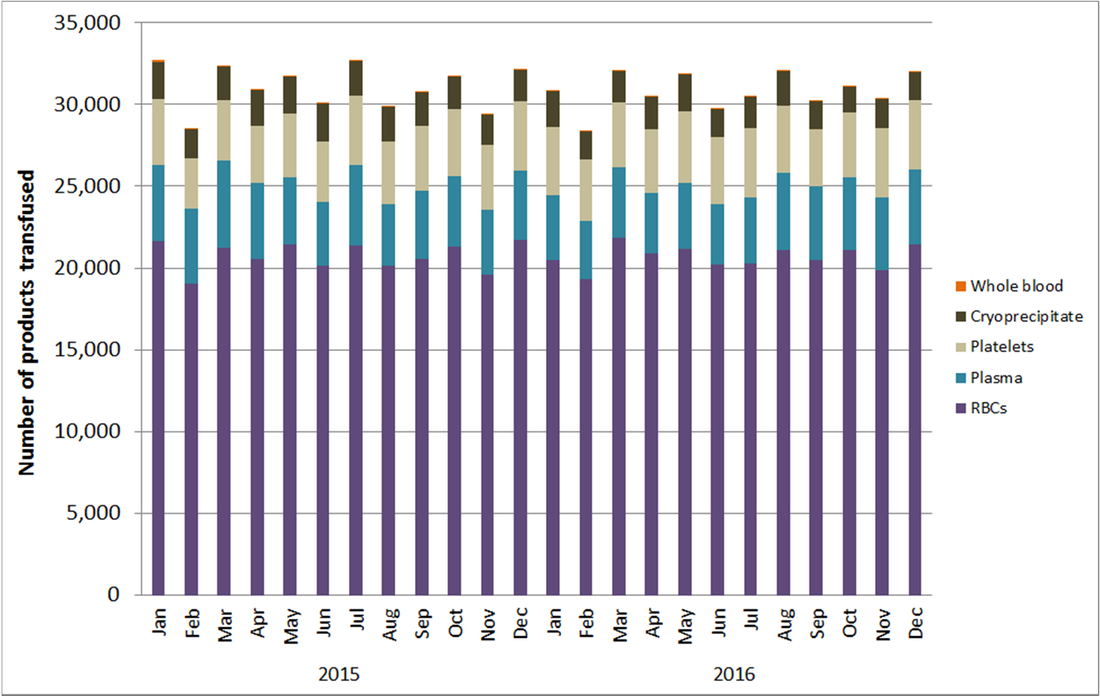
Data are as of May 22, 2017 and subject to change.

13

Transfusion Volume by Transfusion Volume Group, Product Type, and Year, 2015-2016

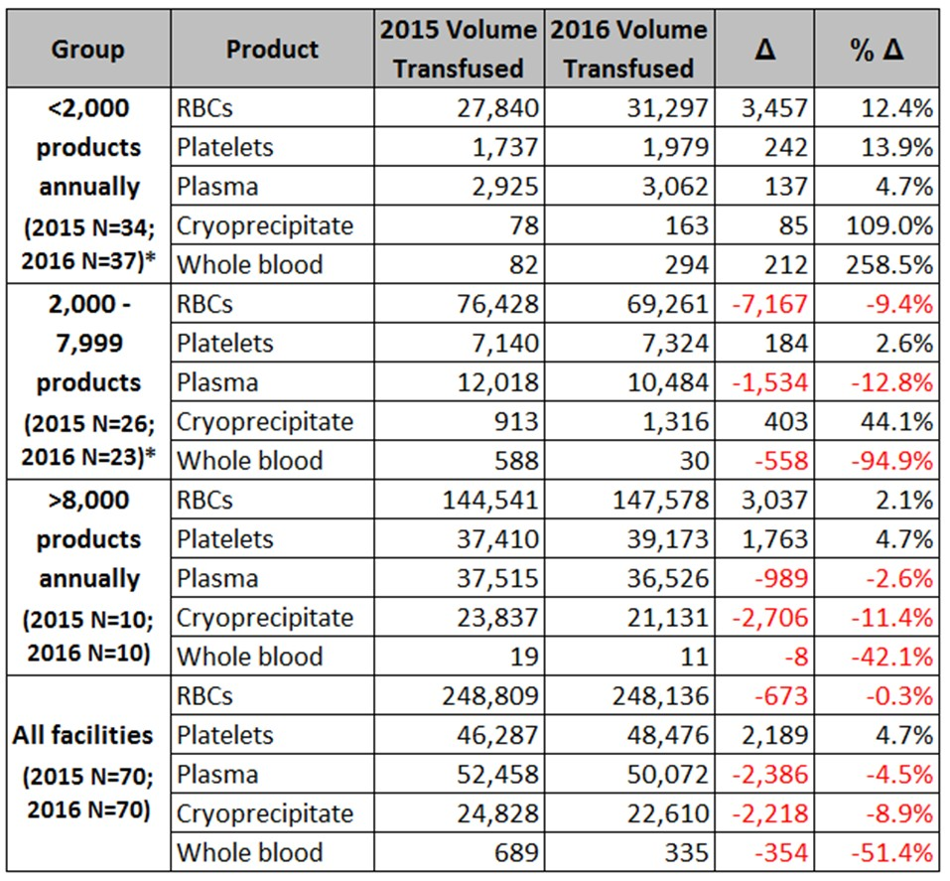

* - Between 2015 and 2016, transfusion volume changed for three facilities, such that they were reclassified into the lowest transfusion volume group.

Transfusion Volume by Emergency Preparedness (EP) Region Massachusetts, 2016
(N=70 facilities reporting)

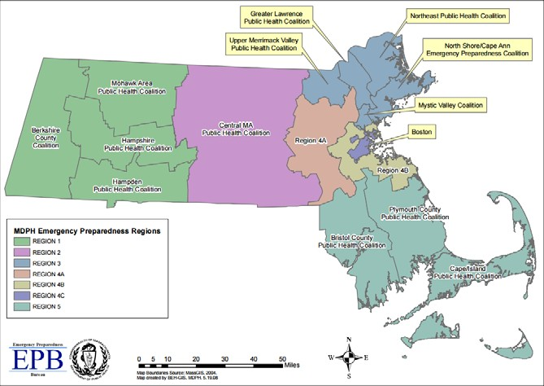

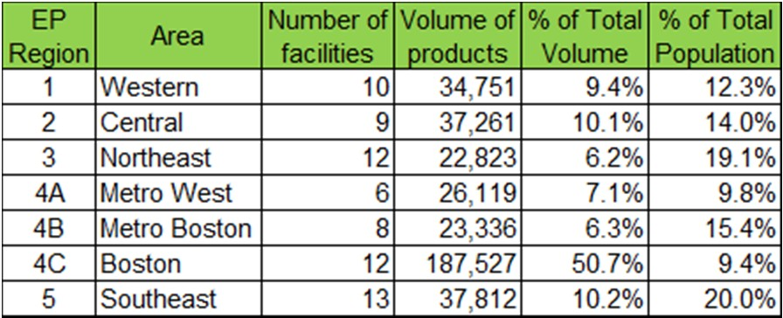

Volume of Blood Products Discarded Massachusetts, 2015-2016
(N=70 facilities)

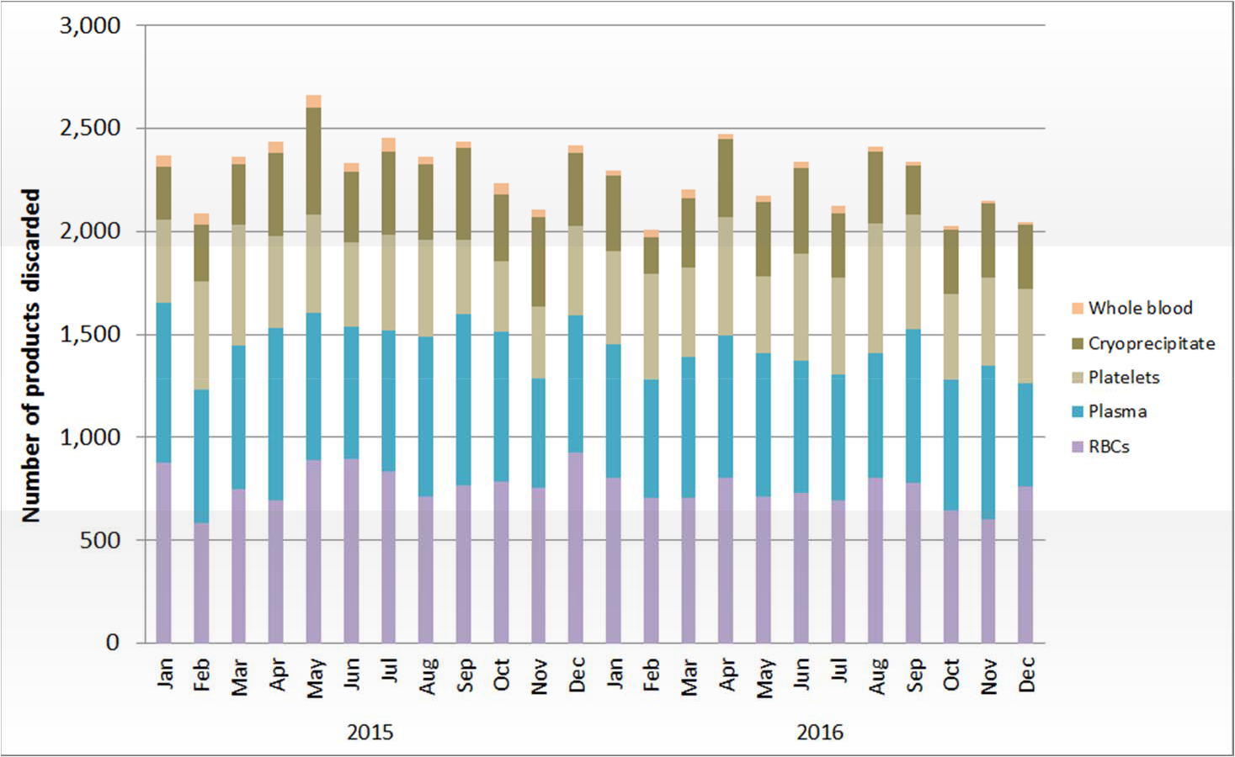

Data are as of May 22, 2017 and subject to change.

16

Number and Ratio of Discarded Products
by Type and Facility Transfusion Volume Group Massachusetts, 2016
(N=70 facilities)

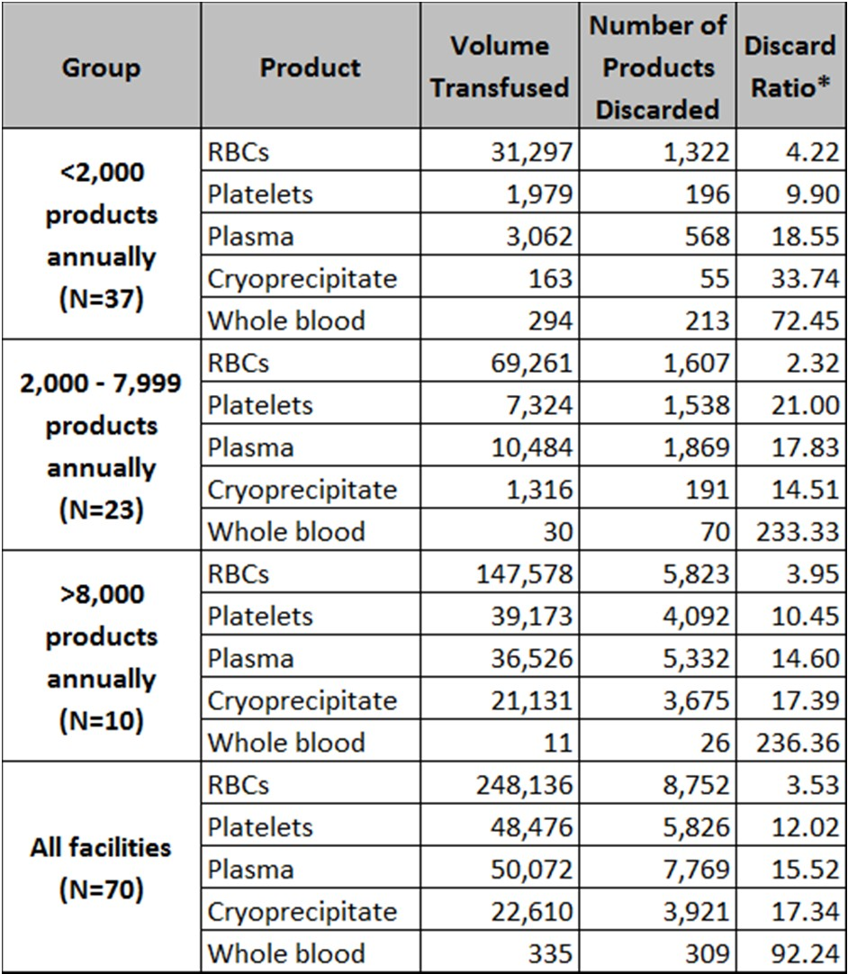

* - Note that the proper interpretation of Discard Ratio is: For every 100 products transfused, X are discarded.

Data are as of May 22, 2017 and subject to change.

17

Number of Adverse Reactions by Type, Age Group, and Gender Massachusetts, 2016
(N=70 facilities reporting)

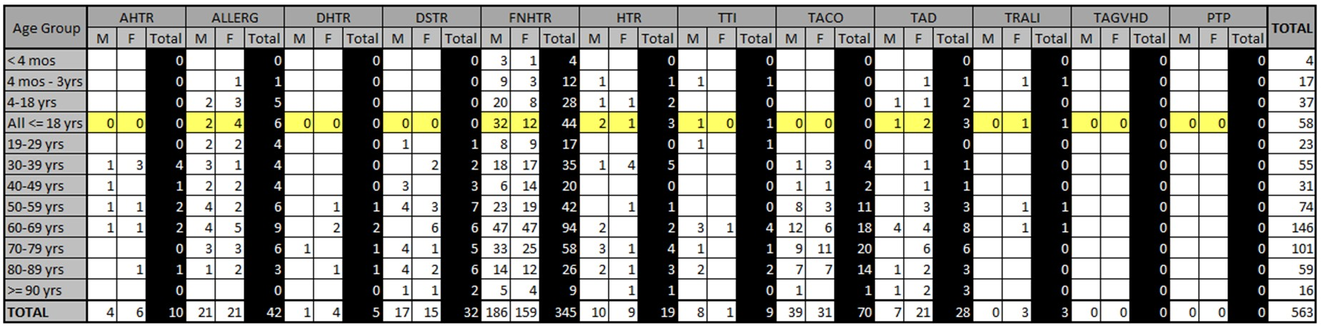

Refer to page 5 for a full listing of abbreviations.

Summary of Transfusion-transmitted Infections Massachusetts, 2016
(N=70 facilities reporting)

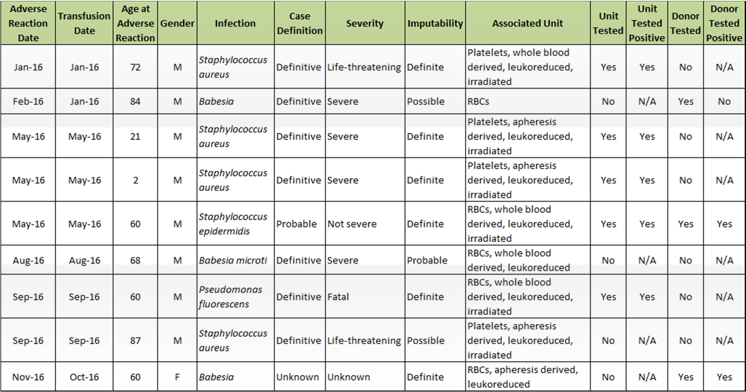

by Product Type Massachusetts, 2015-2016 (N=70 facilities reporting)

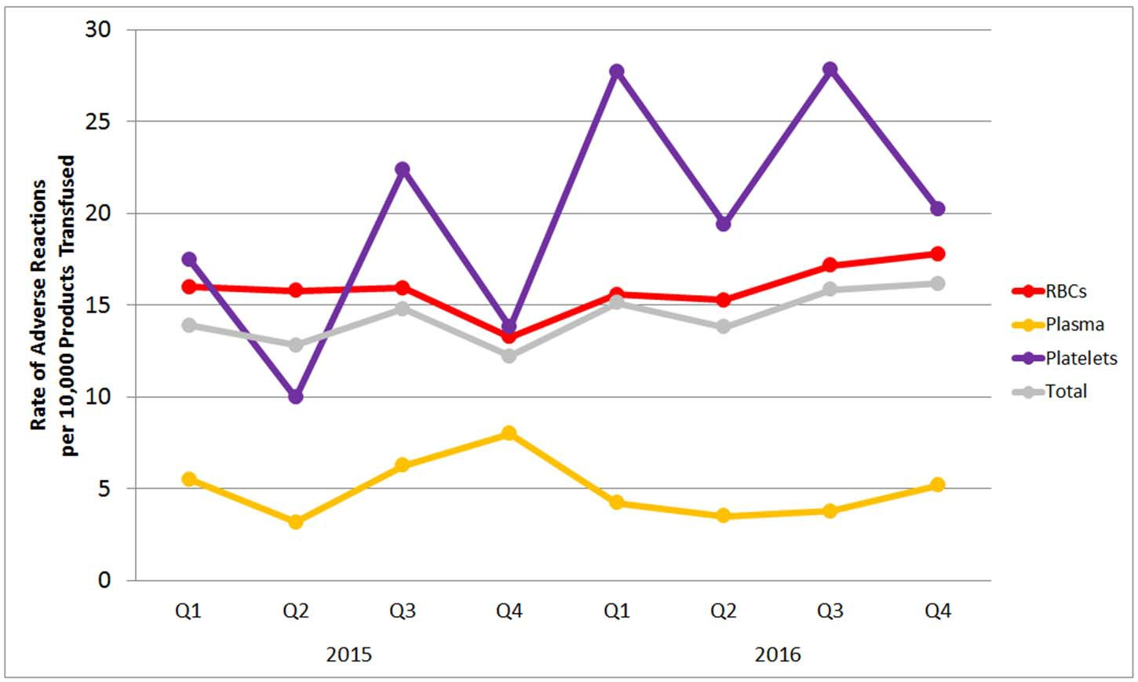

By Facility Transfusion Volume Group Massachusetts, 2015-2016 (N=70 facilities reporting)

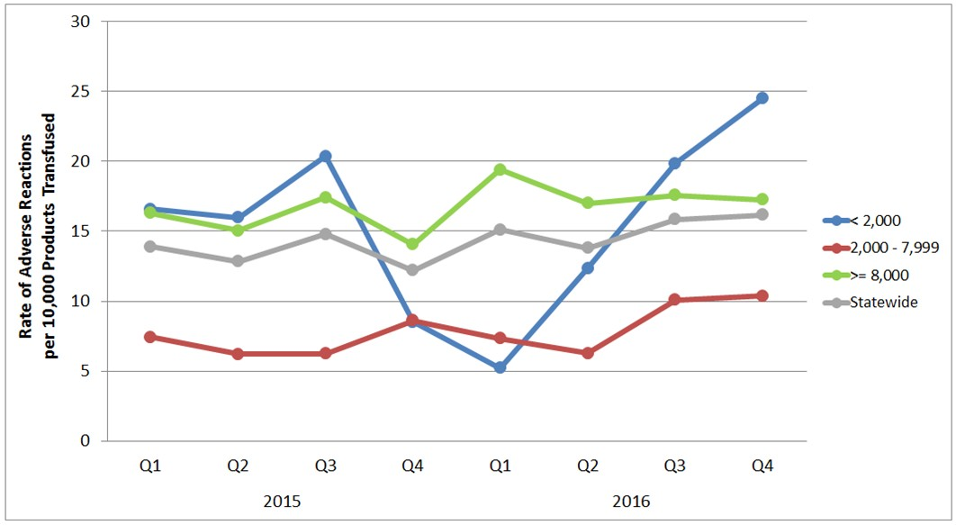

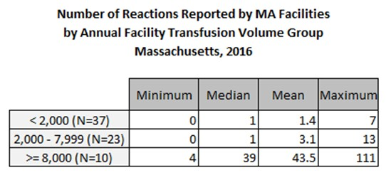

Component |  | All AdvRxns |  | Allergic |  | FNHTR |  | DSTR |  | TACO |  | HTR |  | DHTR
Type | N | N | Rate | N | Rate | N | Rate | N | Rate | N | Rate | N | Rate | N | Rate
All components
All | 369,629 | 563 | 15.23 | 42 | 1.14 | 345 | 9.33 | 32 | 0.87 | 70 | 1.89 | 19 | 0.51 | 5 | 0.14
Severe, life-threatening, and fatal adverse reactions | 369,629 | 73 | 1.97 | 22 | 0.60 | 6 | 0.16 | 0 | 0.00 | 29 | 0.78 | 2 | 0.05 | 0 | 0.00
Fatal | 369,629 | 3 | 0.08 | 0 | 0.00 | 0 | 0.00 | 0 | 0.00 | 2 | 0.05 | 0 | 0.00 | 0 | 0.00
RBCs
All | 248,136 | 408 | 16.44 | 10 | 0.40 | 268 | 10.80 | 31 | 1.25 | 48 | 1.93 | 11 | 0.44 | 5 | 0.20
Collection method
Apheresis | 29,838 | 76 | 25.47 | 4 | 1.34 | 55 | 18.43 | 3 | 1.01 | 8 | 2.68 | 1 | 0.34 | 0 | 0.00
Whole blood-derived | 218,298 | 321 | 14.70 | 6 | 0.27 | 211 | 9.67 | 24 | 1.10 | 37 | 1.69 | 10 | 0.46 | 5 | 0.23
Irradiation
Irradiated | 104,015 | 186 | 17.88 | 6 | 0.58 | 143 | 13.75 | 5 | 0.48 | 14 | 1.35 | 3 | 0.29 | 1 | 0.10
Not irradiated | 141,355 | 211 | 14.93 | 4 | 0.28 | 123 | 8.70 | 22 | 1.56 | 31 | 2.19 | 8 | 0.57 | 4 | 0.28
Leukoreduction
Leukoreduced | 232,818 | 373 | 16.02 | 9 | 0.39 | 248 | 10.65 | 27 | 1.16 | 43 | 1.85 | 11 | 0.47 | 4 | 0.17
Not leukoreduced | 12,552 | 24 | 19.12 | 1 | 0.80 | 18 | 14.34 | 0 | 0.00 | 2 | 1.59 | 0 | 0.00 | 1 | 0.80
Platelets
All | 48,476 | 115 | 23.72 | 20 | 4.13 | 63 | 13.00 | 0 | 0.00 | 10 | 2.06 | 7 | 1.44 | 0 | 0.00
Collection method
Apheresis | 46,186 | 112 | 24.25 | 20 | 4.33 | 61 | 13.21 | 0 | 0.00 | 10 | 2.17 | 7 | 1.52 | 0 | 0.00
Whole blood-derived | 2,290 | 3 | 13.10 | 0 | 0.00 | 2 | 8.73 | 0 | 0.00 | 0 | 0.00 | 0 | 0.00 | 0 | 0.00
Irradiation
Irradiated | 43,654 | 108 | 24.74 | 18 | 4.12 | 59 | 13.52 | 0 | 0.00 | 10 | 2.29 | 7 | 1.60 | 0 | 0.00
Not irradiated | 4,551 | 7 | 15.38 | 2 | 4.39 | 4 | 8.79 | 0 | 0.00 | 0 | 0.00 | 0 | 0.00 | 0 | 0.00
Leukoreduction
Leukoreduced | 47,887 | 114 | 23.81 | 20 | 4.18 | 63 | 13.16 | 0 | 0.00 | 9 | 1.88 | 7 | 1.46 | 0 | 0.00
Not leukoreduced | 318 | 1 | 31.45 | 0 | 0.00 | 0 | 0.00 | 0 | 0.00 | 1 | 31.45 | 0 | 0.00 | 0 | 0.00
Plasma
All | 50,072 | 21 | 4.19 | 10 | 2.00 | 7 | 1.40 | 0 | 0.00 | 3 | 0.60 | 1 | 0.20 | 0 | 0.00
Collection method
Apheresis | 2,580 | 2 | 7.75 | 2 | 7.75 | 0 | 0.00 | 0 | 0.00 | 0 | 0.00 | 0 | 0.00 | 0 | 0.00
Whole blood-derived | 47,492 | 19 | 4.00 | 8 | 1.68 | 7 | 1.47 | 0 | 0.00 | 3 | 0.63 | 1 | 0.21 | 0 | 0.00
Cryoprecipitate
All | 22,610 | 0 | 0.00 | 0 | 0.00 | 0 | 0.00 | 0 | 0.00 | 0 | 0.00 | 0 | 0.00 | 0 | 0.00

Component |  | TAD  N Rate |  | TRALI  N Rate |  | AHTR  N Rate |  | TTI  N Rate |  | PTP  N Rate |  | TA-GVHD  N Rate
Type | N
All components
All | 369,629 | 28 | 0.76 | 3 | 0.08 | 10 | 0.27 | 9 | 0.24 | 0 | 0.00 | 0 | 0.00
Severe, life-threatening, and fatal adverse reactions | 369,629 | 4 | 0.11 | 1 | 0.03 | 2 | 0.05 | 7 | 0.19 | 0 | 0.00 | 0 | 0.00
Fatal | 369,629 | 0 | 0.00 | 0 | 0.00 | 0 | 0.00 | 1 | 0.03 | 0 | 0.00 | 0 | 0.00
RBCs
All | 248,136 | 22 | 0.89 | 2 | 0.08 | 6 | 0.24 | 5 | 0.20 | 0 | 0.00 | 0 | 0.00
Collection method
Apheresis | 29,838 | 4 | 1.34 | 0 | 0.00 | 0 | 0.00 | 1 | 0.34 | 0 | 0.00 | 0 | 0.00
Whole blood-derived | 218,298 | 18 | 0.82 | 2 | 0.09 | 5 | 0.23 | 3 | 0.14 | 0 | 0.00 | 0 | 0.00
Irradiation
Irradiated | 104,015 | 9 | 0.87 | 1 | 0.10 | 2 | 0.19 | 2 | 0.19 | 0 | 0.00 | 0 | 0.00
Not irradiated | 141,355 | 13 | 0.92 | 1 | 0.07 | 3 | 0.21 | 2 | 0.14 | 0 | 0.00 | 0 | 0.00
Leukoreduction
Leukoreduced | 232,818 | 22 | 0.94 | 1 | 0.04 | 4 | 0.17 | 4 | 0.17 | 0 | 0.00 | 0 | 0.00
Not leukoreduced | 12,552 | 0 | 0.00 | 1 | 0.80 | 1 | 0.80 | 0 | 0.00 | 0 | 0.00 | 0 | 0.00
Platelets
All | 48,476 | 6 | 1.24 | 1 | 0.21 | 4 | 0.83 | 4 | 0.83 | 0 | 0.00 | 0 | 0.00
Collection method
Apheresis | 46,186 | 6 | 1.30 | 1 | 0.22 | 4 | 0.87 | 3 | 0.65 | 0 | 0.00 | 0 | 0.00
Whole blood-derived | 2,290 | 0 | 0.00 | 0 | 0.00 | 0 | 0.00 | 1 | 4.37 | 0 | 0.00 | 0 | 0.00
Irradiation
Irradiated | 43,654 | 5 | 1.15 | 1 | 0.23 | 4 | 0.92 | 4 | 0.92 | 0 | 0.00 | 0 | 0.00
Not irradiated | 4,551 | 1 | 2.20 | 0 | 0.00 | 0 | 0.00 | 0 | 0.00 | 0 | 0.00 | 0 | 0.00
Leukoreduction
Leukoreduced | 47,887 | 6 | 1.25 | 1 | 0.21 | 4 | 0.84 | 4 | 0.84 | 0 | 0.00 | 0 | 0.00
Not leukoreduced | 318 | 0 | 0.00 | 0 | 0.00 | 0 | 0.00 | 0 | 0.00 | 0 | 0.00 | 0 | 0.00
Plasma
All | 50,072 | 0 | 0.00 | 0 | 0.00 | 0 | 0.00 | 0 | 0.00 | 0 | 0.00 | 0 | 0.00
Collection method
Apheresis | 2,580 | 0 | 0.00 | 0 | 0.00 | 0 | 0.00 | 0 | 0.00 | 0 | 0.00 | 0 | 0.00
Whole blood-derived | 47,492 | 0 | 0.00 | 0 | 0.00 | 0 | 0.00 | 0 | 0.00 | 0 | 0.00 | 0 | 0.00
Cryoprecipitate
All | 22,610 | 0 | 0.00 | 0 | 0.00 | 0 | 0.00 | 0 | 0.00 | 0 | 0.00 | 0 | 0.00

105 CMR 135.120

