INDOOR AIR QUALITY ASSESSMENT
FOLLOW-UP
MOLD INVESTIGATION

Henry Lord Middle School
151 Amity Street
Fall River, MA 02721

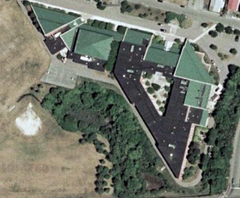.

Prepared by:
Massachusetts Department of Public Health
Bureau of Environmental Health
Indoor Air Quality Program
October 2008

Background/Introduction
At the request of the Fall River Health Department (FRHD) and Mr. Joseph Correia, Director, Administrative & Environmental Services, Fall River Public Schools, the Massachusetts Department of Public Health (MDPH), Bureau of Environmental Health (BEH) provided assistance and consultation regarding indoor air quality concerns at the Henry Lord Middle School (LMS) located at 151 Amity Street, Fall River, Massachusetts. The primary purpose of the assessment was to evaluate remediation measures taken in response to mold growth on pipe insulation and other building materials that occurred over the summer of 2008. The MDPH visit was coordinated through the FRHD and Mr. Correia.
On August 29, 2008, a visit was made to this building by Cory Holmes, Regional Inspector for BEH’s Indoor Air Quality (IAQ) Program. Mr. Holmes was accompanied by Tom Souza, LMS Head Custodian; Dr. Henry Vaillancourt, Director, Fall River Department of Health and Human Services; Tony Furtado, Senior Sanitary Inspector and Lisa Golden, Sanitarian, of the FRHD. The building was previously visited by BEH staff on August 6, 2008, and a report was issued detailing conditions observed at the time of the assessment with recommendations for mold remediation (MDPH, 2008).

Methods
BEH staff performed a visual inspection of building materials for water damage and/or microbial growth.

Microbial/Moisture Concerns
Prior to the BEH assessment, the school department had consulted with JEES Environmental Services, who had conducted a separate assessment and prepared a report with recommendations relative to remediation. The JEES report recommended:
- Removal and replacement of water damaged wallboard, ceiling tiles and air diffusers;
- Staff performing remediation work should wear proper protective equipment (PPE), classroom doors be shut and that high efficiency particulate air (HEPA) filtration units be used in remediation areas;
- Removal of corkboard coverings/stained fabric;
- Cleaning and disinfection of non-porous materials;
- Removal of mold growth on the surface of chilled water pipes;
- Consulting with a professional insulation firm to evaluate the chilled water pipe insulation;
- Repair of window leaks;
- Evaluation of the ceiling plenum to determine if the space can be ventilated to prevent condensation; and
- Post-remediation testing of affected areas (JEES, 2008).

At the time of the BEH follow-up assessment all mold-colonized chilled water pipe insulation had been removed and replaced by a professional insulation firm (Pictures 1 and 2). In addition, other water damaged porous building materials (e.g., ceiling tiles and gypsum wallboard) had been replaced (Pictures 3 and 4). Although the majority of mold-colonized cork boards and stored materials had been removed, several other items (e.g., exercise mats, bulletin boards and paper items) were recommended for removal (Picture 5).
Finally, although non-porous metal surfaces of dropped ceiling tracks and univent cabinets had been cleaned, they showed dark, unsightly, oxidation stains from chronic moisture exposure (Pictures 6 through 9).

Conclusions/Recommendations
Removal and replacement of water damaged/mold-colonized pipe insulation, ceiling tiles and GW has removed any actively growing mold colonies that may be present on porous building materials. In view of the findings at the follow-up visit,
- Discard any remaining mold-colonized materials (e.g., bulletin boards, gym mats, books).
- Continue with plans to consult with a building engineer to evaluate the building and its HVAC system to address chronic moisture issues.
- Develop an Operation and Maintenance (O & M) Plan to monitor for water-damaged building materials and, in particular, pipe insulation in areas of chronic moisture issues.
- Building occupants should notify the maintenance department if mold/moisture issues occur so that prompt action may be taken.
- Scrape and prime rusted metal ceiling tracks and univent cabinets. Contact the univent manufacture to determine the proper products/options for repainting.
References
JEES. 2008. JEES Environmental Services. Site Assessment of the Henry Lord Middle School, Fall River, Massachusetts. August 7, 2008.

MDPH. 2008. Indoor Air Quality Assessment. Mold Investigation. Henry Lord Middle School, Fall River, MA. Massachusetts Department of Public Health, Bureau of Environmental Health Boston, MA. August 2008.

Picture 1

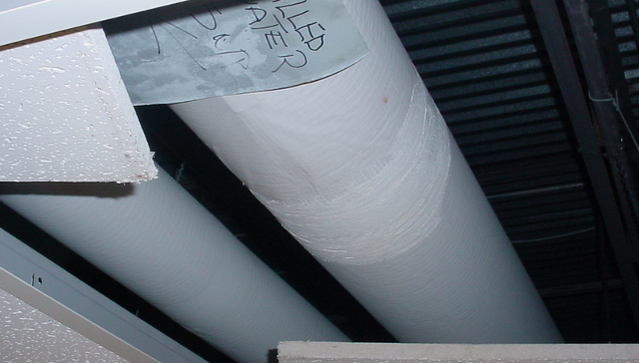

Replaced Chilled Water Pipe Insulation in Classroom

Picture 2

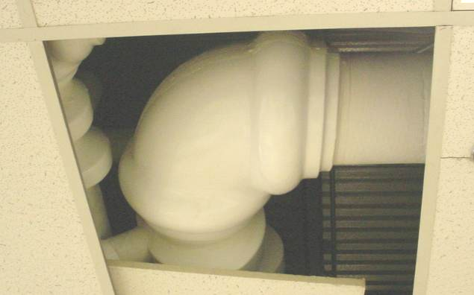

Replaced Chilled Water Pipe Insulation in Classroom
Picture 3

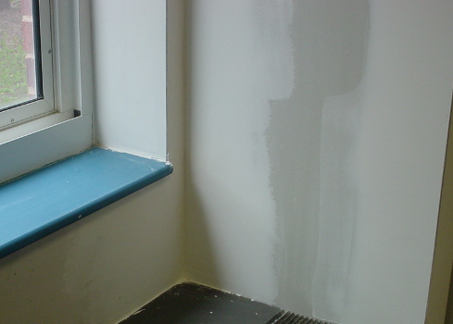

Replaced Gypsum Wallboard in Classroom

Picture 4

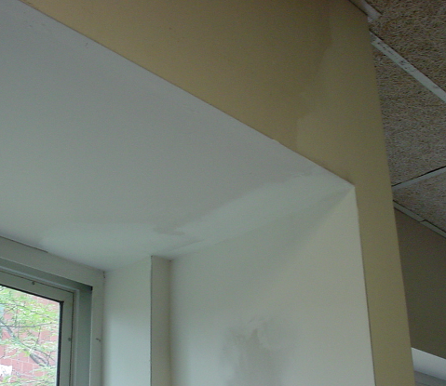

Replaced Gypsum Wallboard in Classroom
Picture 5

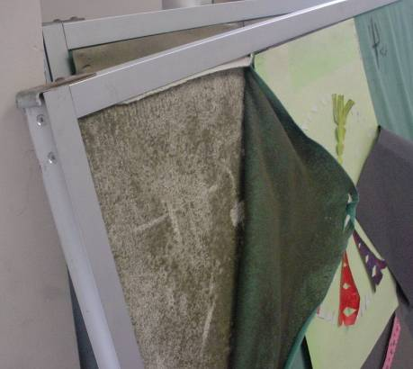

Mold Growth beneath Fabric on Bulletin Boards

Picture 6

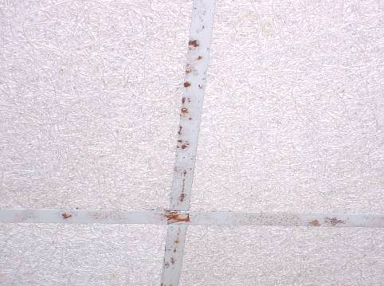

Oxidation (Rust Stains) from Chronic Moisture on Metal Ceiling Tracks
Picture 7

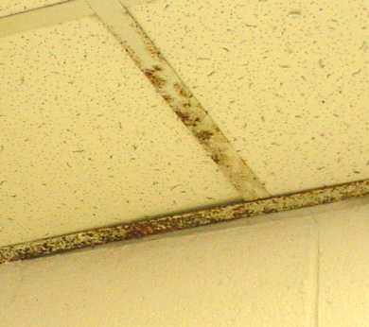

Oxidation (Rust Stains) from Chronic Moisture on Metal Ceiling Tracks

Picture 8

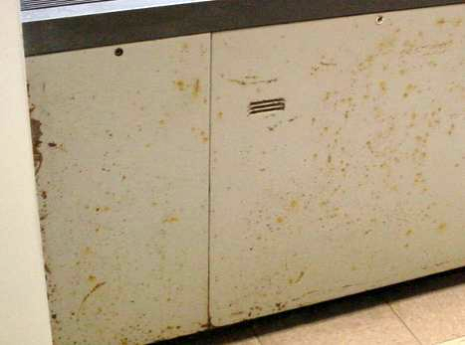

Oxidation (Rust Stains) from Chronic Moisture on Surface of Metal Univent Cabinet

Picture 9

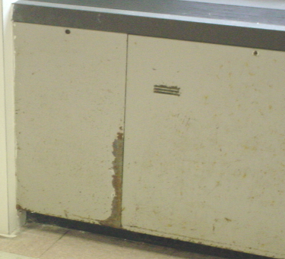

Oxidation (Rust Stains) from Chronic Moisture on Surface of Metal Univent Cabinet

