Boston Public Health Commission
Massachusetts Department of Public Health
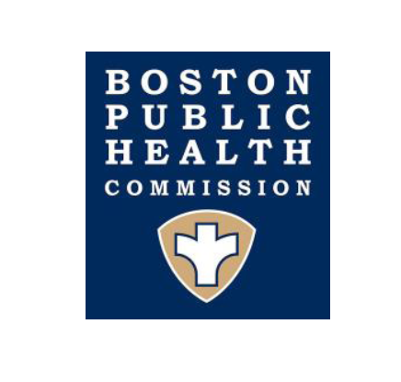
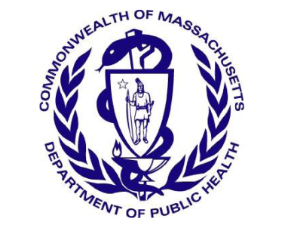

Public Health Advisory – Hepatitis A among Persons Experiencing Homelessness and who Inject Drugs

Between April 1 and July 15, 2018, there have been six cases of acute hepatitis A virus (HAV) infection investigated in Boston residents experiencing homelessness. Four of the six cases are male, with an average age of 35. Five of the six cases report recent injection drug use. There is no history of travel outside of Massachusetts and no common sources of food, beverages or drugs identified with this cluster. Illness among this group has been severe, with 5 of the 6 cases requiring hospitalization.

Statewide, during this time period there have been four additional cases of acute HAV infection investigated among people experiencing homelessness and/or substance use disorder (SUD) in Massachusetts residents living outside of Boston. All of these cases are male and are between 28-50 years of age. The cases have been reported from Plymouth, Hampden and Bristol Counties. Three of these four cases have required hospitalization. There is no known connection between the Boston and non-Boston cases.

These cases are occurring in the context of several large outbreaks in other areas of the US. On September 1, 2017, the San Diego County Health and Human Services Agency declared a local health emergency in response to an HAV outbreak unprecedented in size and severity which began November 2016. The majority of persons infected were experiencing homelessness and/or SUD. As of July 4, 2018, a total of 590 cases have been identified, including 408 (68%) hospitalizations, and 20 (3.4%) deaths. There were additional large clusters in Los Angeles and Santa Cruz Counties. Indiana, Kentucky, Michigan, Tennessee, Utah and West Virginia have also reported outbreaks of HAV since March 2017.
(see: https://emergency.cdc.gov/han/han00412.asp)
Hepatitis A is a highly contagious liver infection caused by the Hepatitis A virus (HAV) ranging in severity from mild infection lasting a few weeks to severe disease lasting several months. HAV is primarily spread person-to-person through the fecal-oral route and contact with a fecal-contaminated environment. Populations at particular risk include individuals experiencing homelessness and people with injection drug use.

Given the pattern of significant HAV outbreaks seen in other states involving similar populations, there is concern for additional transmission and morbidity in the Commonwealth. Effective prevention and response measures include early identification of cases, vaccination, enhanced sanitation processes and education of vulnerable populations.

Prevention and Response Activities:
Multiple measures have already been implemented to help reduce spread of HAV in Boston. Coordinated efforts are underway to increase HAV vaccine delivery through Boston Health Care for the Homeless Program (BHCHP). BPHC’s AHOPE program, and street teams and mobile units from several other programs across the city including BHCHP, Kraft Center’s CareZONE van, and the Pine Street Shelter van, have increased education and outreach efforts, with a specific focus on contacting unsheltered homeless in the encampments across Boston, encouraging vaccination and connecting persons to care. Doses of HAV vaccine have been provided by the Massachusetts Department of Public Health (MDPH) to support control efforts. Enhanced cleaning/sanitation efforts were initiated at all BPHC Homeless and Recovery Bureau and BHCHP sites including AHOPE, PAATHS, the Engagement Center, the Boston Night Center, the Barbara McInnis House, and all Boston shelters. BPHC has also been working closely with Emergency Preparedness personnel at BMC, MGH, and Tufts and the Conference of Boston Teaching Hospitals.

Statewide, hepatitis A is treated as a high priority disease for follow-up by MDPH and each case is investigated promptly to determine close contacts and obtain a risk history. MDPH is working with local Boards of Health and relevant stakeholders to further enhance education and prevention among people at high-risk.

Recommendations for Providers:
Report
- Regulations require healthcare providers and institutions in Boston to report all cases of HAV infection, hepatitis B virus (HBV) infection or meningococcal meningitis diagnosed in Boston residents to the Boston Public Health Commission (Phone: 617-534-5611, 24/7 coverage. For assistance identifying close contacts, please contact BPHC.)
- Reporting forms for Boston healthcare providers and for laboratories are available at: http://www.bphc.org/cdc.
- Cases residing outside Boston should be reported to the local board of health where the patient lives or to MDPH (617-983-6800, available 24/7).

Vaccination and Referral to Treatment
At the current time, we wish to target our initial vaccination efforts to the groups identified to be most at risk, as outlined below.
- Vaccinate all persons at high risk including persons experiencing homelessness, persons who use injection or non-injection drugs or have chronic liver disease (including chronic hepatitis C infection or chronic hepatitis B infection), and men who have sex with men. Vaccine options include single antigen hepatitis A vaccine (HAVRIX® or VAQTA®) and the combination hepatitis A and B vaccine (Twinrix®). Please keep in mind that Twinrix requires 3 doses for maximum efficacy and that it should not be used for postexposure prophylaxis.
- Offer vaccines at point of care including Emergency Department or Urgent Care encounters, inpatient admissions, observation stays, and outpatient clinic visits. If possible, vaccination information should be captured within the facility’s electronic medical record to assist with monitoring of vaccine coverage.
- Targeted street-based workers and mobile van units serving these high-risk populations are encouraged to provide HAV and other vaccines to unsheltered individuals, persons living in encampments or otherwise not utilizing services within the shelters.
- For clients in Boston, connect clients to a BHCHP clinic site. For a list of BHCHP clinics, go to: https://www.bhchp.org/patient-services/primary-care
- Refer clients with SUD to syringe services programs.
  - In Boston, refer to AHOPE Harm Reduction Services located at 774 Albany Street. For more information re hours and services, go to: http://www.bphc.org/whatwedo/Recovery-Services/services-for-active-users/Pages/Services-for-Active-Users-AHOPE.aspx.
  - For clients outside of Boston, refer to this document for sites and contact information: https://www.mass.gov/files/documents/2018/01/09/resources-guide.pdf
- Consider recommending HAV vaccination to all potentially exposed staff at facilities serving these high-risk populations, who are under- or un-immunized.
- Immunize all close contacts of persons diagnosed with acute HAV with single antigen hepatitis A vaccine (and/or immune globulin, if indicated and available). For more information see: https://www.cdc.gov/hepatitis/hav/havfaq.htm. Please note, Twinrix is not recommended for postexposure prophylaxis.
- For persons presenting with signs/symptoms consistent with acute HAV infection, connect immediately to BHCHP clinic or closest Emergency Department for further evaluation.

Hygiene and Sanitation
- Facilities serving high-risk populations should increase opportunities for hand hygiene at entrances/exits and encourage frequent handwashing. Hand washing with antimicrobial soap and hot water should be encouraged. Portable hand hygiene stations utilizing hot water are suitable.
  - Alcohol-based hand sanitizers (ABHS) may not be effective against HAV and are not recommended.
- Implement enhanced hygiene and sanitation control measures, including cleaning of all high touch surfaces and bathroom facilities at least twice daily (and as needed) with a disinfectant labeled by EPA as active against feline calicivirus, norovirus or hepatitis A virus, or as sporocidal. Dilute bleach solution (1:100) is also effective.
- BPHC has educational materials about hygiene in English, Spanish, Haitian and Portuguese Creole. (Materials can be downloaded at: http://bphc.org/whatwedo/infectious-diseases/Infectious-Diseases-A-to-Z/Pages/Hepatitis-A.aspx).

Education – Education should be provided to all high-risk populations and agencies serving these populations about signs/symptoms of HAV, need for vaccination, and hygiene measures to reduce transmission.
- Hospitals, clinics, and other agencies serving these populations should educate residents, nurses, community health workers, intake staff, etc.
- Strengthen education and outreach efforts to sheltered and unsheltered homeless, with a focus on necessary enhanced hygiene practices, referral for vaccination, and connecting potentially exposed and ill persons to care.

Boston Public Health Commission Massachusetts Department of Public Health
Infectious Disease Bureau Bureau of Infectious Disease & Laboratory Sciences
1010 Massachusetts Avenue 305 South Street
Boston, MA 02118 Jamaica Plain, MA 02130
Tel. (617) 534-5611, Fax. (617) 534-5905 Tel. (617) 983-6800, Fax. (617) 983-6813
www.bphc.org/cdc www.mass.gov/dph

