

HEPATITIS B

INFORMATION GUIDE



I've just been diagnosed with

Hepatitis B - What do I do now?



Encourage family members to get

tested

Find

a doctor

Find

Resources

Understand

your diagnosis

Tell others and protect loved

ones

Learn more about

hepatitis B



**Understand your diagnosis**

Knowing whether your hepatitis B is acute or chronic will help you and your doctor determine the next steps. When someone is first infected with hep B, it is considered an acute infection. Most healthy adults who are acutely infected are able to get rid of the virus on their own. If you continue to test positive for hepatitis B after 6 months, it is considered a chronic infection.



**Find a Hepatitis B Specialist**

If you have been diagnosed with chronic hep B, it is important to find a doctor that has knowledge in treating liver disease.



**Protect your loved ones**

Hepatitis B can be transmitted to others through blood and sexual contact. There is a safe and effective vaccine that can protect your loved ones from hep B.

Hepatitis B- What is it?

# What does it do?

## Hep B is the world’s most common liver infection. Almost **300 million** people are living with chronic hep B infections across the world.

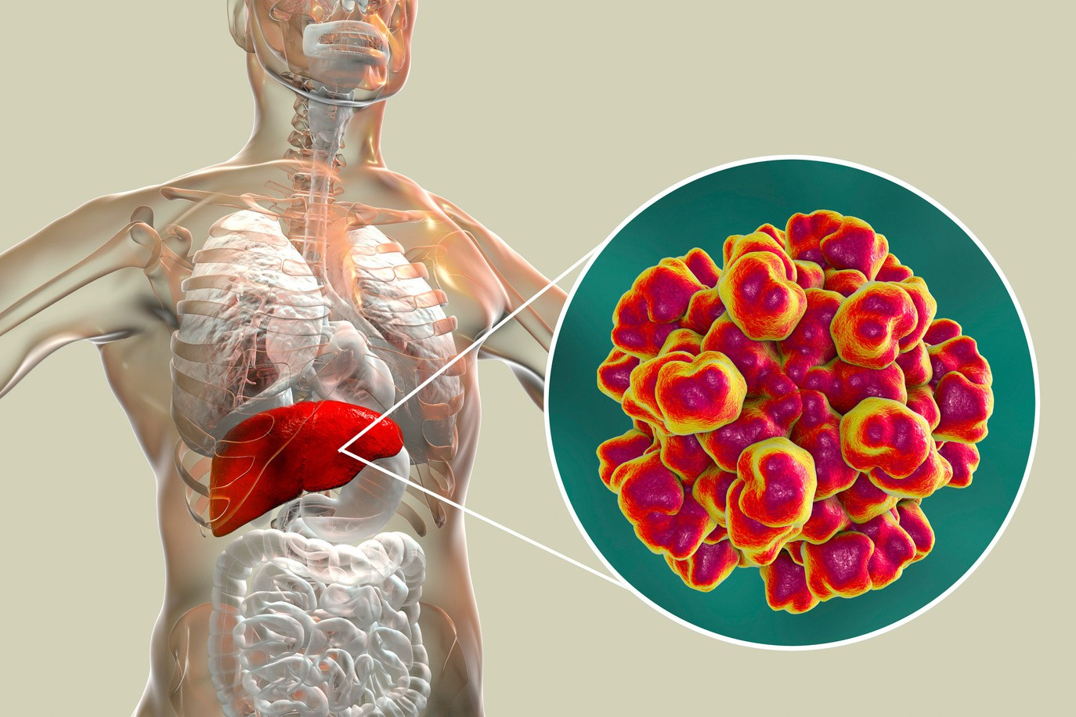

How does it spread?



**Mother to child**

**transmission**

**Unprotected**

**sex**

**Injection**

**drug use**

**Unsafe injections**

**and medical procedures**

**Contaminated**

**blood and bodily fluids**

Source: *https://[www.nature.com/scitable/definition/virus-308/](http://www.nature.com/scitable/definition/virus-308/)

Addressing Myths

Q.Is hep B spread by sharing food, bowls, utensils or chopsticks?

A. Hep B is NOT spread by sharing meals or food prepared by someone with hep B.

Q.Is hepB spread by all body fluids?

A. Hep B is NOT spread by kissing, hugging, shaking hands, sweat, or saliva.

Q. Can I get married or be in a relationship if I have hep B?

A.YES! People with hep B can get married & have children.

Q. Can I have children without giving them hep B?

A. Yes, make sure your baby gets the HepB birth dose within 24 hours of delivery and then completes the vaccine series

Q.How can I prevent spreading Hep B to my sexual partner?

A. Ask your partner to be tested for hep B, if negative, use protection (condoms) until the vaccine is complete!

LIVING WITH HEPATITIS B: STAY HEALTHY!

KEEP YOUR LIVER HAPPY!

Did you know? Everything you eat, drink, breathe or even absorb

through the skin is eventually filtered by the liver. Here are some tips to make your life more liver-friendly.

### KEEP GOING

Schedule regular visits with your healthcare provider to keep

### TAKE THE SHOT!

yourself and your liver healthy. Get the Hepatitis A vaccine to protect yourself from another virus that attacks the liver.

### SMOKE LESS, DRINK LESS

Avoid drinking alcohol and smoking since both will hurt your liver

### BEFRIEND YOUR PHARMACIST

### WATCH OUT FOR HERBS

Tell your provider about herbal remedies or vitamins you take because some could affect your hep B medications or even

damage your liver.

Tell your pharmacist about all medications you take (even over the counter) since most medications are processed through the liver. Remember to take your medicine on time!

### BREATHE CLEARLY

EAT HEALTHIER

Avoid fumes from paint, paint thinners, glue, cleaning products, nail polish removers, and other potentially toxic chemicals that could damage your liver.

Eat more fruit, whole grains, fish, lean meats, and LOTS of vegetables especially cabbage, broccoli, and cauliflower.

## REDUCE SUGARS AND FATS

### COOK YOUR SEAFOOD

Limit foods and drinks with added sugar (like soda, juice & packaged snacks) or saturated fats (like fatty cuts of

meat,& fried food).

Avoid raw or undercooked shellfish (like clams, mussels, oysters and scallops) which may be contaminated with bacteria (vibrio vulnificus) which can hurt the liver

## NO MOLD, PLEASE!

STAY WELL AND RESTED

Reduce your stress levels by eating healthy foods, exercising regularly, and getting plenty of rest.

Check for mold on nuts and grains, especially if kept

damp and unsealed since certain molds (like aflatoxins)

are risk for liver cancer

Managing Hepatitis B

If you have chronic hep B infection, your provider should monitor your hep B infection and the health of your liver with **regular check-ups every 3 to 6 months, using the following tests:**

 Physical exam

 Blood tests for liver enzymes

Blood tests indicating liver function Blood tests for liver cancer screening



 Blood tests for hepatitis B markers

 Complete Blood Count (CBC) Imaging studies of the liver

#### Liver Enzymes

These blood tests measure potential liver damage caused by the hepatitis B virus. When the liver is injured, the liver enzymes can leak into the bloodstream. The larger the number, the greater the potential liver damage.

#### Alanine Aminotransferase (ALT or SGPT)

This enzyme is monitored closely with a hepatitis B infection and is found almost exclusively in the liver. This test is useful in deciding whether a person would benefit from treatment or for evaluating how well a person is responding to treatment.

#### Alpha-Feto Protein (AFP)

This blood test is used to screen for the development of primary liver cancer in those living with chronic hepatitis B and should be tested at every visit for this. If an individual does have elevated AFP, then more tests and imaging studies should be ordered.

#### Imaging Studies of the Liver

Your doctor may order an ultrasound, FibroTest, or transient elastography to evaluate or monitor liver damage (e.g. inflammation, fibrosis, cirrhosis) and to screen for primary liver cancer. Be sure to talk to your doctor about liver cancer screening. Generally, imaging of the liver and blood tests at least every 6-12 months is recommended.

Talking to your provider- Questions to ask



*Where can I get my family, spouse or sexual partner tested and vaccinated for hepatitis B? What do I need to do to protect them until they are completely vaccinated?*

Your household members and sexual partners should be tested for hepatitis B. Ask your doctor for local clinics or you can tell your household members or partners to talk to their primary care doctors and ask to be tested for hepatitis B.

**Not everyone is a good fit for hepatitis B treatment**. Treatment for hepatitis B is based on many things, including age, family history, liver enzyme test results, hepatitis B DNA levels, and other things. Talk to your doctor to see if treatment is right for you. Keep in mind that currently, **treatment is a long-term commitment**, and you should expect to be on treatment for the rest of your life or until a cure is available.

*Am I a good candidate for treatment? If not, why not? If yes, please explain why and tell me about the treatment options?*

*If I am not eligible for medical treatment, what do I need to do to monitor my hepatitis B?*

**People on treatment and not on treatment need monitoring for hepatitis B.** Monitoring for hepatitis B could include HBV DNA testing, ALT testing, and ultrasound or some type of imaging of the liver.

If you test positive for hepatitis B infection while pregnant, your doctor also should do a hepatitis B viral load blood test (HBV DNA) during your pregnancy. In some cases, the laboratory test results may show a very high viral load. In these cases, your physician may recommend that you take an oral antiviral drug in your third trimester to reduce the risk of infecting your newborn at birth. Your baby will need a hepatitis B birth dose within the first 24 hours of birth followed by childhood immunizations (at least 2 doses of hepatitis B vaccine) within their first year of life. This can prevent hepatitis B transmission during the birthing process.

Talking to your provider- questions to ask

*If I want to have children, should I wait to start treatment? If I need to start treatment now, at what point can I consider having children?*

*Here are the names of the medications that I currently take – are they safe for my liver?*

The liver is one of the most important organs in our bodies and can absorb medications you might take. It is important that your doctor is aware of any medications you are taking, particularly if you have hepatitis B because it impacts your liver. Bring a list of all medications (herbals, vitamins, included) to your doctor so they know what you are taking.

*What over the counter medications or herbal supplements can I safely take for pain, cold symptoms, etc.?*

Many people are interested in using herbal remedies or supplements to boost their immune systems and help their livers. The problem is that there is no regulation of companies manufacturing these products, which means there is no rigorous testing for safety or purity. So the quality of the herbal remedy or vitamin supplement may be different from bottle to bottle. Some herbal remedies could interfere with your prescription drugs for hepatitis B or other conditions; some can even actually damage your liver. Talk to your doctor first before starting herbals.

*Should I be vaccinated to protect myself against hepatitis A?*

Yes, the hepatitis A vaccine is recommendMedofroer Rpeeosoplue cweitsh hepatitis B. Ask your doctor about getting the hepatitis A vaccine today.