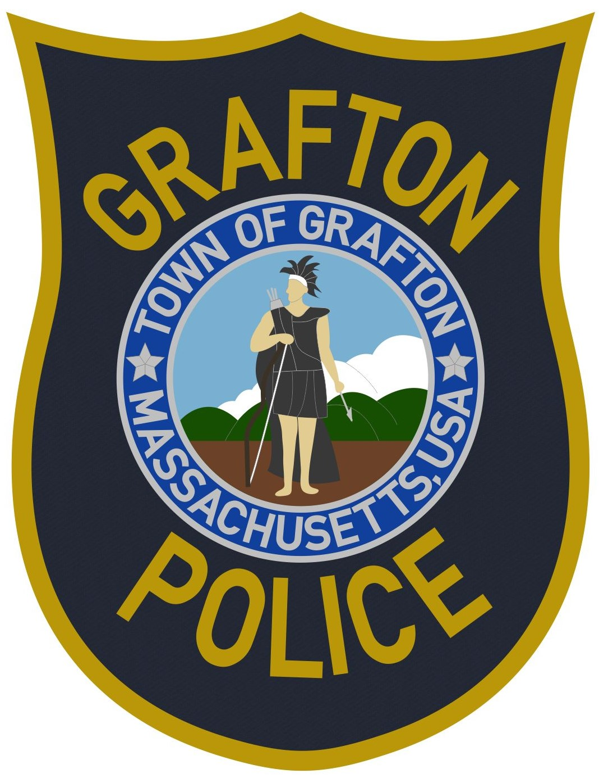

Grafton Police Department
28 Providence Road • Grafton, Massachusetts 01519
Telephone (508) 839-2858 • Fax (508) 839-8562
www.graftonpolice.com

Normand A. Crepeau, Jr.

Chief of Police

June 9, 2021

Town of Grafton
Full-Time Public Safety Dispatcher

The Grafton Police Department is accepting applications for the position of full-time public safety dispatcher. Candidates must be at least 18 years old and have a High School Diploma or GED as well as a valid drivers' license. We are seeking individuals who possess strong communication and interpersonal skills, can maintain attention to detail and demonstrate a positive attitude in a fast-paced public safety environment.

Candidates should have excellent data entry skills and should have, or shall be required to obtain, the following certifications: E911 Next Generation, CJIS, APCO-PST 1, PowerPhone Emergency Medical Dispatch and CPR. Experience with IMC/TriTech public safety software is preferred. Selected candidates will undergo assessment training and a complete background investigation. Salary negotiable based on experience.

The Grafton Police Communications Center is a 24/7 operation therefore, candidates must be willing to work all shifts including nights, weekends and holidays when needed.

Resume and cover letter may be sent to:

chief@graftonpolice.com
or
Chief Normand A. Crepeau, Jr.
Grafton Police Department
28 Providence Road
Grafton, MA 01519

THE TOWN OF GRAFTON IS AN EQUAL OPPORTUNITY EMPLOYER

