Human Granulocytic Anaplasmosis (HGA)
Surveillance in Massachusetts, 2017
Massachusetts Department of Public Health
Bureau of Infectious Disease and Laboratory Sciences

Investigation of suspect cases of HGA, and the collection of clinical and exposure data by local public health enables MDPH to analyze trends and provide this surveillance summary.
2017 Surveillance Highlights

- 1,209 confirmed and probable cases of HGA were reported in Massachusetts in 2017, a 38% increase over 2016. Overall 2,473 suspect cases of HGA were investigated.

- Statewide, HGA incidence increased from 13.3 to 18.4 cases per 100,000 residents. The counties with the highest incidence are Barnstable, Berkshire, Dukes, Franklin, Nantucket and Plymouth. Berkshire County had the greatest change in incidence, from 66.3 to 133.4 cases per 100,000 residents.

- The majority of cases occurred in May, June, and July, with only 45% of cases reporting awareness of a recent tick bite.

- People aged 60 years and over continue to be at greatest risk for clinical disease (56% of patients identified with HGA were 60 or over) and 64% of all cases were male.

- Nearly one out of three patients with HGA (29%) was hospitalized. The symptoms most commonly reported included fever (93%), malaise (72%), and muscle aches and pain (63%). There were three fatalities.

- For more information about HGA and other tick-borne diseases, including things you can do to keep you and your loved ones safe, please visit www.mass.gov/dph/tick.

The map below illustrates HGA incidence rates per 100,000 population by city and town of residence in Massachusetts from 2013-2017. Areas of highest incidence include southern and western Berkshire County, Southeastern Massachusetts, Cape Cod and the Islands. Many locations within Central Essex, Norfolk and Middlesex Counties also had areas of elevated incidence.
County | 2017 Cases  Confirmed and Probable | 2017  Incidence Rate per 100,000
Barnstable | 66 | 30.6
Berkshire | 175 | 133.4
Bristol | 91 | 16.6
Dukes & Nantucket | 11 | 41.2
Essex | 73 | 9.8
Franklin | 27 | 37.8
Hampden | 18 | 3.9
Hampshire | 30 | 19.0
Middlesex | 282 | 18.8
Norfolk | 88 | 13.1
Plymouth | 178 | 36.0
Suffolk | 12 | 1.7
Worcester | 153 | 19.2
State Total | 1,204 | 18.4
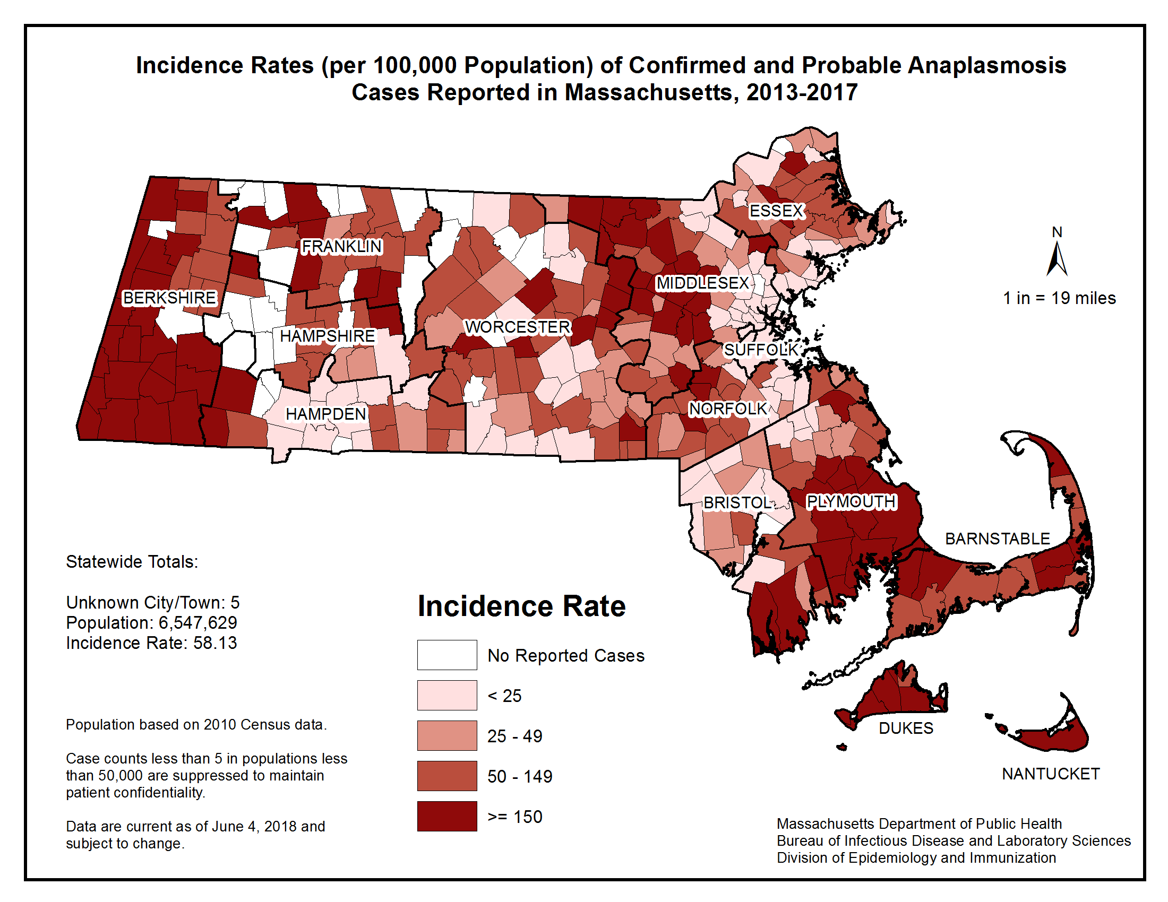
Note: 5 cases with unknown address have been excluded from this table.

Figure 1.
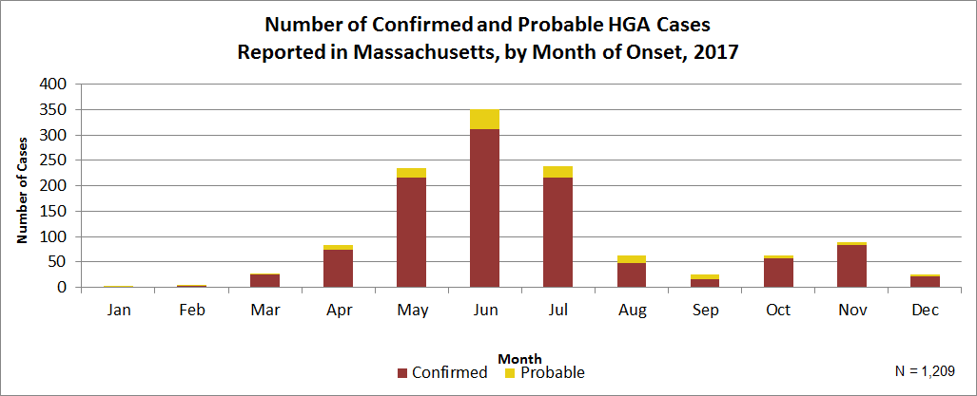

Figure 2.
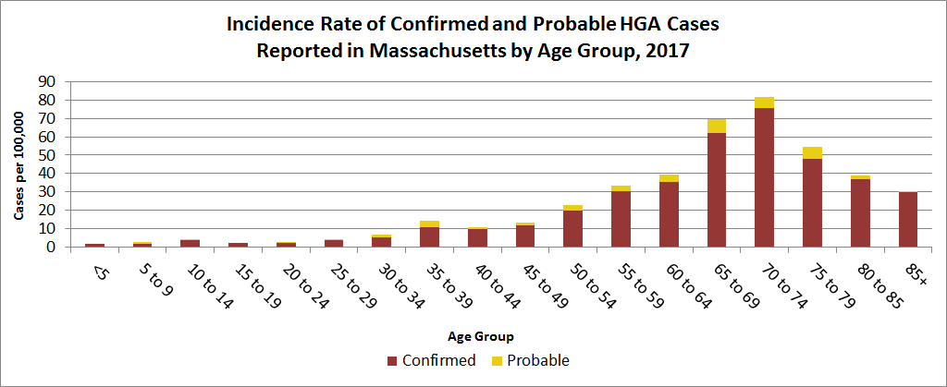
Figure 3.
