INDOOR AIR QUALITY ASSESSMENT

**Highlands Elementary School**

190 Hobart Street

Danvers, MA

**March 2024**

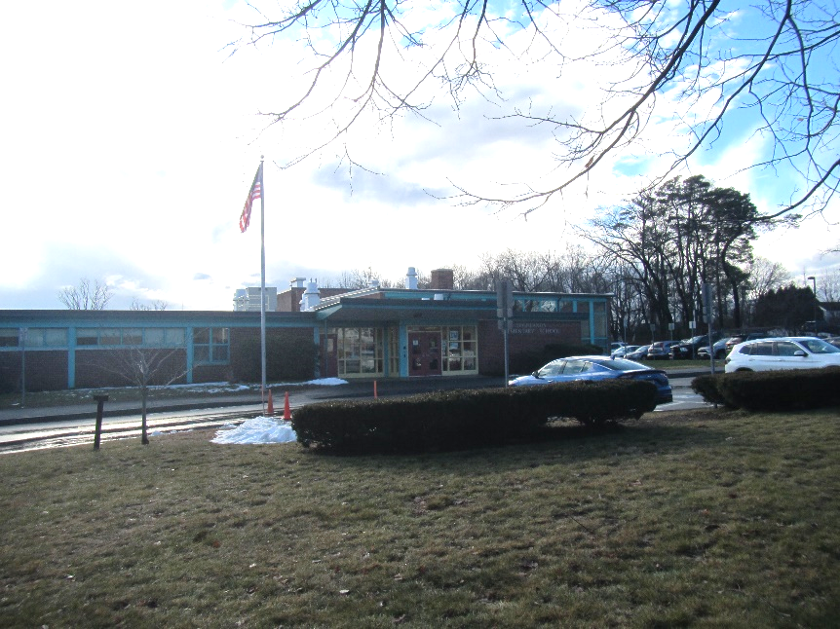

Prepared by:

Massachusetts Department of Public Health

Bureau of Climate and Environmental Health

Indoor Air Quality Program

Contents

[EXECUTIVE SUMMARY 3](https://massgov-my.sharepoint.com/personal/stefanie_santora_mass_gov/Documents/Desktop/danvers-highland-school-feb-2024-new%20template.docx#_Toc160113684)

[BACKGROUND 4](https://massgov-my.sharepoint.com/personal/stefanie_santora_mass_gov/Documents/Desktop/danvers-highland-school-feb-2024-new%20template.docx#_Toc160113685)

[RESULTS AND DISCUSSION 4](https://massgov-my.sharepoint.com/personal/stefanie_santora_mass_gov/Documents/Desktop/danvers-highland-school-feb-2024-new%20template.docx#_Toc160113686)

Ventilation 5

HVAC System Maintenance 6

HVAC Types and Specific Conditions 6

Water Damage and Moisture Concerns 7

Sources of Respiratory Irritants/Possible Asthma Triggers 9

Other IAQ Issues 11

[CONCLUSIONS AND RECOMMENDATIONS 12](https://massgov-my.sharepoint.com/personal/stefanie_santora_mass_gov/Documents/Desktop/danvers-highland-school-feb-2024-new%20template.docx#_Toc160113693)

REFERENCES 16

[FIGURES 17](https://massgov-my.sharepoint.com/personal/stefanie_santora_mass_gov/Documents/Desktop/danvers-highland-school-feb-2024-new%20template.docx#_Toc160113695)

Table 1 30

Table 2A 34

Table 2B 35

Table 2C 36

Table 3 37

Table 4 39

# R an EXECUTIVE SUMMARY

The Massachusetts Department of Public Health’s Indoor Air Quality Program (MADPH IAQ) conducted an IAQ assessment of The Highlands School located at 190 Hobart Street in Danvers on January 10, 2024. This assessment was requested by The Superintendent of the Danvers School Department for the purpose of investigating musty odors and general IAQ.

Any building can have indoor air quality (IAQ) issues. These issues can be made worse through conditions common to marginalized communities [i.e., environmental justice communities (EJ)] such as inequitable exposure to outdoor air pollution and a greater likelihood of poor building conditions leading to deterioration of IAQ and higher asthma rates. The Highlands Elementary School is not within an EJ community, however the town of Danvers and surrounding towns do have EJ communities (<https://www.mass.gov/info-details/environmental-justice-populations-in-massachusetts#environmental-justice-maps-update-2022->). In addition, the pediatric asthma rate for this school as of 2018 is 13.9% compared to the statewide pediatric prevalence rate of 11.8%.

The assessment was conducted by evaluating several key elements within the school; a visual inspection of the heating, cooling, and ventilating (HVAC) systems, water/microbial damage, cleanliness, point sources of respiratory irritants such as chemicals, and electronic measurement of carbon dioxide (CO2), carbon monoxide (CO), temperature, relative humidity (RH), and small particulate matter (PM2.5) all taken with a Qtrak XP monitor. Data is collected in this manner to identify potential asthma triggers, allergens, and other environmental factors that can cause indoor air quality symptoms. Please refer to the [Indoor Air Quality Manual](https://www.mass.gov/lists/indoor-air-quality-manual-and-appendices#indoor-air-quality-manual-) on the MDPH website for methods, sampling procedures, and interpretation of results.

As a result of this assessment, there are several findings: conditions in this school are typical of elementary schools of this age and type, musty odors of concern are present in the hallway, univents and other HVAC components may be beyond their lifespan, and there are occupant-induced issues such as clutter. (Results and Discussion)

Upon review of these findings, the musty odors are likely due to water infiltration in the area where the older and newer portions of the school meet, the age of univents and other HVAC components make maintenance increasingly difficult, and clutter can be addressed to reduce dust and odors. (Conclusions)

Based on the results of the assessment, the following primary recommendations are made:

* Maintain the HVAC system, including regular filter changes and repairing exhaust vents that are not working.
* Address drainage issues leading to water infiltration and musty odors in the hallway.
* Use equipment that may produce odors and fumes, such as laminators and the kiln, with good ventilation and away from occupants, which may mean moving these items,

(Conclusions and Recommendations)

# R an BACKGROUND

|  |  |
| --- | --- |
| Building: | Highlands Elementary School |
| Address: | 190 Hobart Street  Danvers, Massachusetts |
| Assessment Requested by: | Dan Bauer, School Superintendent in Danvers |
| Reason for Request: | Musty odors and general IAQ |
| Date of Assessment: | January 10, 2024 |
| Massachusetts Department of Public Health/Bureau of Climate and Environmental Health (MDPH/BCEH) Staff Conducting Assessment: | Mike Feeney, Director, IAQ Program  Ruth Alfasso, Inspector, IAQ Program |
| Building Description: | The Highlands School is a brick-faced one-story school originally constructed in 1956 with an addition built in 1995. It contains classrooms, offices, and accessory rooms including a gym, library, and cafetorium. |
| Windows: | Most windows in the building are openable. |

# R an RESULTS AND DISCUSSION

The following is a summary of indoor air testing results (Table 1)

|  |  |  |
| --- | --- | --- |
| * ***Carbon dioxide (CO2)*** | *a measure of the adequacy of ventilation* | Levels were below the MDPH guideline of 800 parts per million (ppm) in most of the areas surveyed. A few areas had levels above 800 ppm, typically smaller rooms with high occupancy. |
| * ***Temperature*** | *a measure of comfort* | Was mostly within the MDPH recommended range of 70°F to 78°F in occupied areas. A few areas were slightly cooler than the recommended temperature range. In some cases, such as the gym, this may be intentional. |
| * ***Relative humidity*** | *a measure of comfort and, when in excess for an extended period, a way to reflect the potential for mold and fungal growth* | Was within the MDPH recommended range of 40 to 60% in all areas tested. This is reflective of outdoor conditions which were unseasonably warm with rain. Relative humidity would be expected to be lower with cold outdoor temperatures and indoor heating. |
| * ***Carbon monoxide***   ***(CO)*** | *a product of combustion that can result in acute and long term cardiovascular, respiratory, and neurological symptoms* | Levels were non-detectible in all areas assessed. |
| * ***Particulate matter (PM2.5)*** | *a way to measure inhalable particle distribution in the air* | Concentrations were below the National Ambient Air Quality Standard (NAAQS) of 35 micrograms per cubic meter (μg/m3) in all areas tested. Most measurements were non-detect (ND). |

## Ventilation

Ventilation refers to both the supply of fresh air and the removal of stale air from a room. The introduction of fresh air into an occupied space will dilute normally occurring pollutants that are generated by occupancy and other activities. In addition, an HVAC system will remove pollutants from a building if operating appropriately. All ventilation systems throughout the building should operate continuously during periods of occupancy.

The Highlands School has a combination of unit ventilators (univents) and rooftop air handing units. Univents (Picture 1) bring in fresh air from a vent on the outside of the building (Picture 2), filter it, heat it, and supply the air through a vent on the top. Some room air is recirculated along with the fresh air through a vent at the bottom (Figure 1). The air handling units bring in fresh air from the roof, filter it, heat it, and bring it into classrooms and offices through a ceiling-mounted supply vent (Picture 3). Classrooms and offices are also equipped with exhaust vents that remove stale air from rooms (Picture 4) (Table 2B).

The various types of ventilation components as well as devices that can move/redirect airflow are listed in Table 2A, Table 2B and Table 2C.

### HVAC System Maintenance

* Univents may be beyond their service life According to the American Society of

Heating, Refrigeration, and Air-Conditioning Engineering (ASHRAE), the service life of

this type of unit is 15-20 years, assuming routine maintenance of the equipment

(ASHRAE, 1991).

### HVAC Types and Specific Conditions

**Balancing**

To have proper ventilation with a mechanical supply and exhaust system, a system must be balanced to provide an adequate amount of fresh air to the interior of a room while also removing stale air from the room.

It is recommended that HVAC systems be re-balanced every five years to ensure adequate air systems function (SMACNA, 1994).

(see HVAC pictures)

**Classroom Unit ventilators**:

* Univents were frequently blocked with furniture or items (Picture 5; Table 1).
* Some univents were turned off (Table 1).
* Items including art supplies and plants were located in the airstream of univents (Picture 6).
* A univent was opened and the filter examined. Filters used in univents are pleated MERV 8, which is reportedly the best quality filter that can be used in the equipment (Picture 7). The MDPH IAQ program recommends that filters of at least MERV 8 be used as these are adequate to filter out pollen, mold, and similar particulates.

**Classroom Exhaust vents**:

* Many exhaust vents were blocked with furniture and items (Table 1).
* Some exhaust vents were not operating, as judged by a lack of air draw. Either these have been turned off or the rooftop fans are not functional.
* Exhaust vents in most classrooms are located near the hallway door (Picture 4) and are behind it when the doors are open. For improved air circulation, the door to the hallway should be closed during class occupancy.

**Additional HVAC Conditions:**

* Most classrooms have openable windows (Picture 1; Table 1). These can be used for additional fresh air during temperate weather. Windows should be kept closed during wet weather, when air conditioning is operating in the room, and at the end of the school day.
* Window-style air conditioners were mounted in the wall of several rooms near the main office (Picture 8; Table 1). These units can supply some amount of fresh air while operating. They are equipped with filters that need to be cleaned periodically. When these and other air conditioners (e.g., portable or window-mounted) are operating, the windows should be closed, and the room door should be kept closed.

## Water Damage and Moisture Concerns

Please note that the IAQ Program does not recommend conducting mold testing in a typical water damage remediation. For details, please consult [Guidance Regarding Testing for Mold in Water-Damaged Public Buildings](https://www.mass.gov/info-details/guidance-regarding-testing-for-mold-in-water-damaged-public-buildings) | Mass.gov

The application of a mildewcide to moldy porous materials is not recommended.

Molds are found naturally in our environment both indoors and outdoors. Inside, mold growth may occur when items, particularly porous products such as paper or gypsum wallboard, are exposed to moisture. Typical water sources include leaks, floods, and condensation. To avoid mold growth, dry all water-damaged items and affected areas within 24-48 hours and reduce indoor humidity. Some people with chronic respiratory conditions, such as asthma, are more likely to experience health symptoms associated with molds, including allergic reactions and respiratory irritation. Controlling moisture is the key to preventing mold growth and potential health symptoms.

Hot humid summers are becoming more frequent due to climate change. Massachusetts has experienced hot, humid, and rainy summers in 2018, 2021, and 2023. July of 2021 was the wettest ever recorded in Massachusetts, and the three-month period from June through August, known as the meteorological summer, was the fourth wettest on record, according to the National Oceanic and Atmospheric Administration’s (NOAA) Centers for Environmental Information (NOAA, 2021). The summer of 2023 was also hot, and wet, being measured as the second rainiest on record (WBUR, 2023). These conditions are challenging for buildings, particularly those without air conditioning.

During these hot and wet summers, extended periods of outdoor relative humidity above 70% occurred. Under these weather periods, public buildings experienced extended periods of water vapor exposure from high relative humidity. When exposed to these conditions, porous materials such as gypsum wallboard, cardboard, and other materials may become prone to developing mold colonization, particularly if located in areas that are prone to developing condensation on floors and walls (e.g., below grade space).

### Water Damage Issues

(see Water Damage and Moisture Concern Pictures)

* **Water-damaged ceiling tiles were found in a few locations (Table 1) and water damage to insulation in the corner of the music room (Picture 9) was noted.**

In addition, many classrooms had sinks, and the backsplash and countertops of

some of these sinks were damaged (Picture 10). Damaged material around sinks

can allow moisture to accumulate, prevents effective cleaning, and may lead to mold

growth.

* **One of the reasons for the site visit request was reports by school staff of mold in a hallway that connects the 1956- to the 1995-constructed wing (Picture 11).**

No moldy materials were found, but a musty odor was noted in this area.

* **Several conditions were noted that likely contribute to water penetration into the hall through the exterior wall/floor slab seam and the window/door framing for the exterior door in this hallway (Picture 12).**

When the 1995 wing was constructed, the section was intended to be drained by a

storm drain (Picture 13). As shown in Picture 13, the ground in this location is either

bare soil or sparse grass. This suggests that these areas are repeatedly exposed to

significant amounts of accumulating rainwater. The pooling of water at the base of

these walls is a result of rainwater runoff striking the ground with velocity to

compress soil. This may result from a lack of gutter/downspouts under roof edge

(Picture 14) as well as soil beneath a roof scupper which operates to remove water

when the roof drains/gutters are overwhelmed. (Picture 15). As rainwater

compresses the soil, water may pool against the base of the building, which can then

enter the wall system through weep holes.

* **Also note that caulking used to seal the seam between the door/window system appears to be worn or missing (Picture 16).**

Direct exposure to wind driven rain or pooling water may result in water entering the

building through the frame.

* **The interior wall in this area shows signs of efflorescence (Picture 11).**

Efflorescence results when rainwater penetrates into brick and mortar. A suspension of water and salts forms in the brick and mortar, which then travels to wall surface. As the water evaporates, a white, powdery material is formed (efflorescence). While efflorescence is a sign of water exposure to brick, and water intrusion, it is not mold growth. The possible cause of this condition is the connection of the roof of the 1995 building to the wall where the efflorescence appears. This wall was originally the exterior wall of the 1956 building. As such it was designed to drain rainwater, not serve as an interior hallway wall. In general, when a roof is attached to a wall, flashing is installed to transition water from the wall surface onto the slanted roof surface. The flashing at the roof junction is inserted through a seam across the entire width of the exterior brick. The interior edge may have an upturned lip to prevent water movement deeper into the wall. In this manner water in the brick drains onto the flashing then onto the roof material to be removed from the building. Since brick and mortar is readily penetrated by water, the flashing is a means to prevent water from penetrating into the building interior.

* **IAQ staff could not directly examine the roof flashing in this location due to its high location above a slanted metal roof.**

Note that all the wall brick and mortar above the flashing appear to be the same

color and style, which likely indicates no bricks were removed to install the roof

flashing in a manner describe.

* **Some corners of the building show signs of chronic exposure to moisture (Picture 17) including dark staining and moss.**This is a result of the inability of this portion of the building to dry due to lack of drainage and lack of exposure to sunlight. Over time, this can lead to deterioration of the building exterior and may eventually lead to leaks inside.

Several other conditions on the outside of the buildings were identified which can contribute to water issues, which are specified in Table 3. Several issues related to water infiltration were identified and are listed below.

**Mold Growth**

Porous materials (e.g., gypsum wallboard, ceiling tiles and carpeting) can be dried with fans and heating within 24 to 48 hours of becoming wet (US EPA, 2008).

If porous materials are not dried within this time frame, mold growth may occur.

* **Some hallway floor tiles showed signs of chronic water exposure (Picture 18).**

Facility staff explained that this was likely due to improper maintenance procedures

over time, and that floor tiles were on a list to be replaced.

* **Plants were noted in some classrooms and offices.**

Plants can be a source of pollen or mold especially if overwatered or not well

maintained. In addition, plants were noted on top of univents (Picture 6), which can

distribute odors and particulates to the rest of the classroom.

* **Bowed or sagging ceiling tiles were noted in some classrooms (Table 1).**

This is an indication that these rooms have been subject to an extended period of

high humidity.

* **Trees overhang the building (Picture 19) which may prevent the exterior of the building from drying, and clog roof drains with leaves and other debris.**

In severe weather, trees may also fall onto the building.

## Sources of Respiratory Irritants/Possible Asthma Triggers

Asthma is a lung disease that can make breathing difficult. Without careful management of asthma, some people can have symptoms, like a tight feeling in the chest, shortness of breath, coughing, or wheezing. Although there is no cure for asthma, people with asthma can live healthy, active lives. A safe and healthy environment helps to reduce asthma symptoms.

**Comparison of Local and State-wide Asthma Rates**

9.3% of children

have asthma

**<Danvers >**

11.8% of children

have asthma

**Massachusetts**

13.9% of children

have asthma

**Highlands School**

* **Sometimes, learning tools and personal items in a classroom can be a source of irritants.** For example, a bird or insect nest is a great learning tool for students but may harbor microbes and allergens. Similarly, food-based projects can attract pests that carry disease or trigger allergies.
* **Personal products, particularly those with volatile organic compounds (VOCs) including scents, can also be a source of respiratory irritation.** VOCs are carbon-containing substances that have the ability to evaporate at room temperature. Frequently, exposure to low levels of total VOCs (TVOCs) may produce eye, nose, throat and/or respiratory irritation in some sensitive individuals.
* **Dust, a common respiratory and eye irritant, can collect on surfaces and items.** Although janitorial and maintenance staff perform routine cleaning in classrooms, they may not be able to clean as effectively if classroom items are not picked up or surfaces are cluttered. Even with a properly functioning ventilation system, it is necessary to either eliminate or reduce the use of materials that can be a source of respiratory irritants to prevent symptoms in individuals who have sensitivity to such pollutants.

For guidance on maintaining an asthma-friendly healthy school environment, please consult the MDPH Asthma Prevention and Control Program’s [Clearing the Air: An Asthma Toolkit for Healthy Schools](https://www.maasthma.org/schooltoolkit).

Possible asthma triggers and/or airborne pollutants exist in the building. These are listed below as well as in (Table 4).

(see Sources of Respiratory Irritant Pictures)

* **The art room has a kiln (Picture 20), which was located in the main room with a barrier around it rather than in its own room.**

No direct exhaust vent or hood was present. Although this is an electric kiln so does

not produce products of combustion, the heat of the kiln can lead to odors. The kiln

should be used only when the classroom is not occupied, and preferable with the

window open until the cycle is complete and it has cooled down. If the kiln is heavily

used, it should be moved to a separate room with a direct-vented exhaust.

* **A laminator was found in a small workroom (Picture 21).**

Laminators melt plastic and produce odors when in use. No exhaust vent for this

room was found.

* **Some classrooms and storage rooms had an excess of items such as books, craft materials, papers, and other materials (Picture 22).**

Items need to be stored neatly so that effective cleaning can be performed.

* **Many classrooms were equipped with area rugs (Picture 23).**

These need to be cleaned regularly to remove dust, debris, and odors. Area rugs

should be stored off the floor in a climate-controlled area during the summer to

prevent moistening by condensation. Used area rugs should not be brought into the

school as they may harbor allergens such as pet dander.

* **Air purifiers were noted in many classrooms (Picture 24).**

These appear to be units which use high efficiency particulate arrestance (HEPA)

filters, and, in some cases, an additional carbon filter. These are good choices for use

in occupied areas. Air purifiers that may produce ozone should not be used (EPA,

2003) All air purifiers should be cleaned and maintained in accordance with

manufacturer’s instructions.

## Other IAQ Issues

*Radon*

Radon is a naturally occurring radioactive gas that seeps into buildings from the surrounding soil and at elevated levels can increase the risk of lung cancer.

The Environmental Protection Agency (EPA) conducted a National School Radon Survey “in which it discovered nearly one in five schools has at least one schoolroom with a short-term radon level above the action level of 4pCi/L (picocuries per liter) – the level at which the EPA recommends that schools take action to reduce the level” (US EPA, 1993).

**The BCEH/IAQ Program therefore recommends that every school be tested for radon, and that this testing be conducted during the heating season while school is in session in a manner consistent with USEPA radon testing guidelines**. Radon measurement specialists and other information can be found at [www.nrsb.org](http://www.nrsb.org) and <http://aarst-nrpp.com/wp>, with additional information at: <http://www.mass.gov/eohhs/gov/departments/dph/programs/environmental-health/exposure-topics/iaq/radon>.

# R an CONCLUSIONS AND RECOMMENDATIONS

**Please note:** this report contains a series of recommendations that should serve as *Best Practices* that apply to most public-school buildings across the Commonwealth and should be shared amongst other buildings in the School District.

Issues typical to many schools were found in this building. The age of the HVAC equipment will make controlling temperature and airflow more difficult as time goes on. Drainage issues and water infiltration issues particularly at the seam between the older part of the building and the newer are likely responsible for the musty odors described in the hallway between the two areas. Other issues described can be mitigated with repairs to the exhaust systems, and with changes to occupant behaviors to reduce blockages of univents and clutter.

**Short-term recommendations** can be implemented as soon as practicable, however **long-term measures** are more complex and will require planning and resources to adequately address overall indoor air quality concerns within the building.

|  |  |  |
| --- | --- | --- |
| **Short-term Recommendations** | | |
| **HVAC System** | | |
|  |  | **Helpful links** |
|  | Ensure all univents are on and operating during occupied periods |  |
|  | Remove blockages from the top and front of univents, including furniture and items |  |
|  | Periodically check the function of all exhaust vents and repair as needed |  |
|  | Close classroom doors for improved exhaust vent function |  |
|  | Continue to change filters in univents and other HVAC units at least twice a year, and more often if the filters are obviously soiled when changed. |  |
|  | During filter changes, clean dust and debris from the inside of univent and HVAC system cabinets |  |
|  | Use openable windows for additional fresh air during temperate weather. Close windows tightly during wet weather and at the end of each day |  |
|  | Clean and maintain window and portable air conditioners in accordance with manufacturer’s instructions. Keep windows closed in rooms where air conditioners are operating to avoid condensation |  |
| **Water Damage Sources** | | |
|  | Replace water-damaged ceiling tiles. Repeated water damage to ceiling tiles indicates leaks from the roof or plumbing/HVAC system which should be repaired | US EPA. 2008. “Mold Remediation in Schools and Commercial Buildings”. EPA 402-K-01-001. United States Environmental Protection Agency, Office of Air and Radiation, Indoor Environments Division, Washington, DC. September 2008. <http://www.epa.gov/mold/mold-remediation-schools-and-commercial-buildings-guide> |
|  | Replace water-damaged insulation on pipes in the music room |  |
|  | Repair or replace water-damaged countertops and backsplashes on sinks to prevent ongoing water exposure of the material beneath the veneer. |  |
|  | Properly maintain plants to avoid mold and odors. Keep plants away from airflow of HVAC equipment |  |
|  | Use these guidelines to control for moisture and increase comfort in a non-air-conditioned school especially during heatwaves. | * Mold Growth Prevention During Hot, Humid Weather <https://www.mass.gov/service-details/preventing-mold-growth-in-massachusetts-schools-during-hot-humid-weather> * Remediation and Prevention of Mold Growth and Water Damage in Public Schools <https://www.mass.gov/service-details/remediation-and-prevention-of-mold-growth-and-water-damage-in-public-schools-and> * Methods for Increasing Comfort in Non-air-conditioned Schools <https://www.mass.gov/doc/methods-for-increasing-comfort-in-non-air-conditioned-schools/download> |
|  | Address drainage around the exterior of the building in the area of the storm drain shown in Picture 13. This may include regrading or installation of French drains or other methods. |  |
|  | Repair window and door sealant/caulking in hallway where mold odor was reported. |  |
|  | Have a building engineer inspect the connections between the two portions of the building including flashing. Determine if flashing is properly installed behind exterior brick wall at an appropriate length to intercept rainwater that penetrates through the brick wall above where the new and old wing meet. |  |
|  | Remove trees and plants from away from the building to allow for better drying of building materials and prevent pollen and odors from being drawn into the building. |  |
|  | Remove plants from the airstream of ventilation equipment. Keep all indoor plants in good condition and do not overwater. |  |
|  | While bowed/sagging ceiling tiles are not a source of mold, this indicates extended exposure to high humidity. Therefore, care should be taken with storage of materials in these areas during hot, humid weather and over the summer. |  |
| **Respiratory Irritants/Possible Asthma Triggers** | | |
|  | Operate the kiln only when the room is unoccupied. Keep items away from the kiln during operation to prevent fires and fumes due to heated plastics. |  |
|  | Add a direct exhaust vent to the kiln area, and enclose the kiln away from the rest of the art room |  |
|  | Move the laminator to an area with an exhaust vent. |  |
|  | Periodically sort classroom and stored items to remove unwanted items. Store remaining items neatly and off the floor. Where rooms have a history of moisture issues, consider storing items in waterproof totes |  |
|  | Clean area rugs frequently using a HEPA-equipped vacuum cleaner. Avoid bringing used area rugs into the school |  |
|  | Clean and maintain air purifiers in accordance with manufacturer’s instructions. Avoid the use of air purifiers that may product ozone. | <https://www.epa.gov/indoor-air-quality-iaq/ozone-generators-are-sold-air-cleaners> |
| **Other Recommendations to Improve Air Quality Conditions** | | |
|  | Test the school for radon by a certified radon measurement specialist during the heating season when school is in session. Radon measurement specialists and other information can be found at: [www.nrsb.org](http://www.nrsb.org), and <http://aarst-nrpp.com/wp> | |
|  | To learn more about radon, review the MDPH’s Radon in Schools and Child Care Programs factsheet, with additional information at: <https://www.mass.gov/radon>. | |
|  | Include an IAQ component in the school’s Wellness Advisory Committee program. An IAQ plan should have an IAQ liaison/teacher representative, a member of maintenance/facilities and administration that conduct regular walk-throughs to identify on-going and/or potential environmental issues. | |
| **Long-term Recommendations** | | |
|  | Upgrade HVAC equipment to beyond its service life. | |

# REFERENCES

ASHRAE. 1991. ASHRAE Applications Handbook, Chapter 33 “Owning and Operating Costs”. American Society of Heating, Refrigeration and Air Conditioning Engineers, Atlanta, GA.

ASHRAE. 2012. American Society of Heating, Refrigeration and Air Conditioning Engineers (ASHRAE) Standard 52.2-2012 -- Method of Testing General Ventilation Air-Cleaning Devices for Removal Efficiency by Particle Size (ANSI Approved).

MDPH. 2015. Massachusetts Department of Public Health. Indoor Air Quality Manual: Chapters I-III. Available at: <http://www.mass.gov/eohhs/gov/departments/dph/programs/environmental-health/exposure-topics/iaq/iaq-manual/>.

NOAA. 2021. Summer 2021 neck and neck with Dust Bowl summer for hottest on record. National Oceanic and Atmospheric Administration, 1401 Constitution Avenue NW, Room 5128, Washington, DC 20230 <https://www.noaa.gov/news/summer-2021-neck-and-neck-with-dust-bowl-summer-for-hottest-on-record>

SMACNA. 1994. HVAC Systems Commissioning Manual. 1st ed. Sheet Metal and Air Conditioning Contractors’ National Association, Inc., Chantilly, VA.

US EPA. 1993. Radon Measurement in Schools, Revised Edition. Office of Air and Radiation, Office of Radiation and Indoor Air, Indoor Environments Division (6609J). EPA 402-R-92-014.

US EPA. 2000. Tools for Schools. Office of Air and Radiation, Office of Radiation and Indoor Air, Indoor Environments Division (6609J). EPA 402-K-95-001, Second Edition. <http://www.epa.gov/iaq/schools/index.html>.

US EPA. 2003. “Ozone Generators that are Sold as Air Cleaners: An Assessment of Effectiveness and Health Consequences”. United States Environmental Protection Agency, Office of Air and Radiation, Indoor Environments Division, Washington, DC. Last updated September, 2018. https://www.epa.gov/indoor-air-quality-iaq/ozone-generators-are-sold-air-cleaners

US EPA. 2008. Mold Remediation in Schools and Commercial Buildings. US Environmental Protection Agency, Office of Air and Radiation, Indoor Environments Division, Washington, D.C. EPA 402-K-01-001. <http://www.epa.gov/mold/mold-remediation-schools-and-commercial-buildings-guide>.

US EPA. 2023. Indoor Air Quality (IAQ),<https://www.epa.gov/indoor-air-quality-iaq>

WBUR. 2023. “It's been a summer of rain and flooding misery in Mass.” WBUR local news. September 12, 2023. <https://www.wbur.org/news/2023/09/12/summer-flooding-rain-massachusetts>.

# R an FIGURES

**Figure 1**

**Unit Ventilator (Univent)**

Mixed Air

Air Diffuser

**Outdoors Indoors**

Fan

Heating/Cooling Coil

Air Mixing Plenum

Filter

Outdoor Return

Air Air

Air

Flow

Control

Louvers

**Air Flow**

= Fresh Air/Return Air

= Mixed Air

# 

# R an PICTURES

(Click to link back to report)

HVAC pictures

**Picture 1**

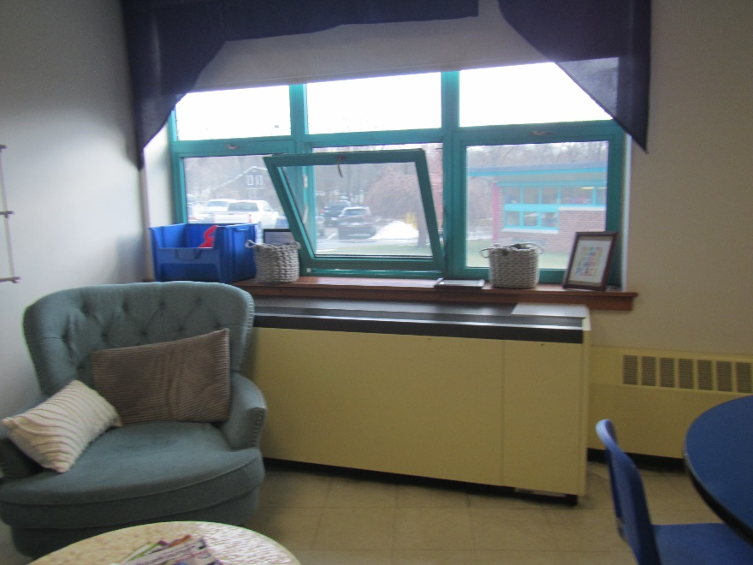

**Unit ventilator (univent) and openable window**

**Picture 2**

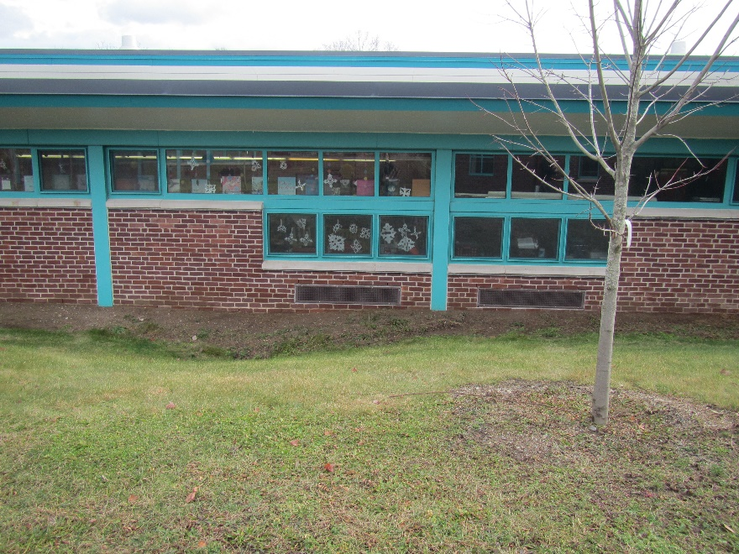

**Univent air intakes under windows**

**Picture 3**

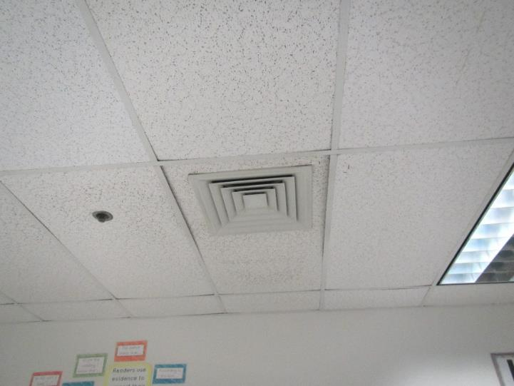

**Typical supply vent from rooftop AHU**

**Picture 4**

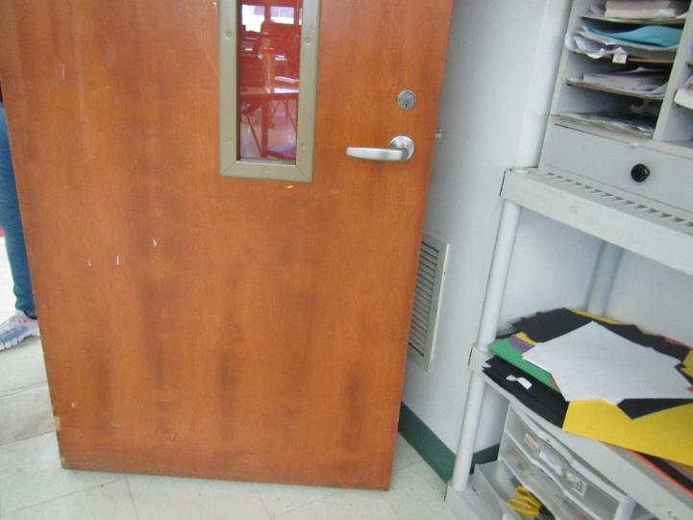

**Typical classroom exhaust vent, note position of open door in front of vent**

**Picture 5**

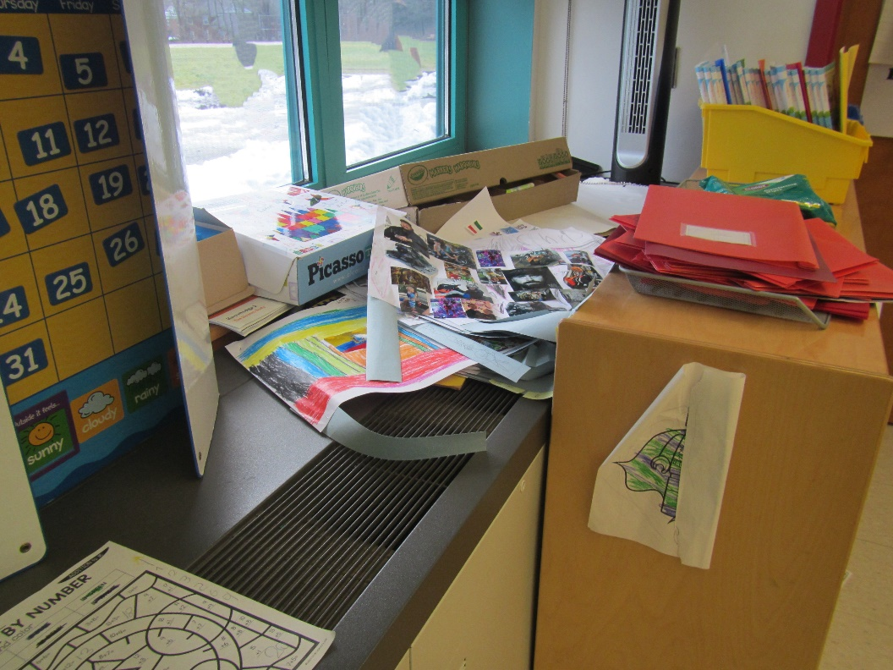

**Univent blocked by furniture and items**

**Picture 6**

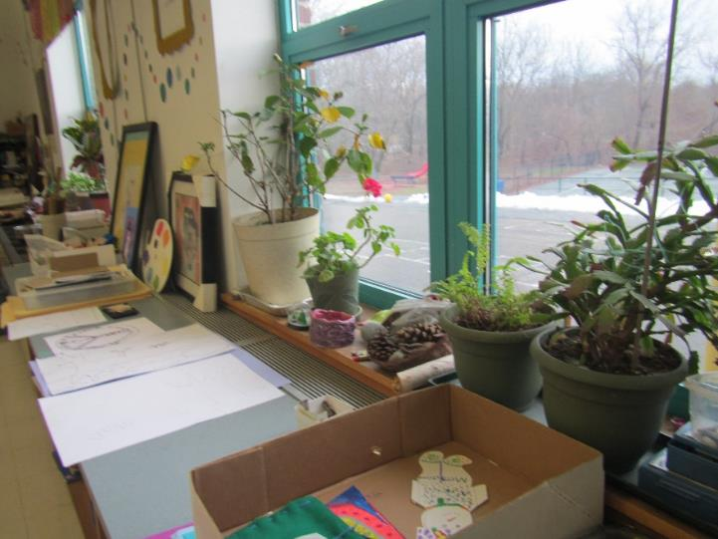

**Classroom plants next to univent air supply**

**Picture 7**

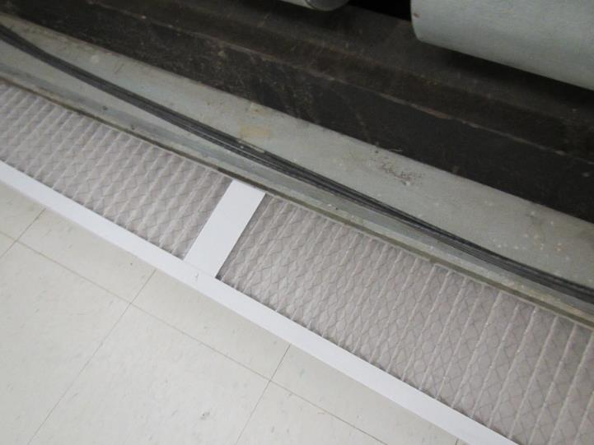

**Univent filter; these are pleated filters with a MERV rating of 8**

**Picture 8**

**Window air conditioner mounted in a wall**

Water Damage and Moisture Concern Pictures

(click to link back to report)

**Picture 9**

**Water damage on pipes near ceiling of music room**

**Picture 10**

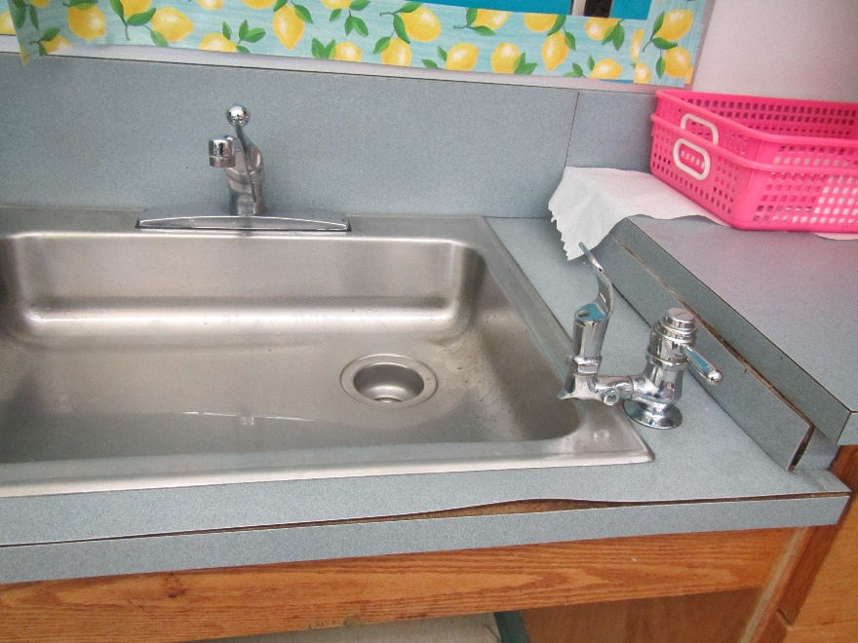

**Damaged countertop and backsplash on classroom sink**

**Picture 11**

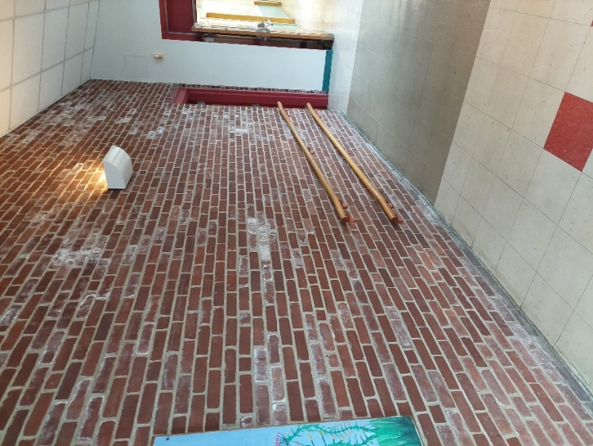

**Hallway connecting 1950s to 1990s wing, note white discoloration on bricks which is efflorescence**

**Picture 12**

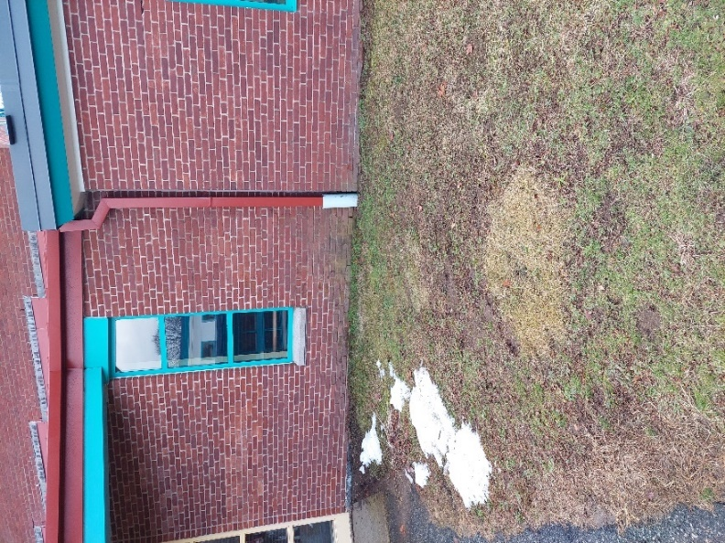

**Exterior wall and window where water penetration may occur**

**Picture 13**

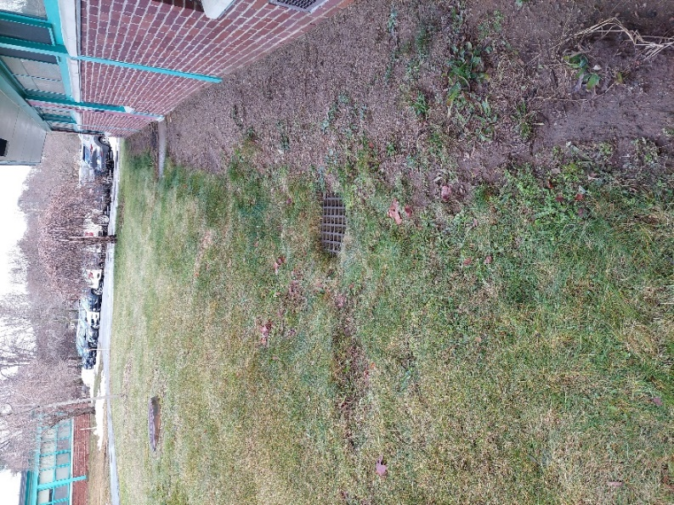

**Storm drain for exterior of 1990s wing, note significant bare ground next to building**

**Picture 14**

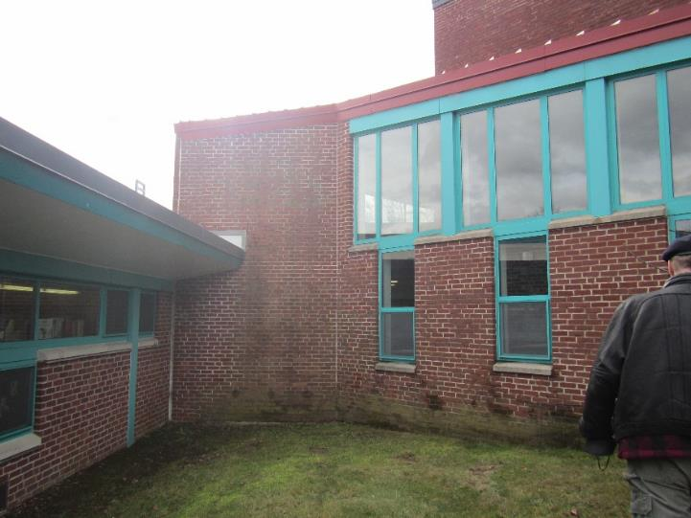

**Roof edge showing lack of downspouts**

**Picture 15**

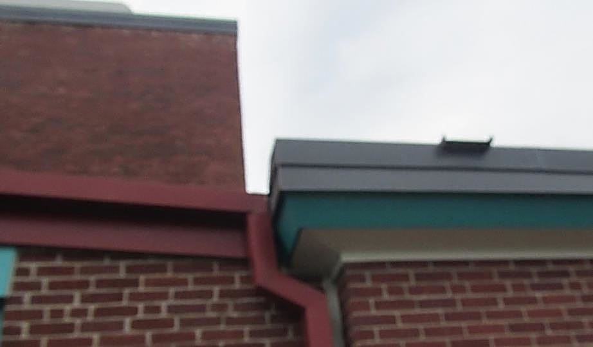

**Scupper on roof edge**

**Picture 16**

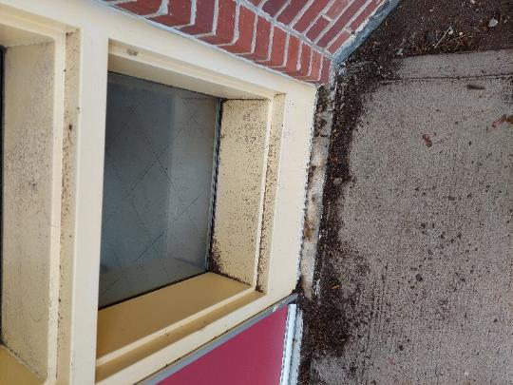

**Missing caulking at window seal**

**Picture 17**

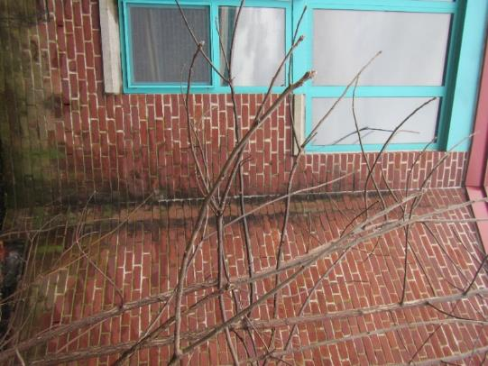

**Interior corner of building showing moss/signs of chronic water exposure**

**Picture 18**

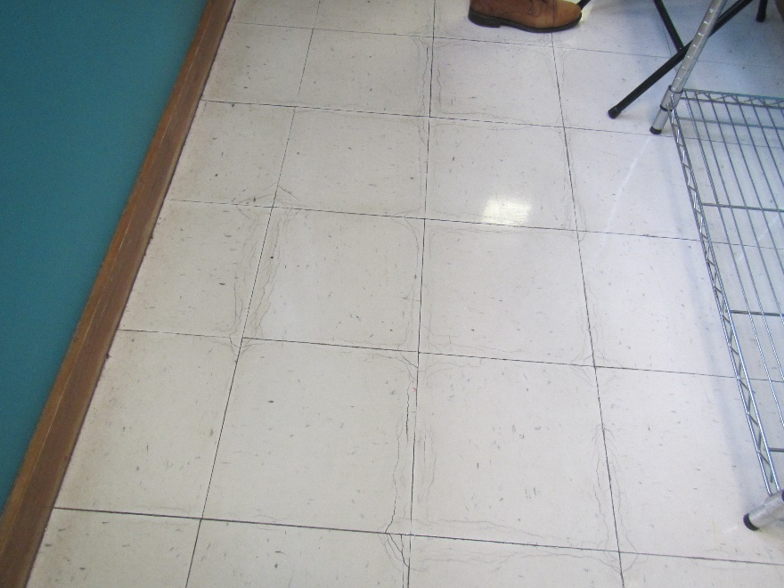

**Floor tiles which may show signs of water exposure**

**Picture 19**

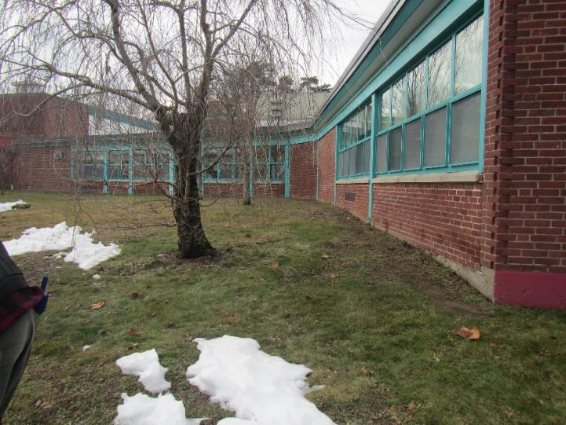

**Tree close to building**

Sources of Respiratory Irritant Pictures

(Click to link back to report)

**Picture 20**

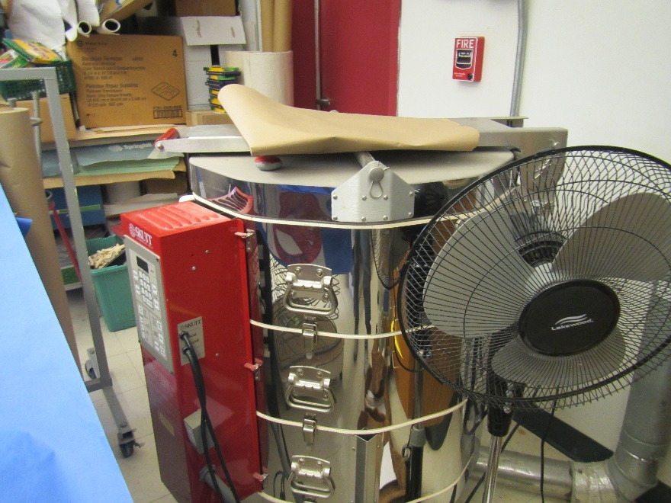

**Kiln in the art room**

**Picture 21**

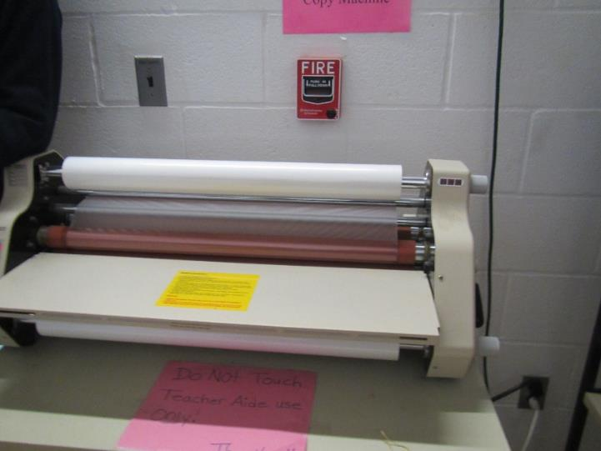

**Laminator in a staff workroom**

**Picture 22**

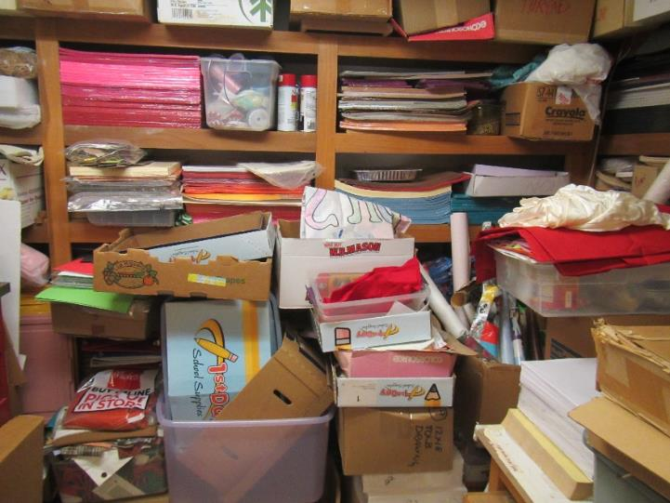

**A collection of items in the art storeroom, including porous items on the floor**

**Picture 23**

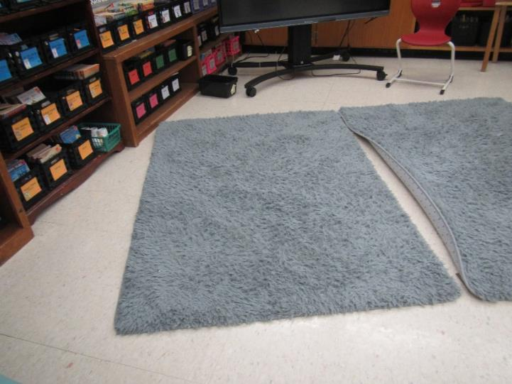

**Area rug**

**Picture 24**

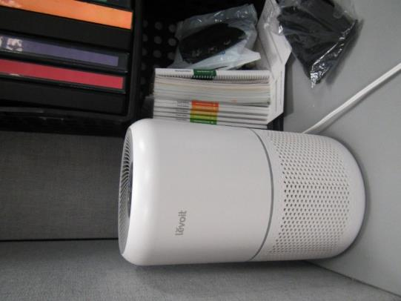

**Air purifier**



| Table 1 **Location** | **Carbon**  **Dioxide**  **(ppm)** | **Carbon Monoxide**  **(ppm)** | **Temp**  **(°F)** | **Relative**  **Humidity**  **(%)** | **PM2.5**  **(µg/m3)** | **Occupants**  **in Room** | **Windows**  **Openable** | **Ventilation** | | **Remarks** |
| --- | --- | --- | --- | --- | --- | --- | --- | --- | --- | --- |
| **Supply** | **Exhaust** |
| Background (outside) | 370 | ND | 55 |  | ND |  |  |  |  | Breezy and intermittent rain |
| Principal’s Office | 508 | ND | 70 | 48 | ND | 6 | Y | Y | Y | Area rug, DEM, AP, pencil sharpener, AC in wall |
| 108 | 452 | ND | 70 | 47 | ND | 3 | N | Y | Y | Bowed CT, WD on insulation of pipe in back, NC, bathroom |
| Conference | 442 | ND | 69 | 46 | ND | 0 | N | Y | Y | AP |
| Main office | 511 | ND | 70 | 46 | ND | 2 | y | Y | Y | DEM, WAC |
| Music | 562 | ND | 70 | 51 | ND | 19 | Y 1 open | Y UV | Y off | Area rug, plants, AP, sink with damaged backsplash, instruments |
| Women’s Staff Restroom |  |  |  |  |  |  |  |  | Y on |  |
| Nurse’s office | 453 | ND | 70 | 44 | ND | 2 | Y 1 open | Y part blocked | Y | Plants |
| Student Services | 598 | ND | 70 | 49 | ND | 3 | N | N | Y off | NC, HS |
| Student Services | 538 | ND | 71 | 46 | ND | 1 | Y | N | Y off | NC |
| Student services | 478 | ND | 70 | 45 | 1 | 1 | Y | Y | Y | Fan, HS |
| Teacher’s Lounge | 424 | ND | 70 | 46 | ND | 1 | Y 1 open | Y | Y | AC in wall, 2 fridges, DEM, sink, lockers |
| Hallway | 453 | ND | 71 | 46 | ND | 0 | Door to outside | N | N | Heater, bowed CT, brick facing |
| Copy Room | 463 | ND |  |  |  | 0 | N |  | N | Laminator, copy machine |
| 35 | 692 | ND | 71 | 49 | ND | 17 | Y | Y UV on, part blocked |  | Area rug, bowed CT, DEM, sink |
| ART | 738 | ND | 71 | 49 | ND | 22 | Y 1 open | Y, 2 UV on |  | Plants on UV, sink dirty, area rug, kiln in room (no kiln exhaust), next to door to outside |
| Art closet |  |  |  |  |  |  | N | Y | Y | Items on floor, NC |
| 46 | 1055 | ND | 71 | 50 | ND | 20 | Y | Y UV blocked | Y, blocked, off | Bowed CT, items, area rug |
| 51 | 700 | ND | 72 | 47 | ND | 24 | Y | Y UV blocked | Y blocked, off | Door, sink, area rug, AP |
| 52 | 508 | ND | 73 | 43 | ND | 16 | Y | Y on | Y blocked, off | UV opened to check filter, MERV 8 pleated style, area rug |
| 53 | 817 | ND | 72 | 48 | ND | 19 | Y | Y off | Y on | Sink, area rug |
| 54 | 765 | ND | 71 | 47 | ND | 15 | Y | Y | Y on | Area rug, sink |
| Gym/auditorium | 867 | ND | 70 | 55 | ND | 20 | N | Y | Y | Curtain for stage |
| Gym office | 702 | ND | 67 | 57 | ND | 0 | N | N | Y | WD CT, rubber balls and other equipment |
| Ms. Keane | 698 | ND | 69 | 53 | ND | 19 | N | Y |  | Area rugs, AP |
| Library | 709 | ND | 72 | 48 | ND | 20 | Y | Y UV | Y | Ceiling fans, area rug |
| Library workroom | 853 | ND | 74 | 46 | ND | 1 | N | N | Y | AP on, rubber balls |
| Library office | 927 | ND | 75 | 45 | ND | 0 | N | N | Y | Shelves, HS |
| Ms. Sheehan | 675 | ND | 74 | 44 | ND | 23 | N | Y | Y | Skylights, mats on floor |
| 25 | 405 | ND | 72 | 41 | ND | 17 | Y 2 open | Y | Y | Sink backsplash damaged, NC, fans |
| 37 | 451 | ND | 72 | 45 | ND | 21 | Y 1 open | Y UV on | Y off | WD CT, area rug |
| 36 | 545 | ND | 72 | 44 | ND | 17 | Y 2 open | Y UV | Y, blocked, on | Area rug, HS, sink, fans, AP |
| 28 (K) | 578 | ND | 72 | 46 | ND | 15 | Y | Y UV | Y, blocked, on | Sink, area rug, 2 bathrooms, AP |
| 29 | 580 | ND | 72 | 46 | ND | 17 | Y | Y | Y, on | 2 bathrooms, area rug, bowed CT, sink, fans |
| 32 | 542 | ND | 73 | 42 | ND | 19 | Y 1 open | Y | Y | Door to outside, sink, bowed CT, area rug |
| 34 | 589 | ND | 71 | 47 | ND | 21 | Y | Y on | Y | Area rug, plush furniture, DEM, bowed CT, sink |
| Cafeteria | 432 | ND | 67 | 48 | ND | ~50 | Y | Y | Y | Doors, NC |
| Testing room | 481 | ND | 70 | 47 | ND | 1 | N | Y | Y | NC, DEM, used to be copy room |
| Baggiano services room | 590 | ND | 71 | 46 | ND | 1 | Y 1 open | Y | Y |  |
| 49 | 609 | ND | 72 | 47 | ND | 18 | Y | Y UV on | Y on | Sink backsplash damaged, AP, rug, class just back |
| 48 | 660 | ND | 73 | 44 | ND | 18 | Y | Y on | Y, on, blocked | Bowed CT, area rug, sink |
| 47 | 625 | ND | 71 | 47 | ND | 20 | Y 1 open | Y | Y blocked | Sink, area rug |

(Click to link back to report)

# Table 2A

|  |  |  |  |  |  |
| --- | --- | --- | --- | --- | --- |
| **Equipment Present in Building**  **(X = Yes)** | **Type of Heating/Cooling Ventilation**  **Equipment** | **Fresh**  **Air**  **Supply**  **(X = Yes)** | **Type of Location(s)** | **Air Filters Installed**  **MERV Rating**  **(1-15, U*)**  **(X = Yes)** | **Comments** |
| X | Univents |  |  |  |  |
| X | Rooftop Air Handling Units |  |  |  |  |
|  | Outdoor, Ground-Installed Air Handling Units |  |  |  |  |
|  | Attic/Crawlspace Air Handling Units |  |  |  |  |
| Maybe | Ceiling-Mounted Air Handling Units (including inside plenum) |  |  |  |  |
|  | Basement/Crawlspace-Installed Air Handling Units |  |  |  |  |
|  | Mechanical Room-installed Air Handling Units |  |  |  |  |
|  | Fan Coil Units |  |  |  |  |
| X | Window-Mounted Air Conditioners |  |  |  |  |
|  | Wall Louver-Controlled Gravity Air Supply |  |  |  |  |
| X | Windows |  |  |  |  |
|  | Fan in window (blowing in) |  |  |  |  |
|  | Built in wall fan (switched) |  |  |  |  |
|  | Heat recovery ventilator unit |  |  |  |  |
|  | Energy recovery ventilator unit |  |  |  |  |
|  | Chilled Beam |  |  |  |  |
|  | Passive combustion supply vent in basement/boiler room |  |  |  |  |

*U = Filter Rating underdetermined due to inaccessibility during building visit

(Click to link back to report)

# Table 2B

|  |  |  |  |  |
| --- | --- | --- | --- | --- |
| **Equipment Present in Building**  **(X = Yes)** | **Type of Exhaust Ventilation**  **Equipment** | **Ducted**  **To Outdoors**  **(X = Yes)** | **Type of Location(s)** | **Comments** |
| X | Rooftop Motors/Fans |  |  |  |
|  | Unit Exhaust |  |  |  |
| X | Ceiling Return Vent |  |  |  |
|  | Ceiling Return Vent, Plenum |  |  |  |
| X | Wall Return Vent |  |  |  |
| X | Kitchen Stove Hood |  |  |  |
| X | Restroom Exhaust Vent |  |  |  |
|  | Photocopier Exhaust Vent |  |  |  |
|  | Garage |  |  |  |
|  | Chemical Hood(s) |  |  |  |
|  | Locker Rooms |  |  |  |
|  | Showers |  |  |  |
|  | Lock up Cells |  |  |  |
|  | Clothes Dryers |  |  |  |
|  | Gas Water Heaters |  |  |  |
|  | Furnace-Flue to Chimney |  |  |  |
|  | Furnace/Boiler direct vent or power vent (no combustion air supply) |  |  |  |
| X | Kiln, Pottery |  |  |  |
|  | Dark Room |  |  |  |
|  | Generator Room |  |  |  |
|  | Wood Shop Dust Collector |  |  |  |
|  | Spray Paint Booths |  |  |  |
|  | Fan in window (blowing out) |  |  |  |

# Table 2C

|  |  |  |  |
| --- | --- | --- | --- |
| **Equipment Present in Building**  **(X = Yes)** | **Type of Equipment** | **Type of Location(s)** | **Comments** |
| X | Floor Fans, pedestal |  |  |
| X | Floor Fans, portable |  |  |
| X | Air Purifier (HEPA, other) |  |  |
| X | Floor heaters, portable |  |  |
| X | Refrigerators, Cold Beverage Vending Machines |  |  |
| X | Radiator, wall-mounted |  |  |
|  | Radiator, floor-mounted |  |  |
|  | Passive Vents (Wall/Door) |  |  |

(Click to link back to report)

# Table 3

| **Found in Building**  **X = Yes** | **Water-Damaged Materials, Building Components or Stored Materials** | **Location** | **Visible Microbial Growth?**  **X = Yes** | **Musty odor detected?**  **X = Yes** | **Comments** |
| --- | --- | --- | --- | --- | --- |
|  | Books-other bound materials |  |  |  |  |
|  | Brick walls – broken, missing mortar |  |  |  |  |
|  | Brick walls – blocked weep holes |  |  |  |  |
|  | Cardboard boxes |  |  |  |  |
|  | Carpet tiles |  |  |  |  |
|  | Carpet - Area rugs |  |  |  |  |
|  | Carpet wall-to-wall |  |  |  |  |
|  | Ceiling tiles - affixed directly to ceiling surface |  |  |  |  |
| X | Ceiling tiles - bowing-in suspended ceiling |  |  |  |  |
|  | Ceiling tiles - water-stained in splined ceiling |  |  |  |  |
| X | Ceiling tiles - water-stained in suspended ceiling |  |  |  |  |
|  | Chairs - laminated |  |  |  |  |
|  | Cloth |  |  |  |  |
|  | Countertops (around sinks) |  |  |  |  |
|  | Curtains |  |  |  |  |
|  | Dust/debris within AHU, uninvent, HVAC, chilled beam units, etc. (WD through condensation, humidity, or leaks) |  |  |  |  |
| X | Efflorescence (i.e., mineral deposits) |  |  |  |  |
|  | Engineered woods - particleboard, plywood, Masonite |  |  |  |  |
| X | Flooring – loosened tiles |  |  |  |  |
|  | Flooring - wooden |  |  |  |  |
|  | Furniture - laminated |  |  |  |  |
|  | Furniture - upholstered |  |  |  |  |
|  | Gypsum wallboard - ceiling |  |  |  |  |
|  | Gypsum wallboard - restroom wall |  |  |  |  |
|  | Gypsum wallboard - interior wall |  |  |  |  |
|  | Gypsum wallboard – located on exterior wall |  |  |  |  |
|  | HVAC drain pan – lack of draining |  |  |  |  |
|  | HVAC filters |  |  |  |  |
|  | Insulation- attic (paper-backed) |  |  |  |  |
|  | Insulation - inside air handling unit |  |  |  |  |
| X | Insulation - on pipe(s) fiberglass | Music room | N | N |  |
|  | Insulation - on pipe(s) other/plaster-like material |  |  |  |  |
|  | Insulation - wall cavity |  |  |  |  |
|  | Insulation – ceiling plenum |  |  |  |  |
|  | Modular furniture – walls/cloth partitions |  |  |  |  |
|  | Musical instrument cases |  |  |  |  |
|  | Plaster ceilings |  |  |  |  |
|  | Records/files |  |  |  |  |
|  | Refrigerator - door gasket |  |  |  |  |
|  | Refrigerator - drip pan |  |  |  |  |
|  | Refrigerator - Interior surfaces |  |  |  |  |
|  | Room divider - ceiling-mounted, sliding |  |  |  |  |
| X | Sink backsplash | multiple classrooms | No | no |  |
|  | Tables – laminated |  |  |  |  |
|  | Wallpaper |  |  |  |  |
|  | Wood - attic/roof materials |  |  |  |  |
|  | Wood - floor joists in basement ceiling |  |  |  |  |
|  | Wood - wall framing |  |  |  |  |
|  | Wood - window sills |  |  |  |  |
|  | Wood - window-mounted air conditioner framing |  |  |  |  |
|  | OTHER |  |  |  |  |

WHAT ARE ENVIRONMENTAL ASTHMA TRIGGERS?

Asthma triggers are any chemical, pollutant, or allergen that can make your asthma worse. Asthma triggers can also be strong chemical smells, dust, or pets. Your asthma triggers may be different from those of other people. Not all asthma triggers affect people the same way. Environmental asthma triggers are found both indoors and outdoors. DPH link: [Asthma and Your Environment (mass.gov)](https://www.mass.gov/doc/asthma-and-your-environment-english/download)

(click to link back to report)

# Table 4

| **Condition Present**  **X = Yes** | **Possible asthma symptom-inducing environmental pollutant** | **Recommendation to reduce or eliminate the pollutant** |
| --- | --- | --- |
| X | Water Damage and/or Mold  (allergen) | Identify water source and repair to eliminate.  Clean non-porous materials.  Remove and replace porous materials susceptible to mold growth.  Perform regular water damage assessments as a tool to ensure timely mitigation as needed.  Use NIOSH water damage assessment protocol as a guide: [NIOSH water damage assessment guideline](https://www.cdc.gov/niosh/docs/2019-115/pdfs/2019-115.pdf?id=10.26616/NIOSHPUB2019115&inf_contact_key=241b5c2ed98c27d94b530dedc36f1623f651f238aa2edbb9c8b7cff03e0b16a0). |
| X | Moistening of building components during hot, humid weather (>2 days in length) (mold, allergen) | Remove materials not dried in <2 days in a manner consistent with [US EPA Mold Removal in Commercial Buildings guideline](https://www.epa.gov/mold/pdf-version-checklist-mold-remediation-mold-remediation-schools-and-commercial-buildings).  Use dehumidification in occupied basement areas and other areas with chronic dampness. |
| X | Vegetation against exterior of building (water damage-mold) | Remove all vegetation preventing building exterior drying.  Remove all vegetation capable of falling onto a building or depositing debris onto the roof. |
|  | Personal humidifiers (lack of proper maintenance)  (pollutant and allergen) | Clean and maintain properly.  Use distilled water to eliminate metal and water treatment odors.  Maintain hydration by increasing water consumption. |
|  | Drains: Floor drains, Sink drains (abandoned use)  Water bubblers (abandoned use) | If in use, pour water into drain at least twice a week.  If not in use, seal the drain with an appropriate material in accordance with Massachusetts Plumbing Code (248 CMR 10.00). |
|  | Live Animals (turtles, gerbils, birds, rabbits, etc.) | Ensure cleanliness or remove animals from the location. |
|  | Improperly maintained aquariums and terrariums (allergen) | Maintain such equipment properly to eliminate odor.  Discontinue use. |
| X | Plants and flowers  (allergen and mold) | Keep indoor plants well maintained and not overwatered. Monitor for signs of mold and pests.  Ensure water for cut flowers does not become stagnant.  Ensure dried plant material is free of odors, mold, and pests and handled carefully  If asthma risks are high, eliminate plants and flowers. |
|  | HVAC system moisture issues  (mold, allergen) | Consult ASHRAE’s minimum standards for HVAC maintenance and inspection of commercial HVAC systems (<https://www.ashrae.org/technical-resources/bookstore/standards-180-and-211>). |
|  | HVAC system contaminant issues (allergen) | Consult ASHRAE’s minimum standards for HVAC maintenance and inspection of commercial HVAC systems (<https://www.ashrae.org/technical-resources/bookstore/standards-180-and-211>). |
|  | Indoor swimming pool odors outside of swimming pool (mold, chemical) | Maintain and operate pool HVAC systems to vent odors from building.  Ensure locker room exhaust vents are operating during building hours.  All doors leading to pool should be rendered airtight and be closed. |
|  | Pollen (allergen) | Recommend installation of MERV 8 or better filters if HVAC engineer confirms HVAC system can be so equipped without adversely affecting function.  Cut grass after hours.  Cut grass in a pattern to direct clippings away from exterior wall.  Remove trees and shrubs from in front of windows and air intakes. |
|  | Dry air | Maintain hydration.  Avoid overheating of air. |
|  | Dust mites  (allergen) | Recommendation to remove non-official upholstered furniture, area rugs, pillows, cushions, etc.  Cleaning with use of HEPA-filtered vacuum cleaner.  Eliminating clutter, storing items in dust and moisture-proof containers, and regularly removing dust through wet wiping. |
|  | Pests, including rodents and cockroaches  (allergen) | Use of integrated pest management guidelines, including:   * Proper disposal of food containers * Proper storage of food products in airtight containers * Elimination of use of food as art projects * Remove pest harborages/clutter * Regular monitoring for pests   [EPA IPM guideline link](https://www.epa.gov/ipm/introduction-integrated-pest-management) |
|  | Latex-containing materials | Remove tennis balls from furniture legs. |
|  | Fragrances  (chemical) | Eliminate point sources, such as:   * Plug-in air fresheners * Aroma/oil reed diffusers * Scented sprays * Discontinue use of other scented materials * Consult DPH fragrance guideline: [*Clean air is odor-free*](https://www.mass.gov/doc/clean-air-is-odor-free-removing-fragrances-to-improve-indoor-air-quality-in-schools-and-0/download) |
|  | Strong smells from /use of Chemicals (such as cleaning products)  (chemical) | Use building-issued cleaning products.  Use products in accordance with manufacturer’s instructions including dilution, application, and ventilation.  Avoid using products that are stronger than needed for the situation. |
|  | Strong odors from new building materials (carpeting/furniture)  (chemical) | Use low VOC-emitting materials.  Air out materials (outside or in unoccupied area) prior to installation. |
|  | Tobacco smoke  Secondhand Smoke  (pollutant) | Eliminate tobacco smoking.  Seal all shared wall penetrations. |
|  | Products with a strong odor such as paint, perfume, hairspray, air fresheners, bug-spray, laminators, candles, wax melters, dry erase markers and other VOC-containing products  (chemical) | If essential:   * Provide proper exhaust ventilation to eject aerosolized product directly outdoors. * Avoid/reduce use during occupied hours.   If not necessary, remove and eliminate. |
|  | Vehicle exhaust  (pollutant) | Enforce anti-idling regulations and post signs to give notice.  Relocate vehicles away from fresh air intakes.  Require cars to park face-in at building walls.  [MA anti-idling law FAQs](https://www.mass.gov/files/documents/2018/02/20/idling-faq.pdf#:~:text=The%20Massachusetts%20Anti-Idling%20Law%20The%20goal%20of%20the,sometime%20wonder%20when%20idling%20might%20be%20considered%20necessary.) |
|  | Vapors and or fumes from gas, oil, or kerosene stoves  (pollutant) | Operate stove hood when stove in use.  Install stove hood if not present.  Ensure equipment is in good working order. |
|  | Ozone (pollutant) | Eliminate use of ozone generating equipment. |
| X | Window Air Conditioners (if not properly maintained) (allergen) | Equip with proper filter and clean periodically.  Clean drip pans.  Install in window with weathertight, non-mold-growth sustaining material. |
| X | Pottery (pollutant) | Do not operate kiln during occupied hours.  Operate kiln with exhaust system activated.  Seal all seams and holes in kiln vent.  Ensure kiln exhaust discharge terminates outdoors. |
| X | Carpeting (allergen) | Clean carpeting in a manner consistent with IICRC standards, including regular vacuuming with a high efficiency particulate air (HEPA) filtered vacuum in combination with annual cleaning or semi-annual cleaning in soiled high traffic areas. |
|  | Sweeping/dusting vs HEPA vacuuming/wet wiping  (allergen or pollutant) | Refrain from using feather dusters or brooms.  Utilize HEPA vacuums and wet wiping to minimize aerosolizing particulate matter. |
|  | Lack of adequate air exchange/mechanical ventilation | Make repairs as necessary and ensure all HVAC system components are operating continuously when building is occupied. |
|  | Lack of local exhaust at source of pollution (vocational shop activities, kitchen exhaust hood) (all) | Recommend installation of exhaust ventilation to direct pollutants directly outdoors. |
|  | Renovating buildings while occupied  (chemical) | Use all SMACNA guidelines for Renovation While Buildings Are Occupied. For information, visit <https://www.mass.gov/service-details/construction-and-renovation-generated-pollutants-in-occupied-buildings>. |
|  | Chemistry program chemical storage  (chemical) | Repair (if needed) and operate chemical storeroom vents appropriately.  Reduce or eliminate unneeded or overstocked chemicals.  Store all chemicals in a manner to separate incompatible chemicals.  Keep chemical storerooms clean. |
| X | Photocopiers/duplicating machines | All machines must have dedicated exhaust vents. |