HIP Community Partners

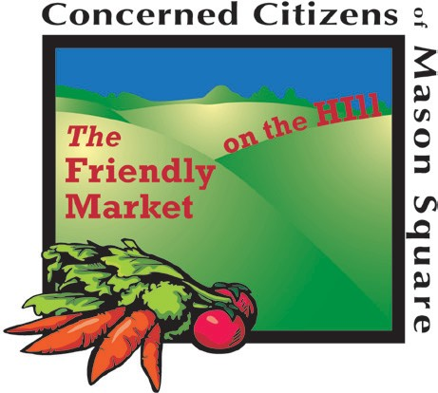Did you know? HIP is working with over 75 community organizations, agencies, hospitals, and churches across Hampden County. A complete list can be found at www.mass.gov/dta/hip. For more information on HIP please call the DTA HIP call-line: 1-888-987-4487.

Agawam Public Library • Agawam Senior Center • American Heart Association • Boston Collaborative for Food and Fitness and Boston Bounty Bucks • Brightwood Health Center • Catholic Charities- Dioceses of Springfield
- Chicopee Public Library • City of Springfield MASS in Motion • Community Involved in Sustaining Agriculture (CISA) • CommunityMusicSchoolofSpringfield • Concerned Citizens of Mason Square • Department of Agricultural Resources • Department of Children and Families • Department of Developmental Services • Department of Early Education and Care • Department of Elder Affairs • Department of Housing and Community Development
- Department of Public Health • Department of Public Health - WIC Local Office • Department of Public Health- WIC • Department of Youth Services • Enlace de Familia
- Executive Office of Education & the Department of Elementary & Secondary Education • Executive Office of Elder Affairs • Executive Office of Health and Human Services • Federation of Massachusetts Farmers Markets
- Food Bank of Western Massachusetts • Gandara Center • Gardening the Community • HAP Housing • Holyoke Community College • Holyoke Food & Fitness Policy Council • Holyoke Girls Inc. • Holyoke Heritage Park Visitor Center • Interagency Council on Housing and Homelessness • Jewish Family Services • Lorraine’s Soup Kitchen and Pantry • Ludlow Adult Learning Center
- Ludlow Hubbard Library • Lutheran Social Services
- MA Farm to School Project • MA Food SNAP Coalition • Martin Luther King Community Center • Mason Square Library • Massachusetts Food Association
- Massachusetts Office of Refugees and Immigrants • Mercy Medical Center • New North Citizens Council
- Noble Hospital • North End Campus Coalition • Nuestras Raices • Office of Medicaid • Open Pantry • Our Lady of Guadalupe Parish • OWL Adult Education Center
- Palmer Library • Partners for a Healthier Community
- Pioneer Valley Planning Commission • Project Bread
- Providence Ministries • Riverview Senior Center • Russian Community Association of Massachusetts • SHINE • Springfield Central Library • Springfield Partners for Community Action • Square One • St. Anthony of Padua Parish • St. Michael’s Cathedral • Trial Court - Housing Department in Western Division • United Way of Pioneer Valley • University of Massachusetts, School of Public Health and Health Sciences • Vietnamese Health Project at Mercy Medical Center • West Springfield Library
- Western MA Network to End Homelessness • Western MA Refugee and Immigrant Coalition • YMCA of Greater Springfield



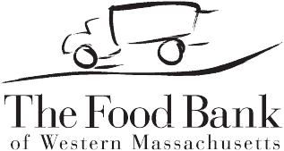

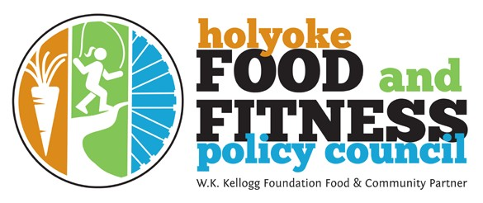

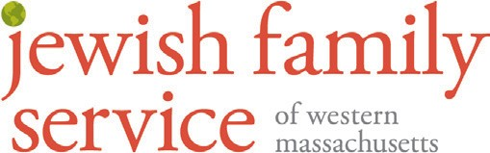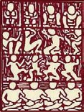NewNorthCC.org
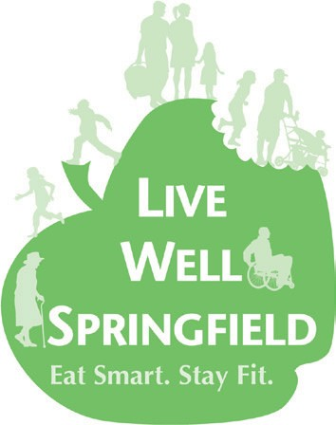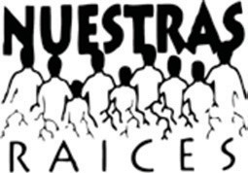New North Citizens’ Council

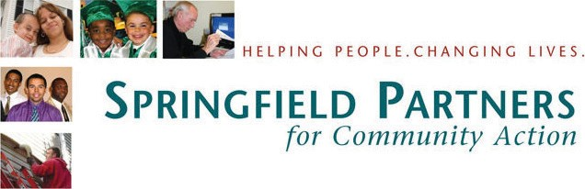A pilot of the Massachusetts Department of Transitional Assistance

Socios HIP de la Comunidad

¿Sabía usted que? HIP está trabajando en más de 75 organizaciones de la comunidad, agencias, hospitales e iglesias de todo el Condado Hampden. Encontrará la lista completa en www.mass.gov/dta/hip. Para obtener más información sobre HIP, favor de llamar a la línea DTA de HIP: 1-888-987-4487.

Agawam Public Library • Agawam Senior Center • American Heart Association • Boston Collaborative for Food and Fitness and Boston Bounty Bucks • Brightwood Health Center • Catholic Charities- Dioceses of Springfield
- Chicopee Public Library • City of Springfield MASS in Motion • Community Involved in Sustaining Agriculture (CISA) • CommunityMusicSchoolofSpringfield • Concerned Citizens of Mason Square • Department of Agricultural Resources • Department of Children and Families • Department of Developmental Services • Department of Early Education and Care • Department of Elder Affairs • Department of Housing and Community Development
- Department of Public Health • Department of Public Health - WIC Local Office • Department of Public Health- WIC • Department of Youth Services • Enlace de Familia
- Executive Office of Education & the Department of Elementary & Secondary Education • Executive Office of Elder Affairs • Executive Office of Health and Human Services • Federation of Massachusetts Farmers Markets
- Food Bank of Western Massachusetts • Gandara Center • Gardening the Community • HAP Housing • Holyoke Community College • Holyoke Food & Fitness Policy Council • Holyoke Girls Inc. • Holyoke Heritage Park Visitor Center • Interagency Council on Housing and Homelessness • Jewish Family Services • Lorraine’s Soup Kitchen and Pantry • Ludlow Adult Learning Center
- Ludlow Hubbard Library • Lutheran Social Services
- MA Farm to School Project • MA Food SNAP Coalition • Martin Luther King Community Center • Mason Square Library • Massachusetts Food Association
- Massachusetts Office of Refugees and Immigrants • Mercy Medical Center • New North Citizens Council
- Noble Hospital • North End Campus Coalition • Nuestras Raices • Office of Medicaid • Open Pantry • Our Lady of Guadalupe Parish • OWL Adult Education Center
- Palmer Library • Partners for a Healthier Community
- Pioneer Valley Planning Commission • Project Bread
- Providence Ministries • Riverview Senior Center • Russian Community Association of Massachusetts • SHINE • Springfield Central Library • Springfield Partners for Community Action • Square One • St. Anthony of Padua Parish • St. Michael’s Cathedral • Trial Court - Housing Department in Western Division • United Way of Pioneer Valley • University of Massachusetts, School of Public Health and Health Sciences • Vietnamese Health Project at Mercy Medical Center • West Springfield Library
- Western MA Network to End Homelessness • Western MA Refugee and Immigrant Coalition • YMCA of Greater Springfield

NewNorthCC.org
New North Citizens’ Council

Un programa piloto del Departamento de Asistencia Transicional de Massachussetts

