Overview of HIPAA Claims Status Report
The HIPAA Claim Status Report will aid providers using HIPAA and allow them to conduct their own reconciliation activities. This report is run through the Reports Module in EIM/ESM and is generated using the same steps as all EIM/ESM reports.

How does it work?
Report input parameters include provider name, service date from/service date to, and services to include. Due to the amount of data included in this report, it is recommended that you complete the criteria for both the required and optional fields prior to running this report. The report can be run to display in Excel or in PDF format.

What information does the report contain?
The HIPAA Claim Status Report displays the following:
- Only 277 Rejections (Only services that rejected on the 277 file)
- Only Claims which persisted (Only services that persisted in EIM)
- All Services (Services that both rejected on the 277 file and persisted in EIM/ESM)
The report will default to the “All Services” view when run.
Reports > HIPAA Claims Status Report
- Select the Reports module.

From the Reports page,

- Click the [HIPAA Claim Status Report] link.

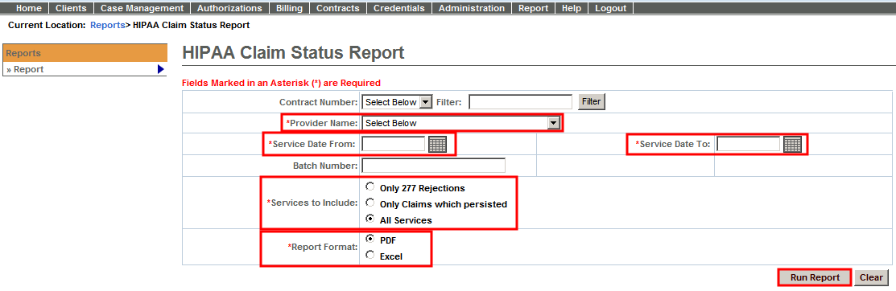
- Select [Contract Number] from the drop-down menu. This is an optional field.
Note: Search for a contract using the Filter field. The wildcard (%) symbol can be used
Tip: This optional field will help to narrow the search if your organization has many contracts in EIM.
- Select the [*Provider Name] from the drop-down menu.
- Enter [*Service Date From].
- Enter [*Service Date To].
- Enter [Batch Number].
Tip: This optional field will help to narrow the search if the organization submitted many batches.
- Select [*Services to Include].
- Only 277 Rejections (Only services that rejected on the 277 file)
- Only Claims which persisted (Only services that persisted in EIM)
- All Services (Services that both rejected on the 277 file and persisted in EIM/ESM)
- Select [*Report Format].
- PDF
- Excel
- Click the [Run Report] button.
Note: The Clear button clears all criteria on page.
HIPAA Claims Status Report - Sample Output

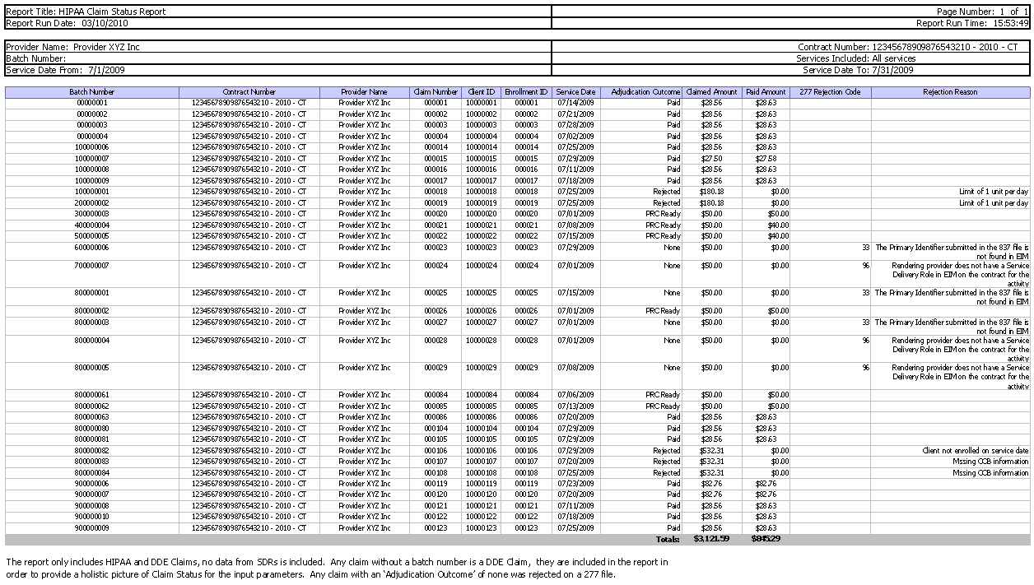
Understanding the HIPAA Claims Status Report
How do I read the report?
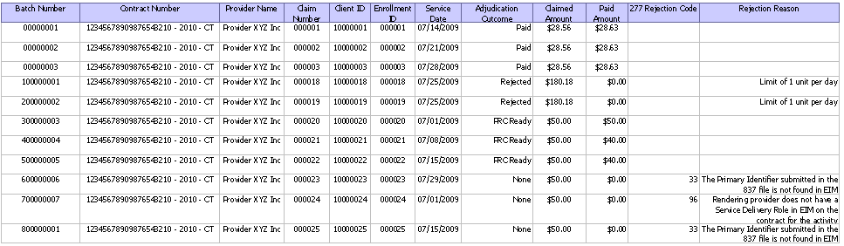
Adjudication Outcome: The current status of the service (will display ‘None’ if it was rejected on a 277).
Claimed Amount: The claimed amount for that individual service (not the claimed amount for the entire service line or claim).
Paid Amount: The paid amount by the agency for that particular service (not the entire service line or claim; will display $0 for a claim rejected on the 277).
277 Rejection Code: The error code for the 277 Rejection (See Table A for listing of 277 Rejection Codes/Reasons).
Rejection Reason: The rejection reason is applicable for claims that reject on both the 277 files and/or during normal EIM adjudication.
- For claims rejecting on the 277 file, the rejection reasons will display in this column. (See Table A for listing of 277 Rejection Codes/Reasons)
- For claims rejecting during EIM adjudication, the rejection reason will display in this column. Example: ‘Limit 1 Unit of Service per Day’. These claims will not have a reason code.
Table A: 277 Rejection Code/Reasons

277 Rejection Code | EIM Description (Adjudication) | Rejection Reason
21 | Claim Frequency Type Code = “6” (at Claim Level) and the Claim Original Reference Number does not exist. | The claim original reference number submitted in the 837 file is not valid in EIM.
21 | Claim Frequency Type Code = “7” (at Claim Level) and the Claim Original Reference Number does not exist. | The claim original reference number submitted in the 837 file is not valid in EIM.
21 | Claim Frequency Type Code = “8” (at Claim Level) and the Claim Original Reference Number does not exist. | The claim original reference number submitted in the 837 file is not valid in EIM.
21 | Claim Frequency Type Code = “6” (at Claim Level) and the Claim Original Reference Number is null. | The claim original reference number submitted in the 837 file is invalid.
21 | Claim Frequency Type Code = “7” (at Claim Level) and the Claim Original Reference Number is null. | The claim original reference number submitted in the 837 file is invalid
21 | Claim Frequency Type Code = “8” (at Claim Level) and the Claim Original Reference Number is null. | The claim original reference number submitted in the 837 file is invalid
21 | When claim frequency code is 1,2,3,4,5 and original claim number is present in XML. | When using claim frequency codes of 1, 2, 3, 4 or 5 do not submit a Claim Original Reference Number with the claim.
26 | Billing Organization (at Claim Level) does not exist within the system. | Billing Organization at claim level does not exist in EIM.
26 | Rendering Provider Organization (at Claim Level or Service Line level) (if information is submitted) does not exist within the system. | Rendering Provider Organization does not exist in EIM.
26 | Service Facility Organization (at Claim Level or Service Line level) does not exist within the system. | Service Facility Organization does not exist in EIM.
28 | Activity (at Claim Level) does not exist within the system. | The activity code submitted in the 837 file is not associated to the contract being billed.
30 | Subscriber and Subscriber ID mismatched. | The claim in the 837 file is attempting to replace, correct or void a prior claim but the Primary Identifier submitted in the file does not match the Primary Identifier of the original claim
33 | Client (at Claim Level) does not exist within the system. | The Primary Identifier submitted in the 837 file is not found in EIM.
48 | Prior Authorization or Referral Number does not contain a numeric value. | The Prior Authorization or Referral Number does not contain a numeric value.
54 | There exists a duplicate claim within the same batch that has the same activity, contract, client ID, and frequency code and service date. | There exists a duplicate claim in EIM for the same batch number that has the same activity, contract, primary identifier, service code and service date.
91 | No enrollment exists in EIM on service dates. | For the service dates identified in the 837 file there are no enrollments in EIM.
91 | Only Draft/Denied/pending Enrollment exists for the client. | The client identified in the 837 file is only associated with draft, denied or pending enrollments in EIM.
91 | No enrollment found at all for the client. | The client identified in the 837 file has no enrollments in EIM.
91 | No enrollment exists for the contract. | The contract identified in the 837 file has no enrollments in EIM.
96 | Contract (at Claim Level) does not exist within the system. | The contract number submitted in the 837 file is not found in EIM.
96 | More than one Contract (comparing the Claim Level and Service Line Level) exists within the claim. | There are multiple contract numbers submitted within the claim. Only one CN1 segment should be present per claim.
96 | Rendering Provider Organization (at Claim Level or Service Line Level) (if information is submitted) does not have a Service Delivery Role on Contract and for Activity. | Rendering provider does not have a Service Delivery Role in EIM on the contract for the activity.
96 | Service Facility Organization (at Claim Level or Service Line Level) does not have a Service Delivery Role on Contract and for Activity. | Service Facility Organization does not have a Service Delivery Role in EIM on the contract for the activity.
96 | Billing Organization is not the Contracting Organization within the system. | Billing Organization submitted in 837 file is not the Contracting Organization in EIM.
96 | Service facility location is not a service provider in the system. | Service Facility Location does not have a Service Delivery Role in EIM on the contract for the activity
476 | Unit qualifier is missing or not valid for this submission or the number of units does not match the number of days of service. | The unit qualifier is missing or not valid for this claim or the number of units submitted do not match the number of days of service.
479 | Other Carrier payer ID is missing or invalid. | The Other Payer Primary Identifier is missing from COB portion of claim or invalid in EIM.
493 | Diagnosis Code(s) (at Claim Level) contained within the claim does not exist within the system. | The diagnosis code submitted in the 837 file at claim level does not exist in EIM.
493 | Taxonomy Code (at Claim Level) for Billing Provider does not exist within the system. | The taxonomy code submitted in the 837 file for the billing provider does not exist in EIM.
493 | Taxonomy Code (at Claim Level or Service Line Level) for Rendering Provider does not exist within the system. | The taxonomy code submitted in the 837 file for the rendering provider does not exist in EIM.
493 | Facility Code (at Claim Level or Service Line level) does not exist within the system. | The facility code submitted in the 837 file does not exist in EIM.
493 | Claim Frequency Code (at Claim Level) does not exist within the system. | The claim frequency code submitted in the 837 file at claim level does not exist in EIM.
493 | Release of Information Code (at Claim Level or Service Line level) does not exist within the system. | The release of information code submitted in the 837 file does not exist in EIM.
493 | Delay Reason Code (at Claim Level) does not exist within the system. | The delay reason code submitted in the 837 file at claim level does not exist in EIM.
493 | Provider or Supplier Signature Indicator (at Claim Level) does not exist within the system. | The provider or supplier signature indicator submitted in the 837 file at claim level does not exist in EIM.
493 | Medicare Assignment Code (at Claim Level) does not exist within the system. | The Medicare assignment code submitted in the 837 file at claim level does not exist in EIM.
493 | Assignment of Benefits Indicator (at Claim Level) does not exist within the system. | The assignment of benefits indicator submitted in the 837 file at claim level does not exist in EIM.
493 | Patient Signature Source Code (at Claim Level) does not exist within the system. | The patient signature source code submitted in the 837 file at claim level does not exist in EIM.
493 | The claim filing indicator does not exist within the system. | The claim filing indicator submitted in the 837 file at claim level does not exist in EIM.
493 | The note reference code does not exist within the system. | The note reference code submitted in the 837 file at claim level does not exist in EIM.
493 | The attachment report type code or attachment transmission code does not exist within the system. | The attachment report type code or attachment transmission code submitted in the 837 file at claim level does not exist in EIM.
493 | The unit or basis of measurement code does not exist within the system. | The unit or basis of measurement code submitted in the 837 file at claim level does not exist in EIM.
493 | The claim note reference code does not exist within the system. | The claim note reference code submitted in the 837 file at claim level does not exist in EIM.
493 | The revenue code submitted in the 837 file at claim level does not exist in EIM. | The revenue code submitted in the 837 file at claim level does not exist in EIM.
493 | Principal Diagnosis does not exist in EIM. | The Principal Diagnosis Code submitted in the 837 file does not exist in EIM.
493 | Admitting Diagnosis does not exist in EIM. | The Admitting Diagnosis Code submitted in the 837 file does not exist in EIM.
499 | Service Code(s) (at Service Line Level) contained within the claim does not exist within the system. | The service code submitted in the 837 file at service line level is not associated to the contract being billed.

Additional Learning Opportunities
192 HIPAA Billing and Claim Level Reconciliation CBT – To take online course, log into PACE.
Questions or need assistance?
Call Virtual Gateway Customer Service
1-800-421-0938
(617-847-6578 - TTY for the deaf and hard of hearing)
8:30 am to 5:00 pm Monday through Friday

