CHAPTER I:
HISTORY AND TRENDS

June 2017

Foodborne illness in the U.S. is a major cause of personal distress, social disruption, preventable death and avoidable economic burden. The Centers for Disease Control and Prevention (CDC) estimates that each year, roughly 1 in 6 Americans (48 million people) get sick, 128,000 are hospitalized, and 3,000 die of foodborne disease. These numbers are much less than reported in the first edition of this manual published in 1997, but the economic impact remains staggering. While it is difficult to put a price tag on the economic loss to industry, estimates are at $152 billion in the U.S. alone. (1)

A. Background on Foodborne Illness

The microbiologic hazards associated with food and food preparation are receiving increasing public attention. They are causing increasing concern, not only among consumers, but also among those involved in all facets of food production and distribution. Historically, most foods were produced and consumed locally. Modern production and distribution of foods, however, have become highly complex, and involve global distribution of many kinds of fresh and processed food products. One has to merely browse the aisles of the local grocery store to witness the tremendous influx of food products from throughout the world. While the benefits of the availability of such a variety of foods are many, the potential for the transmission of foodborne pathogens to large populations, spread over large geographic areas, also increases.

"In 2015, CDC monitored between 17 and 40 potential food poisoning or related clusters each week, and investigated more than 195 multistate clusters. These investigations led to the identification of confirmed or suspected vehicles of transmission and the recalls of a variety of foods including chicken, pork, sprouts, cheese, ice cream, nut butter, cucumbers and raw frozen tuna." (2)

Figure 1-1: Factors Associated with the Increase in Emerging and Re-emerging Infectious Diseases

Population growth Crowding
Changes in agriculture and food practices Microbial evolution
Changes in ecology and climate Modern travel
Animal migration Animal relocation
Inadequacy of public infrastructure Population shifts

B. A National Overview of Foodborne Illness

Public health surveillance is the foundation of communicable disease epidemiology and an essential component of a food safety program. Multiple types of surveillance systems are in place throughout the country and each plays an important role in detecting and preventing foodborne illness outbreaks in the U.S. Some examples include: notifiable disease surveillance; consumer complaints of suspect food-related illness and reports of outbreaks; the Foodborne Diseases Active Surveillance System (FoodNet); the National Molecular Subtyping Network for Foodborne Disease Surveillance (PulseNet); and the National Outbreak Reporting System (NORS).

"FoodNet is a collaboration among CDC, 10 state health departments, the U.S. Department of Agriculture's Food Safety and Inspection Service (USDA-FSIS), and the Food and Drug Administration (FDA). FoodNet conducts active, population-based surveillance for laboratory-confirmed infections caused by Campylobacter, Cryptosporidium, Cyclospora, Listeria, Salmonella, Shiga toxin-producing Escherichia coli (STEC), Shigella, Vibrio, and Yersinia in 10 sites covering approximately 15% of the U.S. population (an estimated 49 million persons in 2014). Confirmed infections are defined as culture-confirmed bacterial infections and laboratory-confirmed parasitic infections (e.g., identified by enzyme immunoassay)." (3)

Figure 1-2: Data from FoodNet on progress towards 2020 goals.
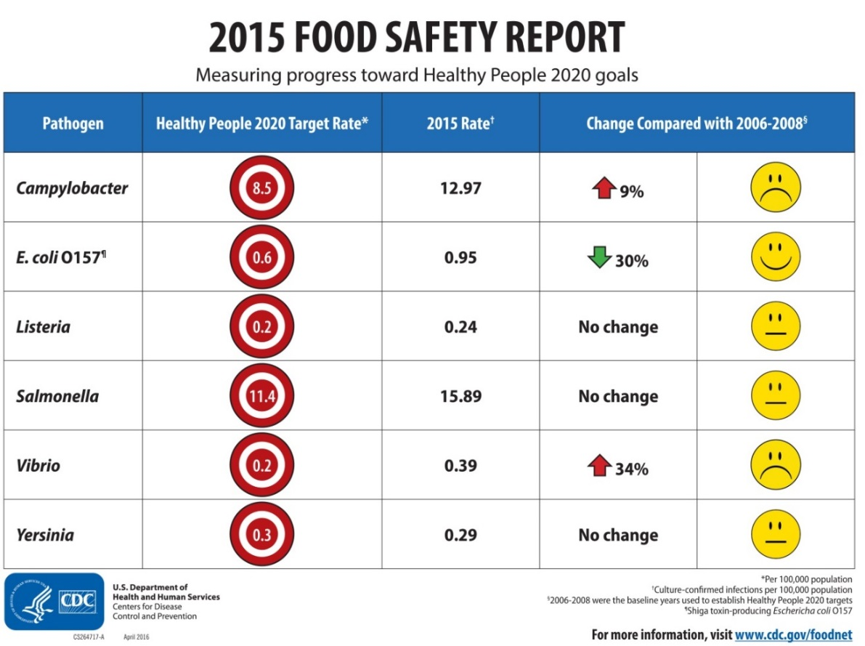

PulseNet, celebrating its 20th anniversary in 2016, is the national network of local, state or territorial, and federal laboratories coordinated by CDC, that has become the cornerstone in foodborne illness outbreak investigations on the national level. It allows comparison of subtypes of pathogens isolated from humans, animals, and food across local, state and national jurisdictions. The name is derived from pulsed-field gel electrophoresis (PFGE), the laboratory method used to determine the molecular fingerprints of bacteria that cause illness. This system allows CDC to look at and compare the PFGE patterns of thousands of isolates of Salmonella and STEC and determine if the numbers are above baseline or geographically or temporarily clustered, suggesting an outbreak that needs further investigation. It is presumed that isolates that share the same PFGE pattern also share a common exposure. This allows investigators to focus their attention on the matching isolates to hopefully identify the source of the outbreak more quickly, thus removing the suspect food from the market place.

"In 2013, PulseNet began using whole genome sequencing (WGS) to detect outbreaks caused by Listeria, the most deadly foodborne pathogen. PulseNet is quickly expanding the use of WGS in state laboratories and has begun using WGS in investigations of other foodborne pathogens such as Campylobacter, E. coli, and Salmonella. With incorporation of WGS and other advanced molecular detection methods, PulseNet will continue to improve foodborne disease detection and identify outbreaks faster and with more accuracy." (4)

The National Outbreak Reporting System (NORS) is a web-based platform used by local, state and territorial health departments in the United States to report all waterborne and foodborne disease outbreaks and enteric disease outbreaks transmitted by contact with environmental sources, infected persons or animals, or unknown modes of transmission to CDC. The platform was launched in 2009. The NORS data from 2014 to 2015 reported 1,769 outbreaks; 28,313 illnesses; 1,645 hospitalizations; and 37 deaths. (5)

The need for resources for foodborne illness investigation at all levels cannot be overstated. In addition, resources for laboratory investigations are necessary. Testing methods for certain parasites and viruses are difficult and often unavailable. Also, testing for staphylococcal, Bacillus cereus or Clostridium perfringens toxins is not commonly performed. Consequently, laboratory confirmation of the causative organism is not available for over half of the foodborne disease outbreaks reported to the CDC. The increased use of culture-independent diagnostic tests (CIDTs) without culture-confirmation, has affected the interpretation of public health surveillance data and our ability to monitor progress toward achieving prevention goals. Despite the challenges, continued surveillance of disease at a national level is imperative and will be achieved only through continued surveillance at state and local levels.

Figure 1-3: Outbreaks Reported in the U.S., 1973-2010 from CIFOR, page 68.

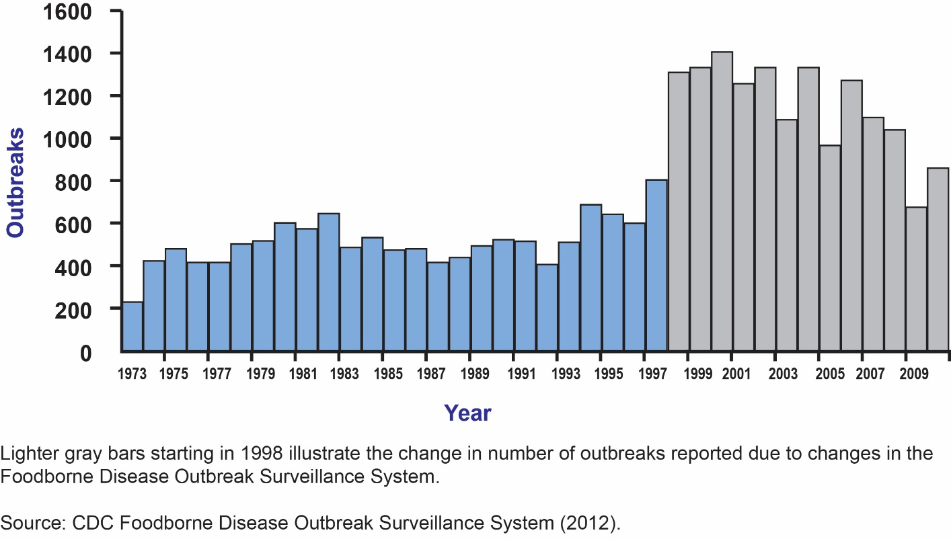

C. A Massachusetts Overview of Foodborne Illness

In 1986 MDPH formed the Working Group on Foodborne Illness Control (WGFIC), a multi-disciplinary team, consisting of epidemiologists from the Epidemiology Program of the Bureau of Infectious Disease, laboratorians from the Bureau of Laboratory Sciences, and food safety and environmental specialists from the Food Protection Program (FPP) in the Bureau of Environmental Health, all within MDPH, to track cases and complaints of foodborne illness. The earlier problems are recognized, the quicker control measures may be implemented and additional cases of illness prevented. For this reason, it is important to track consumer complaints, and review the data periodically for clusters of illness, or changes in trends of illness. Changes in the occurrence of disease compared to previous time periods may necessitate further investigation.

Figure 1-4 below shows the number of multi-person complaints received by year, 2006 through 2015, and figure 1-5 reflects the number of single person complaints received for the same time period. The number of single complaints (n=473) received in 2015 is 31% higher than the mean number of annual single complaints (n=361) received during the previous nine years. Figure 1-6 shows the total number of people reported ill by month from all initial complaints received in 2015. Figure 1-7 reflects the number of complaints received by category of infectious agent. Diagnoses of specific infections are only recorded for initial complaints when at least one ill person has visited a healthcare provider and received a specific diagnosis. Figure 1-8 further breaks down the largest category of bacterial pathogen diagnoses with 42% due to non-typhoidal Salmonella sp. Many complaints (37%) were not associated with a specific infection diagnosis, due in large part to individuals not seeking medical attention. Additionally, some individuals who do see a healthcare provider do not have a specific diagnosis made. Diagnostic information is based on information provided during the initial report and may not reflect subsequent diagnoses.

Figure 1-4: Number of multi-person complaints received by WGFIC by year, 2006 – 2015

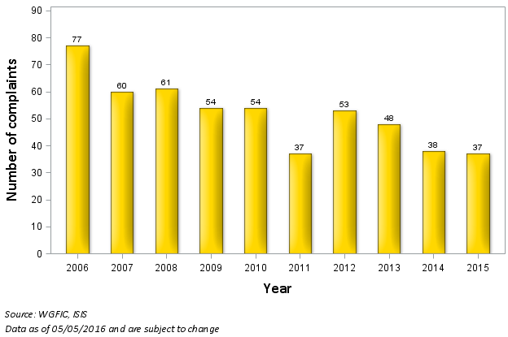

Figure 1-5: Number of single person complaints received by WGFIC, by year, 2006 – 2015
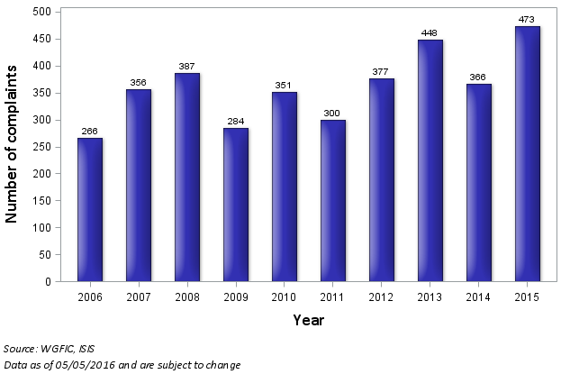

Figure 1-6: Total number of people reported ill in all complaints to WGFIC by month, 2015
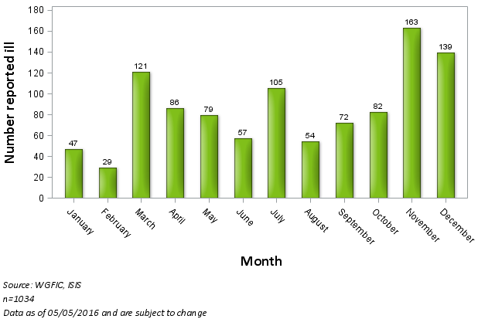

Figure 1-7: Percent of complaints in 2015 by diagnosed disease categories

Figure 1-8: Percent of complaints in 2015 by specific diagnoses of bacterial diseases.

Figures below, 1-9 through 1-13 reflect confirmed cases due to select foodborne pathogens, including Salmonella sp., Campylobacter sp., Shiga toxin-producing E.coli (STEC), and Vibrio sp. reported to MDPH through the Office of Integrated Surveillance and Informatics Services (ISIS). Cases are considered "confirmed" when they meet the Centers for Disease Control and Prevention (CDC) surveillance case definition. Cases are reported to MDPH through mandatory reporting by laboratories, physicians, and local boards of health. These data are used to detect clusters of foodborne disease, but effectiveness is often hampered by the two-to-three-week lag time from illness onset to subsequent reporting to public health officials. In addition, many case reports do not include a complete food history, which makes it difficult to determine the source of the infection. The number of reported cases of infection with Salmonella sp. (n=1161)
remained similar to the average of the previous five years (1152). Reported Campylobacter sp. cases (n=1456) were 5.2% higher than the average of the previous 5 years (1383). Total STEC cases reported in 2015 (n=66) were 47% lower than the average of the previous 5 years (124.2). In 2015, the number of reported cases of infection due to all three pathogens increased during the summer months, (Figures 1-9 through 1-11), which is consistent with past experience and the epidemiology of the infections. Figure 1-13 reflects the total number of confirmed Vibriosis cases reported to MDPH from 2009 to 2015. In Massachusetts, the number of reported V. parahaemolyticus cases (n=47) were 23.5% higher than the average of the previous 5 years.

Figure 1-9: Confirmed cases of Salmonella infection reported to MDPH, by month, 2015
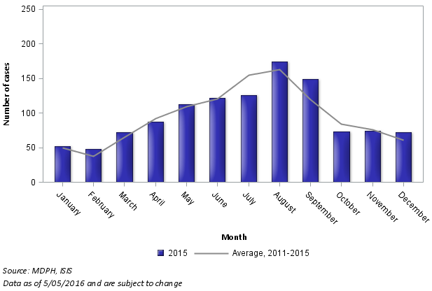

Figure 1-10: Confirmed cases of Campylobacter infection reported to MDPH by month, 2015
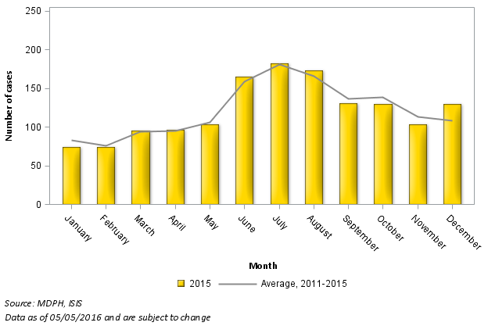

Figure 1-11: Confirmed & probable cases of STEC infection reported to MDPH, by month, 2015
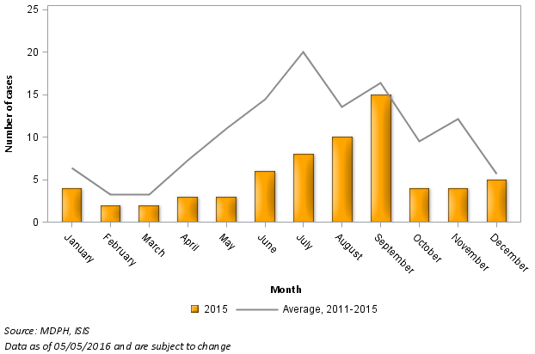

Figure 1-12: STEC, Salmonella, Campylobacter reportable cases by year 2009 – 2015
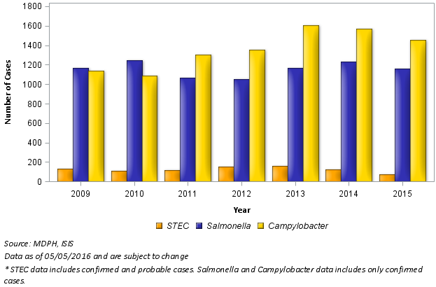

Figure 1-13: Confirmed cases of Vibrio infection reported to MDPH, by NEARS
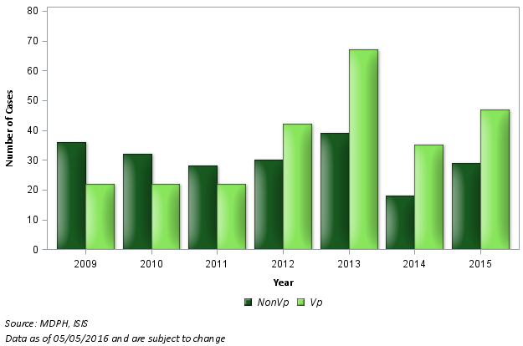

Collecting information and tracking reportable foodborne diseases or conditions is a difficult undertaking. Most of these illnesses resolve within 24 to 48 hours with the person never seeking medical attention. Even when a health care provider is consulted, laboratory testing is not always performed. The task becomes even more difficult when an illness or syndrome is caused by a pathogen that is "emerging," i.e., not widely known or newly recognized as causing illness. Frequently these new diseases are not on the list of reportable diseases and conditions, and the MDPH is therefore unlikely to be notified.

Thoughtful analysis of surveillance data allows the identification of areas of concern and is useful in planning. Foodborne illness surveillance, with accurate and complete documentation, is necessary at local, state, national and international levels. Food is often imported and exported. Raspberries are imported from Guatemala, blackberries from Mexico, blueberries from Argentina and people all over the world use maple syrup from Vermont. We must always be aware of what is happening now, and what has happened in the past, in order to develop effective strategies for preventing foodborne and waterborne illness.

References:

(1) Centers for Disease Control and Prevention, Burden of Foodborne Illness: Overview,
https://www.cdc.gov/foodborneburden/estimates-overview.html

(2) Centers for Disease Control and Prevention, Foodborne Outbreaks, Multistate Outbreaks,
https://www.cdc.gov/foodsafety/outbreaks/multistate-outbreaks/index.html

(3) Huang JY, Henao OL, Griffin PM, et al. Infection with Pathogens Transmitted Commonly Through Food and the Effect of Increasing Use of Culture-Independent Diagnostic Tests on Surveillance - Foodborne Disease Active Surveillance Network, 10 U.S. Sites, 2012-2015. MMWR Morb Mortal Wkly Rep 2016; 65:368-371. DOI: http://dx.doi.org/10.15585/mmwr.mm6514a2.
(4) Announcement: 20th Anniversary of PulseNet: The National Molecular Subtyping Network for Foodborne Disease Surveillance - United States, 2016. MMWR Morb Mortal Wkly Rep 2016; 65:636. DOI: http://dx.doi.org/10.15585/mmwr.mm6524a5.

(5) Centers for Disease Control and Prevention, Foodborne Outbreak Tracking and Reporting;
Foodborne Outbreak Online Database (FOOD Tool) https://www.cdc.gov/foodborneoutbreaks/

Council to Improve Foodborne Outbreak Response (CIFOR). Guidelines for Foodborne Disease Outbreak Response. 2nd edition. Atlanta: Council of State and Territorial Epidemiologists; 2014

