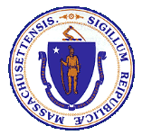

Health Information Technology Council
Report to the Massachusetts Legislature

Reporting Period: January 2021 to December 2021

Submitted in April 2022
by the Health Information Technology Council

Contents
I. Executive Summary 1
II. Introduction 1
III. Mass HIway COVID-19 Response Support 2
(A) Clinical Gateway Nodes 3
(B) Clinical Gateway Node Expansion – MIIS QBP & MIIS Demographic 3
IV. Mass HIway Operations 4
(A) Connection Requirement 4
(B) 2021 Attestation Data 5
(C) Mass HIway Development Activity 6
(D) Outreach and Account Management 9
(E) 2021 HAUS Program Update 10
(F) Statewide Event Notification Service Framework 12
V. Federal Developments 13
(A) Interoperability Rules Updates 13
VI. Future Initiatives 14
(A) ePOLST 14
(B) API and FHIR Development 15
VII. Budget 16
(A) Background 16
(B) Budget Reduction and Mitigation Strategies 18
VIII. Conclusion 18

Executive Summary
The Massachusetts Health Information Highway (Mass HIway) is a health information exchange program within the Commonwealth of Massachusetts’ Executive Office of Health and Human Services (EOHHS) and advised by the Health Information Technology Council composed of consumer, provider, legal, policy, and technology stakeholders.

In 2021, the Mass HIway continued to pursue its primary goal of improving provider interoperability and health information exchange throughout the state during the COVID-19 pandemic. It supported the state’s need for data to track COVID-19 through electronic data exchange technologies developed and operated since 2013.

The Mass HIway continued operations to support and promote utilization of Direct Messaging to facilitate care coordination exchanges and enable public health reporting with seven state registries. Provider outreach and use case implementation efforts continued to help providers increase interoperability and the HIway conducted its annual attestation process to measure connections and utilization of HIway services. The Consolidated Clinical Gateway and Mass HIway business applications and services were successfully migrated to Amazon Web Services cloud servers. Additionally, the Statewide Event Notification Service (ENS) Framework completed certification of vendors and is now fully operational, with the two certified vendors collecting admit, discharge and transfer (ADT) messages from all acute care hospitals within the state and sharing these messages with each other’s subscribers.

Policies under the Centers for Medicare and Medicaid Services’ (CMS) Interoperability and Patient Access rule (CMS Interoperability Rules) went into effect in 2021, leveraging technical certification standards and rules set by the Office of the National Coordinator (ONC) for Health Information Technology to remove barriers and enable information access for patients, providers and payers. With the establishment of federal standards under the CMS Interoperability Rules, including Application Programming Interfaces that use Fast Healthcare Interoperable Resources (FHIR), the Mass HIway is exploring ways to leverage an aligned technical infrastructure.

The Mass HIway developed strategies in response to federal revenue reductions resulting from the end of the Health Information Technology for Economic and Clinical Health (HITECH) Act, a component of the American Recovery and Reinvestment Act of 2009 (ARRA) program, which expired on September 30, 2021. These strategies were implemented to manage the impact of the federal revenue loss and to ensure existing and future health information technology investments can be sustained.

The Mass HIway continued to explore potential future services to pursue to further enhance interoperability and health information exchange in the Commonwealth. The Mass HIway joined a cross-agency initiative to develop an electronic registry for Physician Orders for Life Sustaining Treatment (POLST) forms, which captures patient preferences for end-of-life care.

Introduction

Pursuant to M.G.L. c. 118I, the Massachusetts Legislature authorized the Executive Office of Health and Human Services (EOHHS) to coordinate and promote the development of a statewide health information exchange (HIE). EOHHS created the Massachusetts Health Information Highway (Mass HIway) program to embody those HIE coordination and promotion efforts. The same enabling statute also created the Health Information Technology Council (HIT Council) to serve as an advisory body to EOHHS and the Mass HIway program.

This HIT Council Report to the Massachusetts Legislature fulfills the statutory requirement under M.G.L. Chapter 118I, Section 15, for the HIT Council to file an annual report that: (a) describes the activities of the HIT Council; and (b) describes the progress made in developing the statewide health information exchange and recommending legislative action, if deemed appropriate.

This report provides an update on notable accomplishments and activities of the HIT Council related to the state’s HIE that occurred between January 1, 2021 and December 31, 2021. This report follows the HIT Council’s previous report, which covered activities through December 31, 2020.

Under the advisement of the HIT Council, the Mass HIway promotes the adoption of HIE through a variety of policy and technical levers. The Mass HIway’s activities aim to increase the Commonwealth’s adoption of health information exchange and technology to improve care coordination, quality, patient satisfaction, and public health reporting, while containing costs. Currently, it operates a Direct Messaging network (HIway Direct Messaging) that offers healthcare entities the ability to securely and seamlessly transmit vital health data electronically, regardless of affiliation, location, or differences in technology. The Mass HIway operates a clinical gateway designed to accept and transform public health data submitted by providers through Direct Messaging to the state’s public health systems. The Mass HIway has also implemented a Statewide Event Notification Service (ENS) Framework to leverage existing market-based solutions to provide ENS to providers throughout the Commonwealth.

Mass HIway COVID-19 Response Support
In response to the COVID-19 pandemic, the Commonwealth declared a public health emergency on March 10, 2020 to respond to COVID-19. As part of this response, the COVID-19 Response Command Center (Command Center), led by the Secretary of EOHHS, Marylou Sudders, was created to coordinate Massachusetts’ pandemic response across different areas – from building up testing and tracing, monitoring data and trends on a daily basis, advising on guidance, and to ensuring sufficient PPE.

In its emergency response efforts, the Command Center relied on data to track COVID-19 infection rates, among many things, to make evidence-based public health and policy decisions. The Command Center in coordination with the Department of Public Health (DPH) and the State Public Health Laboratory (State Lab) used the data submitted for Syndromic Surveillance (Syndromic) and Electronic Lab Reporting (ELR) to produce the public daily dashboard. The Command Center tracked COVID-19 vaccinations through the Massachusetts Immunization Information System (MIIS) system.

The Mass HIway operates technology enabling providers to electronically transmit data to DPH and the State Lab systems through HIway Direct Messaging and Clinical Gateway Nodes (CG Nodes). In February 2021, the Mass HIway developed an additional CG Node, known as the MIIS Query by Parameter (MIIS QBP) node, for the purpose of allowing payers and large provider groups access to retrieve patient vaccination status to help facilitate efforts aimed at increasing vaccination rates such as provider outreach to patients who have not received a first vaccination dose or reminders for a second dose or booster.

Clinical Gateway Nodes
Public health reporting is a key use case for HIway Direct Messaging. The public health reporting process via HIway Direct Messaging is mature, with transaction volumes averaging over 15 million messages per month. There has been gradual growth year to year with some seasonal variability, especially in reports of immunizations. In 2013, the Mass HIway created the CG Nodes to reduce the burden for providers to submit public health data and reports. These CG Nodes are designed to receive data submitted by the providers through HIway Direct Messaging and technically transform the data into formats that the state’s public health systems can accept and analyze. This use case was an early success, with widespread, robust use by providers across Massachusetts. Almost every Massachusetts hospital and many other providers implemented HIway Direct Messaging for public health reporting purposes.

Relative to the state’s COVID-19 response, the Mass HIway supported, and continues to support, the Command Center and DPH through its previously established CG nodes for Syndromic and ELR reporting. The Syndromic CG node receives data from hospitals, transforms the data, and submits data to the US Center for Disease Control’s BioSense Platform for national syndromic surveillance. DPH epidemiologists access data on BioSense to identify trends and expand situational awareness. In addition, a number of large hospitals and their subsidiaries in the Commonwealth send their Lab reporting, including the COVID-19 test results to the State Lab using the Mass HIway through an automated process.

As COVID-19 vaccinations became available, DPH collected – and will continue to collect – immunization data using its existing provider connections through the Mass HIway’s MIIS CG node. MIIS is the state system that holds records of all immunizations as well as additional functions like vaccination reminders that will be critical to ensure individuals receive additional doses or booster shots of the COVID-19 vaccine pursuant to evolving FDA and CDC guidelines. In anticipation of increased immunizations due to COVID-19 vaccinations, the Mass HIway team coordinated closely with the MIIS application team at DPH to increase the message capacity and throughput of both systems. The Mass HIway, in this initial implementation, tripled capacity of the systems to transmit data for tracking vaccinations in support of the Commonwealth’s COVID-19 response efforts.

Clinical Gateway Node Expansion – MIIS QBP & MIIS Demographic

The Massachusetts Immunization Information System (MIIS) allows providers to submit immunization information to the state via the Mass HIway. About 5 million transactions are submitted by providers on a monthly basis. The COVID-19 onset and the availability of the vaccine has increased the submissions to the MIIS backend system. In addition to the regular, unsolicited vaccination record updates (VXUs) submitted, the system allows the providers to query the MIIS database using a Query by Parameter (QBP) methodology. These QBP requests traverse the Mass HIway to the MIIS backend system where the requested information is gathered, and then sent back to the provider in a message response.

There was a need to optimize this system to accommodate massive volume surges from health insurance carriers (“carriers”) looking to determine the vaccination status of their members. In order to accommodate this large processing load, a new clustered Clinical Gateway node was built to address this specific need. The carriers were able to send large volumes of requests through this newly built node which would query the MIIS backend system and send back the results.

Utilizing and expanding on this same design, the Mass HIway then prepared for increased message volumes to support the new Massachusetts’ Immunization Consumer Portal (MICP) system, publicly known as My Vax Records. The MICP application was designed and configured to support new and larger request volumes without disruption to regular MIIS exchanges and processing. The system is designed to perform under anticipated peak loads and should not be subject to slowdowns as seen in the early stages of other such system deployments. The development for this was completed in CYQ4 2021, and the MICP system went live on January 10, 2022.

Mass HIway Operations
In 2021, Mass HIway operations implemented important developments to improve the technical infrastructure, provider usage, and adoption support services. The Mass HIway continued to track connections, began efforts to create new service program offerings, and continue current service program offerings, such as the Statewide ENS Framework.

Connection Requirement
As set forth in M.G.L. Chapter 118I, Section 7, and as detailed in the Mass HIway Regulations (101 CMR 20.00), certain healthcare providers in the Commonwealth are required to connect to and utilize HIway Direct Messaging. As outlined in Figure 1 below, this requirement for each provider is phased in over a four-year period, which is intended to incrementally promote the use of HIway Direct Messaging for provider-to-provider communications to achieve bi-directional exchange of health information.

Every provider organization subject to the connection requirement is required to submit an annual attestation indicating how it met the annual requirement to connect to HIway Direct Messaging. If a provider organization could not fulfill the connection requirement, it was required to submit a Health Information Exchange Exception Form stating why it did not meet the connection requirement and explaining the organization’s plans to comply prospectively.

Figure 1
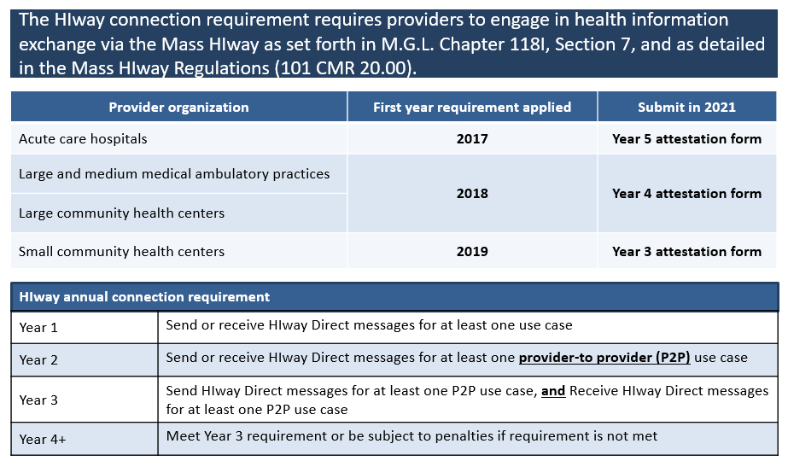

In late 2020, the Mass HIway considered how to improve the process through which organizations declare to the Commonwealth whether they have fulfilled the connection requirement. To improve the process, through sub-regulatory guidance, the Mass HIway clarified DirectTrust HISP-to-HISP exchange as an additional method to meet the HIway connection requirement. For more information, see graphic below. The use of DirectTrust HISP-to-HISP exchange leverages technical advantages such as using a common trust certificate that authenticates the user allowing data sharing rather than having each provider use a specific trust certificate for each and every other provider. (i.e., the use of a single multi-party certificate rather than many individualized 1:1 certificates.) In addition, providers will have the opportunity to use the Direct Messaging systems that are already imbedded in their EHRs.

2021 Attestation Data

The 2021 attestation timelines as outlined below resulted a strong number of attestations overall. This year marks the first year that all provider organizations must attest to both sending and receiving notifications.

2021 Attestation timeline:
Dec. 31, 2020: Use case implementation deadline
May-July 2021: HIway outreach and education, consisting of Emails and Newsletters,
Website updates, Webinars, Direct contact with POs
July 2021: Web form testing
Aug. 2, 2021: HIway attestation/exception Web forms go live and begin
accepting submissions
Oct. 31, 2021: Deadline for attestation/exception submissions
November 2021: HIway reaches out to POs that have not submitted
Winter 2022: HIway closes Web form

As of December 30, 2021, the Mass HIway had received 149 Attestation Forms and 32 HIE Exception Forms, for a total of 181 forms. As of that date, the HIway had received submissions from 66 of the Commonwealth’s 67 Acute Care Hospitals, 30 of 40 Community Health Centers, and 85 of 152 Medium and Large Medical Ambulatory Practice entities.
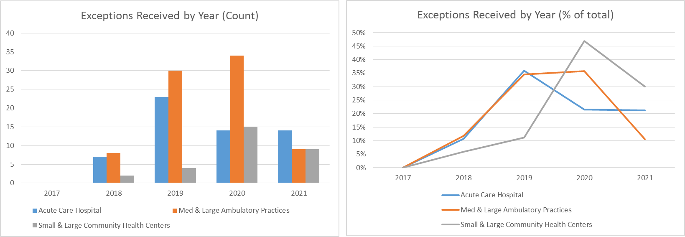

Mass HIway Development Activity
The Mass HIway development team focused on merging the Clinical Gateway (CG) nodes into a single, consolidated application and migrating that core application and a suite of supporting applications and tools to Amazon Web Services (AWS) cloud-based servers. While critical changes and fixes were addressed as needed, most functional changes requested by the backend application teams have either been incorporated into the new Consolidated Clinical Gateway application (CCG) (described below) or deferred until after the migration is complete.

Background
The CG nodes are Mass HIway software applications that connect providers securely to DPH and other state agencies for public health reporting. Providers send public health reports via Direct Message to the CG nodes, which transform the message into a format useable by the agency’s systems. The CG node transformation processes include decryption of the original message, validation that the data is correctly submitted, and transformation of the message into a format acceptable to the receiving system. Reporting providers and state agencies benefit by allowing each group to keep their existing technology infrastructure while the CG node does the transformative work to allow for the seamless exchange of information.

Each of the following CG nodes is a separate application that supports a corresponding public health reporting back-end application:

- Children’s Behavioral Health Initiative (CBHI)
- Childhood Lead Poison Prevention Program (CLPPP)
- Electronic Lab Reporting (ELR)
- Opioid Treatment and TB Reporting Programs (I-EATS)
- Massachusetts Cancer Registry (MCR)
- Massachusetts Immunization Information System (MIIS)
- Syndromic Surveillance Program (Syndromic)

Migration of CG Nodes to AWS
The Mass HIway conducted a business and architectural review of the CG nodes in 2019 that identified current and future needs and challenges of the CG nodes, including affiliated applications and operational tools. The comprehensive review identified the following challenges:

- Infrastructure not easily scalable or extensible.
- Infrastructure requires a long turnaround time to update nodes including routine software updates.
- Infrastructure not positioned to meet emerging FHIR-based API standards.

As a result, the Mass HIway team began a program in October 2019 to implement the recommended architecture (see Figure 2). Arrangements for use of a cloud infrastructure, hosted by AWS, were made through the Executive Office of Technology Services and Security and development environments were established. As work progressed through 2020, additional AWS environments for testing and production were added.

By December 2020, a significant amount of work including the finalization of the AWS architecture and procuring the various development environments was completed along with performance testing and evaluations. And, by June 2021, the Consolidated Clinical Gateways and all HIway business applications were successfully migrated and deployed in the new AWS architecture.

Figure 2

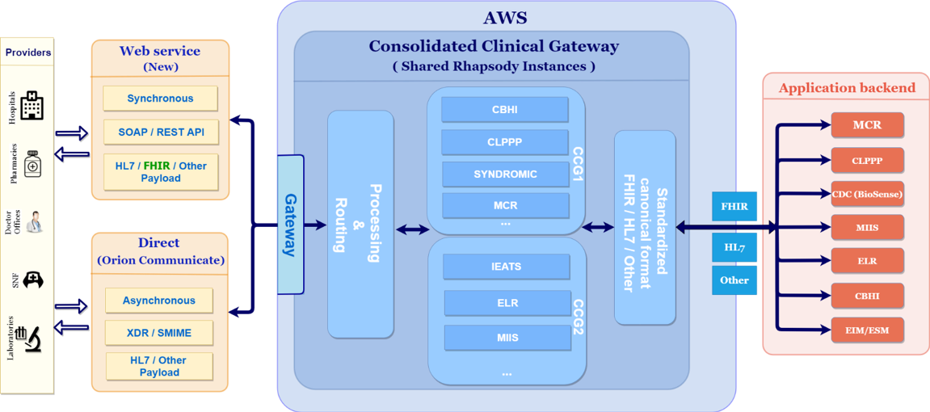

Consolidation of CG Nodes
The Mass HIway team transformed the current set of Clinical Gateway (CG) nodes into a Consolidated Clinical Gateway (CCG), as depicted in Figure 2 above. The CCG allows the Mass HIway to address challenges identified in the business and architectural review, as described above.

The CCG implements a technical shift from the previous design, by consolidating multiple independent applications into a single application for all public health reporting needs. This redesign improves scalability for future changes which impact all nodes, as the Mass HIway will only need to update a single module within the CCG, rather than making individual updates for each of the seven CG node applications. In addition, implementing new nodes will be faster and easier as they can be implemented as an add-on to the existing CCG application.

In addition to maintaining current business functionality, several enhancements requested by the DPH application teams were included in the new CCG as part of the implementation.

During the design and implementation of the CCG nodes, there was a surge in the incoming volume due to the COVID-19 submissions to some of the high-volume nodes such as Syndromic Surveillance and Massachusetts Immunization Information System (MIIS). In response to this, the architecture was redesigned to separate these two nodes into their own CCG environments. Syndromic Surveillance, Children’s Behavioral Health Initiative (CBHI), Childhood Lead Poison Prevention Program (CLPPP) and Massachusetts Cancer Registry (MCR) were in one CCG environment and Electronic Lab Reporting (ELR), Opioid Treatment and TB Reporting Programs (I-EATS) and Massachusetts Immunization Information System (MIIS) were accommodated in another CCG environment. The work was completed by December 2020 and production transactions began flowing soon after.

Maintenance and Enhancement of CCG Functionality

In order to accommodate the national trends and latest rules from the Centers for Medicare and Medicaid Services (CMS) and the Office of the National Coordinator for Health Information
Technology (ONC) the HIway team is building new Application Programming Interface (API) services and Fast Healthcare Interoperability Resources (FHIR) standard integration. By the end of 2021, the initial APIs have been developed and preparations have been started for new OAuth 2.0 security features and FHIR integration. Fast Healthcare Interoperability Resources (FHIR) is a standard describing data formats and elements and an application programming interface (API) for exchanging clinical and administrative data.

Other Applications Moving to AWS
All Mass HIway business systems that support the program have been migrated to AWS. These include, 1) the online attestation form, 2) the customer relationship manager (CRM) software and database, and 3) the public website. The development team activated the 2021 attestation forms on AWS in August 2021. In December 2021, the CRM software and database were migrated to the latest version to address ADA compliance and identified security vulnerabilities.

Outreach and Account Management
A core function of the HIway program is raising awareness, educating and supporting health information exchange (HIE) among Massachusetts providers delivery system more broadly. The outreach team educates providers, clinicians, and administrative staff on the value of HIE and its ability to improve care coordination. They leverage a number of channels to educate providers and increase awareness. These include live monthly webinars, recorded on-demand webinars, and HIE “Spotlight Stories” highlighting organizations that have utilized HIE to advance care coordination objectives. In addition, virtual workshops and learning collaborative sessions have been held to share HIE best practices among clinicians and administrative staff. Furthermore, the new Mass HIway website was improved with new educational content, animation videos, webinar recordings, and pages to introduce the Statewide ENS Framework.

Live Monthly and On-Demand Webinars
Mass HIway Account Management team hosted 6 webinars in 2021. Recordings of the latest versions of these webinars are posted on the Mass HIway website here.
The following webinars were prepared and presented by the HIway team:
- One 2021 HIway requirements webinar (Total of 97 attendees)
- Two webinars to launch the ENS framework (Total of 256 attendees)
- One Query HIE webinar (Total of 83 attendees)
- One Provider Directory 2.0 webinar (Total of 17 attendees)

HIE Case Studies and Spotlight Stories
The HIway team published five spotlight stories illustrating how five provider organizations are using the Mass HIway and HIE to improve care coordination. These organizations include: Merrimack Valley ACO, Boston Home Health Aides, HealthFirst, Island Healthcare, and PhysicianOne. The stories have been published on the Mass HIway website and spotlight summaries of these stories were included in the monthly HIway newsletters.

Mass HIway Newsletters and Bulletins
The HIway team drafted the content for 9 monthly HIway newsletters, including Spotlight story summaries, attestation, the launch of the Statewide ENS Framework, and workshop and webinar invitations. Numerous bulletins were created with targeted announcements and reminders for these same topics. The newsletters were posted on the Mass HIway website.

Learning Collaboratives
The HIway team organized and presented a Learning Collaborative to discuss the latest requirements and strategies for obtaining HIE Patient Consent with the healthcare providers. The input from the participants was used to update the corresponding provider supporting documentation developed in a similar 2016 Learning Collaborative. There were 39 attendees at this event.
.

New Mass HIway Website
A new informational/educational Mass HIway website was developed and released in January 2021. During the technical development of the new Mass HIway website, all information was posted onto the MeHI website. Upon launch of the new Mass HIway website, all content was updated, reorganized, and incorporated.

The following information originally posted on the MeHI website was updated and posted to the new Mass HIway website:

- HAUS, PD 2.0, Mass HIway, and Regulation & Attestation pages.
- Query HIE Toolkit, with enhancements based on input from the API/Query HIE project.
- HIE Use Case Toolkit, with improved tools and new use cases linked to spotlight stories.
- Spotlight Story Library, expanded with recently developed stories.
- Webinar Library, with closed captioning added to all Mass HIway webinar recordings.

2021 HAUS Program Update

Background
HITECH funding ended on September 30, 2021 which resulted in the HAUS Program ending the services it provided to provider organizations. The HAUS Program was launched in September of 2018. Over the last three years, the Account Management team completed 47 HAUS engagements with providers of all sizes and specialties. These included large hospital systems and Accountable Care Organizations as well as small single provider practices. These engagements assisted providers in the utilization HIE technology with the end goal of improving care coordination, increasing efficiency and lowering costs.
The primary goal of the HAUS Program was to improve patient transitions of care among Medicaid provider organizations through increased electronic provider-to-provider communication. A secondary goal of this program is to assist providers in achieving Meaningful Use measures through integration of electronic exchange of information.
The HAUS Program was aimed at offering high-touch, hands-on change management consulting services to eligible provider organizations to ensure use cases were fully implemented by sending and receiving organizations. Typical use cases include the following:
- Closed-loop referral between a primary care provider and specialty practice so the specialist has the necessary clinical information when treating the patient and the primary care physician has all clinical information regarding specialty treatment and medication updates to provide appropriate follow up care.
- Sending a discharge summary from a hospital to a Community Health Center (CHC). The summaries include updated prescription information and guidance on follow up care from a patient’s primary care physician.
- Exchanging care plans and consent forms between behavioral health community partners (CP) and PCPs in an ACO.
The following are examples of typical activities performed during a HAUS engagement:
- Creating cross-functional teams between participants to enhance coordination. These teams may include clinical, information technology, and business leadership to ensure that the needs of all stakeholders (clinicians, clinical staff, etc.) are addressed and that the information exchange approach genuinely improves patient care, not just complies with information exchange regulations.
- Facilitating communication between multiple provider organizations to define clinical information exchange requirements and protocols through Zoom meetings, emails and calls.
- Documenting agreed-upon clinical protocols, including the content of clinical documents to be exchanged and release triggers for exchange.
- Creating workflows reflecting clinical protocols to ensure the right information is available when and where it is needed to accomplish goals such as streamlined discharges from a hospital to a skilled nursing facility (SNF).

HAUS Impact
The HAUS Program completed 30 engagements in 2021. The Account Management team worked with a variety of organizations including MassHealth Accountable Care Organizations (ACOs), Community Partners (CPs), Community Health Centers (CHCs), specialty practices, and large and small Acute Care Hospitals.
In 2021, the HAUS Program focused on supporting CHCs and specialty practices in implementing closed-loop referral use cases. Both hospital-based groups as well as specialists practicing within the healthcare community were involved in these use cases.
The HAUS Program continued to support MassHealth ACO organizations and their Community Partner (CP) organizations in exchanging Care Plans for their shared patients so that behavioral health and long-term services and supports could be coordinated among their respective care providers. The Account Management team also worked with CHCs and hospitals to increase the use of Direct Messaging for discharge summaries to be sent to the CHC after a patient left the hospital’s emergency department.

Statewide Event Notification Service Framework
Event Notification Service (ENS) systems are a mechanism for hospitals to notify PCPs and other health care providers of events (admissions, discharges, transfers – ADTs) about their patients. Prior to the implementation of the statewide system, PCPs only received notifications if they subscribed to the same ENS vendor as the hospital. The statewide system requires MA state Certified ENS Vendors to share (reflect) ADTs with other MA state Certified ENS Vendors so that vendors who did not directly receive the original ADTs can notify their subscribers as needed. Each subscriber periodically updates a list of their patients with their MA state Certified ENS Vendors so that the ENS vendor’s software can determine in real time where to send notifications.
The Statewide ENS Framework developed by EOHHS and the Mass HIway constitutes an interoperable ENS network consisting of Certified ENS Vendors who have interconnected their ENS systems to serve more care providers in Massachusetts in a more streamlined format.
The goal of the ENS program is to support timely ADT exchange across the Commonwealth in order to improve health care delivery, quality, and coordination.

ENS Vendor Guiding Principles
The ENS initiative was guided by the following principles to define how an ENS framework should be created:
- Universal access: promoting data sharing within an ENS framework to increase accessibility to ENS for providers of all sizes
- Streamline provider experience: crafting ENS framework to allow single point of submission and single point of reception of ADT data
- Improve notification timing: improving timing for flow of data (real/near-real time)
Certified ENS Vendors have been certified by the HIway to meet specific functional, data security, data sharing, and business criteria focused on ensuring statewide ENS access, delivery, reliability, and integrity.
To participate in the Statewide ENS Framework, Certified ENS Vendors have agreed to share all incoming ADT alerts from Acute Care Hospitals with the other Certified ENS Vendors; by a process called reflection, for distribution to their collective Acute Care Hospital subscribers. The Statewide ENS regulations require all Acute Care Hospitals in Massachusetts to subscribe to one Certified ENS Vendor. The framework thereby ensures that all Massachusetts care providers who subscribe to any of the Certified ENS Vendors can receive ADT alert notifications from all Acute Care Hospitals in the Commonwealth. This means that each care provider in the Commonwealth only needs to subscribe to a single Certified ENS Vendor to send and/or receive the alerts pertaining to their patients.
ADTs received by reflection are admit, discharge, and transfer alerts shared with another vendor which have been generated by a hospital. Notifications sent using reflected ADTs are messages sent to subscribers such as physician’s offices. Each subscriber can choose what kind of messages they are interested in receiving, such as: all discharges but no transfers, additionally, if a single patient were admitted to a hospital, transferred, and then discharged that would be interpreted as three different events, and therefore counted as three individual ADTs. While only a single notification might have been aggregated from those multiple ADTs.
The following events occurred in 2021 prior to implementation and go live:
- Certification of Certified ENS Vendors was completed February 2021. Currently there are two Certified ENS Vendors, Collective Medical Technologies and PatientPing.
- Certified ENS Vendors conducted technical connections from February 2021 to April 2021
- Acute care hospitals submitted ADTs to the Statewide ENS Framework allowing the Statewide ENS Framework to have full ADT data for streamlined notifications in April 2021.

Certified ENS Vendors submit quarterly reports to the HIway to track the number of ADTs being shared as well as the number of notifications generated. In the first live quarter, April 2021 through June2021, the Certified ENS Vendors reflected approximately one million ADT messages. In the next quarter from July 2021 to September 2021, that count increased substantially to six million ADT messages in a quarter.

Federal Developments
In 2021, policies under the CMS Interoperability and Patient Access and the ONC Cures Act Final Rules went into effect requiring expanded access to information for patients, providers and payers. The Mass HIway and HIT Council continue to monitor regulatory compliance efforts and industry adoption of the new technical standards to identify barriers and assess areas of need and support.

Interoperability Rules Updates
In May 2020, the U.S. Department of Health and Human Services finalized the ONC Cures Act Final Rule (ONC Cures Rule) which implements certain provisions of Title IV of the 21st Century Cures Act to advance interoperability and stop information blocking. The implementation of this rule supports the access to, exchange of, and use of electronic health information. The 21st Century Cures Act also directed the Trusted Exchange Framework and Common Agreement (TEFCA) to create a “single on-ramp” for health information exchange by aligning participation requirements and technical standards across qualified networks.
In conjunction with the ONC 21st Century Cures Act Final Rule, CMS released the Interoperability and Patient Access Final Rule in May 2020, which expands access requirements to health information held by providers and certain health plans. As of July 1, 2021, two of the policies from the Interoperability and Patient Access final rule are now in effect.
- On April 30, 2021, the requirements for hospitals with certain EHR capabilities to send admission, discharge and transfer notifications to other providers involved in the patient’s care went into effect.
- On July 1, 2021, CMS began to enforce requirements for certain payers to support Patient Access and Provider Directory APIs. Regulated health plans are required to provide claims, encounter, and clinical data (if managed by the plan) to beneficiaries. In addition, health plans will be required to provide access to Application Programming Interfaces (APIs) that will allow patients to use third-party applications to manage their data.
On December 10, 2021, CMS published a notification in the Federal Register (86 FR 70412) to formalize its decision to exercise enforcement discretion over certain payer-to-payer data exchange provisions of the May 2020 Interoperability and Patient Access final rule.

Future Initiatives

ePOLST
In 2020, EOHHS embarked on a cross-agency effort to support patient preferences for end-of-life care through technology that improves care coordination. The project is a combination of policy and technical development. First, the state will update the state’s Medical Order for Life Sustaining Treatment (MOLST) form to align with the national paradigm for Portable Order for Life Sustaining Treatment (POLST) form for transferability between states. In the second phase, the state will procure and implement an electronic centralized POLST (ePOLST) registry to serve as the single source of truth across all care settings.

Background
The POLST form was developed in Oregon in the 1990s, after a group of clinicians and medical ethicists realized that current advance directive documents were inadequate for those with serious, advanced illness. These patients frequently require emergency care, but it can be challenging to both locate and then subsequently honor their wishes for limited care (e.g., EMS is often required to transfer a patient to hospital, even though the patient expressed desire to avoid hospital treatment). The MOLST program in Massachusetts started with the passage of Chapter 305 of the Acts of 2008, which authorized DPH to establish a MOLST program in the Commonwealth. In 2010, the state began a MOLST demonstration program in Central Massachusetts and expanded it statewide two years later.

2021 Activities
The Mass HIway, along with the Executive Office of Elder Affairs (EOEA), hired an ePOLST project management team in January 2021 to conduct stakeholder outreach to determine requirements and develop for a solicitation for an ePOLST registry system. That outreach included over 150 community stakeholders such as providers, payers, and patient advocacy groups. The goal of the outreach is to identify the gaps that exist with documentation, information flow, and version control of the current MOLST form and recommendations on how to fill the gaps to ultimately create an ePOLST registry for the state. That outreach generated business and technical requirements to help the state draft the solicitation documents and also helped informed the programmatic functions needed to successfully launch and maintain ePOLST.

Planned 2022 Activity
In 2022,EOHHS and EOEA plan to develop a joint solicitation for an ePOLST registry system through an existing marketplace vendor. EOEA will continue to engage with stakeholders and the provider community to develop educational materials to drive statewide adoption of the new form and registry. EOEA plans to create a continuous quality improvement process to iterate on the educational material and training modules to improve adoption rates.

API and FHIR Development

Clinical Gateway API and FHIR Integration Project
For the past nine years providers have been able to submit to the Massachusetts public health registries using Direct Messaging. However, new standards and approaches to exchanging secure clinical information are emerging. Recent regulations and Fast Healthcare Interoperability Resources (FHIR) accelerators are removing barriers to clinical data sharing and are creating demand for real-time, synchronous access to data to support public health reporting, care quality, care coordination and value-based care. The Mass HIway is positioning itself to align with these trends and leading FHIR interoperability efforts by developing an Application Programming Interface (API) and FHIR Integration to the Clinical Gateway. This will enable providers in the Commonwealth to send/receive messages synchronously with the public health registries from their EHR systems using current and emerging message formats (HL7 v2, HL7 FHIR, and other formats). The APIs will complement and, in several cases replace current less efficient and more complex methods to collect, receive, query, access, or disclose data from and by external stakeholders.
A survey of Mass HIway participants indicates there is a high level of interest in utilizing a FHIR API to the Mass HIway Clinical Gateway for Public Health Reporting. As such, the Mass HIway will accelerate development of API and FHIR Integration to the Clinical Gateway for Public Health Reporting.
Overall, APIs provide innovative, simplified, standards-based, bi-directional functionality which supports efficient, effective and timely public health interactions with external and internal partners. Standardized APIs allow public health to obtain data from external stakeholders through a more efficient, less expensive, less resource-intensive mechanism. APIs also allow public health to seek information, in real time and from the data source, whenever that information is needed for public health to fulfill its responsibilities.
The Clinical Gateway API and FHIR Integration Project will implement and maintain secure, standards-based APIs with FHIR integration by redesigning the current state architecture and data systems and revising business and technical processes and related support efforts.
The intent of this project is to develop a foundation for a common API infrastructure that can be used for multiple public health use cases instead of establishing multiple ‘custom solutions’, each with their own unique infrastructure. And where possible, to align with the industry API infrastructure work being developed for activities beyond public health, so that public health needs, service delivery and costs can be optimized.

HIway FHIR API Initiatives
The architecture being developed to support the new CCG plans to extend web services to include FHIR API capability and provide FHIR-HL7 message transformation services to and from the source registry systems (see Maintenance and Enhancement of CCG Functionality). The foundational technical development work was completed in the fourth quarter of 2021. This development will allow hospitals to send public health data using the emerging technical standards and allow state agencies to continue to receive data in its current format with the Mass HIway performing the transformation work.

The technical components (e.g., Amazon Web Services, Rhapsody engine) and new FHIR capabilities of the Consolidated Clinical Gateway development could be leveraged to support other FHIR API initiatives and a range of FHIR-enabled HIE services. The Mass HIway will continue to gather and consolidate stakeholder feedback related to APIs and FHIR-based HIE services to inform direction and planning. The Mass HIway will identify interested state agencies, provider organizations and other stakeholders to define use cases and proposed HIE services.

Once use cases have been defined, the proposed FHIR API solutions will be scoped and an assessment of the Mass HIway technology and capability gaps will be conducted to determine change areas necessary to support development. Additionally, a framework of options and opportunities to align proposed FHIR API solution(s) with the CMS and ONC requirements on regulated entities will be developed.

Budget

Background
The Mass HIway program has been funded by a combination of two federal programs, state funds from the Health Information Technology Trust Fund, and participant contributions. The federal programs are the Health Information Technology for Economic and Clinical Health (HITECH) Act, a component of the American Recovery and Reinvestment Act of 2009 (ARRA) program, and the Medicaid Enterprise System (MES) program within CMS. ARRA/HITECH funding expired as of Sept 30, 2021. The MA legislature annually appropriates funds to support the Health Information Technology Trust Fund (1595-1069). Participants contribute participation fees for their use of the Mass HIway based on provider type (ex. Large hospital, small hospital, etc.), in accordance with 101 CMR 20.13.

The HITECH Act offered 90/10 enhanced federal financial participation (FFP) for the following general categories of time-limited activities: on-boarding activities that connect providers to an HIE and enable them to use HIE services and activities pertaining to infrastructure design, development, and implementation (DDI) to support health information exchange and Meaningful Use. The Mass HIway used HITECH Act funding to support the Development, Design, and Implementation (DDI) of the statewide Direct Messaging system and interfaces, known as CG Nodes, to public reporting registries. Reporting to public registries supported a clinician’s ability to meet federal Meaningful Use requirements to qualify for incentive payments and avoid reimbursement penalties. Additionally, the Mass HIway used HITECH Act funding to help support Mass HIway outreach and HAUS activities.
The last incentive payments were issued by December 31, 2021.

Under MES, the Mass HIway has three different FFP rates based on the activities performed. Like HITECH, MES offers 90% enhanced FFP for DDI activities. MES offers 75% “enhanced” operational funding to support the ongoing Mass HIway operational activities, to the extent that those activities benefit the Medicaid program, after the DDI phase ends once the Mass HIway achieves CMS certification. Finally, MES allows for 50% standard FFP for any additional operational costs, also to the extent that these benefit the Medicaid program, not qualifying for enhanced FFP. Unlike HITECH, MES requires states to allocate the costs under these three activities based on the systems’ benefit to Medicaid, typically measured as share of patients. As of October 2021 in Massachusetts, 29% of the population receives health care through MassHealth and thus that is generally the CMS required cost allocation factor. However, for certain activities EOHHS requests CMS to consider provider-based allocation. The provider-based methodology is the percentage of providers accepting MassHealth patients that participate in the Mass HIway program. The Mass HIway’s analysis found that 91% of its participants accepted MassHealth. Thus, for certain activity the Mass HIway uses this figure when seeking cost allocated FFP.

  - Expected Federal Funding Changes

Sunset of HITECH Act
The HITECH Act, and the related funding provisions, had a sunset date at the end of Federal Fiscal Year 2021 (September 30, 2021). The spending for the development of the HIE infrastructure and most related services spending was completed by the end of Federal Fiscal Year 2021. Limited HITECH Act funding past that date is permitted by CMS for close out activities related to the incentive payment program, such as conducting final audits and winding down programmatic and technical activities. CMS recommends that states move formerly covered HITECH Act activities (such as DDI and other operational activities) to the MES program, to the extent that those activities are for the benefit of the overarching Medicaid program. EOHHS has completed the last development projects using HITECH funds. There are two projects remaining that are now being supported by MES funding. One of these projects will be migrated to ARPA funding as of October 1, 2022. The Mass HIway general operations and maintenance are being supported by MES 75% FFP in FFY 2022 and beyond.

Changes in Cost Allocation Requirements

In addition to the shift in the cost allocation baseline, CMS also made a change to the application of cost allocation for DDI. Previously, DDI activities were allocated at 100% to the Medicaid program using the logic that the cost to develop a system is the same whether it is developed exclusively for MassHealth or is open to all payers. However, CMS changed its policy and requires DDI to be cost allocated at the patient-based methodology level. EOHHS is evaluating fiscal impact of the federal changes and adjusting the Mass HIway program spending accordingly.

Budget Reduction and Mitigation Strategies
In response to the federal revenue reductions, the Mass HIway identified some near term strategies to maintain current operations and continue priority development areas while accounting for the federal revenue loss. These strategies were implemented through adjusted operations and support which included: lowering operating costs by renegotiating vendor contracts, refocused provider outreach, reorganized technical operations, increased private funding share and policy updates to support foundational services, end-user value, innovation areas and aligned HIE investments. In light of the changing revenue landscape, the Mass HIway will continue to evaluate strategies that draw support from users and stakeholders as well as those that enable valuable services and programs.

Conclusion

This report describes key services and activity the Mass HIway and partners have taken to improve provider interoperability and health information exchange throughout the state, delivering valuable, secure Direct Messaging and Provider Directory services, enabling Public Health Reporting through the Consolidated Clinical Gateway and stream-lining event notifications through the Statewide Event Notification Service Framework. The Mass HIway program continues to educate providers, build awareness and promote best practice in the use of health information exchange and advancement of interoperability. And, the Mass HIway will continue to develop an enhanced infrastructure to align with new standards, such as FHIR and the use of APIs for exchanging secure clinical information and to respond to the growing demand for real-time, synchronous access to data to support public health reporting, care quality, care coordination and value-based care.

85 FR 25642

