Slide 1
Health Information Technology Council Meeting
February 3, 2020
Slide 2
Agenda
- Welcome
Presented by: Undersecretary Lauren Peters
    - Approval of the Nov. 4 2019 minutes (vote)
    - Approval of the 2019 Annual Report (vote)
- HIway strategic plan
Presented by: Undersecretary Lauren Peters & Bert Ng
- HIway connection requirement 2020
Presented by: Bert Ng & Chris Stuck-Girard
- Market-based ENS Initiative — Certification update
Presented by: Bert Ng
- Conclusion
Presented by: Undersecretary Lauren Peters
Slide 3
Welcome
Presented by: Undersecretary Lauren Peters
Slide 4
MOTION: That the Health Information Technology Council hereby approves the minutes of the council meeting held on November 4, 2019 as presented/amended
Slide 5
MOTION: That the Health Information Technology Council hereby approves the Health Information Technology Council 2019 annual report as presented/amended
Slide 6
HIway strategic plan
Presented by: Undersecretary Lauren Peters & Bert Ng
Slide 7
HIway strategic plan: future initiatives
Current state?
- SWOT analysis to assess current state functionality and identify future opportunities (see Appendix for reference)
- 2019 HIway activity highlights
Where do we go?
- To inform the Council’s consideration of future initiatives and strategy, the HIway conducted a multistate scan of other state HIE initiatives
- Prioritize services and initiatives to pursue
How do we get there?
- Determine the best approach to implementation (state-run services/infrastructure vs. leveraging market-based functions)
Slide 8
2019 HIway Highlights
- HIway 2.0 Upgraded Direct Messaging System (DirectTrust accredited)
- HIway account team HIway account team
- Consolidated Clinical Gateway
- Began investigating the consolidation of public health reporting protocols
- HIway regulation update
- EOHHS amended regulations to create new service category: HIway-facilitated Services
- Event Notification Service
- Began development of the Statewide ENS Framework and issued certification RFA
- API & FHIR
- Proposed federal rules require providers and payers to use FHIR-enabled API
Slide 9
Results: multistate scan of services
- Jurisdictions reviewed: CA, DC, ME, MD, MI, NY, OK, OR, RI, VT
- Governance for HIEs is a mix of public, private, and public-private partnerships
- In all states reviewed, participation is voluntary
- Patient consent policies vary from state to state
- Prescription Drug Monitoring Program Integration (OK, * OR)
- Referral Loop Management (CA, OR*)
- eCQM (CA, DC, MD, MI)
- Facilitating disclosure of Part 2 data (RI)
- Event Notification (CA, DC, MD, ME, MI, NY, OR, RI, VT)
- Record Locator Service# (CA, MI, NY, OK)
- Web portal (RI, VT)
- Patient access via mobile apps (MD, MI)
* Proposed service # Prior HIway service – shut down due to low adoption rate
Slide 10
Use case discussion
- What type of use case should we prioritize?
- What use cases does your organization currently have or currently implementing?
- Should any of these use case be implemented statewide?
- Are there any uses cases of value not listed on the previous slide?
Slide 11
Query HIE & FHIR Research
Support HIE Outreach Program through technical engagement with providers, vendors, and consortia to determine Query HIE and FHIR business and technical requirements, develop program knowledge base, and communicate capabilities to the community.
Nov 2019 Dec 2019 Jan 2020 Feb 2020 Mar 2020 April2020 May202

Query HIE research process
- Develop expertise in the Query HIE space and with the vendors, CommonWell, and Carequality.
- Facilitate meetings with stakeholders, CommonWell, Carequality, major EHR vendors, and their customer base to understand requirements and workflow.
- Gather and document the key processes, business, and technical requirements to connect and utilize Query HIE
Query HIE work product
- Priority-setting framework
- HIE Query Landscape Assessment
- Business-Technical Requirements Index
- EHR-HIE Query Process Workbooks
- Training Guides
FHIR research process
- Develop expertise in Fast Healthcare Interoperability Resources (FHIR) and its applicability to the Mass HIway.
- Facilitate meetings with vendors, providers, and other stakeholders with FHIR implementation experience.
- Gather and document technical and business requirements related to the application of FHIR to the Mass HIway.
FHIR work product
- FHIR Design-Approach Options
- FHIR Capability Assessment
- FHIR Market Assessment
- Business-Technical Requirements Index
- Training Guides
Slide 12
Technical discussion: Query HIE & FHIR
- Have your organizations implemented or considered implementing Query HIE or FHIR?
- Is there value in using these modalities for information exchange?
- Has any organization developed use cases around these technologies?
- What are the challenges and opportunities of implementing these services?
Slide 13
HIway connection requirement 2020 follow-up
Presented by: Bert Ng & Chris Stuck-Girard
Slide 14
HIway connection and attestation requirement
Provider organization | First year requirement applies | Submit in 2020
Acute care hospitals | 2017 | Year 4 attestation form
Large and medium medical ambulatory practices | 2018 | Year 3 attestation form
Large community health centers
Small community health centers | 2019 | Year 2 attestation form
The HIway connection requirement requires providers to connect to the Mass HIway
as set forth in M.G.L. Chapter 118I, Section 7, and as detailed in the Mass HIway Regulations (101 CMR 20.00)

HIway annual connection requirements
- Year 1 Send or receive HIway Direct messages for at least one use case
- Year 2 Send or receive Hiway Direct messages for at least one provider to provider (P2P) use case
- Year 3 Send HIway Direct messages for at least one P2P use case and receive HIway Direct messages for at least one P2P use case
- Year 4 Meet Year 3 requirements or be subject to penalties if requirement is not met
Slide 15
Follow up: future of attestation
- Currently, to meet the Connection Requirement, one party must send/receive messages via the HIway
- HIE has evolved in recent years: Many provider organizations now exchange Direct Messages without “touching” the HIway
- The HIway strives to advocate for the adoption of HIE, not to impose limitations or be a competitor
- Accordingly, we are considering broadening the Connection Requirement to recognize alternative approaches (Direct Messages between two non-HIway DirectTrust HISPs

Slide 16
Technical challenge: HIway 1.0 Direct Message
- Prior to DirectTrust, HISPs/the HIway had to agree to individualized contracts between each set of HISPs for Direct Message exchanges.
- This required a negotiation process before setup of each new HISP for
exchange with the HIway.

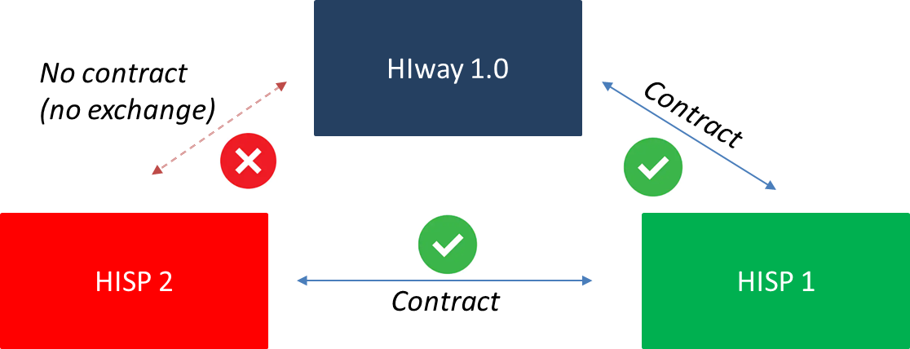

Illustration of technical challenge prior to Direct Trust certification; HIway 1.0 operating with a contact with HISP 1 resulted in exchange, while HIway 1.0 operating without a contract with HISP 2 results in no exchange, yet exchange between HISP 1 and HISP 2 does occur because they have a contractual agreement amongst themselves

Slide 17
Technical solution: HIway 2.0 Direct Message
- DirectTrust-certified HISPs (including the HIway’s HISP) follow uniform security, technical, legal, and business standards for Direct Message exchange.
- This facilitates immediate interoperability - there is no need for the HIway’s HISP and other HISPs to contract directly with each other.

HIway 2.0
HISP 2
HISP 1
DT
DT
DT

Illustration of technical solution: when all parties operate under DirectTrust certification immediate interoperability is facilitated

Slide 18
Result: DirectTrust expands universe for Direct Message
- Via DirectTrust, HIway 2.0 connects to 25+ in-state and 120+ out-of-state HISPs

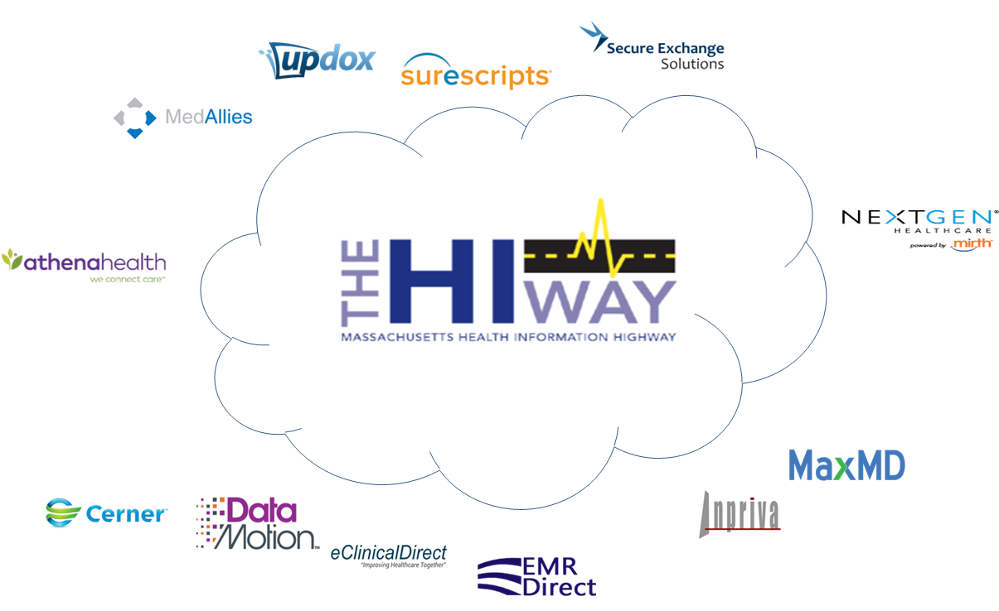

Illustration MA HIway in the middle surrounded by various HISPs
Slide 19
Direct Messaging and interoperability
Recommendation:
Expand connection requirement to include uses cases through DirectTrust-accredited HISPs
- Direct Messages can be exchanged between the HIway and a myriad of HISPs
- From a technical POV, Direct Messaging via the HIway’s HISP and via another HISP are identical (no downside to using another HISP)
- From an interoperability POV, all providers using a DirectTrust HISP can exchange messages with all providers using the HIway
- DirectTrust facilitates easy exchange between HISPs – as simple as sending an email
Slide 20
Market-based ENS Initiative — Certification update
Presented by: Bert Ng
Slide 21
ENS Initiative history
EOHHS ENS Initiative goal:
- Supporting timely statewide Event Notification Services (ENS) across the Commonwealth in order to improve health care delivery, quality, and coordination
EOHHS process:
- Oct 2018: State-operated ADT repository RFR cancelled – Creating a state-operated ADT repository would be duplicative of existing market capabilities
- Oct 2018: RFI issued – Leveraging the gains of existing ENS marketplace to achieve universal provider access to ENS more quickly
- Oct 2019: Regulation finalized – Formalizing certification process for ENS vendors
- Nov 2019: RFA issued – Accepting applications for certification of ENS vendors
- Jan 2020: Applications submitted – Processing the applications to determine certification of ENS vendors
EOHHS guiding principles:
- Universal access – Promoting data sharing within an ENS framework to increase accessibility to ENS for providers of all sizes
- Streamline provider experience – Crafting ENS framework to allow single point of submission and single point of reception of data
Improve notification timing – Improving timing for data flow (real/near-real time)

Slide 22
ENS Initiative: ENS regulation and certification timeline
Q3 2019
- 6/28 – Proposed regulation published
- 7/19 – Proposed regulation public hearing &
written testimony
Q4 2019
- 10/4 Final regulation in effect
- 10/4 Listening session on certification criteria
- Post finalized certification criteria on COMMBUYS
Q1 2020
  - Qualifying vendors certified
  - ENS framework implementation
Q2 2020
  - ENS framework live
Slide 23
Conclusion
Presented by: Undersecretary Lauren Peters
Slide 24
May HITC meeting
May 4th, 2020
3:30 – 5 p.m.
One Ashburton Place (21st floor), Boston
Slide 25
Appendix A: HIway SWOT analysis from Nov 19 HIT Council meeting
Strengths, Internal
- Connection requirement
- Direct Message – Webmail
- Consulting services for providers to adopt – HAUS
- Clinical gateway – Public health uniform submission
Weaknesses, Internal
- No repository to enable pull technology through the HIway
- Lengthy procurement processes
(state procurement plus CMS approval for federal match)
- Regulation limits HIE requirement to hospitals, CHCs, physician practices
Opportunities, External
- Increased FHIR API adoption by providers and payers
- CMS/ONC Interoperability activities
- Medicaid Enterprise Systems funding
- USCDI v1.0 data requirements
- Increased data exchange for specified use cases (e.g., Distributed Data Network (DDN) model)
Threats, External
- 42 CFR Part 2 – SUD data policies
- HITECH funding ending 10/1/21 requiring modified funding strategy
- TEFCA focus on pull technology
- EHRs increasingly building Direct messaging natively into systems
- Disparate data:
garbage in garbage out
Slide 27
Appendix B: HIway operations update
Slide 28
HIway participation
October 21, 2019 – January 20, 2020
3 New participation agreements
- Merrimack Valley ACO
- Northeast Rehabilitation Hospital Network
- Purple Crayon Pediatrics
Slide 29
HIway participation continued
2 New connections
- Cape Cod Healthcare
- Purple Crayon Pediatrics Participant was enrolled and connected in this period
Slide 30
HIway transactions
HIway transaction volume update
- HIway 2.0 processed a total of 16.2 million transactions during the January reporting period (12/21/19 – 1/20/20).
- Public Health Reporting in January accounted for 13.9 million transactions, or 87% of total production volume. This included 9.5 million Syndromic Surveillance transactions and 4.4 million Immunization transactions, of which 3.3 million used the new Immunization Query functionality.
- Provider-to-Provider transactions totaled 170,944 for January.
The Mass HIway team continuously monitors transaction levels, both to support operations and to identify data that provide additional insight into HIway trends and progress
Slide 31
HIway transactions continued

- HIway 2.0 processed a total of 16.2 million transactions during the January reporting period (12/21/19 – 1/20/20).
- Public Health Reporting in January accounted for 13.9 million transactions, or 87% of total production volume. This included 9.5 million Syndromic Surveillance transactions and 4.4 million Immunization transactions, of which 3.3 million used the new Immunization Query functionality.
- Provider-to-Provider transactions totaled 170,944 for January.
- The Mass HIway team continuously monitors transaction levels, both to support operations and to identify data that provide additional insight into HIway trends and progress.
Slide 32
Thank you!

