The Commonwealth of Massachusetts

Executive Office of Health and Human Services

Department of Public Health

Bureau of Infectious Disease and Laboratory Sciences

250 Washington Street, Boston, MA 02108-4619



MAURA T. HEALEY

Governor

KIMBERLEY DRISCOLL

Lieutenant Governor

KATHLEEN E. WALSH

Secretary

ROBERT GOLDSTEIN, MD, PhD Commissioner

**Tel: 617-624-6000**

**www.mass.gov/dph**

**TO:** Health and Social Service Providers, Advocates, and Community Members Working with Persons Who Use Drugs in Massachusetts

**FROM:** H. Dawn Fukuda, Assistant Commissioner, Director, Bureau of Infectious Disease and Laboratory Sciences

**DATE:** Wednesday, May 31, 2024

**RE:**  Ongoing HIV infections among persons who inject drugs in Boston

**Key Highlights**

The Massachusetts Department of Public Health (MDPH) and the Boston Public Health Commission (BPHC) continue to identify new cases of HIV attributed to injection drug use (IDU). A cluster of HIV infections among people who inject drugs (PWID) in the Boston region was first identified in late 2018, and to date includes over 200 individuals. While this cluster is concentrated in Boston, new HIV diagnoses among PWID have occurred state-wide. People in this cluster have co-occurring psychosocial stressors, and engagement in HIV prevention and care has been suboptimal. MDPH is seeking partnership with providers across the state to optimize HIV prevention and facilitate timely treatment initiation and adherence support for people who inject drugs.

**Background**

Between 2000 and 2014 the number of new HIV infections attributed to IDU in Massachusetts declined by 91%, however, starting in 2015 the number of new HIV diagnoses among PWID increased. From 2016 to 2018, an HIV outbreak occurred in the cities of Lawrence and Lowell, with 129 HIV cases linked to that cluster. In November 2018, a separate cluster of HIV infections was identified among PWID in the Boston region. Clinical alerts regarding this cluster were released on [January 25, 2019](https://www.mass.gov/doc/joint-mdph-and-bphc-clinical-advisory-hiv-transmission-through-injection-drug-use-in-boston-0/download), [January 8, 2020](https://www.mass.gov/doc/joint-mdph-and-bphc-clinical-advisory-hiv-transmission-through-injection-drug-use-in-boston-1/download), and [March 15, 2021](https://www.mass.gov/doc/joint-mdph-and-bphc-clinical-advisory-hiv-transmission-through-injection-drug-use-in-boston-march-15-2021/download). The purpose of this notice is to provide an update on this ongoing Boston PWID cluster with recommendations for an effective response.

**Boston PWID Cluster Cases, 10/2018 - 1/2024\***

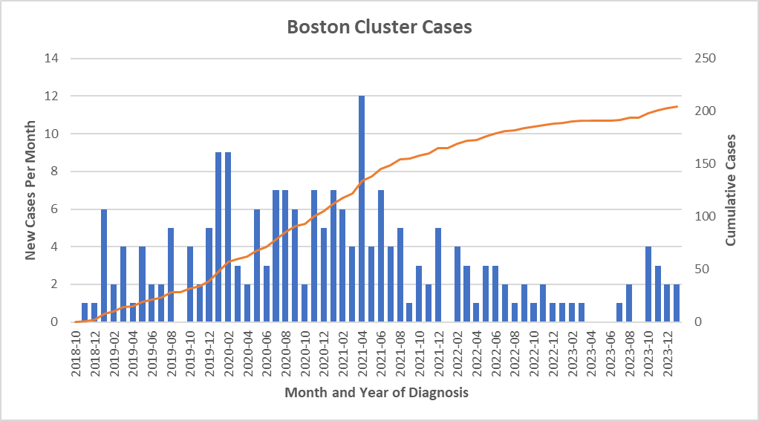

*Data as of 03/01/2024 and subject to change

**Updates**

As of January 31, 2024, there have been 205 individuals diagnosed with HIV linked to the Boston PWID cluster. Almost a quarter of individuals in this cluster report male-to-male sexual contact, underscoring the intersectional nature of behavioral and environmental factors that may contribute to HIV risk*.* In this cluster, 87% of individuals have a direct connection to the city of Boston by residing in, receiving medical or social support services in, or participating in activities with a high risk of HIV exposure (e.g., sharing injection equipment) in the city of Boston. The remaining individuals are linked through named injection and/or sex partners with ties to Boston. Many people in this cluster have had connections to the area of Boston around Massachusetts Avenue and Melnea Cass Boulevard where many people have stayed in tents and temporary structures. Several agencies provide integrated services in this area, however, in recent months, there has been increased mobility among individuals, and people affiliated with the Boston PWID cluster may now be residing in or accessing services in other parts of the city and across the state. People may be seeking care in diverse service settings including substance use disorder treatment settings, emergency and acute care settings, primary care practices, obstetrics and gynecology clinics, and mental and behavioral health care settings.

Many people in or at risk of being in the Boston PWID cluster experience multiple factors that make consistent engagement in HIV treatment and prevention more difficult. Many people in this cluster experience homelessness or unstable housing and report polysubstance use including methamphetamine use. There are high rates of co-occurring mental illness*.* At least 20% of people in this cluster have a documented history of incarceration, many in the year immediately prior to HIV diagnosis, and multiple HIV diagnoses among individuals in this cluster were made in carceral settings. With these multiple disruptive psychosocial circumstances and recent increased mobility as referenced above, it has been challenging to accomplish optimal engagement in HIV treatment and prevention. Only approximately half of the individuals in this cluster have had an HIV viral load measured after diagnosis, and among those with testing in the past 12 months, almost a third had a detectable viral load on their most recent check, signifying the potential for onward HIV transmission.

**There is a need for broad provider and stakeholder involvement to respond to the co-occurring needs of this group. This response necessitates involvement of a wide range of medical, behavioral health, and social service providers across Boston and across the state who can offer HIV testing, prevention (including biomedical prevention), and linkage to care for people at high risk for HIV exposure, infection, and disease progression.**

**Recommendations:**

1. **Test people at risk for HIV, HCV, and STIs.**
2. Assess HIV, HCV, and STI risk by asking about both substance use and sexual practices.
3. Integrate HIV risk assessment into protocols for individuals seeking SUD services, including harm reduction, detoxification, and medication assisted treatment.
4. Offer regular testing in diverse settings including substance use treatment sites, emergency and acute care settings, primary care practices, [obstetric and gynecology clinics](https://www.acog.org/clinical/clinical-guidance/committee-opinion/articles/2018/09/prenatal-and-perinatal-human-immunodeficiency-virus-testing), and mental and behavioral health care settings.
5. Because some individuals may not feel comfortable disclosing risks, regardless of endorsed behaviors, offer HIV testing at least once to all individuals per USPSTF recommendations and consider using opt-out HIV testing protocols consistent with [M.G.L c. 111 § 70F](https://malegislature.gov/Laws/GeneralLaws/PartI/TitleXVI/Chapter111/Section70F).
6. In addition to HIV screening, offer HCV and STI screening to individuals who endorse risk factors.

1. **Engage PWID in HIV prevention efforts.**
2. For individuals with ongoing injection drug use, discuss opportunities for harm reduction through safer injection practices, refer to syringe service programs to access sterile syringes and other injection equipment, and advise as to the proper disposal of used injection equipment.
3. Discuss the full range of SUD treatment options, including medications for opioid use disorder (MOUD) such as methadone and Suboxone. If you do not provide these services, offer supported referrals to SUD treatment facilities or local providers who prescribe MOUD.
4. Discuss methods of HIV prevention including condoms and biomedical prevention including HIV pre-exposure prophylaxis (PrEP), post-exposure prophylaxis (PEP), nPEP, and treatment as prevention. If you do not prescribe PrEP or PEP, assess your organization’s potential to develop this capacity and offer referrals to providers who offer PEP and PrEP.

1. **Link individuals with HIV infection to care and treatment.**
2. Report new diagnoses of HIV in a person who injects drugs immediately to DPH by calling the HIV/STD Reporting and Partner Services Line at 617-983-6999.
3. Emphasize that HIV is treatable, and that treatment can improve health and prevent transmission. If you do not treat HIV, link individuals to local providers where HIV treatment is offered.

1. **Respond to the complex needs of PWID with or at risk for HIV infection.**
2. Refer people experiencing homelessness or unstable housing to housing resources.
3. Refer people with unmet mental health needs to local mental health and behavioral health providers.
4. Offer language assistance for individuals who have limited English proficiency and/or other communication needs.

**Resources**:

* HIV testing resources: <https://www.mass.gov/info-details/integrated-testing-and-linkage-services-locator>
* Syringe Service Programs: <https://www.mass.gov/syringe-service-programs>
* Syringe disposal sites: <https://www.mass.gov/doc/proper-use-and-disposal-of-needles-and-syringes-2023/download>
* Substance use treatment providers: <http://www.mass.gov/eohhs/gov/departments/dph/programs/substance-abuse/providers/substance-abuse-services.html>
* The Massachusetts Substance Use Helpline: [MA Helpline](https://helplinema.org/), 800-327-5050
* Grief and Trauma Support:
  + Support After a Death by Overdose: [sadod.org](https://sadod.org/)
  + Learn to Cope: <https://learn2cope.org/grief-resources/>
  + Lewis D. Brown Peace Institute: <https://ldbpeaceinstitute.org/healing-support-services/>
* Locations offering PrEP/PEP: <https://www.mass.gov/hiv-pre-exposure-prophylaxis-prep>
* Division of STD Prevention Reporting and Partner Services Line:

<https://www.mass.gov/partner-services-program-psp>, 617-983-6999

* Massachusetts Housing Assistance:

<https://www.mass.gov/info-details/massachusetts-housing-assistance-emergency-and-long-term-help>

* Behavior health providers in Massachusetts:
  + <https://www.mass.gov/info-details/find-your-cbhc>
  + [masshelpline.com](http://masshelpline.com), 833-773-2445
* Mental health resources: <https://www.mass.gov/guides/finding-mental-health-support-in-massachusetts>
* Boston Recovery Services: <https://www.boston.gov/government/cabinets/boston-public-health-commission/recovery-services>