Human Immunodeficiency Virus (HIV)



**HIV Treatment and Care in Massachusetts: Key Findings from Analysis of Medical Chart Review data, 2013-2021**

January 2025

The Massachusetts Department of Public Health (DPH) estimates that there are more than 23,000 people living with HIV in Massachusetts as of 2022. For people living with HIV (PWH), engagement in routine, ongoing care is critical for better health outcomes, including decreasing mortality and community transmission.

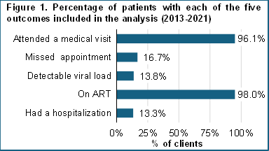To assess engagement in HIV care for PWH and identify areas of improvement in care, DPH analyzed medical chart data among PWH receiving care in 33 medical facilities in Massachusetts. A review was conducted on 10,031 patient medical charts for care delivered between 2013 and 2021. Patient medical charts were randomly selected from a pool of individuals who were diagnosed with HIV and were in care during the two years prior to the review year. Key outcomes of interest examined included patient engagement in, use of, and adherence to HIV care and treatment (Figure 1). Logistic regression modeling was used to determine factors significantly associated with these outcomes and identify gaps in care and areas for improvement in continuity of care. Key findings are presented here:

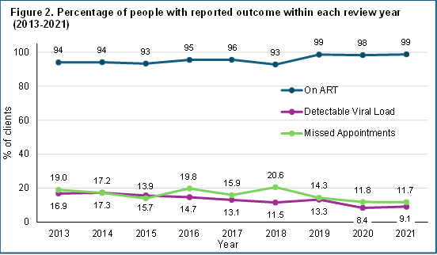**Viral suppression and engagement in HIV care and treatment have improved over time.** Between 2013 and 2021, the likelihood of having a detectable HIV viral load and missing an appointment each had a statistically significant decrease over time. Compared to patients in 2013, there was about an 8-percentage point decrease in patients with missed appointments, and a 7-percentage point decrease in patients with detectable viral loads. There was also a statistically significant increase in ART use. The proportion of patients on ART rose 5 percentage points from 2013 – 2021. Figure 2 illustrates these improvements.

**Patients are more likely to be retained in HIV care as they age.** The analysis found that as age increases, the likelihood of attending a medical visit increases while the likelihood of missing appointments and having a detectable viral load decreases. For each year increase in age, the odds of attending a visit during the review period increase about 2%, and the odds of having a missed appointment or having a detectable viral load decrease by 3%.

**Substance use during the review period is associated with lower retention and adherence in HIV care.** Patients reporting active substance use during the review year were about twice as likely to miss an appointment, have a detectable viral load, and be hospitalized in the review year, compared to those with history of substance use and those with no active substance use. Patients who reported injection drug use as an exposure mode at the time of HIV diagnosis showed similar patterns. They were 1.3 times as likely to miss an appointment or be hospitalized in the review year. Additionally, they were about half as likely to have a clinic visit for HIV care in the review year or be on ART.

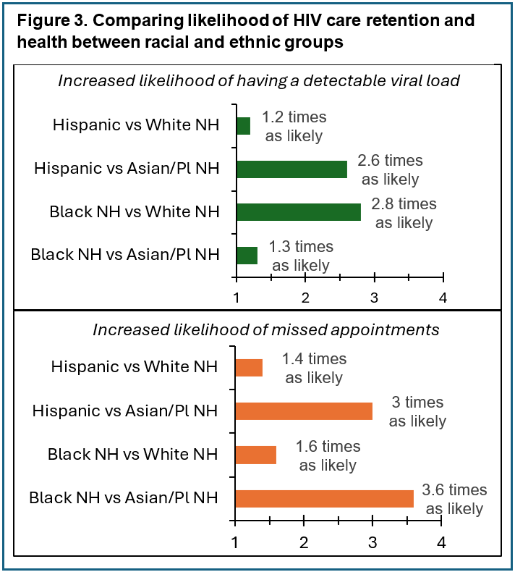**Racial and ethnic disparities persist in HIV care retention and health outcomes.** Hispanic patients had an increased likelihood of having a detectable viral load compared to White non-Hispanic (NH) patients and Asian/Pacific Islander NH patients (1.2 and 2.6 times as likely, respectively). Hispanic patients also had an increased likelihood to miss HIV care appointments when compared to the same groups (1.4 times as likely as White NH patients and 3 times as likely as Asian/Pacific Islander NH patients). Similar disparities were found for Black NH patients. Black NH patients had an increased likelihood of having a detectable viral load compared to White NH and Asian/Pacific Islander NH patients (1.3 and 2.8 times as likely, respectively). For missed appointments, Black NH patients had an increased likelihood to miss HIV care appointments when compared to the same groups (1.6 times as likely as White NH patients and 3.6 times as likely as Asian/Pacific Islander NH patients). Figure 3 highlights these results. The lack of significant results for American Indian/Alaska Native NH patients are due to insufficient data in this demographic group.

**Experiencing mental health issues may reduce HIV care continuity.** Patients reporting that they were actively experiencing mental health issues in the review year were approximately 1.4 times as likely to have missed appointments, 1.2 times as likely to have detectable viral loads, 1.5 times as likely to be hospitalized, compared to people reporting no mental health issues or people with a history of mental health issues.

**Recommendations:**

To address disparities in HIV care, it is imperative to address the needs of disproportionately affected groups, including younger patients, patients with active substance use disorder, patients experiencing mental health issues, and patients who are Hispanic and Black NH. Sub-optimal engagement and retention in HIV care with poorer health outcomes was indicated by our analysis among these individuals. Clinicians, case managers, and other HIV care team members should work with their patients to assess anticipated challenges to engagement in care and adherence to treatments. Awareness of factors such as substance use, mental illness, and other social determinants of health are important to tailor effective interventions.

DPH recommends that to best support racial and ethnic groups that are disproportionately affected, HIV care teams should consider equitable and culturally relevant interventions to facilitate continuity of care. To effectively identify gaps and ensure interventions are tailored appropriately, proactive collaboration with HIV community organizations is encouraged. Actively seeking and incorporating the voices of PWH in designing and delivering HIV care interventions is vital to achieving better HIV outcomes. Care teams may consider offering support such as health education, intensive navigation, assisted referrals, or modifying practices to remove identified barriers. Any interventions aimed at increasing engagement in HIV care should always be implemented with a health equity lens.

**Resources:**

* Massachusetts HIV/AIDS Epidemiologic profiles: [mass.gov/lists/hivaids-epidemiologic-profiles](https://www.mass.gov/lists/hivaids-epidemiologic-profiles)
* HIV Treatment guidelines and clinical advisories from DPH: [mass.gov/lists/hiv-treatment-guidelines-and-clinical-advisories](https://www.mass.gov/lists/hiv-treatment-guidelines-and-clinical-advisories)
* HIV Nexus: CDC Resources for Clinicians: [cdc.gov/hivnexus/hcp/index.html](https://www.cdc.gov/hivnexus/hcp/index.html)
* New England AIDS Education and Training Center: <https://www.neaetc.org/p/neaetc-online-health-resource-library#populations>
* HRSA Target HIV Special Projects of National Significance (SPNS) Program Resource Dictionary: <https://targethiv.org/library/spns-directory>