***Provider Agencies***

**western ma**

Way Finders

***Live More Independently at Home***

(Agawam, Chicopee, Holyoke, Northampton, Springfield,

W. Springfield and Westfield)

Carmen Pagan

[cpagan@wayfindersma.org](mailto:cpagan@wayfindersma.org)

413-233-1615

[www.wayfindersma.org](http://www.wayfindersma.org/)

TTY/TDD: 413-233-1699

Pioneer Valley Planning Commission

(all other Hampden, Hampshire, Franklin and

Berkshire county communities)

Shirley Stephens

[sstephens@pvpc.org](mailto:sstephens@pvpc.org)

413-781-6045

[www.pvpc.org](http://www.pvpc.org/)

TTY/TDD: 413-781-7168

**central ma**

RCAP Solutions Financial Services, Inc.

Lovette Chislom

[lchislom@rcapsolutions.org](mailto:lchislom@rcapsolutions.org)

978-630-6725

[www.rcapsolutions.org](http://www.rcapsolutions.org/)

TTY/TDD: 978-630-6754

**northeast/north shore ma**

Community Teamwork, Inc.

Alan Trebat

[atrebat@commteam.org](mailto:atrebat@commteam.org)

978-654-5741

[www.commteam.org](http://www.commteam.org/)

Mass Relay Available: Dial 711

**metrowest ma**

South Middlesex Opportunity Council, Inc.

Linda Hochen

[lhochen@smoc.org](mailto:lhochen@smoc.org)

508-620-2682

[www.smoc.org](http://www.smoc.org/)

TTY/TDD: 508-872-4853

**southeastern ma/cape/islands**

South Middlesex Opportunity Council, Inc.

Amy Allen

[aallen@smoc.org](mailto:aallen@smoc.org)

508-202-5919

[www.smoc.org](http://www.smoc.org/)

TTY/TDD: 508-872-4853

**The Dykeman Family**

John Dykeman has muscular dystrophy, a disease that leads to the loss of muscle mass and weakness. He currently uses a wheelchair, but since muscular dystrophy is a progressive disorder,

his care needs will become

more complex over time.

The Dykeman family turned to the Home Modification Loan Program for assistance to modify their home to help John better access his familiar surroundings.

A lot needed to be done to accommodate their son’s needs. For the Dykemans, the modifications reconfigured their downstairs space to be more accessible.

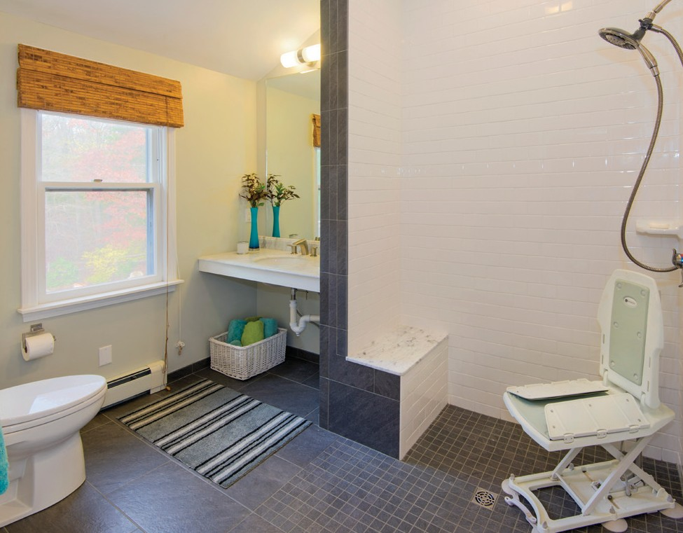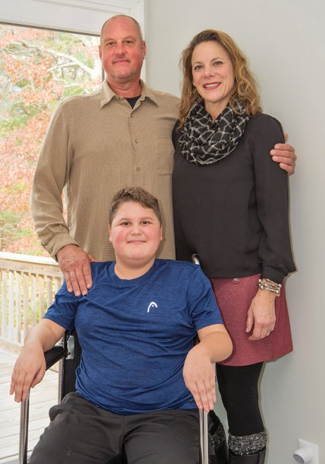

On their second floor, HMLP transformed John’s living area to help meet his future needs. This included an accessible bathroom with a zero-entry or curbless shower, laminate flooring for ease of clean- up and space for other medical equipment. The construction work started in February 2015 and was finished by July.

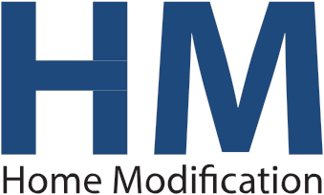

*A state loan program that could help you or a loved one live more independently at home*

**metropolitan boston** Metro Housing Boston Jennifer Shaw

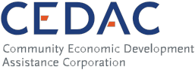

[jennifer.shaw@metrohousingboston.org](mailto:jennifer.shaw@metrohousingboston.org)

617-425-6637

[www.metrohousingboston.org](http://www.metrohousingboston.org/)

Mass Relay Available: Dial 711

(fax) 617-532-7539 *HMLP is a MRC program in collaboration with CEDAC*

***Assisting Your Way to Accessible Living***

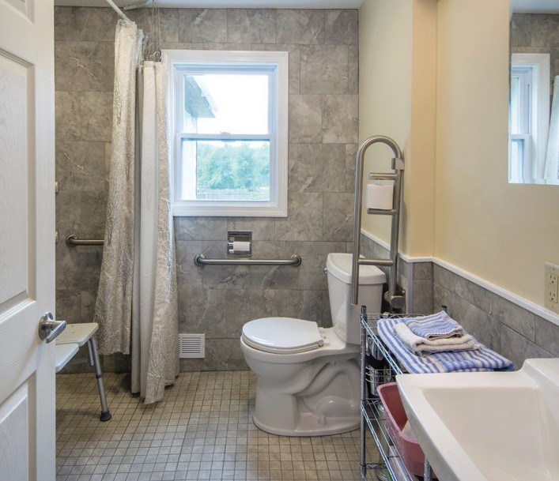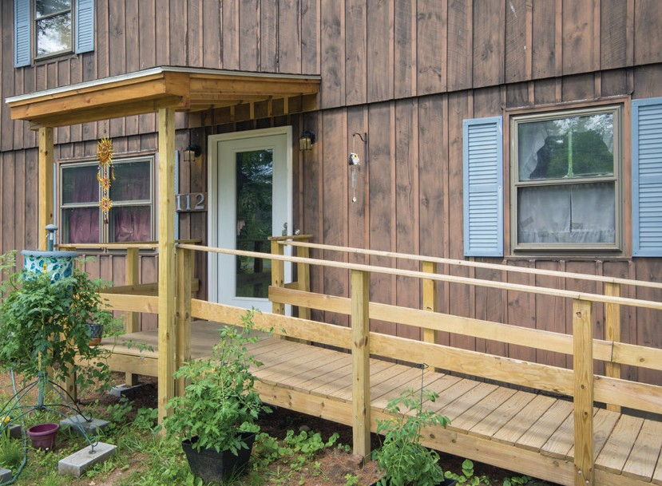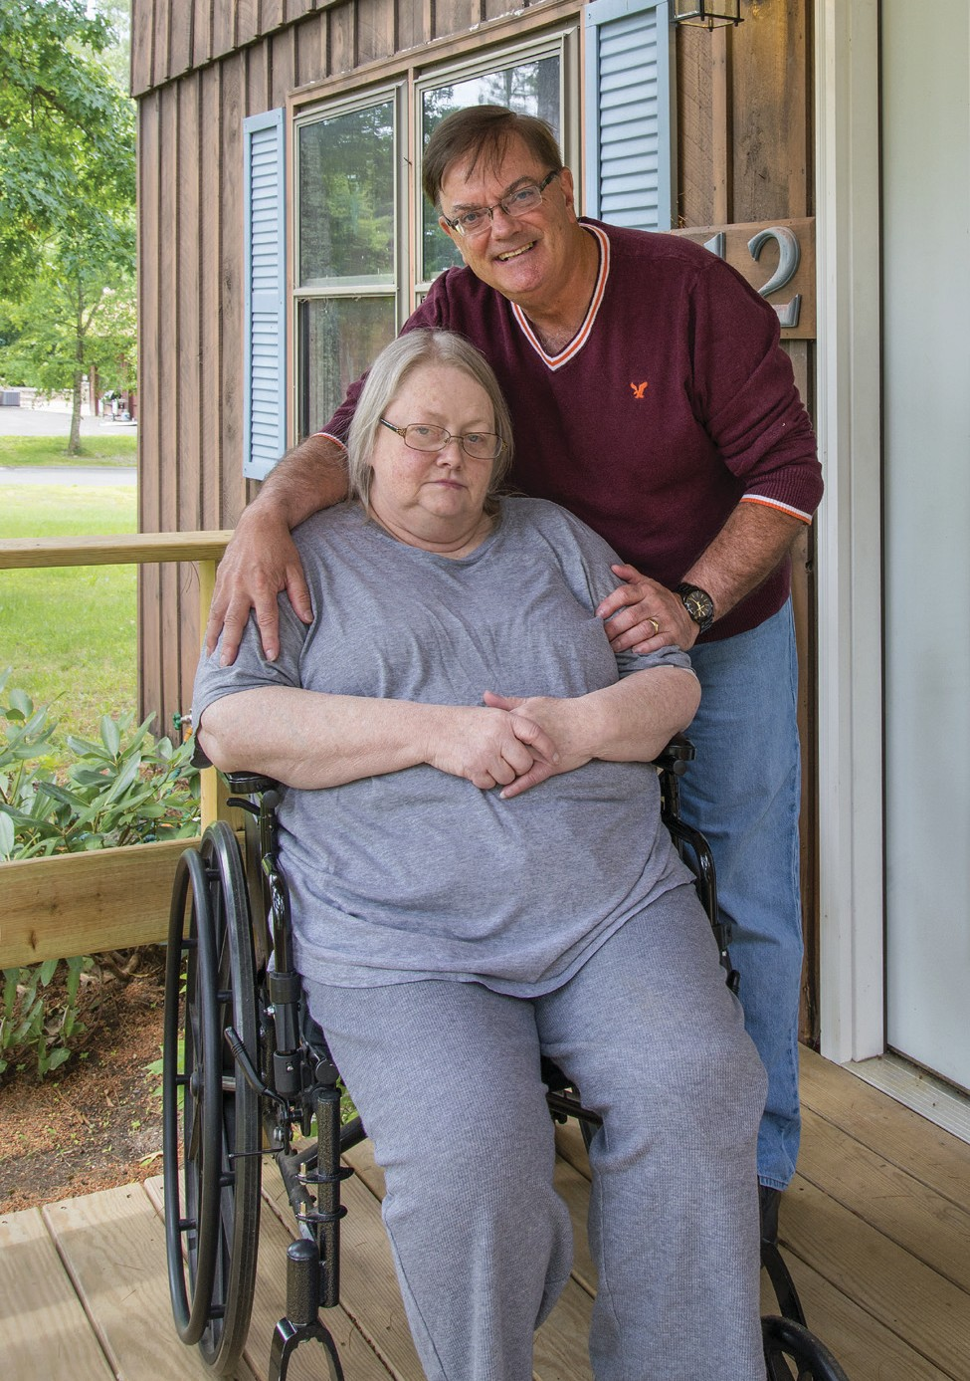

***About the Program***

Home Modification Loan Program (HMLP) is a state- funded lending program that provides loans to homeowners and small landlords to fund neccessary changes to keep disabled or elderly family members in their own homes and communities.

This program is not a home repair program. Some examples of projects funded through HMLP include ramps and lifts, hardwired alarm systems, fencing, sensory spaces, accessory dwelling units, and bathroom and kitchen adaptations.

***Are You Eligible?***

□ Do you own your home?

□ Are you, or a household member, an elder or

have a disability or limitation that is professionally

documented?

□ Does the proposed modification relate to the beneficiary’s ability to function in the home on a day- to-day basis?

□ Is your household gross income at or below 200%

area medium income for Metro Boston FMR area (see

the HMLP application for the program’s income limits,

which are updated annually)?

***Loan Information***

• $1,000 to $50,000 loans to property owners, secured by a promissory note and a mortgage lien

• 0% interest, deferred payment loan

• No require monthly payments and no interest

• Repayment is required when property is sold or when

the property’s title is changed

• $1,000 to $30,000 loans to owners of manufactured or mobile homes, secured by a promissory note and security agreement

• Landlords with fewer than 10 units may be eligible for

a 3% loan for a tenant

**The Perrault Family**

Ruth and Leonard Perrault (pictured above) learned about HMLP from the staff at the rehabilitation facility where Ruth was recovering from a recent amputation surgery. HMLP

allowed them to completely remodel the existing bathroom and entrance to their home so it is wheelchair accessible. They describe the impact of these modifications as allowing Ruth to “feel less dependent on others” and has “significantly improved her spirits and outlook on life since the operation”.

***Application Process***

Applications are reviewed by regional provider agencies on a first come first serve basis to determine both income eligibility and eligibility of the proposed modification. Eligibility is determined by evaluating the application and documentation submitted. Items required as part of your application:

• Verification of household size and gross income

• A professional’s certification that the proposed modification relates to the beneficiary’s ability to function on a day to day basis

• Verification of paid state income taxes and property

taxes

• A copy of the property deed or the manufactured/

mobile homes bill of sale.

***Get Started Today***

If you think you might be eligible, contact the provider agency in your region to start the application process.

The applications and more information can be found at: cedac.org/hmlp. Here you can also watch a brief video on the loan process.

For more information contact Susan Gillam at 1-866-

500-5599 or [sgillam@cedac.org.](mailto:sgillam@cedac.org)