HMO Self-Assessment Update Form – Years 2 and 3
Note: This form is to be completed in the two Fiscal Years following the HMO’s completion of its triennial Community Health Needs Assessment

I. Community Benefits Process:
- Has there been any change in the past year to the composition or leadership of the Community Benefits Advisory Committee/committee responsible for oversight of Community Benefits programs? ☐ Yes ☐ No
  - If so, please list updates:
Click or tap here to enter text.

II. Community Engagement:
- If there have been any updates to the key partners with whom the HMO collaborates, please indicate in the table below. Please feel free to add rows as needed.

Organization | Name and Title of Key Contact | Brief Description of Engagement
Click or tap here to enter text. | Click or tap here to enter text. | Click or tap here to enter text.
Click or tap here to enter text. | Click or tap here to enter text. | Click or tap here to enter text.
Click or tap here to enter text. | Click or tap here to enter text. | Click or tap here to enter text.
Click or tap here to enter text. | Click or tap here to enter text. | Click or tap here to enter text.

- Please use the spectrum below from the Massachusetts Department of Public Health to assess the HMO’s level of engagement with the community in implementing its plan to address significant documented needs, and the effectiveness of its community engagement process.

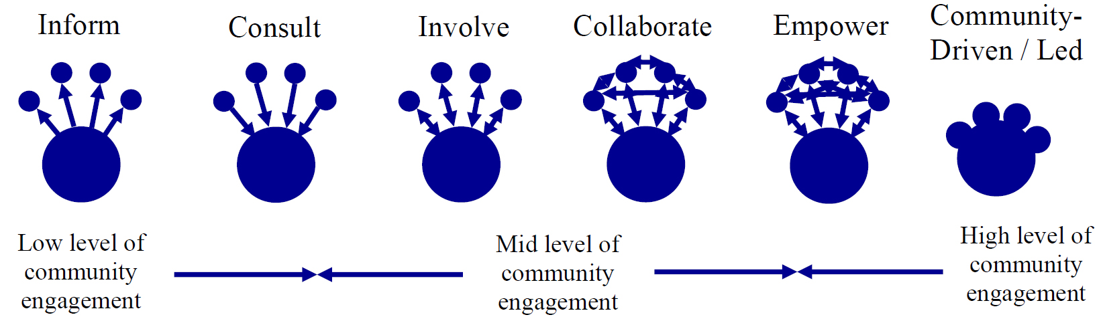

Category | Level of Engagement | Did Engagement Meet HMO’s Goals? | Goal(s) for Engagement in Upcoming Year(s)
Overall engagement in implementing filer’s plan to address significant documented needs | Choose an item. | Click or tap here to enter text. | Choose an item.
Determining allocation of HMO Community Benefits resources/selecting Community Benefits programs | Choose an item. | Click or tap here to enter text. | Choose an item.
Implementing Community Benefits programs | Choose an item. | Click or tap here to enter text. | Choose an item.
Evaluating progress in executing Implementation Strategy | Choose an item. | Click or tap here to enter text. | Choose an item.

- For categories where community engagement did not meet the HMO’s goal(s), please provide specific examples of planned improvement for next year:
Click or tap here to enter text.

- Optional FY20 Question: Please describe how the COVID-19 pandemic impacted the HMO’s process for engaging its community and developing responsive Community Benefits programs.
Click or tap here to enter text.

- Did the HMO hold a meeting open to the public (either independently or in conjunction with its CBAC or a community partner) at least once in the last year to solicit community feedback on its Community Benefits programs? If so, please provide the date and location of the event. If not, please explain why not.
Click or tap here to enter text.

III. Updates on Collaboration:
- If the HMO reported on a collaboration in its Year 1 HMO Self-Assessment, please briefly describe any updates to that collaboration, including any progress made and/or challenges encountered in achieving the goals of the collaboration
Click or tap here to enter text.

- If the HMO entered a larger community health improvement planning process in the past year, please briefly describe it.
Click or tap here to enter text.

“Community Engagement Standards for Community Health Planning Guideline,” Massachusetts Department of Public Health, available at: http://www.mass.gov/eohhs/docs/dph/quality/don/guidelines-community-engagement.pdf. For a full description of the community engagement spectrum, see page 10 of the Attorney General’s Community Benefits Guidelines for Health Maintenance Organizations.

